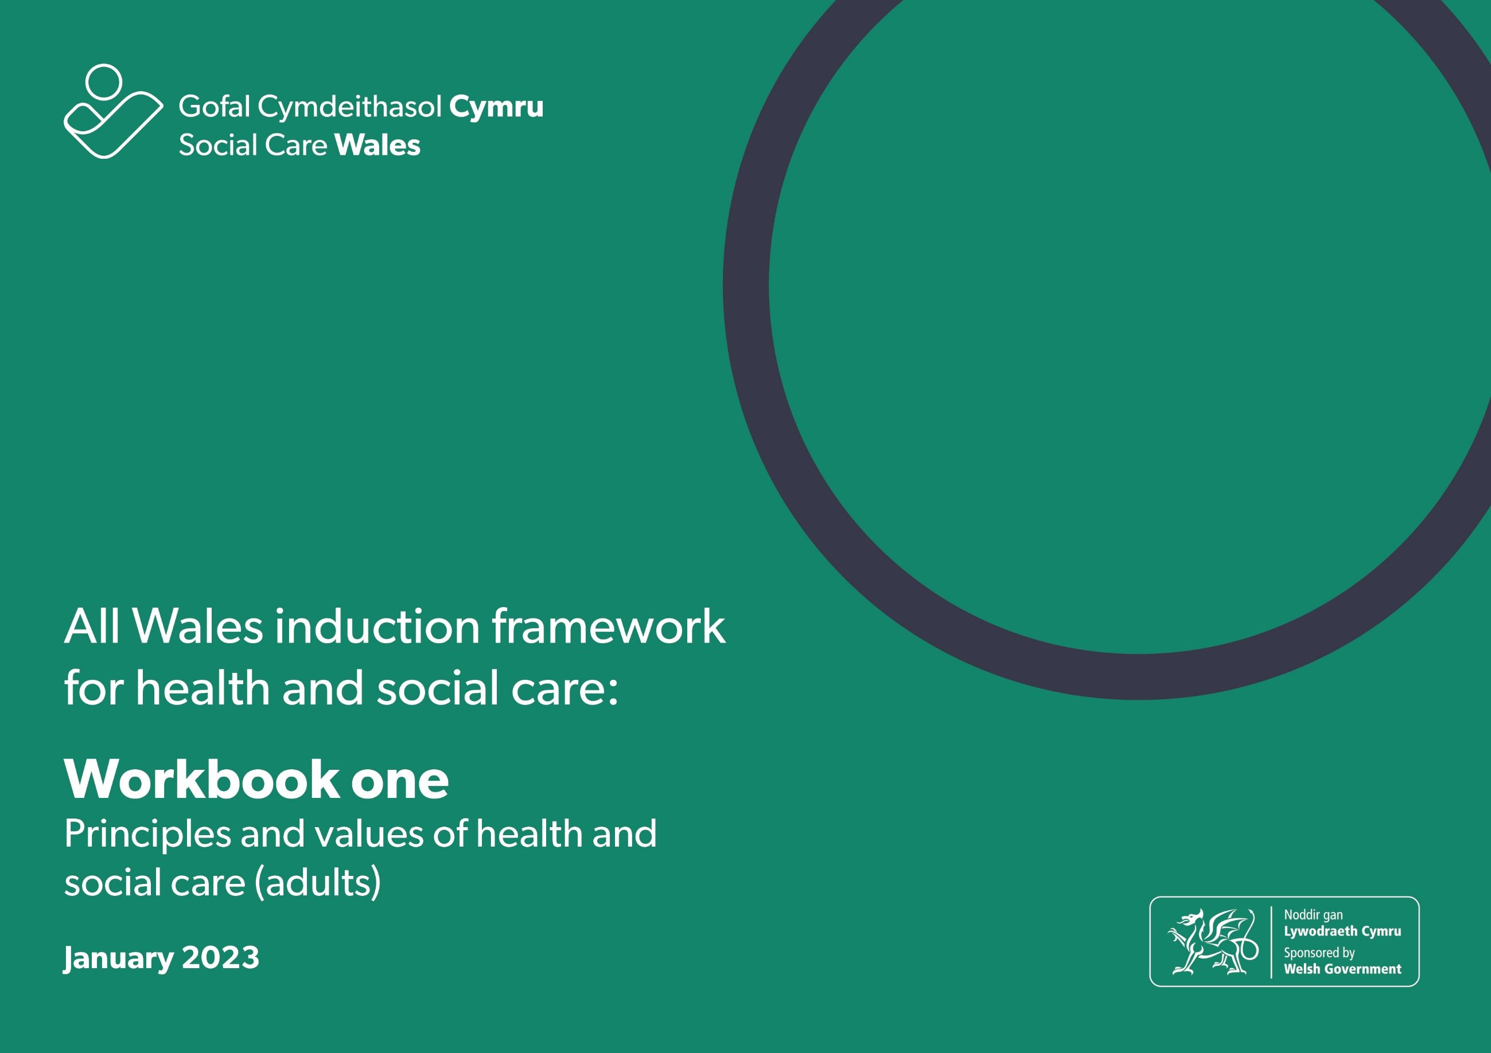

All Wales Induction Framework for Health and Social Care workbook 1: Principles and values of health and social care (adults)
This workbook will help you explore the principles and values that underpin the practice of health and social care workers.
The workbook can either be downloaded and completed electronically or printed and completed by hand.
You can use the completed workbook activities:
- towards achieving the All Wales induction framework for health and social care (Induction framework)
- to help you get ready to complete the Core qualification for health and social care
- as evidence towards your practice qualification.
Some words are highlighted in bold in the progress log. There’s a glossary at the end of this workbook if you want help to know what these mean.
Throughout the workbook, we refer to ‘health and social care workers’. This means the person providing care and support or services to individuals.

Contents
1.1 Legislation, national policies and codes of conduct and practice
1.2 How rights-based approaches relate to health and social care
1.3 How to use person-centred approaches
1.4 Equality, diversity, inclusion and discrimination
1.5 Positive risk taking
1.6 Positive relationships and professional boundaries
1.7 Communication
1.8 Welsh language and culture
1.9 Positive approaches to reduce restrictive practices in social care
1.10 Change and transitions in health and social care
1.11 Reflection
1.12 Workbook reflection

1.1 Legislation, national policies and codes of conduct and practice
Code of Professional Practice for Social Care
The Code:
Describes the standards of professional conduct and practice required of social care workers.
It helps social care workers know what’s expected of them.
The Code has seven sections:
As a social care worker, you must:
1. Respect the views and wishes, and promote the rights and interests, of individuals and carers.
2. Strive to establish and maintain the trust and confidence of individuals and carers.
3. Promote the well-being, voice and control of individuals and
carers while supporting them to stay safe.
4. Respect the rights of individuals while seeking to ensure that their behaviour does not harm themselves or other people.
5. Act with integrity and uphold public trust and confidence in the social care profession.
6. Be accountable for the quality of your work and take responsibility for maintaining and developing knowledge and skills
7. In addition to sections 1 – 6, if you are responsible for managing or leading staff, you must embed the Code in their work.
If you need to register with Social Care Wales, you must comply with the Code. However, the Code should also be used by other social care workers who don’t have to register with Social Care Wales, as it sets clear standards of the conduct and practice expected of everyone employed in the social care profession in Wales.
This section will help you start to know about the principles and values of health and social care which have been built into legislation/laws, national policies and codes of conduct and professional practice. It will also help you think about what these mean to you in your day-to-day work.
The learning activities in this workbook will help you think about how you apply the standards in the Code in your day-to-day work.
There is also a code of conduct for healthcare workers. The NHS Wales Code of Conduct for Healthcare Support Workers in Wales describes what is expected from healthcare support workers employed by NHS Wales for the standards of conduct, behaviour and attitude expected when they’re at work. The code applies to all healthcare support workers employed in clinical and non-clinical environments within the NHS.
Legislation and national policies
As you develop as a health and social care worker you will learn about the legislation/laws and national policies which inform the way you need to work. You won’t need to know about these in detail, but you should understand the key principles and spirit of the law. This section will focus on the principles of the Social Services and Well-being (Wales) Act 2014 and give you an overview of other important pieces of legislation/laws which support people’s rights.
The Social Services and Well-being (Wales) Act 2014
The Social Services and Well-being (Wales) Act 2014 is an important piece of legislation/law about how we should be providing care and support to the people who need it in Wales.
The Act has:
- regulations, which give more detail about what must be done to put the Act into practice
- codes of practice, which give guidance to help put the Act into practice.
- The Act covers:
- adults (people aged 18 or over)
- children (people under the age of 18)
- carers (adults or children who provide or intend to provide care and support).
The Act is built on five important core principles. You don’t need to know details about the Act and the regulations, but you do need to understand about the principles as these will guide your work:
- voice and control
- prevention and early intervention
- well-being
- co-production
- multi-agency.
To help you get started, watch this film that introduces the Act and its principles. Let your manager know if you need help to access this.
We’re now going to look at these principles one at a time.

Principle 1: Voice and control
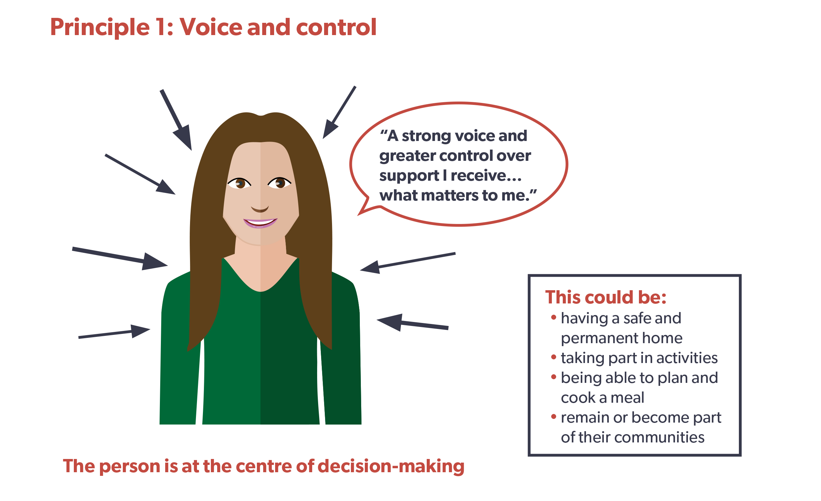
The Act gives individuals a stronger voice and greater control over the support and services they receive to help them achieve well-being and the things that matter most to them.

Principle 2: Prevention and early intervention
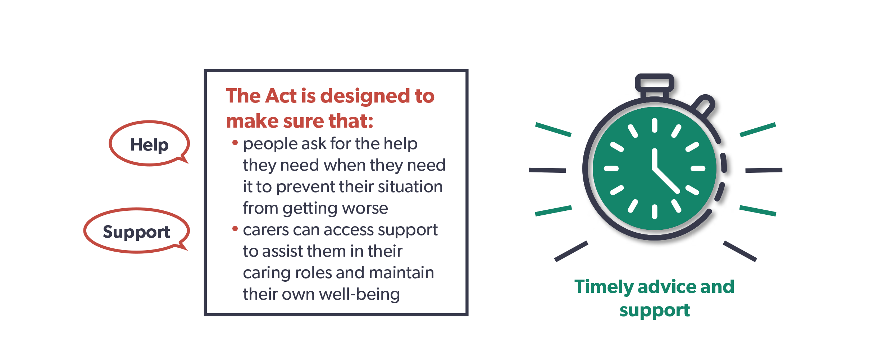

It’s important to give timely advice and assistance to prevent things reaching a crisis point. Stepping in early to help people can reduce or delay the need for longer term care and support.

Learning activity – prevention and early intervention

Read this case study and answer the questions.

Case study – June and Llinos
June is 52 years old and has multiple sclerosis. Llinos, her 15-year-old daughter, is her carer. When June’s symptoms are very bad, Llinos can’t go to school as she must stay home to look after her mother.
After struggling for some months, June and Llinos decide they need help, so they contact their local authority’s information, advice and assistance (IAA) service. The service carries out an early assessment over the phone. This is followed up with visits from an information, advice and assistance worker who completes a full assessment with June and Llinos. The assessment helps June and Llinos talk about their situation, what they want to achieve, and how they may do this. As Llinos is under 18, the assessment must take into account her welfare and development needs.
Both are clear about what would make their lives better. June doesn’t want to rely on Llinos so much. She would also like to be able to get out of the house more and feel she’s doing something worthwhile with her time. Most of all, June is worried about Llinos missing school.
Llinos would like to be able to go to school without having to worry about how her mother is coping and have time to do her homework. She also wants to see more of her friends.

Answer these questions:
- What do you think might be important to June and Llinos?

- What do you think might be important for June and Llinos?

- How could advice and assistance support positive outcomes for June and Llinos?

- What could happen to June and Llinos if they don’t receive any advice or assistance?

Principle 3: Well-being
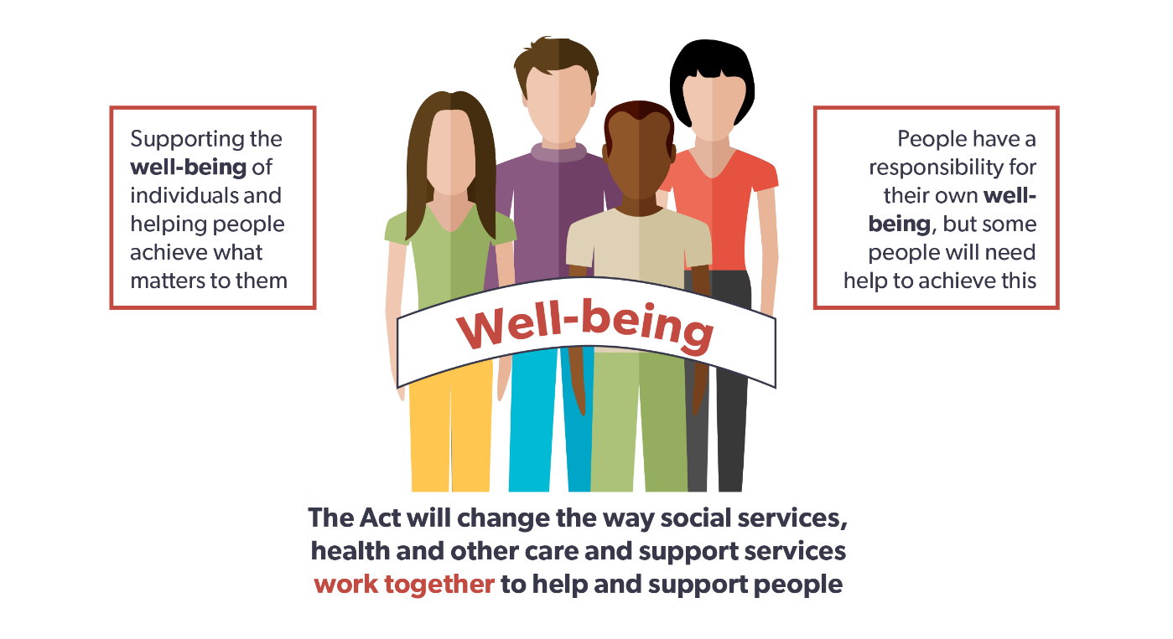
At the heart of the Act is people’s right to well-being. While people have a responsibility for their own well-being, some will need help to achieve this.
There are many interpretations of well-being. The Oxford English Dictionary defines well-being as “the state of being comfortable, healthy or happy.” It’s important to understand what this means to the people you support.
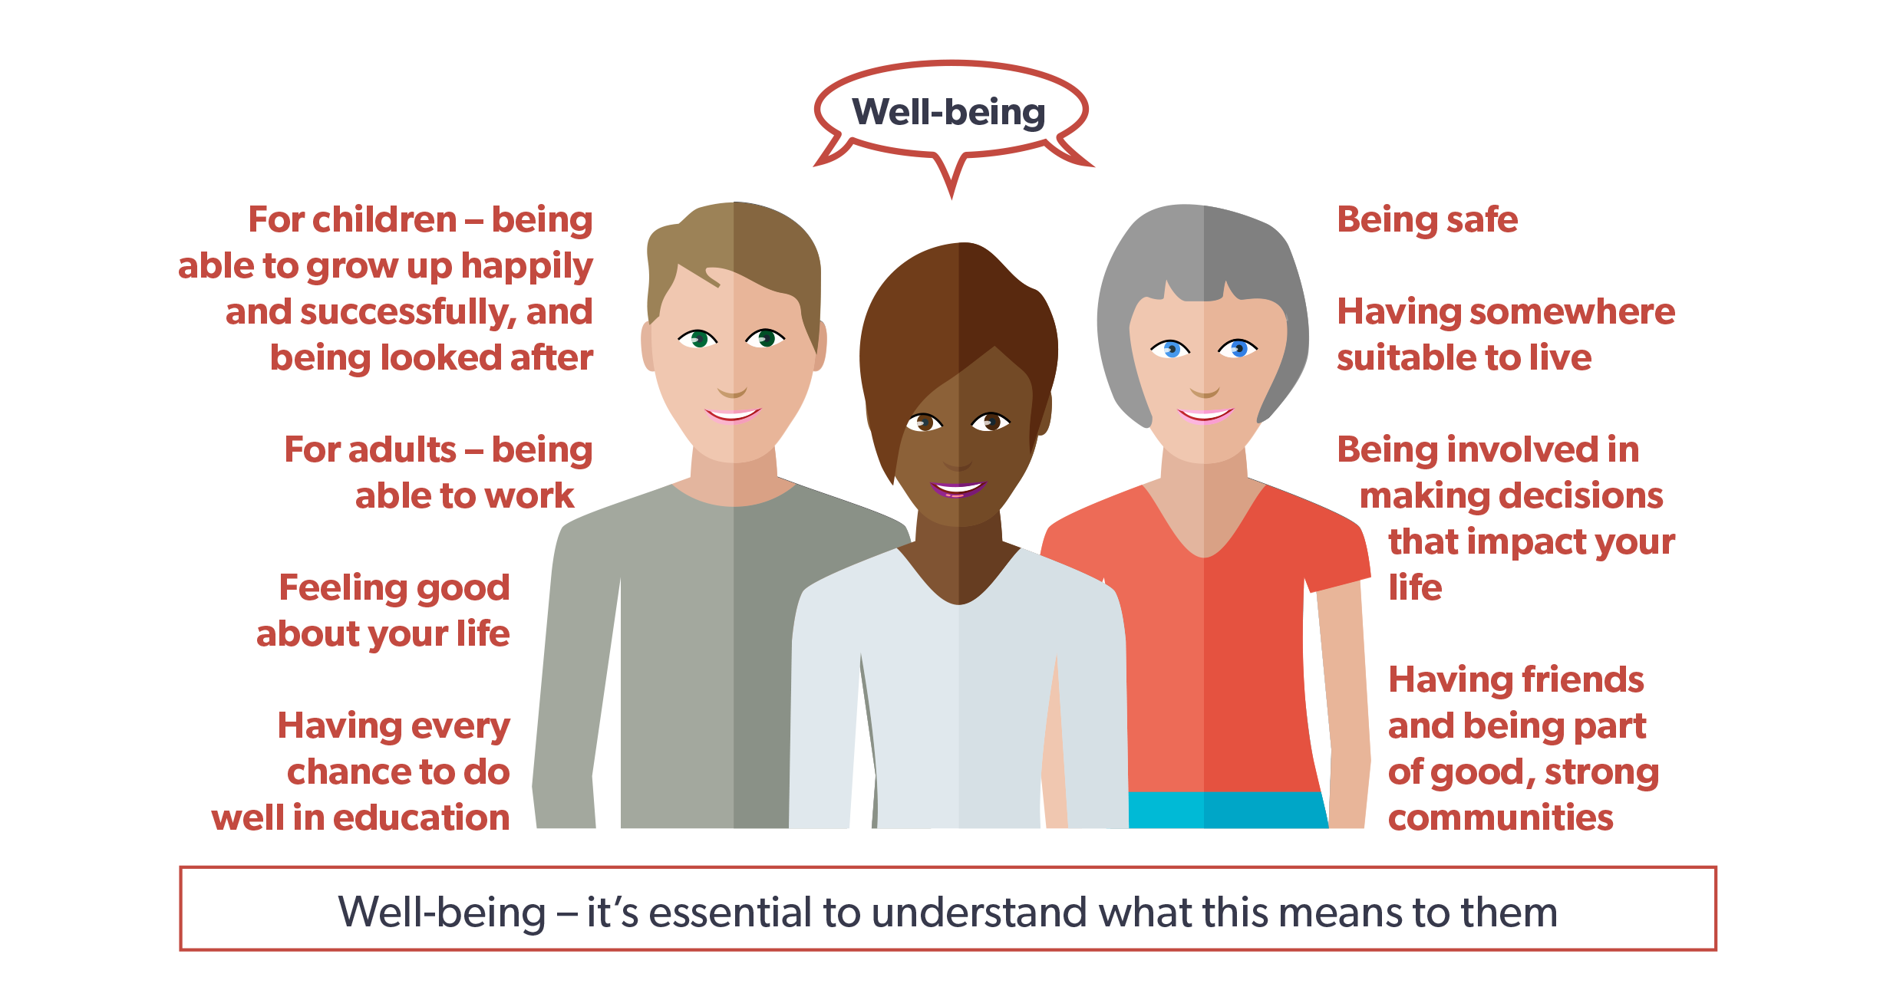
Well-being is about more than just being healthy. It can also include:
• being safe
• having somewhere suitable to live
• being involved in decisions about your life
• having friends
• being part of good, strong communities
• having every chance to do well in education
• feeling good about your life
• for adults – being able to work
• for children – being able to grow up happily and successfully, and being well-looked after.

Learning activity – well-being
A helpful starting point is to think about well-being in your own life and what this means to you. Think about this and write a few sentences about what’s important to you and what helps you achieve a good life.

The arts and well-being
The arts bring colour, comfort, imagination and meaning to life, and can be important for our sense of well-being. They can be especially helpful in health and social care settings.
Engaging with the arts can:
• improve emotional health by helping relaxation and emotional release
• provide an important way of self-expression
• provide enjoyable social contact
• increase self-esteem, confidence, and personal growth
• develop our self-awareness.

Learning activity – the arts and well-being

Read this case study and answer the question.

Case study – Idris
Idris lives in a residential care home in Mountain Ash. He has no family or visitors. Idris is living with dementia and is often depressed and withdrawn. The workers notice him singing along to Calon Lân when a male voice choir is singing in a concert on the television.
The workers download some choir concerts for Idris to listen to in his room on his tablet. He does this most evenings and it lifts his mood. The workers have now arranged for members of a local choir to come and perform a small concert and are planning to set up a home choir for workers and residents to sing together.

Think about how the arts could be used to support their well-being of the individuals you work with and write some notes here:

Principle 4: Co-production
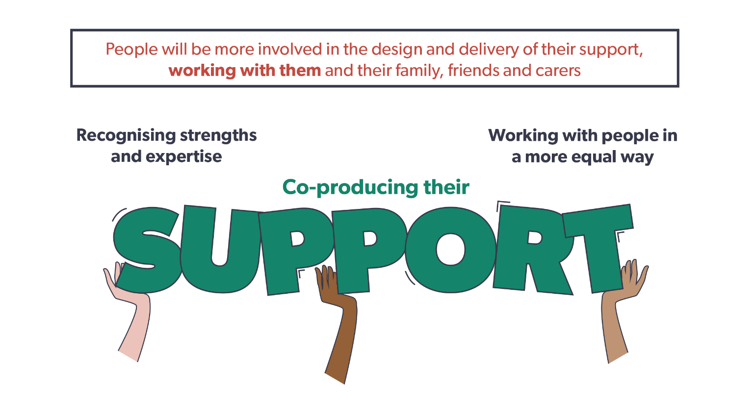

Under the Act, individuals will be more involved in the design and provision of their care and support. It means working with them and their family, friends and carers so their care and support is the best it can be. It recognises people’s strengths and the expertise they can bring, which will make sure our care and support services are designed around what matters most to individuals.

Learning activity – the importance of working with individuals to achieve positive outcomes

Read this case study and answer the questions.

Case study – John
John is 31 years old and lives at home with his parents.
He has a happy family life. He enjoys cooking and helping his mother prepare the evening meal. He also helps his mother with the weekly shopping and likes to choose some of the ingredients for cooking.
John has a learning disability and has support from day services two days a week. His brother lives close by but works away during the week. He usually goes out with him on a Saturday. John is close to all his family.
John’s parents are getting older, and they’re struggling to look after him on their own. John’s dad has had a stroke and his mum is losing her sight. They don’t want to think about the future and what might happen to John when they can no longer support him.
When John’s mum has a fall that results in hospital admission, his dad can’t look after himself and John. John has to move into emergency supported living accommodation.
The move makes John unhappy. It isn’t close to his home, he doesn’t get on with the people he lives with, and he doesn’t do any cooking as the workers prepare all the meals. As a result, John has become withdrawn and has stopped talking to anyone.

Answer these questions:

- What do you think is important to John?

- What do you think is important for John?

- What could change to help John achieve the outcomes that are important to him?

- What may have helped earlier?

- How could you work with John and his family to make sure they’re equal partners and have real voice and control over his care and support?

Principle 5: Multi-agency
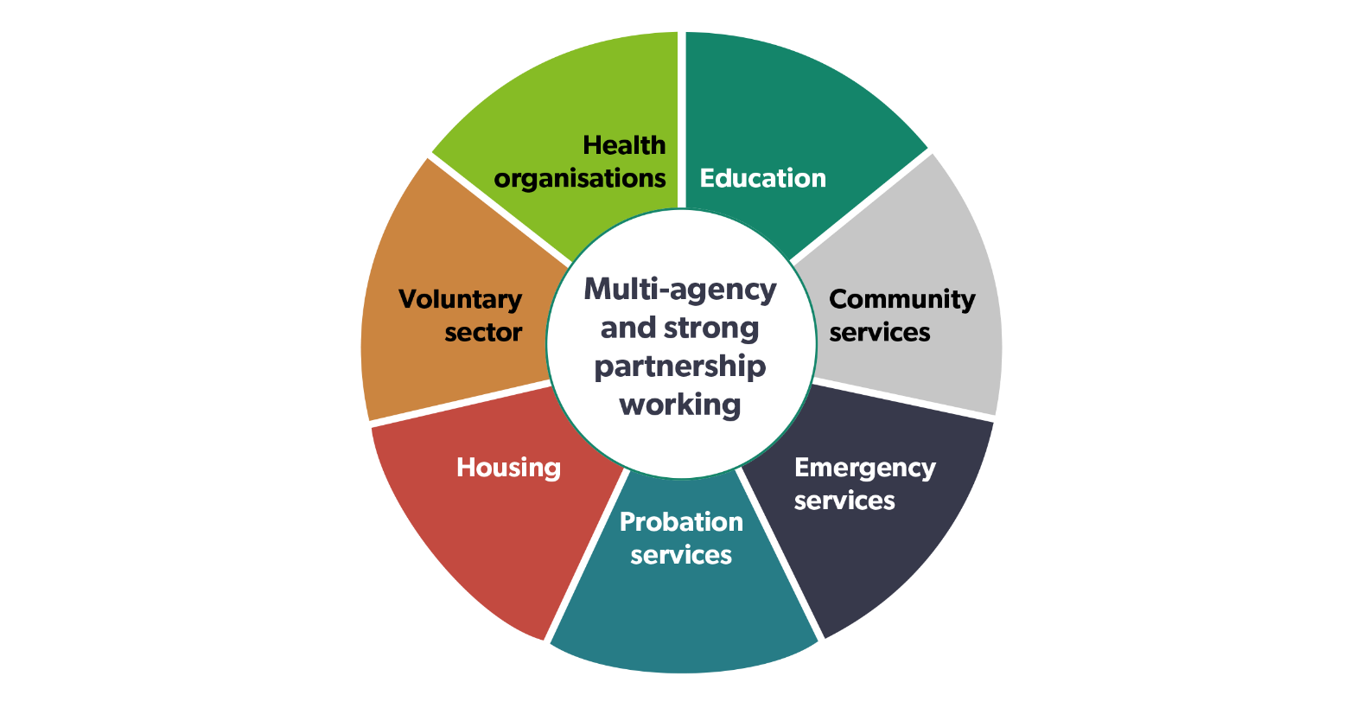

The Act strengthens joint working between local authorities and other partners, such as health, housing and the voluntary sector, to improve people’s well-being and the quality of services. This is sometimes called ‘integration’.

Learning activity – working in partnership

Think about how you work in partnership with other agencies and local communities in your role and answer these questions:
- Who do you work with and what are you aiming to achieve?

- Are there others in your local community you could work with?

- What are the benefits of agencies working together for individuals?

- What difference would this make to the lives of the individuals you support?

Summary

The Social Services and Well-being (Wales) Act 2014 sets out how we should provide care and support. It has five important principles:
• voice and control – putting an individual and their needs at the centre of their care and support, with voice and control over the outcomes that will help them achieve well-being
• prevention and early intervention – being able to access advice and support at an early stage to maintain a good quality of life and reduce or delay the need for longer term care and support
• well-being – supporting individuals to achieve well-being in every part of their lives
• co-production – involving individuals in the design and provision of their support and services and recognising the knowledge and expertise they can bring
• multi-agency – strong partnership working between all agencies and organisations to improve the well-being of individuals in need of care and support, and carers in need of support.

Quiz
Let’s review what we have learnt
Q1. How many sections does the Code of Professional Practice have?
- 5
- 6
- 7

Q2. Name the five principles of the Social Services and Well-being (Wales) Act 2014
a)
b)
c)
d)
e)

Q3. What does ‘voice and control’ mean?
- Workers say what matters for individuals
- Social workers say what matters for individuals
- Individuals say what matters to them
Manager’s comments for section 1.1

Progress log – to be completed by the manager
1.1 How legislation, national policies and codes of conduct and practice underpin health and social care and support for individuals
By completing the workbook activities in this section the worker has shown they know | Sign and date
The principles and values of the Social Services and Well-being (Wales) Act 2014

Why these principles are important for health and social care and support and how they underpin practice

What the Codes of Conduct and Professional Practice are, who these apply to and how they can be used

How the Code of Conduct and the Code of Professional Practice underpin the principles and values of health and social care and support

1.2 How rights-based approaches relate to health and social care
In your role as a health and social care worker, you will be supporting individuals who come from different backgrounds, religions and cultures. This is supported by the principles and values you learnt about in the last section, along with the rights:
- to be treated as an individual
- to be treated equally and not discriminated against
- to be respected
- to have privacy
- to be treated in a dignified way
- to be protected from danger and harm
- to be supported and cared for in a way that meets their needs, takes account of their choices and protects them
- to communicate using their preferred methods of communication and language
- to access information about themselves.
This section will help you learn about how rights-based approaches relate to health and social care.
Legislation/laws and national policies have developed over time to support the rights of all citizens. As well as the Social Services and Well-being (Wales) Act 2014, there are some other key pieces of legislation/laws that support people’s rights such as the:
- Equality Act
- Human Rights Act
- Mental Health Act
- Mental Capacity Act
- Welsh Language Act.
This is a summary of what each of these Acts mean. There are also conventions and national guidance you should be aware of:
Equality Act 2010
The Equality Act 2010 makes it unlawful to discriminate against someone on the grounds of any of these characteristics:
- age
- disability
- gender reassignment
- marriage or civil partnership
- pregnancy and maternity
- race
- religion/belief
- sex (gender)
- sexual orientation.

These are often referred to as protected characteristics. You can find an easy read version of the Equality Act here.
The Equality and Human Rights Commission also provides information about the Equality Act if you would like to find out more.
Human Rights Act 1998
The Human Rights Act 1998 sets out the fundamental rights and freedoms that everyone in the UK is entitled to. The Act incorporates the rights set out in the European Convention on Human Rights (ECHR) into domestic British law. You can find an easy read version of the Human Rights Act here.
The Equality and Human Rights Commission also provides information about the Human Rights Act if you would like to find out more.
UN Convention on the Rights of Persons with Disabilities
The UN Convention on the Rights of Persons with Disabilities is an international legal agreement to protect and promote the human rights of disabled people. You can find an easy read version of the UN Convention on the Rights of Persons with Disabilities here.
The Equality and Human Rights Commission also provides information about the UN Convention on the Rights of Persons with Disabilities if you would like to find out more.
UN Principles for Older Persons 1991
The UN Principles for Older Persons 1991 is made up of 18 principles, which can be grouped under five themes:
- independence
- participation
- care
- self-fulfilment
- dignity.

Governments were encouraged to incorporate them into their national programmes whenever possible. You can find information about the UN Principles for Older Persons here.
Declaration of rights of older people in Wales (2014)
The Declaration of rights of older people in Wales (2014) sets out the rights of older people in Wales. You can find information about the declaration here.

Mental health legislation
The Mental Health Act (1983, amended 2007), Mental Health Act Code of Practice for Wales (2016) and the Mental Health (Wales) Measure (2010) place legal duties on local health boards and local authorities about the assessment and treatment of mental health problems. They make sure people’s rights are upheld when they’re accessing services.
For information about the Mental Health Act, take a look at this information from Mind Cymru.
The Mental Capacity Act 2005 and associated Code of Practice are designed to protect and give back power to vulnerable people who may lack capacity to make certain decisions, because of the way their mental health is. You can find an easy read version of the Mental Capacity Act here.
The Social Care Institute for Excellence also provides information about the Mental Capacity Act if you would like to find out more.
Welsh language legislation
The Welsh Language Act 1993, Welsh Language measure (2011) and Mwy na geiriau / More than just words give the Welsh language official status in Wales. They also introduce standards to explain how organisations are expected to:
- use the Welsh language
- increase the use of the Welsh language
- make it easier for people to use it in their everyday lives.
You can find information about Welsh language legislation here.
The Welsh Government Strategic Framework for the Welsh Language in Health and Social Care (2013) is the Welsh Government’s commitment to strengthen Welsh language services to people accessing health and social care, and their families affected by illness or disability, or the effects of drugs or alcohol.
Rights-based approaches means working in ways that promote and uphold the rights of the individuals you support. All health and social care workers’ practice should promote equality and diversity and challenge discrimination.
Learning activity – legislation and national policy
Look up the easy read versions of one of the pieces of legislation/laws, conventions or national policy and write down the rights it supports and how it does this. Let your manager know if you need help to access these.
Legislation/law, convention or national policy | The rights it promotes | How it promotes these rights

Learning activity – supporting diversity and challenging discrimination
Read this case study and answer the questions.
Case study – Christina
Christina is transgender and has gone through procedures to reflect her gender identity. She has had a number of strokes and a series of falls and can no longer stay living at home.
Christina has moved into a large residential care home which is split into different living areas, each housing 10 to 12 people. She’s upset as the people sharing her accommodation are always making snide comments about her appearance and don’t include her in their conversations. One person often mutters “freak” when there aren’t any workers around. She also feels vulnerable about having her personal care needs met as a few times she has noticed two of the workers ‘making eyes’ at each other while they support her with intimate personal care. They also refer to Christina as “he”. Christina is feeling isolated, anxious and depressed.
  - What are the issues that need to be addressed here?

  - What actions could you take?

  - How could these actions impact on Christina’s well-being?

  - Which legislation/laws would support Christina’s rights?

  - How could Christina be supported to make a complaint?

Advocacy
Advocacy underpins all the principles of the Social Services and Well-being (Wales) Act 2014 and is an important tool to support people’s voice and control, and well-being. Advocacy can help people access information about services, be involved in decisions about their lives, explore choices and options, and make their needs, views and wishes known. Advocacy upholds rights and challenges discrimination.
There are lots of different types of advocacy:
- self-advocacy – when individuals represent and speak up for themselves
- informal advocacy – when family, friends or neighbours support someone to have their views wishes and feelings heard
- collective advocacy – involves groups of individuals with common experiences, being empowered to have a voice, influence change and promote social justice
- peer advocacy – one individual acting as an advocate for another who shares a common experience or background
- formal advocacy – may refer to the advocacy role of workers in health, social care and other settings where they are required, as part of their role, to consider the wishes and feelings of the individual and to help make sure they’re addressed properly
- citizen advocacy – involves a one-to-one long-term partnership between a trained or supported volunteer citizen advocate and an individual
- independent volunteer advocacy – involves an independent and unpaid advocate who works on a short term, or issue led basis, with one or more individuals
- independent professional advocacy – involves a professional, trained advocate working in a one-to-one partnership with an individual to make sure their views are accurately communicated, and their rights upheld. This might be for a single issue or multiple issues.
Independent advocates work with individuals who wouldn’t be able to take part in decisions being made about them without this support. They are completely independent of the service and the individual, this means they can truly represent their needs, views and wishes and ‘what matters’ to the individual without any conflict of interest.
Learning activity – advocacy
Write down an example of how you think advocacy may support a individual’s rights. If you can’t think of a real example, use one of the characters in the other learning activities you have completed so far.

Learning activity – rights-based approaches
Talk to your manager or mentor about how you can apply rights-based approaches in your daily work and write down the main points here:

Learning activity – concerns and complaints
Ask your manager for a copy of your workplace policy for concerns and complaints so you know how you can support individuals and their families or carers if they aren’t happy with their service.
Let’s review what we have learnt in this section by answering these questions.
Quiz
  - Name five of the laws or acts that support people’s rights
1.
2.
3.
4.
5.
  - Which of the following statements is correct? Advocacy means:
    - Being individual’s voice and control
    - Supporting individual’s voice and control
    - Allowing individual’s voice and control
Manager’s comments for section 1.2

Progress log – to be completed by the manager
1.2 Rights-based approaches
How rights-based approaches relate to health and social care
By completing the workbook activities in this section the worker has shown they know | Sign and date
The meaning of a rights-based approach

How legislation and national policies underpin a rights-based approach

What this legislation means in practice

What is meant by advocacy and how this can support a rights-based approach

How individuals and their families or carers can be supported to make a complaint or express a concern about their service

1.3 How to use person-centred approaches
Person-centred approaches are at the heart of care and support for individuals. Being person-centred means seeing the person first, supporting them as an individual by knowing what matters to them and how they want to be supported. It’s about making sure the person has as much voice and control over their life and services as possible. This section will build on what you have learnt so far and help you think about how it can be applied in your practice.
Learning activity – person-centred approaches
Describe what you think is meant by the term ‘person-centred approaches’ and why these are important.

Dignity and respect
The principle of dignity is at the centre of supporting and working with any individuals. It’s important that health and social care workers understand what dignity means and how this can be built into practice.
Learning activity – dignity and respect
Write down:
- What you think is meant by the term ‘treating people with dignity and respect’?

- Why is this central to the role of the health and social care sector?

- Three examples of how you can treat people with dignity and respect in your day-to-day work.

Learning activity – the importance of knowing an individual’s preferences and background and ‘what matters’ to them

Read this case study and answer the questions

Case study – Mrs Desai
Towards the end of her life my mum was more or less bed-bound and unable to walk. She had carers who came three times a day (morning, lunchtime and evening). The biggest problem was language, as none of her carers spoke Gujarati, which is the only language my mum spoke. So there was total lack of communication and she felt completely isolated and started feeling more and more depressed. Luckily, they sent female carers so at least she was spared the humiliation of being tended to by a man. Hindu women (particularly the elderly) are very shy – I had never seen my mum's legs as she always wore a sari and no part of her was ever exposed, even to us as children.
One day I visited her in hospital and the nurse (female) was giving her a bed bath, so I waited outside her room. Then for some reason the nurse was called away and she left the room, leaving the door open and my mum half-dressed and exposed to anyone walking into ward to see. I quickly went in and closed the door. Mum was very, very upset, she was crying and kept saying to me “please take me home”. She found the whole hospital experience very disturbing. She was – the only word I have is traumatised – not only because of the bathing incident but not being able to understand a word the nurses and doctors said to her. She couldn't understand what they were saying and was unable to ask for help or request a bed pan or anything.
Modesty is such a big part of Hindu culture. The home care workers had no idea about dignity and modesty. When I visited mum at home, I often found them giving mum a bed bath and leaving her exposed and talking to someone on their mobile phones. They had no idea how to put a sari on mum – in the end we had to buy kaftans as mum would not wear short nighties. Also, since my father died mum always wore sacred tulsi beads around her neck. The workers didn’t understand the significance of this and removed it without her permission.
Mum had a small shrine in her bedroom where for years she lit a candle and incense each day and prayed. None of us ever wore our shoes in mum's bedroom because although it was her bedroom, it was also her prayer room. The workers had no understanding of this and because they changed so often you would inform one of them and the following week there would a different worker.
Mum was a pure vegetarian so she wouldn’t even eat eggs. Some workers/nurses had very poor knowledge of what Hindu vegetarians can or can’t eat. Mum wouldn’t even eat something which was cooked with utensils used to cook meat, so she never ate hospital food and the family would take her food from home.
So, the key thing is high quality cultural awareness training is most essential for anyone who works with older Hindu people. I felt really sorry for my mum because this dignified, proud lady who bore eight children and worked really hard to help my dad in his business and made many sacrifices to educate her children really well and had led an exemplary life, found her end of life so hard and undignified.

Answer these questions:
  - What would have helped in this situation?

  - How could the health and social care workers have acted differently?

  - How could Mrs Desai be treated with dignity and respect?

  - How could Mrs Desai’s cultural, religious and linguistic background have been valued?

  - What is meant by establishing consent with individuals when providing care and support, and why is this important?

  - How could Mrs Desai have been helped to give her consent for the way her care and support was being provided?

  - How could a personal plan for Mrs Desai help?

Establishing consent
Getting the individuals you’re supporting’s consent for any tasks or activities you’re helping them with is important. This helps to make sure they have voice and control over what’s happening, and you’re taking account of what matters to them. This could be anything from supporting the use of medication or personal care to knocking a door and asking if you can enter a room.
Active participation
Active participation is defined as “a way of working that regards individuals as active partners in their own care rather than passive recipients”. Active participation recognises everyone’s right to take part in everyday activities and relationships as independently as possible.
Learning activity – active participation
Write down why you think ‘active participation’ is important:

Learning activity – person-centred approaches
You have learnt about the importance of using person-centred approaches. Ask an individual you’re working with, another worker or your manager to give you feedback about how your approaches are helping to meet wishes, needs and preferences. Write down the main points here:

Learning activity – Code of Professional Practice
Pick one of the standards from section 1 of the Code and write down how you apply this in your day-to-day work. If you don’t have a copy, you can access the Code here https://socialcare.wales/cms_assets/file-uploads/Code-of-Professional-Practice-for-Social-Care-web-version.pdf. Let your manager know if you need help to access the Code.

Quiz
Let’s review what we have learnt.
    - Which of the following statements describes treating someone with dignity and respect?
      - Treating someone as you would want to be treated yourself
      - Knowing what matters to someone, respecting their views and not making assumptions about how they want to be treated

    - Which of the following statements describes co-production?
      - Getting feedback from individuals about their service
      - Working with individuals to design and provide their service around what matters to them
      - Listening to individual’s views about the service

    - True or false? Active participation is:
Workers taking part in everyday activities with individuals
Manager’s comments for section 1.3

Progress log – to be completed by the manager
1.3 Person centred approaches
How to use person centred approaches
By completing the workbook activities in this section the worker has shown they know | Sign and date
What is meant by the term ‘person centred approaches’ and why these are important

What is meant by the terms ‘co-production’ and ‘voice, choice and control’

The importance of knowing an individual’s preferences and background (the unique mix of a person’s experience, history, culture, beliefs, preferences, family relationships, informal networks and community)

Ways of working to establish the preferences and backgrounds of individuals, what matters to them and the outcomes that they want

What is meant by the term ‘behaving towards people with dignity and respect’ and why this is central to the role of the health and social care worker

What is meant by establishing consent with an individual when providing care or support and why this is important

Ways of working that support person centred approaches

What is meant by the term ‘active participation’

Why it’s important to support individuals to engage in activities and experiences that are meaningful and enjoyable

How person centred approaches are used to support active participation and inclusion

The purpose of personal plans

1.4 Equality, diversity, inclusion and discrimination
‘Equality’ means everybody has the same opportunities and is treated with the same respect. Equality challenges discrimination.
‘Diversity’ relates to a mix of different kinds of people. For example, men and women, young and old people, people of different races, disabled and non-disabled people. Diversity celebrates differences and recognises and values the uniqueness of people.
‘Inclusion’ means everybody has the opportunity to participate and is not excluded because of their differences.
‘Discrimination’ is when people are treated unfairly because of their differences.
The Equality Act 2010
The Equality Act 2010 (‘the Act’) is legislation/law that applies in England, Wales and Scotland. It protects people from discrimination, harassment or victimisation. It does this by setting out a number of ‘protected characteristics’. It’s against the law to discriminate against anyone because of:
- age
- disability
- gender reassignment
- marriage and civil partnership
- pregnancy and maternity
- race
- religion or belief
- sex
- sexual orientation.

Direct discrimination
This is when you’re treated worse than another person or other people because:
- you have a protected characteristic
- someone thinks you have that protected characteristic (known as discrimination by perception)
- you’re connected to someone with that protected characteristic (known as discrimination by association).

Indirect discrimination
Indirect discrimination happens when there’s a policy that applies in the same way for everybody but it disadvantages a group of people who share a protected characteristic, and you’re disadvantaged as part of this group. If this happens, the person or organisation applying the policy must show there’s a good reason for it.
- a ‘policy’ can include a practice, a rule or an arrangement
- it makes no difference whether anyone intended the policy to disadvantage you or not.

Learning activity – promoting equality, diversity and inclusion and challenging discrimination
Read this case study and answer the questions.
Case study – George
George is a 73-year-old gay man. He recently moved into a care home. George didn’t ‘come out’ until he was 40 years old. He was scared of anybody knowing he was gay, especially his mother, for fear of upsetting her and being rejected. He eventually found the courage to tell his family and friends that he was gay and that he had a long-term partner called Jonathon.
George has had a series of strokes and needs support with eating and his personal care. He doesn’t want to be a burden on Jonathon and has decided to pay to live in a residential care home.
Jonathon is worried about how George will be treated in the care home by the workers and other people living there but agrees they can’t manage with George living at home any longer. They are both worried about the views of the care home’s workers and residents when Jonathon visits and how they will be treated.
After living in the care home for a few weeks, George confides in one of the care workers, Sharon. He tells Sharon he’s gay and Jonathon is his long-term partner, but they hadn’t told anybody in the care home as they were afraid of how people would react.
Recently, Sharon has noticed some of the other people living in the care home commenting about Jonathon’s visits, saying they are more than just friends. Some residents have become less friendly towards George, leaving him out of conversations and activities. Sharon has noticed George seems to be becoming withdrawn and isolated and asks him what he would like them to do. George doesn’t want anything to be said as he feels it would make the situation worse.
Answer these questions:
      - What is happening here in relation to:

- equality

- diversity

- inclusion

- discrimination.

      - What should Sharon do?

      - Which section of the Code would help Sharon know what her responsibilities are here?

Learning activity – challenging discrimination
When you work in health and social care, there may be times when discrimination happens, and you have to challenge it. Give an example of how someone you work with may be discriminated against and how you could challenge this.

Learning activity – equality and diversity
Talk to your manager about what equality and diversity means to you and ways that your practice respects and promotes this. Write down the main points here:

Quiz
Let’s review what we have learnt in this section by answering these questions
  - Which of the following are the nine protected characteristics under the Equality Act 2010?
    - Race
    - Religion/belief
    - Sex (gender)
    - Sexual orientation
    - Age
    - Disability
    - Health
    - Pregnancy and maternity
    - Gender reassignment
    - Marriage or civil partnership

  - True or false?
Equality means treating everybody the same
  - True or false?
‘Discrimination’ is when people are treated unfairly because of their differences.

Manager’s comments for section 1.4

Progress log – to be completed by the manager
1.4 Equality, diversity and inclusion
How to promote equality and diversity and inclusion
By completing the workbook activities in this section the worker has shown they know | Sign and date
What is meant by the terms ‘equality, diversity, inclusion and discrimination’

What is meant by the term ‘protected characteristics’

How person centred approaches promote equality, diversity and inclusion

How cultural, religious and linguistic backgrounds of individuals and carers can be valued

Ways in which discrimination or practice that doesn’t support equality, diversity and inclusion can be challenged

1.5 Positive risk taking
Positive risk taking can support well-being, voice, choice and control. However, while it’s important to support people to make their own choices, there are times when this may place them at risk. So, it’s important you know how to work with people to balance their rights, risks and responsibilities.
Positive risk taking is about supporting individuals to take risks that support them to achieve ‘what matters’ and to grow and develop into independent young adults.
For a positive risk-taking approach, decision-making should be:
- balanced, recognising the potential for benefit as well as the risk of harm, and considering the possible emotional, psychological and social impact of each option, as well as the physical
- defensible, that is well-founded, justifiable and recorded proportionately. Not defensive, that is, driven by the need to protect ourselves and our agencies
- collaborative with individuals who use services, their families and other professionals, using all available resources to achieve the outcomes that matter most.
Learning activity – managing risks to support positive outcomes
Read this case study and answer the questions.
Case study – Megan
Megan’s story shows how people are sometimes prevented from doing or having things that they would like – sometimes for good reason. As you read through Megan’s situation: ask yourself how you could justify limiting Megan’s choice to drink coffee and tea when she wanted.
Megan has an acquired brain injury, and a long-term history of making herself physically unwell with caffeine overdoses, resulting in numerous admissions into hospital. She would drink coffee from straight from the jar and hide tea bags to eat when she wasn’t supervised.
Megan moved into a supported living home a month ago. In her previous home she wasn’t allowed in the kitchen and could only drink caffeine free drinks. To begin with, in her new home, it wasn’t safe for her to go into the kitchen to make drinks as she became very stressed and aggressive when she couldn’t have the jars of coffee and teabags that were on the counter for everyone living in the home to use. She also became stressed and aggressive if she couldn’t make herself a drink.
Her social care workers have now made steady progress with her. She goes into the kitchen with support and is able to make her own drinks using sachets of coffee rather than coffee from a jar. She can make herself drinks, which is important to her, and to keep physically well, which is important for her.
Answer these questions:
- What were the risks that workers were trying to manage in stopping Megan going into the kitchen?

- What was the impact on Megan of stopping her making herself drinks?

- Who might have been involved in making the decision to support Megan to make herself drinks in a way that minimised the risks?

- Why is being able to take risks important for people’s well-being?

- The Convention on the Rights of Persons with Disabilities is an international human rights treaty of the United Nations intended to protect the rights and dignity of persons with disabilities. Look at the easy read version write down how you think Megan’s rights were not being upheld when she was not allowed to make herself drinks. Let your manager know if you need help to access this.

- Which section of the Code would be most relevant to this scenario?

Sometimes, a ‘best interest decision’ will be made if someone doesn’t have the mental capacity to make legal, healthcare, welfare or financial decisions for themselves. This is one of the principles of the Mental Capacity Act. The decision can only be made after an assessment is carried out. There are strict principles and codes of practice which must be followed to carry out the assessment.
Learning activity – positive risk taking
Talk to your manager or mentor about positive risk taking and how you can use risk assessments in your workplace to support positive outcomes. Write down the main points here:

Quiz
Let’s review what we have learnt in this section by answering these questions
    - A ‘best interest decision’ will take place when:
      - an individual has been assessed as not having mental capacity
      - an individual has a learning disability
      - an individual has dementia

    - Complete the missing word from the following sentence:

Rights, risks and ………………….
Manager’s comments for section 1.5

Progress log – to be completed by the manager
1.5 Positive risk taking
How positive risk taking supports well-being, voice, choice and control
By completing the workbook activities in this section the worker has shown they know | Sign and date
What is meant by the term ‘positive risk taking’ and the importance of being able to take positive risks on the well-being of individuals

The rights of individuals to make choices and take risks

How balancing rights, risks and responsibilities contributes to person centred approaches

What to consider when supporting individuals to take positive risks

What is meant by best interest decisions

1.6 Positive relationships and professional boundaries
In your role, you will need to work in partnership with the individuals you support and their families and carers. Part of a successful working partnership is maintaining professional boundaries as you develop a caring relationship.
The Senses Framework is a framework for improving individual’s care through promoting positive relationships. It highlights the importance of not only meeting the needs of individuals who use services, but also addressing the needs of families and friends who visit as well as workers who work in care settings.
To achieve good relationships and quality of life for all involved, it suggests we need to consider what gives each person a sense of:
- security (feel safe)
- belonging (feel part of things)
- continuity (make connections between past, present and future)
- purpose (have goals)
- achievement (moving towards their goals)
- significance (matter as a person).
Paying attention to these senses can help us identify the needs and personal outcomes for individuals who use services, as well as families and workers, and create a caring environment that involves everyone.
Learning activity – positive relationships and professional boundaries
How can you develop relationships that help people feel a sense of:

- Security

- Belonging

- Continuity

- Purpose

- Achievement

- Significance

We have practice guidance for workers, which sets out important information about professional boundaries:
“The quality of your relationship with the individual is very important. It’s essential to create a warm, kind and friendly environment. Sometimes, however, this ‘closeness’ can blur professional boundaries and create difficulties. Examples include things like sharing too much personal information or taking on tasks outside your role. You should work with your manager to:
a. make sure you understand your professional role and your limits
b. understand and keep to your organisation’s policy on professional boundaries
c. address any potential crossing of professional boundaries.
“You must make sure all your actions with individuals and families are out in the open for discussion with your manager. Some things clearly breach acceptable boundaries. While this isn’t a complete list, unacceptable things include:
a. having a sexual or other improper relationship with an individual
b. using your personal beliefs, for example, political, religious or moral, in a way which exploits or causes distress
c. borrowing from or lending money to an individual
d. acting in any way which harms an individual.
“The consent of the individual is never a defence for these things.”

Learning activity – positive relationships and professional boundaries
Read this list and tick which would be unacceptable practices.

- Watching an individual undress before bathing even though they don’t need any help with this. They only need help with getting in and out of the bath
- Asking a young adult if they would like a hug because they’re very upset and crying following the death of a friend
- Accepting a birthday card with £20 in it from someone you support
- Staying in the room while an individual is undressing as they need help with some of this before bathing
- Lying on the sofa to have a cwtch with a young adult while watching TV
- Refusing to take an individual to church on Sunday because you don’t believe in God
- Accepting a Christmas card from a family member that thanks you for your care for their mother
- Persuading an individual to go to the Salvation Army church because this is the one that you go to, even though they would normally go to chapel

Professional boundaries are not always clear and very often workers may cross these even though they may have the best interests of the person at heart.
Learning activity– positive relationships and professional boundaries
Read this case study and answer the questions
Case study – Jenny
Jenny lived in a residential healthcare setting for 45 years. She has learning disabilities and mental health issues. She moved into her own home four years ago. She shares her home with Francis, and they receive 24-hour support. Jenny gets upset and angry when workers move on. Only a few have stayed in contact with her as she can be very demanding and is verbally abusive if she’s distressed. Jenny takes this as a personal rejection and the team are trying to help her build relationships with her family and friends.
Francis goes home for Christmas every year and Jenny stays at the house. Although Jenny is back in contact with her family, relationships are strained, and she doesn’t see them over the Christmas holidays.
Jenny gets very distressed at this time of year. The deputy manager, Sian, thinks it would be a good idea for Jenny to spend Christmas day with her and her family. Sian would officially be on duty on Christmas day.
Answer these questions.
- How may Sian be crossing professional boundaries here?

- Why may her suggestion to take Jenny home for Christmas be inappropriate?

- What would be a more appropriate course of action?

- Who else may be involved in these discussions?

Learning activity – positive relationships and professional boundaries
Which standard in section five of the Code relates to professional boundaries?

Quiz
Let’s review what we have learnt in this section by answering these questions
- Finish the words. The Senses Framework helps people feel a sense of:
      - Sec…..
      - Con…….
      - Ach……..
      - Bel……
      - Pur….
      - Sig……..

- True or false?
It’s acceptable for a worker to lend an individual money to pay their electric bill.
Manager’s comments for section 1.6

Progress log – to be completed by the manager
1.6 Positive relationships and professional boundaries
How to develop positive relationships with individuals and their families and carers in the context of ‘professional boundaries’
By completing the workbook activities in this section the worker has shown they know | Sign and date
What ‘relationship centred working’ means

The importance of developing a positive relationship with individuals, their families and carers

The meaning of the term ‘professional boundaries’ and how to balance these with relationship centred working

Unacceptable practices in relationships with individuals, their families and carers

1.7 Communication
As a social care worker, you will need good communication skills to develop positive relationships and share information with individuals using services.
Communicating is a two-way process where each person is trying to understand what the other person is saying. We communicate for lots of reasons, for example to:
- express our views or feelings
- share information
- find out things
- learn
- satisfy our needs and wishes
- have meaningful contact with people
- develop and maintain relationships.
Sometimes you may need to adapt your method of communication to meet someone’s needs, for example by changing the environment or using aids if someone has sensory loss.
To help with communication, we should always speak clearly and avoid using jargon or words which may be difficult for the individuals to understand. Communication shouldn’t be rushed, as this may make someone feel they aren’t important, or that there’s little respect for them.
Active listening helps to show that you’re listening and have heard and understood what has been said. This could include using reassuring smiles and eye contact, having open body language and using gestures. Showing interest in what is being said encourages individuals to communicate more and can help you build a positive relationship.
The language we use is very important and we should take care to make sure we think about the impact of our choice of words on how individuals and their families/carers are perceived and treated. As a health and social care worker, you should never use any language that stigmatises or reinforces negative perceptions of individuals, their families or carers, such as “dementia sufferer”, “bed bound”, “retarded”.
Disability Wales has ‘top tips’ for communicating with disabled individuals which you may find helpful:
- use a normal tone of voice, don’t patronise or talk down
- don’t be too precious or too politically correct – being super-sensitive to the right and wrong language and depictions will stop you doing anything
- never attempt to speak or finish a sentence for the person you’re talking to
- address disabled people in the same way as you talk to everyone else
- speak directly to a disabled person, even if they have an interpreter or companion with them.
Learning activity – communication
Read this case study and answer the questions.
Case study – Dafydd
Dafydd has limited verbal communication skills. It’s difficult to understand his speech and he doesn’t have a wide vocabulary. You often take Dafydd to a café for tea and he likes to order and pay for his own meal. This has always worked well as there’s usually the same member of staff in the café who has got to understand Dafydd over time. When you go to the café the usual member of staff isn’t working and there’s a new person serving. Dafydd tries to order his food but they can’t understand him. Dafydd gets frustrated and upset and the café assistant tries to talk to you rather than him.

- What are the barriers to communication here?

- What could you do to help Dafydd and the café assistant to communicate effectively?

- Why is it important to do this?

Learning activity – communication
Answer these questions to show your understanding of the importance of good communication.
- What is meant by the term ‘effective communication’ and what are the key features? For example, listening carefully and not interrupting someone.

- What skills will you need as a health and social care worker to support effective communication? For example, speaking clearly and not too quickly.

- Why is effective communication important for positive relationships with:
          - individuals
          - families and carers

Learning activity – communication
Ask your manager to observe your communication with an individual you’re working with and give you feedback on your practice. Write some brief notes about their feedback here.

How has this observation and feedback helped you to think about your practice? What did you learn about the way you communicate?

What does the Code say about communication?

Quiz
Let’s review what we have learnt in this section by answering these questions
- List three reasons why we communicate:
a)
b)
c)

2. List three barriers to communication:
a)
b)
c)

3. True or false?
Active listening means repeating everything someone says.

Manager’s comments for section 1.7

Progress log – to be completed by the manager
1.7 Communication
The importance of effective communication in health and social care
By completing the workbook activities in this section the worker has shown they know | Sign and date
What is meant by the term ‘effective communication’ and why this is important for the well-being of individuals and positive relationships

Key features of effective communication

The skills that are needed to communicate effectively

How to find out an individual’s communication and language needs, wishes and preferences

Barriers to effective communication and ways to address these

1.8 Welsh language and culture
The individuals you work with will come from many different backgrounds. Recognising and meeting their language needs helps with good quality care and support for positive outcomes.

Welsh language

The Welsh Language Act 1993; Welsh Language Measure (2011) and Mwy na geriau / More than just words:

- give the Welsh language official status in Wales
- introduce standards to explain how organisations are expected to use the Welsh language.

In Wales, the Welsh language should be treated no less favourably than the English language and people in Wales should be able to live their lives through the medium of Welsh if they wish to. The Welsh Government Strategic Framework for the Welsh Language in Health and Social Care (2013) is the Welsh Government’s commitment to strengthen Welsh language services to people accessing health and social care and their families and carers.
Mwy na geiriau / More than just words has principles to make sure individual’s Welsh language needs are met. It puts a duty on care providers to make sure they have workers with the language skills to care for Welsh speakers.
The principle of the ‘Active Offer’ is at the heart of Mwy na geiriau. Under the Active Offer, service providers shouldn’t wait for individuals to ask for Welsh services. Instead, they should actively identify their language needs. The strategy notes that if you’re a Welsh speaker, being able to use your own language must be seen as a core part of your care and not an optional extra.

Learning activity – the importance of language
Read this case study and answer the questions
Case study – Ifan
Ifan is 93 years old and lives on his own in a rural part of Wales. His wife died 10 years ago, and his only son lives in Australia.
Ifan has started to lose his sight and needs help with day-to-day tasks. He also wants company and somebody to talk to.
Ifan has spoken Welsh all his life and doesn’t feel confident speaking English.
Until recently Ifan was independent and an active member of the community. He attended church every week and was in the local choir, but now he can’t drive to the village. His friends from church and the choir visit sometimes, but like Ifan, they are less mobile as they’re growing older.
Ifan has three visits a day from home care workers to help him with his daily tasks. At first, he looked forward to the visits as it meant he’d have somebody to talk to. But the workers don’t have enough time to get to know Ifan well or spend a lot of time talking to him. Only one of the workers speaks Welsh, so Ifan can’t have a good conversation with most of his care workers, as he finds it difficult to express himself in English.

Answer these questions
- What do you think may be important to Ifan?
- What do you think may be important for Ifan?
- Why is receiving care in the Welsh language important for Ifan’s:
  - voice and control
  - well-being
- What else can you think of to help Ifan achieve his well-being needs?
- What actions should you take as a worker, if you’re aware someone prefers to communicate in Welsh?

Quiz
Let’s review what we have learnt in this section by answering these questions
  - True or false?
The Active Offer should only be made if you know for certain that someone speaks Welsh

  - The date of the Welsh Language Act is:
      - 1983
      - 1993
      - 2003

Manager’s comments for section 1.8

Progress log – to be completed by the manager
  - Welsh language and culture
The importance of Welsh language and culture for individuals and carers
By completing the workbook activities in this section the worker has shown they know | Sign and date
The importance of recognising and supporting Welsh language and culture

Legislation and national strategies for Welsh language

The principles of Mwy na geiriau / More than just words

The meaning of the Active Offer

1.9 Positive approaches to reduce restrictive practices in social care
This section will help you develop an awareness of how positive approaches can reduce restrictive practices in health and social care.

Feeling what we say has been heard and understood and being in control of our life has a massive impact on our behaviour. When this is not the case, we’re more likely to feel powerless and distressed and engage in behaviour that challenges others.

This will also be the case with the individuals you offer care and support to. Because of their circumstances, they too, may at times feel powerless to make changes in their lives and will say and do things that challenge others. It’s important to always treat individuals with compassion, dignity and kindness, and to try to understand the cause of any challenging behaviour.

What do we mean by positive and proactive approaches?

Positive and proactive (or preventative) approaches are based on the principles of person-centred care:

- getting to know someone, respecting and valuing their histories and backgrounds, and understanding:
- their likes and dislikes
- their skills and abilities
- their preferred method of communication
- understanding the impact of their environment on them and using this to identify positive and consistent ways to support
- feeding into and following care plans that set out an individual’s needs, their well-being outcomes and how they’ll be supported to achieve them.

Developing good relationships is important, and positive and proactive approaches should always be used. They are essential when someone is:

- stressed
- distressed
- frightened
- anxious or angry
- at risk of behaving in a way that’s challenging to their safety and/or to the safety of others.

Positive approaches involve working with the individuals and key people in their lives to:

- try to understand what someone is feeling and why they are responding in the way they are
- where possible, make changes and intervene at an early stage to try to prevent difficult situations
- understand what needs to be planned and put in place to support the individuals to manage distressed and angry feelings
in a way that reduces the need for challenging behaviour and places restrictions on them.

What do we mean by behaviour that challenges us?

There are several definitions of the term ‘behaviour that challenges us’ or ‘challenging behaviour’. Some focus on the seriousness of the behaviour, the length of time it goes on for, and the risks it presents to the individuals, family and carers, health and social care workers or others.

How we recognise behaviour that challenges can vary depending upon the frequency, severity, intensity and risks of that behaviour. It may also depend on how the behaviour affects us and/or others around us. This may differ, as, for example, one social care worker may not mind if an individual asks them the same question repeatedly, while another worker may find it difficult and stressful, and so may try to avoid spending time with them.

Behaviour that challenges may include behaviour that is:

- aggressive
- anti-social
- disruptive
- isolating, such as withdrawal
- repetitive
- obsessive
- verbally abusive
- putting the physical safety of the individuals or others in serious jeopardy, or is likely to seriously limit the individual’s use of ordinary community facilities.

You will have your own examples but some of these behaviours could be:

- swearing
- threatening
- pushing, grabbing, scratching, biting and pinching
- spitting
- shouting or screaming for long periods of time
- sexually disinhibited behaviour such as exposing genitals, removing clothing and making sexual comments and gestures
- continually moving around
- banging of the head
- asking repetitive questions
- ignoring.

It’s important to try to understand the meaning of this behaviour and what the person is trying to communicate. This may not always be possible straight away as the situation may need urgent action to keep the individuals or others safe.

Underlying causes could be:

- chronic or acute pain
- infection or other physical health issues
- sensory loss
- an acquired brain injury or other neurological condition
- communication difficulties
- environment
- fear and anxiety
- unhappiness
- boredom
- loneliness
- unmet needs
- demands
- change
- transitions
- recent significant events, such as the death of a family member
- past events or experiences
- abuse or trauma
- bullying
- over-controlling care
- being ignored.

However, reflection and discussion with family members, close colleagues and multi-disciplinary team members after the event or incident will help us develop a better understanding.

What do we mean by ‘restrictive practices’?

Restrictive practices are a wide range of activities that stop individuals from doing things that they want to do or encourages them do things that they don’t want to do. They can be very obvious or very subtle. They should be understood as part of a range, from limiting choice, to a reactive response to an incident or an emergency, or if a person is going to seriously harm themselves or others.

To reduce the use of restrictive practices, we need to understand how to use positive and proactive approaches.

Learning activity – using positive and proactive approaches

Read this case study.

Case study – John

John, a young autistic man, asks constantly to call his family and former friends. Some of them don’t want him to call every day. He becomes very distressed when they don’t want to talk to him and is verbally aggressive towards his social care workers.

A plan was agreed with him to make a list of his friends and family who mean a lot to him, and to agree a set time to call them. For example, he will call his mum at 6pm each day and his friend Derek once a week on a Saturday after 7pm.

This has worked for John as he feels more secure having set times and his support workers can help him look at his calendar if he becomes distressed and wants to call at other times.

Although he doesn’t have the free access to use the phone when he wants, his stress levels have reduced, and his family and friends are happy to talk to him at the agreed times. He can now carry on having a good relationship with the people who mean a lot to him. This reflects a positive approach to supporting John.

The restrictive practice in this scenario was limiting the times John could use the phone.

Restrictive practices could also include more obvious actions such as those listed in Welsh Government’s Reducing Restrictive Practices Framework such as:

- physical restraint
- chemical restraint
- environmental restraint
- mechanical restraint
- seclusion or enforced isolation
- long-term segregation
- coercion.

They should only be used as part of an agreed behaviour support plan and should only ever be used as an immediate and planned response to behaviours that challenge, or to take control of a situation where there’s a real possibility of harm if no action is taken.

Any act of restrictive practice has a potential to interfere with an individual’s human rights. So all acts of restrictive practice must be lawful, proportionate and the least restrictive option available.

Restrictive practices must never be used to punish or with the sole intention of inflicting pain, suffering, humiliation or to achieve compliance. It’s never lawful to use restraint to humiliate, degrade or punish people.
Key point

Restrictive practices, other than those used in an emergency, should always be planned in advance and agreed by a multi-disciplinary team and wherever possible, the individual. They should be included in their personal plan, behaviour support or behaviour management plan. They should always be recorded in an individual’s care plan.

Learning activity – positive approaches to reduce restrictive practices in social care

The following scenarios show situations that health and social care workers may find themselves in. The scenarios cover a wide range of restrictive practices.

Some of the scenarios are more obvious than others, but as you go through them remember that in real life, we don’t work alone. Any decision to restrict someone should be based on discussions with others, including the individual, their families and those who know them well.

When reading the scenarios, think about the following questions (you don’t need to record your answers):

- what type of restrictive practice do you think has been used?
- do you think the use of the restrictive practice was intentional or non-intentional?
- do you think this was the least restrictive option?
- was the practice contrary to the rights of the individual?
- was the practice ethically or legally justifiable?
- who should be involved in making the decision about the restrictive practice used?
- what other methods of working could have been used to reduce the need for restrictive practice?
- what steps could be taken to reduce the use of restrictive practice in the future?

Scenario 1: In a residential care home, Tudor’s glasses are moved out of his reach while he’s being supported with his personal care in the morning. He’s without them until lunchtime.

Scenario 2: Zac, a young man with mild/moderate learning disabilities is out on a group trip to Thorpe Park. Zac’s case history indicates infantile and pre-school seizures, although he hasn’t experienced anything recently. The group leader decides Zac is not allowed on any of the rides.

Scenario 3: In a day centre, Lizzie is left for several hours with her wheelchair with the seatbelt on to prevent her continually moving around.

Scenario 4: Agnes who lives in a residential care home is regularly encouraged to return to spend time in her room alone because her singing upsets other residents.

Scenario 5: Kyle, a man in his early 20s with learning disabilities recently lost his mother, who was his sole carer. Now living in supported accommodation, Kyle wants a small tattoo on his arm – “MUM”. A social care worker approaches his line manager who tells him he will be suspended if he helps Kyle do this because of “health and safety”.

Scenario 6: Social care workers in a residential care home switch off the television in the communal lounge at 10.30pm to encourage people living there to go to bed.

Scenario 7: In a residential care home, Albert, an 87-year-old man living with dementia regularly gets up in the night and wanders around disturbing other residents. As he has been trying to climb over the bed rails fitted to his bed to get up, the care home team decide to place his mattress on the floor. He can’t get up from the floor and so has stopped wandering.

Scenario 8: Bedroom doors are routinely locked to stop people going back to bed in the day.

Scenario 9: Megan has dementia and can only speak and understand Welsh. She goes to day centre three days a week. No-one at day centre speaks Welsh so Megan can’t ask for help to use the toilet when she needs it or let people know when she’s thirsty.

Working in health and social care can be very rewarding, but like any job, at times, it can be difficult and demanding. Offering care and support to individuals who may be distressed, frightened, angry, stressed, confused and who may display behaviours that challenge us can leave us feeling powerless, frightened, angry, anxious and out of our depth. At these times it’s important to reflect on what’s happening around you, how you’re feeling and the support you need.

Learning activity – positive approaches to reduce restrictive practices
Which section of the Code relates to behaviour that may cause harm?

Quiz
Let’s review what we have learnt.
- Which of these statements is correct?
      - Positive approaches manage an individual’s behaviour
      - Positive approaches help individuals manage their behaviour

- List five possible underlying causes of behaviour which challenges:
a)
b)
c)
d)
e)
3. True or false?
Restrictive practices must always be agreed and recorded in an individual’s care plan / personal plan / behaviour support plan
Manager’s comments for section 1.9

Progress log – to be completed by the manager
1.9 How positive approaches can be used to reduce restrictive practices in social care
Positive approaches to reduce restrictive practices in health and social care
By completing the workbook activities in this section the worker has shown they know | Sign and date
The meaning of the terms ‘positive approaches’ and ‘restrictive practices’

Underlying causes that may impact upon the behaviour of individuals

How positive approaches can be used to reduce restrictive practices

1.10 Change and transitions in health and social care
A transition is a period of change from one stage of life to another. These changes happen to everyone throughout life. They can happen suddenly or gradually and can last for different amounts of time. A transition can also be moving from one activity to another such as day centre to home. For some individuals, disruptions to their routine can make them feel unsettled and/or cause distress.

We all face significant life events at certain times during our lives, these can include:
- having new siblings
- leaving home
- getting married
- moving house
- starting a new school or job
- having children and grandchildren
- retirement
- ill health
- death of parents or other close family member.

Changes that take place because of significant life events or transitions could be positive, for example improved health and well-being as a result of a retirement, or negative, for example reduced health and well-being as a result of advanced dementia.

Some of these changes or transitions have a positive effect on our lives, while others can have a negative effect. We can experience a whole host of emotions when facing significant changes. These can range from happiness and excitement to worry, fear, anger and depression. The way we respond can be influenced by whether the change is chosen, such as, moving house, or imposed, for example moving into a residential care home. How much control we feel we have is an important factor in how we react. Many of the individuals accessing care and support may feel they have little or no control over what’s happening to them, which can cause distress and anxiety.

Planning and preparing as much as possible for change or transition can help individuals cope better. It’s important that they’re:
- fully involved in all aspects of the planning
- told about what’s happening and why
- supported to express what matters to them and know how they will be helped to achieve this.

Learning activity – change and transitions

Read this case study and answer the questions

Case study – David

David is an only child, he has always lived at home with his parents. He attends day services Monday to Friday but doesn’t go out in the evenings or at the weekend. David’s mother died a year ago and his father is 78 years old and isn’t in good health. He’s struggling to care for David.
A place has become available in a house one mile away where two other men live with 24-hour support. It has been agreed that David could move there.

Write down what you think needs to happen to support David and his father to prepare for and adjust to the change in a positive way.

Manager’s comments for section 1.10

Progress log – to be completed by the manager
1.10 Change and transitions in health and social care
Know how change and transitions impact upon individuals
1.10a Core knowledge learning outcomes for all workers | Sign and date
Types of change that may occur in the course of an individual’s life as a result of significant life events or transitions

Factors that make these changes either positive or negative

1.11 Reflection
This section will help you think about how your own beliefs, values and life experiences can affect your attitude and behaviour towards individuals and carers.

Learning activity

It’s human nature to react to the way that people behave towards us, for example, if someone smiles at us, we usually smile back but if someone is rude to us, we can become cross or angry.

We all have different beliefs, values and life experiences, but when supporting individuals in the social care sector, it’s important that these don’t impact negatively on the way you work.

Learning activity – thinking about how our own beliefs may affect our practice

Read this case study and answer the questions.

Case study – Alun

Alun is a social care worker in a day centre. He has had a very strict upbringing and doesn’t drink alcohol, smoke or swear. He hates hearing bad language, especially if it’s spoken in front of a woman, as he believes this is disrespectful.

Sion has started to attend the day centre where Alun works. Sion uses bad language in almost every sentence. The workers have been challenging Sion about his swearing but recognise that he has only just started attending. They will need to get to know him and he will take some time to settle. They also acknowledge that he lives in a household where this type of language is normal.

Alun comes on duty and immediately gives Sion a warning about his language. Sion takes no notice and continues swearing, going on to call one of the other people in the day centre “a f…… bitch” when she pinches his arm as she walks past him.
Alun tells Sion he will be banned from attending for a week if he uses language like that again. He makes him sit at a table on his own for an hour.

Answer these questions:

- How do you think Alun’s beliefs have affected his practice here?

- Do you think the way Alun has behaved will have a positive or negative effect on Sion?

- What other approaches could Alun have taken?

Learning activity – reflection

What do you think the impact of your own attitude and behaviour might be on individuals? Reflect on this and write down your thoughts here:

Learning activity – Code of Professional Practice

How can the Code be used to help you think about your role and responsibilities, the actions you take and how you should behave?

Manager’s comments for section 1.11

Progress log – to be completed by the manager

1.11 Reflection
How our own beliefs, values and life experiences can affect attitude and behaviour towards individuals and carers
1.11a Core knowledge learning outcomes for all workers | Sign and date
The impact of own attitude and behaviour on individuals and carers

1.12 Workbook reflection

Learning activity

Reflection is an essential part of health and social care practice. In the space below, identify three things that you have learnt from completing this workbook and how you will put this into practice.

a)

b)

c)

Learning activity – reflection on workbook topics

Watch the film ‘Home from home’ through the Dropbox link. After watching the film, think about what you have learnt by completing this workbook and answer these questions. Ask your manager to help if you are having difficulties accessing this.

Workbook topics | Question | Answer
Legislation, national policies and codes of conduct and professional practice | What legislation relates to Betsan having voice and control over her situation?
How rights-based approaches relate to health and social care | How were Betsan’s rights not being met in version one of the film?
How to use person-centred approaches | Give three examples of person-centred approaches from version two of the film
Equality, diversity and inclusion | In version one of the film, what discrimination was Betsan experiencing?
Positive risk taking | How could Betsan be supported to continue engaging in the activities that are important to her, such as baking, while living in the care home? How could risk assessments help with this?
Positive relationships and professional boundaries | In version two of the film, how did the worker develop a positive relationship with Betsan?
Communication | Give three examples of poor communication from version one of the film
Welsh language and culture | In version two of the film, the worker spoke Welsh to Betsan. What else could have helped with Welsh language in the home?
Positive approaches to reduce restrictive practices in health and social care. | What restrictive practices may have been happening in version one of the film?
Change and transitions in health and social care | What would have helped Betsan have a smoother transition into the home?

New worker’s declaration

I confirm that the evidence listed for the workbook is authentic and a true representation of my own work.

Learner’s signature:

Date:

Manager’s declaration

I confirm that the new worker has achieved all the requirements of the workbook with the evidence submitted.

Manager’s signature:

Date:

Practice learning outcomes
These are the practice learning outcomes of the All Wales induction framework (AWIF). It may be helpful to ask your manager to complete these here rather than have a separate document to record evidence of how you apply your knowledge in your day-to-day work.
1.1 How legislation, national policies and codes of conduct and practice underpin health and social care and support for people
1.1b AWIF practice learning outcomes: You are able to work in ways that: | Evidence used | Signatures and date
Relate the principles and values of the Social Services and Well-being (Wales) Act 2014 to your practice

Uphold the codes of conduct and professional practice in your work

1.2 Rights-based approaches
1.2b: AWIF practice learning outcomes: You are able to work in ways that: | Evidence used | Signatures and date
Embed a rights-based approach in your practice

1.3 Person-centred approaches
1.3b AWIF practice learning outcomes: You are able to work in ways that: | Evidence used | Signatures and date
Recognise the importance of knowing an individual’s preferences and background and reflect this in the way that you practice

Embed person-centred approaches in your practice

1.4 Equality, diversity and inclusion
1.4b AWIF practice learning outcomes: You are able to work in ways that: | Evidence used | Signatures and date
Respect and promote equality, diversity and inclusion

1.5 Positive risk taking
1.5b AWIF practice learning outcomes: You are able to work in ways that: | Evidence used | Signatures and date
Follow workplace policies and procedures for the use of risk assessments to support individuals to take positive risks

1.6 Positive relationships and professional boundaries
There are no practice learning outcomes for this section.

1.7 Communication
1.7b AWIF practice learning outcomes: You are able to work in ways that: | Evidence used | Signatures and date
Identify and use a range of communication methods to meet the needs and preferences of the individual/s that you support

  - Welsh language and culture
1.8b AWIF practice learning outcomes: You are able to work in ways that: | Evidence used | Signatures and date
Implement the principles of Mwy na geiriau / More than just words in your work

1.9 How positive approaches can be used to reduce restrictive practices in social care
1.9b AWIF practice learning outcomes: You are able to work in ways that: | Evidence used | Signatures and date
Embed the use of positive approaches in your practice

Follow workplace policies and procedures that are in place for behaviour support

  - Change and transitions in health and social care
There are no practice learning outcomes for this section.
1.11 Reflection
1.11b AWIF practice learning outcomes: You are able to work in ways that: | Evidence used | Signatures and date
Reflect on how your attitude and behaviour impact on the individual/s that you support

Checklist for related workplace policies and procedures

Effective communication

Equality and diversity

Compliments, concerns and complaints

Person-centred/Outcome-focused approaches

Positive risk taking

Professional boundaries

Restrictive practices

Rights-based approaches

Risk taking

Welsh language

Glossary

Active participation is a way of working that looks at individuals or children and young people as active partners in their own care or support, rather than passive recipients. Active participation recognises each individual or young person’s right to take part in the activities and relationships of everyday life, as independently as possible. For children and young people, this will depend on their age and stage of development.

Advocacy – the Social Services and Well-being (Wales) Act 2014 defines advocacy services as:
“services which provide assistance (by way of representation or otherwise) to persons for purposes relating to their care and support”.
Advocacy supports and enables people who have difficulty representing their interests to exercise their rights, express their views, and explore and make informed choices. It could include:
- self-advocacy
- informal advocacy
- collective advocacy
- peer advocacy
- citizen advocacy
- independent volunteer advocacy
- formal advocacy
- independent professional advocacy.
Best interest decision occurs if someone doesn’t have the mental capacity to make legal, healthcare, welfare or financial decisions for themselves. It’s one of the principles of the Mental Capacity Act 2005. The decision can only be made after an assessment has found that the individual doesn’t have capacity. Strict principles and codes of practice should be followed to carry out the assessment as set out in the Mental Capacity Act 2005.
The codes of conduct and professional practice should include:
- the Code of Professional Practice for Social Care
- the NHS Wales Code of Conduct for Healthcare Support Workers in Wales
- the Code of Practice for NHS Wales Employers
- any additional practice guidance issued by NHS Wales or the regulators of health or social care in Wales, such as the Practice guidance for residential child care workers registered with Social Care Wales.
The individual is the person you support or care for in your work. This could be a child or an adult.
Legislation and national policies to include:
- Social Services and Well-being (Wales) Act 2014
- Equality Act 2010
- Human Rights Act 1998, and associated conventions and protocols such as:
  - UN Convention on the Rights of Persons with Disabilities
  - UN Principles for Older Persons (1991)
- Declaration of Rights of Older People in Wales (2014)
- Mental Health Act 1989, Code of Practice for Wales (2008) and the Mental Health (Wales) Measure 2010
- Mental Capacity Act 2005 and associated Code of Practice
- Deprivation of Liberty Safeguards
- Welsh Language Act 1993, Welsh Language (Wales) Measure 2011 and More than just words: Strategic Framework for Welsh Language Services in Health, Social Services and Social Care (Welsh Government, 2012)
Personal plans set out how an individual’s care will be provided. They are based on assessment information, and care and support plans. They will cover the individual’s personal wishes, aspirations and care and support needs.
They provide:
- information for individuals and their representatives about the agreed care and support, and the way in which this will be provide
- a clear and constructive guide for workers about the individual, their care and support needs, and the outcomes they would like to achieve
- a basis for on-going review
- a means for individuals, their representatives and workers to measure progress and whether the individual’s personal outcomes are being met.
Positive approaches are based upon the principles of person-centred care:
- getting to know the individual
- respecting and valuing their histories and backgrounds, and understanding:
  - their likes and dislikes
  - their skills and abilities
  - their skills and abilities, their preferred communication style and support structures.
- understanding the impact of their environment on the individual and using this to identify ways to support people consistently in every aspect of the care they receive
- developing good relationships is fundamental, and positive approaches should always be used. They are essential when someone is stressed, distressed, frightened, anxious or angry and at risk of behaving in such a way that is challenging to their safety and/or the safety of others.
Positive approaches involve working with an individual and their support systems to:
- try to understand what someone is feeling and why they are responding in the way they are
- where possible, make any changes needed, and intervene at an early stage to try to prevent difficult situations
- understand what needs to be planned and put into place to support someone to help them manage distressed and angry feelings in a way that reduces behaviour that challenges restrictions.
Restrictive practices are a range of activities that stop individuals from doing things they want to do or encourages them do things they don’t want to do. They can be obvious or subtle. They should be understood as part of a continuum, from limiting choice to a reaction to an incident or an emergency, or if a person is going to seriously harm themselves or others.
Significant life events would include important changes in an individual or a child or young person’s life, both positive and negative.
For individuals with some conditions, they may be changes and disruption to their routines. For some, they may be the onset of a deteriorating condition such as sensory loss or dementia. For some, they may be a sudden change to their lives such as stroke, accidents, loss and bereavement. For others, it may be a crisis affecting them.
Transitions could include:
- individuals moving into or out of the service provision
- births
- deaths
- marriages
- employment
- redundancy
- retirement
- becoming a carer.
Unacceptable practices would include:
- sexual contact with an individual or child using the service, or a family member
- causing physical harm or injury to individuals
- making aggressive or insulting comments, gestures or suggestions
- seeking information about personal history, where it isn’t necessary nor relevant
- watching an individual or child or young person undress, where it’s unnecessary
- sharing the worker’s own private or intimate information, where it’s unnecessary
- inappropriate touching, hugging or caressing
- concealing information about individuals or children and young people from colleagues. For example, not completing records, colluding with criminal acts
- accepting gifts and hospitality in return for better treatment
- spreading rumours or hearsay about an individual or child and young person, or others close to them
- misusing an individual, child or young person's money or property
- encouraging individuals or children and young people to become dependent or reliant for the worker’s own gain
- giving special privileges to 'favourite individuals or children and young people'. For example, spending excessive time with someone, becoming over involved, or using influence to benefit one individual more than others
- providing forms of care that will not achieve the planned outcome
- providing specialist advice or counselling, where the worker isn’t qualified to do this
- failing to provide agreed care and support for, or rejecting, an individual or child or young person. For example, due to negative feelings about an individual or child or young person
- trying to impose the worker’s own religious, moral or political beliefs on an individual or child or young person
- failing to promote dignity and respect
- any practices specifically prohibited in relevant legislation, statutory regulations, standards and guidance
Professional boundaries: A resource for managers (2016)
Underlying causes could include:
- chronic or acute pain
- infection or other physical health issues
- sensory loss
- an acquired brain injury or other neurological condition
- communication difficulties
- environment
- fear and anxiety
- unhappiness
- boredom
- loneliness
- unmet needs
- demands
- change
- transitions
- recent significant events, such as the death of a family member
- past events or experiences
- abuse or trauma
- bullying
- over-controlling care
- being ignored.

e2871 NLIAH NHS HSW Booklet ENG (wales.nhs.uk)
https://www.gov.uk/government/publications/easy-read-the-equality-act-making-equality-real
https://www.equalityhumanrights.com/en/equality-act/equality-act-2010
https://www.bihr.org.uk/Handlers/Download.ashx?IDMF=4d5e5a20-93c0-44b5-8e22-e903ea41885f
https://www.equalityhumanrights.com/en/human-rights/human-rights-act
https://www.equalityhumanrights.com/sites/default/files/uncrpd_guide_easyread.pdf
https://www.equalityhumanrights.com/en/our-human-rights-work/monitoring-and-promoting-un-treaties/un-convention-rights-persons-disabilities
http://www.olderpeoplewales.com/en/about/UN-principles.aspx
https://www.olderpeoplewales.com/en/ageism/declaration-of-the-rights-of-older-people.aspx
https://www.mind.org.uk/information-support/legal-rights/mental-health-act-1983/about-the-mha-1983/
https://www.local.gov.uk/sites/default/files/documents/easy-read-guide-pdf-16-pa-2cc.pdf
https://www.scie.org.uk/mca/introduction/mental-capacity-act-2005-at-a-glance#:~:text=The%20Mental%20Capacity%20Act%20%28MCA%29%202005%20applies%20to,power%20to%20those%20vulnerable%20people%20who%20lack%20capacity.
https://www.golleyslater.com/understanding-welsh-language-laws/
https://www.golleyslater.com/understanding-welsh-language-laws/
Code of Professional Practice for Social Care (socialcare.wales)
Codes of Practice and guidance | Social Care Wales
https://www.disabilitywales.org/socialmodel/inclusive-language-and-imagery/
Delivering Home First (gov.wales)

