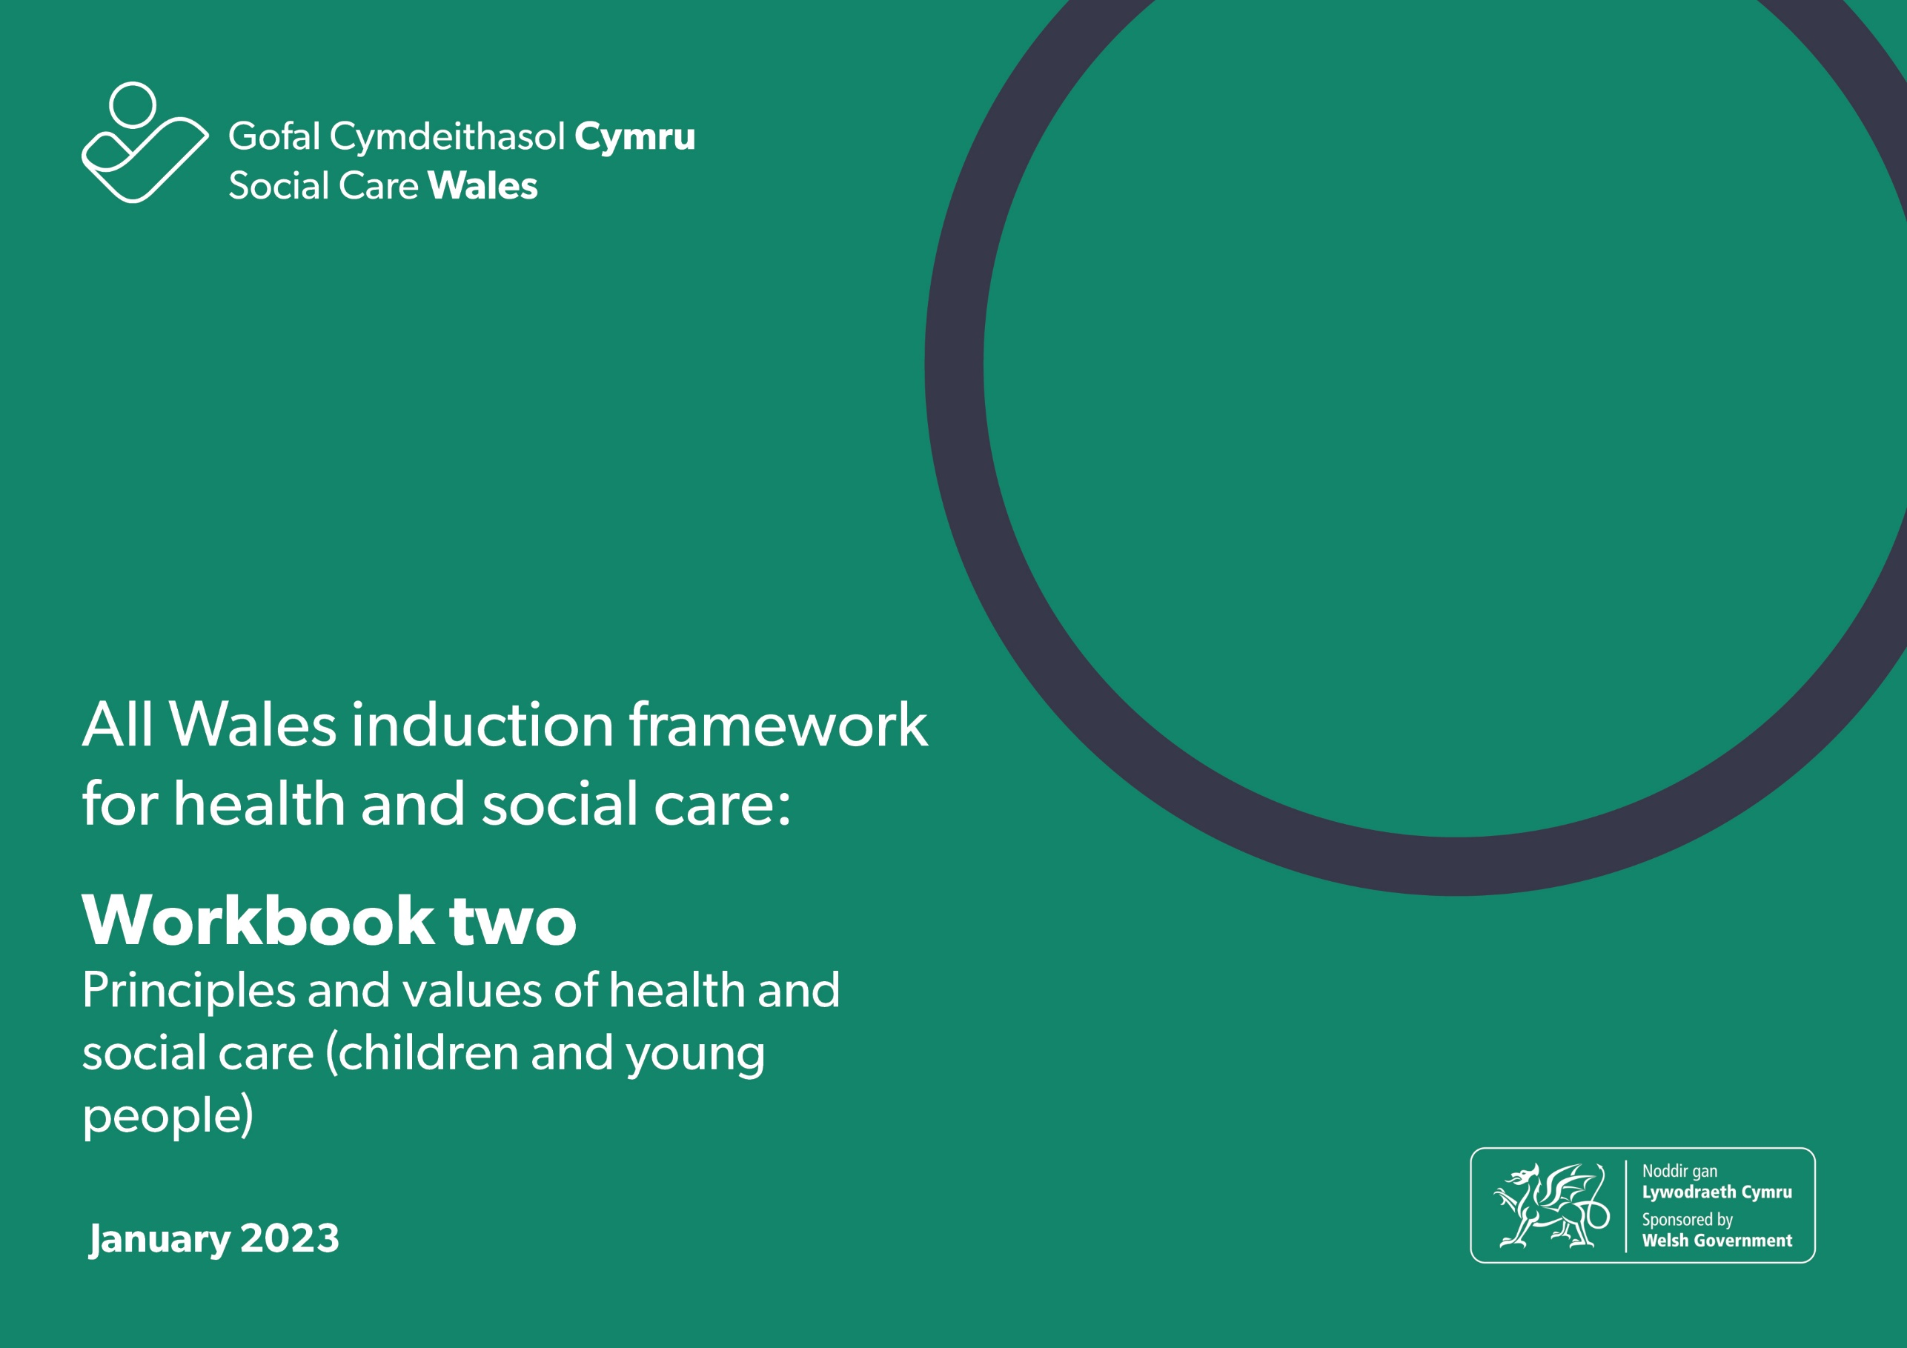
F

All Wales induction framework for health and social care workbook 2: Principles and values of health and social care (children and young people)
This workbook will help you explore the principles and values that underpin the practice of health and social care workers.
The workbook can either be downloaded and completed electronically or printed and completed by hand.
You can also use the completed workbook activities:
- towards achieving the All Wales induction framework for health and social care (Induction framework)
- to help you get ready to complete the Core qualification for health and social care
- as evidence towards your practice qualification.
Some words are highlighted in bold in the progress log. There’s a glossary at the end of this workbook if you want help to know what they mean.
Throughout the workbook, we refer to ‘health and social care workers’. This means the person providing care and support or services to children and young people.

Contents:

2.1 Legislation, national policies and codes of conduct and practice

2.2 How rights-based approaches relate to health and social care

2.3 How to use child-centred approaches

2.4 Equality, diversity and inclusion

2.5 Positive risk taking

2.6 Positive relationships and professional boundaries

2.7 Communication

2.8 Welsh language and culture

2.9 Positive approaches to reduce restrictive practices in social care

2.10 Change and transitions in health and social care

2.11 Reflection

2.12 Workbook reflection

2.1 Legislation, national policies and codes of conduct and practice
Code of Professional Practice for Social Care
The Code
Describes the standards of professional conduct and practice required of social care workers.
It helps social care workers know what’s expected of them.
The Code has seven sections.
As a social care worker, you must:
1. Respect the views and wishes, and promote the rights and interests, of individuals and carers.
2. Strive to establish and maintain the trust and confidence of individuals and carers.
3. Promote the well-being, voice and control of individuals and carers while supporting them to stay safe.
4. Respect the rights of individuals while seeking to ensure that their behaviour does not harm themselves or other people.
5. Act with integrity and uphold public trust and confidence in the social care profession.
6. Be accountable for the quality of your work and take responsibility for maintaining and developing knowledge and skills.
7. In addition to sections 1 to 6, if you are responsible for managing or leading staff, you must embed the Code in their work.
If you need to register with Social Care Wales, you must comply with the Code. However, the Code should also be used by other social care workers who don’t have to register with us, as it sets clear standards of the conduct and practice expected of everyone employed in the social care profession in Wales.
This section will help you start to know about the principles and values of health and social care that have been built into legislation, national policies and codes of conduct and professional practice. It will also help you think about what these mean to you in your day-to-day work.
The learning activities in this workbook will help you think about how you apply the standards in the Code in your day-to-day work.
There is also a code of conduct for healthcare workers. The NHS Wales Code of Conduct for Healthcare Support Workers in Wales describes the standards of conduct, behaviour and attitude expected from healthcare support workers when they’re at work. The Code applies to all healthcare support workers employed by NHS Wales in clinical and non-clinical environments.
Legislation and national policies
As you develop as a health and social care worker, you will learn about the laws/legislation and national policies that inform the way you need to work. You won’t need to know about these in detail, but you should understand the key principles and spirit of the law. This section will focus on the principles of the Social Services and Well-being (Wales) Act 2014 and give you an overview of other important legislation/laws that support children and young people’s rights.
The Social Services and Well-being (Wales) Act 2014
The Social Services and Well-being (Wales) Act 2014 is an important piece of legislation/law about how we should be providing care and support to those who need it in Wales.
The Act has:
- regulations, which give more detail about what must be done to put the Act into practice
- codes of practice, which give guidance to help put the Act into practice.
The Act covers:
- adults (people aged 18 or over)
- children (people under the age of 18)
- carers (adults or children who provide or intend to provide care and support).

The Act is built on five important core principles. You don’t need to know details about the Act and the regulations, but you do need to understand the principles as these will guide your work:
- voice and control
- prevention and early intervention
- well-being
- co-production
- multi-agency.
To help you get started, watch this film that introduces the Act and its principles. Let your manager know if you need help to access this.
We’re now going to explore these principles one at a time.

Principle 1: Voice and control

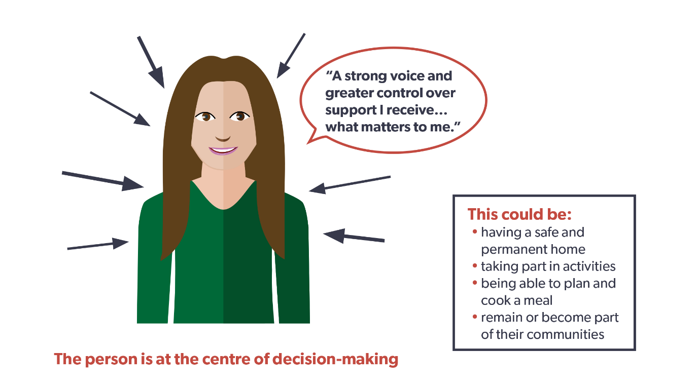
The Act gives people a stronger voice and greater control over the support and services they receive to help them achieve well-being and the things that matter most to them.

Principle 2: Prevention and early intervention

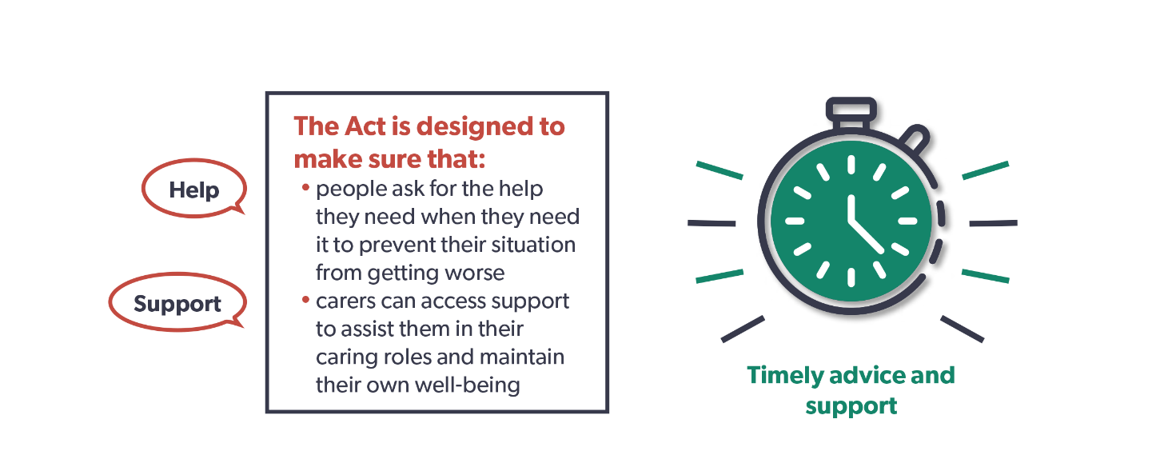

It’s important that timely advice and assistance is given to prevent things reaching a crisis point. Stepping in early to help people can reduce or delay the need for longer term care and support

Learning activity – prevention and early intervention
Read this case study and answer the questions.
Case study – June and Llinos
June is 52 years old and has multiple sclerosis. Llinos, her 15-year-old daughter, is her carer. When June’s symptoms are very bad, Llinos can’t go to school as she must stay home to look after her mother.
After struggling for some months, June and Llinos decide they need help, so they contact their local authority’s information, advice and assistance (IAA) service. The service carries out an early assessment over the phone. This is followed up with visits from an information, advice and assistance worker who completes a full assessment with June and Llinos. The assessment helps June and Llinos talk about their situation, what they want to achieve, and how they may do this. As Llinos is under 18, the assessment must take into account her welfare and development needs.
Both are clear about what would make their lives better. June doesn’t want to rely on Llinos so much. She would also like to be able to get out of the house more and feel she’s doing something worthwhile with her time. Most of all, June is worried about Llinos missing school.
Llinos would like to be able to go to school without having to worry about how her mother is coping and have time to do her homework. She also wants to see more of her friends.

Answer these questions:
- What do you think might be important to June and Llinos?

- What do you think might be important for June and Llinos?

- How could advice and assistance support positive outcomes for June and Llinos?

- What could happen to June and Llinos if they don’t receive any advice or assistance?

Principle 3: Well-being

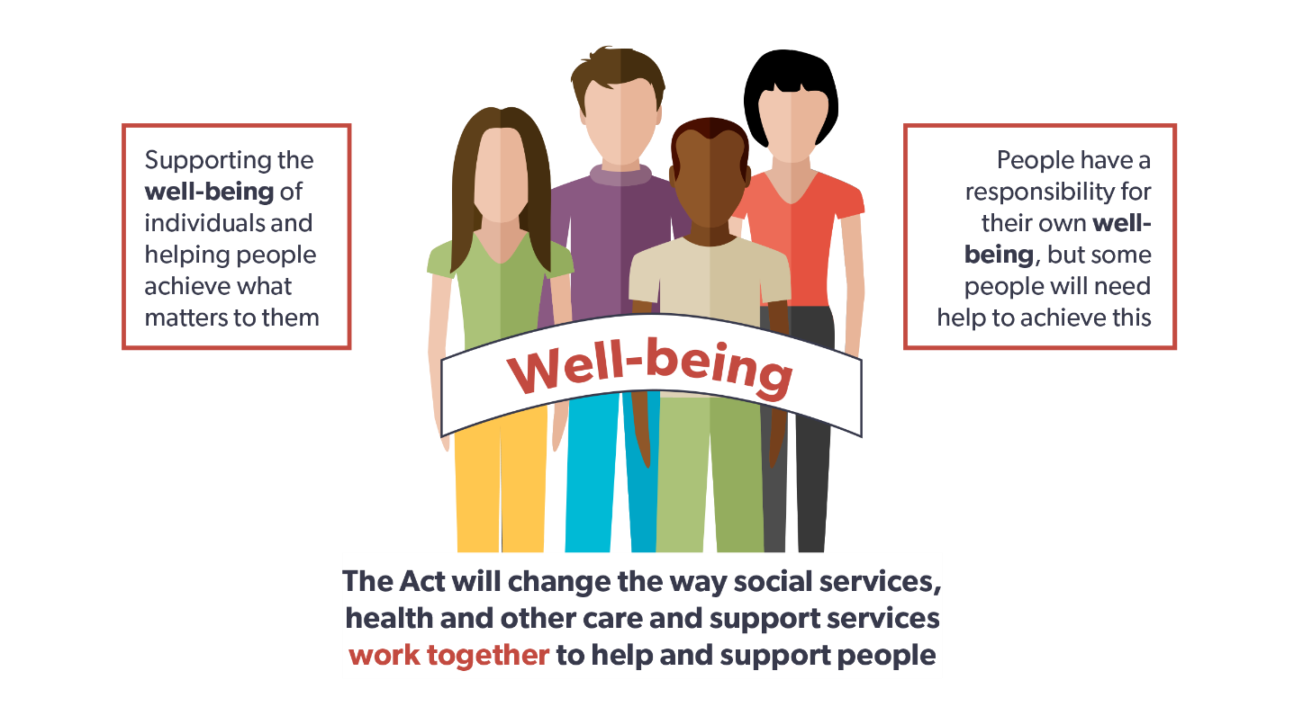
At the heart of the Act is people’s right to well-being. While individuals have a responsibility for their own well-being, some will need help to achieve this.
There are many interpretations of well-being. The Oxford English Dictionary defines well-being as “the state of being comfortable, healthy or happy.” It’s important to understand what this means to the people you support.
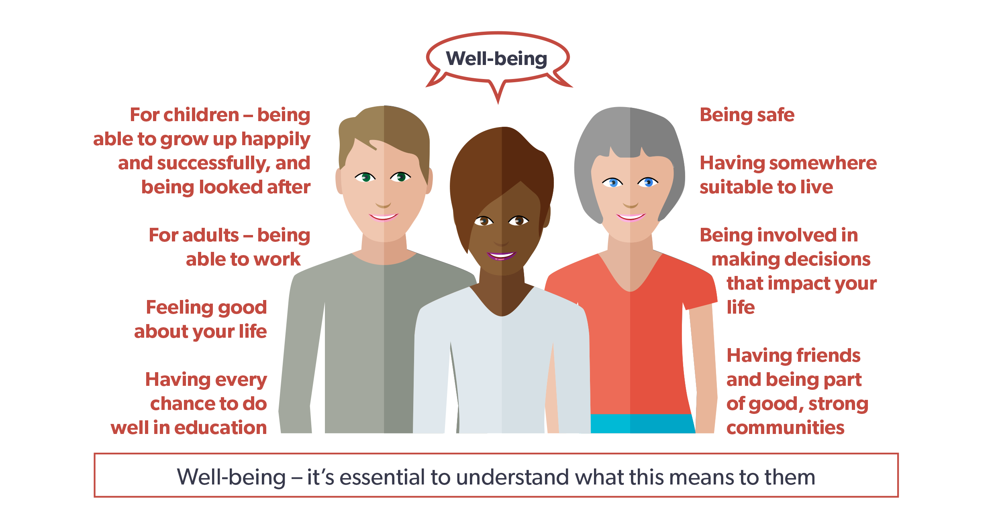
Well-being is about more than just being healthy. It can also include:
- being safe
- having somewhere suitable to live
- being involved in decisions about your life
- having friends
- being part of good, strong communities
- having every chance to do well in education
- feeling good about your life
- for adults – being able to work
- for children – being able to grow up happily and successfully, and being well-looked after.

Also, for children and young people, it’s important for them to be engaged in activities, such as play, as these are important for physical, mental and emotional well-being.

Learning activity – well-being
A helpful starting point is to think about well-being in your own life and what this means to you. Think about this and write a few sentences about what’s important to you and what helps you achieve a good life.

The arts and well-being
The arts bring colour, comfort, imagination and meaning to life, and can be important for our sense of well-being. They can be especially helpful in health and social care settings.
Engaging with the arts can:
- improve emotional health by helping relaxation and emotional release
- provide an important way of self-expression
- provide enjoyable social contact
- increase self-esteem, confidence and personal growth
- develop our self-awareness.

Learning activity – the arts and well-being
The Arts Council of Wales has supported many projects that use the arts to support well-being. This is an example of one of them in a primary school.
The project used outdoor learning and animation to explore the cultures and traditions of the First Nations people of North America. Indoor and outdoor activities included making artefacts, den building, orienteering and producing a documentary film, which included animated sections.
The project developed pupil understanding of well-being issues, for example, how to deal with worries, recognising feelings and having empathy for others and the environment. As well as seeing improvements in pupils’ ability to express themselves, they also developed their digital skills, emotional intelligence and worked more collaboratively.

Think about how the arts could be used with the children and young people you work with to support their well-being and write some notes here:

Principle 4: Co-production
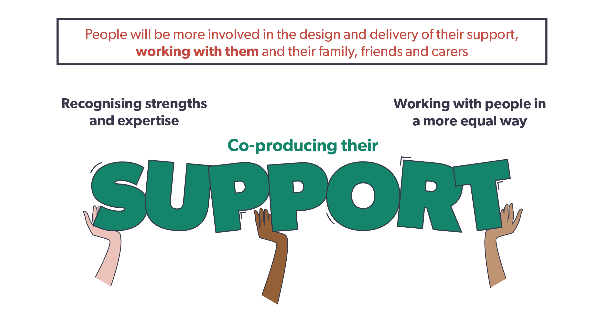
Under the Act, children and young people will be more involved in the design and provision of their care and support. It means working with them and their family, friends and carers so their care and support is the best it can be. It recognises children and young people’s and their families and carers’ strengths and the expertise they can bring, which will make sure our care and support services are designed around what matters most.

Principle 5: Multi-agency
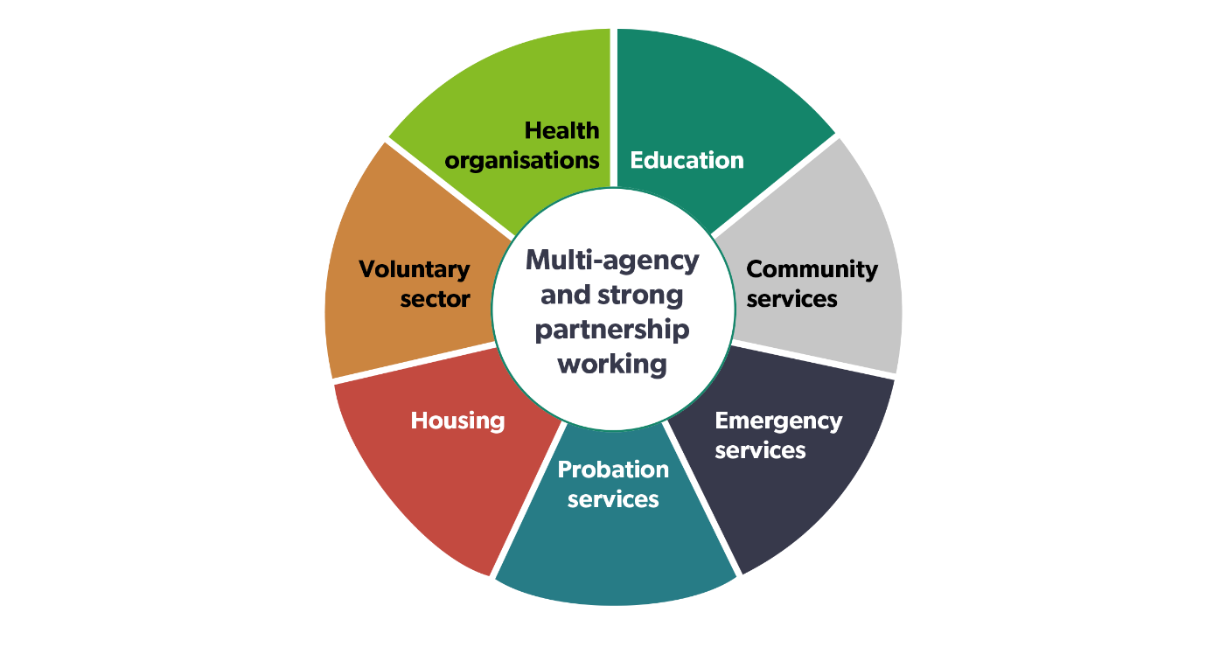

The Act strengthens joint working between local authorities and other partners, such as health, housing and the voluntary sector, to improve children and young people’s well-being and the quality of services. This is sometimes called ‘integration’.

Learning activity – working in partnership
Think about how you work in partnership with other agencies and local communities in your role and answer these questions:
- who do you work with and what are you aiming to achieve?

- are there others in your local community you could work with?

- what are the benefits of agencies working together for children and young people?

- what difference would this make to the lives of the children and young people you support?

Summary

The Social Services and Well-being (Wales) Act 2014 sets out how we should provide care and support. It has five important principles:
• voice and control – putting children and young people and their needs at the centre of their care and support, with voice and control over the outcomes that will help them achieve well-being
• prevention and early intervention – being able to access advice and support at an early stage to maintain a good quality of life and reduce or delay the need for longer term care and support
• well-being – supporting children and young people to achieve well-being in every part of their lives
• co-production – involving children and young people in the design and provision of their support and services, and recognising the knowledge and expertise they can bring
• multi-agency – strong partnership working between all agencies and organisations to improve the well-being of children and young people in need of care and support, and carers in need of support.

The Children Act 1989 (1989 and 2004) provides a framework for the care and protection of children up to their 18th birthday.
It defines parental or carer responsibility and encourages partnership working with parents and carers. It focuses on putting children
and young people at the heart of planning and decision making through co-production and person-centred practice.

The main principles of the Act:

- the welfare of the child is always the main focus
- wherever possible, children should be brought up and cared for within their own families
- parents and carers with children in need should be supported to bring up their children themselves. This support should:
- be provided in partnership
- meet each child's identified needs
- be appropriate to the child's race, culture, religion and language
- be open to effective independent representations and complaints procedures
- use existing partnerships between the local authority and other agencies, including voluntary agencies.
Quiz
Let’s review what we have learnt in this section by answering these questions
Q1. How many sections does the Code of Professional Practice have?
- 5
- 6
- 7

Q2. Name the five principles of the Social Services and Well-being (Wales) Act 2014.
a)
b)
c)
d)
e)

Q3. What does ‘voice and control’ mean?
- Workers say what matters for children and young people
- Social workers say what matters for children and young people
- Children and young people say what matters to them

Manager’s comments for section 2.1

Progress log – to be completed by the manager
2.1 Legislation, national policies and codes of conduct and professional practice
How legislation, national policies and codes of conduct and practice underpin health and social care and support for children and young people
By completing the workbook activities in this section the worker has shown they know | Sign and date
The principles and values of the Social Services and Well-being (Wales) Act 2014 and the Children Act (1989)

Why these principles are important for health and social care and support and how they underpin practice

What the Codes of Conduct and Professional Practice are, who these apply to and how they can be used

How the Code of Conduct and the Code of Professional Practice underpin the principles and values of health and social care and support

2.2 How rights-based approaches relate to health and social care
In your role as a health and social care worker, you will be supporting children and young people who come from different backgrounds, religions and cultures. This work is underpinned by the principles and values you learnt about in the last section along with the rights:
- to be treated as an individual
- to be treated equally and not discriminated against
- to be respected
- to have privacy
- to be treated in a dignified way
- to be protected from danger and harm
- to be supported and cared for in a way that meets their needs, takes account of their choices and protects them
- to communicate using their preferred methods of communication and language
- to access information about themselves.
These rights will be explored throughout this workbook and this section will help you learn about how rights-based approaches relate to health and social care.
Universal children’s rights
All children living in Wales have rights under the United Nations Convention on the Rights of the Child (UNCRC), which sets expectations for governments to meet children’s basic needs, protect them and help them reach their full potential.
In 2011 Wales became the first country in the UK to make the UNCRC part of its domestic law: Rights of Children and Young Persons (Wales) Measure 2011.
When working with children under the Social Services and Well-being (Wales) Act (the Act) you must have “due regard” to the UNCRC. There are four articles in the UNCRC, known as the ‘General Principles’, which help interpret all the other articles and are important in realising all the other rights in the UNCRC:
- non-discrimination (article 2)
- best interest of the child (article 3)
- right to life, survival and development (article 6)
- right to be heard (article 12).
This is a summary of the articles provided by the Children’s Commissioner for Wales:
Article 1: Everyone under 18 has these rights.
Article 2: All children have these rights no matter what.
Article 3: Everyone who works with children should always do what’s best for each child.
Article 4: The government should make sure that all these rights are available to all children.
Article 5: Governments should help parents to help you know about and use children’s rights as you grow up.
Article 6: You have the right to life and to grow up to be healthy.
Article 7: Your right to a name and nationality.
Article 8: The government should respect your right to a name, nationality and family.
Article 9: Your right to be with your parents if this is what’s best for you.
Article 10: Your right to see your family if they live in another country.
Article 11: Your right not to be taken out of the country illegally.
Article 12: Your right to say what you think should happen and be listened to.
Article 13: Your right to have information.
Article 14: Your right to follow your own religion.
Article 15: Your right to meet with friends and join groups and clubs.
Article 16: Your right to have privacy.
Article 17: Your right to honest information from newspapers and television that you can understand.
Article 18: Both parents share responsibility for bringing up their children, and they should always think about what’s best for each child.
Article 19: You shouldn’t be harmed and should be looked after and kept safe.
Article 20: You should be looked after properly if you can’t live with your own family.
Article 21: Your right to live in the best place for you if you can’t live with your parents.
Article 22: Refugee children have the same rights as children born in Wales.
Article 23: Your right to special care and support if you have a disability so that you can lead a full and independent life.
Article 24: Your right to good food and water and to see a doctor if you’re ill.
Article 25: Children who aren’t living with their families should be checked on regularly to make sure they’re okay.
Article 26: The right to extra money if your family hasn’t got enough to live on.
Article 27: Your right to a good standard of living.
Article 28: Your right to learn and go to school.
Article 29: Your right to become the best that you can be.
Article 30: Your right to use your own language.
Article 31: Your right to relax and play.
Article 32: You should be protected from work that’s dangerous.
Article 33: You should be protected from dangerous drugs.
Article 34: The government should protect children from sexual abuse.
Article 35: You have a right not to be sold.
Article 36: You should be protected from doing things that could harm you.
Article 37: Your right to be treated fairly if you break the law.
Article 38: Children should be protected during a war and not allowed to fight in the army if they are under 15.
Article 39: Children should get special help if they have been abused.
Article 40: Your right to legal help if you have been accused of breaking the law.
Article 41: If the laws in your country protect you better than the rights in this list, those laws should stay.
Article 42: The government must let children and families know about children’s rights.
Articles 43-54: These articles discuss how governments, and organisations like ours should work to make sure children are protected in their rights.
It’s important to familiarise yourself with the UNCRC. If you want to find out more about it, look at the information on the Children’s Commissioner’s website.
Learning activity – UNCRC
Choose five of these articles and give examples of how you promote and support them with the children and young people you work with.
a)

b)

c)

d)

e)

A Children’s Rights Approach in Wales
The Right Way:
A Children’s Rights Approach in Wales is a framework for working with children, grounded in the UNCRC, to help public bodies integrate children’s rights into every aspect of decision-making, policy and practice.
Created with expert advice from the Wales Observatory on Human Rights of Children and Young People, it encourages public services across the country to commit to the UNCRC and to improve how they plan and provide their services.
A Children’s Rights Approach means that:
- organisations will prioritise children’s rights in their work with children and families to improve children’s lives
- all children are given the opportunities to make the most of their talents and potential
- all children are given access to information and resources to allow them to take full advantage of their rights
- children are given meaningful opportunities to influence decisions about their lives
- authorities and individuals are accountable to children for decisions, and for outcomes that affect children’s lives.
If you’re interested, you can find out more about the Children’s Rights approach here.
Advocacy
Advocacy underpins all the principles of the Social Services and Well-being (Wales) Act and is an important tool to support children and young people’s voice and control and well-being. Advocacy can help children and young people access information about services, be involved in decisions about their lives, explore choices and options, and make their needs, views and wishes known. Advocacy upholds rights and challenges discrimination.
Advocacy is about:
- speaking up for children and young people
- empowering children and young people to make sure their rights are respected and their views, wishes and feelings are heard at all times
- representing the views, wishes and feelings of children and young people to decision-makers
- helping children and young people navigate the system.
There are lots of different types of advocacy:
- self-advocacy – when children and young people represent and speak up for themselves
- informal advocacy – when family, friends or neighbours support a child or young person to have their views wishes and feelings heard
- collective advocacy – involves groups of children and young people with common experiences, being empowered to have a voice, influence change and promote social justice
- peer advocacy – one child or young person acting as an advocate for another who shares a common experience or background
- formal advocacy – may refer to the advocacy role of workers in health, social care and other settings where they need, as part of their role, to consider the wishes and feelings of the child or young person and to help make sure they’re addressed properly
- citizen advocacy – involves a one-to-one long-term partnership between a trained or supported volunteer citizen advocate and a child or young person
- independent volunteer advocacy – involves an independent and unpaid advocate who works on a short term, or issue-led basis, with one or more children and young people
- independent professional advocacy – involves a professional, trained advocate working in a one-to-one partnership with a child or young person to make sure their views are accurately communicated and their rights upheld. This might be for a single issue or multiple issues.
The law states that children and young people have the right to say what they think should happen when adults are making decisions that affect them.
In practice, this isn’t always as easy as it sounds. Many children and young people need support to speak out or, sometimes, even someone to speak up on their behalf. Some children and young people will turn to their parents, friends or other family members for this support, but for others this isn’t possible and they will need professional support.
An independent professional advocate will support a young person and make sure their voice is heard when decisions affecting them are being made.
The support to the child or young person will include:
- listening to them
- helping them look at their options
- supporting them to make a decision
- making sure they know their rights
- helping them to have their say.
An advocate won’t:
- judge the young person
- tell the young person what to do
- talk to anyone else without their permission.
In what situations can an advocate offer support?
Independent advocates can help young people to get their voice heard:
- in school
- at home
- in care
- in hospital
- in housing
- in court.
Local authorities have a legal obligation under the Social Services and Well-being (Wales) Act 2014 to provide an independent professional ‘voice’ or advocate for every looked after child and young person, care leaver and child in need of care and support, who wants to take part or comment on decisions about their lives. An independent professional advocate should also be provided if a child or young person wants to make a complaint.
The Active Offer of Advocacy is one element of the new statutory advocacy provision, which involves a meeting between a child or young person and an advocate when the child comes into care or when the child or young person is the subject of child protection procedures.
At this meeting, the child or young person is told about their rights under the UNCRC, about different types of advocacy and information about the local Independent Professional Advocacy Service, the Children’s Commissioner, the Meic Helpline (the helpline service for children and young people up to the age of 25 in Wales) and the right to complain.
The Welsh Government has published a National Standards and Outcomes Framework for independent professional advocacy for children and young people in Wales. This identifies the outcomes children and young people can expect in relation to children and young people’s advocacy.
It sets out a framework against which advocacy service providers and those commissioning them can be sure those standards are being achieved, enabling them to evidence they are making a positive difference to children and young people’s lives.
Learning activity
Read this case study from TGP Cymru and answer the questions.
Linda, aged 14, was placed in a secure unit that was more than 200 miles from her home area. She had been there for four weeks and was missing her parents and family. Most of the other residents were male and they teased her about being a girl.
Linda’s parents were unable to visit as they couldn’t afford the travel expenses. The social worker had said the local authority would reimburse any travel costs, but Linda’s parents couldn’t afford the train fare up front. Linda was unable to contact her social worker as they were on sick leave. No one from her placing authority had visited Linda and she didn’t know what was happening, what the plans were and when she would be able to go home. Linda said at this stage she felt very frightened and very sad. She felt no one cared and she had been forgotten.
Linda saw the information about the Residential Visiting Advocate (RVA) and information about her rights on the notice board. The other young people in the unit told Linda that the RVA was nice, independent and easy to talk to. Linda asked the RVA to help her. The RVA spoke to the staff at the unit and asked for the details of Linda’s placing local authority.
The RVA then found out who was the contracted independent advocacy provider for that authority and engaged their help to get travel warrants and expenses so that Linda’s parents and little sister could visit her. The independent professional advocate was also able to make sure that Linda could see her care plan and understand the reasons she was in the unit, and more importantly, how much longer she could expect to be there.
It was agreed that the RVA would help Linda prepare for, and support her during, any planning review meetings while she was at the unit. The local authority advocacy provider and the residential visiting advocacy provider negotiated an arrangement to pay for this service.
The RVA was also able to work with Linda’s key worker at the unit to arrange a restorative meeting with the other young people to talk about the teasing, which was getting Linda down. The other residents said they didn’t realise it upset Linda so much and were very apologetic and said they had meant it in a friendly and inclusive way.
Linda’s parents and sister continued to visit Linda every two weeks. Linda told the RVA that she felt happier and safer in the unit and that being there helped her sort herself out and actually saved her life.

Answer these questions:
- What were Linda’s rights regarding support from an independent advocate?

- How did the residential visiting advocate and the independent advocate help Linda?

- Why do you think the Active Offer of Advocacy may be important for children and young people entering the care system?

There are also other laws or legislation that support the rights of children and young people. These include:
Play sufficiency legislation
The Welsh Government aims to create an environment in Wales where all children and young people have the best opportunities to play and enjoy their recreation time. It believes that high quality play opportunities for all children and young people may help to alleviate the negative effects of poverty on children and young people’s lives and build their resilience.
To help achieve this change, the National Assembly for Wales passed the Children and Families (Wales) Measure 2010, which addresses the commitment to tackle child poverty. Section 11 of the Measure places a duty on local authorities to assess and secure sufficient play opportunities for children in their area.
The Mental Capacity Act
The Mental Capacity Act 2005 and associated Code of Practice are designed to protect and give back power to vulnerable people who may lack capacity to make certain decisions because of their mental health. This includes young people over the age of 16. You can find an easy read version of the Mental Capacity Act here.
The Social Care Institute for Excellence also has information about the Mental Capacity Act if you want to find out more.
Learning activity – concerns and complaints
Ask your manager for a copy of your workplace policy for concerns and complaints so you know how you can support children and young people and their families or carers if they aren’t happy with their service.
Manager’s comments for section 2.2

Progress log – to be completed by the manager
2.2 How rights-based approaches relate to health and social care

How rights-based approaches relate to health and social care
By completing the workbook activities in this section the worker has shown they know | Sign and date
The meaning of a rights-based approach

How legislation and national policies underpin a rights-based approach.

What this legislation means in practice

What is meant by advocacy and how this can support a rights-based approach

How to support children and young people and their families or carers to make a complaint or to express concern about the service that they receive

2.3 How to use child-centred approaches
Child-centred approaches are at the heart of care and support for children and young people. Being child-centred means seeing the child or young person first and supporting them as an individual by knowing what matters to them and how they want to be supported. It’s about making sure the child or young person has as much voice and control over their life and services as possible. This section will build on what you have learnt so far and help you think about how these can be applied in your practice.
Learning activity – child-centred approaches
Describe what you think is meant by the term ‘child-centred approaches’, why these are important and the ways of working that support them.

Co-production, voice, choice and control
Co-production and voice and control are at the heart of the Social Services and Well-being (Wales) Act. Being fully involved in decisions about our lives, having choices about what we do and being able to achieve ‘what matters’ is important to us all whatever our age.
Children and young people who have care and support needs often have many more people involved in their lives than other children. Professionals may include:
- social workers
- independent advocates
- social care workers
- family support workers
- school welfare officers
- child and adolescent mental health teams
- independent advocates
- a range of health professionals.
Parental responsibility
In addition to this, most parents have legal rights and responsibilities, which are known collectively as 'parental responsibility'. Parental responsibility involves providing a home for a child or young person, as well as protecting the child or young person. Parental responsibility also involves legal rights and duties, powers, responsibilities and any authority a parent has for a child or young person and their property.
Parental responsibility is a legal status underpinned by the Children Act 1989. Others, besides parents, can have parental responsibility for a child or young person. For example, a local authority for children and young people in its care, a child or young person’s guardian, their stepfather or other relatives will be able to acquire parental responsibility in certain circumstances.
An individual who has parental responsibility for a child or young person has the right to make decisions about their care and upbringing.
Through all this, the voice of the child or young person must be heard and their views, wishes and preferences must inform any decision making.
Establishing consent
Getting the consent of the children and young people you are supporting for any tasks or activities you are completing with them is important. This helps make sure they have voice and control over what’s happening, and you’re taking account of what matters to them. This could be anything from supporting the use of medication, personal care, knocking on a door and asking if you can enter a room to consent to share information.
Dignity and respect
The principle of dignity and respect is at the centre of supporting and working with children and young people and their families or carers. It’s important that health and social care workers understand what dignity means and how this can be built into practice.
Learning activity – dignity and respect
Write down:
- What you think is meant by the term ‘treating children and young people with dignity and respect’?

- Why is this central to the role of the health and social care sector?

- Three examples of how you can treat children and young people with dignity and respect in your day-to-day work.

Active participation
Active participation is defined as ‘a way of working that regards individuals as active partners in their own care rather than passive recipients’. Active participation recognises each child or young person’s right to take part in everyday activities and relationships as independently as possible.
Learning activity – active participation
Write down why you think ‘active participation’ is important

Learning activity – how to use child-centred approaches
Read this case study
Case study – Gethin
Gethin is 13 years old. His mother Nia has been violently attacked by her partner Graham and is in hospital with head injuries.
Nia has experienced periods of mental ill health and is supported by the mental health team. She hasn’t had contact with Gethin’s father for 10 years. Nia has two other daughters by a previous partner, Caitlin, aged nine, and Bethan, aged eight. They still have regular contact with their father.
Nia has told her mental health support worker that she can’t look after the children anymore and refuses to leave Graham who has told her he’s sorry for losing his temper, but it was Gethin’s fault for answering back all the time. Nia believes Graham when he says it will never happen again.
Caitlin and Bethan go to live with their father and Gethin moves into a residential child care home on an emergency admission. The home is 30 miles away from his hometown, Llanelli. The staff team don’t have much information about Gethin yet. They’re waiting for a copy of his care and support plan. His mother, Nia, has been diagnosed with clinical depression and won’t talk to the social worker, staff team or Gethin.
Gethin’s first language is Welsh. There are three other young people living in the home, none of whom speak Welsh. When Gethin’s in the home, he stays in his room for most of the time.
Gethin runs away six times in his first week and each time he’s found trying to get back to Llanelli.

Answer these questions:
- What do you think Gethin’s behaviour may be saying?

- Do you think Gethin has voice and control over his situation? Why do you think this?

- How could Gethin be supported to say what matters to him and the outcomes he wants?

- How could a personal plan help Gethin and the workers?

The workers are trying to get to know Gethin and help him settle in his new home. They have made contact with his sisters’ father through the social worker and arranged for him to see them at the weekend. They have one Welsh speaking worker, Ceri, who has taken on the role of key worker for Gethin and is starting to get to know him.
Gethin’s social worker calls to visit and she tells him she has been in contact with his father to find out if he has parental responsibilities. Gethin is angry and upset. He hasn’t seen his father since he was very young and doesn’t want anything to do with him. He runs away again that night.

Answer these questions:
- What could the social worker have done differently?

- Do you think Gethin should have been asked before his father was contacted? Why?

- What other support should Gethin have been offered as a young person entering the care system?

- How do you think this may have helped him?

Ceri speaks to Gethin’s social worker about offering Gethin support from an independent advocate, and this is arranged. The advocate helps him express what he wants to his social worker. The social worker spends time with Gethin, getting to know him, and after her assessment, develops a care and support plan. Gethin has told her he doesn’t like living in the care home as he’s too far from his friends and sisters, and is struggling in his new school which teaches through the medium of English. The other young children living in the home only speak English and he feels bored and lonely. He used to have an active social life going to youth club and playing football for the local youth team.
Arrangements are made for Gethin to live with Welsh speaking foster carers in Llanelli, which means he’s closer to his sisters and friends, and can go back to his old school. But he has missed a lot of school time and his teachers are worried about how far he has fallen behind.
His foster carers help him spend time with his sisters every weekend and to start playing football again. They talk to Gethin about the importance of catching up on his schoolwork and agree that he can go to youth club in the evenings as long as he has spent an hour catching up on the school work he has missed first.
Gethin’s foster carers encourage him to talk about how he is feeling – in particular about his mother. Gethin says he feels let down by her. He’s hurt, angry and upset that she has chosen Graham over him and his sisters. He says he wants to see her when she comes out of hospital, but not with Graham as he hates him. The foster carers ask Gethin if he would like them to support him to raise it with his social worker and he agrees.

Answer these questions:
How have the foster carers:

- supported Gethin’s participation and inclusion?

- treated Gethin with dignity and respect?

- worked in a co-productive way and supported Gethin’s voice and control?

Learning activity – child-centred approaches
As a health and social care worker, you will be responsible for developing a positive relationship with the children in your care. You will need to understand their preferences and backgrounds, what matters to them and the outcomes they want.
You have learnt about the importance of using child-centred approaches. Ask someone you’re working with, another worker or your manager to give you feedback about how your approaches are helping to meet children and young people’s wishes, needs and preferences. Write down the main points here:

Learning activity – Code of Professional Practice
Pick one of the standards from section 1 of the Code and write down how you apply this in your day-to-day work. If you don’t have a copy, you can access the Code here. Let your manager know if you need help accessing the Code.
Let’s review what we have learnt in this section by answering these questions:
1. Which of the following statements describes treating someone with dignity and respect?
- Treating someone as you would want to be treated yourself
- Knowing what matters to a child or young person, respecting their views and not making assumptions about how they want to be treated
2. Which of the following statements describes co-production?
- Getting feedback from children and young people about their service
- Working with children and young people to design and provide their service around what matters to them
- Listening to children and young people’s views about the service
3. True or false. Active participation is:
- Workers taking part in everyday activities with children and young people
Manager’s comments for section 2.3

Progress log – to be completed by the manager
2.3 How to use child-centred approaches
How to use child-centred approaches
By completing the workbook activities in this section the worker has shown they know | Sign and date
What is meant by the term ‘child-centred approaches’ and why these are important

What is meant by the terms ‘co-production’ and ‘voice, choice and control’

The importance of knowing a child or young person’s preferences and background (the unique mix of a child’s experience, history, culture, beliefs, preferences, family relationships, informal networks and community)

Ways of working to establish the preferences and backgrounds of children and young people, what matters to them and the outcomes they want

What is meant by the term ‘behaving towards children with dignity and respect’ and why this is central to the role of the health and social care worker

Ways of working that support child-centred approaches

What is meant by the term ‘active participation’

Why it is important to support engagement in activities that are meaningful and enjoyable

How child-centred approaches are used to support active participation and inclusion

What is meant by establishing consent with a child or young person when providing care or support and why this is important

What is meant by ‘parental responsibility’

The purpose of personal plans

2.4 Equality, diversity and inclusion
‘Equality’ means everybody has the same opportunities and is treated with the same respect. Equality challenges discrimination.
‘Diversity’ relates to a mix of different kinds of people. For example, men and women, young and old people, people of different races, disabled and non-disabled people. Diversity celebrates differences, and recognises and values people’s uniqueness.
‘Inclusion’ means everybody has the opportunity to take part and isn’t excluded because of their differences.
‘Discrimination’ is when people are treated unfairly because of their differences.
The Equality Act 2010
The Equality Act 2010 is legislation that applies in England, Wales and Scotland. It protects people from discrimination, harassment or victimisation. It does this by setting out a number of ‘protected characteristics’. It’s against the law to discriminate against anyone because of:
- age (under-18s are only protected against age discrimination in relation to work)
- disability
- gender reassignment
- marriage and civil partnership
- pregnancy and maternity
- race
- religion or belief
- sex
- sexual orientation.

Direct discrimination
This is when you’re treated worse than another person or other people because:
- you have a protected characteristic
- someone thinks you have that protected characteristic (known as discrimination by perception)
- you’re connected to someone with that protected characteristic (known as discrimination by association).
Indirect discrimination
Indirect discrimination happens when there’s a policy that applies in the same way for everybody but disadvantages a group of people who share a protected characteristic, and you’re disadvantaged as part of that group. If this happens, the person or organisation applying the policy must show there’s a good reason for it.
- A ‘policy’ can include a practice, a rule or an arrangement.
- It makes no difference whether anyone intended the policy to disadvantage you or not.
Learning activity
Disability direct discrimination example
A school finds out that a pupil has been diagnosed as autistic and immediately excludes him from the school play as they suspect he will ‘not be able to cope’. This is likely to be unlawful direct disability discrimination.
Disability indirect discrimination example
A pupil with cerebral palsy who is a wheelchair user is told she can’t attend a school trip to a local theatre to watch a play she’s studying for English, because the building is not wheelchair accessible. The pupil and her parents are aware that the play is also on at a theatre in a neighbouring city, which is accessible, but the school doesn’t investigate this option. This is likely to be direct discrimination because of a disability.
Sex direct discrimination example
A mixed sex school attempts to keep a gender balance in the school by admitting one sex and not another when places are limited. This is likely to be direct sex discrimination and is unlawful.
Race direct discrimination example
After a fight in the school playground between Asian and White pupils, an independent school limits the time the Asian pupils involved in the fight can spend in the playground during lunch hour, but doesn’t impose a similar restriction on the White pupils. If ethnicity is one of the causes of the disadvantageous treatment of this group of pupils, this is likely to be direct racial discrimination.
Read these case studies from the Equality and Human Rights Commission. They’re based around education settings but could just as easily apply to the children and young people you care for.
Race indirect discrimination example
A school bans 'cornrow' hairstyles as part of its policy on pupil appearance. These hairstyles are more likely to be adopted by specific racial groups, so a blanket ban is likely to be indirect discrimination because of race, and is unlikely to be objectively justified and proportionate. Although this is classed as indirect discrimination, the criteria, particularly where it only applies to a small group of people, are close to direct discrimination.
Religion or belief indirect discrimination example
A school brings in a policy that no jewellery should be worn. A young woman of the Sikh religion is asked to remove her Kara bangle in line with this policy, although the young woman explains that she is required by her religion to wear the bangle. This could be unlawful indirect discrimination on the grounds of religion and belief.
Sexual orientation direct discrimination example
A sixth form pupil is bullied for being bisexual and although he reports the bullying to a teacher, no action is taken because the teacher believes it’s just a bit of banter and he deserves 'some teasing' if he is going to say he’s bisexual. This is likely to be unlawful direct discrimination because of sexual orientation, rather than harassment.
Transgender direct discrimination example
A pupil undergoing gender reassignment is told she can’t attend the school camp because they don’t have suitable toilet facilities. This is likely to be less favourable treatment because of gender reassignment, which would constitute direct discrimination.
Learning activity – child-centred approaches and equality, diversity and inclusion
Reflect on your understanding of child-centred approaches and write down how you think these promote equality, diversity and inclusion.
Learning activity – challenging discrimination
Read this case study
Case study – Jarek
You support Jarek to attend an arts and crafts session in the local community hall on Saturday mornings. The community hall is undergoing building work and they have closed the main entrance. The only way in and out of the building is through the side entrance, which has six steps.
You talk to the arts and crafts session organiser who tells you the work will take at least eight weeks and Jarek won’t be able to attend until this has been completed, as he needs to use a wheelchair to access the building.
Answer these questions:
- What sort of discrimination could this be?

- What action could you take?

- Which section of the Code would help you know what your responsibilities are here?

Learning activity – challenging discrimination
When you work in health and social care, there may be times when discrimination happens and you have to challenge it. Give an example of how a child or young person you work with may be discriminated against and how you could challenge this.

Learning activity – equality and diversity
Talk to your manager about what equality and diversity means to you and the ways your practice respects and promotes this. Write down the main points here:

Quiz
Let’s review what we have learnt in this section by answering these questions:
  - Which of the following are the nine protected characteristics under the Equality Act 2010?
    - Race
    - Religion/belief
    - Sex (gender)
    - Sexual orientation
    - Age
    - Disability
    - Health
    - Pregnancy and maternity
    - Gender reassignment
    - Marriage or civil partnership

  - True or false
Equality means treating everybody the same
  - True or false
‘Discrimination’ is when children or young people are treated unfairly because of their differences
Manager’s comments for section 2.4

Progress log – to be completed by the manager
2.4 Equality, diversity and inclusion
How to promote equality and diversity and inclusion
By completing the workbook activities in this section the worker has shown they know | Sign and date
What is meant by the terms ‘equality, diversity, inclusion and discrimination’

How child centred approaches promote equality, diversity and inclusion

How cultural, religious and linguistic backgrounds of children and young people can be valued

Ways in which discrimination or practice that does not support equality, diversity and inclusion can be challenged

2.5 Positive risk taking
This section will focus on how positive risk taking can support well-being, voice, choice and control. But, while it’s important to support children and young people to make their own choices, there are times when this may include putting themselves at risk. It’s important that workers know how to support children and young people to balance their rights, risks and responsibilities.
Risk taking
Risk taking is an important part of child development. We all experience the time in life where the thrill of the ‘process’ outweighs the associated ‘risks’. As health and social care workers, you will need to support children and young people to learn how to take safe risks.
Risk taking behaviour is a broad term that’s sometimes mistaken as negative behaviour. It’s important to understand that not all risks are bad. For example, risks such as engaging in sports, learning to ride a bike or travelling to school independently are risks we want to encourage children and young people to take. While risks such as drug use, unprotected sex or riding a bike dangerously are risks we don’t want children and young people to engage in as they grow up.
Taking risks is an important part of young people’s development. As they grow through their teenage years, they want to find their own identity. They do this by exploring the limits around them, pushing boundaries and testing their abilities to handle different situations independently. Adolescent risk taking is an important part of this journey and part of becoming independent young adults. However, our brains typically don’t fully mature until the age of 25, which means teenagers are more likely than adults to make quick and risky decisions. Children and young people need support from adults to develop their ability to evaluate risks and consequences, and learn how to manage their impulses so they stay safe.
Peer pressure plays an important part in the way children and young people respond to risk taking. Wanting to be accepted by others and feeling part of a group are all connected to adolescent development and the search for self-identity and one’s place in the world.
Risk-taking is a natural urge and part of adolescent development, so simply holding back a young person’s desire to take risks isn’t likely to be successful. Instead, health and social care workers need to be creative in how they support young people to take safe risks.
Positive risk taking
Positive risk taking is about supporting children and young people to take risks that help them achieve ‘what matters’ and to grow and develop into independent young adults.
For a positive risk-taking approach, decision-making should be:
- balanced, recognising the potential for benefit, as well as the risk of harm, and considering the possible emotional, psychological and social impact of each option, as well as the physical
- defensible, that is well-founded, justifiable and recorded proportionately and not defensively (that is, driven by the need to protect ourselves and our agencies)
- collaborative with children and young people who use services, their families and other professionals, using all available resources to achieve the outcomes that matter most.
Risk-benefit assessment
It’s important to recognise that while we have a legal duty to minimise the risk of serious injuries for children and young people, taking risks promotes physical health, self-confidence, social development and resilience, and has an important role in supporting health, well-being and development. Through risk taking, children and young people will learn to find their own limits and boundaries, and how to keep themselves safe. These are valuable life skills they can take into adulthood.
Children and young people who haven’t learned to manage risk through play may be more vulnerable in the long term or have high anxieties about new situations.
It’s important that workers and families or carers support risk taking, although this must be balanced and child centred. Using a risk-benefit assessment approach towards children and young people provides a balanced and child-centred approach.
Risk-benefit assessment refers to the written process of weighing up risks and benefits. The Health and Safety Executive’s (HSE) High Level Statement promotes a balanced approach to managing risk in children's play and recreation. The statement emphasises that when planning and providing play and recreational opportunities, the goal isn’t to eliminate risk, but to weigh up the risks and the benefits – children won’t learn about risk if they’re wrapped in cotton wool.
Learning activity – positive risk taking
Read these case studies and answer the questions.
Case study 1 – Sara
Sara is 14 years old and she lives at home with her parents. She’s allowed to meet her friends on Monday, Wednesday and Friday as long as she’s finished all her homework. She must tell her parents where she’s going, take her mobile phone with her and be home by 9pm. She can stay out until 10pm at the weekend. Two months ago, she got drunk with five of her friends and her parents had to collect her. Sara was grounded for a week because of this, and her parents talked to her about the dangers of drinking and asked her to think about her behaviour. Sara was told that if it happened again she would be grounded for two weeks and that she would need to be home an hour earlier in the evenings for a month.
Kelly is one of Sara’s friends. Kelly is also 14 and lives in a residential child care home. Kelly has run away from the home in the past. Kelly also goes out with the same group of friends as Sara, but she has to tell her social care workers exactly who she’s meeting and where she’s going. Kelly is also expected to give her social care workers her friends’ phone numbers. She’s allowed to stay out until 9pm but has to be picked up by her social care workers because they’re worried she won’t come home.
Kelly was one of the friends who got drunk with Sara. When her social care workers went to meet her, she wasn’t in the pre-arranged place and they had to report her to the police as missing. Kelly came home at 11pm and wouldn’t tell her social care workers where she had been. Kelly was grounded for a week as a sanction and asked to complete a ‘thinking about my behaviour’ form, which the workers attached to the incident form. Kelly must now be home by 8pm and has to respond to text messages from her social care workers every hour. Kelly has started telling lies about where she’s going and who she will be with. She says she feels embarrassed about having to give the names and phone numbers of her friends, being texted by the workers all the time and being treated as a child. She hates being picked up by her social care workers and doesn’t see why she must be home an hour before all her friends. She says it makes her feel singled out.
Answer these questions:
      - What’s the difference in the approaches Sara and Kelly experience?

      - Why do you think these different approaches have been taken?

      - What do you think the impact may be on Kelly?

      - What other approaches could the social care workers have taken to support Kelly with her rights, responsibilities and the risks?

      - What do you think would be a ‘reasonable’ approach here?

Case study 2 – Eddie
Eddie is 13 years old. He stays in a short break service for disabled children and young people in Newtown for one night every other week. Eddie is fascinated with electronic equipment and uses every opportunity to pick up or grab phones, laptops, calculators or iPads. He then either tries to flush them down the toilet or put them in the microwave.
The staff team develop a plan to support Eddie with appropriate use of the iPad when he stays. They judge his behaviour, and as long as he isn’t off his baseline, tell him that he can have the iPad to use in the lounge for 30 minutes. They sit in the lounge with him and put a timer on that Eddie can see and they let him know when there are 10 minutes, five minutes, two minutes and one minute left.
Eddie spends his time on the iPad either taking photos or looking at photos of the other young people who access the service. Eddie goes to the same school as all the young people who stay at the short breaks service and he likes to name them and talk about them as he sees their photographs. Eddie is happy to give the iPad back to the workers at the end of the 30 minutes. They praise him and promise more iPad time after tea or after bathing and getting ready for bed.
They are now planning on building up the amount of time Eddie has on the iPad and withdrawing gradually from being in the room with him. Eddie likes to talk about his school friends and the workers feel this helps him with his sense of belonging and place in the world.

Answer these questions:
- What approach have the social care workers taken to the risks here?

- How have the workers balanced the rights, risks and responsibilities for Eddie?

- What do you think the benefits may be for Eddie?

Learning activity – positive risk taking
Talk to your manager or mentor about positive risk taking and how you can use risk-benefit assessments in your workplace to support positive outcomes. Write down the main points here:

Manager’s comments for section 2.5

Progress log – to be completed by the manager
2.5 Positive risk taking
How positive risk-taking supports well-being, voice, choice and control
By completing the workbook activities in this section the worker has shown they know | Sign and date
What is meant by the term ‘positive risk taking’ and the importance of being able to take positive risks on the well-being of children and young people

The rights of children to make choices and take risks

How balancing rights, risks and responsibilities contributes to child centred approaches

What to consider when supporting children and young people to take positive risks including their stage of development and life experiences

2.6 Positive relationships and professional boundaries
In your role, you will need to work in partnership with the children and young people you support and their families and carers. Part of a successful working partnership is maintaining professional boundaries as you develop a caring relationship.
The Senses Framework is a framework for improving care by promoting positive relationships. It highlights the importance of not only meeting the needs of children and young people who use services, but also addressing the needs of their families and friends, as well as those who work in care settings. To achieve good relationships and quality of life for all involved, it suggests we need to think about what gives each person a sense of:
- security (feel safe)
- belonging (feel part of things)
- continuity (make connections between past, present and future)
- purpose (have goals)
- achievement (moving towards their goals)
- significance (matter as a person).
Paying attention to these senses can help us identify the needs and personal outcomes for children and young people who use services, as well as those of families and workers, and create a caring environment that involves everyone.
Learning activity – positive relationships and professional boundaries
How can you develop relationships that help people feel a sense of:
- security

- belonging

- continuity

- purpose

- achievement

- significance

We have practice guidance for residential child care workers, which sets out key information about professional boundaries:
“The quality of your relationship with children and young people is very important. It’s essential to create a warm, kind, homely and friendly environment. Sometimes, however, this closeness can blur professional boundaries and create difficulties. Examples include things like sharing too much personal information or taking on tasks outside your role.
“You must work with your manager to:
- make sure you understand your professional role and your limits
- understand and keep to your organisation’s policy on professional boundaries
- apply professional boundaries with fairness and consistency
- seek support and take sensitive action where a child or young person misreads or becomes confused about the relationship
- address any potential crossing of professional boundaries.
“You must make sure all your actions with children, young people and their families are out in the open for discussion with your manager.
“Professional boundaries apply to all forms of communication between workers, children and young people, and their families. This includes any use of mobile phones and social media.
“Some things clearly breach acceptable boundaries. While not a complete list, unacceptable things include:
- pursuing a sexual or other improper relationship with a young person using the service or someone close to them
- borrowing from or lending money to a child or young person
- giving special privileges to ‘favourite’ individuals
- failing to provide agreed care and support, for example, due to negative feelings about an individual
- trying to impose your own religious, moral or political beliefs on an individual
- acting in any way which harms an individual
- any practice specifically prohibited in law or statutory regulations.
“The apparent agreement of the child or young person or their family is never a defence for these things.”

Learning activity – positive relationships and professional boundaries
Read this list and tick which would be unacceptable practices:
☐ Watching a child who has a physical impairment undress before bathing even though they don’t need any help with this, just
getting in and out of the bath
☐ Asking a young person if they would like a hug because they are very upset and crying after supervised contact with their
parents
☐ Accepting a birthday card with £20 in it from the parent of a child you support
☐ Staying in the room while a child who has a physical impairment is undressing as they need help with some of this before
bathing
☐ Lying on the sofa to have a cwtch with a young person while watching TV
☐ Refusing to take a child to church on Sunday because you don’t believe in God
☐ Accepting a Christmas card from a family member that thanks you for your care for their child
☐ Persuading a child to go to the Salvation Army church because this is the one that you go to even though they would normally
go to chapel
Learning activity – professional boundaries
Read this case study and answer the questions:
Case study – Rebecca
Rebecca is a teenager who lives in a residential child care setting. One of her school friends committed suicide a few months ago and Rebecca has been withdrawn ever since.
Rebecca has started talking to one of the support workers, Paul, about the death of her friend and how this has made her feel. She says that Paul is easy to talk to and really listens to her. She sends Paul a ‘friend’ request on Facebook. They both share a passion for music and Rebecca says she wants to share their interest. She also asks Paul for his mobile phone number. If she’s feeling down, she thinks Paul will help her. This is the first time she has shown any real interest in getting on with life since her friend’s death.
Answer these questions:
- What are the risks in this situation?

- What advice would you give Paul about professional boundaries?

- Who else should be involved in these discussions?

Learning activity – positive relationships and professional boundaries
Which standard in section 5 of the Code relates to professional boundaries?
Quiz
Let’s review what we have learnt in this section by answering these questions:
1. Finish off the words. The Senses Framework helps people feel a sense of:
a) Sec…..
b) Con….
c) Ach…..
d) Bel….
e) Pur….
f) Sig….
2. True or false
It’s acceptable for a worker to lend a young person money to pay their mobile phone bill.
Manager’s comments for section 2.6

Progress log – to be completed by the manager
2.6 Positive relationships and professional boundaries
How to develop positive relationships with children and young people and their families and carers in the context of ‘professional boundaries’
By completing the workbook activities in this section the worker has shown they know | Sign and date
What ‘relationship centred working’ means

The importance of developing a positive relationship with children and young people and their families and carers

The meaning of the term ‘professional boundaries’ and how to balance these with relationship centred working

Unacceptable practices in relationships with children and young people, their families and carers

2.7 Communication
As a health and social care worker, you will need good communication skills to develop positive relationships and share information with children and young people and their families or carers.
Communicating is a two-way process where each person is trying to understand what the other person is saying. We communicate for lots of reasons, for example, to:
- express our views or feelings
- share information
- find out things
- learn
- satisfy our needs and wishes
- have meaningful contact with people
- develop and maintain relationships.

Children will start to develop communication skills from birth. There are four broad areas covered in the stages of speech and language development:
- listening and attention
- understanding
- speech sounds and talk
- social skills.
Children with delayed development may progress through each of the stages at a slower rate. If you’re working with children and young people who have delayed development, they will have a communication plan.
Sometimes you may need to adapt your method of communication to meet the needs of children and young people, for example, changing the environment or using methods such as Makaton.
To help with communication, we should always speak clearly and avoid using jargon or words which may be difficult for the child or young person to understand. Communication shouldn’t be rushed, as this may make a child or young person feel they aren’t important, or that there’s little respect for them.
Active listening helps show you’re listening and have heard and understood what’s been said. This could include using reassuring smiles and eye contact, having open body language and using gestures. Showing interest in what’s being said encourages children and young people to communicate more and can help you build a positive relationship.
The language we use is very important and we should take care to make sure we think about the impact of our choice of words on how children and their families or carers are perceived and treated. As a health and social care worker, you should never use any language that stigmatises or reinforces negative perceptions of children and young people and their families and carers. Jargon, such as ‘placement’ or ‘contact’, can contribute to children and young people’s sense of feeling different.
Learning activity – communication
Read this case study and answer the questions:
Case study – Dafydd
Dafydd has limited verbal communication skills. It’s difficult to understand his speech and he doesn’t have a wide vocabulary. You often take Dafydd to a café for tea and he likes to order and pay for his own meal. This has always worked well as usually the same member of staff works in the café, who has got to understand Dafydd over time. When you go to the café, the usual member of staff isn’t working and there’s a new person serving. Dafydd tries to order his food but they can’t understand him. Dafydd gets frustrated and upset, and the café assistant tries to talk to you rather than him.

- What are the barriers to communication here?

- What could you do to help Dafydd and the café assistant communicate effectively?

- Why is it important to do this?

Learning activity – communication
Answer these questions to show your understanding of the importance of good communication.
- What is meant by the term ‘effective communication’ and what are the key features? For example, listening carefully and not interrupting someone.

- What skills will you need as a health and social care worker to support effective communication? For example, speaking clearly and not too quickly.

- Why is effective communication important for positive relationships with:
      - children and young people
      - families and carers?

Learning activity – communication
Ask your manager to observe your communication with a child or young person or their family or carers that you’re working with and give you feedback on your practice. Write brief notes about their feedback here:

How has this observation and feedback helped you think about your practice? What did you learn about the way you communicate?

What does the Code say about communication?

Quiz
Let’s review what we have learnt in this section by answering these questions:
- List three reasons why we communicate
a)
b)
c)

2. List three barriers to communication
a)
b)
c)

3. True or false.
Active listening means repeating everything someone says
Manager’s comments for section 2.7

Progress log – to be completed by the manager
2.7 Communication
The importance of effective communication in health and social care
By completing the workbook activities in this section the worker has shown they know | Sign and date
What is meant by the term ‘effective communication’ and why this is important for the well-being of children and young people and positive relationships

Key features of effective communication

The skills that are needed to communicate effectively

How to find out a child’s communication and language needs, wishes and preferences

How the stage of development of a child or young person will impact upon their communication skills

Barriers to effective communication and ways to address these

2.8 Welsh language and culture
The children and young people you work with will come from different backgrounds. Recognising and meeting their language needs is connected to good quality care and support outcomes.

Welsh language

The Welsh Language Act 1993, Welsh Language Measure (2011) and Mwy na geriau / More than just words:

- give the Welsh language official status in Wales
- introduce standards to explain how organisations are expected to use the Welsh language.

In Wales, the Welsh language should be treated no less favourably than the English language and people in Wales should be able to live their lives through the medium of Welsh if they wish to. The Welsh Government Strategic Framework for the Welsh Language in Health and Social Care (2013) is the Welsh Government’s commitment to strengthening Welsh language services to people accessing health and social care and their families or carers.

Mwy na geiriau / More than just words has principles to make sure people’s Welsh language needs are met. It puts a duty on care providers to make sure they have workers with the language skills to care for Welsh speaking children and young people and their families or carers.

The principle of the ‘Active Offer’ is at the heart of Mwy na geiriau. Under the Active Offer, care providers shouldn’t wait for children and young people and their families or carers to ask for Welsh services. Instead, they should actively identify their language needs. The strategy notes that if you’re a Welsh speaker, being able to use your own language must be seen as a core part of your care and not an optional extra.

Learning activity – the importance of language
Read the case study and answer the questions
Case study – Dyfan
Dyfan is 18 years old. He moved into his own flat in Carmarthen six months ago after living with foster carers for four years. Dyfan is a first language Welsh speaker. His support workers only speak English and he hasn’t been offered any services in Welsh.
Dyfan is anxious as he doesn’t think he’s budgeting very well and is getting into debt with some of his bills. He has asked for help but is having difficulties understanding his support worker, Carl, when they’re working out how much he needs to save every week to pay his bills. He feels too embarrassed to ask Carl for more help and is getting more anxious.

      - What do you think may be happening here?

      - Why may Dyfan not want to ask for more help?

      - How could the Active Offer have helped?

Quiz
Let’s review what we have learnt in this section by answering these questions:
  - True or false
The Active Offer should only be made if you know for certain that someone speaks Welsh

  - The date of the Welsh Language Act is:
      - 1983
      - 1993
      - 2003
Manager’s comments for section 2.8

Progress log – to be completed by the manager
2.8 Welsh language and culture
The importance of Welsh language and culture for children and young people
By completing the workbook activities in this section the worker has shown they know | Sign and date
The importance of recognising and supporting Welsh language and culture

Legislation and national strategies for Welsh language

The principles of Mwy na geiriau / More than just words

The meaning of the Active Offer

2.9 Positive approaches to reduce restrictive practices in social care
This section will help you develop an awareness of how positive approaches can reduce restrictive practices in health and social care.

Feeling what we say has been heard and understood, and being in control of our life has a massive impact on our behaviour. When this isn’t the case, we’re more likely to feel powerless and distressed, and engage in behaviour that challenges others.

This will also be the case with the children and young people you offer care and support to. Because of their circumstances, they too, may at times feel powerless to make changes in their lives and will say and do things that challenge others. It’s important to always treat children and young people with compassion, dignity and kindness, and to try to understand the cause of any challenging behaviour.

What do we mean by positive and proactive approaches?

Positive and proactive (or preventative) approaches are based on the principles of child-centred care:

- getting to know a child or young person, respecting and valuing their histories and backgrounds, and understanding:
- their likes and dislikes
- their skills and abilities
- their preferred method of communication
- understanding the impact of their environment on them and using this to identify positive and consistent ways to support
- feeding into and following care plans that set out a child or young person’s needs, their well-being outcomes and how they’ll be supported to achieve them.

Developing good relationships is important, and positive and proactive approaches should always be used. They are essential when someone is:

- stressed
- distressed
- frightened
- anxious or angry
and at risk of behaving in a way that’s challenging to their safety and/or to the safety of others.

Positive approaches involve working with the child or young person and key people in their lives to:

- try to understand what someone is feeling and why they are responding in the way they are
- where possible, make changes and intervene at an early stage to try to prevent difficult situations
- understand what needs to be planned and put in place to support the child or young person to manage distressed and angry feelings in a way that reduces the need for challenging behaviour and places restrictions on them.

What do we mean by behaviour that challenges us?

There are several definitions of the term ‘behaviour that challenges us’ or ‘challenging behaviour’. Some focus on the seriousness of the behaviour, the length of time it goes on for, and the risks it presents to the child or young person, their family and carers, health and social care workers or others.

How we recognise behaviour that challenges can vary depending upon the frequency, severity, intensity and risks of that behaviour. It may also depend on how the behaviour affects us and/or others around us. This may differ, as, for example, one health and social care worker may not mind if a child or young person asks them the same question repeatedly, while another worker may find it difficult and stressful, and so may try to avoid spending time with them.

Behaviour that challenges may include behaviour that is:

- aggressive
- anti-social
- disruptive
- isolating, such as withdrawal
- repetitive
- obsessive
- verbally abusive
- putting the physical safety of the child or young person or others in serious jeopardy, or is likely to seriously limit the child or young person’s use of ordinary community facilities.

You will have your own examples, but some of these behaviours could be:

- swearing
- threatening
- pushing, grabbing, scratching, biting and pinching
- spitting
- shouting or screaming for long periods of time
- sexually disinhibited behaviour such as exposing genitals, removing clothing and making sexual comments and gestures
- continually moving around
- banging of the head
- asking repetitive questions
- ignoring.

It’s important to try to understand the meaning of this behaviour and what the child or young person is trying to communicate. This may not always be possible straight away as the situation may need urgent action to keep the child or young person or others safe.

Underlying causes could be:

- chronic or acute pain
- infection or other physical health issues
- sensory loss
- an acquired brain injury or other neurological condition
- communication difficulties
- environment
- fear and anxiety
- unhappiness
- boredom
- loneliness
- unmet needs
- demands
- change
- transitions
- recent significant events, such as the death of a family member or being moved away from parents
- past events or experiences
- attachment disorder
- abuse or trauma
- bullying
- over-controlling care
- being ignored.

However, reflection and discussion with family members, close colleagues and multi-disciplinary team members after the event or incident will help us develop a better understanding.

What do we mean by ‘restrictive practices’?

Restrictive practices are a range of activities that stop children or young people from doing things they want to do or encourages them do things they don’t want to do. They can be very obvious or very subtle. They should be understood as part of a range, from limiting choice, to a reactive response to an incident or an emergency, or if a child or young person is going to seriously harm themselves or others.

To reduce the use of restrictive practices, we need to understand how to use positive and proactive approaches.

Learning activity – using positive and proactive approaches

Read this case study and answer the questions:

Case study – Lucy

Lucy is 16 years old. She stays at residential short breaks in Port Talbot two days each month, usually mid-week.

Lucy is autistic and doesn’t have any verbal communication. She has become increasingly agitated over the past three months and on the most recent visit, this resulted in an incident where another young person, Grace, and a social care worker were injured.

The social care workers have noticed that Lucy seems to have become more sensitive to high pitched noises and is more agitated when there are noisy children staying at the same time as her.

The incident was reported, and a meeting called between the short break service, the school and Lucy’s parents. Her parents are separated, and the social care workers have found it difficult to engage them in the past. As Lucy usually stays mid-week, she is picked up from and dropped back to school so there’s little direct contact with her parents.

At the meeting, the workers find out Lucy’s father and his partner had a new baby six months ago. Lucy has carried on staying with her father at the weekend, but is becoming more agitated every time her baby brother cries. He’s a poor sleeper so this can often be several times through the night. Her parents agree to stop the weekend visits for a period of time, and her father now just takes her out for a few hours on a Saturday and Sunday. The workers agree to match her mid-week stays with other children and young people who are quiet and usually sleep through the night.

Lucy has settled down because of the changes made, and her father is hoping to gradually introduce her to spending more time with her brother as he develops, sleeps better and cries less.

This has worked for Lucy as she isn’t distressed by the noise of her baby brother crying through the night, but can still spend time with her father. This reflects a positive approach to supporting Lucy.

The restrictive practice in this scenario was limiting overnight stays with her father. The scenario also shows the importance of social care workers and families and carers working in partnership to understand the meaning of behaviour and find solutions to reduce any distress the child or young person is experiencing.

Restrictive practices could also include more obvious actions, such as those listed in Welsh Government’s Reducing Restrictive Practices Framework:

- physical restraint
- chemical restraint
- environmental restraint
- mechanical restraint
- seclusion or enforced isolation
- long term segregation
- coercion.

They should only be used as part of an agreed behaviour support plan and should only ever be used as an immediate and planned response to behaviours that challenge or to take control of a situation where there’s a real possibility of harm if no action is taken.

Any act of restrictive practice has a potential to interfere with a child or young person’s human rights. So, all acts of restrictive practice must be lawful, proportionate and the least restrictive option available.

Restrictive practices must never be used to punish or with the sole intention of inflicting pain, suffering, humiliation or to achieve compliance. It’s never lawful to use restraint to humiliate, degrade or punish children or young people.

Key point

Restrictive practices, other than those used in an emergency, should always be planned in advance and agreed by a multi-disciplinary team and wherever possible, the child or young person. They should be included in their personal plan, behaviour support or behaviour management plan. They should always be recorded in a child or young person’s care plan.

Learning activity – positive approaches to reduce restrictive practices in social care

The following scenarios show situations that health and social care workers may find themselves in. The scenarios cover a range of restrictive practices.

Some of the scenarios are more obvious than others, but as you go through them, remember that in real life we don’t work alone. Any decision to restrict a child or young person should be based on discussions with others, including the child or young person, their families or carers and those who know them well.

When reading the scenarios, think about the following questions (you don’t need to record your answers):

- what type of restrictive practice do you think has been used?
- do you think the use of the restrictive practice was intentional or non-intentional?
- do you think this was the least restrictive option?
- was the practice contrary to the rights of the person?
- was the practice ethically or legally justifiable?
- who should be involved in making the decision about the restrictive practice used?
- what other methods of working could have been used to reduce the need for restrictive practice?
- what steps could be taken to reduce the use of restrictive practice in the future?

Scenario 1: Maddie, a young girl living in foster care is told she can’t have a lift from her foster carer to meet her friend who lives eight miles away until she has completed her chores. Maddie has no money to catch a bus.

Scenario 2: Zac, a young man with mild/moderate learning disabilities is on a group trip to Thorpe Park. Zac’s case history indicates infantile and pre-school seizures, although he hasn’t experienced anything recently. The group leader decides Zac isn’t allowed on any of the rides.

Scenario 3: John, a young person, is watching cartoons on TV in the lounge. A social care worker enters the room and changes the channel while saying, “John, shall we watch Eastenders?”

John uses symbols for communication and didn’t understand the verbal question. John starts to become upset and agitated, and begins to engage in self-harming behaviour.

Scenario 4: Tanya, a young person living in a residential care home for children has been prescribed a new contraceptive pill. She has been having sexual relationships with local boys and is at risk of having an unwanted pregnancy. She is grounded by her social care worker until she agrees to take it.

Scenario 5: Kalam, a young person with autism, is physically restrained by three health and social care workers following an incident where he bit and scratched a member of his care team.

Scenario 6: Emil, a young person, is becoming confrontational towards another young person in the home they share. The social care worker steps between them and asks Emil to leave the room. He refuses and continues the confrontational behaviour.

The social care worker guides Emil out of the room using an agreed physical intervention that holds his arm.

Working in health and social care can be very rewarding, but like any job, at times it can be difficult and demanding. Offering care and support to children and young people who may be distressed, frightened, angry, stressed, confused and who may display behaviours that challenge us can leave us feeling powerless, frightened, angry, anxious and out of our depth. At these times, it’s important to think about what’s happening around you, how you’re feeling and the support you need.

Learning activity – positive approaches to reduce restrictive practices
Which section of the Code relates to behaviour that may cause harm?
Quiz
Let’s review what we have learnt in this section by answering these questions
- Which of these statements is correct?
      - Positive approaches manage children and young people’s behaviour
      - Positive approaches help children and young people manage their behaviour

- List five possible underlying causes of behaviour that challenges:
a)
b)
c)
d)
e)

3. True or false
Restrictive practices must always be agreed and recorded in a child or young person’s care plan / personal plan / behaviour support plan.
Manager’s comments for section 2.9

Progress log – to be completed by the manager
2.9 Positive approaches to reduce restrictive practices in health and social care
How positive approaches can be used to reduce restrictive practices in social care
By completing the workbook activities in this section the worker has shown they know | Sign and date
The meaning of the terms ‘positive approaches’ and ‘restrictive practices’

Underlying causes that may impact on the behaviour of children and young people

How positive approaches can be used to reduce restrictive practices and promote positive behaviour

2.10 Change and transitions in health and social care
A transition is a period of change from one stage of life to another. These changes happen to everyone throughout life. They can happen suddenly or gradually and can last for different amounts of time. A transition can also be moving from one activity to another such as school to home. For some children and young people disruptions to their routine can make them feel unsettled and/or cause distress.

We all face significant life events at certain times during our lives, these can include:

- having new siblings
- leaving home
- getting married
- moving house
- starting a new school or job
- having children and grandchildren
- retirement
- Ill health
- death of parents or other close family member.

The children and young people you support may face additional transitions such as:

- moving from the parental home into a residential care setting or to live with foster carers
- moving between care settings, for example, foster care to residential care
- moving from foster care to adult placement or shared lives
- leaving care
- a deteriorating condition for children with complex health needs
- puberty and moving through adolescence to adulthood.

And of course, they’re also making the transition from being a child to becoming an adult.

Some of these changes or transitions have a positive effect on our lives, while others can have a negative effect. We can experience a whole host of emotions when facing significant changes. These can range from happiness and excitement to worry, fear, anger and depression. The way we respond can be influenced by whether we choose the change, such as moving house, or it is imposed, for example, moving into care. How much control we feel we have is an important factor in how we react. Many of the children and young people accessing care and support may feel they have little or no control over what’s happening to them, which can cause distress and anxiety.

Planning and preparing as much as possible for change or transition can help children and young people cope better. It’s important that children and young people are:

- fully involved in all aspects of the planning
- told about what’s happening and why
- supported to express what matters to them and know how they will be helped to achieve this

Preparing for adulthood

The transition through adolescence into adulthood is challenging and turbulent for most of us. Helping young people prepare for adulthood is an important part of your role. For those who will be leaving care there are some important practical and emotional skills they will need to develop such as:

- budgeting
- cooking
- household routines
- housing/tenancy agreements/living arrangements
- healthcare checks and support
- healthy living
- assessing risks
- concept of citizenship (rights, responsibilities and behaviours)
- healthy and safe relationships
- safe sex
- how to be assertive and resist unwanted peers and other negative influences
- strategies to stay safe
- dealing with relocation
- engaging in education
- training or employment
- accessing help, information, advice and support if needed.

It’s important that young people know what to expect and are given the opportunities and support they need to develop these skills, try things out and learn from their successes and mistakes.

Learning activity – transitions

Many of the case studies you have looked at in this workbook include examples of transitions, but here’s another one to help you think about the impact of multiple transitions on children and young people.

Read this case study and answer the questions.

Case study – Lowri

Lowri lived at home with her mother until the age of five when she moved to live with her grandparents as her mother wasn’t able to care for her. Lowri’s mother misused alcohol both during pregnancy and after Lowri was born. Lowri’s behaviour has been a concern to her family and professionals from a young age and Lowri struggled in school. Her grandparents were granted a Special Guardianship Order, but when she was seven, her grandfather died and her behaviour became more problematic. Lowri was moved to live with a foster family for a year then returned to live with her grandmother.

Lowri was diagnosed with attention deficit hyperactivity disorder (ADHD), conduct disorder and family relationship disorder, she was prescribed ‘Concerta’ medication.
When Lowri was 10, she was moved to live in a residential care home with three other children as her grandmother was struggling to look after her. Lowri started to damage property and physically attack workers at the home. Lowri had 1:1 support from workers and weekly psychological support but said that she didn’t feel safe. An assessment identified that Lowri needed more structure and support, and a secure setting. Lowri said she always felt angry and sad and didn’t want to feel this way. She didn’t understand why she wanted to lash out and smash everything.

A court order was obtained, which had to be approved by Welsh ministers as Lowri was under the age of 13. A transition plan was developed to meet Lowri’s needs and support the move into a specialised therapeutic placement with education. While living at the secure setting Lowri had a key worker and a case manager who worked closely with the local authority. With support, Lowri started to attend education. Lowri took some time to settle into her new home and initially her physically aggressive and destructive behaviour escalated. The court order was extended and Lowri gradually became more settled. There were fewer incidents of physically aggressive and destructive behaviour and Lowri began to form relationships with workers and other young people living in the secure setting. Lowri’s mother and grandmother visited every week.

After 18 months, at the end of the court order, Lowri was moved to a residential care home, but she became increasingly anxious and told workers that she wanted to hurt herself. There were still instances of workers being assaulted and destruction of property. The arrangement to keep Lowri safe and meet her needs broke down and she was moved once again to live in the secure setting.

Lowri settled back into the routines and boundaries that were in place at the secure setting and the incidents of physically aggressive and destructive behaviour reduced again. Another residential care home has now been identified for Lowri and her key worker is supporting her and is working with the staff team in her new home to prepare for her move there. Lowri has had several visits and is getting to know the staff team and the other young people who live there. She has chosen the decoration for her new bedroom and is planning the next visit with her key worker and grandmother.

Answer these questions:

        - What do you think the impact of these transitions has been on Lowri’s health and well-being?

        - What could have happened differently?

        - Why were clear transition plans important here?

        - What else could workers do at both the secure setting and Lowri’s new home to help her settle?

Manager’s comments for section 2.10

Progress log – to be completed by the manager
2.10 Change and transitions in health and social care

How change and transitions impact upon children and young people

By completing the workbook activities in this section the worker has shown they know | Sign and date
Types of change that may occur in the course of a child or young person’s life as a result of significant life events or transitions

Factors that make these changes either positive or negative

How to support young people to develop the skills, confidence and knowledge that will prepare them for adult life

2.11 Reflection
This section will help you think about how your own beliefs, values and life experiences can affect your attitude and behaviour towards children and young people and their families and carers.

Learning activity

It’s human nature to react to the way that people behave towards us, for example, if someone smiles at us, we usually smile back but if someone is rude to us, we can become cross or angry.

We all have different beliefs, values and life experiences, but when supporting children and young people in the health and social care sector, it’s important these don’t impact negatively on the way you work.

Learning activity – thinking about how our own beliefs may affect our practice

Case study – Alun
Alun is a residential child care worker. He has had a very strict upbringing and doesn’t drink alcohol, smoke or swear. He hates hearing bad language, especially if it’s spoken in front of a woman, as he believes this is disrespectful.

Sion has recently moved to live in the residential care home where Alun works. Sion uses bad language in almost every sentence. The social care workers have been challenging Sion about his swearing but recognise that he has only just moved in and will take some time to settle. They also acknowledge that he grew up in a household where this type of language was normal.

Alun comes on duty and immediately gives Sion a warning about his language. Sion takes no notice and continues swearing, going on to call one of the other young people living in the care home a “f…… bitch” when she pinches his arm as she walks past him.

Alun tells Sion he’s grounded for a week and needs to hand in his phone and iPad as they will be confiscated because of his bad language.
Answer these questions:

- How do you think Alun’s beliefs have affected his practice here?

- Do you think the way Alun has behaved will have a positive or negative effect on Sion?

- What other approaches could Alun have taken?

Learning activity – reflection

What do you think the impact of your own attitude and behaviour might be on people? Reflect on this and write down your thoughts here:

Learning activity – Code of Professional Practice

How can the Code be used to help you think about your role and responsibilities, the actions you take and how you should behave?

Manager’s comments for section 2.11

Progress log – to be completed by the manager
2.11 Reflection

How own beliefs, values and life experiences can affect attitude and behaviour towards children and young people

By completing the workbook activities in this section the worker has shown they know | Sign and date
The impact of own attitude and behaviour on children and young people

2.12 Workbook reflection

Learning activity

Reflection is an essential part of health and social care practice. In the space below, identify three things that you have learnt from completing this workbook and how you will put this into practice.

New worker’s declaration

I confirm that the evidence listed for the workbook is authentic and a true representation of my own work.

Learner’s signature:

Date:

Manager’s declaration

I confirm that the new worker has achieved all the requirements of the workbook with the evidence submitted.

Manager’s signature:

Date:

Practice learning outcomes
These are the practice learning outcomes of the All Wales induction framework (AWIF). It may be helpful to ask your manager to complete these here rather than have a separate document to record evidence of how you apply your knowledge in your day-to-day work.
2.1 Legislation, national policies and codes of conduct and professional practice
How legislation, national policies and codes of conduct and practice underpin health and social care and support for children and young people
2.1b AWIF practice learning outcomes: You can work in ways that: | Evidence used | Signature and date
Relate the principles and values of the Social Services and Well-being (Wales) Act 2014 and the Children Act (1989) to your practice

Uphold the codes of conduct and professional practice in your work

2.2 How rights-based approaches relate to health and social care

How rights-based approaches relate to health and social care
2.2b: AWIF practice learning outcomes: You can work in ways that: | Evidence used | Signature and date
Embed a rights-based approach in your work

2.3 How to use child-centred approaches
How to use child-centred approaches
2.3b AWIF practice learning outcomes: You can work in ways that: | Evidence used | Signature and date
Embed child-centred approaches in your practice

Support children and young people to engage in activities and experiences that reflect their preferences and are meaningful and enjoyable

Ensure the best interests of the child are paramount

2.4 Equality, diversity and inclusion
How to promote equality and diversity and inclusion
2.4b AWIF practice learning outcomes: You can work in ways that: | Evidence used | Signature and date
Respect and promote equality, diversity and inclusion

2.5 Positive risk taking
How positive risk taking supports well-being, voice, choice and control
2.5b AWIF practice learning outcomes: You can work in ways that: | Evidence used | Signature and date
Follow workplace policies and procedures for the use of risk assessments to support children and young people to take positive risks

Balance a child or young person’s normal need to experiment and take some risks with your duty to keep them safe

2.6 Positive relationships and professional boundaries
There are no practice learning outcomes for this section.
2.7 Communication
The importance of effective communication in health and social care
2.7b AWIF practice learning outcomes: You can work in ways that: | Evidence used | Signature and date
Identify and use a range of communication methods to meet the needs and preferences of the children and young people you support

2.8 Welsh language and culture
The importance of Welsh language and culture for children and young people
2.8b AWIF practice learning outcomes: You can work in ways that: | Evidence used | Signature and date
Implement the principles of Mwy na geiriau / More than just words in your work

  - Positive approaches to reduce restrictive practices in health and social care
How positive approaches can be used to reduce restrictive practices in social care
2.9b AWIF practice learning outcomes: You can work in ways that: | Evidence used | Signature and date
Embed the use of positive approaches in your work

Follow workplace policies and procedures that are in place for behaviour support

2.10 How change and transitions impact upon children and young people

There are no practice learning outcomes for this section.

2.11 Reflection

How own beliefs, values and life experiences can affect attitude and behaviour towards children and young people

2.11b AWIF practice learning outcomes: You can work in ways that: | Evidence used | Signature and date
Reflect on how your attitude and behaviour impact on the children and young people you support

Checklist for related workplace policies and procedures

☐ Effective communication
☐ Equality and diversity
☐ Compliments, concerns and complaints
☐ Child-centred / Outcome-focused approaches
☐ Positive risk taking
☐ Professional boundaries
☐ Restrictive practices
☐ Rights-based approaches
☐ Risk taking
☐ Welsh language

Glossary:

Active participation is a way of working that looks at individuals or children and young people as active partners in their own care or support, rather than passive recipients. Active participation recognises each individual or young person’s right to take part in the activities and relationships of everyday life, as independently as possible. For children and young people, this will depend on their age and stage of development.

Advocacy – the Social Services and Well-being (Wales) Act 2014 defines advocacy services as:
“services which provide assistance (by way of representation or otherwise) to persons for purposes relating to their care and support”.
Advocacy supports and enables people who have difficulty representing their interests to exercise their rights, express their views, and explore and make informed choices. It could include:
- self-advocacy
- informal advocacy
- collective advocacy
- peer advocacy
- citizen advocacy
- independent volunteer advocacy
- formal advocacy
- independent professional advocacy.

The codes of conduct and professional practice should include:
- the Code of Professional Practice for Social Care
- the NHS Wales Code of Conduct for Healthcare Support Workers in Wales
- the Code of Practice for NHS Wales Employers
- any additional practice guidance issued by NHS Wales or the regulators of health or social care in Wales, such as the practice guidance for residential child care workers registered with Social Care Wales.

The individual is the person you support or care for in your work. This could be a child or an adult.
Legislation and national policies to include:
- Social Services and Well-being (Wales) Act 2014
- Children Act (1989 and 2004)
- Equality Act 2010
- Human Rights Act 1998, and associated conventions and protocols such as:
  - UN Convention on the Rights of Persons with Disabilities
  - The United Nations Convention on the Rights of the Child (1989)
- the Welsh Assembly Government’s Seven Core Aims for children and young people (2000)
- Mental Capacity Act 2005 and associated Code of Practice
- Welsh Language Act 1993, Welsh Language (Wales) Measure 2011 and More than just words: Strategic Framework for Welsh Language Services in Health, Social Services and Social Care (Welsh Government, 2012).

Personal plans set out how an individual’s care will be provided. They are based on assessment information, and care and support plans. They will cover the individual’s personal wishes, aspirations, and care and support needs.
They provide:
- information for individuals and their representatives about the agreed care and support, and the way in which this will be provided
- a clear and constructive guide for workers about the individual, their care and support needs, and the outcomes they would like to achieve
- a basis for on-going review
- a means for individuals, their representatives and workers to measure progress and whether the individual’s personal outcomes are being met.

Positive approaches are based upon the principles of person-centred care:
- getting to know an individual
- respecting and valuing their histories and backgrounds, and understanding:
  - their likes and dislikes
  - their skills and abilities
  - their preferred communication style and support structures
- understanding the impact of their environment on the individual and using this to identify ways to support people consistently in every aspect of the care they receive
- developing good relationships is fundamental, and positive approaches should always be used. They are essential when someone is stressed, distressed, frightened, anxious or angry and at risk of behaving in such a way that’s challenging to their safety and/or the safety of others.

Positive approaches involve working with an individual and their support systems to:
- try to understand what someone is feeling and why they’re responding in the way they are
- where possible, make any changes needed, and intervene at an early stage to try to prevent difficult situations
- understand what needs to be planned and put into place to support someone to help them manage distressed and angry feelings in a way that reduces behaviour that challenges restrictions.

Restrictive practices are a range of activities that stop people from doing things they want to do or encourages them do things they don’t want to do. They can be obvious or subtle. They should be understood as part of a continuum, from limiting choice to a reaction to an incident or an emergency, or if a person is going to seriously harm themselves or others.
Significant life events would include important changes in an individual or a child or young person’s life, both positive and negative.
For individuals with some conditions, they may be changes and disruption to their routines. For some, they may be the onset of a deteriorating condition such as sensory loss or dementia. For some, they may be a sudden change to their lives such as stroke, accidents, loss and bereavement. For others, it may be a crisis affecting them.
Transitions could include:
- children or young people moving into or out of the service provision
- births
- deaths
- transferring between years in schools or colleges
- transferring between education establishments
- physical changes such as the onset of puberty
- moving into adulthood.
Unacceptable practices would include:
- sexual contact with an individual or child using the service, or a family member
- causing physical harm or injury to individuals
- making aggressive or insulting comments, gestures or suggestions
- seeking information about personal history, where it isn’t necessary or relevant
- watching an individual or child or young person undress, where it’s unnecessary
- sharing the worker’s own private or intimate information, where it’s unnecessary
- inappropriate touching, hugging or caressing
- concealing information about individuals or children and young people from colleagues. For example, not completing records, colluding with criminal acts
- accepting gifts and hospitality in return for better treatment
- spreading rumours or hearsay about an individual or child and young person, or others close to them
- misusing an individual, child or young person's money or property
- encouraging individuals or children and young people to become dependent or reliant for the worker’s own gain
- giving special privileges to 'favourite individuals or children and young people'. For example, spending excessive time with someone, becoming over involved, or using influence to benefit one individual more than others
- providing forms of care that won’t achieve the planned outcome
- providing specialist advice or counselling, where the worker isn’t qualified to do this
- failing to provide agreed care and support for, or rejecting, an individual or child or young person. For example, due to negative feelings about an individual or child or young person
- trying to impose the worker’s own religious, moral or political beliefs on an individual or child or young person
- failing to promote dignity and respect
- any practices specifically prohibited in relevant legislation, statutory regulations, standards and guidance.

Underlying causes could include:
- chronic or acute pain
- infection or other physical health issues
- sensory loss
- an acquired brain injury or other neurological condition
- communication difficulties
- environment
- fear and anxiety
- unhappiness
- boredom
- loneliness
- unmet needs
- demands
- change
- transitions
- recent significant events, such as the death of a family member
- past events or experiences
- abuse or trauma
- bullying
- over-controlling care
- being ignored.

https://socialcare.wales/cms_assets/file-uploads/Code-of-Professional-Practice-for-Social-Care-web-version.pdf
https://www.wales.nhs.uk/nhswalescodeofconductandcodeofpractice
https://www.youtube.com/watch?v=-Ci5WByP6Gw
https://creativelearning.arts.wales/case-studies/learning-outdoors
https://www.childcomwales.org.uk/uncrc-childrens-rights/
https://www.childcomwales.org.uk/wp-content/uploads/2017/04/The-Right-Way.pdf
Independent Professional Advocacy National Standards and Outcomes Framework for Children and Young People in Wales (Welsh Government, 2019)
Advocacy standards and outcomes framework for children and young people | GOV.WALES
an independent Welsh children’s charity working with some of the most vulnerable and marginalised children, young people and families in Wales
https://www.local.gov.uk/sites/default/files/documents/easy-read-guide-pdf-16-pa-2cc.pdf
https://www.scie.org.uk/mca/introduction/mental-capacity-act-2005-at-a-glance#:~:text=The%20Mental%20Capacity%20Act%20%28MCA%29%202005%20applies%20to,power%20to%20those%20vulnerable%20people%20who%20lack%20capacity.
https://socialcare.wales/cms_assets/file-uploads/Code-of-Professional-Practice-for-Social-Care-web-version.pdf
https://socialcare.wales/dealing-with-concerns/codes-of-practice-and-guidance
https://www.equalityhumanrights.com/en/secondary-education-resources/useful-information/equality-case-studies
Children’s Play and Leisure: promoting a balanced approach (2012)
Microsoft Word - Document2 (hse.gov.uk)
https://socialcare.wales/cms_assets/file-uploads/Practice-guidance-residential-child-care-workers.pdf
https://socialcare.wales/cms_assets/file-uploads/Code-of-Professional-Practice-for-Social-Care-web-version.pdf
https://gov.wales/sites/default/files/publications/2021-07/reducing-restrictive-practices-framework.pdf
https://socialcare.wales/cms_assets/file-uploads/Code-of-Professional-Practice-for-Social-Care-web-version.pdf
https://socialcare.wales/cms_assets/file-uploads/Code-of-Professional-Practice-for-Social-Care-web-version.pdf
Professional boundaries: A resource for managers (2016)

