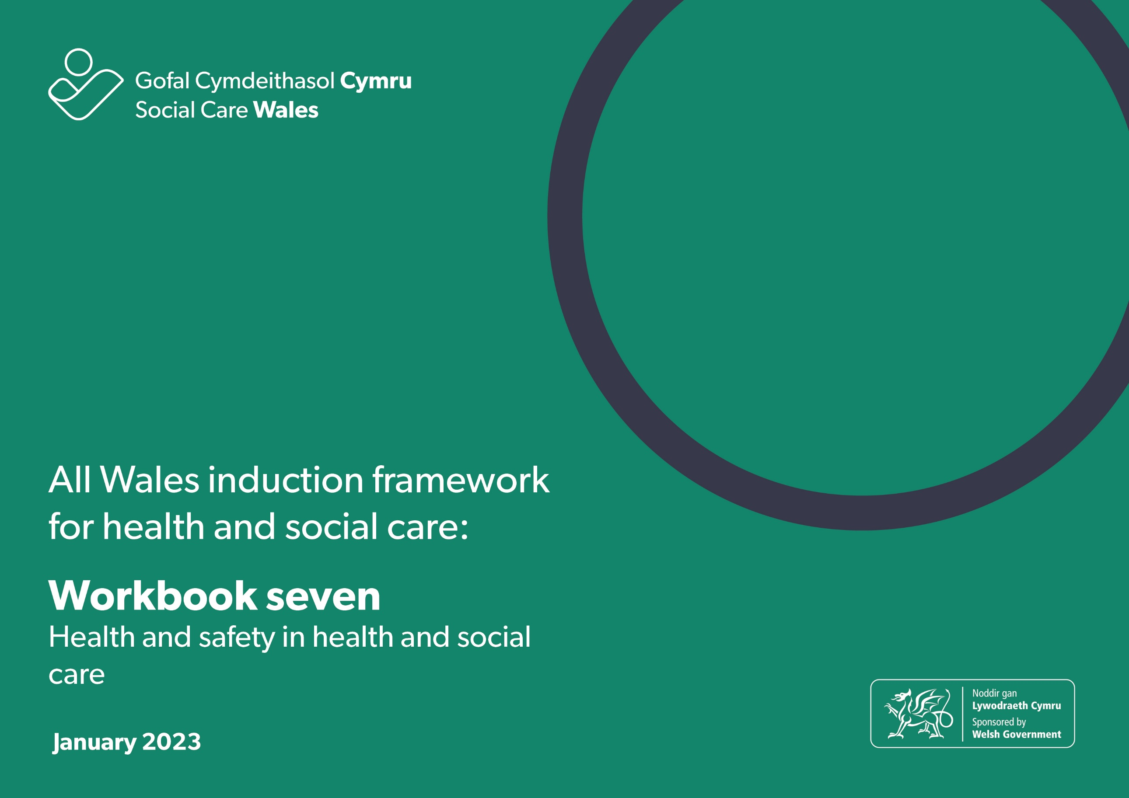

All Wales induction framework for health and social care workbook 7: Health and safety in health and social care

This workbook will help you to explore the legal requirements for health and safety in a health and social care setting and know your and your employer’s responsibilities for maintaining safety at work.
The workbook can either be downloaded and completed electronically or printed and completed by hand.
You can also use the completed workbook activities:
- towards achieving the All Wales induction framework for health and social care (Induction framework)
- to help you get ready to complete the Core qualification for health and social care
- as evidence towards your practice qualification.

Some words highlighted in bold in the progress log. There’s a glossary at the end of this workbook if you want help to know what these mean.
Throughout the workbook, we refer to ‘health and social care workers’. This means the person providing care and support or services to individuals.

Contents

7.1 Health and safety in the workplace
7.2 Risk assessments for health and safety
7.3 Fire safety
7.4 Moving and handling and moving and positioning
7.5 Emergency first aid
7.6 Infection prevention and control
7.7 Food safety
7.8 Hazardous substances
7.9 Security in the work setting
7.10 Managing stress
Practice learning outcomes

7.1 Health and safety in the workplace

As a health or social care worker you’re responsible for taking reasonable care of yourself and others in the workplace. Your employer has legal responsibilities to make sure you and the individuals you work with and support are protected from harm, but you also have a role to play. Health and safety is everyone’s responsibility.

The Health and Safety at Work Act (1974) sets out a range of expectations for employers, workers and others who may enter a work setting.
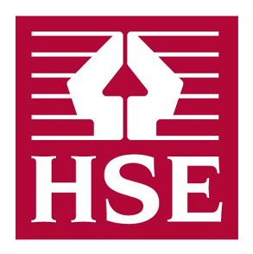
The Health and Safety Executive (HSE) is the national independent watchdog for work-related health, safety and illness. It acts in the public interest to reduce work-related death and serious injury across workplaces in the UK. There’s useful information and guidance for health and social care on their website and there’s also a leaflet which has a summary of the law. You can find the leaflet here. Let your manager know if you need help to access this.

Under health and safety legislation:

Employers must:

- have a written policy for health and safety if they employ more than five people
- ensure the health and safety of employees at work and other people on the premises (work setting)
- display the poster ‘Health and Safety Law – what you should know’
- carry out risk assessments and make sure employees have the right information, instruction and training to carry out their work safely
- provide free of charge, any equipment and protection you need to do your job safely, such as personal protective equipment (PPE) like face masks, aprons and gloves.

Employees or workers must:
- follow legislation and make sure their actions don’t have a negative effect on others
- take reasonable care for their own and others’ safety
- co-operate with the employer on health and safety matters. For example follow risk assessments, use PPE, and report accidents, incidents and near misses
- not intentionally damage any health and safety equipment or materials provided by the employer.

Others accessing the work setting must:
- take reasonable care of themselves
- avoid taking unnecessary risks
- follow health and safety signs
- follow procedures, for example sign in and out of reception
- follow guidance from workers.

Regulation 57 of the Regulation and Inspection of Social Care (Wales) Act 2016 says: “Health and safety - The service provider must ensure that any risks to the health and safety of individuals are identified and reduced so far as reasonably practicable”.
And the Statutory Guidance says “Service providers ensure the premises comply with current legislation and national guidance in relation to health and safety, fire safety, environmental health and any standards set by the Food Standards Agency. Examples include:
- required safe water temperatures
- fitting and maintenance of window restrictors
- fire evacuation and drills
- safe disposal of clinical waste
- safe storage and preparation of food
- regular health and safety risk assessments of the premises which include the grounds and equipment”.

There are other regulations, laws and legislation about health and safety such as RIDDOR - Reporting of Injuries, Diseases and Dangerous Occurrences Regulations 2013 or The Regulatory Reform (Fire Safety) Order (2005). We’ll pick some of these up as we look at different topics in the workbook.
Learning activity – working within the limits of your own role and raising concerns

Read this case study then answer the questions

Case study – Stacey

You’ve recently been employed as a care worker supporting an individual in their own home. You’ve been shadowing another member of staff called Stacey.

One of your calls is to Mrs Pearce, to help her with her morning routine, which includes bathing and getting dressed. Mrs Pearce needs to use a hoist to help her in the bathroom. You haven’t had any training on moving and positioning, but Stacey tells you not to worry as she’ll show you what to do. You feel uncomfortable but don’t want to make a fuss.

While supporting Mrs Pearce to get into the hoist, she loses her balance and falls and bangs her head. Stacey makes sure she’s ok and tells you she’ll report it to the office later, but you notice that she doesn’t record it in the log.
Answer these questions:

- What action would you take?

- What should Stacey have done differently?

- What should you have done when Stacey asked you to help Mrs Pearce using the hoist?

Let’s review what we’ve learnt so far.
Quiz
Q1: Tick all the statements that are correct.
- Employers must display a health and safety poster in work settings
- Employees or workers must put the safety of others before their own safety
- Others accessing the work setting must follow health and safety signs
- Others accessing the work setting must read the health and safety policy and agree to it
- Employers must train all workers in moving and positioning, fire safety, food safety and first aid, no matter what their role
- Employees or workers must report accidents, incidents and near misses

Q2. Under health and safety legislation, who is responsible for raising concerns about unsafe working practices?
- The employee and/or worker
- Individuals
- Families

Manager’s comments for section 7.1

Progress log – to be completed by the manager

7.1 Health and safety in the workplace

How to meet legislative requirements for health and safety in the workplace

By completing the workbook activities in this section the worker has shown they know | Sign and date
Key relevant legislation that relates to health and safety in the workplace and what this means in practice

The responsibilities of employers, the worker and others for health and safety at work

The importance of working within the limits of own role and responsibilities

The importance of raising concerns about practices or working conditions that are unsafe or risky

7.2 Risk assessments for health and safety

Assessing risk is an important part of health and safety within the workplace and for ensuring the well-being and protection of individuals and others.

The Health and Safety Executive (HSE) describes risk assessment as “identifying potential health and safety hazards. Employers are then required to act to minimise risks to their staff or anyone else at their workplace”.

As a health and social care worker, you’re also responsible for risk assessment. The workplace needs to be kept as safe as possible both for yourself and the individuals you support. This includes following formal risk assessments and carrying out informal risk assessments every day.

Hazards and risks

A hazard is something that could cause harm, for example, a wet floor or uneven steps.

A risk is the chance, which could be high or low, that someone could be harmed by these hazards.

For example: Dannie spills some water in Mrs Patel’s kitchen while washing up. She gets distracted and forgets to clean it up before she leaves. Mrs Patel goes into the kitchen, slips on the wet floor and falls. The spilt water is the hazard, the risk is that Mrs Patel will slip and fall.

There are different types of hazards, including:
- health hazards, which are incidents that could lead to someone getting ill
- safety hazards, which are incidents that could lead to someone getting injured.

Some of the hazards in social care settings are:
Environmental

Environmental hazards are things within the environment that could cause harm, such as the temperature of rooms, pollution, clutter, noise, poor lighting.

Equipment

Equipment needs to be maintained and used correctly and safely to prevent risk of harm. Poorly maintained equipment is a hazard.

Spread of infection

Working closely with individuals can lead to the spread of infections such as colds, flu, covid and norovirus. This can be from an individual to a worker or a worker to an individual.

Substances

Substances and chemicals can be hazardous to health. Cleaning products like bleach can cause serious harm if they aren’t used safely. Exposure to some chemicals may lead to short-term problems such as rashes or allergic reactions, while others can cause long-term illnesses like asthma or dermatitis.

Working conditions

Working conditions are about the way you work, such as your workload, the hours you work and working with individuals with complex needs. These are also called 'psychosocial' hazards and they can cause stress and affect mental health.

Learning activity – hazards in the workplace
Think about your workplace and write down some of the hazards or potential hazards you’ve noticed.

Incidents, accidents and emergencies
Incidents
An incident in the workplace is an unplanned event that doesn’t result in, but could cause, harm or injury. Incidents are sometimes described as a near miss - an event that doesn’t cause harm, but has the potential to cause injury or ill health.

For example: Ryan is a young person who stays in a residential short breaks service in Maesteg once a month. Ryan is autistic, he has limited verbal communication and only sleeps for two to three hours a night. Ryan seems distressed when he arrives at the short break service. During the night, the social care worker on duty hears a bang from Ryan’s room. She goes in to find that he has climbed onto the windowsill and pulled the curtain pole off the wall. Ryan isn’t hurt and the worker is able to calm the situation. This would be classed as an incident as it had the potential to cause harm or injury to Ryan, but didn’t.
What is the difference between accident and incident?

The main difference between accident and incident is that accidents result in harm, injury or damage to property, whereas incidents may not. So, if Ryan had fallen from the windowsill and banged his head it would be classed as an accident rather than an incident, as he’s been injured.

Accidents should always be recorded and reported, but remember that incidents should be recorded too, to make sure they don’t become accidents in the future. After all, incidents are just accidents waiting to happen!
There’s no such thing as an unimportant incident or accident. We need to learn from them to keep everyone as safe as possible.
Learning activity – incidents and accidents
Look at the following scenarios. Are they incidents or accidents?
- The front door of a residential care home for individuals living with dementia is left open by mistake. The care home is close to a busy road
- Mary lives on her own. She has support from care workers three times a day. When they arrive on duty in the morning, Mary tells them she has already taken her tablets because they were left on the kitchen table by the care worker. They can see that there are three doses missing from her bubble pack. Shortly afterwards, Mary starts vomiting
- Edith burns her leg from sitting too close to her electric fire
- Mary is given the wrong dose of medication by her social care worker. She is monitored and hasn’t shown any signs of adverse effects
- Jim’s social care worker takes his falls pendant off and puts in on the bathroom windowsill while helping him with his personal care. She forgets to put it back on before she leaves
- Jeff is walking around the garden of his care home. He trips on a broken slab and falls and cuts himself
- Jim slips on his stairs. He falls to the bottom and hurts his back. He isn’t wearing his falls pendant
- Edith leaves her electric fire on all night. It’s close to her armchair. The social care workers turn it off when they arrive the next morning and notice the side of her chair is very hot.

What is RIDDOR?
RIDDOR (Reporting of Injuries, Diseases and Dangerous Occurrences Regulations 2013 (RIDDOR 2013) is the law that means employers, and other people in control of work premises must report and keep records of:
- work-related accidents that cause death
- work-related accidents that cause certain serious injuries (reportable injuries)
- diagnosed cases of certain industrial diseases and
- certain ‘dangerous occurrences’ (incidents with the potential to cause harm).

Your workplace policy for health and safety will set out your responsibilities for reporting and recording accidents, and your employer’s responsibility for reporting to the HSE.
Emergencies
An emergency could be described as an unexpected event or accident that puts people in immediate danger, such as a heart attack, fire or car accident.
Risk assessments
Risk assessments are important for identifying hazards in the workplace and putting steps in place to reduce the risk of harm or injury from them. Risk assessments can be formal or informal.
Formal risk assessments
Your employer is responsible for carrying out, or appointing people to carry out, a wide range of risk assessments. Some may relate to the whole workforce, for example lone working for domiciliary care workers. Others will relate to specific work settings or circumstances. It’s your responsibility to make sure you’re familiar with and follow any formal risk assessments. You must also report any concerns or changes which may have an impact on the level of risk.
Informal risk assessments
You’ll carry out informal risk assessments all day, every day as a matter of course. For example, each time you cross a road, you assess the risk to make sure it’s safe for you to do so. In your work environment, you’ll find that you do informal risk assessments automatically, perhaps scanning a room as you enter it looking for potential hazards, such as clutter which could cause trips or electrical equipment left on by mistake.
Learning activity – risk assessments
List three formal risk assessments related to your workplace:
a)

b)

c)

Taking a balanced approach to risks

We need to take a balanced approach to risks to make sure we’re not restricting the freedoms and rights of individuals we support and care for. The Health and Safety Executive says:

“When considering the care needs of an individual, everyday activities are often identified that will benefit their lives, but also put them at some level of risk. This requires a balanced decision to be made between the needs, freedom and dignity of the individual and their safety – with the aim of enabling them to live fulfilled lives safely rather than providing reasons for restricting them.”

Let’s review what we have learnt so far:

Quiz
Q1. True or false?
A hazard is something that could cause harm

Q2. An incident is an:
- unplanned event that results in an injury
- unplanned event that results in an accident or an injury
- unplanned event which does not, but could result in an injury

Manager’s comments for section 7.2

Progress log – to be completed by the manager

7.2 Risk assessments for health and safety

How risk assessments are used to support health and safety in the workplace

By completing the workbook activities in this section the worker has shown they know | Sign and date
What is meant by ‘risk assessment’ in relation to health and safety

The types of accidents, incidents, emergencies and health and safety hazards that may occur in the workplace

Why it is important to risk assess any identified hazards related to the work setting or activities

Responsibilities for carrying out, recording and following risk assessments for work activities
The difference between formal recorded risk assessments and those that are carried out routinely as part of working practice, for example. checking a room for tripping hazards on entry

The importance of reporting concerns or incidences that have or may be likely to occur

7.3 Fire safety

Fires are a serious hazard. As a health and social care worker you need to know what to do to prevent fires and what to do if a fire breaks out. Organisations have specific procedures to follow for fire prevention and protection, which you should be trained in. You should be aware of your own and your employer’s fire safety responsibilities.

How do fires start?

Fires need three things to start – a source of ignition (heat), a source of fuel (something that burns) and oxygen:

- sources of heat or ignition include heaters, lighting, naked flames, electrical equipment, smokers' materials such as cigarettes or matches and anything else that can get very hot or cause sparks
- sources of fuel include wood, paper, plastic, rubber or foam, loose packaging materials, waste rubbish and furniture
- sources of oxygen include the air around us.
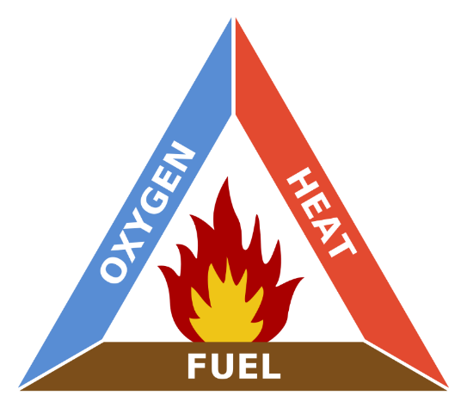
The fire triangle - oxygen, heat and fuel are what’s needed to start a fire.
If we remove just one of these, we reduce the risk of fire.
Removing oxygen
We can remove oxygen from the area around a fire with a carbon dioxide extinguisher or a fire blanket. The carbon dioxide extinguisher pushes oxygen away from the fire and replaces it with carbon dioxide, which is inflammable and denser than air. Fire blankets form a seal around the fire and stop more oxygen reaching the fire.
Another example of removing oxygen is closing doors when evacuating a building, as this stops fresh supplies of oxygen entering the building.
Removing heat
Blowing out the flame on a candle is a good example of this. The fast-moving air removes the heat from the candle, stopping it from burning any more.
A useful method of removing heat from a fire is to use water, which effectively absorbs the heat. But you should never use water on electrical fires because of the risk of electrical shock. You also shouldn’t use water on oil fires as oil and water don’t mix, so the water makes the oil form smaller droplets which makes the fire even worse.
Removing fuel
Using fire-resistant materials stops fires having enough fuel to keep burning, so it’s an effective method of fire prevention. Fire-resistant materials can be used for clothes, furniture and building materials.
The law

The Regulatory Reform (Fire Safety) Order 2005 covers general fire safety in Wales and England and is an important piece of legislation.

The Fire Safety Order applies to all non-domestic settings, for example residential care homes or offices. Each setting must have a named responsible individual who must carry out a fire risk assessment and take actions to minimise the risk of a fire happening, have a clear evacuation procedure and make sure that workers are trained to know what to do if a fire starts.

Learning activity – fire safety

Read these case studies and answer the questions

Case study – Gwyn

You’ve started supporting Gwyn, who is a heavy smoker. Gwyn has recently had a stroke so he has limited mobility and has become clumsy, often dropping things as he can’t grip with his hands. During a visit to Gwyn, you notice cigarette ash on his clothes and scorch marks on the arms of his chair. His room tends to be very cluttered and there’s always a stack of newspapers by his chair.

Answer these questions:

- What are the risks?

- Which parts of the fire triangle (oxygen, heat and fuel) are present?

- Who could offer support or advice to help keep Gwyn safe?

- What could you do to help Gwyn understand the risks?

- What practical things could Gwyn be helped with to reduce the risks?

- Who would you tell about your concerns and how would you do this?

Case study – residential family centre
You’re a social care worker in a residential family centre in Swansea which has facilities to support up to six families. You’re covering the sleep-in shift and it’s really hot, so before going to bed you prop open the doors from the lounge, dining room and kitchen to help air circulate.
Answer these questions:
- What are the risks?

- Who is responsible for carrying out the fire risk assessment for the building?

Case study – residential care home
You’re a care worker in a residential care home for older people. The home has had a singer in to provide some entertainment for the residents. When you come on duty that evening, you can see that the furniture in the lounge has been moved around to make room for all of the residents and the singer. You see that someone has placed an armchair in front of the fire exit.
Answer these questions:
- What are the risks?

- What actions would you take?

- Who would you inform?

Learning activity – fire evacuation procedure

Read your organisation’s policy and procedure for fire evacuation and make some brief notes here about your responsibilities here.

Let’s review what we’ve learnt so far.

Quiz
Q1. Fire needs which three of the following?
- Heat
- Oxygen
- Wind
- Fuel

Q2. Who is responsible for fire safety in the workplace?
- Workers
- The responsible individual
- Everyone

Manager’s comments for section 7.3

Progress log – to be completed by the manager

7.3 Fire safety

How to promote fire safety in work settings

By completing the workbook activities in this section the worker has shown they know | Sign and date
Key legislation that relates to fire safety

The responsibilities of employer, the worker and others for fire safety in the work setting

Practices that prevent fires from starting and spreading

The importance of knowing about and following fire evacuation procedures

The importance of maintaining clear exit routes at all times

7.4 Moving and handling and moving and positioning

Moving and handling is an important part of the working day for many workers, from carrying heavy bags of shopping to moving equipment or boxes. Your role may also involve moving and positioning people. Moving and handling and moving and positioning are sometimes called manual handling.

We use the term moving and handling for the manual handling of inanimate objects such as boxes and we use the term moving and positioning for the manual handling of people who may need support to move from one place or position to another, for example from a chair to a bed.

The term manual handling covers a wide variety of activities including lifting, lowering, pushing, pulling and carrying. There’s a risk of injury if any of these tasks aren’t carried out appropriately. The Health and Safety Executive tells us that manual handling causes over a third of all workplace injuries. These include work-related musculoskeletal disorders (MSDs) such as pain and injuries to arms, legs and joints, and repetitive strain injuries.

Manual handling tasks should be avoided where possible to help prevent injuries. But, when it’s not possible to avoid handling a load, employers must look at the risks and put sensible health and safety measures in place to prevent and avoid injury.

If you need to support individuals with moving and positioning, you’ll receive specific training to help you know how to do this, minimising risks both to yourself and the individual. You must not attempt any moving and positioning tasks until you’ve been trained. If individuals need support with moving and positioning, there will be an individual risk assessment in their care and support plan so you must make sure that you read and follow this.

Principles and techniques for moving and handling

For any lifting activity you should always consider:
- your own individual capability
- the nature of the load, such as its size and shape
- environmental conditions and if there’s space to move the object, without clutter or obstructions
- training you’ve received.

If you need to lift something you should:
- assess the weight to be carried and whether you can move the load safely or need help. Maybe the load can be broken down to smaller, lighter parts
- reduce the amount of twisting, stooping and reaching
- avoid lifting from floor level or above shoulder height, especially with heavy loads
- adjust storage areas to minimise the need to carry out such movements
- reduce carrying distances where possible.

Even if you don’t support individuals with moving and positioning, your employer should provide you with basic moving and handling training.

The law

The Manual Handling Operations Regulations 1992 (as amended) apply to work that involves lifting, lowering, pushing, pulling or carrying.

The Regulations apply to manual handling activities involving transporting or supporting loads, including lifting, lowering, pushing, pulling, carrying or moving loads.

The use of lifting equipment in a health and social care setting is regulated by the Lifting Operations and Lifting Equipment Regulations 1998. (LOLER). This would apply to equipment such as hoists.

Learning activity – moving and handling and moving and positioning

Explain what the following terms mean:

- Moving and handling

- Moving and positioning

Learning activity – safe moving and handling

Read these case studies and answer the questions

Case study – Jack

Jack asks you to pass him a box of games which is on top of the wardrobe in his bedroom. He says he tried standing on a chair to get it himself but couldn’t reach it.
Answer these questions:
- What are the risks?

- What actions should you take?

Case study – Tommy and Martin
Tommy and Martin live in their own home and are supported by social care workers. You’re helping Tommy with the weekly shop at the local supermarket. There are six heavy bags of shopping so you agree to get a taxi home.
The taxi driver can’t park outside Tommy’s house so stops at the top of the road and leaves the bags of shopping on the pavement for you.
Answer these questions:
- What are the risks?

- What actions should you take?

Let’s review what we have learnt so far.

Quiz
Q1. True or false?
Moving and positioning means moving people and inanimate objects

Q2. Which of the following are principles and techniques of moving and handling?
- Avoid lifting from floor level
- Reduce twisting, stooping and reaching
- Use the strength of your arms to lift
- Minimise carrying distances

Manager’s comments for section 7.4

Progress log – to be completed by the manager

7.4 Moving and handling and moving and positioning

The principles of moving and handling and moving and positioning

By completing the workbook activities in this section the worker has shown they know | Sign and date
The meaning of the terms ‘moving and handling’ and ‘moving and positioning’

Key legislation that relates to moving and handling and what this means in practice

The principles and techniques of moving and handling

The implications of poor practice in moving and handling

7.5 Emergency first aid

What the law says about first aid in the workplace

Under the Health and Safety (First Aid) Regulations 1981, employers must provide adequate and appropriate equipment, facilities and personnel so that their employees receive immediate attention if they’re injured or taken ill at work. These Regulations apply to all workplaces.

As a minimum, a low-risk workplace such as a small office should have a first-aid box and a person appointed to take charge of first aid arrangements, such as calling the emergency services. Employers must tell their employees about first-aid arrangements.
Workplaces that have more significant health and safety risks are more likely to need a trained first aider. Employers must carry out a first aid needs assessment to decide what’s appropriate.

You may need to attend an accredited first aid course if this is part of your employer’s first aid needs assessment. You shouldn’t attempt any form of first aid if you haven’t been trained, but you must seek help immediately.

Learning activity – emergency first aid

Read the policy and procedures for first aid in your workplace and write down what your responsibilities are:

Manager’s comments for section 7.5

Progress log – to be completed by the manager

7.5 Emergency first aid

How and when emergency first aid can be applied in the work setting

Note: this hasn’t been included in the progress log as workers in health and social care settings are expected to attend an external first aid course to complete this area of learning if it’s relevant to their role.

7.6 Infection prevention and control

Infection prevention and control describes measures taken to reduce the risk and prevent the spread of infection.

Roles and responsibilities for infection, prevention and control
We’re all responsible for infection prevention and control. The Health and Safety at Work Act puts a general duty on employers to protect employees’ health and safety. All workers also have a duty to protect themselves and others by following infection, prevention and control procedures.

Infections can spread in many ways. They can affect all of us, but some adults and children are more at risk than others. For example, older people, young babies, those who are pregnant and people with immune system problems or underlying health conditions.

We should all act in ways that help to stop the spread of infection. Working in ways that use infection prevention and control measures can support the well-being of individuals, children and young people, helping them to stay safe to achieve what’s important to them.

We have a digital learning module for infection prevention and control that we strongly recommend you complete to help you with your learning. If you complete it and pass the test at the end, you don’t need to complete this section of the workbook. You can find the digital learning module here, please let your manager know if you need help to access this.

What causes infection?

- Infections are caused by microbes invading the body. These are also known as ‘germs’ or ‘bugs’
- Microbes or germs are found almost everywhere, and they can be useful or harmful. They’re all around us and they live on and in us. Microbes or germs that cause harm are known as pathogens
- Viruses, bacteria and fungi are all microbes. Infections can also be caused by parasites
- Infection occurs when microbes or germs invade the body, multiply and cause illness or disease. When a microbe or germ enters our body, our immune system tries to fight it off
- Infection can overpower our immune system when it’s weak
- Infectious disease, also known as transmissible disease or communicable disease is an illness caused by an infection.

Colonisation, systemic and localised infections

It’s helpful for you to understand what’s meant by these terms when we’re thinking about infection prevention and control:

Colonisation

Colonisation refers to the presence of microbes or germs which can cause infection, but not the infection itself. Colonisation happens when microbes or germs live harmlessly on the skin or in the body, there aren’t signs of infection and they don’t invade tissues. For example, many of us have MRSA colonised or living harmlessly on our skin without it causing us illness. But it can be passed on to others who are more vulnerable and cause a serious infection.

Systemic and localised infections

Localised infections stay in one part of the body, for example, if a cut on the hand which gets infected with bacteria is treated effectively, the infection won’t spread anywhere else. Conjunctivitis is an example of a localised infection which doesn’t affect other parts of the body.

Systemic infections happen when the microbes or germs spread through the body rather than staying in one place. The infection is usually spread through the blood stream and can cause symptoms in different parts of the body. For example, influenza can cause a high temperature, joint and muscle aches and respiratory symptoms. In severe cases, an infection may lead to sepsis, which is a life-threatening reaction by the body.

Viruses

Viruses are the smallest microbes. There are millions of different types of viruses, most of which live alongside, or within us harmlessly. Many have a role in protecting us from bacterial infections but some can be harmful to humans, for example norovirus, coronavirus, or the flu.

Viruses need a living host cell to survive and reproduce. Once inside the host cell, they reproduce quickly and destroy the cell.

Bacteria

Bacteria are larger than viruses but smaller than fungi and can be useful and harmful to humans. During their growth, some bacteria produce toxins which cause infections, but more than 70 per cent of bacteria aren’t harmful. They are essential for human life for example, digestion.

Bacteria are used in food production and can be found in our gut, helping our digestion. You’ll find yoghurt-based drinks in the supermarket which are full of good bacteria to help digestion.

Harmful bacteria, such as salmonella, can cause a wide range of infections including food poisoning.

Fungi

Fungi are the largest microbes and can be useful or harmful to humans. They include moulds, yeasts and mushrooms. Penicillium is an example of a useful mould which is used to produce the antibiotic penicillin. You may have been prescribed a type of penicillin for an infection like tonsillitis.

Some fungi can cause infections, such as athlete’s foot and ringworm, which can lead to serious infections in people with poor immune systems.

Some fungi can be eaten safely, such as the button mushroom whereas others can cause poisoning, such as the death cap mushroom.

Parasites

Parasites live in or on a host and get food at the host’s expense. A harmful type of parasite is a mite called the sarcoptes scabiesi. The female mite burrows beneath the skin, lays eggs and causes scabies.

How infections are spread

Infections can be spread by people, water, food or animals through ‘the chain of infection’.

The chain of infection

1. Viruses, fungi or bacteria are harmful viruses
2. Germs can be found on places such as people, animals, food, water and soil. These places are called a reservoir
3. Way out is when germs leave the reservoir. It can happen through contaminated food or water, faeces, saliva, bodily fluids, cough or sneezes
4. Germs can be passed on through direct contact with hands, surfaces, clothing, or by breathing in or swallowing. This process is called a spread
5. Way in is when germs enter a new host through the mouth, eyes, nose, broken skin or cuts
6. The person who becomes infected is called as a host. In the case of flu, the harmful germ or bug is the influenza virus
7. The person’s lungs and airway is the reservoir
8. When the person sneezes, coughs or blows their nose, the virus finds a way out of the reservoir
9. The spread of flu is through droplets or contact
10. A person inhales the virus through their nose or mouth, or by touching their hands to their face
11. Elderly people, those who are vulnerable or have existing chronic diseases, or people who aren’t vaccinated play the role of host in this case.

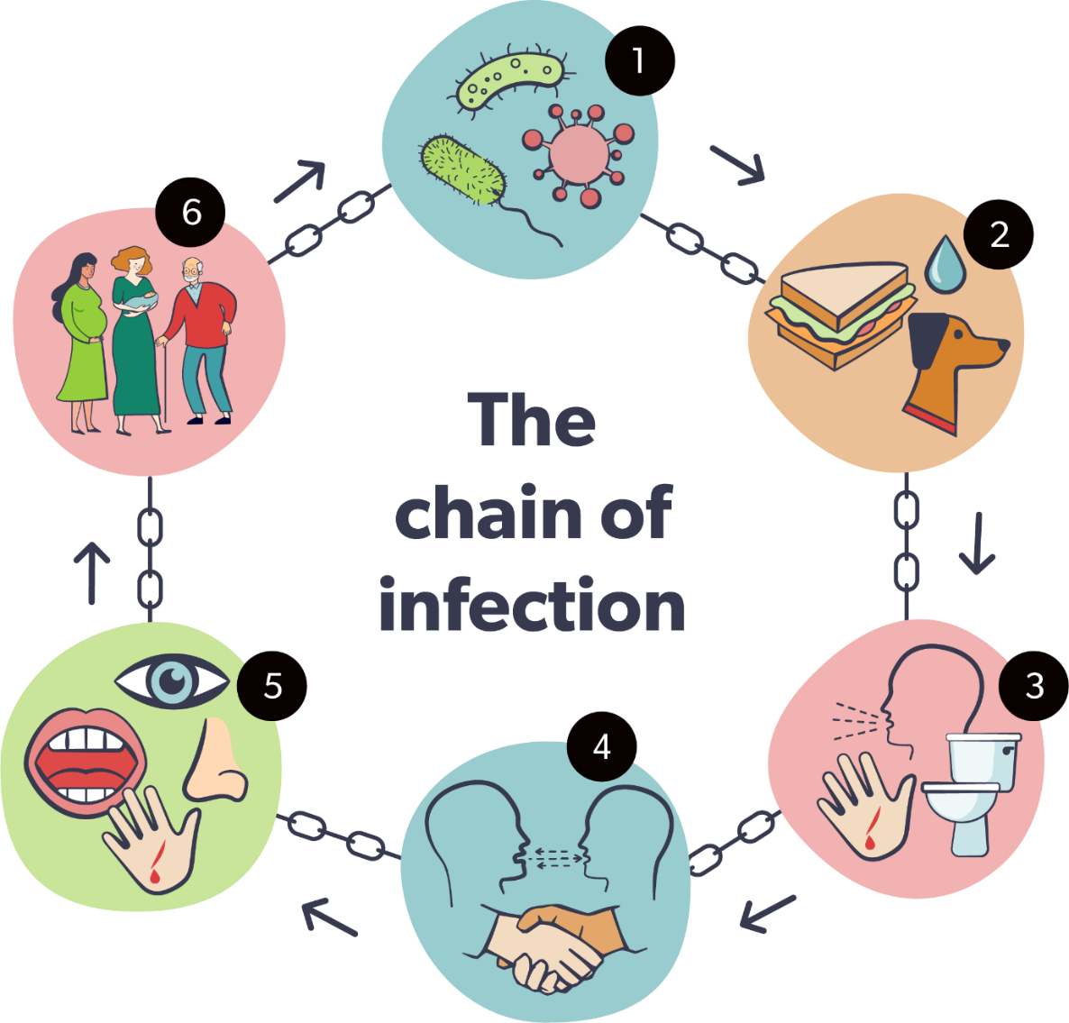
Diagram showing the chain of infection
For microbes or germs to survive and repeat the infection in other hosts, they must leave an existing reservoir and cause infection elsewhere.

Infectious diseases can be spread or transmitted in several ways including:

Direct contact – infections are often passed from person to person by direct contact. For instance, through shaking hands, sneezing, or kissing. Some examples of infections spread through direct contact are flu, the common cold and chicken pox.

Indirect contact – some microbes or germs can survive for a while outside of the host. They may be on touch points or objects such as door handles and phones. Many of the infections that are spread through direct contact can also be spread through indirect contact.

Contamination through food and water –some infectious microbes or germs can be passed on by eating or drinking contaminated food or water. This could be through undercooked food or when sewage gets into the water supply. Examples of diseases spread in this way are E.coli, cholera, and salmonella.

Droplet transmission – some infectious microbes or germs can be passed on when droplets produced through coughing, sneezing or talking are propelled through the air. They land on another person, entering through the nose or mouth. They can usually only travel short distances of up to two metres. But the infected droplets may stay on surfaces for a long time, waiting to be picked up by the next person who touches them.

Airborne transmission – this happens when small droplets or dust particles containing infections microbes or germs remain suspended in the air for a long time and can be dispersed by currents of air. Because of this, there’s a risk that all the air in a room could be contaminated.

Vector borne transmission – this is infection spread through insect bites. Insects such as head lice, mosquitos and ticks can carry microbes or germs that get passed on when they make contact with humans. Some examples of diseases spread by insects include malaria by the mosquito and Lyme disease by ticks.

Let’s review what we have learnt in this section.

Quiz
  - True or false?
Pregnant women are more at risk from infections
  - Infections can be caused by an invasion of the body by:
- Viruses
- Virals

  - Which of the following is correct?
- More than 70 per cent of bacteria aren’t harmful
- More than 80 per cent of bacteria aren’t harmful
- 60 per cent of bacteria aren’t harmful

  - True or false
Penicillin is produced from mould

  - Infections spread by direct contact could be through:
- Shaking hands
- Waving
- Touching a phone

How to stop the spread of infection
Infection is most likely to spread when:
- handling food
- eating with fingers
- when using the toilet
- coughing, sneezing and nose blowing
- touching surfaces frequently touched by other people
- handling and laundering ‘dirty’ clothes and household linens
- caring for domestic animals
- handling and disposing rubbish
- caring for an infected family member
- not cleaning care equipment properly.

To stop the spread of infection, we need to break the chain of infection, for example not passing on germs through contact with contaminated hands or surfaces, or sneezing without a tissue, and making sure we prepare and store food properly.
We can do this by something called ‘standard infection prevention and control precautions’, such as:
- hand hygiene - washing and drying or sanitising our hands properly and regularly
- respiratory hygiene – coughing or sneezing into a tissue
- personal protective equipment (PPE) - using PPE such as face masks, gloves, or aprons correctly to create a barrier against microbes or germs which can cause infection. This is called ‘donning’ and ‘doffing’
- a clean environment - keeping the surfaces we touch, equipment we use, and the cloths we use to wipe them, clean
- safe handling of used linen and clothes
- safely disposing of contaminated waste including ‘sharps’
- taking the correct action if we’re injured or exposed to blood or other body fluids
- not passing it on - not having any contact with others if we’re infected or showing symptoms of infection.

These precautions are important for everyone in all health and social care settings whether infection is present or not. You can find out more about these precautions in the National Infection and Prevention and Control Manual.
If you’re employed in health or social care you should take care not to wear jewellery, watches or nail varnish when you’re working as these can harbour germs. Keep your nails short and clean and try to wear short sleeves or roll your sleeves up.
All links in the chain of infection need to be in place for an infection to spread. If we break one of the links, an infection can’t spread.
Hand hygiene
Regular, thorough hand hygiene is one of the most important defences we have. Many germs are invisible to our eyes and germs on our hands can be passed on by touching people, surfaces, or food. We can also infect ourselves by touching our mouths, noses, or eyes with contaminated hands.
You should wash your hands with soap and water:
  - after using the toilet or changing a nappy or a pad
  - before and after handling or eating food
  - after blowing your nose, sneezing or coughing
  - before and after touching a cut or wound
  - after contact with any body fluids such as blood, faeces, vomit or mucous
  - after touching animals, pet waste, equipment or bedding
  - after contact with contaminated surfaces, for example food-contaminated surfaces, rubbish bins or cleaning cloths
  - before and after engaging in tasks or activities such as administering medication, health care, personal care or playing with children
  - if they’re visibly dirty
  - before and after using PPE
  - before you start and when you finish work.

Why should we wash our hands with soap and water?
  - Our hands secrete oil which helps keep our skin moist
  - The oil helps microbes or germs stick to our skin
  - Soap is needed to break up oil on the surface of our hands and release the microbes or germs
  - Washing hands with just water may get rid of visible dirt, but without soap, the microbes or germs will remain
  - Soap only has limited killing power on microbes or germs, so rinsing hands well under running water is important to remove the microbes or germs which have been released by the soap.

Washing your hands properly with soap and water removes dirt and microbes or germs and is the most effective way of preventing the spread of infections.
If your hands aren’t visibly dirty and you can’t wash your hands with soap and water, use an alcohol-based hand sanitiser. Always dry your hands properly after washing them as damp hands spread more germs.
Watch this film which shows you how to wash your hands properly. Let your manager know if you need help to access this.
Skin care
It’s important to take care of your skin as regular hand washing and sanitising can make them dry. Use an emollient hand cream and avoid hand creams which make hand hygiene products less effective.
Personal protective equipment (PPE)
This is used to help prevent the spread of infection. It includes:
Face masks:
These are worn to prevent germs transferring from one person to the other through droplets carried in the breath. Face masks may be disposable, or they may be reusable if they’re made of cloth and are washable.
Disposable gloves and aprons:
These should be used when providing intimate care or any tasks where there’s a risk of contact with the blood or body fluids through:
  - direct contact with the person
  - indirect contact through cleaning equipment or surfaces.

You should change gloves and aprons immediately after supporting an individual or child or young person and between different tasks.
Remember to wash and dry your hands before and after wearing gloves and aprons and dispose of these safely following your workplace procedures.
If you’re in an environment where you need PPE, your employer will advise you what to wear and how to use it. Public Health Wales has lots of guidance about using PPE, including how to put in on and take it off.
Catch it, bin it, kill it
Colds and flu are the most common illnesses in people of all ages.
Why do we sneeze?
Sneezing is how our body tries to get rid of any harmful microbes or germs and dust we might inhale.
The harmful microbes or germs and dust get caught on the nose hair and tickle our nose. The nose sends a message to the brain which then sends a message back to our nose, mouth, lungs and chest telling them to blow the irritation away, or sneeze.
In the case of colds and flu, millions of virus particles rush out, spread through the air and contaminate the surface they land on. This could be our food, surfaces or hands.
Good respiratory hygiene can help prevent the spread of infection.
Top tips
- Don’t touch your nose, mouth or face
- Block coughs or sneezes with a tissue and throw it in the bin straight away
- Wash hands, or if there isn’t a wash basin use hand sanitiser and then wash your hands as soon as you can
- Don’t shake hands or hug others
- Keep the home well ventilated
- Use an antiviral disinfectant to keep surfaces and touch points clean
- Wash laundry separately and don’t share towels
- Minimise your contact with other people.

Let’s review what we have learnt in this section

Quiz
- Infection is most likely to spread:
- When handling food
- Before eating food
- When eating with your fingers

- True or false?
If we break the chain of infection, we can stop the spread of infection

- True or false?
We can only pass infections on if we’re showing symptoms

- The most effective way of removing dirt and microbes from your hands is by:
- Washing them with soap and water
- Using hand sanitiser

The importance of a clean environment

The importance of good hygiene in the home or workplace to prevent the spread of infection can’t be stressed enough. A dirty environment contributes to the spread of infection
- Use detergent and hot water to rinse microbes or germs away, or a disinfectant to reduce them
- Focus on areas where microbes or germs are more likely to spread, such as the kitchen or toilet, and things people touch frequently, such as door handles and light switches
- Clean in an ‘S’ shape in the direction of top to bottom and cleanest to dirtiest area
- Change the cleaning cloth regularly between different rooms and surfaces to avoid spreading the microbes or germs from one area to another
- If you use a disinfectant make sure you leave it in ‘contact’ with the surface long enough to do its job before wiping.

Effective cleaning is important to remove dirt and microbes or germs from an environment. If it’s not done effectively, microbes or germs can spread from an environment to a person and cause infection.

Disinfecting is the process used to reduce the number of microbes or germs. It doesn’t kill or remove all microbes.
Disinfecting is carried out in two ways:
- heat, for example washing dishes and linen in hot water
- chemical, for example through a disinfectant cleaning product.

Disinfectant is used after cleaning with a detergent.

Cleaning up spillages

Spillages of blood, faeces or other body fluids are hazardous and must be cleaned up straight away. You should:
- put on PPE to protect yourself
- clean up the excess spillage with disposable cloths then put these in a clinical waste bin
- clean up the spillage using detergent and warm water with disposable cloths then put these in a clinical waste bin
- if there isn’t a clinical waste bin in your work setting, double bag and place them in a normal waste bin, empty the waste bin into a bin bag and seal this when you’ve finished
- if there aren’t any disposable cloths and you need to use non-disposable cloths, these should be laundered at 65 degrees Celsius or higher
- once the area is visibly clean, apply disinfectant
- clean any equipment used
- remove your PPE and dispose of this safely
- wash and dry your hands.

Your work setting may have procedures that you need to follow for cleaning the environment and disposing waste, including sharps. Your employer will provide guidance for this.

Learning activity – stopping the spread of infection

Read this case study and answer the questions.

Case study – Mr Williams
You are visiting Mr Williams who has been feeling a bit ‘off colour’ for the last few days. After checking how he is, you assist Mr Williams to go to the toilet, and you notice that the toilet seat is soiled, so you clean this before he uses it. You then support him to take his lunchtime medication, and go to prepare lunch.

Answer these questions

- What are the potential risks for the spread of infection?

- What actions would you take?

- What PPE would you use to prevent the spread of infection?

- How would you clean the environment?

Let’s review what we have learnt in this section.

Quiz
- When do you use disinfectant?
- Before cleaning with a detergent and water
- After cleaning with a detergent and water

- At what minimum temperature should you wash non-disposable cloths used to clean hazardous spillages such as blood?
- 50 degrees Celsius
- 55 degrees Celsius
- 60 degrees Celsius
- 65 degrees Celsius

Learning activity – stopping the spread of infection

In this section, you’ve learnt that hand washing is a crucial part of providing safe care and for the prevention of cross infection.

List when handwashing should be carried out:

Symptoms of infections

There are important symptoms of infections that you should look out for, which include a high temperature or fever, drowsiness and loss of appetite. You should always seek advice if you have any concerns about symptoms the individual, child or young person you’re caring for is experiencing. There may be times when they need to be isolated to prevent further spread of infection. A medical practitioner will advise if this is the case.

Learning activity – symptoms of infections

Read this case study and answer the questions

Case study – Jim

Jim is 84 and he lives alone in his own home. He has care and support three times a day. The care workers have reported that he hasn’t been drinking much of the water left out for him and he needs lots of prompts to drink while they’re with him. Jim has dementia and they’re worried that he seems more forgetful than usual and he’s having difficulty with his mobility.

As Sheila is supporting Jim to get ready for bed, she can see several pairs of wet pants and trousers on the floor in his bedroom. Jim refuses to get into his night clothes. He says his back aches and he’s cold and just wants to sit in the chair by the fire. He’s snappy with Sheila, which is unlike him. Sheila is worried that Jim isn’t himself.

Answer these questions:

- What are the possible symptoms Jim has an infection?

- What actions should Sheila take?

Infections and causes

These are some of the more common types of infection caused by viruses, bacteria, fungi and parasites.

Virus
  - Covid
  - HIV
  - Common cold
  - Rubella
  - Chicken Pox
  - Shingles
  - Measles
  - Mumps
  - Influenza
  - Herpes simplex.

Bacteria
  - Salmonella
  - Syphilis
  - Impetigo
  - Clostridium difficile (C diff)
  - Whooping cough.

Fungi
  - Ringworm
  - Vaginal yeast infection
  - Athlete’s foot
  - Oral thrush.

Parasite
  - Malaria
  - Tapeworm
  - Roundworm
  - Scabies
  - Headlice.

Let’s review what we have learnt in this section.

Quiz
- Common symptoms of infection could include:
- High temperature
- Increased appetite
- Loss of appetite
- Drowsiness

- True or false
Pneumonia can be caused by both viral and bacterial infections

- Influenza is
- A viral infection
- A bacterial infection

- Which of the following is a bacterial infection?
- Salmonella
- Rubella

- Which of the following is a fungal infection?
- Syphilis
- Ringworm

- Scabies is an infection caused by:
- Fungi
- Parasites

Learning activity – hand hygiene

Ask your manager to watch your hand washing technique and give you feedback. You don’t need to write anything down for this activity.

Manager’s comments for section 7.6

Progress log – to be completed by the manager

7.6 Infection prevention and control
The main routes to infection and how to prevent the spread of infections in the workplace

By completing the workbook activities in this section the worker has shown they know | Sign and date
The difference between bacteria, viruses, fungi and parasites

Common illnesses and infections caused by bacteria, viruses, fungi and parasites and the potential impact of these

What is meant by the terms ‘infection’ and ‘colonisation’

What is meant by the terms ‘systemic infection’ and ‘localised infection’

How infections are transmitted and poor practices that may lead to this

Factors that make it more likely that infections will occur

Key legislation and standards related to infection prevention and control

The role and responsibilities of employers, workers and others for infection prevention and control

How to maintain a clean environment to prevent the spread of infection

The importance of good personal hygiene to prevent the spread of infection

Hand washing technique to prevent the spread of infection

The use of personal protective equipment to prevent the spread of infection

7.7 Food safety

This section will support you to develop an awareness of food safety. Food safety training is a legal requirement for people involved in the preparation, handling or cooking of food. If your role involves preparing or serving food your employer will arrange for you to attend training.

The law

The Food Safety Act (1990) is the framework for food hygiene and safety legislation in England, Wales and Scotland.

The Food Hygiene Regulations (Wales) 2006 make it an offence for food businesses to supply food which shouldn’t be eaten and could be harmful. These regulations apply to any social care service that provides food to individuals. All workers involved in handling, preparing or providing food must have received appropriate training in how to do this safely.

The Food Standards Agency is an independent government department that protects public health in relation to food. They have lots of helpful information on their website.

People with weakened immune systems, pregnant women and their unborn babies, young babies and elderly people are all more at risk of serious illness from food poisoning. Food poisoning can be caused by bacteria such as listeria or salmonella or viruses such as Hepatitis E.

Good hygiene is the best defense against food poisoning and this section will look at the 4Cs of food safety. These are the four things you need to remember:
- Cleaning
- Cooking
- Chilling
- (avoiding) Cross contamination.

Cleaning
You’re removing harmful germs or microbes by cleaning with warm soapy water. You should regularly clean your:
- hands
- work surfaces
- chopping boards
- knives.

Washing with warm soapy water means the lather and physical motion of washing will detach bacteria from the surface, but won’t kill it. To kill bacteria you need to wash the surfaces at over 70 degrees Celsius, which is too hot for your hands.
Dish cloths and tea towels should be changed or washed and dried regularly – dirty, damp clothes allow bacteria to breed.
All utensils and dishes must be clean before they’re used to prepare or serve food, to avoid cross contamination. You should use different utensils, plates and chopping boards when preparing ready to eat foods and raw foods that need to be cooked, such as meat. Remember to wash them thoroughly with warm soapy water between tasks to avoid the spread of harmful bacteria
Cleaning products
You should always read the instructions on cleaning products carefully to make sure they’re suitable for food surfaces and that you’re using them correctly.
Cooking
Cooking food at the right temperature and for the right length of time will make sure that any harmful bacteria are killed. You should always check the advice on food packaging and follow the cooking instructions provided.
How time and temperature kill bacteria
During cooking, heat energy transfers into and breaks down proteins in the food. Meat changes colour from pink to brown. Cooking also causes the proteins in bacteria to break up so they can’t function and the bacteria die. Cooking properly removes the risk from harmful bacteria that are in some food.
Bacteria usually grow in the ‘danger zone’ between eight degrees and 60 degrees Celsius. Below eight degrees, growth is stopped or significantly slowed down. Above 60 degrees, the bacteria start to die. Time and temperature are both important because proteins need to be heated up for enough time for them to be broken down. Standard advice is to cook food until it has reached 70 degrees Celsius and stayed at that temperature for two minutes.
The other time and temperature combinations to make sure bacteria are killed are:
- 60 degrees Celsius for 45 minutes
- 65 degrees Celsius for 10 minutes
- 70 degrees Celsius for two minutes
- 75 degrees Celsius for 30 seconds
- 80 degrees Celsius for six seconds

Chilling food
Some foods need to be kept in the fridge to slow down the growth of bacteria. To keep food safe:
- follow the storage instructions on the packaging, including the best before and use by dates
- keep chilled food out of the fridge for the shortest time possible during preparation
- cool cooked food quickly at room temperature, then place in the fridge within one to two hours
- the fridge should be five degrees Celsius or lower as some bacteria can grow at temperatures below eight degrees Celsius
- don’t over fill the fridge, leaving space allows air to circulate and maintains the set temperature.

Freezing food
A freezer acts as a pause button. Food in a freezer won’t deteriorate and most bacteria can’t grow in it. The cold temperature of a freezer (-18 degrees Celsius) delays chemical reactions within foods and puts any bacteria that may be present on pause. The bacteria are still alive, but they stop growing or producing toxins.
The important thing to remember is that because bacteria haven’t been killed, they may be revived as the food defrosts. Make sure when you’re defrosting, that the food never enters the danger zone because the bacteria may grow and make anyone who eats it ill.
Once defrosted, food should be eaten within 24 hours. It shouldn’t be re-frozen.
Cross contamination
Cross contamination is what happens when bacteria or other microbes are transferred from one object or surface to another. The most common example is the transfer of bacteria between raw and cooked food.
This is thought to be the cause of most foodborne infections, for example when you’re preparing raw chicken bacteria can spread to your chopping board, knife and hands and could cause food poisoning.
Bacterial cross contamination is most likely to happen when raw food touches or drips onto ready to eat food, utensils or surfaces.
You can prevent it by:
- preparing food hygienically:
  - use different utensils, plates and chopping boards for raw and cooked meat
  - wash utensils, plates and chopping boards for raw and cooked food thoroughly between tasks
  - don’t wash raw meat
  - wash your hands after touching raw foods and before you handle ready to eat food
- storing food effectively
  - cover raw food, including meat and keep it separate from ready to eat foods
  - use a dish which has a lip to prevent spillages
  - store covered raw meat, poultry, fish and shellfish on the bottom shelf of the fridge.

Some foods are more likely to cause food poisoning than others. These include raw milk, raw shellfish, soft cheeses, pâté, foods containing raw egg and cooked sliced meat. The Food Standards Agency has a helpful leaflet called Foods that need extra care.

PPE

Hand washing is one of the most important actions you can take to prevent cross contamination of food. The Food Standards Code doesn’t say that food handlers have to use gloves, but you should cover any bandages and dressings on exposed parts of the body with a waterproof covering, make sure your clothes are clean and tie back long hair.

Safe disposal of food waste

Food waste should be put in a food waste bin and the lid should be locked to keep out pests.

Learning activity

Read this case study and answer the questions
Case study – Ruth
You work with Ruth who has a mild learning disability. You notice there’s an opened packet of ham with flies around it and a packet of mouldy cheese on the worktop. Ruth says she forgot to throw them out. You ask Ruth to check the fridge to see there’s any more gone off food in there, as these need to be thrown away. You can see that an out-of-date uncooked chicken has leaked on top of a new packet of ham.

Answer these questions:
- What are the food safety issues here?

- How could you support Ruth to manage food storage and disposal safely?

Let’s review what we have learnt in this section.

Quiz
- Which of the list below are the 4Cs?
- Contamination
- Cooking
- Cleaning
- Cross contamination
- Chilling

- The danger zone is between
- Five and 70 degrees Celsius
- Five and 60 degrees Celsius
- Eight and 70 degrees Celsius
- Eight and 60 degrees Celsius

- True or false?
Bacteria are still alive on frozen food

Manager’s comments for section 7.7

Progress log – to be completed by the manager

7.7 Food safety

How to implement food safety measures

By completing the workbook activities in this section the worker has shown they know | Sign and date
Key legislation for food safety

The role and responsibilities of employers and workers for food safety

The importance of implementing food safety measures

Food safety hazards that can occur through the preparation, serving, clearing away and storing of food and drink

Why surfaces, utensils and equipment must be clean for food preparation

When personal protective equipment should be used

Safe storage of food and drink

Safe disposal of food waste

7.8 Hazardous substances

The law

The Control of Substances Hazardous to Health (COSHH) Regulations 2002, requires employers to:
- assess the risks of the use of hazardous substances. The risk assessment must also include health and safety risk from storing, handling and disposing substances
- prevent, or if this isn’t possible, control exposure to the hazardous substances
- provide workers with information, instructions and training about the risks, steps and precautions they have to take to control the risks, such as wearing PPE.

What do we mean by ‘hazardous substances’?
Hazardous substances can include things like chemicals, fumes and gases. Many of the household cleaning agents you use every day include chemicals that would be classed as a hazardous substance. You should know how to use any hazardous substances you come across in the workplace safely, by:
- reading the label and following the instructions
- keeping the room well ventilated
- using PPE as needed
- practicing good hand hygiene after use
- knowing what to do if you accidentally spill the chemical on yourself or others
- report any dangers, spills or damaged containers and clear up spills straight away
- storing them in a safe place in the original container and not pouring into other bottles or containers.

Safety data sheets provide information about chemical products that help users make a risk assessment. They describe the hazards the chemical presents, and give information on handling, storage and emergency measures in case of an accident.

These are the symbols you’ll find on hazardous substance containers:
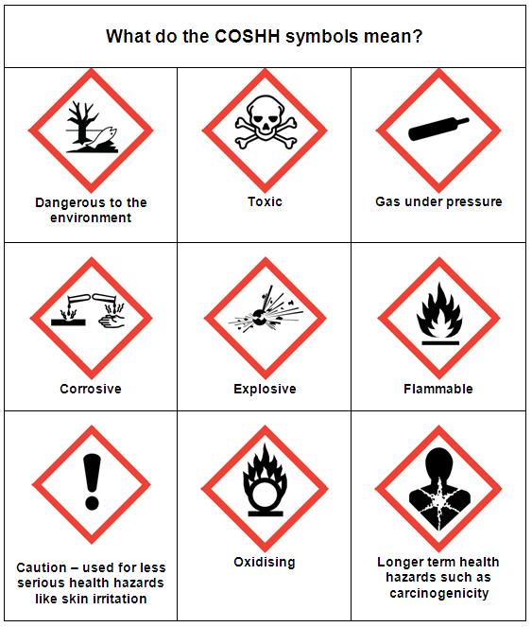
The COSHH symbols show the dangers of hazardous substances.

Learning activity

Ask your manager for a copy of your policy and procedure for COSHH and make some notes about your role and responsibilities.

Manager’s comments for section 7.8

Progress log – to be completed by the manager

7.8 Hazardous substances

How to store, use and dispose of hazardous substances safely

By completing the workbook activities in this section the worker has shown they know | Sign and date
What is meant by the term ‘hazardous substances’

What is meant by the term ‘Control of Hazardous Substances’

The types of hazardous substances that may be found in the workplace

Safe practice for: storing, using, dealing with spillages and disposing of hazardous substances

7.9 Security in the work setting

Good security measures help to keep you and the individuals you work with safe. This could include anything from safe entry and exit to your place of work to what needs to be in place if you’re employed as a lone worker. Your organisation will have policies and procedures for security in the workplace which you’ll need to be familiar with to protect yourself and others you work with.

Lone workers

Lone workers face the same hazards at work as anyone else, but there’s a greater risk of these hazards causing harm as you may not have anyone to help or support you if things go wrong. Employers must carry out a risk assessment for lone working and should consider:
- assessing areas of risk including violence, manual handling, the medical suitability of people to work alone and whether the workplace itself presents a risk to them
- requirements for training, levels of experience and how best to monitor and supervise lone workers to keep them safe
- having systems in place to keep in touch with workers and respond to incidents or accidents.

The Health and Safety Executive (HSE) says that employers must manage the risks to lone workers, including the risk of violence.

Lone working doesn’t always mean a higher risk of violence, but it does make workers more vulnerable. The HSE defines violence as “an incident in which a person is abused, threatened or assaulted in circumstances relating to their work.” This includes verbal threats. Verbal abuse and threats are the most common types of incident. Physical attacks are comparatively rare.

One of the main risks of workplace violence is late evening or early morning work. This applies to many of our domiciliary care workers in Wales.

Learning activity – security in the workplace

Read these case studies and answer the questions
Case study – Irena
Irena has just started her shift and she meets an angry visitor in the corridor who is looking for a member of staff to make a complaint about the way his friend is being cared for. He’s very angry and starts shouting at Irena.
Answer this question
- How should Irena deal with this situation?

Case study – Elaine
Elaine is a domiciliary care worker and her last call of the day is to Mr Evans, from 9pm to 10pm. Mr Evans lives in a terraced house in Cardiff and getting a parking space is sometimes a struggle. It’s dark and raining and Elaine is really pleased that she finds a parking space close to Mr Evans’ house. As she’s leaving at 10pm, she can see that one of the neighbours is waiting in the road to park their car. When they see Elaine, they get out of their car and are verbally abusive to her, shouting that she has no right to park there and if she does again, she’ll be sorry. Elaine feels intimidated and is shaken up by the incident.
Answer these questions
- What should Elaine do?

- What should her employers do?

Learning activity – policy and procedure
Ask your manager for a copy of your workplace policy and procedure for security in the workplace and describe your responsibilities here.

Manager’s comments for section 7.9

Progress log – to be completed by the manager

7.9 Security in the work setting

How to maintain security in the work setting

By completing the workbook activities in this section the worker has shown they know | Sign and date
Potential risks to security in the work setting

Safe practice to ensure security in the work setting

7.10 Managing stress

Being under pressure is a normal part of life. It can be a positive force that helps us to take action, feel more energised and get things done, but it can also be negative if we often feel overwhelmed, under too much pressure and overloaded. These feelings can affect our well-being and cause illness. We need to be able to recognise stress in our lives and know how to manage it so it doesn’t make us ill.

The HSE defines stress as “the adverse reaction people have to excessive pressures or the types of demand placed on them”.

Stress isn’t an illness in itself but it can make you ill, so it’s important to recognise the symptoms and take action. Some of the symptoms of stress are:

Physical
- Headaches or dizziness
- Muscle tension or pain
- Stomach problems
- Chest pain or a faster heartbeat
- Sexual problems.

Mental
- Difficulty concentrating
- Struggling to make decisions
- Feeling overwhelmed
- Constantly worrying
- Being forgetful
- Lack of motivation
- Lack of confidence.

Changes in behaviour
- Mood swings
- Being irritable and snappy
- Feeling tearful or sensitive
- Sleeping too much or too little
- Avoiding places or people and being withdrawn
- Drinking or smoking more.

There are some things you can do yourself to reduce the impact of stress on your well-being, such as:
- exercise
- eating well
- talking about your feelings
- keeping in contact with family and friends
- taking a break
- focusing on some positive things every day.
And most importantly, asking for help.
The NHS has excellent resources to help you cope with stress, such as breathing exercises plus links to other organisations like MIND and the Samaritans.
If you’re feeling stressed, because of your job or something more personal, the first step to feeling better is to identify the cause. This will help you start to identify the steps you can take to reduce it. Your employer also has a legal duty to assess risks to your health from stress at work. You should talk to your manager to let them know how you’re feeling and you can also talk to your doctor or other people you trust.
Learning activity – managing stress

Read this case study and answer the questions.

Case study – Ebube

Ebube is a new worker in a care home setting for children who are looked after. The manager of the setting has had a car accident and is on extended sick leave.

Ebube has only had a brief induction and isn’t able to shadow a more experienced worker as they’re so short staffed. She feels out of her depth and is exhausted by working long hours. On top of that, one of the young people is constantly verbally abusive towards her.

Ebube feels as though she’s failing at her new job. She isn’t sleeping well and is snappy and irritable at home with her own children.

Answer these questions

- What symptoms of stress is Ebube is showing?

- What actions could Ebube take?

- What actions should her employers take?

Manager’s comments for section 7.10

Progress log – to be completed by the manager

7.10 Managing stress

How to manage stress

By completing the workbook activities in this section the worker has shown they know | Sign and date
The common signs and indicators of stress

The circumstances that can trigger stress

Ways to manage stress

The importance of recognising stress and taking action to reduce it

Where to access additional support if experiencing stress

New worker declaration

I confirm that the evidence listed for the workbook is authentic and a true representation of my own work.

Learner’s signature:

Date:

Manager’s declaration

I confirm that the new worker has achieved all the requirements of the workbook with the evidence submitted

Manager’s signature:

Date:

Practice learning outcomes

These are the practice learning outcomes of the All Wales induction framework (AWIF). It may be helpful to ask your manager to complete these here rather than have a separate document to record evidence of how you apply your knowledge in your day-to-day work.

7.1 Health and safety in the workplace

7.1b AWIF practice learning outcomes:  You are able to work in ways that: | Evidence used | Signature and date
Meet your responsibilities in line with health and safety legislation

Adhere to your workplace policies and procedures for health and safety

Follow workplace processes for the recording and reporting of any concerns or incidents related to health and safety

7.2 Risk assessments for health and safety

7.2b AWIF practice learning outcomes:  You are able to work in ways that: | Evidence used | Signature and date
Are compliant with health and safety risk assessments for your workplace and procedures for reporting concerns or incidents

7.3 Fire safety

7.3b AWIF practice learning outcomes:  You are able to work in ways that: | Evidence used | Signature and date
Adhere to the procedures of your work setting that must be followed in the event of a fire

7.4 Moving and handling and moving and positioning

7.4b AWIF practice learning outcomes:  You are able to work in ways that: | Evidence used | Signature and date
Undertake safe moving and positioning and/or moving and handling in accordance with your training and in the context of your role

7.5 Emergency first aid

Note: workers in health and social care settings would be expected to attend an external first aid course to complete this area of learning if it is relevant to their role

7.5b AWIF practice learning outcomes:  You are able to work in ways that: | Evidence used | Signature and date
Attended emergency first aid training suitable to your role and know when it is appropriate to apply emergency first aid and when medical help needs to be sought

7.6 Infection prevention and control

7.6b AWIF practice learning outcomes:  You are able to work in ways that: | Evidence used | Signature and date
Follow good hygiene practice

Implement your workplace policies and procedures for infection prevention and control

Follow hand washing technique that is used to prevent the spread of infection

7.7 Food safety

7.7b AWIF practice learning outcomes:  You are able to work in ways that: | Evidence used | Signature and date
Follow your workplace policies and procedures in relation to food safety

7.8 Hazardous substances

7.8b AWIF practice learning outcomes:  You are able to work in ways that: | Evidence used | Signature and date
Follow your workplace policies and procedures for the storage, use and disposal of hazardous substances

7.9 Security in the work setting

7.9b AWIF practice learning outcomes:  You are able to work in ways that: | Evidence used | Signature and date
Adhere to arrangements that are in place to ensure that you, individuals and others are safe in the work setting

Adhere to workplace policies and procedures for lone working, advising of whereabouts and access to the work setting

7.10 Managing stress

7.10b AWIF practice learning outcomes:  You are able to work in ways that: | Evidence used | Signature and date
Using supervision to discuss your well-being with your line manager

Checklist for related workplace policies and procedures

Health and safety
Fire safety
Food safety
Moving and handling
Lone working
Managing stress
Infection prevention and control

Glossary

Aggressive behaviour can cause physical or emotional harm to others. It may range from verbal abuse to physical abuse. It can also involve harming personal property. In the context of security in the workplace, this relates to aggressive behaviour from members of the public rather than individuals.

Employer – in the case of foster carers or adult placement or shared lives carers, this is the agency. In the case of personal assistants, this would the person employing them to provide care and support.

Hand washing technique using current national and international guidelines.

Important relevant legislation that relates to health and safety include:

- The Health and Safety at Work etc. Act 1974
- The Management of Health and Safety at Work Regulations 1999
- The Workplace (Health, Safety and Welfare) Regulations 1992
- The Manual Handling Operations Regulations 1992
- The Provision and Use of Work Equipment Regulations 1998
- The Lifting Operations and Lifting Equipment Regulations 1998
- Reporting of Injuries, Diseases and Dangerous Occurrences Regulations 2013
- The Personal Protective Equipment at Work Regulations 1992
- The Control of Substances Hazardous to Health Regulations 2002 (COSHH).

Important legislation and standards related to infection prevention and control. You can find these on Public Health Wales' website - infection prevention and control.

Lone workers are people who work by themselves without close or direct supervision, for example:
- people who work from home
- people who work alone for long periods
- people who work outside of normal working hours
- health and social care workers who visit other premises.

How to carry out safe practice to ensure security in the work setting to include:
- lone working
- advising of whereabouts
- access to work settings
- dealing with incidents of aggressive behaviour.
Workplace is a setting in which care and support is provided, such as residential child care, the individual’s own home and foster care.
Worker is the person providing care and support or services to individuals.

www.hse.gov.uk
lawleaflet.pdf http://scw-intranet/Programmes/WorkforceProgrammeBoard/slearn/Projects/QUALIFICATIONS/AWIF Workbooks Digital edit 2022/lawleaflet.pdf (hse.gov.uk)
Statutory Guidance for service providers and responsible individuals on meeting service standard regulations for: • Care home services • Domiciliary support services • Secure accommodation services; and • Residential family centre services
Health and Safety in Care Homes | Health and Safety Executive 2014
https://www.hse.gov.uk/firstaid/faqs.htm#first-aid-box
https://www.hse.gov.uk/firstaid/faqs.htm#appointed-persons
IPC 2022 https://learning.nhs.wales/enrol/index.php?id=682
NIPCM - Public Health Wales https://phw.nhs.wales/services-and-teams/harp/infection-prevention-and-control/nipcm/
how to wash your hands nhs video https://www.bing.com/search?q=how+to+wash+your+hands+nhs+video&cvid=57762b0f390d4152bcea406bcbce13b4&aqs=edge.3.0l9.10066j0j1&pglt=43&FORM=ANNAB1&PC=U531
Homepage | Food Standards Agency https://www.food.gov.uk/
https://www.food.gov.uk/sites/default/files/media/document/foods-that-need-extra-care.pdf
Get help with stress - NHS https://www.nhs.uk/mental-health/feelings-symptoms-behaviours/feelings-and-symptoms/stress/
https://phw.nhs.wales/services-and-teams/harp/infection-prevention-and-control/

