





Consultation document

A social care research and development strategy for Wales 2017-2022

Consultation closes on 21 August 2017

Contents

Foreword 4

Executive summary 5

1. Introduction 8

2. Partners - Public, practitioners, researchers and policy makers 12

2. The strategic context 14

3. Overview 16

4. Focus area 1 – Involving the public in social care research 17

5. Focus area 2 - Research priorities 19

6. Focus area 3 - Use of existing and routinely collected data 20

7. Focus area 4 - Developing the workforce and organisations 22

8. Focus area 5 – Communication and use of research 25

List of abbreviations 28

Appendix 1 29

Health and Care Research Wales Guidelines for social care research 29

Appendix 2 30

Knowledge mobilisation pathway 30

Appendix 3 31

The Social Care Research and Development Sub Group membership 31

# Foreword

I am pleased to share this Social Care Research and Development Strategy, which is a draft for consultation - your views are important to us.

The draft strategy has been produced in partnership by Social Care Wales, a new national leadership body for the social care sector with Health and care research Wales and a wide range of stakeholders. We have published this strategy and are consulting on it on behalf of all those who have contributed to its development. The aim is to provide a coherent approach to improving the research capacity and capability in Wales.

This is the first time a collaborative approach has been used to develop a national strategy for research in social care and it has been pleasing to observe the contributions made, where public representatives have provided a strong voice to steer our work.

We are aiming to support practitioners, employers and researchers to better understand what works to support those who need protection, care and support.

Our ambition is to help improve well-being, through the application of evidence based policy, practice and service models in Wales, with a focus on prevention and early intervention. We know this is an ambitious plan and we will need to prioritise our activities, which are set out in the strategy.

Following consultation, the final strategy will be launched in the Autumn 2017.

I look forward to receiving your comments and observations.

Sue Evans

Chief Executive, Social Care Wales

On behalf of Social Care Wales Research Strategic Coordination Group

# Executive summary

In Wales, we believe the time is right for:

* a national co-ordinated approach to building social care research and development capacity
* realising the positive impact of research and development on social care policy, practice and improvement
* strengthening the links between social care research, social care policy, practice and improvement.

Wales’s legislation places an emphasis on high quality and sustainable social care provision that puts people’s well-being at the centre of their care and promotes prevention and early intervention. Excellent social care research can support the evidence base for practitioners to do this, as well as inform decision and policy makers.

There are many strengths we can build upon:

* the quality of social care research in Wales
* the strength of the social care improvement agenda
* Welsh Government’s commitment to giving people voice and control over the care and support they receive.

By working with the public, people who use care and support, and their carers, we will develop a better understanding of what research needs to be done and how it can have a positive impact where it matters.

This national strategy aims to bring social care practice and research closer by sharing and agreeing actions, responsibilities and accountability.

The strategy looks at five areas:

**Focus area 1** – Involving the public in social care research

**Focus area 2 –** Research priorities

**Focus area 3 –** Use of existing and routinely collected data

**Focus area 4 –** Developing the workforce andorganisations

**Focus area 5 –** Communication and use of research

Our responsibilities for leading social care regulation, workforce development and service improvement in Wales means we are perfectly placed to take this strategy forward in partnership with Health and Care Research Wales and the organisations it funds, such as the Wales School for Social Care Research.

#### Our vision is:

**For Wales to be internationally renowned for its excellent social care research that supports the people of Wales by informing and improving social care policy and practice.**

#### Putting the strategy into practice

Alongside this strategy, there will be an implementation plan that looks at how we put the recommendations into practice. It will also identify the roles and responsibilities of partners involved, and the impact and outcome measures for the next five years.

#### Recommended areas for action

1. Social Care Wales and Health and Social Care Research Wales will establish a clear governance framework for making decisions about social care research and deciding who is accountable for putting the research strategy into practice.
2. Social Care Wales, Health and Care Research Wales, the Wales School for Social Care Research and other research centres will work together to support social care research in Wales, to make sure we’re clear about the roles and responsibilities of the main research bodies.
3. Review the funding arrangements for social care research and develop a plan for funding the first five years of the strategy, which uses the current sources of research funding as effectively as possible.
4. Develop guidance around social care research ethics in Wales.
5. Social Care Wales, working with the Wales School for Social Care Research, Health and Care Research Wales, and the Health and Care Research Public Delivery Board, will develop an action plan that involves the public, people who use care and support and carers in social care research. This will build upon existing best practice.
6. Make sure social care practitioners have access to research findings and evidence in their workplace.
7. Work with main partners involved in the social care sector in Wales to develop an approach that addresses the main issues in social care practice, by analysing the evidence of best practice and developing good practice guidance.
8. Develop programmes of research for Social Care Wales’s three strategic improvement areas: care and support at home, people with dementia and children who are looked after.
9. Support research activity that explores research questions that effect both social care and health.
10. Carry out a scoping exercise around the potential of making better use of technology to improve the provision of social care.
11. Social Care Wales will develop a data set for social care in Wales that will be used to inform the planning, developing and monitoring of the social care sector.
12. Continue Health and Care Research Wales’s current programme of developing research capacity, by funding studentships and fellowships in social care that specifically focus on skills and subject areas considered a national priority.
13. Explore opportunities for undertaking joint appointments between the social care practice and research sectors.
14. Increase awareness of the use of research and research practice in social work and social care training.
15. Identify research champions within social care organisations in Wales and establish a support network for them.
16. Explore the potential for raising awareness of how research contributes to social care practice and policy development, by making use of existing awards for good practice in social care.

**Case study**

**The Keeping Safe? Research project** came about following discussions with a local authority about how to respond to child sexual exploitation (CSE). CSE is an emerging and rapidly developing area of social care practice and there is little evidence for practitioners about ‘what works’ or ‘what doesn’t work’.

This research aims to:

* investigate the outcomes for children and young people ‘at risk’ of sexual exploitation
* explore how to protect young people from experiencing harm because of CSE
* meet gaps in knowledge and inform effective prevention, early intervention and work with young people experiencing CSE.

Contact: This study is funded by Health and Care research Wales led by Dr Sophie Hallett, Cardiff University.

# 1. Introduction

#### Background

This strategy sets out a plan to position Wales as a leader in the development, conduct and implementation into practice, of excellent social care research.

Recent reports into social care across Wales have highlighted the importance of investment in social care research to advance a responsive and quality social care agenda[1],[2]. The case for this emphasis is at many levels. Research can support social care to stay abreast of changing factors (demographic, cultural, technological, social and economic) and meet diverse and changing needs. It provides an evidence base to evaluate service and practice interventions and policy initiatives; and can identify and develop new approaches to providing care and support.

The development of a significant and new legislative framework in Wales, with a focus on early intervention and sustainability, provides a base for social care in Wales[3]. Reorientation to effective prevention and early intervention needs to be informed by a better understanding of what helps people and communities to

achieve wellbeing. It is further recognised that existing approaches to the care and support of children, families and vulnerable people are no longer sustainable[4]. The capacity to respond to such a requirement in Wales is a priority, particularly for local authorities in Wales in assisting in defining the development of the sector over the next five years, and in ways that are responsive to geographical and population diversity.

Basing social care decisions on evidence about what works, and where, allows limited resources to be focused where they will be most effective, and can lead to new ways of working that can improve care, outcomes, and productivity. A dynamic and innovative Research and Development (R&D) culture can also create a better environment for social care and health professionals to work and develop, with more potential to attract and retain high calibre staff and attract investment from industry.

In summary, research can make a number of direct and indirect contributions to the social care and wider economic landscape:

Provide a strong evidence enriched base for social care practitioners to work with individuals, families and communities.

Support policy makers, social care organisations and practitioners to keep up-up-date with wider demographic, economic, technological and social trends.

Support the identification of cost effective and quality interventions for service development.

Provide a unique vehicle by which members of the public, service users, carers and professionals can agree service and practice priorities.

Develop stimulating and innovative service and academic environments.

* Explore the development of ethical emerging technologies to adapt to the changing landscape of social care.
* Contribute to the national economy by bringing new resources into Wales and making sure resources are directed to cost effective and quality services.

Against this backdrop, the *Social Care Research and Development Strategy for Wales (2017-2022)* is an overarching national strategy designed to formally link social care research and practice through shared and mutually agreed actions, responsibilities, and accountability.

This strategy outlines goals and objectives for the next five years to advance the social care research agenda in Wales.

#### What is social care research?

The Social Care Institute for Excellence (SCIE) defines research as 'a form of systematic enquiry that contributes to knowledge'[5]. This knowledge can contribute to the development of ideas and theories, formulation of government policy, local decision making and social care practices. Social care research will take different forms, and will be shaped by the context of the research, the research questions being investigated, and the perspectives on knowledge. It is informed by values of human rights, social participation and inclusion and access.

Research can involve quantitative methods (e.g. quantitative surveys, outcome focused studies, socio-economic analysis); qualitative research methods (participatory action research, ethnographic research, focus groups, and interviews); and systematic reviews of existing literature[6].

Social care research will seek to develop knowledge in a broad range of areas[7]:

* Macro level (e.g. the socio-economic factors that impact on social care needs; national and local policies; models of social care delivery);
* Community level (e.g. early intervention and prevention; social and community cohesion); and
* Individual level (e.g. protection and social support services, care, support and personal assistance).

This breadth is shown in the diagram below.

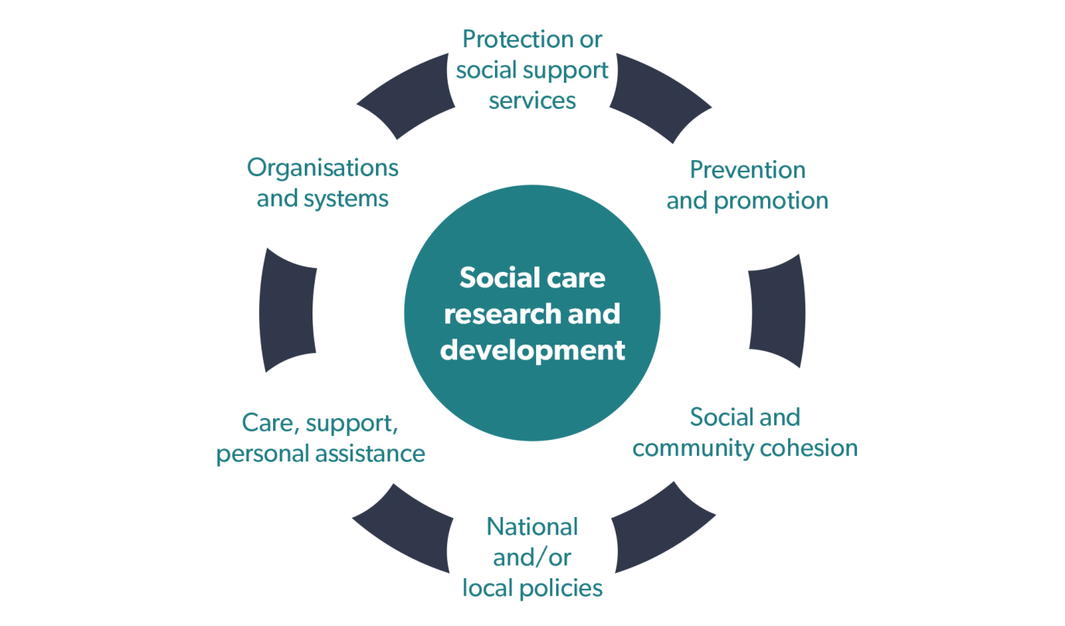

**Case study**

**Wales Kidney Research Unit** - **Linking health and social care**

The multi-disciplinary health and social care renal team includes clinicians, specialist nurses, renal social workers, renal pharmacists and renal psychologists. We undertook two systematic reviews to identify renal social care priorities. There was a clear gap in published renal social care research.

**Supporting care home residents to drink enough fluids to prevent acute kidney injury**

Using evidence, Owain Brooks, pharmacist from Morriston Hospital Swansea, is introducing and evaluating a range of interventions in care homes, such as blue tableware (cups, mugs, jugs etc.) as a visual prompt for older people and staff to drink enough fluids, and redesigning some care home food, fluid and medical record systems.

‘Kidney stickers’ are placed on medication administration record charts alongside medication known to damage the kidneys in acute dehydrating illness. Evidence, practice and evaluation are working together to support well-being.

More at: <http://kidneyresearchunit.wales/en/social-care-research.htm>

# 2. Partners - Public, practitioners, researchers and policy makers

Key partners and audiences for this *Social Care Research Strategy for Wales* include;

* members of the public;
* people using services and carers;
* social care practitioners and employing organisations;
* umbrella groups;
* universities/higher education institutions;
* social care researchers;
* government policy makers;
* industry; and
* third sector organisations.

#### 2.1 Public and service user and carer involvement

is a foundation stone of this strategy reflecting the importance of public views and service user and carer involvement in social care research.

#### 2.2. Social care and social work practitioners and social care providers

are a key audience in the realisation of the ambition of this strategy. They include practitioners across government, non-government and private sectors working in social care settings. The creation of Social Care Wales has created the formal structures through which research and practice can work together more closely, aligning mutual goals to ensure that research funding and activity is more transparent; better coordinated and better targeted; and that evidence is disseminated and implemented more effectively.

#### 2.3 Social care researchers

are located in Welsh universities, government departments, local authorities and umbrella groups (i.e. Welsh Local Government Association (WLGA)); the third sector, and private researchers and organisations.

UK collaborators include the Social Care Institute for Excellence (SCIE); Improving Lives Through Knowledge, Evidence and Innovation (IRISS) in Scotland; Health and Social Care (HSC) Research and Development in Northern Ireland; the National Institute for Health Research (NIHR) School for Social Care Research in England; and various professional bodies.

Governments at national and local levels are key players in the development and use of social care research to inform policy development, decision making, resource use and service development and provision. In addition, government are the primary commissioners and funders of social care research in Wales. Within Welsh Government, social care research capacity building is led by Health and Care Research Wales which commits around £1.5m per year directly to support social care research projects and initiatives. It has made over 78 social care research funding awards since 2005 with a total value of more than £8.7m, and funds a national research infrastructure to conduct and support high quality health and social care research across Wales. More small scale projects are directly commissioned by Welsh Government researchers to inform the development and evaluation of social care legislation and policies.

# The strategic context

The development of this strategy has been informed by Welsh public policy.

Key policy areas are:

3.1 The Welsh Government is developing strategies to create a Wales that is: Prosperous and Secure; Healthy and Active; Ambitious and Learning; and United and Connected. Through those four areas, Welsh Government will contribute to the seven well-being goals set out in the *Well-being of Future Generations (Wales) Act* (2015): to make Wales a prosperous, resilient, healthier, more equal and globally responsible country with cohesive communities, [8] with a vibrant culture and a thriving Welsh language. Knowledge and learning are central to these agendas.

3.2 The Welsh Government’s approach to social care is set out in *The Social Services and Wellbeing (Wales) Act* (2014), which emphasises a preventative approach to care and support through early intervention and increased integration. It requires statutory partnerships to be created between local authorities and health boards to drive integration, innovation and service change. Further integration of public services will also be promoted through the *Wellbeing of Future Generations (Wales) Act*, which requires local authorities, health boards, and other public services to form Public Service Boards to assess and promote local wellbeing.

3.3 Supporting information for *The* *Social Services and Wellbeing (Wales) Act* was published in *The Future of Regulation and Inspection of Care and Support in Wales* (Welsh Government, 2014). This document outlined the creation of a new organisation with a clear remit for leading on social care improvement, whilst supporting social care research capacity building and the dissemination of evidence and best practice through collaborative and partnership working. The organisation was later branded Social Care Wales.

Social Care Wales, Health and Care Research Wales and the Wales School of Social Care Research will have a critical role in implementing the strategy.

**Key players**

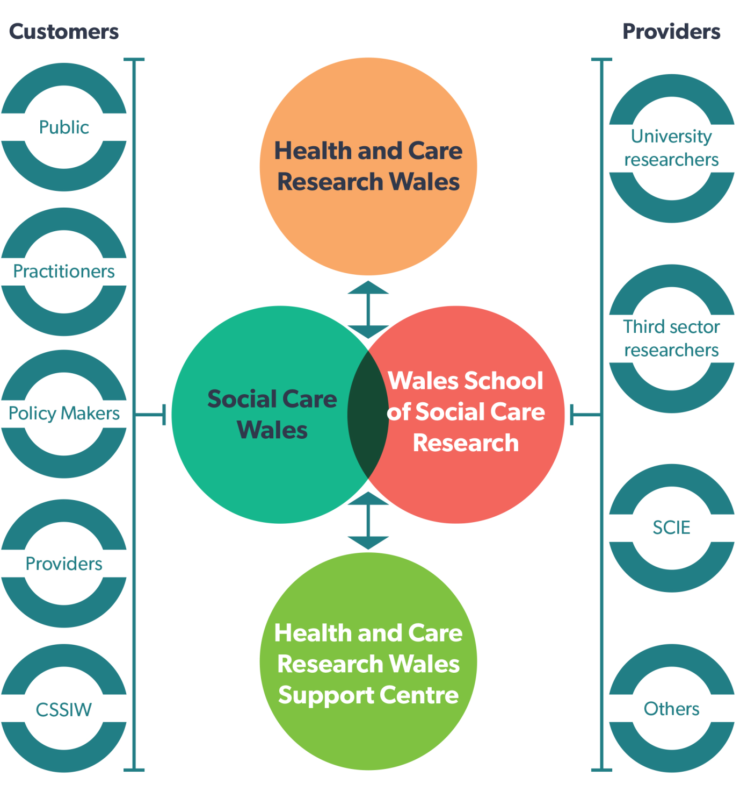

# Overview

This strategy sets out a direction and the steps needed to achieve the following aim:

* For Wales to be internationally renowned for its excellent social care research that supports the people of Wales by informing and improving social care policy and practice.

It looks at five areas:

**Focus area 1** – Involving the public in social care research

**Focus area 2 –** Research priorities

**Focus area 3 –** Use of existing and routinely collected data

**Focus area 4 –** Developing the workforce andorganisations

**Focus area 5 –** Communication and use of research

For each area, we have included reasons why the issue is important and an overview of what we will do.

# Focus area 1 – Involving the public in social care research

# 

#### Why is this important?

This strategy is built upon a firm and clear commitment to public ‘voice and control’ and co-production in policy, practice and research, as articulated in Welsh Government legislation and policy guidelines. This includes involving people with experiences as service users and carers.[9] Their involvement is important in achieving high quality, useful and effective social care research[10]. This has benefits in determining research questions, how research is best conducted, and in processes of translating research findings to make a difference in social care.

Across Wales, there are many examples of strong public involvement and co-production. Social care services have processes for active public involvement, as do third sector organisations. There are networks active across Wales. Welsh Government’s funded infrastructure-Health and Care Research Wales-supports and enables public and service user and carer involvement in social care research. Some examples are the Involving People Network and the Health and Care Research Wales Public Delivery Board.

A priority of the *Health and Care Research Wales Strategic Plan* is to facilitate and enable wider public involvement, engagement and participation in health and social care research. This includes awareness raising; creating opportunities for the public to engage with research, facilitating and supporting that engagement, and establishing Wales as a centre of excellence for active and meaningful public involvement and engagement in research*.[11]*

Across Welsh universities are examples of active public involvement in research development and research studies, such as CASCADE Voices (Cardiff University in partnership with Voices from Care Cymru).

#### What we will do

This focus area has four objectives, which will be achieved through co-production amongst the main partners involved in implementation.

**Objective 1:** Foster social care research cultures where there is authentic and meaningful public, service user and carer involvement in the development of social care research questions, how research is conducted, and how research is communicated and used.

**Objective 2**: Support the research and social care policy and practice sectors, to share and build on good practices of public and service user and carer involvement in social care research.

**Objective 3:** Explore good practices of public and service user and carer involvement in generating and agreeing priority areas for social care research.

**Objective 4**: Collaborate to develop communication strategies regarding the benefits and purpose of public, service user and carer involvement in social care research, including using various media.

**Case study**

**Involving the public in social care research**

CASCADE Voices is a group of care-experienced young people who advise on research and take part in conducting studies as peer researchers, having received training in research methods from staff at the Children’s Social Care Research and Development Centre (CASCADE) at Cardiff University.

<http://sites.cardiff.ac.uk/cascade/people/young-peoples-advisory-group/>

The CASCADE research project commissioned by Welsh Government, on looked-after children’s experience of education, involved the production of videos about the research findings and also music videos made by young people with experience of being in care, as well as articles in peer-reviewed journals. The project was conducted in partnership with Voices from Care, the Fostering Network and the time credit organisation Spice.

<http://sites.cardiff.ac.uk/cascade/looked-after-children-and-education/>

# Focus area 2 - Research priorities

#### Why is this important?

Critical to the success of any research programme is targeting scarce resources onto a small number of key priority areas so there is a concerted and consistent focus on making progress in those areas. In establishing Social Care Wales the Minister for Health and Social Services agreed that the new body should focus on:

* Care and support at home
* Looked after children, and
* Dementia

Within these areas is a focus on prevention and early intervention. While these priorities do not preclude improvement and research in other areas, the above should be the national strategic priorities for research for the next five years and co-ordinated programmes of research should be developed.

For the longer term, the creation of an equitable, accessible and transparent process to generate and agree research priorities will be needed. Critical to this will be bringing together meaningful input from the public along with the views of the Regional Partnership Boards for social care and health established through the *Social Services and Wellbeing Act*, the views of providers and practitioners and those of Government and researchers.

#### What we will do

This focus area has two objectives, to be achieved by partners involved in implementing this strategy working together. Social Care Wales will lead the researchprioritisation process through providing a bridge between the social care sector and the research community. The process will constitute a key part of the governance framework to be further developed between Social Care Wales and Health and Care Research Wales in 2017.

**Objective 1**: Maximise the best use of scarce social care research resources by concentrating efforts on the Social Care Wales strategic agenda to focus on the areas of:

* Care and support at home
* Looked after children, and
* Dementia

**Objective 2:** Through the leadership of Social Care Wales, design and instigate an accessible, transparent, and co-productive model for generating and prioritising research areas through a systematic and inclusive process.

# Focus area 3 - Use of existing and routinely collected data

#### Why is this important?

Information routinely collected as part of existing social care data systems is a rich source of knowledge that informs the development and quality of social care improvement and public policy formulation. Existing data is collected for various purposes; some examples are data for service planning and evaluation and performance management. This information can be used to paint a broader picture of gaps, patterns or trends (e.g. in service delivery, population needs or in resource allocations). It can also inform future research questions.

In addition to demonstrating gaps and trends by analysing routinely collected data, bringing together existing data from a variety of sources beyond social care (i.e. health, housing and economic data) widens the opportunities to inform knowledge about social care needs and issues, and pathways to improvement. In particular the linkage of existing data from these data sources can provide an inexpensive but effective means by which relationships between demand, service delivery and impact, in terms of outcomes for individuals and populations, can be assessed at a national, regional and local level. In Wales a key opportunity in data linkage is SAIL (The Secure Anonymised Information Linkage Database) which safely houses de-identified data from a variety of information sources.

Bringing together existing data on the demand and supply of social care; linked to outcomes for those who need care and support, will benefit services and researchers. It will provide a national view of the position of social care as well as opportunities for evaluating, monitoring and researching the relationship between service activity and outcomes for users.

#### What we will do

This focus area has three objectives. They will be achieved through the strategy’s main partners working together.

**Objective 1:** Establish a Social care data access and use working group to bring together key players in the social care arena who have an interest/role to play in this area.

**Objective 2**: Establish a collaborative process with SAIL to explore the feasibility and mechanisms to link social care data into the SAIL databank[12] and data from other sectors such as education, public health and housing.

**Objective 3**: A National Social Care Data Set for Wales will be established comprising data drawn from a range of existing and planned routine data gathering exercises, with Social Care Wales managing a data repository for social care aggregate data.

**Case study**

**Data linkage in social care: a pilot project**

Existing data linkage projects in Wales have primarily focused on health datasets. The aims of this pilot project, funded by NISCHR (2013-2015), were to:

1. test the feasibility of linking routinely collected health, social care and third sector data at an individual level using the Secure Anonymised Information Linkage (SAIL) system;
2. build a more complete picture of service provision using adults referred to social services to avoid hospital admission or to facilitate hospital discharge;
3. assess the range and quality of data available in each of the organisations providing services to those individuals.

**A Bangor University lead** research team, partnered with Gwynedd Local Authority, explored the governance issues and practicalities of providing an anonymised dataset to the SAIL databank. Two third sector agencies were also approached. With the required service level agreements in place, data were put through the SAIL process.

Results show that it isfeasible to link large amounts of health data in the SAIL databank with social services and third sector data for research purposes. The data provided by social services is in the form of coded and structured labels with a high level of consistency. The high matching success rate (96.4%) suggests the data are of excellent quality.

Contact: Dr Alison Orrell, Bangor University

# Focus area 4 - Developing the workforce and organisations

#### Why is this issue important?

Achieving the ambition of this strategy has implications for culture and practices within social care organisations and research environments. Central to its success will be the development of a skilled research workforce, with expertise in all relevant academic disciplines, and which can cross traditional boundaries between academia and practice. A further group in the social care workforce is those practitioners and policy makers who wish to use research evidence and evaluations to support their practice or to improve service effectiveness. There is also a need to enhance research minded cultures within social care organisations.

Presently, social care research expertise in Wales is situated almost exclusively within the Welsh universities. Overall, there is a need to increase the number of social care researchers of national and international standing in Wales who can undertake high quality research. This will attract additional resources to the country, assist with the development of new researchers, and attract additional talent to Wales.

To achieve this, we need to encourage new social care researchers, develop existing social care researchers and draw new researchers from other fields (e.g. psychology, public health or health economics) to a research career in social care. We also need to ensure that social care professionals who want to move into academia are provided both with opportunities to do so, and the skills to conduct high quality research once they get there. There is also a need for skilled practitioner-researchers who straddle the academic and practice arenas.

Two primary obstacles can be identified which reduce the capacity of practitioners to work in this way. First, is the availability of time within their work schedules. Second, evaluation and research methods and the use of evidence in practice receive limited attention in social work qualifying training, and even less in the training for other social care practitioner groups. These challenges need to be addressed in the review of the social work qualifying training led by Social Care Wales and the development of new qualifications for the social care workforce. Related is the issue of reviewing ethics and permissions processes for social care researchers and implementing clear and accessible ethical guidelines for research conducted outside the jurisdiction of the Welsh universities.

Although the Continuing Professional Education and Learning (CPEL) programme currently enables social work practitioners to undertake small pieces of research, opportunities for practitioners to undertake larger studies are limited and those for practitioner groups beyond social work even more so. There is a need to encourage and support practitioners who wish to undertake small projects to inform their practice or wish to make full use of research findings to inform their practice. This could be through conducting small projects or literature reviews on discrete areas of practice or service delivery. There is a need to develop individuals who can either lead or support applications for both small and large scale grants to undertake practice-relevant research in the workplace. Developing and supporting skilled practitioner-researchers, and providing them with opportunities to develop and lead large-scale projects are therefore a key area for this strategy. The creation of relevant posts and the development of individuals to fulfil these functions will require both organisational commitment and leadership, and the development of research minded cultures.

Finally, capacity is lacking in Wales in some key academic areas related to social care. First, there is limited ability to undertake economic analysis at practice/service and national or regional levels. At a time when the efficient and effective use of resources is at a premium, this deficit places the social care sector at a major disadvantage in debates regarding resource provision and accountability for resource usage. Second, there is limited capacity for policy and strategy analysis, particularly the capacity to undertake such studies in relatively short time frames while remaining rigorous in terms of methodologies. This is an area of particular concern to social services departments in Wales and results in a significant proportion of such work being commissioned from outside Wales.

#### What we will do

This focus areahas seven objectives, to be achieved by the strategy’s main partners working together.

**Objective 1**: Through a range of actions develop both skilled social care practitioner researchers who can bridge academic and practice and policy worlds, and practitioners in the workplace who undertake research to inform practice and service improvement.

**Objective 2**: Develop a skilled research workforce of national and international standing that can undertake high quality research.

**Objective 3**: Through the work of the Wales School for Social Care Research (DEEP program -Developing Evidence Enriched Practice) and the ExChange model, support connections and bridges between research institutions and policy and practice settings to support facilitating research- minded social care organisational cultures.

**Objective 4**: Support the development of tools and processes for social care practitioners to engage with evaluation and research in their setting.

**Objective 5**: Support the development of incentives to engage in research drawing on examples in clinical health research such as time awards for NHS clinicians.

**Objective 6:**  Actively support and showcase the value of social care research and reflect this in the funding for social care research.

**Objective 7:** Review ethics and permissions processes for social care researchers.

**Case study**

**Workforce and organisational development**

Consultant social workers in Wales take a lead in developing evidence informed practice and supporting development through the balance of practice, research and mentoring.  Their experience, commitment to practice, and development of expertise, combined with the mentoring and coaching part of their role leads to more effective interventions with individuals, families and groups. Evidence is growing about the contribution of consultant social workers to research cultures within social care workplaces.

**The CPEL (Continuous Professional Education and Learning)** framework is a suite of programmes that has been designed to support career pathways for social workers in Wales. The CPEL framework has been commissioned and approved by Social Care Wales, and is delivered by an alliance between Cardiff, Bangor, Glyndŵr and Swansea Universities.

The three programmes are designed for social workers at different stages in their career but the framework is shaped to allow practitioners to extend their knowledge and expertise while remaining in practice. There is an unrelenting focus on practice throughout all modules, and an opportunity to engage in a research project with relevance to practice. The programmes are delivered using a mixture of face-to-face and distance learning, including online learning. The rationale for this is to allow flexibility for hard-pressed practitioners as well as equality of access across Wales.

For more detail on the programmes and accompanying material please go to the CPEL website [www.cpel.ac.uk/](http://www.cpel.ac.uk/)

# Focus area 5 – Communicating and using research

#### Why is this issue important?

A major challenge for social care is ensuring practitioners and policy makers have access to the results of research evidence, so that policy and practice, as well as service organisation and delivery, take into account the best available research evidence. For evidence dissemination to be effective, a culture of research mindedness within social care organisational environments is also required, so that staff are both able and motivated to engage with research and make use of it. There is also a need to overcome the perception that individuals operate either as researchers or practitioners, but not both. The view of practitioners as passive recipients of research findings also needs to be overcome.

Another challenge is the question of how to enable access to research evidence in an understandable format that enables organisational leaders and practitioners to inform practice. For example, the way that research is communicated can create barriers to its adoption by those without research backgrounds. Individuals working in social care are also often restricted in their ability to access academic journal articles and some research data-bases. Also, time pressure in social care work schedules is a recognised issue.

A number of steps can be taken to address these challenges. The *Knowledge Mobilisation Pathway* developed jointly by Health and Care Research Wales and Social Care Wales (Appendix 2) provides a structured process through which existing resources can be harnessed and coordinated to provide evidence syntheses to support policy development, and to fund new research where knowledge gaps are identified.

Furthermore, as recommended in *Mobilising the use of research into practice for impacts on health and wealth*[13], social care organisations need to develop their own internal processes and mechanisms to support knowledge dissemination and bridge building between research, practice and policy. In addition, researchers should aim to engage with the social care sector to maximise the utility and impact of their research. This will help researchers meet the requirements of the Higher Education UK Research Excellence Framework (REF), and to produce evidence with the potential to inform and improve social care organisation and practice.

Responsibility for this area is shared across a number of stakeholders. First, research funders such as Health and Care Research Wales need to prioritise applications for funding with the potential to produce evidence that is relevant and useful to social care. Second, researchers need to disseminate their research findings and try to undertake research with the potential to have an impact on social care. Third, social care organisations need to ensure staff are able and supported to access research evidence and use it in practice.

This strategy takes the view that many of these challenges can be overcome through establishing regular and effective dialogue between people working in practice and policy development, and those undertaking research. A concerted effort is required to create structures and processes to support on-going communication between those communities.

#### What we will do

This focus area has five objectives, to be achieved by the strategy’s main partners working together.

**Objective 1**: Through the Wales School for Social Care Research and Social Care Wales, develop and support on-going formal arrangements for social care researchers, leaders, and practitioners to regularly engage in focused dialogue to develop much stronger links between research and practice.

**Objective 2:** Adopt the Knowledge Mobilisation Pathway (Appendix 2) as standard working practice in strategy development, ensuring that all new Social Care Wales strategies are developed following a review of the best available research evidence.

**Objective 3:** Develop a range of strategies for practitioners and organisations to access research evidence including SCIE resources and online data bases and resources.

**Objective 4:** Publish guidance to encourage and support social care organisations to develop research mindedness and improve research knowledge dissemination.

**Objective 5:** Support social care researchers to plan for maximum utility and impact, and help researchers to effectively communicate their research results to the practice sector (following the Recommendations of the Academic Health Sciences Collaboration (AHSC) Knowledge Transfer Task and Finish Group to Health and Care Research Wales).[14]

**Case study**

**Developing Evidence-Enriched Practice (DEEP), Wales School for Social Care Research**

DEEP is a Welsh initiative that has, at its heart, the motivation to make the world a better place. DEEP uses a range of techniques within an appreciative, democratic, narrative and dialogue-based approach to learning and development. This process comes alive when different sorts of knowledge, including research, come together to enrich practice.

The DEEP approach has five elements, all of which need to be addressed.

**Element 1**: Valuing and empowering all of the people involved in a project.

**Element 2:** Valuing and using a range of evidence.

**Element 3:** Preparing the evidence, so that it is interesting and relevant.

**Element 4:** Facilitating the exploration and use of evidence.

**Element 5:** Recognising and addressing the national and local organisational circumstances and obstacles.

Contact *-* Nick Andrews [N.D.Andrews@Swansea.ac.uk](mailto:N.D.Andrews@Swansea.ac.uk)

## List of abbreviations

|  |  |
| --- | --- |
| ADSS Cymru | Association of Directors of Social Services Cymru |
| AHSC | Academic Health Sciences Collaboration |
| CASCADE | [Children's Social Care Research and Development Centre](http://sites.cardiff.ac.uk/cascade/) |
| CPEL | Continuing Professional Education and Learning |
| CSSIW | [Care and Social Services Inspectorate Wales](http://cssiw.org.uk/?lang=en) |
| DEEP | Developing Evidence Enriched Practice |
| NHS | National Health Service |
| NISCHR | National Institute for Social Care and Health Research- (Predecessor to Health and Care Research Wales) |
| R&D | Research and development |
| SCIE | Social Care Institute for Excellence |

# Appendix 1

## Health and Care Research Wales Guidelines for social care research

According to Health and Care Research Wales Guidelines*[15]* social care research should broadly focus on at least one of the following:

* The provision of care, support, and personal assistance in the context of interpersonal relationships, whether formal or informal, in relation to: activities of daily living, maintenance of independence, social interaction, enabling the individual to play a fuller part in society, assisting individuals to manage complex relationships, and assisting the individual to access or receive services from a care home or other supported accommodation or to take advantage of educational facilities.
* The provision of: advice; practical assistance in the home; assistance with equipment and home adaptions; visiting and sitting services; meals; or facilities for occupational, social, cultural and recreational activities outside the home.
* The provision of: protection or social support services for children or adults in need or at risk, or those with social needs arising from illness, disability, age or poverty.
* The social needs of people receiving social care, and the services or initiatives addressing those needs, including: prevention of deterioration; promotion of physical or mental health; improving opportunities and life chances; strengthening families; and protecting human rights.
* The organisational systems, infrastructures, care settings, and/or personnel involved in the management and leadership, commissioning, provision, delivery, monitoring and evaluation of care and support services, and/or the interface between; or impact of the above on related systems such as healthcare, education, housing, and the criminal justice system.

# Appendix 2

## Knowledge mobilisation pathway

## 

# Appendix 3

## The Social Care Research and Development Sub Group membership

|  |  |  |  |
| --- | --- | --- | --- |
| **Name** | **Position** | **Organisation** | **Representing** |
| Chris Cottrell-Jones | ‎Senior Research Permission Service Manager | Health and Care Research Wales Support Centre | Health and Care Research Wales Support Centre |
| Gerry Evans | Director of Regulation and Professional Standards  Sub-Group Co-Chair | Social Care Wales | Social Care Wales |
| Craig Greenland | Well-being and improvement Senior Manager | Social Services and Integration Division | Health and Social Services, Welsh Government |
| Beverley Luchmun | Social Care Lead | Health and Care Research Wales Support Centre | Health and Care Research Wales Support Centre |
| Bob McAlister | Public Member | Public Involvement | Public Involvement |
| Eleri Quayzin | Policy Manager (Secretariat) | Health and Care Research Wales, Welsh Government | Health and Care Research Wales, Welsh Government |
| Professor Jonathan Scourfield | Deputy Head of School | Cardiff School of Social Sciences | Cardiff School of Social Sciences |
| Bethan Sherwood | Well-being improvement Senior Policy Manager | Social Services and Integration Division | Health and Social Services, Welsh Government |
| Lucy Treby | Consultant Social Worker | Barnados, Newport Children and Young Person Services | Barnados, Newport Children and Young Person Services |
| Dr Dan Venables | Head of Social Care R&D and Public Involvement | Health and Care Research Wales, Welsh Government | Health and Care Research Wales, Welsh Government |
| Professor Fiona Verity | Director, Wales School for Social Care Research  Sub-Group Co-Chair | College of Human and Health Sciences, Swansea University | College of Human and Health Sciences, Swansea University |
| Naomi Alleyne | Director of Social Services and Housing | Welsh Local Government Association (WLGA) | WLGA |
| Suzanne Clifton | Head of Business Development | Vale of Glamorgan Council | ADSS |
| Donna Davies | Policy Advisor to the Chief Inspector | Care and Social Services Inspectorate Wales | Care and Social Services Inspectorate Wales |
| Sue Evans | Chief Executive | Social Care Wales | Social Care Wales |
| Alex Hills | Acting Head, Health and Care Research Wales Support Centre | Health and Care Research Wales(Support Centre) | Health and Care Research Wales(Support Centre) |
| Melanie Minty | Policy Advisor | Care Forum Wales | Care Forum Wales |
| Professor Catherine Robinson | Professor of Social Policy Research | Bangor University | Bangor University |

**Contact details**

**Social Care Wales**

South Gate House

Wood Street

Cardiff

CF10 1EW

Tel: 0300 3033 444

Minicom: 029 2078 0680

Email: info@socialcare.wales

[**socialcare.wales**](http://socialcare.wales)

Twitter: @SocialCareWales

© 2017 Social Care Wales

Consultation draft

All rights reserved. No part of this publication may be reproduced, stored in a retrieval system or transmitted in any form or by any means without the prior written permission of Social Care Wales. Enquiries for reproduction outside the scope expressly permitted by law should be sent to the Chief Executive of Social Care Wales at the address given above.

**Other formats:**

This document is available in large text or other formats, if required.

Copies are also available in Welsh.

1. Independent Commission on Social Services in Wales (2010). *From Vision to Action: The Report of the Independent Commission on Social Services in Wales*.
2. National Institute for Social Care and Health Research (NISCHR) and Academic Health Sciences Centre (AHSC), *Mobilising the use of research into practice for impacts on health and wealth – Recommendations of the AHSC Knowledge Transfer Task and Finish Group to NISCHR,* Welsh Government.
3. Welsh Assembly Government (2007). *A Strategy for Social Services in Wales over the Next Decade: Fulfilled Lives, Supportive Communities*. February.

   Welsh Assembly Government (2011). *Sustainable Social Services: A Framework for Action.*

   White Paper (2014). *The Future of Regulation and Inspection of Care and Support in Wales.* Welsh Government, WG19628.

   Welsh Assembly Government (2014). *Social Services and Wellbeing (Wales) Act 2014*.

   Welsh Assembly Government (2015). *Well-being of Future Generations (Wales) Act 2015.*
4. Independent Commission on Social Services in Wales (2010). *From Vision to Action: The Report of the Independent Commission on Social Services in Wales*.
5. <http://www.scie.org.uk/publications/researchmindedness/whyrm/whatisresearch>
6. SCIE, Ibid.
7. See *Appendix 1* for the full description of the Health and Care Research Wales Guidelines for Social Care Research.
8. Welsh Assembly Government (2007). *A Strategy for Social Services in Wales over the Next Decade: Fulfilled Lives, Supportive Communities*.

   Welsh Assembly Government (2011). *Sustainable Social Services: A Framework for Action.*

   White Paper (2014). *The Future of Regulation and Inspection of Care and Support in Wales.* Welsh Government, WG19628.

   Welsh Government (2014). *Social Services and Wellbeing (Wales) Act 2014*.

   Welsh Government (2015). *Well-being of Future Generations (Wales) Act 2015*
9. Commission on Public Service Governance and Delivery: *Summary Report.* Welsh Government; January 2014.
10. Brett, J., Staniszewska, S., Mockford, C., Herron-Marx, S., Hughes, J., Tysall, C., and C. Suleman, R. (2014) Mapping the impact of patient and public involvement on health and social care research: a systematic review, *Health Expectations pp.1-14.* 
11. https://www.healthandcareresearch.gov.wales/public-engagement-involvement-and-participation/
12. (Secure Anonymised Information Linkage Database*) https://saildatabank.com/*
13. National Institute for Social Care and Health Research (NISCHR) and Academic Health Sciences Centre (AHSC), (2014) *Mobilising the use of research into practice for impacts on health and wealth – Recommendations of the AHSC Knowledge Transfer Task and Finish Group to NISCHR,* Welsh Government.
14. National Institute for Social Care and Health Research (NISCHR) and Academic Health Sciences Centre (AHSC), *Mobilising the use of research into practice for impacts on health and wealth – Recommendations of the AHSC Knowledge Transfer Task and Finish Group to NISCHR,* Welsh Government.
15. <https://www.healthandcareresearch.gov.wales/research-support/>