Case studies and examples (information sharing)
https://ico.org.uk/for-organisations/uk-gdpr-guidance-and-resources/data-sharing/case-studies-and-examples/

Slide number | Slide | Notes | References | Suggested follow-up Learning
1 | 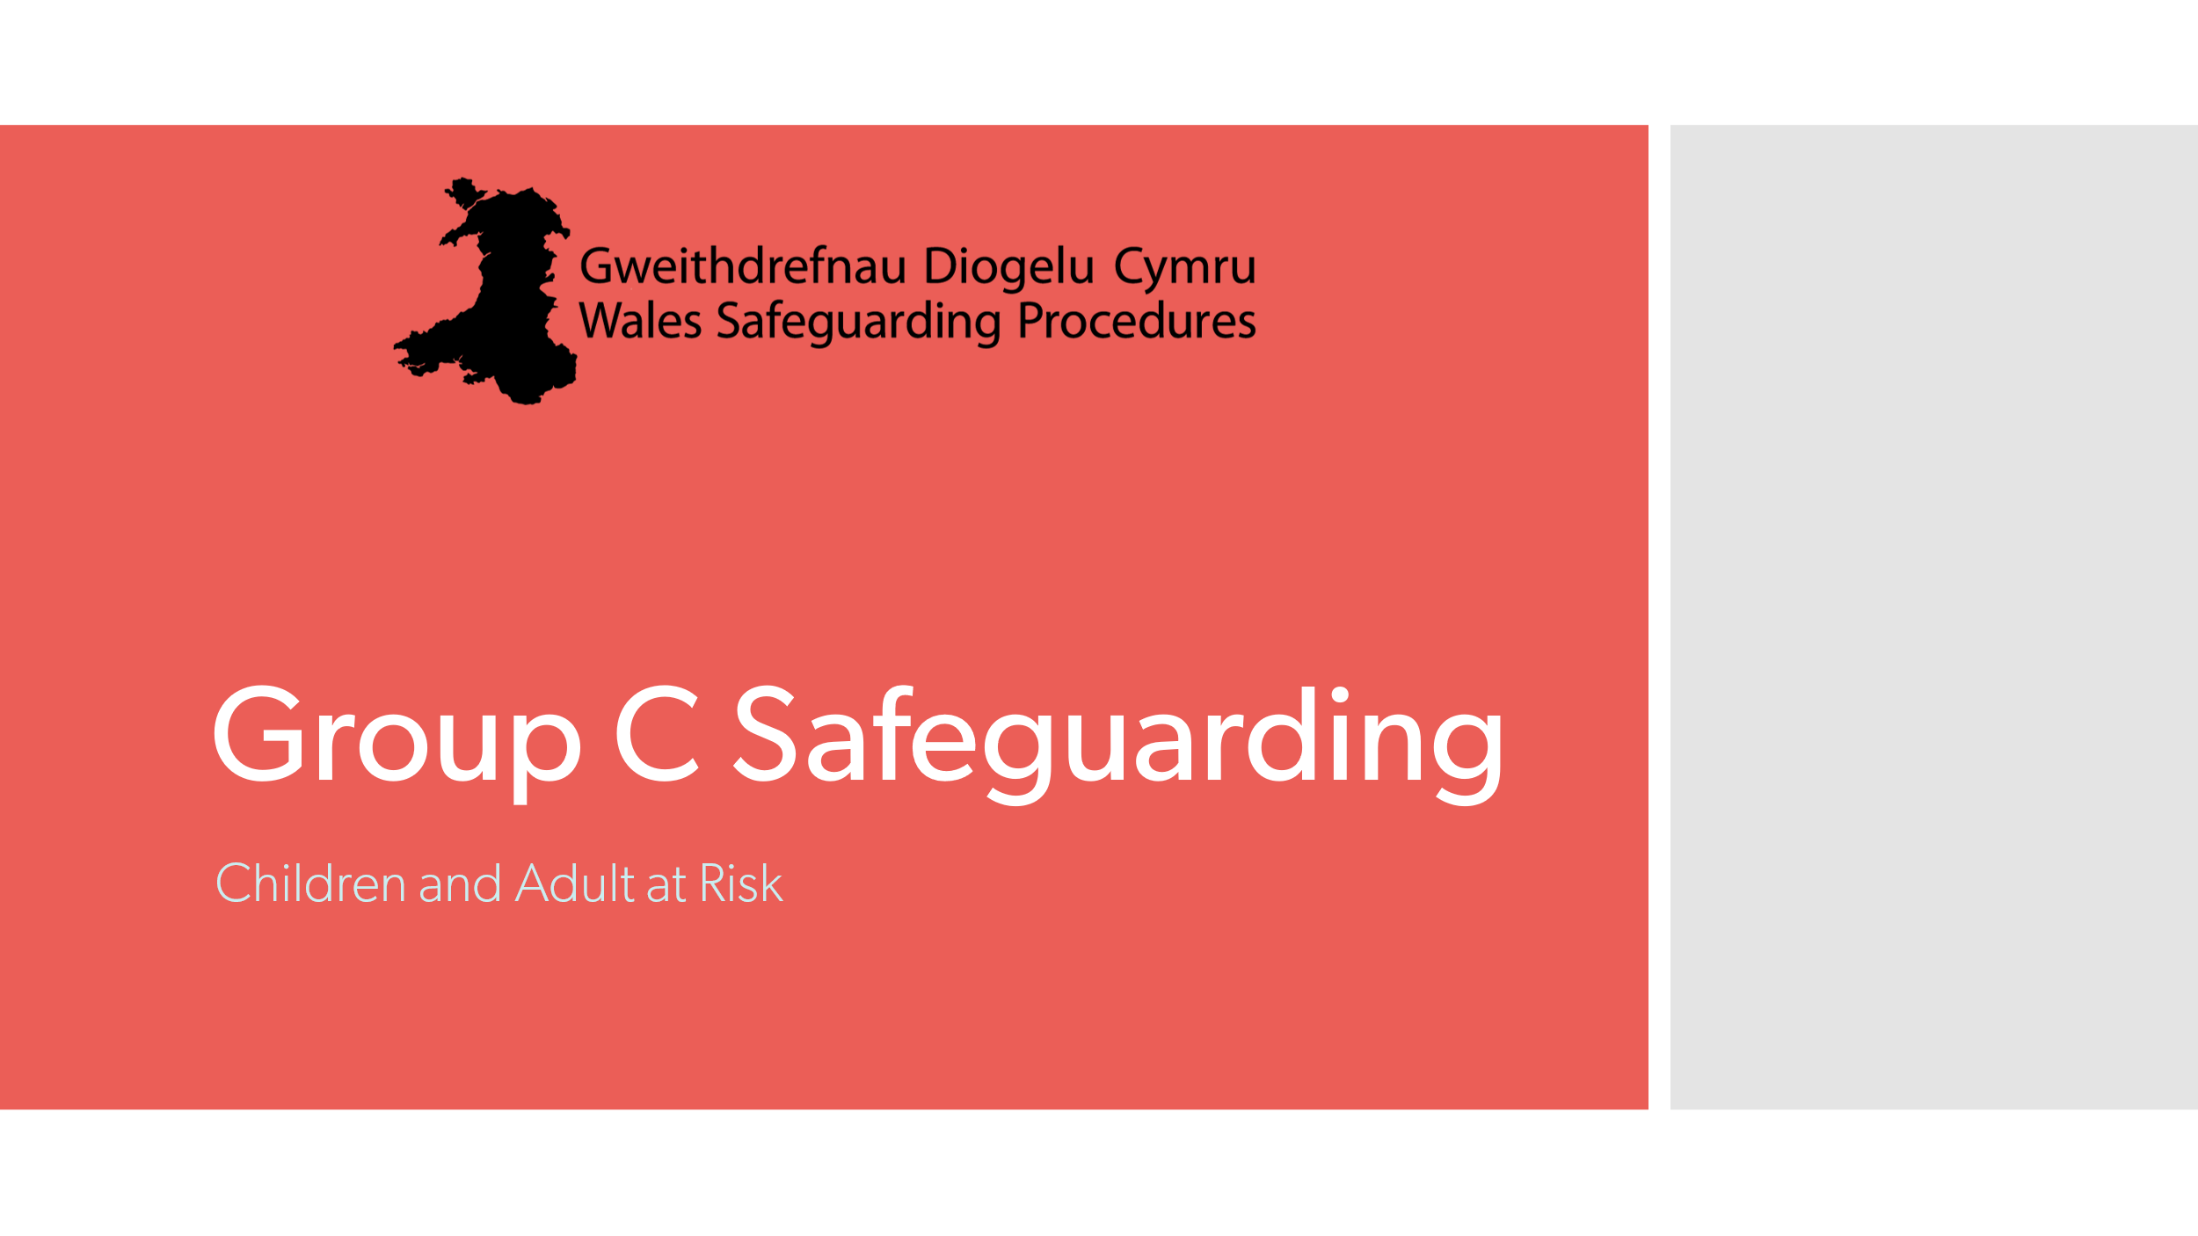 | Title slide
2 | 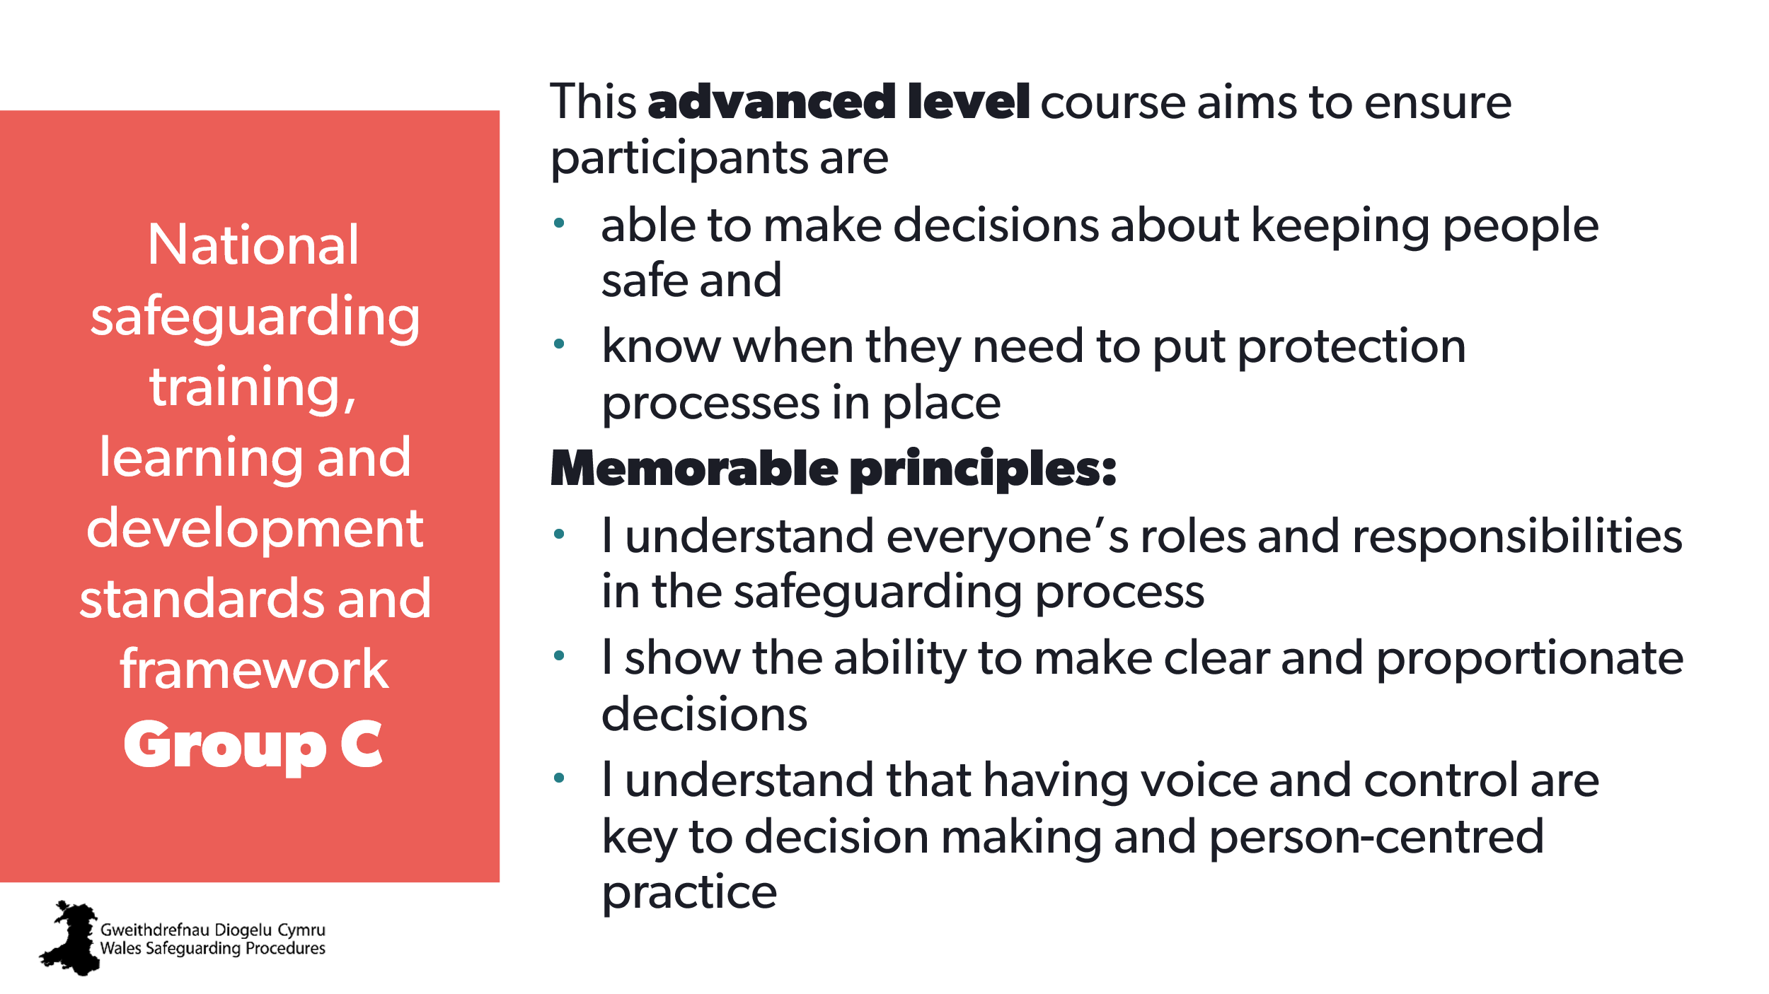 | Aim:  To make sure everyone understands the aims of the course (set expectations) and how it’s relevant to their roles.  Note to trainer:  Stress that this course will build upon Group B training. | National safeguarding training, learning and development standards - group C  National safeguarding training, learning and development framework - group C | Use the standards and framework to develop a Personal Development Plan for safeguarding skills and knowledge.
3 | 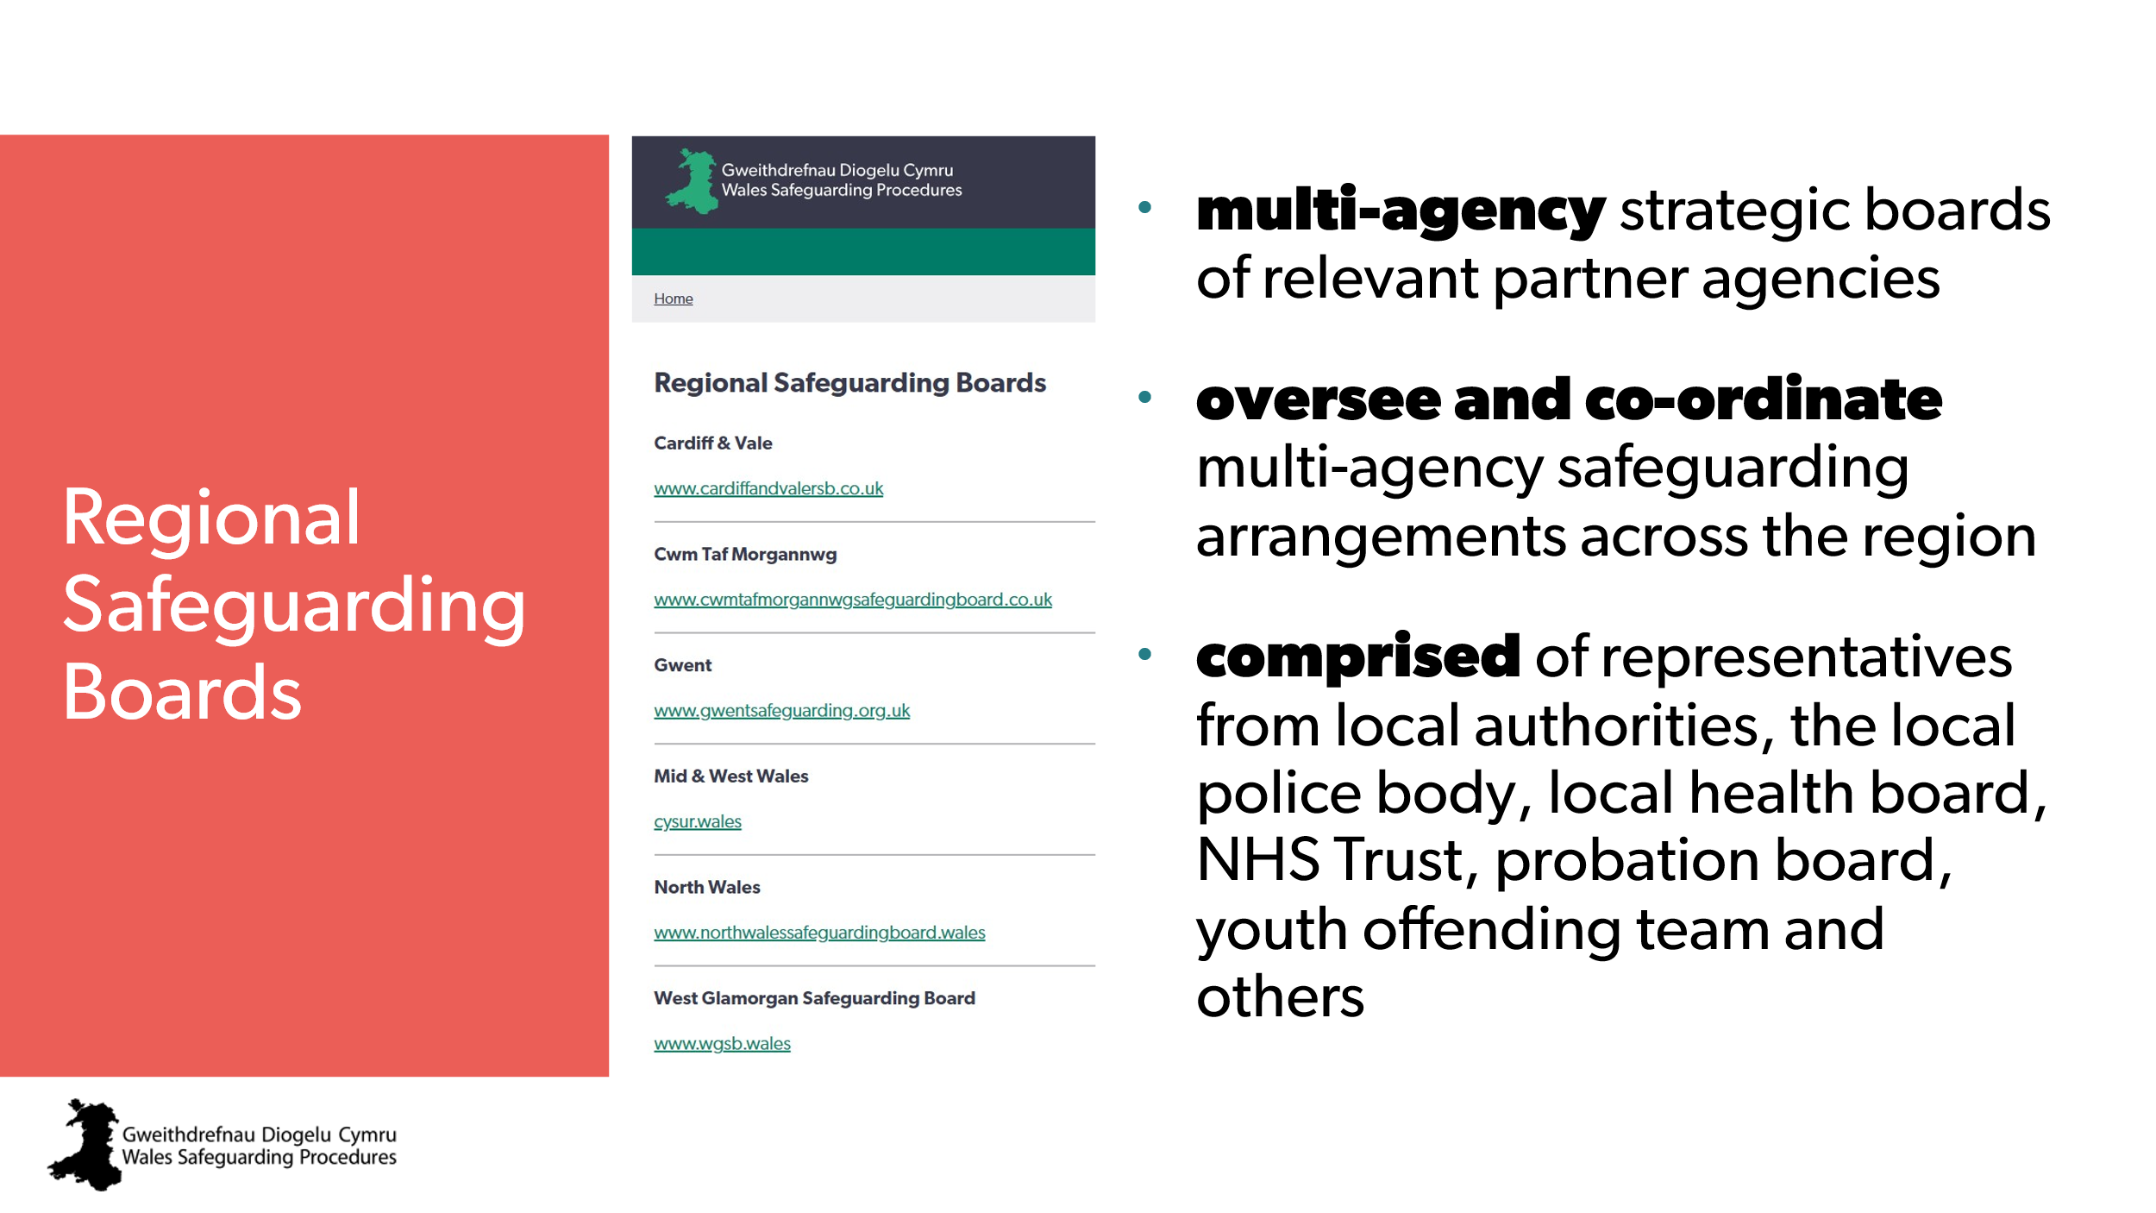 | Aim:  To make sure everyone knows about their Regional Safeguarding Board (RSB) and the resources and support available. | Wales Safeguarding Procedures  - Introduction  - Regional Safeguarding Boards
4 | 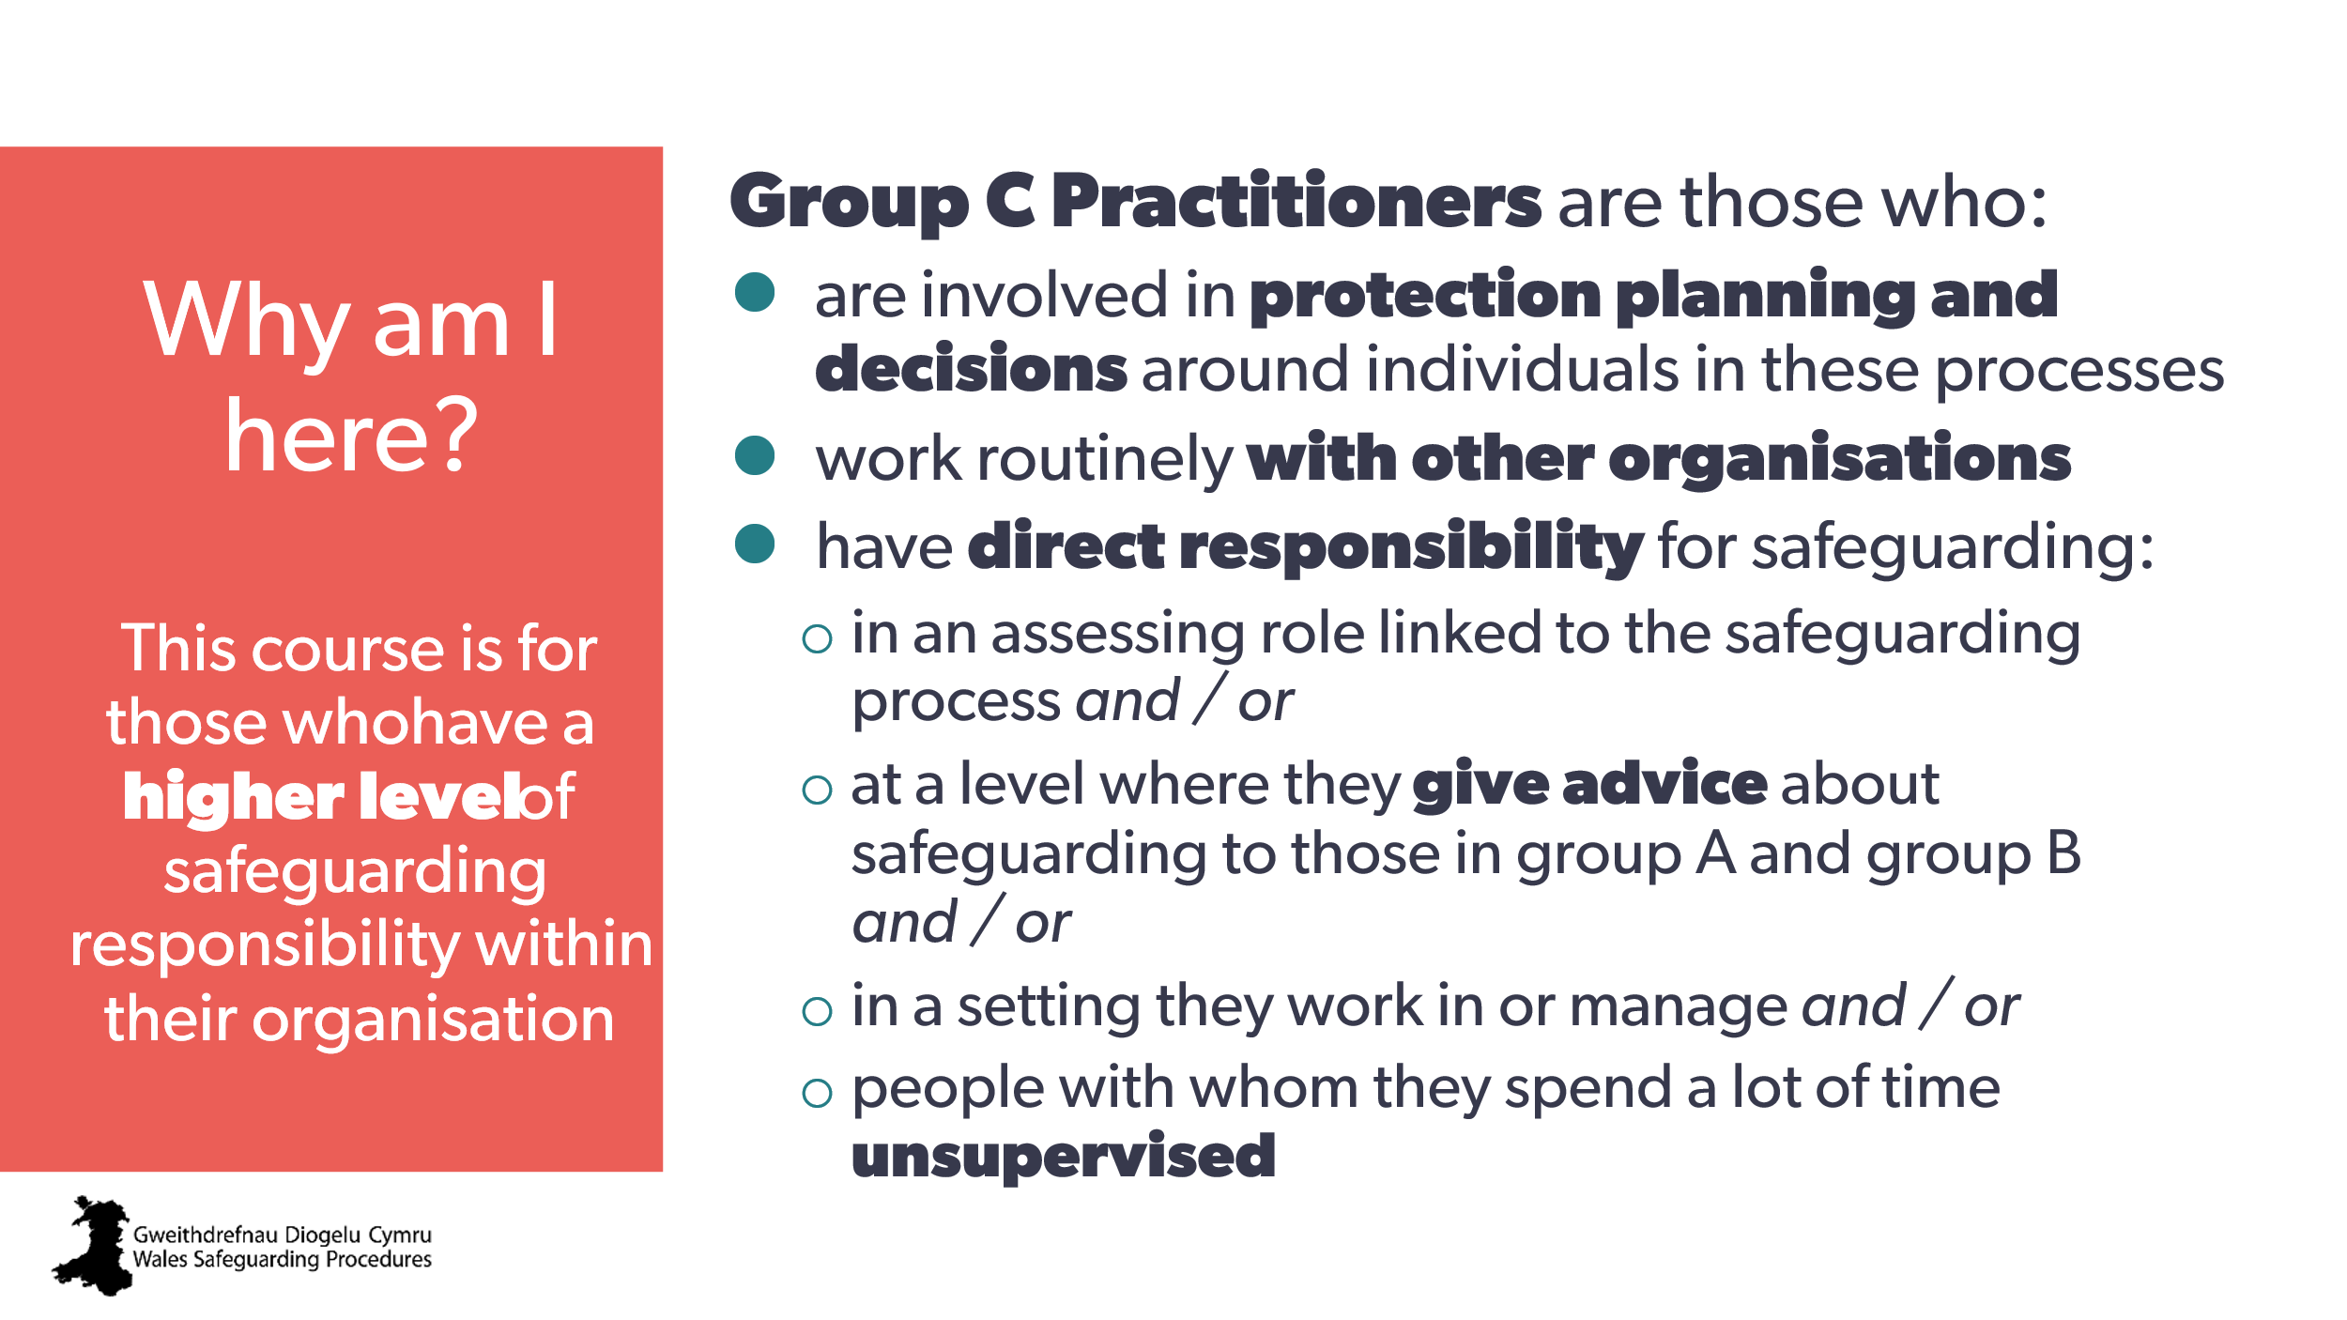 | Aim:  To set expectations and relevance to individual roles  Trainer to explain:  - This is generic group C safeguarding training that everyone in group C must do.  - Additional training that’s relevant to specific roles and responsibilities will be needed after completion of the generic group C training. | National safeguarding training, learning and development standards - group C | Additional training that is relevant to specific roles and responsibilities
5  6  7 | 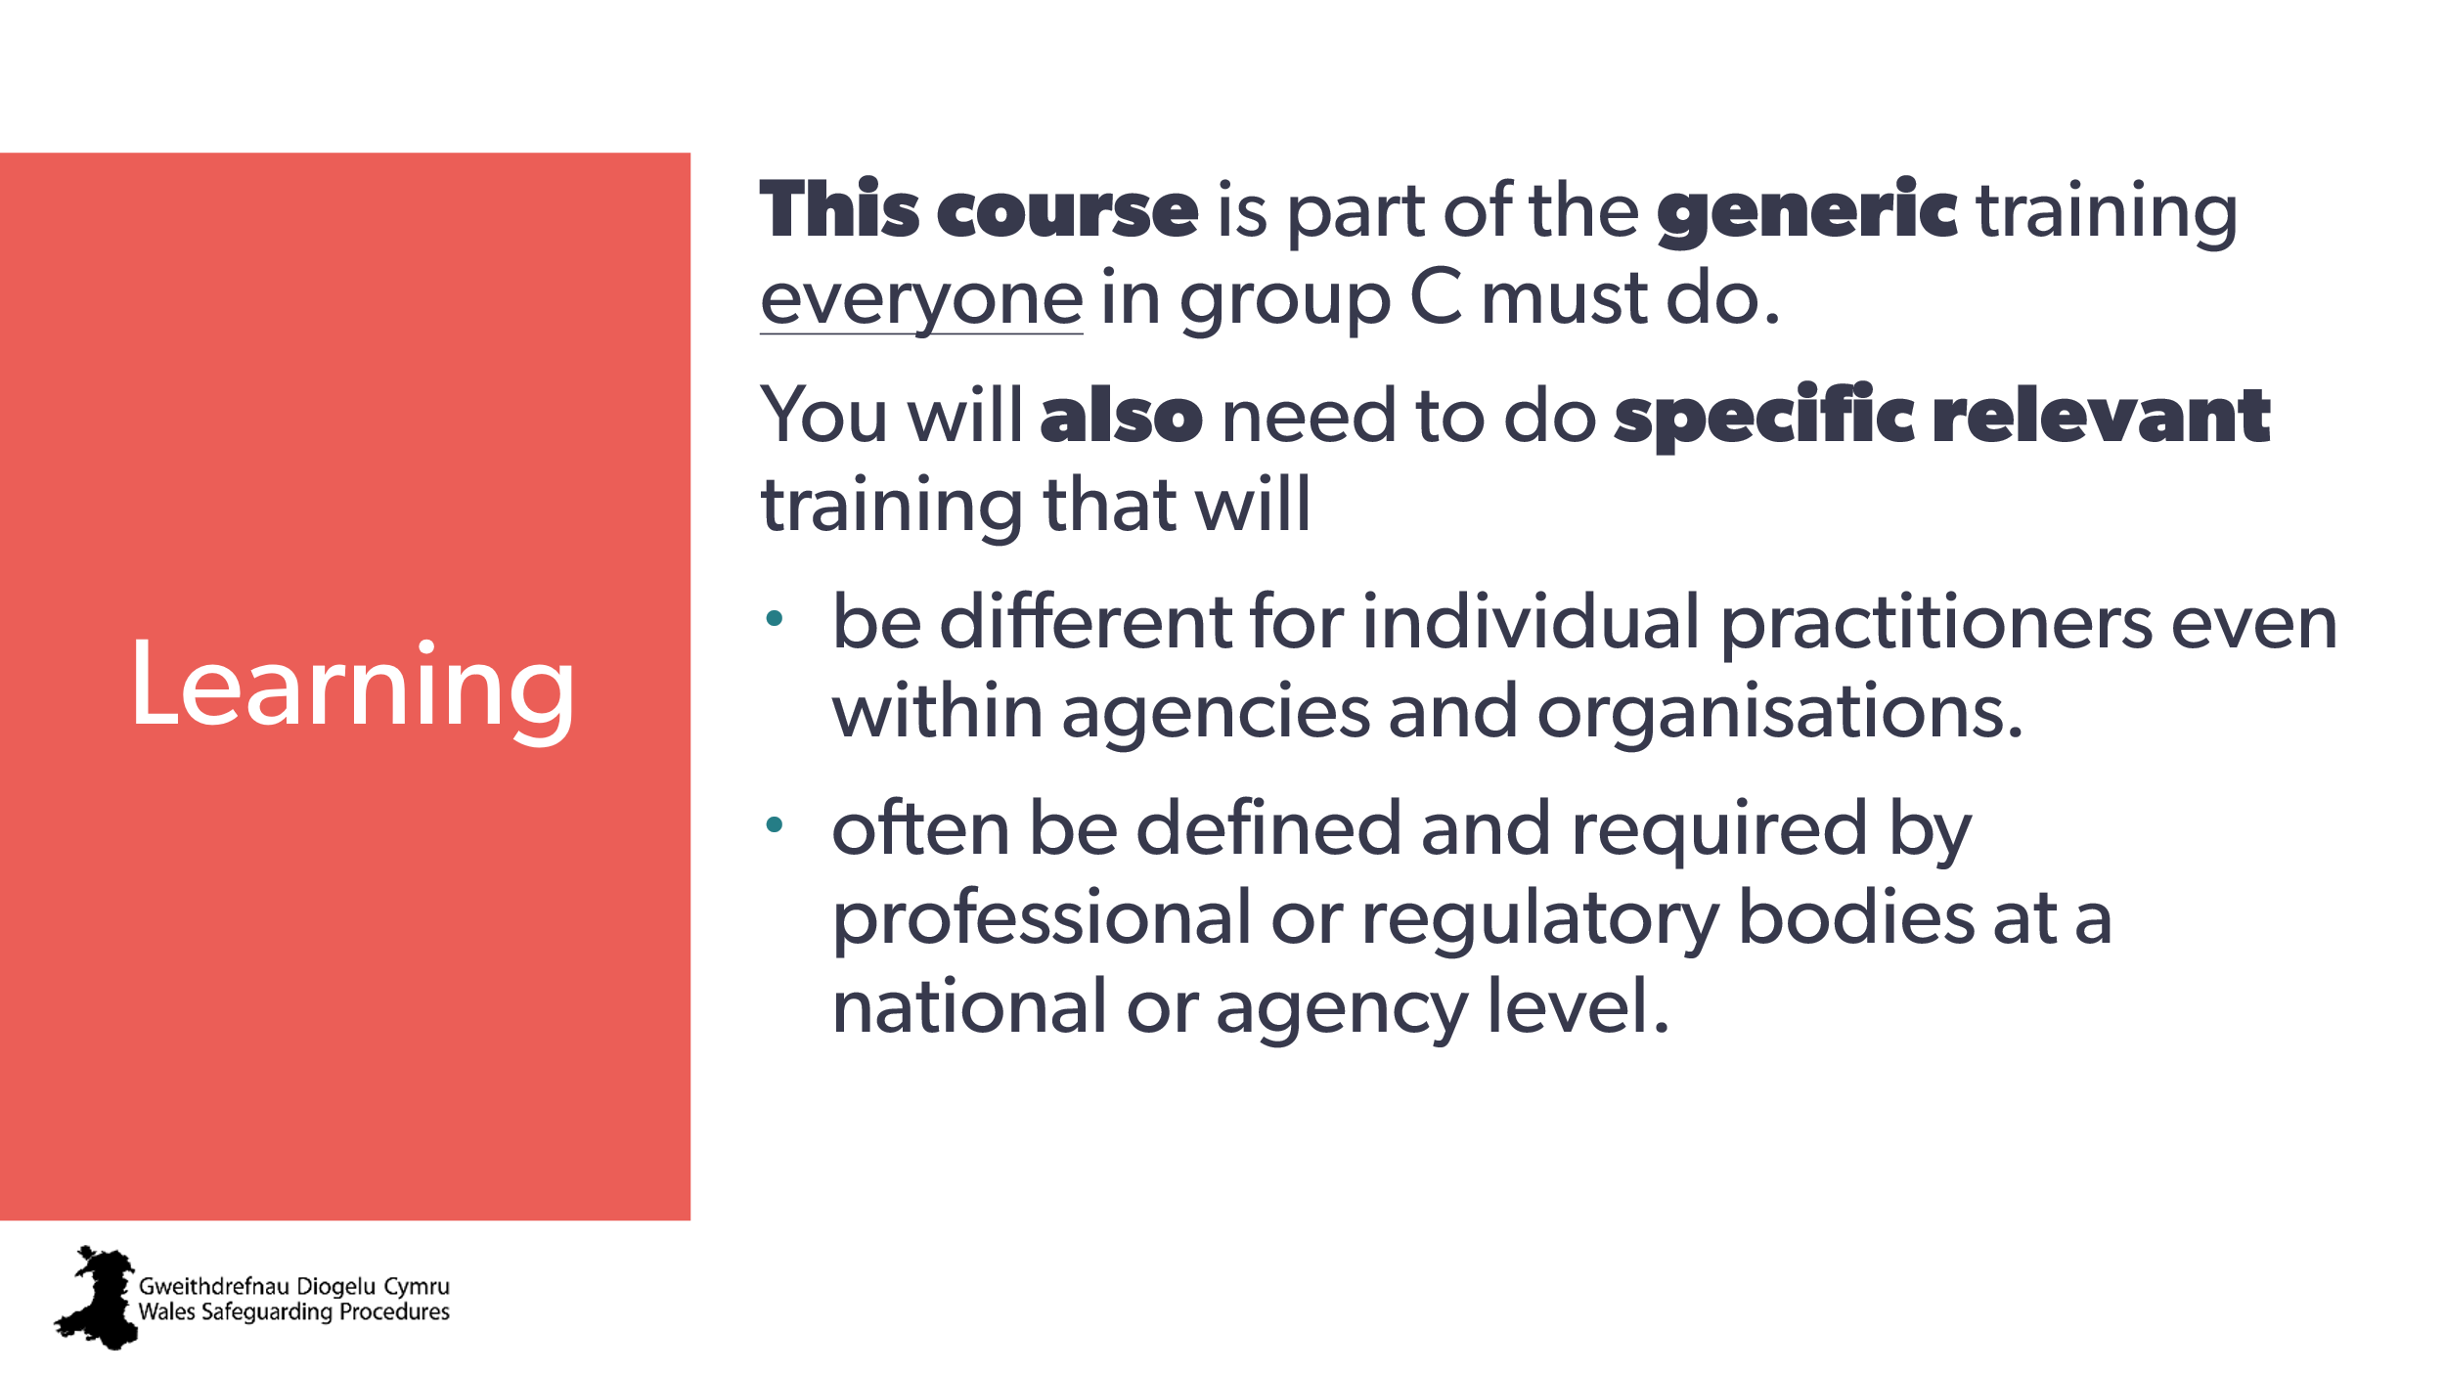  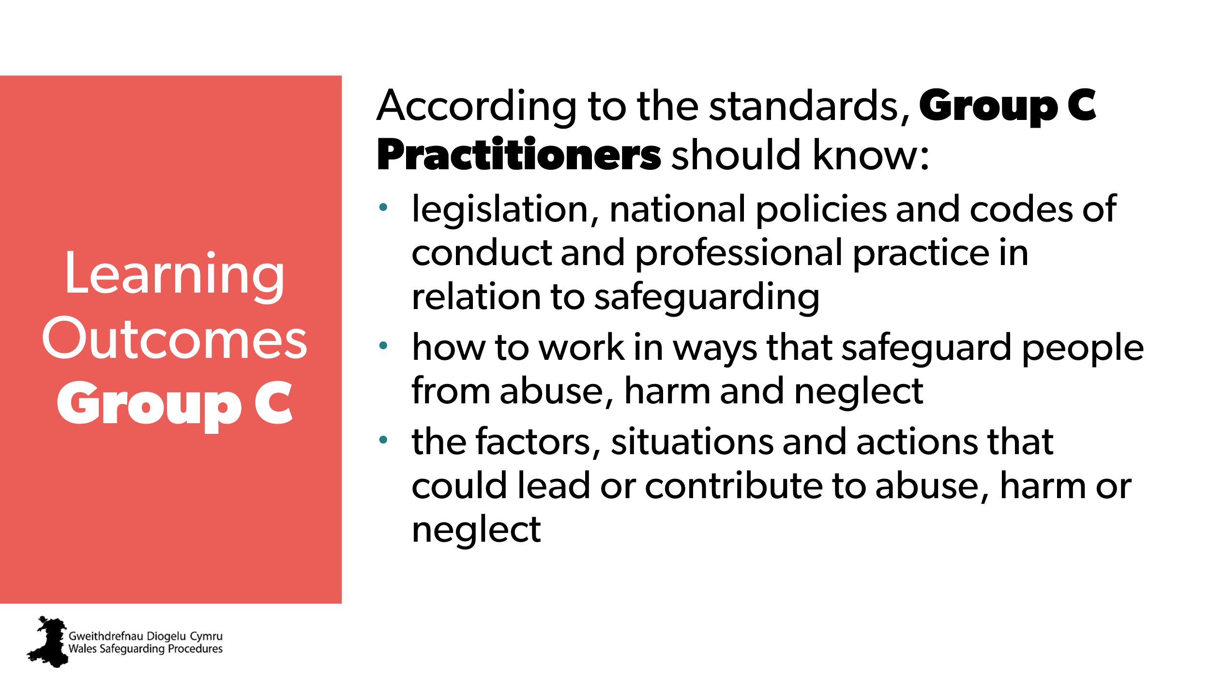  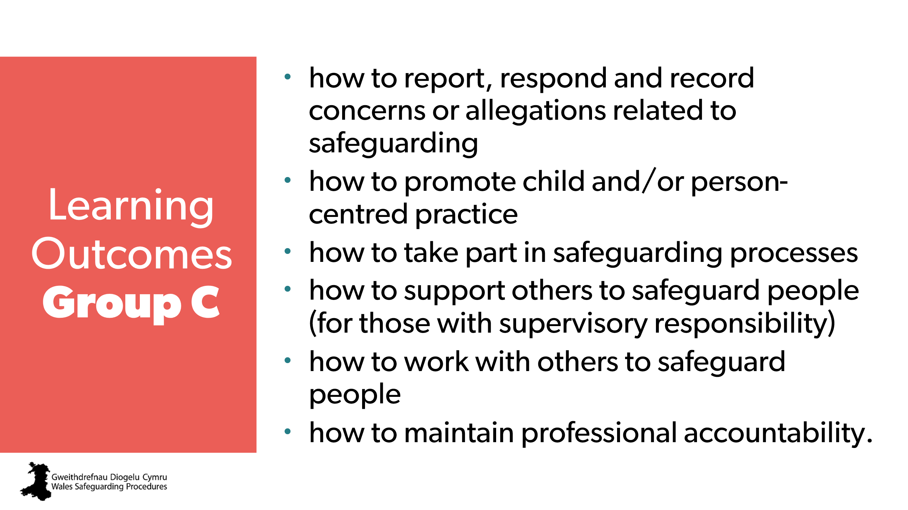 | Aim:  To make sure everyone knows about the expectations set by the Framework and Standards.  Optional:  - Trainer may wish to direct people to the standards on their phone/laptop.  - This could be a handout. | National safeguarding training, learning and development standards - group C
8 | 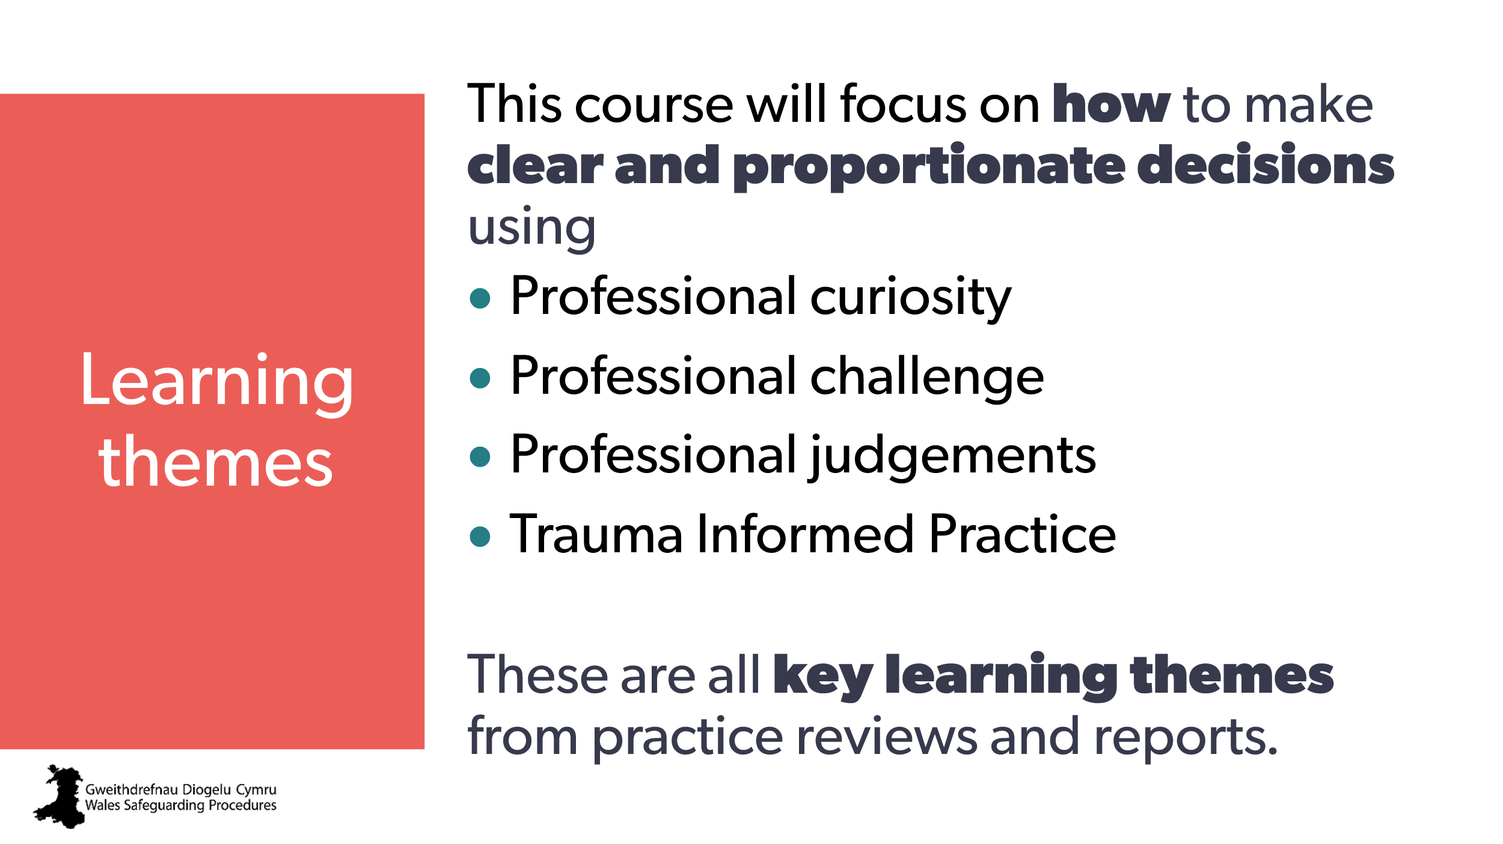 | Aim:  - To set expectations  - To set goals and objectives  Trainer to explain:  This course focuses on decision making, including:  - professional curiosity - to gather enough information to make appropriate decisions  - professional challenge when considering information, giving advice or designing interventions  - professional judgement when considering thresholds for interventions and information sharing  - trauma informed approach to safeguarding to ensure voice and control, build trust and emotional safety and enhance multi-agency collaboration | Trauma-Informed Wales  https://traumaframeworkcymru.com/ | CPD / Further training on  - professional curiosity  - Wales Trauma Informed Practice Framework.
9 | 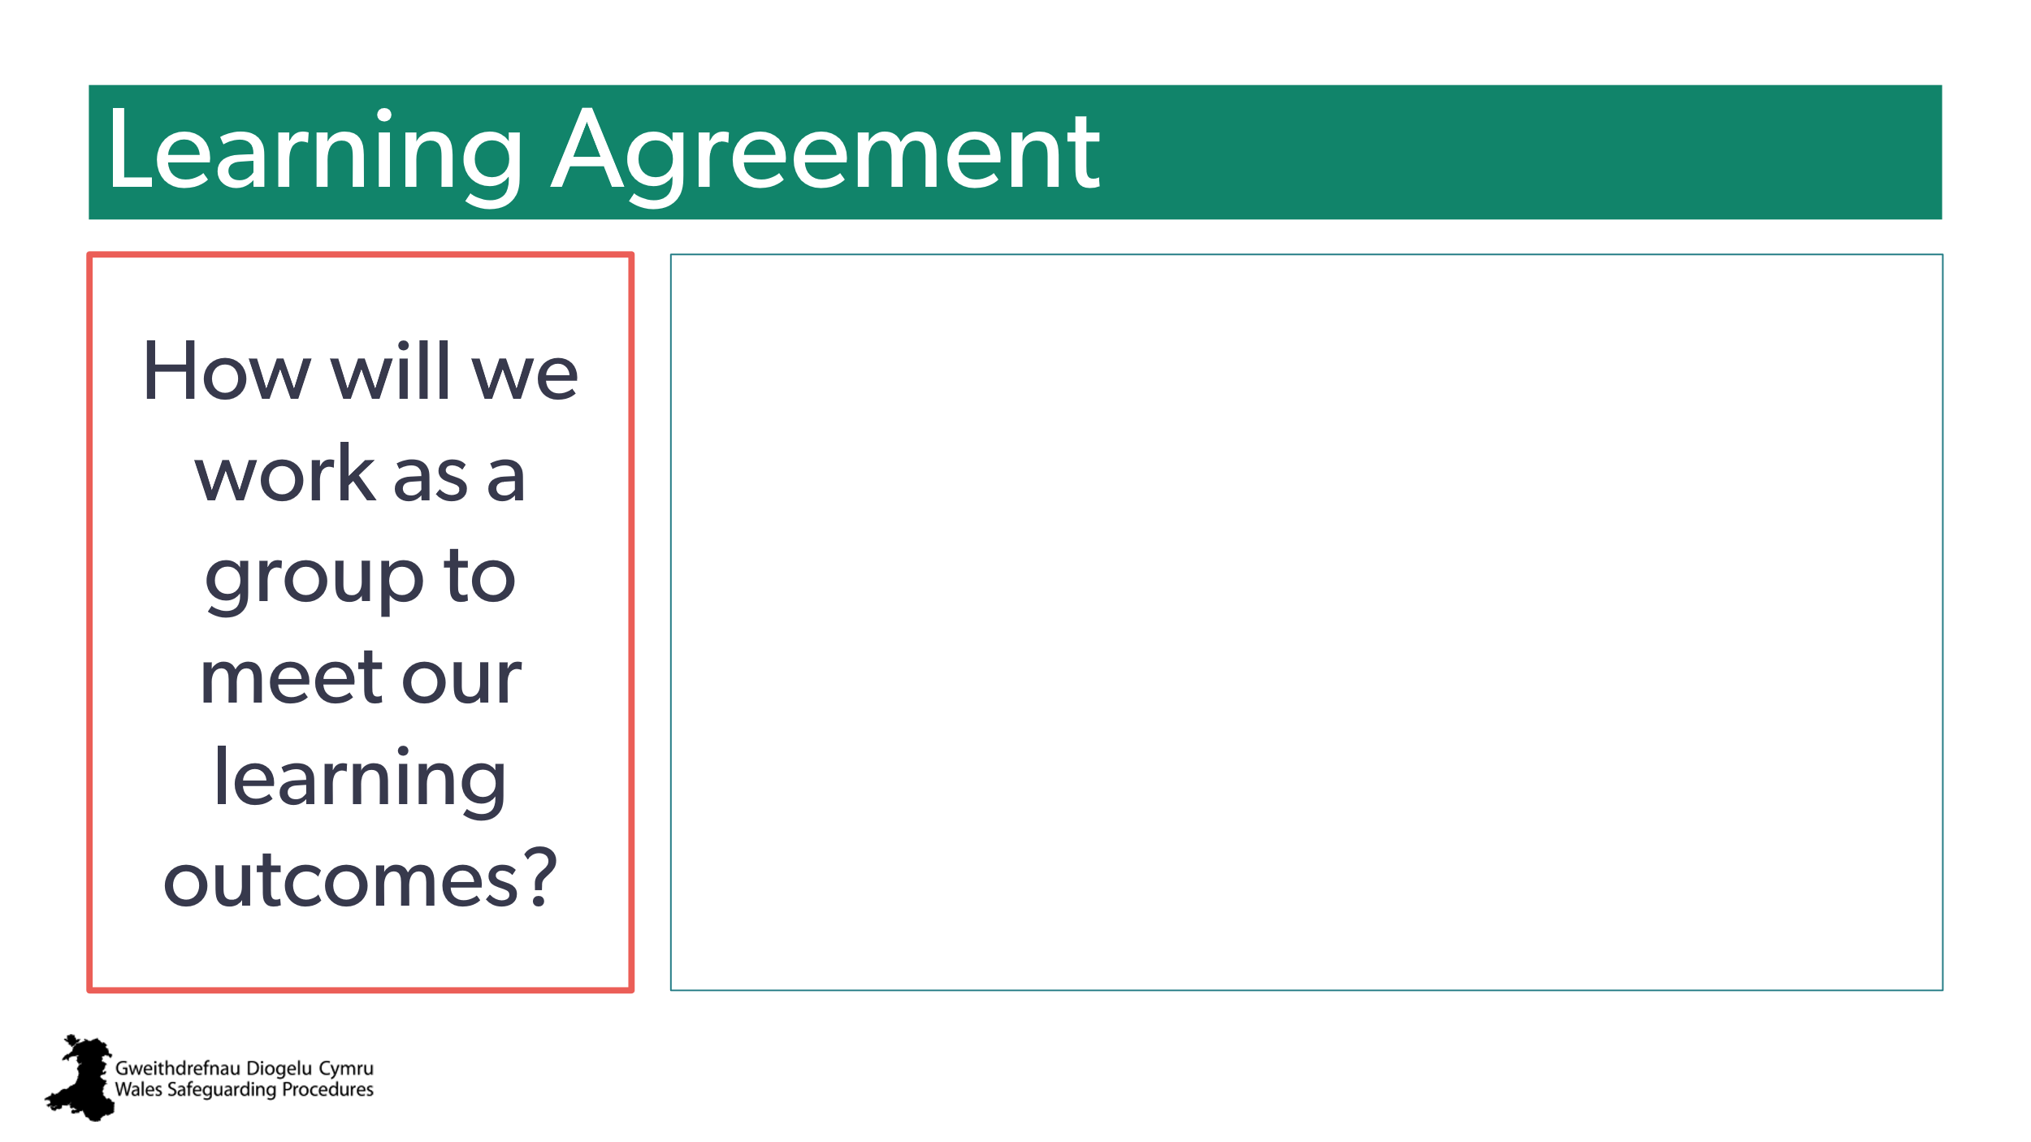 | Note: Blank text box to add group/venue-specific aspects  Aim:  - to set out what’s expected  - to manage/set expectations for contributing and participation  - to highlight expectation of individual learning responsibility.  Notes to trainer:  - people on course may be in completely different roles – encourage the more experienced to share knowledge with the less experienced  - they need to consider how this is relevant to them within their own roles  - encourage people to apply what they learn to their own individual roles.  Trainer to stress:  Highlight the importance of consolidating learning after today and ask learners to be thinking about practical activities they could carry out after today’s session, to gain further experience and/ or embed their learning.
10 |  | Note: Blank text box to add group/venue-specific aspects  Aim:  - to develop rapport, trust and emotional safety (trauma informed approach)  - to find out if there are specific issues that may need addressing  - to find out if there are any particular learning needs  - to set expectations.  Note to trainer:  If possible, sit down with the group to be ‘part of’ the group, and change the power dynamic to a more equal one to support confidence.  If there are very experienced people in the room,  reassure them that:  - much of this information should be a refresh for them so they’re as up to date as possible  - this course is designed to allow people to share experience and ideas – encourage them to add their practical knowledge  - emphasise that this is a baseline course that everyone must do as a starting point – addressing aspects common to all sectors and services  - remind them there’s always something new to learn in safeguarding!  If there are people very new to this level of safeguarding:  You may wish to:  - reassure them that there will be opportunities for CPD and further learning following this course  - encourage them to ask questions and learn from those around them
11 | 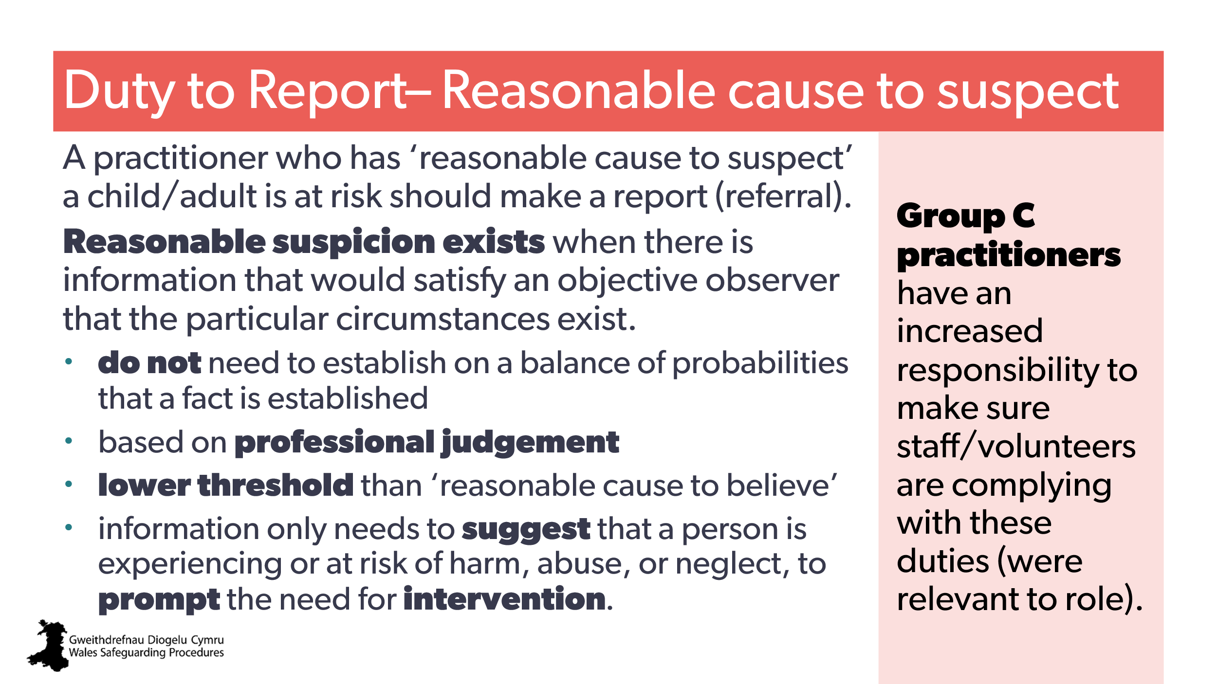 | Aim:  - reminder slide  - make sure everyone understands the lower threshold of ‘reasonable cause to suspect’  - highlight that although covered in Group B, the Group C attendees have an increased responsibility to make sure staff/volunteers are complying with these duties.  Trainer To explain:  Previously, we were often asked for ‘proof’ or ‘evidence’ of neglect or abuse. We had to have evidence to believe someone was at risk.  This is no longer the case. We now stress prevention and taking early action and intervention, so we only need a reasonable suspicion of risk of harm to act.  This is an important part of the Welsh preventative agenda. Safeguarding has changed in emphasis to a pro-active approach that focuses on reducing the need for safeguarding enquiries and intervention. | Social Services and Well-being Act (Wales) 2014  - 128.Duty to report adults at risk  - 130.Duty to report children at risk  Working Together to Safeguard People Volume I > Paragraph 83  Wales Safeguarding Procedures  - S2 – The Duty to Report (adults)  - S2 – The Duty to Report (children and young people)
12 | 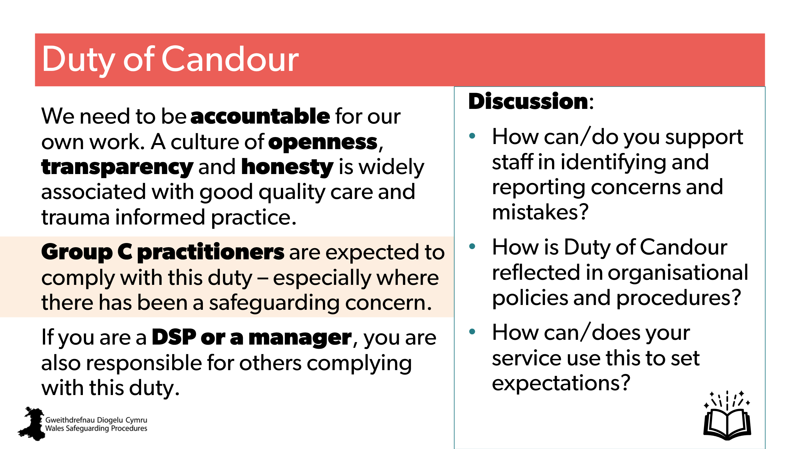 | Aim  - to highlight this duty  - to highlight need for transparency  - to offer discussion of #6 to 9 in the workbook  Trainer to explain:  Part of your role is to make sure everyone complies with their duty of candour – especially where there has been a safeguarding concern.  Duty of candour applies to all social care professionals (social workers, social care managers, residential child care workers) registered with Social Care Wales (section 6.3 of the Code of Professional Practice for Social Care)  Note to trainer:  Discussion group activity:  Split learners into four or more discussion groups.  Ask each group to discuss and prepare to share back a different topic:  - How do you demonstrate your commitment to making sure the duty of candour is embedded within your organisational culture, practice, policies and procedures, and service expectations?  - How can/do you support staff to identify and report concerns and mistakes?  - How is duty of candour reflected in organisational policies and procedures?  - How can/does your service use this to set expectations? | Openness and honesty when  things go wrong: the professional duty of candour  Explanatory guidance for social care professionals registered with Social Care Wales  Code of Professional Practice for Social Care  Health and Social Care (Quality and Engagement) (Wales) Act 2020 | CPD  Applying the Duty of Candour
13 | 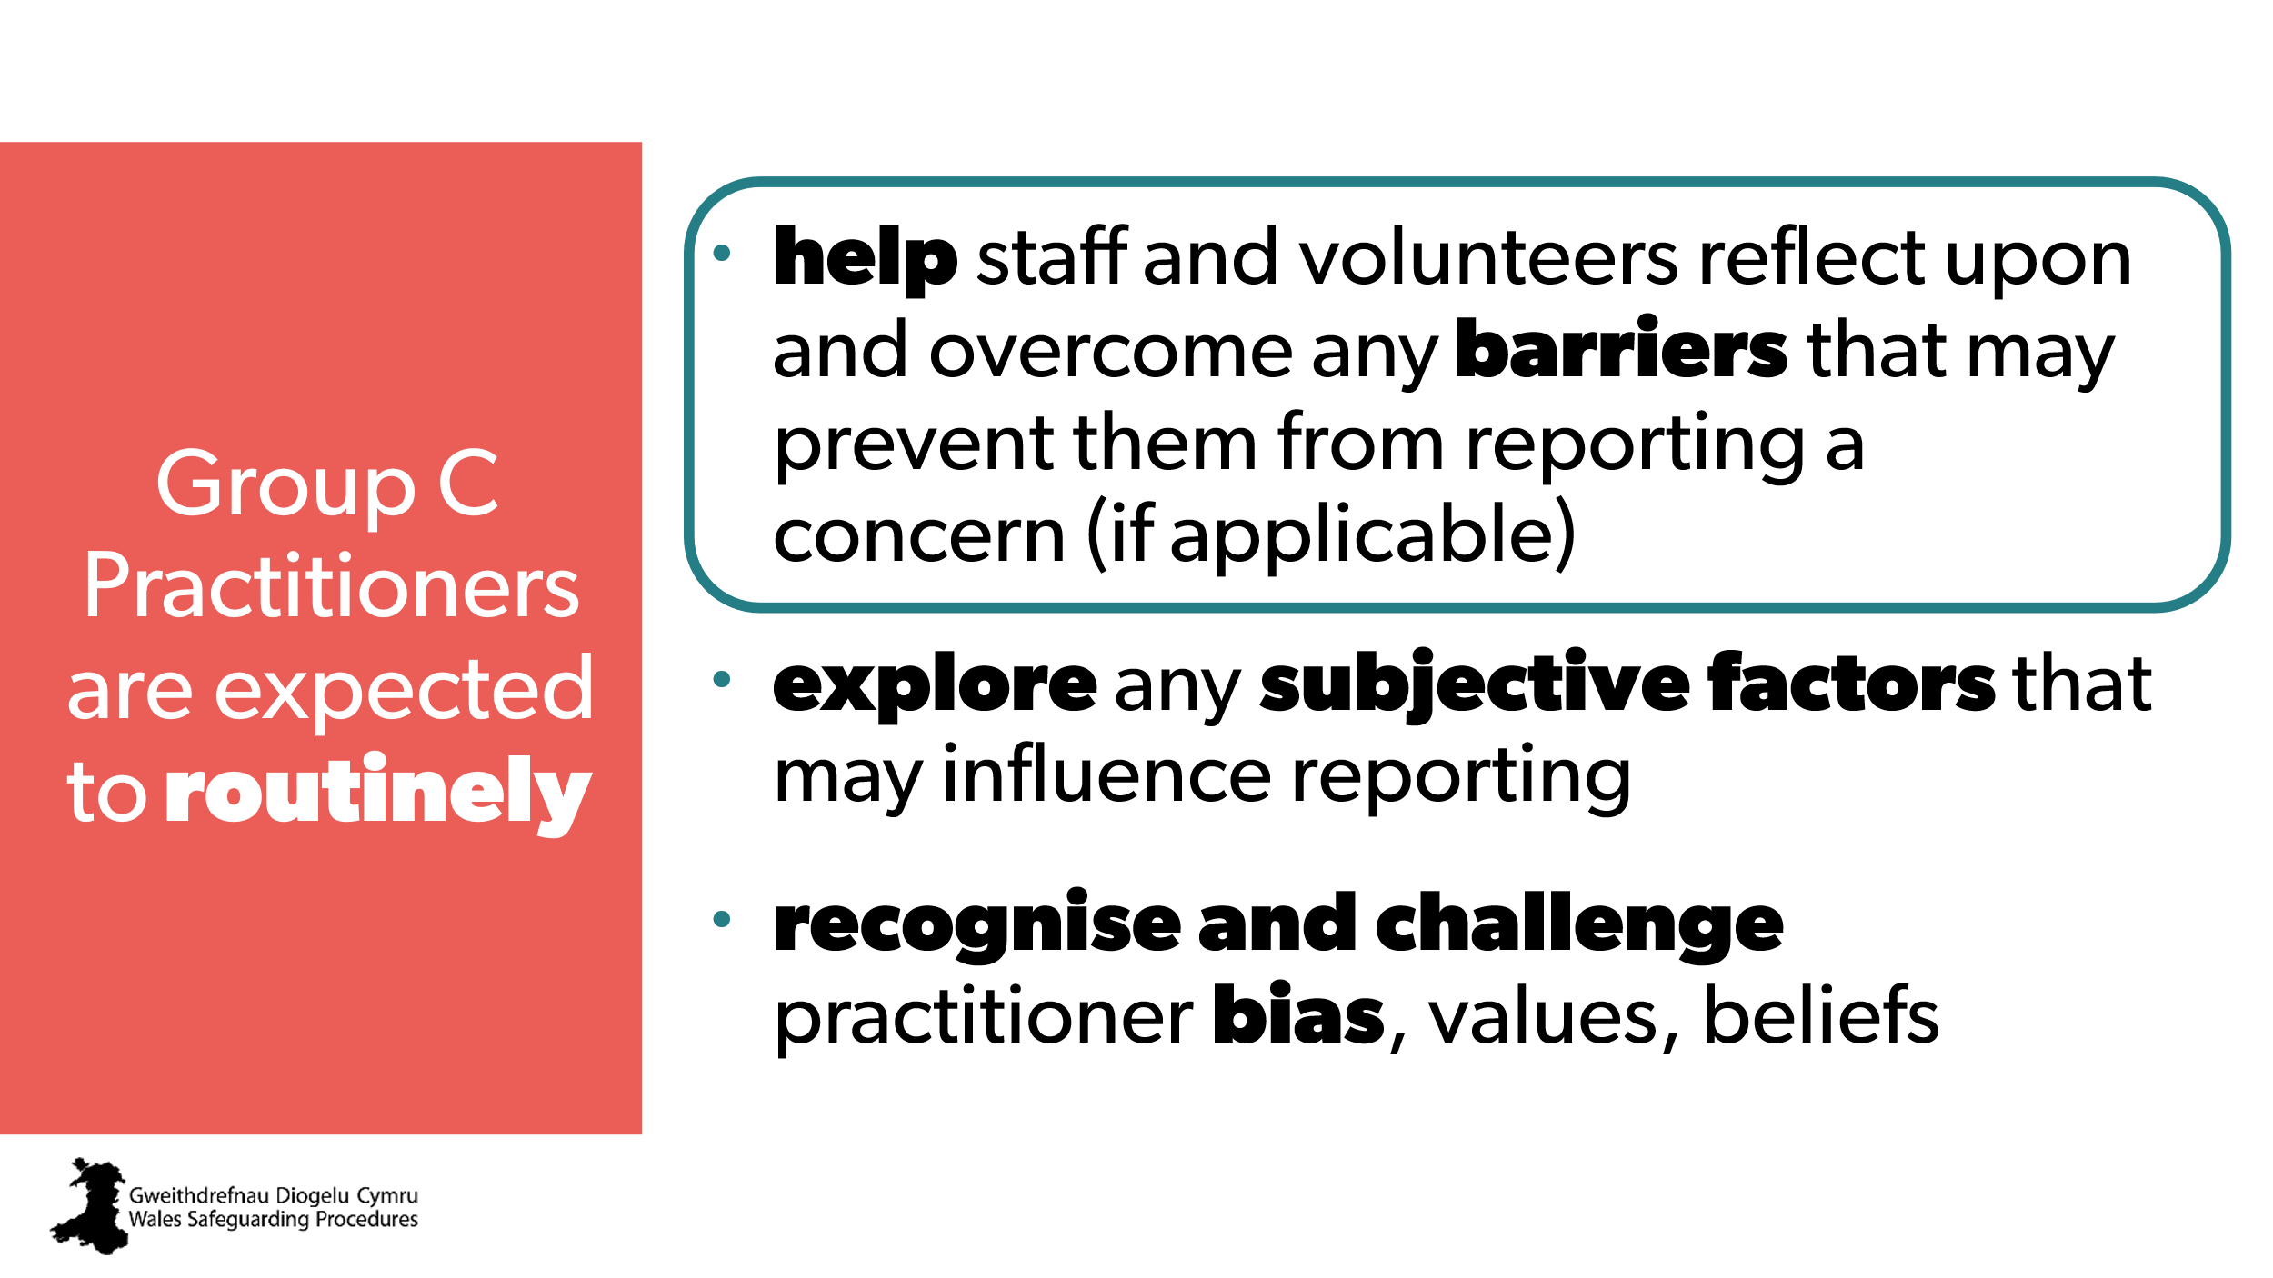 | Aim:  - to outline responsibilities of Group C practitioners  - to announce what section we’ll be covering  - highlight circle - will first focus on the first bullet.
14  15 | 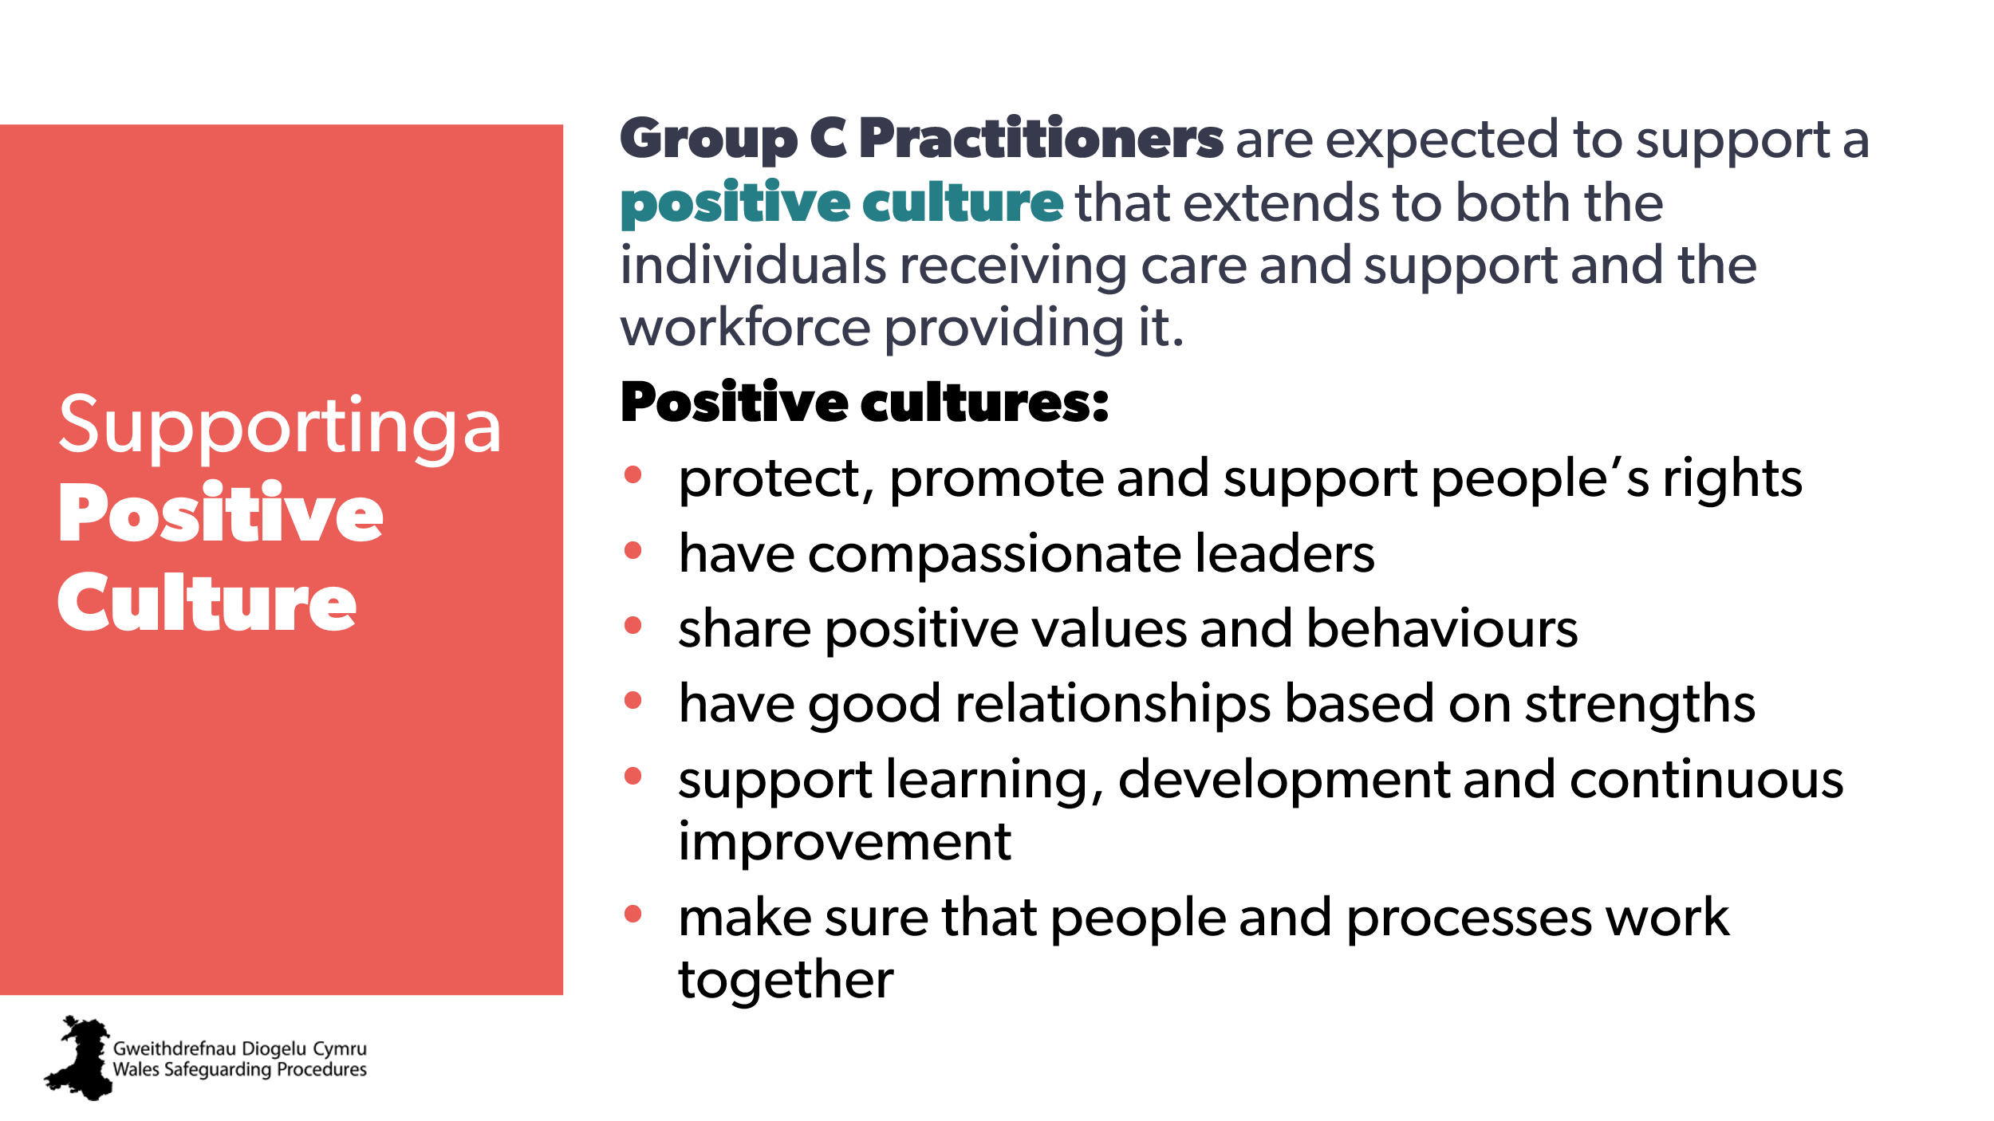  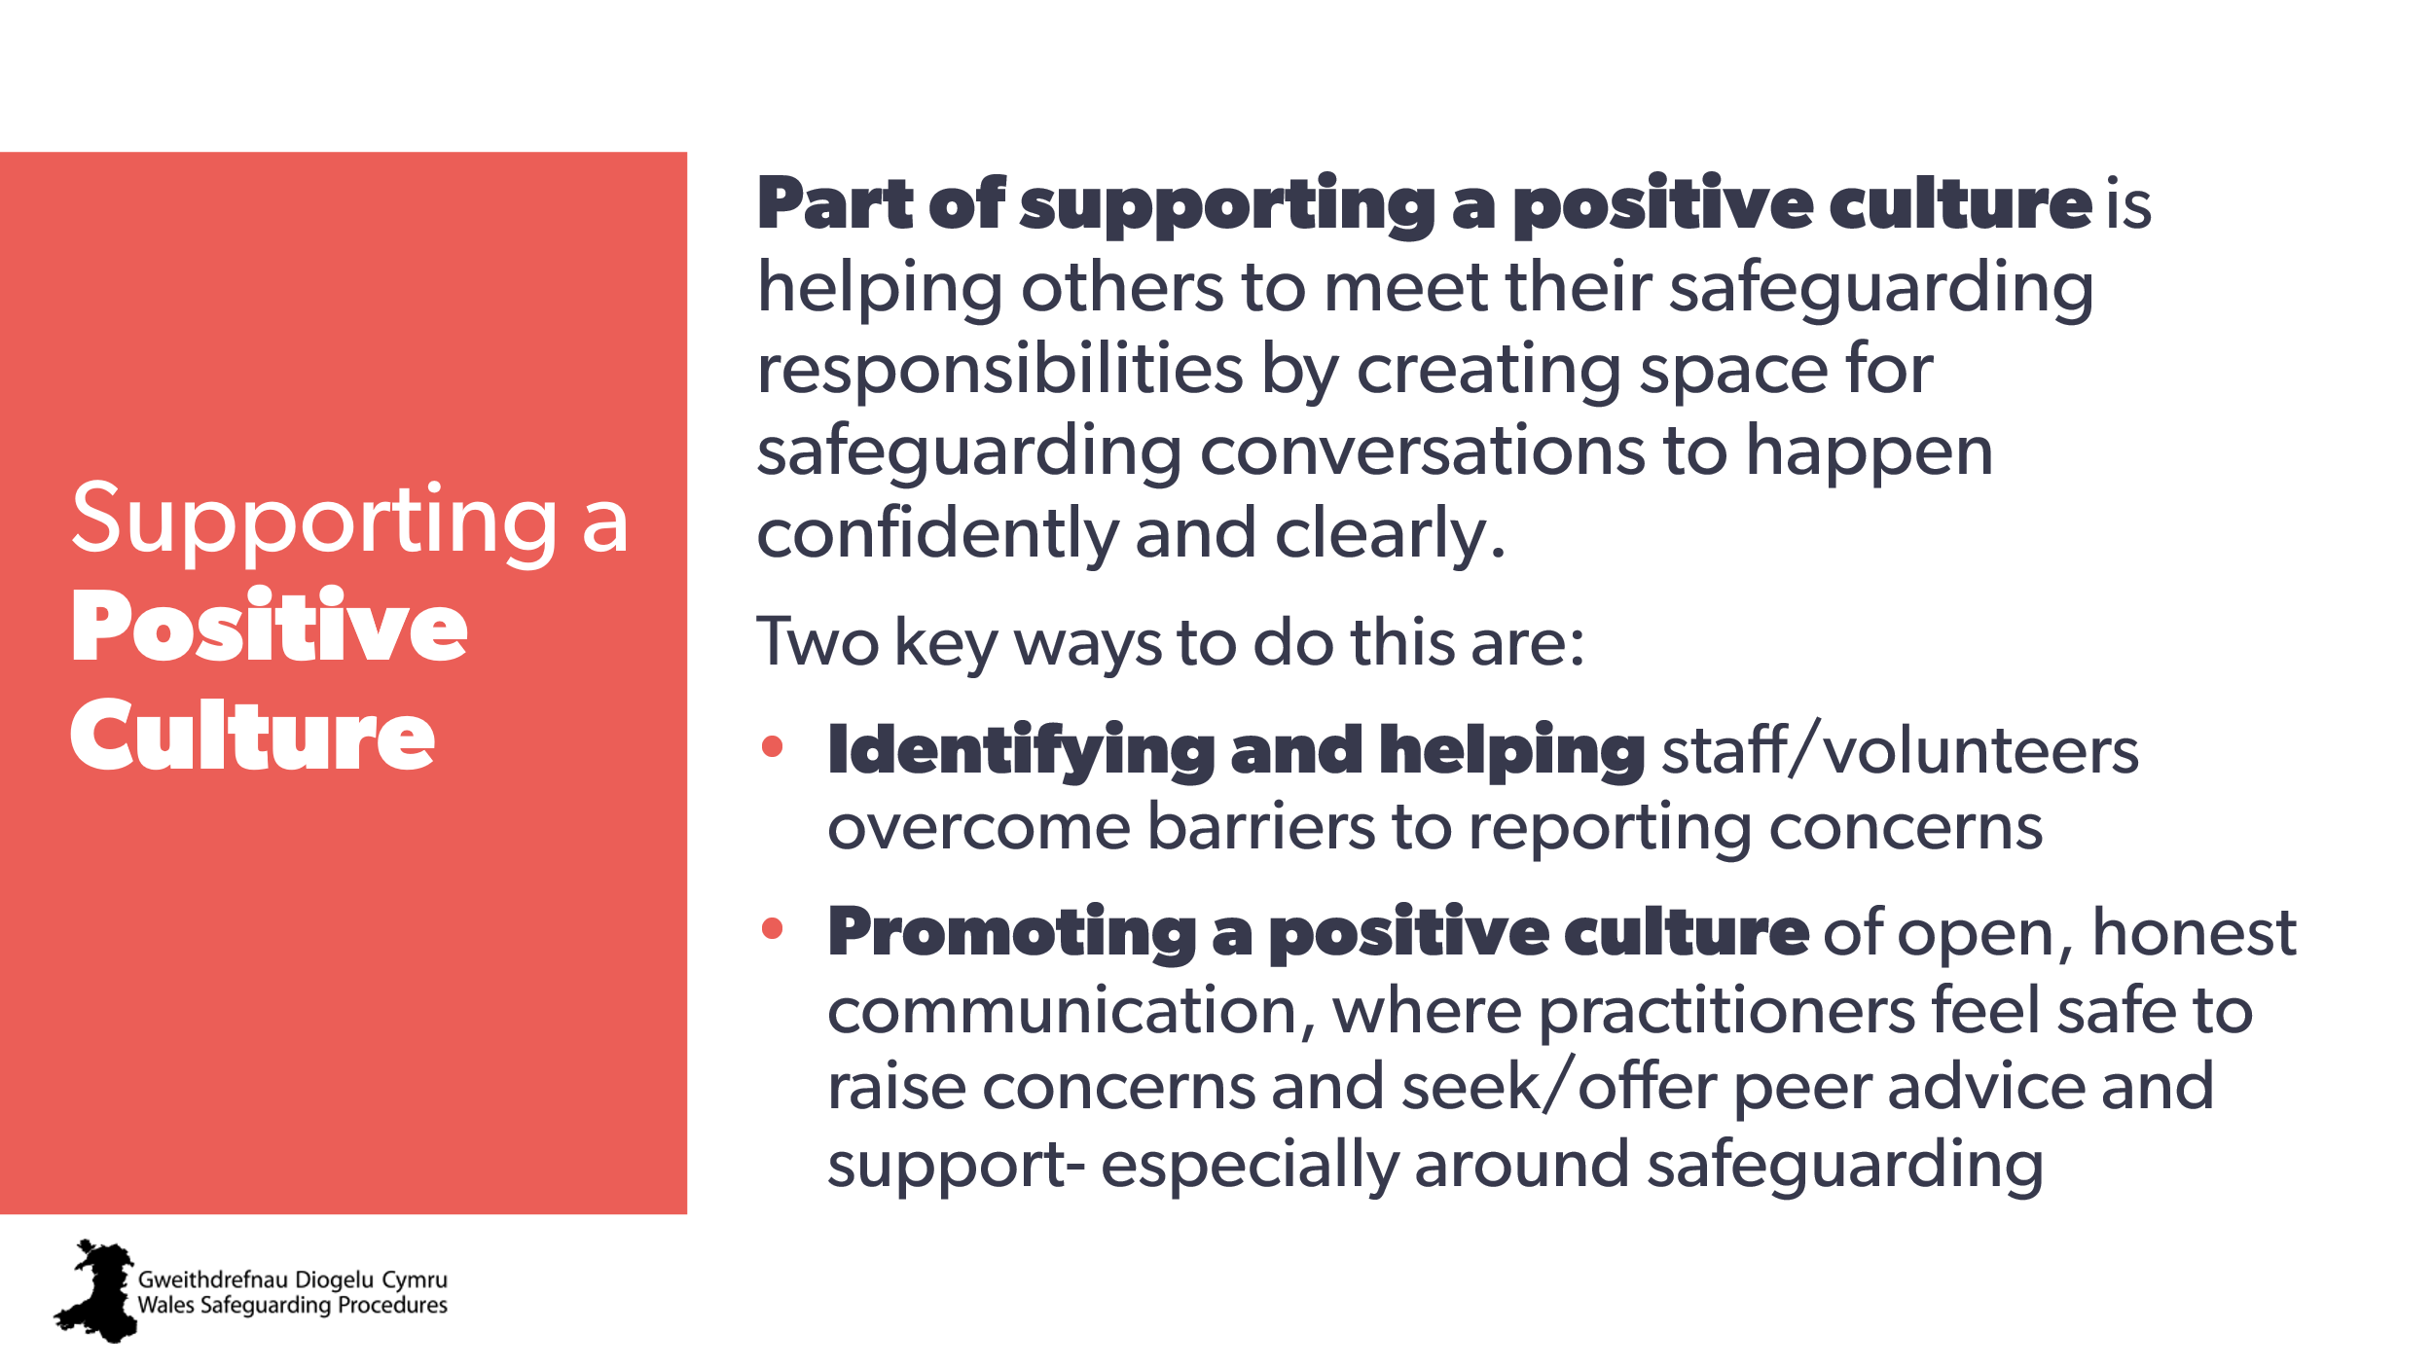 | Aim:  - to introduce/highlight the term ‘positive culture’  - explain role of Group C practitioners.  Background for trainer:  In 2025, Care Inspectorate Wales, Social Care Wales and Welsh Government launched the guide for supporting positive cultures. | Guide: Supporting positive cultures  https://insightcollective.socialcare.wales/positive-cultures | CPD suggestions:  Supporting Positive Cultures  Positive Safeguarding Culture
16 | 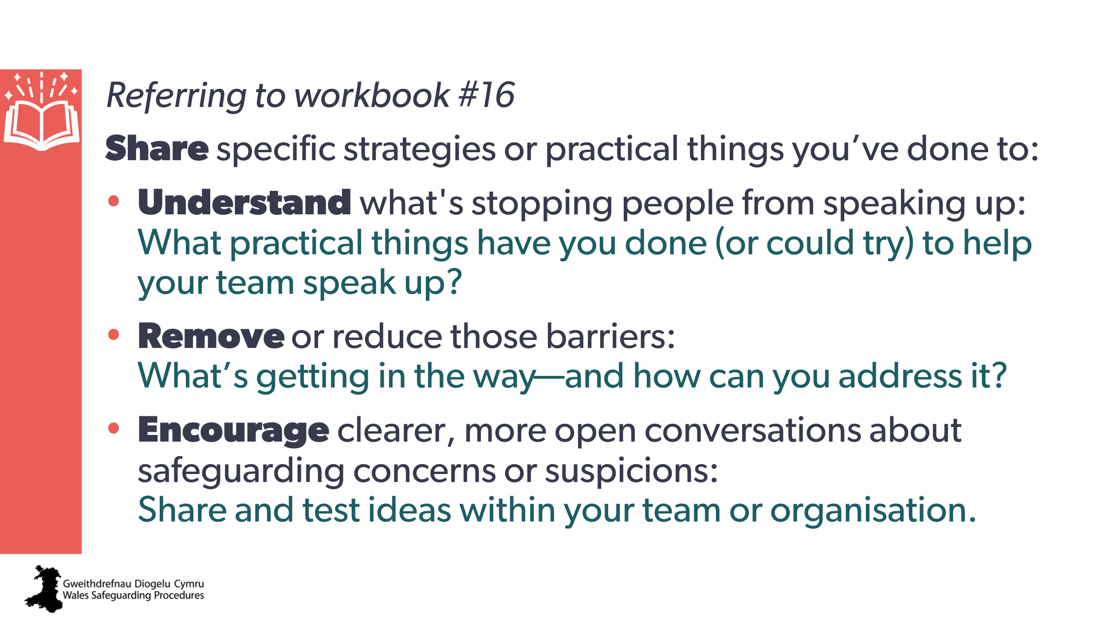 | Aim:  - to allow discussion and sharing of ideas of ways to overcome and address subjective and external influences  - to enable learners to start an ‘actions list’ of practical, specific steps they can take, put in place, or do to accomplish this.  Trainer to explain:  We do want people to come to us when they have a concern, even with a ‘gut feeling’ or something they think is ‘insignificant’.  We want people to never be afraid to seek advice or support, no matter how small they think it is.  And that means that part of the roles you all have is to be able to help them overcome those obstacles and difficulties and then find a way forward with whatever it is that might be concerning them.  Discussion activity workbook #16  Note to trainer:  - consider if there is enough rapport/trust to direct people to sit with people not from their setting (if it’s too early in rapport building for this, simply suggest it)  - small groups / tables of three to four people  - encourage people to be as specific as possible with detailed descriptions | Resources  Wales Safeguarding Procedures:  Walsh W and Jones L Factors that Influence Child Abuse Reporting: A Survey of Child-Serving Professionals  Pointers for Practice: Care and support or care and support, protection needs?​ (adults)  Pointers for Practice:  Subjective Decision-Making​ (children and young people)  Pointers for Practice: Subjective factors that can influence the response to a report​ (Adults)  Pointers for Practice: Subjective Factors That Can Influence the Response to a Report​ (children and young people)  Pointers for Practice:  How to Apply the Safeguarding Process to Practice (children and young people)
17 | 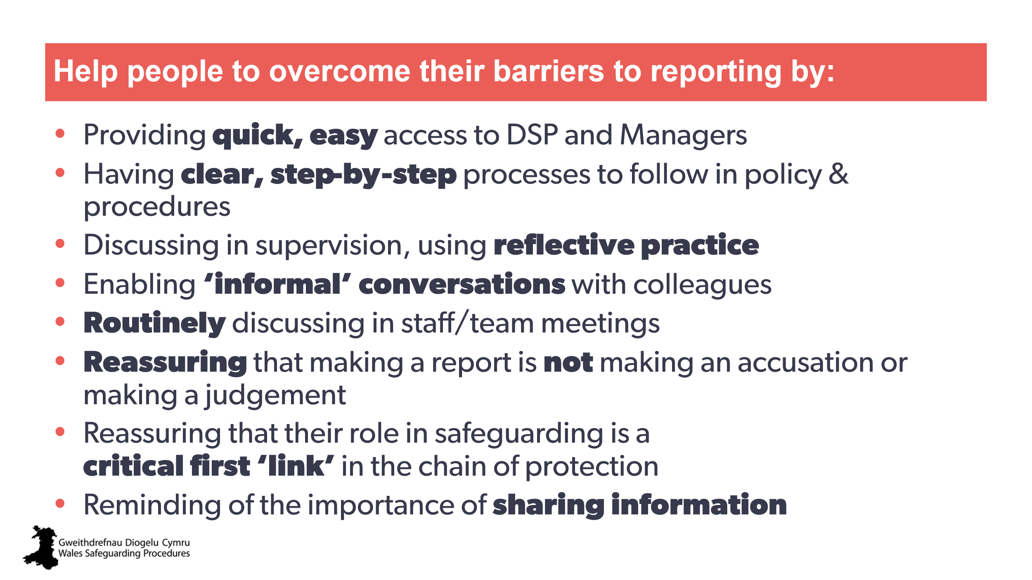 | ​Optional slide to use with activity  Aim:  - to support / jump start the above activity if learners are struggling  - to use as idea generator  - to make sure all suggestions are covered / fill in the gaps.  Note to trainer:  - you may wish to direct people to the procedures’ ‘Pointers for Pratice’ on this  - available for those groups that may have difficulty starting conversations, intended to give broad/generic ideas  - you may wish to show this slide during the discussion as ‘idea starters’. | ​Pointers for Practice: Potential Barriers to Recognising and Reporting Abuse and Neglect (children and young people)  Pointers for Practice: Potential barriers to recognising and reporting abuse and neglect (Adults)
18 | 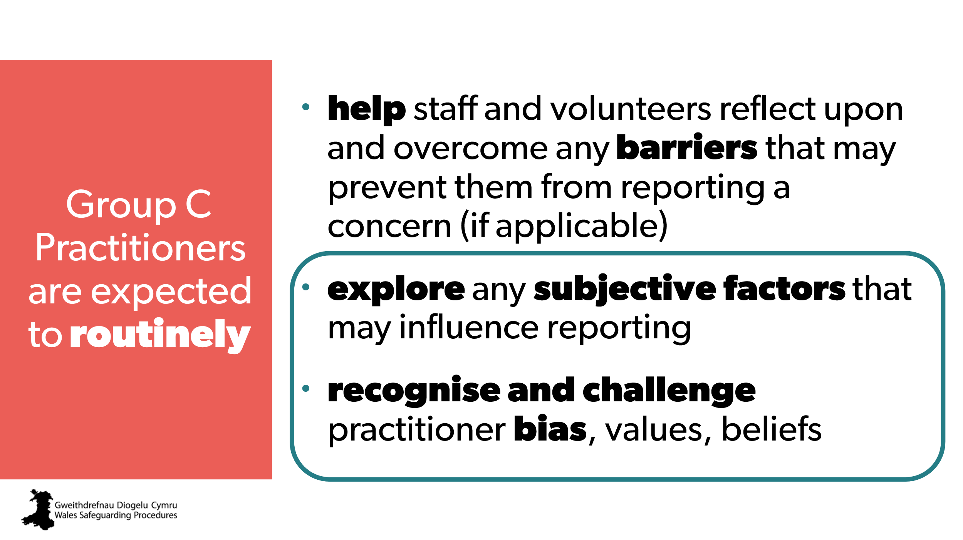 | Slide to show that we are moving on to the next section highlighted
19 | 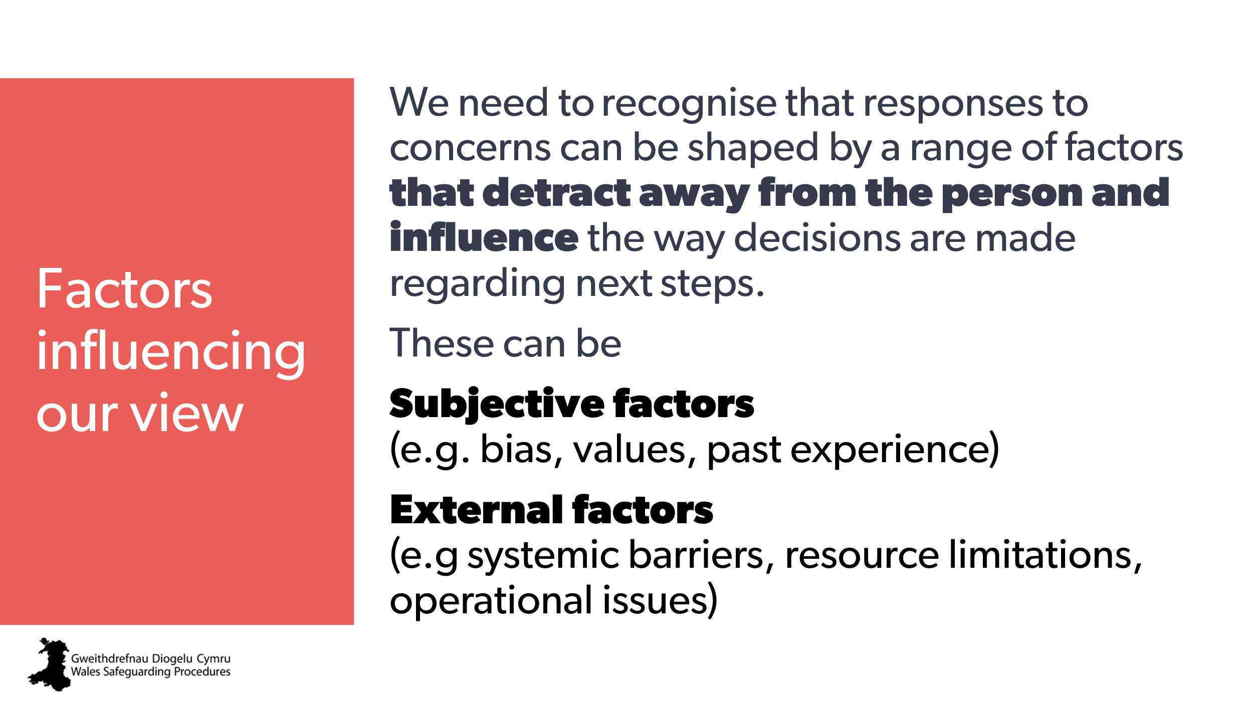 | Aim:  to acknowledge the various influences on us when considering a concern.
20 | 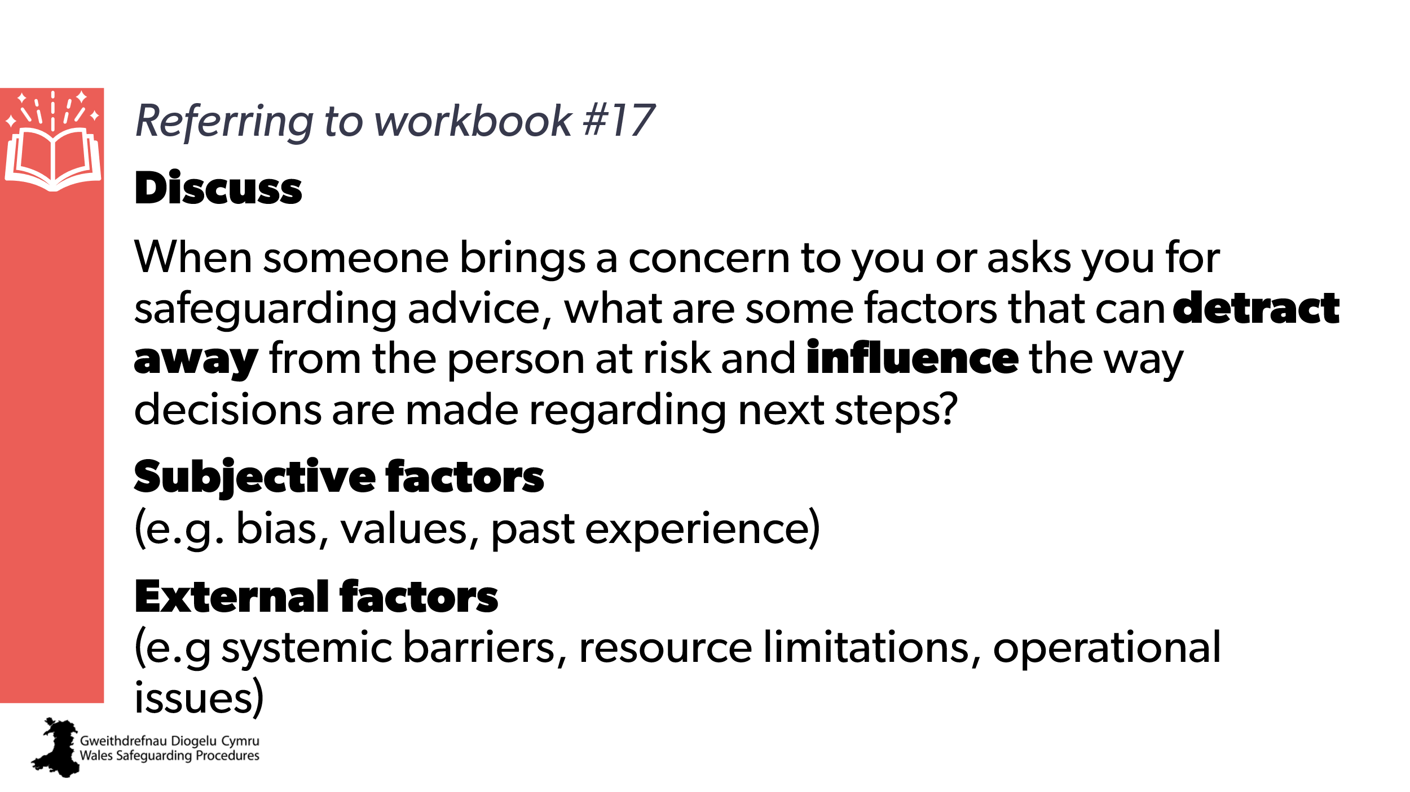 | Activity  Aim:  - to allow discussion and sharing of ideas for ways of overcoming and addressing subjective and external influences  - to enable learners to start an ‘actions list’ of practical, specific steps they can take, put in pace, or do  Note to trainer:  Examples may include:  - time constraints  - caseload  - source of the concern  - unconscious bias  - timing of report  - availability of resources.
21 | 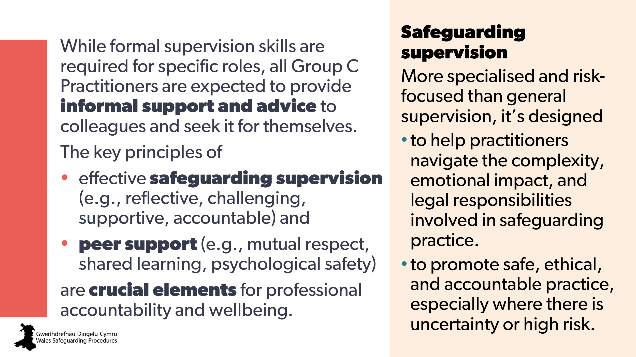 | Aim:  - to highlight the need for safeguarding supervision  - to highlight need for peer support.  Trainer to explain:  Safeguarding supervision is a vital tool for maintaining safe and effective safeguarding practice.  More specialised and risk-focused than general supervision, it’s designed to help practitioners navigate the complexity, emotional impact, and legal responsibilities involved in protecting children and adults from harm.  Safeguarding supervision aims to promote safe, ethical, and accountable practice, especially where there is uncertainty or high risk. | All Wales Safeguarding Supervision Guidance (NHS)  Effective supervision in social care, early years and childcare | Suggest CPD:  CPD that looks at the key principles of effective safeguarding supervision  CPD for supporting peer support (for example, mutual respect, shared learning, psychological safety).
22  23 | 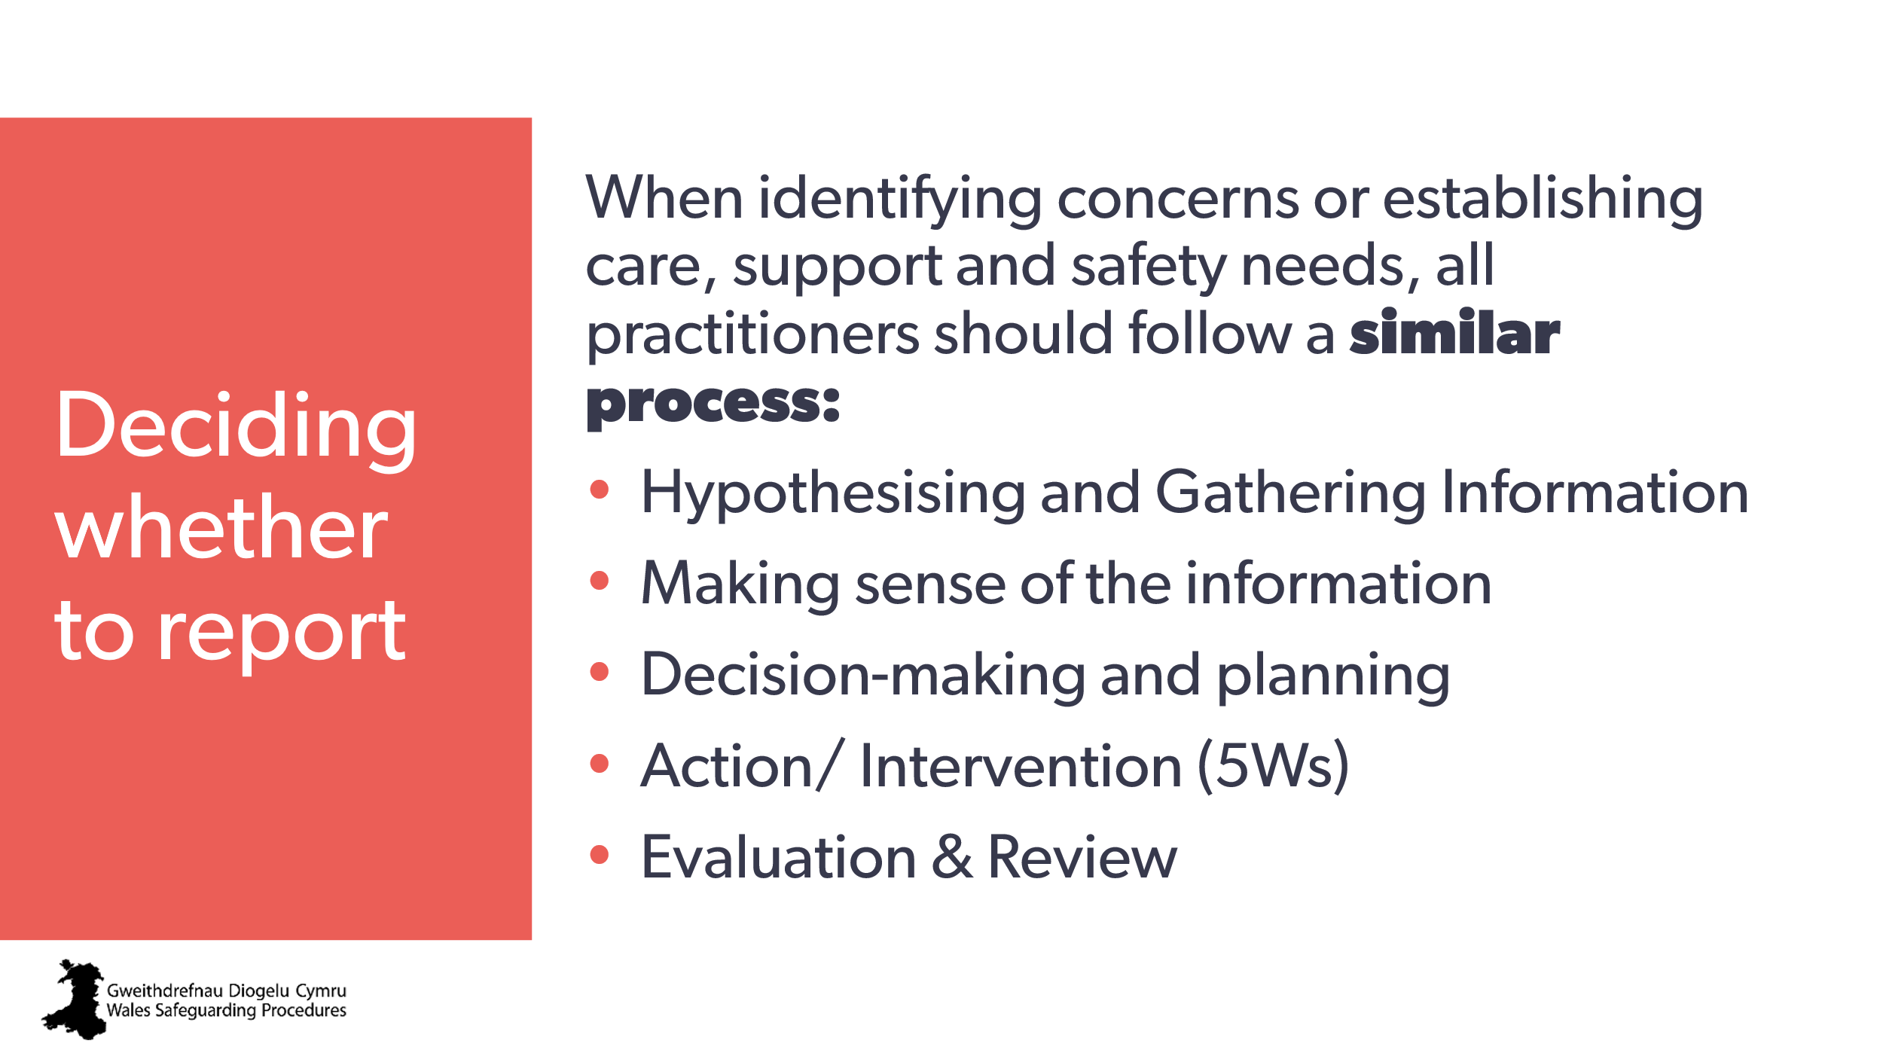  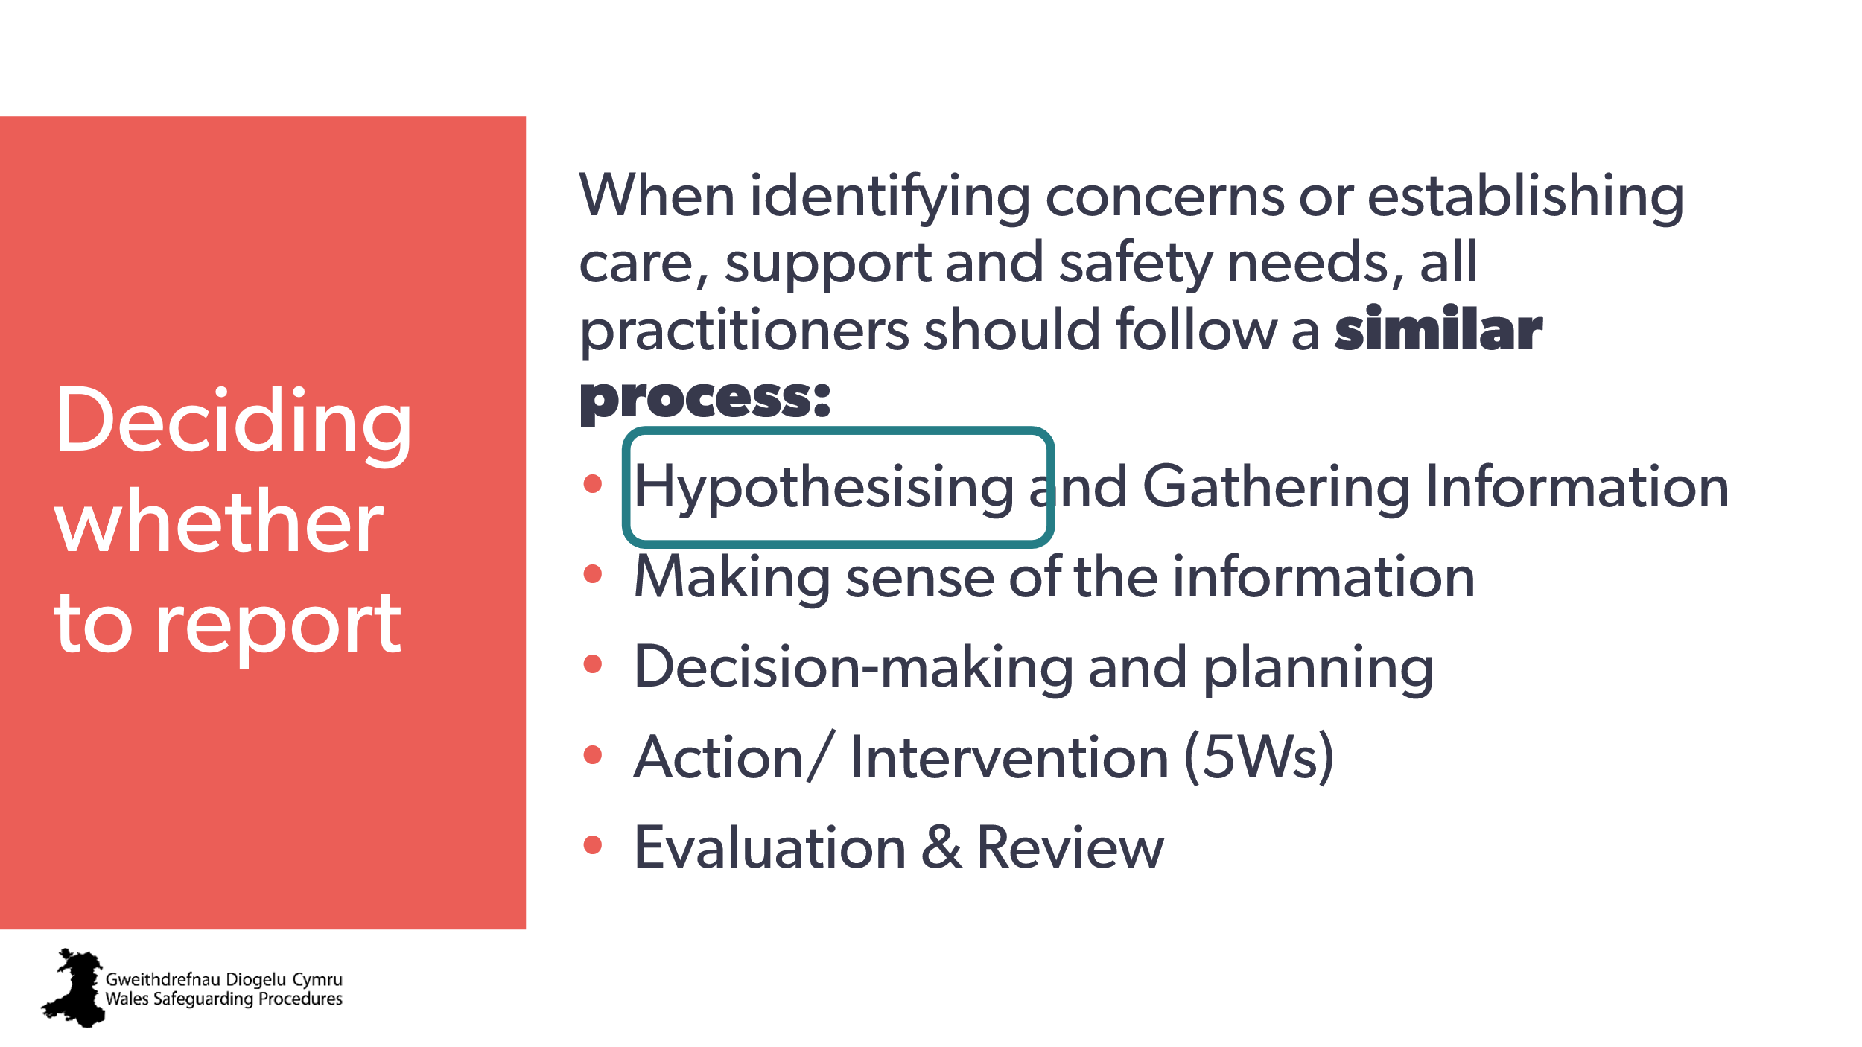 | ​Aim:  - to introduce the next section on decision making.  Trainer to explain:  We will be looking at a basic decision-making process, as outlined in the Wales Safeguarding Procedures.  We’re starting with hypothesising  Note to trainer:  - reassure learners that this isn’t new - it’s a process that goes on in our minds all the time. We have it in the Wales Safeguarding Procedures because when we have a difficult decision to make, it can help to break it into parts to make it a bit more manageable.  - the two versions of the Wales Safeguarding Procedures (children and young people / adults) are slightly different, but they basically have the same guidance. | Slides based directly on:  Pointers for Practice:  How to Apply the Safeguarding Process to Practice​ (children and young people)  Pointers for Practice: The safeguarding process (Adults)
24 | 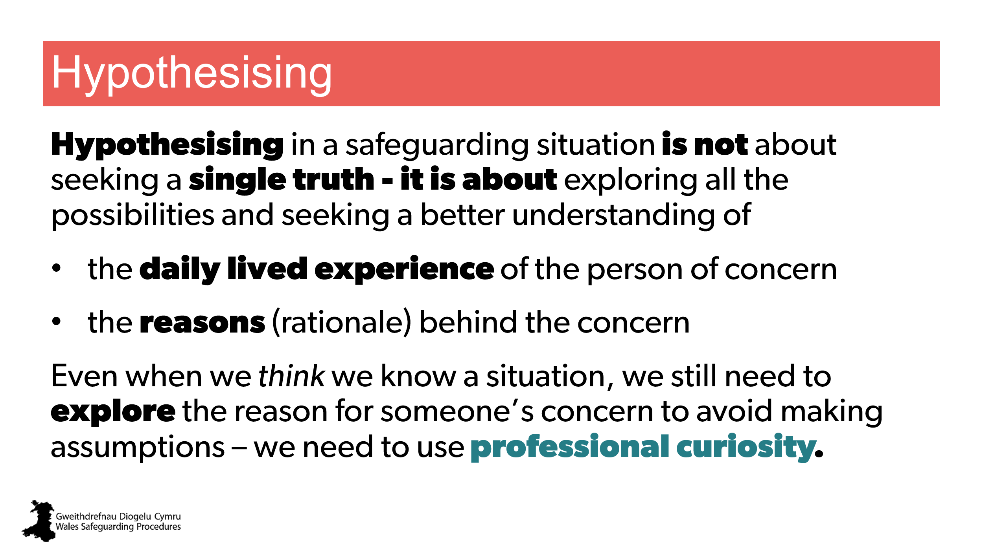 | Aim:  - to introduce and emphasise the importance of professional curiosity in considering concerns  - to explain how to offer support to someone reporting a concern or seeking advice.  Trainer to explain:  When you or someone else has a ‘gut feeling’, an ‘instinct’, a ‘sense’ that ‘something isn’t quite right’, you need to be curious and explore that further with them.  What’s important at this stage of the process is to remember is that we’re not looking to understand a single situation or aspect to address, but to look for and understand all (or as many of) the aspects that may be contributing to a person’s risk, as well as to their ongoing safety.  Hypothesising is about constantly testing, reconsidering and revising our hypotheses, assumptions and judgements. | Reflection and Professional Curiosity Practice Resource; page 6
25  26 | 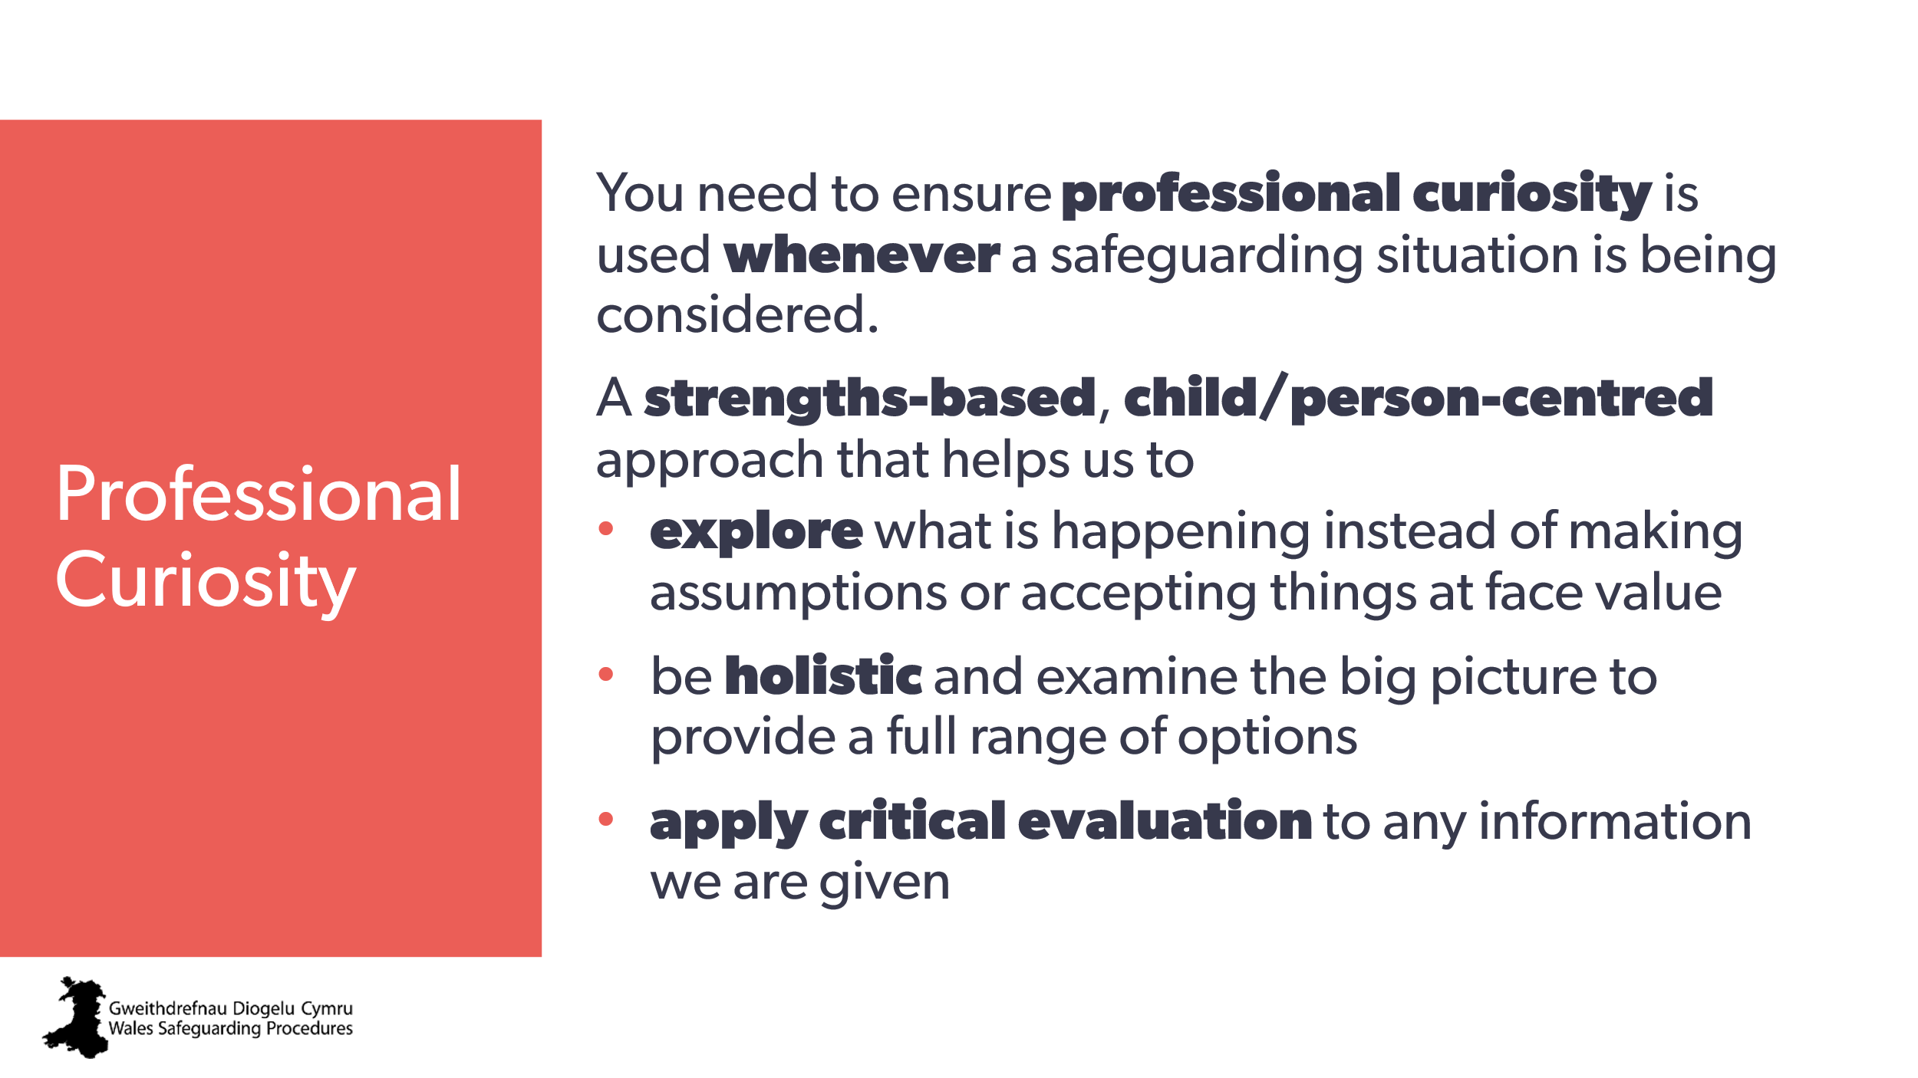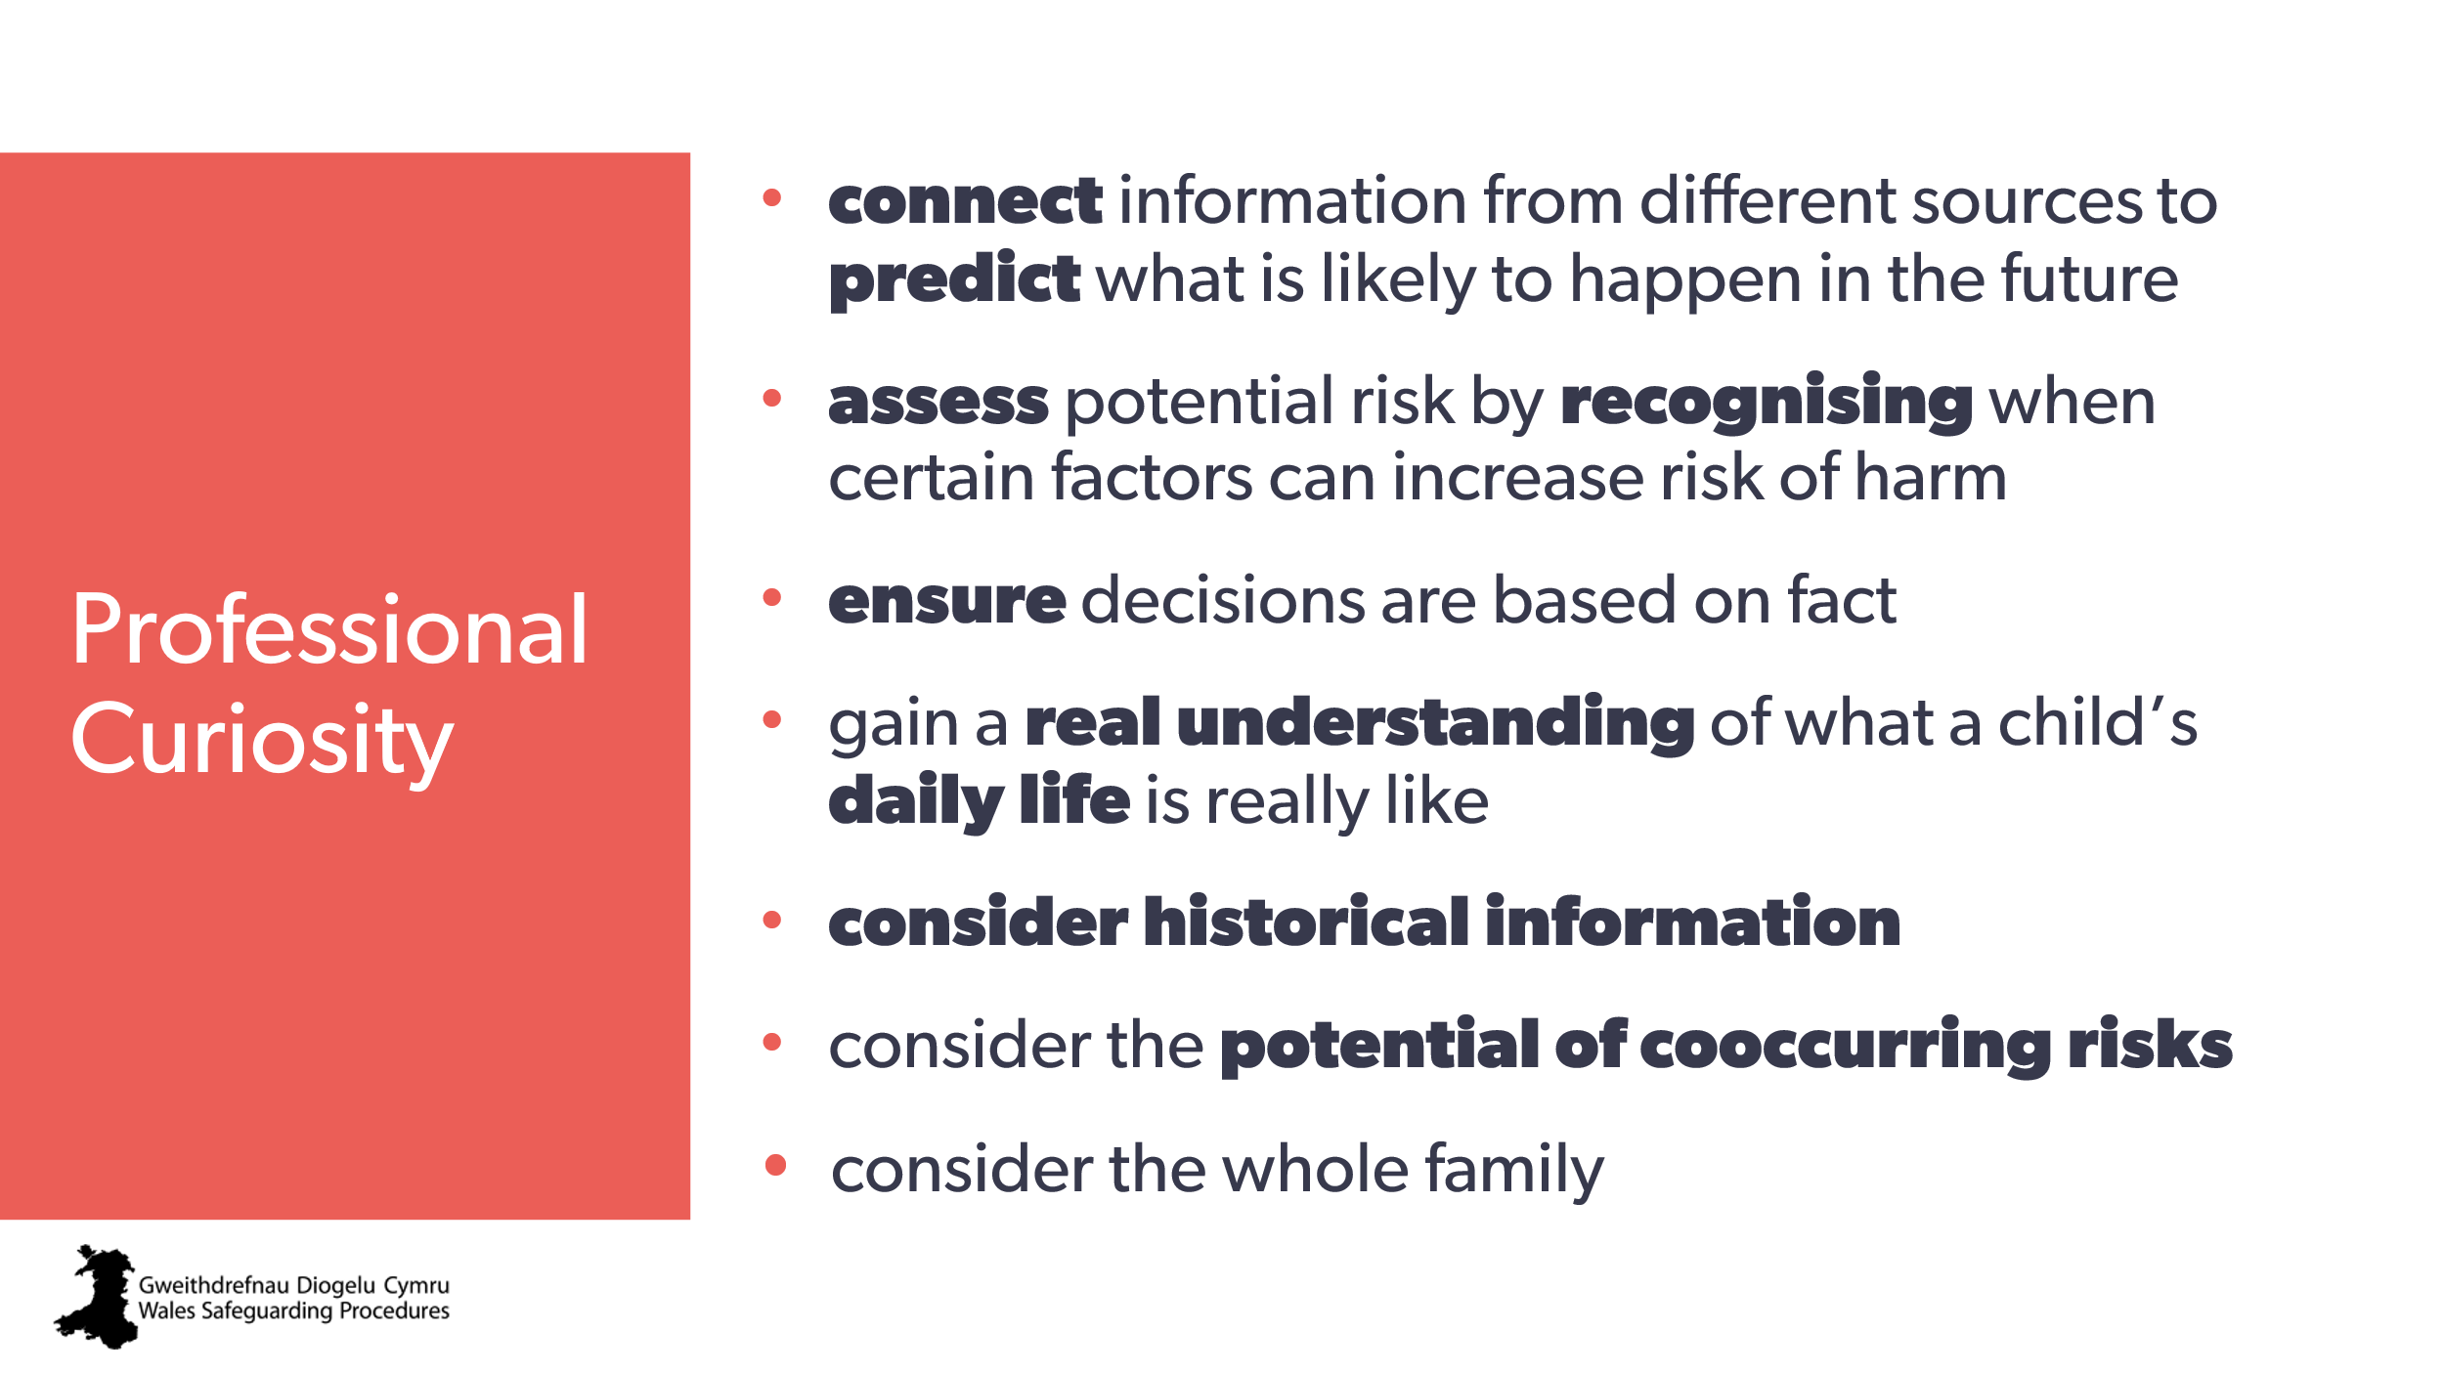 | Aim:  - highlight need for greater professional curiosity  - to look at professional curiosity as a tool to help decide on appropriate and effective actions.  Trainer to highlight:  Group B included: “What is professional curiosity and why is it important in safeguarding?”  Now we want to talk and think about how we can use professional curiosity as a tool to consider and connect information from different sources to:  - predict what’s likely to happen in the future  - share and connect information from different sources  - gain an understanding of what a child’s / family’s life is like and to assess potential risks and strengths  - enable us to be critical - not cynical - so we don’t miss anything. | Risk, Response and Review: Multi-Agency Safeguarding  Learning from Reviews: Analysis of Emerging Themes from Child Practice, Adult Practice and Domestic Homicide Reviews in Wales  Background for trainer  Several thematic reviews of practice reviews highlight the need for professional curiosity:  - increased holistic approaches - recognition of patterns, wider context, interaction between different risk factors, understand the wider (multi-agency) picture, how to consider historical information and co-occurring risks  - increased information sharing  - the dangers of tunnel vision and professional optimism.
27 | 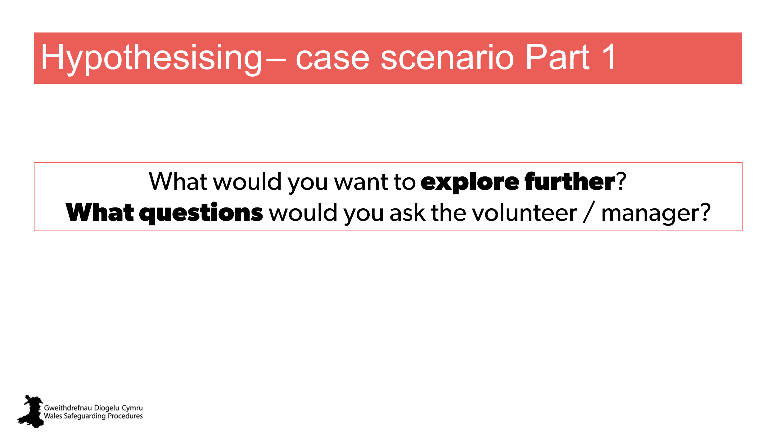 | Aim:  to have everyone consider how they use professional curiosity  - to consider a concern they have  - to help a staff member figure out why they are concerned  Activity  Distribute: case scenario/s Part 1 (children and young people, Adult, or both)  Trainer to explain:  In groups (or as a shout out):  What questions would you ask? | Case scenarios  Adapted from:  Child at risk - Maisie Pointers for Practice: The Identification, Assessment, Planning, Intervention and Review Process Applied to Making a Report  Adult at risk – Mrs Adams Pointers for Practice: The identification, assessment, planning, intervention and review process applied to making a report
28 | 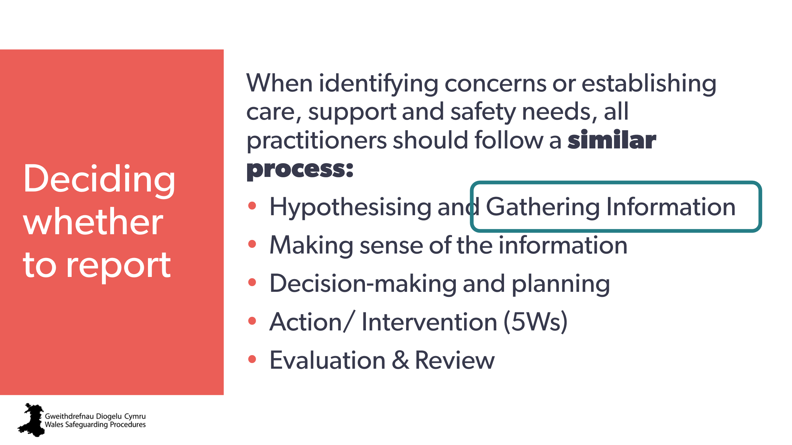 | Aim:  - to introduce the next step in the process: gathering information.
29 | 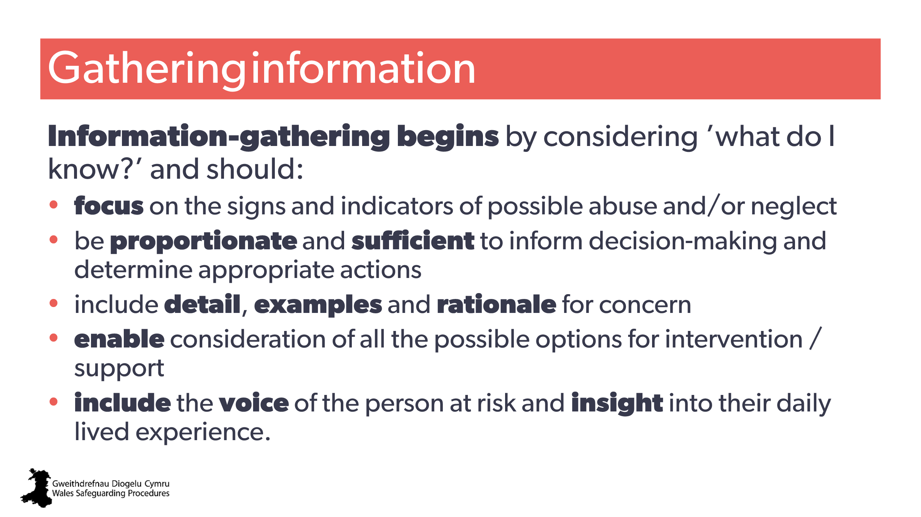 | Aim:  - slide to highlight Wales Safeguarding Procedures importance/purpose on gathering information.  - Promote voice and lived experience | Wales Safeguarding Procedures:  Pointers for Practice: How to Apply the Safeguarding Process to Practice (children and young people)  Pointers for Practice: The safeguarding process (adults)  Pointers for Practice: Taking a Child-centred Approach (children and young people)  Pointers for Practice: Taking a Person-centred Approach (adults)
30 | 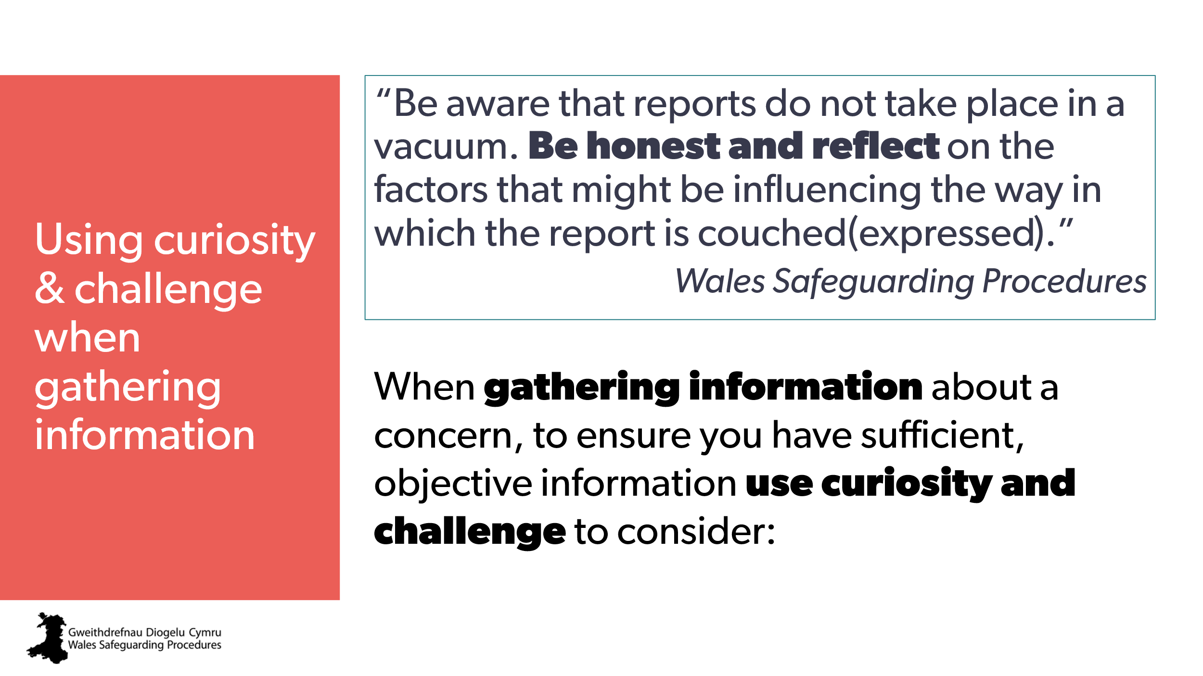 | Aim:  - to introduce aspects of gathering and challenging information  - To offer examples of what to consider/challenge  Note to trainer:  - this can be a quick review exercise  Trainer to explain:  - when someone has come to you for advice or to report a concern, there are aspects you need to explore and potentially challenge to make sure you have as much information as possible. | Wales Safeguarding Procedures:  Pointers for Practice: Eliciting Information Following Report-The Challenges (children and young people)  Information-gathering by the report-taker (Adults)  Pointers for Practice: Eliciting information during the screening and initial evaluation - the challenges (adults)  Pointers for Practice: Subjective factors that can influence the response to a report (adults)  Pointers for Practice: How to Apply the Safeguarding Process to Practice (children and young people)  Pointers for Practice: Making A Report (children and young people)  Pointers for Practice: Making A Report (Adults)  Pointers for Practice: Eliciting Information Following Report-The Challenges (children and young people)  Pointers for Practice: Subjective Decision-Making (children and young people)  Pointers for Practice; Subjective Factors That Can Influence the Response to a Report (children and young people)  Pointers for Practice: Making A Report (children and young people)  Pointers for Practice: Eliciting information during the screening and initial evaluation - the challenges (adults)  Information-gathering by the report-taker (adults)  Pointers for Practice: Subjective factors that can influence the response to a report (Adults)
31 | 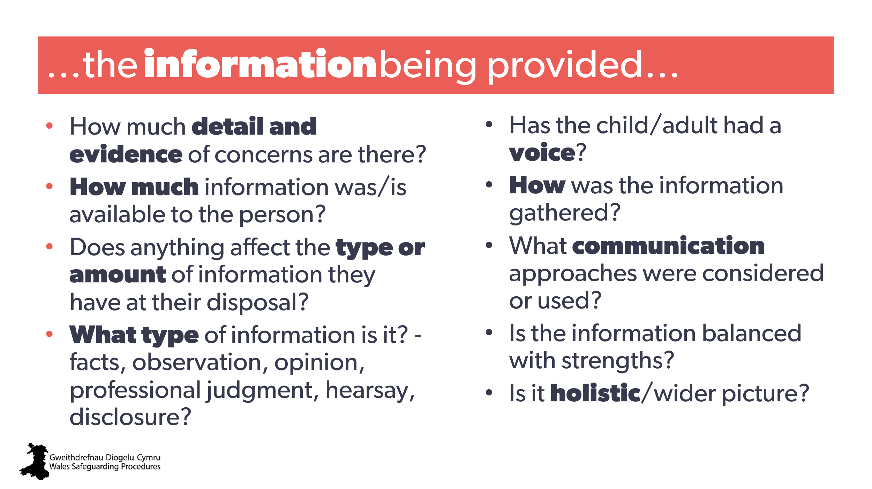 | Aim:  - to focus the learner’s thinking on the information itself.  Trainer to ask:  - ask the room to read the slide to themselves and then offer any further insight or examples based on their own experiences  - allow quick shoutout responses.  Note to trainer:  - Make sure everyone’s clear that in this context, “evidence” means rationale for the concern – it does not necessarily mean evidence of abuse or neglect.  - Definition of Duty to Report in the Wales Safeguarding Procedures includes: “reasonable cause to suspect”. In this context, evidence = what is the basis for their reasonable cause?
32 | 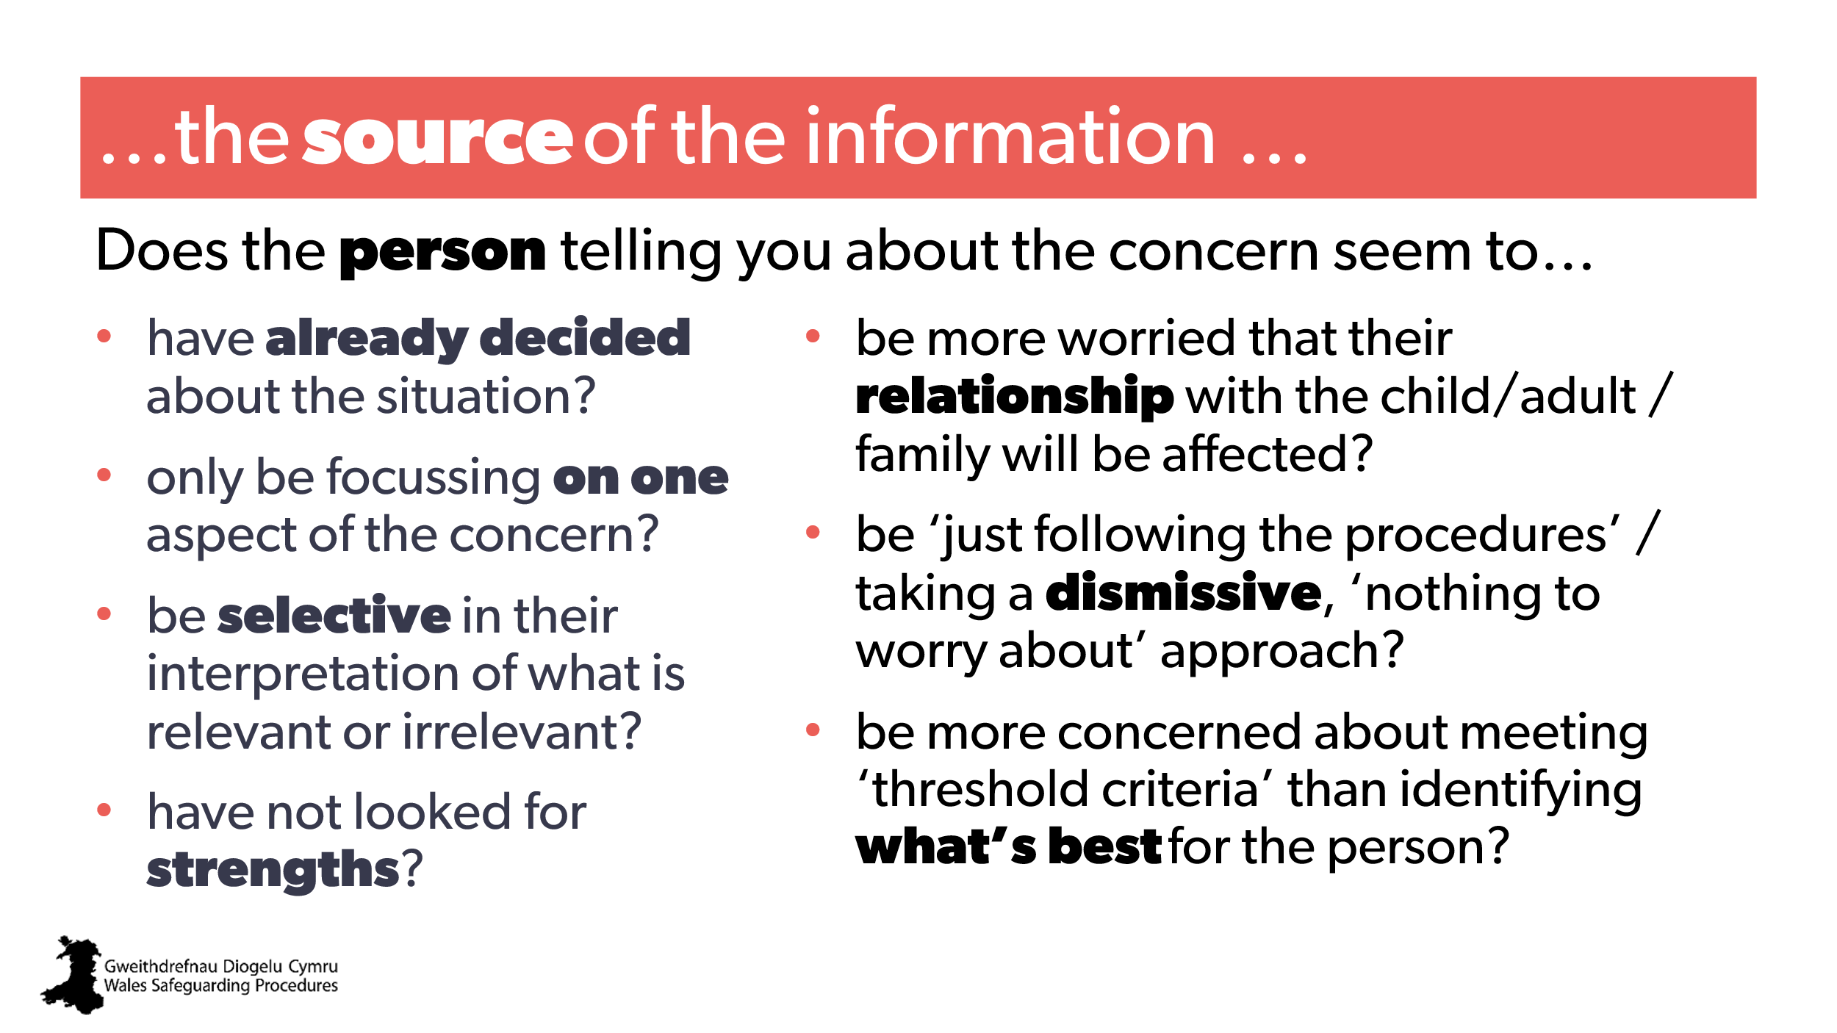 | Aim:  - to focus the learner’s thinking on where the information is coming from.  Trainer to ask:  - ask the room to read the slide to themselves and then offer any further insight or examples based on their own experiences  - allow quick shoutout responses.
33  34 | 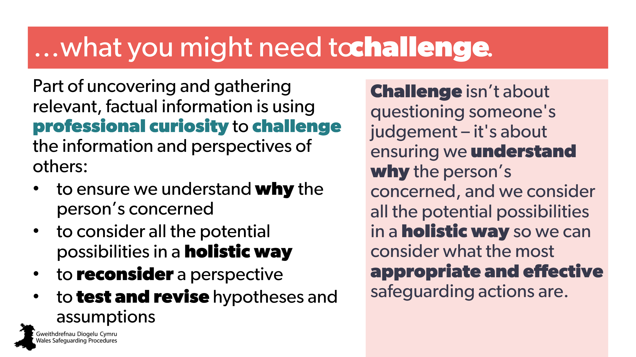  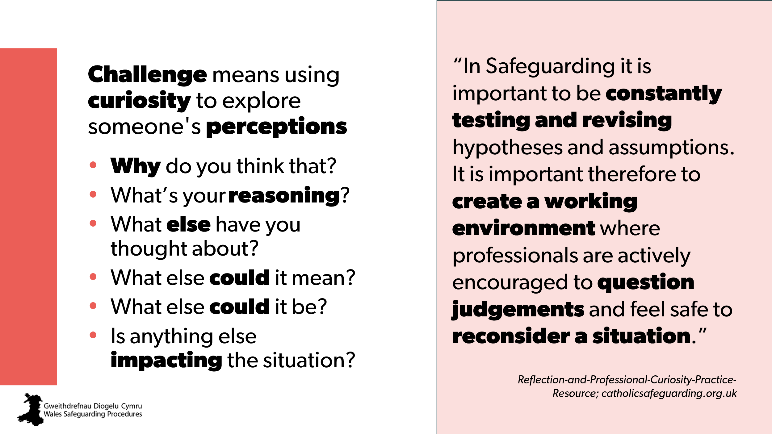 | Aim  - introduce the need for challenge with positive intent  - remind of positive culture  - remind of professional curiosity.  Note to trainer:  Stress the need to do this in a supportive way. If the person becomes defensive or feels their judgement is being doubted, they may shut down or not come forward later. Questioning needs to be in a supportive way to explore possibilities and challenge perceptions. | Reflection and Professional Curiosity Practice Resource; page 6 | CPD  Using Professional Challenge
35 | 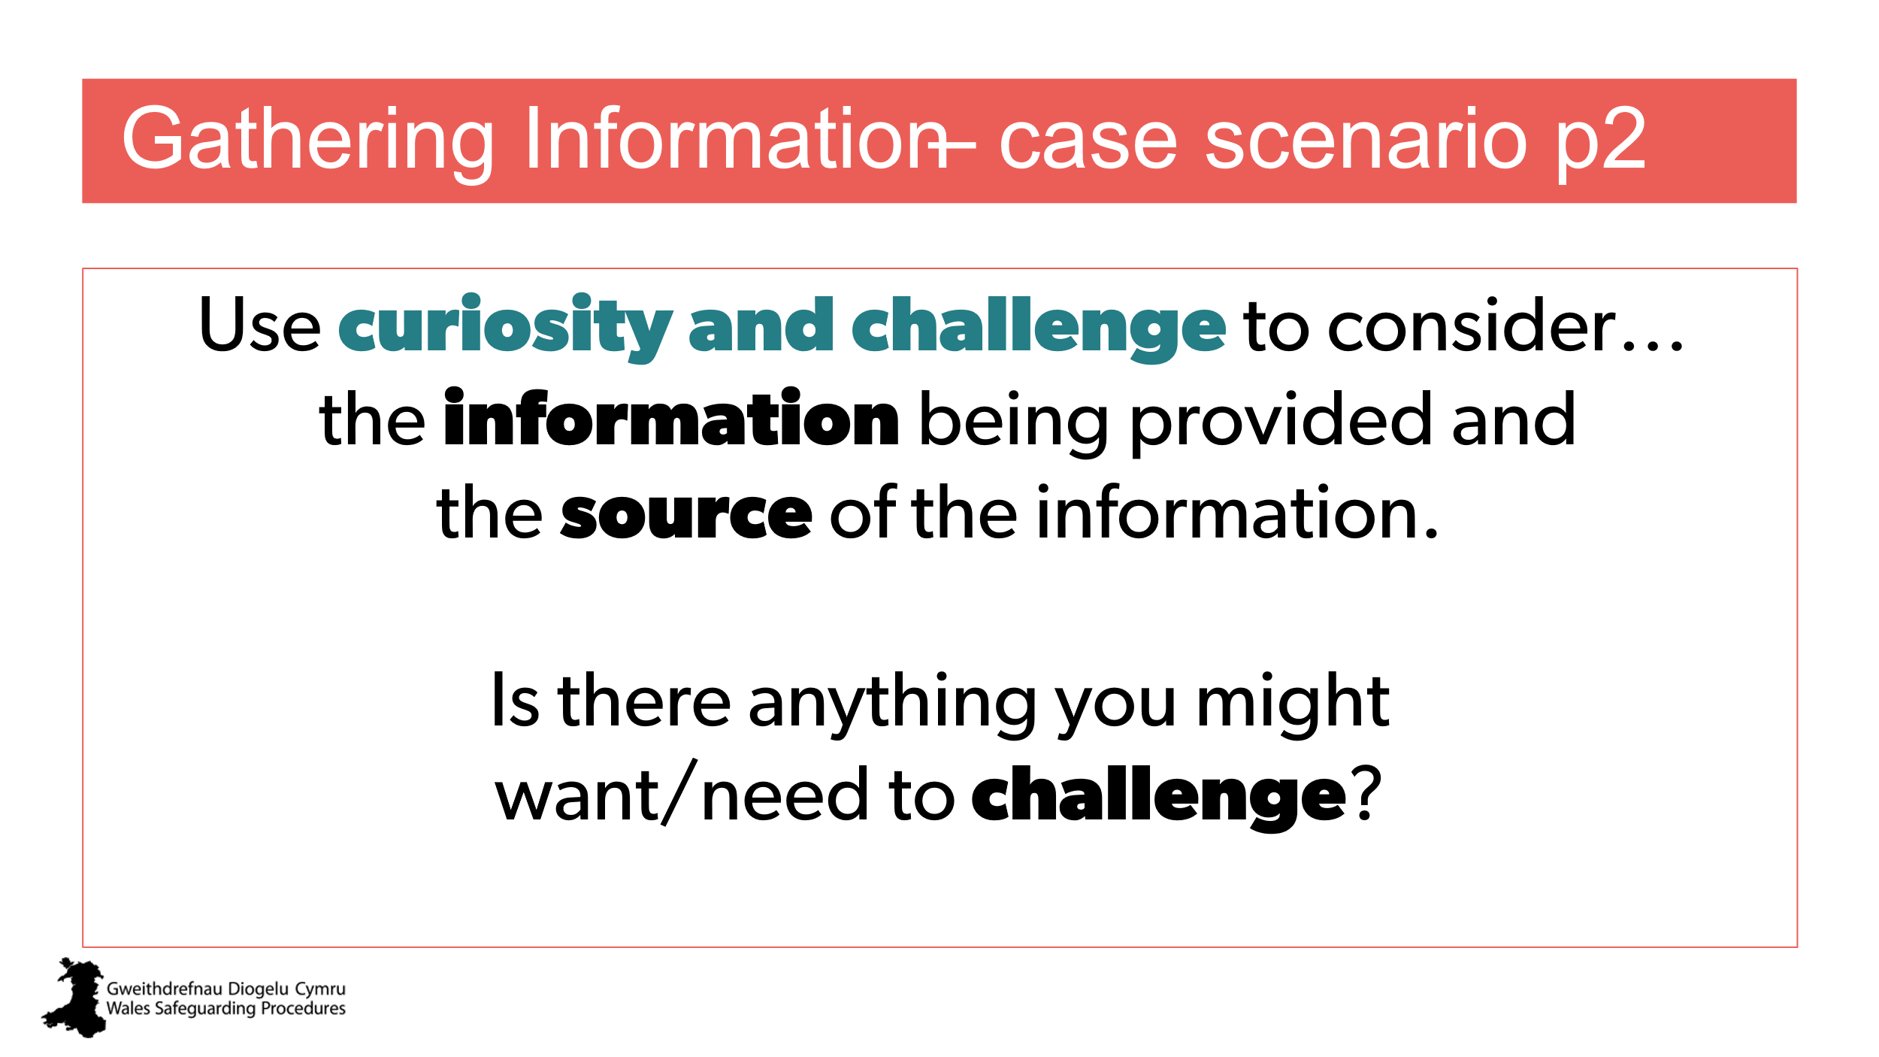 | Aim:  To provide practical discussion  Activity – small group discussions  Distribute:  Case scenario/s Part 2  (children and young people, Adult, or both)
36 | 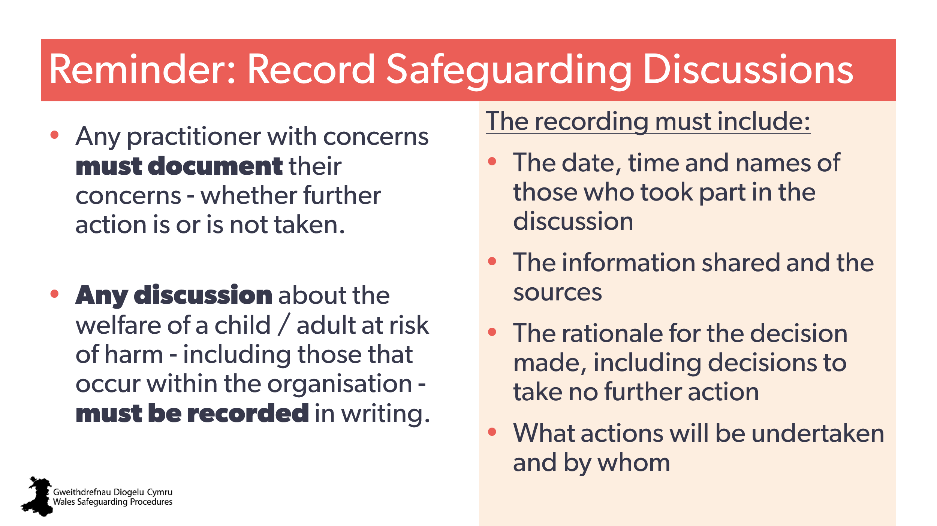 | Aim:  to stress the need to record in writing any and all safeguarding discussions, no matter the outcome decision  Note to trainer:  you may want to direct attendees to the Wales Safeguarding Procedures page that features this. | Wales Safeguarding Procedures > S2 - Recording initial discussions  Adults: https://safeguarding.wales/en/adu-i/adu-i-a2/a2-p9/  Children and young people: https://safeguarding.wales/en/chi-i/chi-i-c2/c2-p13/ | CPD:  Recording / notes
37 | 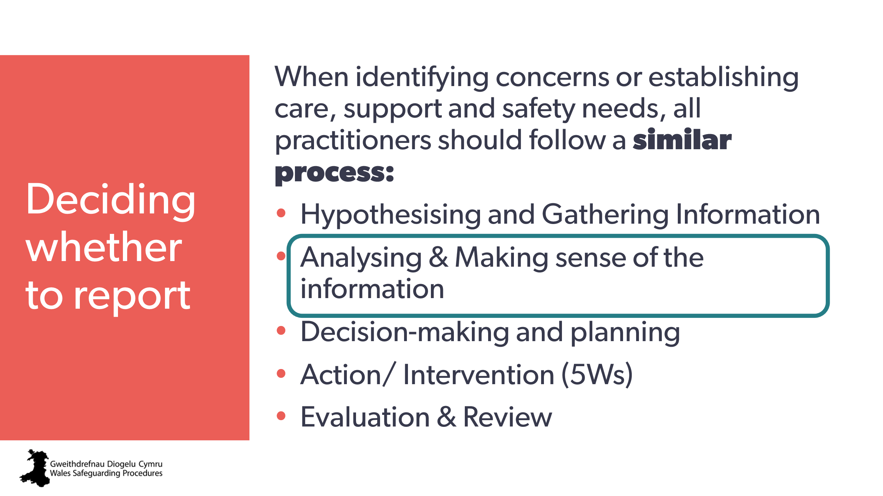 | Aim:  - to introduce the next step in the process: analysing and making sense of the information.
38 | 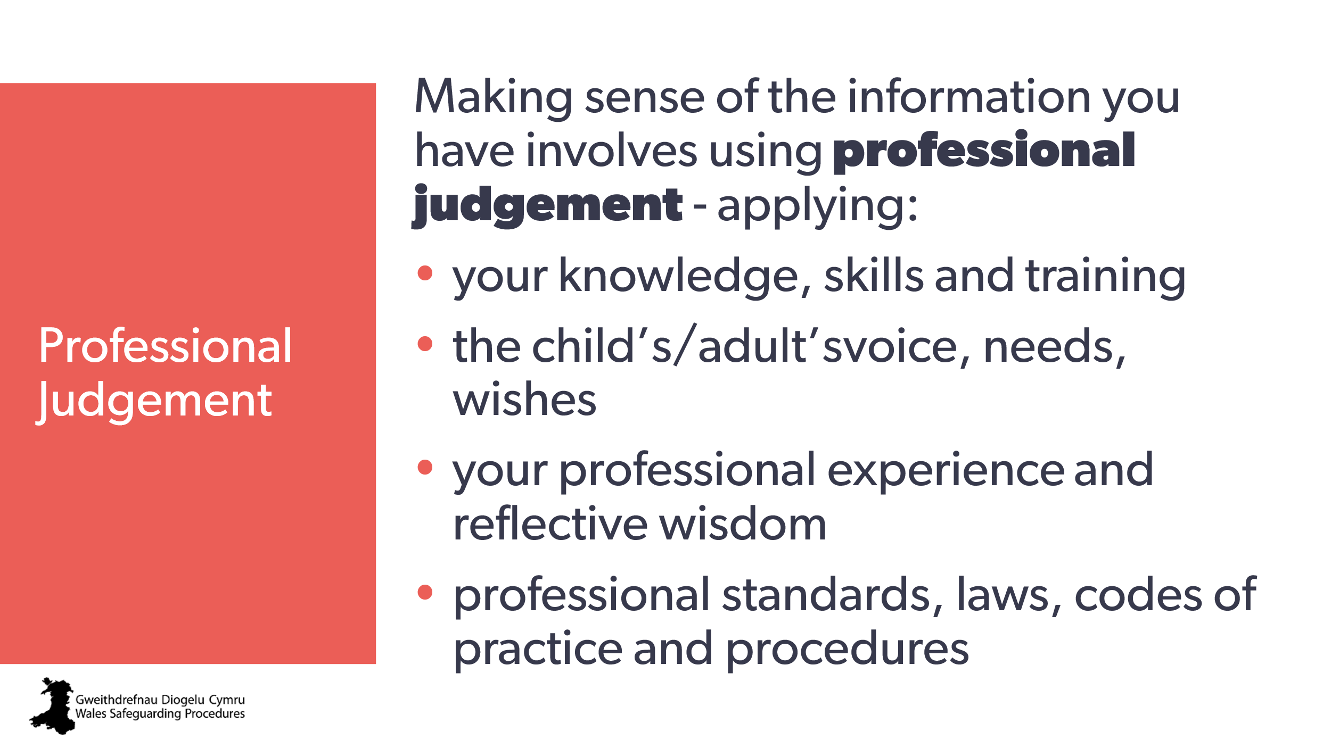 | Aim:  - to highlight the need for professional judgement.  Note to trainer:  - this is a key aspect in today’s safeguarding – so they really need to understand it and be confident to use it  - repeated throughout the Wales Safeguarding Procedures  - individual responsibility to use this.  Trainer to explain:  - judgement is a decision (not opinion)  - all four elements must be considered and applied to the decision-making process  - provides the rationale and back-up to your decisions. | Adapted from:  Professional judgment — a working definition
39 | 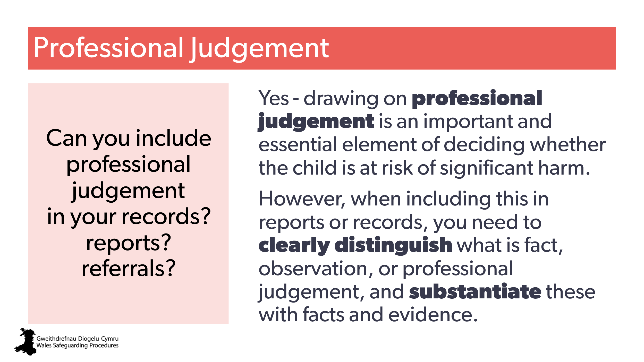 | Aim:  to stress the need to use this and include it in referral.  Ask:  - ask the group – allow thought and discussion  - reveal yes  - Stress how to do this -  Trainer to explain:  it’s important to both understand and clarify the difference between fact, opinion and judgement when recording and reporting information. If the information gathered is hearsay or professional opinion this should be made clear.  Note:  many practitioners still think you can’t include professional judgements or opinions in reports or records. | Wales Safeguarding Procedures:  An effective safeguarding system - children and young people  Principle 4: All practitioners are able to use their professional judgment to put the child’s needs and personal outcomes at the centre of the system so that the right solution can be found for them.  An effective safeguarding system - adults  Principle 5: All professionals are able to use their expert judgement to put the individual’s needs and personal outcomes at the centre of the system so that the right solution can be found for them.
40 | 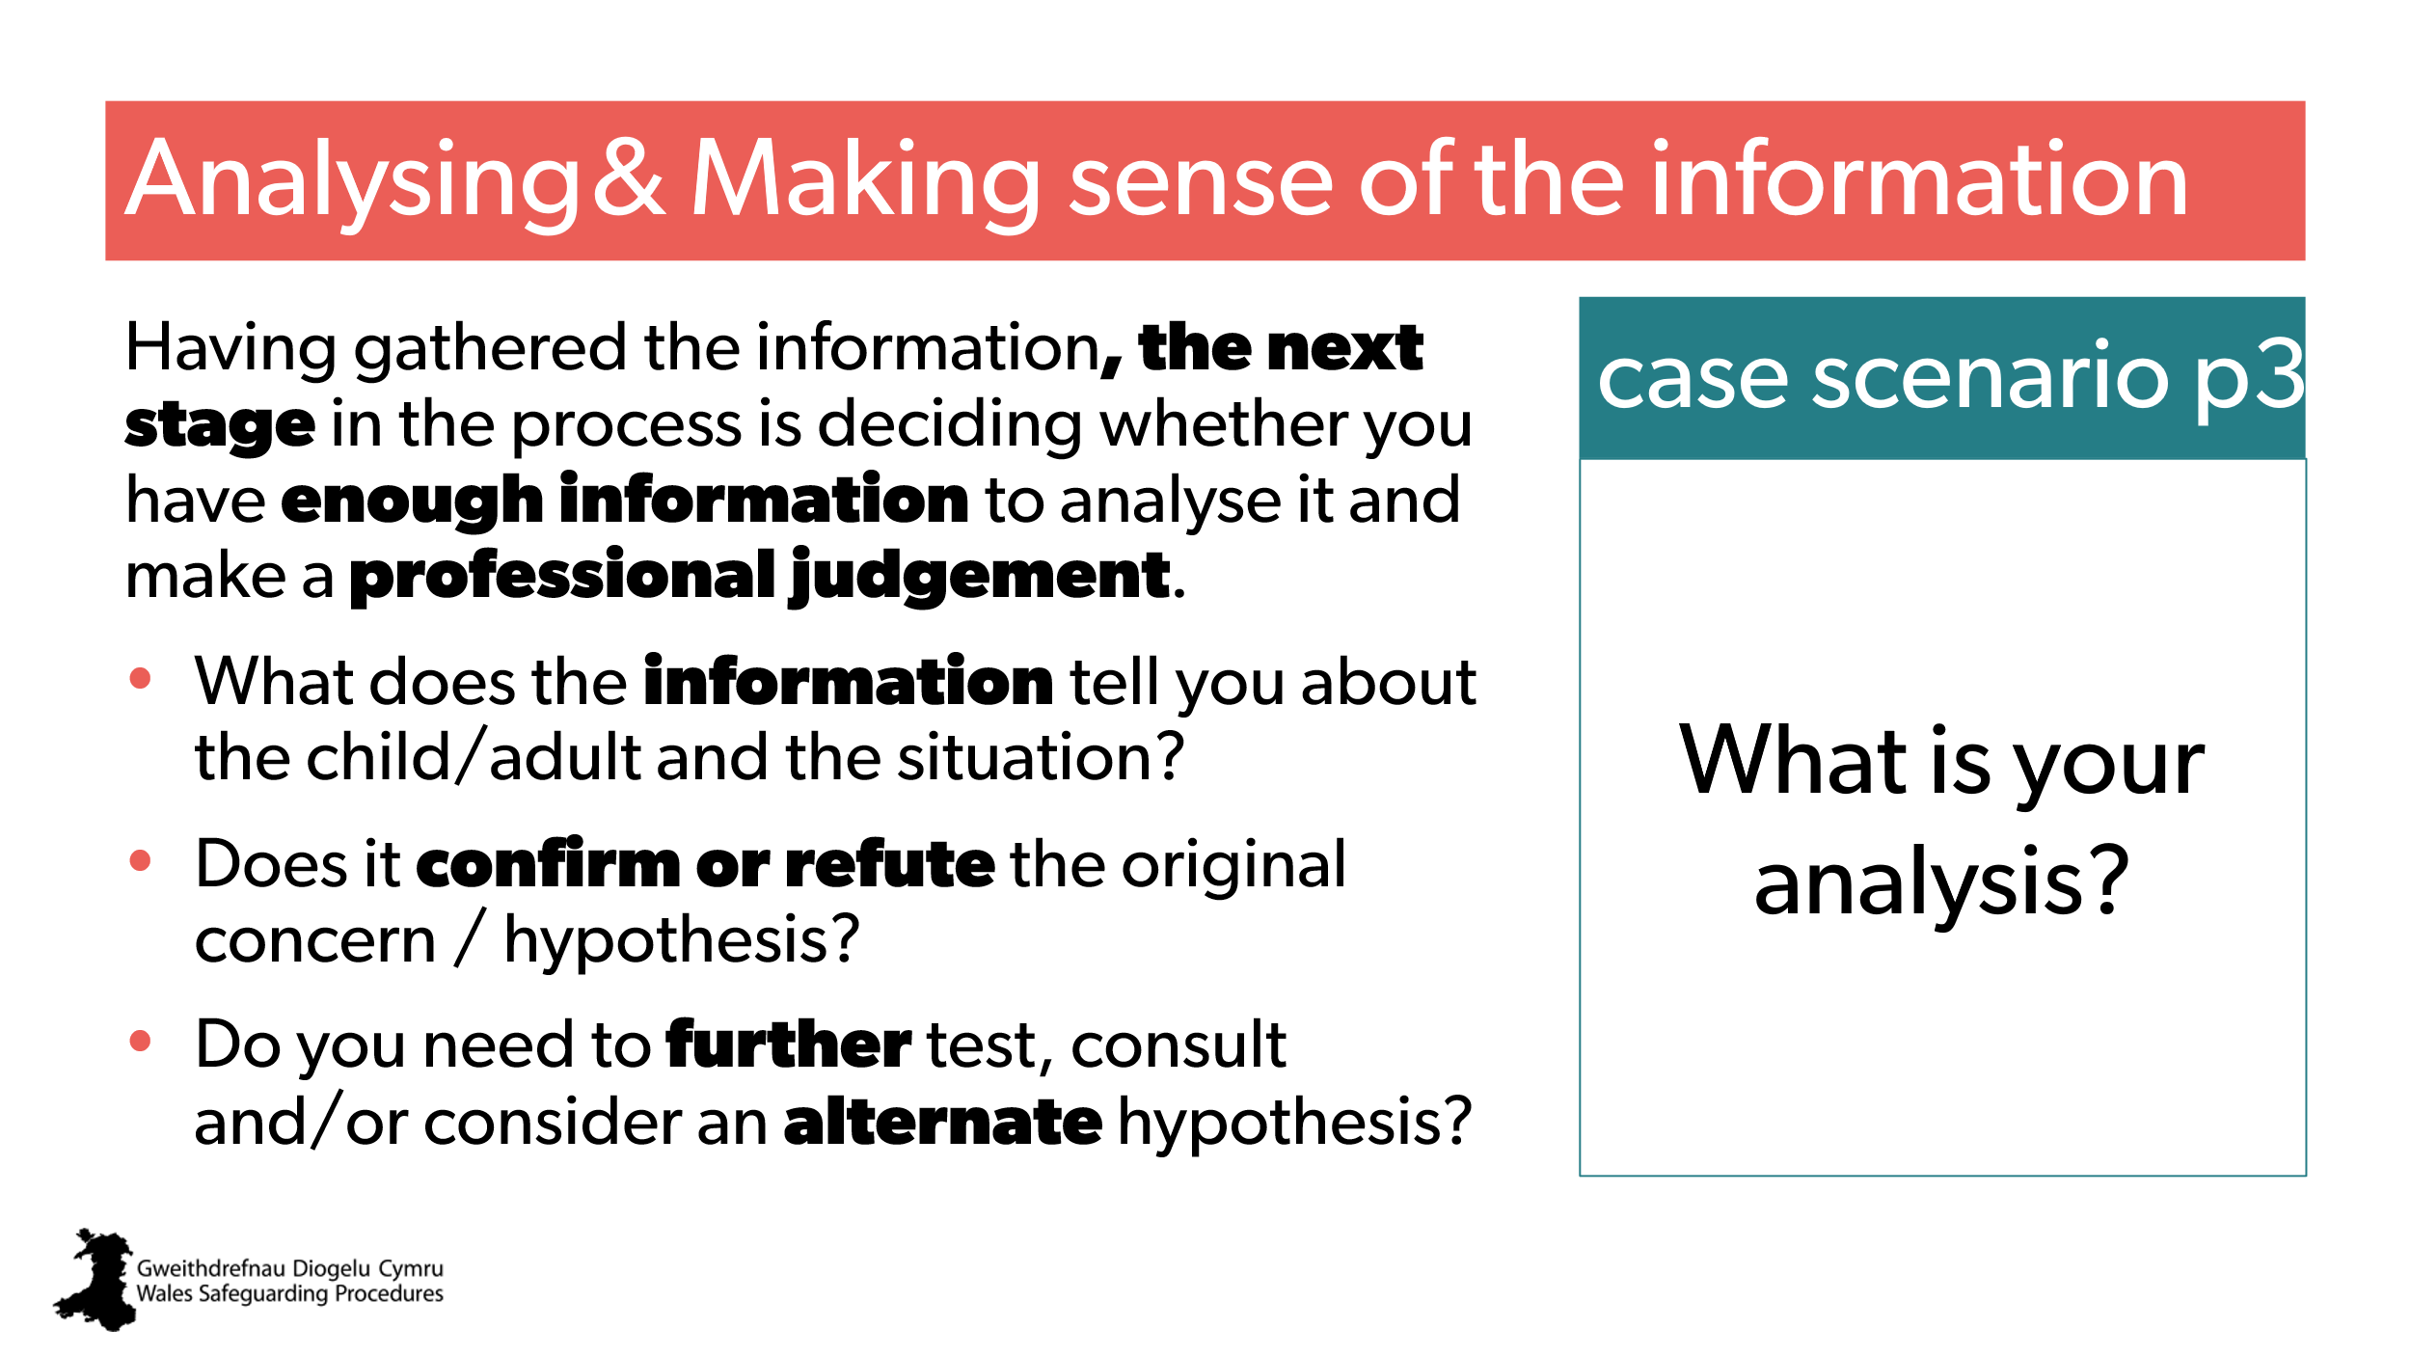 | Aim:  - to provide practical discussion.  Activity – small group discussions  Distribute:  - case scenario/s Part 3  (children and young people, adult, or both) | Pointers for Practice: Analysis and Decision-Making  Pointers for Practice: How to Apply the Safeguarding Process to Practice
41 | 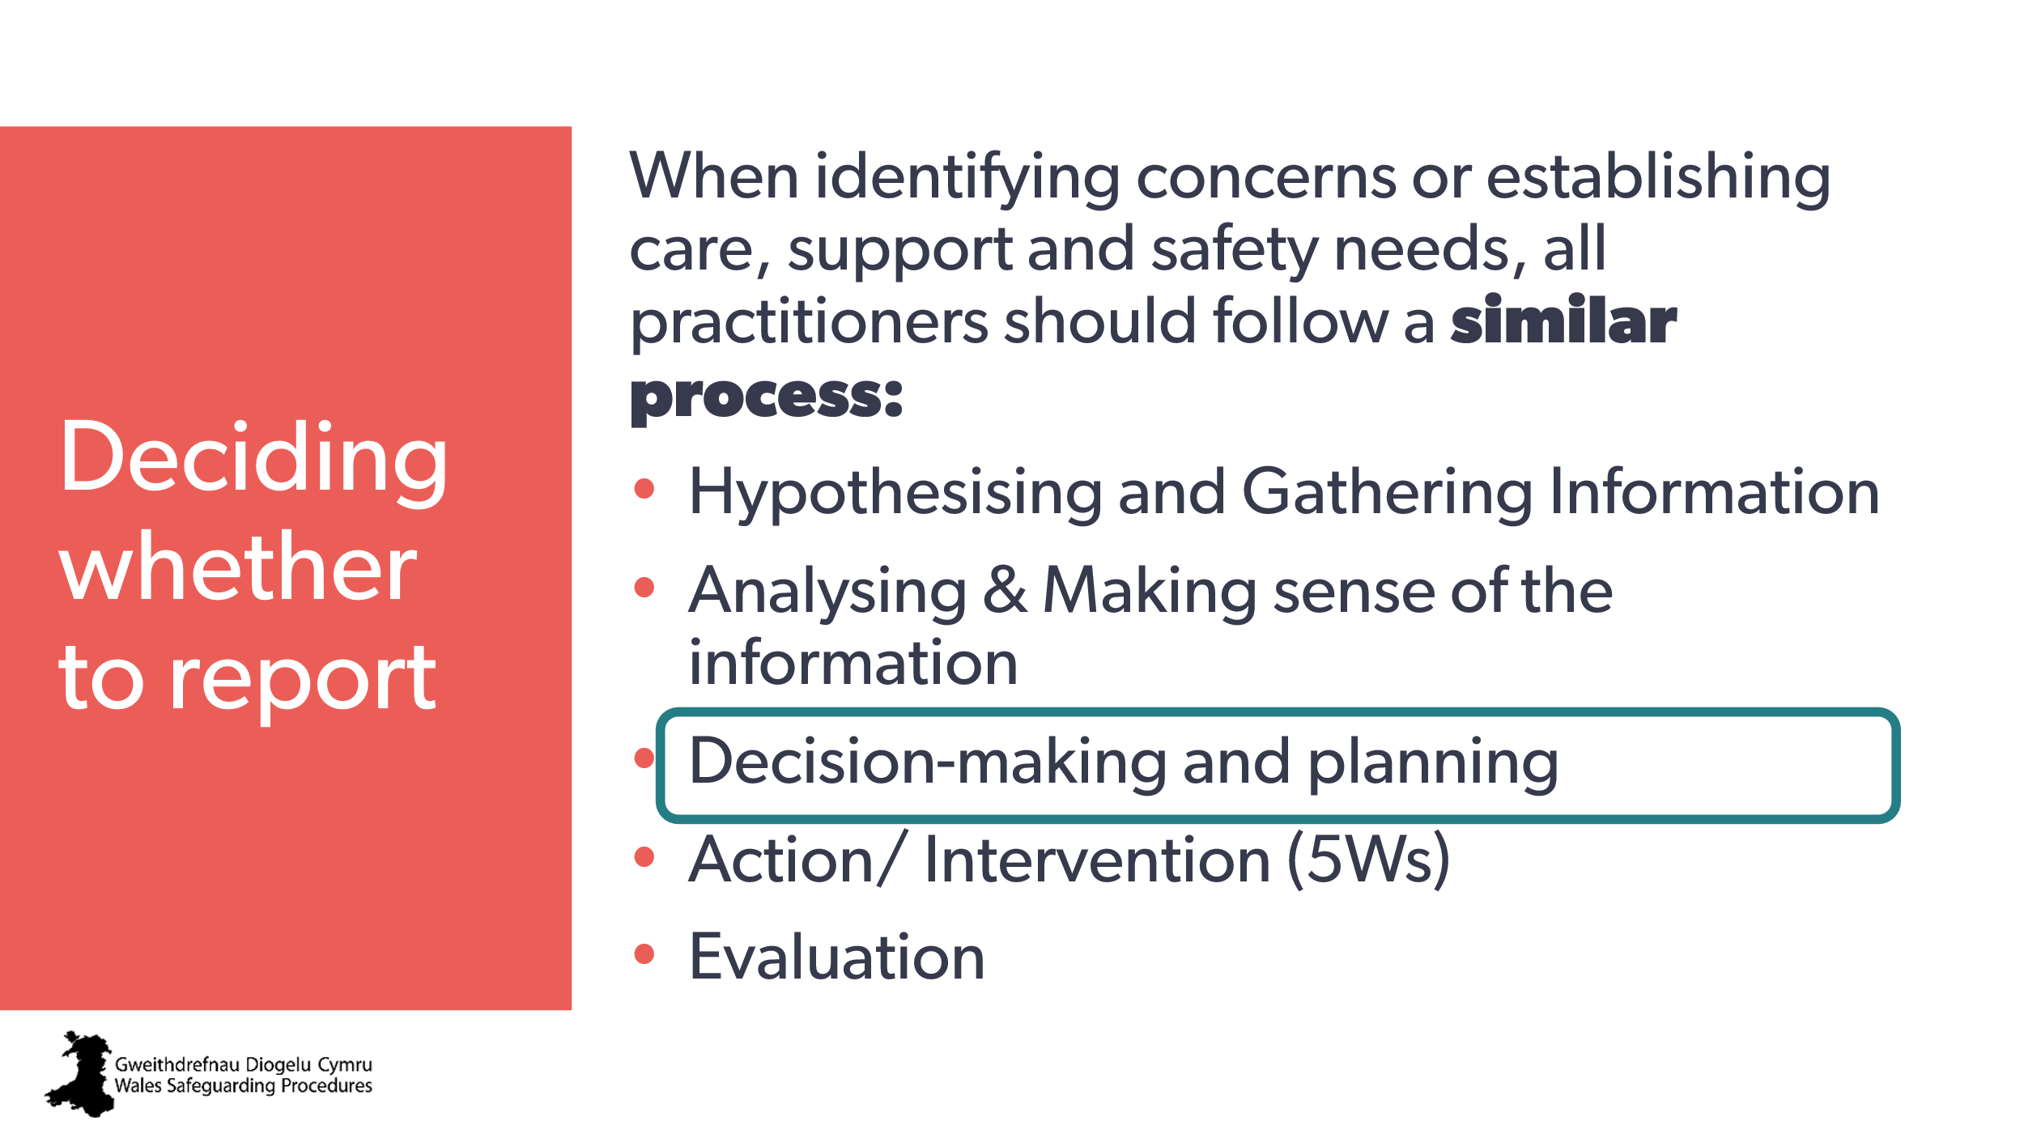 | Aim:  - to introduce the next step in the process: Decision-making and planning.
42  43 | 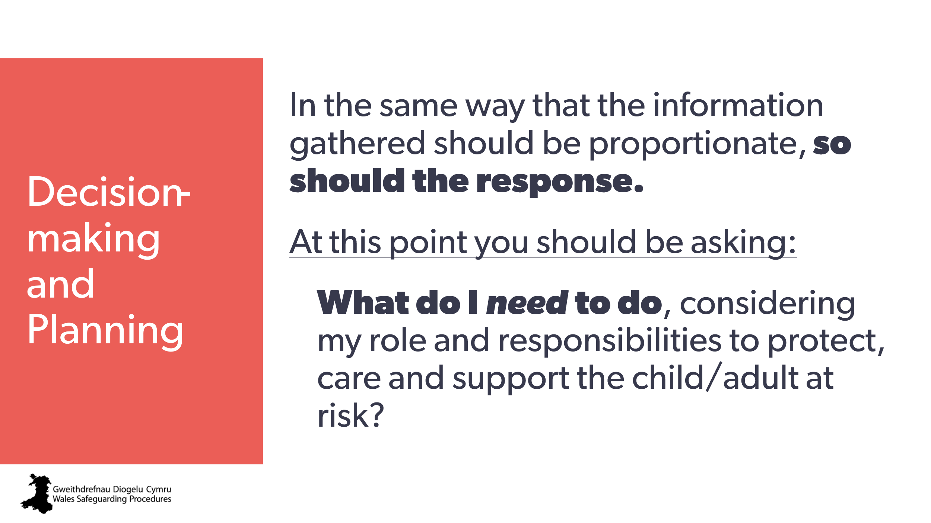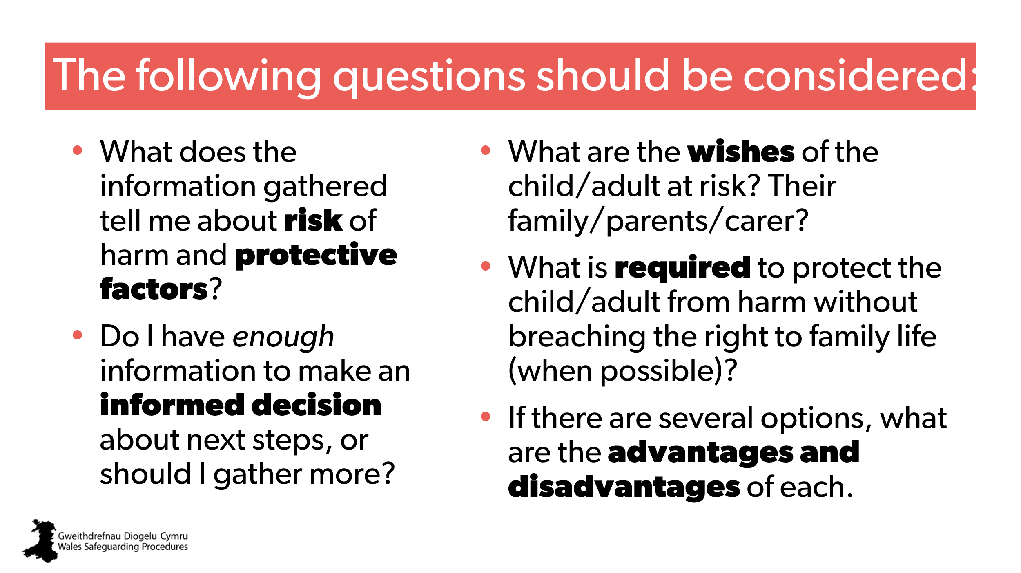 | Aim:  - to highlight the next step in the process.  Note to trainer:  - stress the need to make effective decisions – long term impact. | From Pointers for Practice: The safeguarding process  - https://safeguarding.wales/en/adu-i/adu-i-ap/a1p-p3/  - https://safeguarding.wales/en/chi-i/chi-i-cp/c1p-p3/
44 | 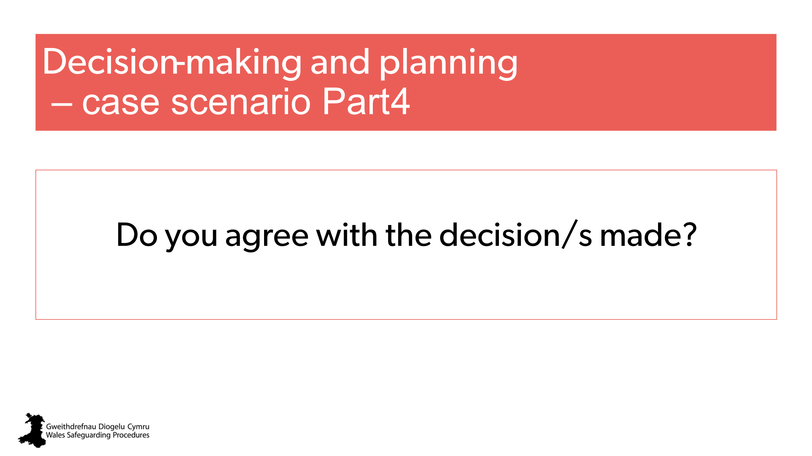 | Aim:  to provide practical discussion.  Activity – small group discussions.  Distribute:  - case scenario/s part 4  (children and young people, adult, or both)
45 | 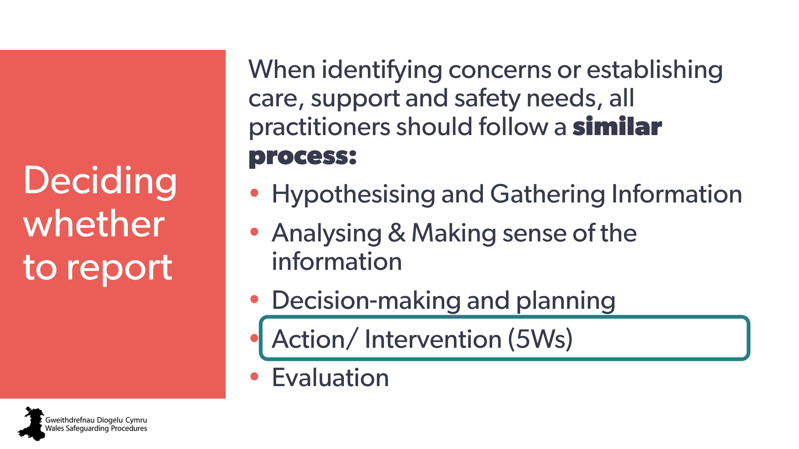 | Aim:  - to introduce the next step in the process: Action/ Intervention (5Ws)
46  47 | 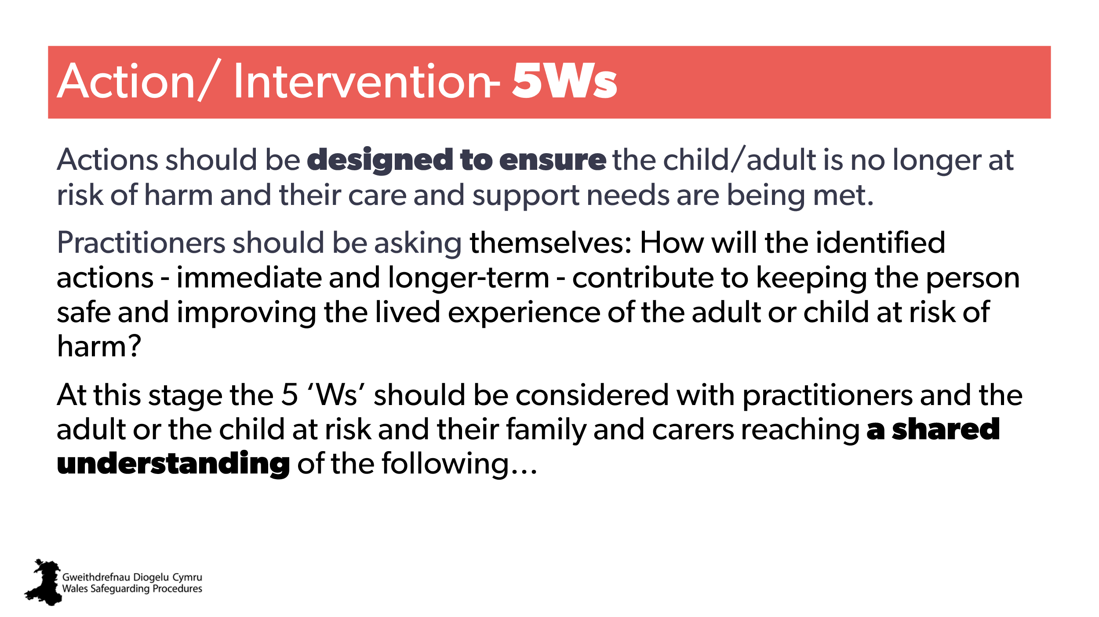  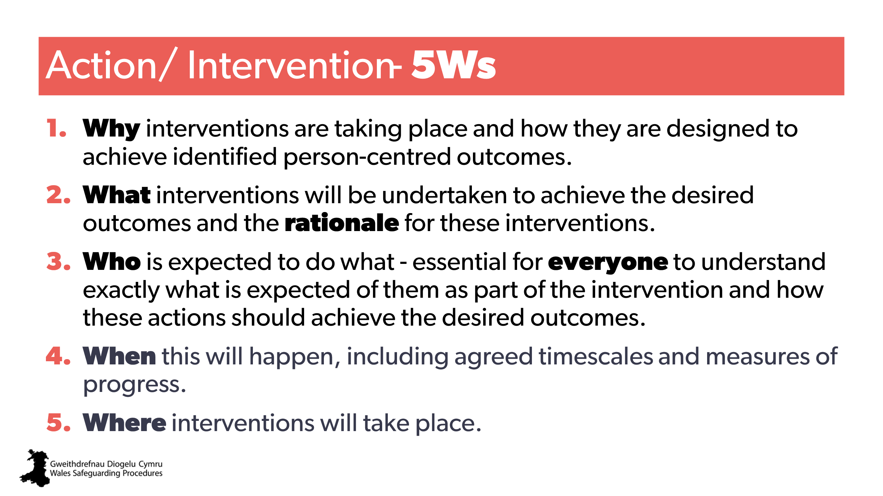 | Aim:  to offer a method of planning actions. | Wales Safeguarding Procedures:  https://safeguarding.wales/en/chi-i/chi-i-cp/c1p-p3/  https://safeguarding.wales/en/adu-i/adu-i-ap/a1p-p3/
48 | 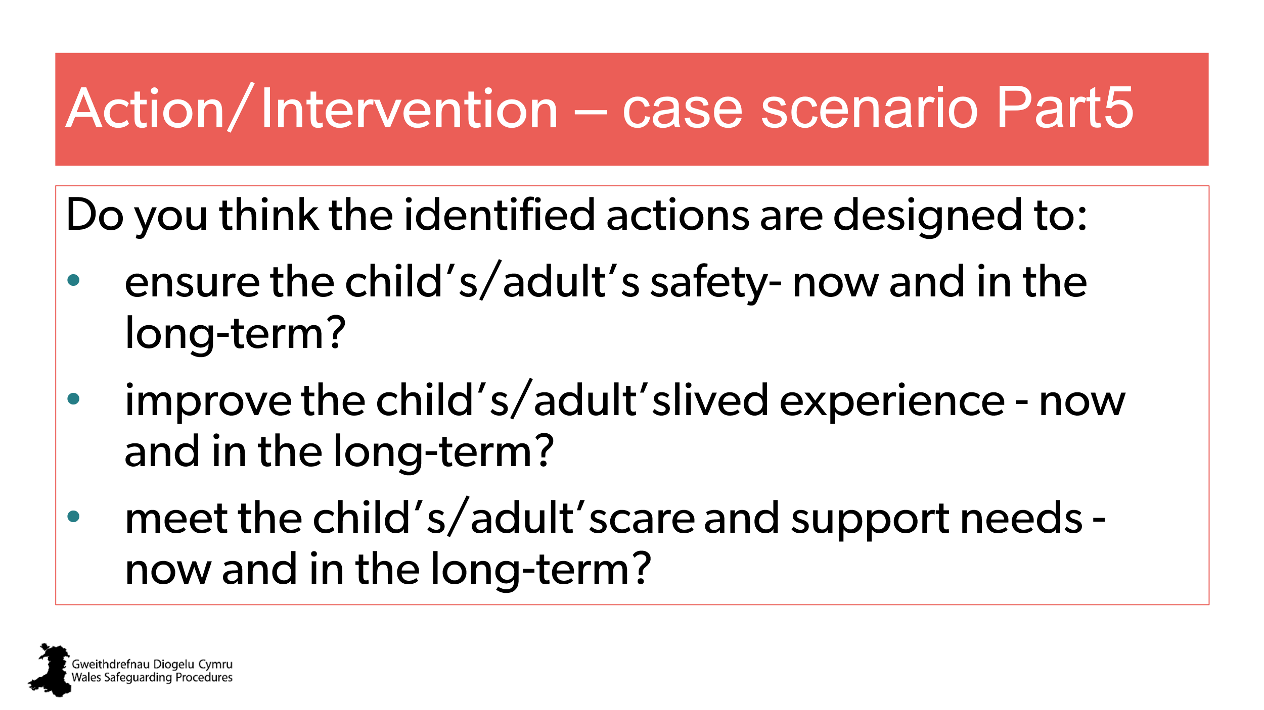 | Handout – case scenario part 5  Small group discussions.
49  50 | 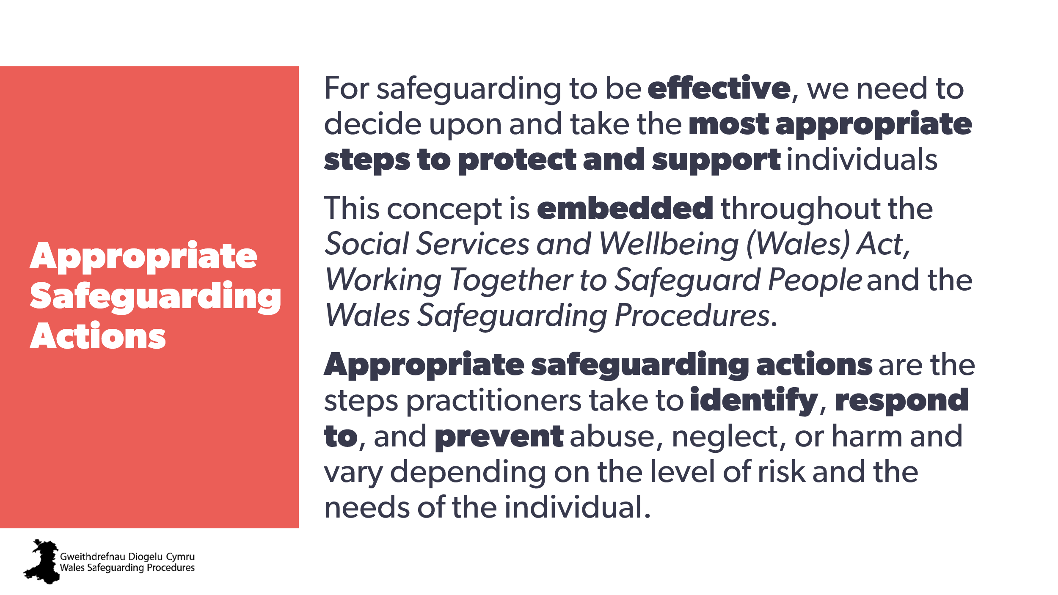  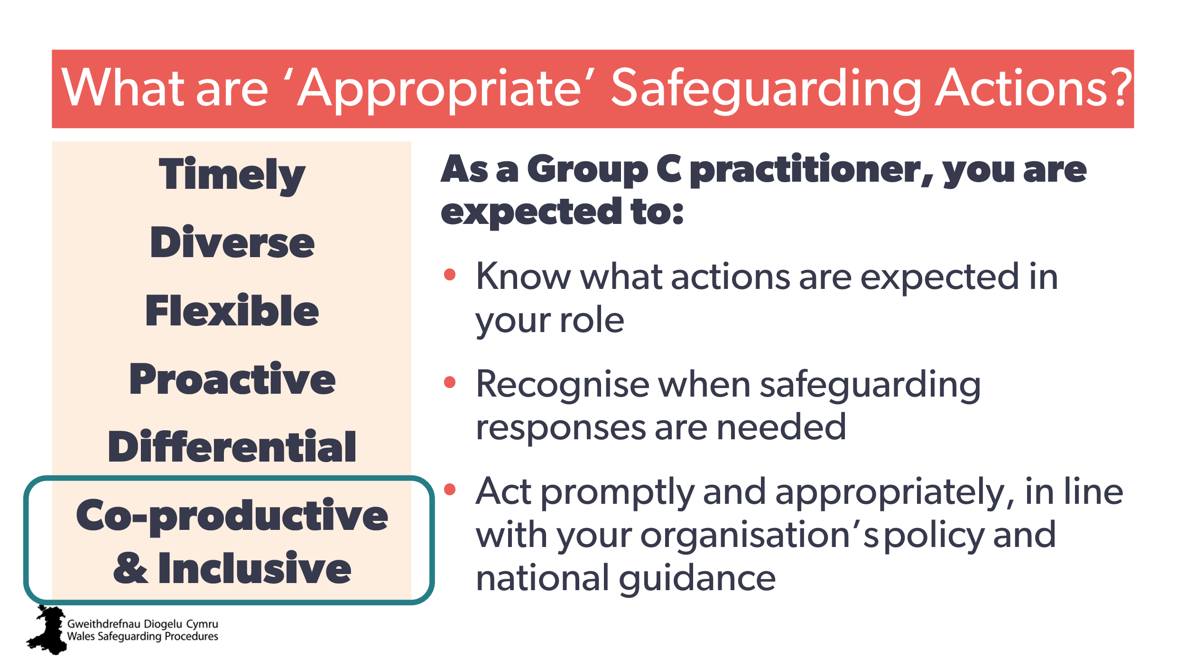 | Aim:  - to stress the need for our actions to be effective and make a real difference  - to provide guidance about what ‘appropriate’ means in terms of safeguarding  - to show how to incorporate all the information gathered to determine the degree of concern, the level of risk and the action required.  Trainer to expand on slide:  Timely - delivered ‘right time, right place’ / raising concerns promptly with the right authority  Diverse - select a range of services that consider the needs of both the adult and their carer/s  Flexible - recognise interventions need to be flexible and suitable for different needs and circumstances  Proactive – anticipate how to address any emerging or new needs  Co-productive – make sure everyone involved actively contributes and there’s shared ownership  Working in partnership with other organisations to ensure the individual is safe  Differential – refers to thresholds / levels and degrees of risk.  Make sure strengths and risks are given equal weight  Note: highlight leads-in to the next slide… | Local authority/ Regional Safeguarding Board guidance about:  - Right Time / Right Place  - Thresholds  - Early Intervention and Prevention  - Co-production / working with service users.  Wales Safeguarding Procedures > Delivering appropriate interventions: co-production | CPD suggestion:  Encourage participants to familiarise themselves with the specific risk assessment tools and frameworks used by their organisation, local authority, and Regional Safeguarding Board - acknowledging they build upon national principles (Wales Safeguarding Procedures).
51 | 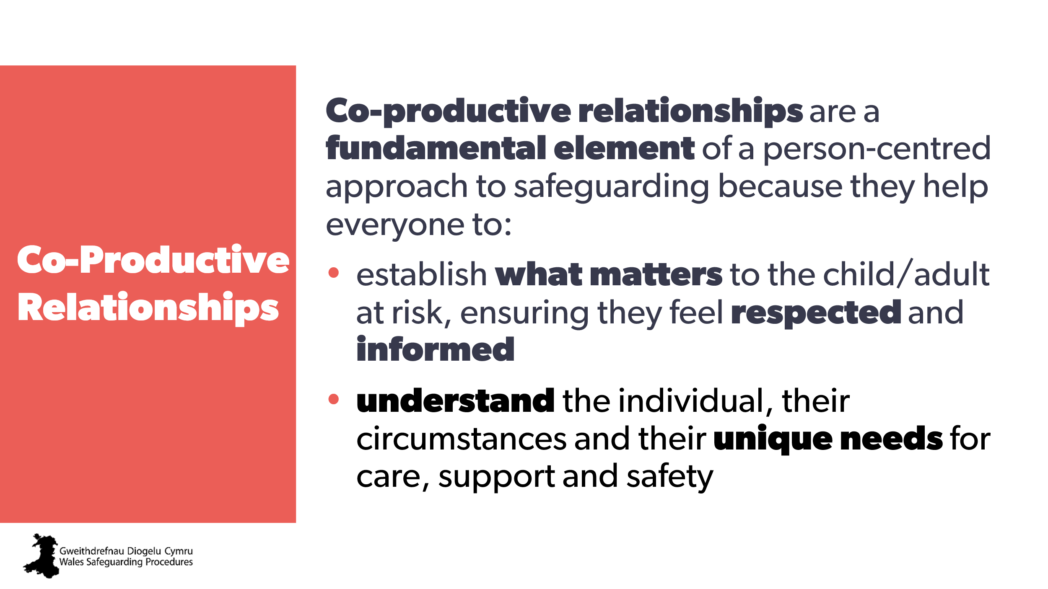 | Aim:  to highlight the need for co-production within a person-centred approach.  Include:  - service users  - colleagues  - other organsiations.  Trainer to stress:  effective safeguarding includes multi-disciplinary working to better understand the child, family and their circumstances and their needs for care, support and safety  co-production across organisations will help achieve the principles of voice and control, through the design and operation of services. | Wales Safeguarding Procedures:  Safeguarding principles and effective practice: children  Safeguarding principles and effective practice: adults
52  53 | 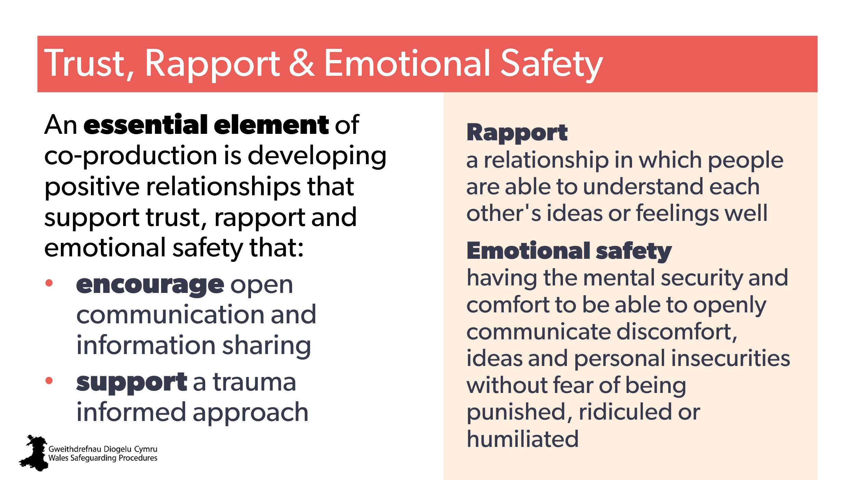  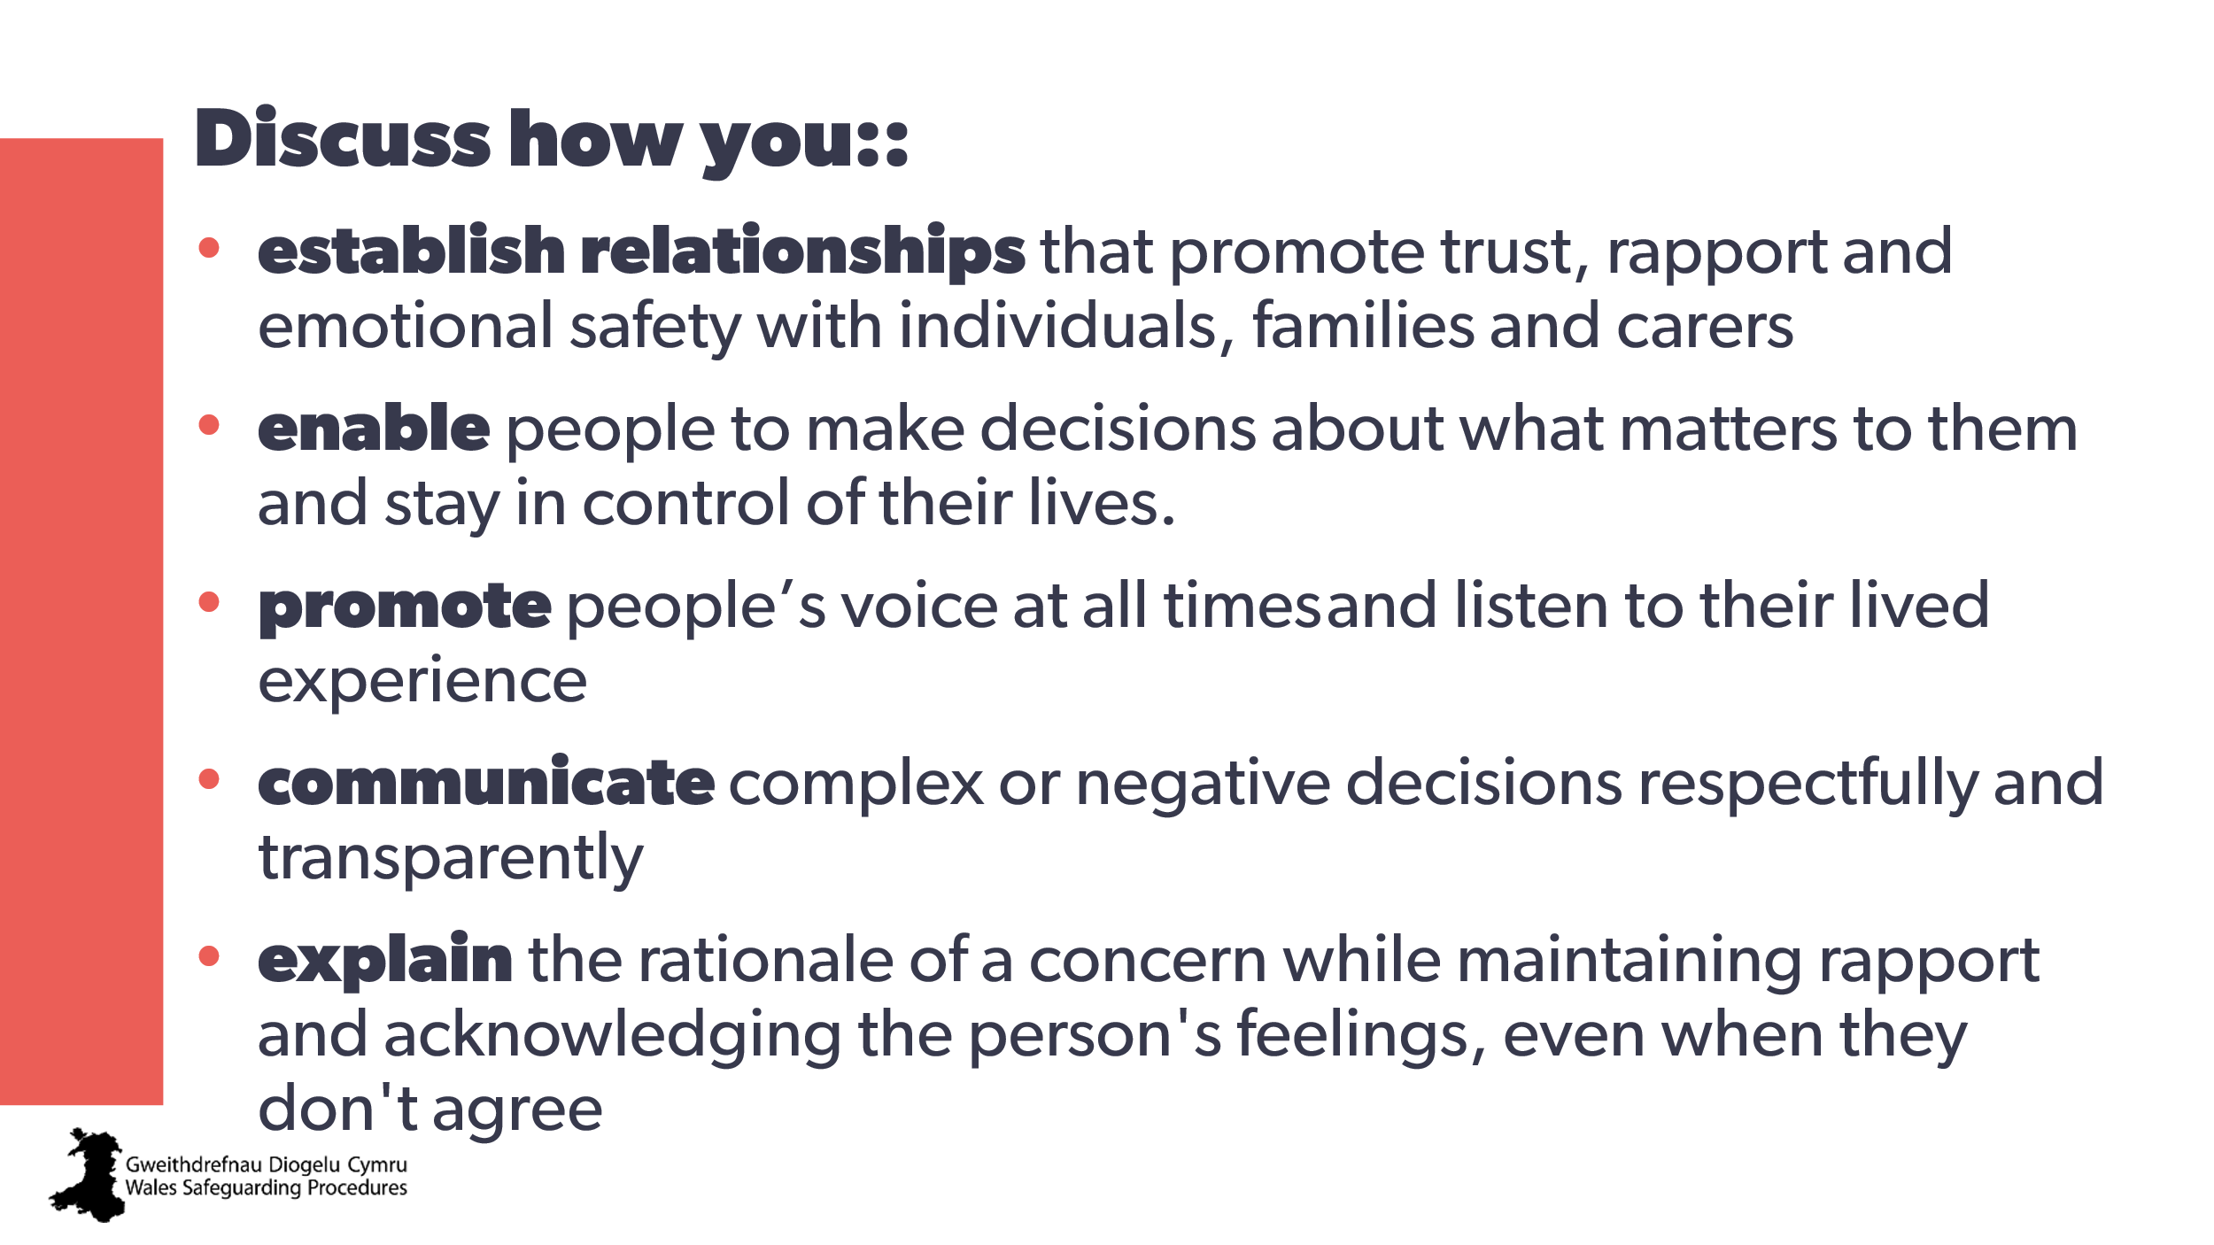 | Aim:  - to introduce need for trust, rapport and emotional safety as critical element  - to highlight this aspect of the standards  Trainer to add  Doing this:  - …with the person at risk and their families/carers helps you to establish what matters to the individual so they feel respected and informed.  - …with other practitioners fosters effective intra- and multi-disciplinary working to help you better understand the individual and their circumstances and their needs for care, support and safety.  Trainer to expand:  All of these are essential elements of trauma informed practice, in particular:  - enabling services to support practice that helps people feel connected, valued and safe  - a co-productive, collaborative cross-sector approach to identifying, understanding and supporting the person’s needs  - promotes psychological and physical safety by promoting choice, collaboration and transparency  - safe, supportive, empathic, compassionate and trusting relationships are central to a trauma-informed approach. | Trauma Informed Practice Framework  From National safeguarding training, learning and development standards - group C  B3 - Build relationships that support trust with people, families and carers…  B8 - Enable people to feel safe and confident to share their worries, concerns and feelings by providing a safe space and consistent messaging. | CPD  Trauma informed practice  Dfficult conversations
54 | 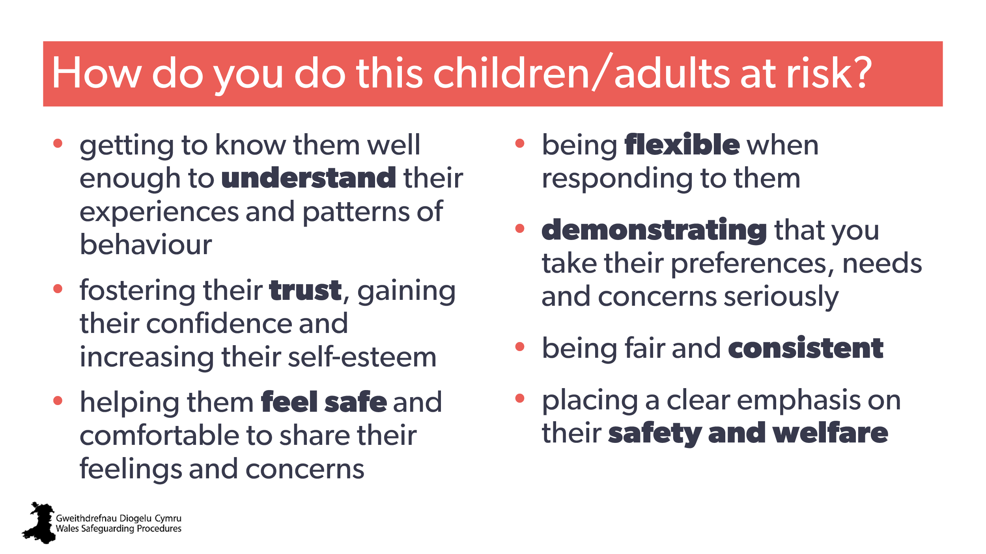 | Note to trainer:  Discussion aid – optional slide  1) first reveal the full slide, allow a few moments to read it, saying, ‘fill in the gaps’ with your own discussions, specific to your settings.
55 | 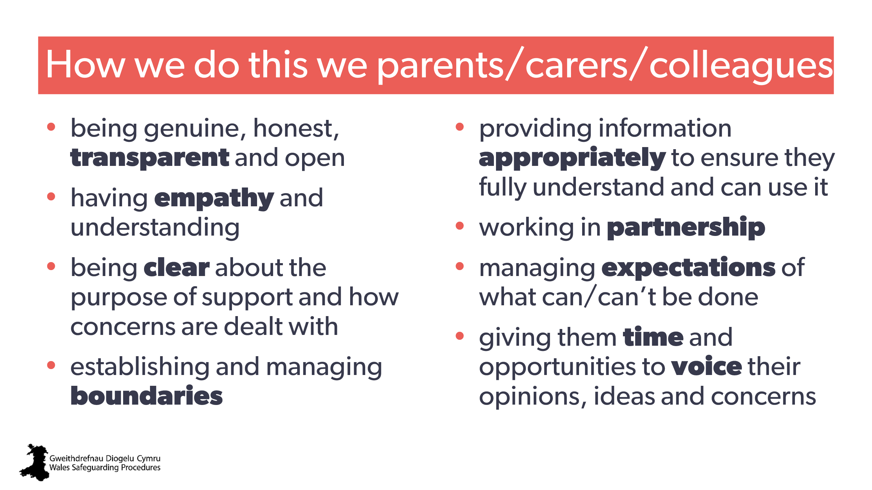 | Note to trainer:  Discussion aid – optional slide  1) first reveal the full slide, allow a few moments to read it, saying, ‘fill in the gaps’ with your own discussions specific to your settings. | Wales Safeguarding Procedures: Pointers for Practice: Securing Active Participation from Practitioners in Core groups
56 | 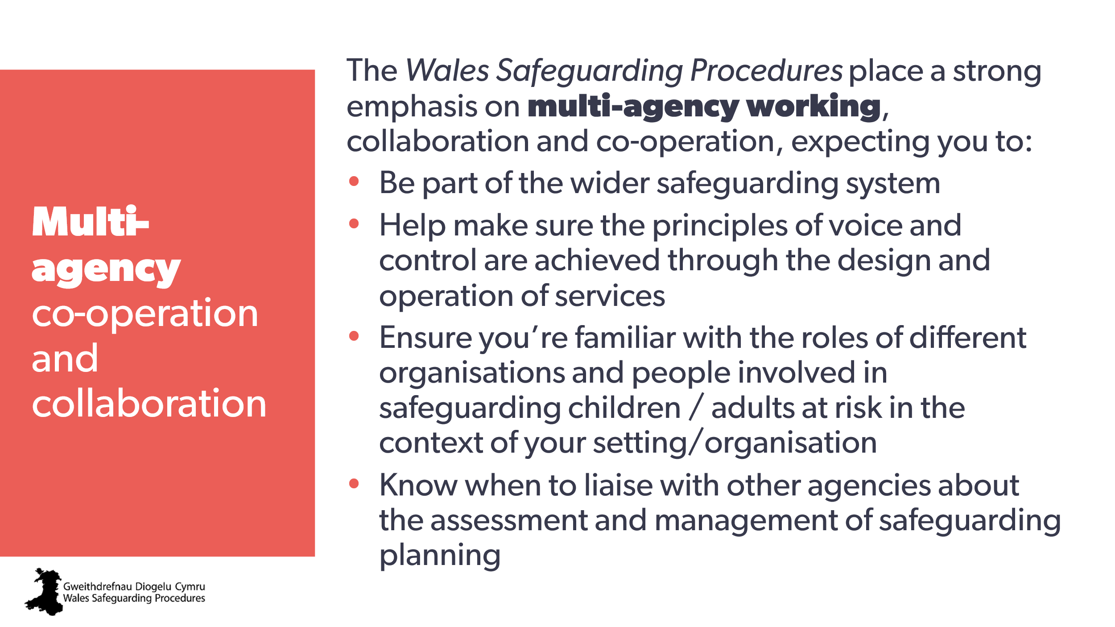 | Aim:  highlight wider safeguarding expectations.  Background for trainer:  see Group C standards criteria. | National safeguarding training, learning and development standards - group C
57 | 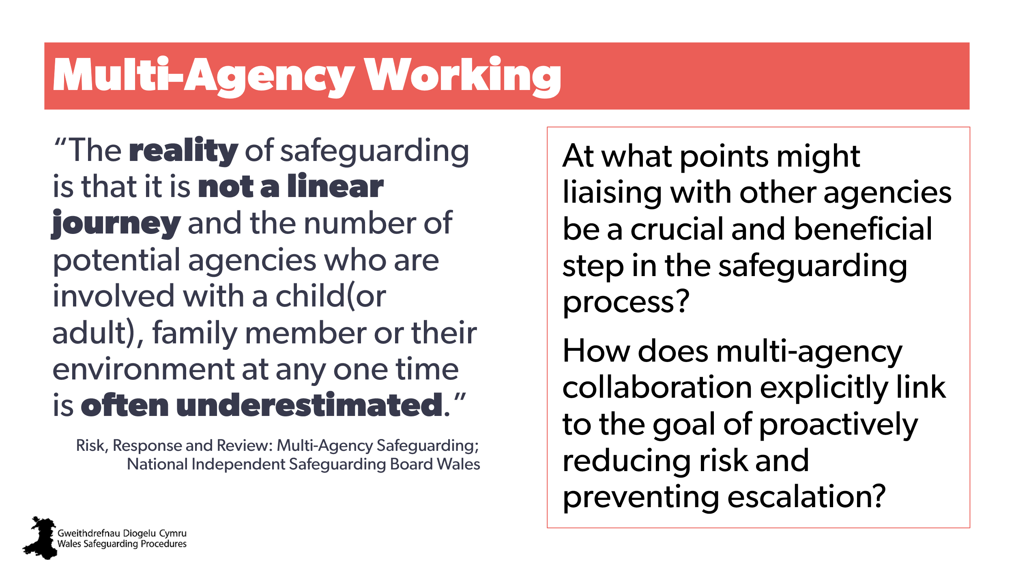 | Aim:  to highlight the need for this throughout the process.  Note to trainer:  For the first question, mention:  - when concerns are first identified  - before making a report  - during assessment  - when developing a plan.  Optional activity  Aim:  to share and build a network of connections and contacts.  a) identify and list some of the different local services or people that can support people.  b) identify and list some of the people or local services that you do/could go to for advice, more information or to discuss a situation for another point of view? | Quote is from:  Risk, Response and Review: Multi-Agency Safeguarding A THEMATIC ANALYSIS OF CHILD PRACTICE REVIEWS IN WALES 2023
58 | 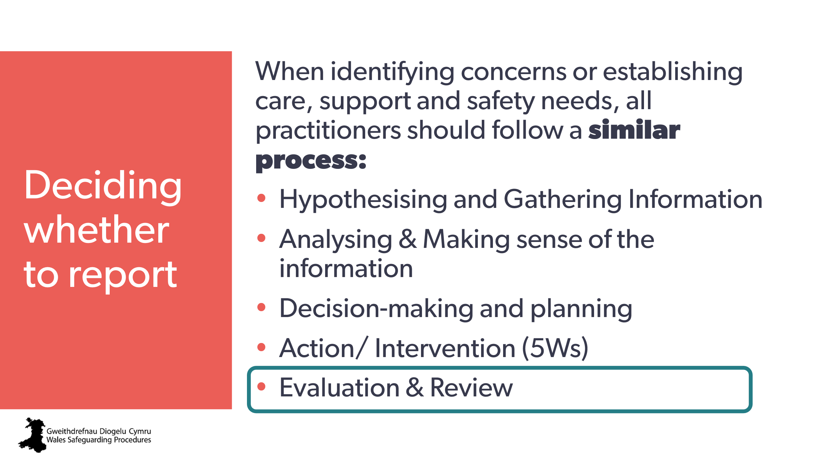 | Aim:  - slide to introduce the next step in process – evaluation.
59 | 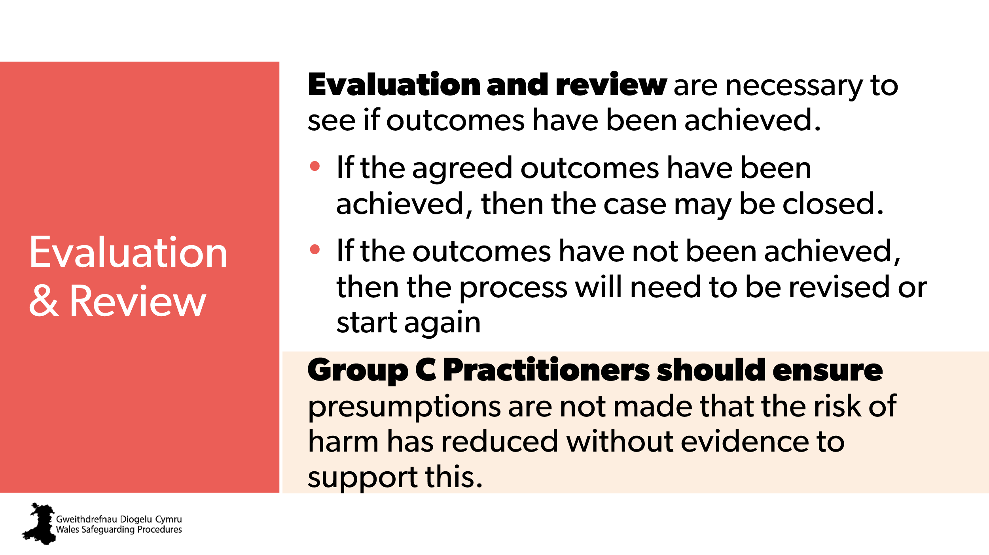 | Aim:  - stress the importance of follow-up  - stress the need for evidence/rationale in order to ‘close’.
60 | 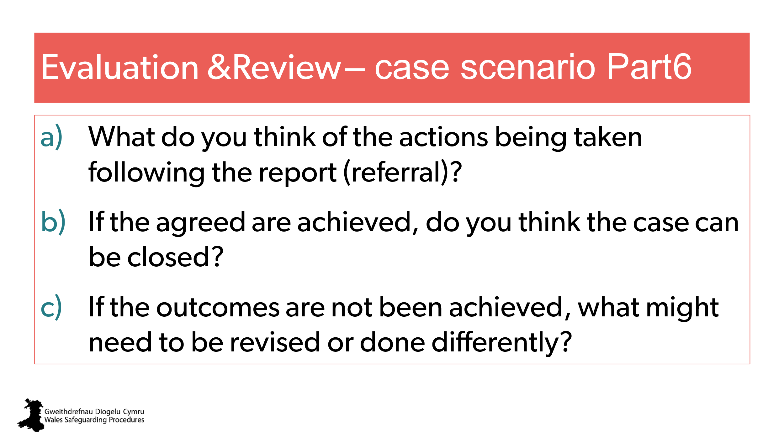 | Handout – case scenario part 6  Small group discussions.
61  62 | 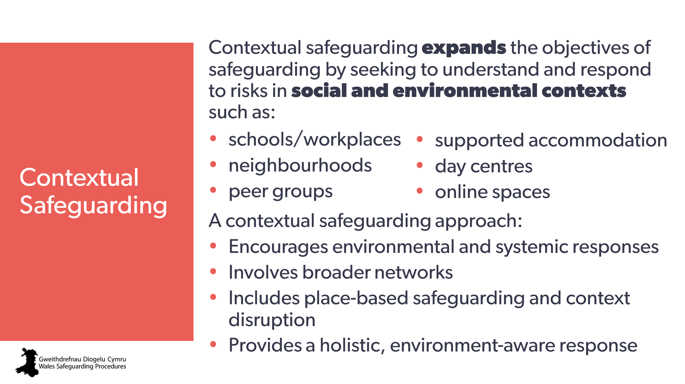  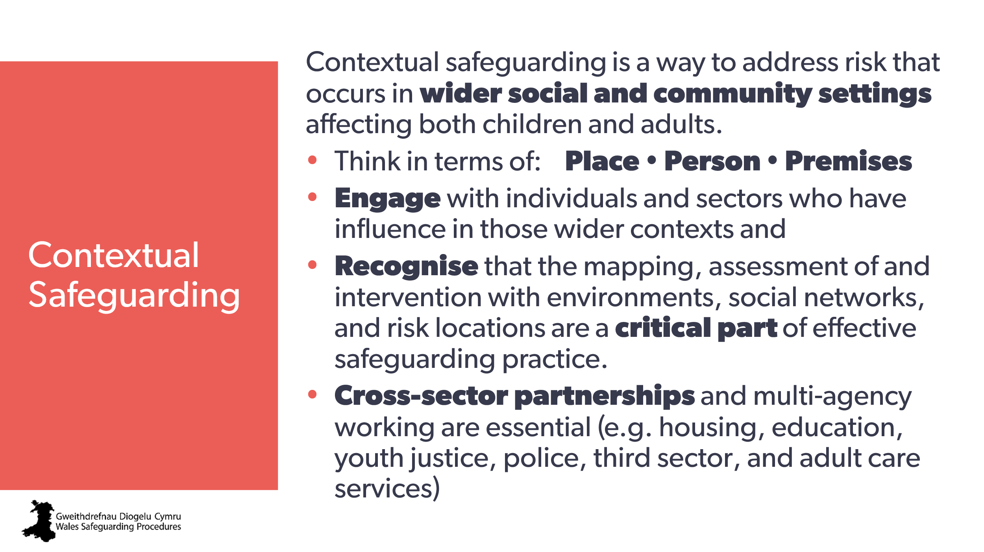 | Aim:  to introduce the idea of contextual safeguarding.  Note to trainer:  You may wish to create and add a slide about the sources and pathways available for support and protection in your local authority.  Trainer to explain:  We need to think holistically and wider than the home – remember: abuse/neglect/harm could be happening anywhere  (such as bullying at school or work, grooming in the community). | Gwent Regional Safeguarding Board:  Bite-size Learning - Contextual Safeguarding  Mid and West wales Safeguarding Board: Contextual safeguarding 7-minute briefing  Contextual safeguarding research programme
63  64 | 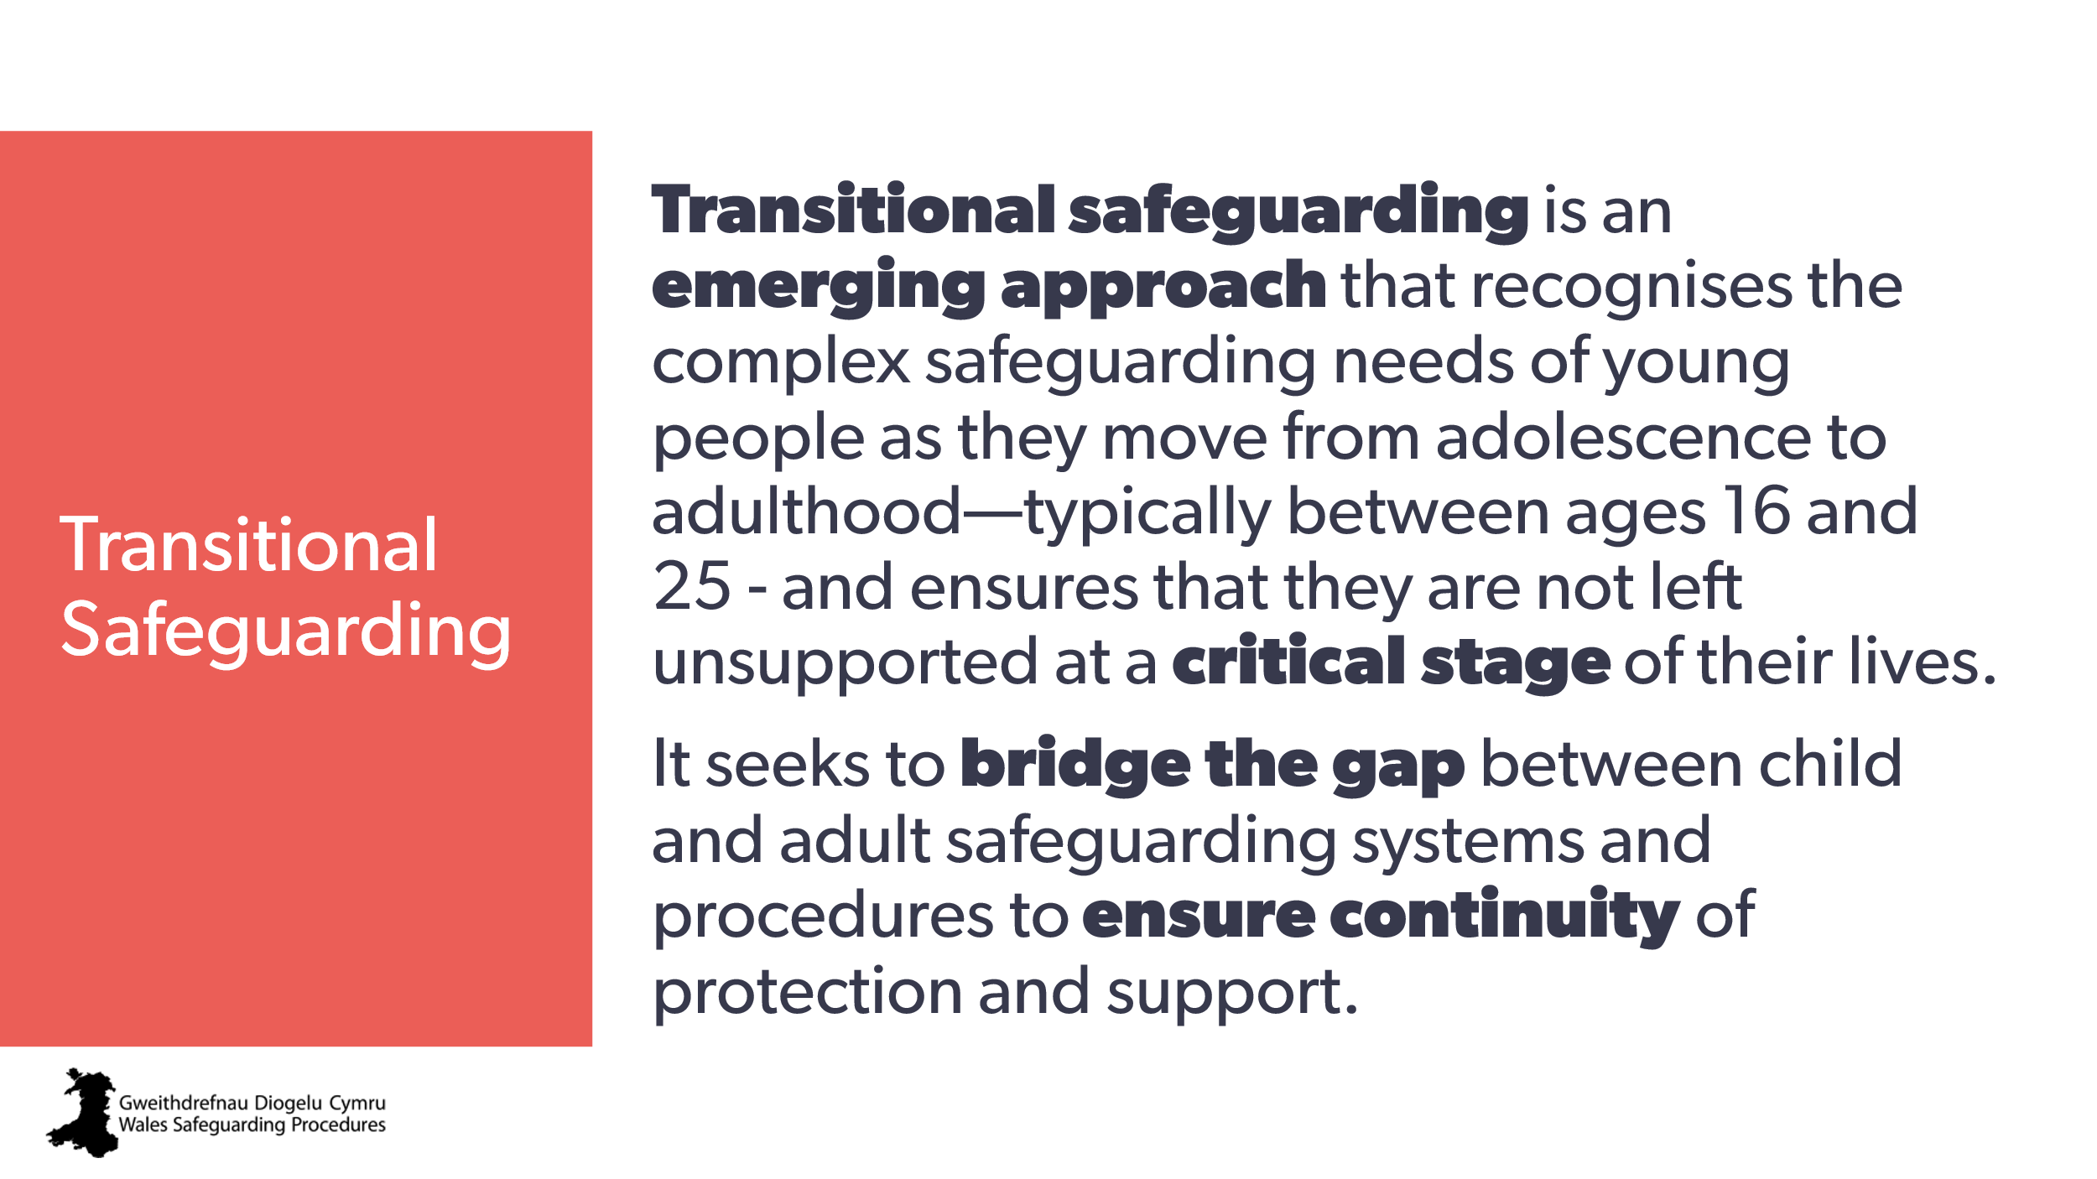  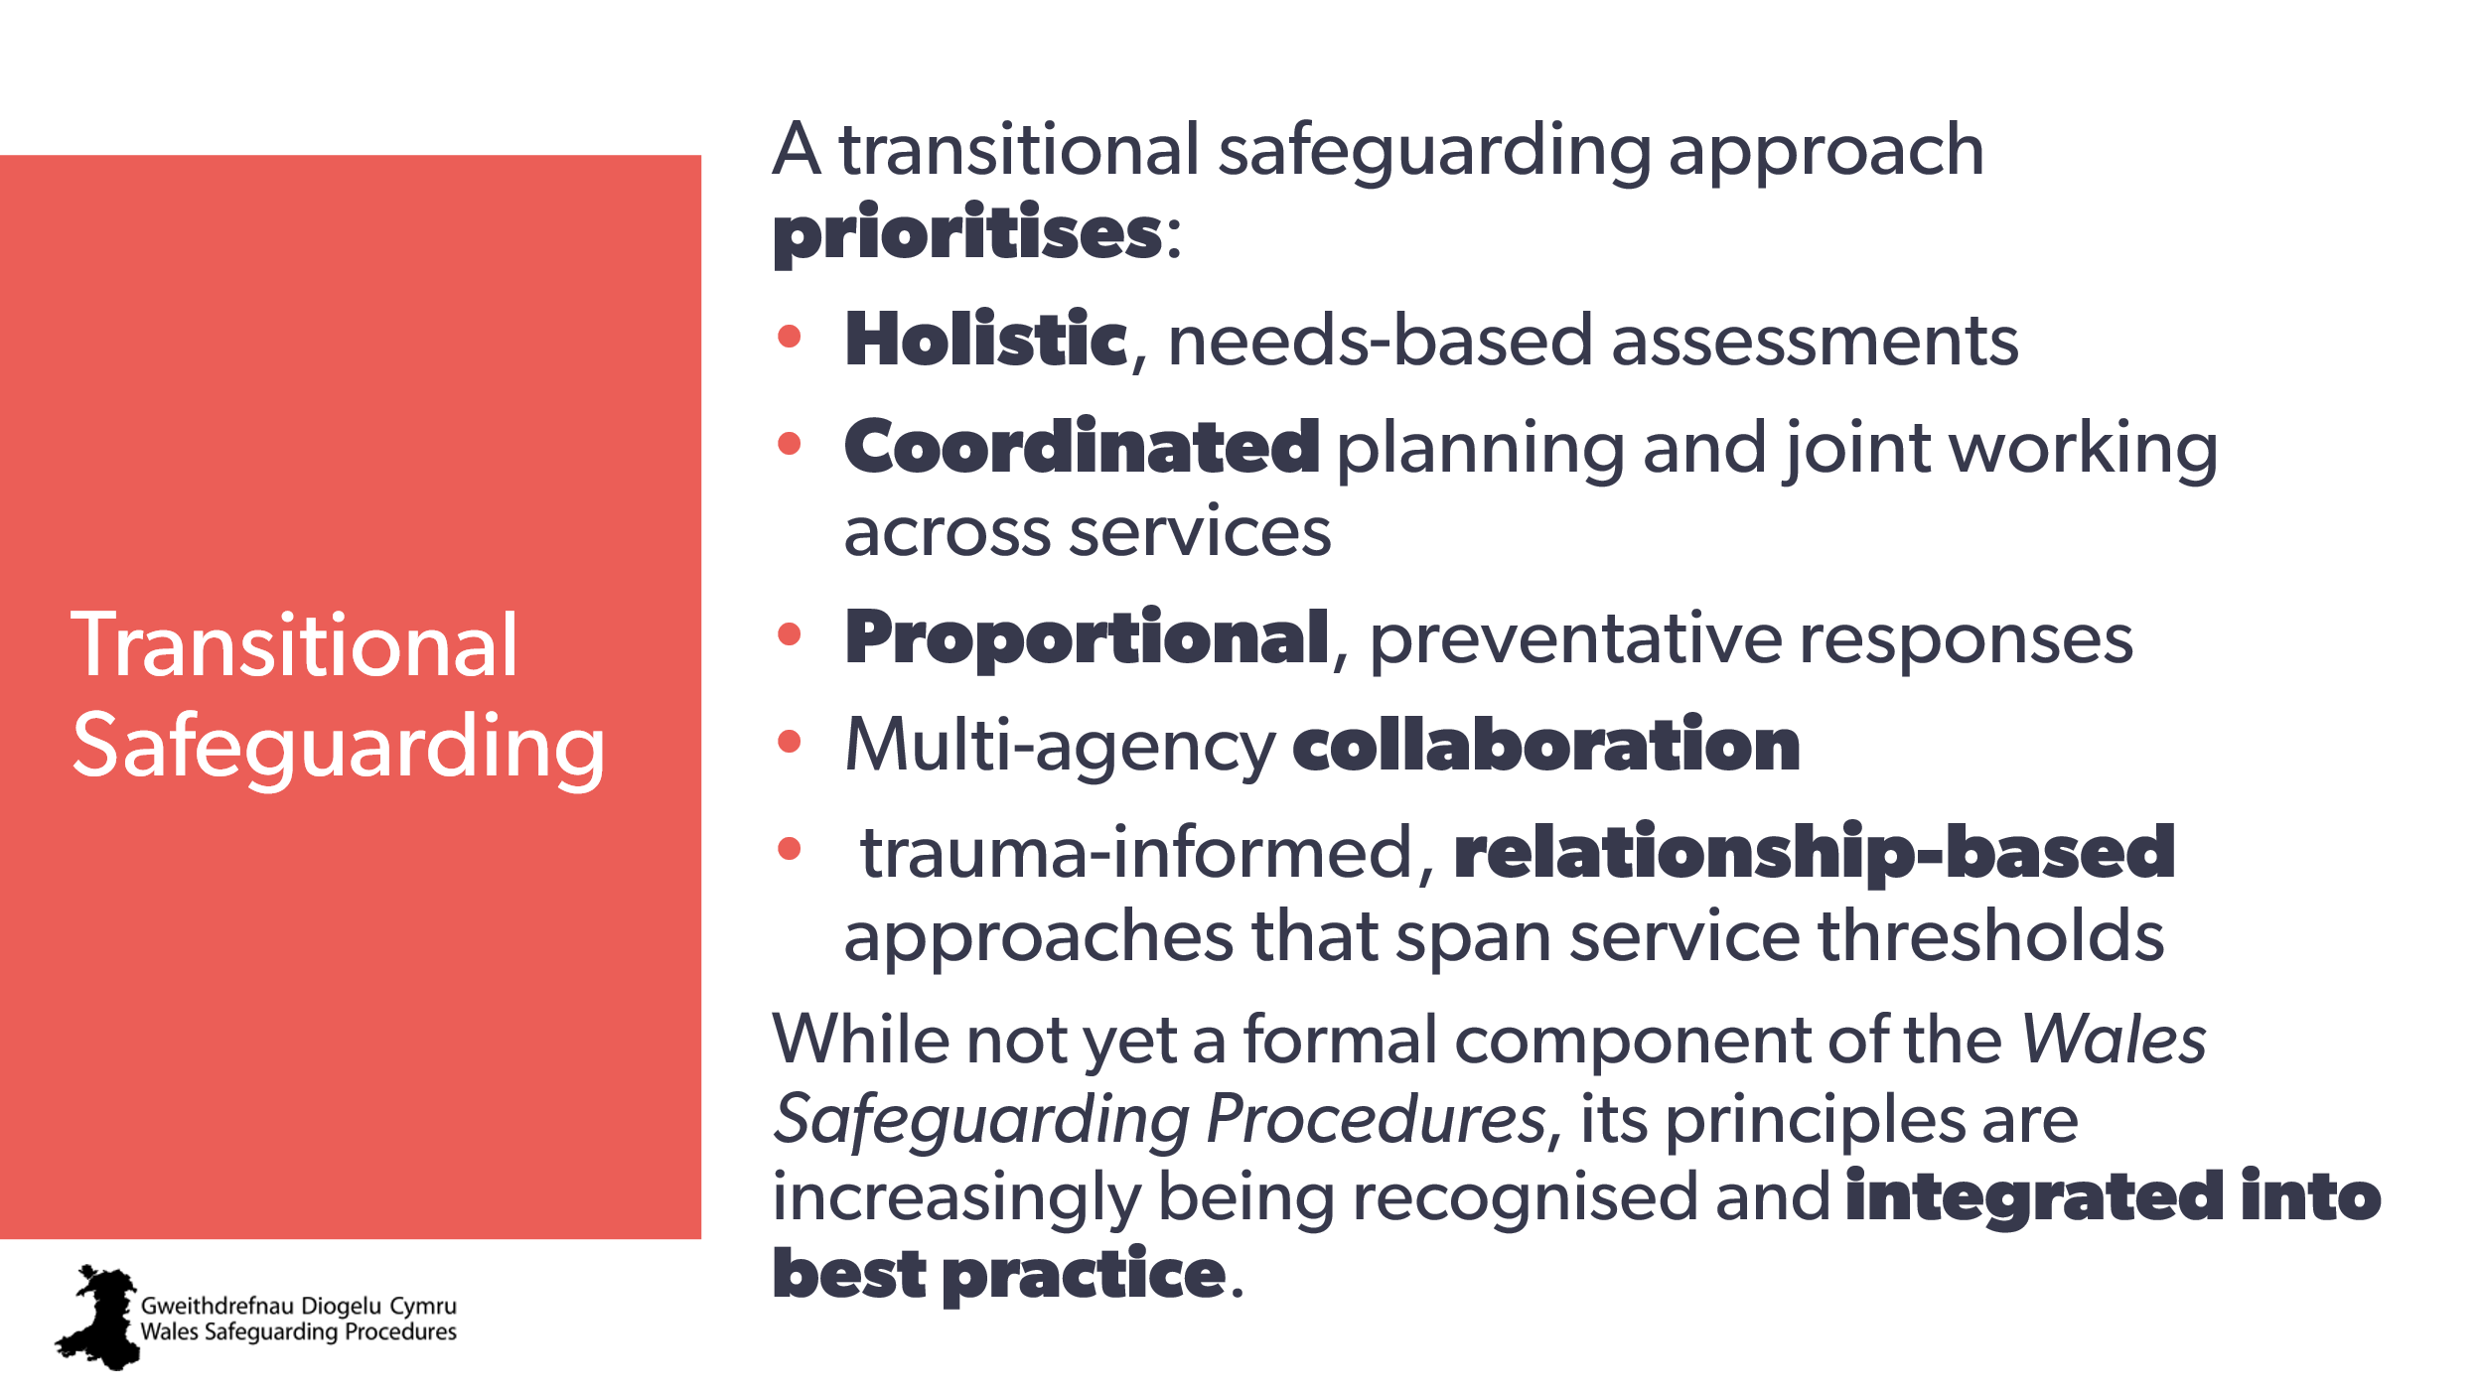 | Aim:  to introduce the idea of contextual safeguarding  Note to trainer:  you may wish to create and add a slide about the sources and pathways of support nd protection available in your local authority.  Trainer may wish to add:  although the focus is on the transition from child to adult (16 to 25), it can apply to other significant transitions/changes in support over the life-course. | Social Care Wales: exploring transitional safeguarding  North Wales Safeguarding Board: Transitional safeguarding 7 minute briefing
65 | 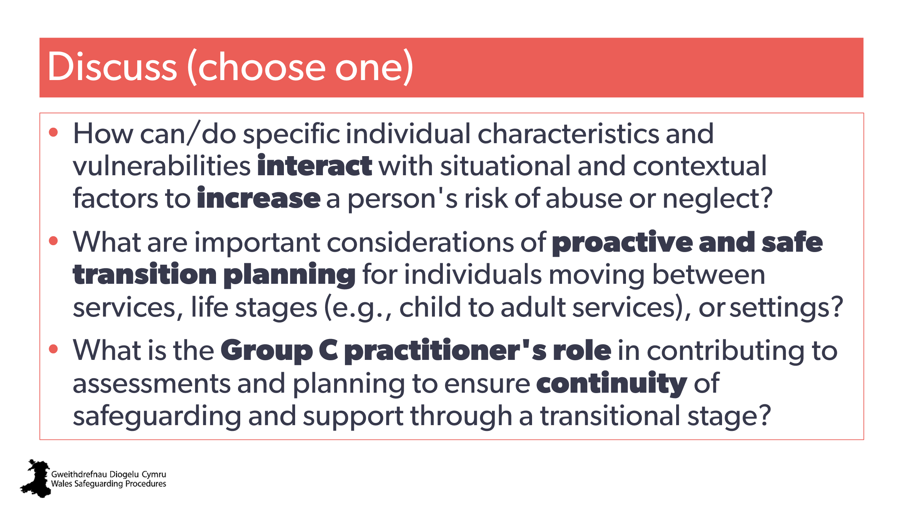 | Optional slide for discussion:  Optional question:  What other pathways for support/intervention are you aware of or would you use for the case scenarios we looked at earlier?
66 | 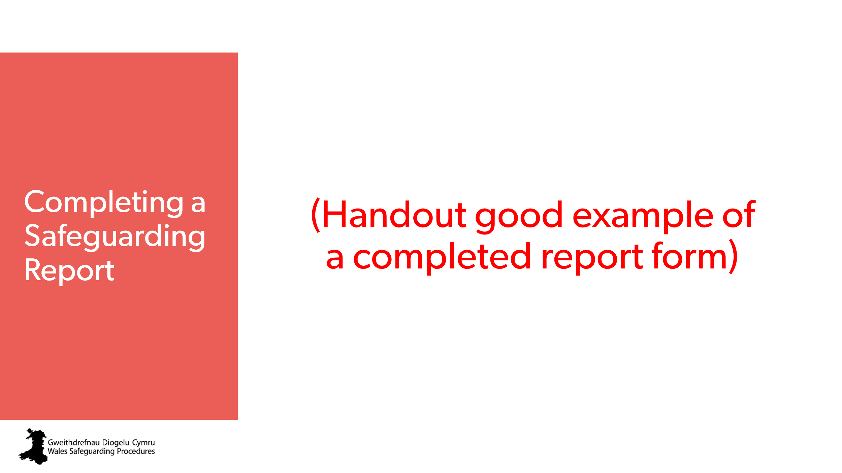  (This slide will be updated when national MARF available) | Handout: example of a good report form – for discussion  Note:  - until there’s a national form available, the trainer should add-in local report forms (child/adult).  Note to trainer:  We highly recommend that you take everyone through completing their report form, referring to the guidance notes. | Regional Safeguarding Board link to report form
67 | 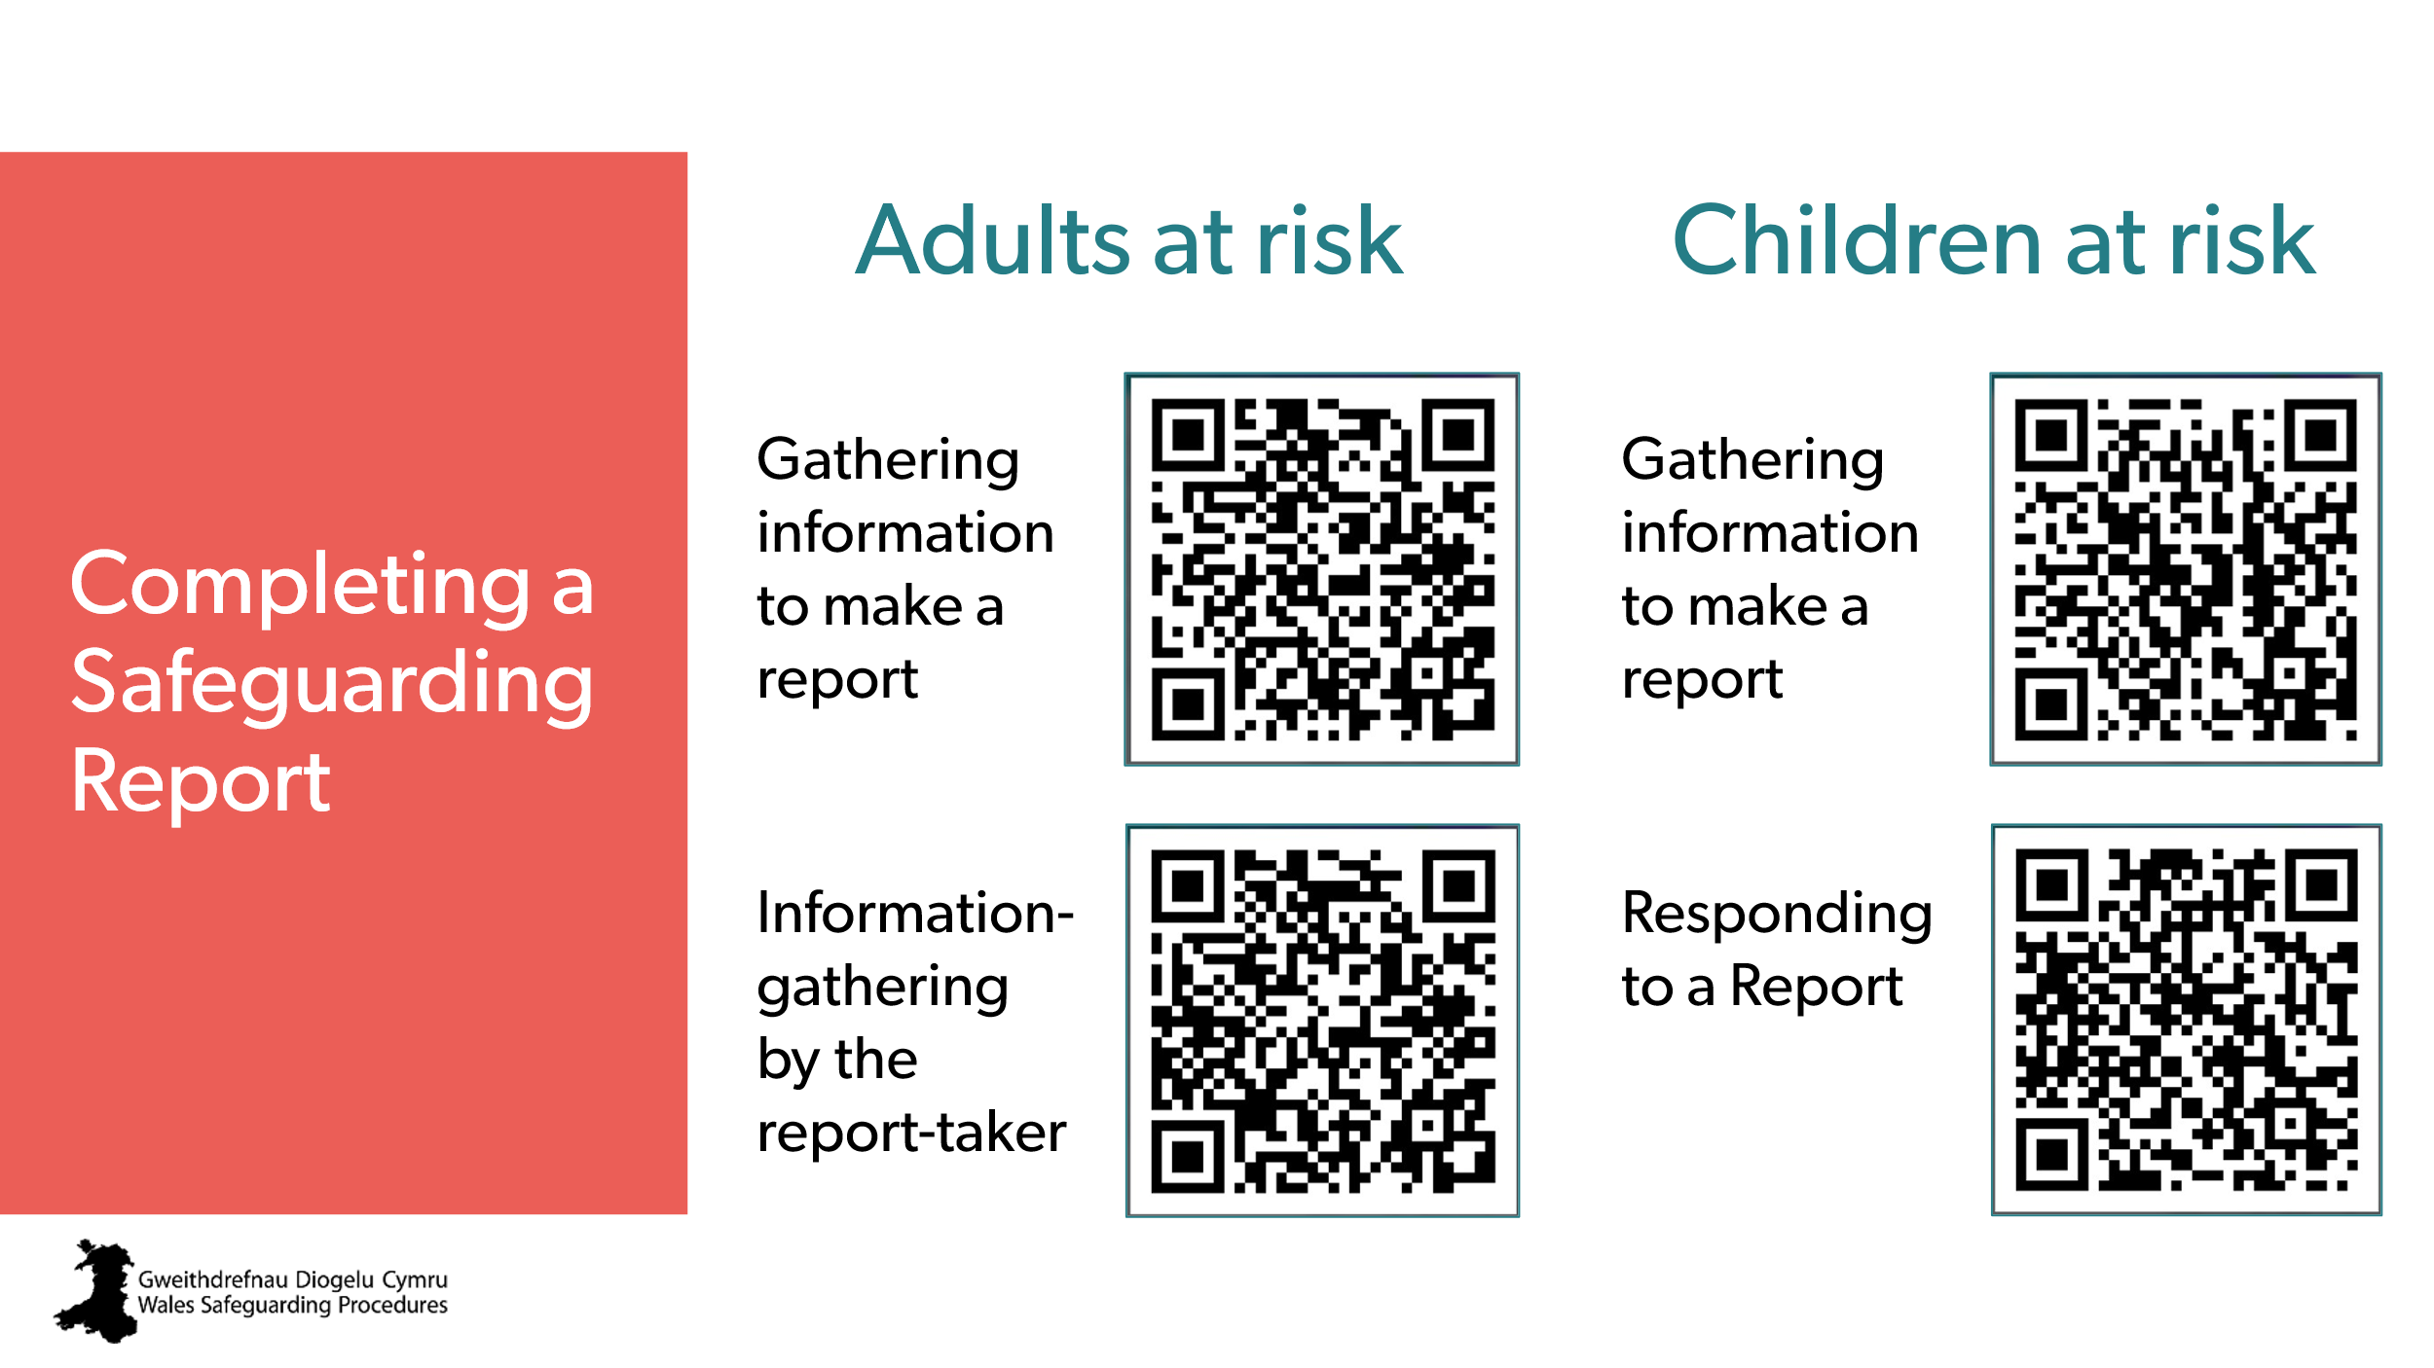 | Note: each QR code is a clickable link.  This slide needs internet access  Aim:  to clarify what kind of information is needed for an effective and appropriate report form.  Trainer to add:  If the report-taker can’t get enough information from the report-maker, they should contact other practitioners who may have information about the child/adult and their family.  Activity:  Trainer to direct learners to the appropriate webpage in the Wales Safeguarding Procedures.  *Ask everyone to click on any Pointers For Practice | Wales Safeguarding Procedures  Gathering information to make a report (children and young people)  Responding to a report (children and young people)  Gathering information to make a report (Adults)  Information-gathering by the report-taker (Adults)  Other resources  Pointers for Practice: Making a report  Pointers for Practice: The Identification, Assessment, Planning, Intervention and Review Process Applied to Making a Report
68 | 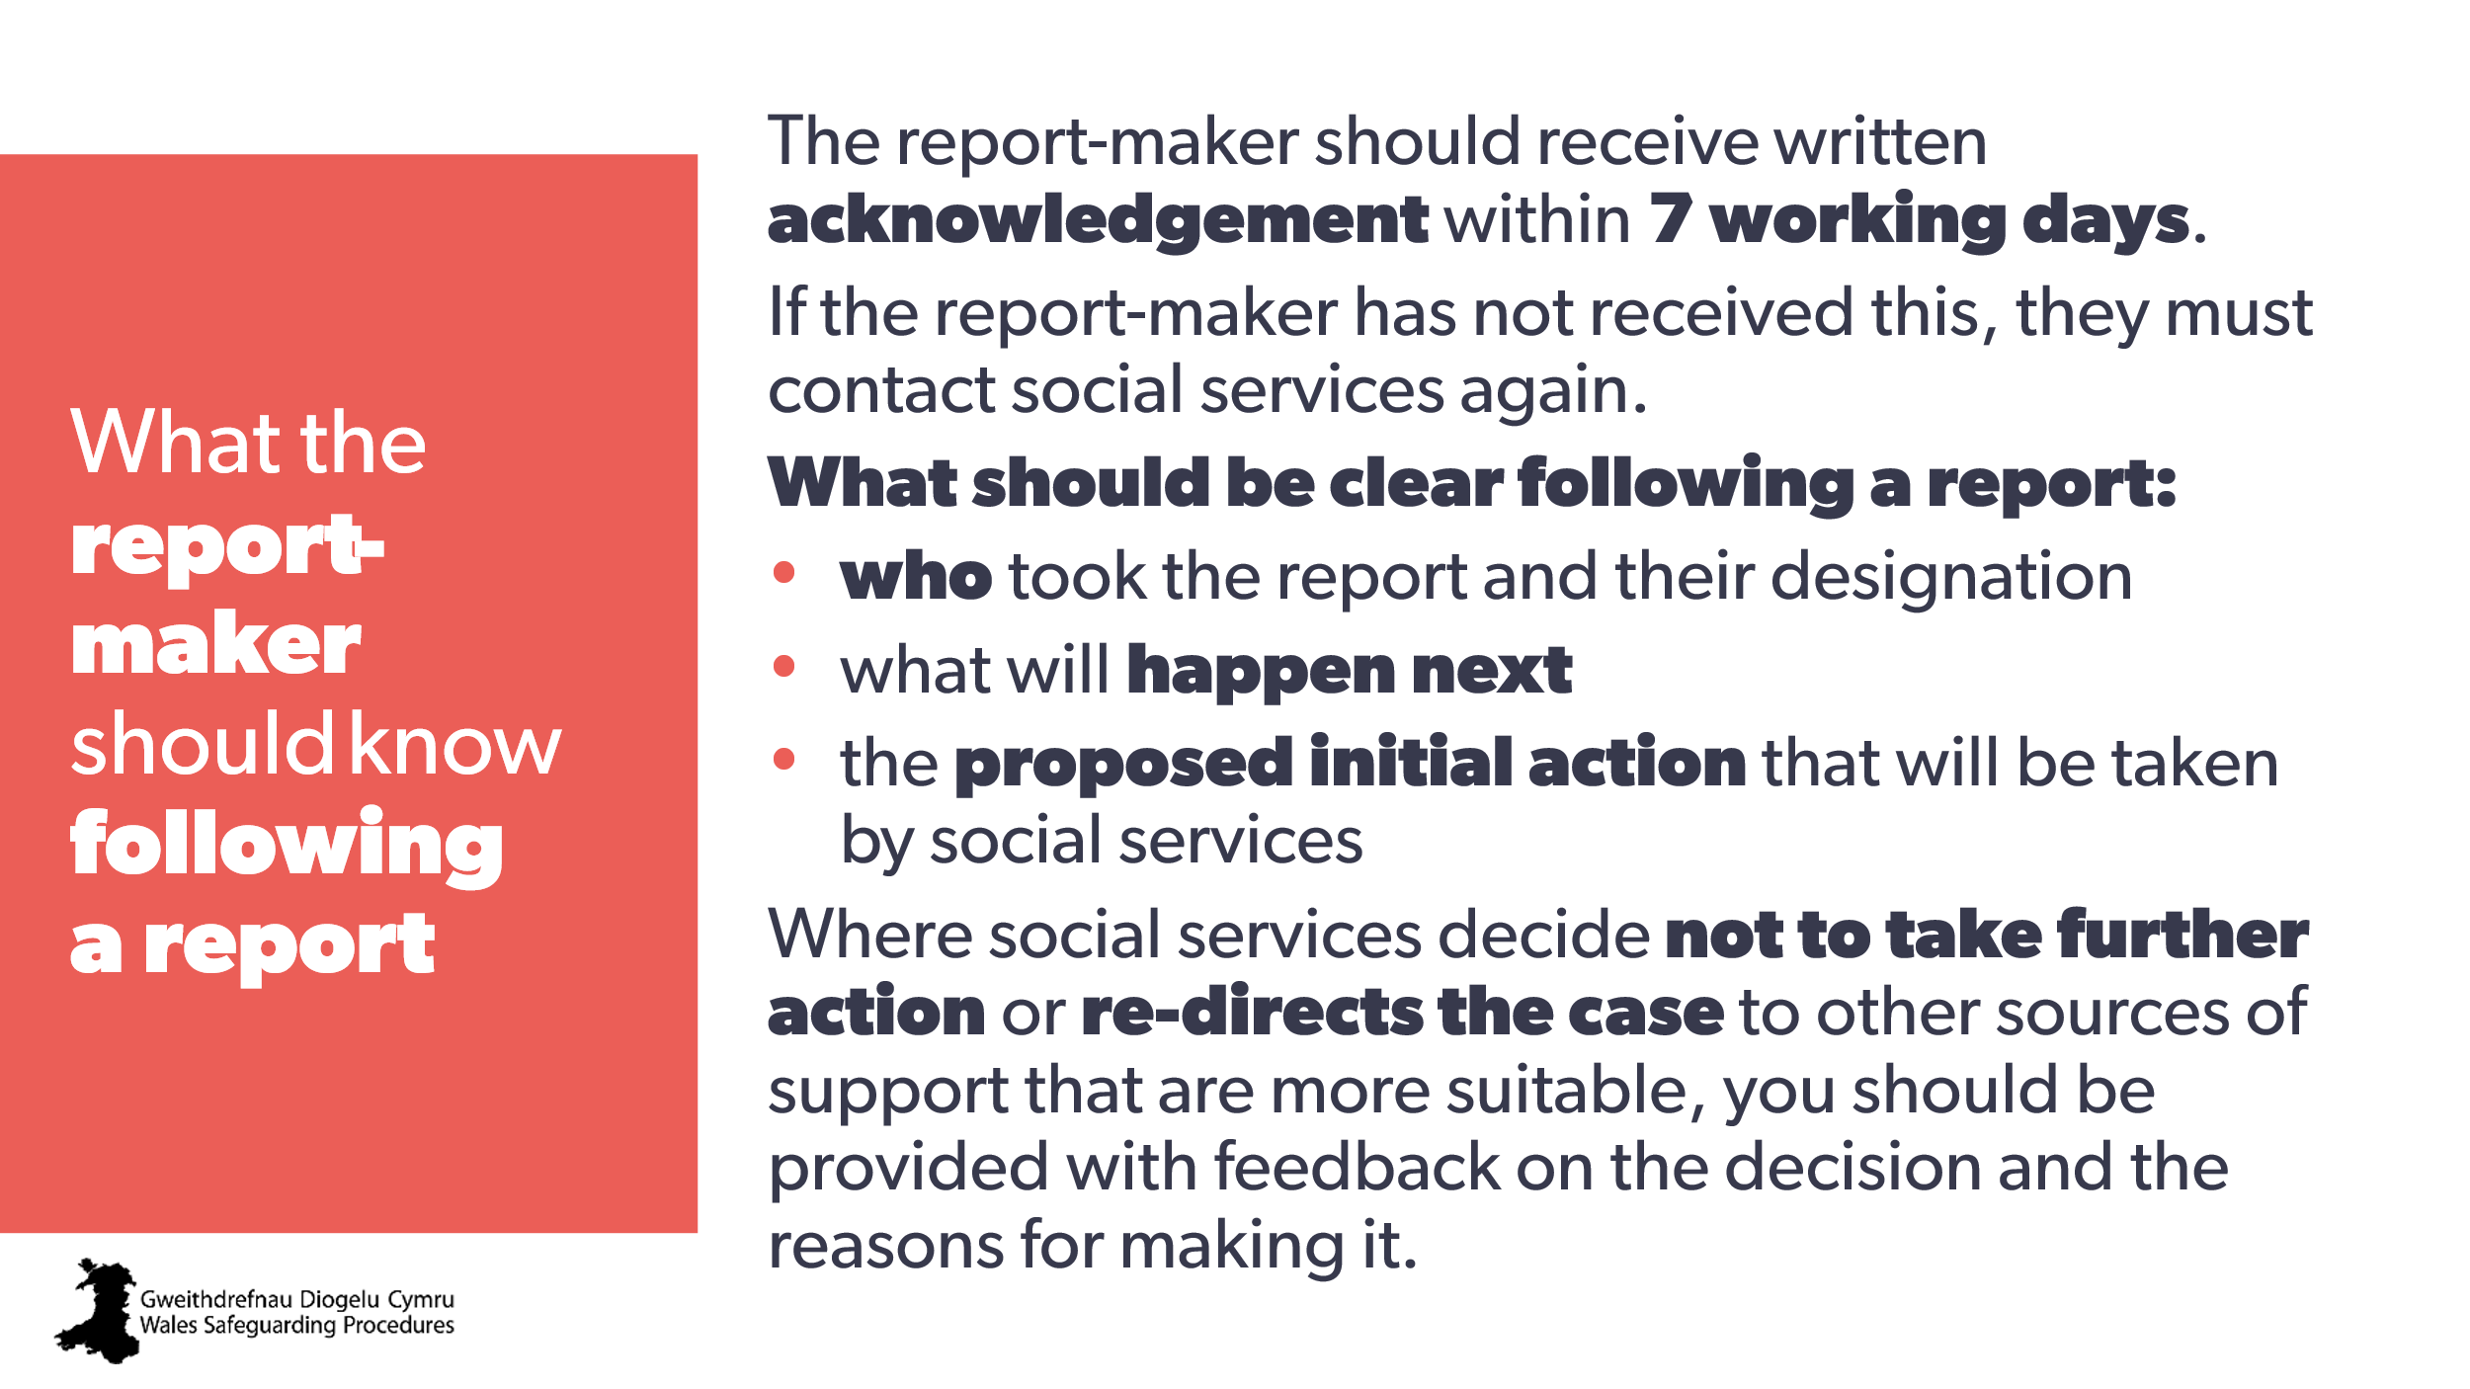 | Aim:  to clarify the need to receive written acknowledgement and keep this with the client records. | Wales Safeguarding Procedures  Children and young people:  https://safeguarding.wales/en/chi-i/chi-i-c2/c2-p18/  If, having made the initial report in writing, the report-maker hasn’t received an acknowledgement from social services within seven working days, they must contact social services again.  The outcome of any discussion and the resulting decision must be recorded by the practitioner making the report.  If no action is to be taken by social services, the child and family should be advised, directly or through the practitioner making the report, of any other support available. There may be a range of options available through information, advice and assistance or the Social Services and Well-being (Wales) Act 2014; Part 3 assessment.  Adults:  https://safeguarding.wales/en/adu-i/adu-i-a3pt1/a3pt1-p4/  Clarifying the next steps with the report-maker  Once social services receives the written report, the person making the report should receive an acknowledgement within seven working days. If they don’t receive this, they should always contact social services again.  Where social services decides not to take further action under s.126(2)(b) of the Social Services and Well-being Act (Wales) 2014, or re-directs the case to other sources of support that are more suitable, the practitioner making the report should be given information, advice and assistance, feedback on the decision and the reasons for making it.
69 | 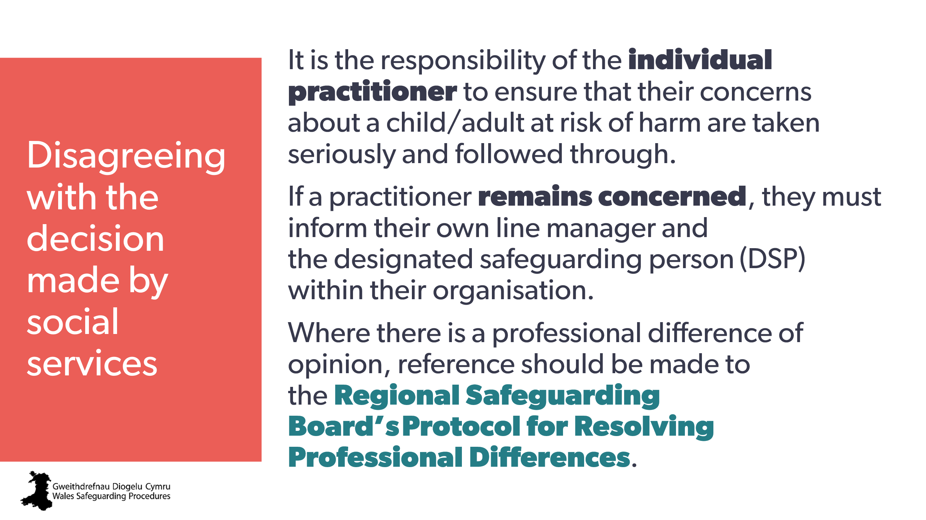 | Discussion opportunity:  Professional challenge to challenge the decision.  Note to trainer:  - you’ll need to refer to local protocols for escalation and to resolve professional differences  - those who work alone, such as childminders, can speak to CIW or another regulatory body representative for advice. | Wales Safeguarding Procedures  Children and young people  Disagreeing with the decision made by social services: resolving differences  Adults  Professional Disagreements  Resolving Professional Differences
70 | 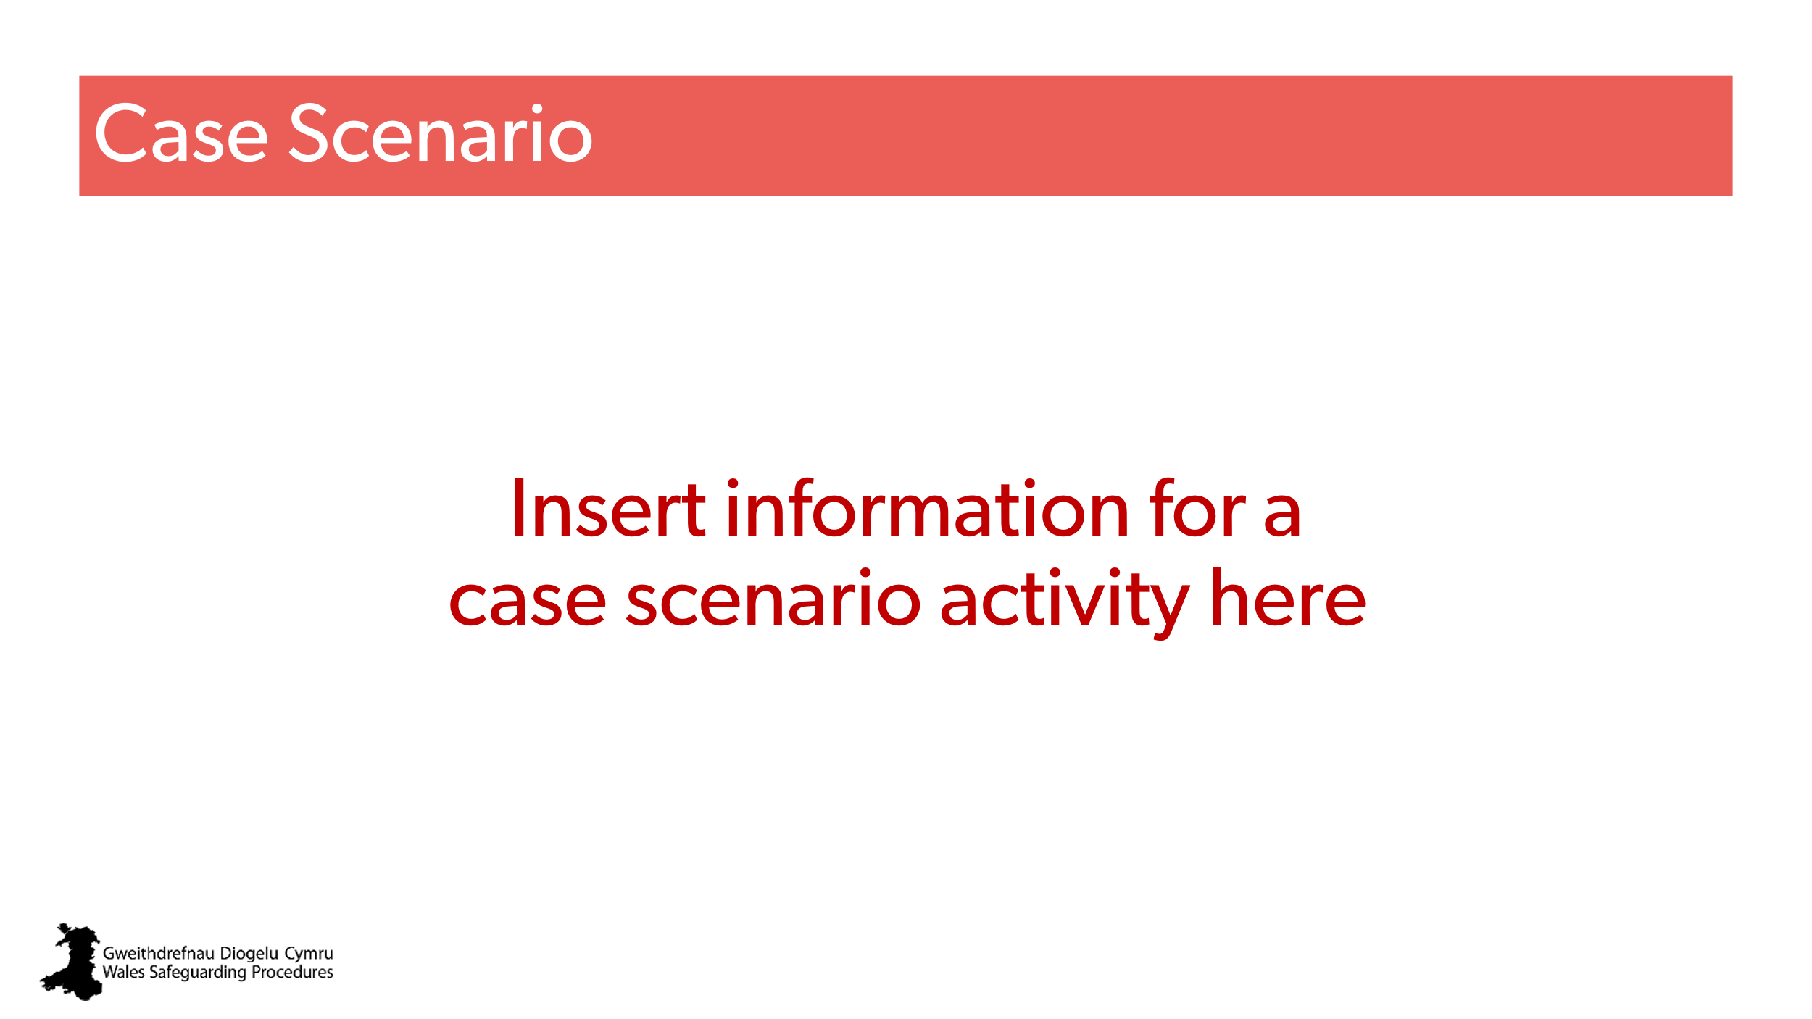 | Aim:  to provide an opportunity to put the learning of the day into practice and enable further discussion.  Activity:  trainer to select an appropriate case scenario for discussion.  Ask groups to think about and discuss concerns and how they/their setting might be able to support.  Remind them to:  - be curious  - think of risks and strengths,  - Think about what other support pathways may be available. | Selection of case scenarios from resources pack or add own.
71 | 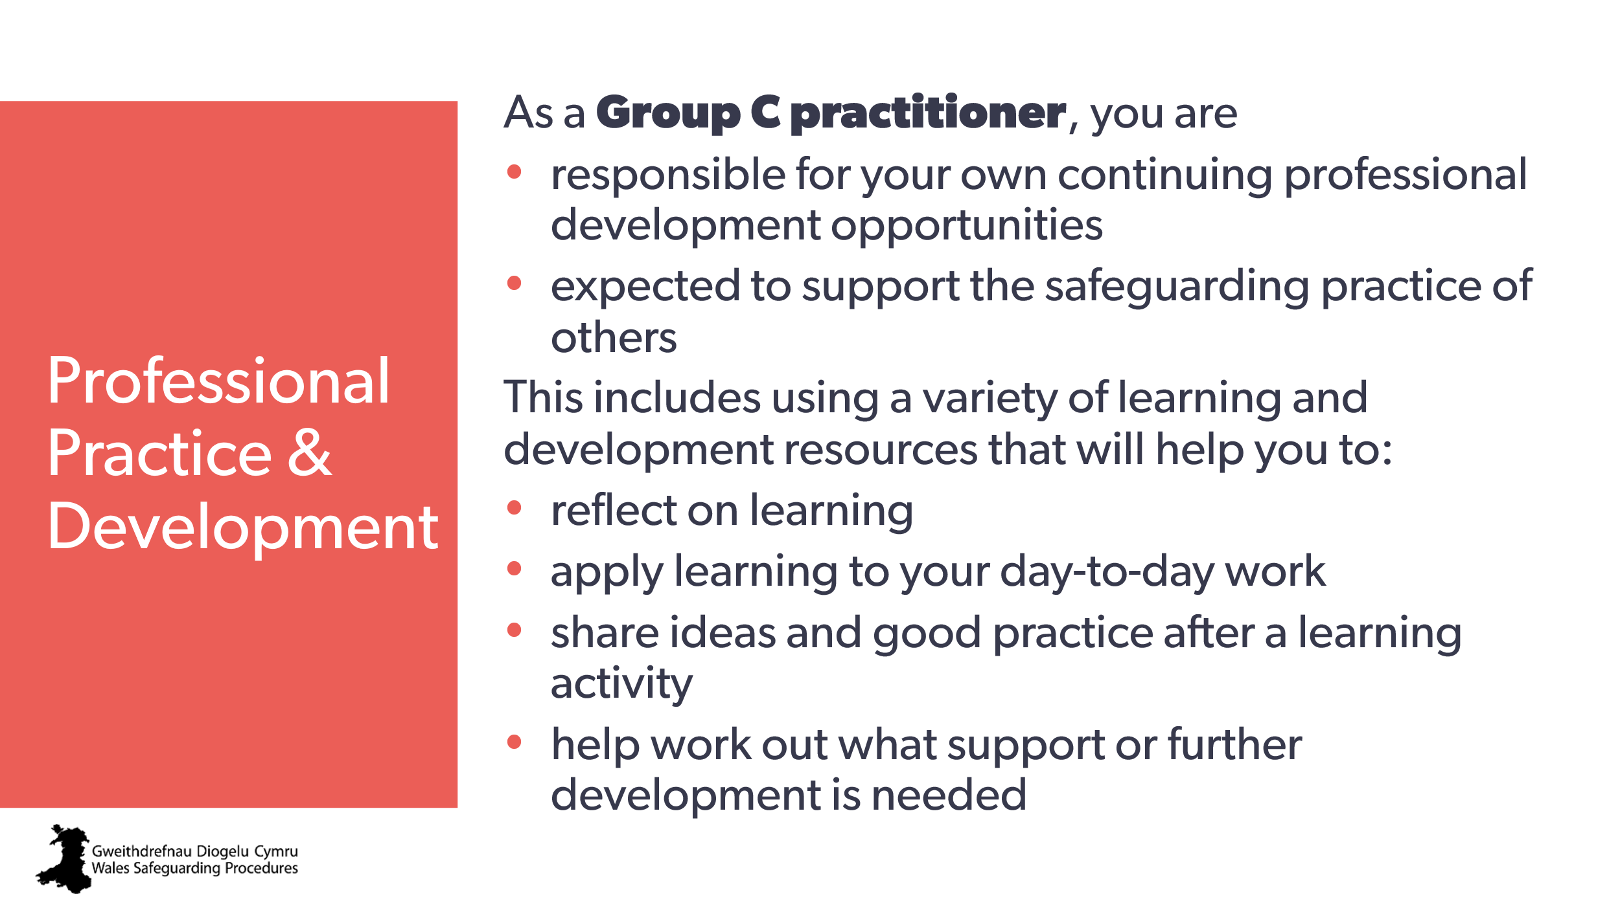 | Aim:  these final slides are designed to make everyone aware of the ongoing learning expectations for Group C practitioners.  Trainer may wish to promote any local training / CPD available. | National safeguarding training, learning and development standards
72 | 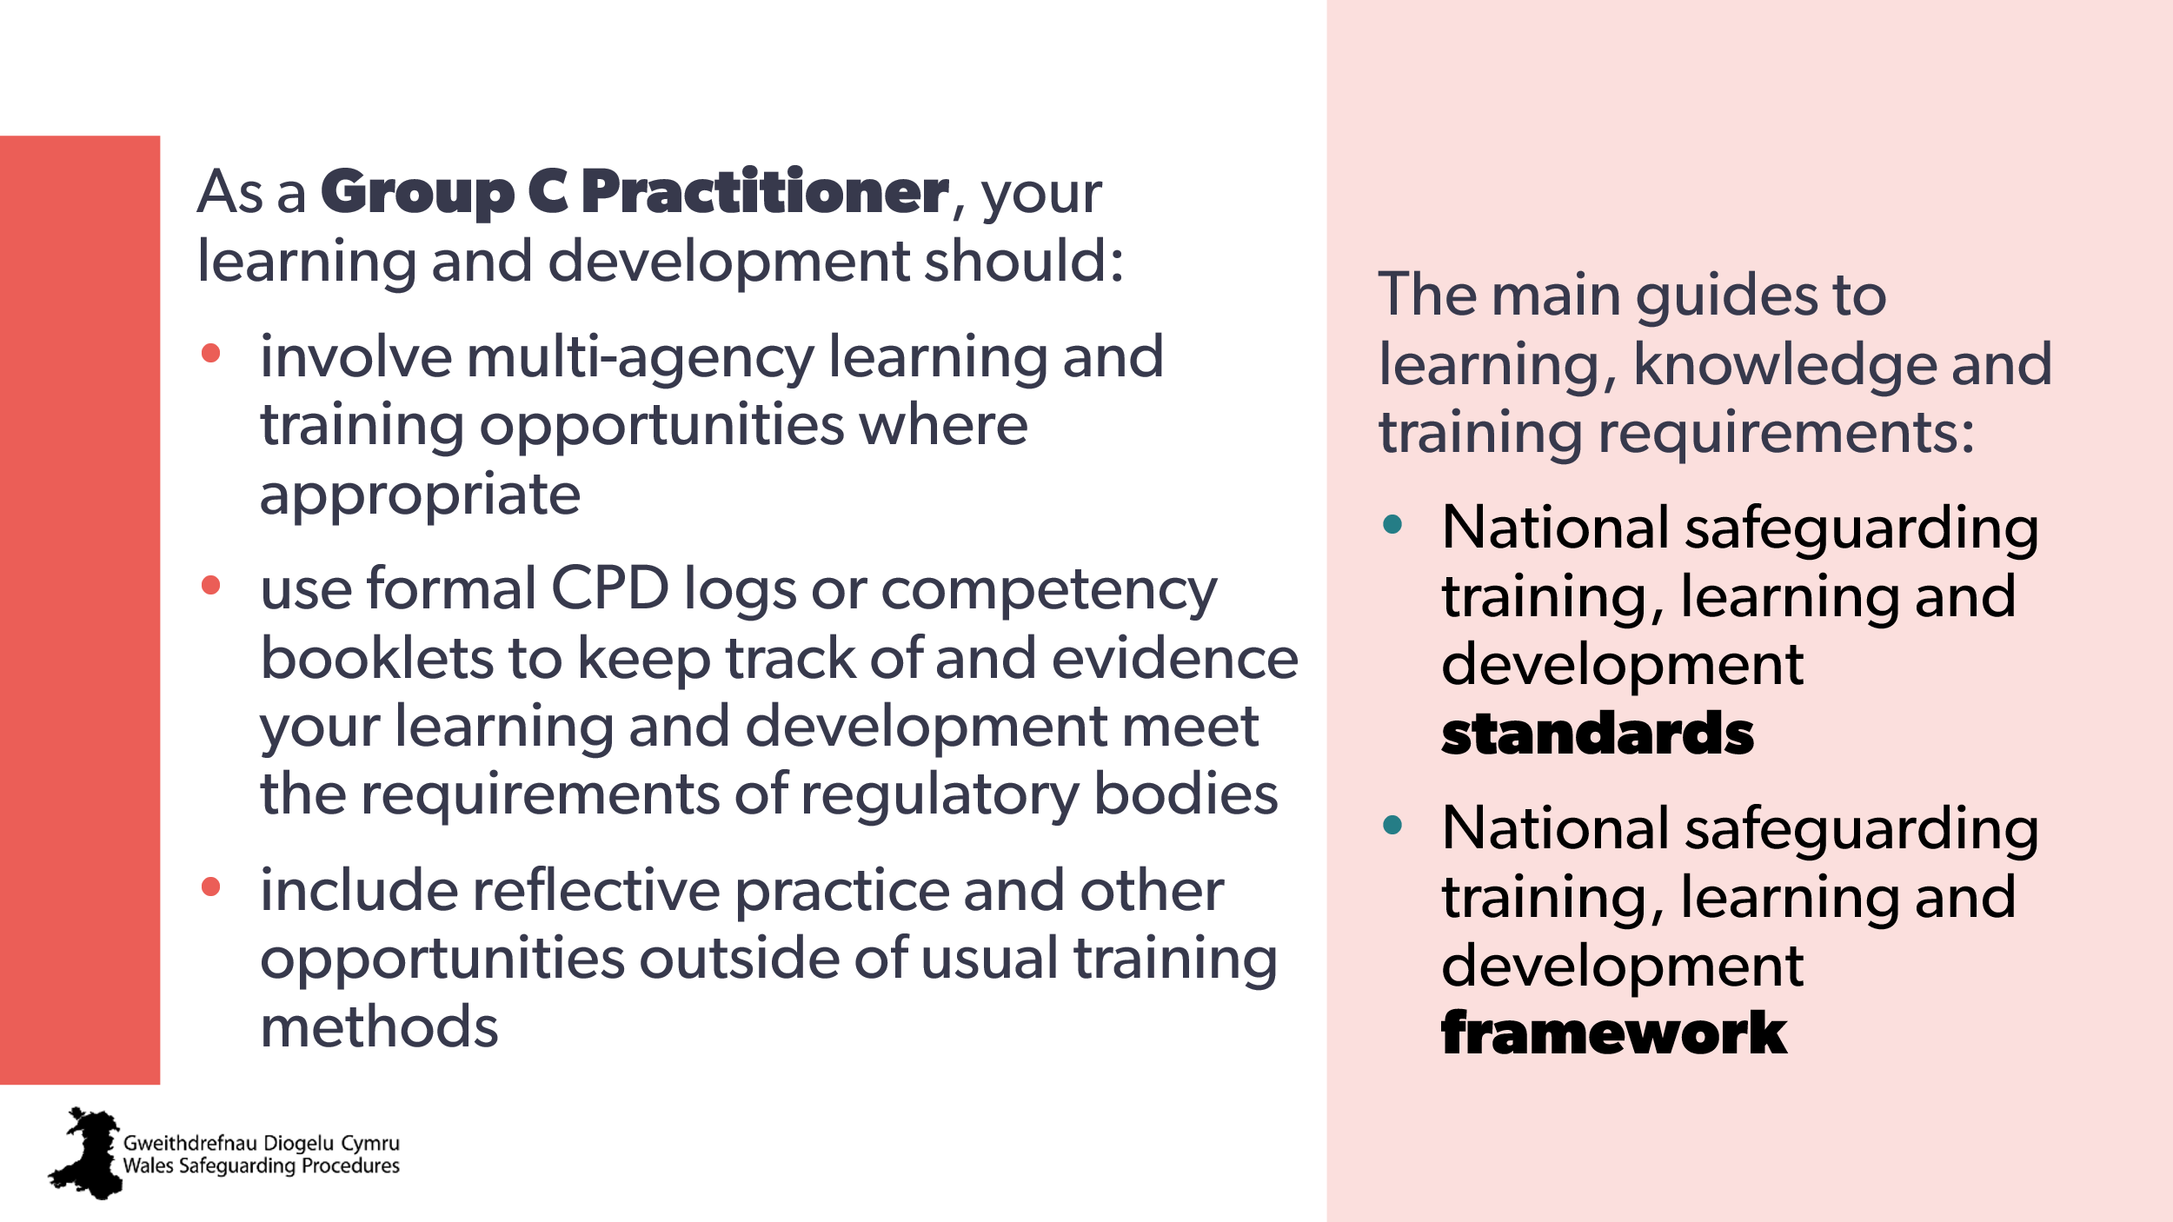 | Review
73 | 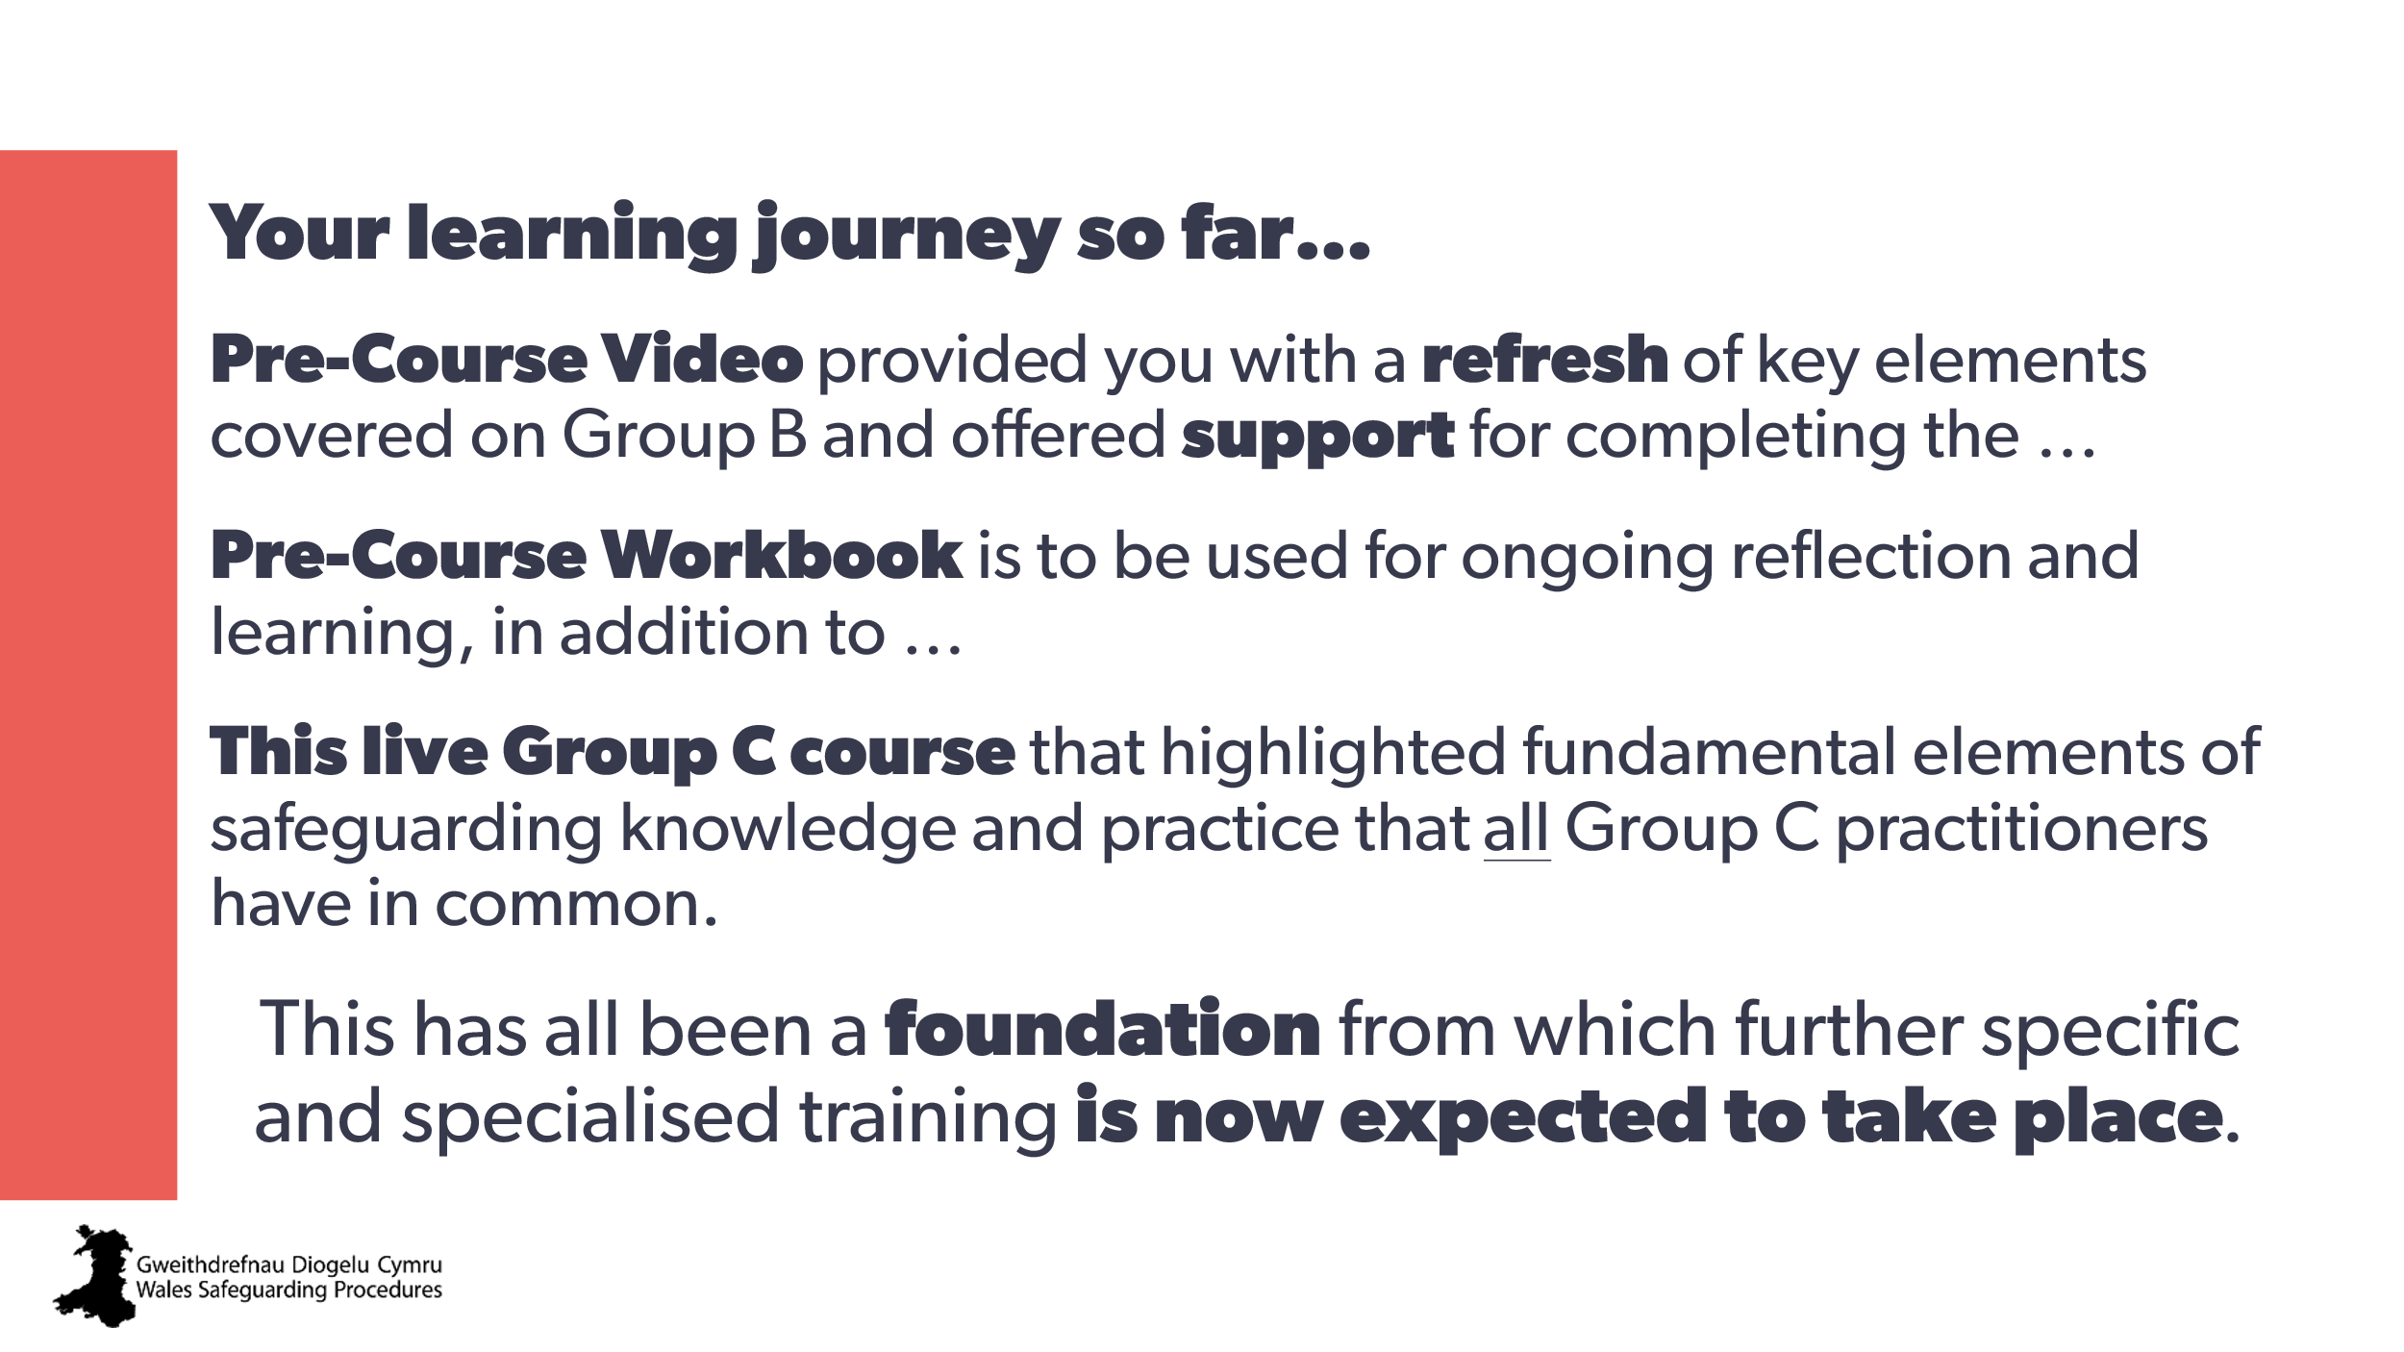 | Review
74 | 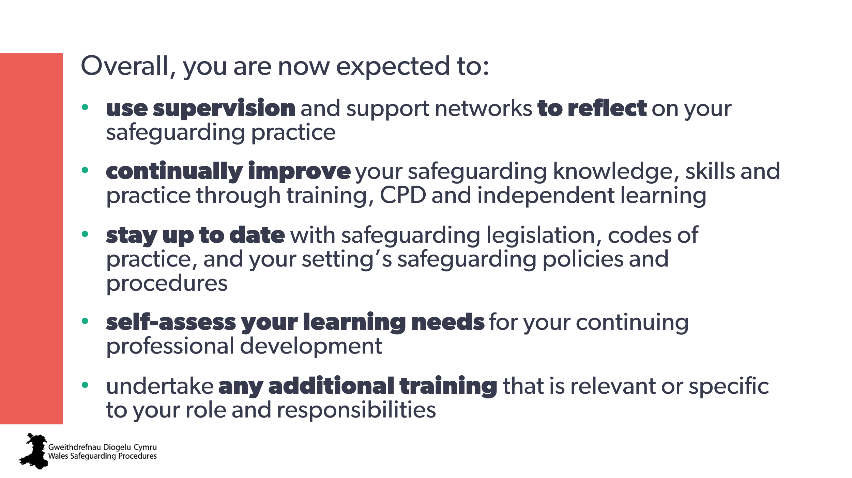 | Review

