Adults at risk
NOTE: info follows order in Wales Safeguarding Procedures – for those who ‘follow along’

Slide | SLIDE | Notes | Criteria and References
1 | 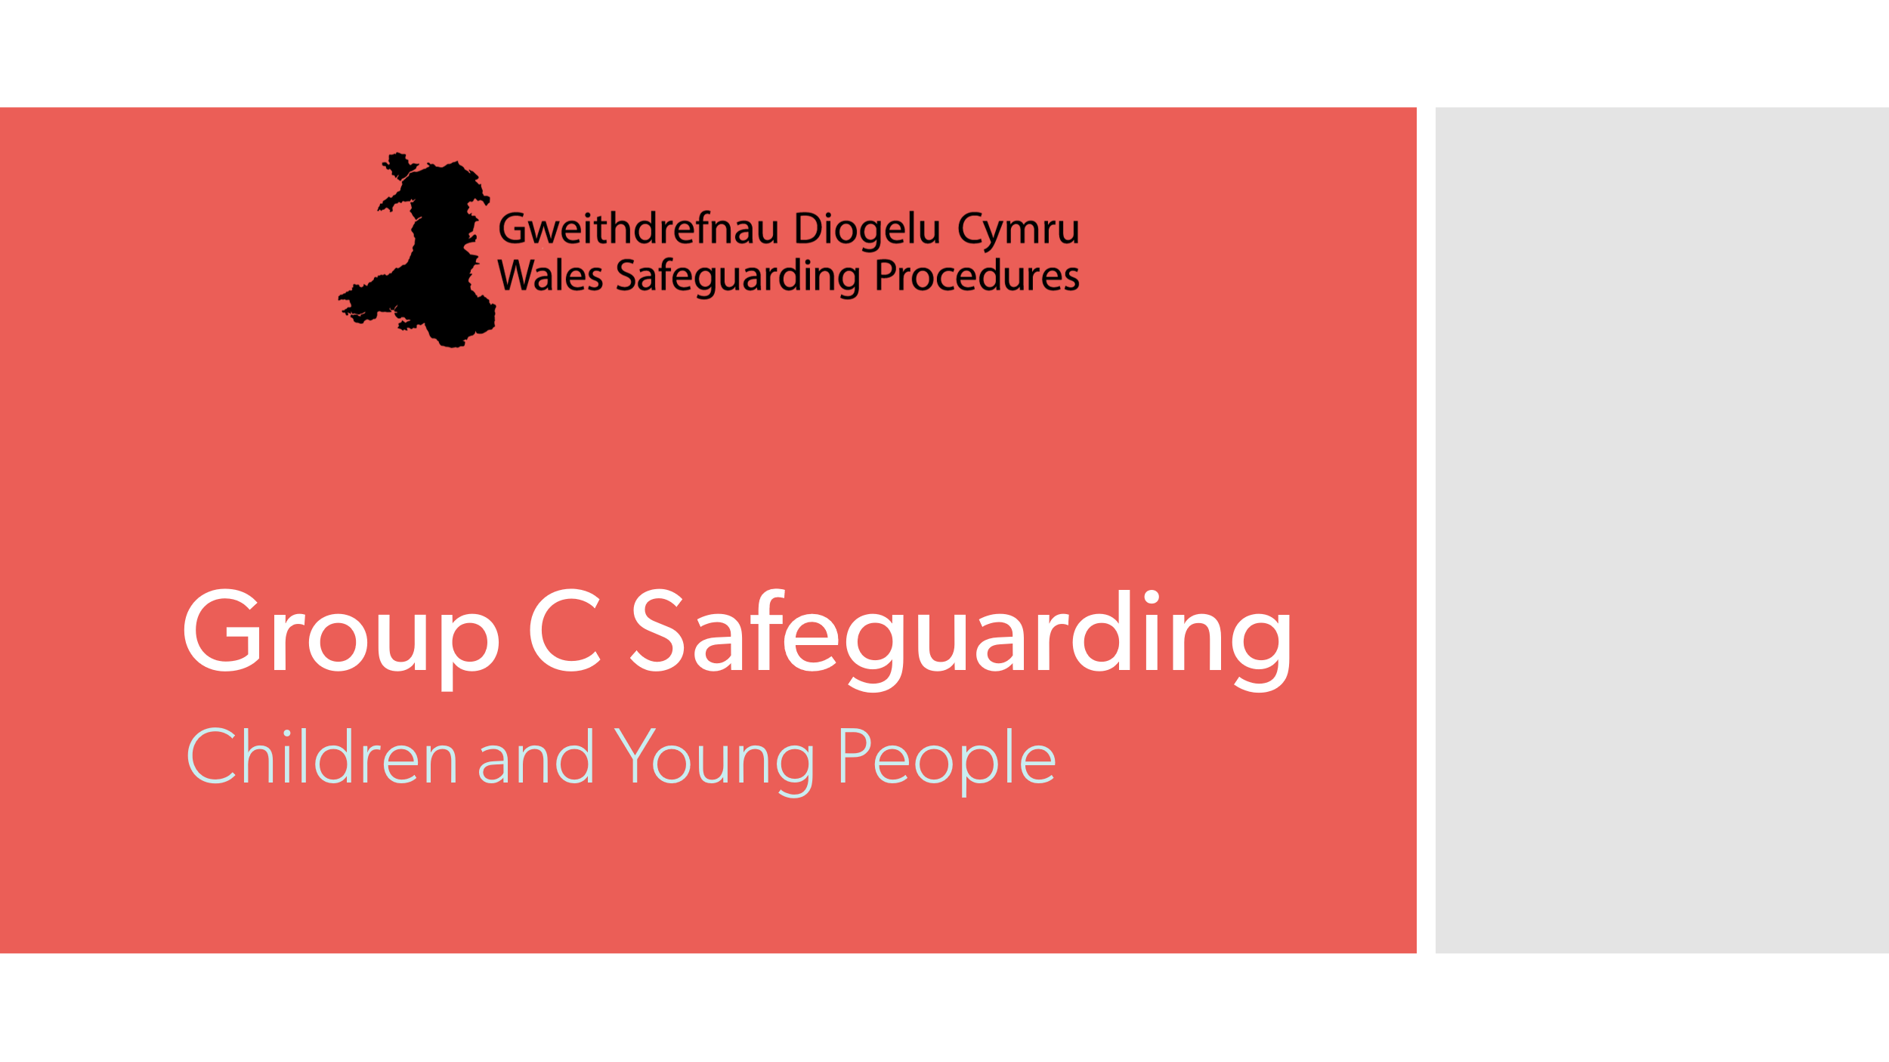 | Title slide to indicate the focus of this session is on safeguarding children and young people
2 | 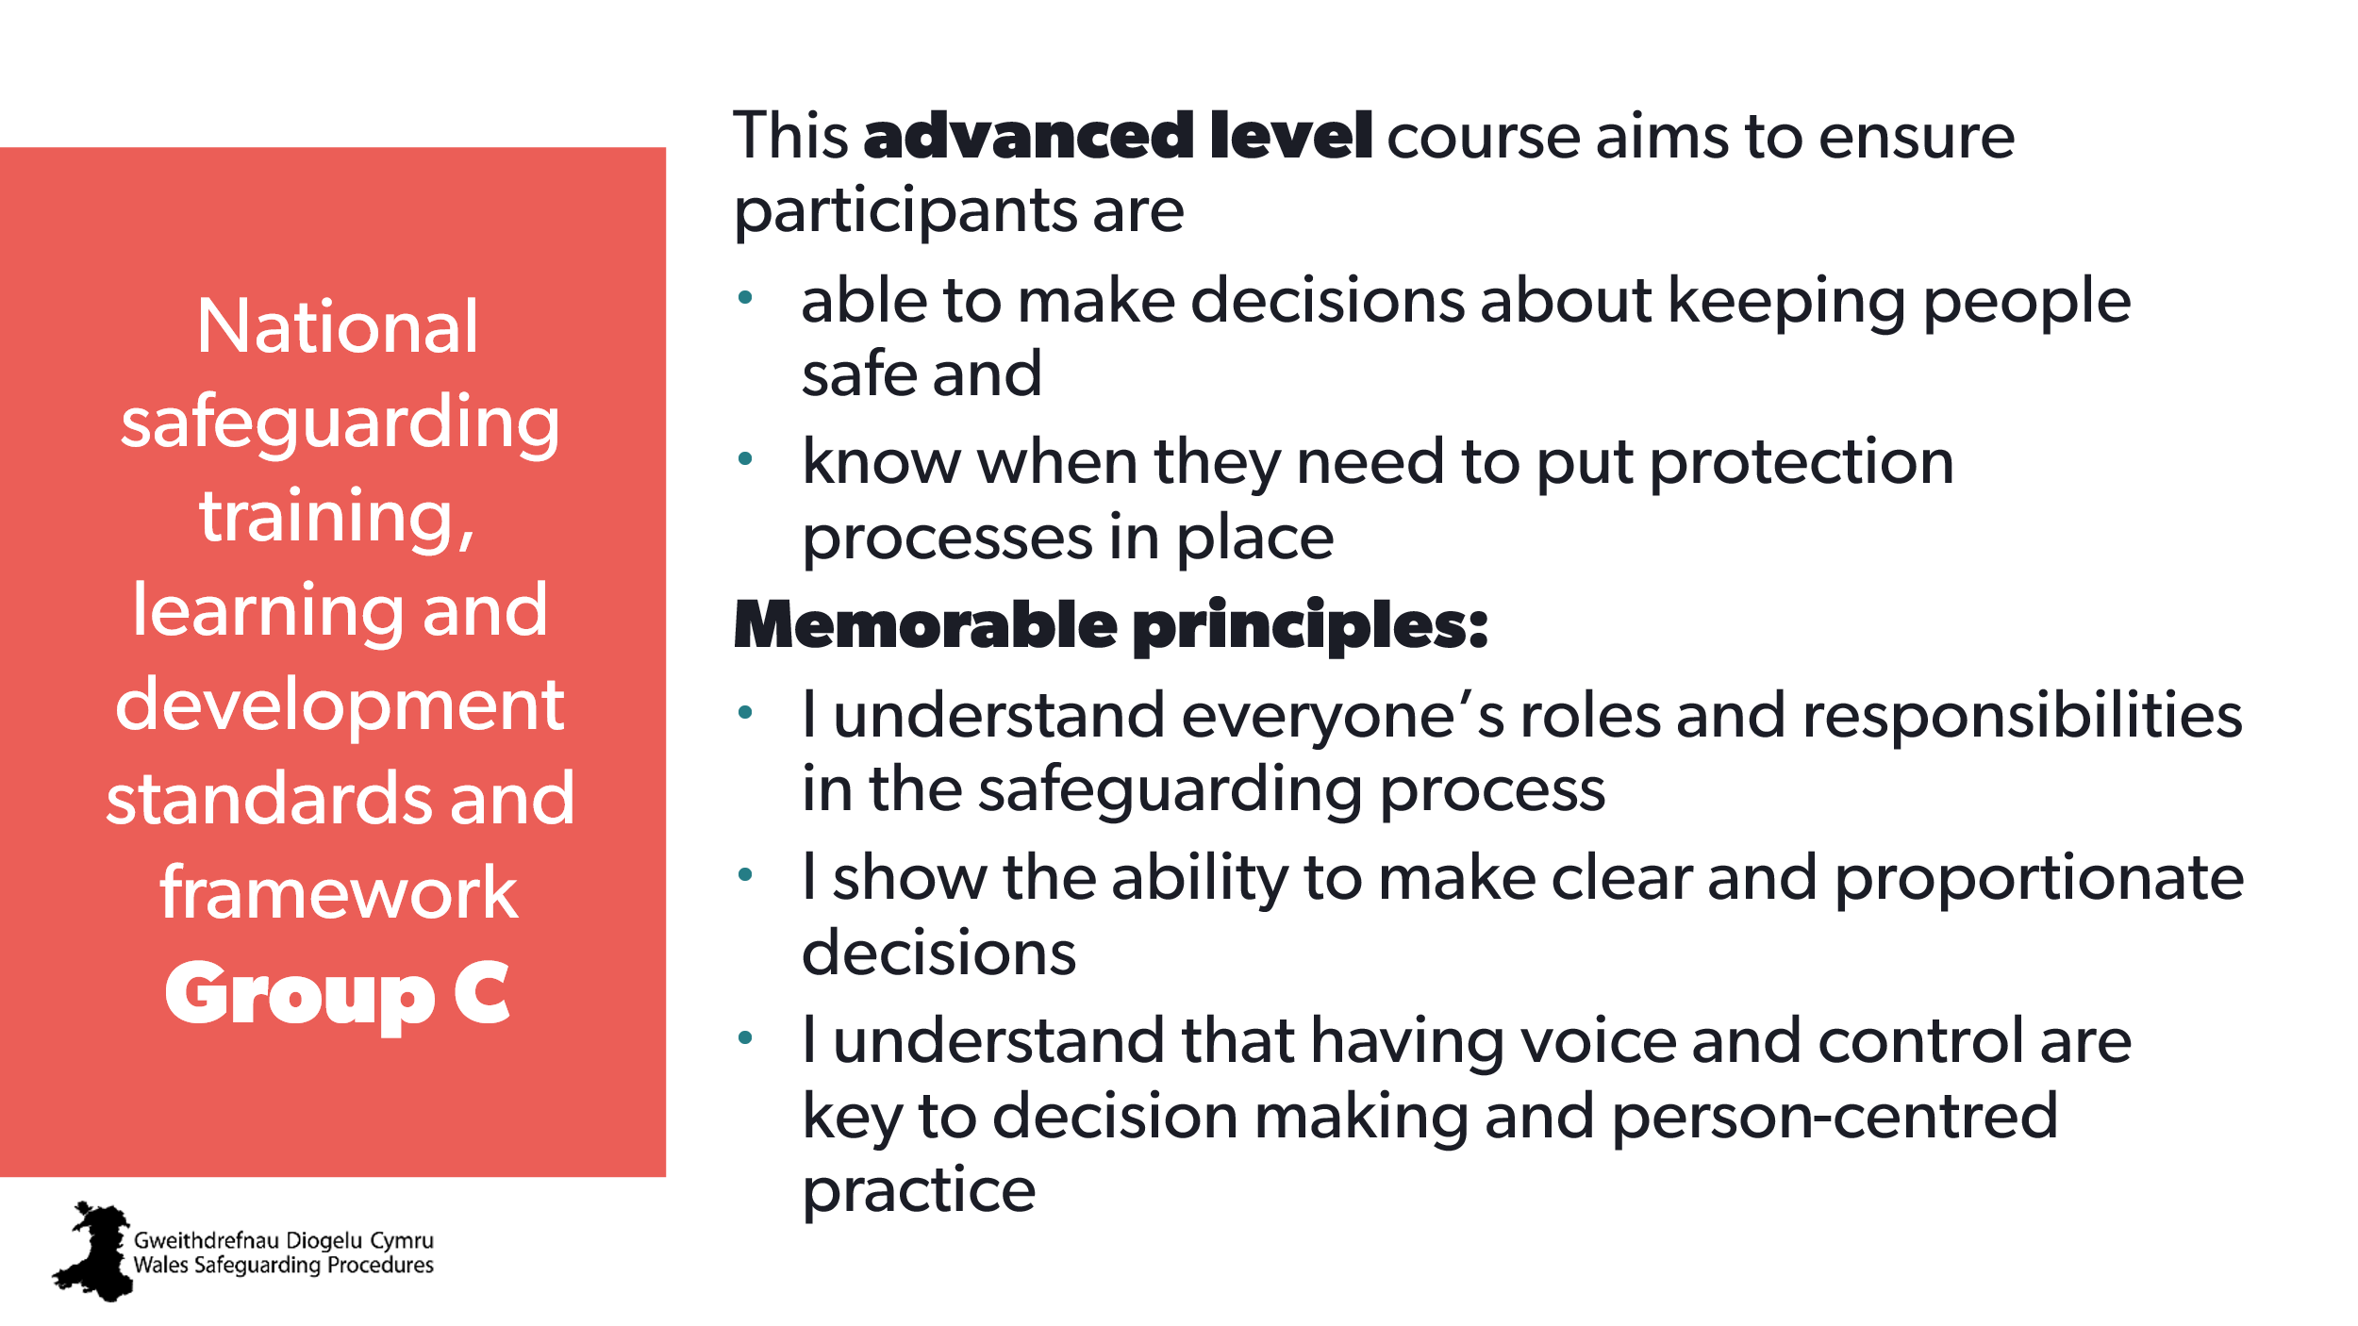 | Aim:  To make sure everyone understands the aims of the course (set expectations) and how it’s relevant to their roles. | National safeguarding training, learning and development standards - group C  National safeguarding training, learning and development framework - group C | Use the standards and framework to develop a Personal Development Plan for safeguarding skills and knowledge.
3 | 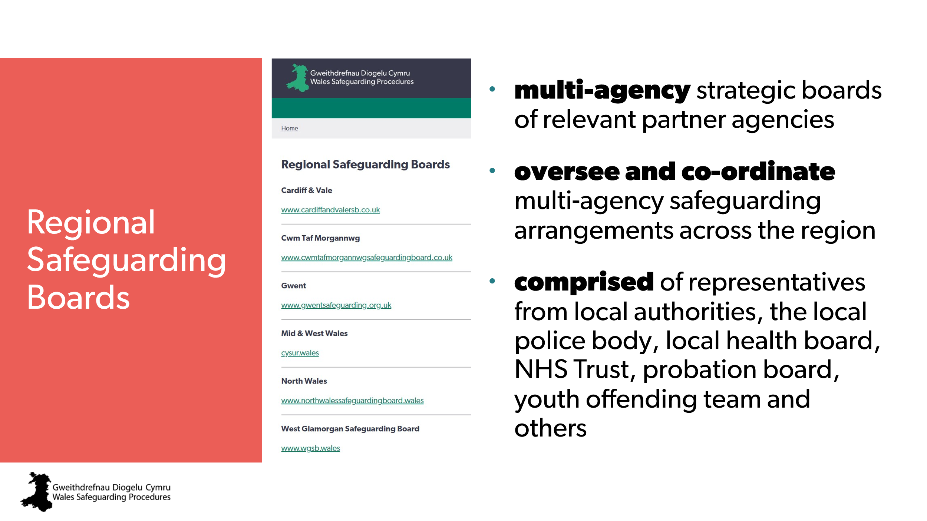 | Aim:  To make sure everyone’s aware of their Regional Safeguarding Board (RSB) and the resources and support available. | Wales Safeguarding Procedures  - Introduction  - Regional Safeguarding Boards
4 | 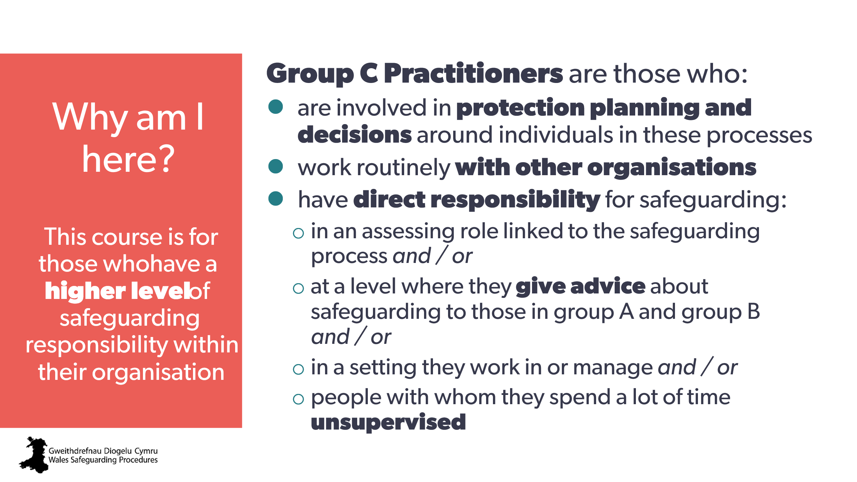 | Aim:  To set expectations of Group C Practitioners and relevance to individual roles.  Trainer to explain:  - this is part of a generic Group C safeguarding training that everyone in Group C must do  - after completing the generic Group C training, they’ll need to do additional training that is relevant to specific roles and responsibilities. | National safeguarding training, learning and development standards - group C | Additional training that is relevant to specific roles and responsibilities
5  6  7 | 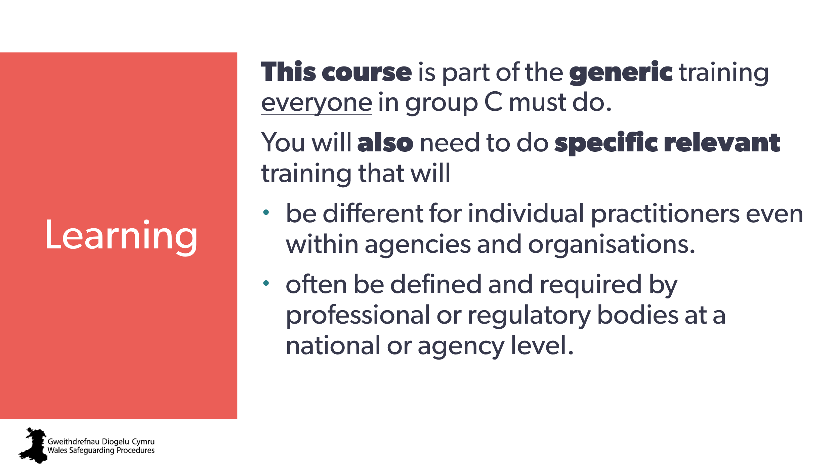  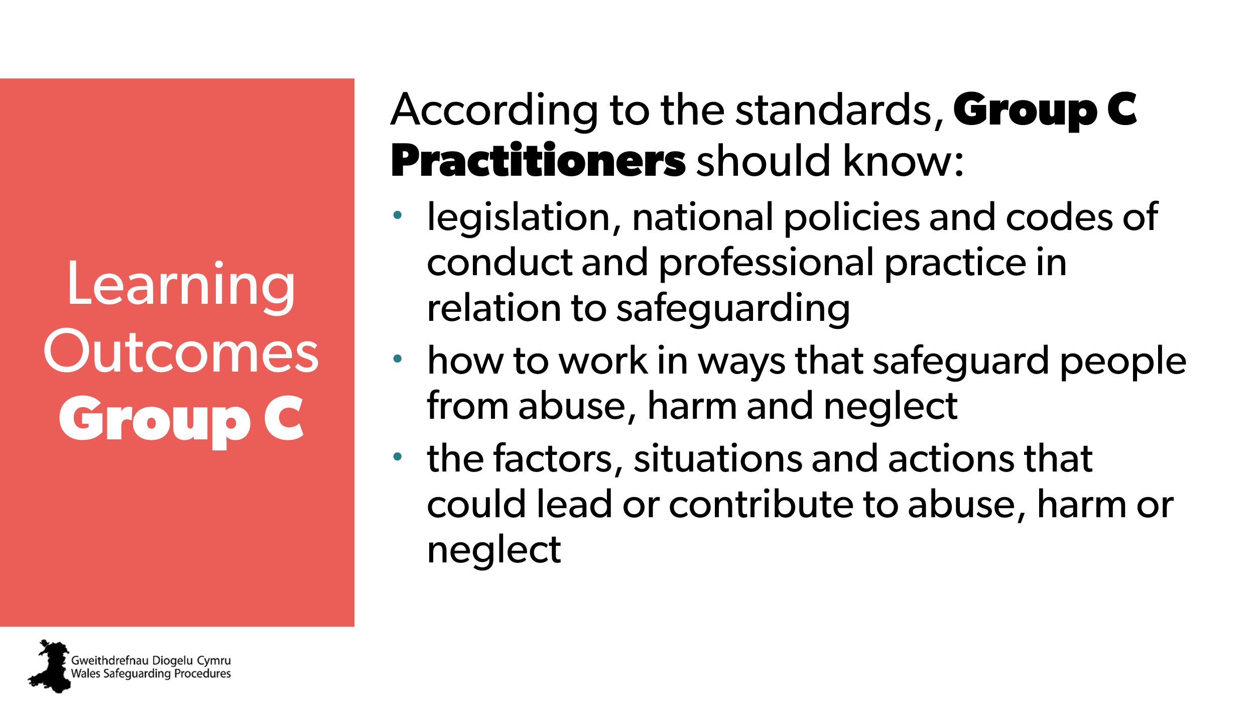  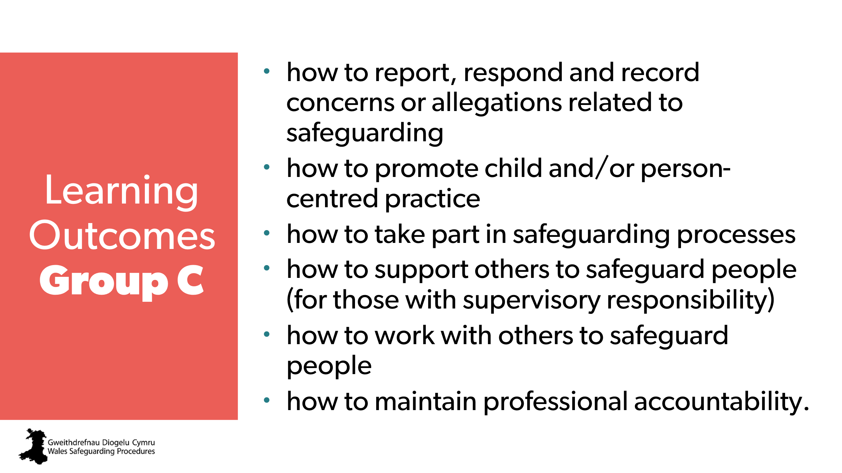 | Aim:  To make sure everyone’s aware of the expectations set by the Framework and Standards.  Optional:  - trainer may wish to direct people to the standards on their phone/laptop  - this could be a handout. | National safeguarding training, learning and development standards - group C
8 |  | Note: blank text box to add group/venue-specific aspects.  Aim:  - to develop rapport, trust and emotional safety (trauma informed approach)  - to find out if there are specific issues that may need addressing  - to find out if there are any particular learning needs  - to set expectations.  Note to trainer:  If possible, sit down with the group to be ‘part of’ the group and change the power dynamic to a more equal one to support confidence.  If there are very experienced people in the room, explain that:  - much of this information should be a refresh for them and a way to make sure they’re as up to date as possible  - this course is designed to allow them to share experience and ideas – encourage them to add their practical knowledge  - this is a baseline course that everyone must do as a starting point – addressing aspects common to all sectors and services  - there’s always something new to learn in safeguarding!  If there are people very new to this level of safeguarding:  You may wish to:  - reassure them that there will be opportunities for CPD and further learning following this course  - encourage them to ask questions and learn from the experience of those around them.
9 | 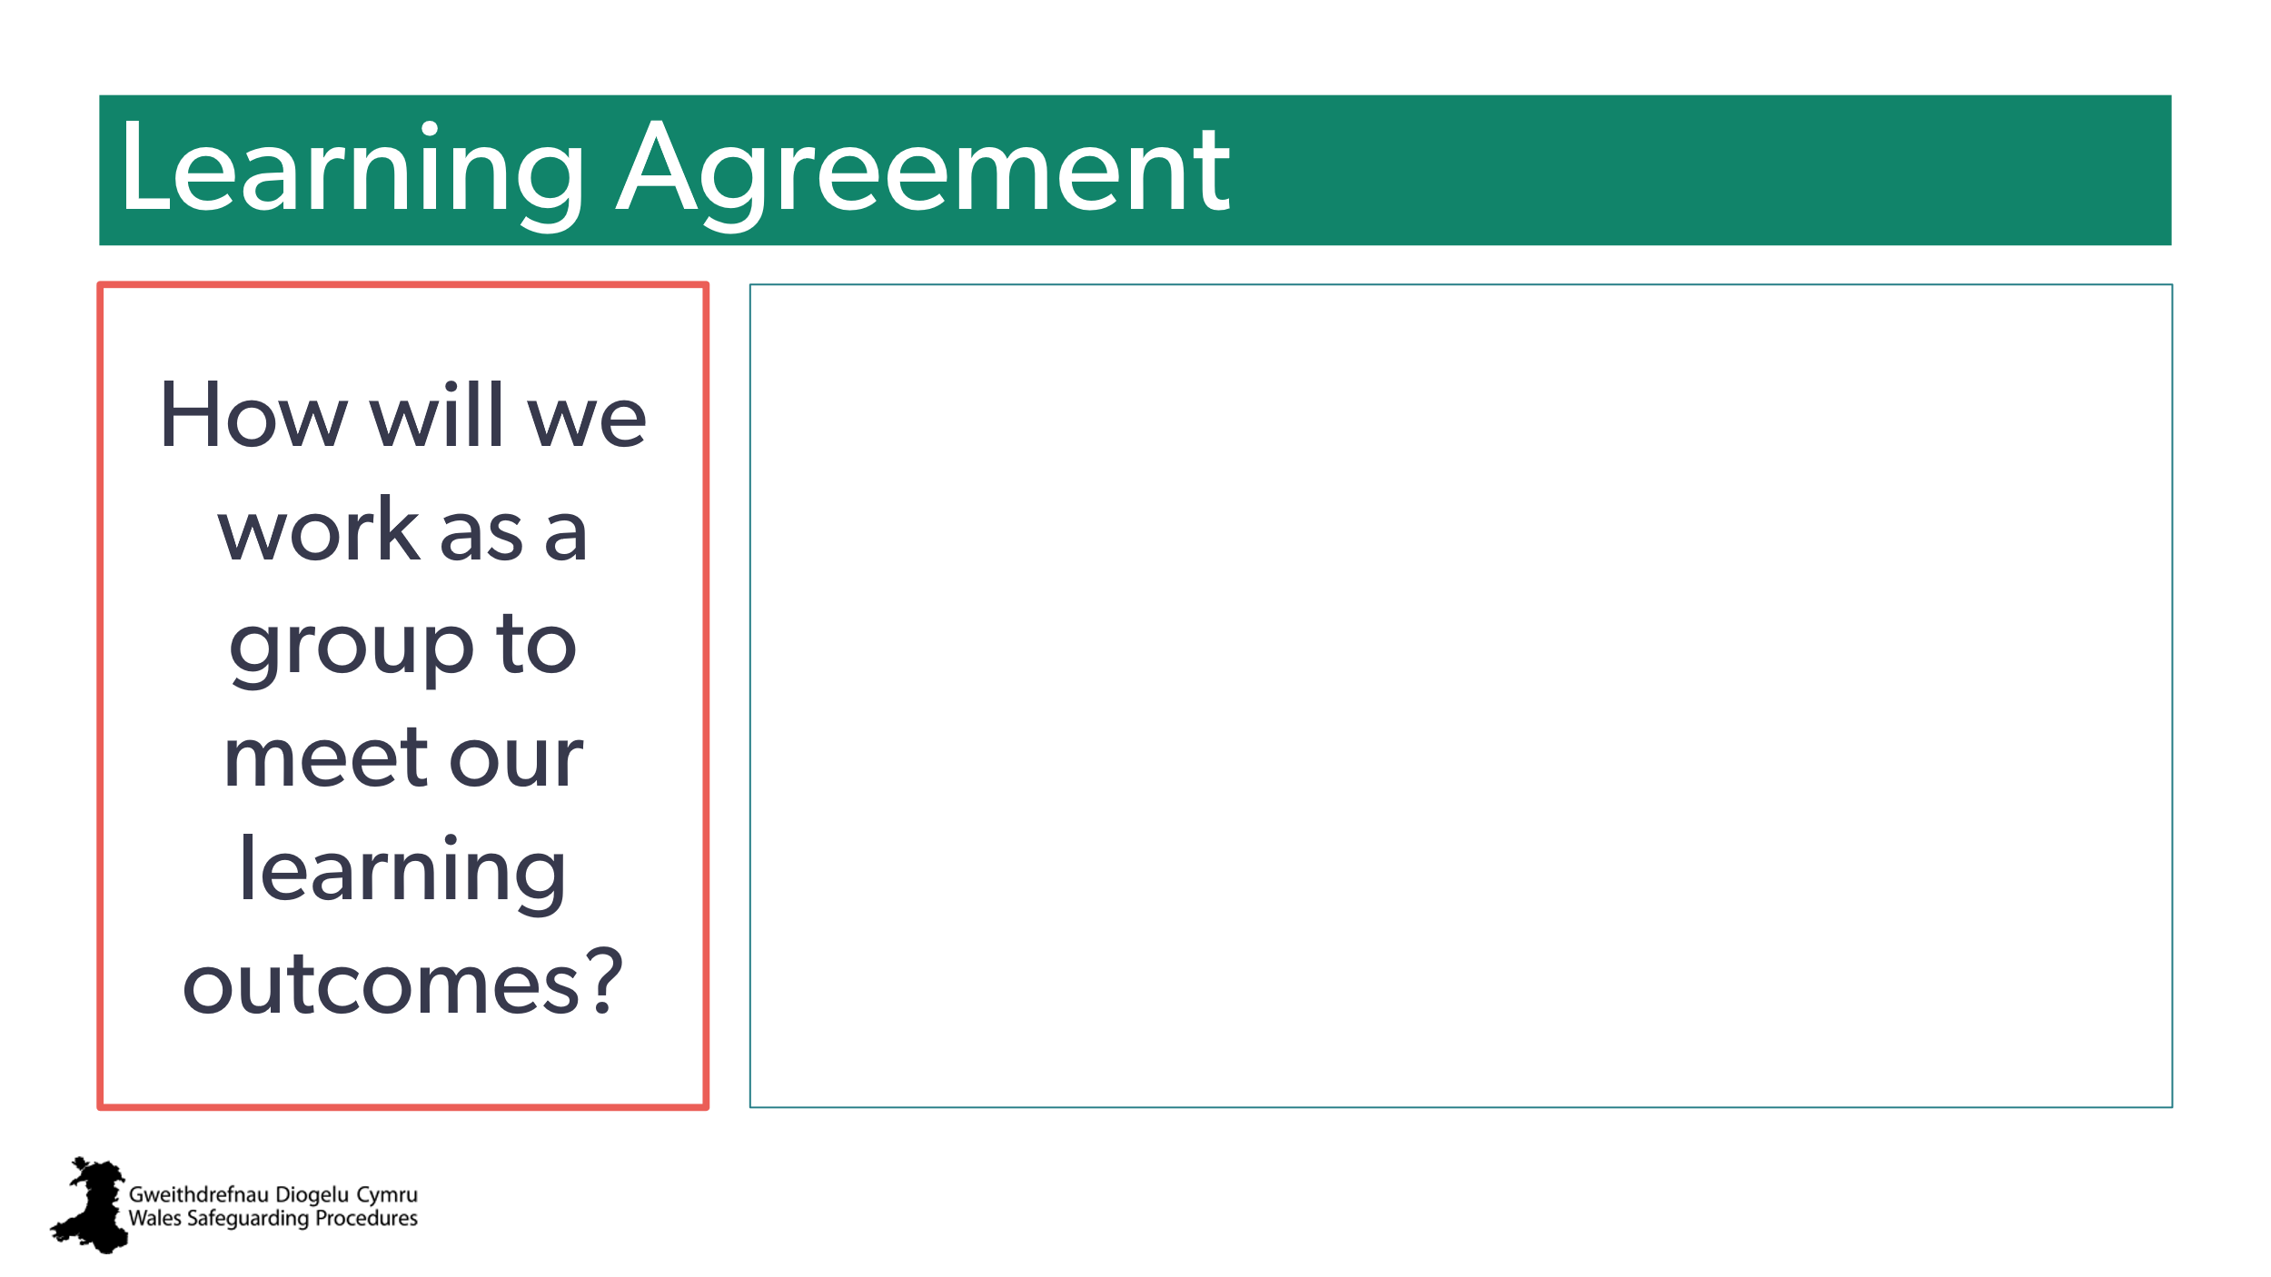 | Note: blank text box to add group/venue-specific aspects.  Aim:  - to set out what’s expected  - to manage/set expectations for contributing and participation  - to highlight expectation of individual learning responsibility.  Notes to trainer:  - people on course may be in completely different roles – encourage more experienced to share knowledge with those less experienced  - they need to consider how this is relevant to them within their own roles  - encourage people to apply learning to their own individual roles.  Trainer to stress:  Highlight the importance of consolidating learning after today and ask learners to think about practical activities they could carry out following today’s session, to gain further experience and/or embed their learning.  Professionals need to have the confidence to say they need additional training in certain areas as part of their CPD. |  | CPD  practical activities they could carry out following today’s session, to gain further experience and/ or embed their learning.
10 | 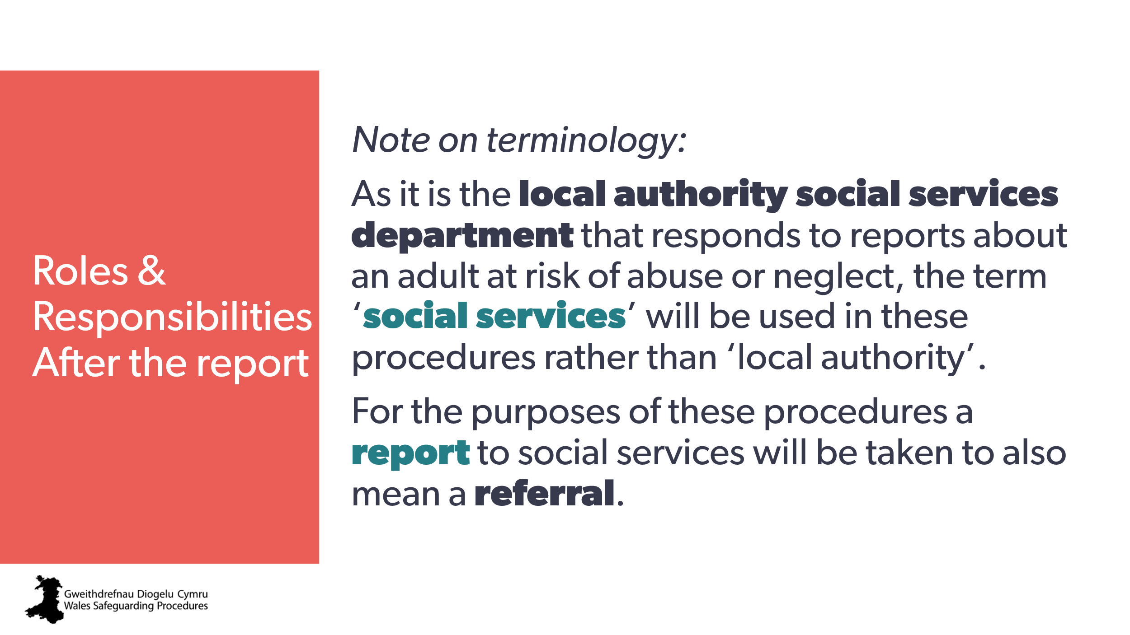 | Aim:  - transition slide into this section of the full Group C course  - to explain terminology to be used.  Trainer to explain:  We’re now going to look at what happens after you’ve submitted a safeguarding report to social services, and what involvement you might have in that process.  A key principle throughout this process should always be making the adult safe.  Note to trainer:  Depending on the experience in the room, you may also wish to point out:  - if/ when the official safeguarding pathway isn’t appropriate, we still need to look at all other options of help and support (for example Information, Advice and Assistance (I.A.A.)/early help), rather than not going down such routes.  - practitioners need to explain to people what will happen after reports/referrals are submitted  - practitioners must report, even if there’s a chance the report will be ‘refused/No Further Action, and must be willing/prepared to have that discussion.
11 | 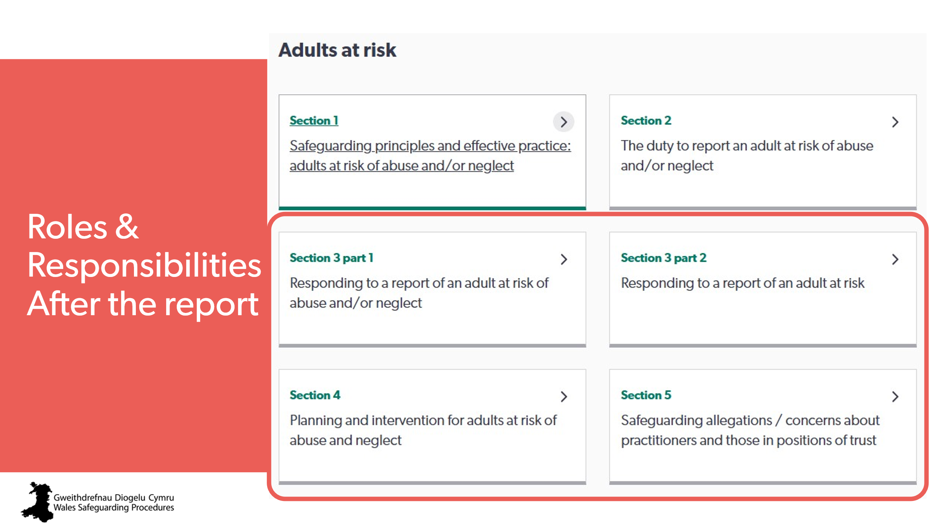 | Aim:  To show the sections of the Wales Safeguarding Procedures that will be covered in this session.  Trainer to suggest:  - invite all the learners to follow along on the Wales Safeguarding Procedures app/website. | Section 3 part 1  Responding to a report of an adult at risk of abuse and/or neglect  Section 3 part 2  Responding to a report of an adult at risk  Section 4  Planning and intervention for adults at risk of abuse and neglect  Section 5  Safeguarding allegations / concerns about practitioners and those in positions of trust
12 | 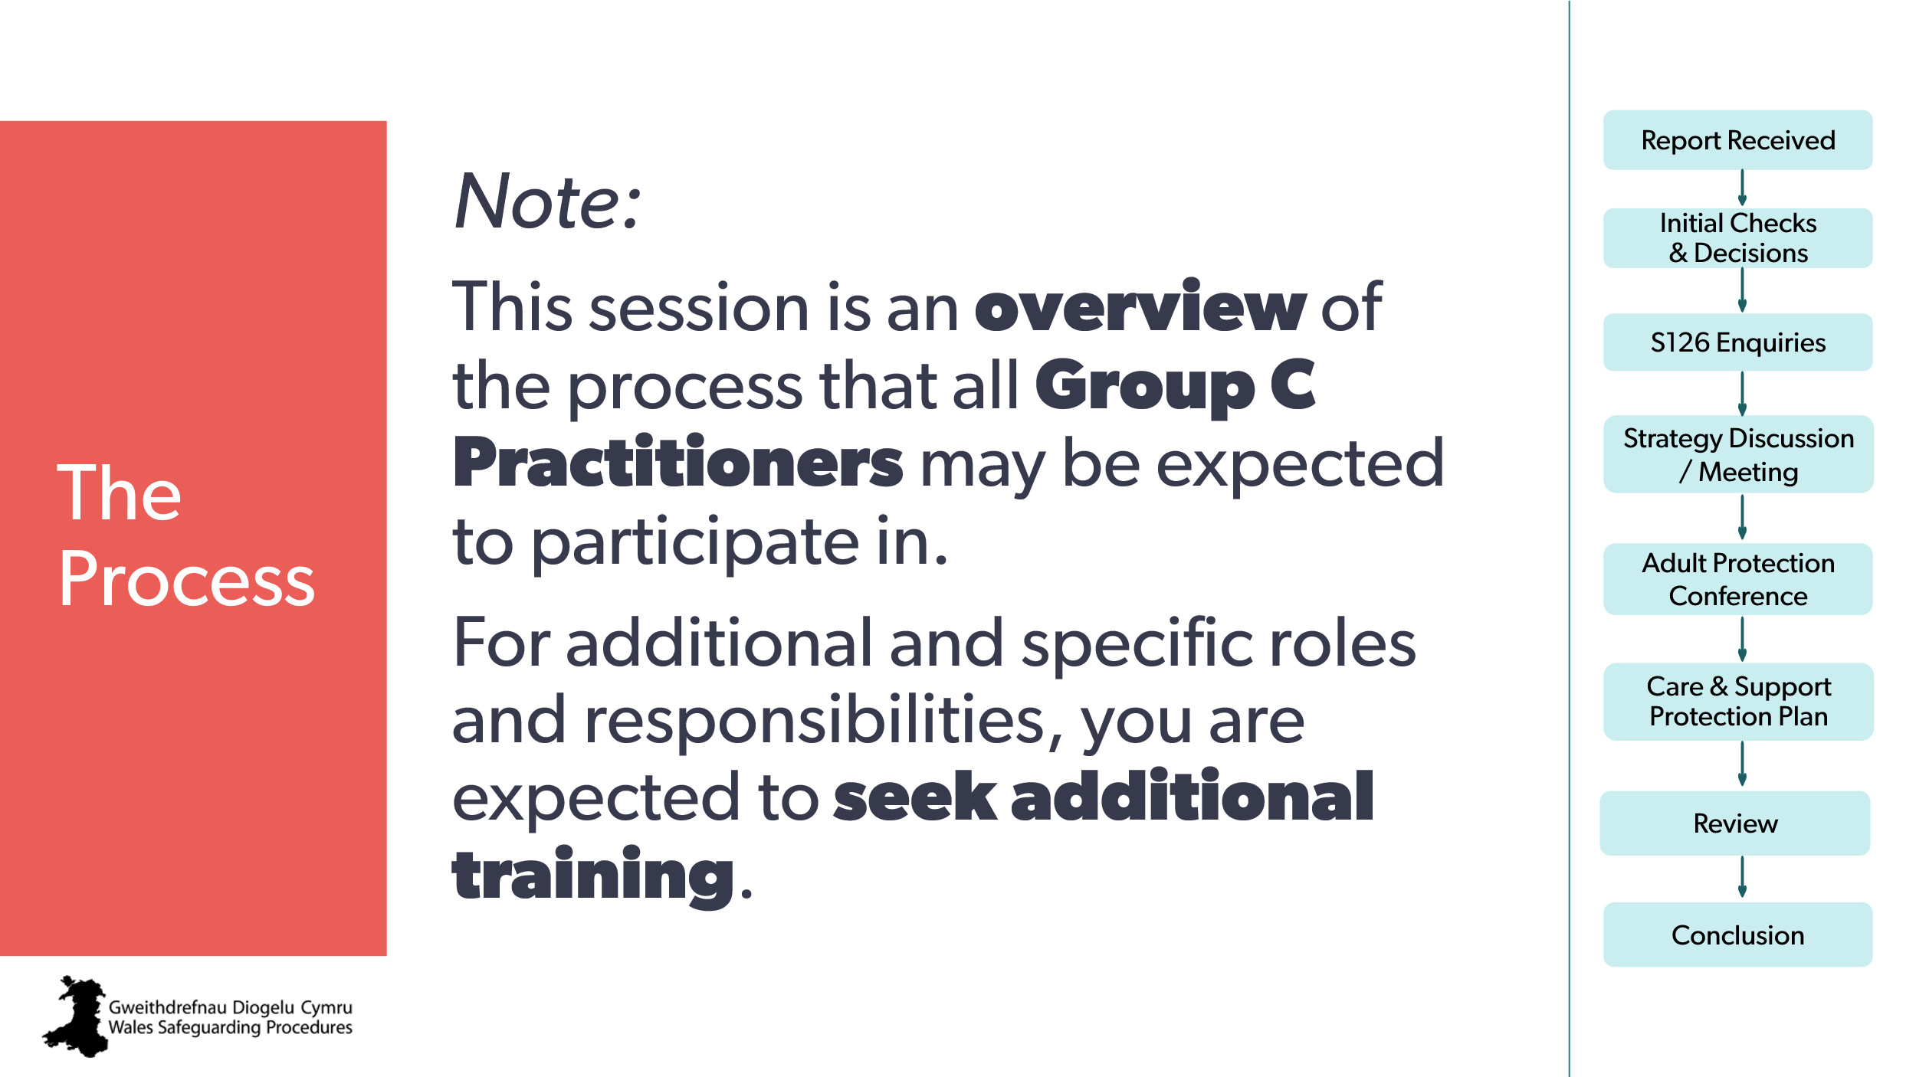 | Aim:  To give overview of the process.  To clarify that we’ll only be looking at the expectations for the majority of people.  Trainer to explain:  Throughout this section, we’ll be following the full process, which we’ll show in a flow chart on the right of the screen.  We’ll focus on the role of the general practitioner. There are many other roles in the process, and the details for these are in the Wales Safeguarding Procedures. But, as this is an overview, we’ll just be focussing on what all Group C Practitioners may be expected to do.  Section 2 of the Wales Safeguarding Procedures ends with the submission of the report.  Section 3.1 starts with the receipt of that report and everything that follows.  We’re starting with Section 3.1 of the Wales Safeguarding Procedures.  You’re welcome to follow along if you have the app on your phone. | Wales Safeguarding Procedures  Section 3 part 1  Responding to a report of an adult at risk of abuse and/or neglect
13 | 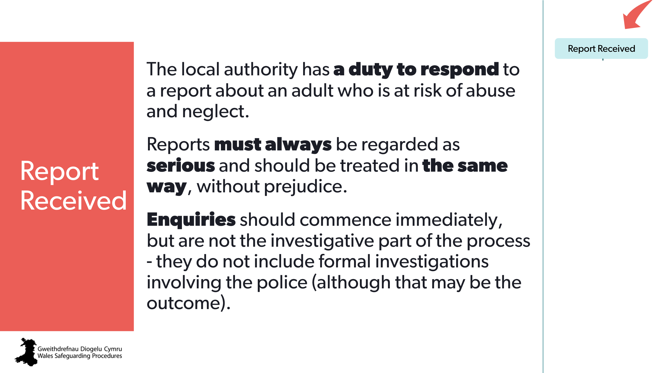 | Aim:  To explain the responsibilities of the report-taker.  Trainer to explain:  We’ll begin at the point the report taker has received your report form.  Trainer may wish to explain:  The three conditions necessary to demonstrate that an adult is at risk of abuse or neglect ensures that protection is provided to people with care and support needs who also need actions to secure their safety in the future because they’re unable to protect themselves:  Although the Wales Safeguarding Procedures tell report makers to make a report regardless of 2 and 3, the report taker must take it into consideration.  Enquiry v investigation  Aim:  It’s very important everyone understands the difference between an enquiry and an investigation.  Enquiries aren’t the investigative part of the process and don’t include formal investigations involving the police, although that may be the outcome.  Optional:  Trainer to ask:  - what are key differences?  - why is it important to know the difference and use correct terminology, especially with clients or service users?  Trainer to explain:  Enquiries:  - describe the information-gathering carried out by social services to determine whether any action should be taken to safeguard the adult at risk  - are not the investigative part of the process and do not include formal investigations involving the police.  Investigation  - describes the gathering of evidence  - by the police when a criminal offence relating to the abuse and neglect is suspected to have occurred,  and/or  - by social services to gather evidence and reach a conclusion about whether people have been placed at risk or are at ongoing risk. | Handout:  Regional Safeguarding Board report form for adults at risk  Wales Safeguarding Procedures:  Responding to a report: overview of task and process  Receiving reports in the local authority where the adult is at risk
14 | 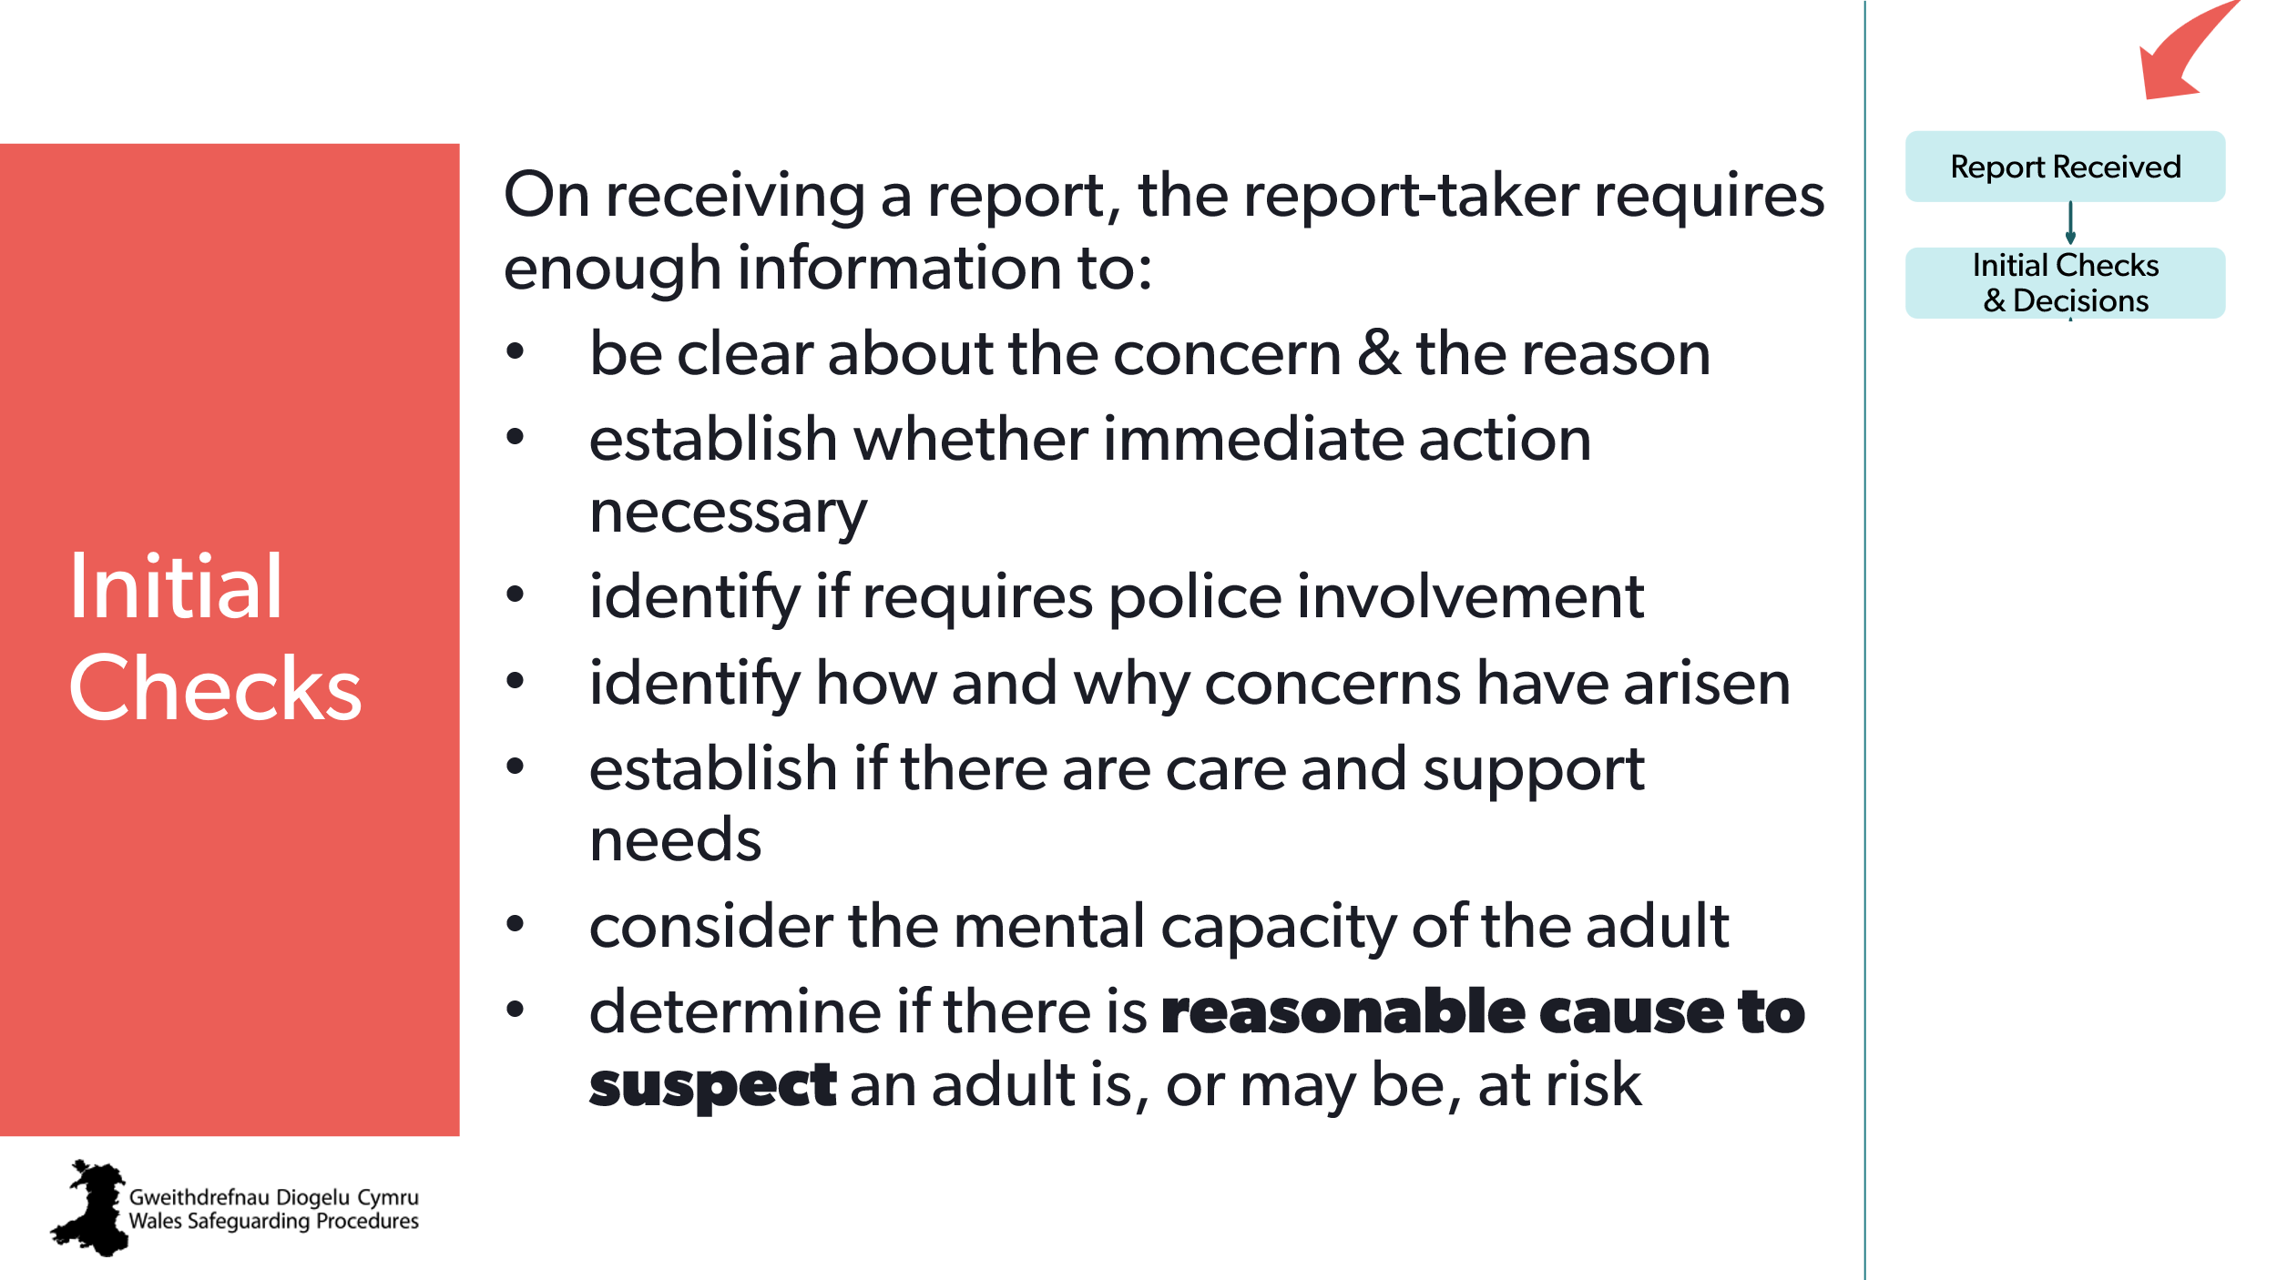 | Aim:  To explain the responsibilities of the report-taker – initial checks  Trainer to explain:  Following a report being made to social services, there will be a consideration of all information (as detailed in the ‘duty to report’ section) to determine if there’s reasonable cause to suspect an adult is, or may be, at risk.  Trainer may wish to note:  The focus should be the safety and well-being of the adult at risk:  - whenever report appears to constitute a criminal offence, social services must always discuss the case with the police immediately  - If the report constitutes an allegation of failure of care standards or breach of regulation by a regulated provider or a statutory agency, the report maker must discuss it with their relevant safeguarding lead and follow Safeguarding Boards’ professional concerns protocol. | Information-gathering by the report-taker  Completing initial checks
15 | 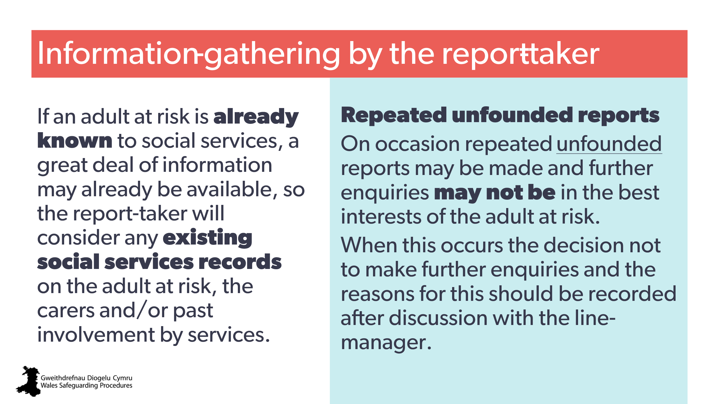 | Aim:  - to point out the amount of information that may be available  - to point out how repeated unfounded reports are to be handled.  Optional activity:  Direct learners to this section in the Wales Safeguarding Procedures and discuss the example given:  “For example, an adult with physical disabilities has a large family, and is being cared for by a relative. The adult is repeatedly being reported to social services by the other members of the family who regard the care he receives as neglectful.  “The adult is deemed to have capacity, and regularly advises his social worker that the allegations about his carer are malicious and made by family members who do not get on with him and the carer.  “Moreover, there is no evidence of neglect. Regular meetings have been held between the adult considered to be at risk, the social worker and his family. The adult with physical disabilities finds the process distressing and tedious.  “Consequently, when a further report is made a decision is taken by social services not to make any further enquiries.” | Information-gathering by the report-taker  Repeated reports of abuse and/or neglect  Pointers for Practice: Subjective Factors that can Influence the Response to a Report  Pointers for Practice: Eliciting Information During the Screening and Initial Evaluation - the Challenges
16  17 | 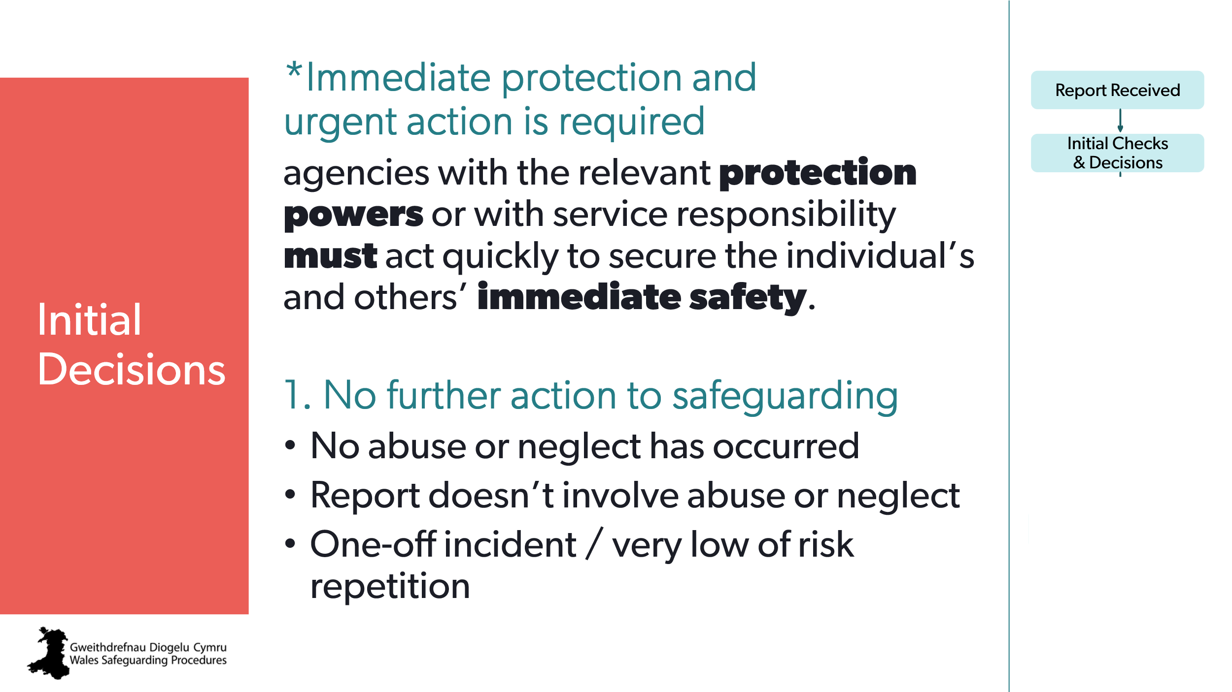  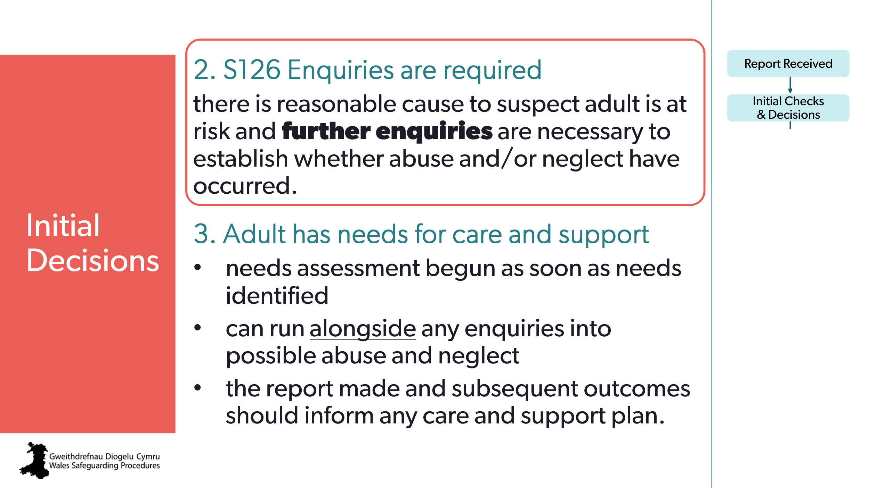 | Aim:  To provide an overview of initial decisions.  Note to trainer:  There’s an appearing box to show this is the process pathway we’ll follow (#2)  Trainer to explain:  Immediate - see adult at risk same day:  Physical injury, sexual abuse, already subject to protection plan, severe neglect / other severe health risk, abandoned  1) trainer may wish to use some of the examples listed in the Wales Safeguarding Procedures  Note: “Where social services decide not to take further action … or re-directs the case to other sources of support that is more suitable… feedback on the decision and the reasons for making it should be provided to the practitioner making the report.”  Wales Safeguarding Procedures Wales Safeguarding Procedures  2) Enquiries: complies with s.126(2) of the Social Services and Well-being Act (Wales) 2014  3) Part 3 of the Social Services and Well-being Act (Wales) 2014 should begin as soon as the needs are identified. | Immediate protection and urgent action  Outcomes following a report: initial screening decisions  s.126(2) of the Social Services and Well-being Act (Wales) 2014  Part 3 of the Social Services and Well-being Act (Wales) 2014  Identifying Care and Support Needs
18 | 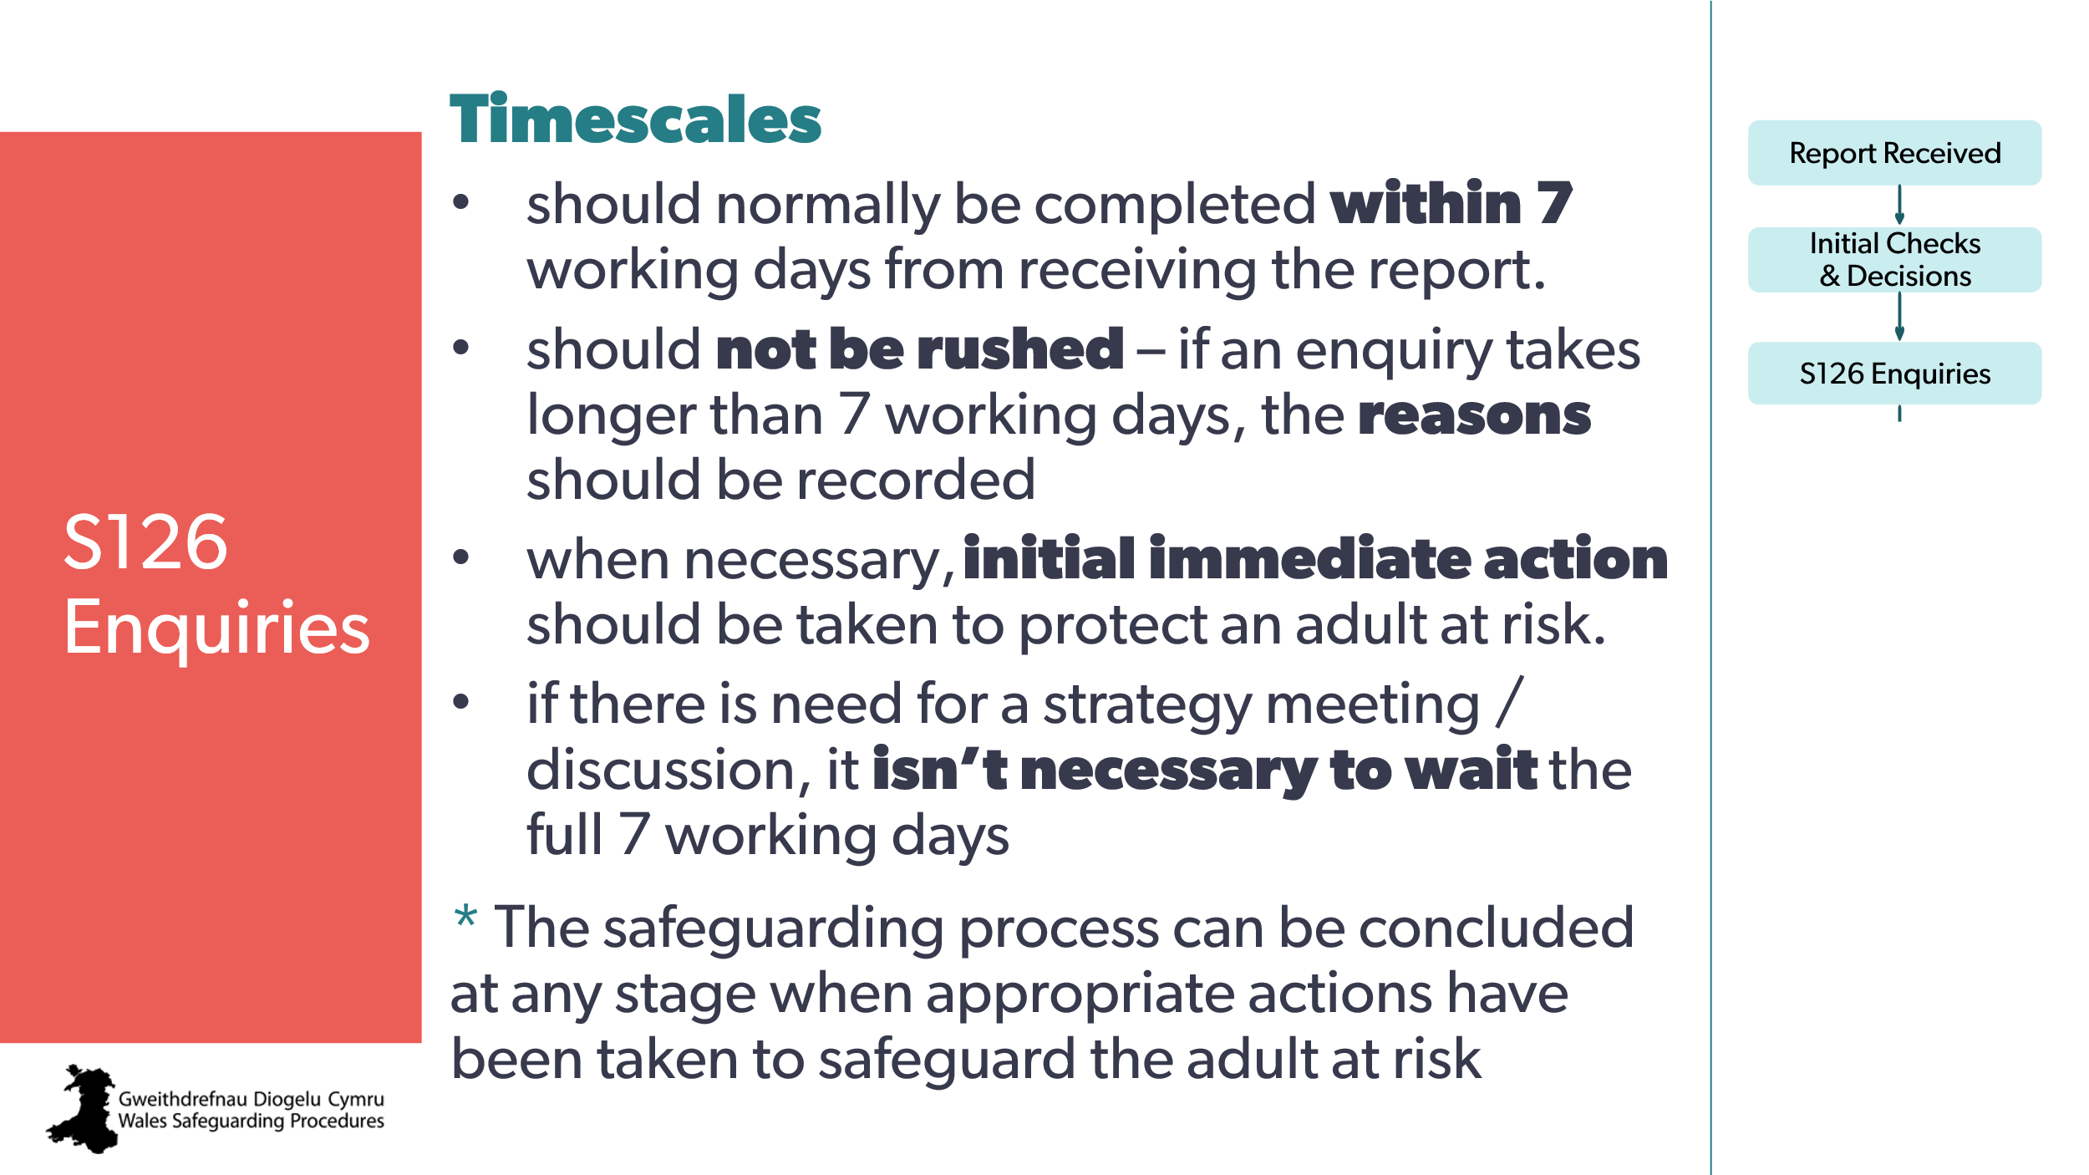 | Aim:  To provide an overview of the next step in process: Section 126 Enquiries.  To look at timescales for this step.  Trainer to explain:  there’s a lot more detail in the Wales Safeguarding Procedures – you have a personal responsibility to make sure you’re compliant and up to date with these. | Wales Safeguarding Procedures:  Actions following the Death of an Adult at risk during s.126 Enquiries  Enquiries under s.126 of the Social services and Well-being Act (Wales) and Police Investigations  The adult at risk moves during s126 Social services and Well-being Act (Wales) 2014 enquiries  Timescales (7 days)  Timescales | CPD  Section 126 Enquiries
19 | 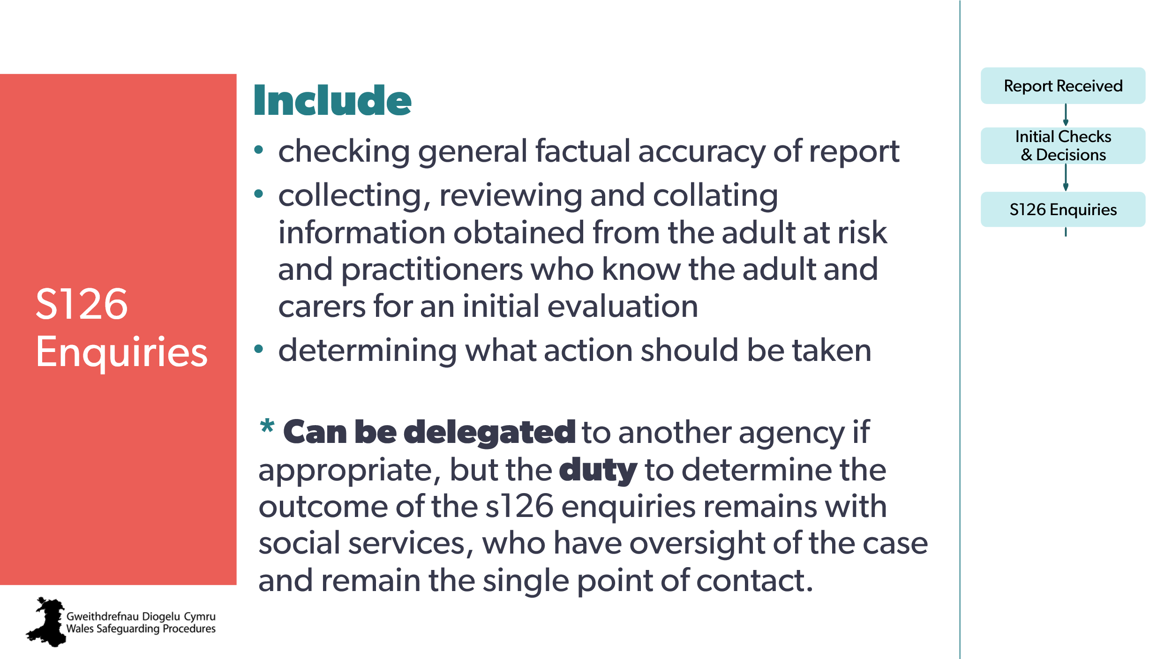 | Aim:  To highlight main aspects of enquiries.  Trainer to explain:  - factual accuracy may have already been established within the reporting and screening stage, but you should get confirmation of this information.  - these don’t need to follow consecutively - proceed to the applicable element. | Duty to make enquiries under Section 126(1) (s126) of the Social services and Well-being (Wales) Act 2014) provides more details  Delegation of s126 Social services and Well-being Act (Wales) 2014 enquiries
20  21 | 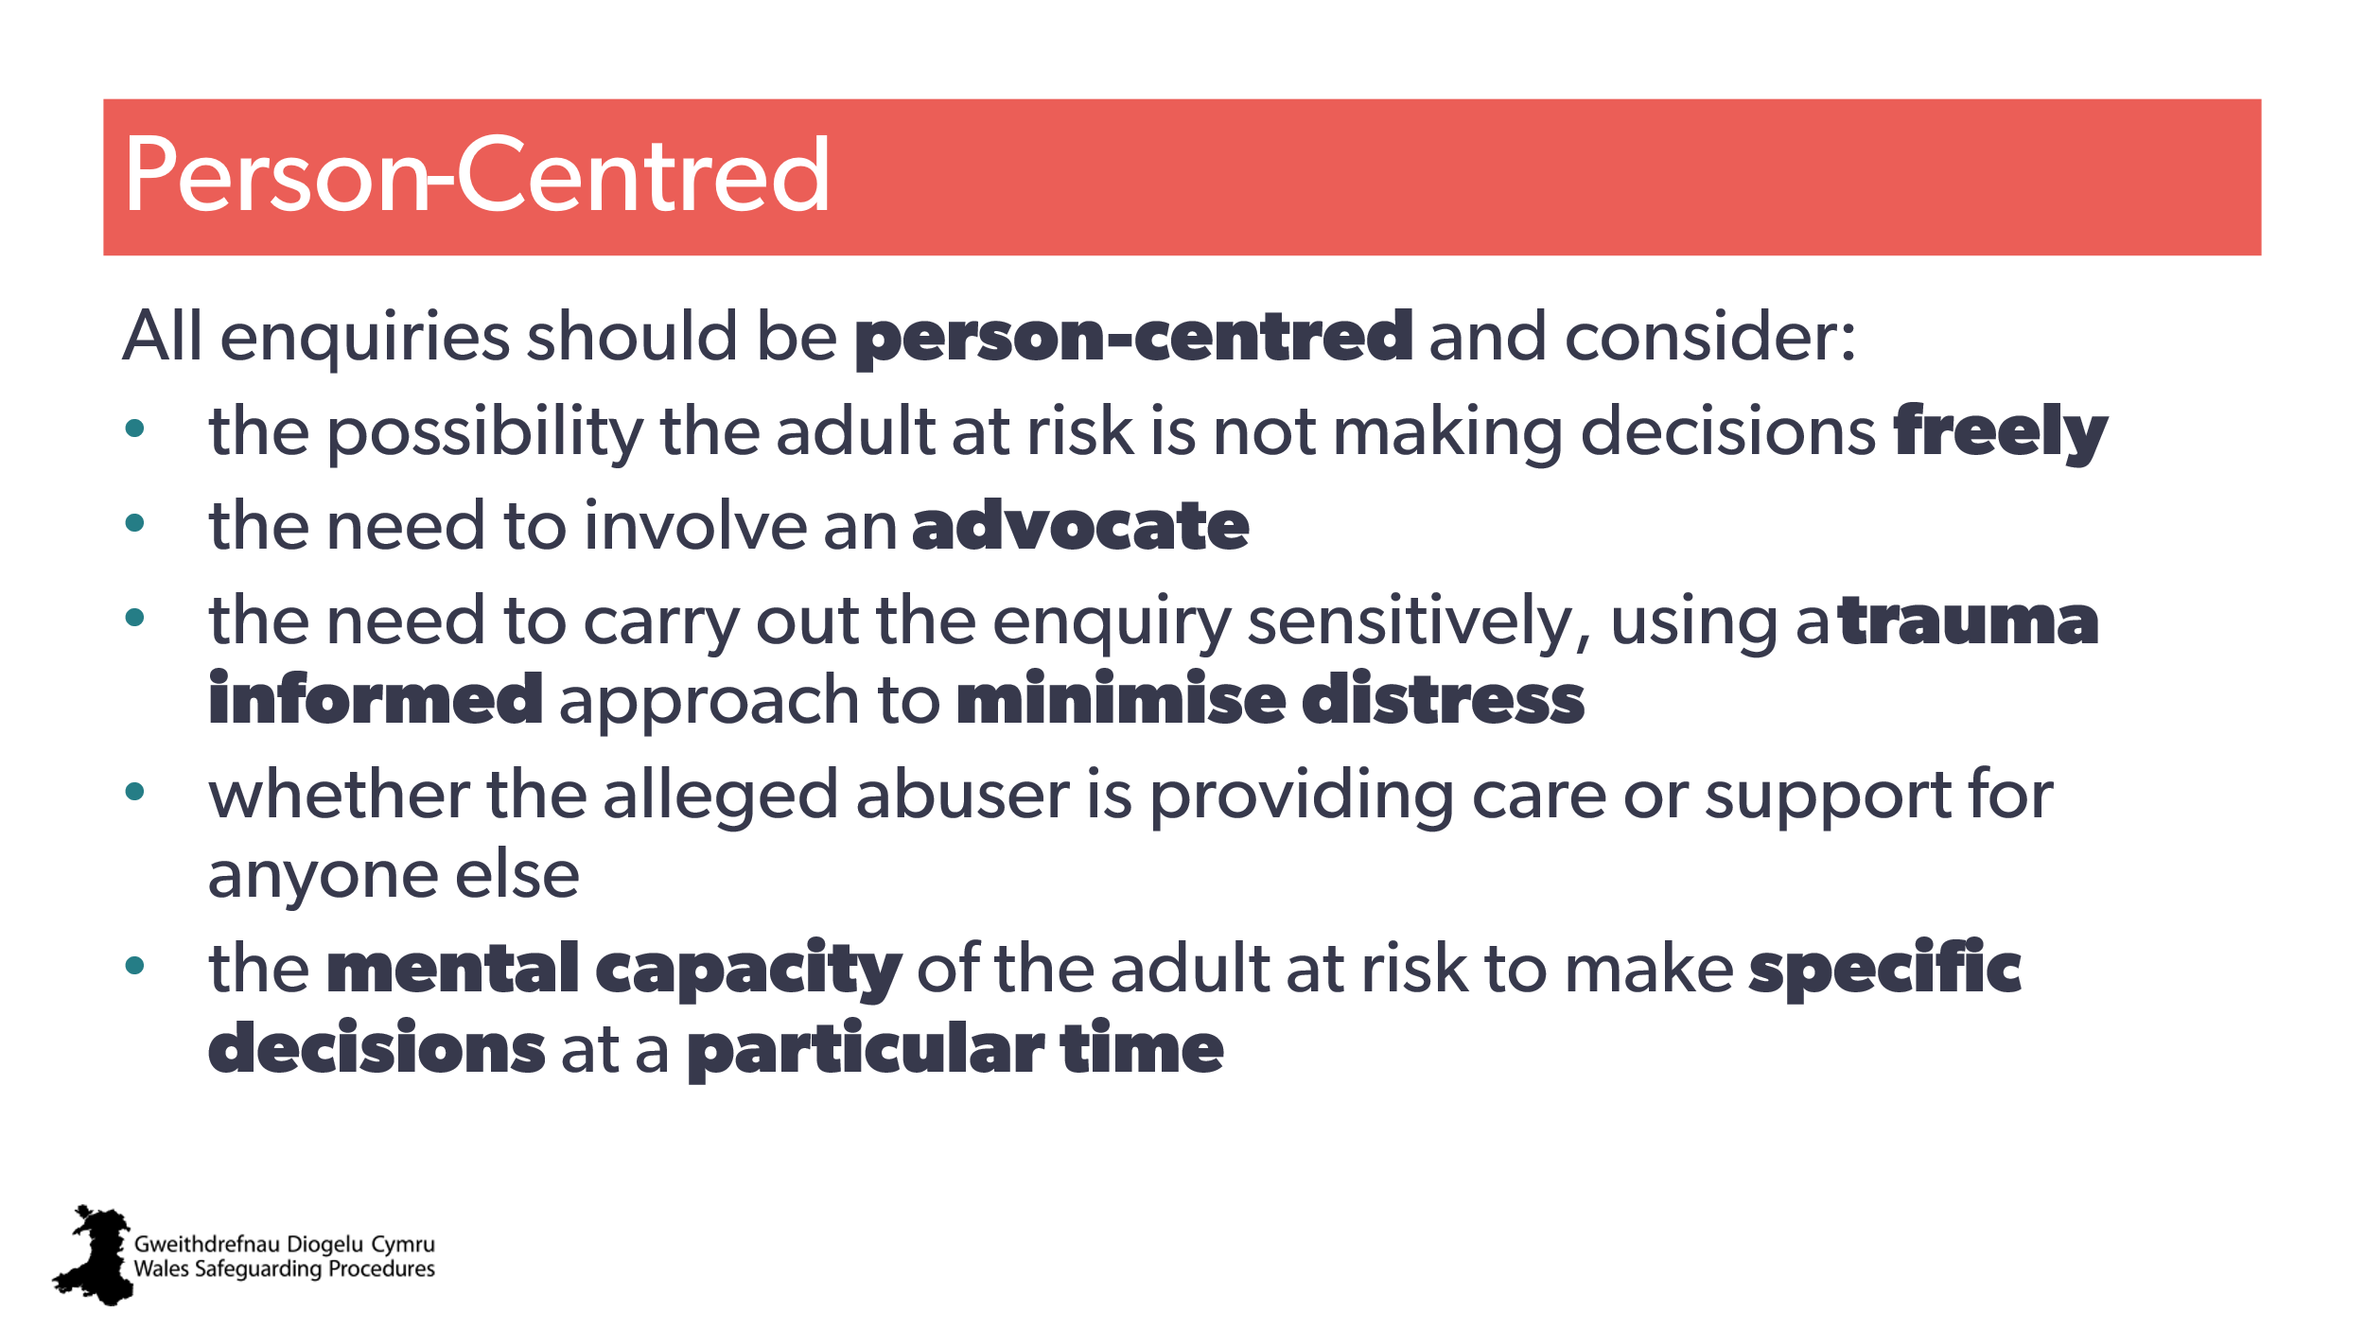  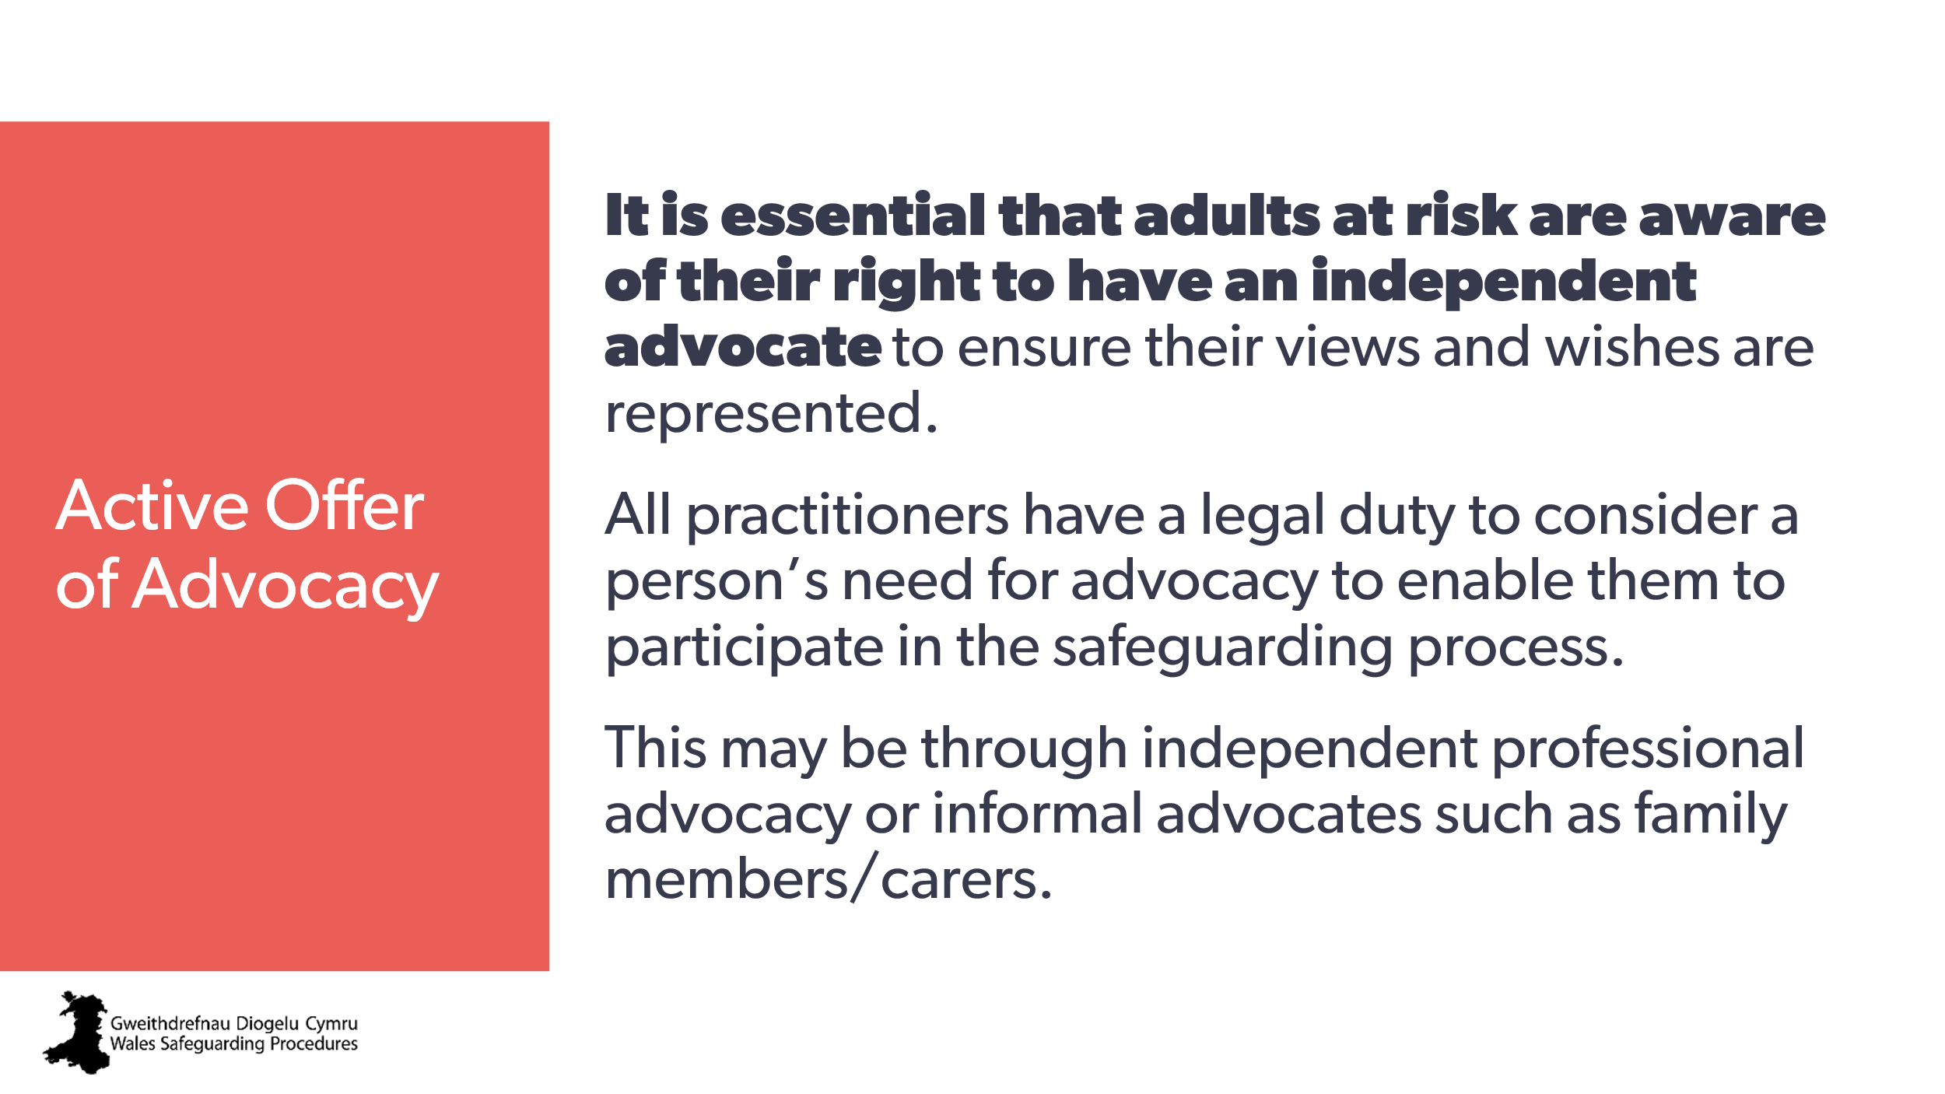 | Aim:  Reminder of need for enquiries to be person-centred.  Trainer to explain:  Remind everyone about the active offer of advocacy.  Depending on the experience of those in room, trainer may wish to explain that an "active offer" of advocacy means:  - not just having advocacy services available, but actively informing individuals about these services and how they can help  - ensuring adults understand their right to an advocate and how to access one  - tailoring the information and support to the individual's needs and preferences, including communication needs. | Person-centred enquiries  Pointers for Practice: Person-Centred Safeguarding  Pointers for Practice: Working with The Adult at risk During Enquiries into Abuse and Neglect  Pointers for Practice: Risk Assessment and a Person-Centred Approach  Pointers for Practice: Eliciting Information During the Screening and Initial Evaluation - The Challenges  Pointers for Practice: Promoting Participation Amongst Adults at Risk with and Without Mental Capacity  Advocacy Code of Practice: Part 10 Social Services and Well-being Act (Wales) 2014
22 | 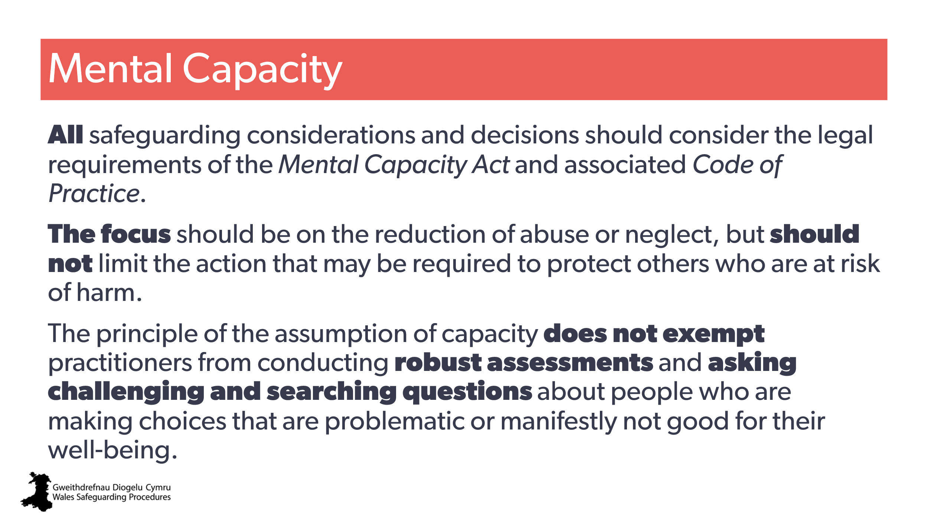 | Aim:  To remind all how mental capacity overlaps with safeguarding.  Trainer to stress:  Full capacity doesn’t exempt us from our duty to report.  Practitioners should always respect the adult’s personal wishes and autonomy, but in some circumstances these wishes may be overridden (More information)  Trainer to ask:  What are some particular considerations when safeguarding?  (This was covered in the pre-course video and workbook – you may wish to ask learners to turn to this now and discuss their entries).  Facilitate drawing out the following answers:  - should be time and decision specific  - should maximise engagement in the enquiry process, for example, provide assistance with communication, talk to the adult at risk at a time when they’re best able to make a decision for themselves  - should result in decisions that are in the best interests of the adult at risk who lacks mental capacity  - should be the least restrictive option to meet care, support and protection needs. | Workbook  Wales Safeguarding Procedures:  When an adult’s wishes may be overridden  Pointers for Practice: Assessing Mental Capacity  Pointers for Practice: Promoting participation amongst adults at risk with and without Mental Capacity  Seeking consent to a report
23 | 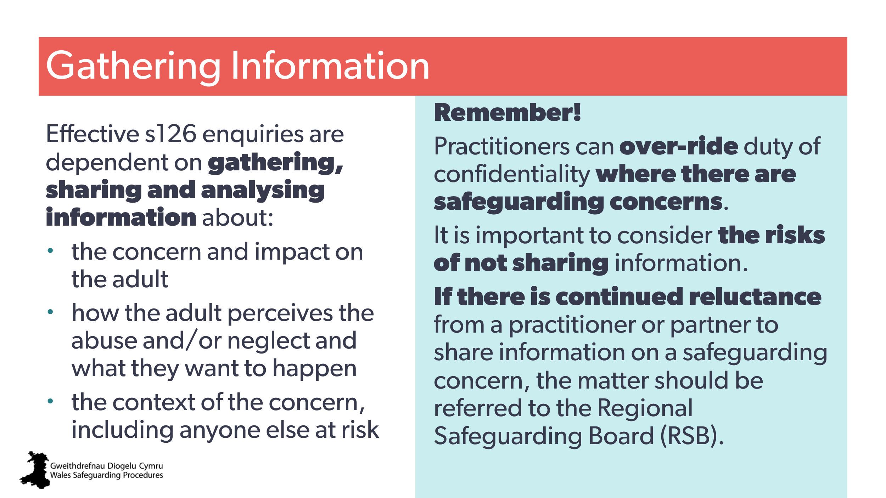 | Aim:  To stress the need to share information.  To highlight the need for gathering information as part of a Section 126 enquiry.  Trainer to explain:  Some frontline staff and managers can be overcautious about sharing personal information, particularly if it’s against the wishes of the individual concerned.  They may also be mistaken about needing hard evidence to share information (we don’t).  This is a key message that Group C Practitioners are expected to make sure any staff, volunteers or colleagues understand:  Practitioners can over-ride the duty of confidentiality:  - to protect the adult at risk from abuse or neglect or the risk of abuse or neglect  - where in the public’s best interest. | Over-riding duty of confidentiality  Gathering and Sharing Information-Sharing as Part of s126 enquiries
24 | 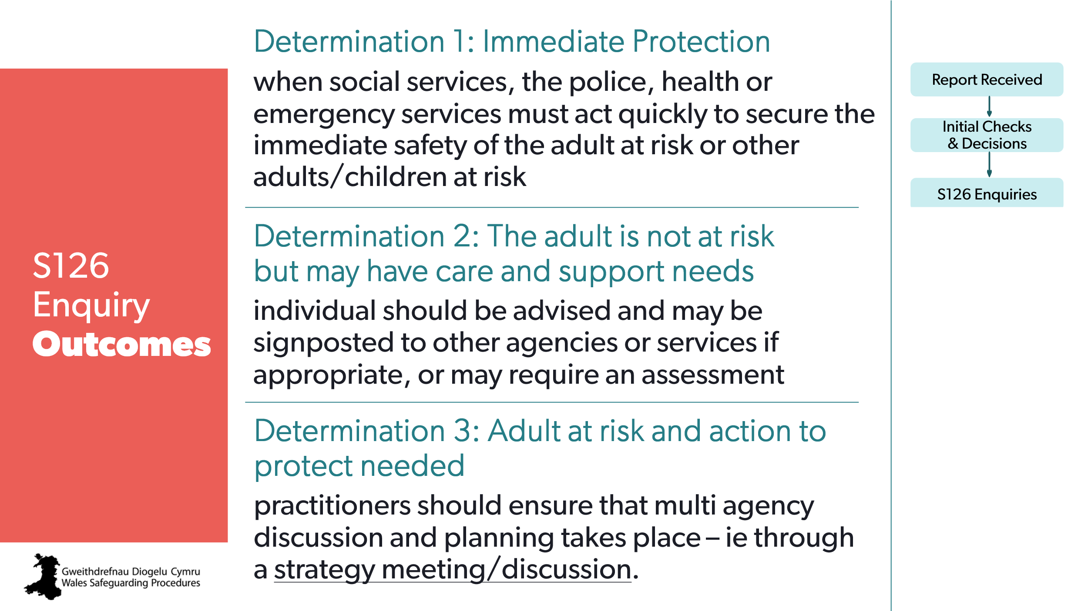 | Aim:  To give a summary of the three possible determinations.  Trainer to explain:  1) examples of the need to see an adult at risk same day:  physical injury, sexual abuse, already subject to protection plan, severe neglect / other severe health risk, abandoned.  No further action - not an official determination, but if the adult is  a) not at risk,  and  b) no unmet care and support needs have been identified, a decision may also be taken that no further action is required, so the safeguarding process is concluded.  This can happen at any stage when appropriate actions have been taken to safeguard the adult at risk.
25  26 | 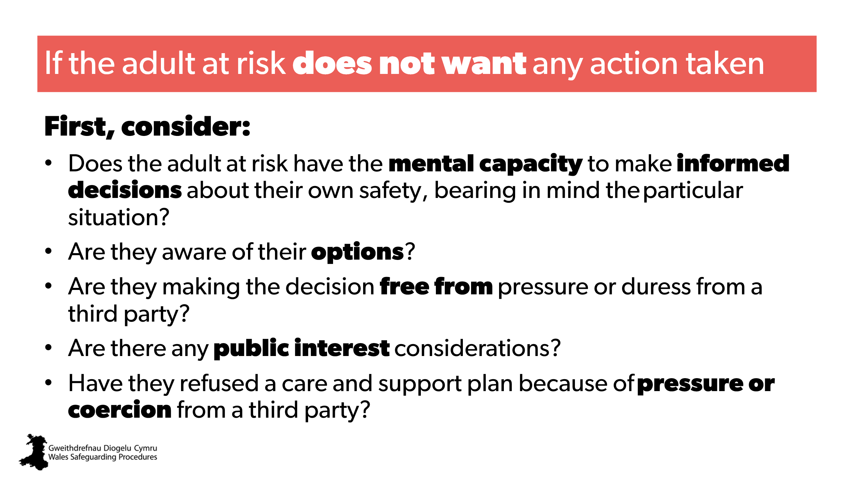  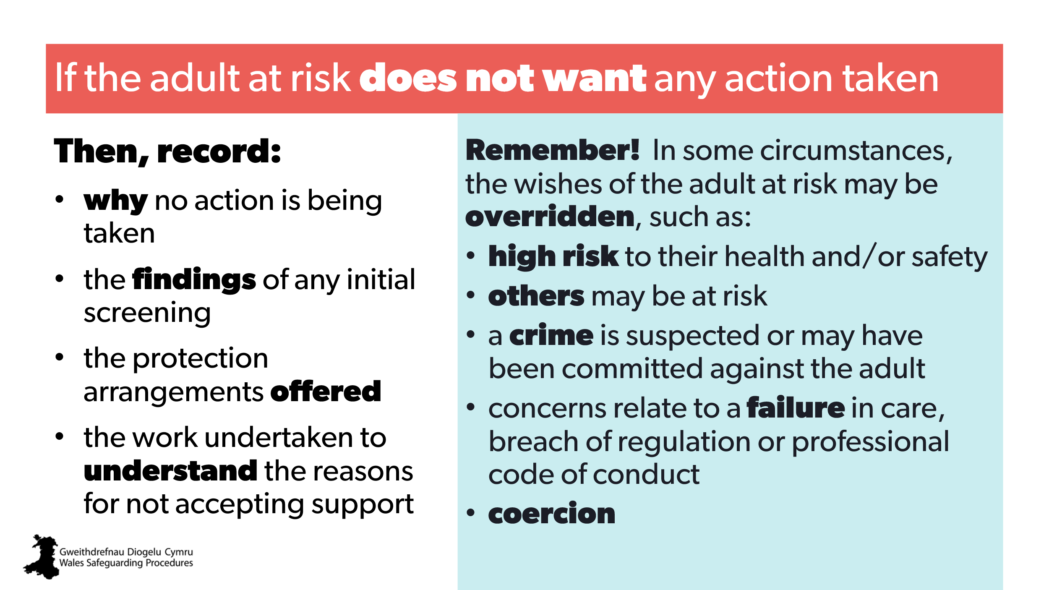 | Aim:  To focus on the involvement of the adult at risk.  Trainer to explain:  “Adults with care and support needs may be able to protect themselves from abuse, neglect and [exploitation] by others. Frailty, age or disability, for example, does not automatically preclude an individual from protecting themselves and mental capacity assessments are always situation specific.  Practitioners should always seek to respect the personal wishes and autonomy of the adult.  Practitioners should ensure that the person is aware of any risks and the potential impact on their safety and well-being and encourage them to develop strategies to protect themselves.  However, a professional judgement is required about the ability of an adult to make an informed choice.” | If the adult at risk doesn’t want any action taken:  Pointers for Practice: Promoting Participation Amongst Adults at Risk with and Without Mental Capacity  Pointers for Practice: Working with Resistance from The Adult at risk and Their Carers  Pointers for Practice: Practitioner Responses to Resistance and Aggression
27 | 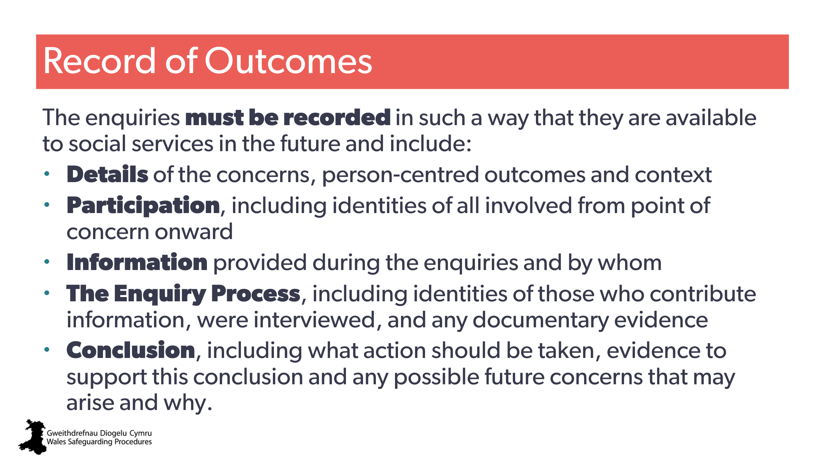 | Aim:  To summarise the need for a record of the outcomes.  Trainer to add:  The conclusions and outcome of the enquiries must be recorded, including those cases that don’t lead to further action.  The conclusions should be recorded so they’re available to social services in the future, for example if a further report is made about abuse and/or neglect. | Recording Outcomes of s126
28 | 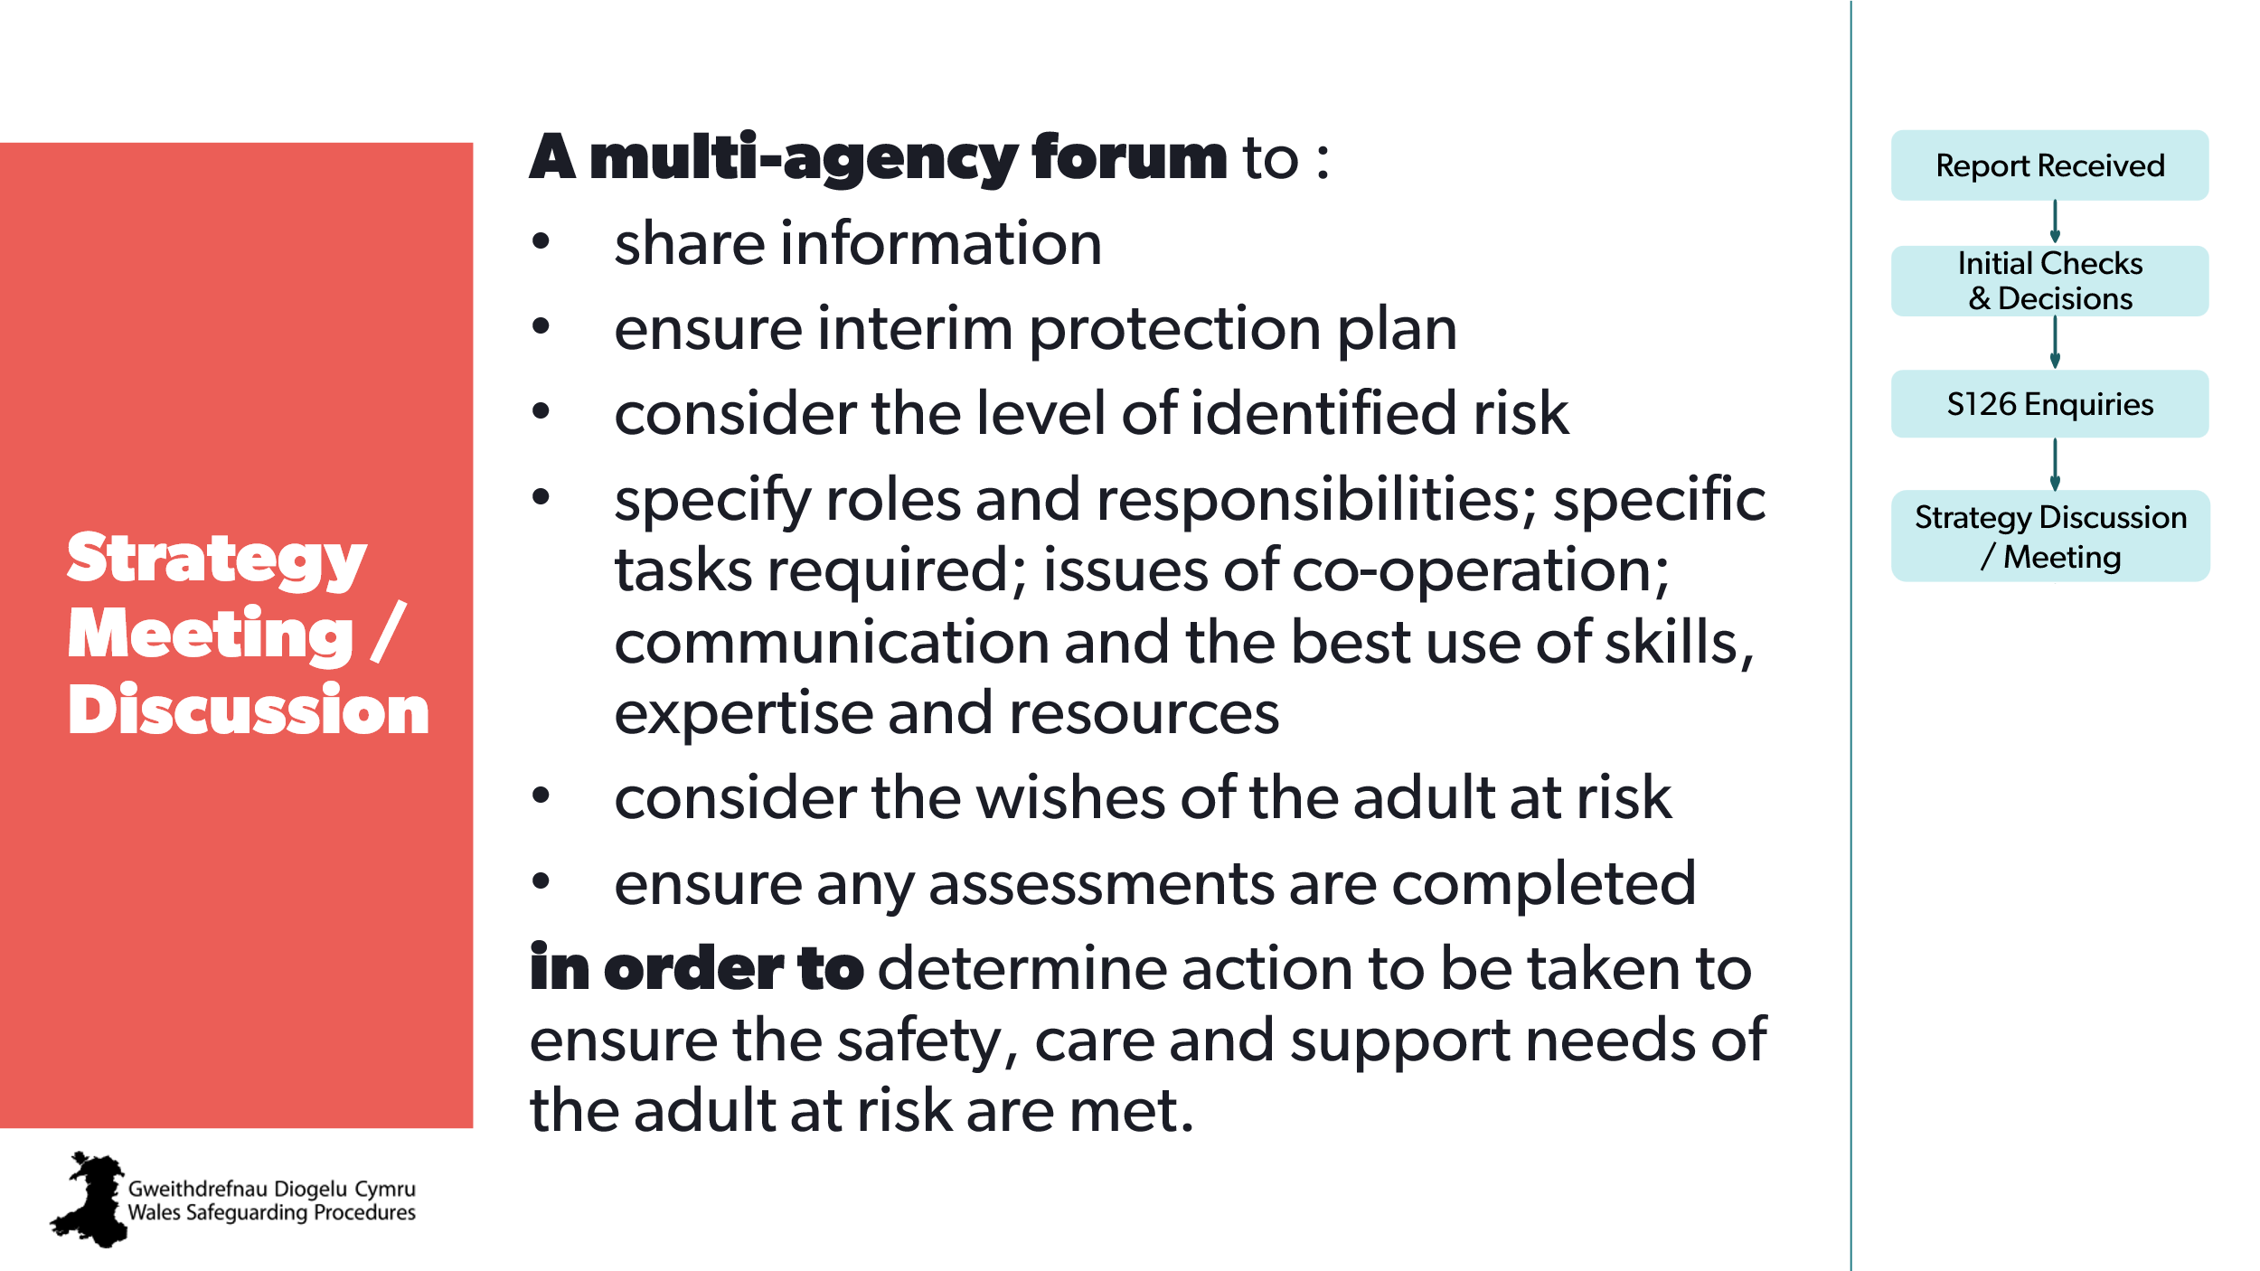 | Aim:  To introduce the next step in the process: strategy meeting/discussion.  Trainer to stress:  - aim is sharing information, making sense of the information, and deciding what action should be taken, by whom and by when  - level of risk and ‘adults wishes’ – what can we do to minimise the risk. Emphasise that the strategy meeting is there to minimise risk in certain situations, where risk can’t be eliminated completely  - professionals need to have the confidence to say if they need additional training in certain areas as part of their CPD.  Note: Strategy meetings and strategy discussions are interchangeable terms. They can be held as often and for as long as necessary. | The strategy discussion/ meeting: the purpose  Pointers for Practice: Strategy Discussion or Meeting?  Pointers for Practice: Risk Assessment and a Person-Centred Approach  Pointers for Practice: Risk Assessment Tools
29 | 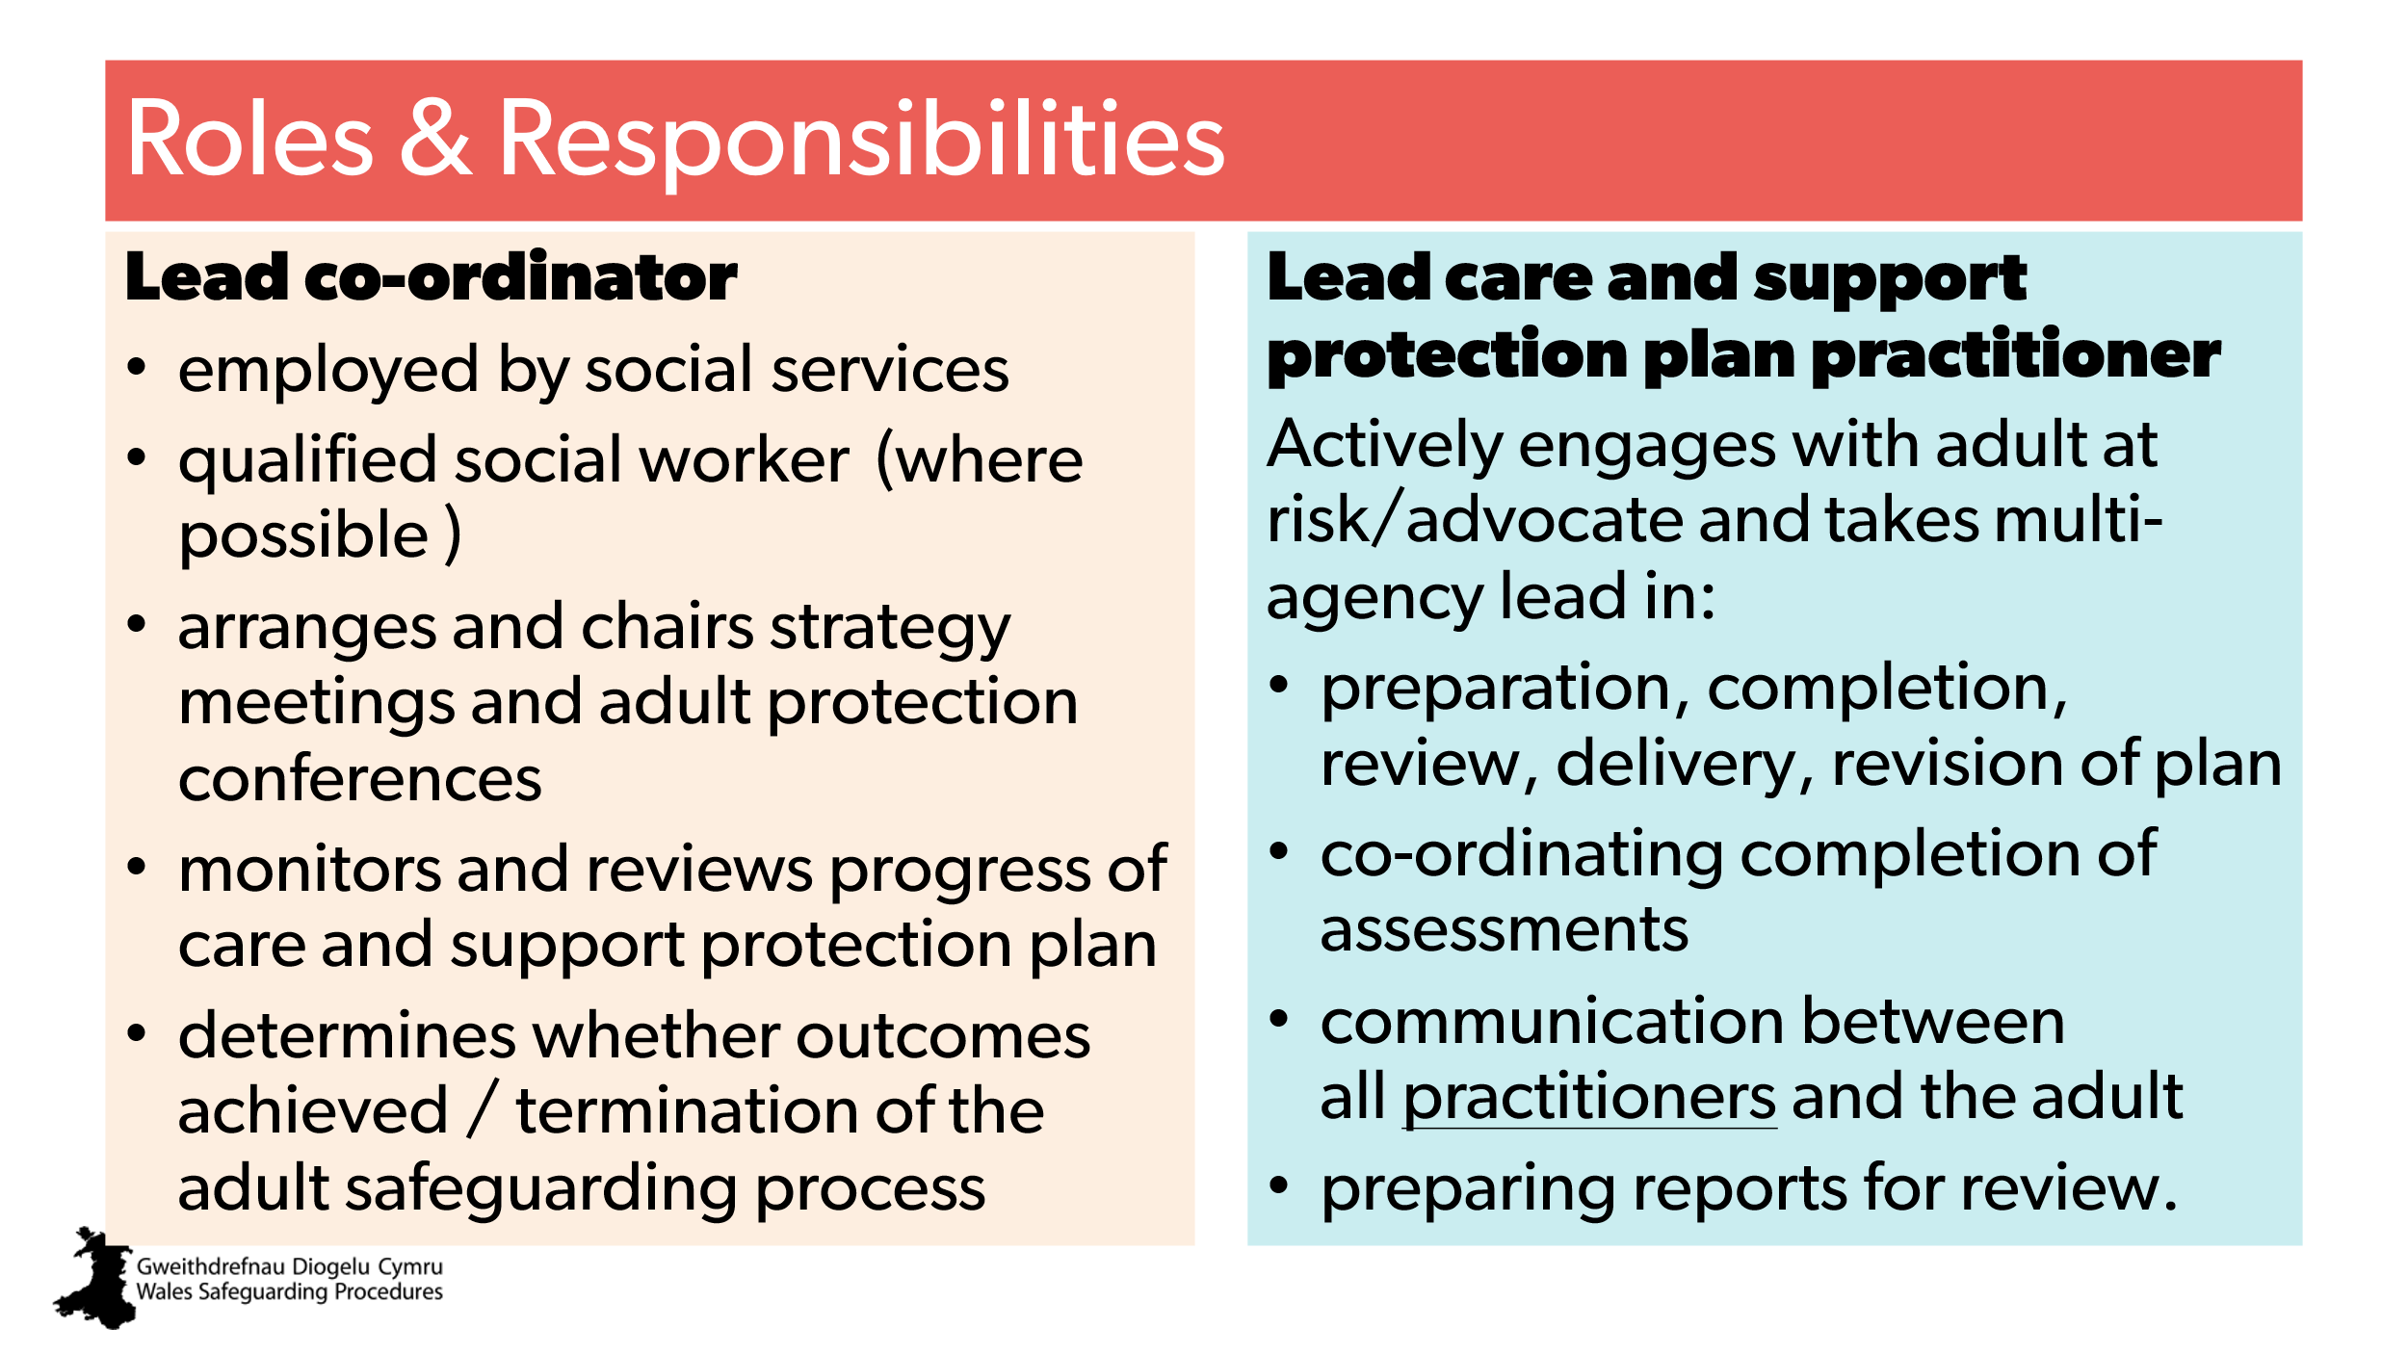 | Aim:  To outline the different roles and responsibilities.  Trainer to explain:  Participants who may be expected to take on these roles should seek additional, specific CPD, training or shadowing opportunities. | Roles and responsibilities  Chairing | CPD  Specific CPD / training / shadowing opportunities.
30 | 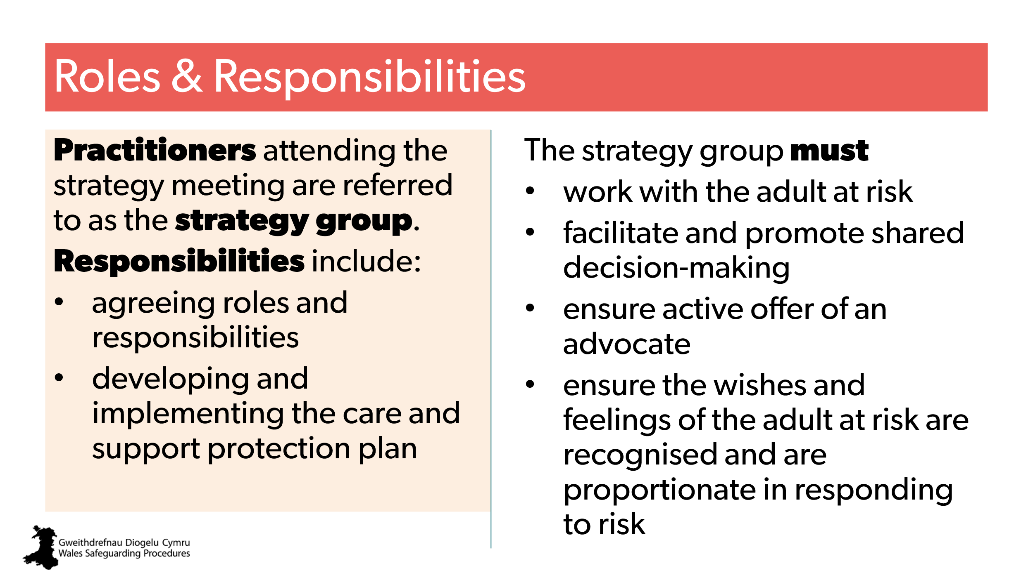 | Aim:  Outline the expectations of the strategy group.  Trainer to emphasise:  The strategy meeting is there to minimise risk in certain situations where risk can’t be eliminated completely.  So, regarding the level of risk and the adult’s wishes, we need to ask: “What can we do to minimise the risk?” | For further information on the responsibilities for members of the strategy group to deliver the care and support protection plan see planning responsibilities of members of the strategy meeting (the strategy group).
31 | 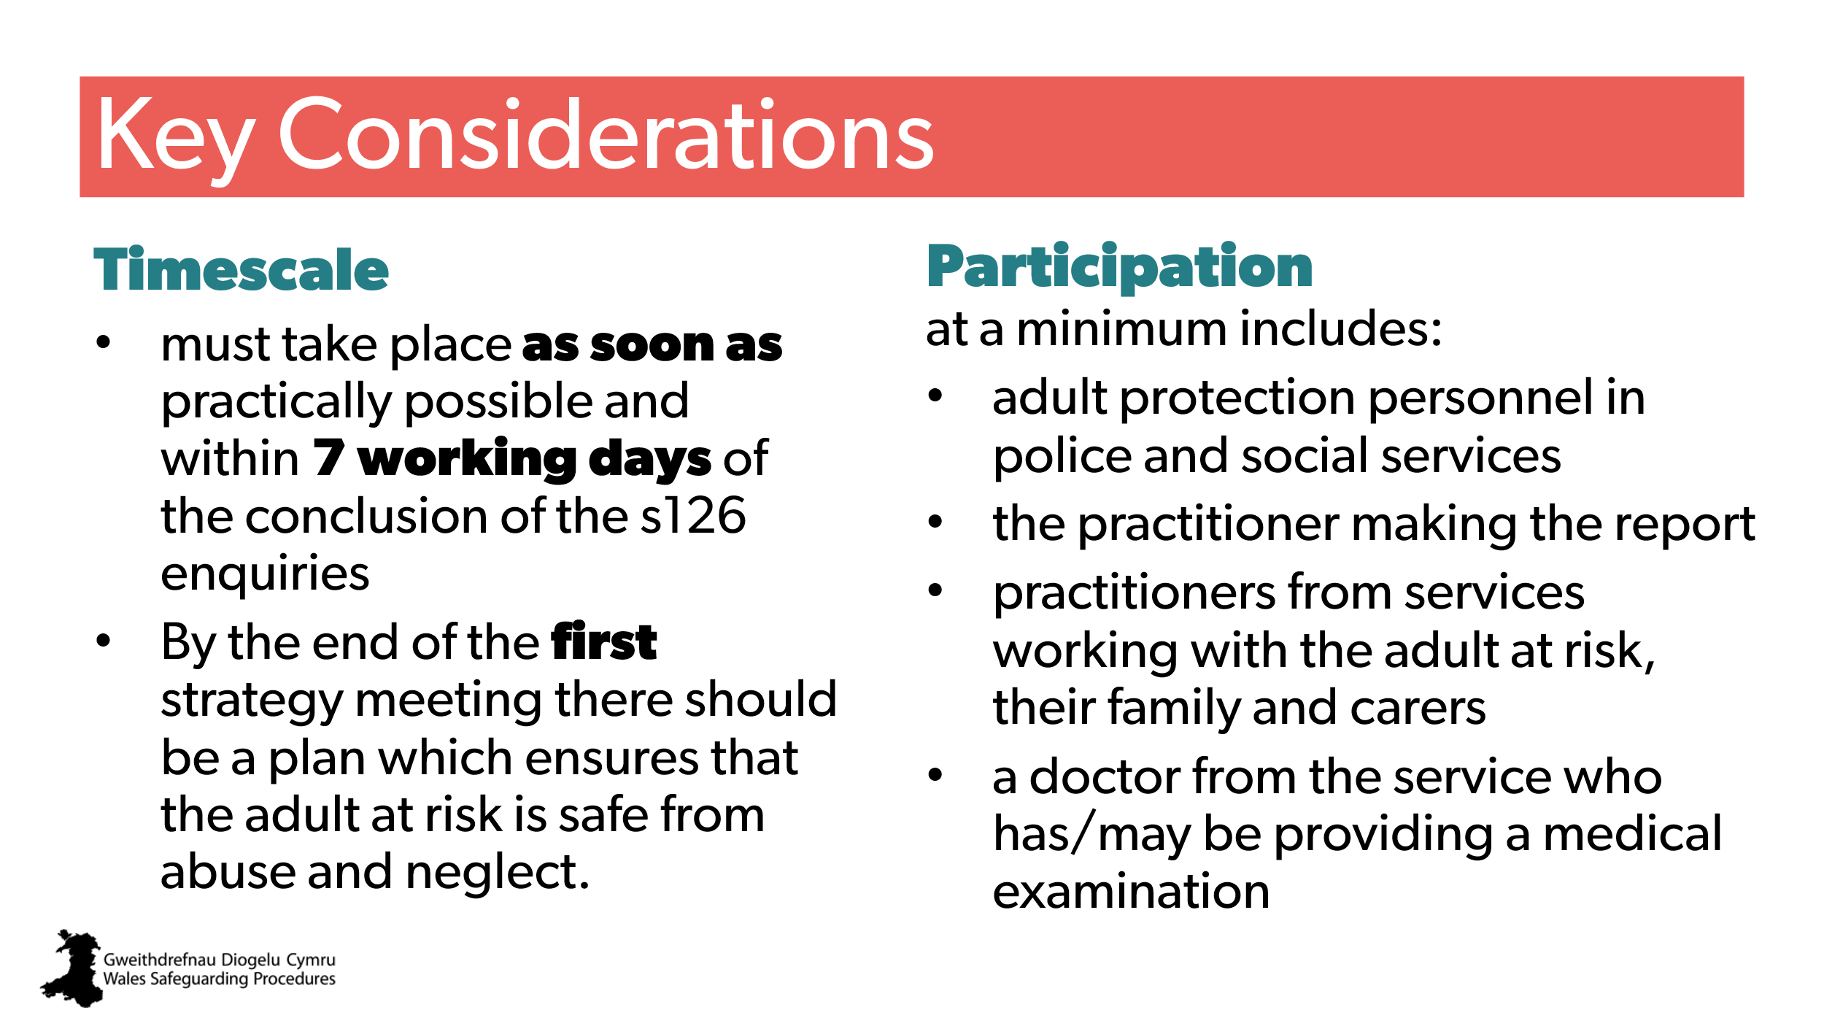 | Aim:  Outline the expectations.  Trainer to add:  If initial screening or Section 126 enquiries determine that there needs to be immediate action, the strategy discussion/meeting should:  - take place before this action and  - be done in a way that doesn’t delay the necessary action. | Strategy meetings/ discussions: key considerations  Timescales  Participation in strategy discussion/ meetings
32 | 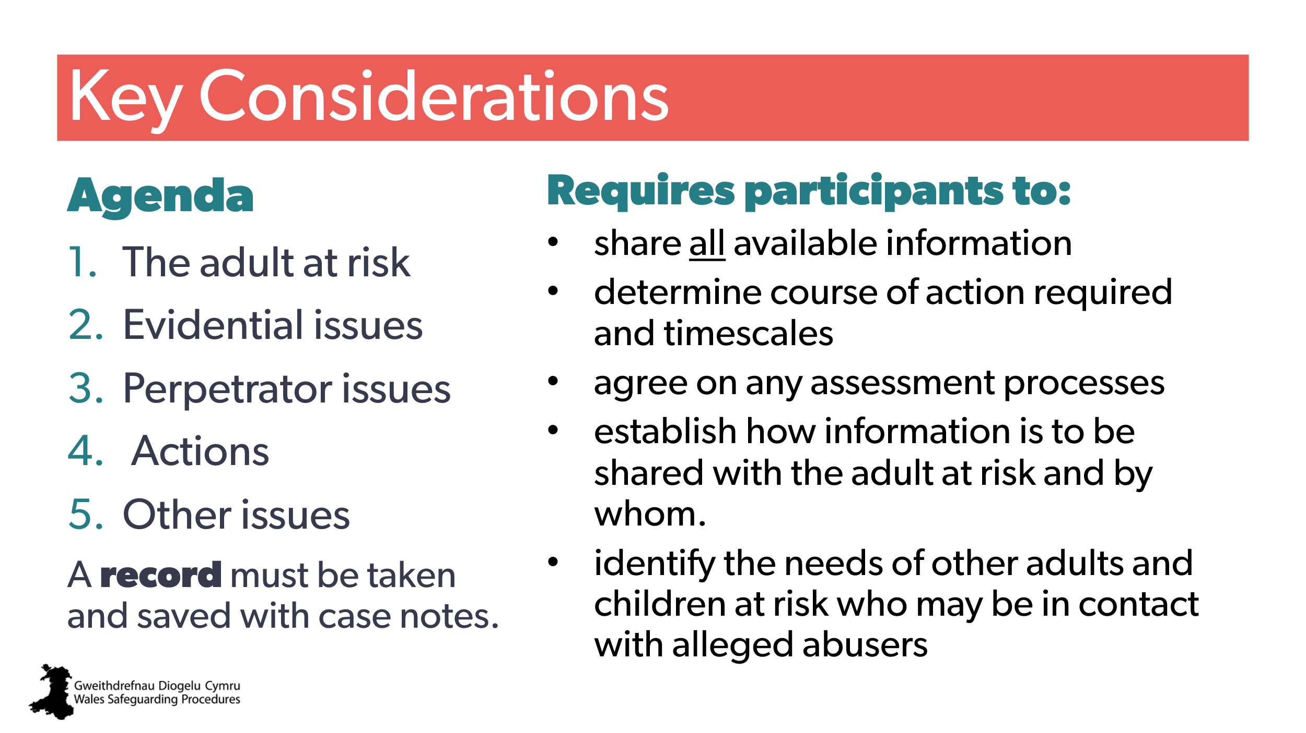 | Aim:  Outline the expectations.  Trainer to explain:  There may need to be more than one strategy meeting/discussion, for example to:  - identify what additional information needs to be gathered  - review actions considering emerging information and/or evidence  - give due regard to the complexity of the case  - consider actions and desired outcomes.  By the end of each strategy discussion / meeting, participants should have an agreed a plan of action that includes:  - the concerns or allegations to be addressed  - actions within each agency and how they will be co-ordinated. | The agenda
33  34  35 | 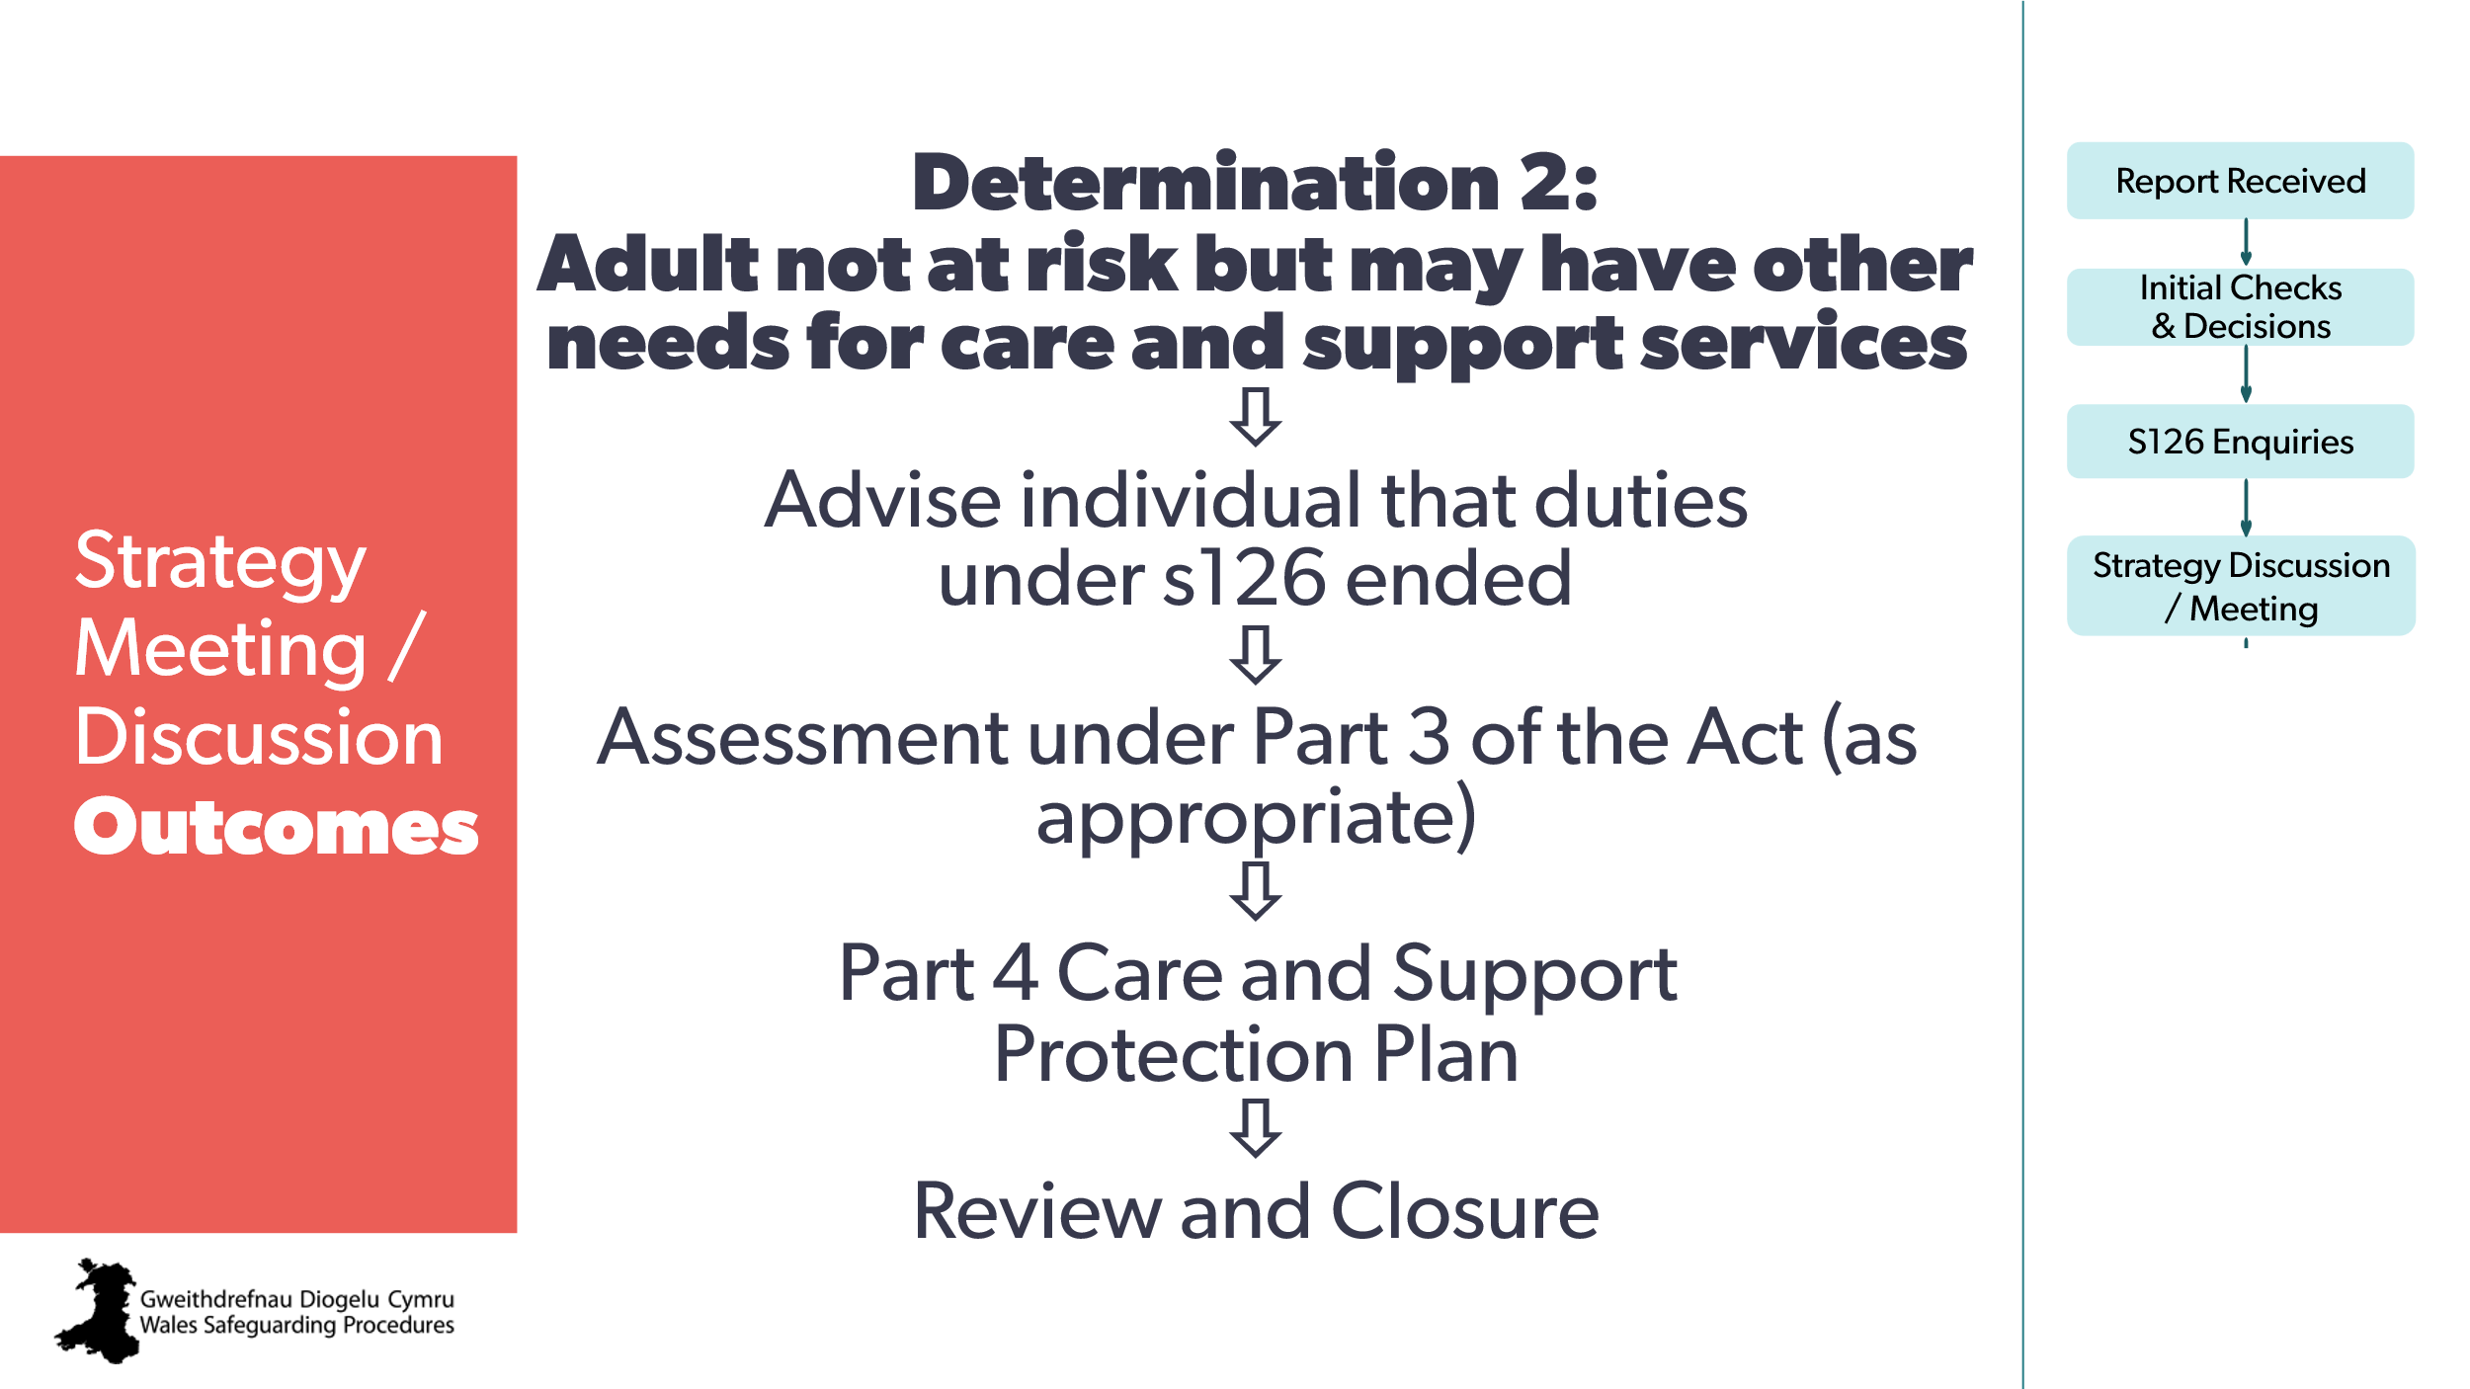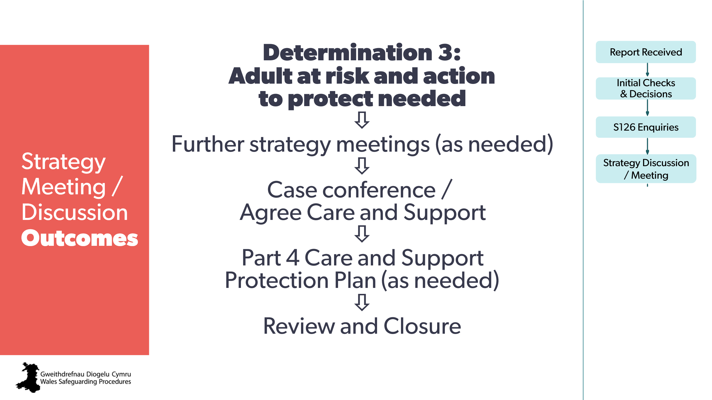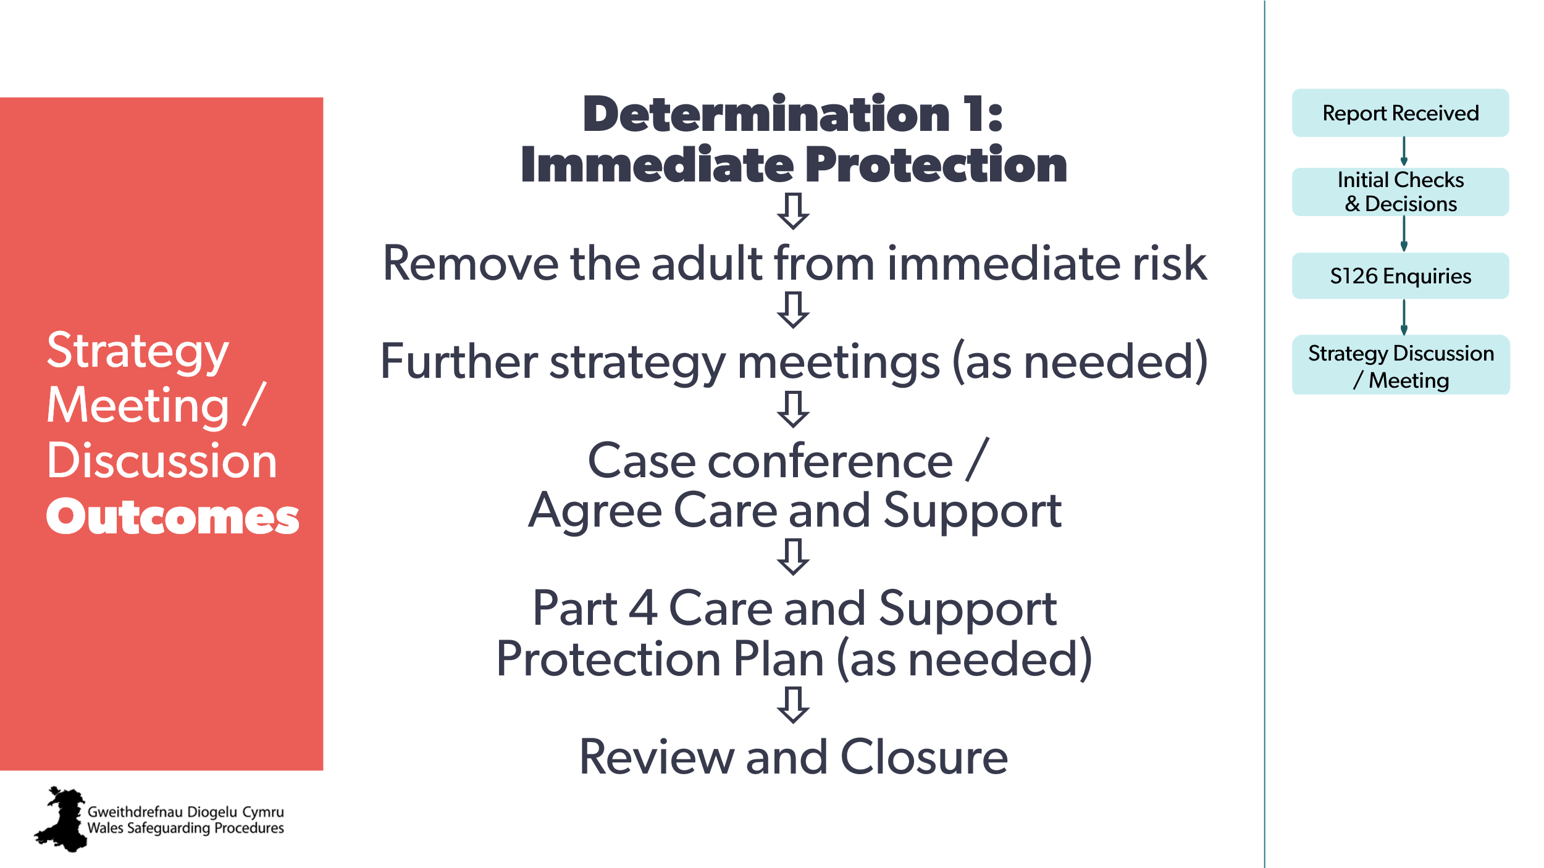 | Aim:  To outline the determinations (outcomes) and next steps for each.  Note to trainer:  Trainer may wish to direct learners to flowchart 3 in the Wales Safeguarding Procedures.  Trainer to explain:  All decisions should include ensuring the adult at risk:  - understands the practitioners’ concerns  - appreciates the options available  - is made aware of the advantages and disadvantages of each option.  In addition, all decisions should:  - be justified and proportionate  - empower the adult as far as possible to make choices  - enable them to develop the capacity to respond to identified concerns  - ensure their rights to safety are balanced with their rights to liberty, autonomy and family life.  Note: If a criminal investigation is taking place, the police should agree what actions can be taken and when to ensure that any criminal investigation is not compromised. | Flowchart 3: strategy meeting and what happens after a strategy meeting:  Outcomes of the Strategy Discussion/ Meeting  Agreed plan of action  Table 3.1 Type of investigation or risk assessment and agency responsible  Investigations and co-ordinated multi-agency response to concerns
36 | 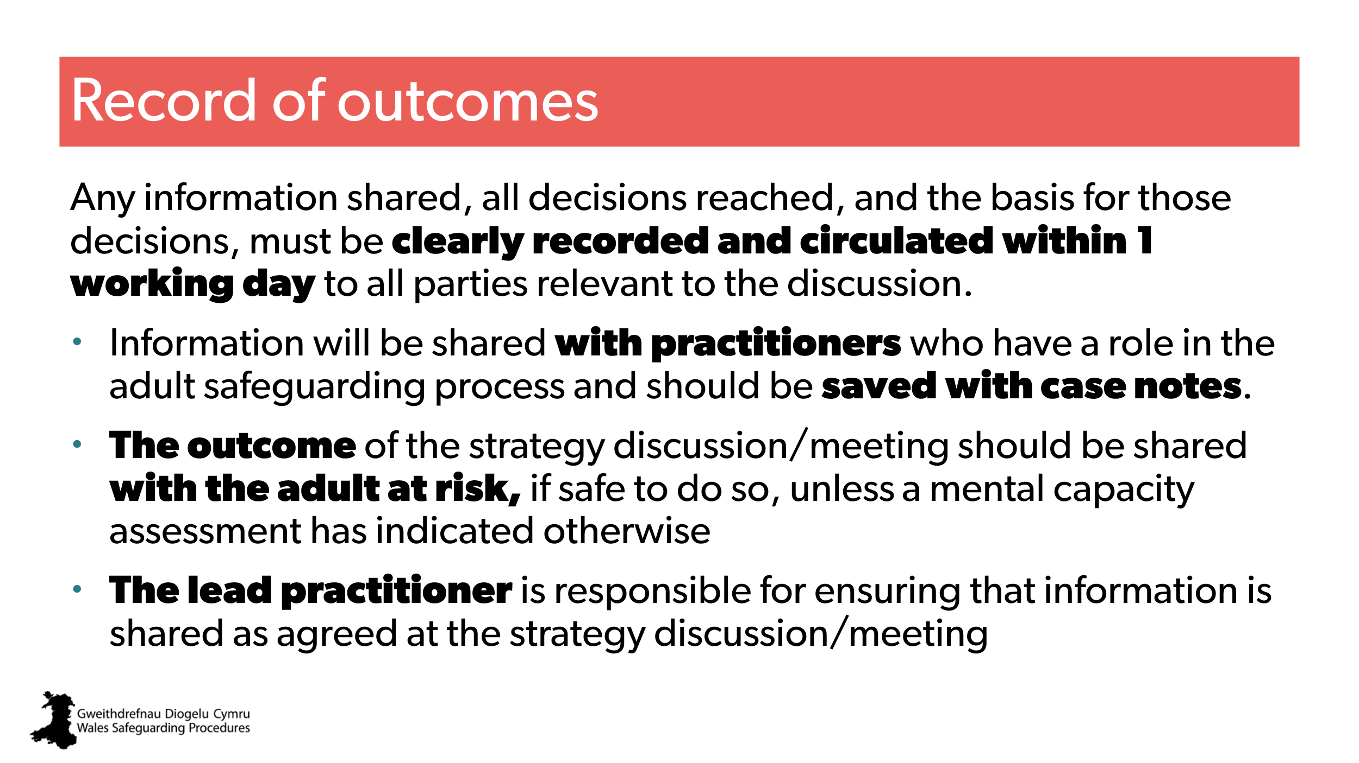 | Aim:  Overview of the record of the strategy discussion/meeting.  Trainer may wish to add:  - contents of the record (here)  - in practice, it is likely that at this stage it will only be possible to tell the adult at risk whether an investigation is going ahead and about the protective measures that directly affect them. | Recording the strategy discussion/ meeting and decisions  Sharing outcomes of a strategy discussion/ meeting  Confidentiality and record of the Professional Strategy Meeting
37 | 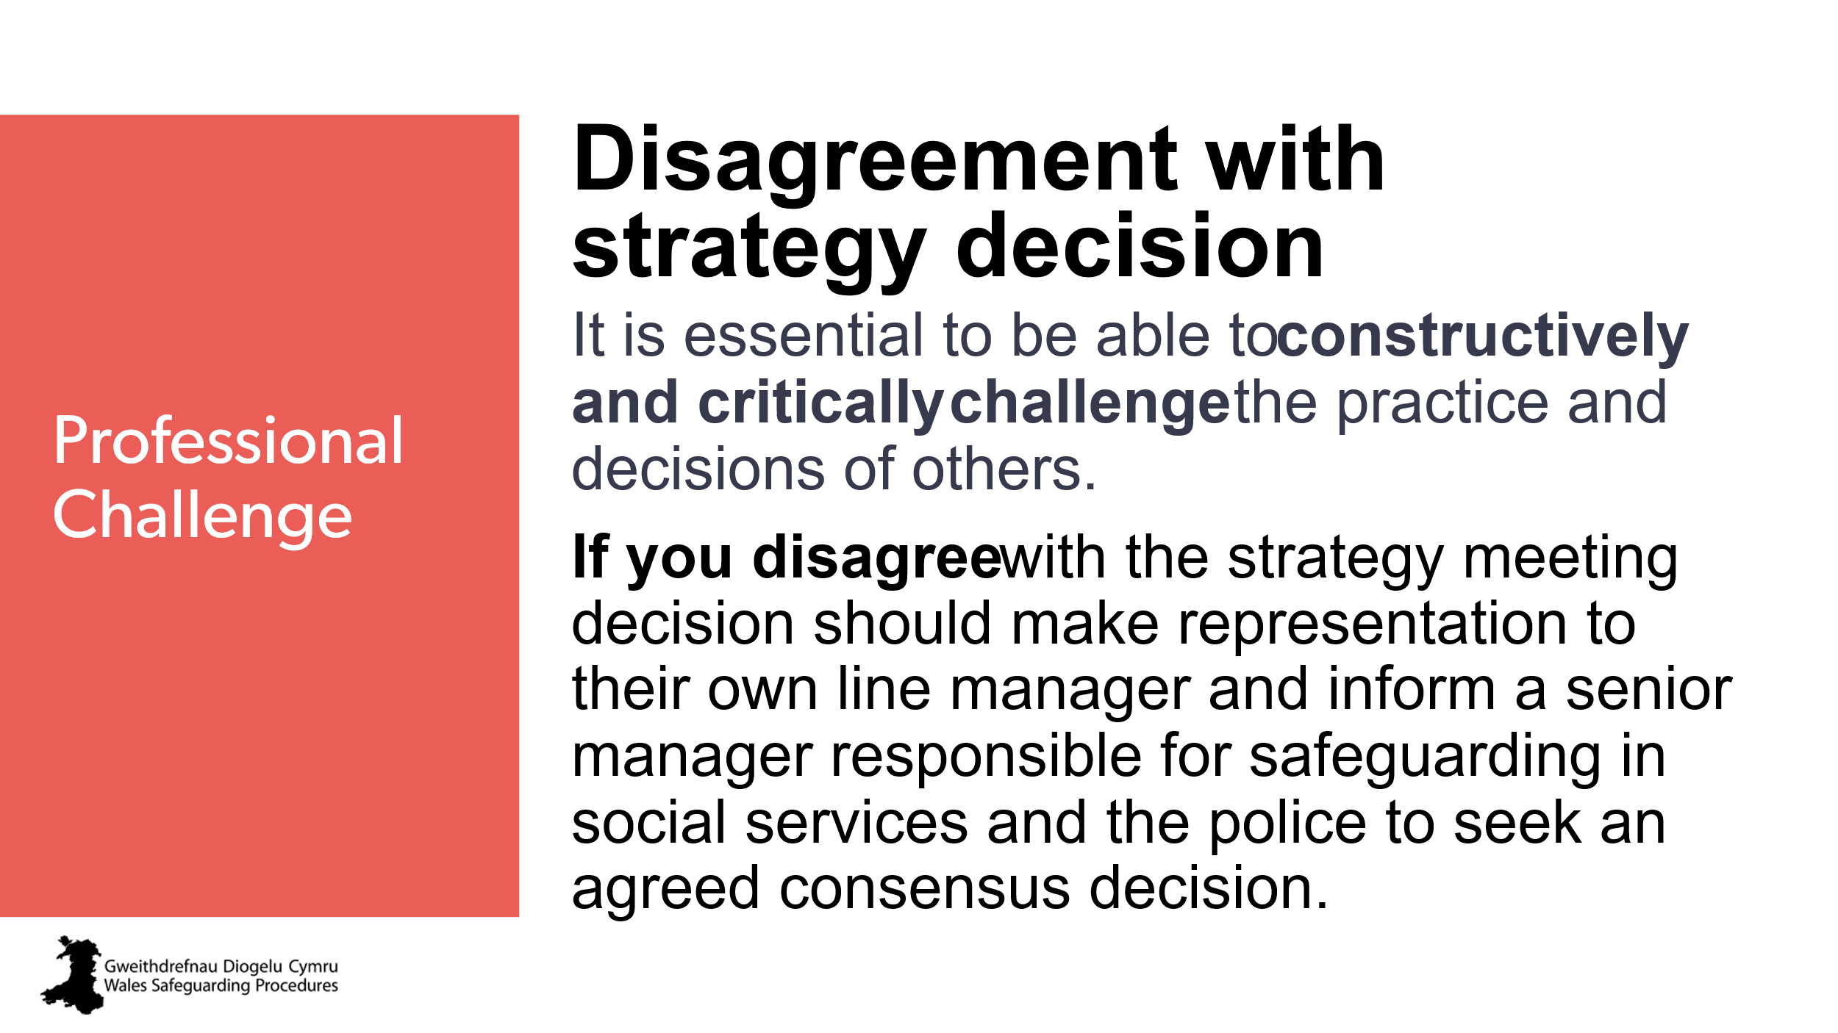 | Aim:  Reminder of need for professional challenge – this is not being used enough in Wales.  Trainer to explain:  - it’s essential to be able to constructively and critically challenge the practice and decisions of others  - important to have your say during the strategy meeting so it’s not left until afterwards  - the chair should check that everyone has had their say.  - adult at risk/family disagreements: “Should the individual or their representative disagree with the process followed by the local authority and the matter cannot be resolved, they should be referred to the local authority’s complaints process or the multi-agency complaints process.” | Professional Disagreements  Adult at risk and Family Disagreements
38 | 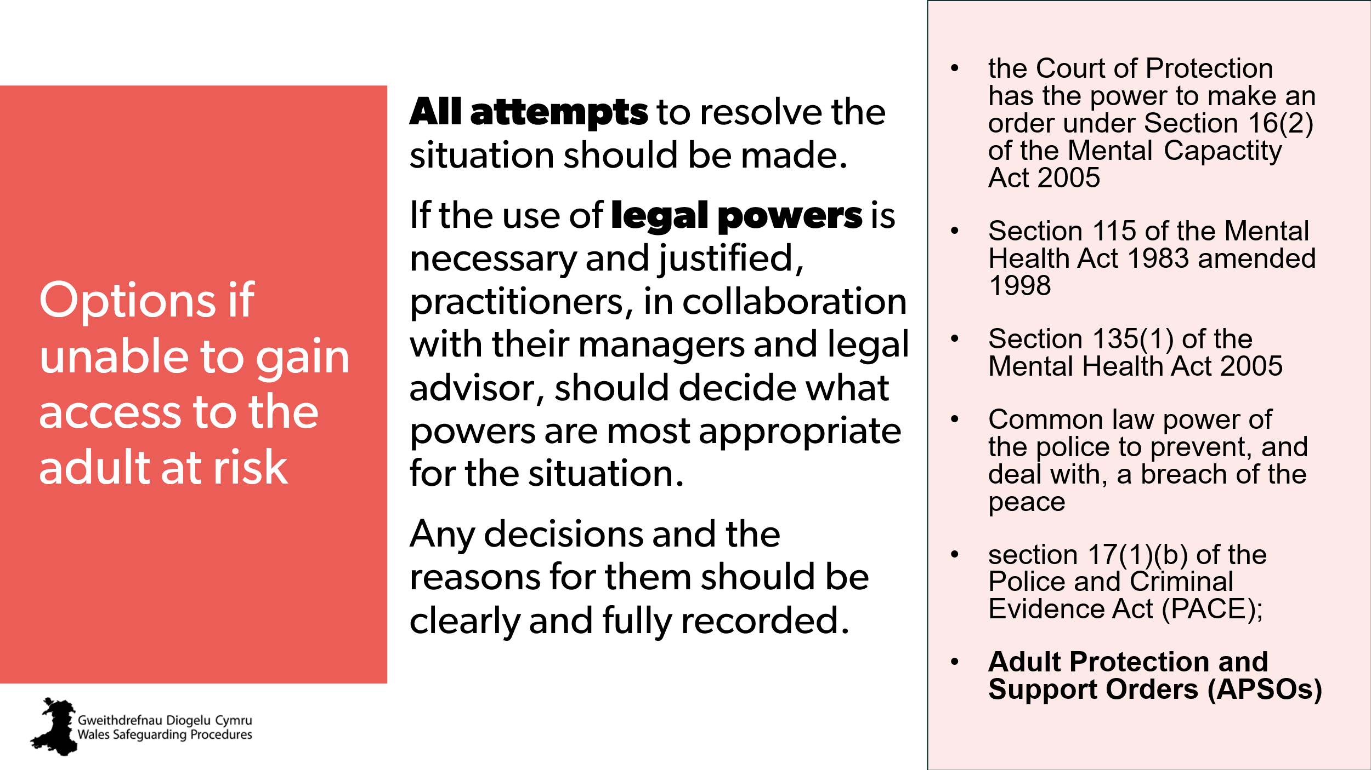 | Aim:  To raise awareness of different options, highlighting Adult Protection Support Orders (APSOs).  Trainer to ask:  What are APSOs, who can apply for them, and what can they be used for?  Answers:  Adult Protection Support Order (APSO) is a civil order that can be sought by an authorised officer.  The main purpose of an APSO is: to enable the authorised officer, and any other person accompanying the officer, to speak in private with a person suspected of being an adult at risk  Note: APSOs are intended to be used only when other, less intrusive methods of engaging with the individual have been tried and failed, or are highly likely to fail | Managing Difficulties in Gaining Access  Adult Protection and Support Orders (APSOs) | CPD  Regional Safeguarding Board APSO information
39 | 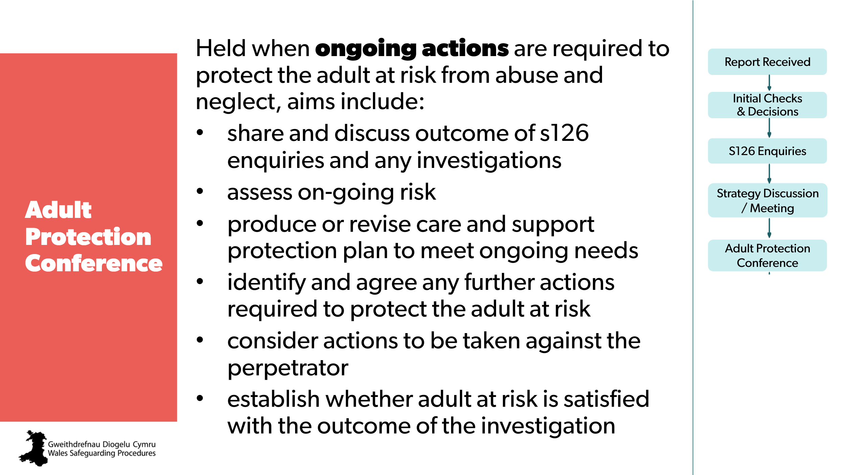 | Aim:  To provide outline of the next step: Adult protection conference  Trainer to explain:  The main aims are:  - to judge the likelihood of ongoing abuse/neglect  - to decide what future action is required to meet care, support and protection needs and enable personal outcomes.  Frequency of conferences:  - held as soon as possible after the conclusion of the investigation  - a number of conferences can be held during the process  - one will always be carried out to conclude the process following an investigation - should be convened with the agreement of the adult at risk  - there are no agreed timescales for when a conference should be held, but they must add value to the process and allow the individual to be engaged in the process. | Adult protection conference: the rationale  The aims  Pointers for Practice: From Duty to Report to Adult Protection Conference  Pointers for Practice: Risk Assessment Tools  Pointers for Practice: Risk Assessment and a Person-Centred Approach  Pointers for Practice: Care and Support or Care and Support, Protection Needs?
40 | 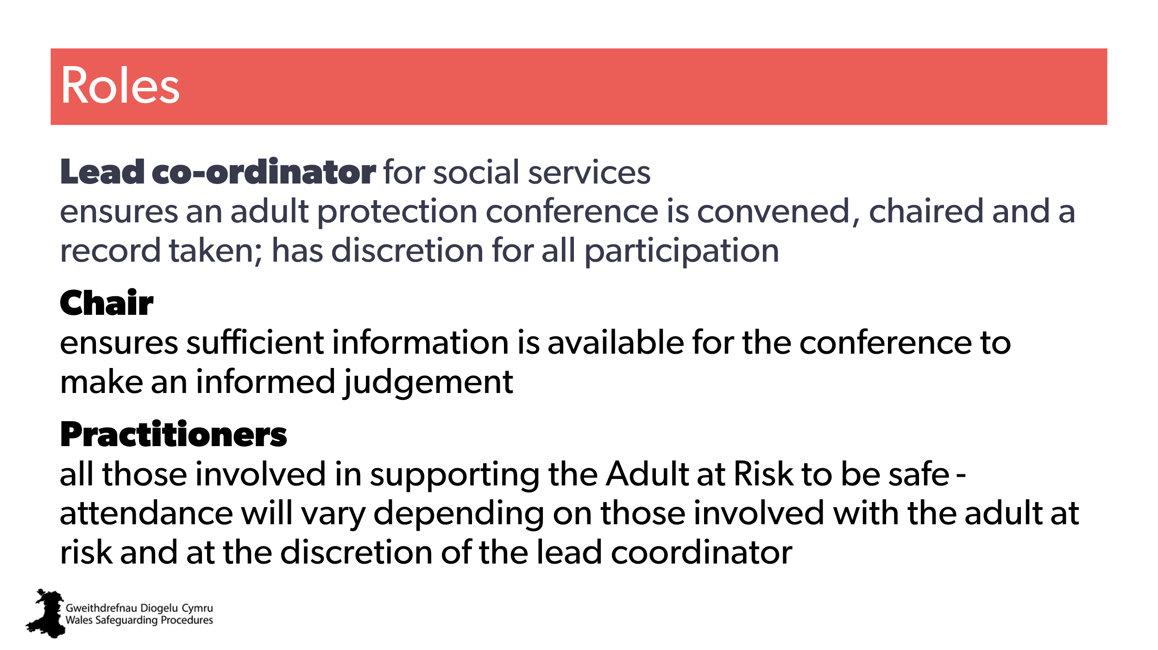 | Aim:  To outline roles and responsibilities.  Trainer to explain:  If anyone’s a participant, they’re encouraged to seek CPD, training or shadowing opportunities from their local authority or Regional Safeguarding Board. | The adult protection conference: roles and responsibilities | CPD, training or shadowing opportunities from local authorities or Regional Safeguarding Boards.
41 | 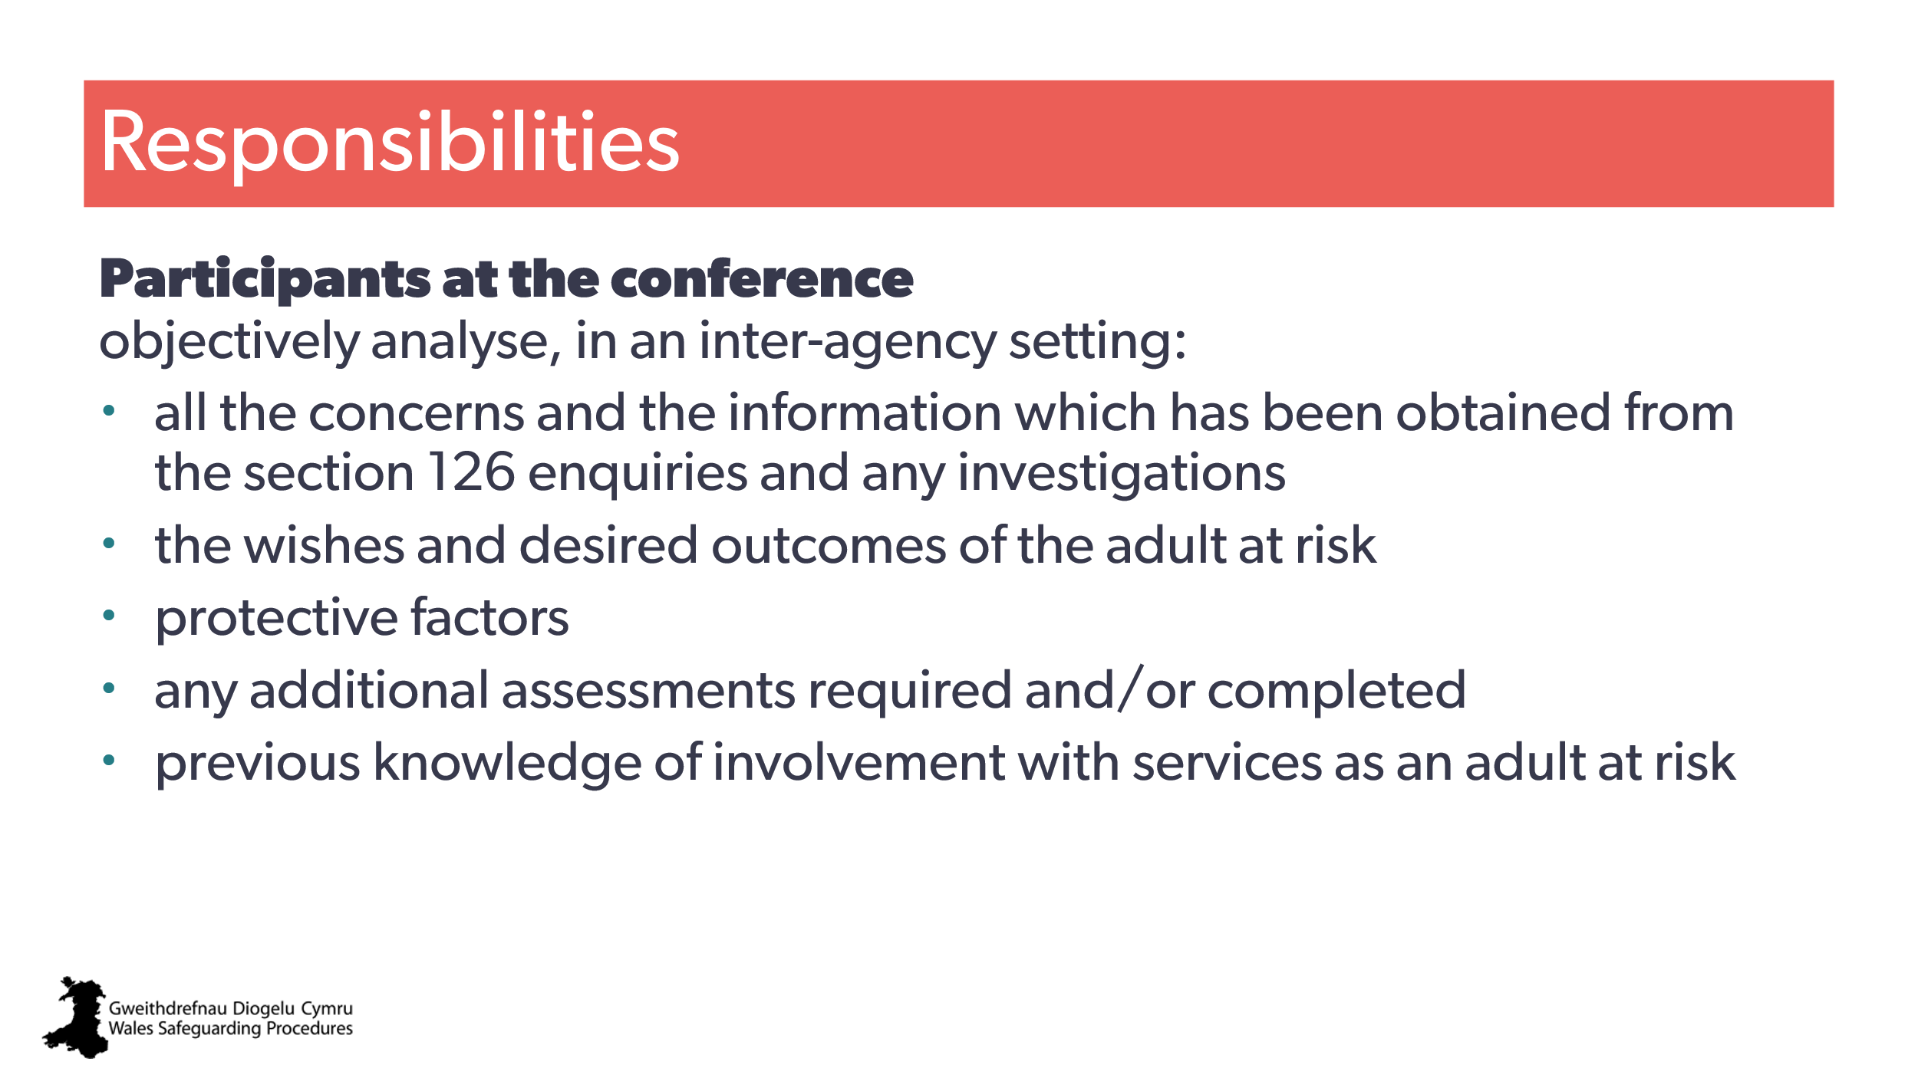
42 | 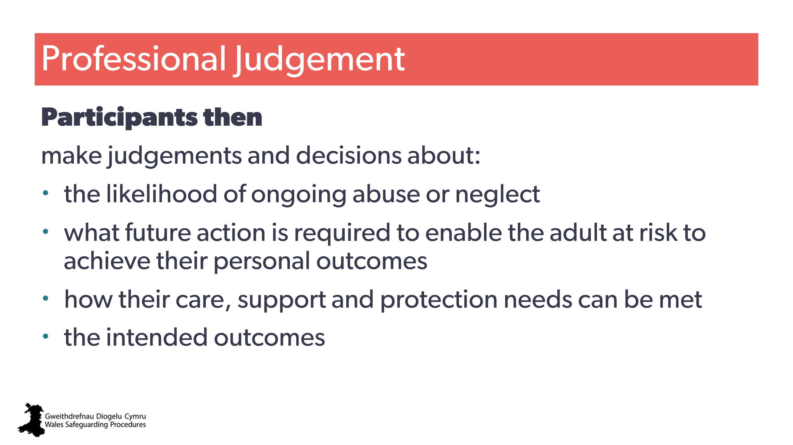 | Aim:  Outline of the type of decision-making.  Reminder of the need for individuals to used their professional judgement
43  44 | 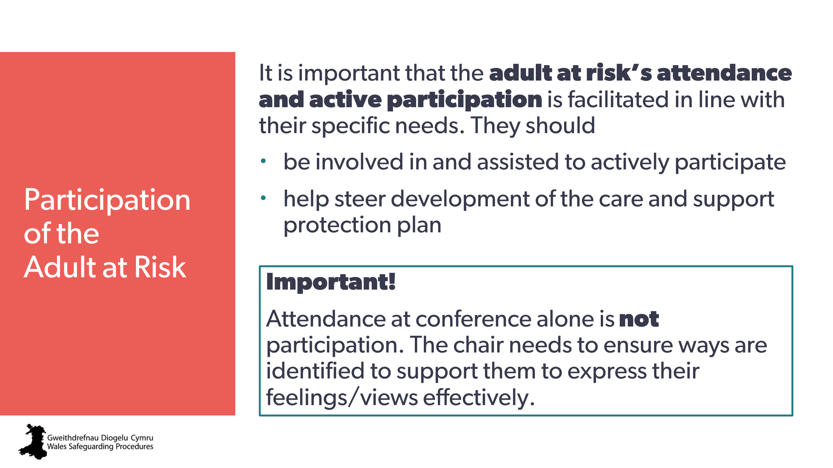  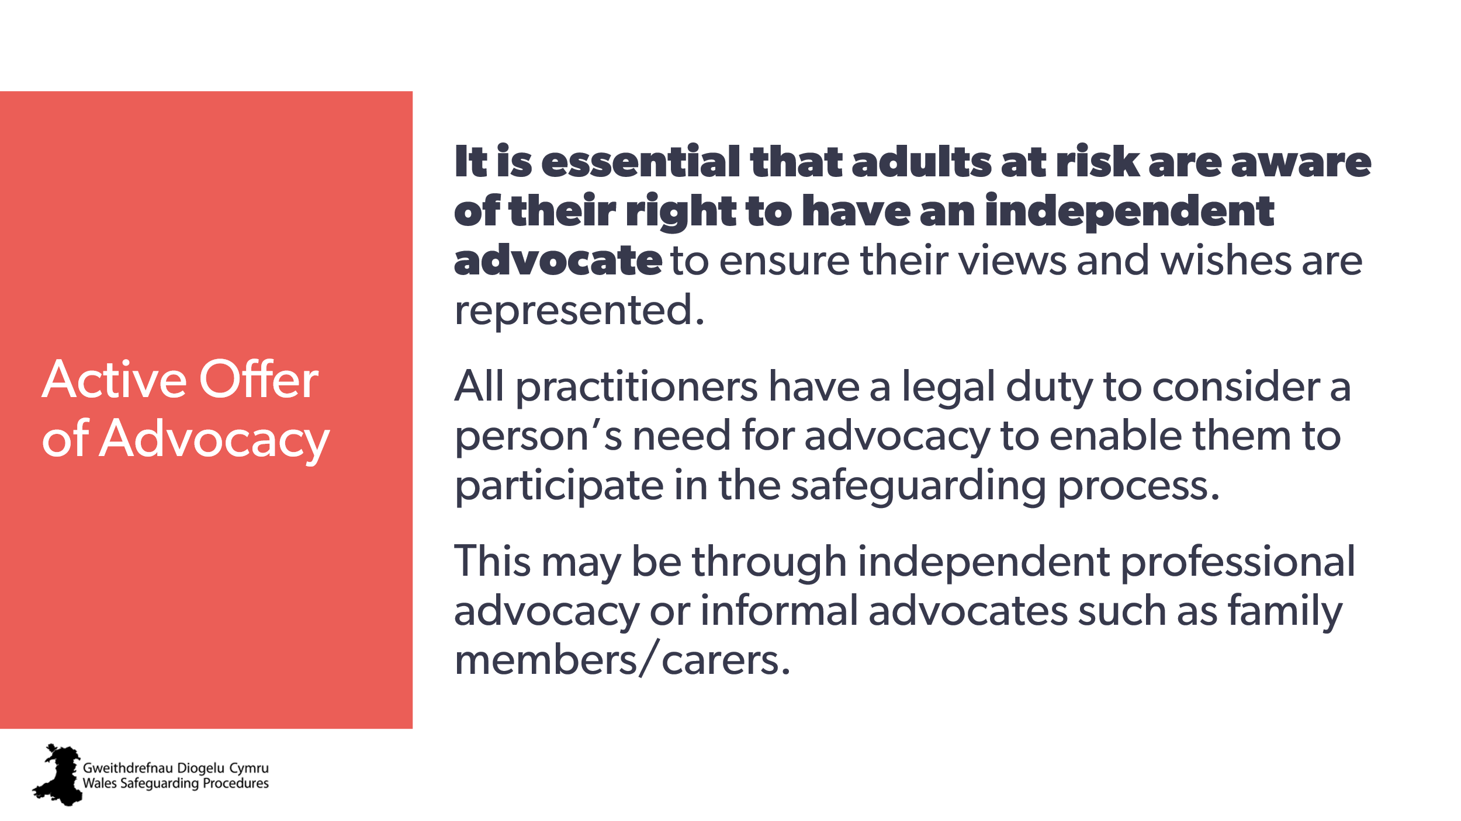 | Aim:  Outline participation of adult at risk.  Trainer to explain:  The Wales Safeguarding Procedures stress:  “It is essential that adults at risk are offered and supported by an independent advocate throughout the process.”  And their views considered as to:  - whether they wish to attend  - whether they wish to attend and bring someone else with them  - whether they wish to nominate someone to attend on their behalf and who this is. | Sharing reports with the adult at risk  Participation by the adult at risk
45 | 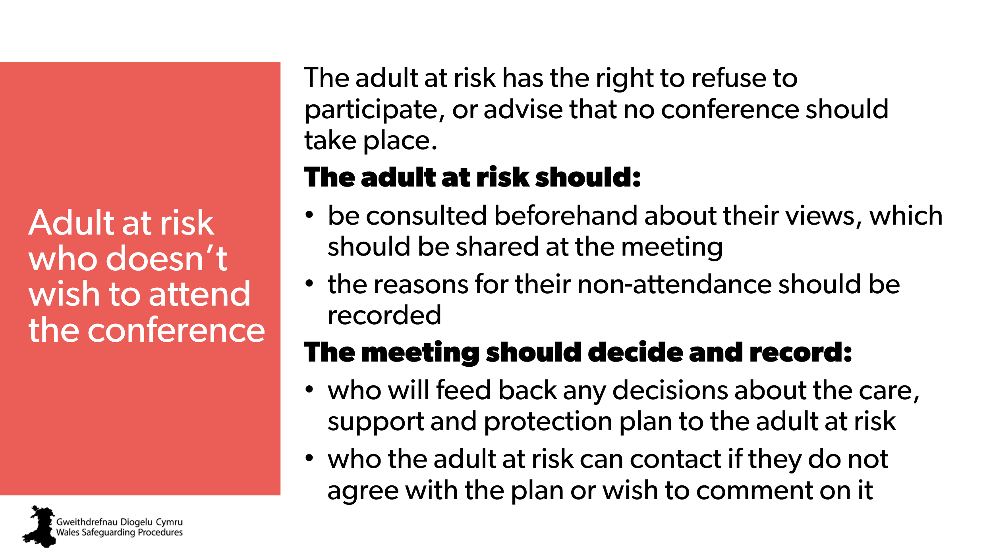 | Aim:  Outline of expectations when adult doesn’t wish to participate.  Trainer to explain:  As always, we need to encourage and facilitate the adult’s participation.  The chair needs to make sure ways are identified to support them in doing this effectively.  Trainer may wish to direct learners to this section in the Wales Safeguarding Procedures, which lists considerations for this: Promoting participation at the conference | Adult at risk who does not wish to attend the conference  Promoting participation at the conference  Pointers for Practice: Preparing Adults at Risk for Safeguarding Meetings  Pointers for Practice: Engaging the Adult at risk on Completion of The Safeguarding Process  Pointers for Practice: Promoting Participation Amongst Adults at Risk with and Without Mental capacity
46 | 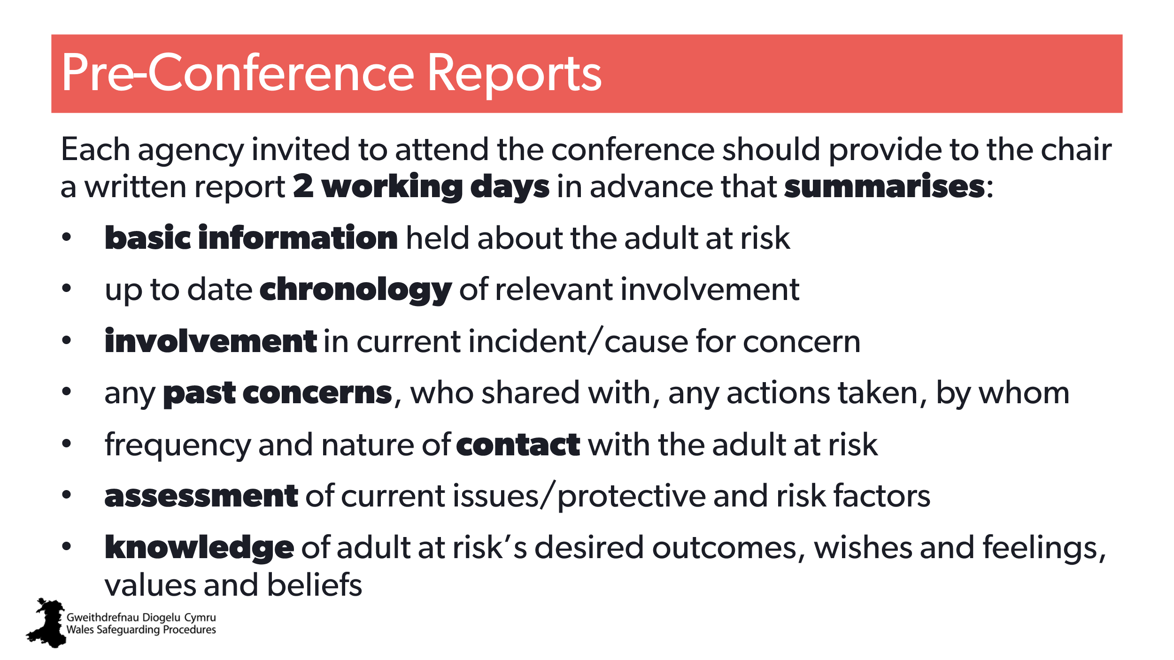 | Aim:  Summary of the pre-conference report.  Note to trainer:  Trainer may wish to add an activity, video, or other support materials/resources to illustrate the next few slides. | Agency Reports  Pointers for Practice: Preparing Reports for Safeguarding Meetings  Confidentiality and the sharing of information at the conference
47 | 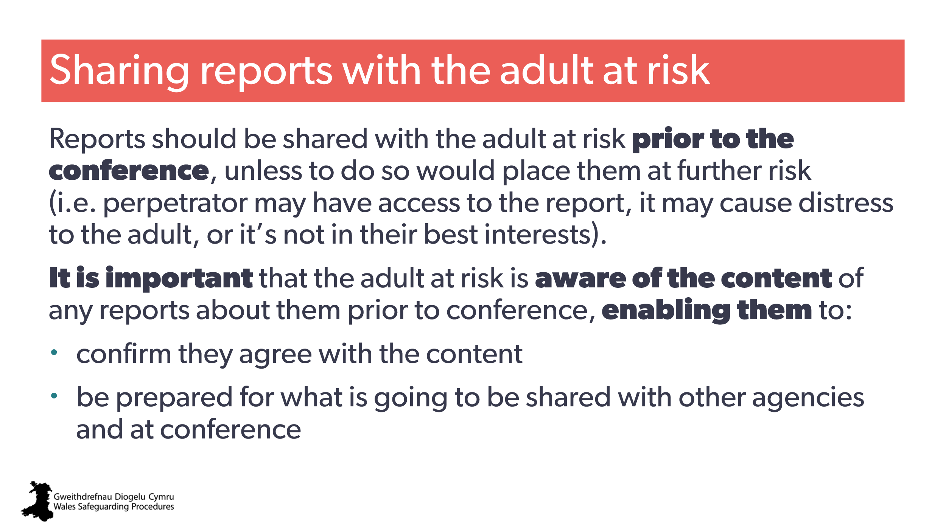 |  | Sharing reports with the adult at risk
48  49 | 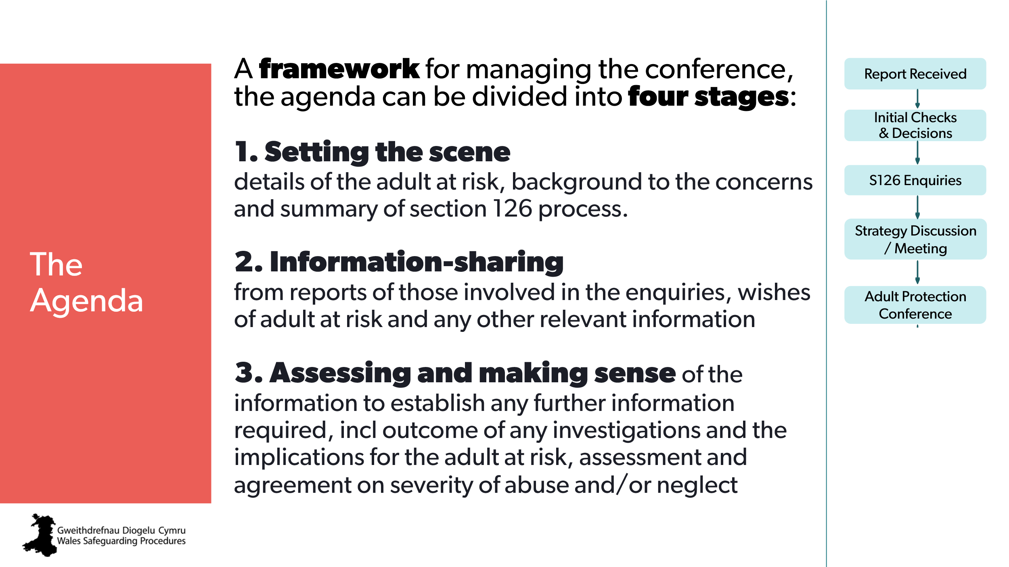  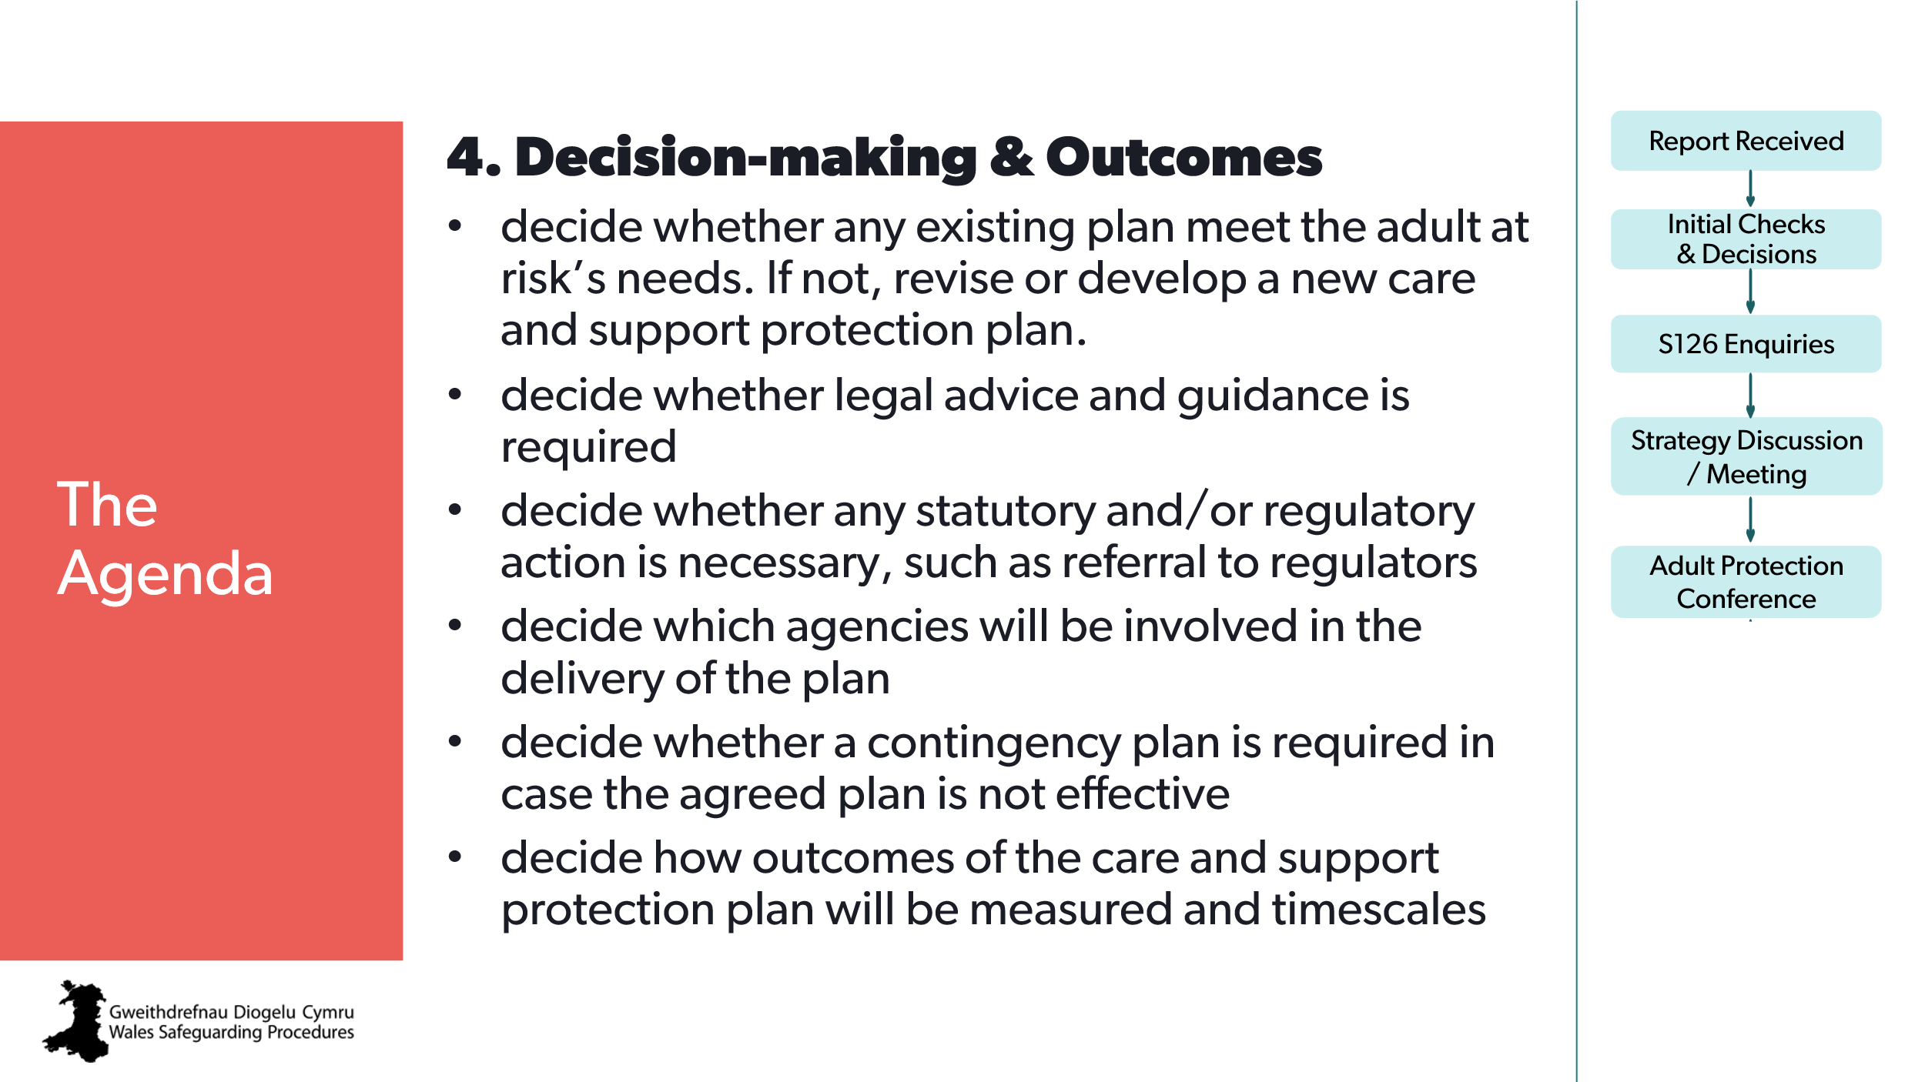 | Aim:  To outline the agenda for the conference.  Trainer to explain:  The agenda provides a framework for managing the conference and can be divided into four stages. | The agenda  Pointers for Practice: From Duty to Report to Adult Protection Conference  Pointers for Practice: Risk Assessment Tools  Pointers for Practice: Risk Assessment and a Person-Centred Approach  Pointers for Practice: Care and Support or Care and Support, Protection Needs?
50 | 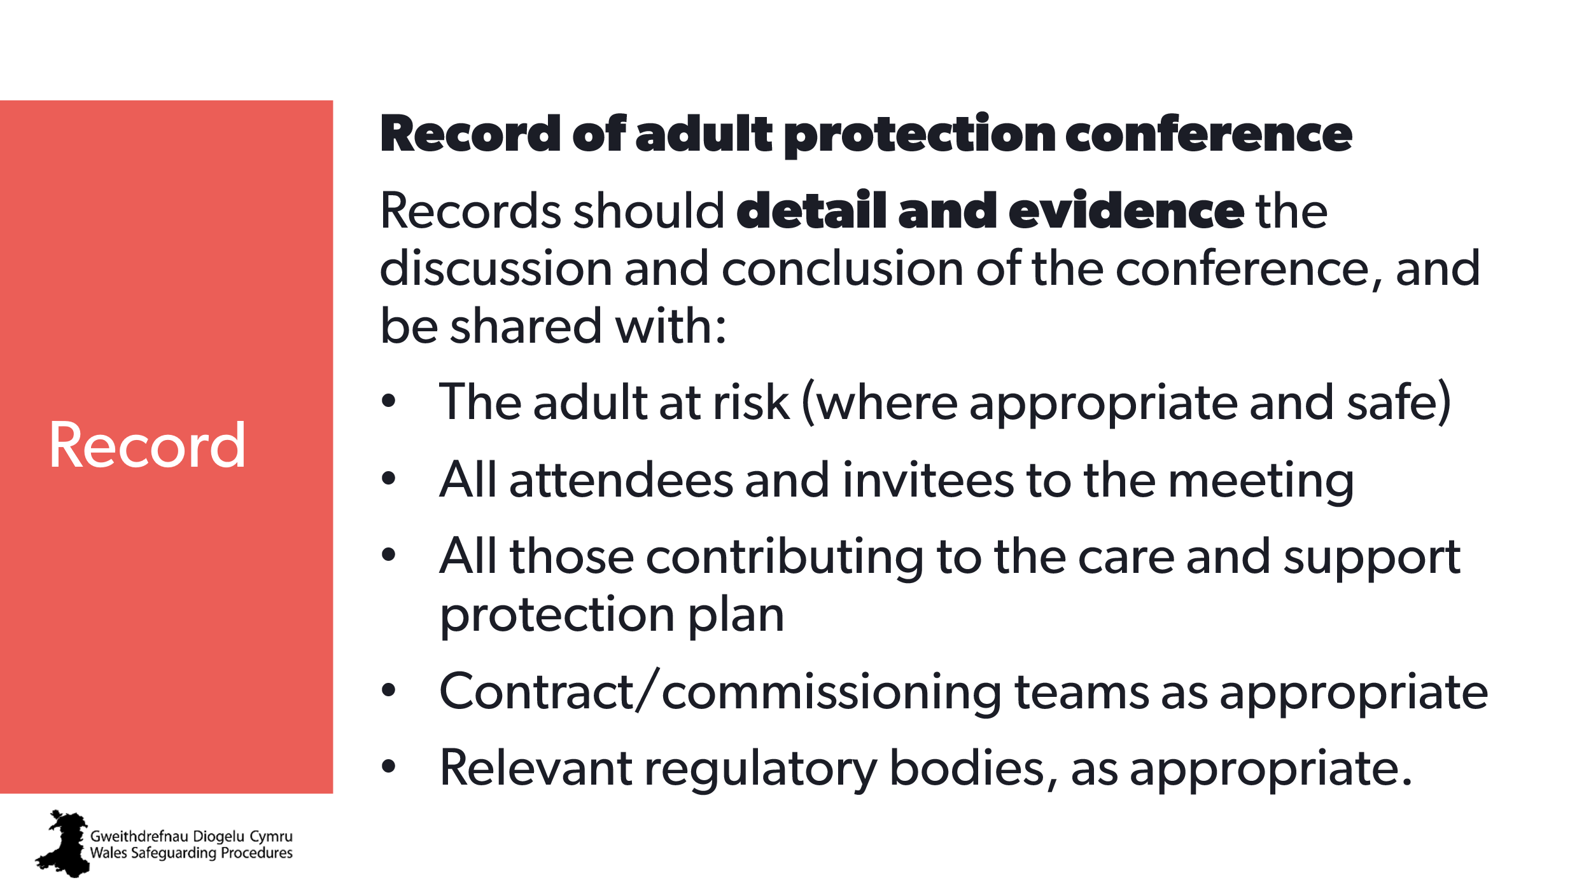 | Aim:  To highlight sharing the record of the conference.  Trainer to add:  The Wales Safeguarding Procedures provide guidance where sharing the record of the meeting with the adult at risk may place them at increased risk of abuse or neglect. | Record of adult protection conference
51 | 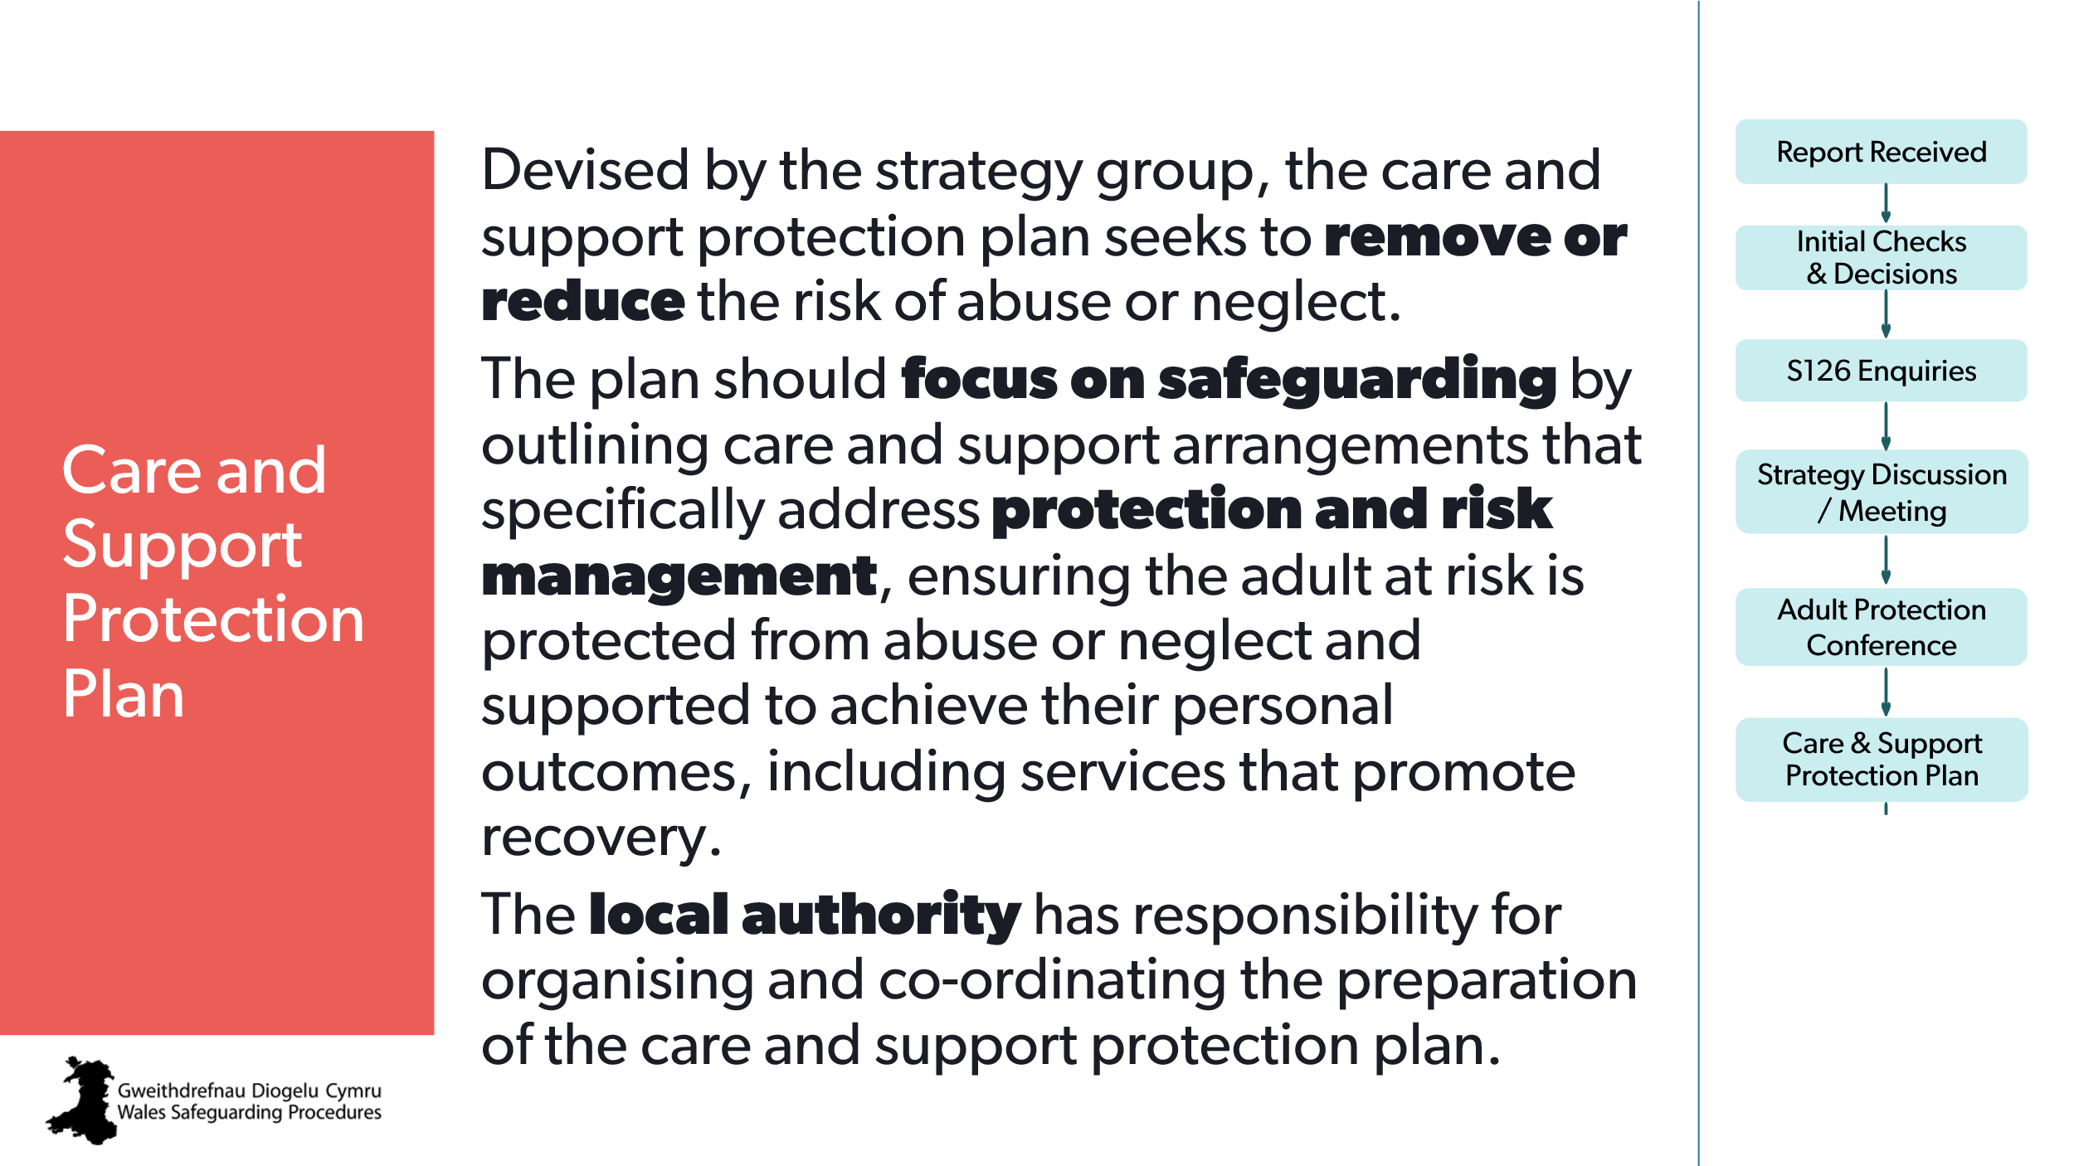 | Aim:  To provide more information about the care and support protection plan.  Trainer to add:  A care and support protection plan (CSPP) doesn’t remove the need for active safeguarding – reports should still be made whenever there’s concern for an adult’s safety.  This goes back to the definition of ‘at risk’: “Has needs for care and support (whether or not the authority is meeting any of those needs)”  Not everyone will be involved in the strategy group, or s126 enquiries, or a conference, but everyone is likely to be in contact with an adult who has a care and support protection plan.  Although the report-maker is contacted as part of the enquiry process, not all practitioners involved with an adult at risk / case may be informed due to relevance to an enquiry and proportionality.
52  53 | 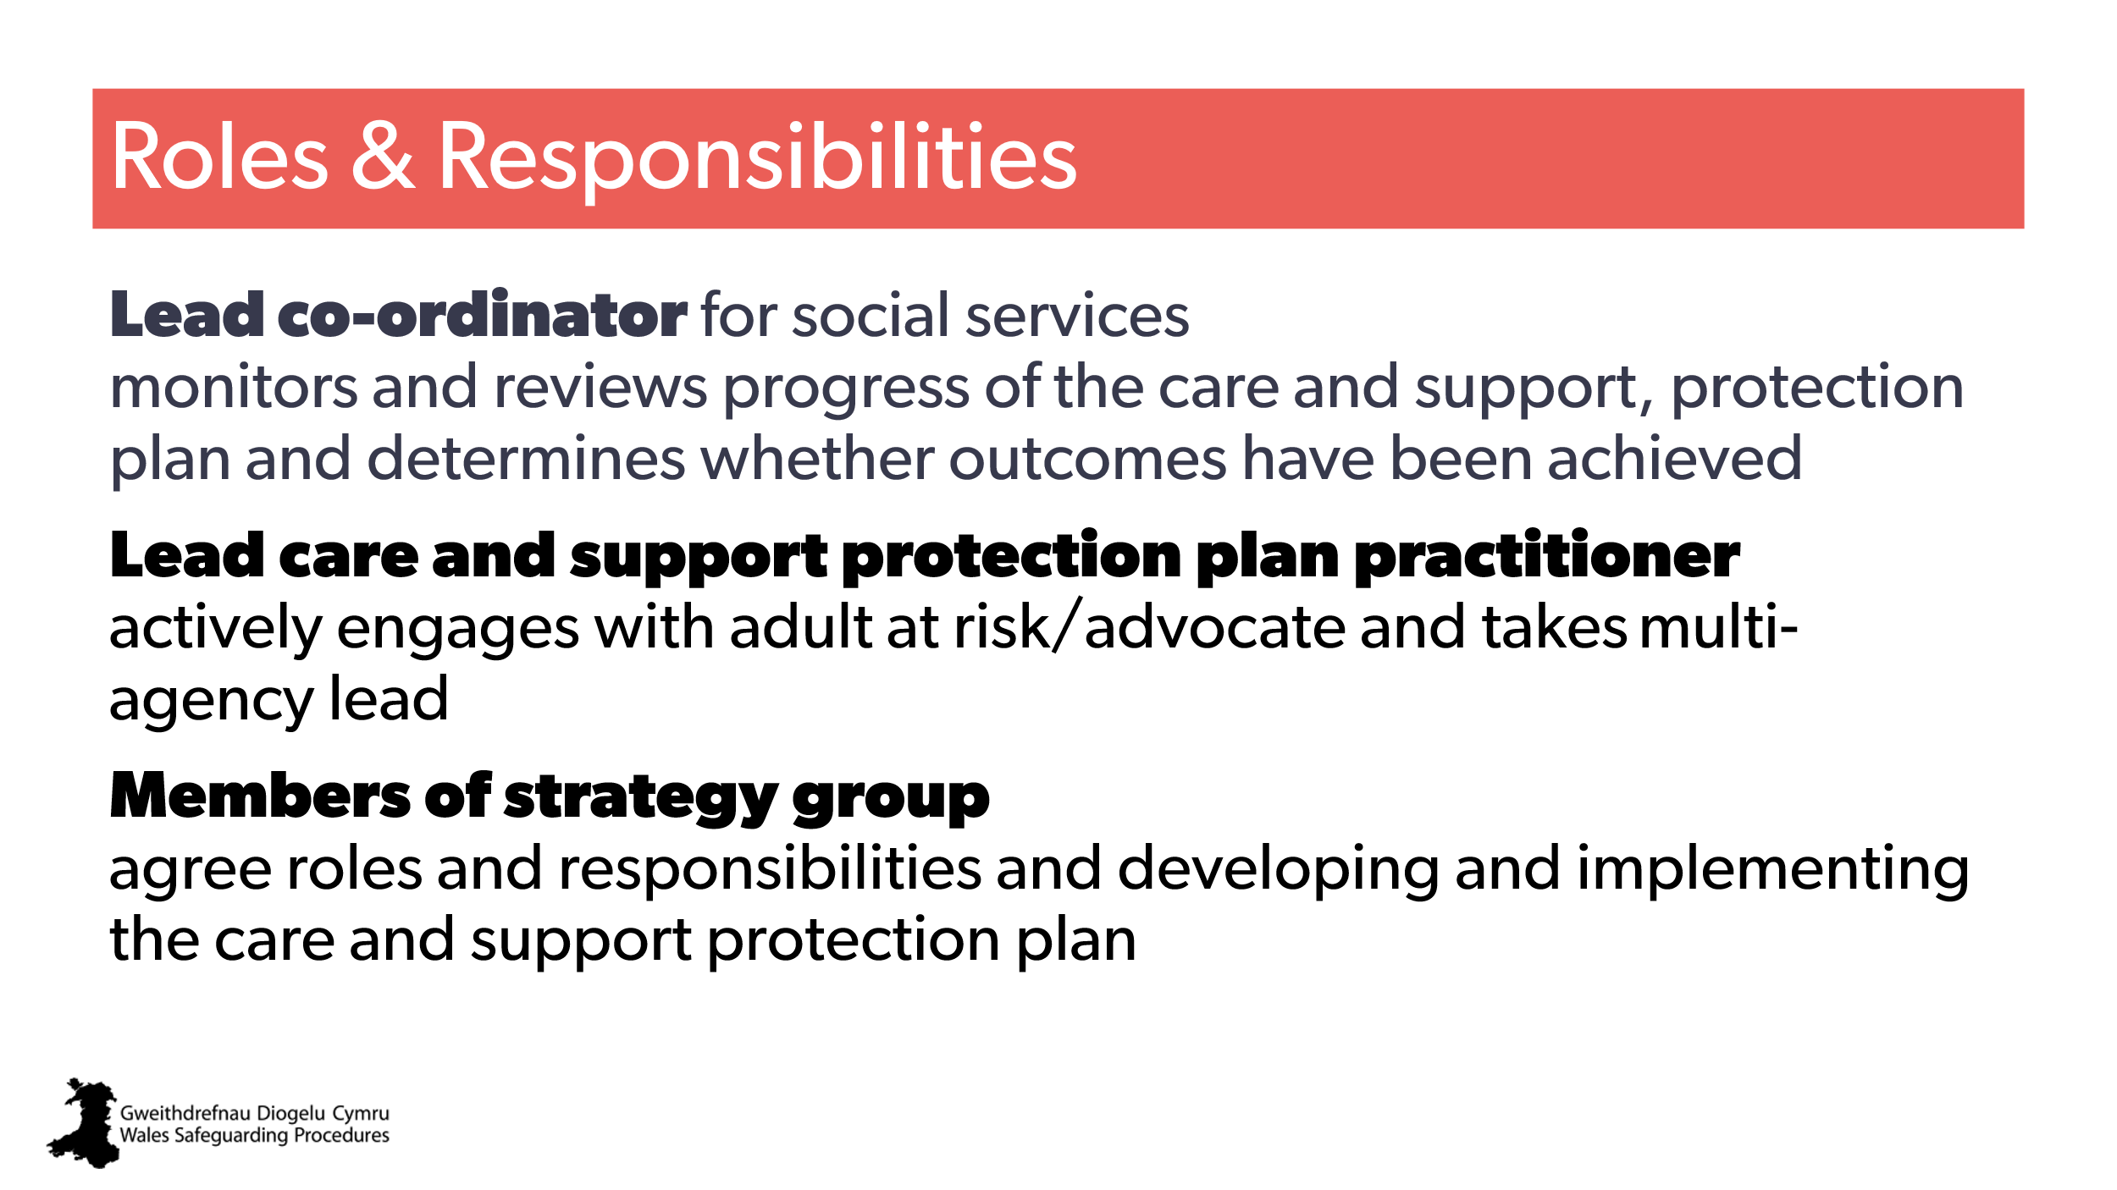  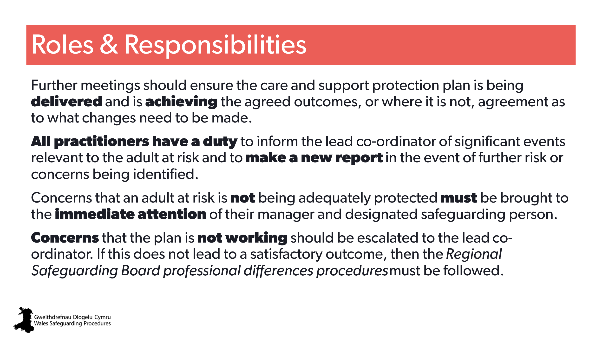 | Aim:  Overview of roles and responsibilities
54  55 | 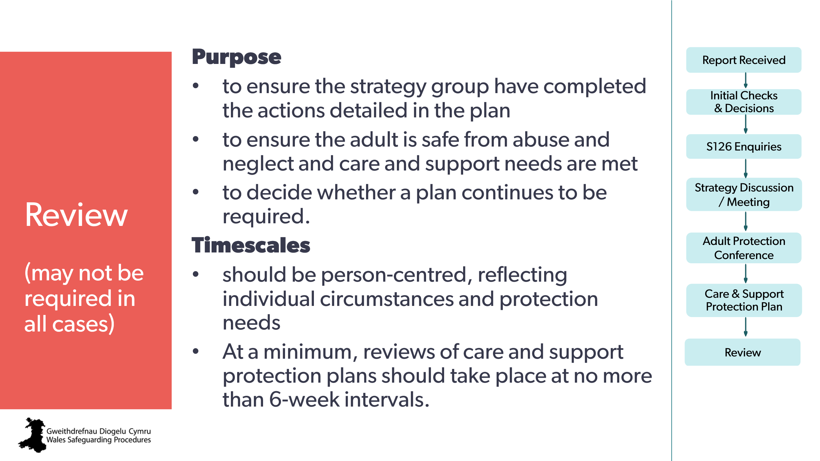  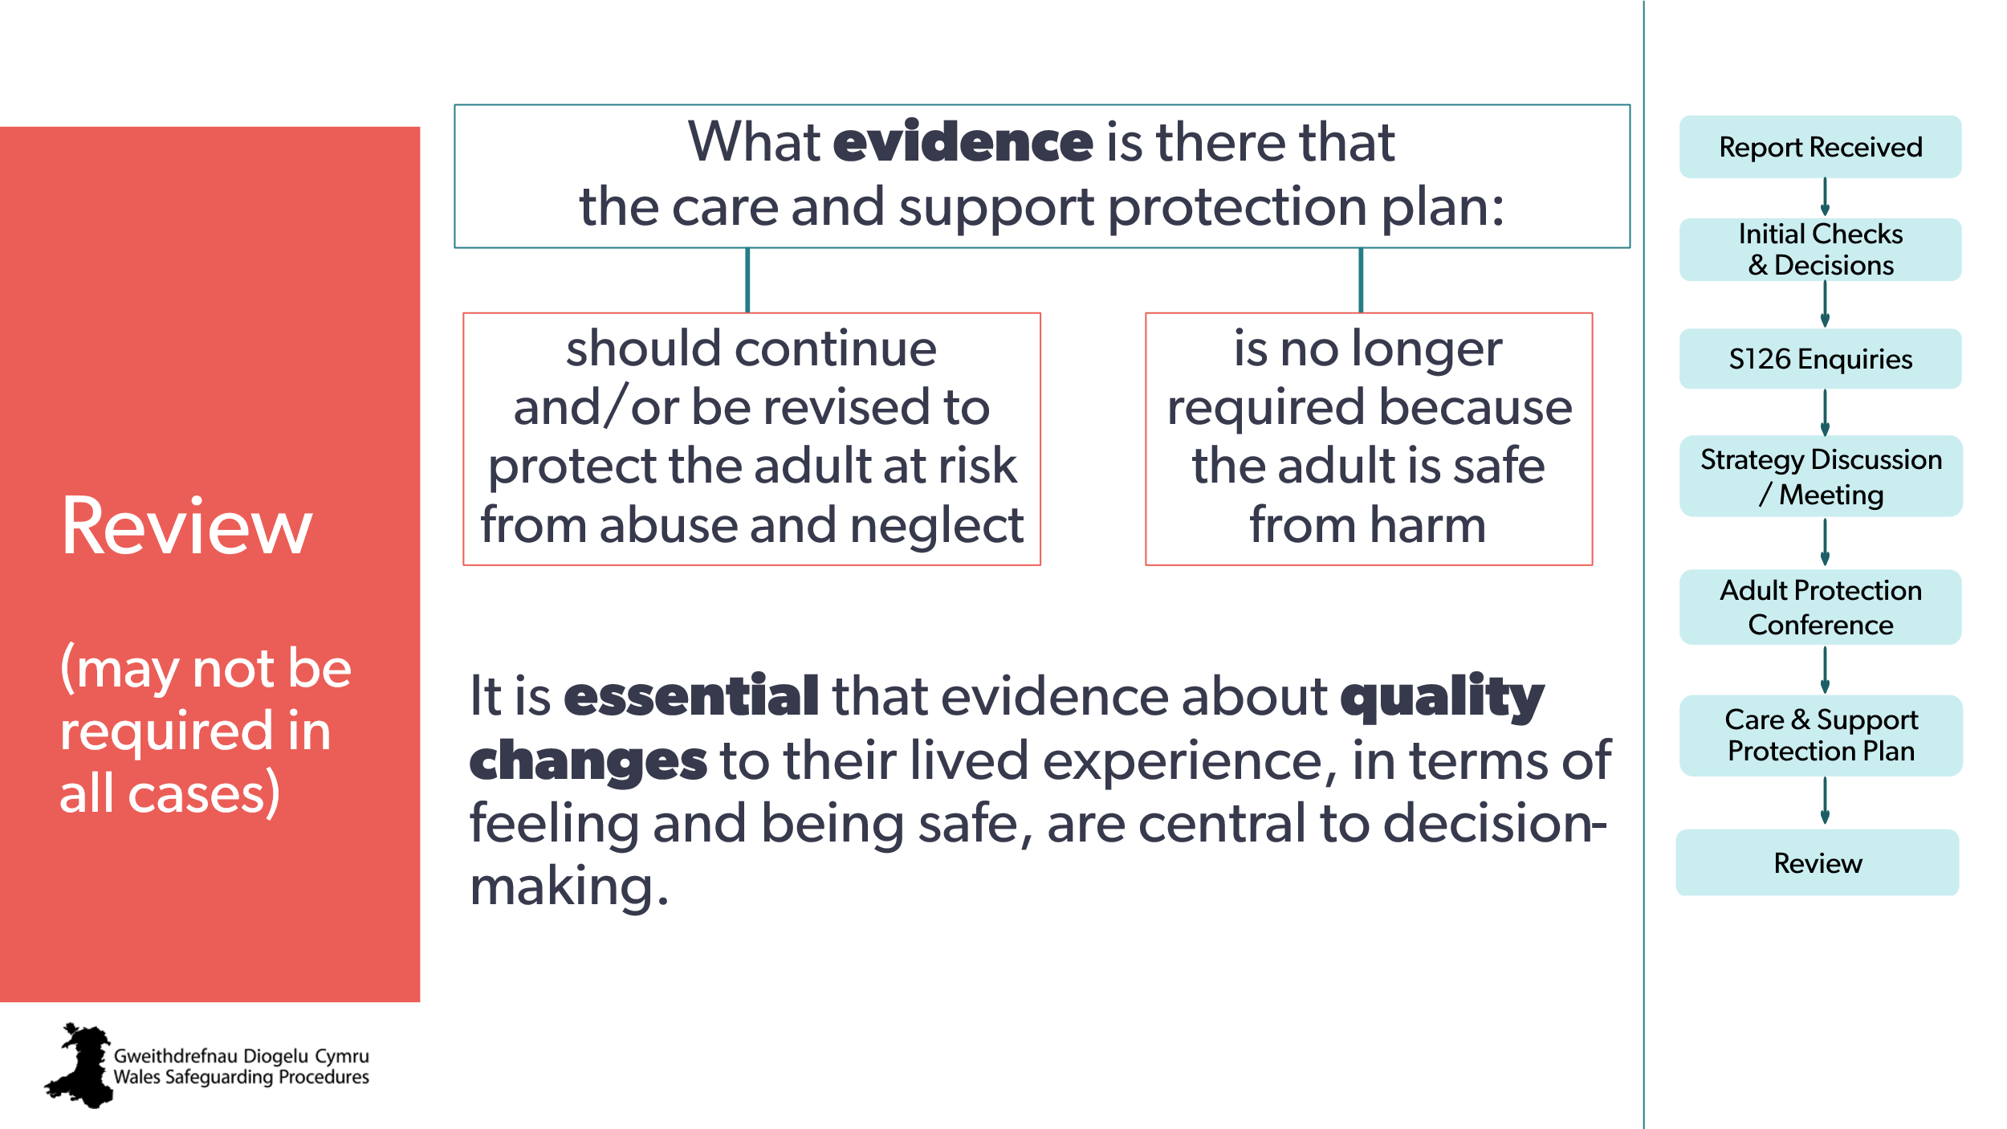 | Aim:  To outline the final stages of the process.  Trainer to explain:  it’s essential the adult at risk or their representative is engaged in the review process.  - reviews may not be needed in all cases  - there can be a number of meeting/conferences  - they must add value to the process and allow the individual to be engaged in the process  - they should be person-centred and reflect individual circumstances and protection needs.  Overall, each review should consider:  - not only whether the actions have been completed but how they’re making a difference  - establishing whether the adult is safer - from both the adult at risk and from practitioners  - what actions indicated in the plan haven’t been done, why, and the implications.
56 | 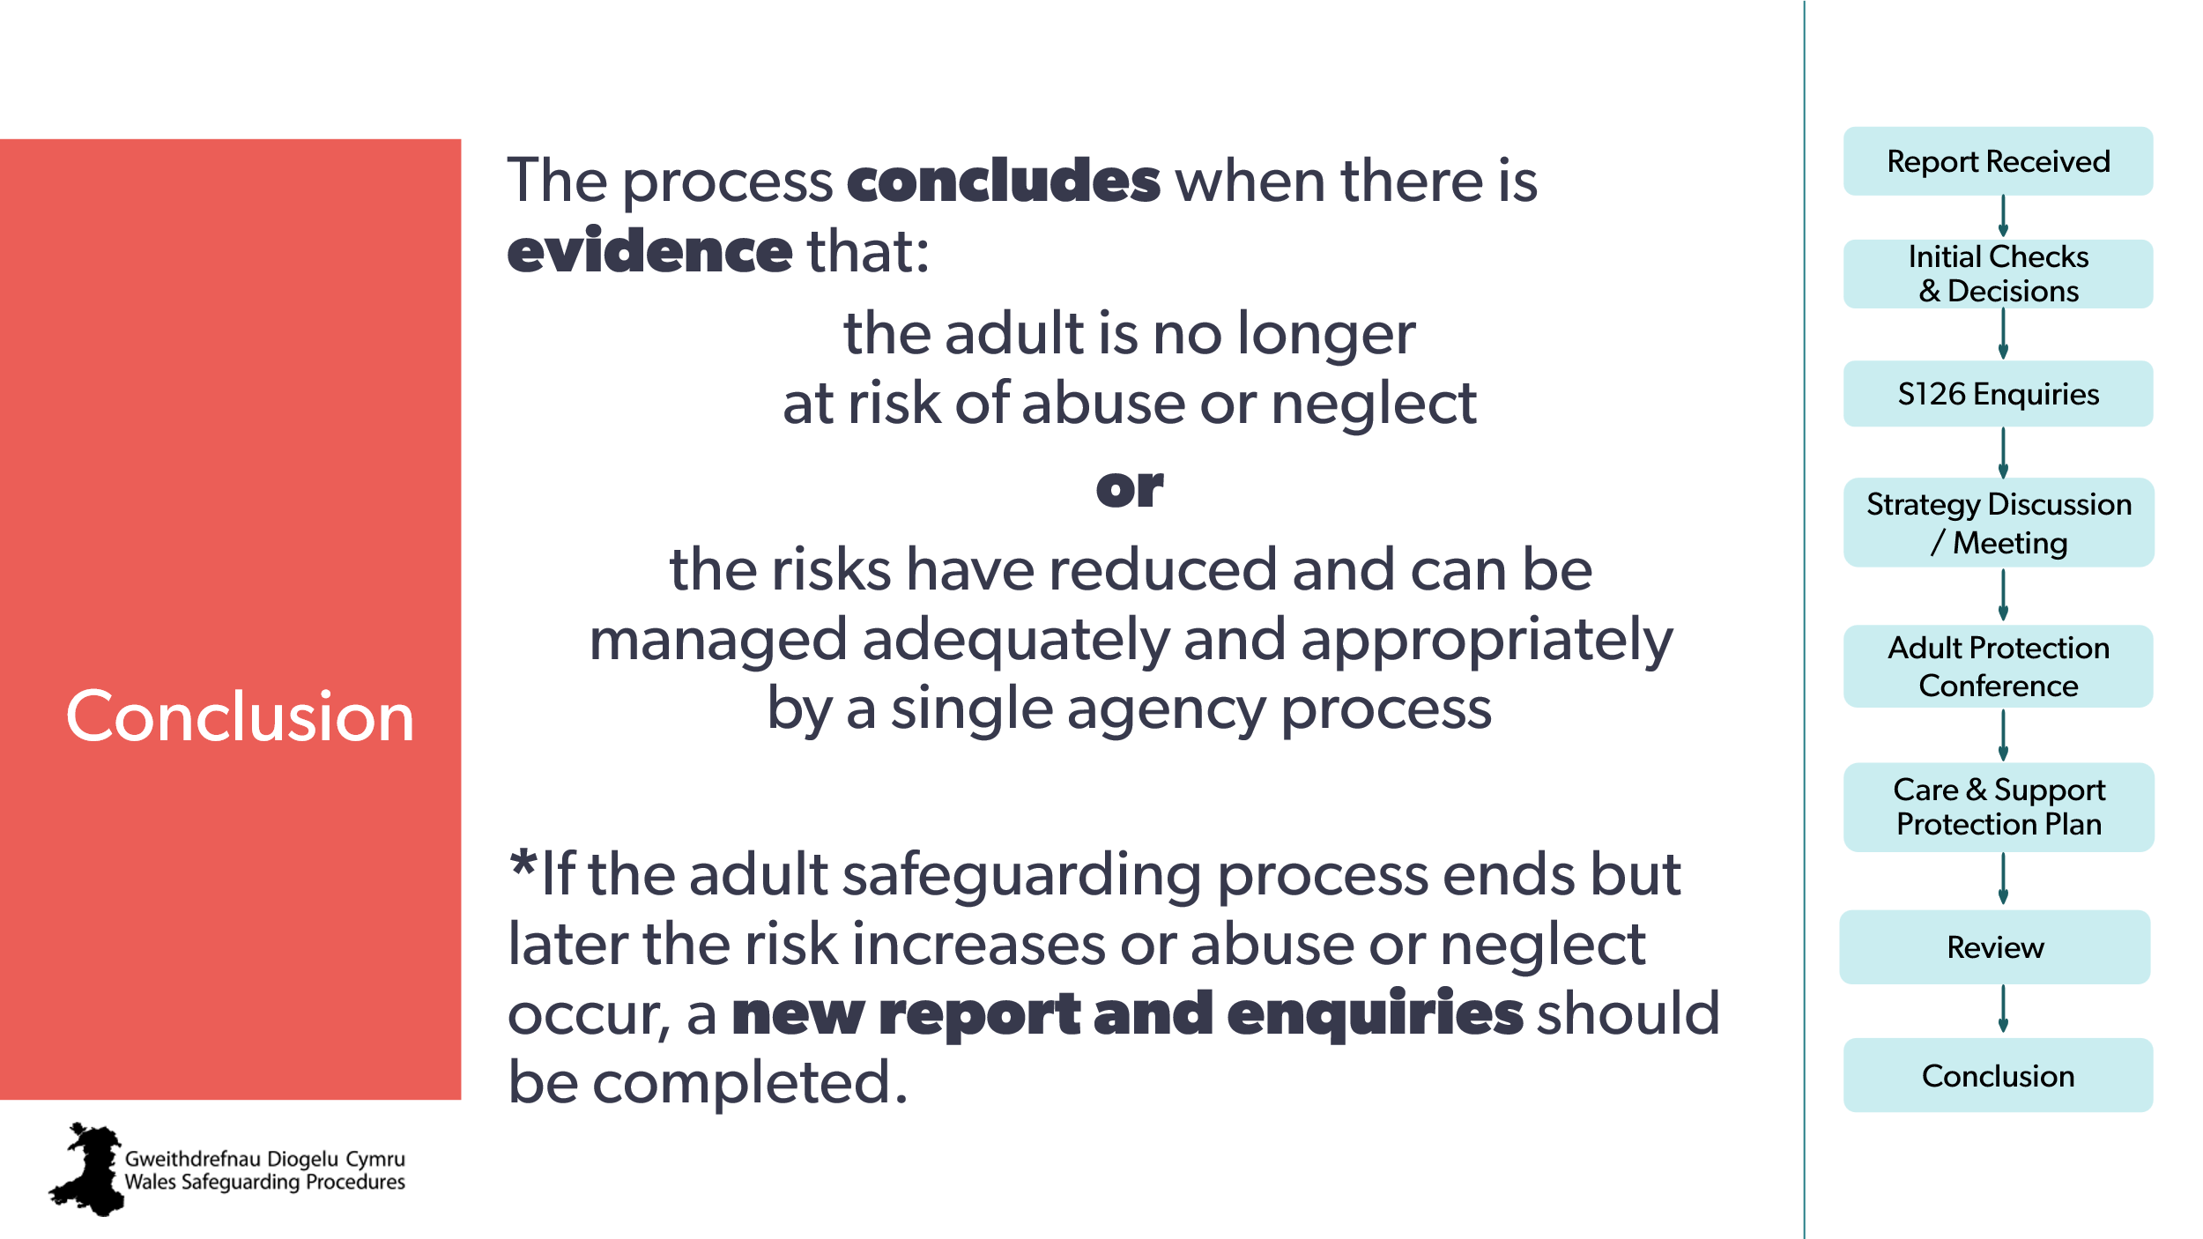 | Aim:  To explain how the process is concluded.  Trainer to explain:  the lead co-ordinator is responsible for terminating the adult safeguarding process  - a decision to end can be made at any point in the safeguarding process  - it’s the responsibility of the strategy group to determine this based on the information/evidence being provided  - wherever possible, the adult at risk should be involved in the conclusion of the safeguarding process  - All relevant agencies and practitioners involved with the adult at risk should be notified when the adult safeguarding process has concluded.  Trainer to stress the need for continued safeguarding:  If the risk increases or abuse or neglect occur after the conclusion of the adult safeguarding process, a new report and enquiries should be completed.  A current or closed CSPP doesn’t remove need for active safeguarding – reports should still be made whenever there is concern about an adult’s safety

Section 5 – children and young people and adults

CYP 48  AR  57 | 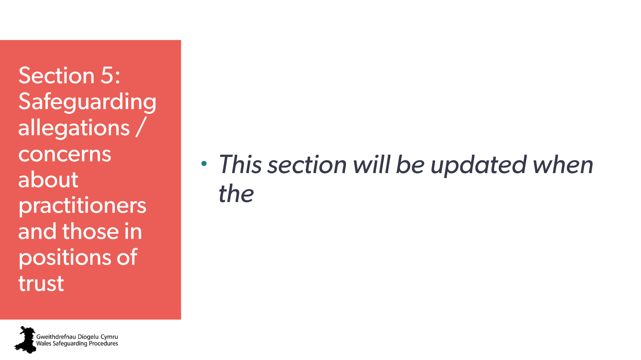 | Holding for section/title slide
CYP 49  AR  58 | 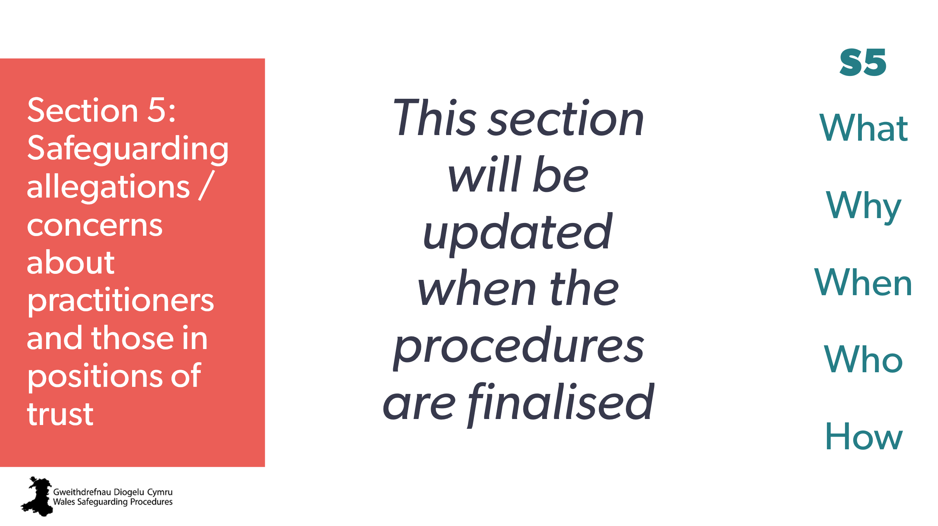 | Aim:  To provide an overview of Section 5 of the Wales Safeguarding Procedures.  Trainer to explain:  We’ll be looking at the main aspects for awareness, using the sections on the right.
CYP 50  AR  59 | 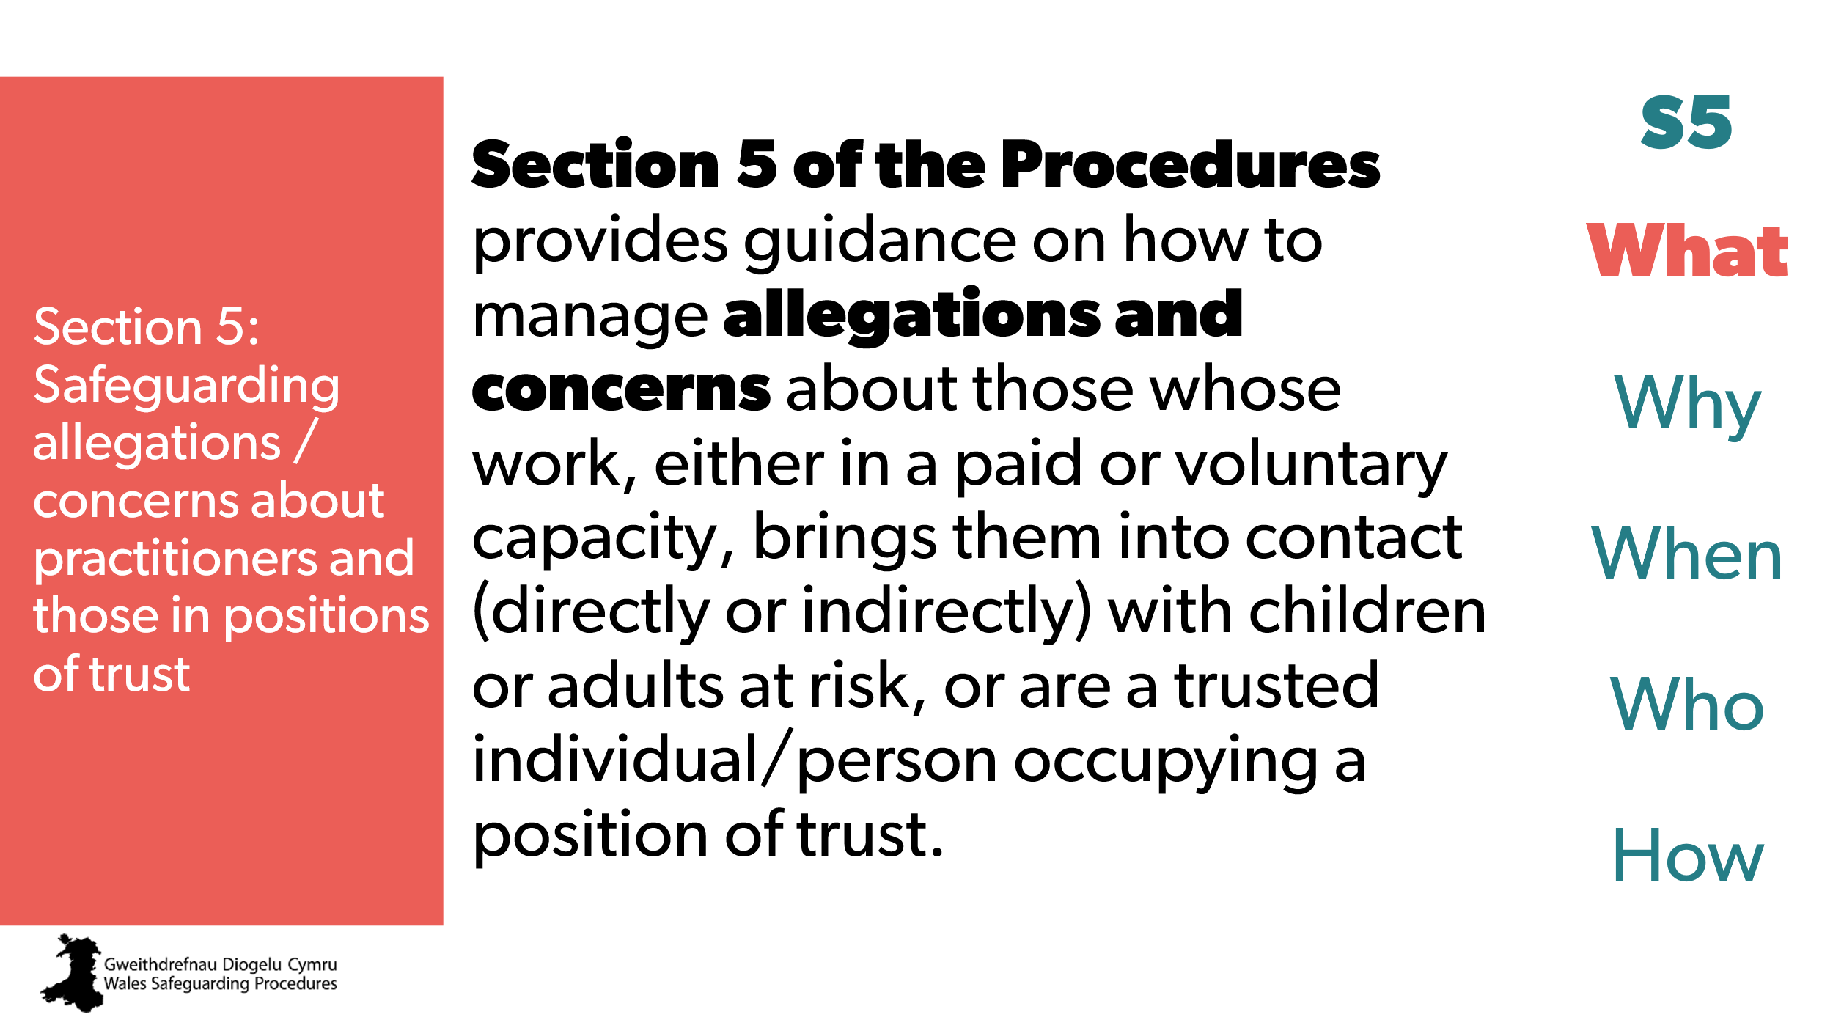 | Aim:  To describe what the Section 5 procedures are. | Appendix 1: Process Flowchart
CYP 51  AR  60 | 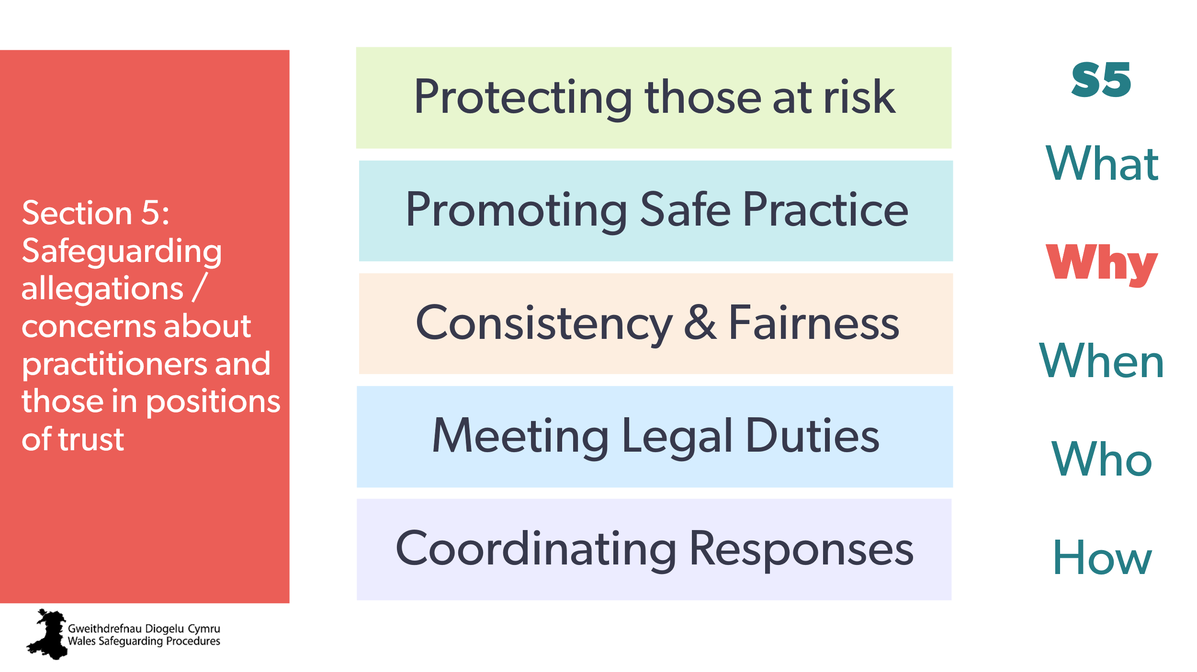 | Aim:  To describe the key reasons for the Section 5 procedures.  Trainer to expand on these:  Protecting those at risk - ensure anyone who may pose a risk is properly investigated and, if necessary, removed from a position of trust.  Promoting safe practice - help organisations reflect on and improve their safeguarding policies and training.  Consistency and fairness - ensure all cases apply the same standards, protecting children/adults at risk and the rights of those who have allegations against them.  Meeting legal duties - support compliance with safeguarding legislation and guidance.  Coordinating responses - ensure a multi-agency approach when managing allegations or concerns.
CYP 52  AR  61 | 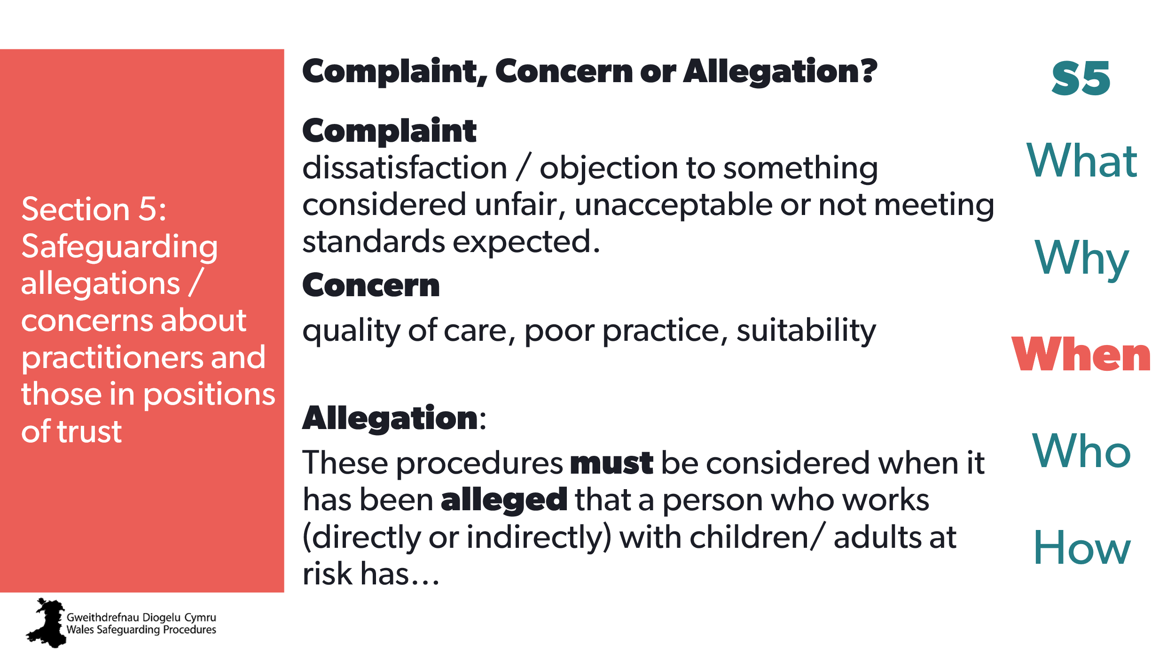 | Aim:  To describe when to use the Section 5 procedures.  To differentiate between complaints, concerns and allegations.
CYP 53  AR  62 | 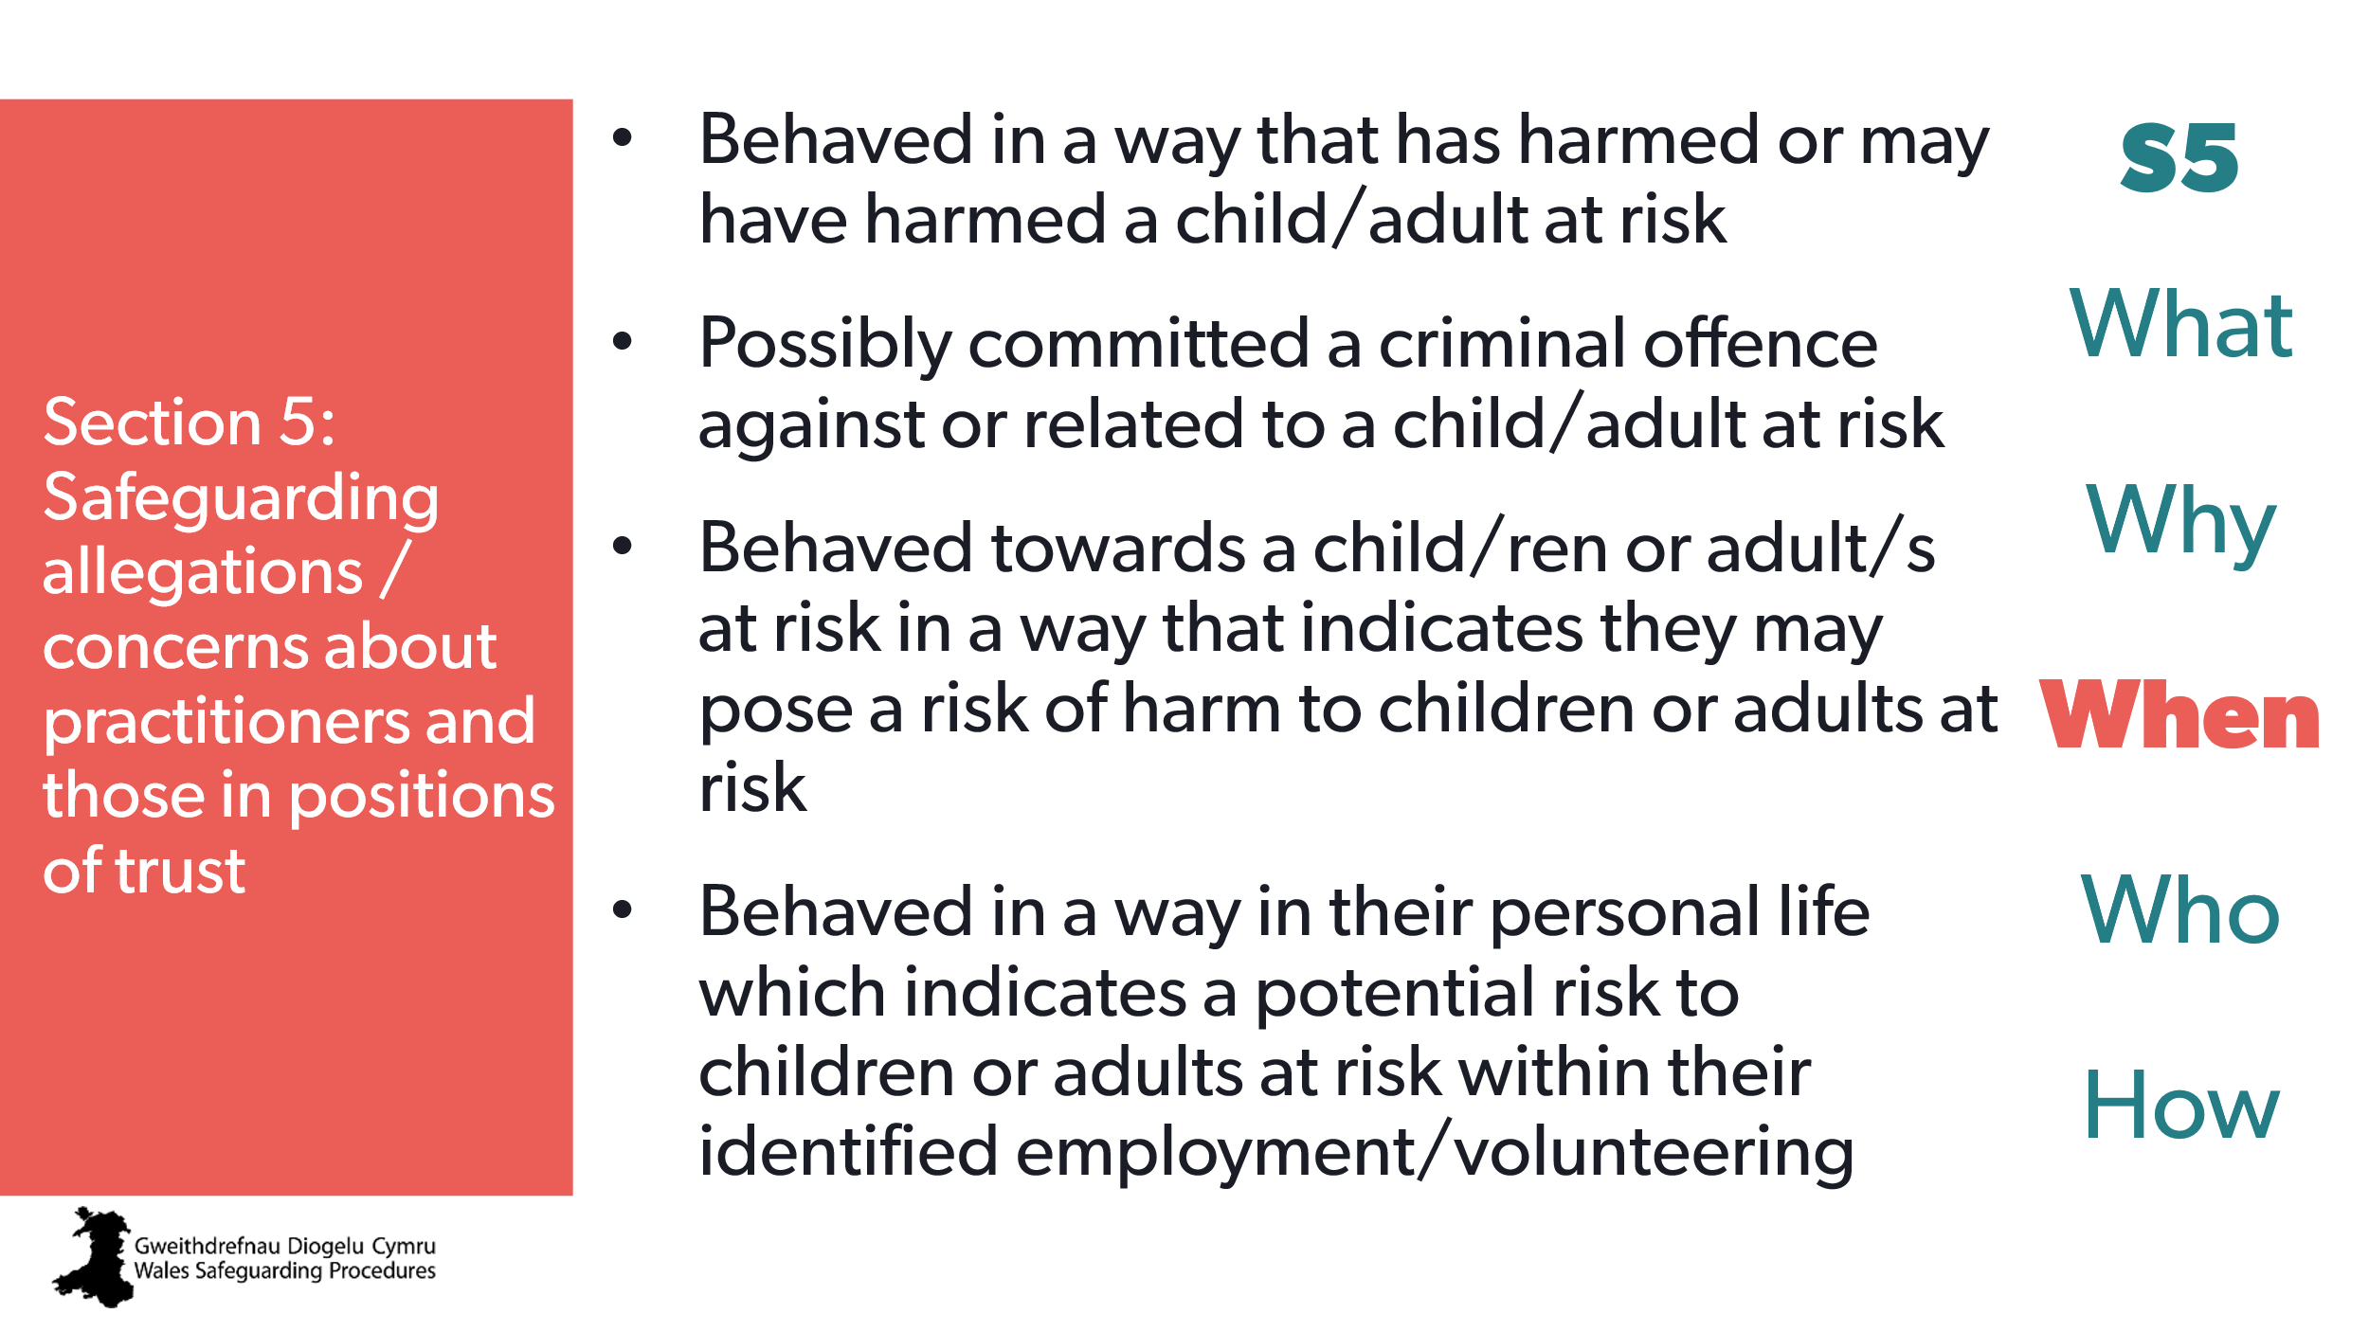 | Aim:  Provide examples of allegations.  Note to trainer:  Be sure to provide examples of ‘unsuitable’ from the procedures.
CYP 54  AR  63 | 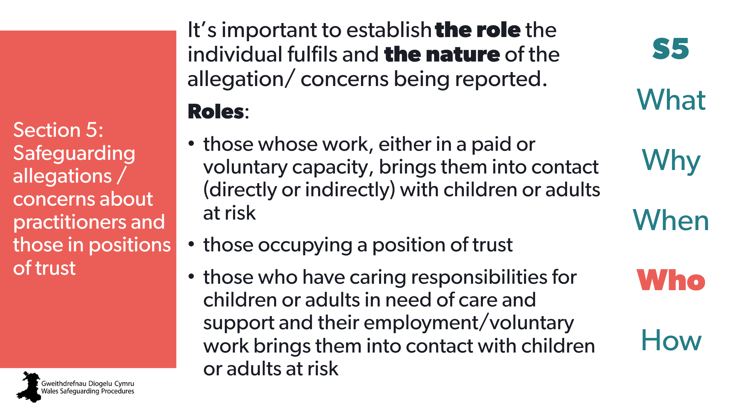 | Aim:  To provide an overview of who may be subject to Section 5 procedures.  To describe what is meant by role.
CYP 55  AR  64 | 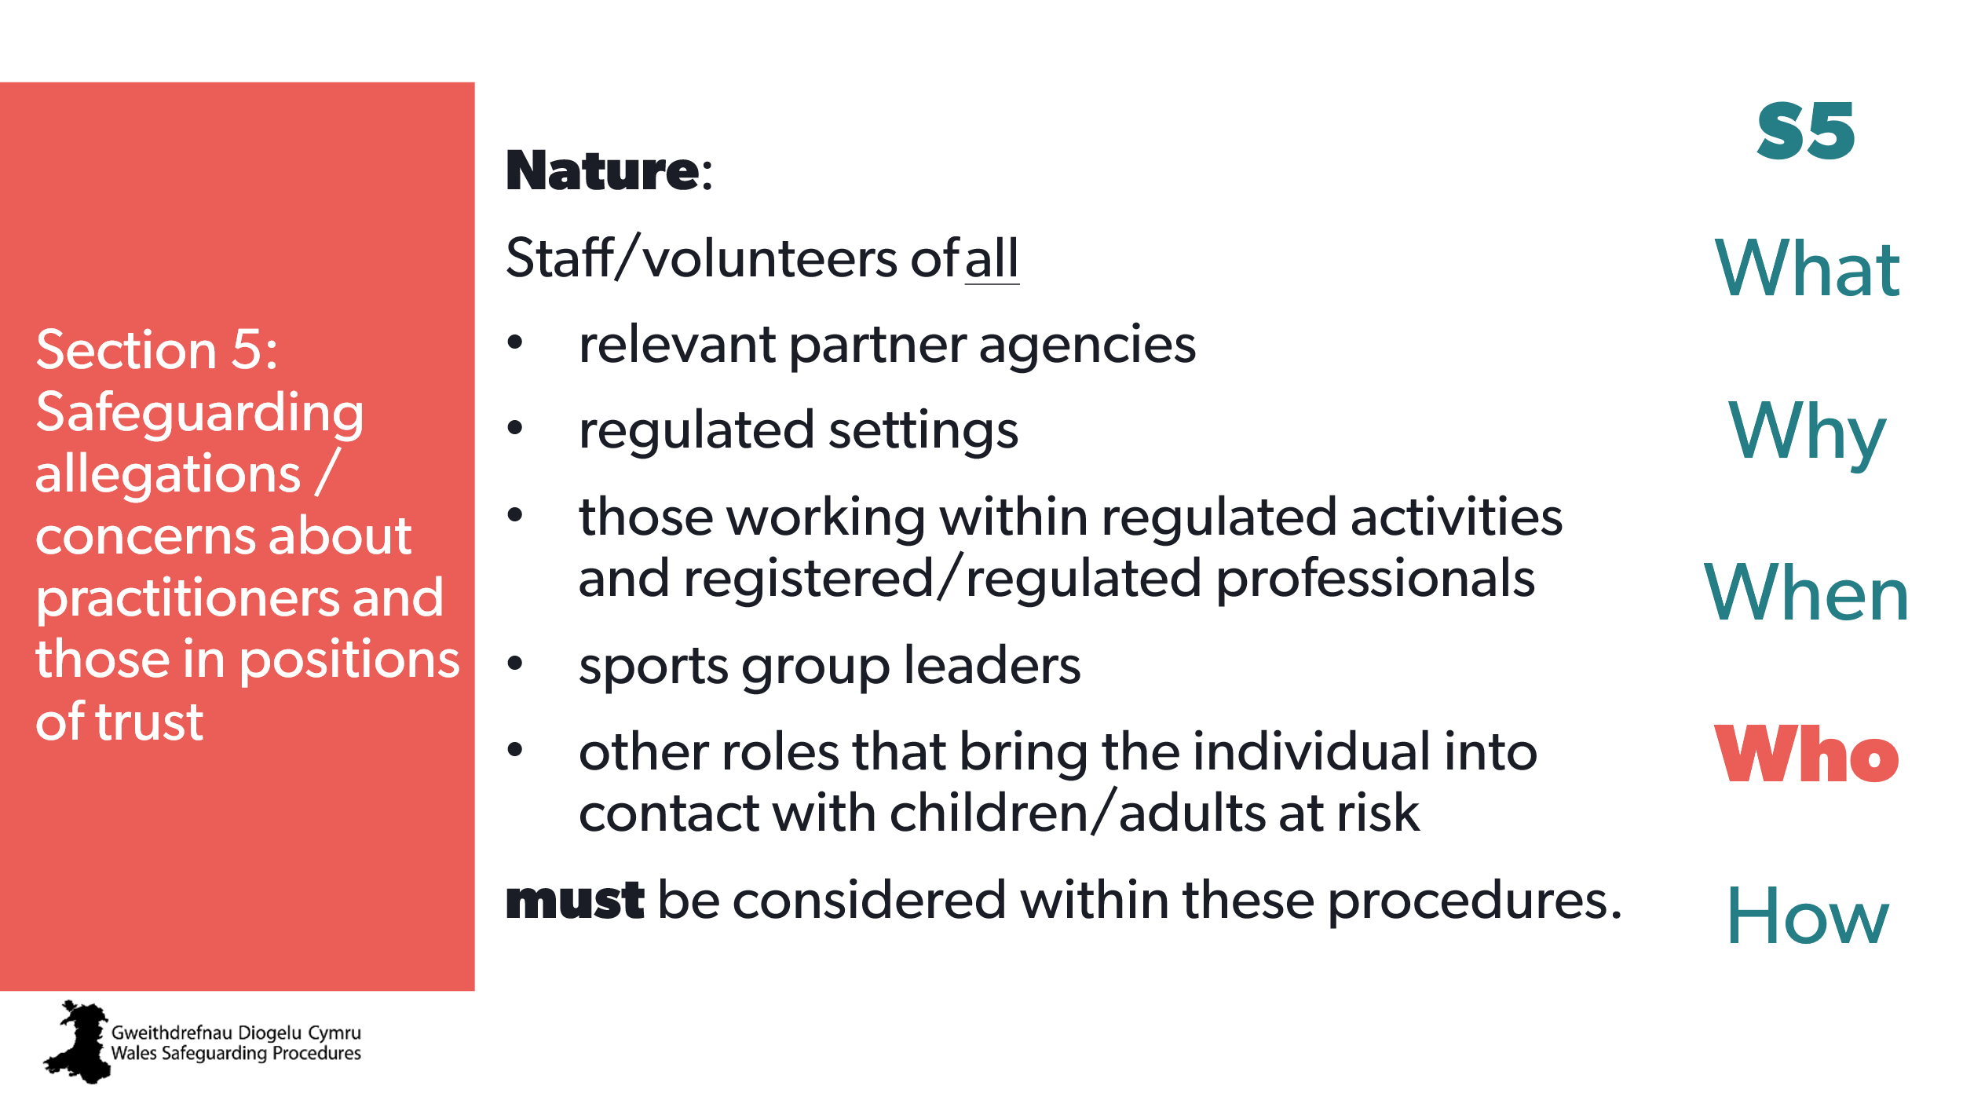 | Aim:  To provide an overview of who may be subject to Section 5 procedures  To describe what is meant by nature.
CYP 56  AR  65 | 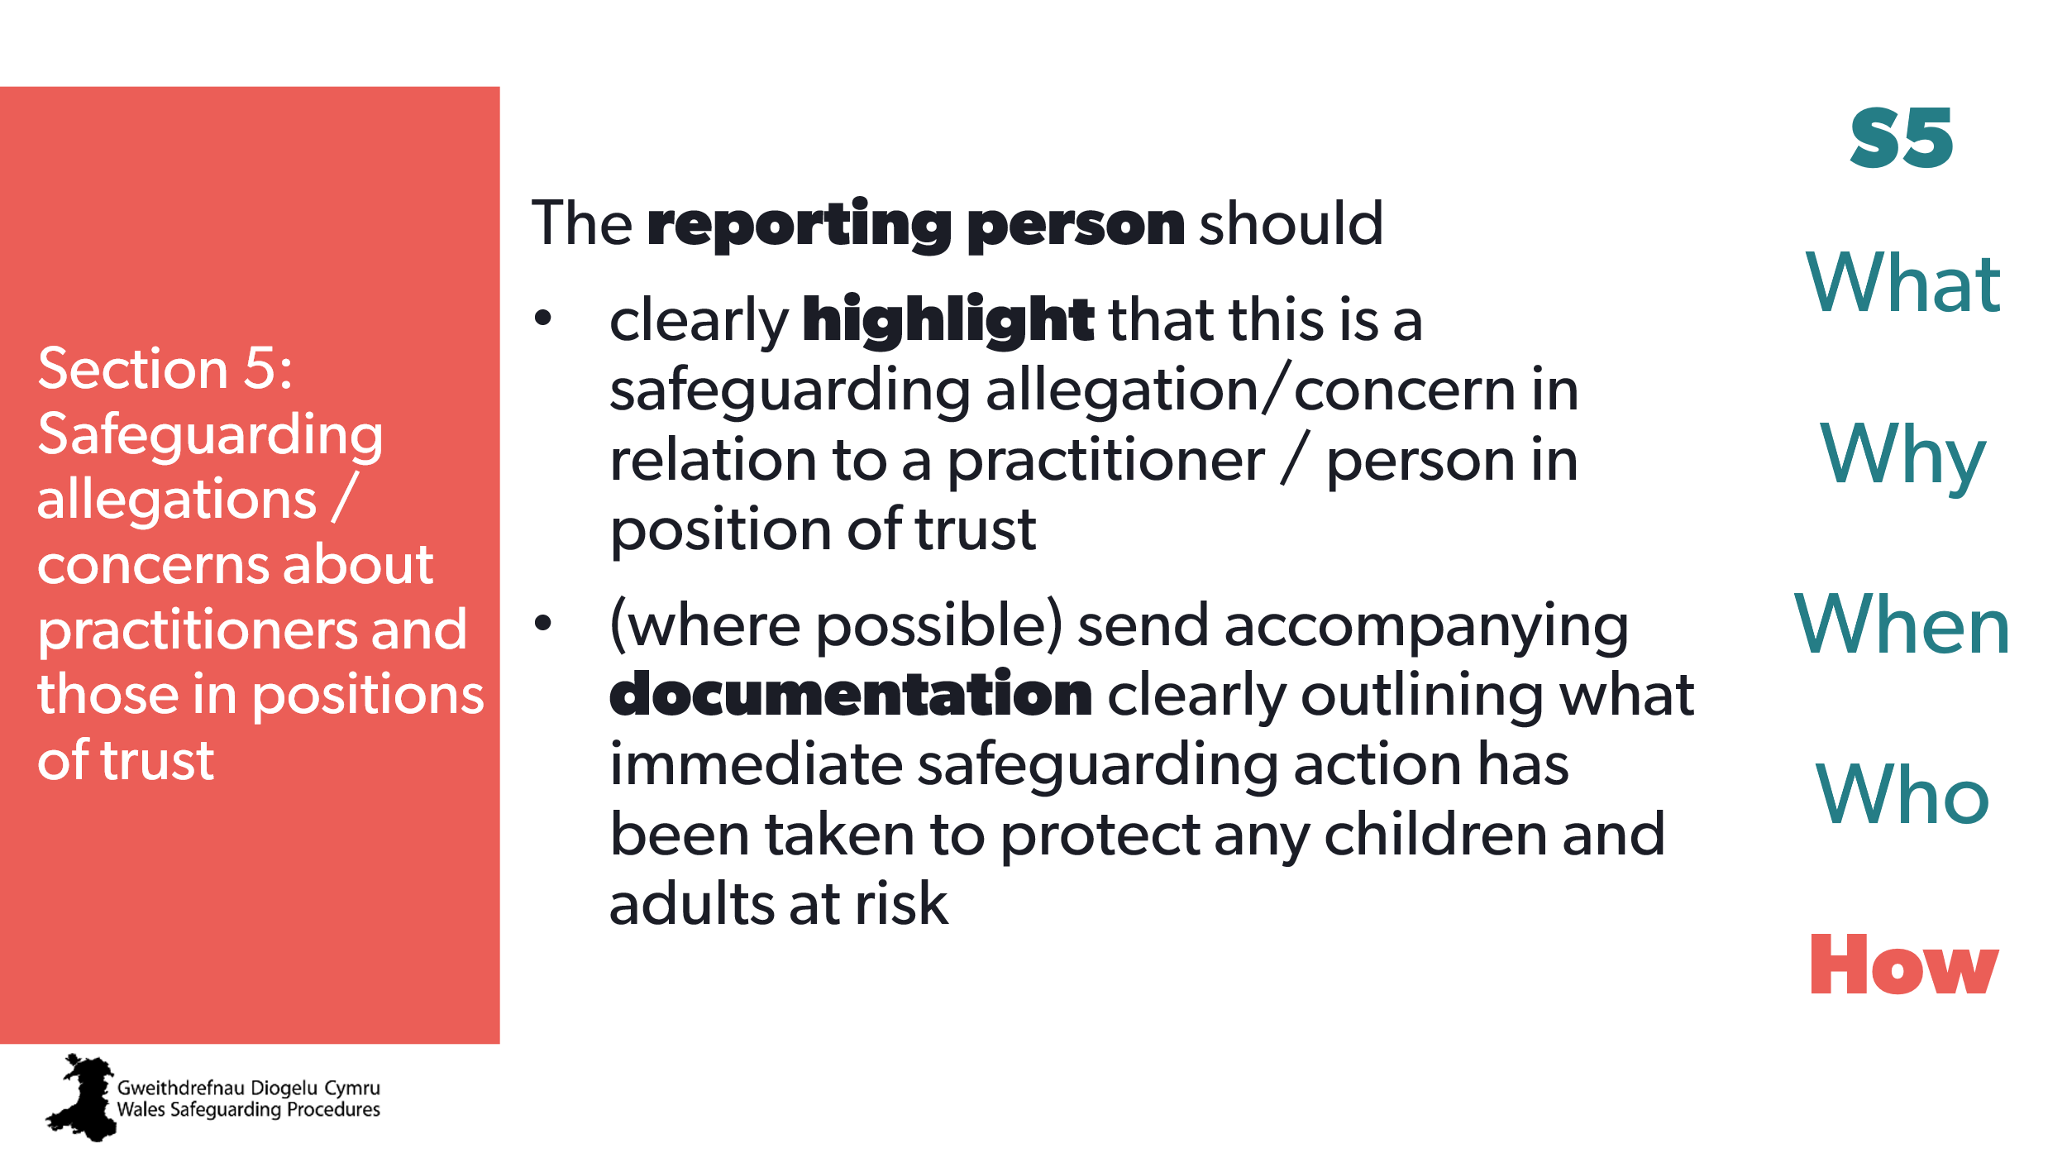 | Aim:  To provide an overview of actions for reporting person / person with the concern.
CYP 57  AR  66 | 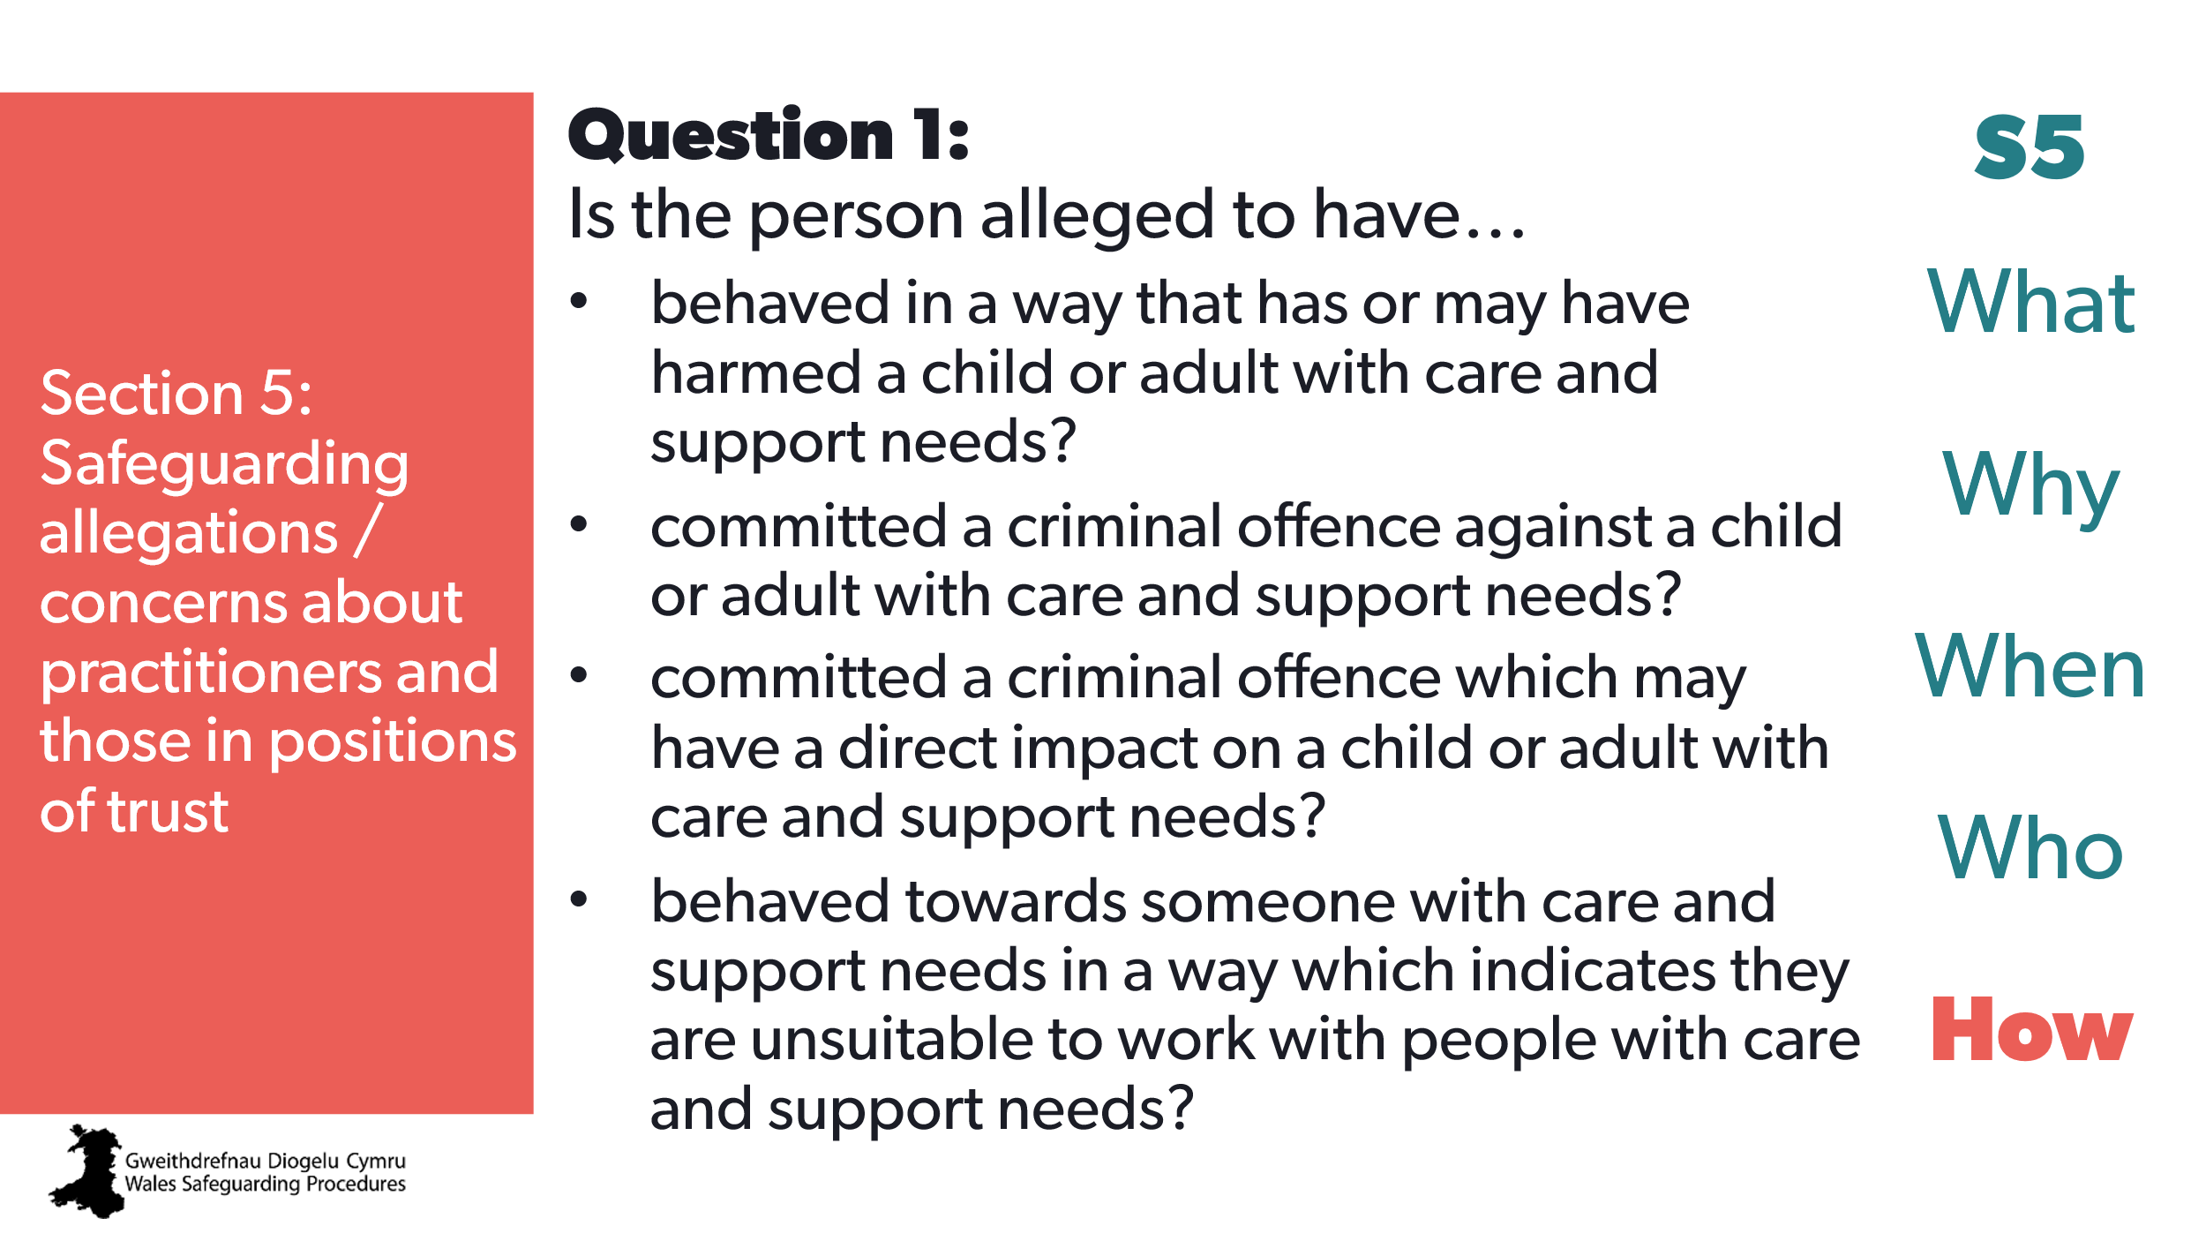 | Aim:  To look at how to determine if Section 5 procedures are appropriate.  Question 1 is about the person of concern
CYP 58  AR  67 | 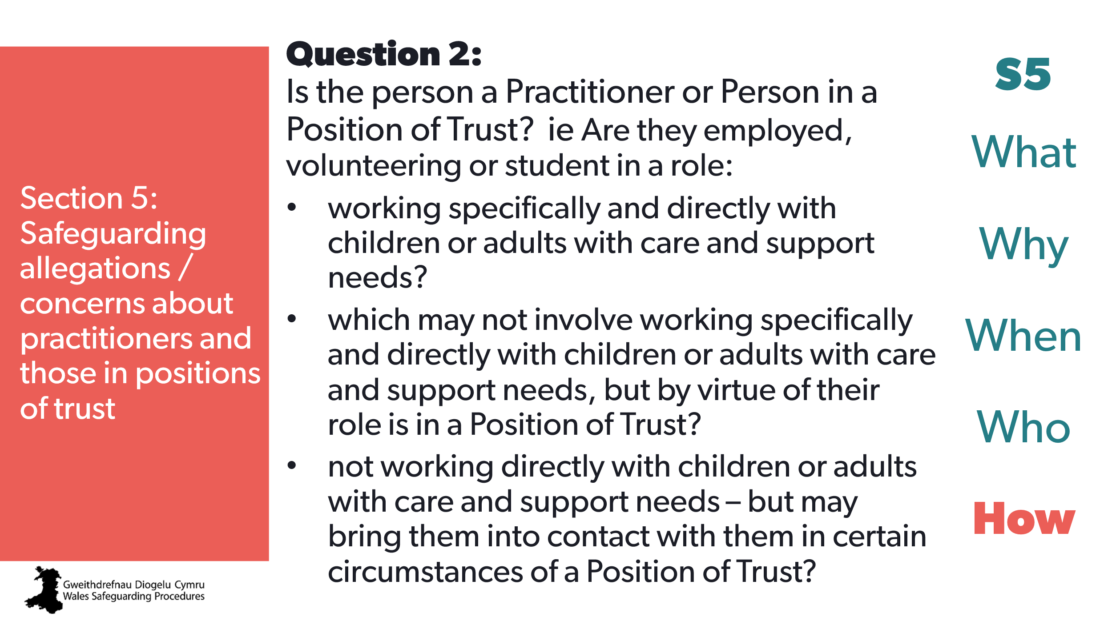 | Aim:  To look at how to determine if Section 5 procedures are appropriate.  Question 2 is about the behaviour of concern.
CYP 59  AR  68 | 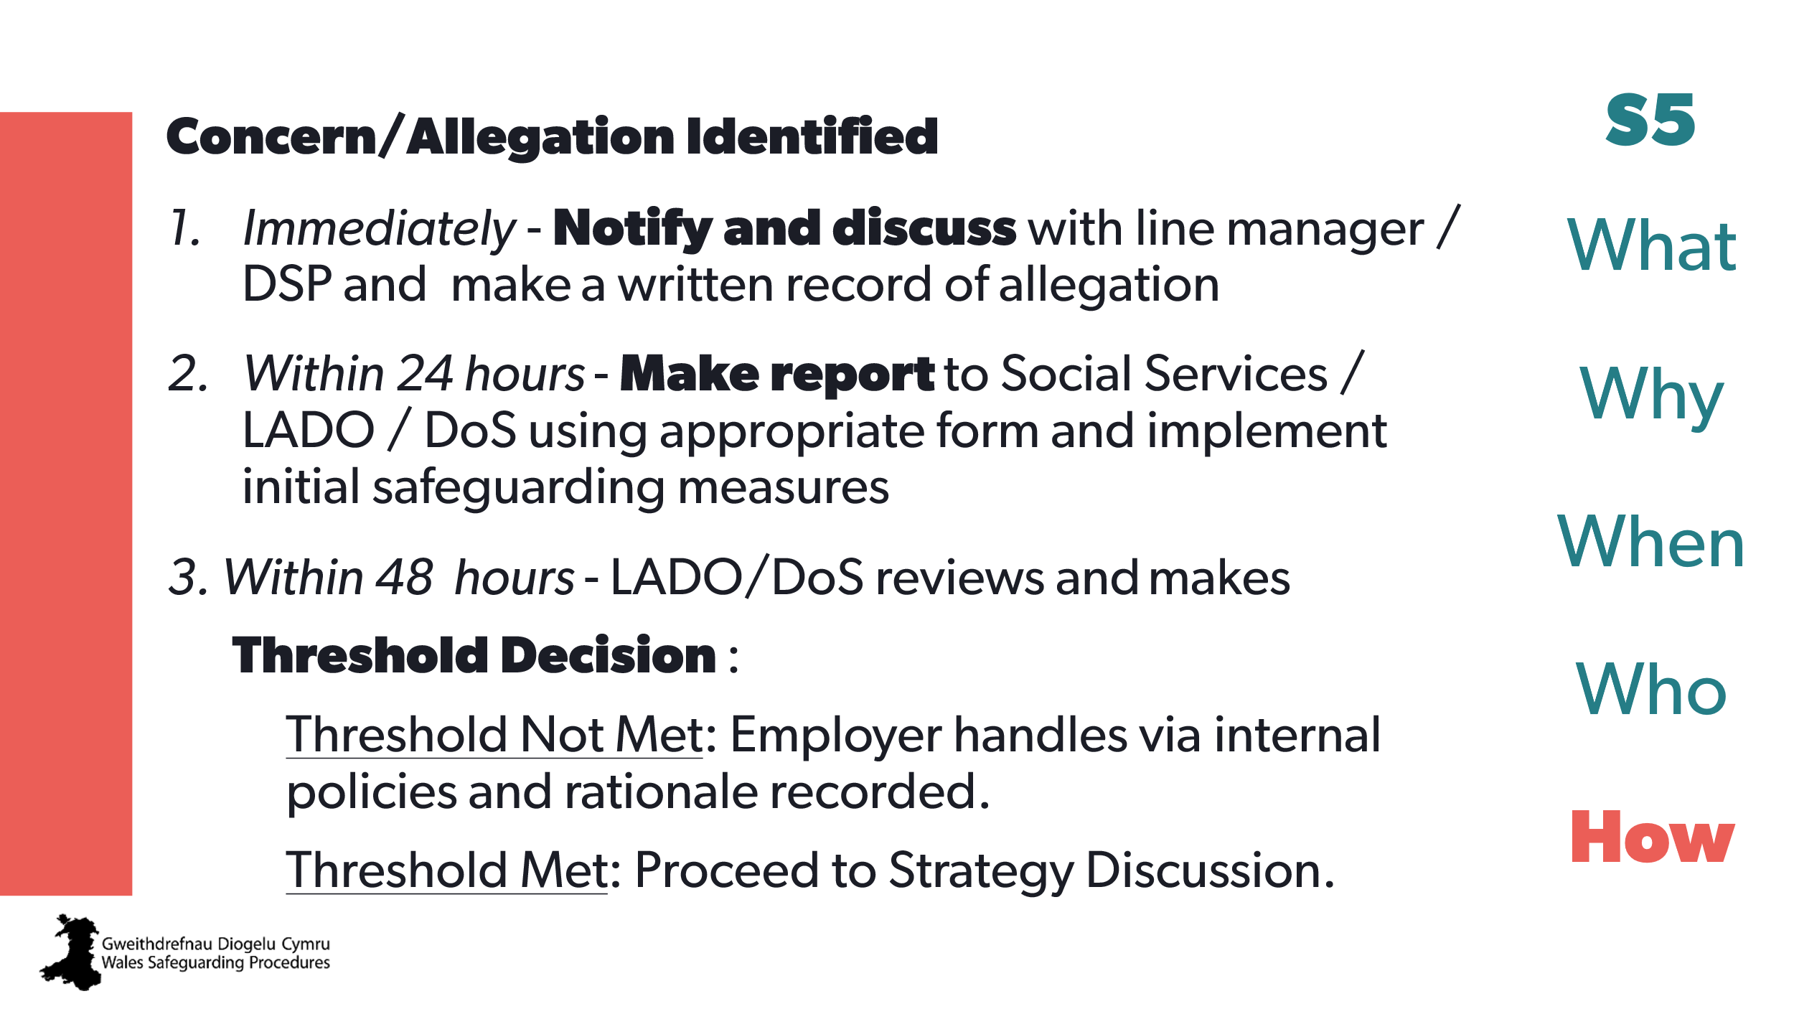 | Aim:  To go through the steps in the process from concern through conclusion.
CYP 60  AR  69 | 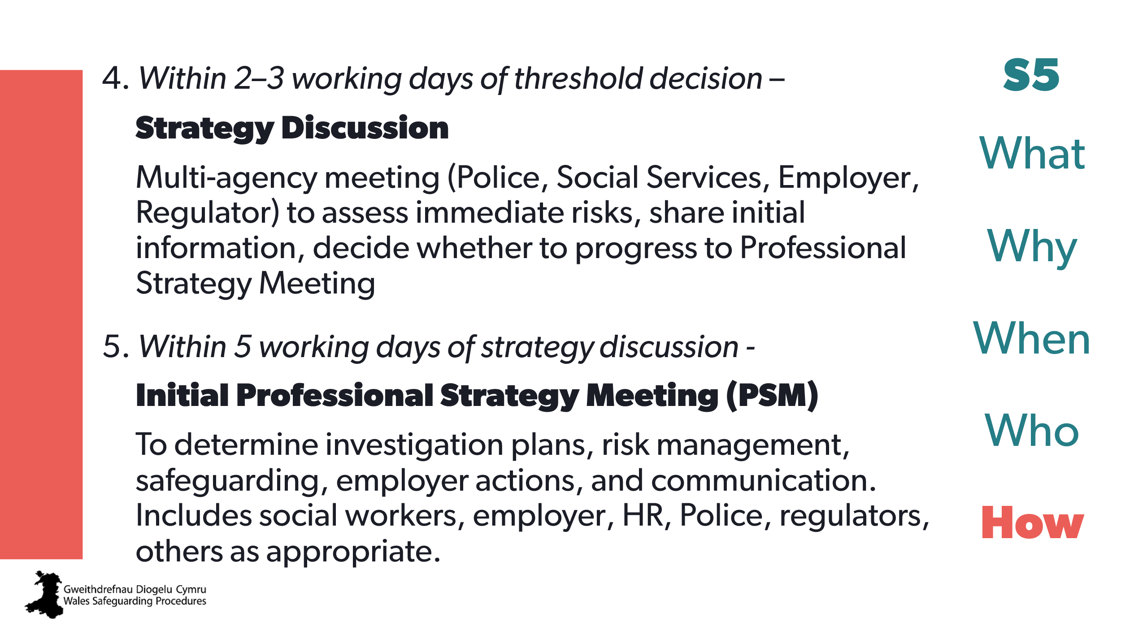
CYP 61  AR  70 | 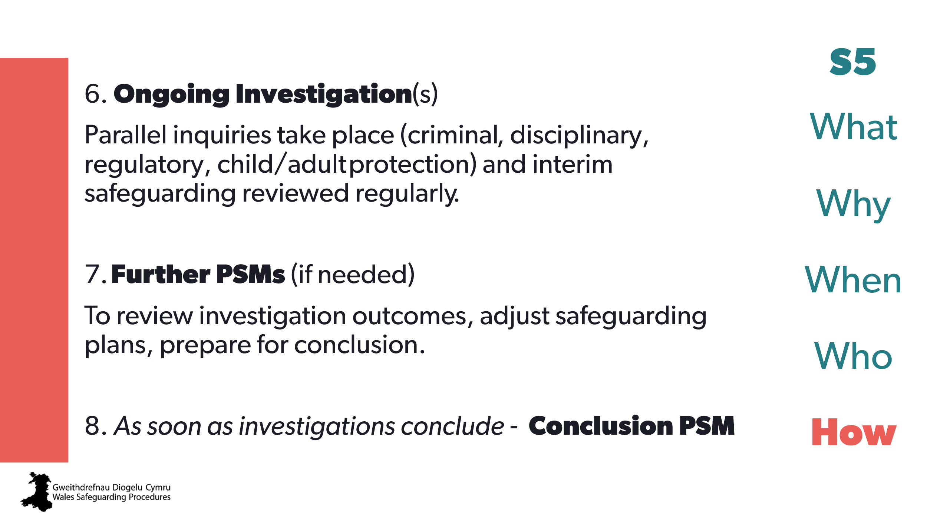
CYP 62  AR  71 | 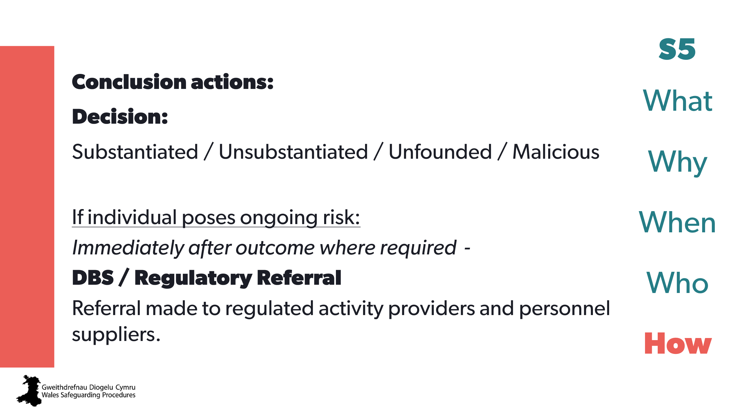
CYP 63  AR  72 | 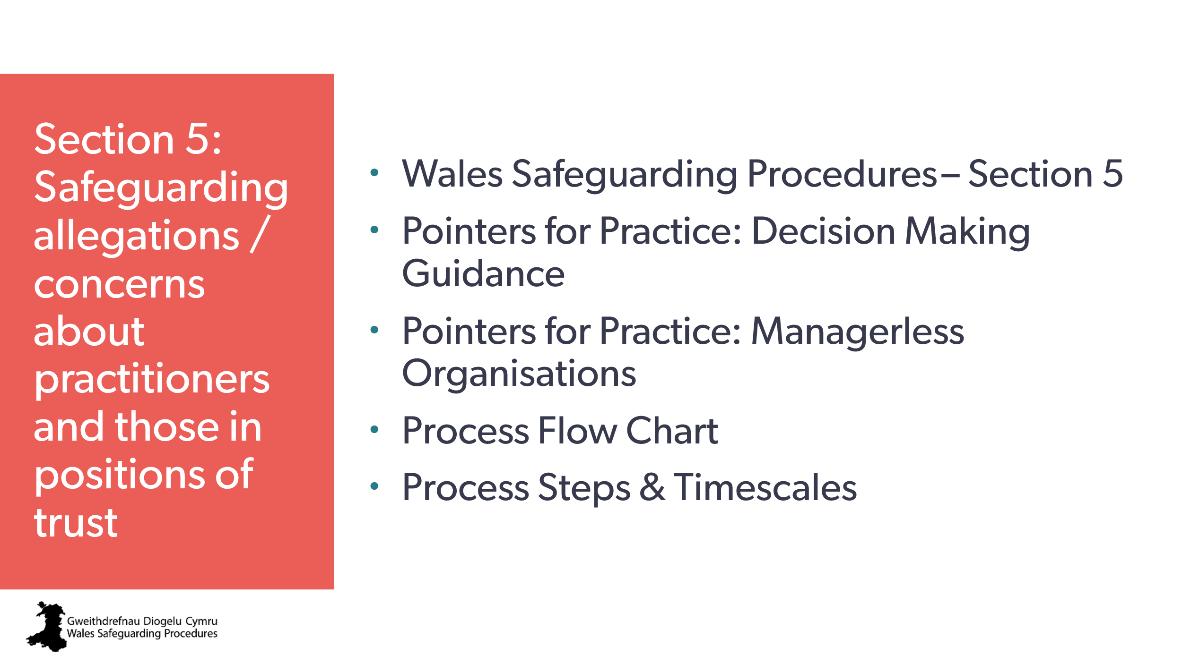 | Aim:  To list all relevant resources and guidance that should be used.  To encourage those who may have responsibilities in Section 5 procedures to seek specific training.

