Safeguarding children and young people
Note: The information follows the order used in the Wales Safeguarding Procedures - helpful for anyone following along.
Slide number | Slide | Notes | References | CPD
1 | 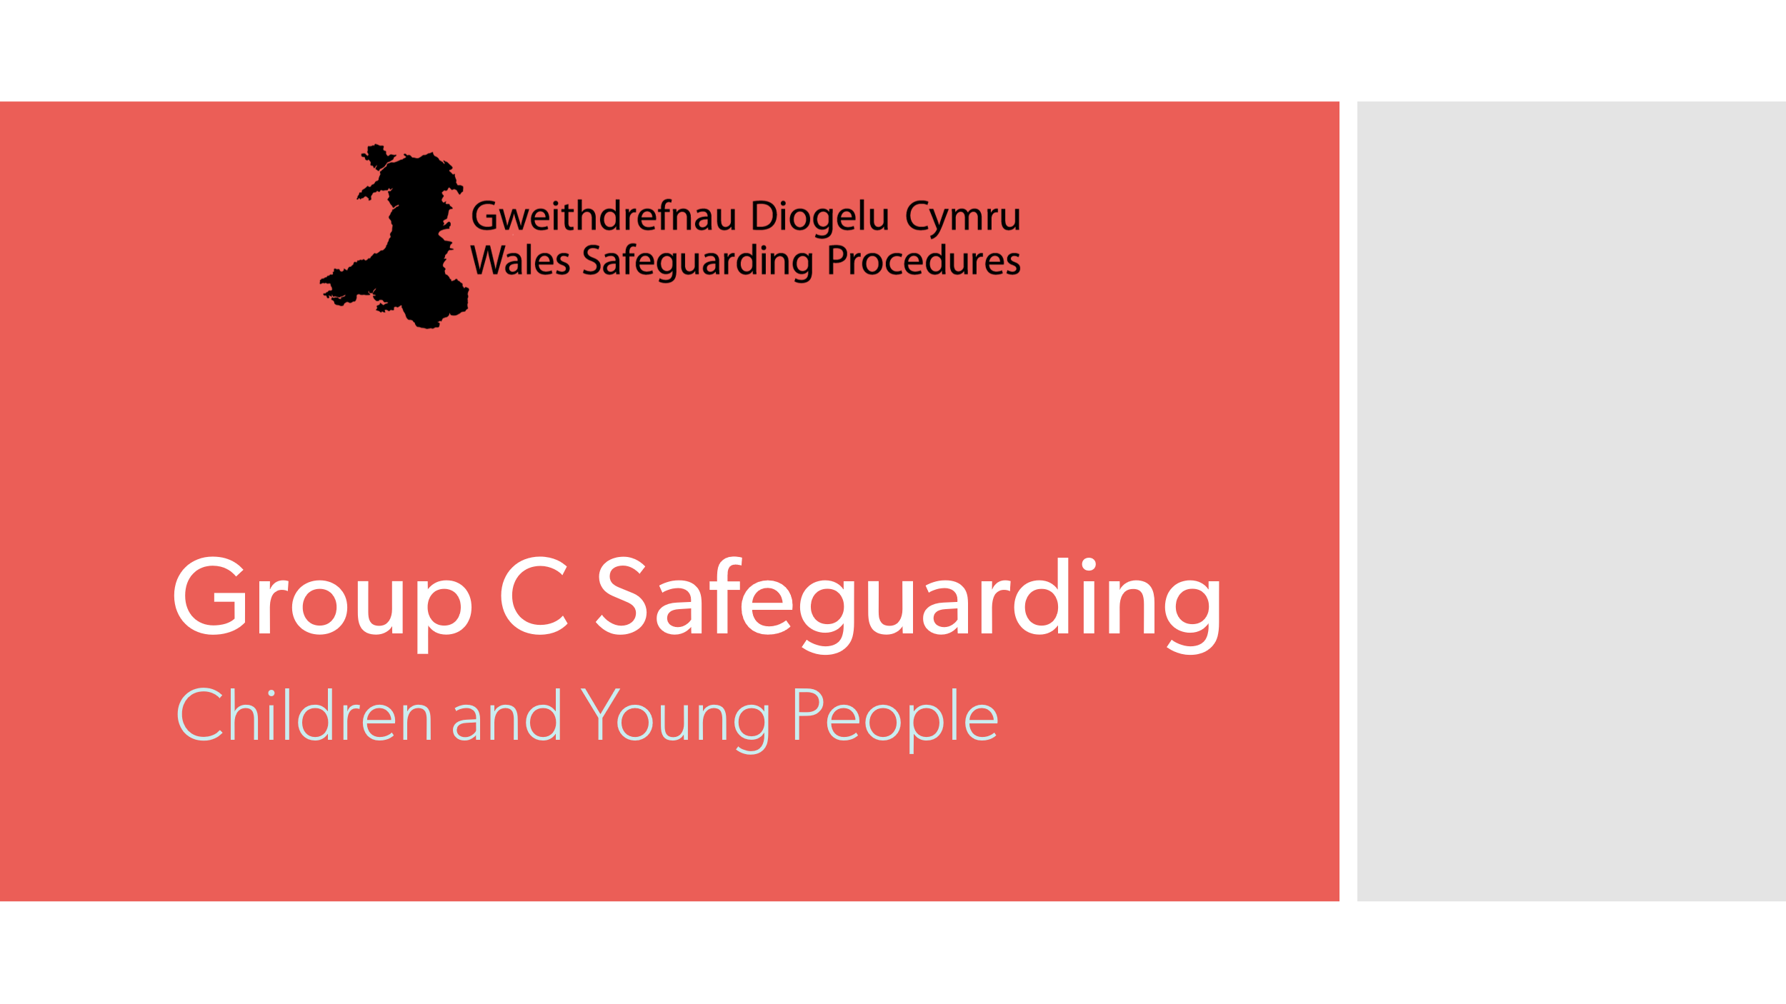 | Title slide to show the focus of this session is on safeguarding children and young people.
2 | 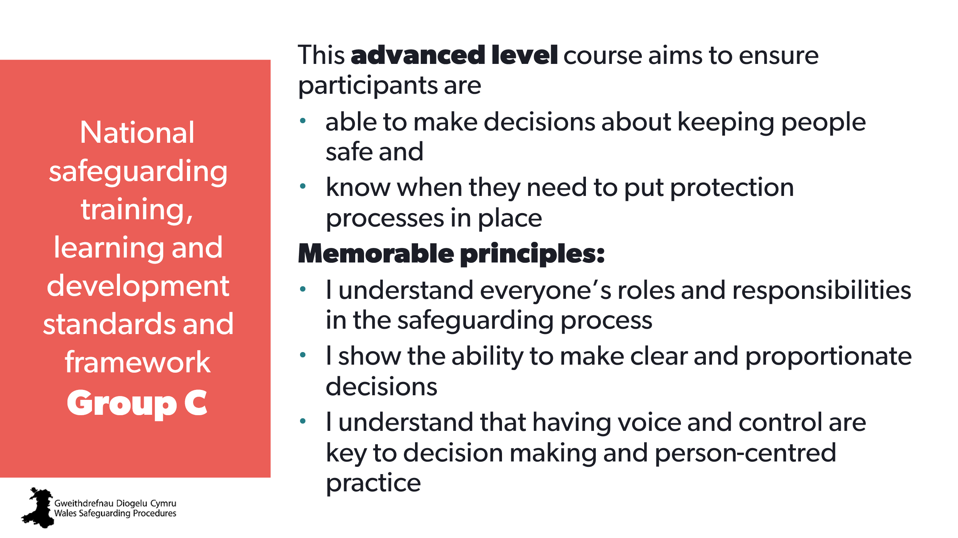 | Aim:  To ensure everyone understands the aims of the course (set expectations) and how it is relevant to their roles. | National safeguarding training, learning and development standards - group C  National safeguarding training, learning and development framework - group C | Use the standards and framework to develop a personal development plan for safeguarding skills and knowledge.
3 | 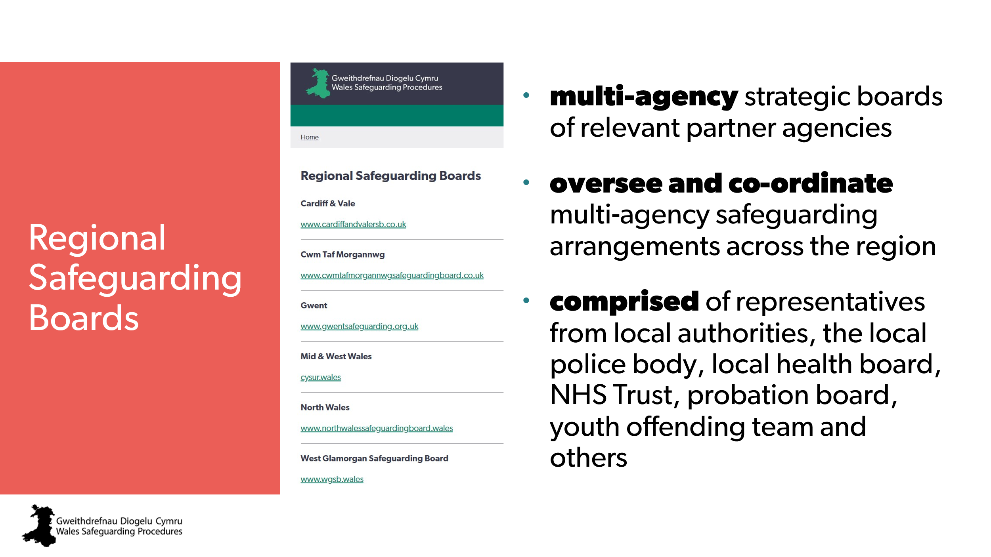 | Aim:  To ensure everyone is aware of their Regional Safeguarding Board (RSB) and the resources and support available. | Wales Safeguarding Procedures  - Introduction  - Regional Safeguarding Boards
4 | 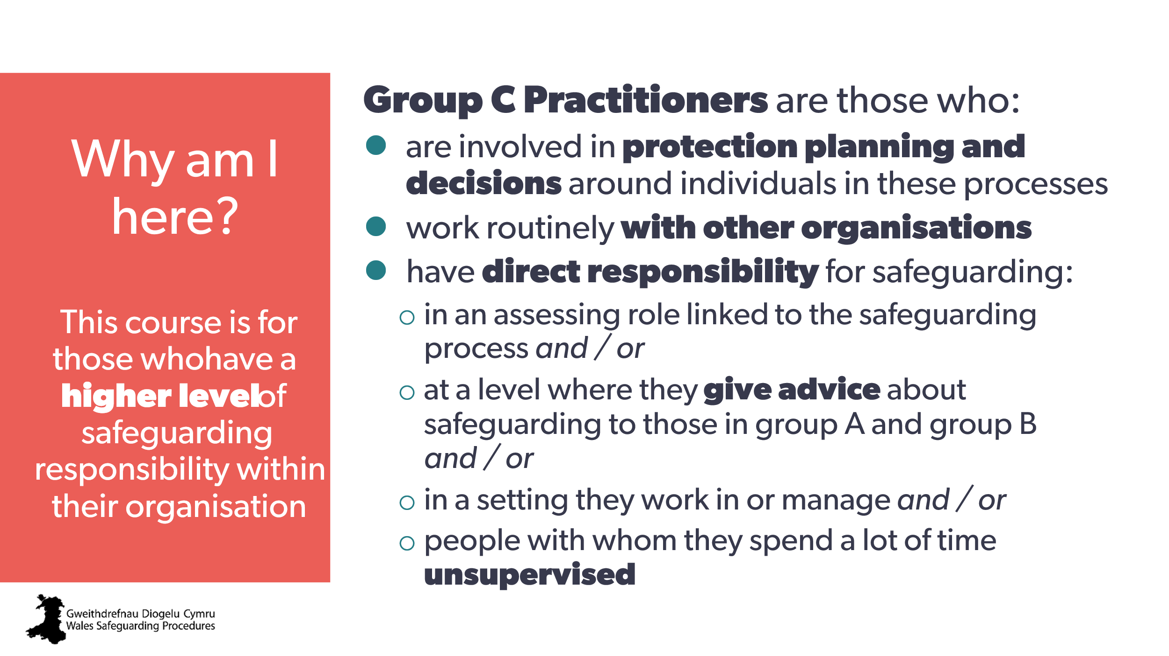 | Aim:  To set expectations of Group C practitioners and the relevance to individual roles.  Trainer to explain:  - this is part of a generic Group C safeguarding training that everyone in Group C must do.  - additional training that is relevant to specific roles and responsibilities will be needed following completion of the generic Group C training. | National safeguarding training, learning and development standards - group C  https://socialcare.wales/resources-guidance/safeguarding-list/national-safeguarding-training-learning-and-development-standards/safeguarding-standards-group-c | Additional training that is relevant to specific roles and responsibilities
5  6  7 | 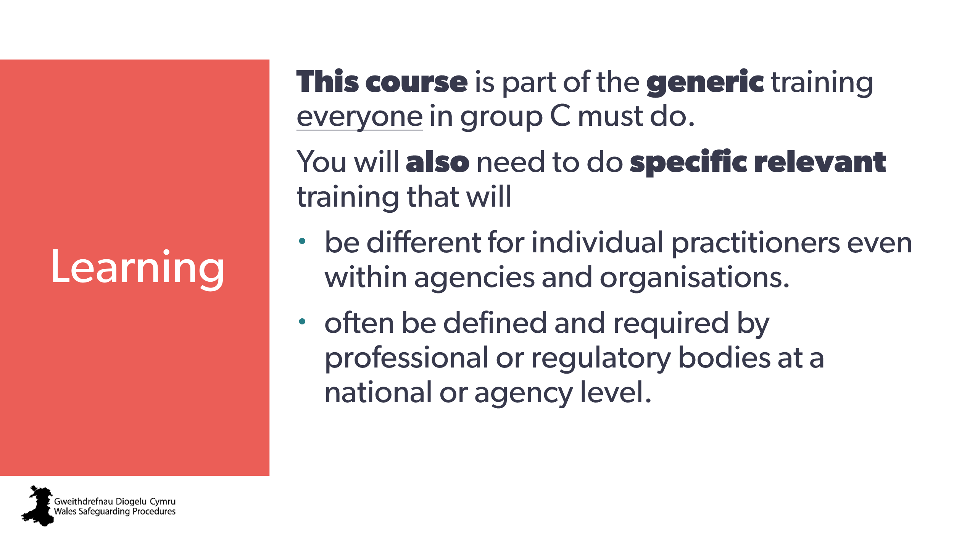  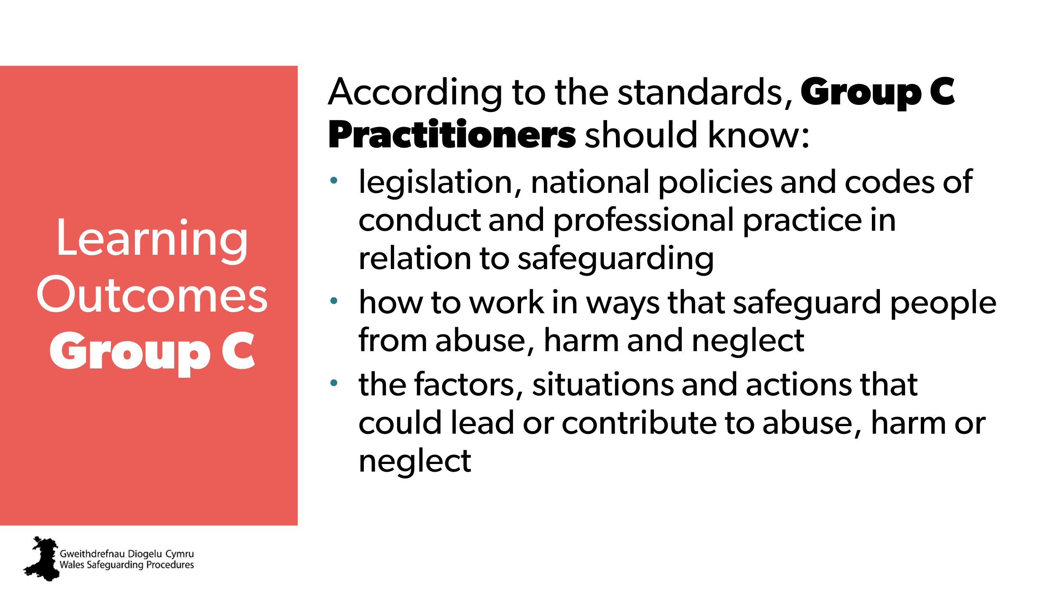  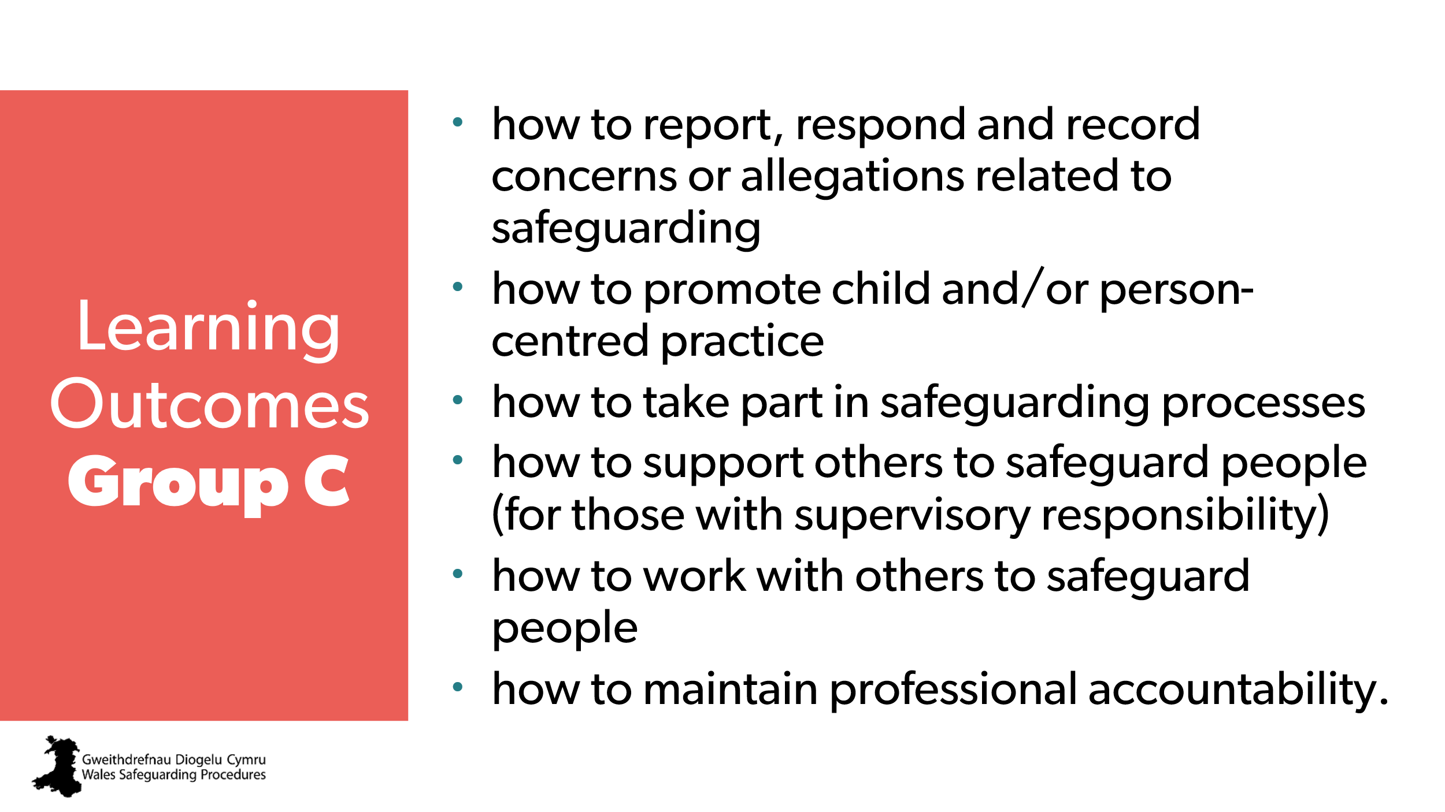 | Aim:  To ensure everyone is aware of the expectations set by the framework and standards.  Optional:  - trainer may wish to direct people to the standards on their phone/laptop  - this could be a handout. | National safeguarding training, learning and development standards - group C
8 |  | Note: blank text box to add group/venue-specific aspects  Aim:  - to develop rapport, trust and emotional safety (trauma informed approach)  - to find out if there are specific issues that may need addressing  - to find out if there are any particular learning needs  - to set expectations.  Note to trainer:  If possible, sit down with the group to be ‘part of’ the group and change the power dynamic to a more equal one to support confidence.  If there are very experienced people in the room:  Reassure them that:  - much of this information should be a refresh for them and a way to ensure they are as up to date as possible  - this course is designed to enable sharing of experience and ideas – encourage them to add their practical knowledge  - emphasise that this is a baseline course that everyone must do as a starting point – addressing aspects common to all sectors and services.  - remind: there is always something new to learn in safeguarding!  If there are people very new to this level of safeguarding:  You may wish to:  - reassure them that there will be opportunities for CPD and further learning following this course  - encourage them to ask questions and learn from the experience of those around them
9 | 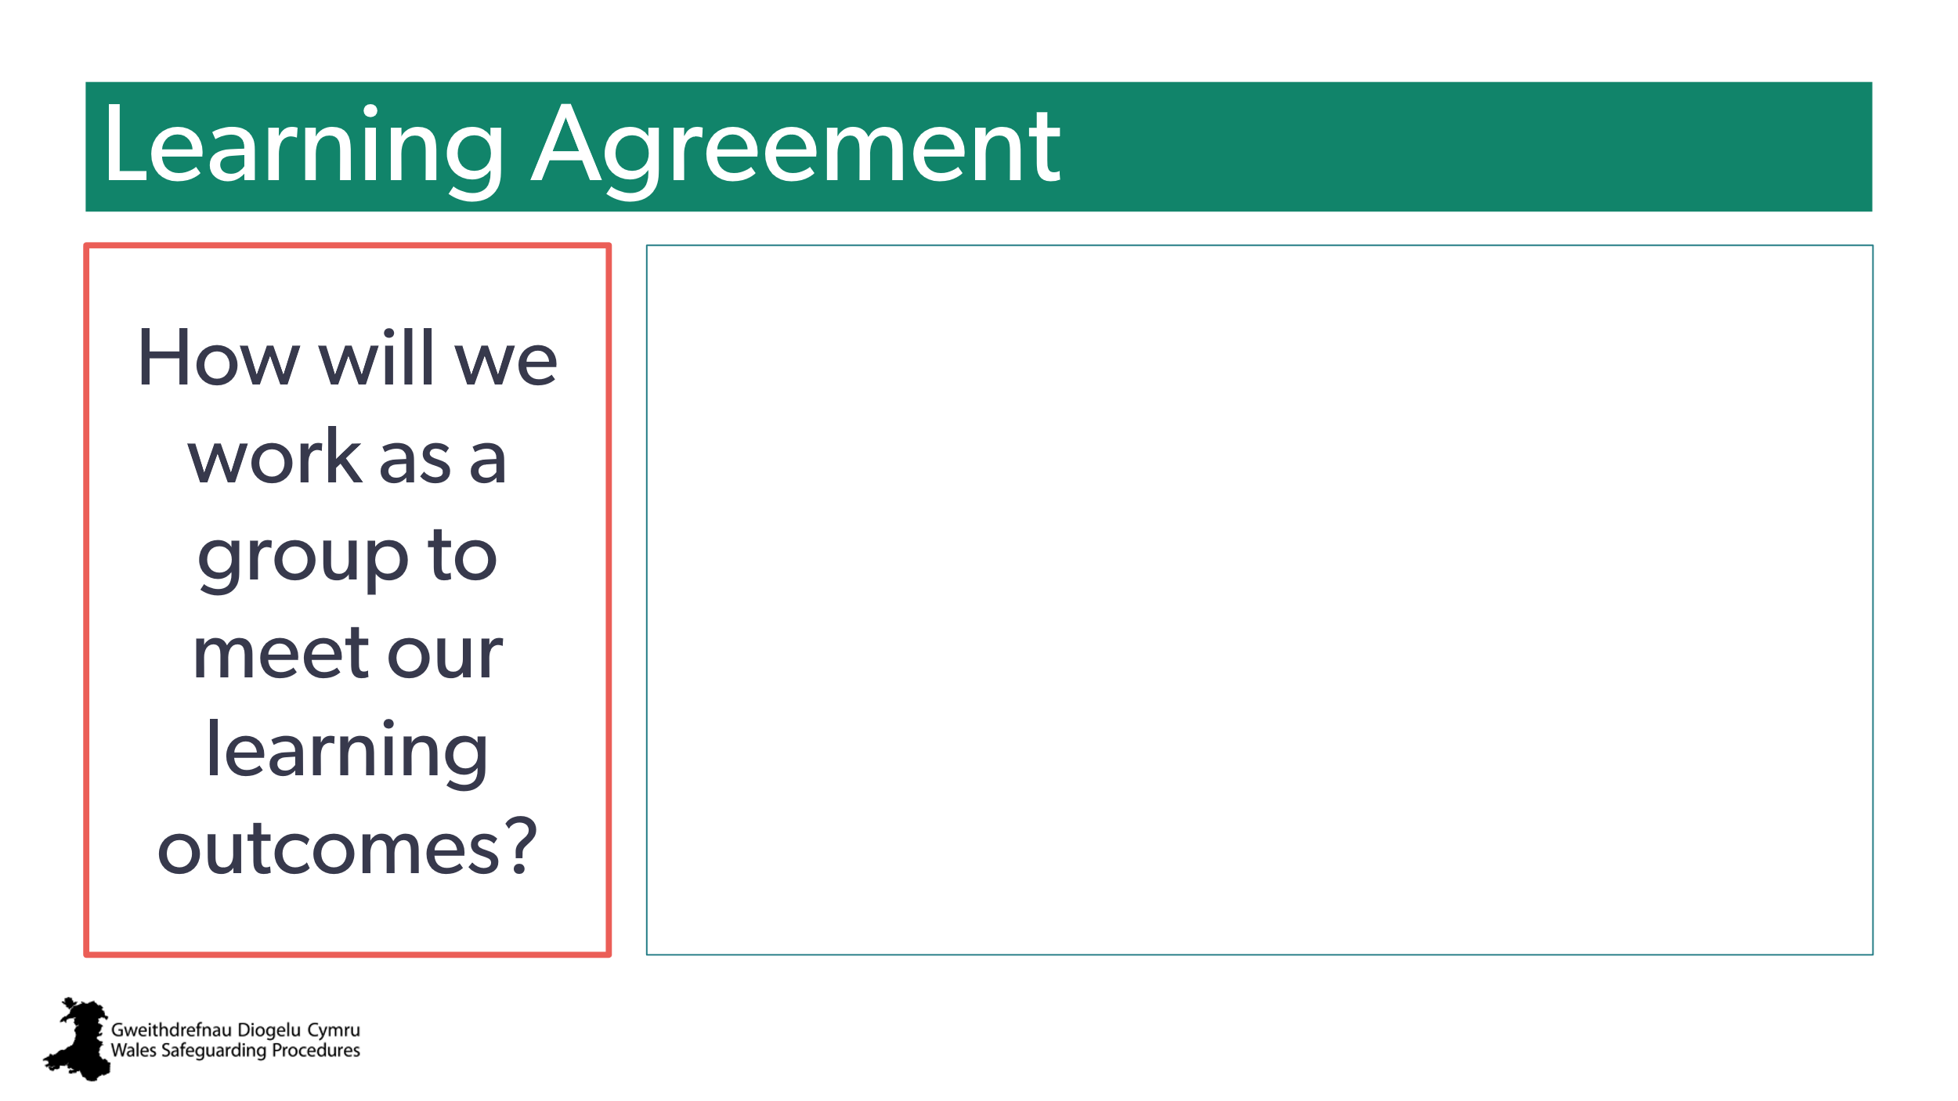 | Note: blank text box to add group/venue-specific aspects.  Aim:  - to set out what’s expected  - to manage and set expectations for contributing and participation  - to highlight expectation of individual learning responsibility.  Notes to trainer:  - people on course may be in completely different roles – encourage more experienced to share knowledge with those less experienced.  - they need to consider how this is relevant to them within their own roles  - encourage people to apply learning to their own individual roles.  Trainer to stress:  Highlight the importance of consolidating learning after today and ask learners to be thinking about practical activities they could carry out following today’s session, to gain further experience and/ or embed their learning. |  | practical activities they could carry out following today’s session, to gain further experience and/ or embed their learning.
10 | 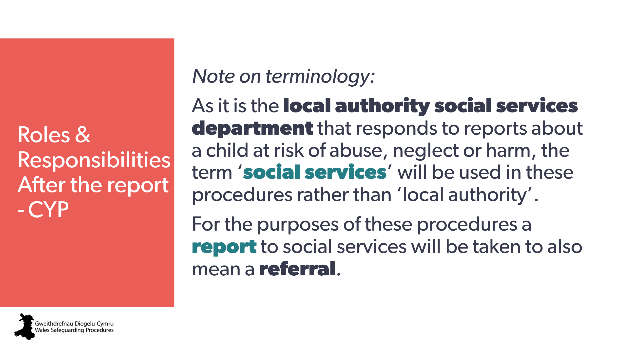 | Aim:  - transition slide into this section of the full Group C course  - to explain terminology to be used  Trainer to explain:  We’re now going to look at what happens after you’ve submitted a safeguarding report to social services, and what involvement you might have in that process.  A key principle throughout this process should always be making the child safe.
11 | 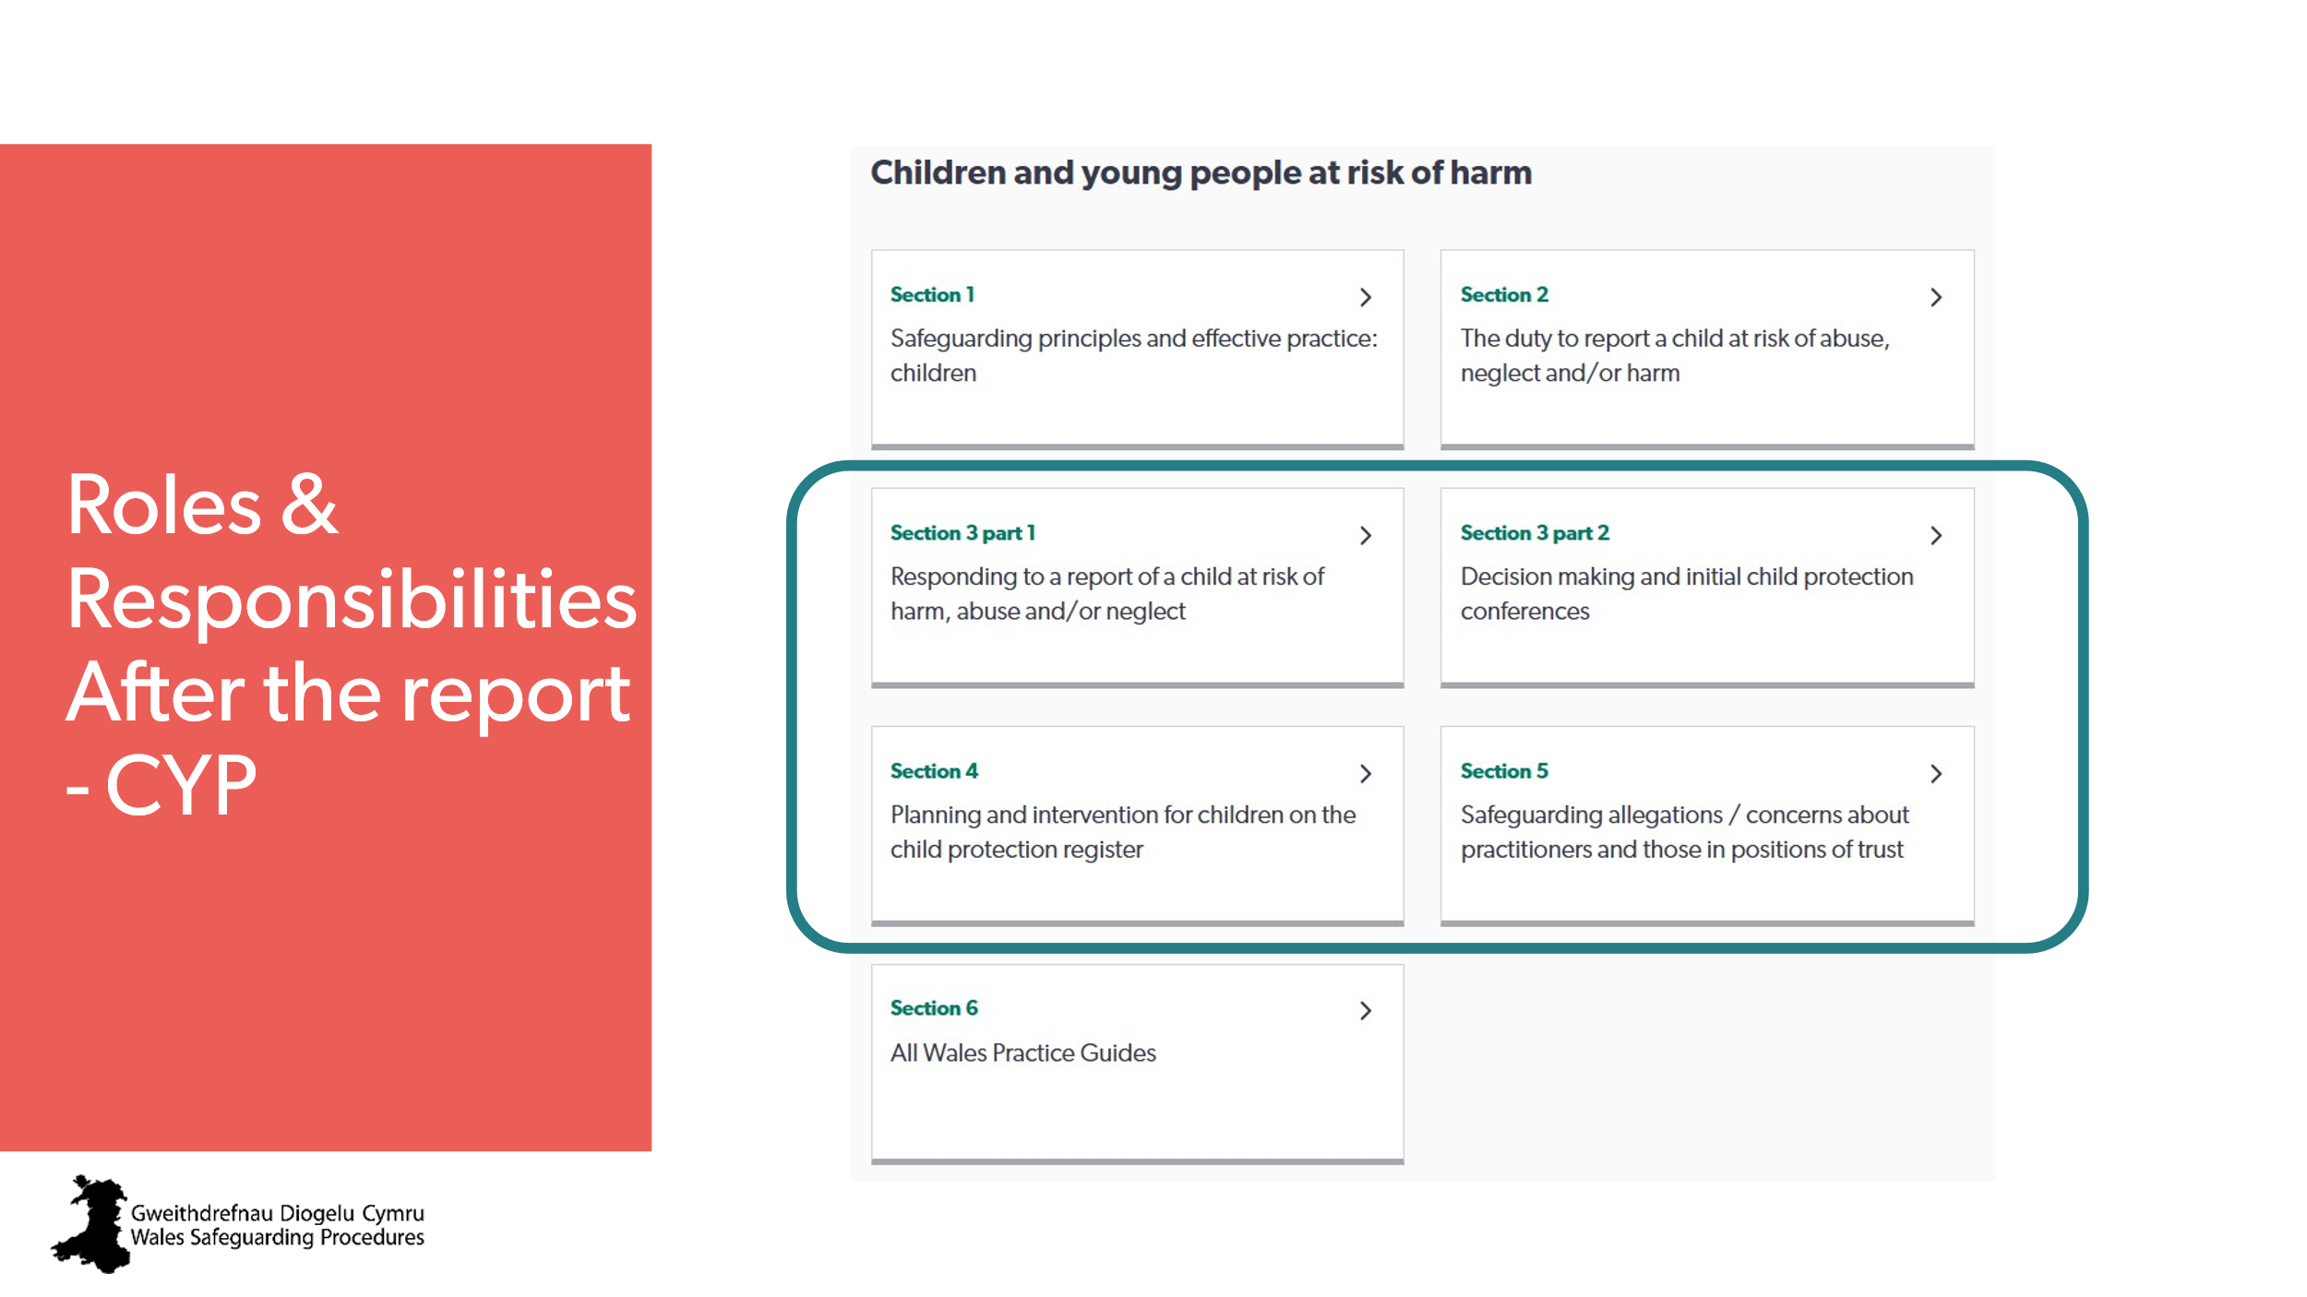 | Aim:  To show the sections of the Wales Safeguarding Procedures that will be covered in this session.  Trainer to suggest:  Invite all learners to follow along on the Wales Safeguarding Procedures app/website. | Wales Safeguarding Procedures  - Section 3 part 1  Responding to a report of a child at risk of harm, abuse and/or neglect  - Section 3 part 2  Decision making and initial child protection conferences  - Section 4  Planning and intervention for children on the child protection register  - Section 5  Safeguarding allegations / concerns about practitioners and those in positions of trust
12 | 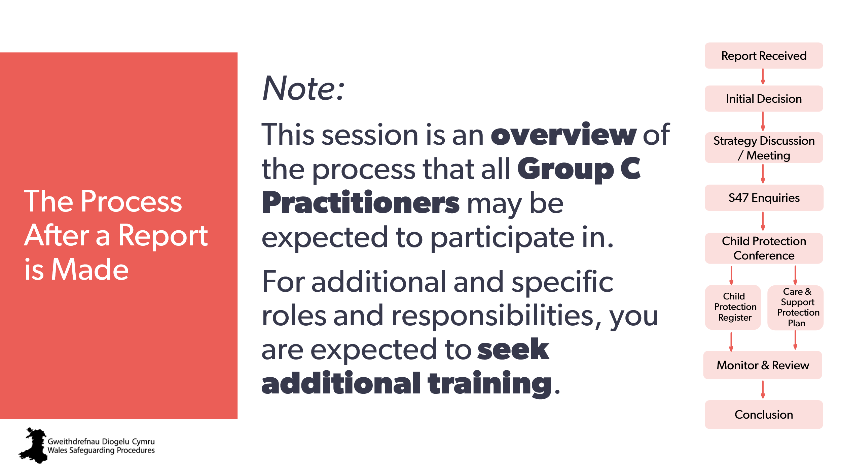 | Aim:  To give an overview of the process  To clarify that we’ll only be looking at the expectations for the majority of people.  Trainer to explain:  Throughout this section, we will be following the full process, which we’ll show in a flowchart on the right of the screen.  We’ll focus on the role of the general practitioner. There are many other roles in the process, and the details for these are in the Wales Safeguarding Procedures, but as this is an overview, we’ll just be focussing on what all Group C practitioners may be expected to do.  Section 2 of the Wales Safeguarding Procedures ends with the submission of the report.  Section 3.1 starts with the receipt of that report and everything that follows.  We’re starting with Section 3.1 of the Wales Safeguarding Procedures  You’re welcome to follow along if you have the app on your phone. | Wales Safeguarding Procedures  Section 3 part 1  Responding to a report of a child at risk of harm, abuse and/or neglect  Pointers for Practice: Subjective Factors that Can Influence the Receipt of a Report  Pointers for Practice:  Eliciting Information Following Report-The Challenges | Specific or special roles and responsibilities
13 | 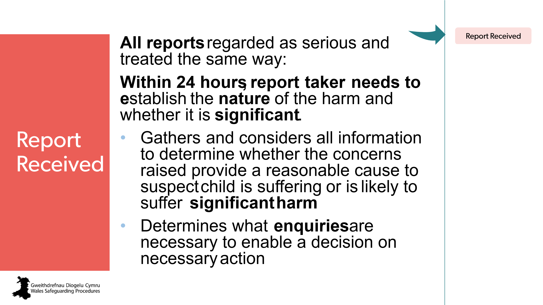 | Aim:  To review this stage of process.  Trainer to explain:  Ask  What is ‘significant harm’?  This is difficult – there’s no set definition or criteria – it’s on a case-by-case basis.  Another way of looking at it is: could this need for protection be achieved with only one to two services, or does it require a full multi-agency approach and formal protection plan?  This is where your information on the referral form can be essential – what’s your professional judgement on this?  Trainer to point out:  Important to understand the difference between ‘enquiry’ and ‘investigation’. Investigate describes gathering evidence - only the police or social services can investigate.  Enquiries describes the information-gathering undertaken by social services in order to determine whether any action should be taken to safeguard the child or adult at risk. | Wales Safeguarding Procedures  Section 3 part 1  Responding to a report of a child at risk of harm, abuse and/or neglect  Establishing ‘significant harm’  Pointers for Practice: Assessing Significant Harm  Glossary > Enquiries  Working Together to Safeguard People: Information Sharing for Safeguarding Children  Information_sharing_advice_practitioners_safeguarding_services.pdf
14 | 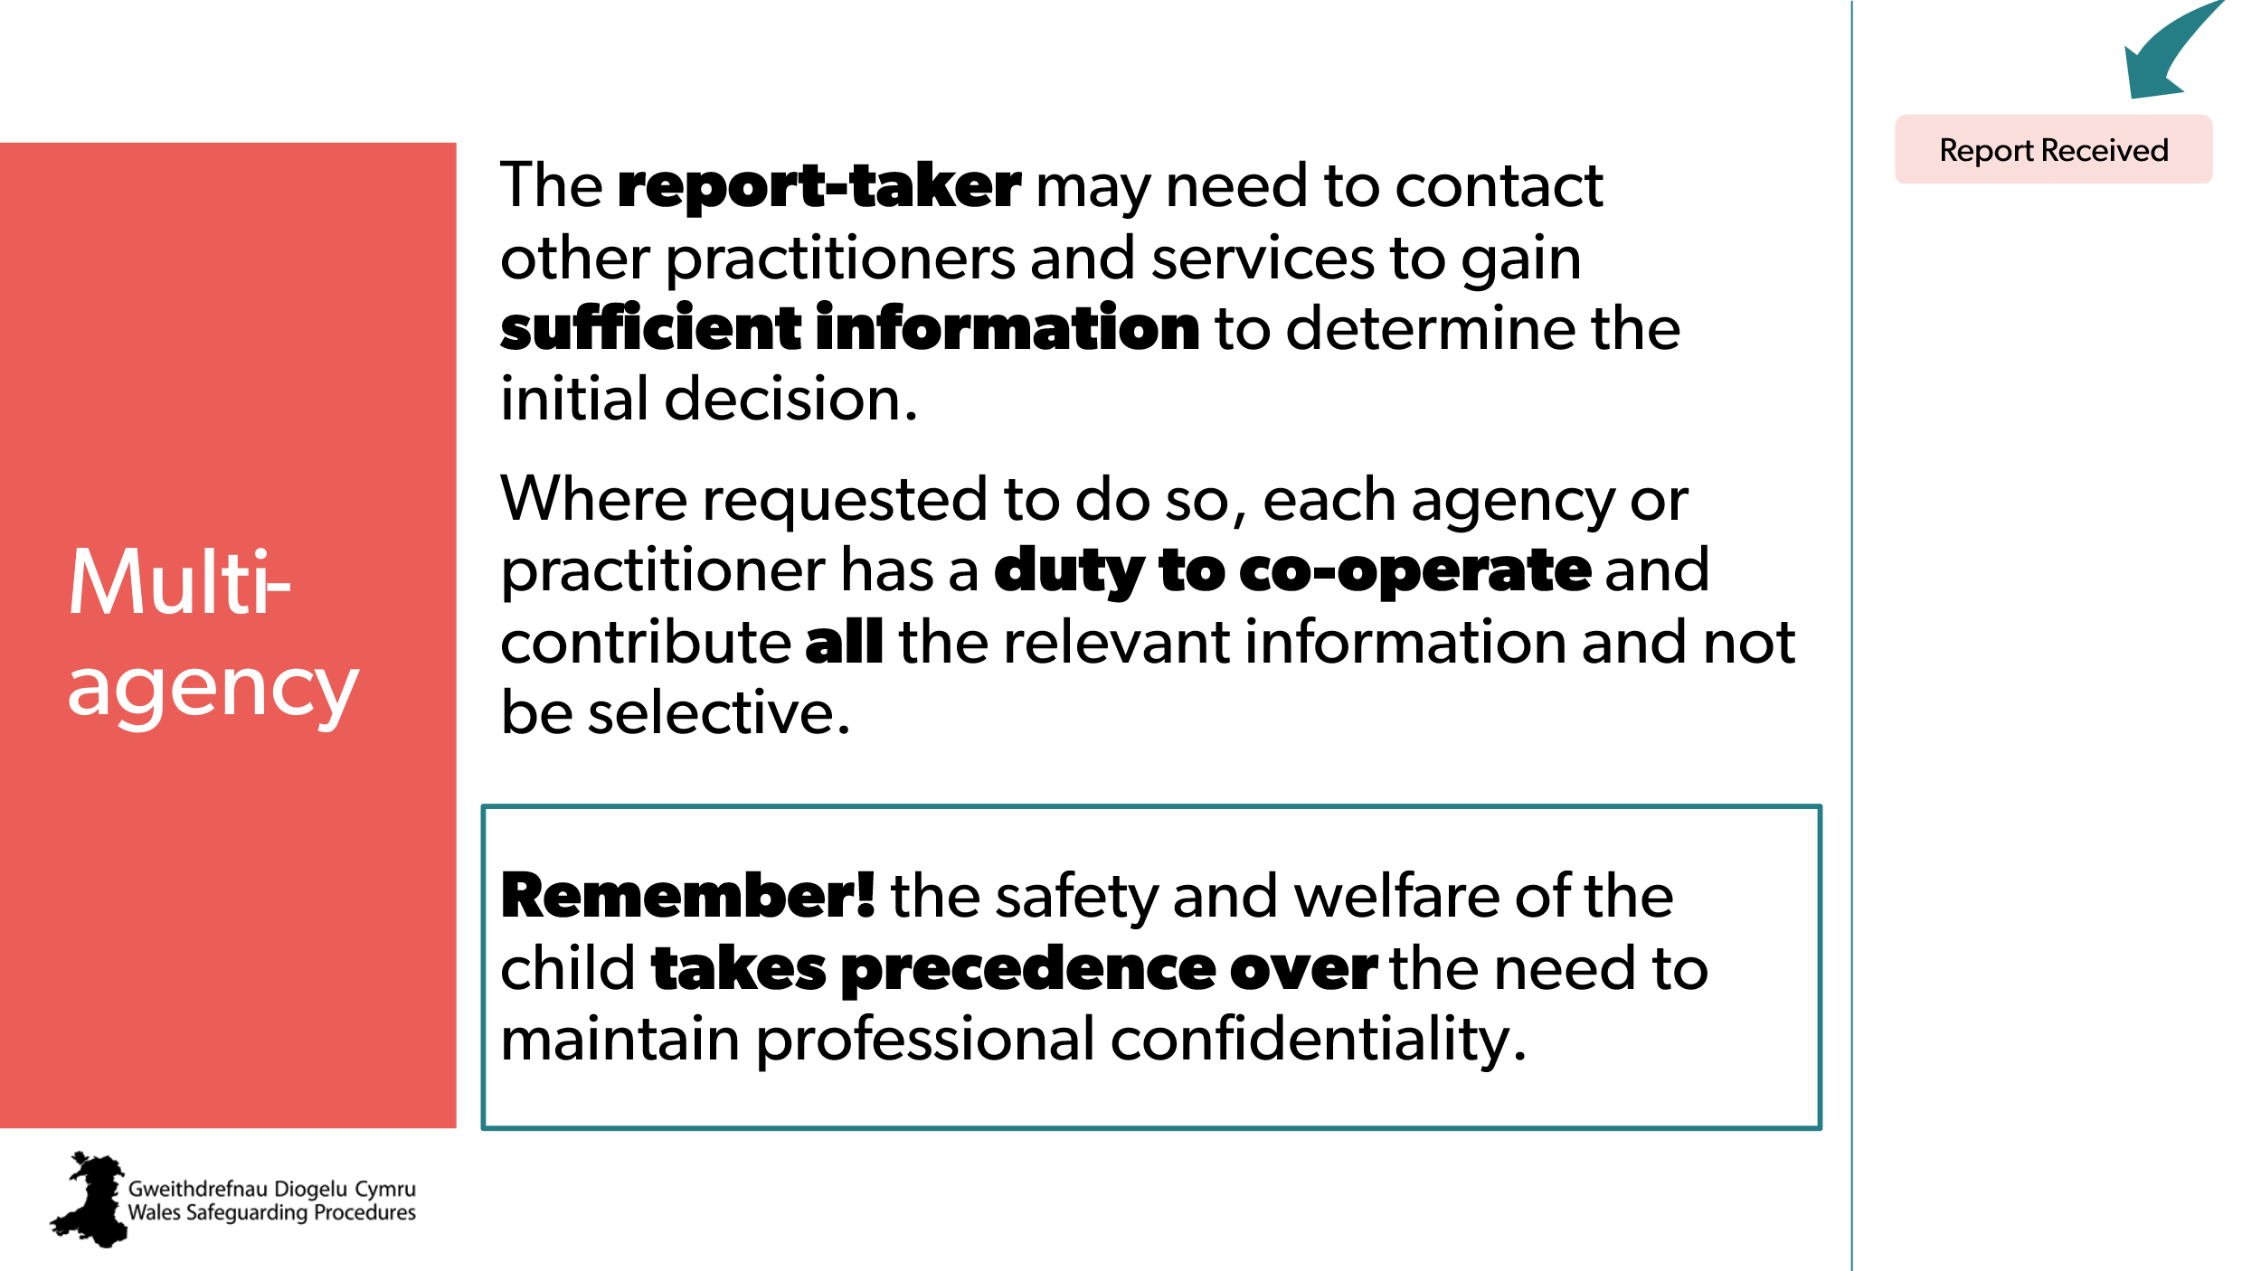 | Aim:  To give overview of the responsibilities of the report-taker | Receiving a report
15 | 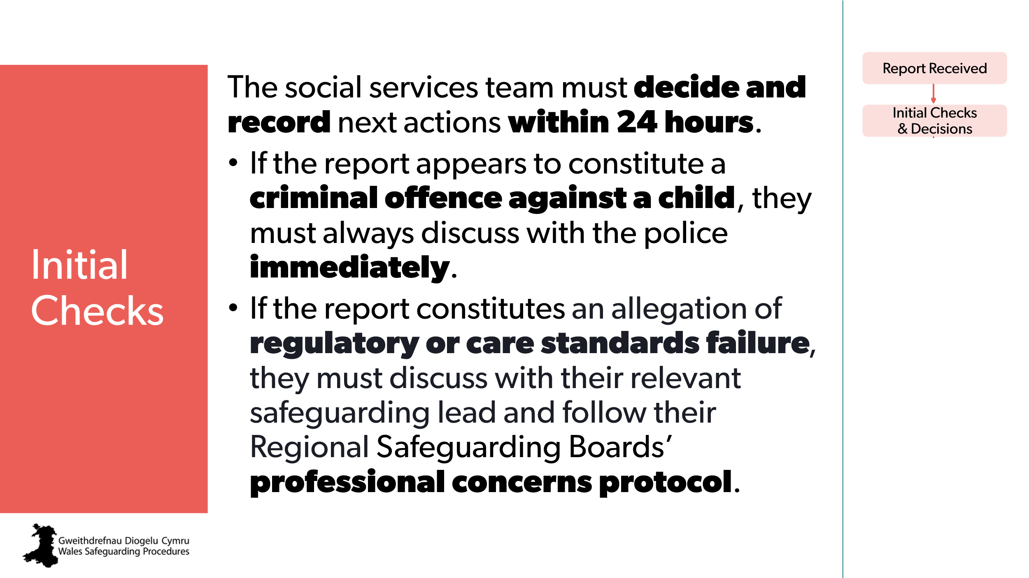 | Trainer may wish to note:  The focus should be the safety and well-being of the child:  - whenever something’s reported that appears to constitute a criminal offence against a child, social services must always discuss the case with the police immediately  - if the report constitutes an allegation of failure of care standards or breach of regulation by a regulated provider or a statutory agency, the report maker must discuss with their relevant safeguarding lead and follow Safeguarding Boards’ professional concerns protocol. | Action following a report: initial checks and decisions
16 | 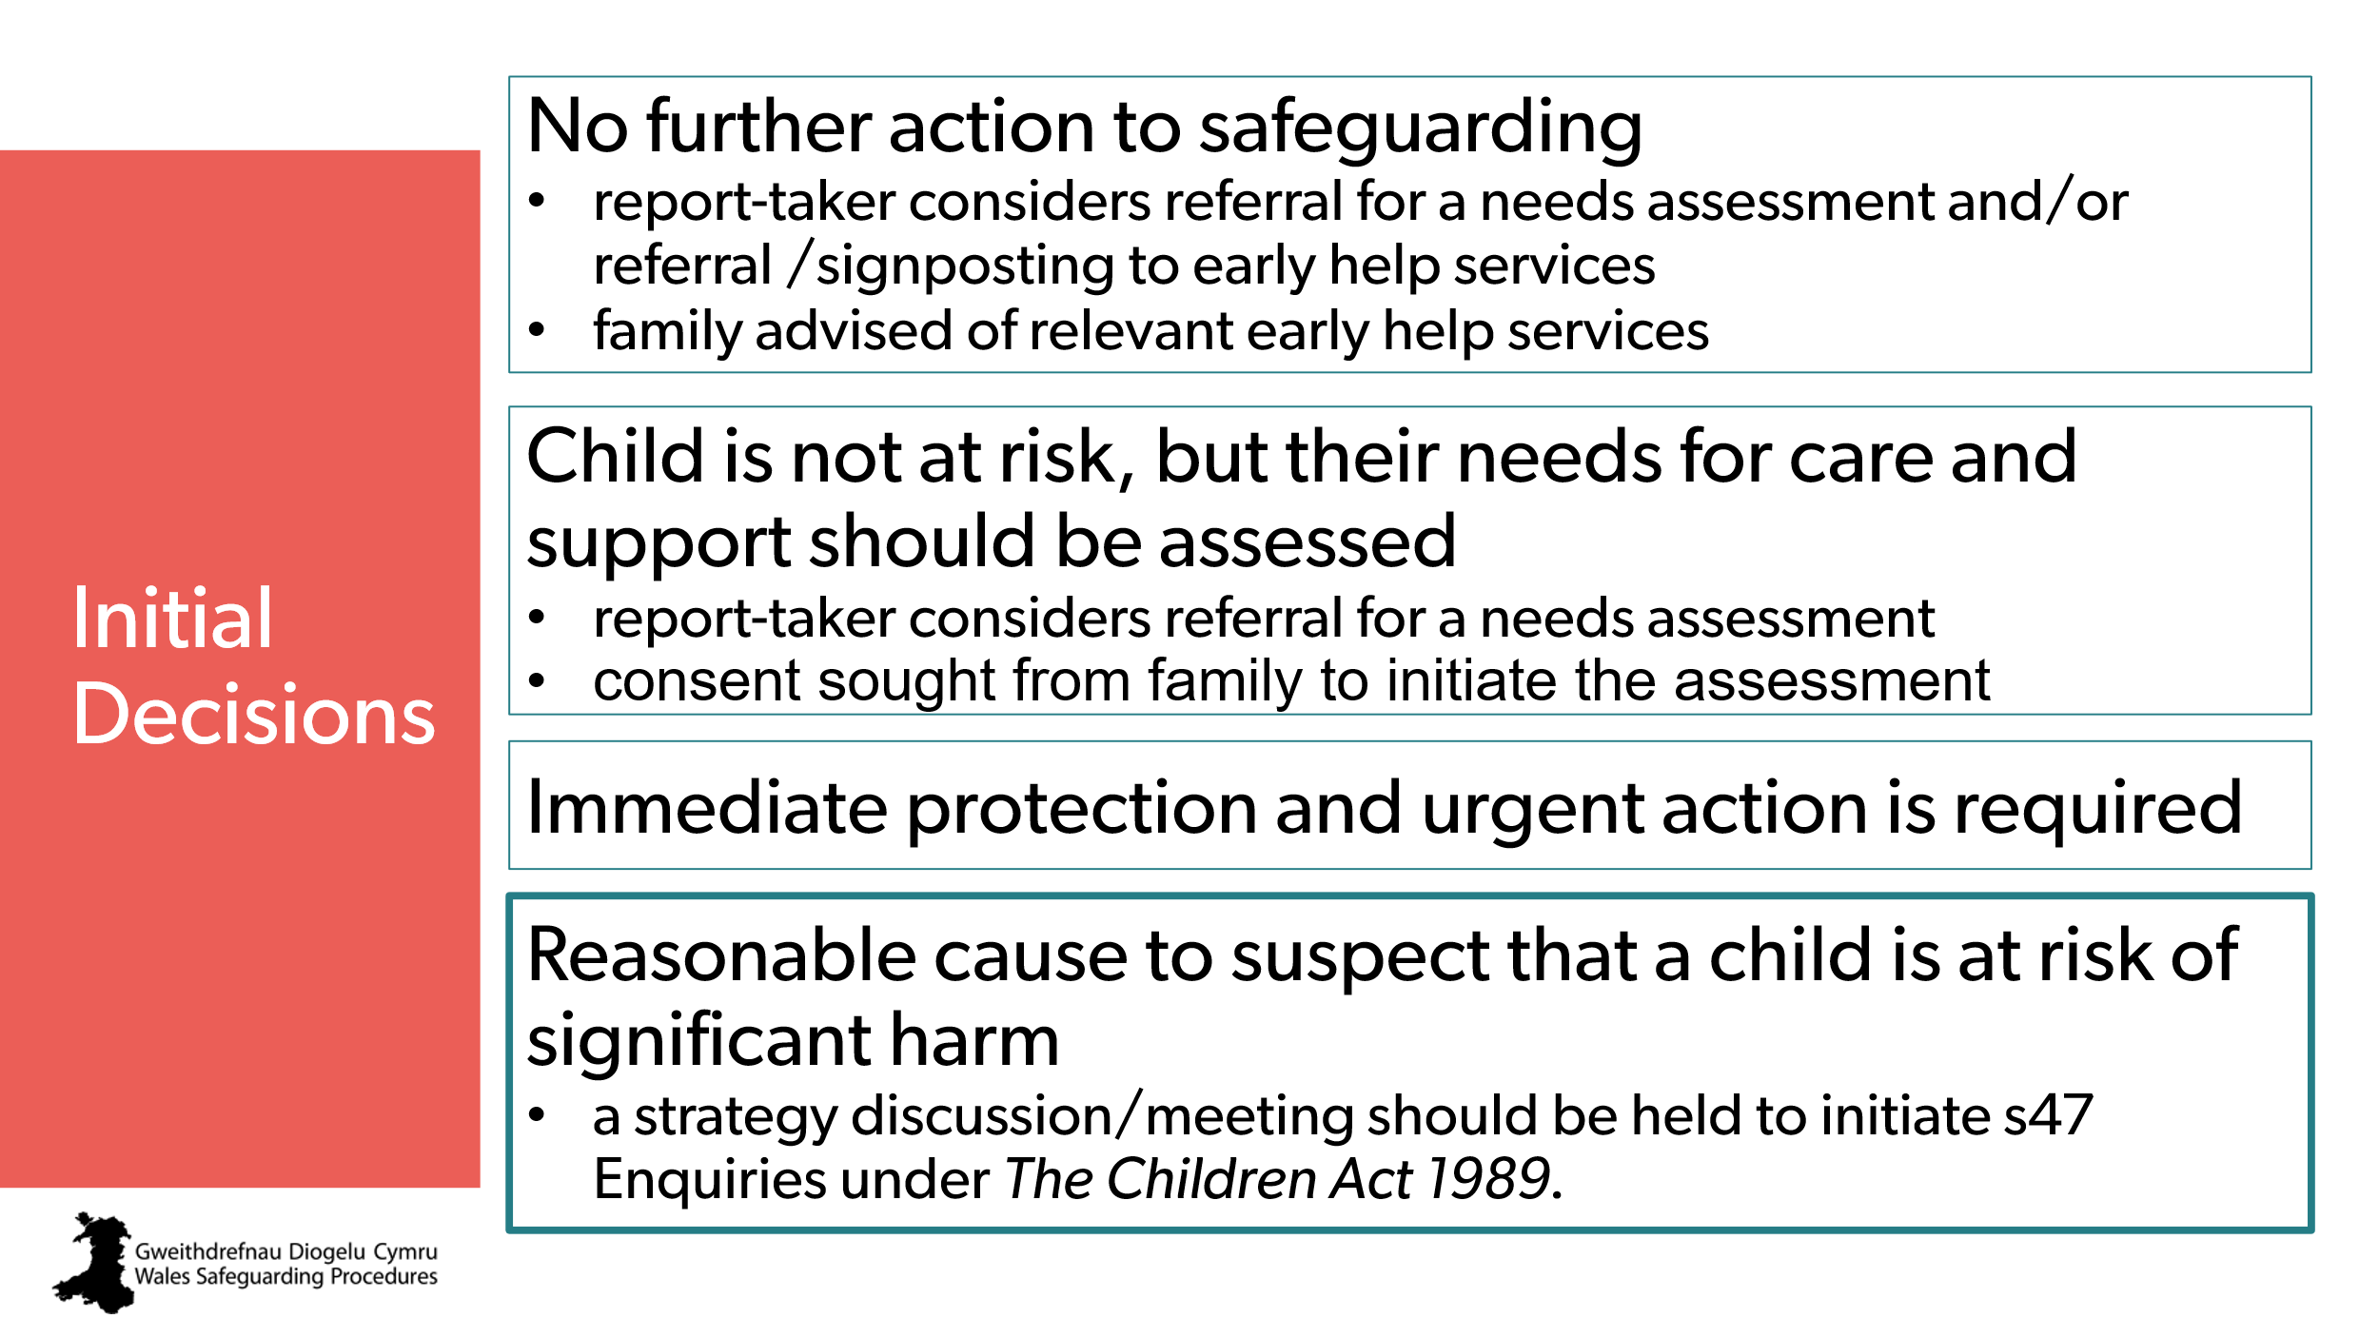 | Aim:  Provide an overview of the possible initial decisions on a report and the actions.  Trainer to explain:  Decisions made following the report must take account of all the known information and the work currently being undertaken with the child and their family.  The child and the family should always be informed of the outcome of any report.  If there’s a reasonable cause to suspect the child is at risk:  the reason for decision and enquiries explained to the family, including details of:  - any immediate protection or  urgent action being taken  - any police investigation  (if appropriate)  - what the next steps are (strategy meeting and assessment). | Action following a report: initial checks and decisions  Engaging the child and family during initial checks and discussions  See also:  Pointers for Practice: Managing Initial Parental Response to a Report  Pointers for Practice: Practitioner Responses to Resistance and Aggression  Pointers for Practice: Seven Golden Rules for Information-Sharing
17 | 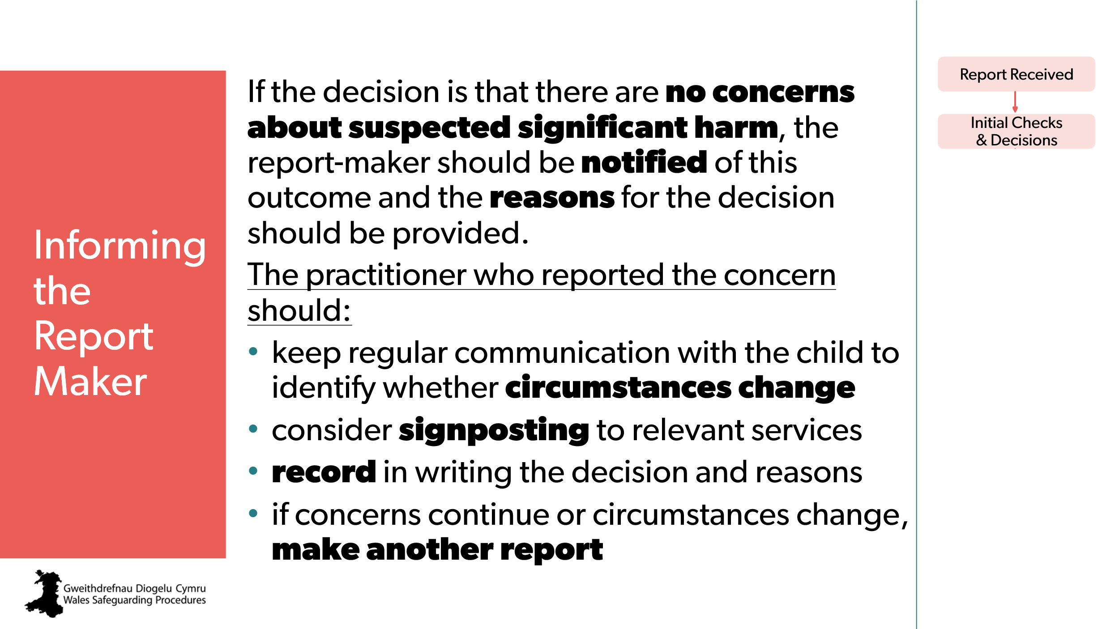 | Aim:  To stress report-maker/practitioner follow-on responsibilities. | Informing the practitioner report-maker of the initial decision
18 | 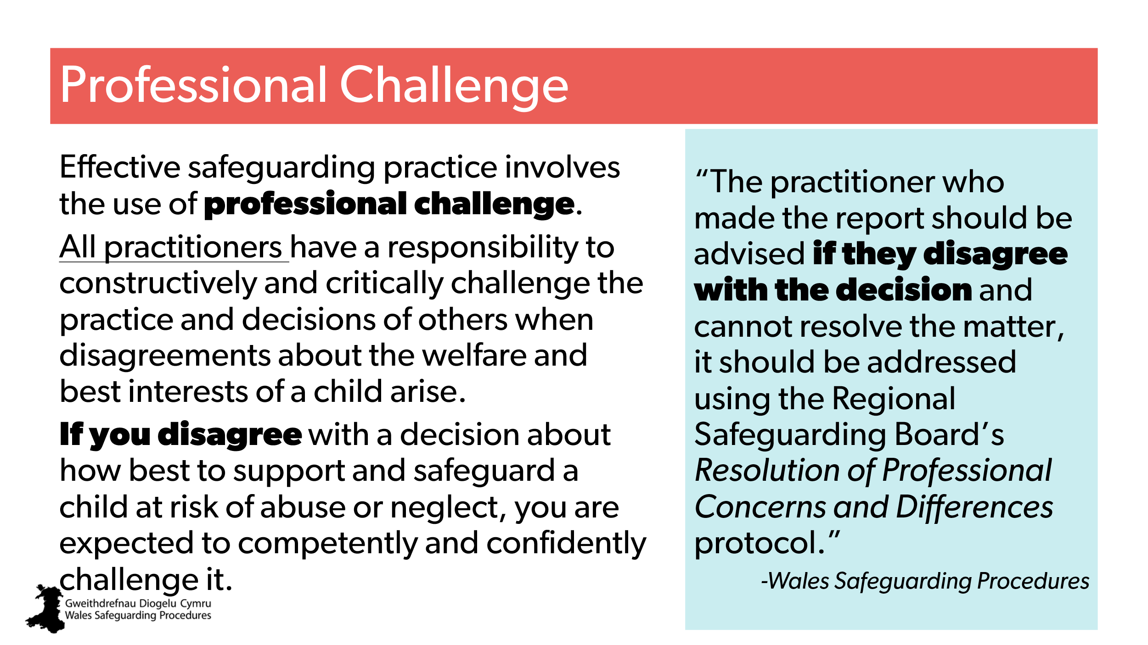 | Aim:  To highlight need for professional challenge if they disagree with the decision. | Disagreeing with the decision made by social services: resolving differences | CPD  Regional Safeguarding Board’s Resolution of Professional Concerns and Differences protocol.
19 | 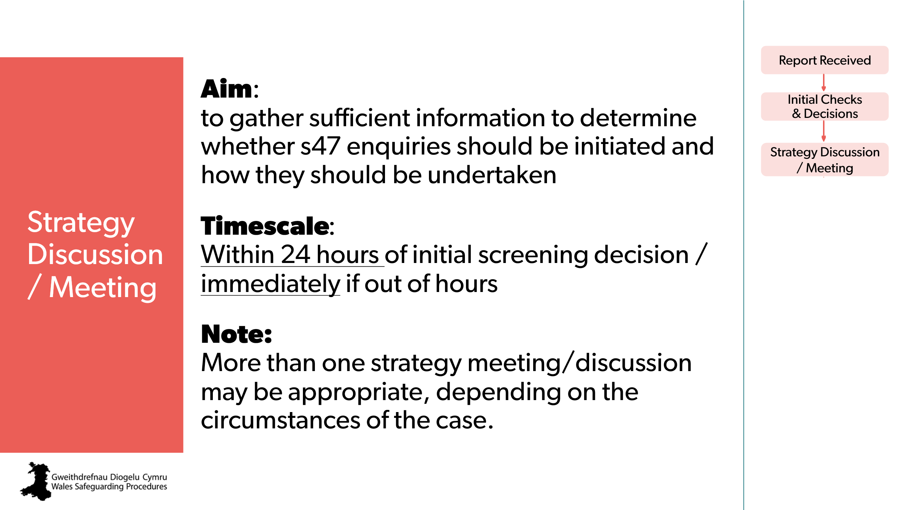 | Aim:  To introduce the next step in the process: strategy discussion/meeting. | Pointers for Practice: Strategy Discussions or Meetings and the Implications for Child-centred Practice  Pointers for Practice: Seven Golden Rules for Information-Sharing
20 | 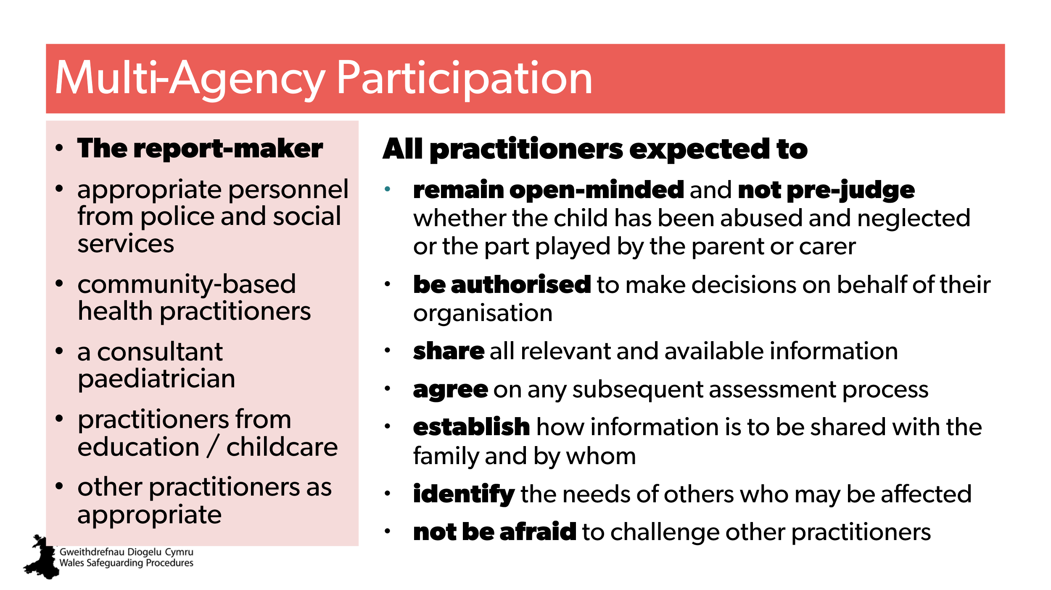 | Aim:  To highlight the need for effective multi-agency working.  Trainer to explain:  It’s all too easy for busy practitioners, working to tight timescales, to spring into action and begin to gather information without spending time planning the Section 47 enquiries in detail. This response can result in selective information-gathering that isn’t child-centred | Table multi-agency planning for s47 enquiries: who does what?
21 | 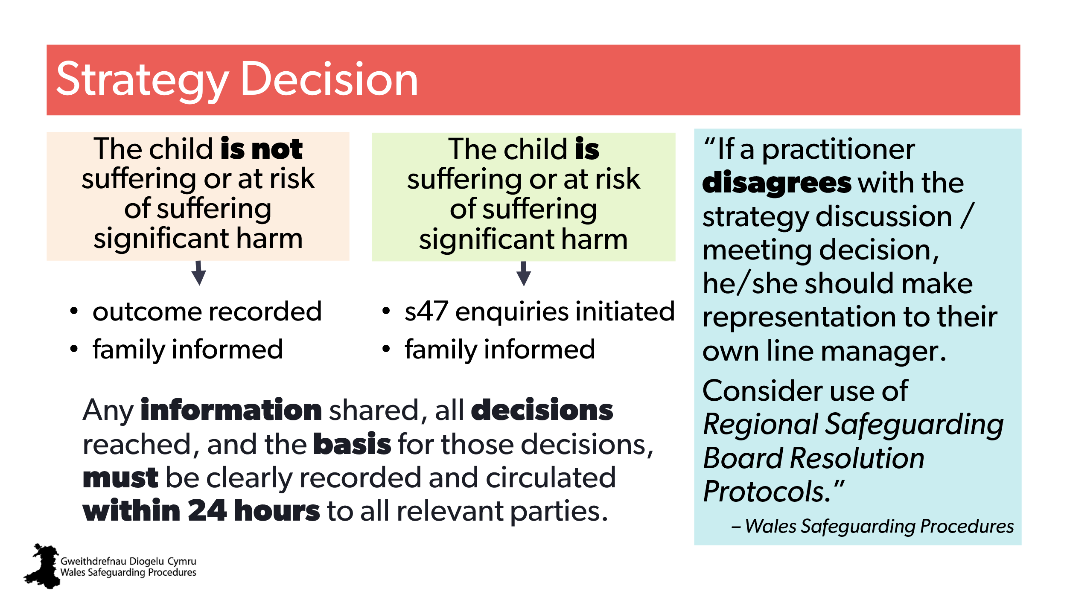 | Aim:  To outline the decisions and next actions.  Trainer to stress:  the need for professional challenge is specifically highlighted by the Wales Safeguarding Procedures at this point.  Ask the group for experiences of professional challenge. | If a practitioner disagrees with the strategy discussion / meeting decision… | CPD  Regional Safeguarding Board’s Resolution of Professional Concerns and Differences protocol.
22 | 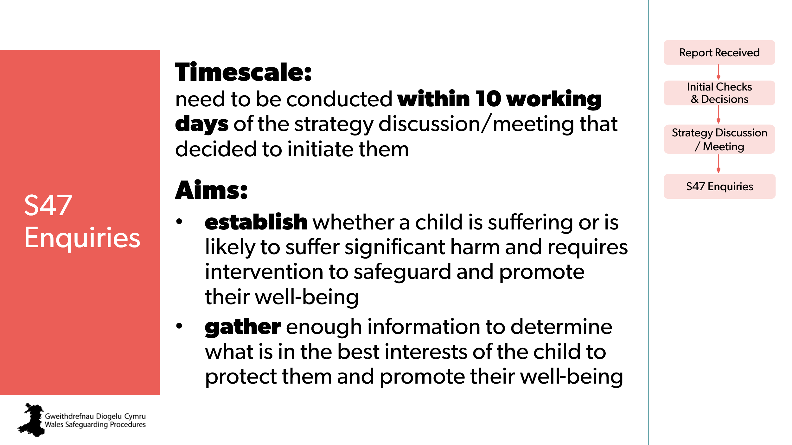 | Aim:  Outline the next step – Section 47 enquiries  Trainer to explain:  The Section 47 enquiries begin once a strategy discussion / meeting decides they’re necessary.  Briefly explain that safeguarding enquiries culminate in an analysis of risk to the individual, their network, and potentially the community.  Stress that Group C practitioners contribute to this analysis and should understand the potential breadth of impact. | Multi-Agency Information Gathering  Pointers for Practice: Gathering Information as Part of s47 Enquiries  Pointers for Practice: Contributing to s47 Enquiries
23 | 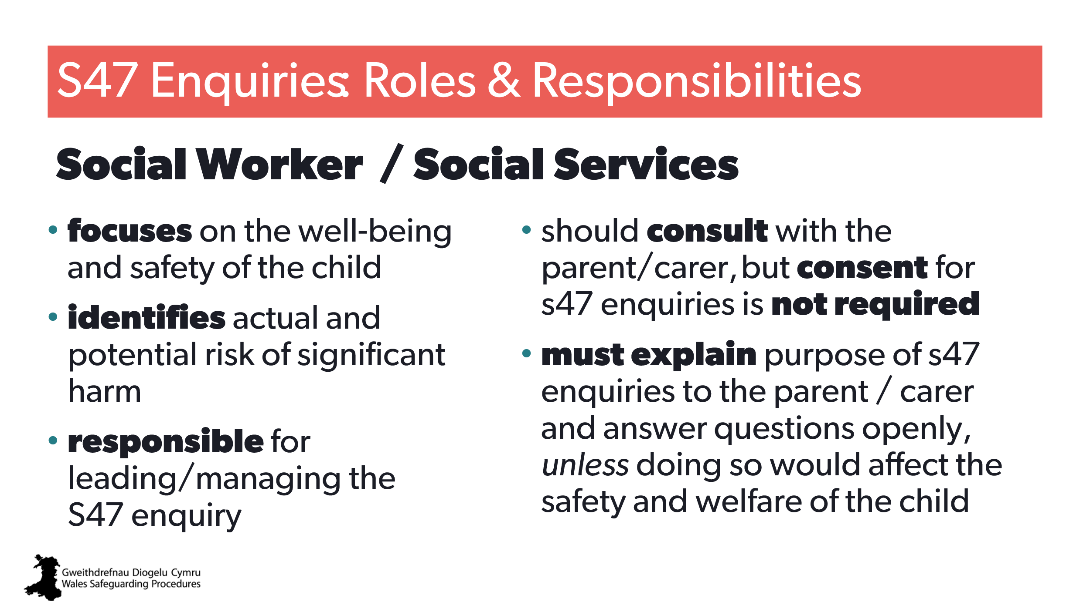 | Aim:  Highlight the role of the social worker (for non-social workers).  Trainer to explain to social workers:  If you’re likely to have this role, be sure to read specific sections in Wales Safeguarding Procedures or seek CPD. | Role of social worker in S47 Procedures | CPD for social workers:  Role of social worker in S47 Procedures  Pointers for Practice: Gathering Information as Part of s47 Enquiries Under the Children Act 1989  Pointers for Practice: Capturing the Daily Lived Experience  Pointers for Practice: Chronologies, Genograms and Eco-Maps
24 | 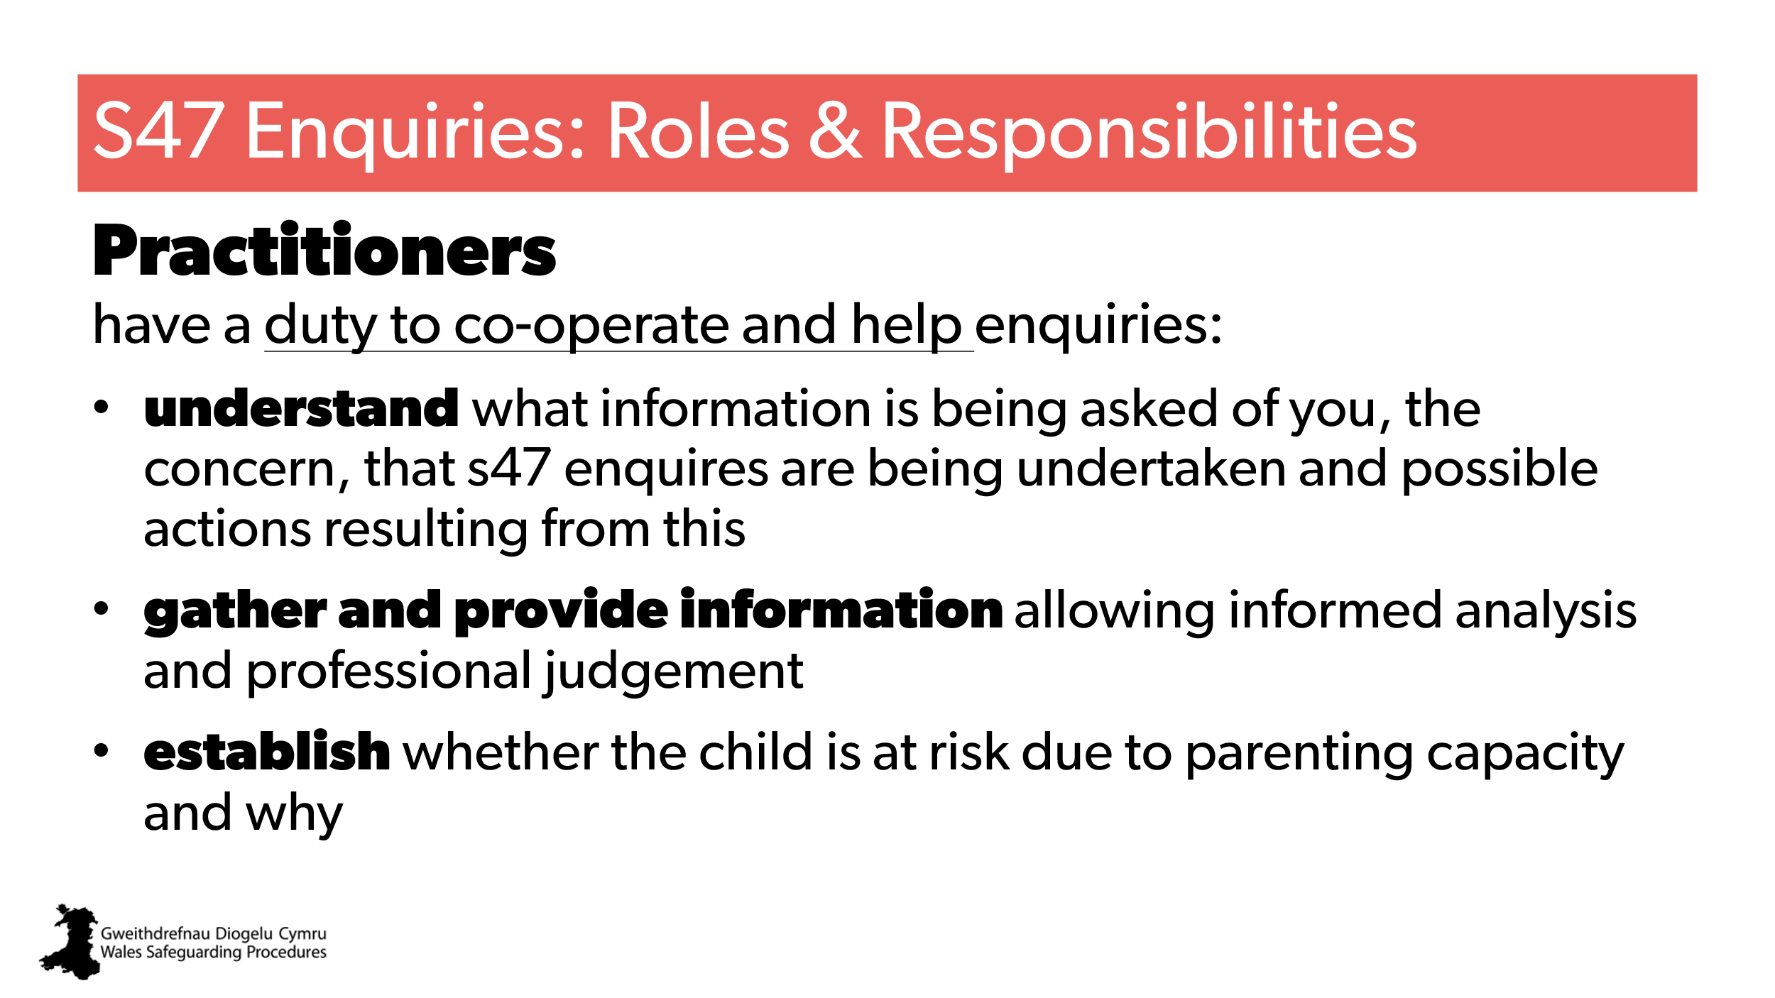 | Aim:  Highlight the general role of practitioners.  Trainer to stress:  If you’re likely to have a significant role in Section 47 enquiries, be sure to read specific sections in Wales the Safeguarding Procedures or seek CPD. | Pointers for Practice: Contributing to s47 Enquiries
25 | 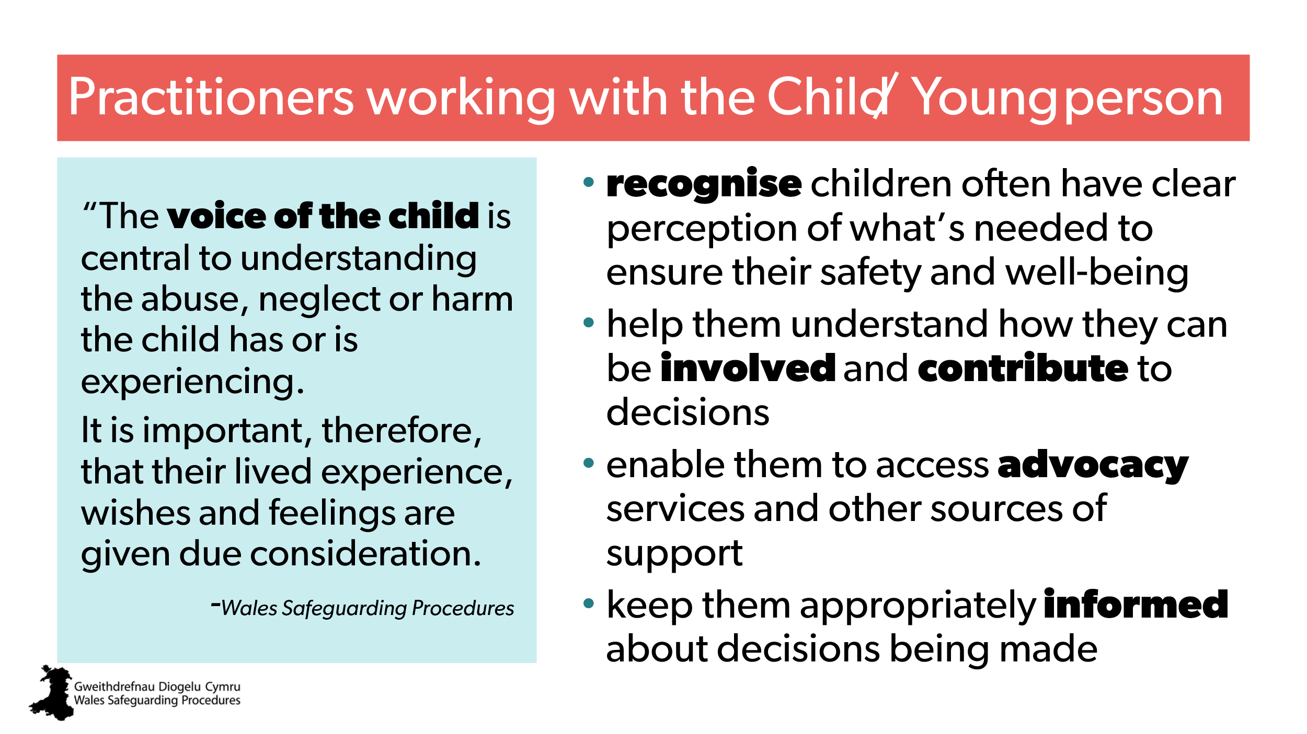 | Aim:  Highlight the expectations of practitioners who work directly with the child/ren involved in Section 47 enquiries.  Trainer to stress:  The voice of the child is central to understanding the abuse, neglect or harm the child has or is experiencing.  It’s important that practitioners recognise that even very young children can be given a voice.  Discussions  1) It’s important practitioners recognise that even very young children can be given a voice. How can this be done with toddlers? Infants?  Answers:  Pointers for Practice: Engaging Young Children  2) What do the Wales Safeguarding Procedures mean by “Seeing the child”?  Answers: ‘Seeing’ the child is much more than physically setting eyes on that child | Information gathering from children  ‘Seeing’ the child is much more than physically setting eyes on that child  Pointers for Practice: Engaging Young Children  Working with the child and family during s47 enquiries  www.socialworkerstoolbox.com  Baby’s Voice & Pledge in Wales | CPD  Listening to the Voice of the Baby
26 | 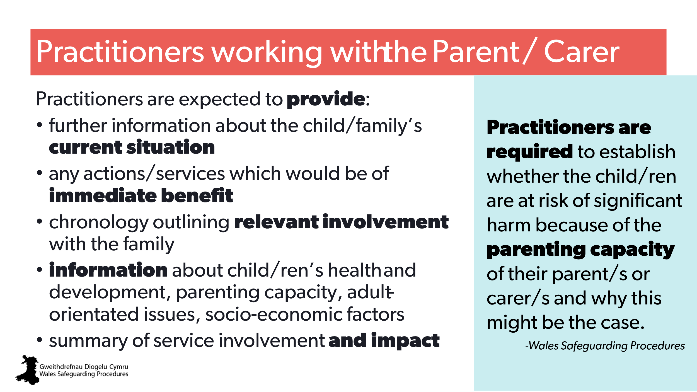 | Aim:  To highlight expectations from practitioners who work with the family.  Trainer to add:  Practitioner should empower and encourage parents/carers to be involved throughout the Section 47 enquiries as far as possible, unless this is inconsistent with the protection of the child.  Discussion  What kind of information should be gathered to be able to make an informed analysis and professional judgement on parenting capacity?  Answers:  - Multi-agency information-gathering  - Information gathering from parent/s | Multi-agency information-gathering  Information gathering from parent/s  Working with the child and family during s47 enquiries  Pointers for Practice: Establishing the Daily Lived Experience of Family Members
27 | 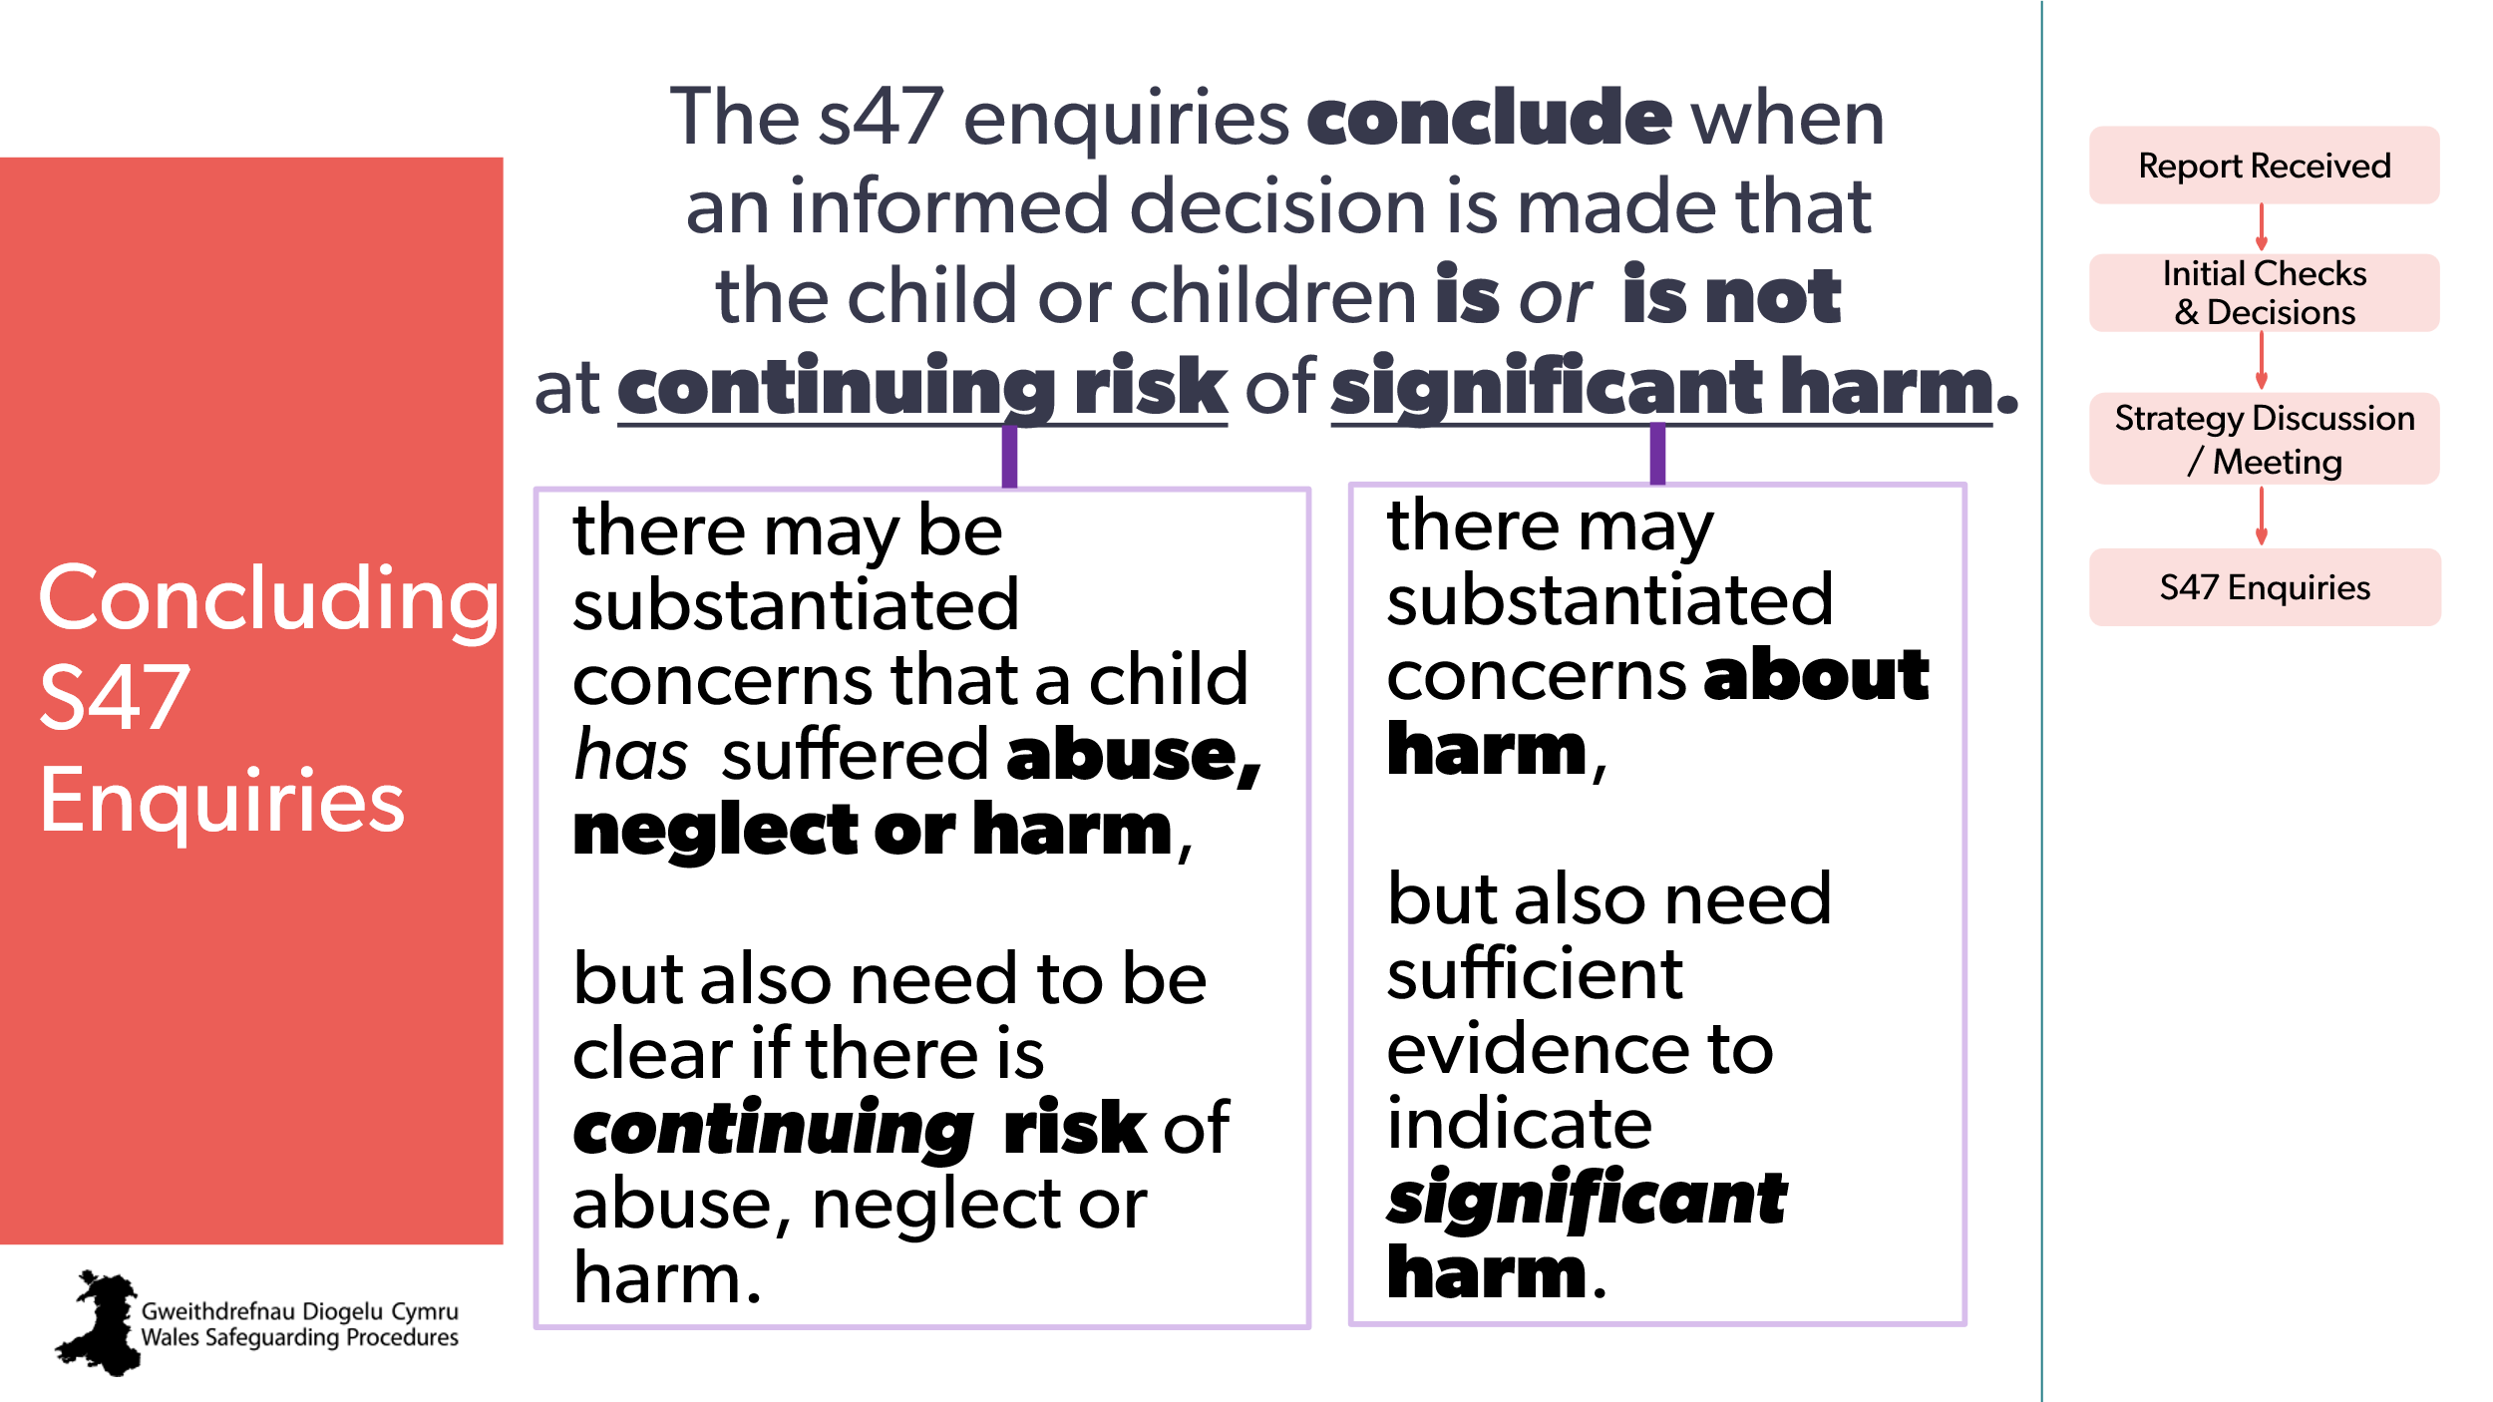 | Aim:  To highlight considerations in determinations (decisions).  Trainer to explain:  There’s the added consideration of establishing significant harm. | Concluding s47 enquiries  S47 enquiries determinations  Establishing ‘significant harm’  Pointers for Practice: Assessing Significant Harm | CPD  Determining significant harm  Thresholds
28  29  30 | 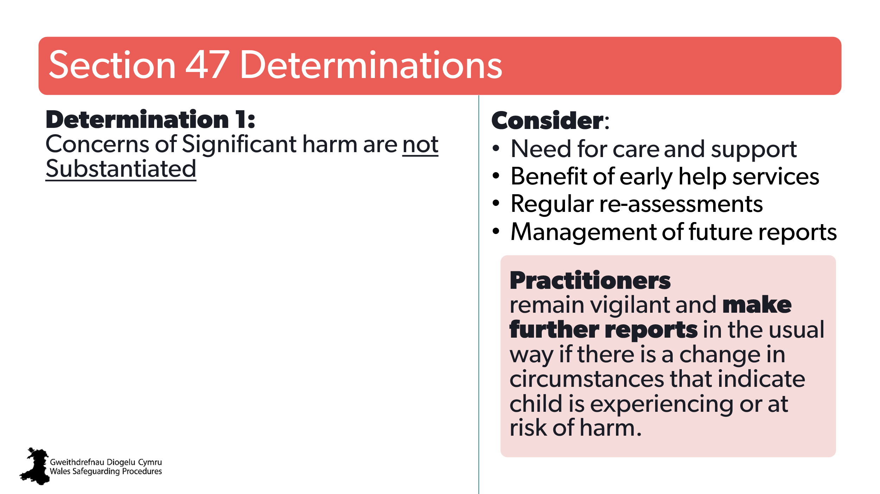  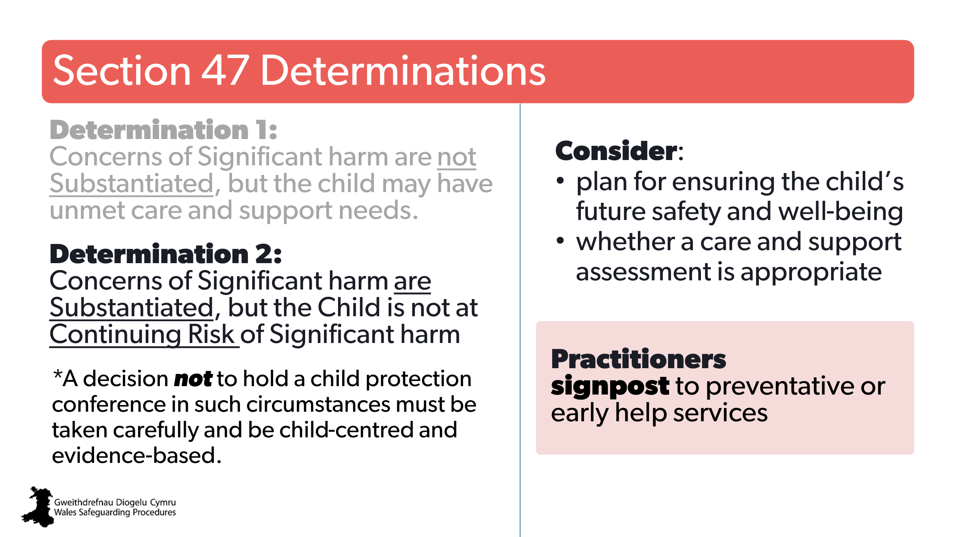  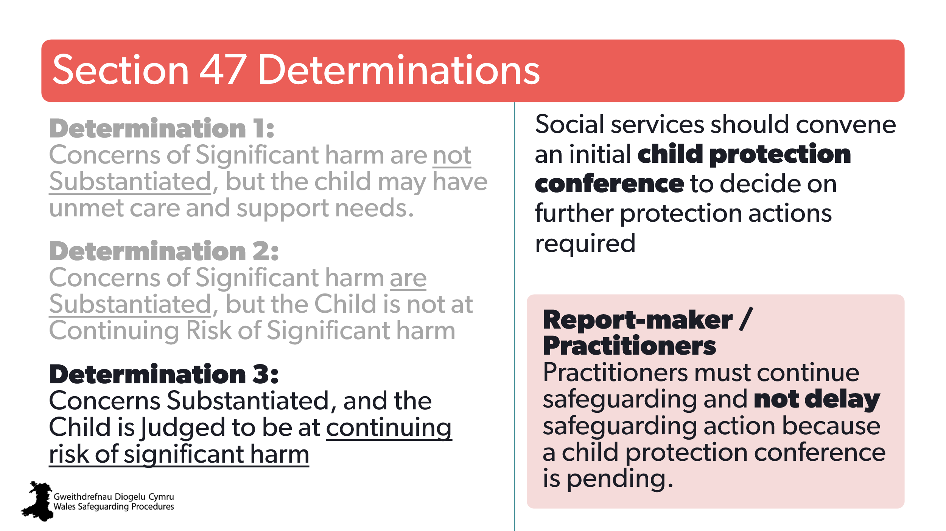 | Aim:  To highlight the different possible determinations and expected actions.  Trainer to add:  - in some situations, the decision may not be clear-cut. So, some Regional Safeguarding Boards have produced threshold documents/guidance that can help with decision-making.  - a decision not to hold a child protection conference must be taken carefully and be child-centred and evidence-based. | S47 enquiries determinations  Local Regional Safeguarding Board threshold documents/guidance | CPD  Thresholds
31 | 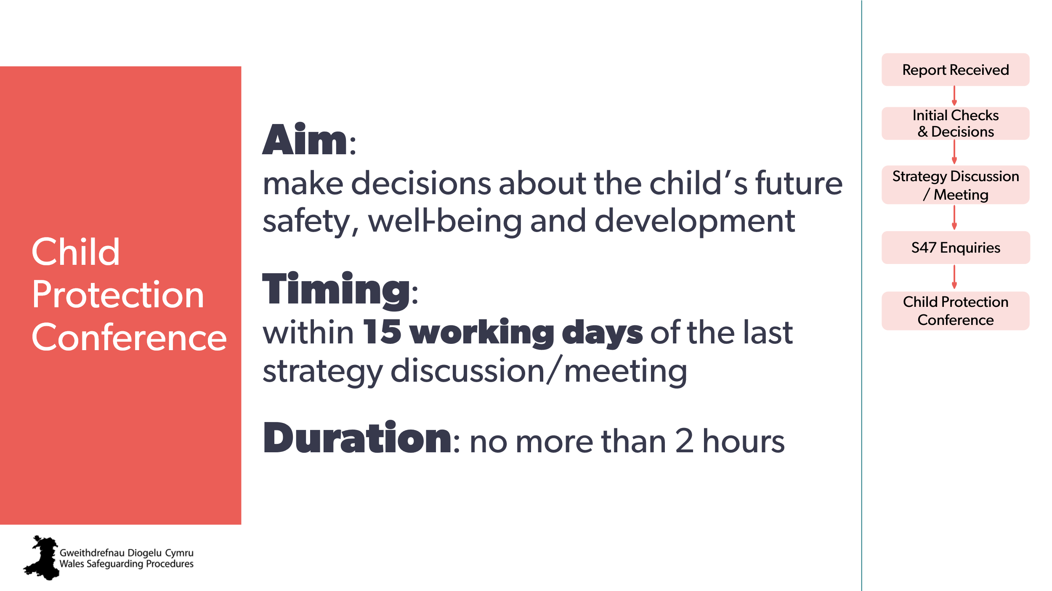 | Aim:  To outline the next step in process: child protection conference.  Trainer to explain:  We’re only looking at general aspects – if attending or leading conferences is/will be part of your role, be sure to read the details in the Wales Safeguarding Procedures and seek CPD training. | The initial child protection conference  Pointers for Practice: Practitioners Attending Child Protection Conferences - Key Messages  Pointers for Practice: Child Protection and The Unborn Child | CPD  Child Protection Conferences
32 | 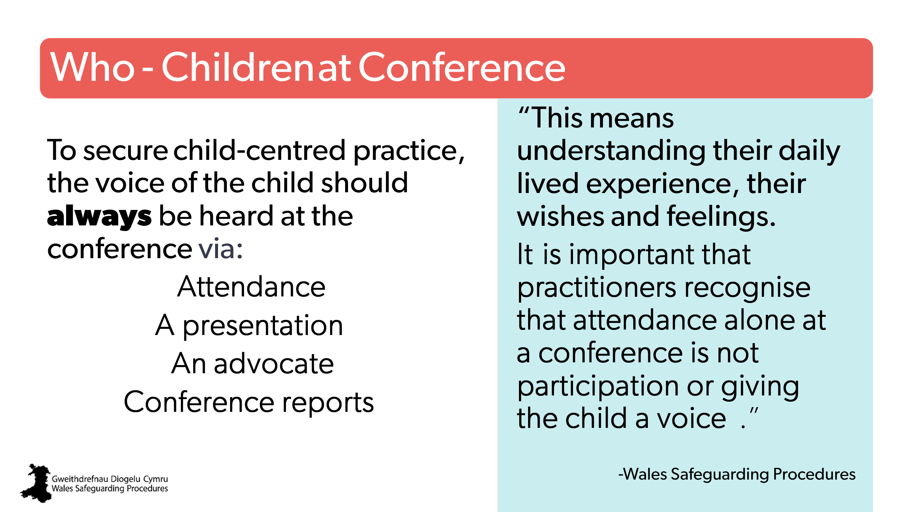 | Aim:  To highlight active involvement of child to ensure child-centred  Trainer to explain:  - there are many ways to ensure the voice of the child and their active participation – even for very young children  - you should choose a method, in collaboration with the child, that allows the child to have a positive experience.  Discuss  What are some of the ways you could make sure a child you work with is heard and actively involved? | Involving children in the conference  Pointers for Practice: Giving Children and Young People A Voice in The Conference  Pointers for Practice: Invisible Children Managing Conferences for Sibling Groups
33 | 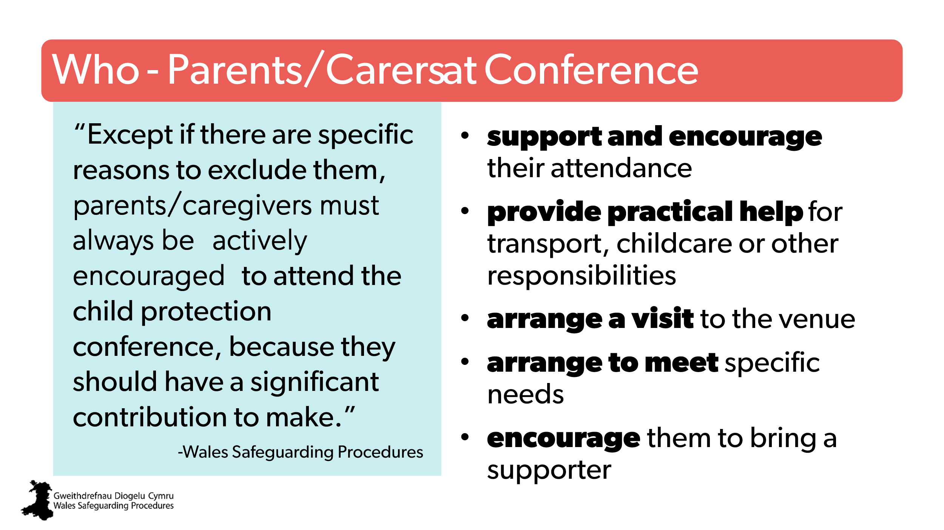 | Aim:  To outline how to include the parent/carer in the conference  Trainer to stress:  - an effective, child-centred, working partnership with parents and family members underpins practitioners’ ability to address the child’s care, and support protection needs.  - practitioner must always actively encourage parents/carers to attend the child protection conference.  - in rare circumstances a parent or caregiver won’t be invited to attend a child protection conference - any practitioner can request the exclusion of a parent/caregiver from the conference. This must be linked to issues relating to risk to child, or others, and can’t be used as a way of not sharing information or fear of damaging ongoing working relationships with parents/caregivers. | Involving parents in the child protection conference  Pointers for Practice: Preparing Parent/s for Child Protection Conferences
3 | 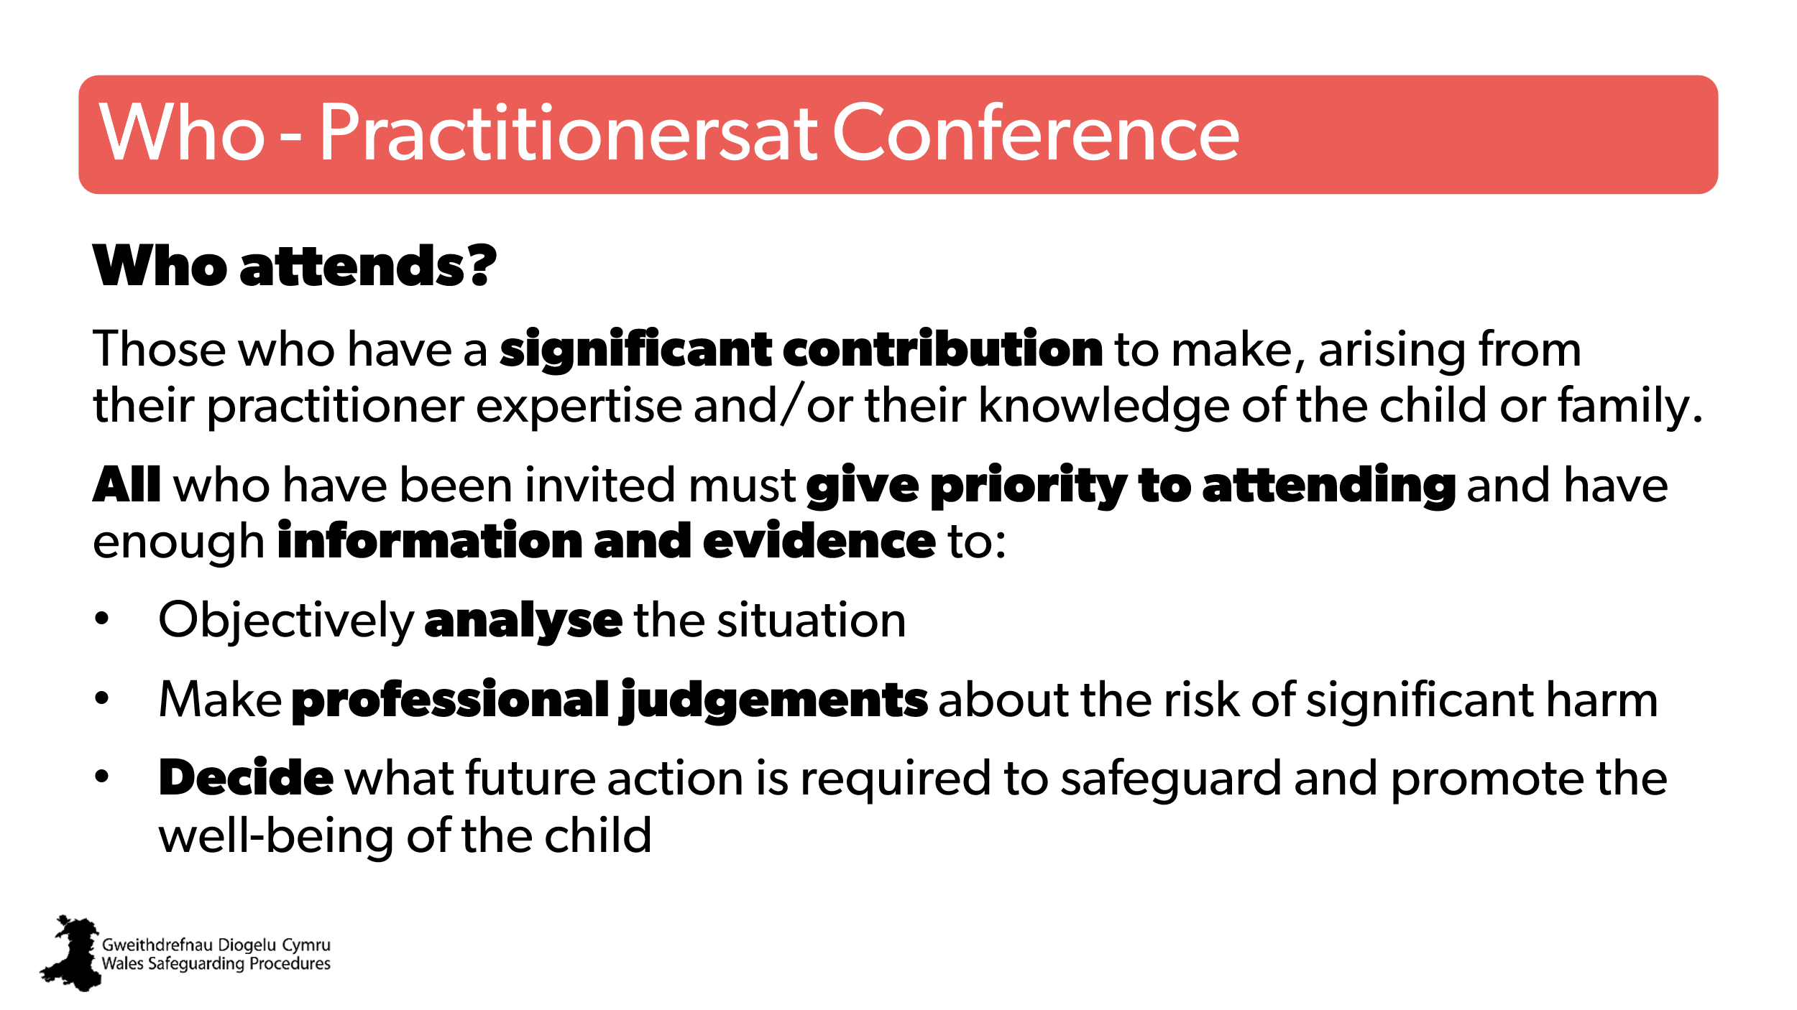 | Aim:  To outline who is expected to participate  Trainer to add:  - Normally, a minimum of three agencies or practitioner groupings that have had direct contact with the child will need to be present before a conference can proceed.  - all those who work directly with the child/family should be invited – including early years / childcare key worker, childminder, club lead, and so on. | The initial child protection conference  Attendance
35 | 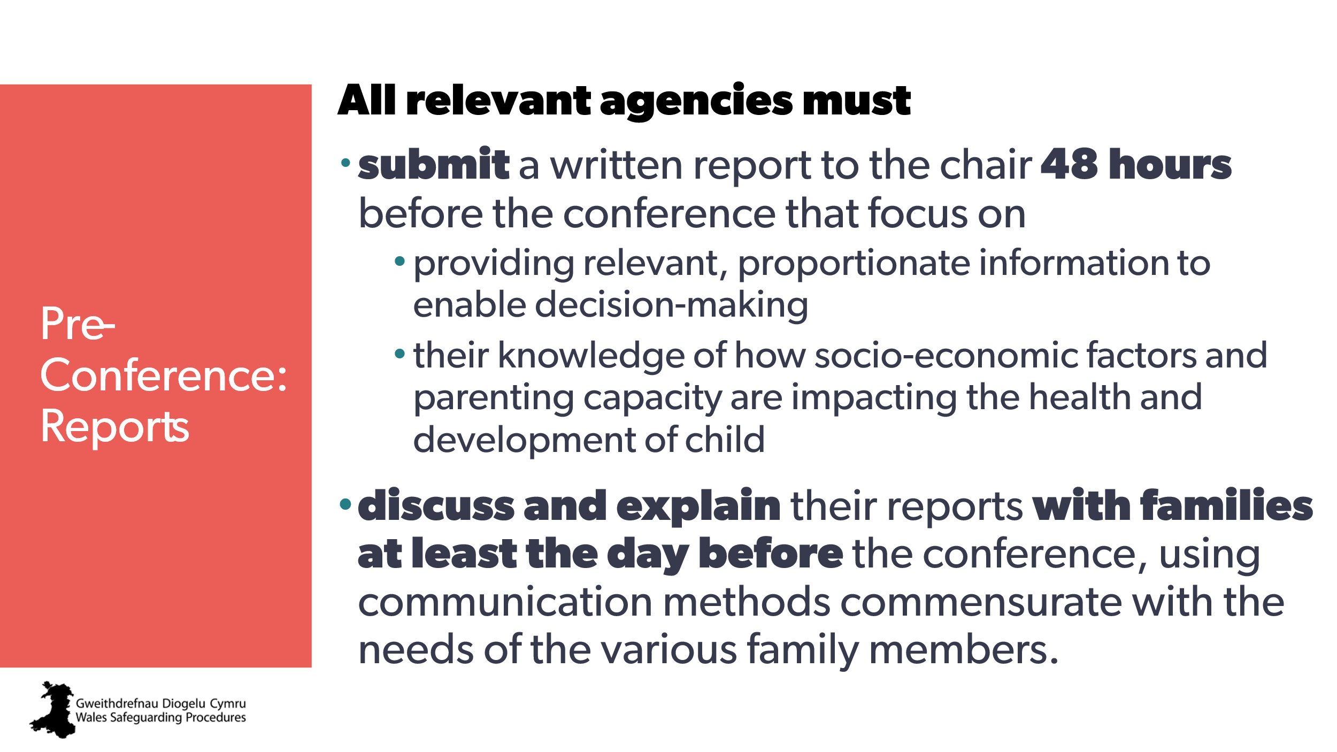 | Aim:  Overview of the need for a report.  Trainer to add:  Report authors must make sure family members:  - are aware of the report contents before the meeting  - can draw attention to any factual inaccuracies  - have time to make sense of the report contents.  Suggested activity:  Ask learners to find and read the section that applies to their role:  - Contributing practitioner reports  - The social worker’s report  - Health reports  - Health practitioners including CAMHS  - GPs  - Education and school practitioners  - Police  - National Probation Service and Community Rehabilitation Companies (CRCs)  - Adult services  - Representatives of other agencies | Preparing reports for conference  Pointers for Practice: Preparing Reports for Conference  Pointers for Practice: Preparing A Social Work Report for Conference Invisible Children | CPD  Writing Reports for Conferences
36 | 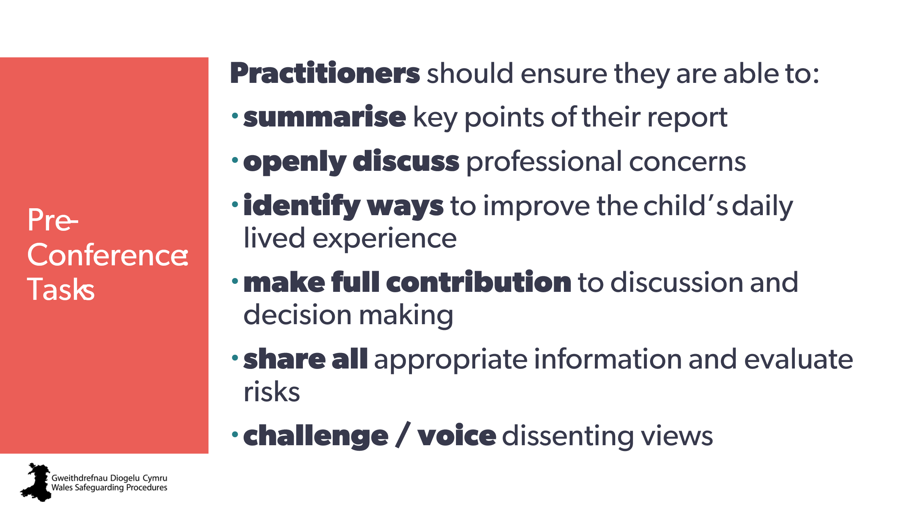 | Aim:  To provide an outline of the tasks to do before attending a conference.  Trainer to stress:  The need for open discussion and voicing challenge.  For details about the responsibilities of specific roles, such as Chair, see the Wales Safeguarding Procedures. | The initial child protection conference: process | CPD  The Role of the Conference Chair
37 | 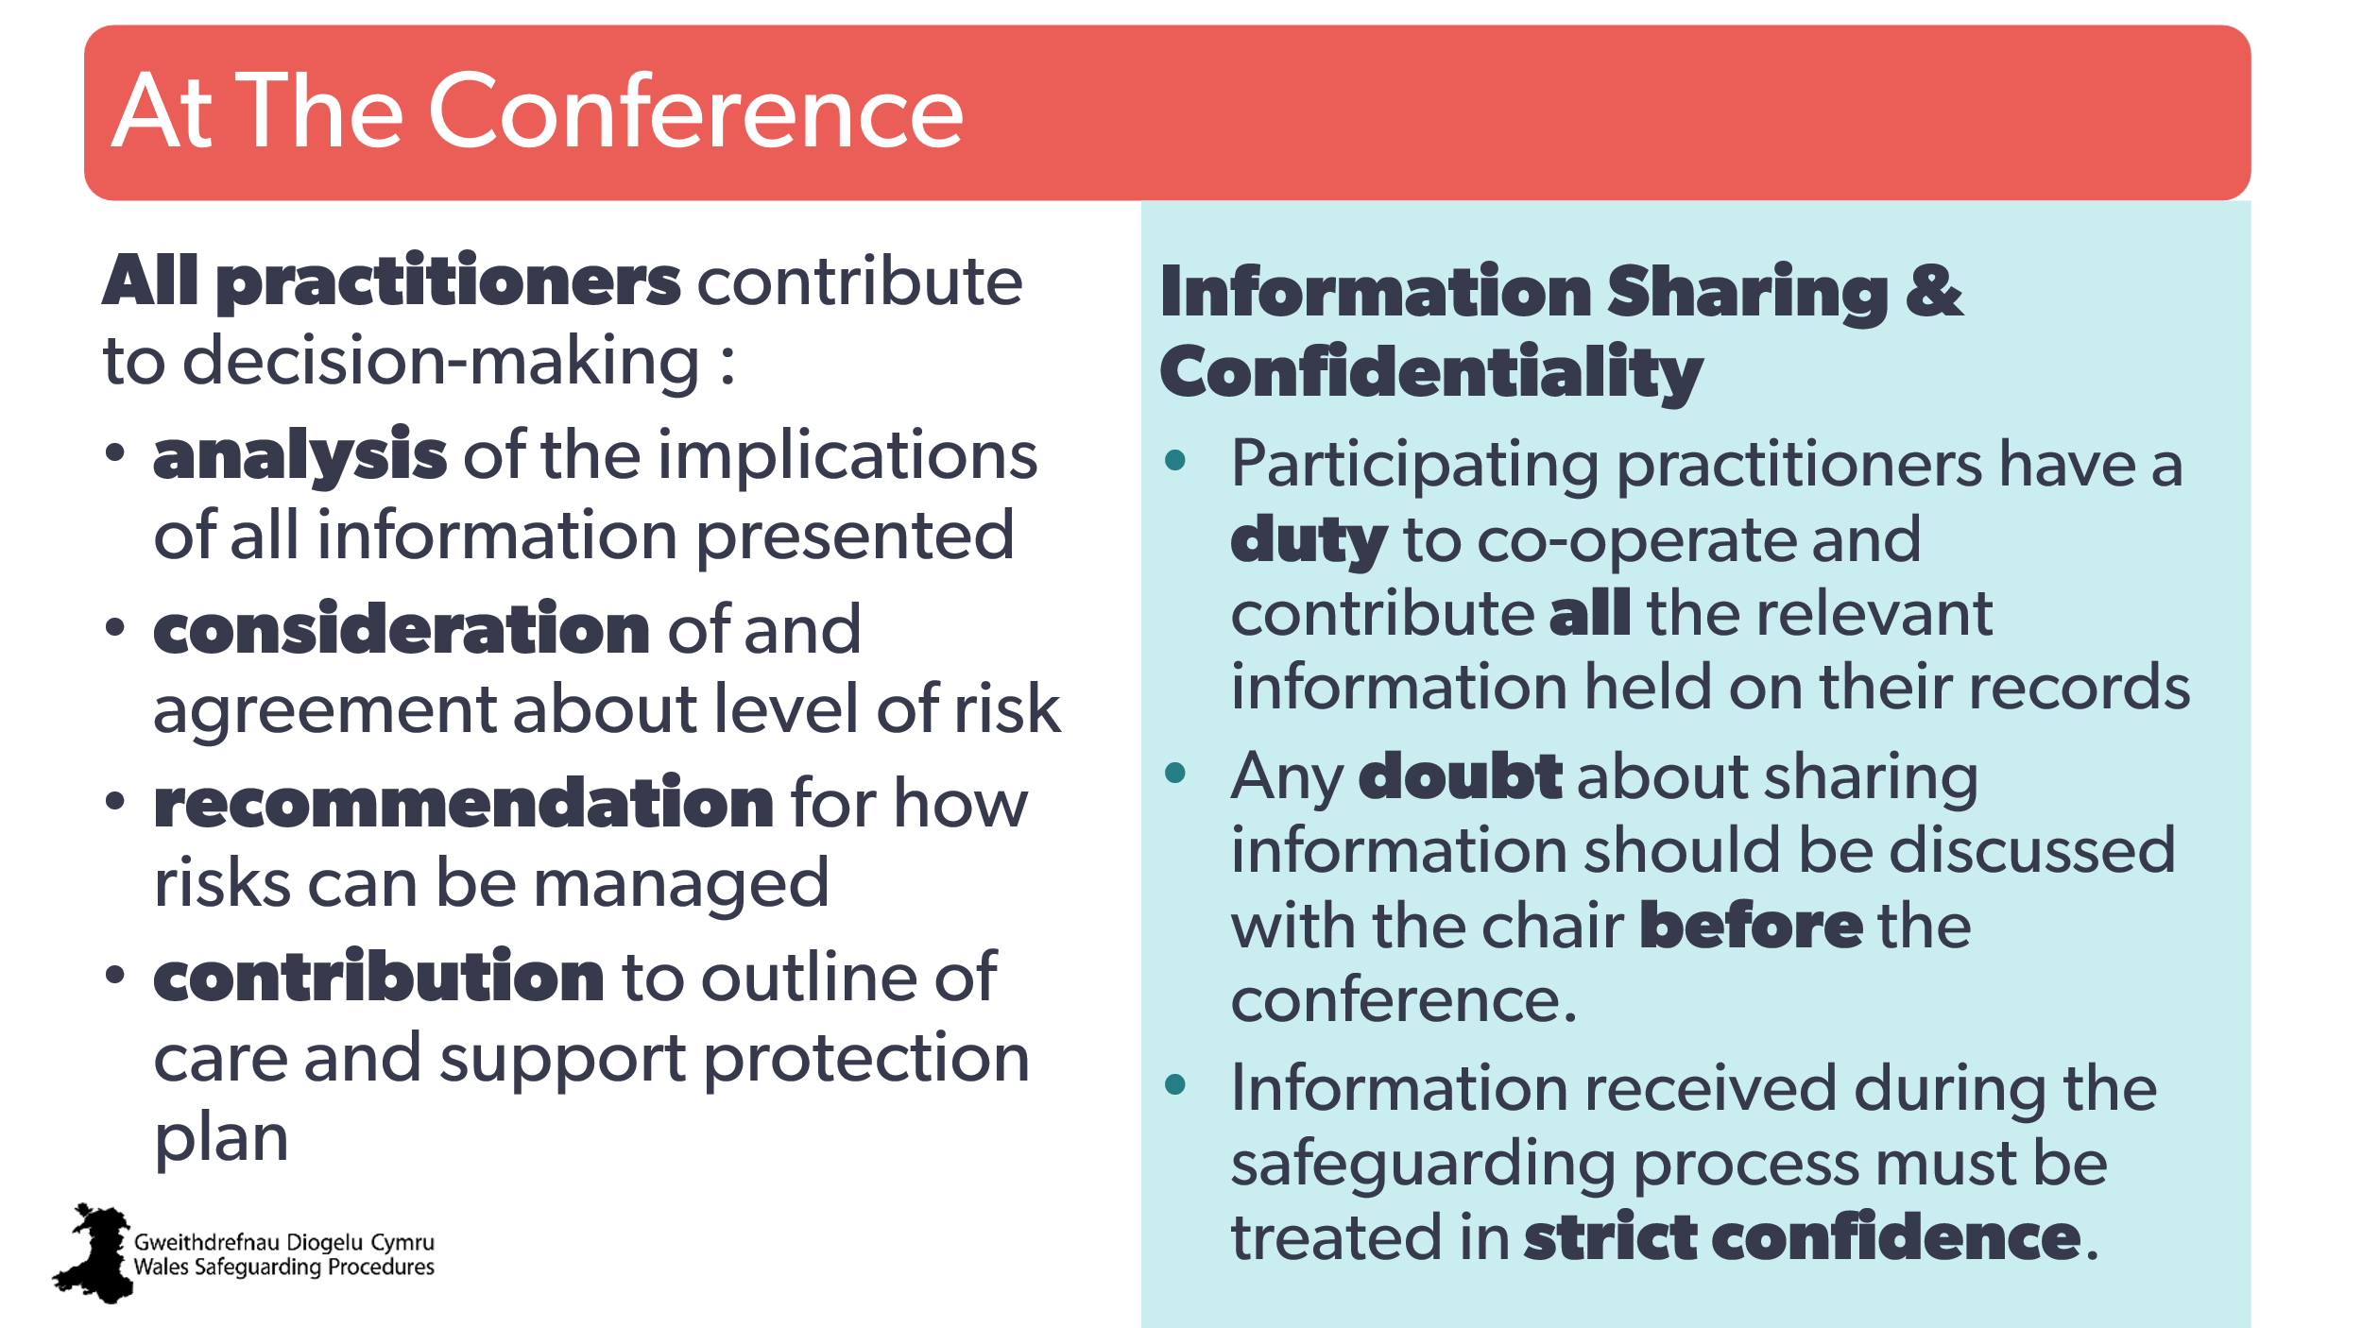 | Aim:  To give an outline of what’s expected.  To highlight the need for information sharing and confidentiality.  Optional:  Trainer may wish to have learners look at the Wales Safeguarding Procedures:  - The Agenda - for an awareness of what to expect from the meeting  - ‘The decision-making process at an initial child protection conference’ - to understand how the decision is made | Pointers for Practice: Practitioners Attending Child Protection Conferences - Key Messages  Pointers for Practice: Translating the Agenda into A Child-Centred Conference Process
38  39 | 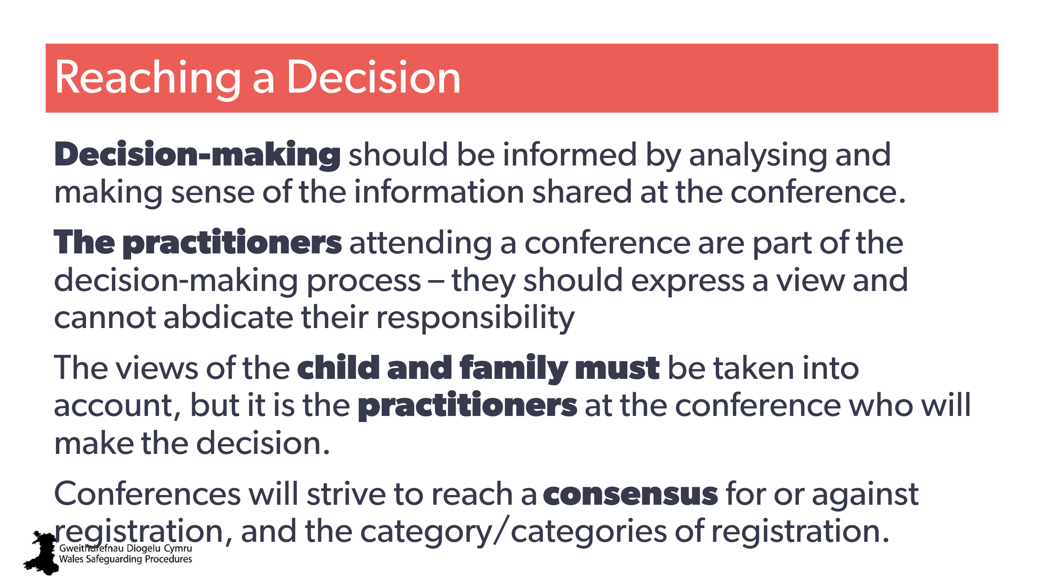  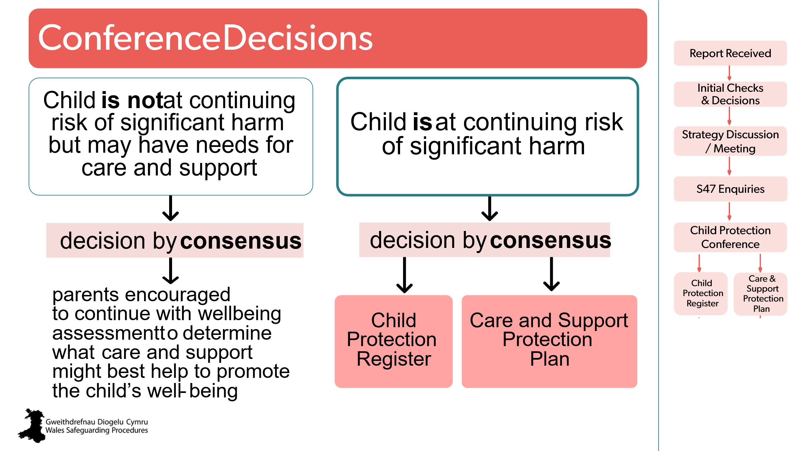 | Aim:  Outline of reaching a decision  Trainer to explain:  When making these decisions practitioners must recognise:  - the focus is on actual, likely and/or ongoing risk of significant harm;  - a decision should be made separately for each child in the family, taking account of the harm they’re experiencing, or are likely to experience, and the impact on their health and development  - practitioners attending a conference can’t abdicate their responsibility  - those attending the conference will be asked to provide a view on registration for each of the children being discussed.  Trainer may wish to explain:  - conferences should strive to reach a consensus for or against registration and the category/categories of registration  - in the event of a lack of consensus the Chair must ensure the view of each agency is sought and should attempt to seek a resolution  - if consensus is still not possible, the decision about registration should be subject to a vote based on agency and/or practitioner groupings identified by the Chair.  - Where there’s no consensus but there is a majority view the Chair will accept the majority view even if he/she may disagree with this  - If members remain split 50/50, the chair will make the decision about registration. | Decision making at child protection conferences where consensus is not reached  Pointers for Practice: Subjective Decision-Making  Pointers for Practice: Decision-Making about Registration and The Need for A Plan  Pointers for Practice: Analysis and Decision-Making
40 | 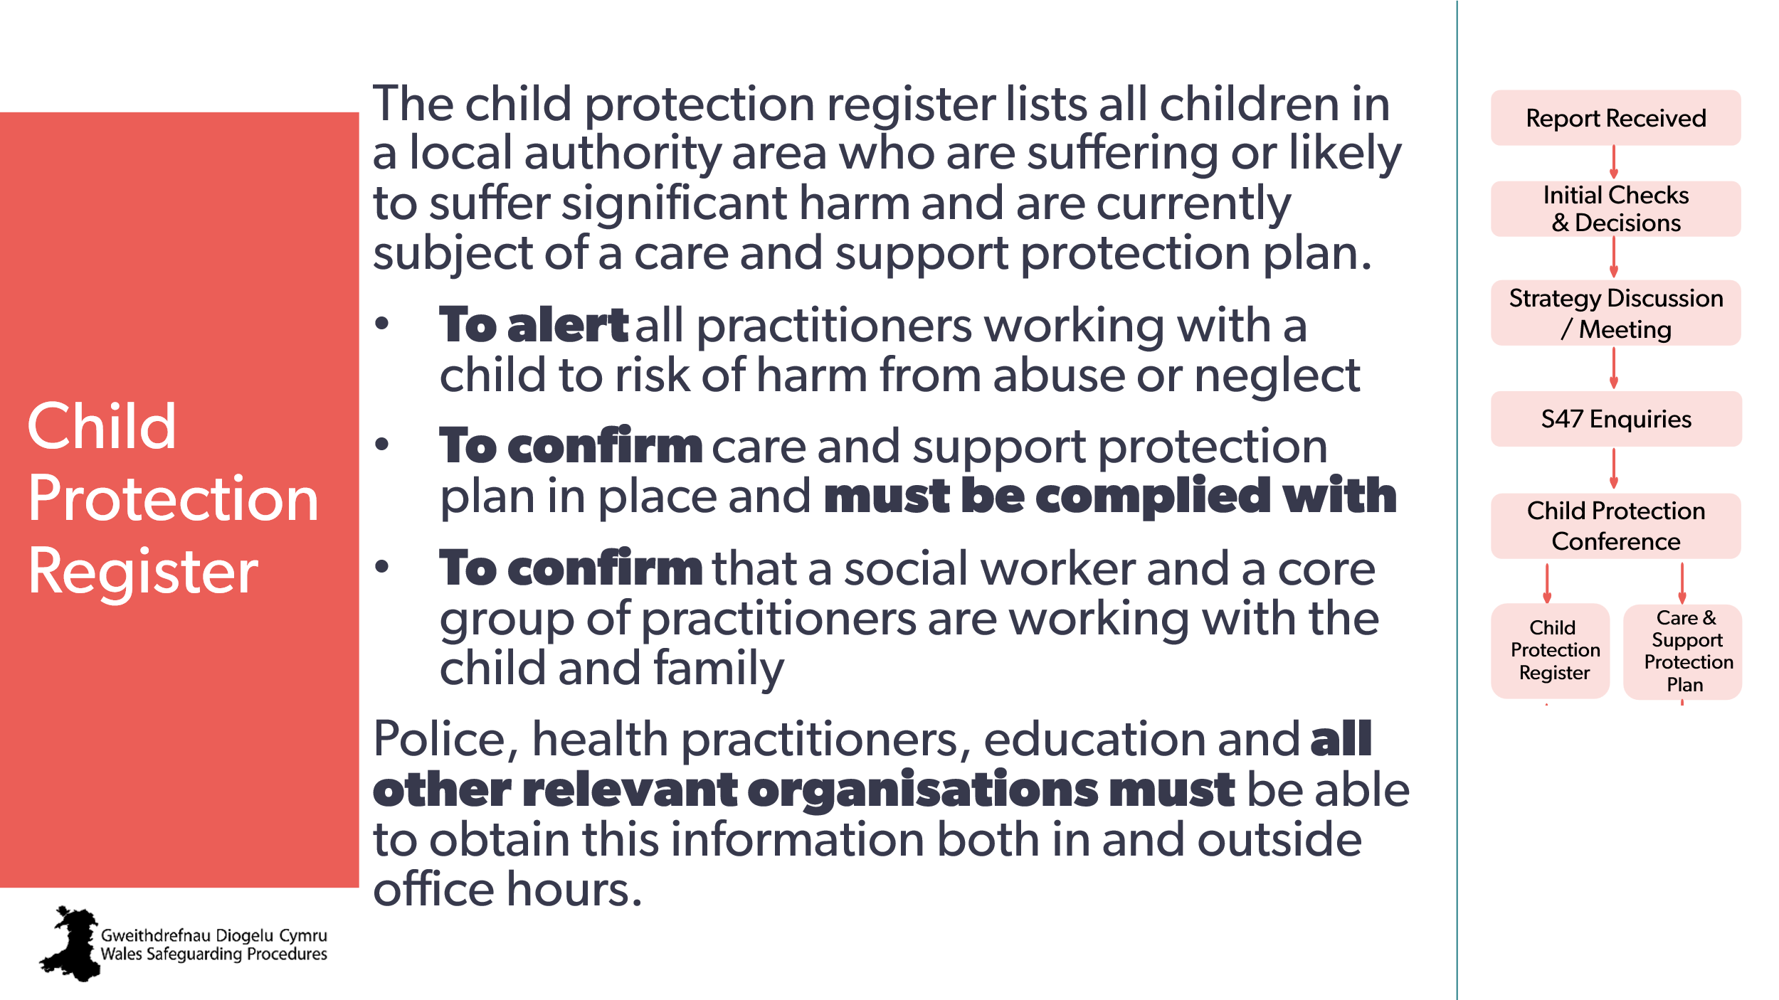 | Aim:  To provide an overview of the Register.  To clarify the availability of the Register. | The Child Protection Register  Pointers for Practice: Decision-Making about Registration and The Need for A Plan  Managing the child protection register
41  42 | 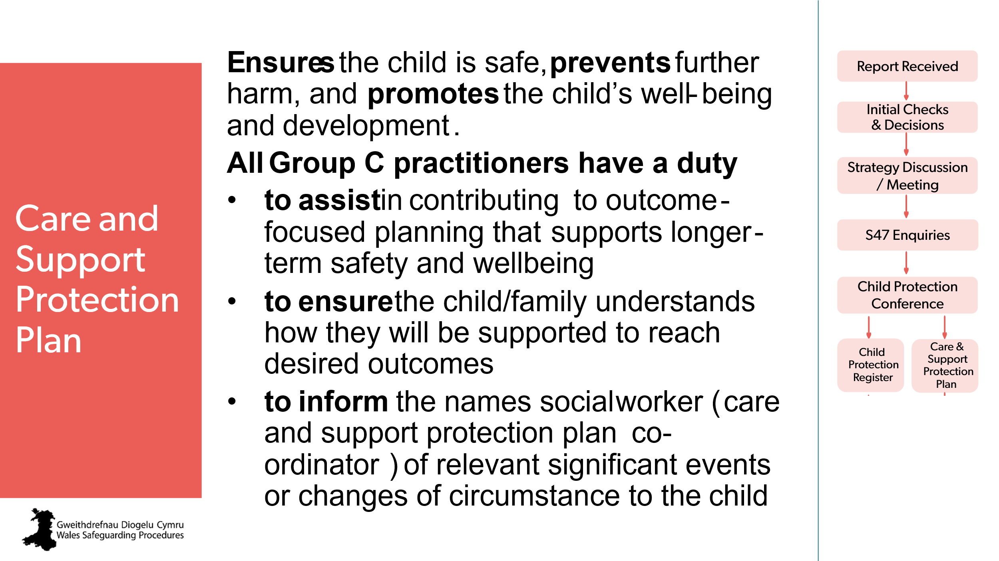  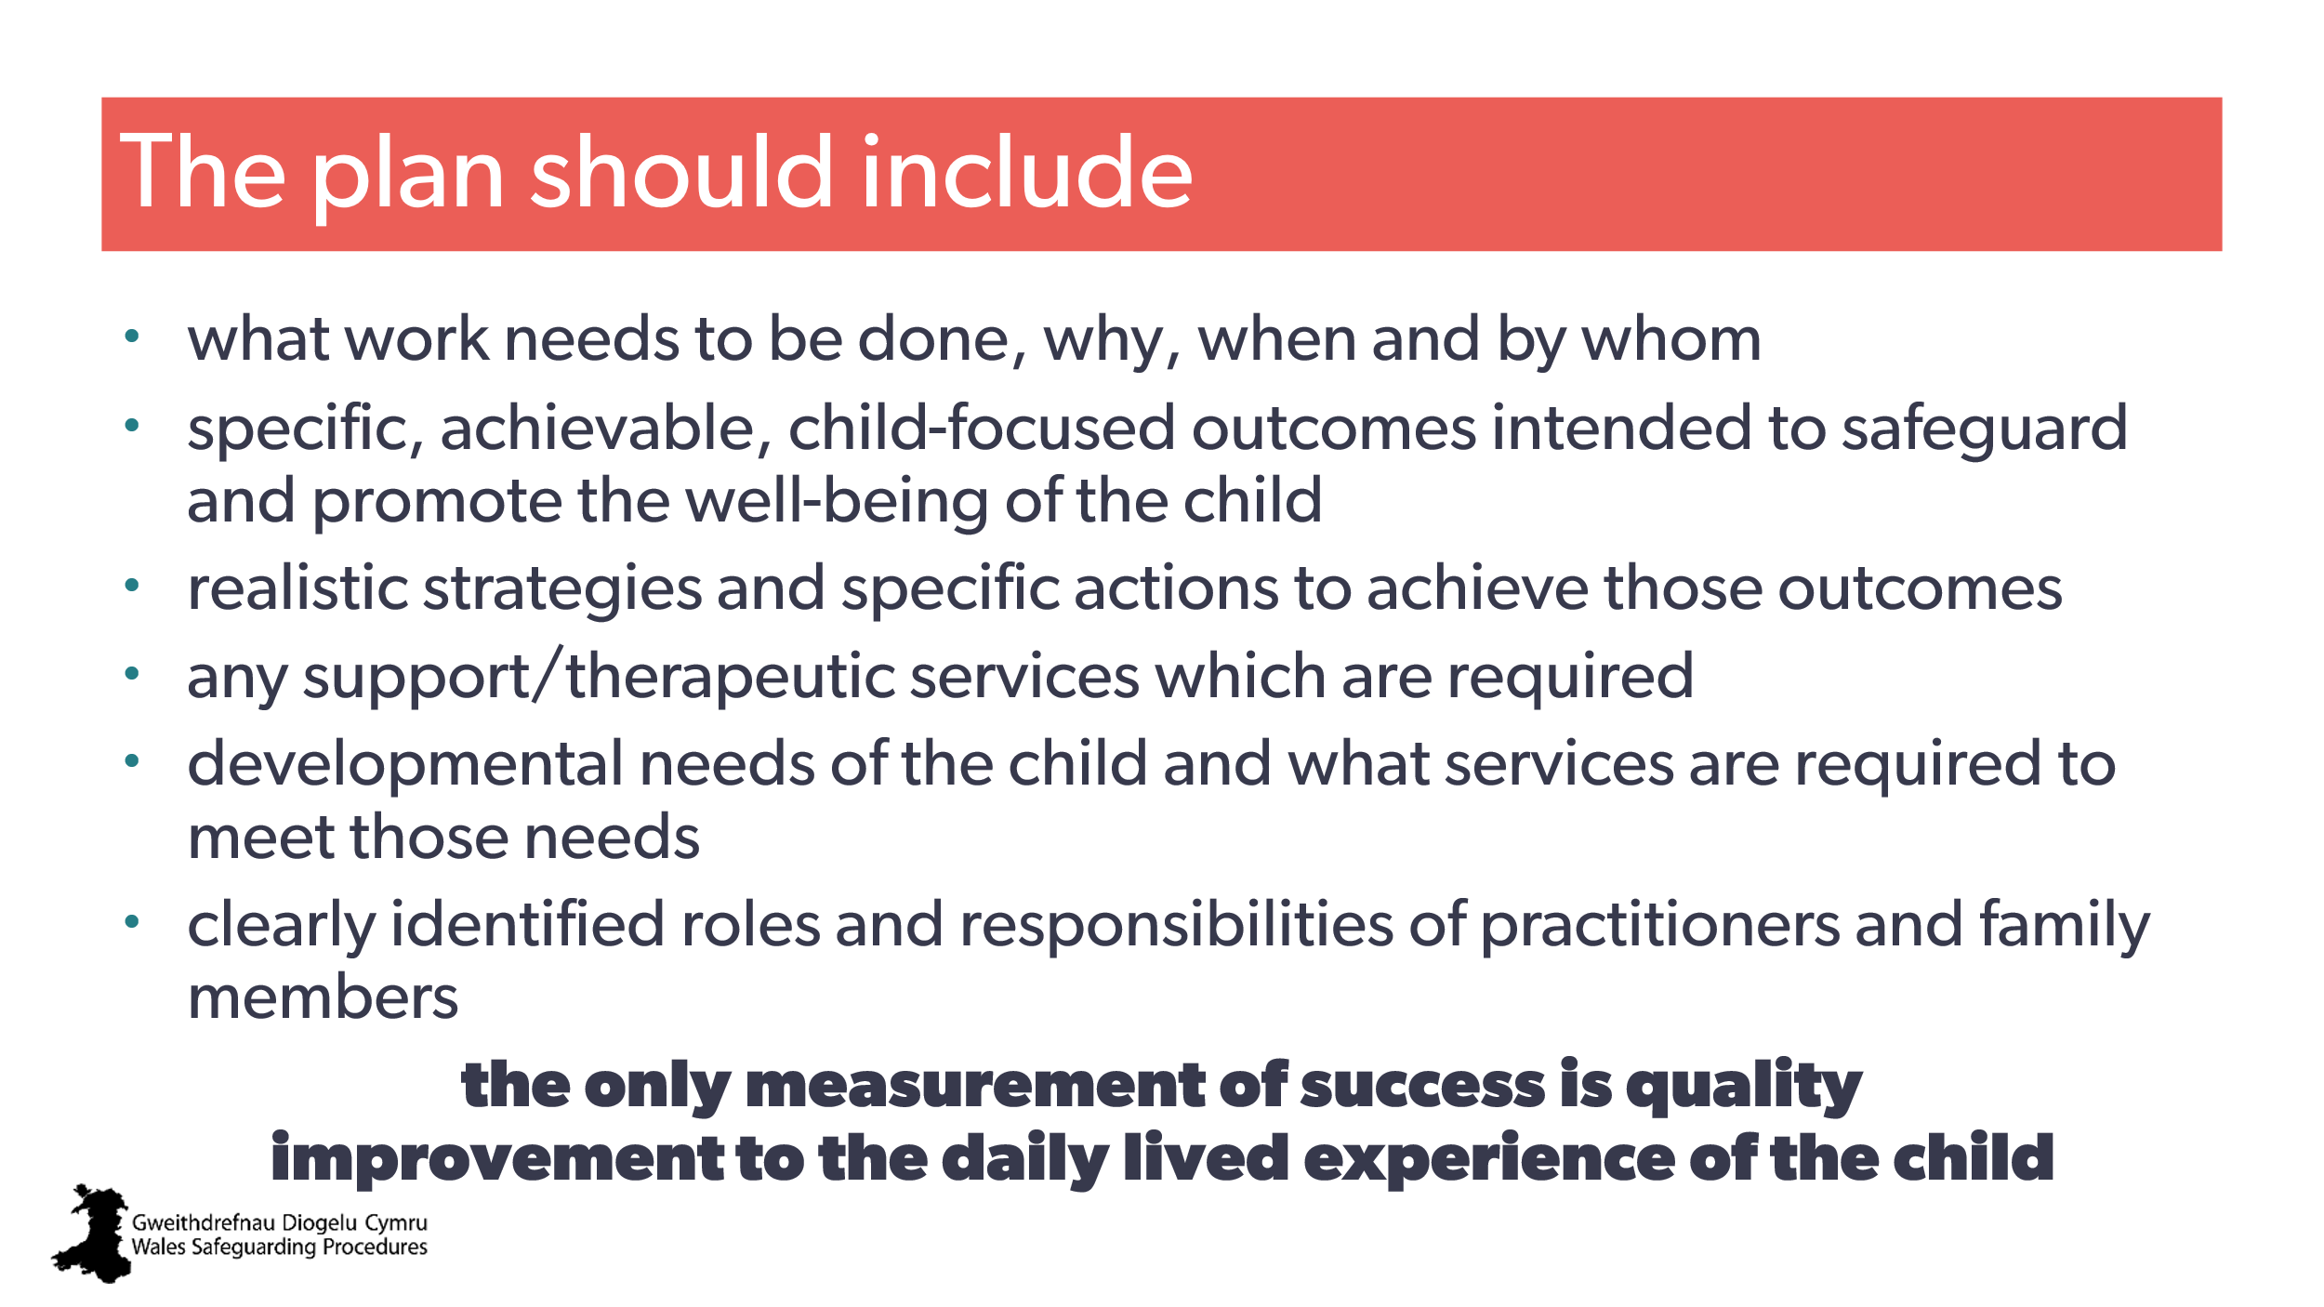 | Aim:  To provide an overview of the care and support protection plan.  Trainer to add:  - the practitioner's role in actively contributing to this collaborative process, focusing on ensuring the plan is child-centred and reflects the child’s needs and voice  - there should be attention to resolution and recovery that goes beyond initial actions to support longer-term safety and well-being  (for example contextual, holistic)  - each child placed on the child protection register, should have a named social worker who carries the practitioner responsibility for the case  - The social worker in their role as care and support protection plan co-ordinator must ensure that they co-ordinate the preparation, completion, review, delivery and revision of the plan.  Note: If learners are the named social worker, be sure to seek further detail from the Wales Safeguarding Procedures CPD training from the local authority. | The outline care and support protection plan  Planning for a child on the register: care and support protection plans  Pointers for Practice: From Outline Plan to Working Care and Support Protection Plan  Pointers for Practice: Identifying Effective Interventions for Children on The Child Protection Register  Regional Safeguarding Board guidance | CPD  Named Social Worker role  Wales Safeguarding Procedures: The social worker: (care and support protection plan co-ordinator)
43 | 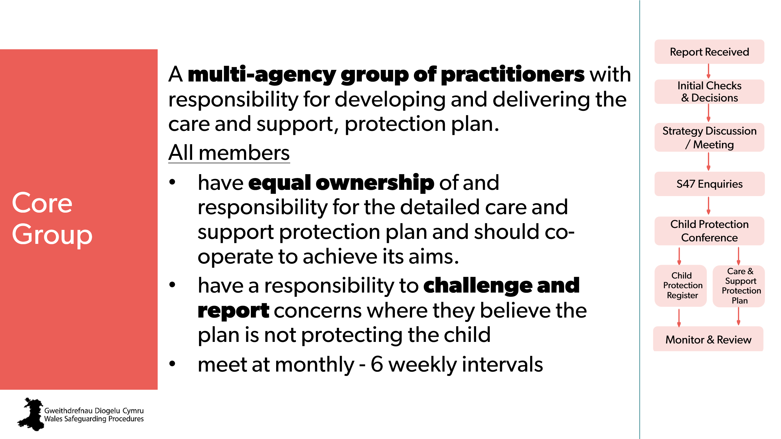 | Aim:  To introduce the core group  Trainer to explain:  The care and support protection plan co-ordinator should bring the group together.
44 | 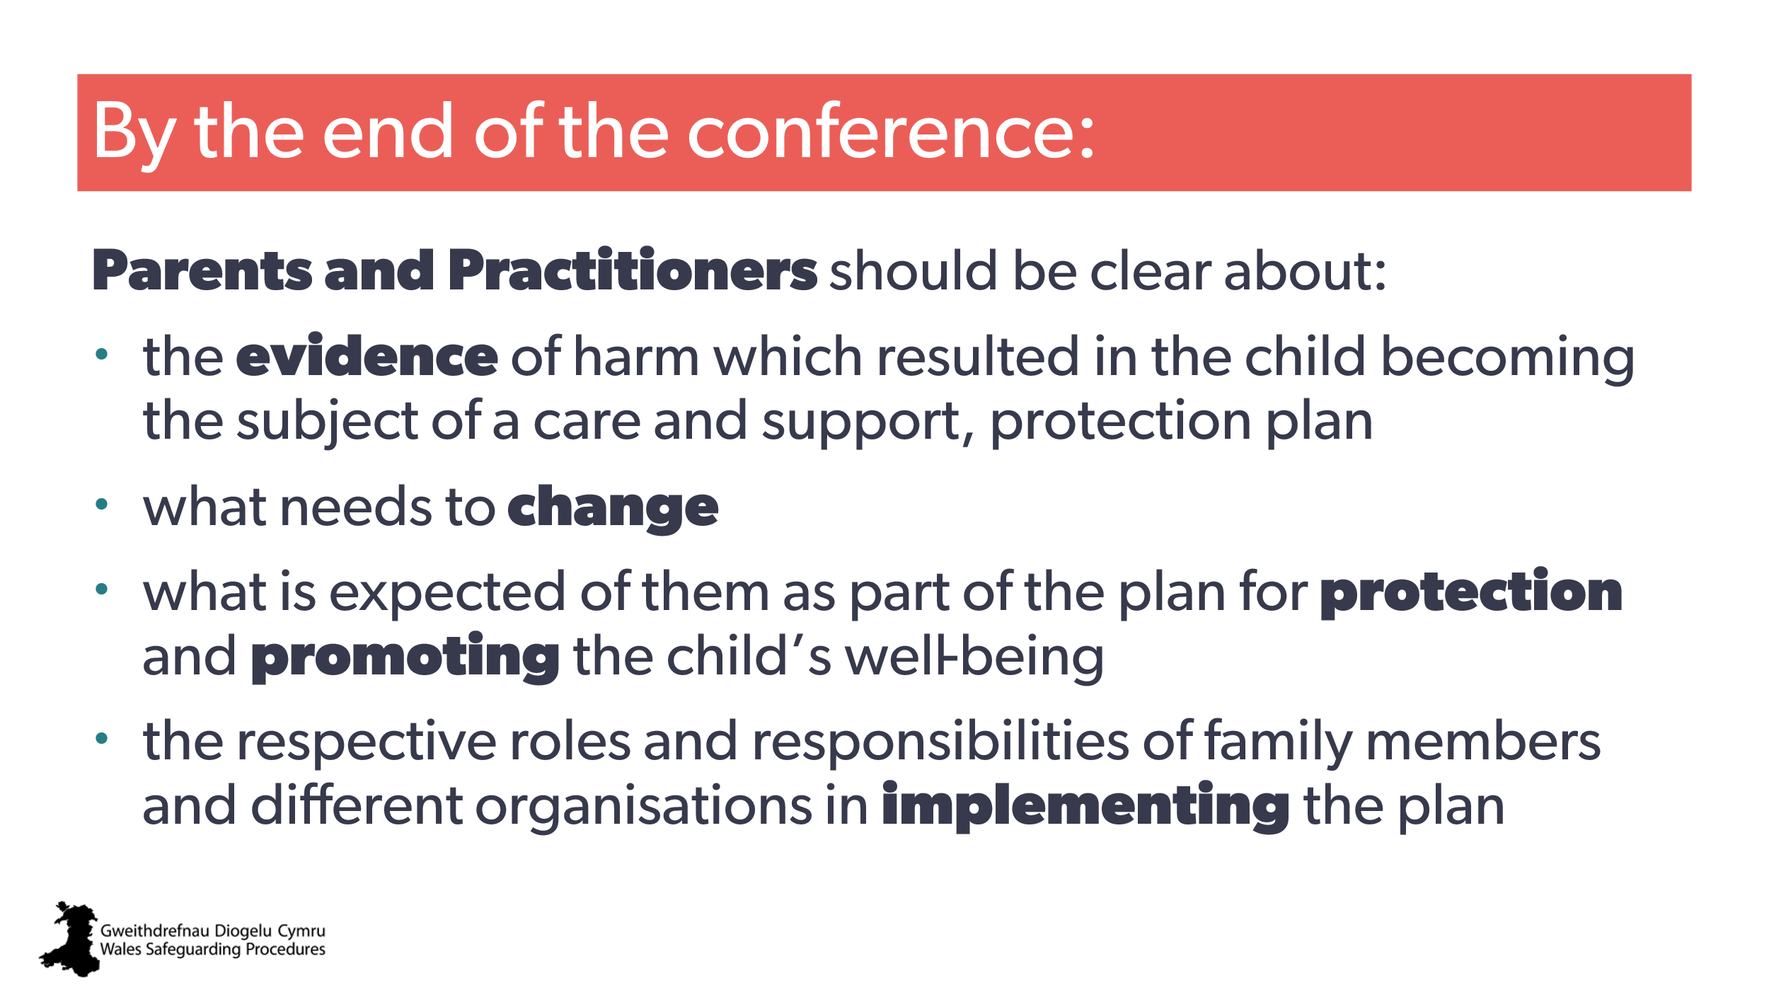 | Aim:  To outline what should be known by the end of the conference.
45 | 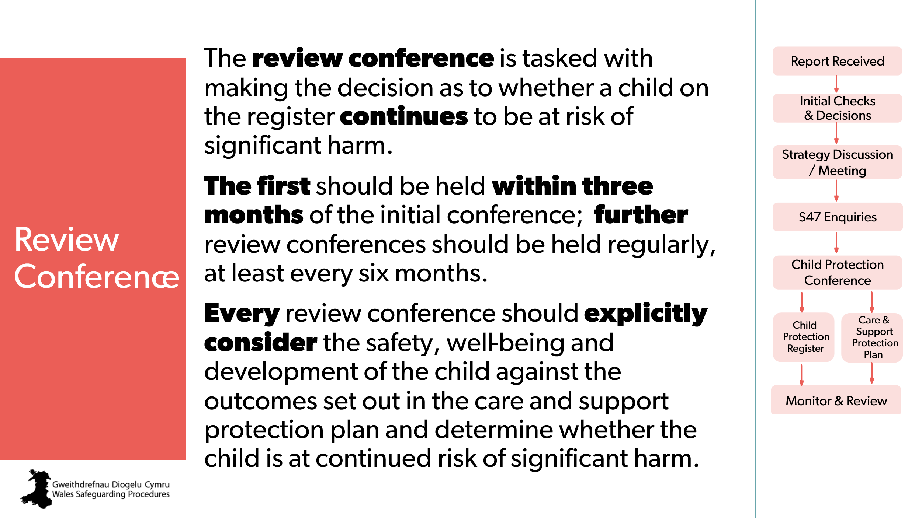 | Trainer to explain:  The review conference needs as much preparation, commitment and management as the initial conference.
46 | 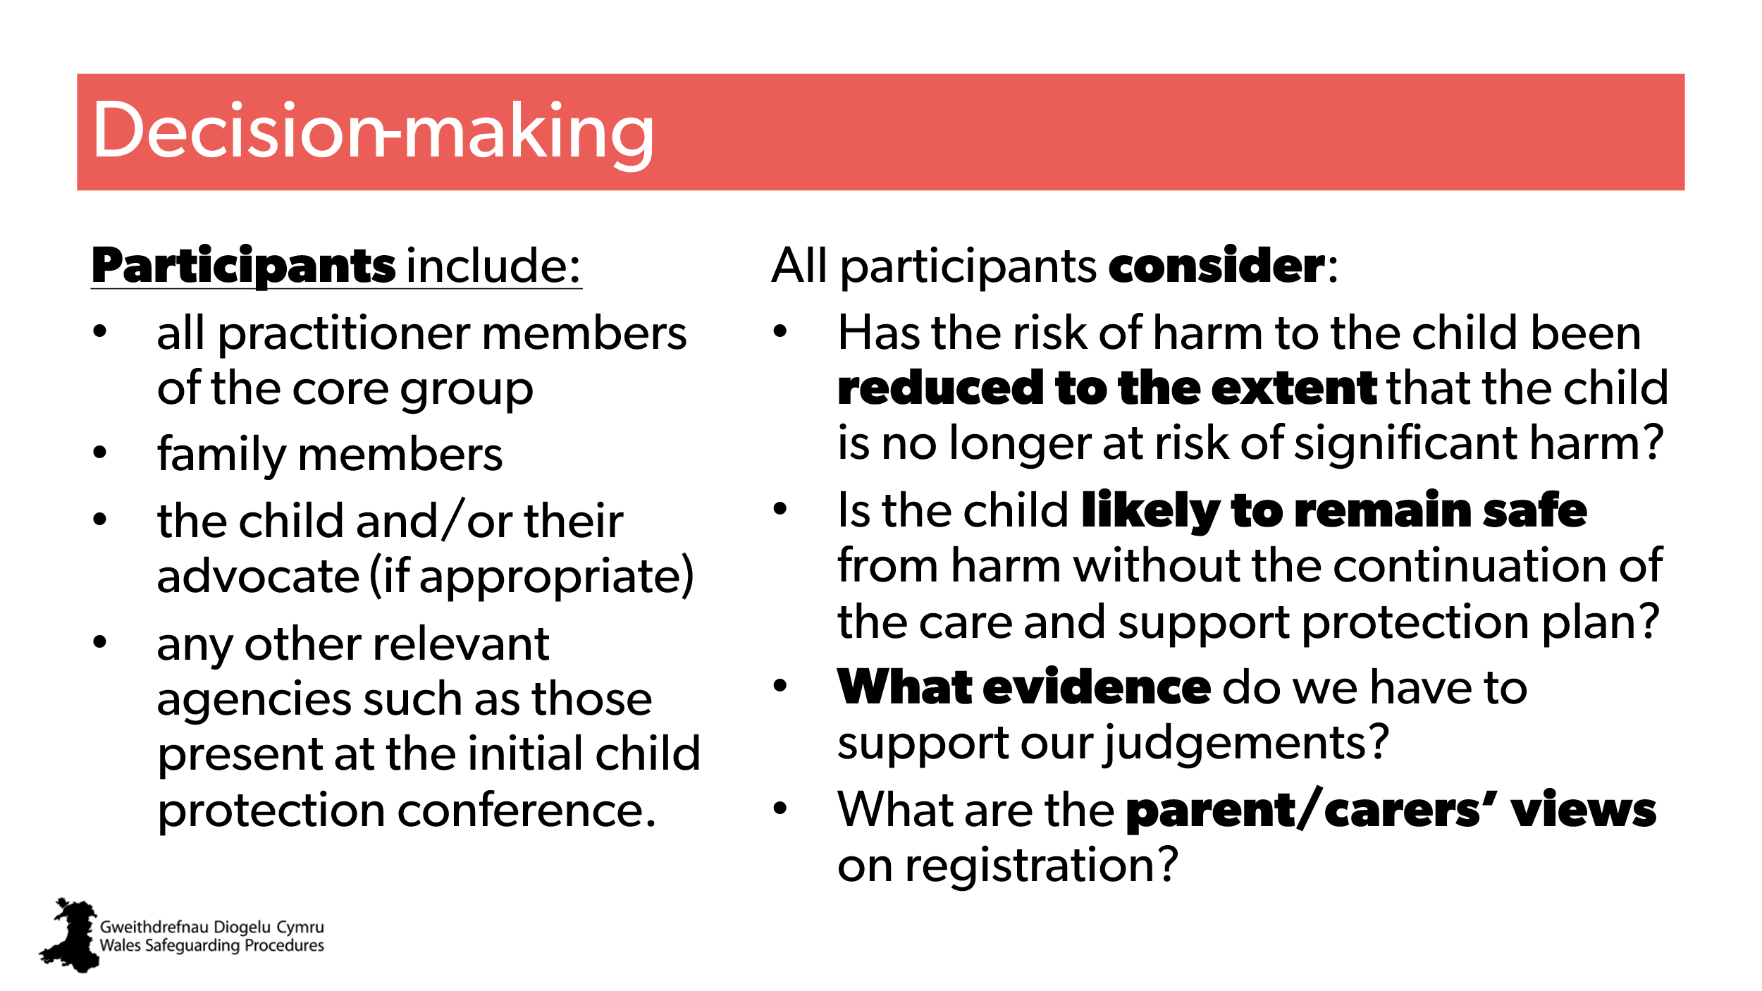
47 | 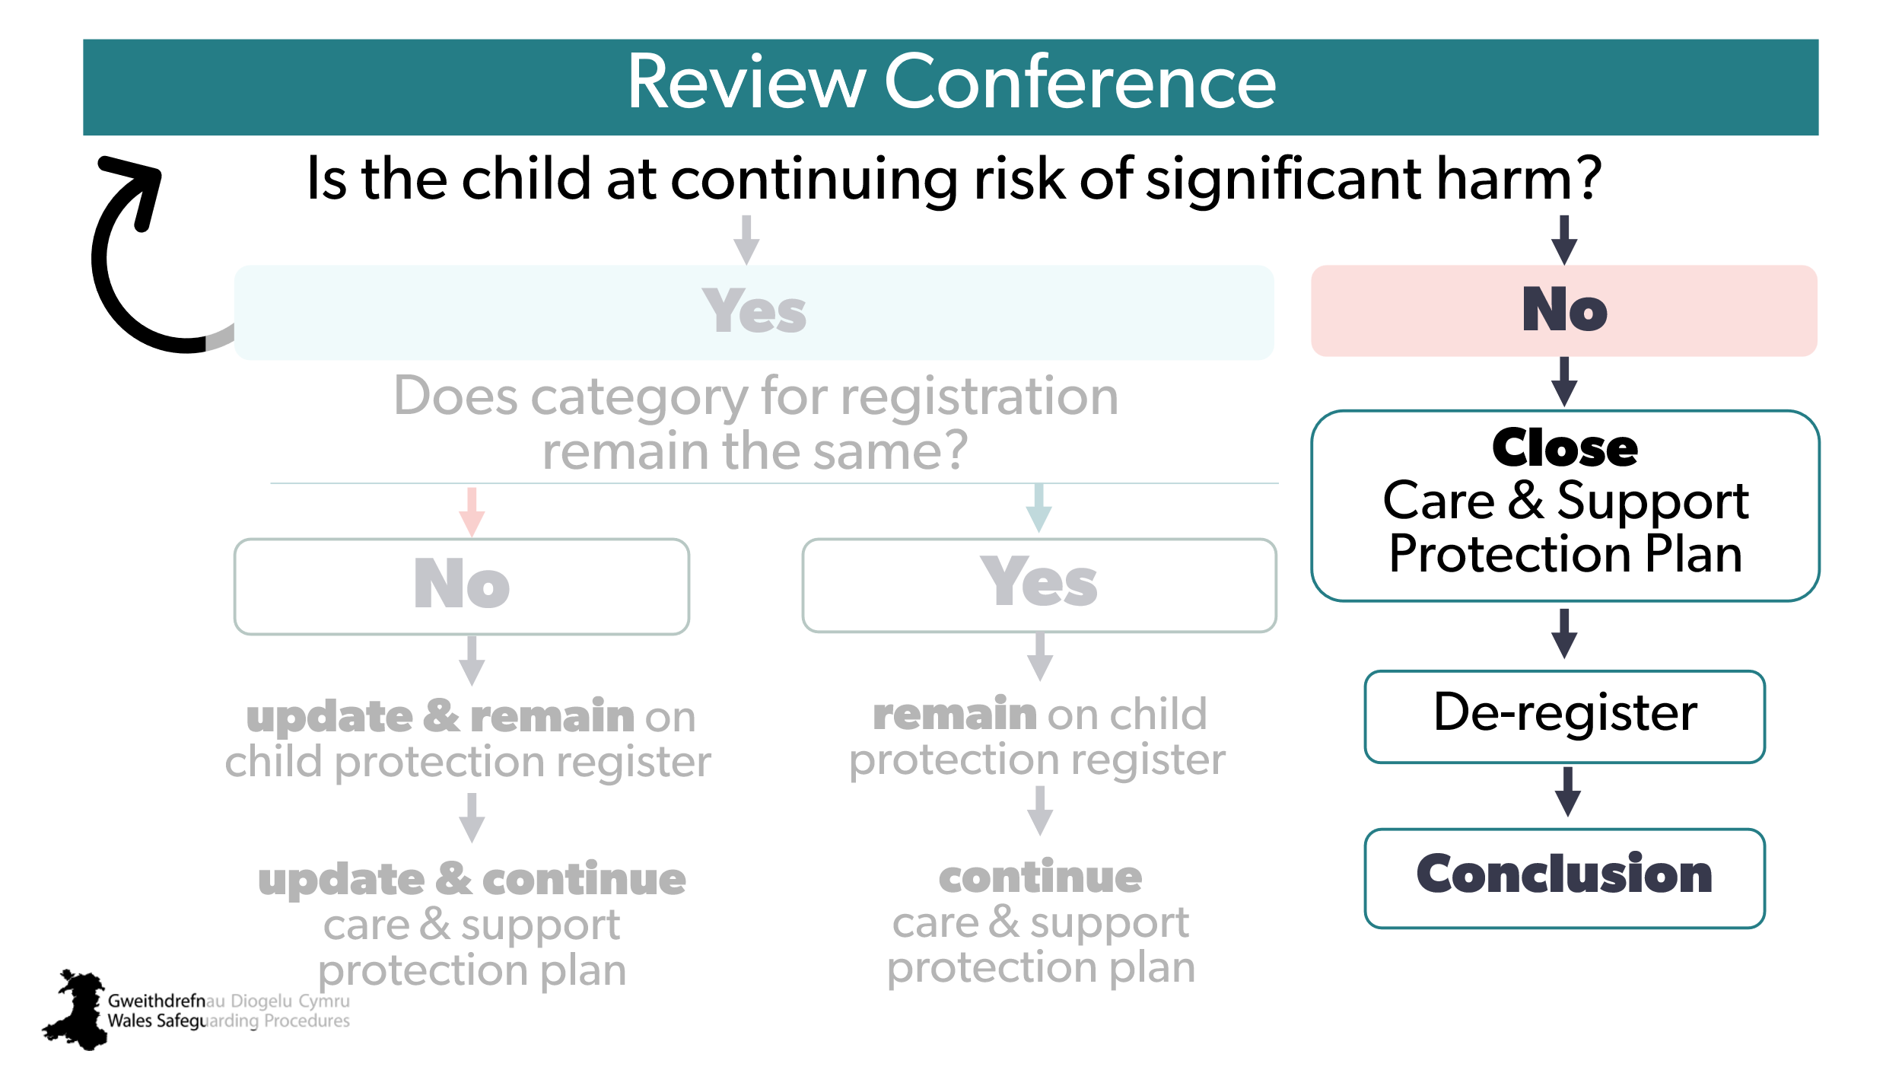

Section 5 – children and young people and adults

CYP 48  AR  x | 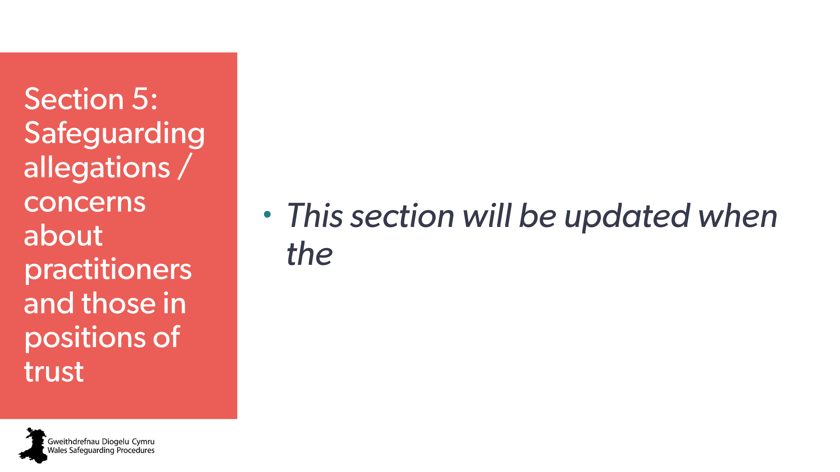 | Holding for section/title slide
CYP 49  AR  x | 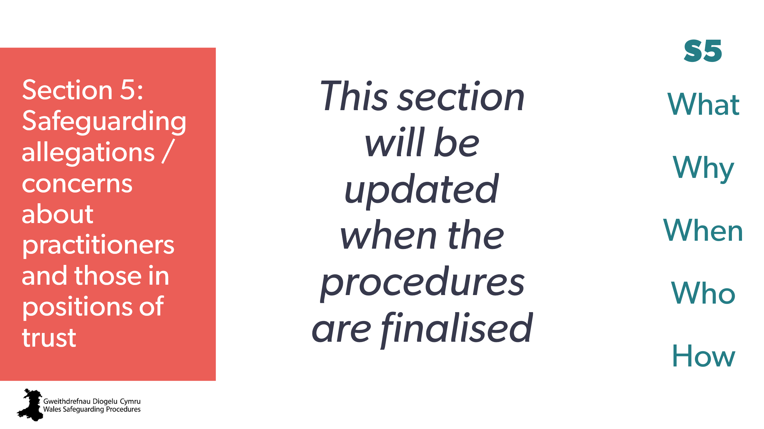 | To be updated  Aim:  To provide an overview of Section 5 of the Wales Safeguarding Procedures  Trainer to explain:  We’ll be looking at the main aspects for awareness using the sections on the right side.
CYP 50  AR  x | 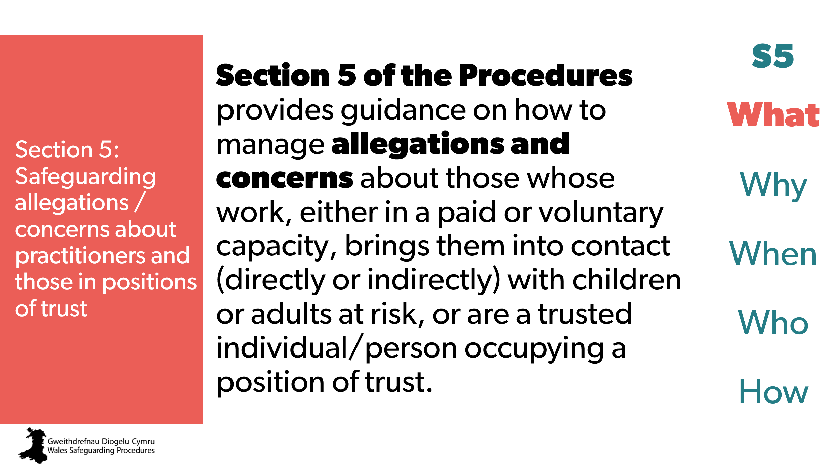 | Aim:  To describe what the Section 5 procedures are.
CYP 51  AR  x | 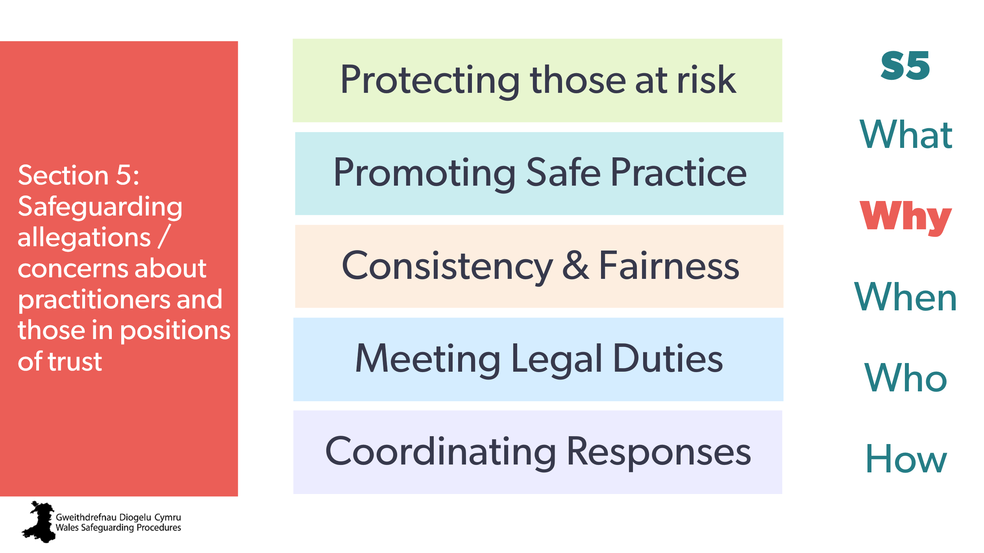 | Aim:  To describe the key reasons for the Section 5 procedures.  Trainer to expand on each:  Protecting those at risk - ensure anyone who may pose a risk is properly investigated and, if necessary, removed from a position of trust.  Promoting safe practice - help organisations reflect on and improve their safeguarding policies and training.  Consistency and fairness - ensure all cases apply the same standards, protecting children and adults at risk and the rights of those who have allegations against them.  Meeting legal duties - support compliance with safeguarding legislation and guidance.  Coordinating responses - ensure a multi-agency approach when managing allegations or concerns.
CYP 52  AR  x | 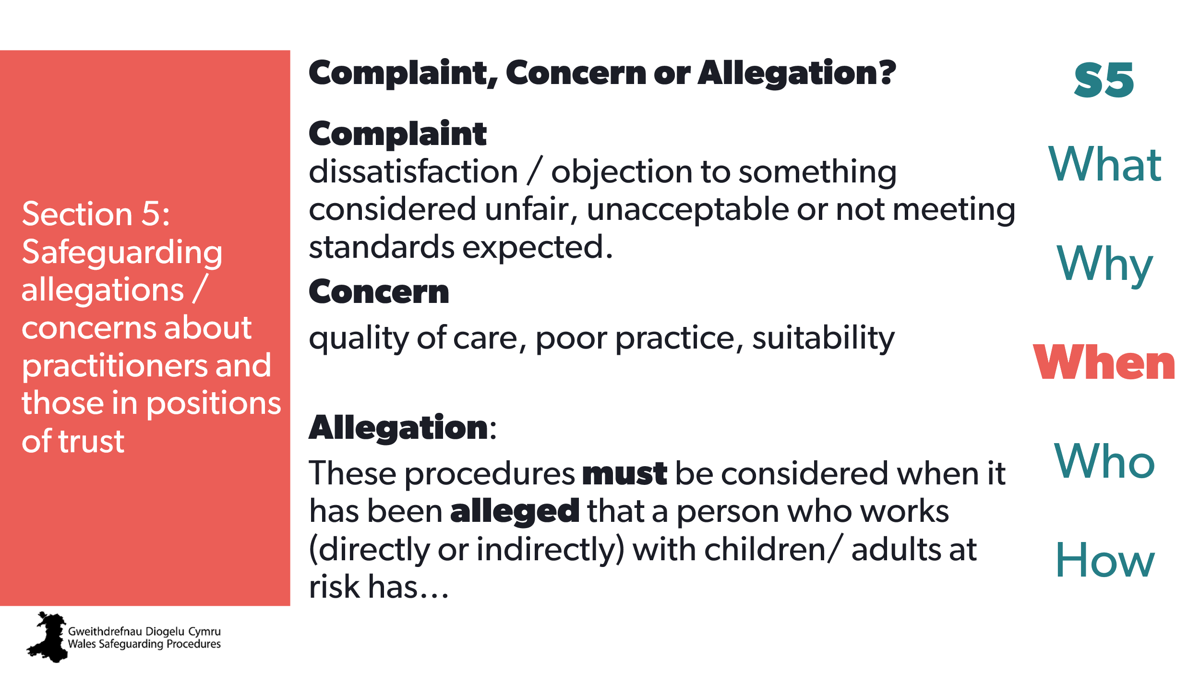 | Aim:  - describe when to use the Section 5 procedures  - know the difference between a complaint, a concern and an allegation.
CYP 53  AR  x | 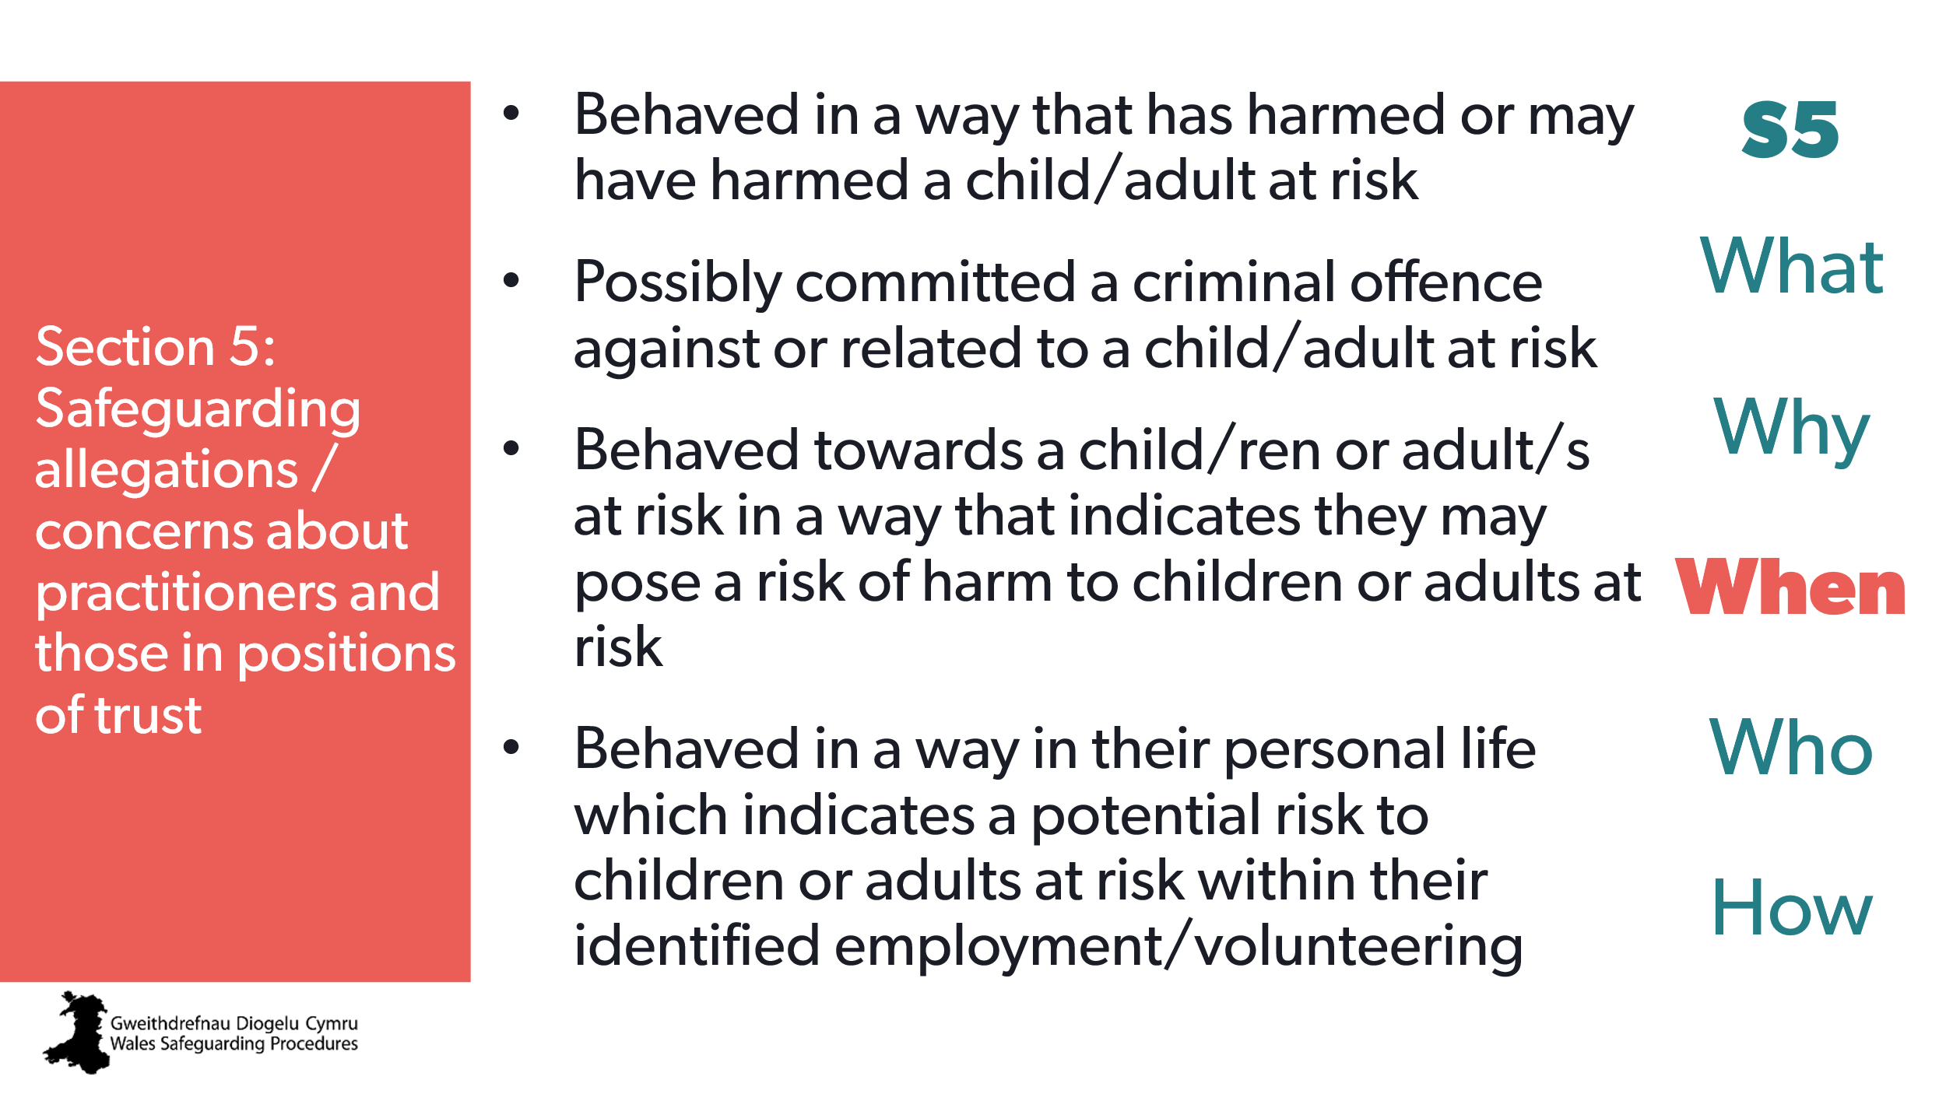 | Aim:  Provide examples of allegations.  Note to trainer:  Be sure to provide examples of ‘unsuitable’ from the procedures.
CYP 54  AR  x | 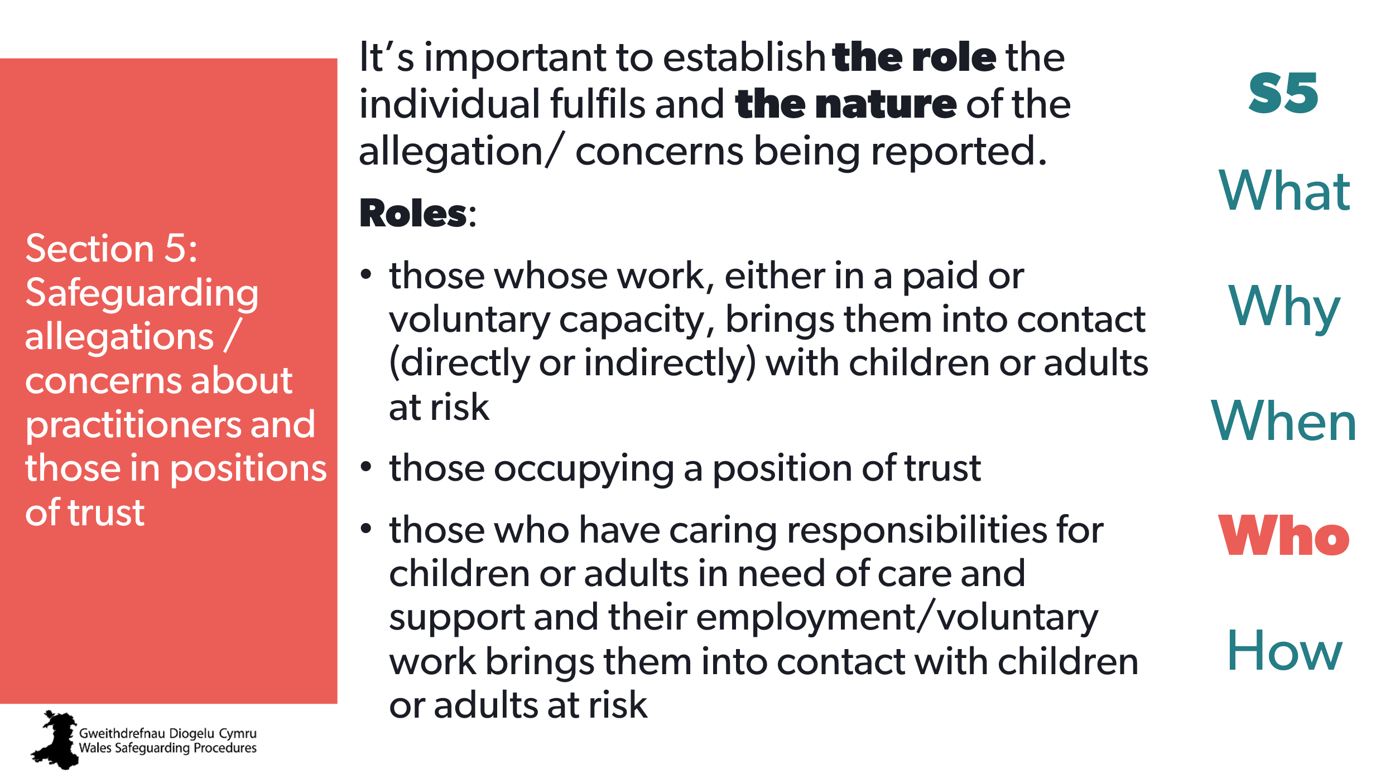 | Aim:  To provide an overview of who may be subject to Section 5 procedures.  To describe what is meant by role.
CYP 55  AR  x | 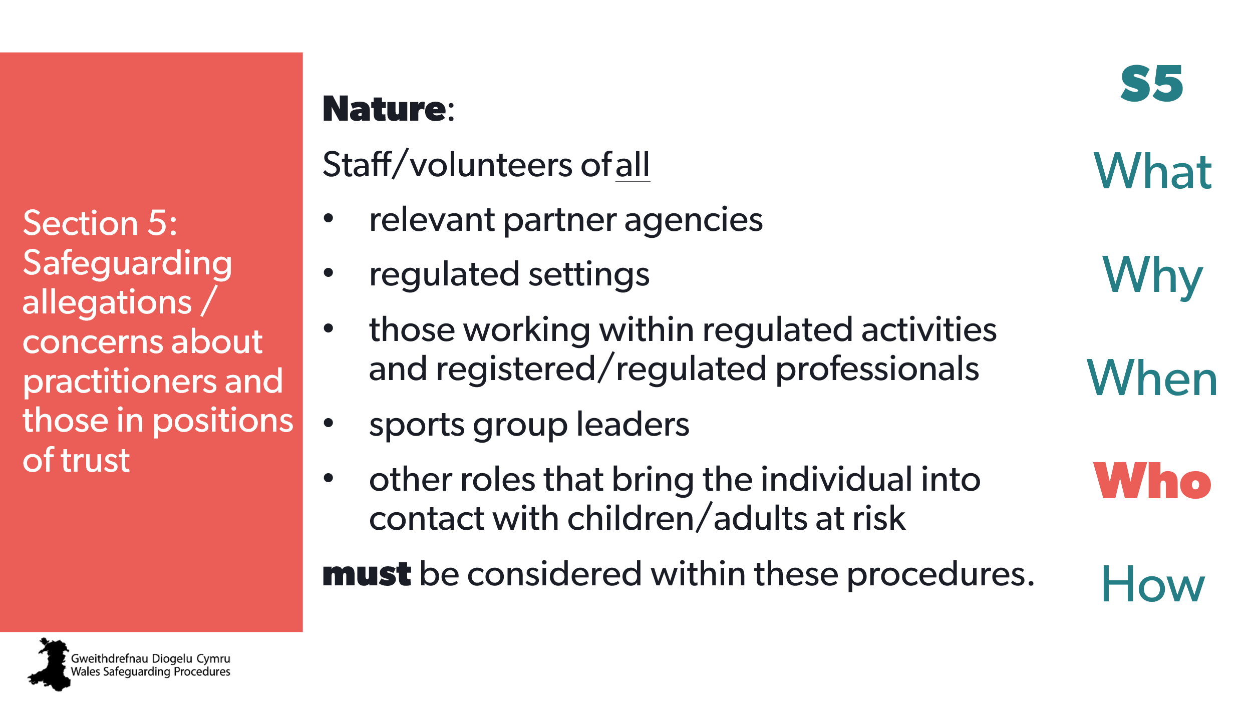 | Aim:  To provide an overview of who may be subject to Section 5 procedures.  To describe what is meant by nature.
CYP 56  AR  x | 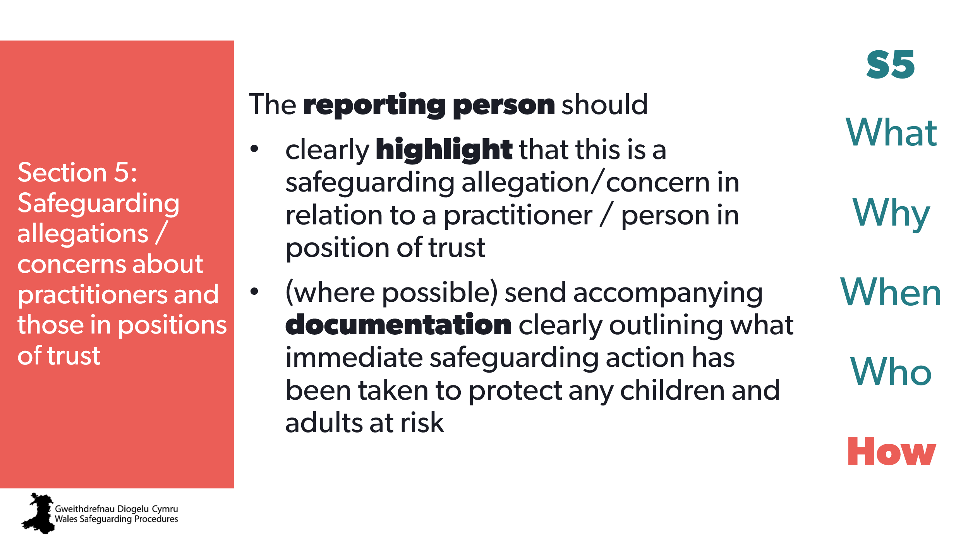 | Aim:  To provide an overview of actions for the reporting person / person with the concern.
CYP 57  AR  x | 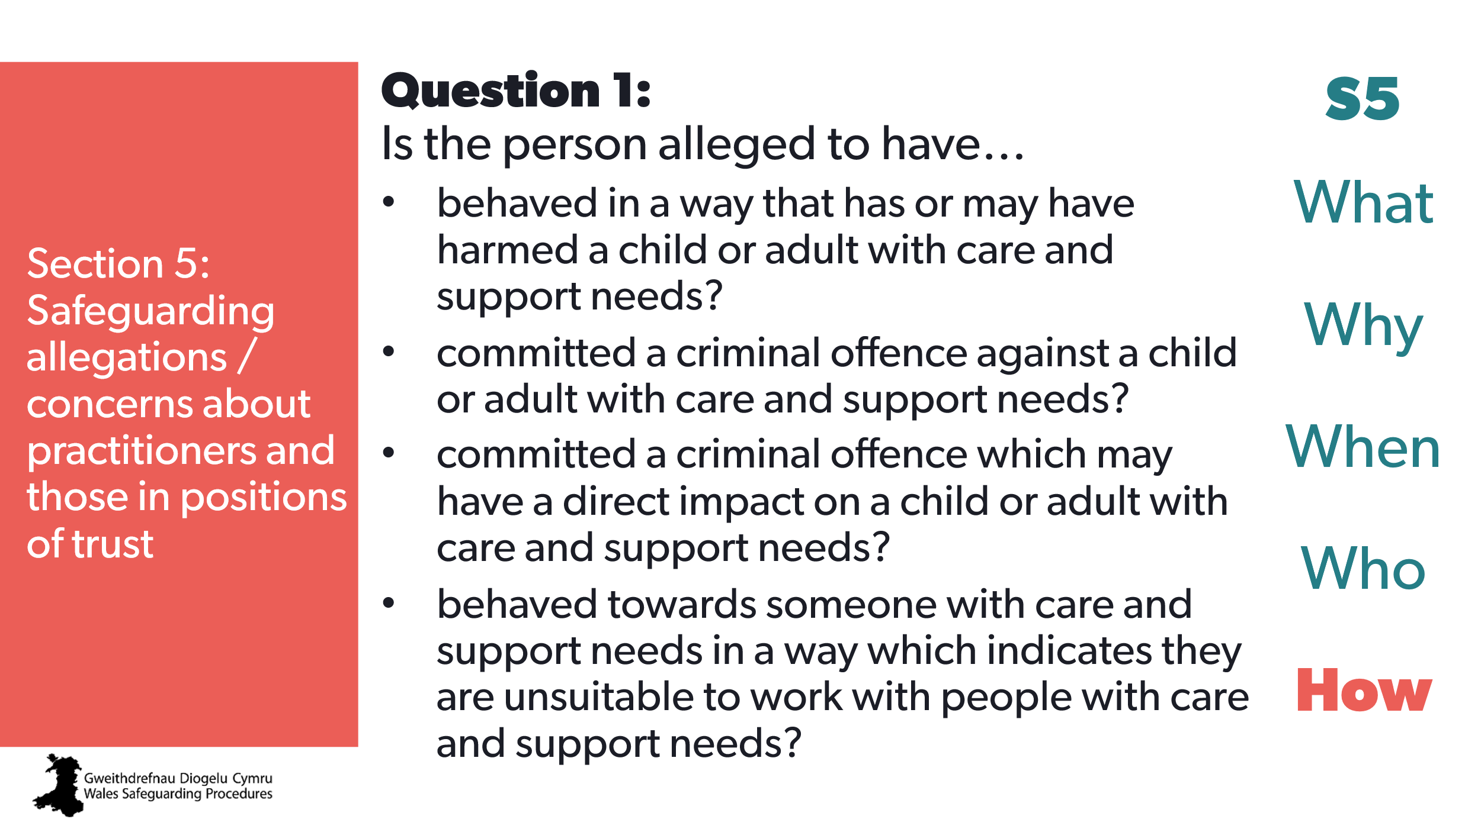 | Aim:  To look at how to determine if Section 5 procedures are appropriate.  Question 1 – is about the person of concern.
CYP 58  AR  x | 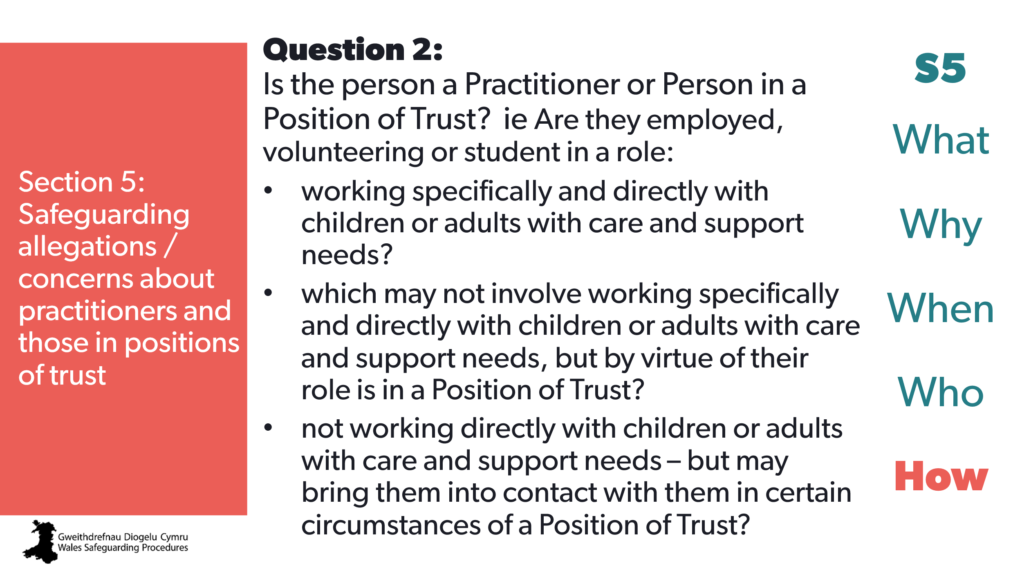 | Aim:  To look at how to determine if Section 5 procedures are appropriate.  Question 2 – is about the behaviour of concern.
CYP 59  AR  x | 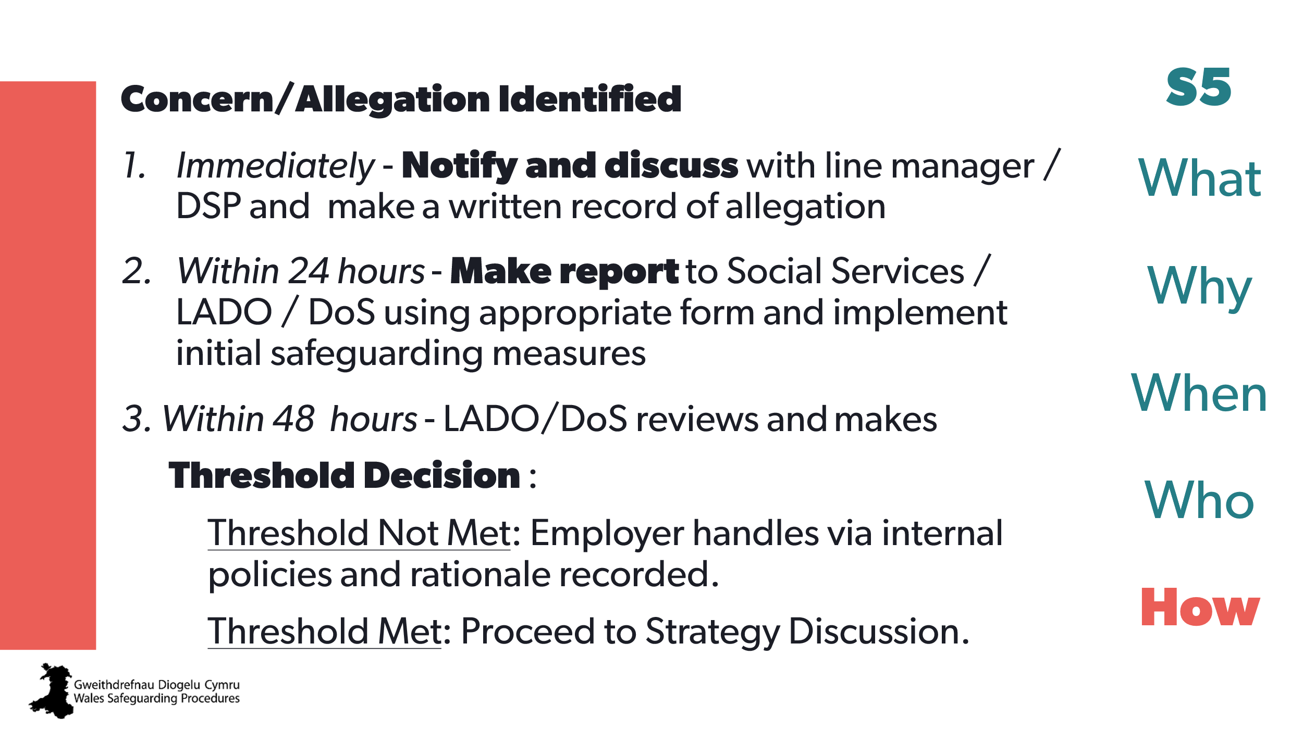 | Aim:  To go through the steps in the process from concern through conclusion
CYP 60  AR  x | 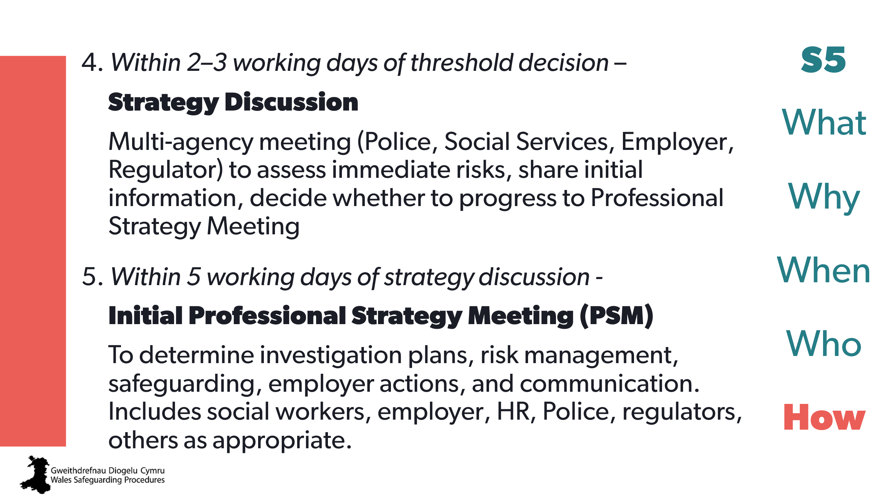
CYP 61  AR  x | 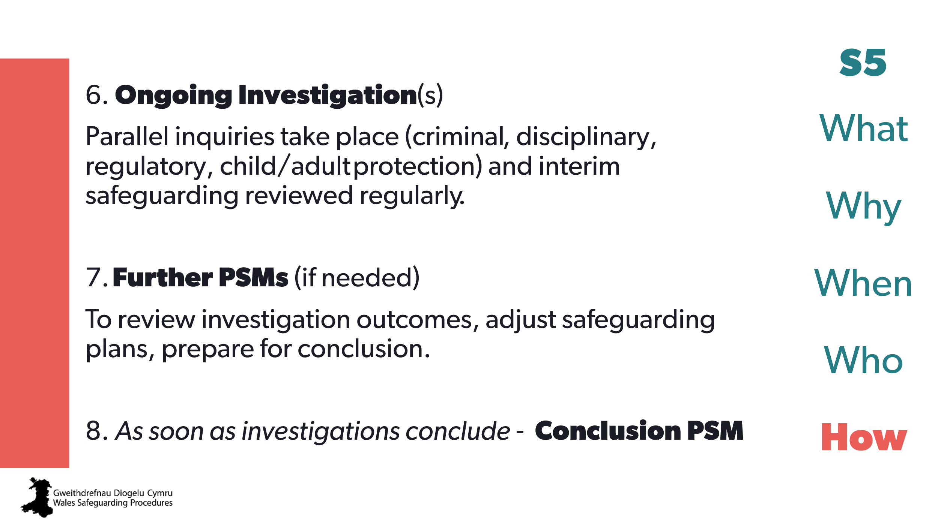
CYP 62  AR  x | 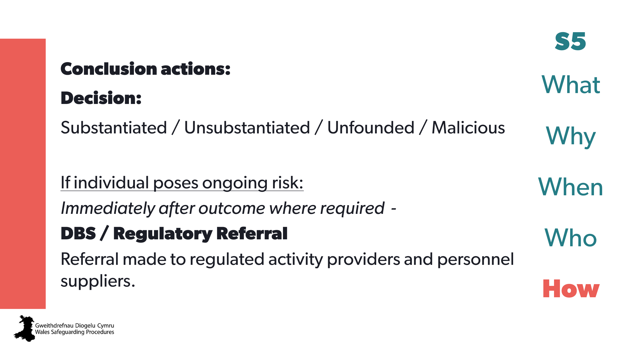
CYP 63  AR  x | 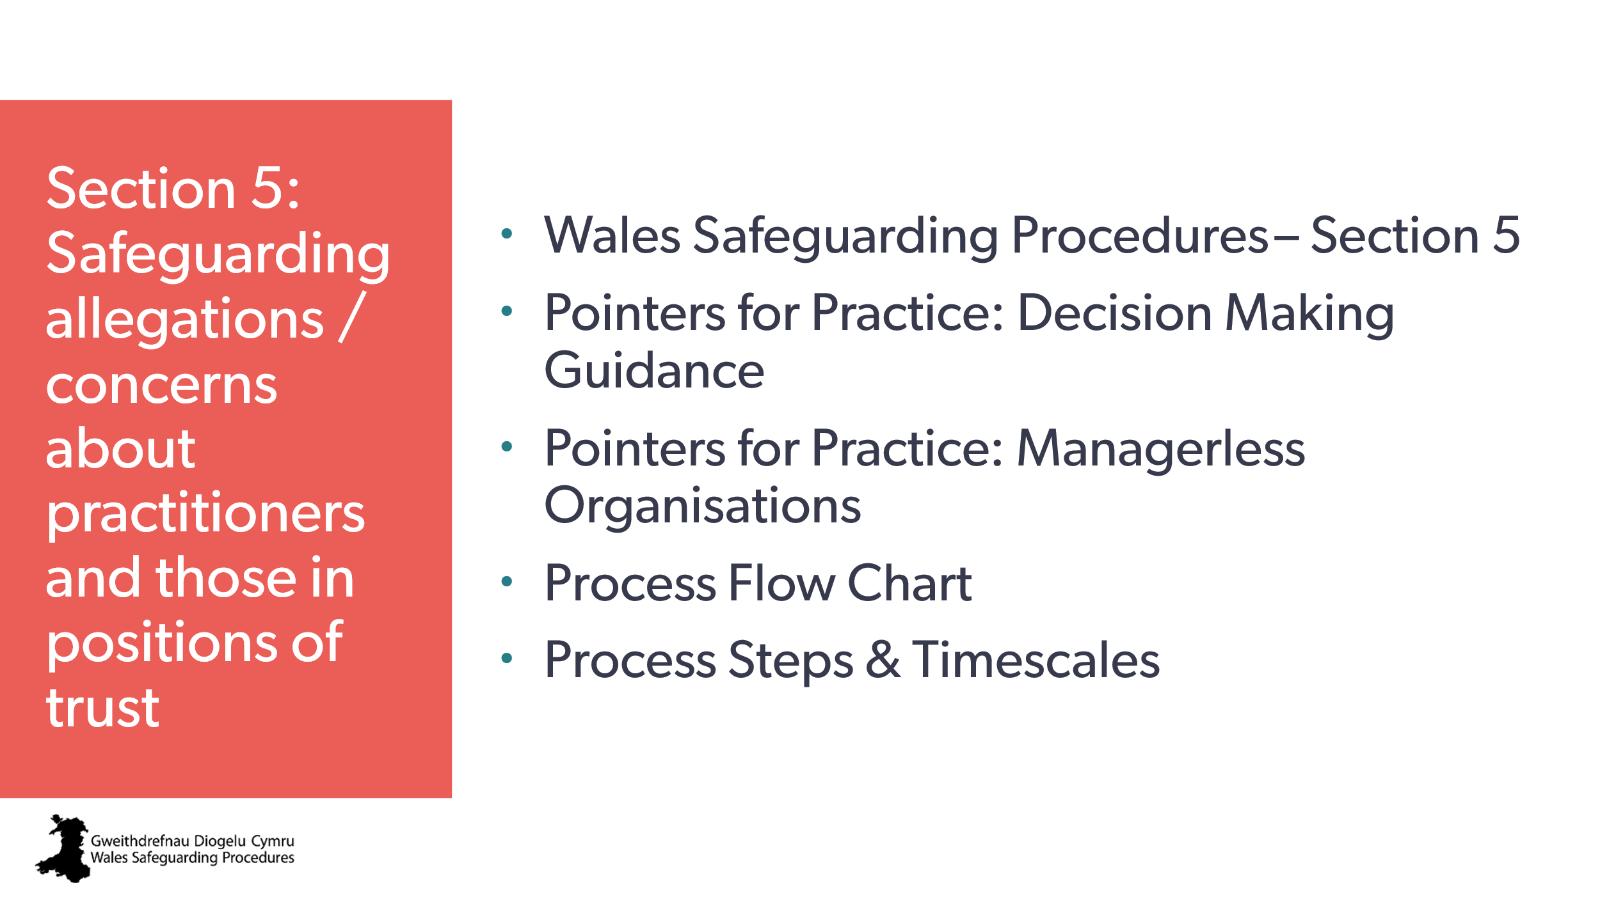 | Aim:  To list all relevant resources and guidance that should be used.  To encourage those who may have responsibilities in the Section 5 procedures to seek specific training.

