Group C pre-course slides and workbook
This is the outline for a presentation that should be viewed before attending the live Group C Safeguarding Course.

Number | Slide | Notes | Related workbook question / resources
1 | 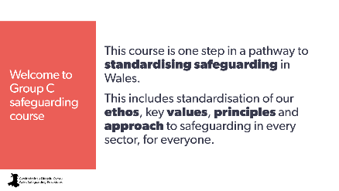 | Welcome to your Group C safeguarding course!  This course is one step in a pathway to standardising safeguarding in Wales.  This includes standardisation of our ethos, key values, principles and approach to safeguarding in every sectors, for everyone.
2 | 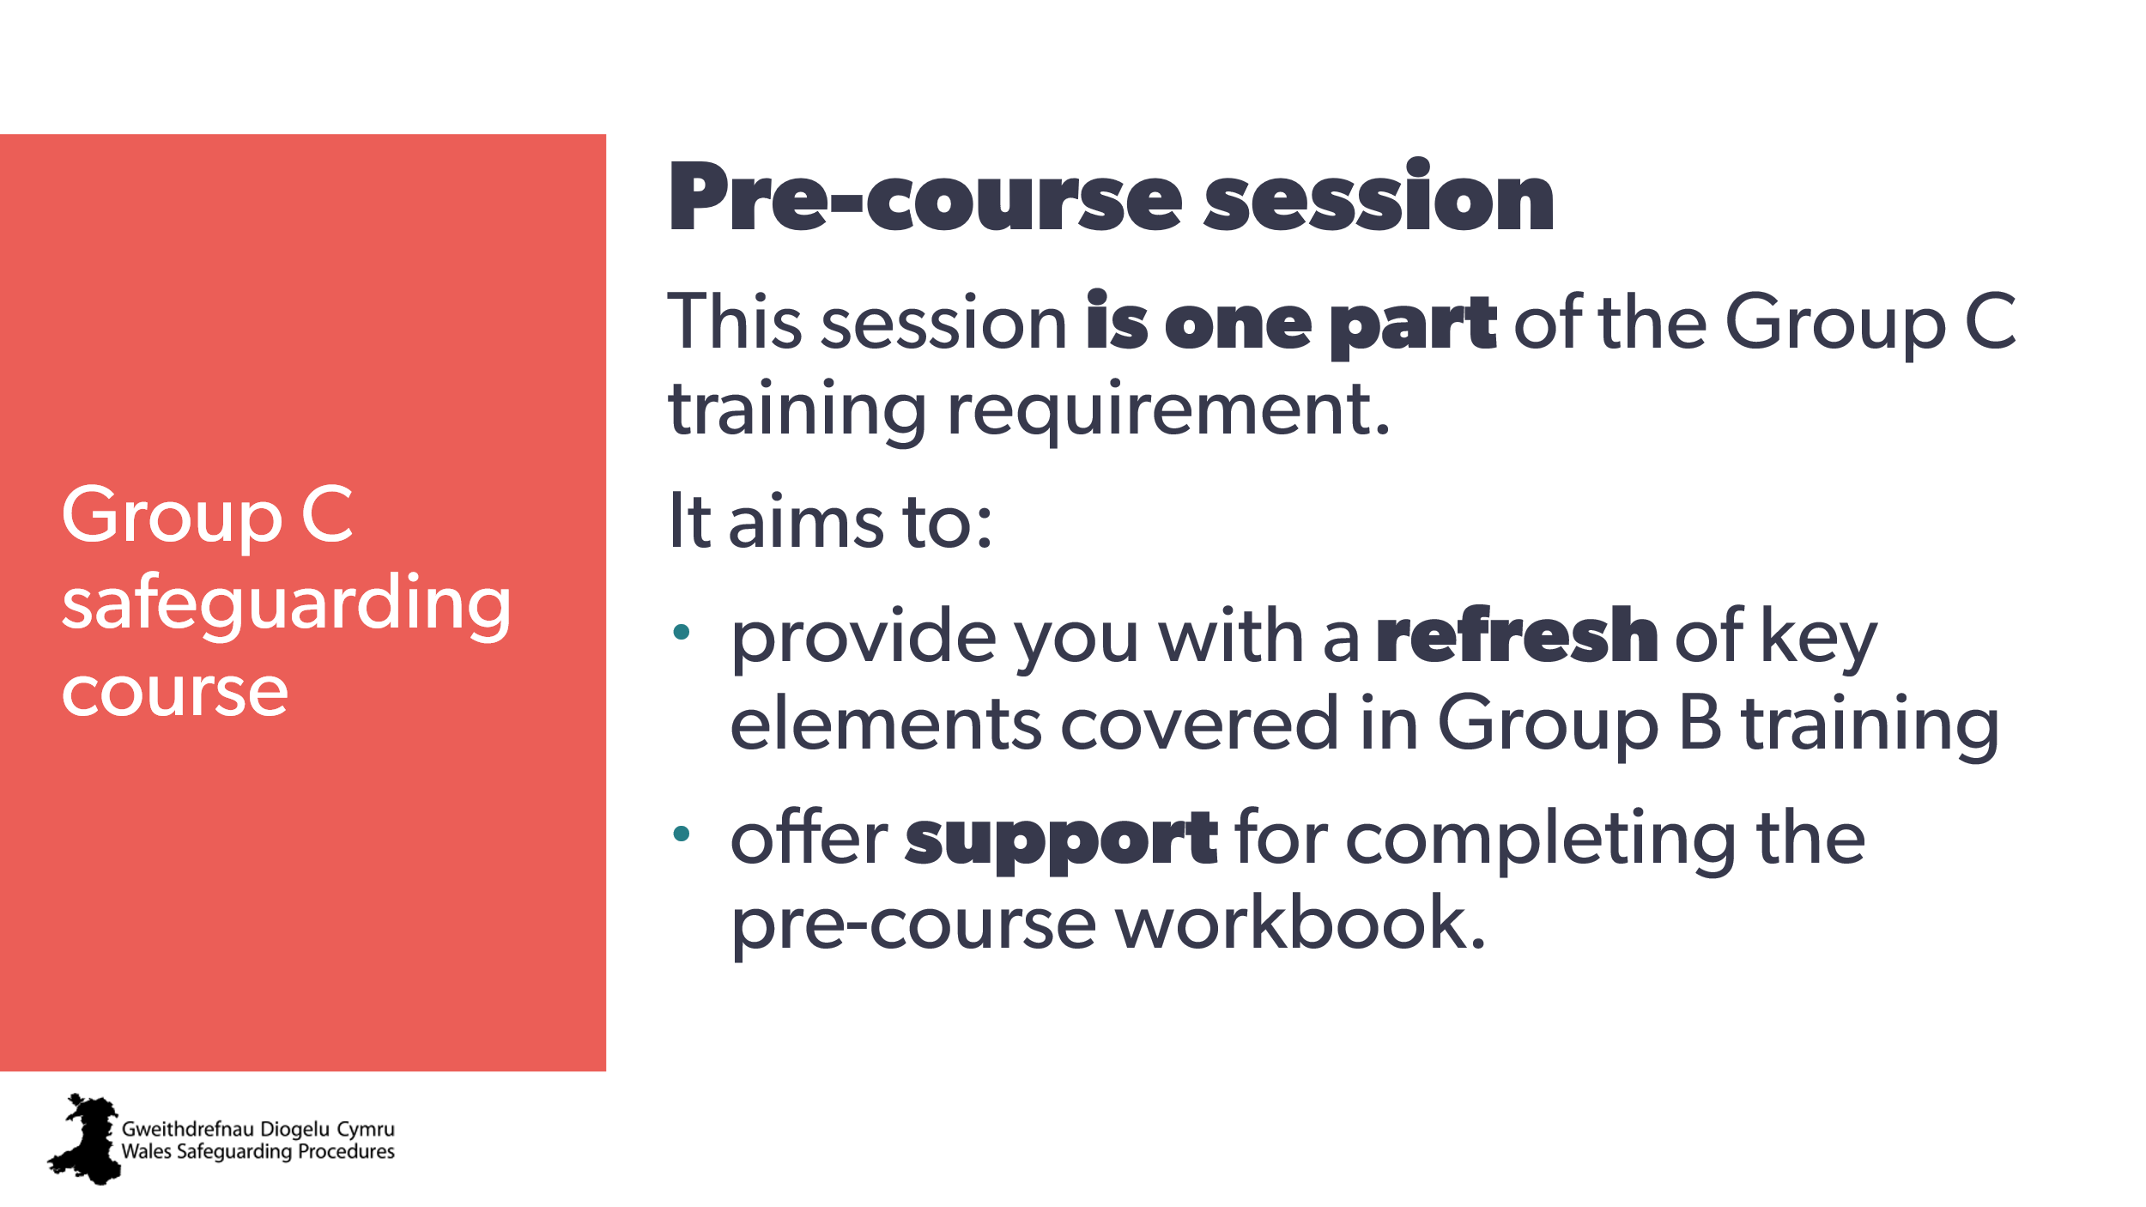 | This session is one part of the Group C training requirement.  It aims to provide you with:  - A refresh and reminder on key aspects of the Group B course  - some background about topics we’ll be discussing on the Group C course  - ‘food for thought’ to bring with you to your Group C course.
3 | 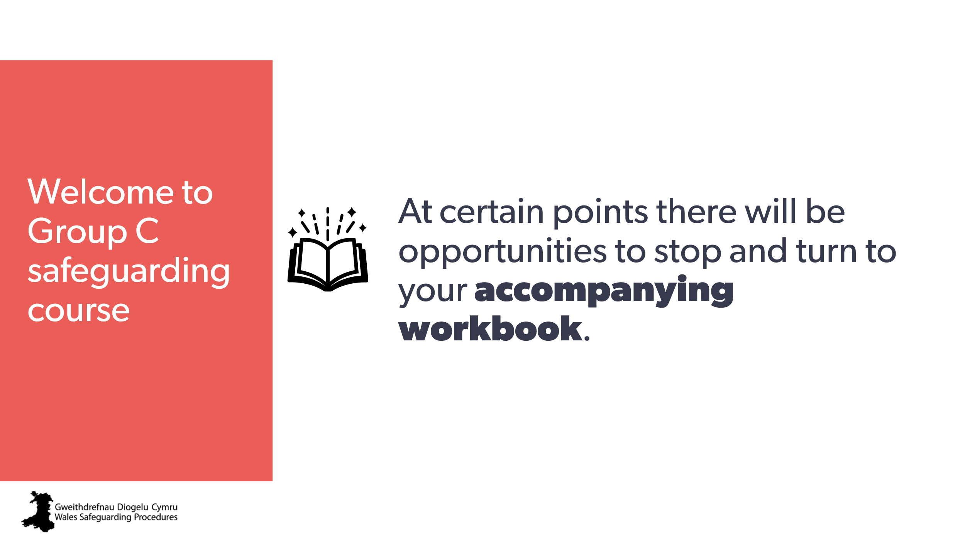 | At certain points there will be opportunities to stop and turn to your accompanying workbook.
4 | 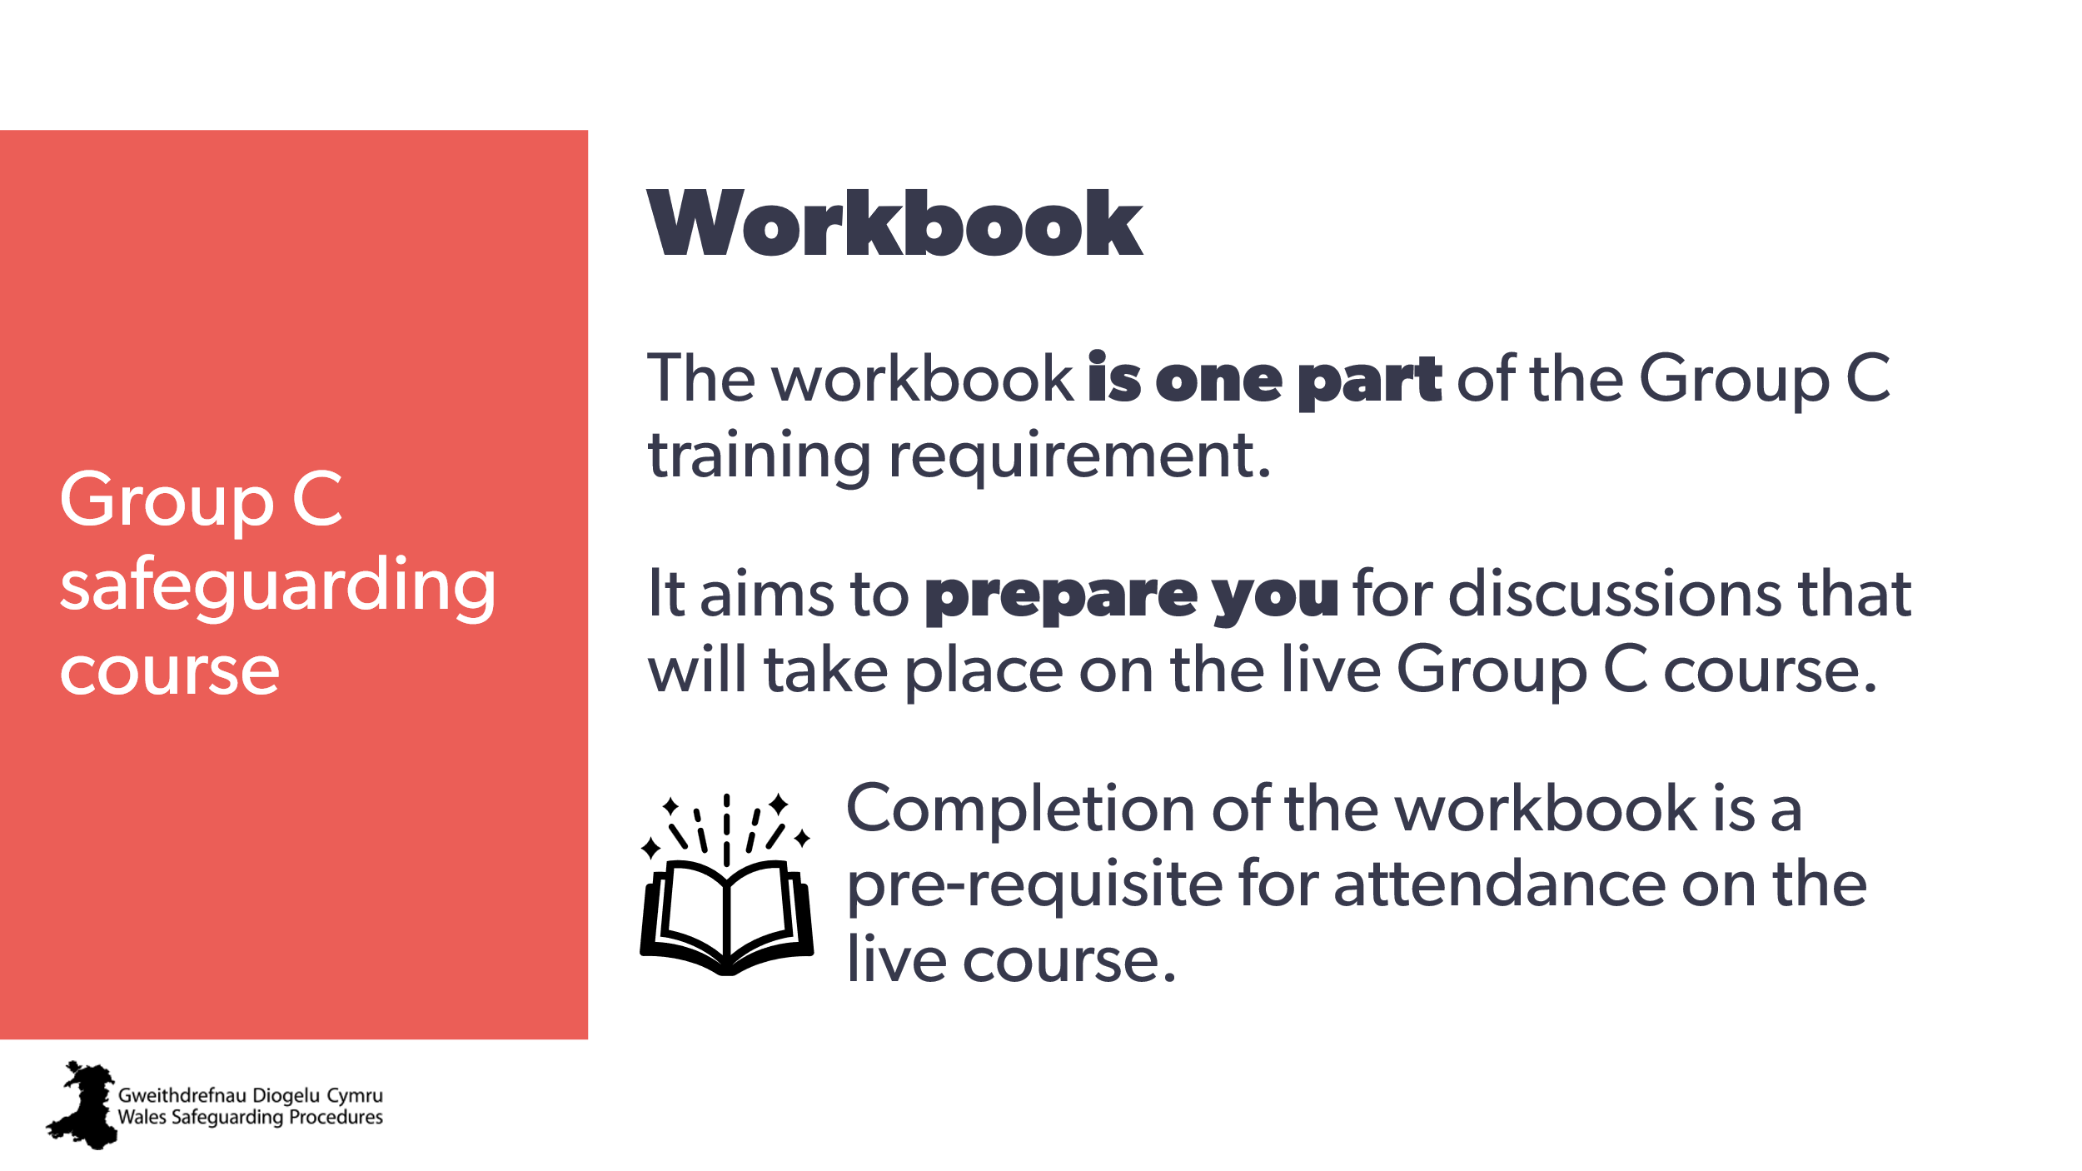 | This workbook is one part of the Group C training requirement.  Its aim is to prepare you for discussions that will take place on the live Group C course.  You must complete the workbook before attending the live course.
5 | 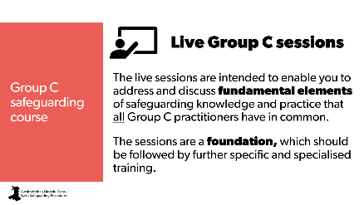 | The live sessions are intended to enable you to address and discuss fundamental elements of safeguarding knowledge and practice that all Group C practitioners have in common.  The sessions are a foundation, which should be followed by further specific and specialised training.
6 | 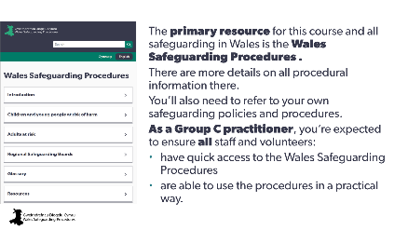 | The primary resource for this course and all safeguarding in Wales is the Wales Safeguarding Procedures.  There are more details on all procedural information there.  You’ll also need to refer to your own safeguarding policies and procedures.  As a Group C Practitioner, you’re expected to ensure all staff and volunteers  - have quick access to the Wales Safeguarding Procedures  - are able to use the procedures in a practical way  The Wales Safeguarding Procedures:  - standardise safeguarding practice across Wales and between agencies  - ensure you understand your essential safeguarding role and responsibilities  - ensure your practice complies with the Social Services and Well-being Actand all statutory guidance, and  - outline the framework for determining how safeguarding referrals, actions and plans are made and carried out | Workbook  1. How do you / could you ensure everyone has ready access to the Wales Safeguarding Procedures?  2. Do your organisation’s policies and procedures specifically refer to and comply with the Wales Safeguarding Procedures?
7 | 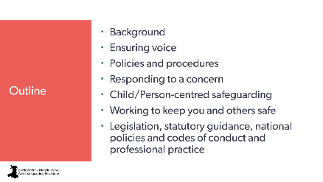 | This session of the Group C course includes the following sections:  - Background  - Ensuring voice  - Policies and procedures  - Responding to a concern  - Child/Person-centred safeguarding  - Working to keep you and others safe  - Legislation, statutory guidance, national policies and codes of conduct and professional practice.
8 | 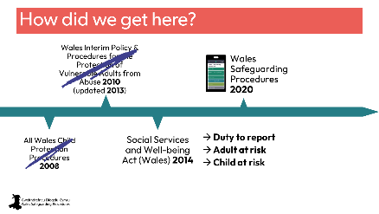 | Standardisation of safeguarding practice across Wales has been an ongoing, developing process. And the Group C safeguarding training course is just one step in that standardisation process.  <click>  Previously, the safeguarding procedures for children and for adults were separate.  <click>  These continued to be used even after the Social Services and Well-being Act (Wales) 2014.  <click>  It wasn’t until the Wales Safeguarding Procedures went into full effect in April of 2020  <click>  that the All Wales Child Protection Procedures 2008 and the Wales Interim Policy & Procedures for the Protection of Vulnerable Adults from Abuse (updated 2013) became obsolete and were replaced by the single Wales Safeguarding Procedures.  <click>  A significant change in our safeguarding language was around our ‘duty to report’ and the terms ‘child at risk’ and ‘adult at risk’. | Workbook  Infographic included
9 | 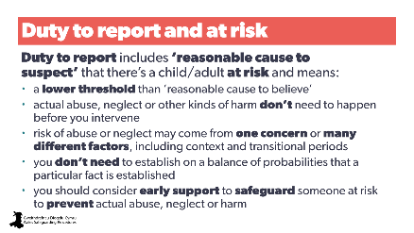 | Duty to report includes ‘reasonable cause to suspect’ that there’s a child/adult at risk and means:  - a lower threshold than ‘reasonable cause to believe’  - actual abuse, neglect or other kinds of harm don’t need to occur before you intervene  - risk of abuse or neglect may come from one concern or many different factors, including context and transitional periods  - you don’t need to establish on a balance of probabilities that a particular fact is established  - you should consider early support to safeguard someone at risk to prevent actual abuse, neglect or harm. | Workbook  3. How have the Wales Safeguarding Procedures’ broader definitions of child at risk and adult at risk altered the way you/your organisation works with people and responds to concerns?  4. Do your organisation’s safeguarding policies and procedures accurately reflect these broader definitions and guidance?
10 | 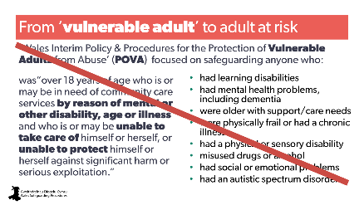 | When considering adults, we need to think more broadly.  The previous ‘Wales Interim Policy & Procedures for the Protection of Vulnerable Adults from Abuse’ – or POVA - focused on safeguarding people who were in need of community care services because of mental or other disability, age or illness and, because of that, might be unable to take care of themself or protect themself against significant harm or serious exploitation.  That meant we concentrated our safeguarding actions on certain groups of people.  We’re no longer using this term and definition in safeguarding. | Workbook
11 | 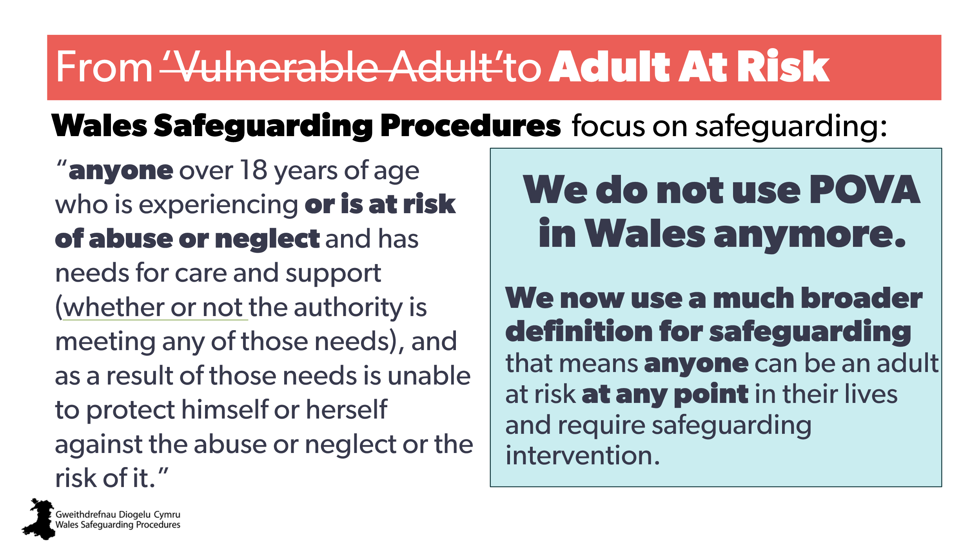 | The term has been replaced by adult at risk, which is a broader definition and acknowledges that anyone can be an adult at risk at any point in their lives and require safeguarding intervention. | Workbook
12 | 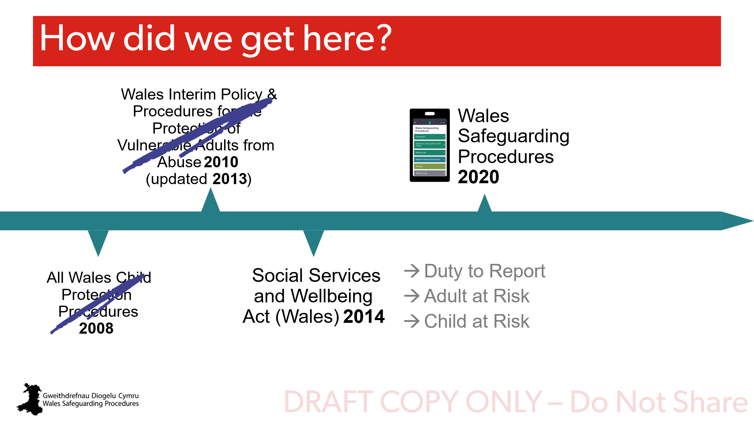 | (Transition slide only) | Workbook
13 | 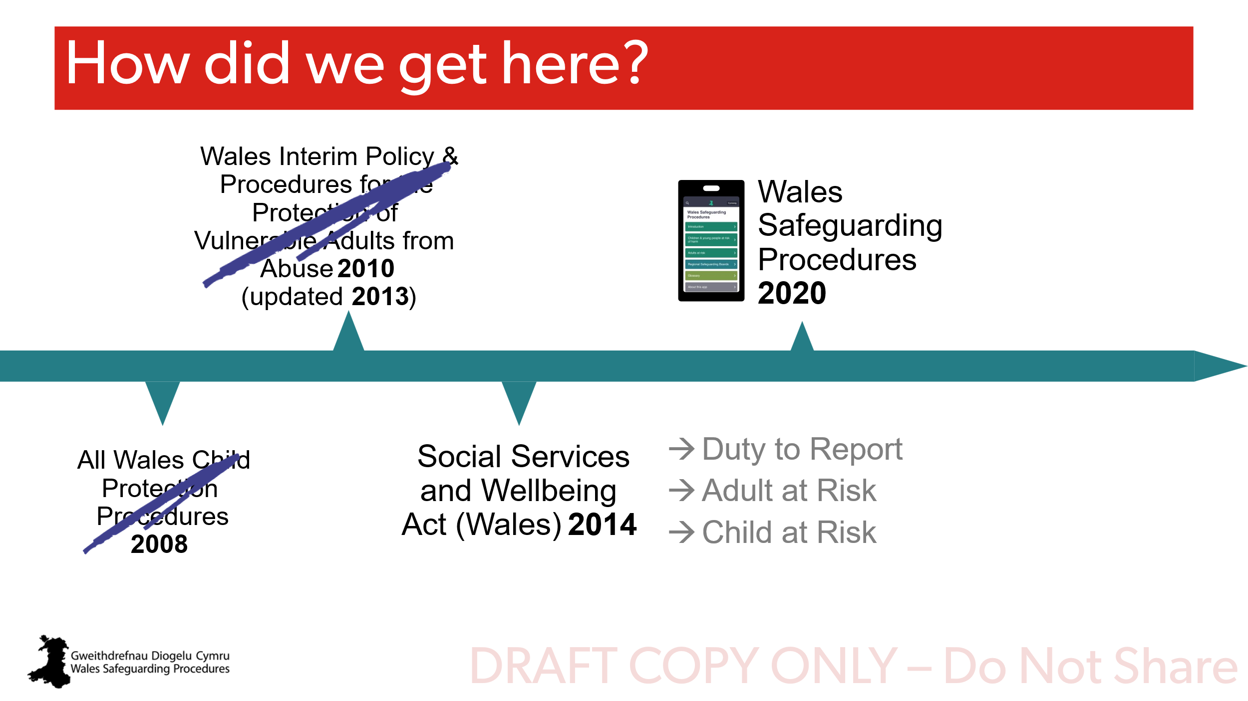 | (Transition slide only)
14 | 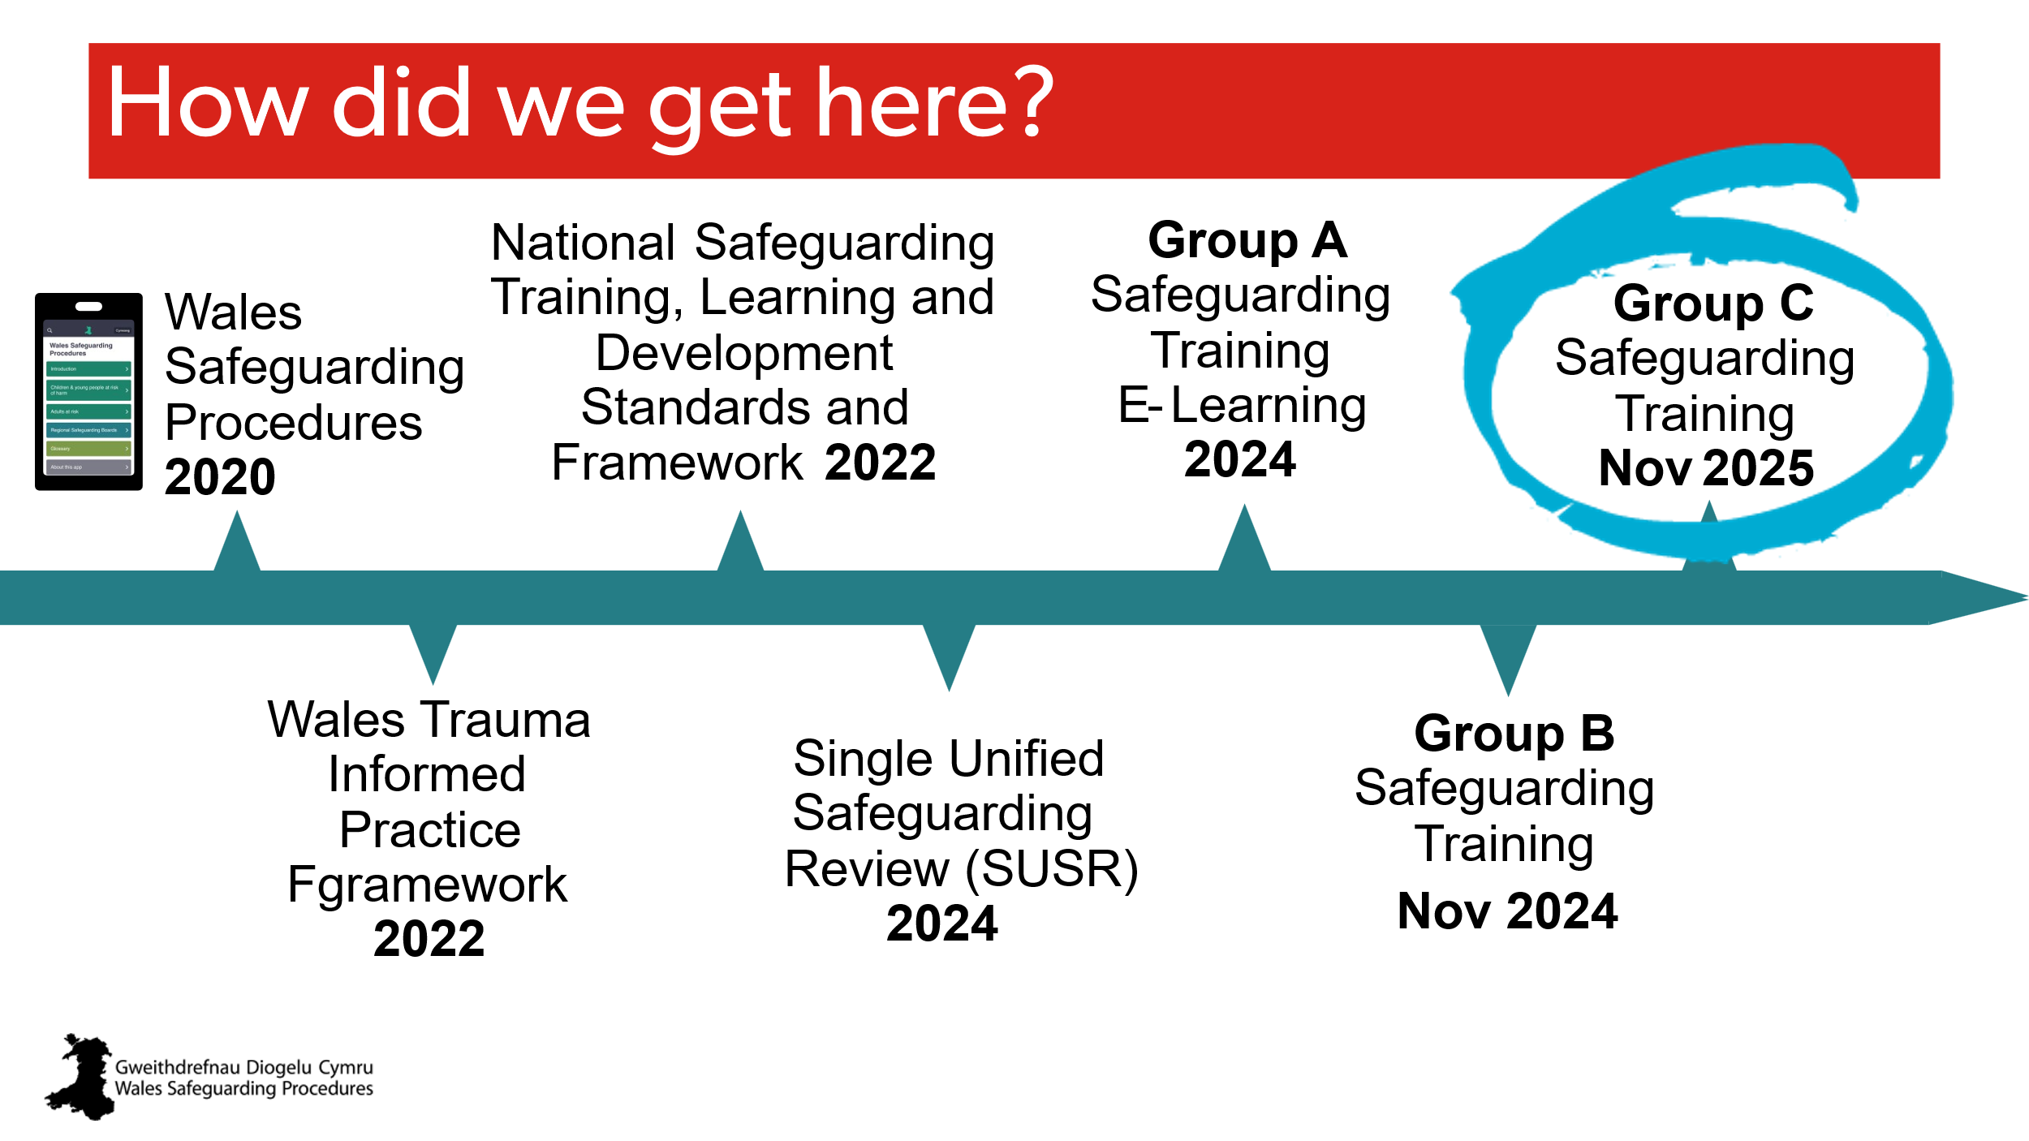 | - In 2022, Wales launched its Trauma Informed Practice Framework as part of its goal to be a trauma informed nation. This framework applies to everything we do, including safeguarding.  - The next step was to make sure all safeguarding training, learning and development was standardised across every sector and area in Wales.  - On 1 October 2024, Wales started using the single unified safeguarding review process.  - The first standardised training – Group A – was launched in 2024 as a free e-learning hosted by Social Care Wales – it applies to and is aimed at every single person in Wales.  - Next, Group B training was launched in November 2024.  - This course - Group C training - was launched in November 2025. | Workbook
15 | 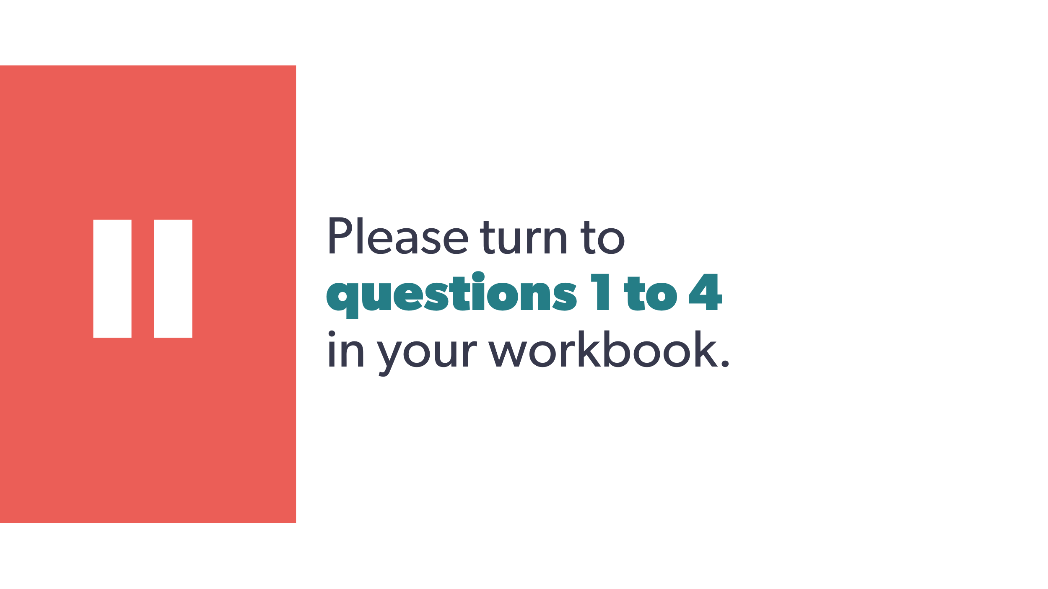 | Please turn to questions 1 to 4 in your workbook. | Workbook
16 | 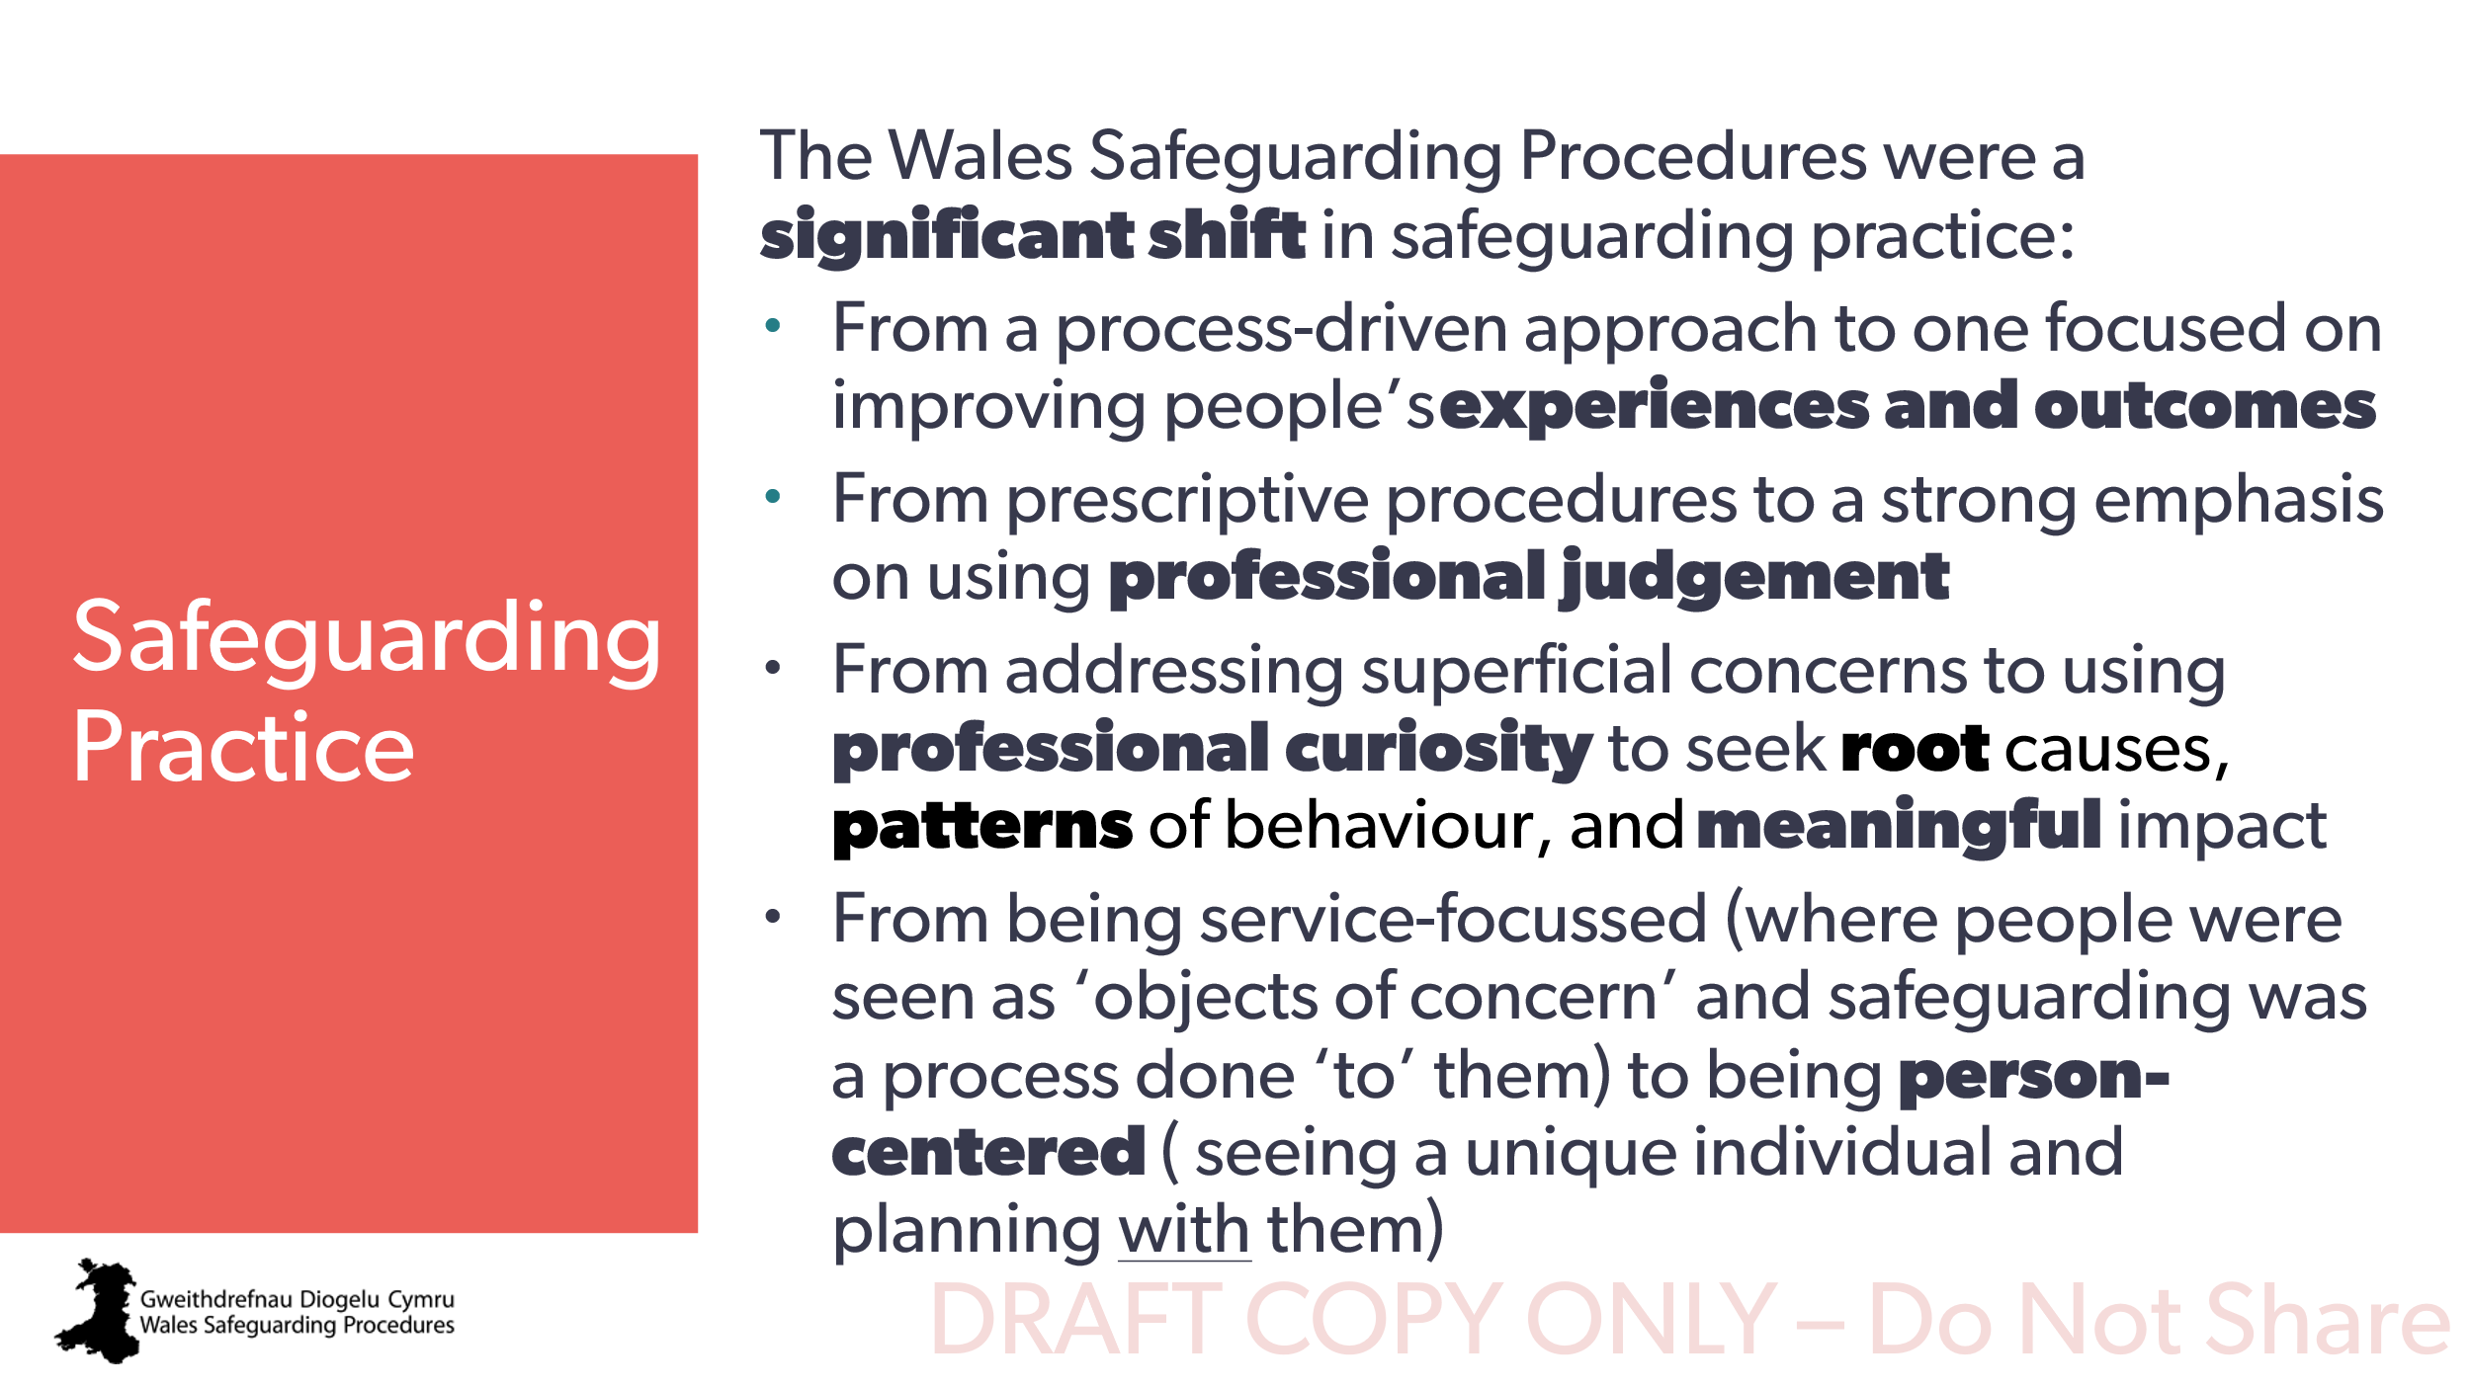 | - From a process-driven approach to one focused on improving people’s experiences and outcomes.  - From prescriptive procedures to a strong emphasis on using professional judgement.  - From addressing superficial concerns to using professional curiosity to seek root causes, patterns of behaviour, and meaningful impact.  - From being service-focussed (where people were seen as ‘objects of concern’ and safeguarding was a process done ‘to’ them) to being person-centered (seeing a unique individual and planning with them). | Workbook
17 | 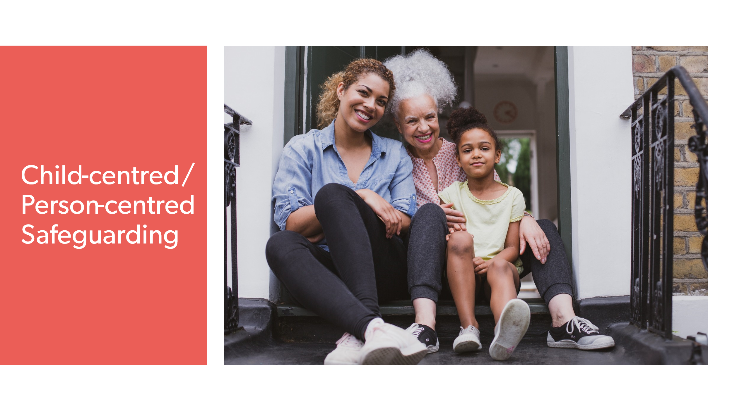 | The Wales Safeguarding Procedures marked a significant shift to a more child-centred / person-centred approach to safeguarding. | Workbook
18 | 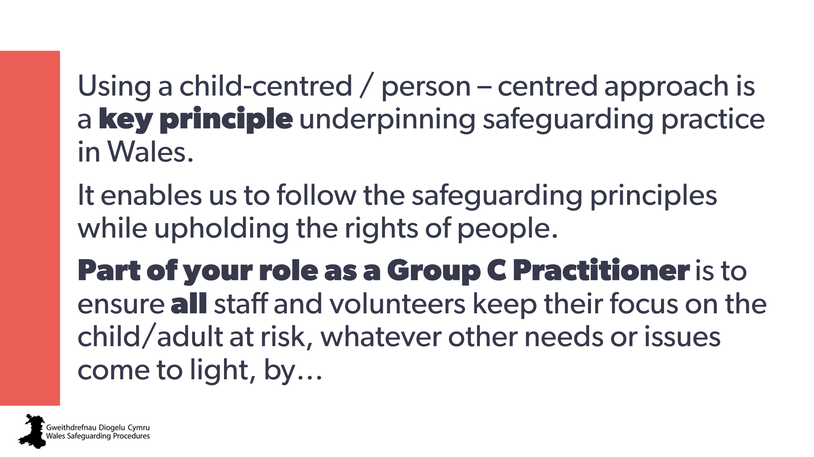 | Using a child-centred / person–centred approach is a key principle underpinning safeguarding practice in Wales.  It enables us to follow the safeguarding principles while upholding the rights of people.  Part of your role as a Group C Practitioner is to ensure all staff and volunteers keep their focus on the child/adult at risk, whatever other needs or issues come to light, by… | Workbook  5. How do you help to ensure all staff and volunteers keep their focus on the child/adult at risk, whatever other needs or issues come to light?
19 | 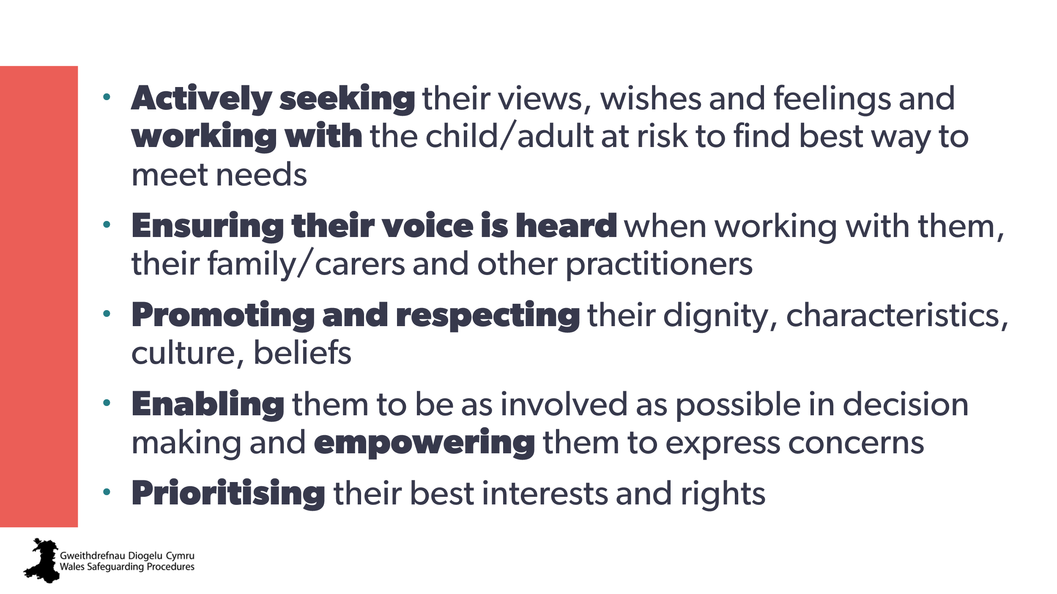 | - Actively seeking their views, wishes and feelings and working with the child/adult at risk to find the best way to meet needs  - Ensuring their voice is heard when working with them, their family/carers and other practitioners  - Promoting and respecting their dignity, characteristics, culture, beliefs  - Enabling them to be as involved as possible in decision making and empowering them to express concerns  - Prioritising their best interests and rights. | Workbook
20 | 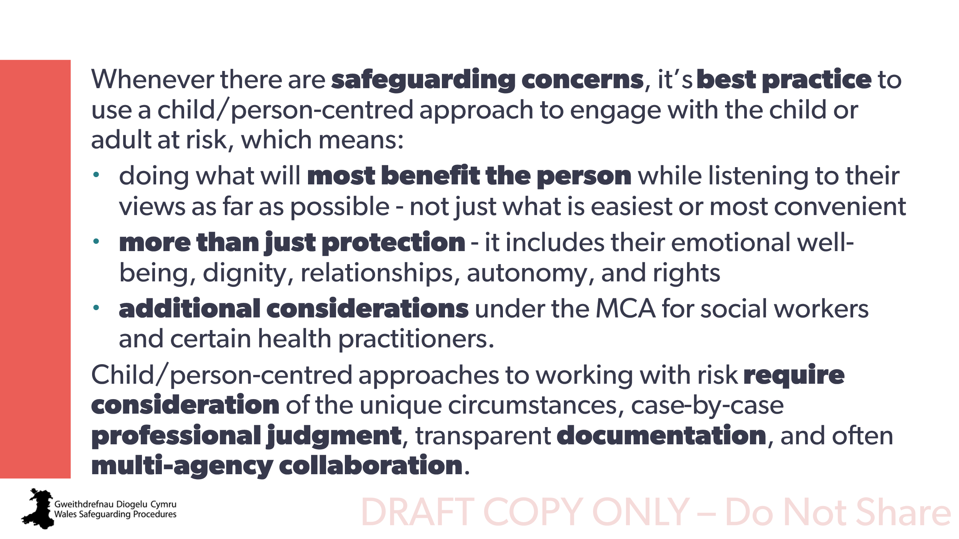 | Especially when there are safeguarding concerns, it’s best practice to use a child/person-centred approach to engage with the child or adult at risk and consider how to make safeguarding personal and do what’s in their best interests. This means:  - working with the child/adult at risk to find best way of doing what will most benefit them - not just what is easiest or most convenient  - considering more than just protection - it includes their emotional well-being, dignity, relationships, autonomy, and rights  - for social workers and certain health practitioners, additional considerations under the Mental Capacity Act.  Child/person-centred approaches to working with risk need consideration of the unique circumstances, case-by-case professional judgment, transparent documentation, and often multi-agency collaboration
21 | 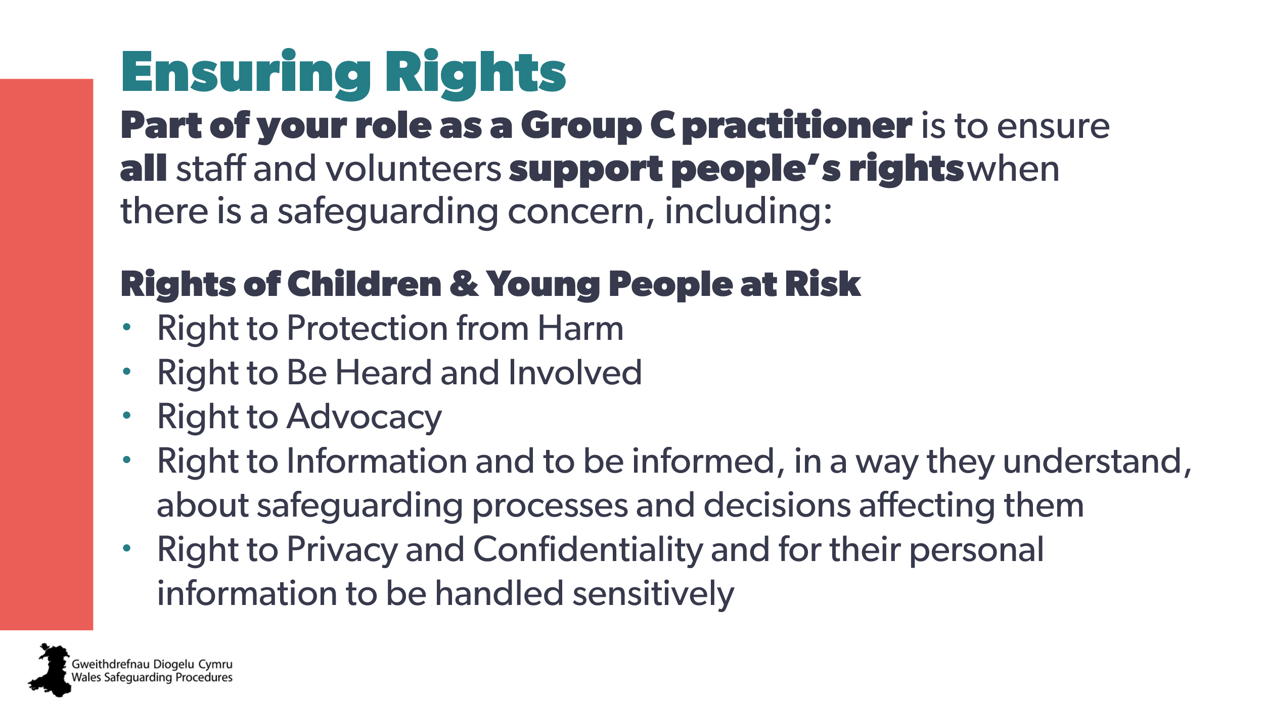 | Part of your role as a Group C practitioner is to ensure all staff and volunteers support people’s rights when there is a safeguarding concern.  You’ll be discussing this in more detail on the live Group C course, so make sure you’re up to date.  Rights of children and young people at risk  - Right to protection from harm  - Right to be heard and involved  - Right to advocacy  - Right to information and to be informed, in a way they understand, about safeguarding processes and decisions affecting them  - Right to privacy and confidentiality and for their personal information to be handled sensitively | Workbook
22 | 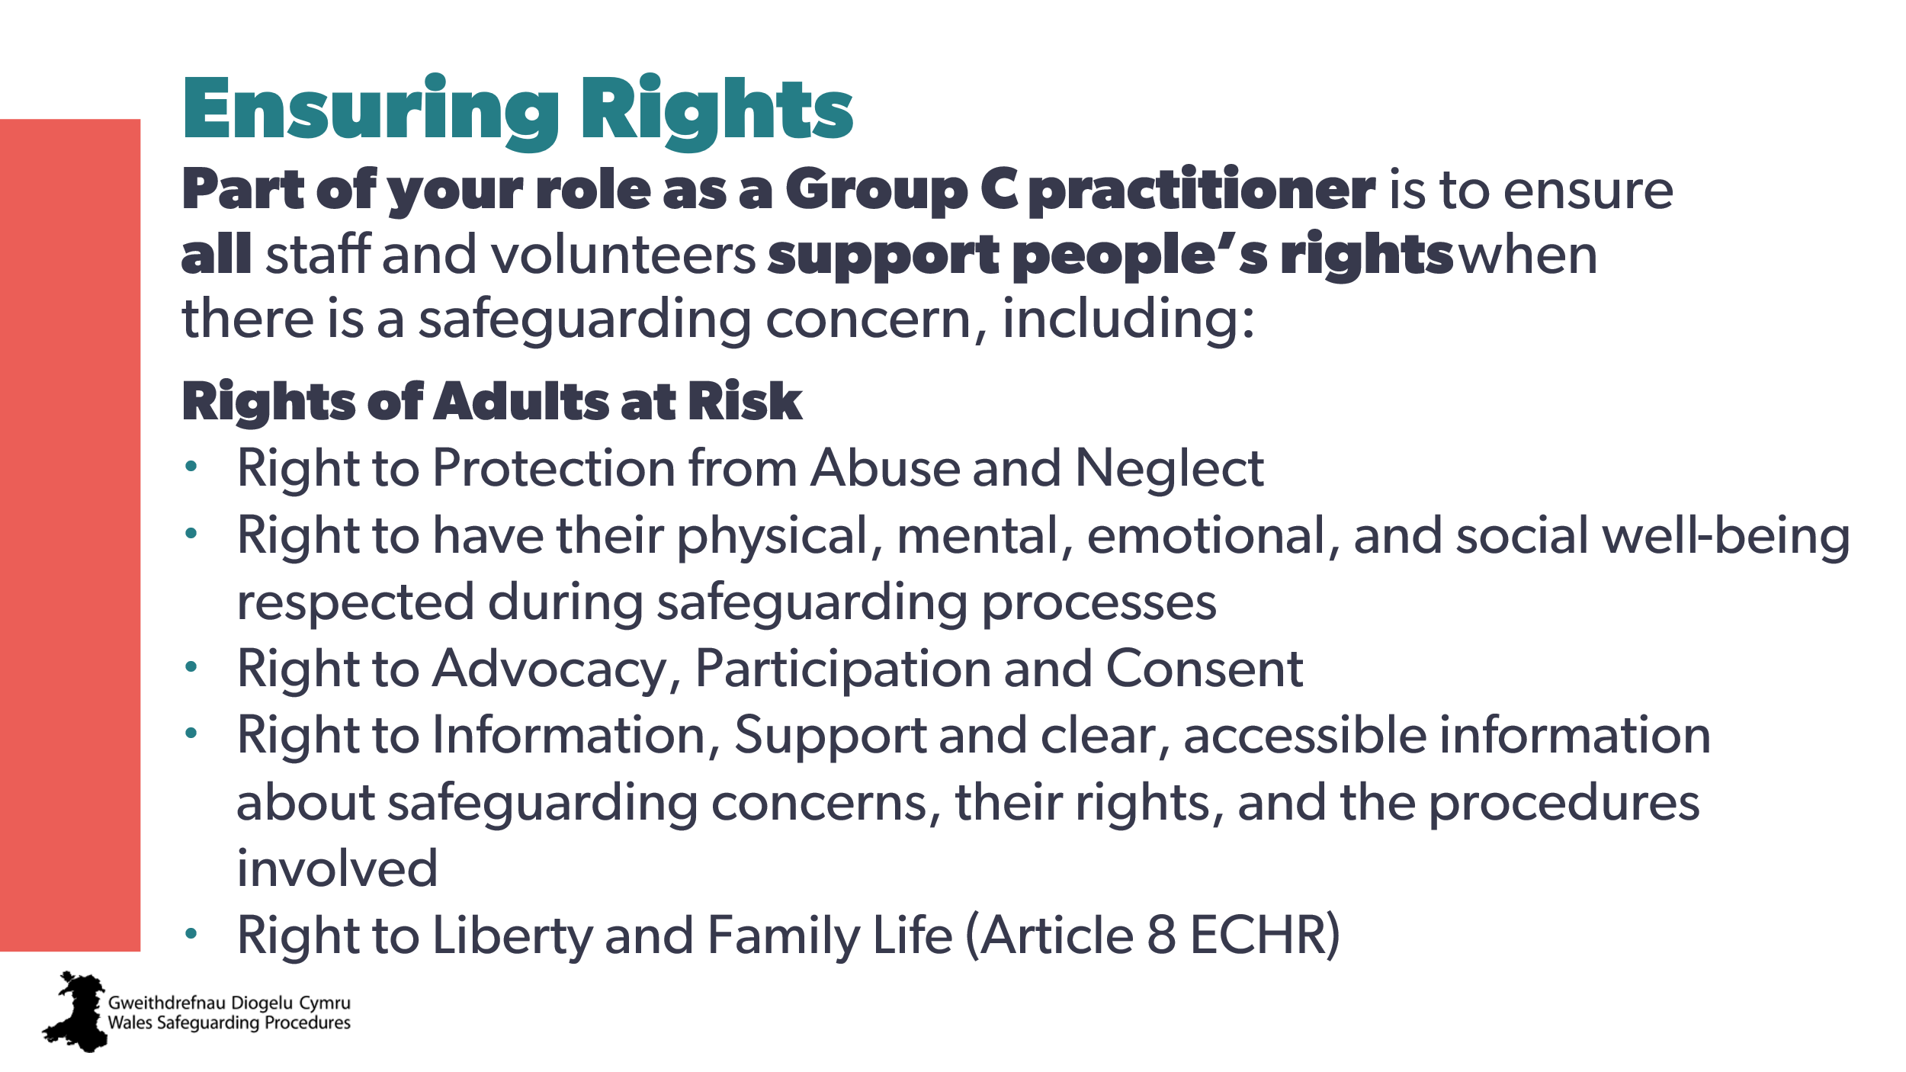 | Rights of adults at risk  - Right to protection from abuse and neglect  - Right to have their physical, mental, emotional, and social well-being respected during safeguarding processes  - Right to advocacy, participation and consent  - Right to information, support and clear, accessible information about safeguarding concerns, their rights, and the procedures involved  - Right to liberty and family life (Article 8 European Convention on Human Rights) | Workbook
23 | 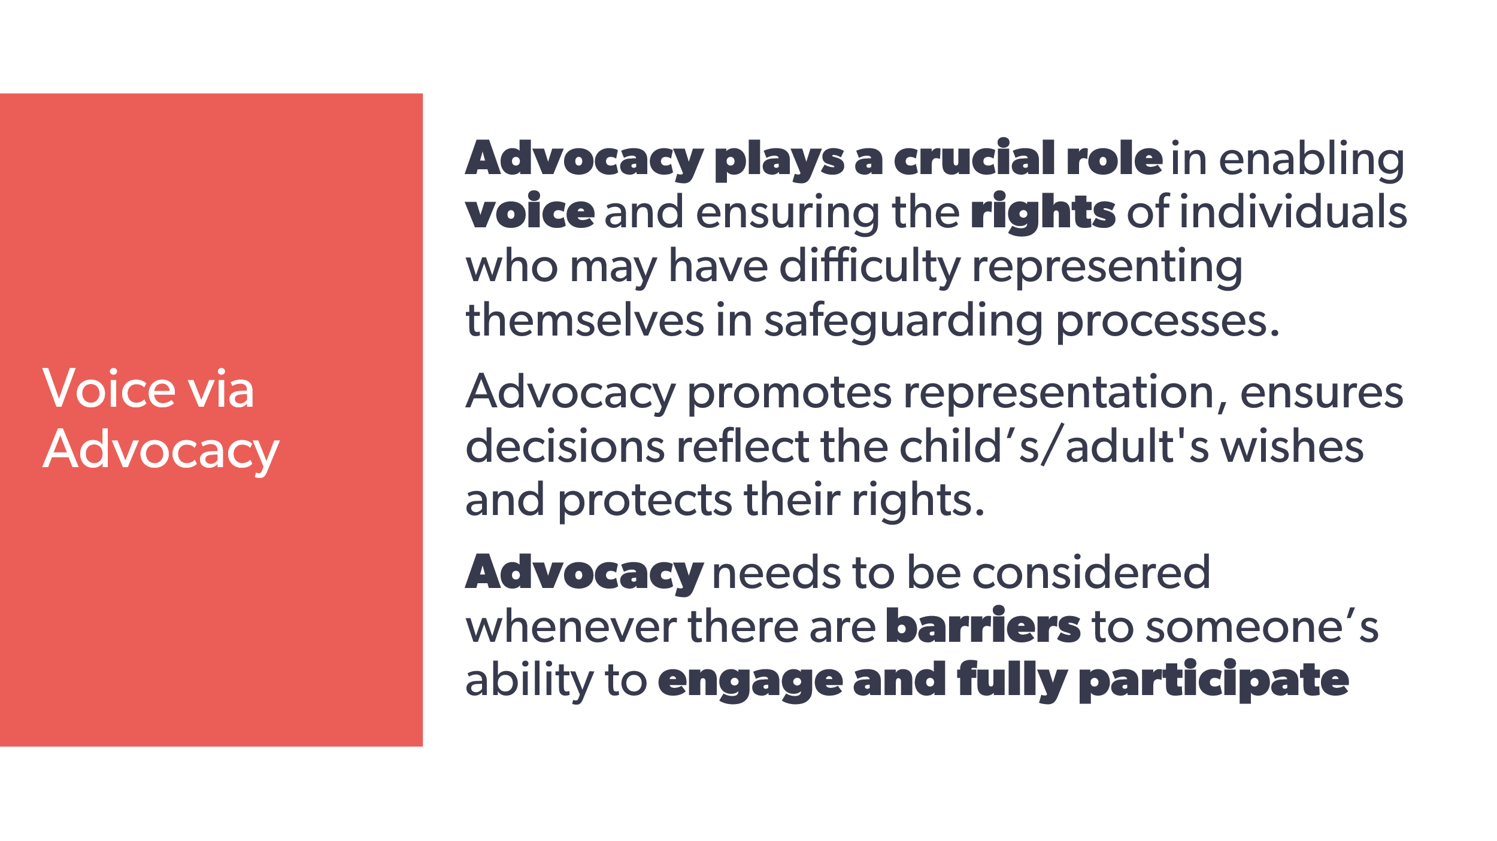 | Advocacy plays a crucial role in enabling voice and ensuring the rights of individuals who may have difficulty representing themselves in safeguarding processes.  Advocacy promotes representation, makes sure decisions reflect the child’s/adult's wishes and protects their rights.  Advocacy needs to be considered whenever there are barriers to someone’s ability to engage and fully participate. | Workbook
24 | 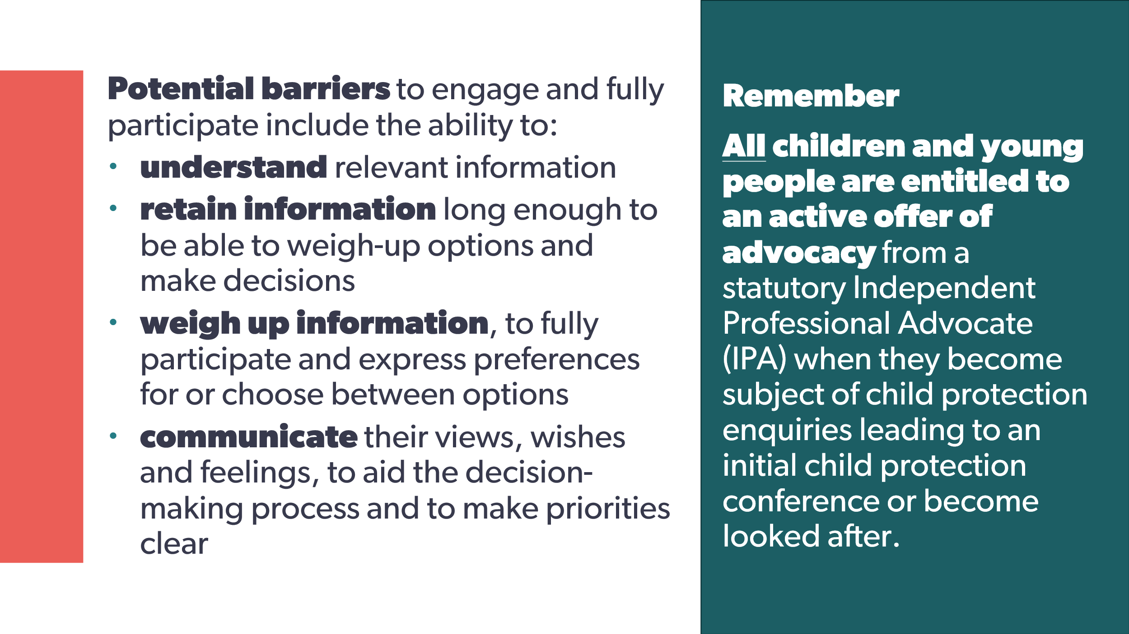 | Potential barriers to engage and fully participate include the ability to:  - understand relevant information  - retain information long enough to be able to weigh-up options and make decisions  - weigh up information, to fully participate and express preferences for or choose between options  - communicate their views, wishes and feelings, to aid the decision-making process and to make priorities clear  Remember!  All children and young people are entitled to an active offer of advocacy from a statutory Independent Professional Advocate (IPA) when they become subject of child protection enquiries leading to an initial child protection conference or become looked after. | Workbook  6. How does your organisation help people identify and overcome barriers to engagement and participation?
25 | 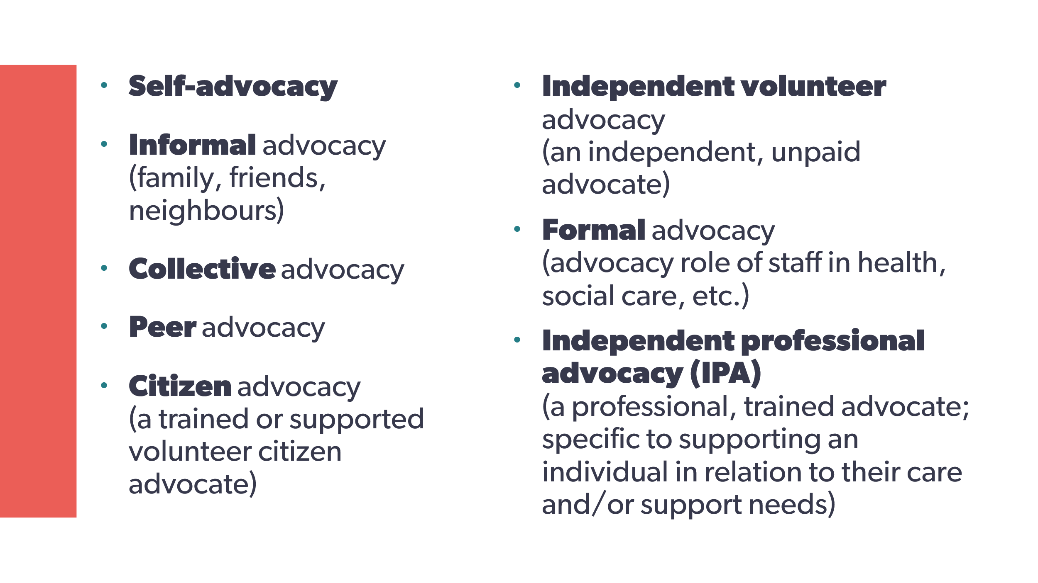 | There are many different forms of advocacy, and these should always be considered – for children and adults - when there are any barriers to engagement with any aspect or your service. | Workbook
26 | 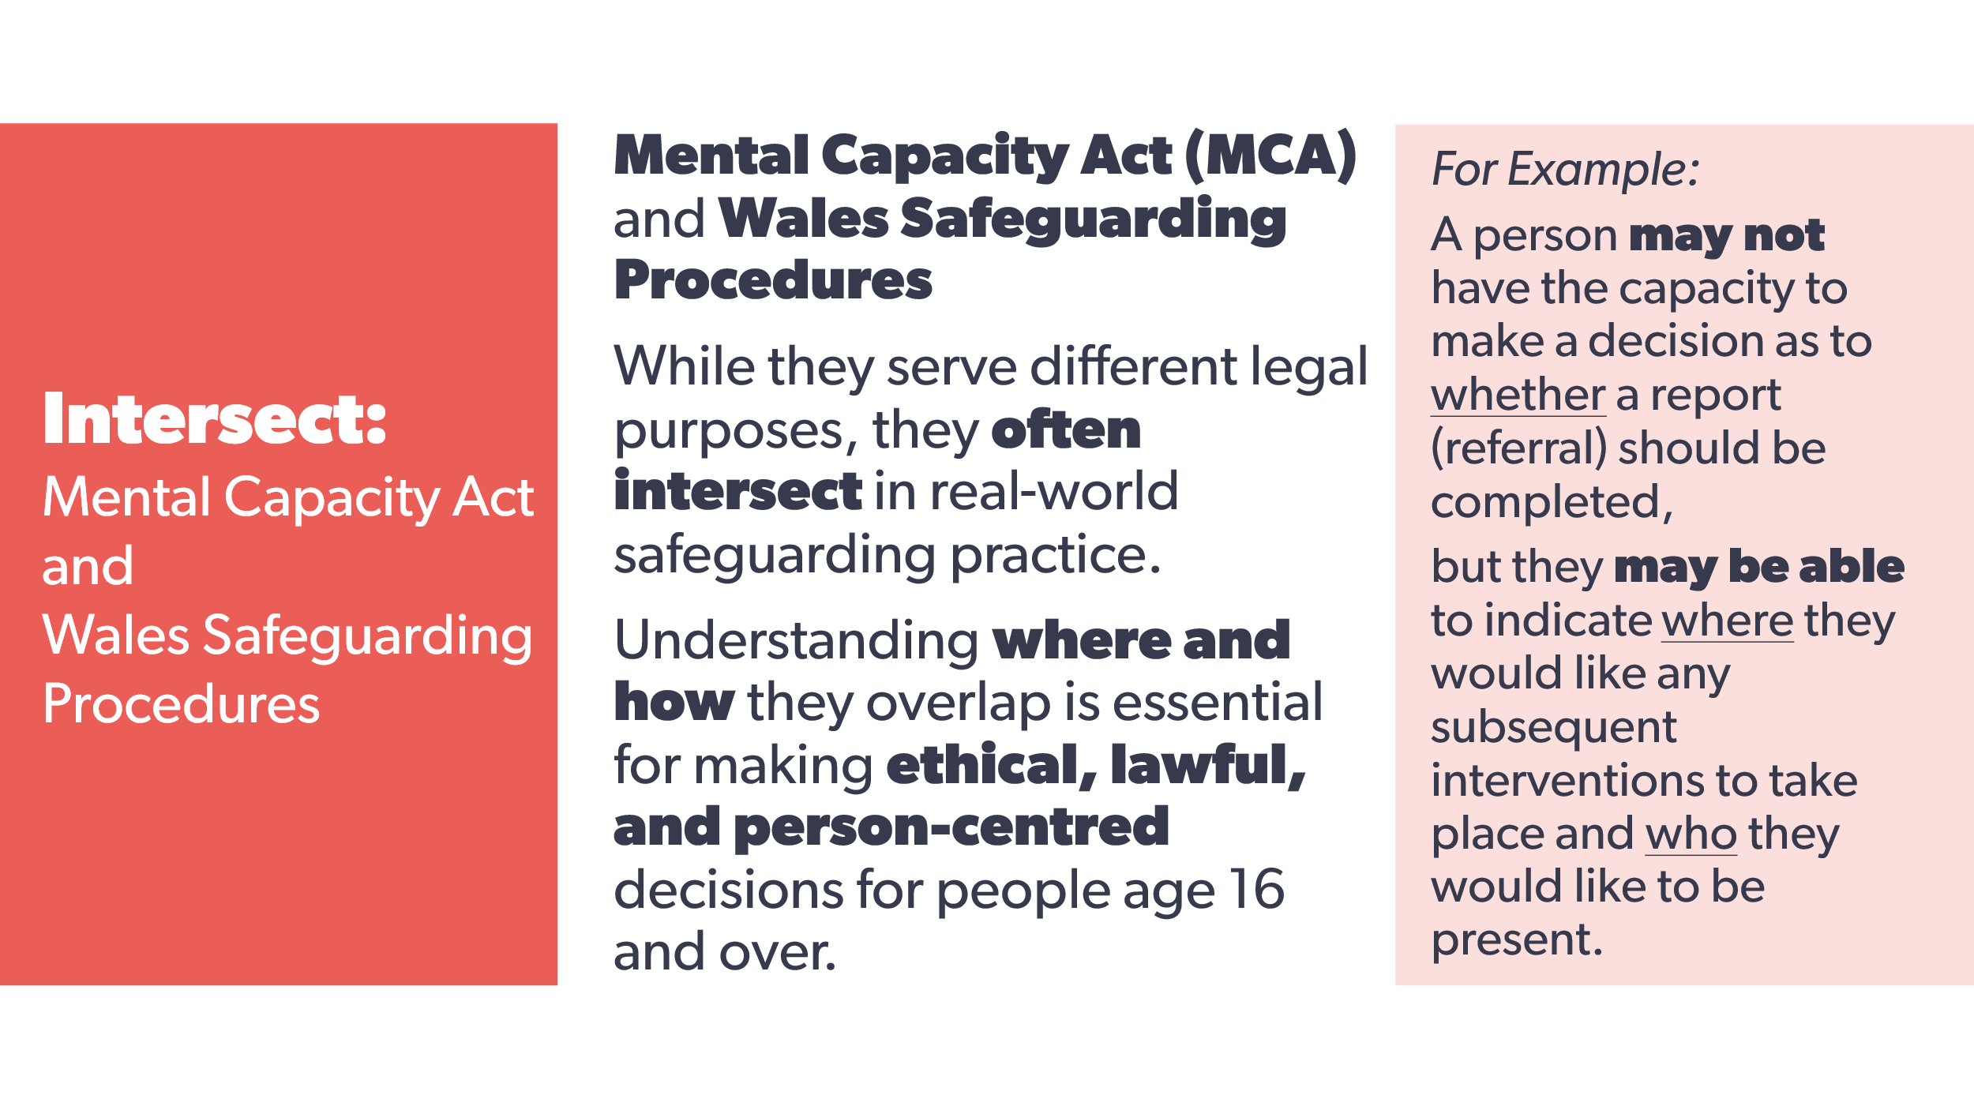 | While the Mental Capacity Act (MCA) and Wales Safeguarding Procedures serve different legal purposes, they often intersect in real-world safeguarding practice.  Understanding where and how they overlap is essential for making ethical, lawful, and person-centred decisions for people age 16 and over.  For example, a person may not have the capacity to make a decision about whether a referral should be completed but they may be able to indicate where they would like any subsequent interventions to take place and who they would like to be present. | Workbook
27  28 | 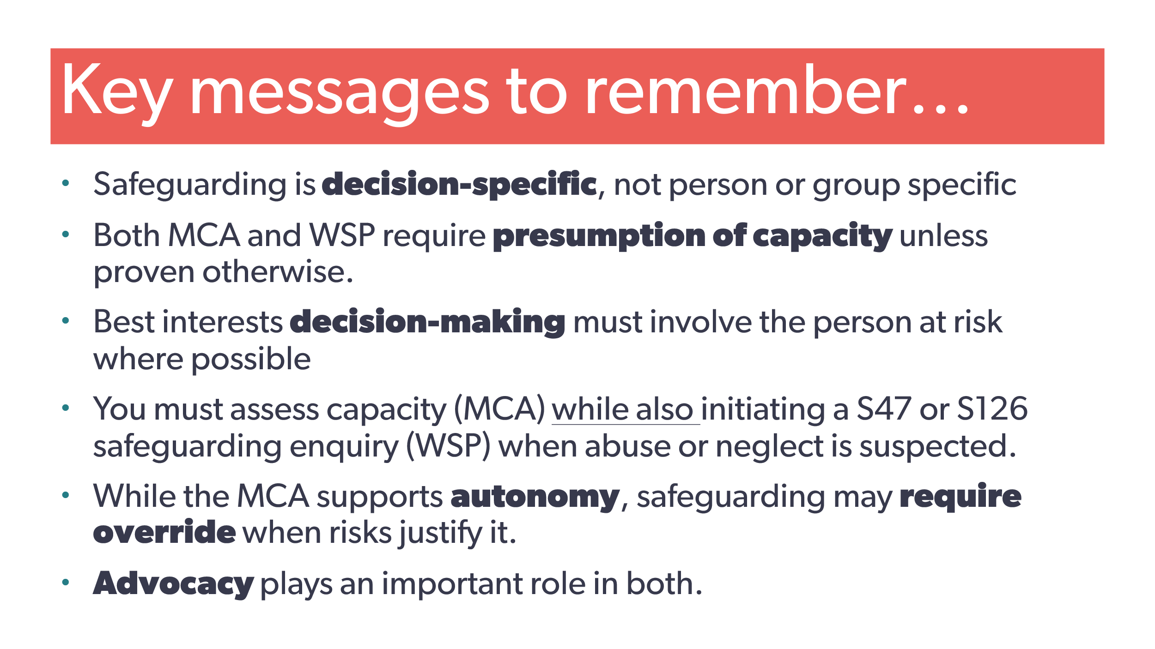  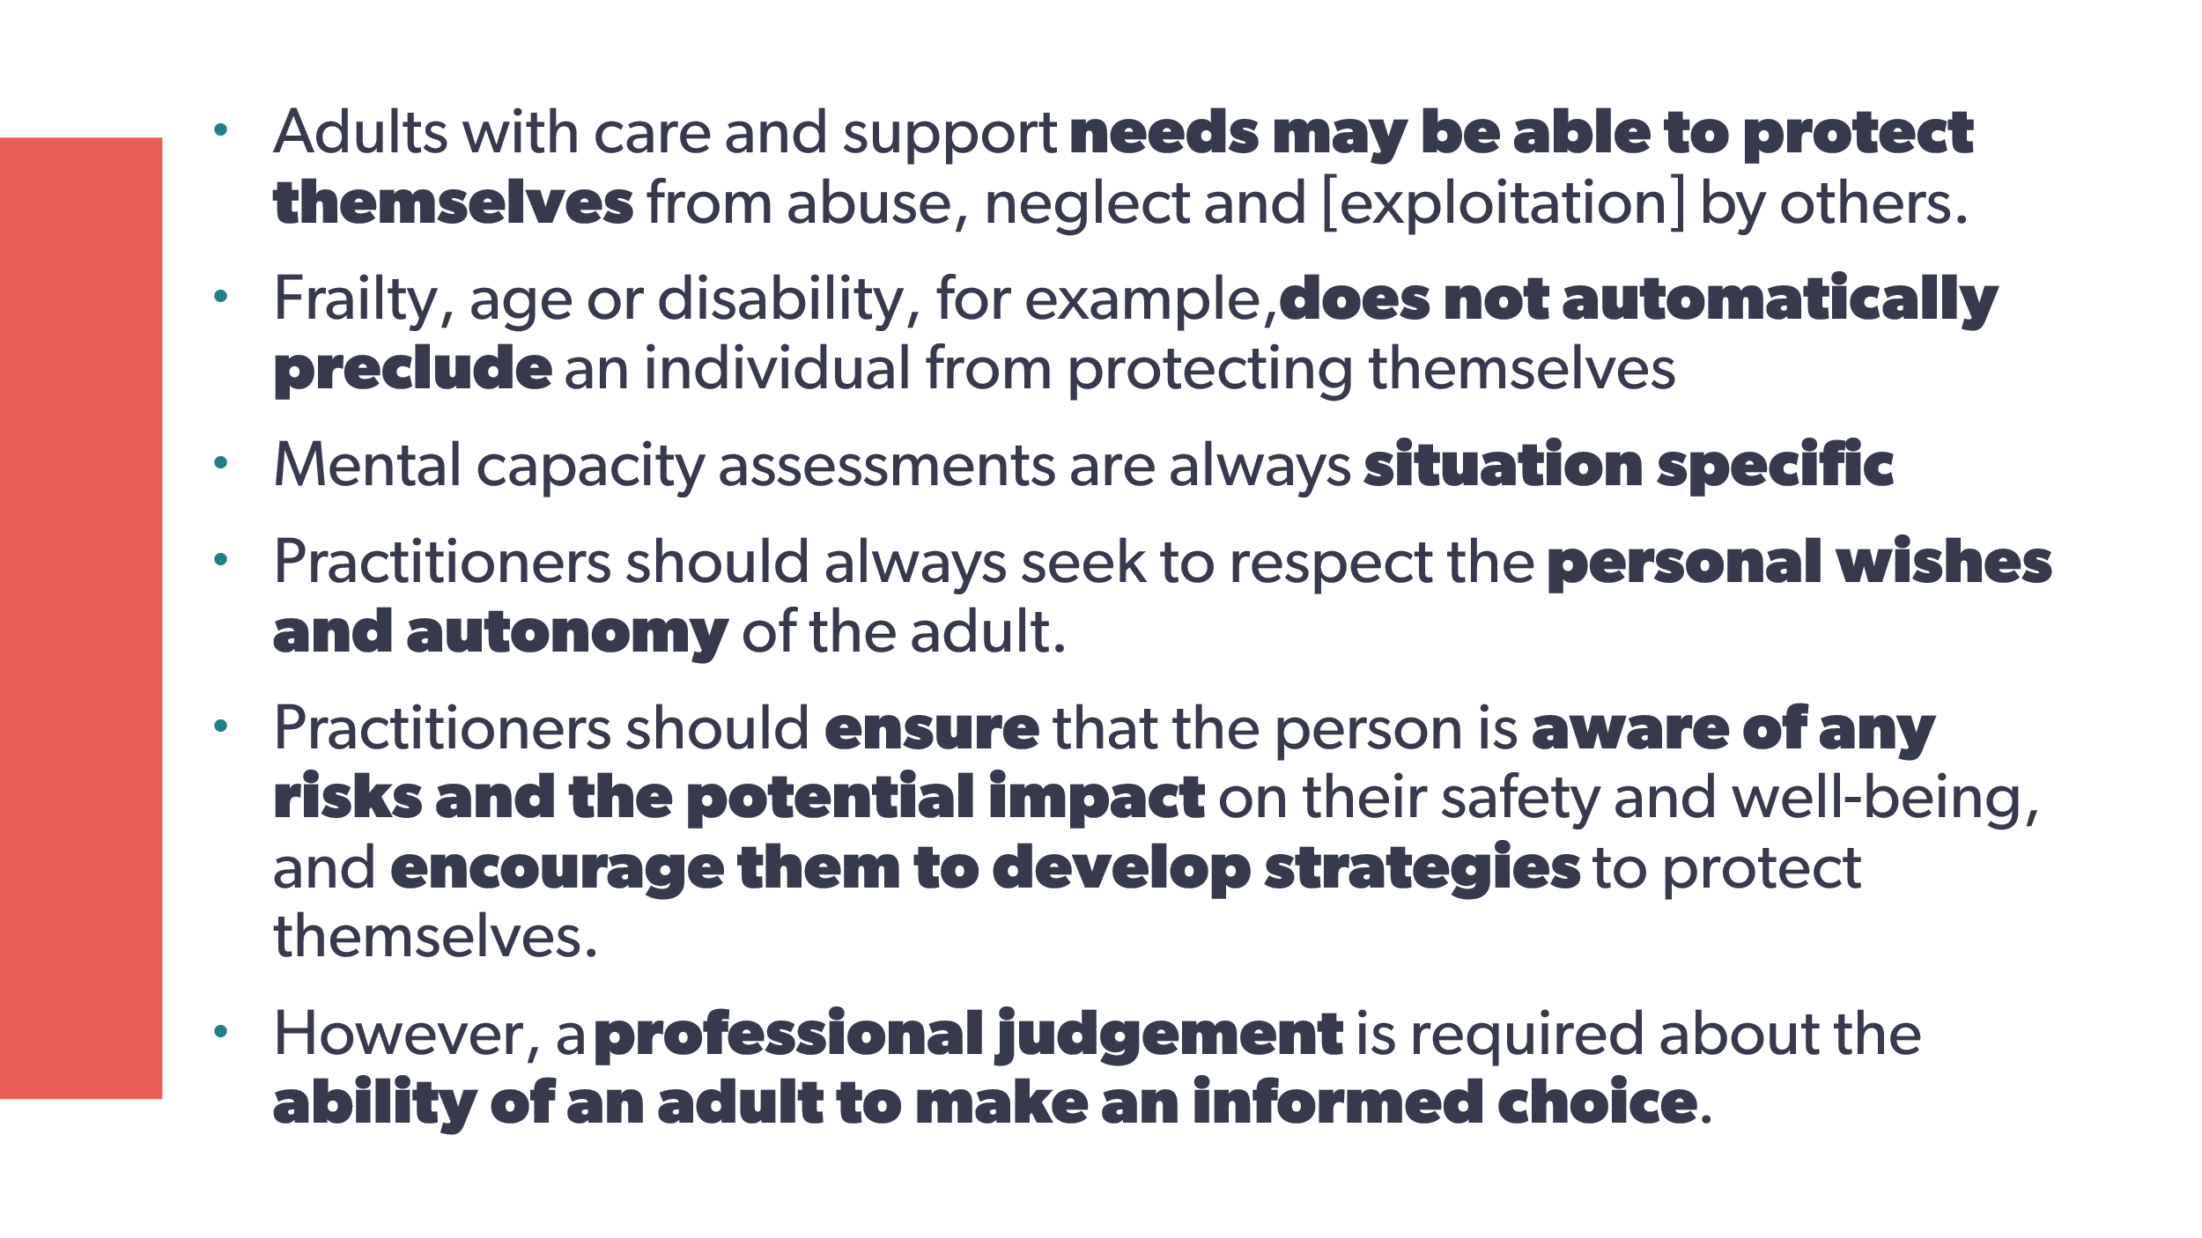 | Key messages to remember about mental capacity when safeguarding:  - safeguarding is decision-specific, not person or group specific  - both MCA and WSP require presumption of capacity unless proven otherwise  - best interests decision-making must involve the person at risk where possible  - you must assess capacity (MCA) while also initiating a S47 or S126 safeguarding enquiry (WSP) when abuse or neglect is suspected  - while the MCA supports autonomy, safeguarding may require override when risks justify it  - advocacy plays an important role in both.  - Adults with care and support needs may be able to protect themselves from abuse, neglect and [exploitation] by others.  - Frailty, age or disability, for example, doesn’t automatically preclude an individual from protecting themselves.  - mental capacity assessments are always situation specific.  - Practitioners should always seek to respect the adult’s personal wishes and autonomy.  - Practitioners should ensure that the person is aware of any risks and the potential impact on their safety and well-being, and encourage them to develop strategies to protect themselves.  - But, there needs to be a professional judgement about the ability of an adult to make an informed choice. | Workbook
29 | 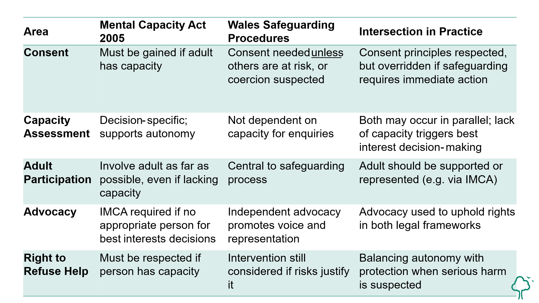 | This table is a useful reminder and is included in your workbook for reference during the Group C live session, but feel free to pause for a moment to read it now. | Workbook  7. If you work with a person age 16 or older, how do balance autonomy with protection when serious harm is suspected? (ie How do you ensure compliance with both the Mental Capacity Act and the Wales Safeguarding Procedures?)
30 | 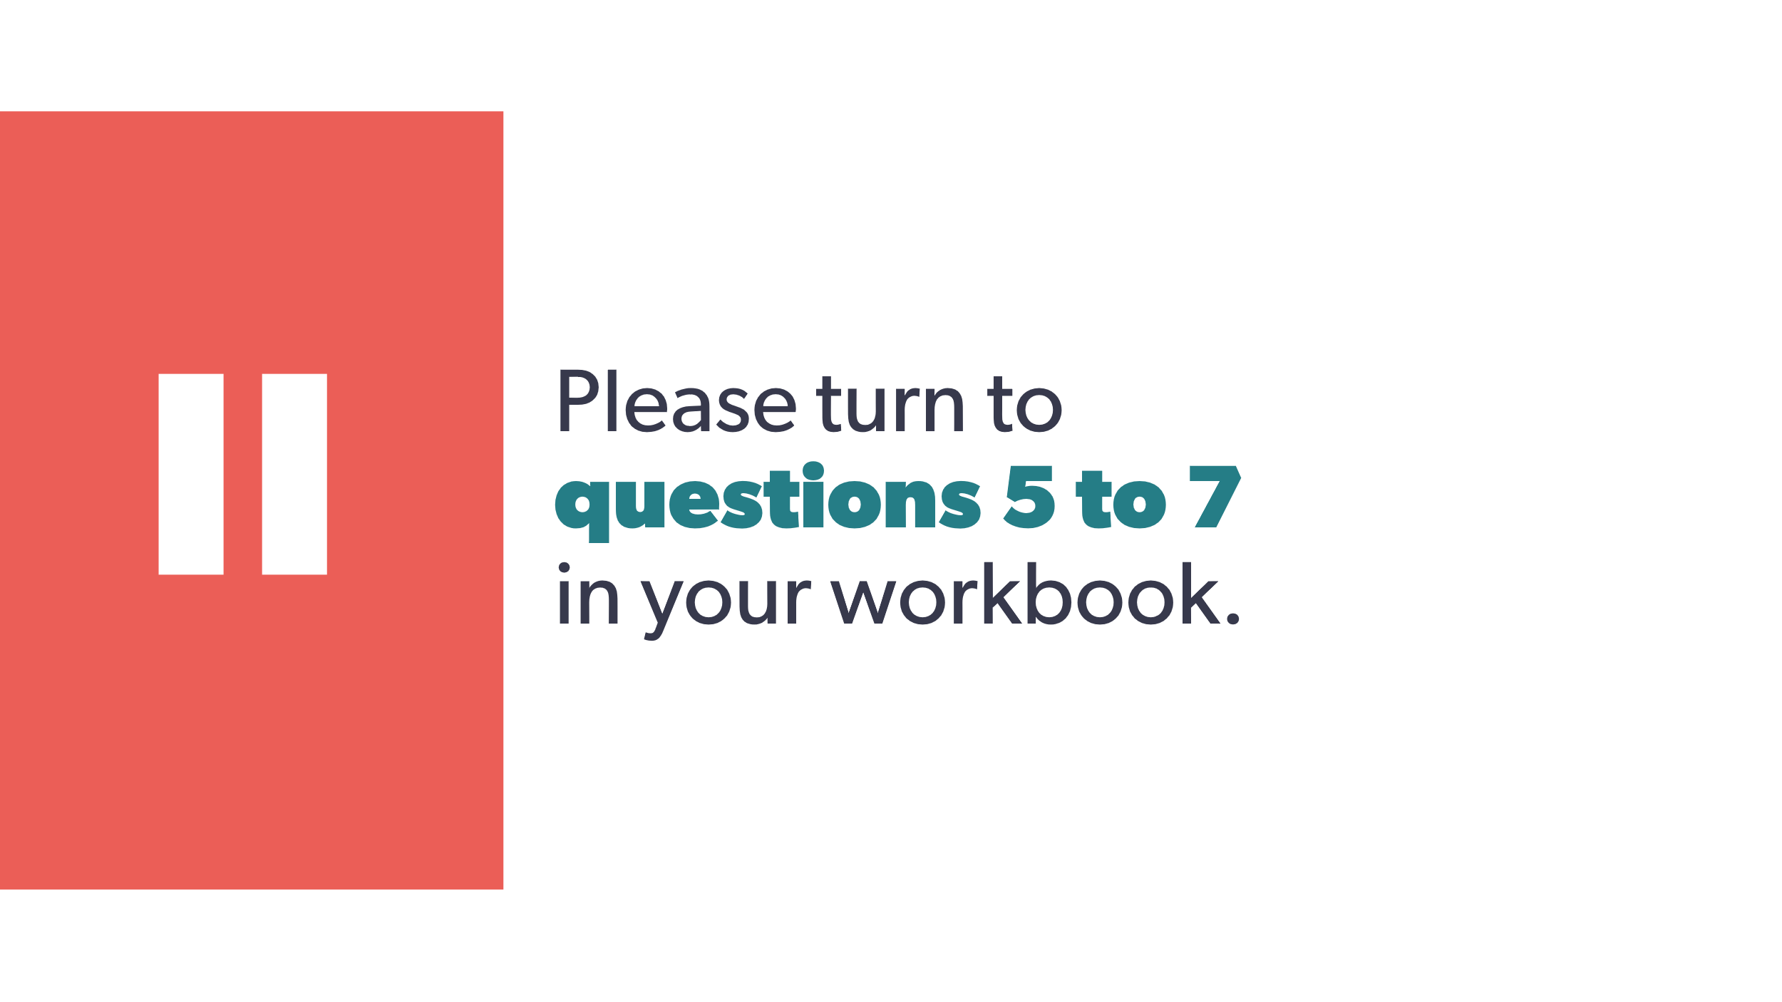 | Please turn to questions 5 to 7 in your workbook. | Workbook
31 | 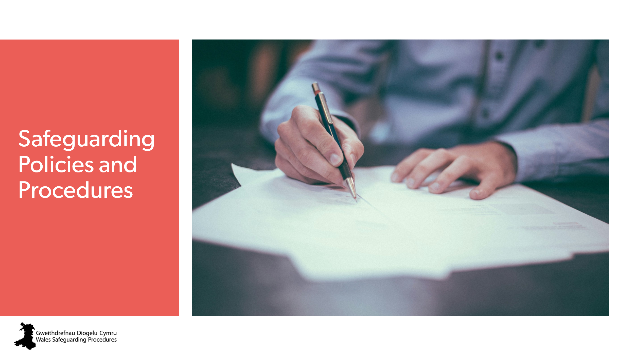 | Safeguarding policies and procedures | Workbook
32 | 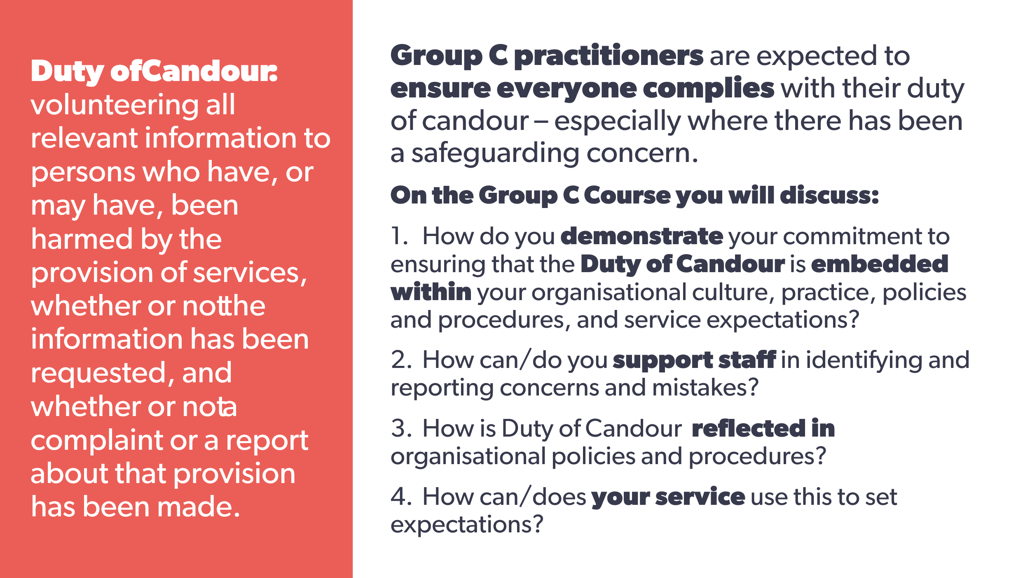 | The Group B course included an explanation of each individual’s duty of candour.  As a Group C practitioner, you’re expected to comply with this duty – especially where there has been a safeguarding concern.  If you’re a Designated Safeguarding Person or a manager, you’re also responsible for helping to ensure others comply with this duty. | Workbook  8. How do you demonstrate your commitment to ensuring that the duty of candour is embedded within your organisational culture, practice, policies and procedures, and service expectations?  9. How can/do you support staff to identify and report concerns and mistakes?  10. How is duty of candour reflected in organisational policies and procedures?  11. How can/does your service use this to set expectations?
33 | 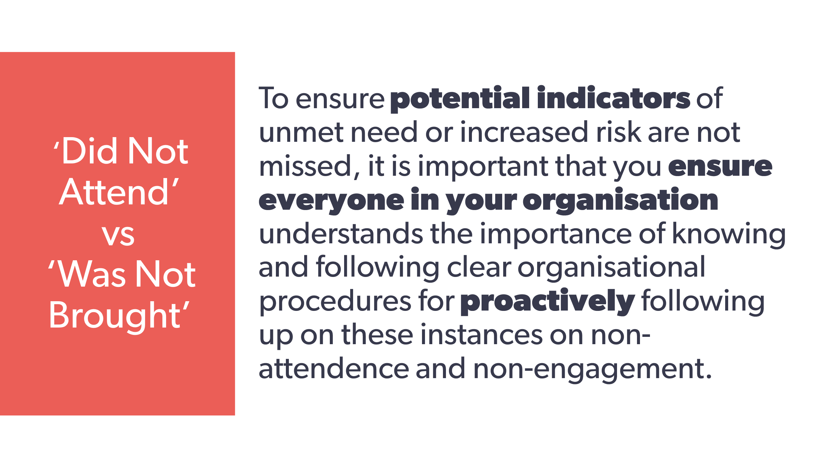 | As part of our Trauma Informed Approach in Wales, we’re becoming more aware of how the language and terminology we use can affect perceptions of risk.  One example of this is the terminology used when someone hasn’t attended an appointment.  The phrases “did not attend” and “was not brought” are often used in safeguarding, particularly in health, education, and social care settings, to describe someone’s absence from an appointment or setting.  Each term carries different implications, and can have a significant effect on professional understanding, accountability, and action. | Workbook  12. Review your organisation’s procedures for proactively following up missed appointments, missed contacts, or restricted access to individuals.  13. How does your organisation view, record and address these?  14. Does your organisation have clear organisational procedures for proactively following up on these instances?
34 | 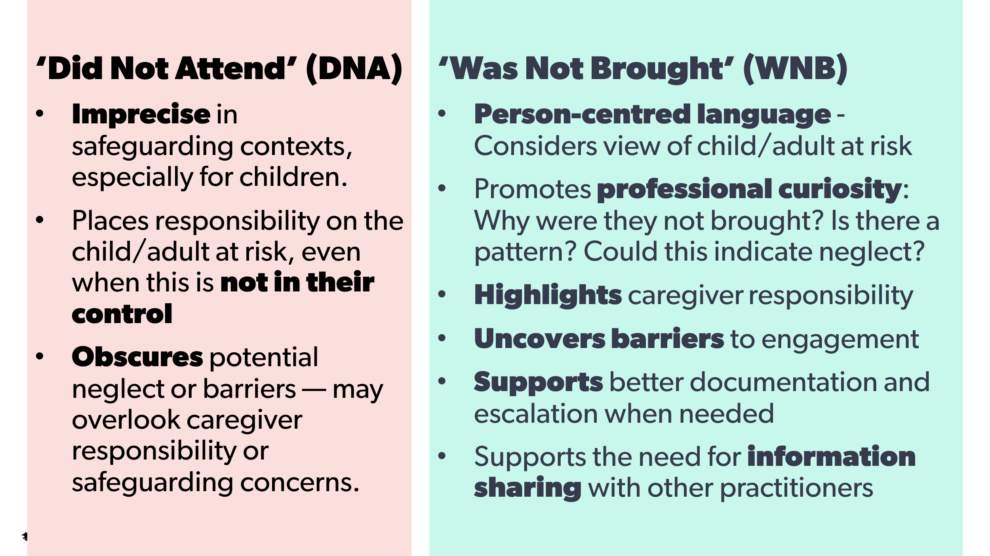 | We are moving away from the term ‘Did Not Attend (or, DNA) when a person relies on someone else to bring them because it  - is Imprecise in safeguarding contexts, especially for children.  - Places responsibility on the child/adult at risk, even when this is not in their control  - Obscures potential neglect or barriers — may overlook caregiver responsibility or safeguarding concerns.  Instead, in these situations we are adopting the term Was Not Brought, because it  - Enables Person-centred language - Considers view of child/adult at risk  - Promotes professional curiosity: Why were they not brought? Is there a pattern? Could this indicate neglect?  - Highlights caregiver responsibility  - Uncovers barriers to engagement  - Supports better documentation and escalation when needed  - Supports the need for information sharing with other practitioners | Workbook  15. Do your policies address the potential safeguarding implications of missed appointments, missed contacts, or restricted access to individuals, and provide guidance for documentation and escalation?  16. Do your procedures specifically encourage  - Person-centred language?  - Professional Curiosity?  - Caregiver responsibilities?  - Identification of barriers to engagement?  - Information sharing with other practitioners / organsations?  reference: Public Health Wales practice guidance primary and/or National Safeguarding Service - NHS Safeguarding for a Safer Wales
35 | 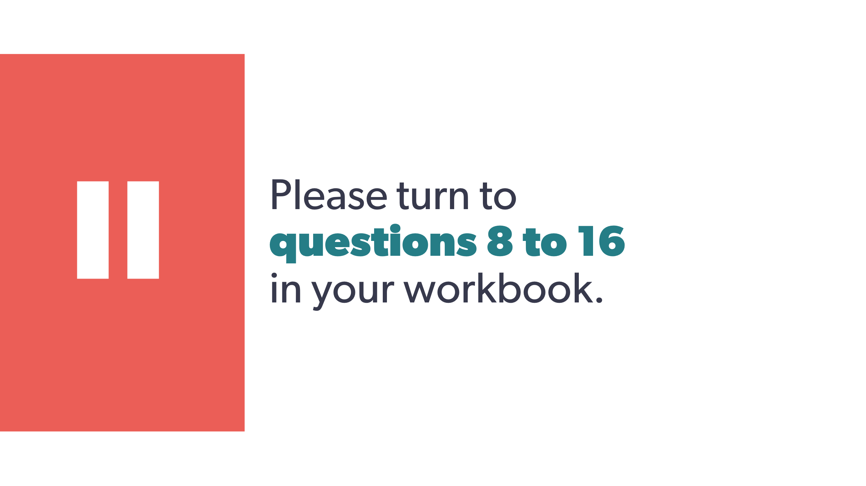 | Please answer questions 8-16 in your workbook. | Workbook
36 |  | Responding to a concern | Workbook
37 | 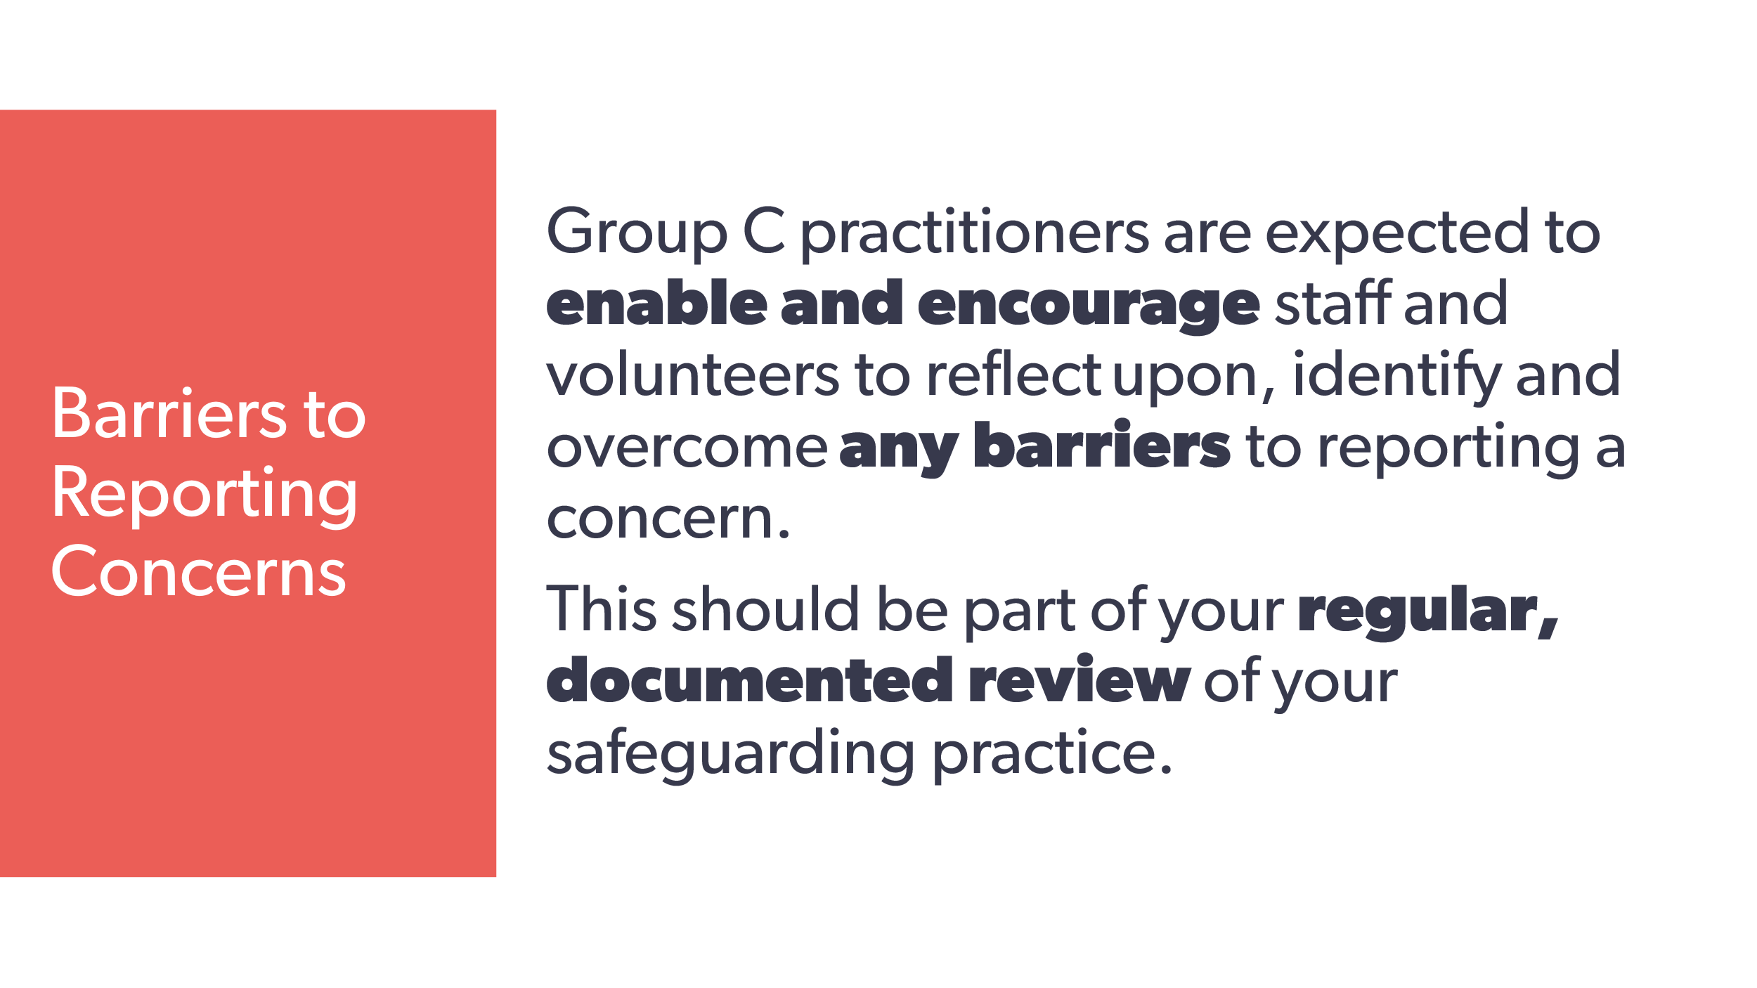 | Group C practitioners are expected to enable and encourage staff and volunteers to reflect upon, identify and overcome any barriers to reporting a concern.  This should be part of your regular, documented review of your safeguarding practice. | Workbook  17. On the group C course, you’ll be discussing how to carry out your professional responsibility to identify, raise awareness of and address any barriers that impede effective safeguarding. To prepare for these discussions, list some of the barriers you’re aware of / have already identified and the specific ways you do this.
38 | 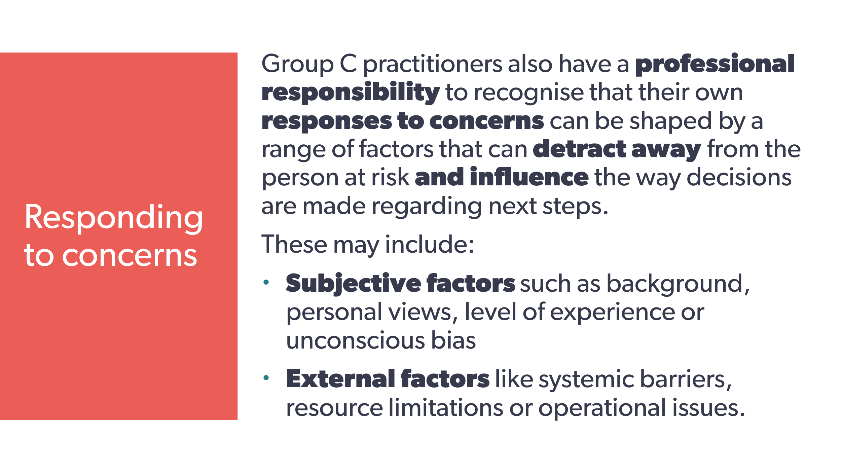 | Group C practitioners also have a professional responsibility to recognise that their own responses to concerns can be shaped by a range of factors that can detract away from the person at risk and influence the way decisions are made about next steps.  These may include:  - subjective factors such as background, personal views, level of experience or unconscious bias  - external factors like systemic barriers, resource limitations or operational issues. | Workbook  18. When someone brings a concern to you or asks you for safeguarding advice, what are some factors that can detract away from the person at possible risk and influence the way decisions are made regarding next steps?  - Subjective factors  - External factors.  19. Describe some of the actions / duties that are part of your professional responsibility to identify and raise awareness of systemic barriers, resource limitations, or operational issues that impede effective safeguarding, and the appropriate channels for escalating such concerns:
39 | 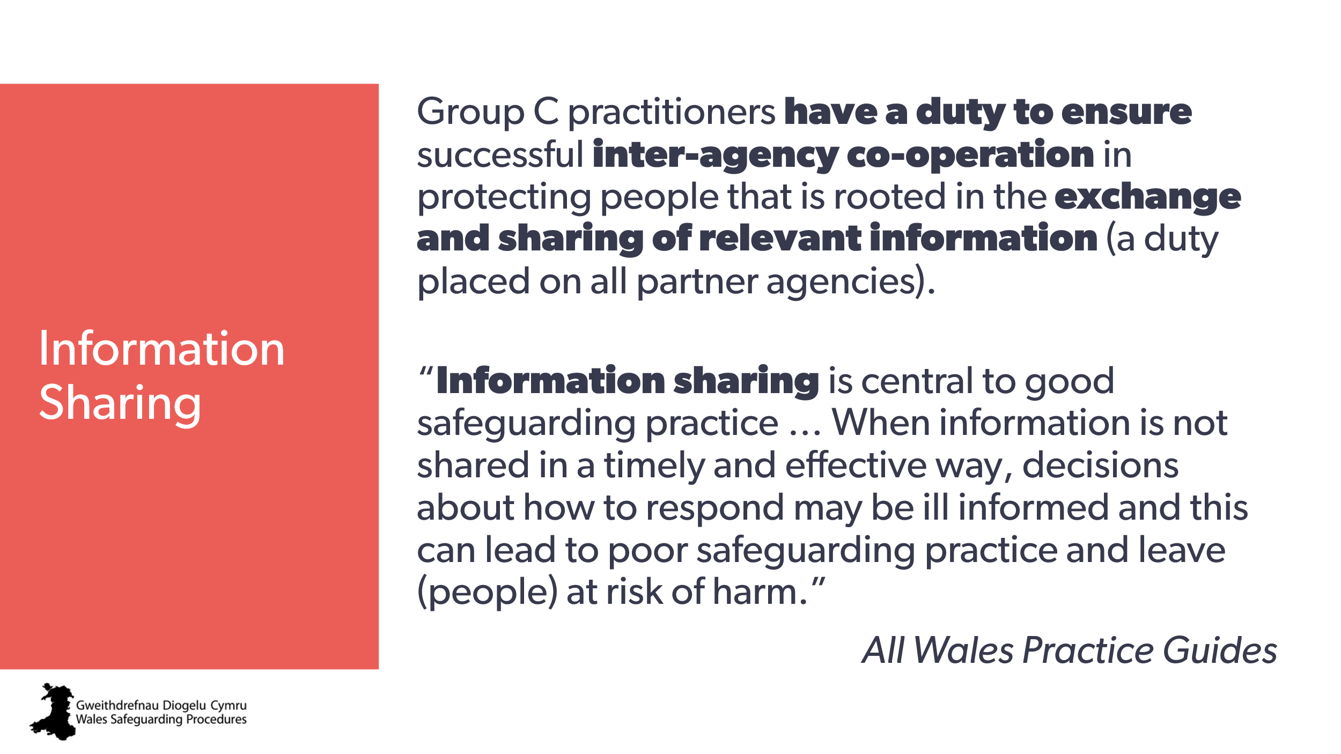 | Group C practitioners have a duty to ensure successful inter-agency co-operation in protecting people that’s rooted in the exchange and sharing of relevant information (a duty placed on all partner agencies).  “Information sharing is central to good safeguarding practice … When information is not shared in a timely and effective way, decisions about how to respond may be ill informed and this can lead to poor safeguarding practice and leave (people) at risk of harm.”  All Wales Practice Guides | Workbook  20. Group C practitioners are expected to use their professional judgement when making decisions about what information to share and when, follow their organisation’s procedures and any information sharing agreements in place, and be able to provide accurate advice to others. Review your own organistion’s information sharing policies and protocols:  - Are they clear?  - Are they specific to different situations, including safeguarding?
40 | 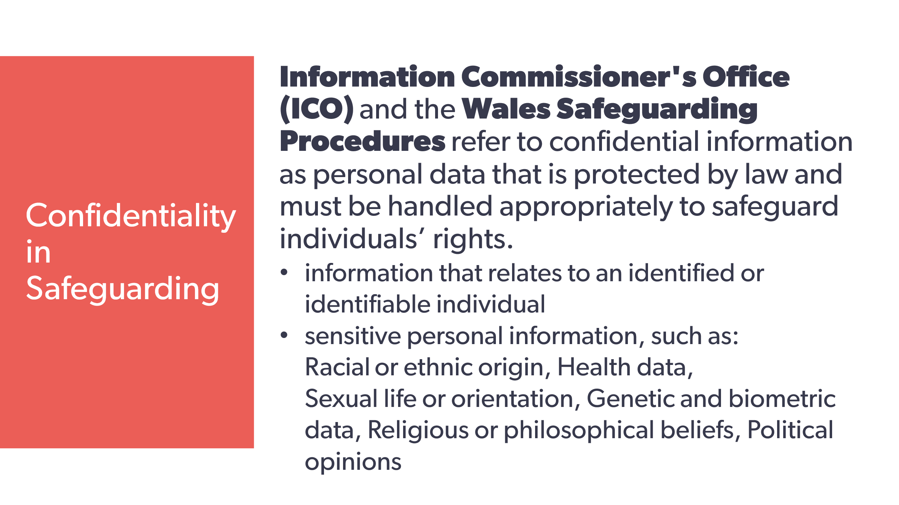 | Information Commissioner's Office (ICO) and the Wales Safeguarding Procedures refer to confidential information as personal data that’s protected by law and must be handled appropriately to safeguard individuals’ rights.  - information that relates to an identified or identifiable individual  - sensitive personal information, such as:  racial or ethnic origin, health data,  sex life or sexual orientation, genetic and biometric data, Religious or philosophical beliefs, political opinions. | Note:  Racial - The wording comes directly from the ICO referring to GDPR : "personal data revealing racial or ethnic origin;"
41 | 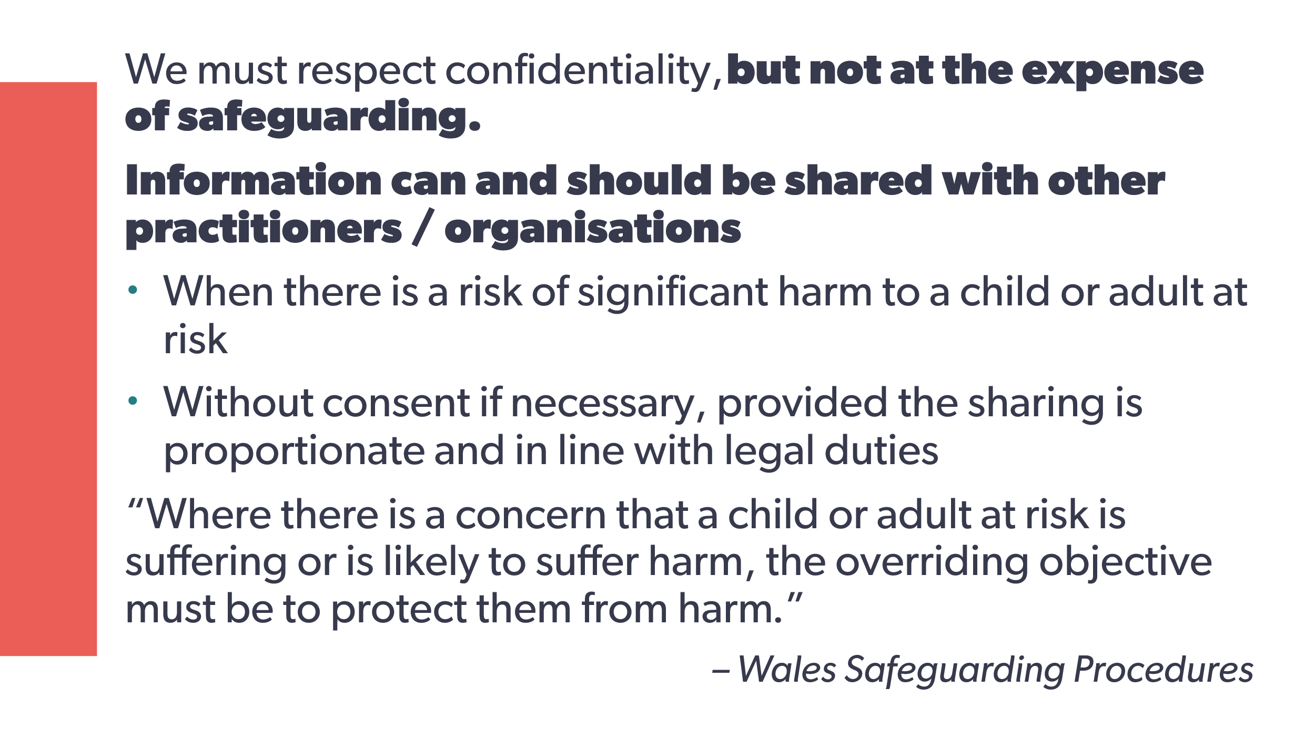 | We must respect confidentiality, but not at the expense of safeguarding.  We can and should share information with other practitioners / organisations:  - when there’s a risk of significant harm to a child or adult at risk  - without consent if necessary, provided the sharing is proportionate and in line with legal duties.  “Where there is a concern that a child or adult at risk is suffering or is likely to suffer harm, the overriding objective must be to protect them from harm.”  Wales Safeguarding Procedures | Workbook  - What are your organisation’s information sharing protocols and policies when it comes to sharing confidential information about a person with other practitioners or organisations?  - How do you record any request for information made to you and ensure the nature and legitimate purpose for sharing is clear?  - What’s included in your service user contracts / agreements regarding sharing information?
42 | 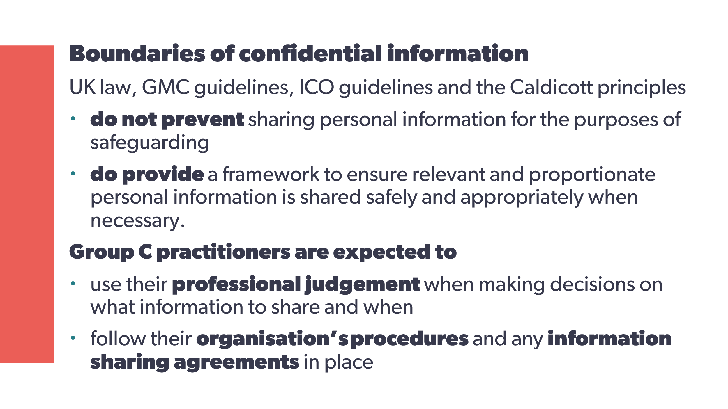 | Boundaries of confidential information  UK law, GMC guidelines, ICO guidelines and the Caldicott principles  - do not prevent sharing personal information for the purposes of safeguarding  - do provide a framework to ensure relevant and proportionate personal information is shared safely and appropriately when necessary.  As a Group C practitioner, you’re expected to:  - use your professional judgement when making decisions about what information to share and when  - follow your organisation’s procedures and any information sharing agreements in place. | Workbook  - What resources and organisations can you to look to for guidance?
43 | 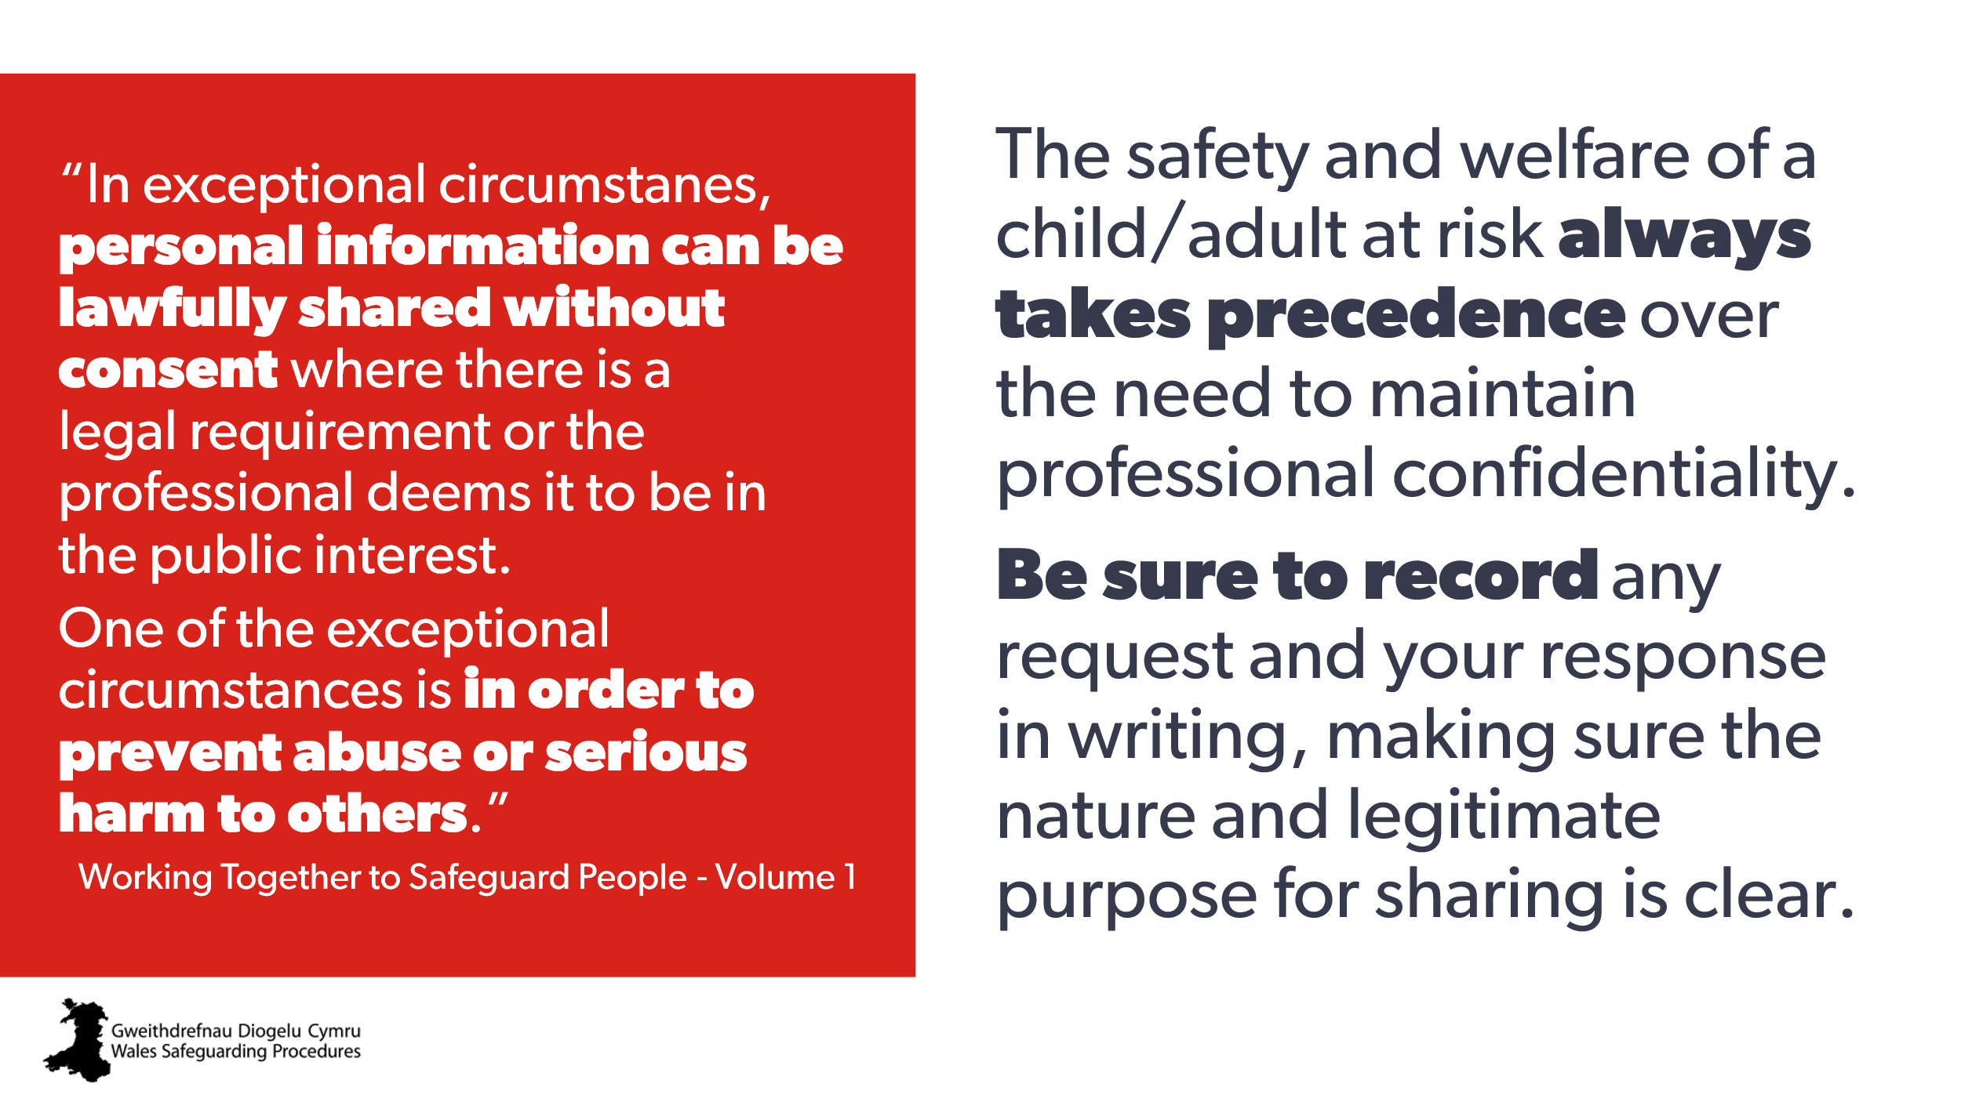 | Remember!  The safety and welfare of a child/adult at risk always takes precedence over the need to maintain professional confidentiality.  Be sure to record any request and your response in writing, making sure the nature and legitimate purpose for sharing is clear. | Workbook
44 | 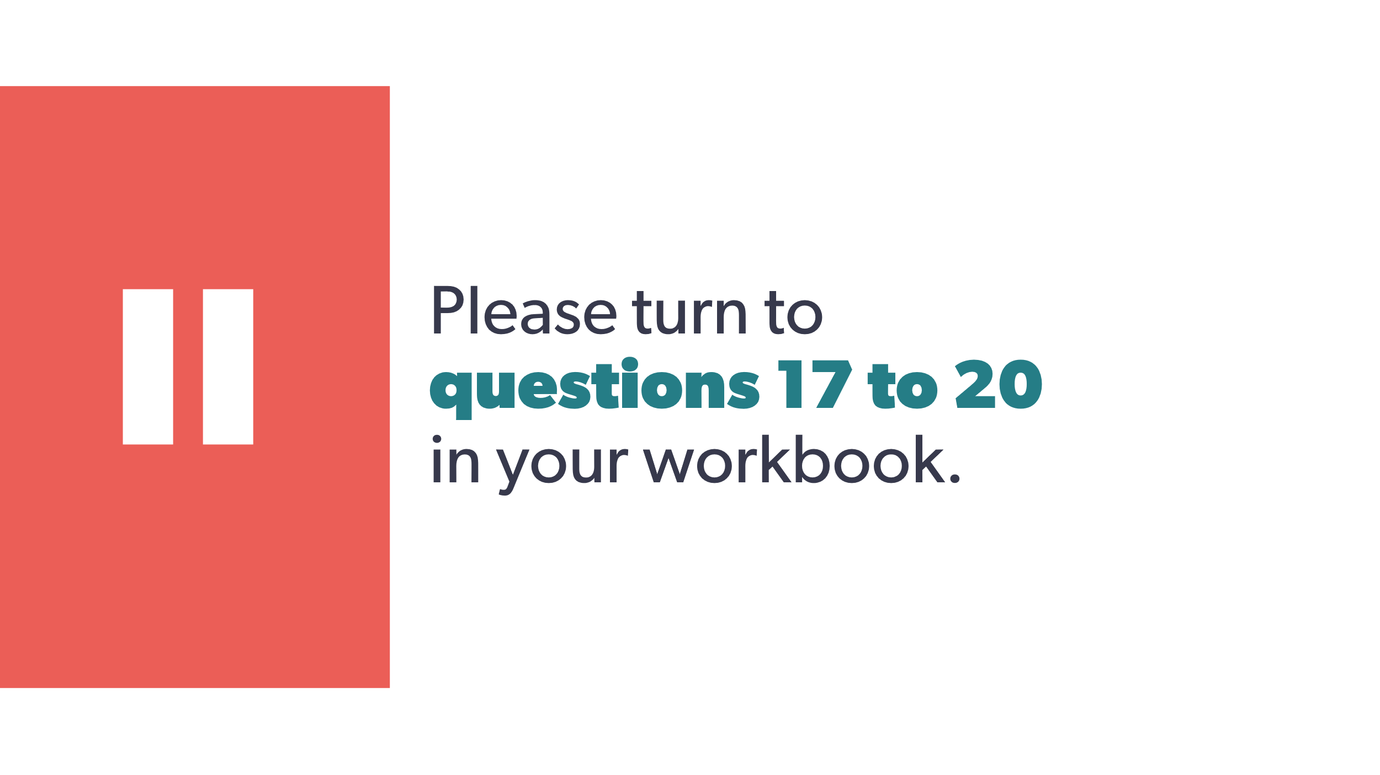 | Please turn to questions 17-20 in your workbook. | Workbook
45 | 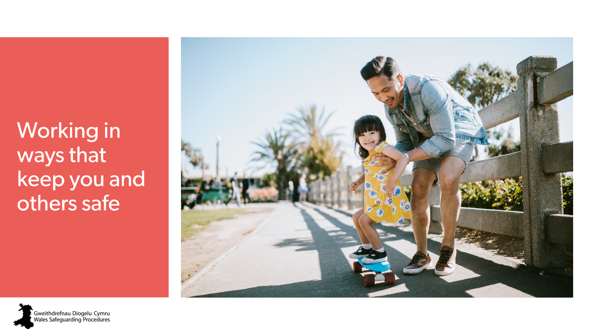 | Working in ways that keep you and others safe | Workbook
46 | 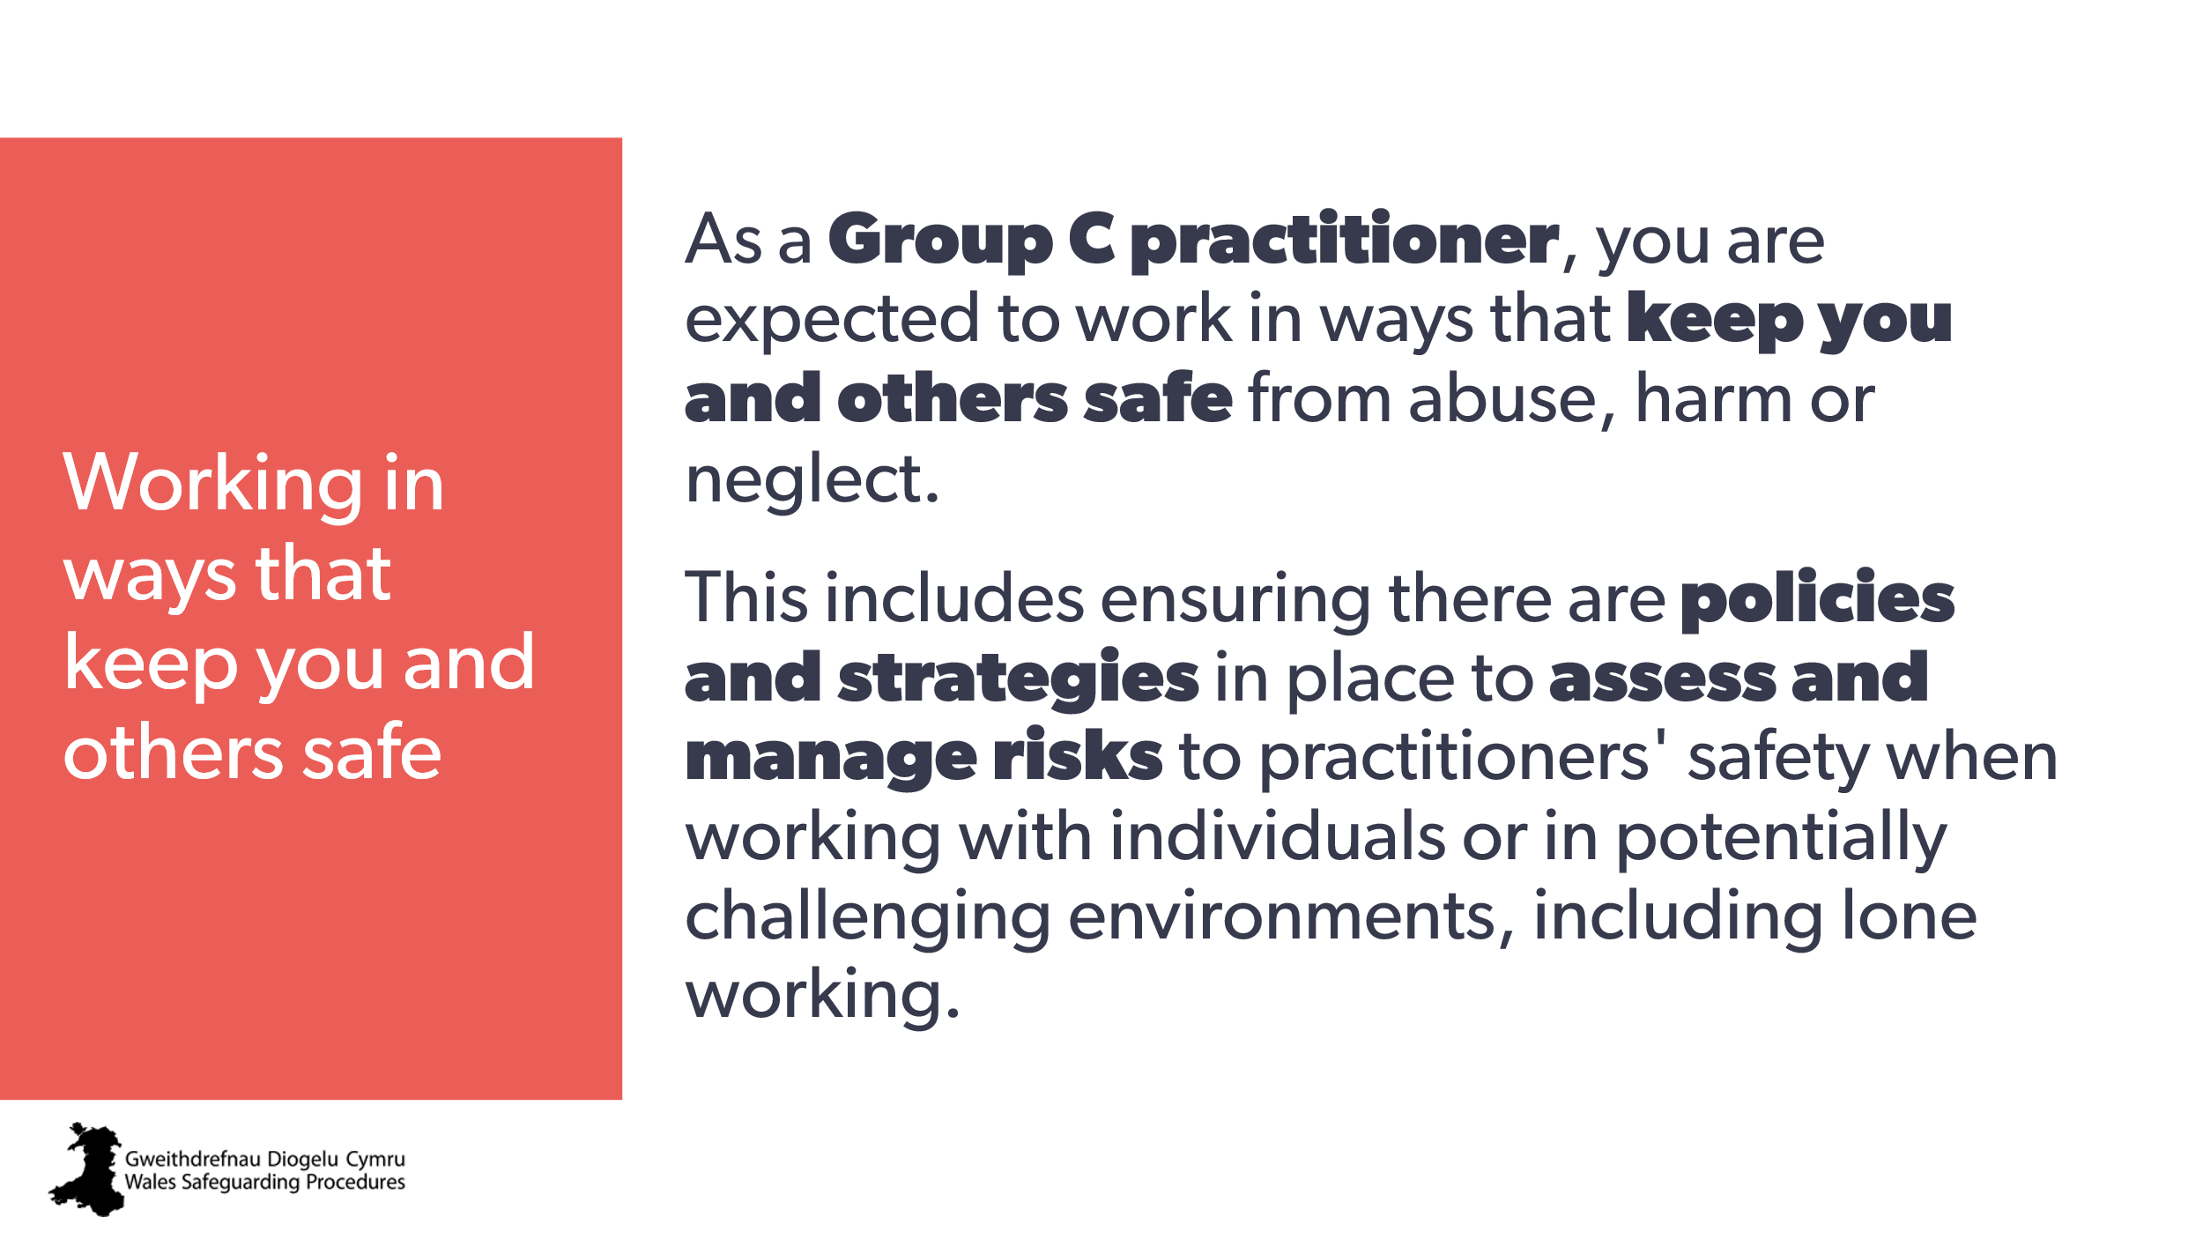 | As a Group C practitioner, you’re expected to work in ways that keep you and others safe from abuse, harm or neglect.  This includes ensuring there are policies and strategies in place to assess and manage risks to practitioners' safety when working with individuals or in potentially challenging environments, including lone working. | Workbook  21. What organisational policies and strategies does your organisation have to assess and manage risks to practitioners' safety when working with individuals or in potentially challenging environments, including lone working?
47 | 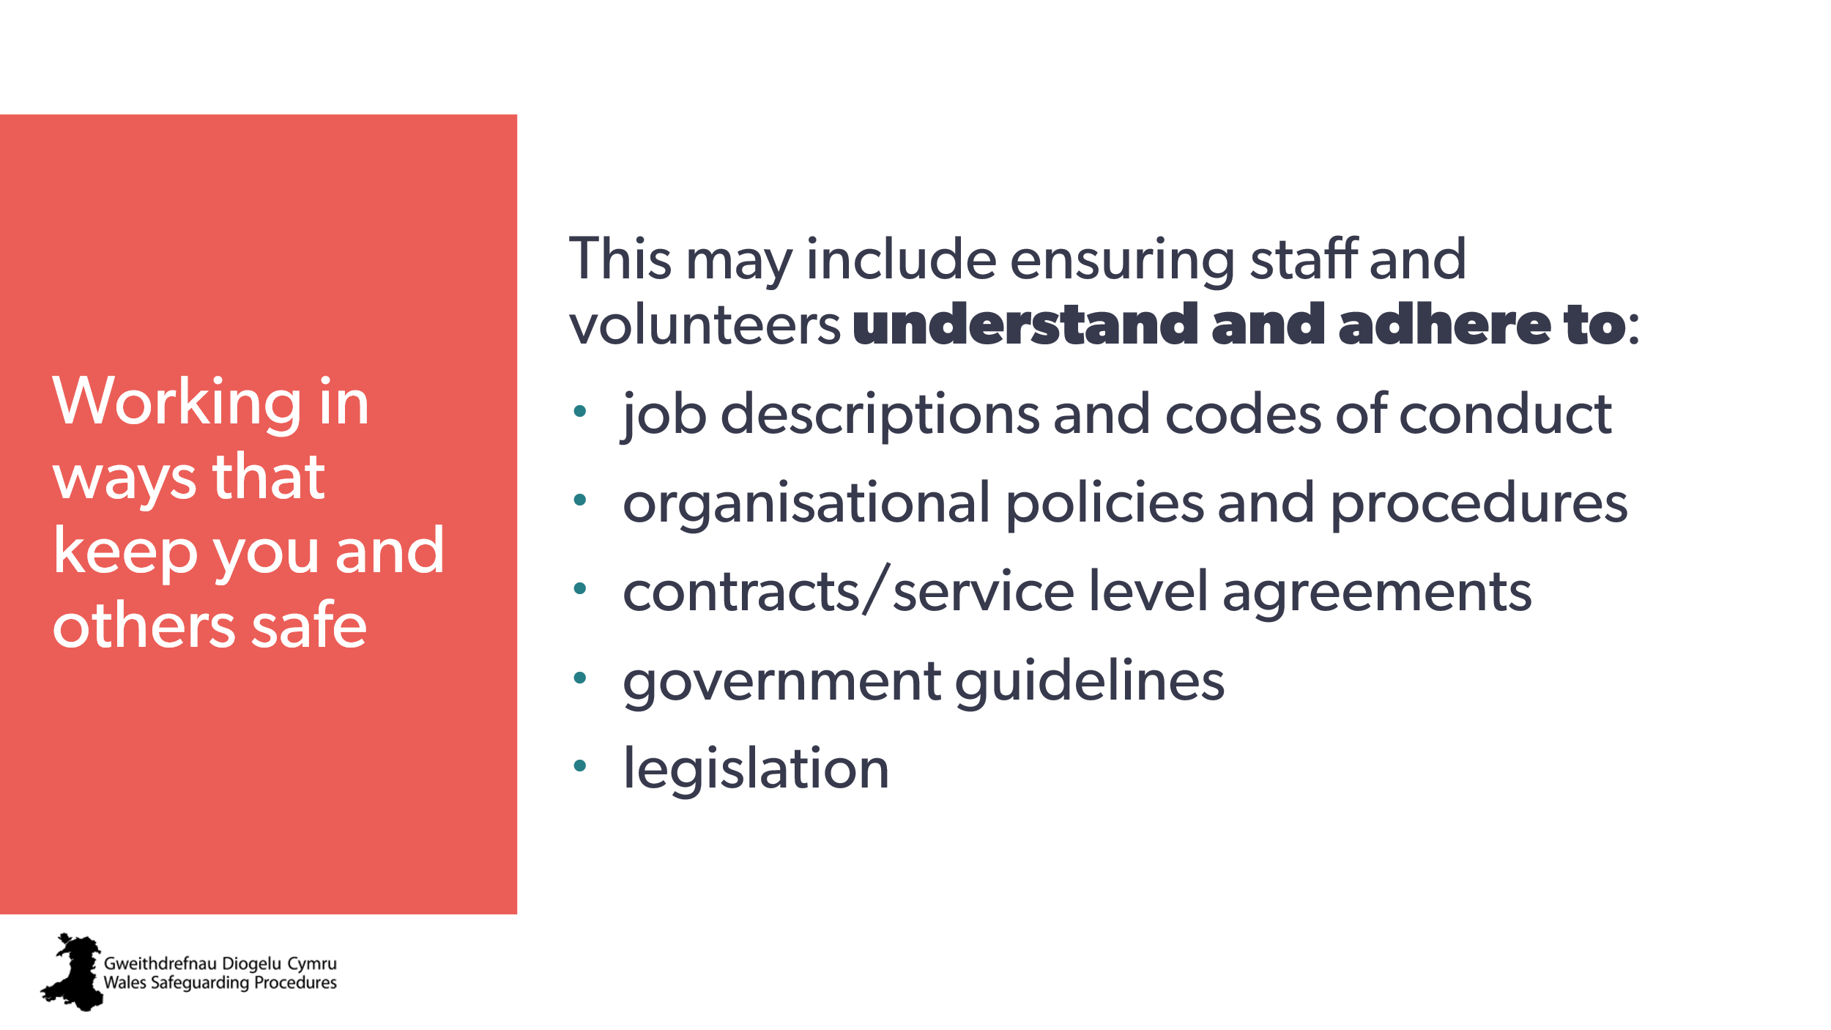 | This may include ensuring staff and volunteers understand and follow:  - job descriptions and codes of conduct  - organisational policies and procedures  - contracts/service level agreements  - government guidelines and legislation. | Workbook  22 (If relevant): What are some specific ways that can help make sure staff and volunteers understand and follow:  - job descriptions and codes of conduct  - organisational policies and procedures  - contracts/service level agreements  - government guidelines and legislation
48 | 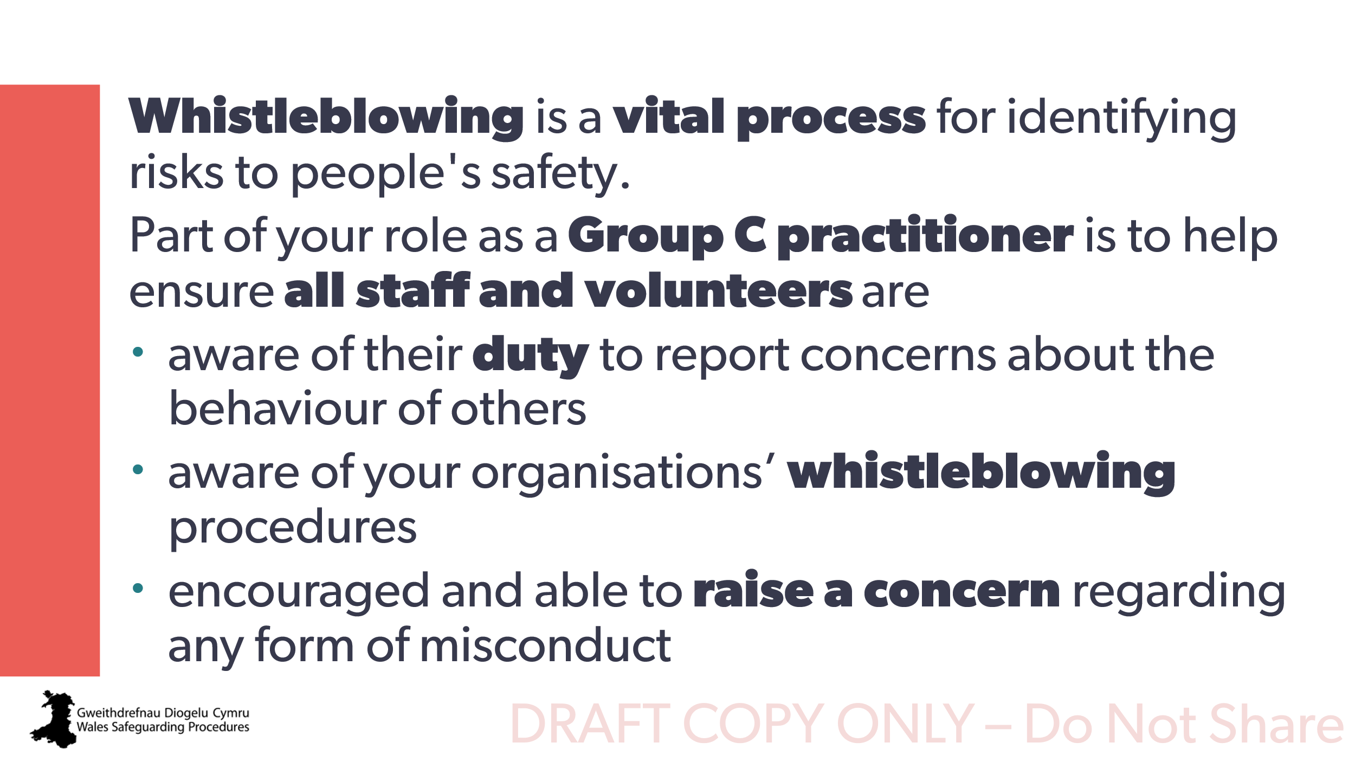 | Whistleblowing is a vital process for identifying risks to people's safety.  Part of your role as a Group C practitioner is to help make sure all staff and volunteers are:  - aware of their duty to report concerns about the behaviour of others  - aware of your organisations’ whistleblowing procedures  - encouraged and able to raise a concern about any form of misconduct. | Workbook  23. What are your organisations’ whistleblowing procedures? Are they clear and available to all? Do they include volunteers as well as staff (if relevant)?
49 | 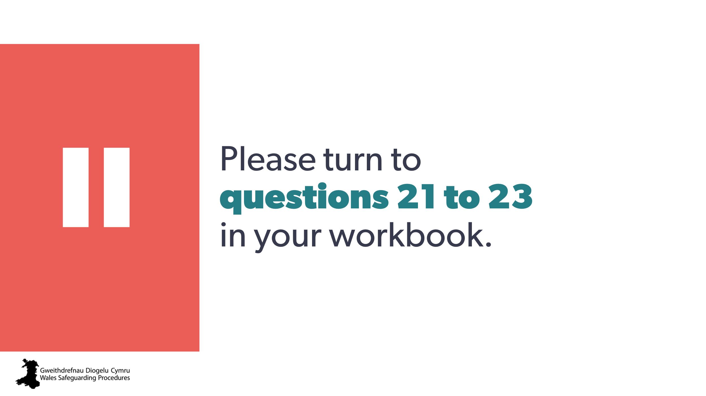 | Please turn to questions 21 to 23 in your workbook. | Workbook
50 | 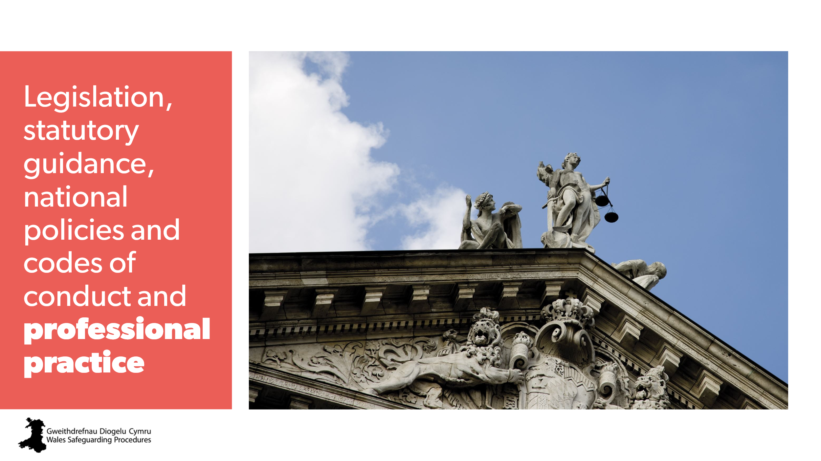 | Legislation, statutory guidance, national policies and codes of conduct and professional practice | Workbook
51 | 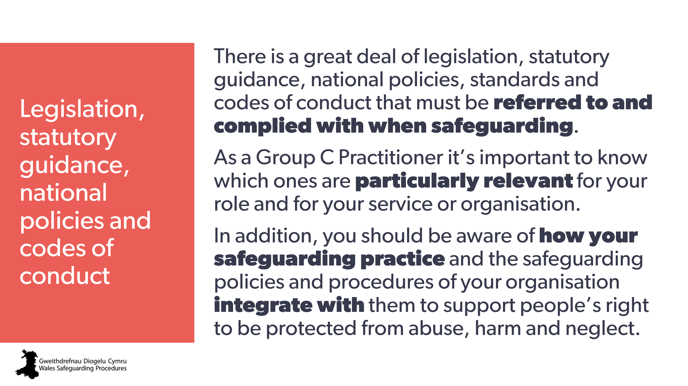 | There’s a great deal of legislation, statutory guidance, national policies, standards and codes of conduct that must be referred to and complied with when safeguarding.  As a Group C practitioner it’s important to know which ones are particularly relevant for your role and for your service or organisation.  You should also be aware of how your safeguarding practice and the safeguarding policies and procedures of your organisation integrate with them to support people’s right to be protected from abuse, harm and neglect. | Workbook  24. What legislation, statutory guidance, national policies, standards and codes of conduct are particularly relevant for your role and/or for your organisation?  25. How do they impact or influence your role in relation to safeguarding?  26. How are they integrated with your safeguarding practice and the safeguarding policies and procedures of your organisation to support people’s rights, voice, safety and well-being?
52 | 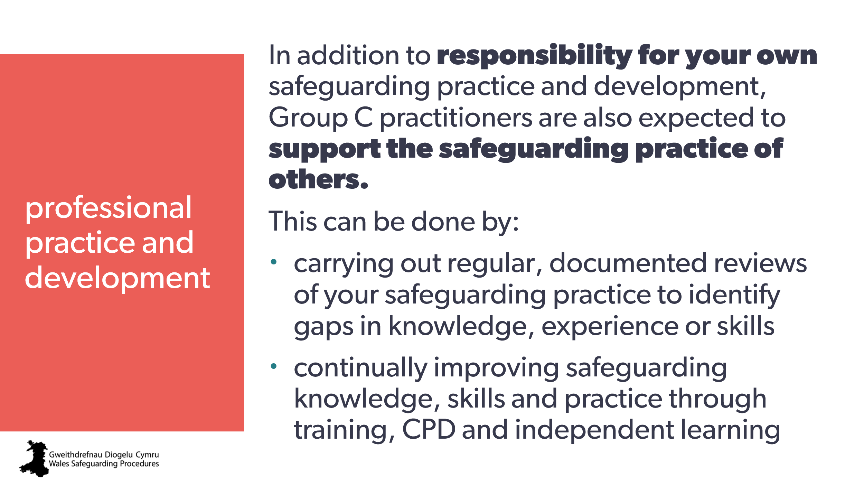 | As well as being responsible for your own safeguarding practice and development, Group C practitioners are also expected to support the safeguarding practice of others.  This can be done by:  - carrying out regular, documented reviews of your safeguarding practice to identify gaps in knowledge, experience or skills  - continually improving safeguarding knowledge, skills and practice through training, CPD and independent learning | Workbook  27. How do you support the safeguarding practice of others in your organisation?
53 | 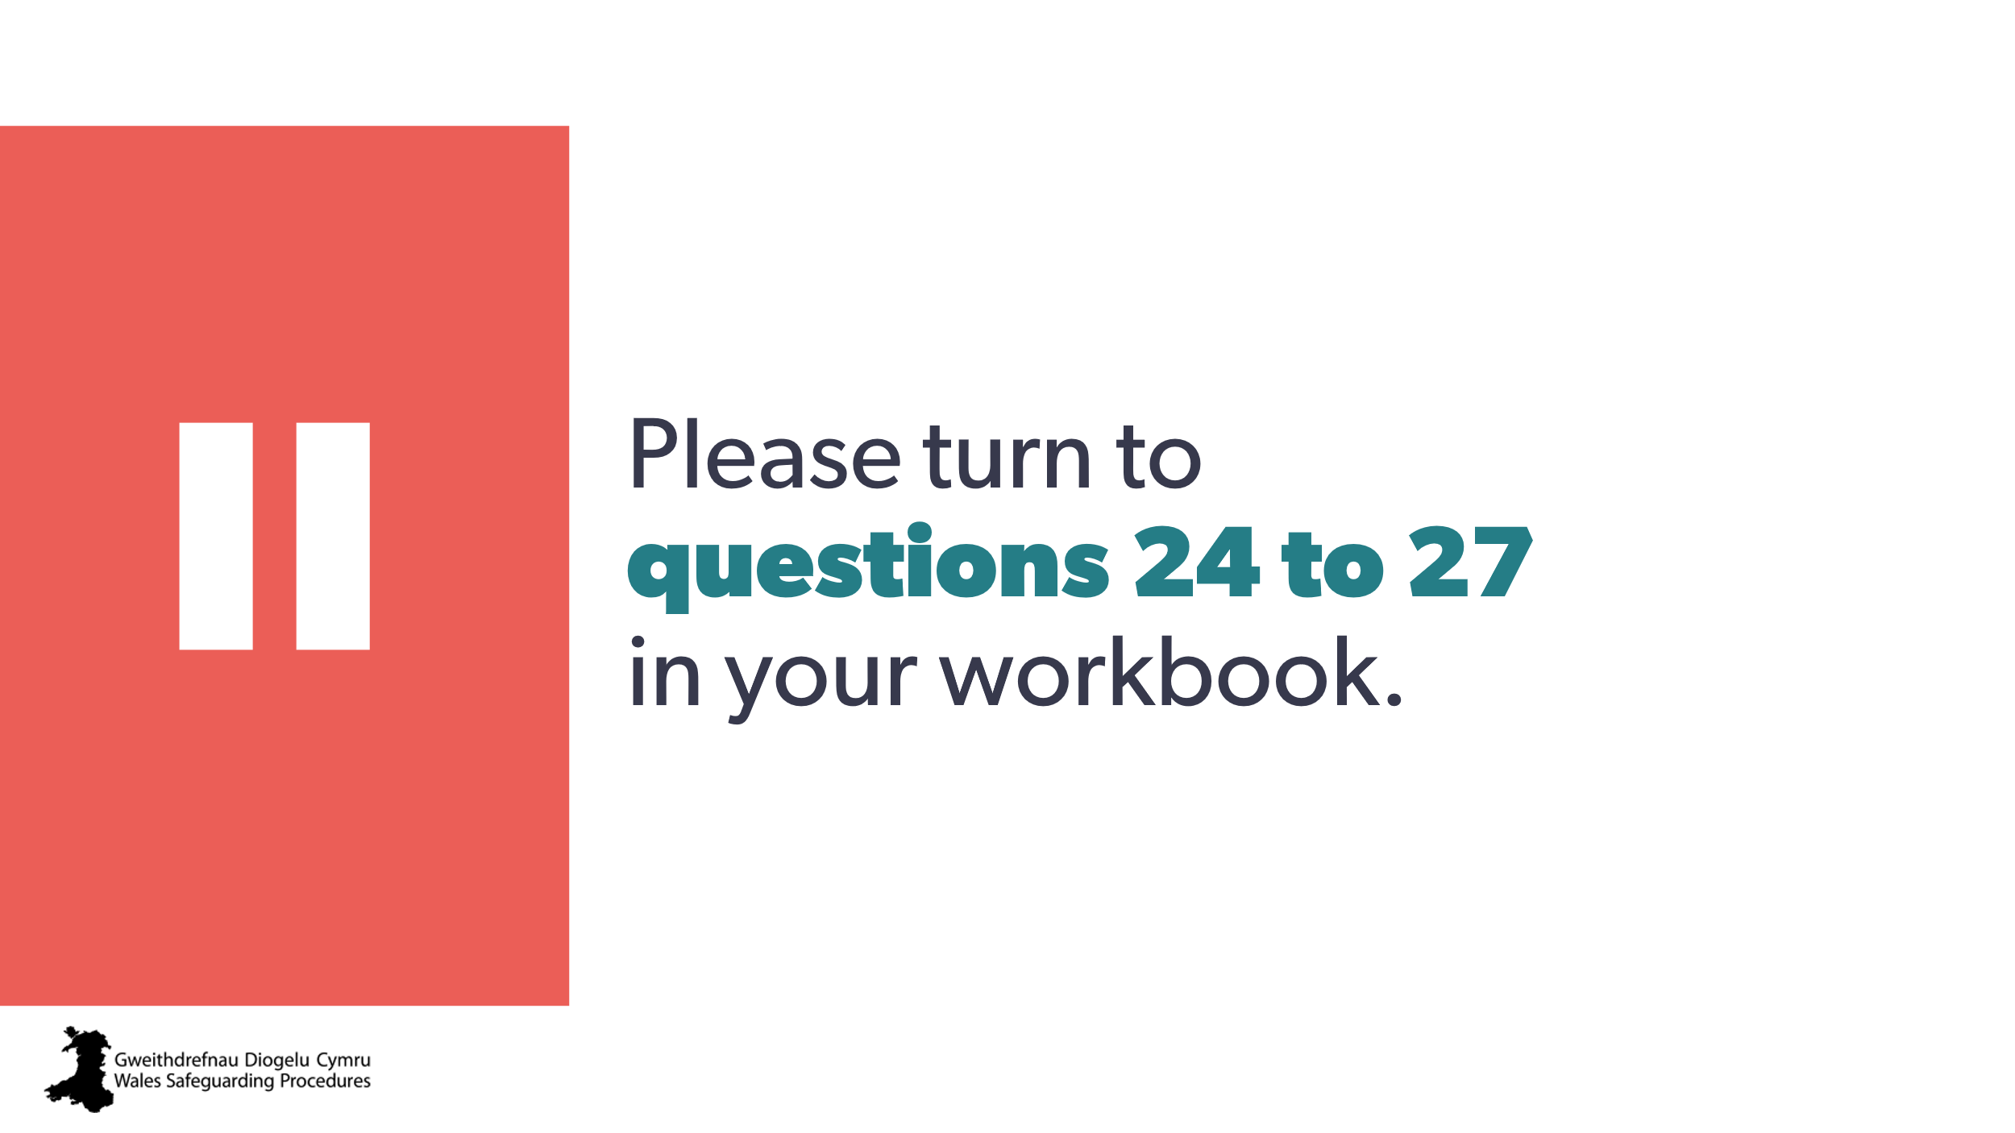 | Please answer questions 24 to 27 in your workbook.
54 |  | Next steps
55 | 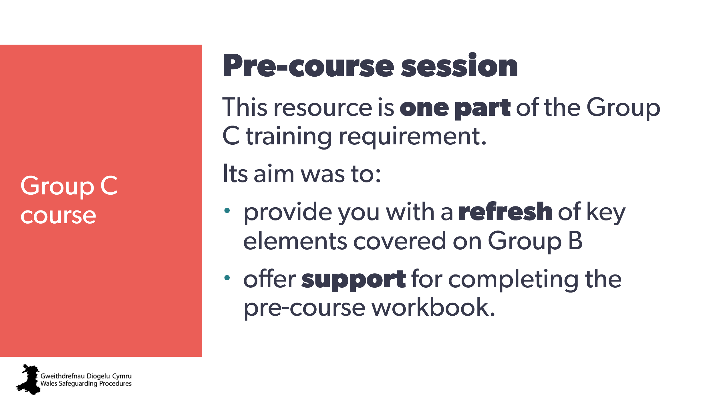 | This resource is one part of the Group C training requirement.  Its aim was to:  - provide you with a refresh of key elements covered in Group B training  - offer support for completing the  pre-course workbook
56 | 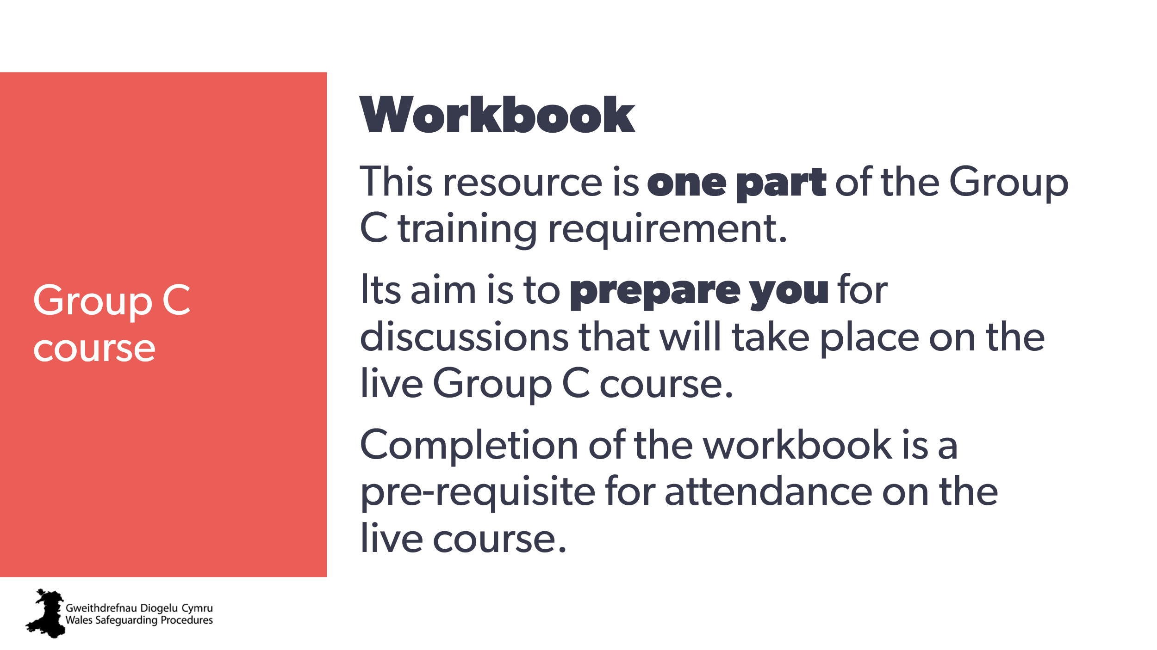 | This resource is one part of the Group C training requirement.  Its aim is to:  - prepare you for discussions that will take place on the live Group C course.
57 | 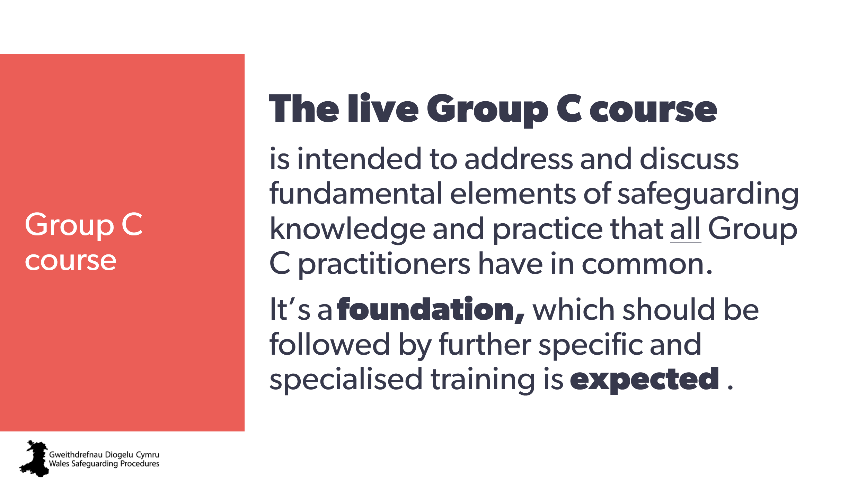 | The live Group C course is intended to address and discuss fundamental elements of safeguarding knowledge and practice that all Group C practitioners have in common.  It’s a foundation from which further specific and specialised training is expected to take place.
58 | 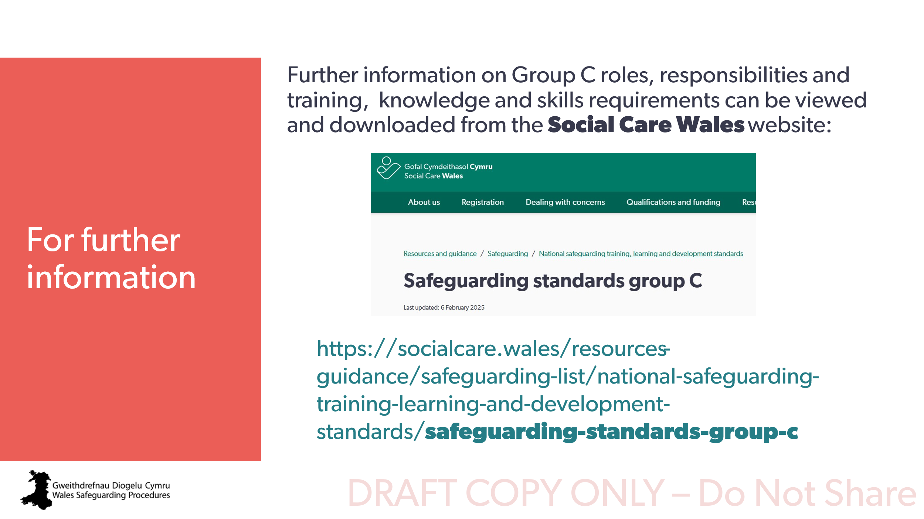 | You can find more information about Group C roles, responsibilities and training, knowledge and skills requirements on the Social Care Wales website.

