Language, dignity and care introductory document

Introduction

The following pack is for individuals who wish to introduce a language awareness training session for their learners. The duration of the session is one hour.

The course is suitable for:

- Level 1, 2, 3, 4 and 5 health and social care or childcare students
- tutors and assessors in colleges
- social care/work or childcare students in universities.

It could also be used as part of in-service training for workers in these areas and the Social Care Wales workforce.

The pack aims to equip trainers to present information about language and discuss how to work bilingually with their learners.

The pack is presented under three headings:

- History and the Welsh language
- Legislation and policy
- Our service users.

It is intended to share information that will educate and empower learners to offer a valuable service to their service users ensuring that language is always a central consideration.

The pack is presented in PowerPoint format with trainer notes to support each slide. The trainer notes present a lead script, in addition to offering a few ideas about how to present tasks and encourage learners to be proactive in the session.

The trainer will be able to use the pack in the manner that they see that is suitable for their audience. The session, as it is, takes an hour to facilitate it but could be curtailed or extended as required. The pack is suitable for an audience new to language awareness, but it would be possible to focus and develop particular sections with a more experienced audience. To support the trainer in developing the session for its own purposes, we also provide ideas for reading and additional information that may be of assistance. We encourage the trainer to do this so that they can respond to queries and questions in a knowledgeable and informed style.

The resource has been prepared bilingually with the intention of delivering it in Welsh or bilingually. In sessions where there are no Welsh speakers, bilingual training methods should be used (to varying degrees) to model bilingual operating skills. Guidance to support the trainer to do this is attached.

Guidelines for training bilingually

Why should I facilitate a bilingual training session?

- To acknowledge that people have different linguistic needs and customs
- To provide people with the opportunity to contribute in their language of choice and to encourage participation
- To ensure that everyone, Welsh speakers and non-Welsh speakers alike, are able to participate
- Providing Welsh speakers with an opportunity to use Welsh will normalise the use of Welsh within your organisation thus increasing your bilingual profile
- To show your support to the Welsh language and to ensure compliance with current public policy and legislation
- To demonstrate that the Welsh language is a living language that is used in work and in business
- Because it is the right thing to do.

It must be remembered that Welsh speakers won’t always choose to use the Welsh language in this situation. Some are very familiar with working through the medium of English and it is possible that, at first, they will be more confident speaking English in public.

But people will very quickly become used to bilingual training, although some familiarisation may be necessary at first.

How to deliver bilingual training?

As a trainer you have a role to encourage everyone to use their chosen language. The challenge is to make it completely natural and easy for Welsh speakers to contribute through the medium of Welsh in new and variable situations.

It’s important that you establish conditions and an environment that will counteract the tendency to switch to English. You need to demonstrate that it is natural for Welsh-speakers to speak Welsh, and that it is not discourteous to do so in the presence of non-Welsh speakers.

Good practice for trainers:

- encourage and support discussions in both languages
- open and close every session bilingually
- welcome contributions in Welsh at the beginning of a training session
- facilitate in a professional and organised way ensuring everyone has an opportunity to speak in turn
- use as much Welsh as you can during the session.

A successful bilingual session doesn’t mean that the use of Welsh and English will be exactly the same. The aim is to create a safe environment for Welsh speakers to use Welsh should they wish to. This will be good practice for your learners to prepare them to use a little bit of Welsh at work.

Further reading

Shadow of History

- Hwb website: Ein Hiaith, Our Language https://hwb.gov.wales/repository/resource/91cc6904-8b3e-419a-bc5f-5294ea233a06/en

Supplementary information for trainers – The language journey: against the elements

  - The laws of Hywel Dda and the age of princes – Welsh as a state language
  - The arrival of the Normans – French gradually replaces Welsh as the language of power and influence
  - The Acts of Union (1536 and 1542) – The Welsh language excluded from public life by statute
  - 1588 – Translating the Bible into Welsh to promote Protestantism offers salvation to the public use of the Welsh language
  - The Church of England – the English influence of the church, nobility and landowners polarises Welsh linguistically along power lines
  - The beginning of the 19th century – riots and rebellion in response to poverty and social injustice
  - 1847 – Treachery of the Blue Books, a damning report on education in Wales, which led to the period of the 'Welsh Not'
  - Economic hardship and two world wars put pressure on the Welsh language again.

Language journey: Turning the tide

- 1950 – Eileen and Trefor Beasley challenge Llanelli Town Council regarding English only tax bills
- 1962 – 'The Fate of the Language' lecture, Saunders Lewis and the establishment of the Welsh Language Society
- 1967 – The Welsh Language Act offers limited status to the language
- 1977 and 1982 – The establishment of Radio Cymru and S4C
- 1993 – The Welsh Language Act and the establishment of the Welsh Language Board
- 1999 – Establishment of the National Assembly for Wales
- 2011 – The Welsh Language Measure and the establishment of the Coleg Cymraeg Cenedlaethol
- 2015 – Publication of Welsh Language Standards
- 2017 – Publication of Welsh 2050.

The ‘language journey' reveals two key points for us to keep in mind:

- The unequal power relationship that exists between a majority language that is powerful on a global scale on the one hand, and on the other, a minority regional language that has historically been oppressed
- Linguistic revival arising from the determined will of Welsh language benefactors to see an increase in the legal status of the Welsh language and the civil use made of it at all levels of Welsh society.

You can find useful resources to explore this further on the following websites:

- Wales timeline: www.llinellamser.cymru
- BBC Website: www.bbc.co.uk/cymru/hanes/safle/themau/iaith.shtml

In addition, two useful books for further reading are recommended:

- Catrin Stevens, Stori’r Gymraeg, Gomer, Llandysul: 2009
- Janet Davies, The Welsh Language: A Pocket Guide, Gwasg Prifysgol Cymru, Caerdydd: 1999.

Legislation

The Welsh Language Measure 2011 and establishing the Welsh Language Commissioner

The Welsh Language Measure:

- gives the Welsh language official status in Wales
- sets the principle that the Welsh language should be treated no less favourably than English
- establishes the position of a Welsh Language Commissioner
- creates a provision for promoting and facilitating the use of Welsh
- develops the idea of the Welsh Language Standards
- provides for the Welsh Language Commissioners Advisory Board
- provides for the Welsh Language Partnership Council
- creates a provision for investigating situations where an individual’s right to speak Welsh has been impacted
- establishes the Welsh Language Tribunal
- dissolves the Welsh Language Board.

The Welsh Language Measure 2011: private companies and third sector organisations

The Welsh Language (Wales) Measure 2011 sets out the framework for placing a duty on certain private companies and third sector organisations to comply with the Welsh Language Standards. It also gives the Welsh Language Commissioner the power to force companies or organisations to comply with the standards.

The Commissioner’s work is underpinned by two principles:

The Welsh language should not be treated less favourably than the English language in Wales.

People in Wales should be able to live their lives through the medium of Welsh if they so wish.

Cymraeg 2050: A million Welsh speakers

Vision

The year 2050: the Welsh language is thriving, the number of speakers has reached a million, and it is used in every aspect of life. Among those who do not speak Welsh there is goodwill and a sense of ownership towards the language, and a recognition by all of its contribution to the culture, society and economy of Wales.

Realising the vision

The challenge of achieving a million Welsh speakers by 2050 calls for far-reaching changes. Boundaries need to be pushed and ambitious action taken to enable more people to learn and use Welsh. This strategy builds on existing foundations and moves us on to the next stage in our language journey.

We have identified three strategic themes to achieve this vision:

- Increasing the number of Welsh speakers
- Increasing the use of Welsh
- Creating favourable conditions – infrastructure and context.

To realise the vision, we will need to take action under the three themes and understand the interdependencies between them.

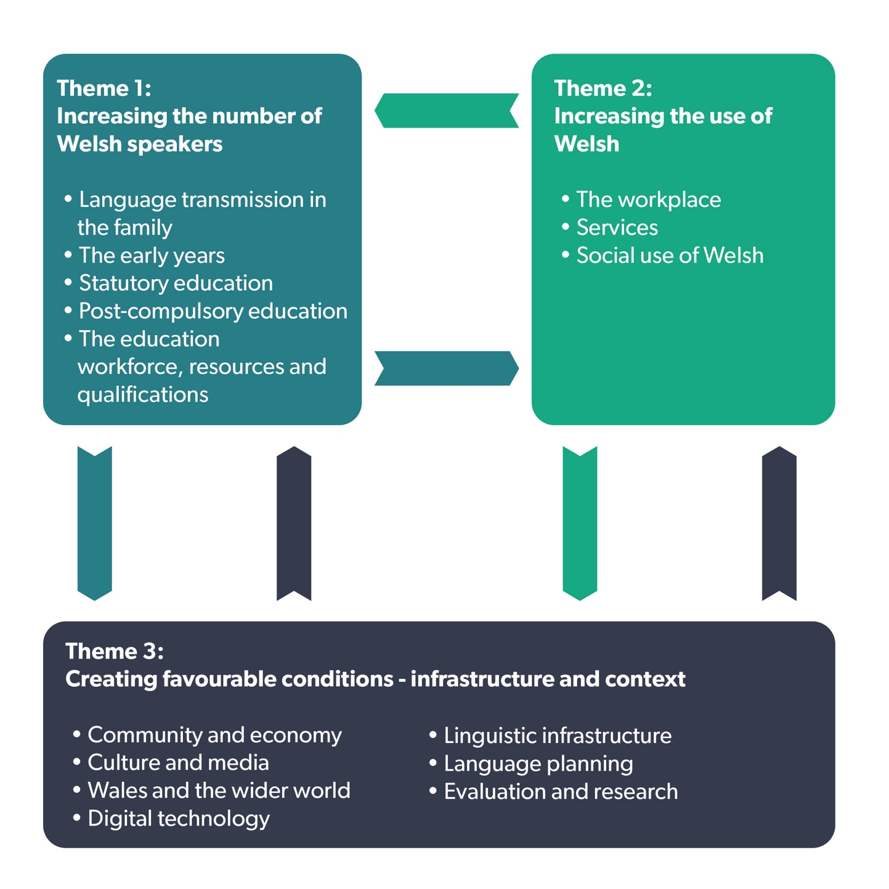
Targets

- The number of Welsh speakers to reach 1 million by 2050
- The percentage of the population that speak Welsh daily and can speak more than just a few words of Welsh, to increase from 10 per cent (in 2013-15) to 20 per cent by 2050.

Achieving the targets

- Make rapid progress to expand Welsh-medium early years provision by 150 nursery groups over the next decade to facilitate a seamless transition into Welsh-medium education
- Increase the proportion of each school year group receiving Welsh-medium education from 22 per cent (based on 7,700 seven-year-old learners in 2015/16) to 30 per cent (about 10,500 in each year group) by 2031, and then 40 per cent (about 14,000 in each year group) by 2050
- Transform how we teach Welsh to all learners so that at least 70 per cent of them report by 2050 that they can speak Welsh by the time they leave school
- Increase the number of primary teachers who can teach in Welsh from 2,900 to 3,900 by 2031 and 5,200 by 2050. Increase the number of secondary teachers who can teach Welsh from 500 to 900 by 2031 and 1,200 by 2050. And increase the number of secondary teachers who can teach through the medium of Welsh from 1,800 to 3,200 by 2031 and 4,200 by 2050
- Reform the post-16 Welsh-medium and bilingual education and skills offer to ensure that young people have the opportunity to continue developing bilingual skills to support a prosperous economy
- Review the legislation which underpins the Welsh language to ensure it offers a strong foundation for promoting and facilitating the use of Welsh
- Ensure that Welsh Government leads by example by promoting and facilitating increased use of Welsh by our own workforce
- Develop a new regional focus on economic development to help all parts of Wales benefit from prosperity and support each area to develop its own distinctive identity
- Transform the Welsh language digital landscape with particular focus on language technologies
- Develop a national programme to increase understanding of bilingualism.

More than just words… Follow-on strategic framework for Welsh language services in health, social services and social care
(2016-19)

2012

Our vision is for Welsh speakers to receive services that meet their needs as a natural part of their care.

2016

This follow-on strategic framework aims to ensure an integrated approach to the delivery of health and social services and social care.

Key objectives have been identified for delivery:

- National and local leadership, and national policy
- Mapping, auditing, data collection and research
- Service planning, commissioning, contracting and workforce planning
- Promotion and engagement
- Professional education
- Welsh in the workplace
- Regulation and inspection.

Aim

2.4.

The ultimate aim of this follow-on strategic framework is to ensure that we reach a point where we have mainstreamed the Welsh language into virtually all aspects of the day to day business of NHS Wales, social services and social care. This will involve a recognition that many vulnerable people, such as older people who suffer from dementia or stroke, also lose their second language and many toddlers only speak Welsh.

Demography

We learned from the film The Shadow of History that the Welsh language belongs to everyone in Wales and it can be spoken by anybody.

Do you remember how many Welsh speakers there are in Wales?

560,000 according to the 2011 census.

But what about here... how many Welsh speakers are there here?

Provide the data (local data will support the learners to put the information into context).

Further reading

You could use maps and graphs to demonstrate the information above. There are useful resources available on the following websites:

- the Welsh Language Commissioner
- Statiaith
- Nomisweb
- Welsh Government.

Please note that there are different methods of calculating the language skills of the population, resulting in varying results. For example, while the 2011 Census indicates that 19 per cent of the population over three years old could speak Welsh, the latest National Population Survey (September 2018) reports that 29 per cent say they can speak the language. This indicates that self-assessment of language skills is not an entirely objective issue and that confidence or lack of language confidence is a key part of the picture.

