Social Care Wales Workforce Development Programme (SCWWDP) end of year monitoring for 2023 to 2024: Summary of themes and findings

Contents

Introduction 2
Main findings and future developments 4
Spend analysis 5
Training places and attendance 20
Qualifications activity 24
Vocational awards and AWIF 26
Social work 27
National priorities key themes and analysis 32
Priority 1: Building a digitally ready workforce 32
Priority 2: Excellent education and learning 35
Priority 3: Qualifying and post qualifying programmes for social work 40
Priority 4: Leadership and succession 44
Priority 5: Workforce shape and supply 46
Regional Facilitation Grant 49
Fundamental principles: Well-being, Welsh language and inclusion 51
Future SCWWDP developments 56

Introduction

This report sets out how the Social Care Wales Workforce Development Programme (SCWWDP) grant was invested by local authorities in 2023 to 2024.

What is the SCWWDP grant?
SCWWDP is a long-established grant programme to support training and workforce development across social care in Wales. The annual grant from Social Care Wales is distributed regionally and is used by local authorities to support training and workforce development activity in both their own organisations and for providers in the independent and voluntary sector.
Local authorities are required to provide match funding for SCWWDP, the same as 30 per cent of the funding provided by Social Care Wales.

How is the grant managed?

We issue the requirements of the grant to regions each year through the ‘grant circular.’ The grant circular is approved by our Board, and includes information about:
- the amount of the grant
- what it can be used for that year
- how to apply for the money
- how the grant should be managed
- what our expectations are for reporting and monitoring.

The SCWWDP programme also includes the Regional Facilitation Grant. This funding doesn’t need to be match funded by local authorities but must be used on specific priorities to support sector wide engagement within the regions.

What’s in this report?

As part of our requirements for receiving the SCWWDP grant, regions must report on how they’ve invested the SCWWDP funds. This includes the money we’ve issued and the 30 per cent match funding contributed by each local authority.

Each region is audited every year by Audit Wales to make sure all the public money invested in SCWWDP is accounted for.

As well as the SCWWDP funding and 30 per cent match funding, some local authorities give more information about the additional funding they spend on training and workforce development. We don’t have to include this additional local authority spending information, but we include it if a local authority has provided it. Because of this, we have two figures for spend. One figure is referred to as the core SCWWDP funding, and the other is referred to as additional local authority spend. Both figures combined are referred to as ‘total’ or ‘overall’ spend.
How is this report structured?

The first part of the report shows:
- the financial data on how the SCWWDP money has been invested in 2023 to 2024
- key figures such as training numbers and qualification activity
- comparisons for the last three financial years, where possible.
The second part of the report:
- highlights the activity against the key themes outlined in the SCWWDP grant circular
- has information on outcomes and outputs for each region.

Following an independent review in 2021, the national priorities of the SCWWDP grant were aligned to selected themes in A Healthier Wales: Our Workforce Strategy for Health and Social Care. We developed and published the joint workforce strategy with Health Education and Improvement Wales in October 2020.

Since SCWWDP can't fully fund the entire ambition of the workforce strategy, and to make sure the current funding is used proportionately, the grant focuses on the following key areas:

SCWWDP (match funded)
- Building a digitally ready workforce
- Excellent education and learning
- Leadership and succession
- Workforce shape and supply
- Provision of qualifying and post qualifying social work training (This is a priority of the Social Work Workforce Plan)

Regional Facilitation Grant (not match funded)
- Attraction, recruitment and retention

2023 to 2024 is the second year that the national priorities in the grant circular matches some of the themes of the workforce strategy.

Main findings and future developments

Main findings
The main findings from the SCWWDP end of year monitoring for 2023 to 2024 are:
- overall, total spend on SCWWDP has increased by 1.8 per cent (£219,086), from £12,475,258 to £12,694,344
- the additional investment by local authorities (over and above their expected 30 per cent match funding) decreased for the first time in three years, by 21.3 per cent (compared to an increase of 32.4 per cent in 2022 to 2023)
- there was an increase of 9.2 per cent in spend on staff who provide direct learning and development
- the two main areas of SCWWDP national priorities spending are:
- providing excellent education and learning, which includes vocational qualifications (43.3 per cent, £1,397,797)
- providing qualifying and post qualifying social work training (35.5 per cent, £1,146,467).
The SCWWDP grant:

- was used to support learning and development programmes in all seven regions of Wales, with a continued trend of delivering on a more local level.

- supported 1,889 vocational qualification learners, an increase of 3.3 per cent on last year.

- supported 1,356 people on social work qualifying training, an increase of 15.9 per cent on last year.

- supported 996 people with social work post qualifying training, an increase of 16.8 per cent on last year

- supported 448 people with social work post qualifying specialist awards, for example enabling practice, best interest assessor and Approved Mental Health Professional (AMHP). This was an increase of 15.2 per cent on last year

- provided 135,169 training places, with 82.8 per cent attendance

- 45.5 per cent of local authorities saw an increase in sector wide training attendance

- helped increase training attendance from wider services such as health, the police, education, unpaid carers and volunteers. This was an increase of 28.2 per cent on last year.

Future developments
We’ve identified many future developments, which are described in more detail in this report, including:

- building a fuller picture of social care workforce development across Wales
- monitoring the risk of higher investment in social work
- strengthening grant guidance
- training take-up and attendance reflecting the sector profile
- measuring impact.

Spend analysis
This section gives an overview of the financial spend analysis of the core funding SCWWDP grant (70 per cent funding provided by us and 30 per cent match funding by local authorities) and the additional local authority funding (over and above their 30 per cent match funding) against elements including staffing, health and safety, and spend against the national priorities.

Table 1 shows the total amount of spend across Wales for 2023 to 2024 against each main category of the SCWWDP grant circular, and the percentage change against the 2022 to 2023 spend.

Table 1: Summary of spend, 2023 to 2024
 | SCWWDP (70%+30%) | % change | Additional local authority funding | % change
SCWWDP grant (70%) | 7,640,051 | +6.9%
30% local authority contribution | 3,274,308 | +6.9%
Additional local authority funding |  |  | 1,779,985
Total (£) | 10,914,359 | +6.9% | 1,779,985 | -21.3%
Staffing
Delivery | 5,193,842 | +9.2% | 206,305 | -60.1%
Management and admin | 2,348,926 | +0.3% | 395,773 | -6.4%
Health and safety | 228,451 | -8.7% | 386,153 | +12.4%
National priorities

Build a digitally ready workforce | 198,534 | -5.3% | 17,464 | +12.7%
Excellent education and learning | 1,397,797 | +17.8% | 266,321 | -28.4%
Provision of qualifying and post qualifying social work training | 1,146,467 | +21.0% | 229,677 | +71.9%
Leadership and succession | 194,489 | -2.8% | 14,974 | -68.0%
Workforce shape and supply | 119,191 | -25.4% | 19,294 | -30.4%
Other priorities | 170,770 | -21.6% | 243,997 | -36.4%
Additional contribution by one region to cover overspend | -80,607
Corrections to be checked with regions | -3,501 |  | 27
Total (£) | 10,914,359 |  | 1,779,985

Total spend and local authority additional funding

- Total spend on SCWWDP in 2023 to 2024 was £12,694,344 compared to £12,475,258 in 2022 to 2023 (an increase of £219,086 or up1.8 per cent compared to a 4.6 per cent increase the year before, as shown in Figure 1).

- Total spend includes the SCWWDP funding from us, the 30 per cent match funding contributed by each local authority and, if the information has been provided, the additional local authority funding (over and above their 30 per cent match funding)

- This increase of 1.8 per cent of total spend is a result of the increased SCWWDP funding of 6.9 per cent (+£701,002) and counteracted by a decrease in additional local authority funding of 21.3 per cent (-£481,916).

Figure 1: Total spend, the three-year trend

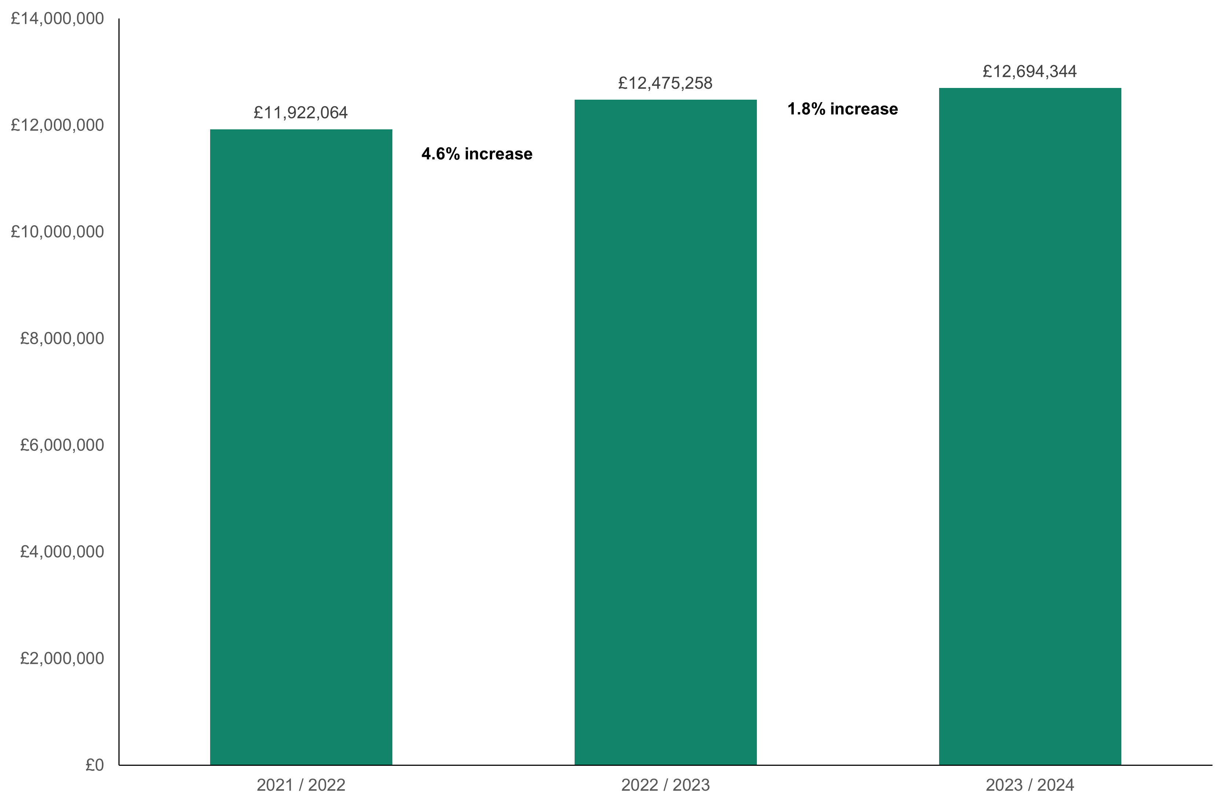

Figure 2: Proportion of funding 2023 to 2024

Figure 2 shows the split between SCWWDP grant funding, 30 per cent match funding from local authorities and the further additional funding provided by local authorities over and above the required match funding in 2023 to 2024.

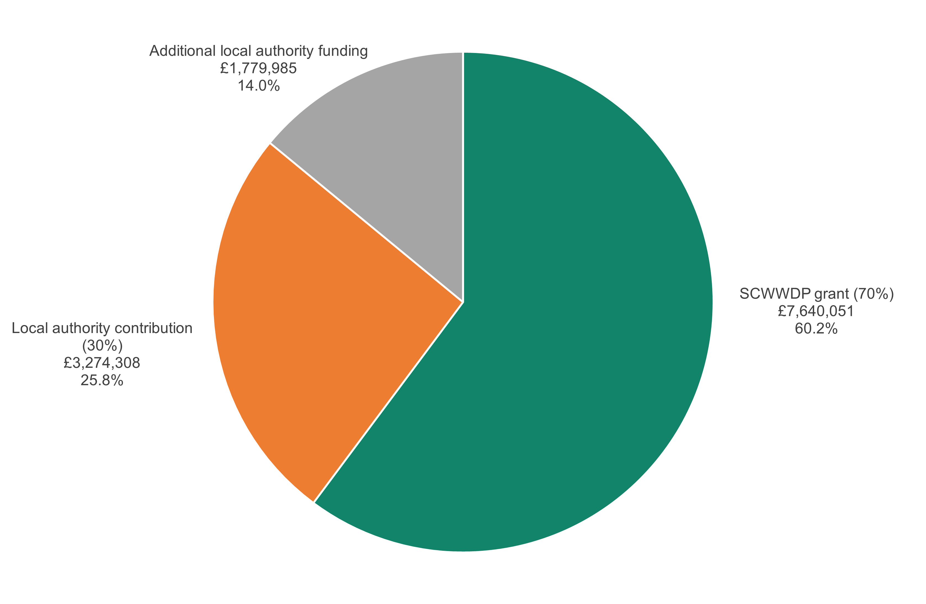
- The SCWWDP grant funding provided by us increased by 6.9 per cent (£490,701), from £7,149,350 in 2022 to 2023, to £7,640,051 in 2023 to 2024. This is the first increase in three years.

- The additional funding by local authorities, over and above their expected 30 per cent match funding, was £1,779,985 in 2023 to 2024 (a decrease of £481,916 or 21.3 per cent compared to a 32.4 per cent increase the year before). This is the first decrease in three years.

Table 2: Local authority additional funding, the three-year trend

Financial year | Local authority additional funding | % change | £ change
2023 to 2024 | £1,779,985 | -21.3% | -£481,916
2022 to 2023 | £2,261,901 | +32.4% | +£553,194
2021 to 2022 | £1,708,707 | +3.8% | +£63,298

- The local authorities not declaring any additional investment over their 30 per cent match funding increased from six to 10 in 2023 to 2024. These 10 authorities were spread across six separate regions, compared to three in 2022 to 2023. Two regions didn’t declare any additional funding at all in 2023 to 2024, compared to only one region in 2022 to 2023.

- Local authority additional funding isn’t required information in the SCWWDP grant reporting. Local authorities have told us that they’re contributing over and above the expected 30 per cent match funding required, but this information isn’t always reported or declared for the following reasons:

  - some local authorities choose not to share this information

  - services will fund additional needs from their own budgets or provide learning and development events themselves without including the workforce development teams

  - there’s an element of variation in financial coding between local authorities and regions.

  - staff time and capacity is used to support workforce development but if the role is fully funded by the local authority, then this information isn’t reported. If the role is SCWWDP funded, it’s reported as part of the staffing costs.

  - because of financial pressure there’s a need to do things differently and use different ways which might not be reported, or are difficult to count for reporting purposes, such as:
    - statutory services arranging and funding their own workforce development through supporting reflective groups
    - using experts in service teams to support and develop others
    - in-service learning events and workshops.

This is reducing reliance on commissioned training by using internal expertise to support broader approaches to learning. We’ll need to change how we capture training and learning opportunities, as well as areas where we’re not meeting needs.

- Without this additional local authority funding information, we’re not able to report all outputs, outcomes and trends to the workforce development for the social care sector in Wales. Also, this reporting won’t capture the workforce investment made by private and third sector providers. We’ll explore the possibilities of building a fuller picture with local authorities, regions and Welsh Government.

Figure 3: Percentage spend split by reporting headings, 2023 to 2024

Figure 3 shows the percentage split of spend across the headings that local authorities need to report on. The SCWWDP figures includes the 30 per cent match funding, while the ‘overall’ figure includes the additional local authority funding above the 30 per cent match funding.

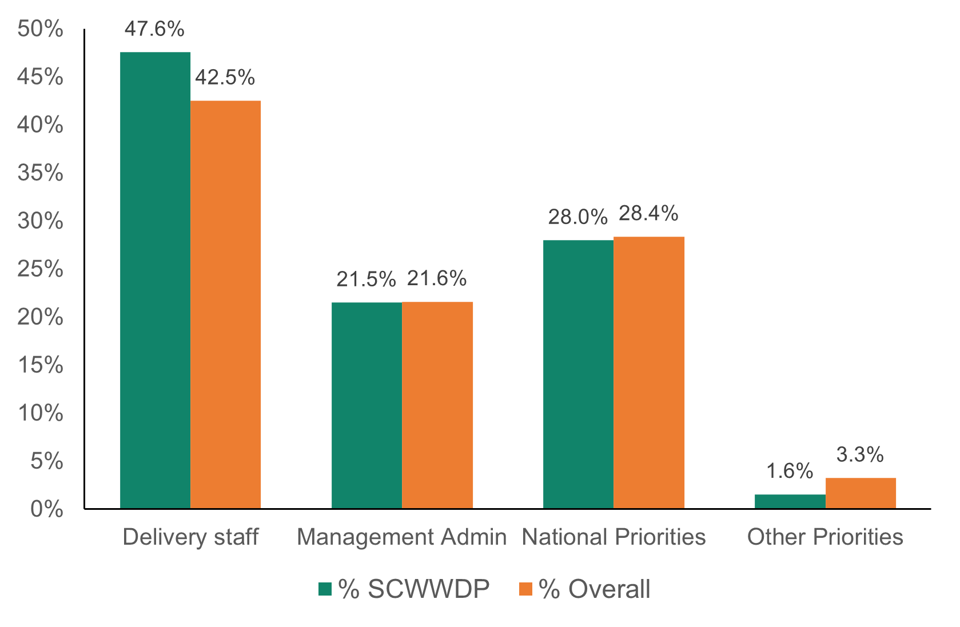

Staffing

- In 2023 to 2024, 69.1 per cent of SCWWDP spend was on staffing (this includes delivery, management, and admin staff) compared to 33.8 per cent of additional local authority funding. Staffing costs make up 64.2 per cent of the overall spend in 2023 to 2024.

- Figure 4, Figure 5 and Table 3 show the split of spend against staffing in terms of spend, and percentage of the overall grant.

- Table 3 shows that the cost to the local authorities administering the SCWWDP grant increased slightly by 0.3 per cent in 2023 to 2024 compared to a 1.9 per cent decrease the previous year.

- Delivery staff costs for the SCWWDP grant have continued to increase, with a 9.2 per cent increase in 2023 to 2024 compared to a 3.9 per cent increase the previous year.

- Delivery staff are:
- staff employed to provide learning and development
- staff who provide work-based and practice-based assessments, including accredited qualification assessment. They should be delivering training for the statutory and non-statutory workforce at the local level. They could also be delivering workforce development activities that align with the national priorities.
- The grant circular says that the largest proportion of the grant must be used for learning, development, and qualifications (including costs of staff to deliver training).

- Local authority additional funding over and above the 30 per cent match funding shows a 6.4 per cent decrease in management and administration costs and a 60.1 per cent decrease in delivery staff costs. As noted above, the additional local authority funding data isn’t always provided, and the trend here isn’t a true reflection of the total spend. For example, there are some roles within local authorities that support the social care workforce, but they won’t be reported as they’re fully funded by the local authority.

Figure 4: Spend on staffing, 2023 to 2024

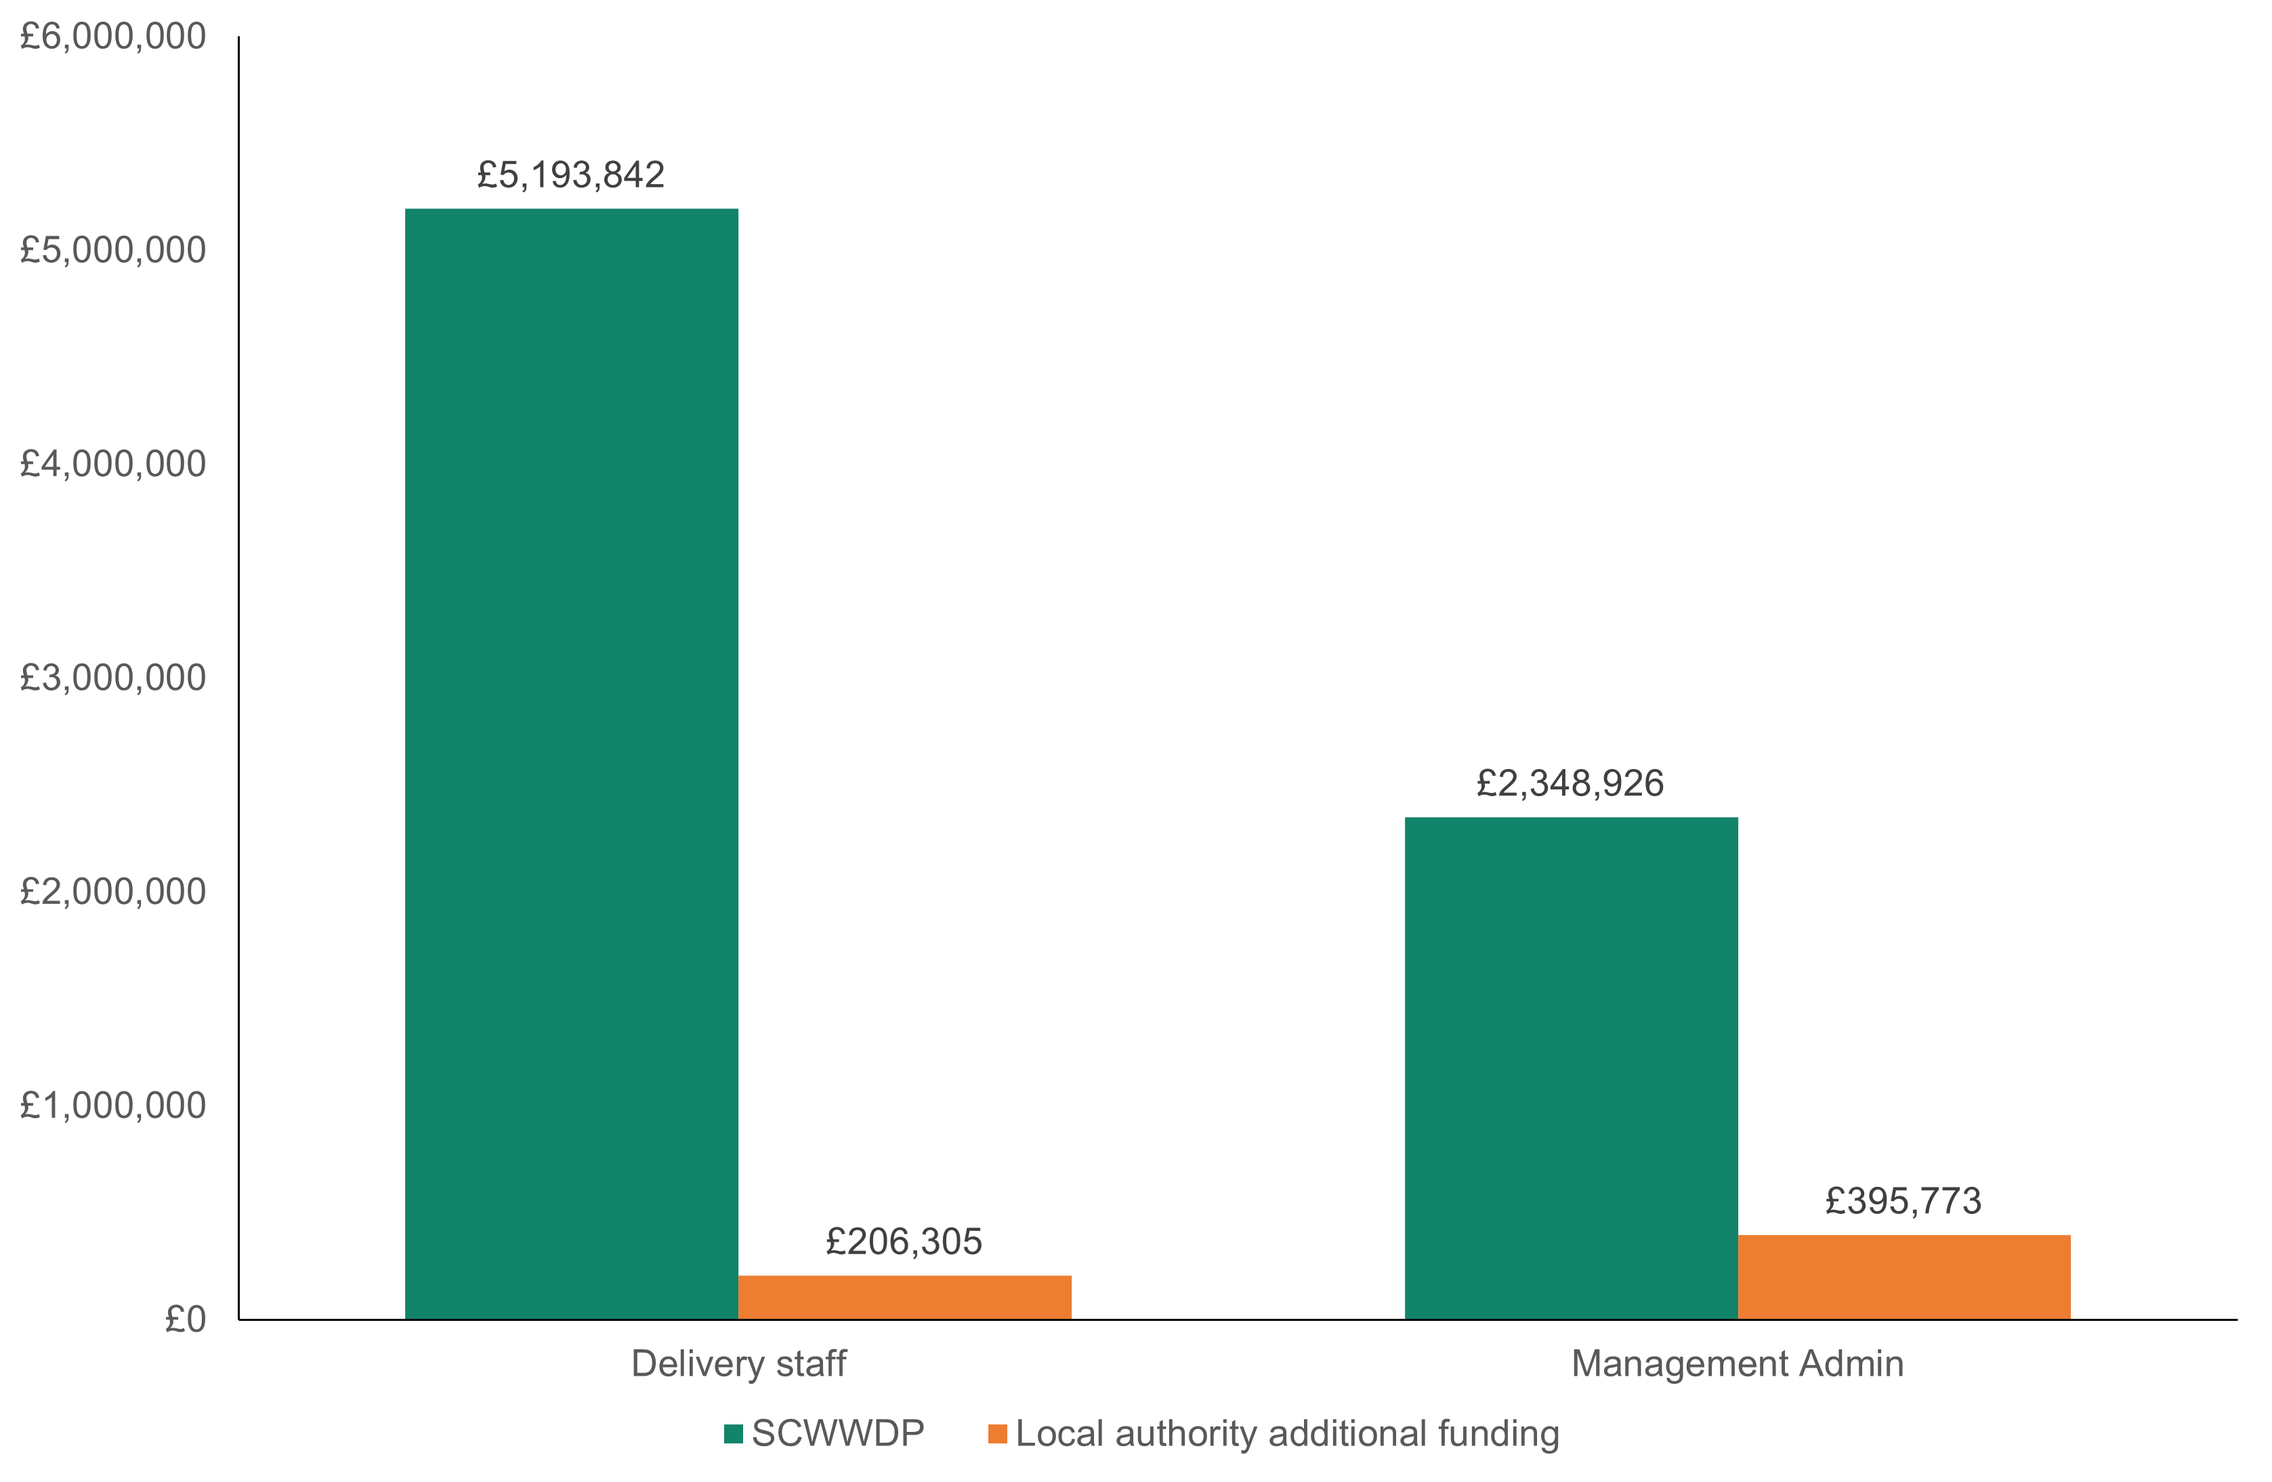

Figure 5: Percentage spend on staffing, 2023 to 2024

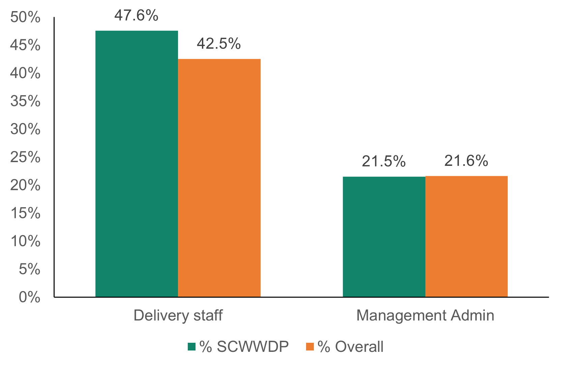

Table 3: Staff spend, the three-year trend
SCWWDP | Delivery staff |  |  | Management and administration
 | £ | £ change | % change | £ | £ change | % change
2023/2024 | £5,193,842 | +£438,854 | +9.2% | £2,348,926 | +£6,084 | +0.3%
2022/2023 | £4,754,988 | +£178,771 | +3.9% | £2,342,842 | -£45,571 | -1.9%
2021/2022 | £4,576,217 | -£221,565 | -4.6% | £2,388,413 | +£215,205 | +9.9%
Local authority additional funding | Delivery staff |  |  | Management and administration
 | £ | £ change | % change | £ | £ change | % change
2023/2024 | £206,305 | -£310,521 | -60.1% | £395,773 | -£26,914 | -6.4%
2022/2023 | £516,826 | +£270,034 | +109.4% | £422,687 | +£176,060 | +71.4%
2021/2022 | £246,792 | +£209,577 | +17.8% | £246,627 | -£119,256 | -32.6%
Overall | Delivery staff |  |  | Management and administration
 | £ | £ change | % change | £ | £ change | % change
2023/2024 | £5,400,147 | +£128,333 | +2.4% | £2,744,699 | -£20,830 | -0.8%
2022/2023 | £5,271,814 | +£448,805 | +9.3% | £2,765,529 | +£130,489 | +5.0%
2021/2022 | £4,823,009 | -£184,350 | -3.7% | £2,635,040 | +£95,949 | +3.8%

Health and safety

- Health and safety spend is capped, and regions aren’t allowed to spend any more than 10 per cent of their grant on health and safety arrangements that the employers are responsible for.

- Figure 6 shows that spending on health and safety as a proportion of the SCWWDP grant remains the same, at 2.1 per cent. The regions’ spend range from 0.6 per cent to 3.1 per cent, which is well within the 10 per cent allowance.

- Table 4 shows that SCWWDP funding spent on health and safety has reduced from £250,176 in 2022 to 2023, to £228,451 in 2023 to 2024, a reduction of 8.7 per cent. This is a positive trend in terms of the reduction in the SCWWDP grant used for legislative training because if the grant was reduced or stopped, the regions would still meet their required legal health and safety needs. It shows how valuable the grant is beyond essential health and safety training.

- Health and safety made up for 21.7 per cent of the additional local authority funding in 2023 to 2024, an increase of 12.4 per cent compared to the previous year.
Table 4: Health and safety spending, the three-year trend

 | SCWWDP grant spend | % of SCWWDP grant | % change | Additional local authority funding spend | % of additional local authority funding | % change
2023/2024 | £228,451 | 2.1% | -8.7% | £386,153 | 21.7% | +12.4%
2022/2023 | £250,176 | 2.4% | +15.7% | £343,440 | 15.2% | +18.7%
2021/2022 | £216,182 | 2.1% | +19.2% | £289,446 | 16.9% | +15.0%

Figure 6: Spend on health and safety, 2023 to 2024

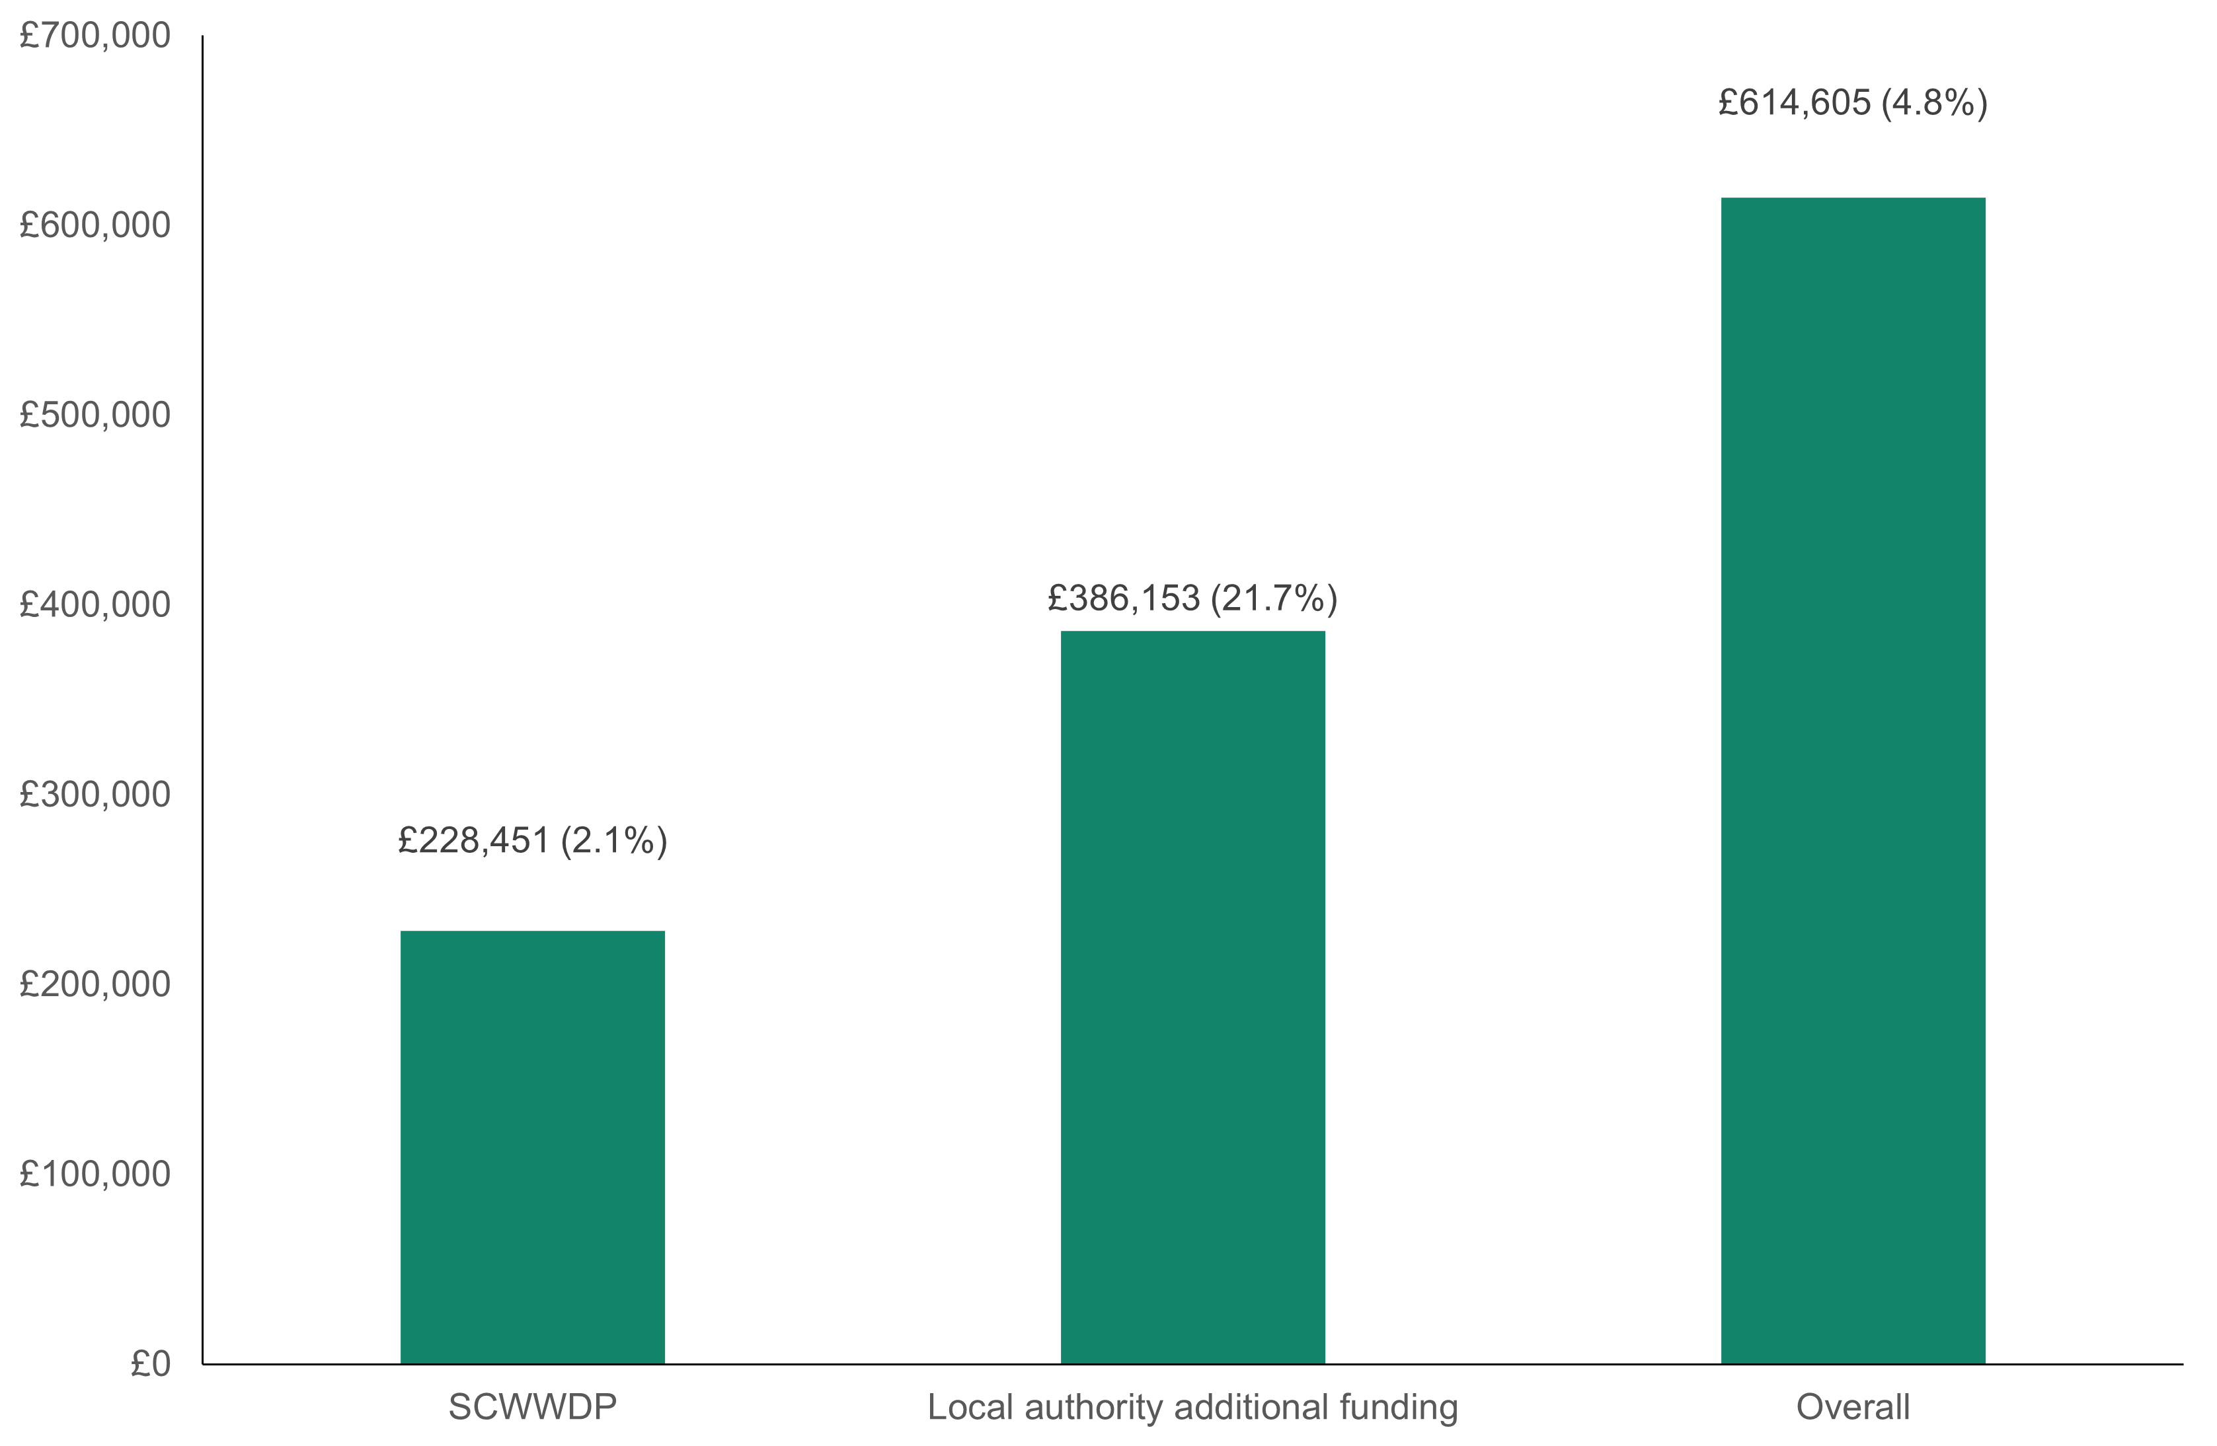

National priorities

- The national priorities for workforce development in the grant circular are taken from the themes of the long term workforce strategy. These are:

  - building a digitally ready workforce
  - excellent education and learning
  - provision of qualifying and post qualifying social work training
  - leadership and succession
  - workforce shape and supply.

- Regions can also use the funding to support other priorities identified at local and regional level.

- In 2023 to 2024, 29.6 per cent of the SCWWDP spend (£3,227,248) was in-line with the national priorities.

- Delivery staff who provide direct learning and development also deliver activities linked to the national priorities. The SCWWDP spend on delivery staff is mentioned earlier in this report.

- SCWWDP national priorities spending is dominated by education and learning, which includes vocational qualifications (43.3 per cent, £1,397,797) as well as qualifying and post qualifying social work training (35.5 per cent, £1,146,467).

- Training in regions is mainly provided at the local authority level, and examples are given by the regions of this range of work. Learning and development is provided by all regions and includes self-directed learning, using on-line resources, virtual classrooms, and face-to-face training.

- All regions use learning platforms that are available for internal and external providers.

- There’s a continued commitment from local authorities in regions to contribute to the national agenda and our activity including:
  - governance of nationally delivered management programmes such as Team Manager Development Programme (TMDP), and Middle Manager Development Programme (MMDP)
  - WeCare Wales campaigns
  - Introduction to social care programme
  - Our communities of practice
  - Safeguarding resources and learning frameworks
  - Qualifications and Standards Advisory Group.
Figure 7: National, regional, and local priorities spend, 2023 to 2024

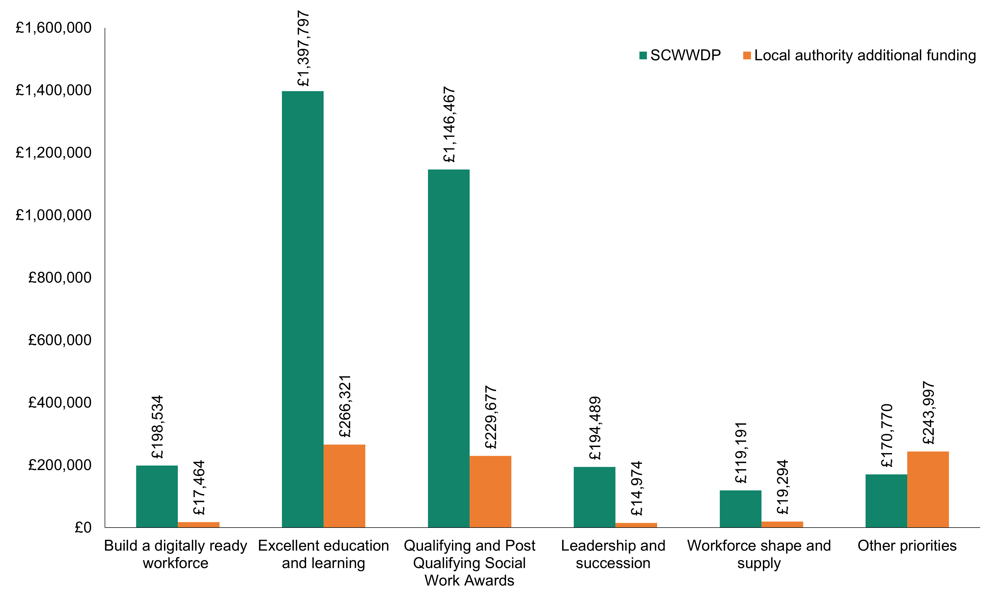

Figure 8: National, regional, and local priorities percentage spend, 2023 to 2024

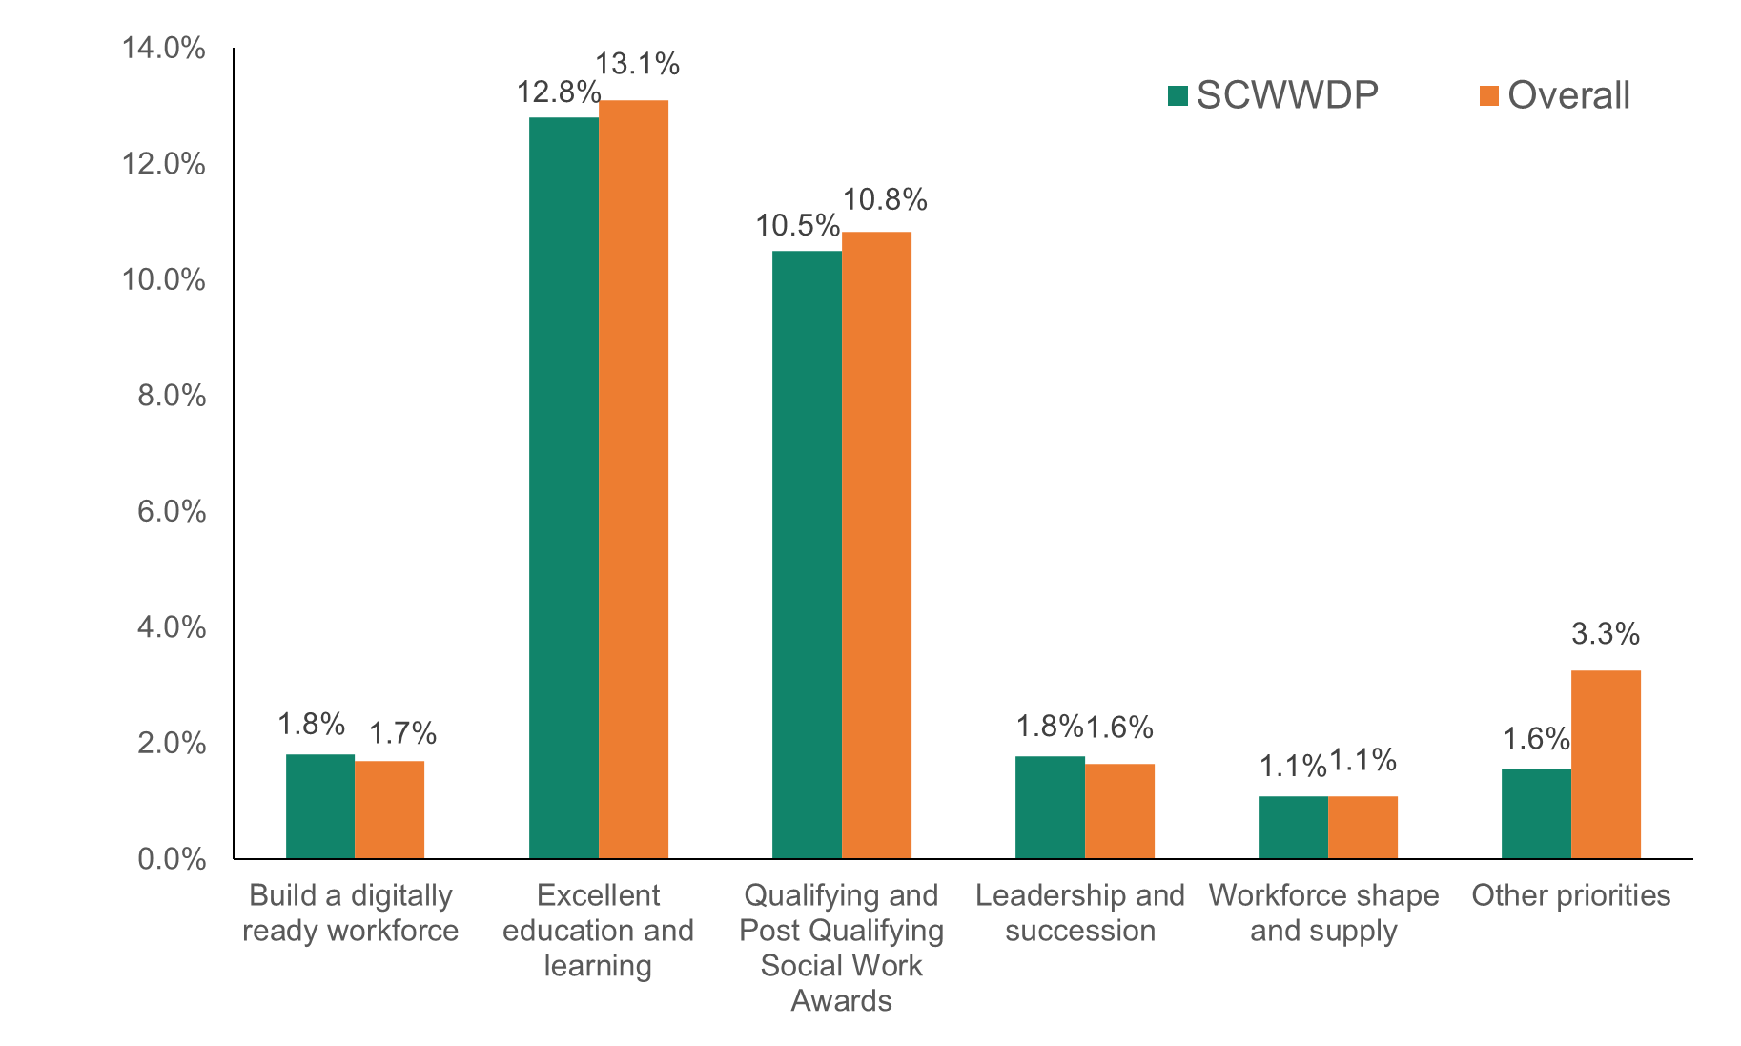

Figure 9: National, regional, and local priorities percentage change on spend, 2023 to 2024

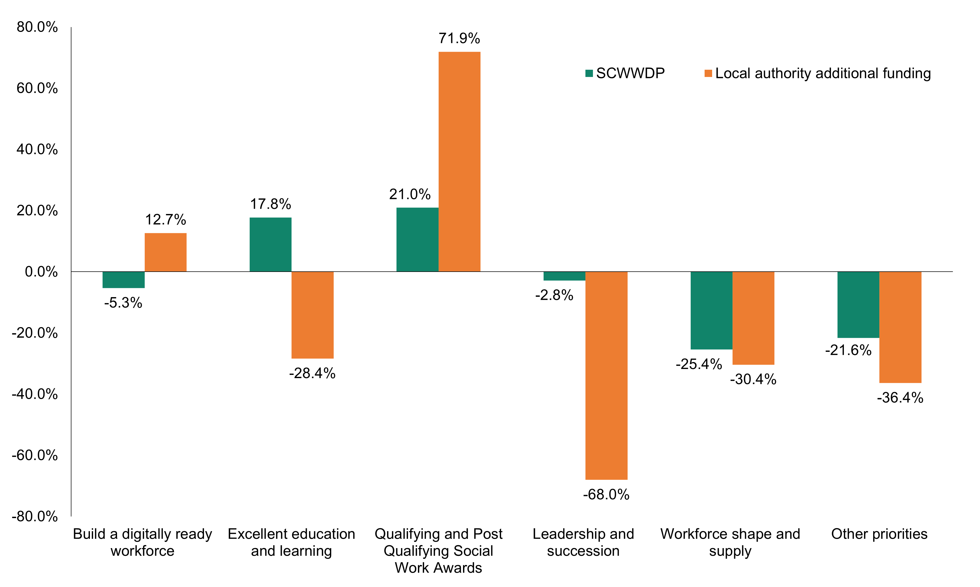

- Figure 9 shows the change in spend on national and other priorities and table 5 shows the information for the last two financial years.

- There was an increase in SCWWDP spend on qualifying and post qualifying social work awards (+21.0 per cent) and excellent education and learning (+17.8 per cent) compared to the previous year, while spend on all other priorities declined.

- Local authorities have told us that we could provide clearer guidance on where some of the financial information should sit when reporting on the national priorities. For example, one region might record the TMDP leadership programme costs against qualifying and post qualifying social work awards, as they see it as a social work development programme, while another region might record it against the leadership and succession national priority. We will work with training managers to strengthen the grant guidance.

- SCWWDP spend on qualifying and post qualifying social work awards made up 35.5 per cent of the SCWWDP spend on national priorities in 2023 to 2024, compared to 32.4 per cent in 2022 to 2023. Social work is important, and the sector wouldn’t be able to function without social work development. But there’s a risk that this could lead to under-investment in the non-social worker workforce.
- The largest decline of SCWWDP spend on national priorities was on workforce shape and supply (-25.4 per cent). It’s worth noting that local authorities use staff capacity to support this national priority and cost is reported as part of the delivery staff spending where roles are SCWWDP funded. The Welsh Local Government Association (WLGA) also worked with the local government association (LGA) on local authority workforce planning during 2023 to 2024, which could have affected the amount of spend.

- The decline in spend on the workforce shape and supply national priority is also linked to the fact that there will be some fully local authority funded capacity, which isn’t always reported. Some local authorities reported that workforce planning, shape and supply is a human resources responsibility, rather than a responsibility of the workforce development teams supported by SCWWDP.

- Some regions told us that when SCWWDP was linked to the workforce strategy, workforce shape and supply became, or was seen to be an extra priority for SCWWDP, but without any extra funding. So, some regions will always prioritise the other national priorities or they would have to remove funding from another national priority to increase spend on workforce shape and supply.

- There was a significant increase of 71.9 per cent in local authority additional funding spend on qualifying and post qualifying social work awards compared to 2022 to 2023. Informally this increase is because of local authorities investing more in their sponsored routes, where staff are sponsored to study for social work qualifications, because it’s seen as an essential way to address social work vacancy levels and recruitment challenges.

- The largest decline in local authorities’ additional spend was on leadership and succession, with a 68.0 per cent decrease compared to 2022 to 2023. The point made above, where regions code spending against different national priorities, is a factor when considering this decrease. Another factor to consider is that some local authorities reported they’re using internal or corporate leadership and management programmes rather than traditional national programmes such as TMDP to save on costs.

Table 5: National, regional, and local priorities spend, the two-year trend

Build a digitally ready workforce
 | SCWWDP grant spend | % of SCWWDP grant | % change | Additional local authority funding spend | % of additional local authority funding | % change
2023/2024 | £198,534 | 1.8% | -5.3% | £17,464 | 1.0% | +12.7%
2022/2023 | £209,710 | 2.1% |  | £15,500 | 0.7%
Excellent education and learning
 | SCWWDP grant spend | % of SCWWDP grant | % change | Additional local authority funding spend | % of additional local authority funding | % change
2023/2024 | £1,397,797 | 12.8% | +17.8% | £266,321 | 15.0% | -28.4%
2022/2023 | £1,186,963 | 11.6% |  | £371,891 | 16.4%
Qualifying and post qualifying social work awards
 | SCWWDP grant spend | % of SCWWDP grant | % change | Additional local authority funding spend | % of additional local authority funding | % change
2023/2024 | £1,146,467 | 10.5% | +21.0% | £229,677 | 12.9% | +71.9%
2022/2023 | £947,860 | 9.3% |  | £133,585 | 5.9%
Leadership and succession
 | SCWWDP grant spend | % of SCWWDP grant | % change | Additional local authority funding spend | % of additional local authority funding | % change
2023/2024 | £194,489 | 1.8% | -2.8% | £14,974 | 0.8% | -68.0%
2022/2023 | £200,177 | 2.0% |  | £46,822 | 2.1%
Workforce shape and supply
 | SCWWDP grant spend | % of SCWWDP grant | % change | Additional local authority funding spend | % of additional local authority funding | % change
2023/2024 | £119,191 | 1.1% | -25.4% | £19,294 | 1.1% | -30.4%
2022/2023 | £159,820 | 1.6% |  | £27,702 | 1.2%
Other priorities
 | SCWWDP grant spend | % of SCWWDP grant | % change | Additional local authority funding spend | % of additional local authority funding | % change
2023/2024 | £170,770 | 1.6% | -21.6% | £243,997 | 13.7% | -36.4%
2022/2023 | £217,973 | 2.1% |  | £383,447 | 17.0%

Training places and attendance

- Table 6 shows a decrease in 2023 to 2024 in the number of training places booked (-15.8 per cent) and the number of people attending (-18.5 per cent) compared to 2022 to 2023.

- This decrease could be seen in all areas of the sector apart from ‘other services.’ ‘Other services’ includes any services outside of the statutory, private and voluntary services and could include health, police, education, unpaid carers and volunteers.

- For other services, the number of training places booked increased by 26.4 per cent while the number of people attending training increased by 28.2 per cent.

Table 6: Training places and attendance levels, 2023 to 2024

 | Training places booked |  | People attending
 | Number | % change to previous year | Number | % change to previous year
Statutory | 102,907 | -17.2% | 87,017 | -19.7%
Voluntary | 2,510 | -12.5% | 2,025 | -7.8%
Private | 19,416 | -22.9% | 14,202 | -28.8%
Other | 10,336 | 26.4% | 8,699 | 28.2%
Total | 135,169 | -15.8% | 111,943 | -18.5%

- This isn’t the trend at all local authorities in Wales, as seen in Table 7. Half (50 per cent) of the local authorities in Wales increased the number of training places booked while 45.5 per cent also saw an increase in the number of people attending training compared to the previous year.

Table 7: Local authorities experiencing an increase in training places and attendance levels, 2023 to 2024

 | Increase in training places booked |  | Increase in people attending
 | Number of local authorities | % of local authorities | Number of local authorities | % of local authorities
Statutory | 9 | 40.9% | 9 | 40.9%
Voluntary | 6 | 27.3% | 8 | 36.4%
Private | 10 | 45.5% | 11 | 50.0%
Other | 14 | 63.6% | 12 | 54.5%
Total | 11 | 50% | 10 | 45.5%
- Informal evidence from the local authorities said that there was a decline in training places booked and training attendance because of the following reasons:

- the most noted reason for being unable to attend were because of service pressures and difficulties around releasing staff to attend training, above the mandatory level needed. This also reflects the recruitment and retention challenges that are seen across social care

- more training is moving to e-learning, but workforce development teams won’t always know when training has been completed, such as staff who complete our learning modules or on HEIW’s Ty Dysgu e-learning platform

- some providers use digital alternatives which they’ve sourced and manage

- some larger, private providers have their own training departments and facilities, so don’t rely on their workers accessing training through the workforce development teams

- in statutory services in particular, some workers access learning and development that has moved to being a corporate responsibility, so the numbers completing these aren’t always reported as SCWWDP funded.

- The actions being taken and reported by some local authorities to try to reverse the decline in training places booked and training attendance, include:

- continually checking that the training and development offer is open to everyone.

- wider promotion of training and development opportunities, such as using the Dewis Cymru website to promote, or reaching out directly to providers and personal assistants (PAs).

- contacting providers directly with information and visiting them to make sure workers are taking up the offer, and providing a training offer tailored for them.

- giving direct support, for example providers can book local authority workforce development staff to attend the care setting with iPads, to help and support care staff with online learning.

- working with commissioned services in each area, to decide on what needs to be done to make the training more relevant and easily available, which will then attract greater buy in.

Table 8: Training places and attendance levels, the three-year trend

 | Training places booked |  |  | People attending
 | Number | % change | % of total training places booked | Number | % change | % of total people attending
Statutory
2023/2024 | 102,907 | -17.2% | 76.1% | 87,017 | -19.7% | 77.7%
2022/2023 | 124,331 | +8.0% | 77.4% | 108,425 | +8.9% | 78.9%
2021/2022 | 115,109 | +14.6% | 78.6% | 99,551 | +21.7% | 81.4%
Private
2023/2024 | 19,416 | -22.9% | 14.4% | 14,202 | -28.8% | 12.7%
2022/2023 | 25,168 | +30.5% | 15.7% | 19,940 | +43.6% | 14.5%
2021/2022 | 19,285 | +46.2% | 13.2% | 13,887 | +50.2% | 11.4%
Voluntary
2023/2024 | 2,510 | -12.5% | 1.9% | 2,025 | -7.8% | 1.8%
2022/2023 | 2,870 | -9.4% | 1.8% | 2,197 | +13.1% | 1.6%
2021/2022 | 3,169 | -13.6% | 2.2% | 1,942 | -41.1% | 1.6%
Other
2023/2024 | 10,336 | +26.4% | 7.6% | 8,699 | +28.2% | 7.8%
2022/2023 | 8,174 | -8.0% | 5.1% | 6,786 | -1.2% | 4.9%
2021/2022 | 8,882 | +18.3% | 6.1% | 6,871 | +45.0% | 5.6%

- Table 8 shows the three-year trend of training places booked and the people attending by service type. It shows that for the last three years, the proportion of training places booked and attended is dominated by the statutory sector. This isn’t in proportion when considering 63 per cent of the estimated number of people employed in the social care workforce in Wales work for commissioned providers.

- This has been an area of focus in the grant circular over the past few years where we stated: “The grant must be used to support equality of access to all types of social care providers in each region, and spend should be broadly reflective of the profile of the sector in the local authority and region.” But it’s clear from the data that the progress towards training take-up and attendance to broadly reflect the profile of the sector isn’t progressing as we anticipated. This area will be strengthened even more as part of the 2025/2026 grant circular.

Figure 10: Training attendance numbers, the three-year trend

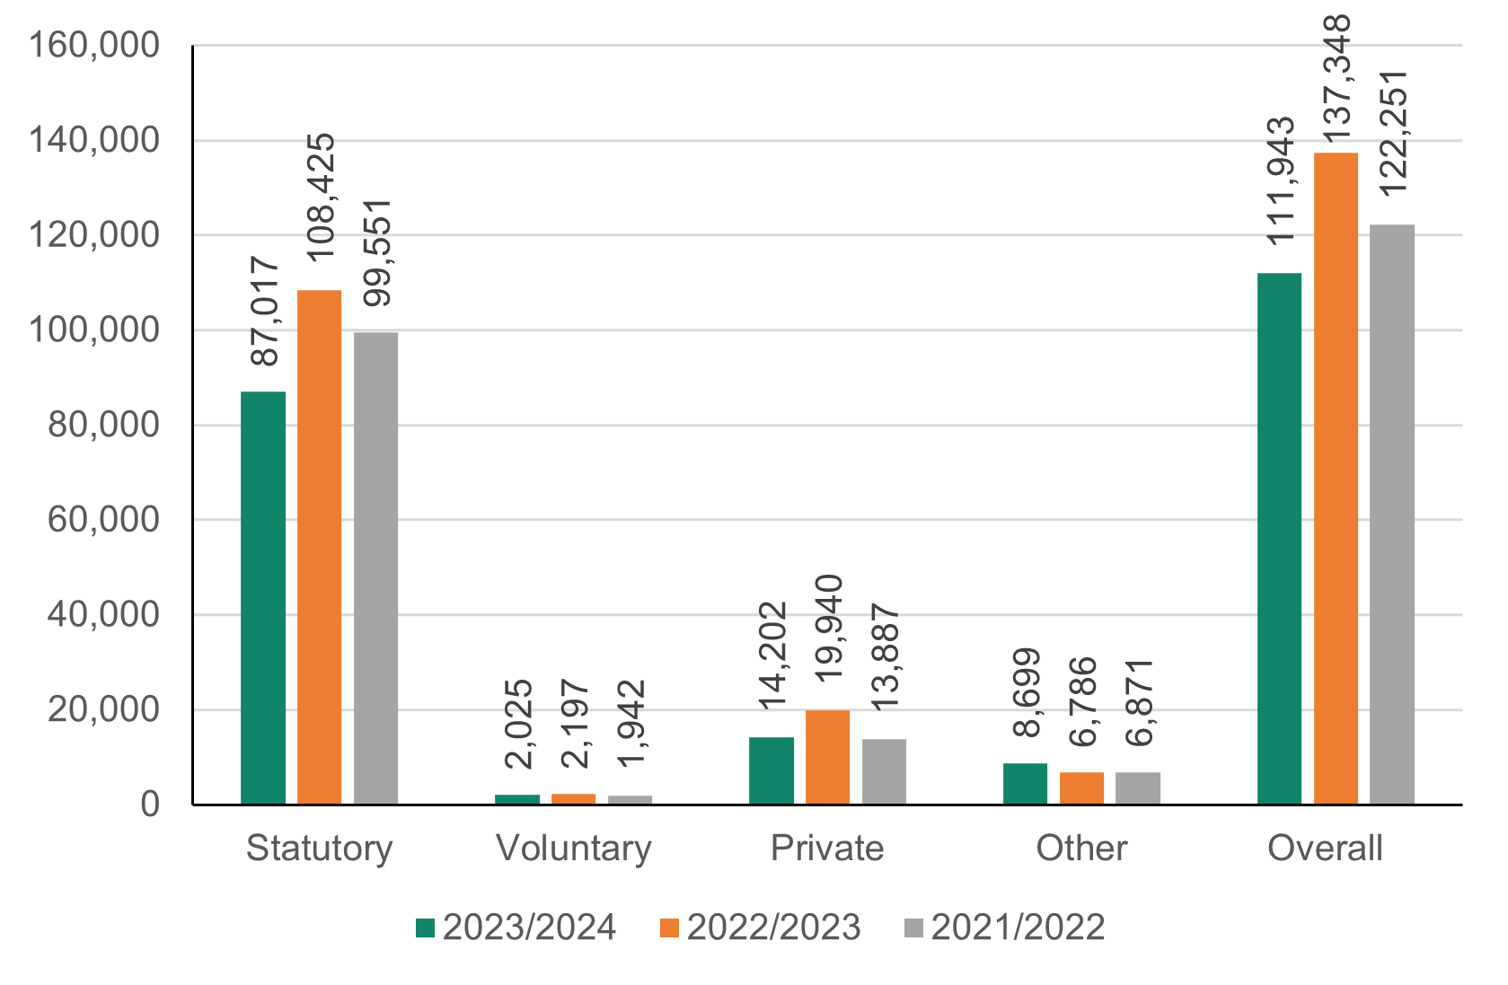

Figure 11: Training attendance percentage, the three-year trend

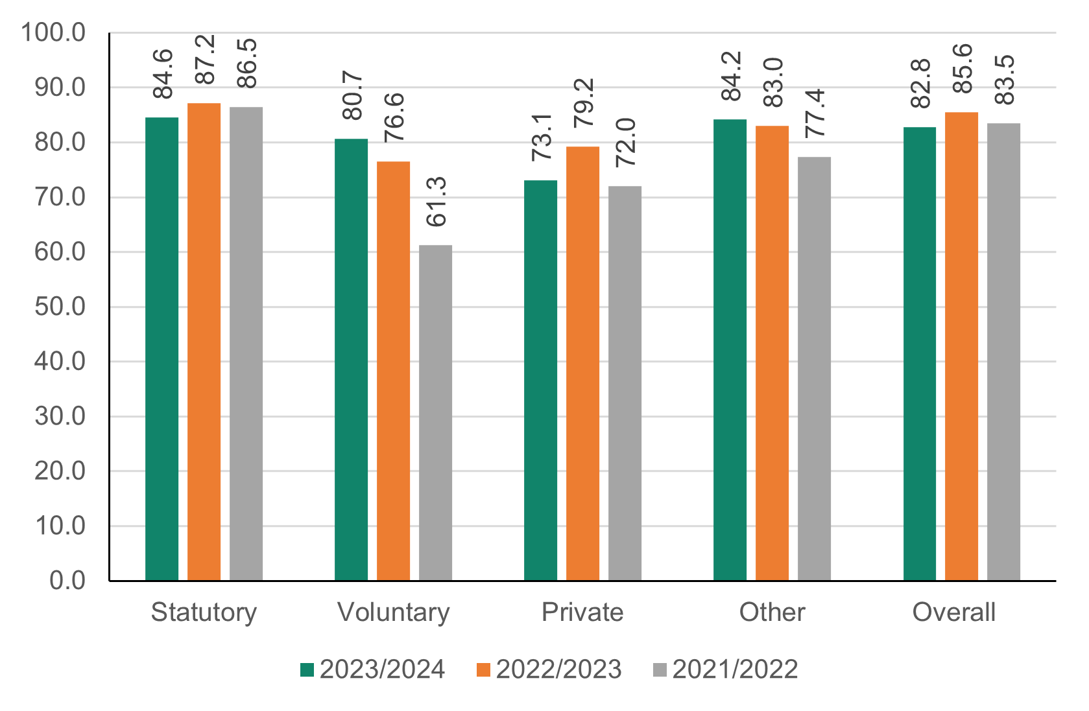

- Figure 11 shows overall attendance at training fell from 85.6 per cent in 2022 to 2023, to 82.8 per cent in 2023 to 2024, but this is still a high proportion.

- There was an increase in training attendance in the voluntary sector (rising from 76.6 per cent in 2022 to 2023 to 80.7 per cent in 2023/2024) and the other sector (rising from 83.0 per cent in 2022 to2023 to 84.2 per cent in 2023 to 2024).

- In the future, to make sure the learning and development offer available is clear, we’ll work with local authorities in the regions. We’ll look at how we can support communicating and publicising local, regional and national learning and development offers and opportunities from partners.

Qualifications activity

- Table 7 shows the range of qualifications offered, including the number of learners who took part in accredited programmes, and numbers achieving in 2023 to 2024.

Table 7: All Wales summary of qualifications activity, 2023 to2024

Programme | Numbers on programme 1 April 2023 | Numbers enrolled during 2023 to 2024 | Numbers achieving during 2023 to 2024 | Numbers withdrawing | Numbers carrying forward to 2024 to 2025
AWIF | 403 | 376 | 256 | 80 | 443
Level 2 approved qualification | 557 | 479 | 330 | 91 | 615
Level 3 approved qualification | 284 | 141 | 89 | 60 | 276
Qualification and Credit Framework (QCF) Level 3 – Children and Young People | 107 | 60 | 28 | 21 | 118
Level 4 approved qualification | 113 | 69 | 36 | 29 | 117
Level 5 approved qualification | 50 | 20 | 10 | 6 | 54
Training, Assessment, and Quality Assurance (TAQA) award - Level 3 | 8 | 1 | 4 | 1 | 4
Training, Assessment, and Quality Assurance (TAQA) award - Level 4 | 0 | 0 | 0 | 0 | 0
Social Services Practitioner Programme | 102 | 64 | 45 | 8 | 113
Social work degree Level 4- sponsored | 70 | 87 | 72 | 8 | 77
Social work degree Level 5 - sponsored | 93 | 128 | 91 | 8 | 122
Social work degree Level 6 - sponsored | 67 | 104 | 64 | 3 | 104
Social work degree Level 4 - other | 80 | 106 | 75 | 22 | 89
Social work degree Level 5 - other | 86 | 105 | 81 | 11 | 99
Social work degree Level 6 - other | 83 | 89 | 69 | 6 | 97
Master Social Work degree - Year 1 – sponsored | 7 | 6 | 1 | 0 | 12
Master Social Work degree - Year 2 – sponsored | 3 | 1 | 1 | 0 | 3
Master Social Work degree - Year 1 – other | 59 | 73 | 48 | 10 | 74
Master Social Work degree - Year 2 – other | 59 | 50 | 49 | 3 | 57
Newly qualified social worker (NQSW) programme | 213 | 236 | 185 | 26 | 238
Consolidation | 306 | 241 | 215 | 19 | 313
Experienced Practice in Social Work | 0 | 0 | 0 | 0 | 0
Senior Practice in Social Work | 1 | 0 | 1 | 0 | 0
Consultant Social Work | 0 | 0 | 0 | 0 | 0
Enabling Practice 6/7  (Practice Assessor Awards) | 157 | 159 | 107 | 29 | 180
Best Interest Assessor | 38 | 34 | 21 | 4 | 47
Approved Mental Health Practitioner | 31 | 29 | 26 | 2 | 32
Team Manager Development Programme | 39 | 25 | 18 | 5 | 41
Middle Manager Development Programme | 7 | 13 | 4 | 3 | 13

Vocational awards and All Wales induction framework (AWIF)

- As seen in table 8, the number of people on the programme and levels of achievement on approved vocational qualifications has increased. Many will also be able to access funding for vocational qualifications through an apprenticeship that isn’t captured in this report. But the data received from local authorities show a decrease in the number taking and achieving the All Wales health and social care induction framework (AWIF).

- A factor to note is that one region has reported they no longer collect AWIF completion data, which affects the AWIF achieving data. If this region had included the same AWIF achieving data as in 2022 to 2023, the change in those achieving the AWIF would show a decline of 7.3 per cent rather than 30.6 per cent.

- Despite the decrease, the number on the AWIF programme is still much higher than the figure three years ago as seen in Figure 12 (779 on the programme in 2023 to 2024 compared to 462 in 2-21 to 2022).

Table 8: Vocational awards and AWIF activity, 2023 to 2024

 | AWIF |  | Approved Awards
 | Number | % change | Number | % change
Numbers on programme | 779 | -2.7% | 1,889 | 2.9%
Numbers achieving | 256* | -30.6%* | 497 | 5.1%
Numbers withdrawing | 80 | 81.8% | 208 | 3.5%
Numbers carrying forward | 443 | 14.2% | 1,184 | 1.9%
Number on programme = Number on programme on 1 April ^{t} and enrolled during the year
*One region has declared that they no longer collect AWIF completion data that will affect the totals and percentage change trend.

Figure 12: Number of people on vocational awards and AWIF programmes, the three-year trend

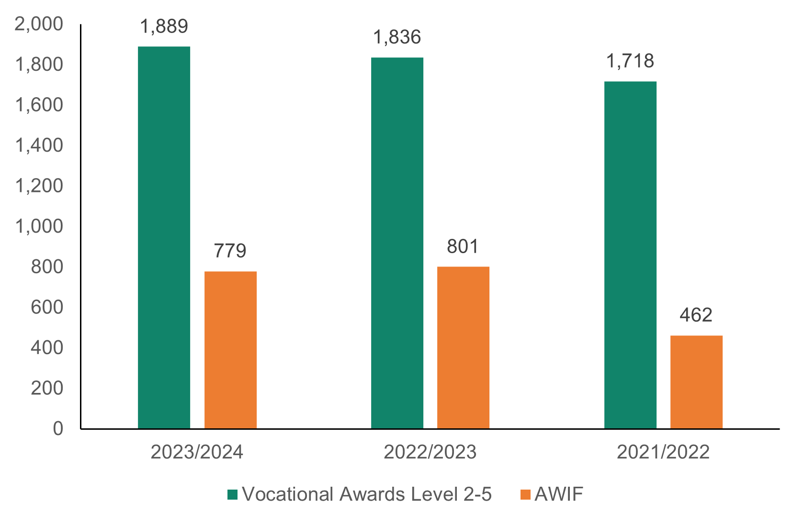

Social work
Social work qualifying awards.

- Figure 13 shows the levels taking part in social work qualifying programmes in 2023 to 2024 and table 9 shows the three-year trend for routes into social work qualifying awards.

Figure 13: Social work qualifying awards, 2023 to 2024

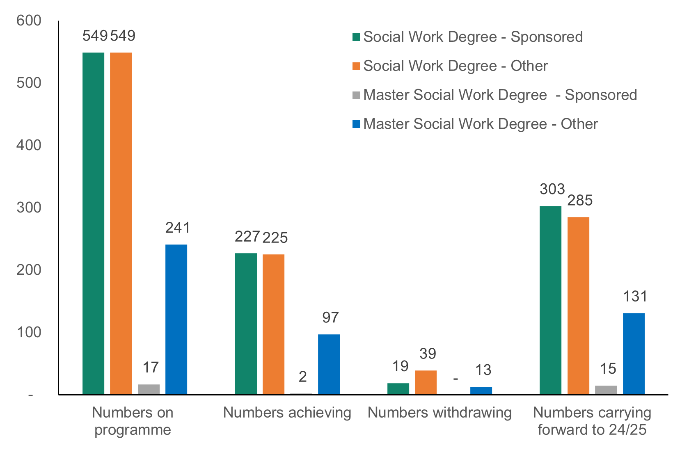
Number on programme = Number on programme on 1 April and enrolled during the year

Table 9: Social work students, the three-year trend

Financial Year | Sponsored | % change | Other | % change | Total | % change
2023/2024 | 566 | +34.1% | 790 | +5.6% | 1,356 | +15.9%
2022/2023 | 422 | +27.5% | 748 | -3.4% | 1,170 | +5.9%
2021/2022 | 331 | +41.5% | 774 | -6.5% | 1,105 | +4.0%
Figures are for those on programme from 1April 1 and enrolled during the year for degree and master's degree.

- The total number of social work students (sponsored and other) involved in any part of the social work degree increased by 15.9 per cent in 2023 to 2024 compared to 1,170 students in 2022 to 2023 and 1,356 in 2023 to 2024.

- The grow your own model has been a response to the recruitment challenges being faced and the investment has been worth it because there continues to be a positive increase in the sponsored route for the social work qualifying awards. The number of sponsored social work students involved in any part of the degree has increased by 34.1 per cent from 422 in 2022 to 2023, to 566 in 2023 to 2024.

- There are still challenges in areas of practice assessment and providing placements, but efforts are being made by all to make sure a suitable number of quality placements are open, to manage this increase in social work student supply.

First three years post qualifying awards
- Figure 14 shows the levels of engagement in the social work first three years post qualifying programmes in 2023 to 2024 and table 10 shows the three-year trend.

Figure 14: First three years post qualifying awards, 2023 to 2024

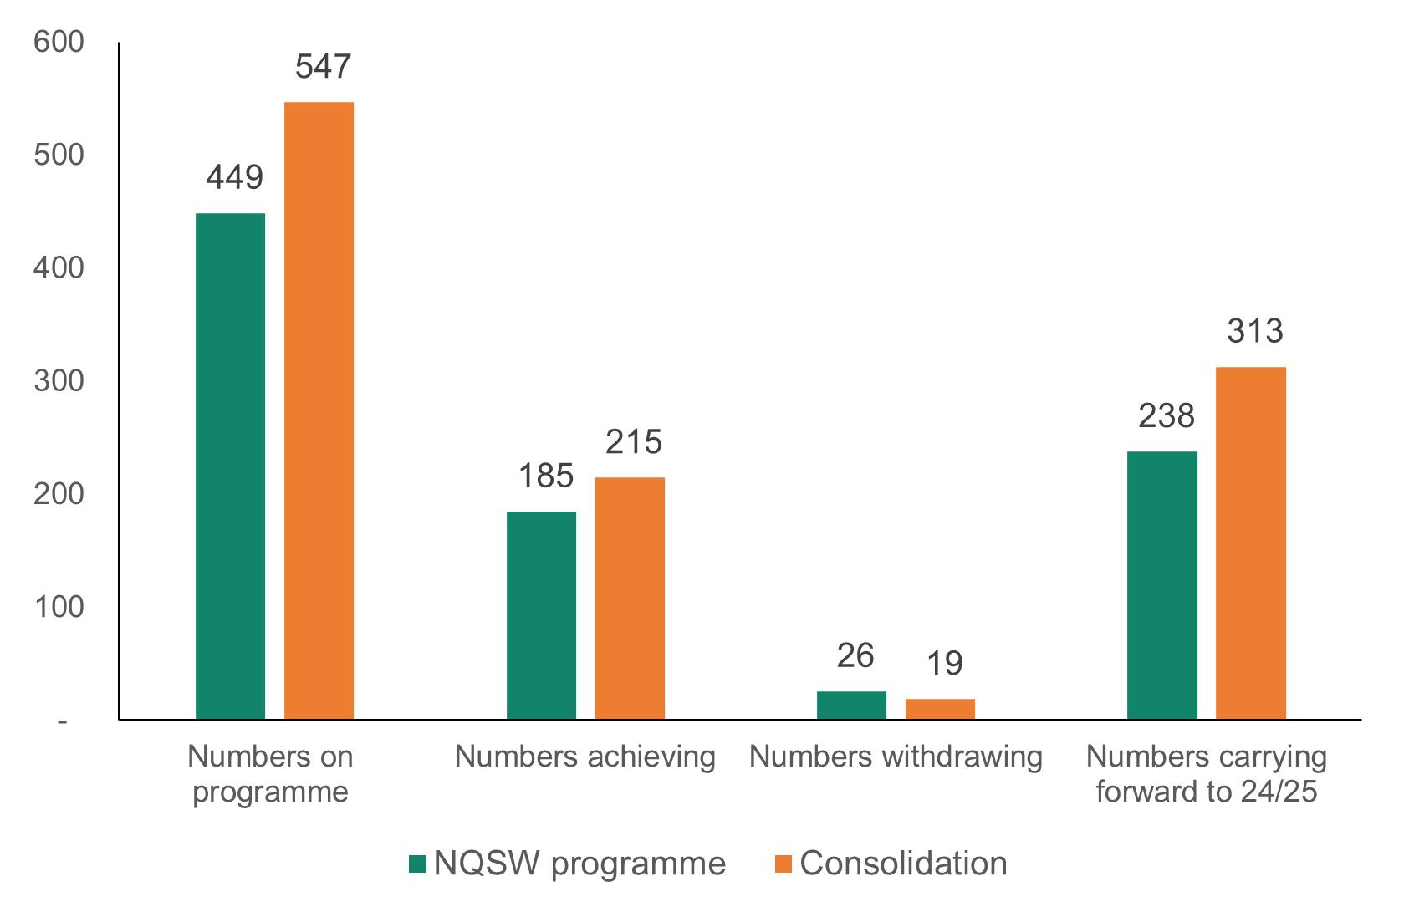
Number on programme = Number on programme on 1 April and enrolled during year

Table 10: First three years post qualifying awards, the three-year trend

Financial Year | NQSW Programme | % change | Consolidation | % change
2023/2024 | 449 | +15.4% | 547 | +17.9%
2022/2023 | 389 | +2.6% | 464 | -7.0%
2021/2022 | 379 | +2.7% | 499 | +2.3%
Figures are for those on programme from 1 April and enrolled during the year
- In 2023 to 2024 the number of newly qualified social workers completing the requirements of their first three years in practice increased by 17.9 per cent, which is opposite to the trend seen the previous year when the number decreased by 7.0 per cent.

- The number accessing newly qualified social work programmes increased by 15.4 per cent which is the same positive trend as last year, but the percentage change is much higher.

Post qualifying awards

- Figure 15 shows the levels of engagement in post qualifying specialist awards in 2023 to 2024 and table 11 shows the three-year trend.

Figure 15: Post qualifying specialist awards, 2023 to 2024

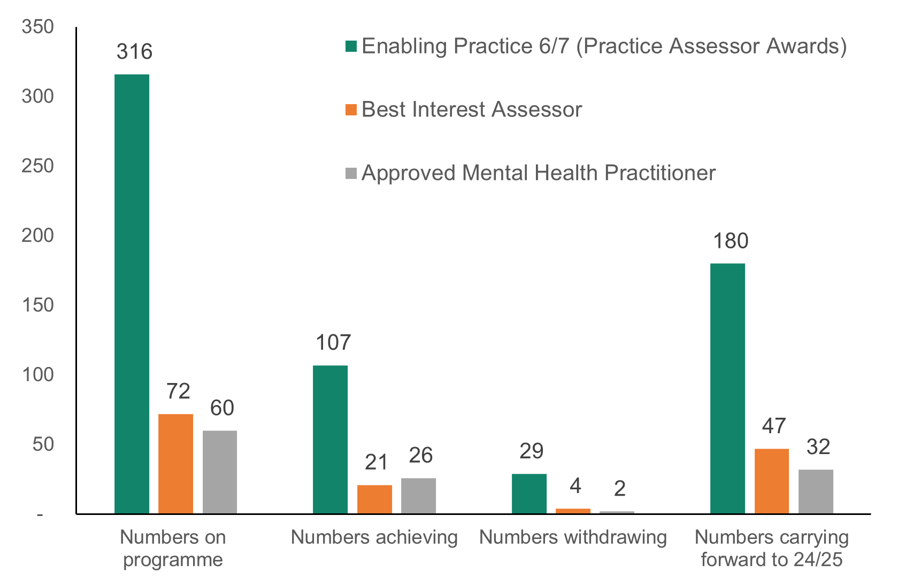
Number on programme = Number on programme on 1 April and enrolled during year

Table 11: Post qualifying specialist awards, the three-year trend

Financial Year | Practice Assessor  Level 6 or 7 | % change | Best Interest Assessor | % change | AMHP | % change
2023/2024 | 316 | +18.8% | 72 | +7.5% | 60 | +7.1%
2022/2023 | 266 | -7.3% | 67 | +59.5% | 56 | -5.1%
2021/2022 | 287 | +16.2% | 42 | -19.2% | 59 | 0%
Figures are for those on programme from 1 April and enrolled during the year

- The numbers of those taking post qualifying specialists awards have all increased in 2023 to 2024.

- In 2023 to 2024 the number undertaking an approved qualification to enable them to become a social work Practice Assessor (Practice Assessor Awards at level 6 or 7) increased by 18.8 per cent, the number taking part in the best interest assessor increased by 7.5 per cent and the number taking part in the Approved Mental Health Practitioner (AMHP) increased by 7.1 per cent.

- The trend for the approved qualification to become a social work Practice Assessor and AMHP is opposite to the negative trend last year, while the trend for the best interest assessor is the same.

Management awards (other than vocational awards)

- Table 12 shows a drop in the numbers taking on a national management programme funded through SCWWDP over the last three years.

Table 12: TMDP & MMDP Engagement, the three-year trend

Year | TMDP | % change | MMDP | % change
2023/2024 | 64 | -12.3% | 20 | +5.3%
2022/2023 | 73 | -28.4% | 19 | -44.1%
2021/2022 | 102 | +3.0% | 34 | +17.2%
Figures are for those on programme from 1 April ^{and} enrolled during the year.

- In 2023 to 2024 the numbers taking the Team Manager Development Programme (TMDP) decreased by 12.3 per cent and the number doing the Middle Manager Development Programme (MMDP) increased by 5.3 per cent but following a significant drop last year.

- Some evidence from the regions suggests that bite size learning opportunities are more attractive to the workforce than longer, intensive, accredited programmes. The TMDP and MMDP programmes are studied on a part-time basis and designed to be finished in around 18 months of study.

- Well-being support, especially for managers, continues to be a priority. There’s a range of provision in place such as mindfulness, resilience and bereavement, as well as the signposting to support and resources that support positive well-being.

National priorities’ key themes and analysis

- The following shows a summary of the key themes and analysis from the regional end of year reports in line with the national priorities.

- The information includes ‘highlights’ from the regional delivery and more localised solutions.

- The information in the end-of-year reporting by regions is mainly a mixture of numbers and stories about the results, but don’t show the full story of the difference the SCWWDP funding is making.

- During 2025 to 2026 we’ll consider future developments in our work with local authorities and regions, and we’ll look at how we can present a strong and meaningful story showing SCWWDP’s impact.

Priority 1: Building a digitally ready workforce

By 2030, we aim to have a workforce with good digital and technological skills that are widely used to improve the way we work, to help us deliver the best possible care for people.

SCWWDP in 2023 to 2024 has helped with the following:

Highlight

A local authority has created a programme of training and learning webinars to upskill and develop the practice development teams’ knowledge of delivering and administrating digital learning programmes for the sector.

After completing training in the use of Book Creator Software, the team put what they’d learned into practice and used this software to start creating a library of eBook resources on different learning and development opportunities available to the sector in the region.

Highlight

A region is working with local education providers and Digital Community Wales to offer a range of digital skills training across the sector.

There are different levels of digital literacy across the sector, and there are courses available at all levels, from basic to advanced. The region is also designing a skills audit tool to get simple data about levels and understanding of digital literacy.

Highlight

A local authority has increased investment in virtual reality (VR) trainer certification courses, and VR training delivery has been expanded, and content is now available bi-lingually. VR has been used for training and development including:
- ACEs
- Trauma Informed Practice
- understanding domestic abuse through the eyes of a child
- working with adults with unresolved trauma
- preparing for and supporting foster placements
- social media and young people.

There has been exceptional feedback from staff attending training using VR.

Highlight

We see continued growth in a region’s Digital Partner programme as a way of supporting colleagues with digital skills.

The digital partners help staff across the wider social care workforce, private care providers, personal assistants, and foster carers.

One digital partner is the training and development officer for Children’s Services and Fostering. Their aim is to build foster carers’ confidence in using technology and help them take part in live training sessions and meetings using Teams.

Another digital partner is an occupational therapist, who uses this role to find better ways to support colleagues and clients in using IT and technology in everyday practice, to help individuals be confident with technology.

- There’s continued reporting of investment in Community Care Inform, to give access to online resources for learning and research for social workers and social care professionals.

- There are digital skills programmes in place to improve digital literacy, with examples of working with local education providers and Digital Communities Wales to offer support to meet the different digital literacy needs of the workforce across the whole sector.

- Many regions use a digital champion, mentor, or partner approach. This upskills workers from the social care workforce to support their colleagues with digital skills and confidence.

- Regions keep investing in improving access to digital learning and support to the whole sector with examples including:
- Maintaining ICT licenses and continuing to build up stock of hardware for training use
- Buying equipment to support learning and development
- Loaning equipment to settings which allows groups to take part in digital learning and to fill gaps in the system
- Teams going into places to offer support and fix issues together.

- Most regions are still investing in workforce development to help with digital learning development, design, and delivery and to create resource internally. This includes working together to get group discounts.

- There’s still a range of support for foster carers to access training and development opportunities that are customised for them.

- There’s still strong collaborative working, continued development of networks and partnerships with agencies that can support digital development such as, Digital Communities Wales and the Wales Union Learning Fund.

- E-learning continues to be used alongside face-to-face learning, with many examples of new e-learning modules being created on a range of topics to meet the sectors learning needs.

Challenges

- Many regions face challenges with recruitment and retention, which then makes it difficult to release staff for face-to-face training. This leads to challenges in delivering projects and sessions have been cancelled because of low participant numbers. But these experiences have helped regions re-evaluate their thinking and look at other ways to empower staff digitally.

Priority 2: Excellent education and learning

By 2030, we hope that investment in education and learning for health and social care professionals will deliver the skills and capabilities needed to meet the future needs of people in Wales.

SCWWDP in 2023 to 2024 has supported the following:

Highlight

Implementing a Trusted Assessor model in a region has changed working practices in social care.

Teams have move away from service lead assessments and towards citizen lead, outcome focused assessments. This improves collaborative working, strengthens professional relationships and improves communication across teams. Teams are now working together, including social work resource assistants, with the citizen at the centre. This has streamlined processes and made the journey through social care as smooth as possible.

Highlight

A region identified that the international workforce needed upskilling in cultural awareness and started developing a regional cultural awareness module which is planned for roll-out across the sector in 2024 to 2025.

Highlight

Events held by a region that formed part of a summer programme of learning from child practice reviews (CPR) were attended by over 200 children’s social care staff.

There was positive evaluation of the events, and a briefing was developed from the sessions. There are training courses based on learning from the CPRs in the 2023 to 2024 training calendars, and attendance is good.

Highlight

A local authority in one region is testing a programme with health and pharmacy colleagues to create a level 2 administration of medication training and competency assessment for domiciliary care workers. Local authority and pharmacy programme members have held an information session for regional colleagues to share what they’ve learnt so far.

Highlight

Children Service’s Consultant Social Workers in one local authority have developed and delivered a new eight-day training programme to combine existing training on the outcome-focused approach with the integrated family support services model, outcome focused case recording, scaling, direct work skills and motivational interviewing.

Attendees have found it really useful to develop new skills about motivational interviewing and put these into practice between sessions. It has also helped to give clarity about how social services works within the authority and will hopefully create consistency across the service. Future courses will be adapted to include adult services social workers in this important skill development.

Highlight

In a region, sixteen consultant social workers have been trained in the Most Significant Change model (MSC) by Nick Andrews, Research and Practice Development Officer for Developing Evidence Enriched Practice (DEEP) with Swansea University. This storytelling technique was supported by consultant social workers at a joint adult and children’s services’ “Championing Research Culture” conference.

This was held on behalf of the National Institute for Health and Care Research: School for Social Care Research (NIHR SCCR) for partner agencies in March 2024, with 86 people attending. Consultant social workers discussed how to bridge the gap between research, evidence and practice. The case mapping model was shown and the journey of pilot teams in adult services was used to show how the model can support practitioners every day.

Highlight

In a local authority, unpaid or informal carers, personal assistants and microenterprises can now access the training calendar through their own page on the Dewis website.

The learning and development offer is now shared with unpaid carers through the newsletter and there’s information on the Age Friendly website.

There is now a process where the carer team can refer unpaid carers to the training and development team for personalised advice around their learning needs. The first point of contact also shares the learning and development offer straight away as part of their prevention plan.

We’re seeing an increase in informal carers, personal assistants and microenterprises using learning and development opportunities.

- SCWWDP spend on this priority remains high, with 43.3 per cent of national priority spending used in 2023 to 2024 to support the whole sector workforce including personal assistants, unpaid carers, volunteers and foster parents.

- This priority also makes up for the highest proportion (33.6 per cent) of national priority spend in terms of the additional local authority funding in 2023 to 2024 (these figures don’t include qualifying and post qualifying programmes).

- All regions continue to support social care staff, both external and internal, with qualifications through different ways. This includes support for managers, including:
  - ‘drop-in’ sessions to discuss registration and qualification queries
  - signposting to our website for resources and information around the pathways and accepted qualifications for registration
  - information about workshops

- The pause in the Government of the United Kingdom’s use of Liberty Protection Safeguards (LPS) has led to many regions creating more training around the Mental Capacity Act (MCA) to strengthen practitioners' knowledge of the Act. Examples include:
  - creating a “Mental Capacity Act in practice” programme, which is a series of weekly bite-sized webinars on topics related to working within the MCA
  - making a recording of the Court of Protection Deputyship webinar available to all staff
  - briefing sessions
  - sessions on self-neglect relating to the MCA
  - training on the MCA specifically for occupational therapists.

- All regions report strong approaches to putting training needs in line with learning and development programmes to the reflect the actual needs of the sector. There were also many examples of regions developing closer relationships with external providers and responding to requests for tailored programmes of training and support.

- There has been a small decrease (2.7 per cent) in the delivery of the All Wales induction framework (AWIF) for supporting the initial journey to full qualifications.

- For the first time in three years there has been a decrease in the numbers of training places booked and those attending training across the whole sector apart from other services.

- Most local authorities have a digitally published learning and development programme that all providers can access. The other local authorities share information through email and post across networks in social care. We’ll look to promote these nationally in the future.

- All regions report on an extensive programme of learning, based on needs analysis, available and marketed to the whole sector free of charge. This includes:
- adults and children’s services across the whole sector (statutory, private and voluntary)
- foster care
- adoption
- paid and unpaid carers
- personal assistants.

- The programmes of learning delivered have aimed to make sure that all statutory, legislative, and requirements linked to registration are included in offers that support resilience and well-being.

- Foster carers have a strong presence in the reporting across all regions, but personal assistants have less.

- Some common themes for learning and development across the regions match previous years reporting which include:
  - dementia
  - safe administration of medicines or medication management
  - neurodiversity
  - the traditional levels of support to the regional safeguarding boards in place to support a wide range of levels of training.

- All regions reported that they had begun to develop and in some cases, deliver training and development in line with the Anti-racist Wales Action Plan, with ongoing work planned for 2024 to 2025.

- All regions showed strength-based approaches and practice, with dedicated training resources in place to support this. Some regions had specific leadership programmes to help with embedding these approaches into service delivery.

- Workforce well-being is still a priority for all regions. Specific well-being training and development is offered and support given through signposting to well-being resources.

- We saw Welsh language training services across all regions, with ongoing partnership working with local training providers to offer Welsh language courses for individuals. Like digital literacy, there are different levels of Welsh language skills across the sector, and a range of courses are available, from entry to advanced. The take-up varies depending on the region and sometimes the individual local authority.

- There’s still a clear focus in supporting the whole sector in terms of registration, not just in vocational qualifications but also in supporting people through the registration process.

- Again in 2023 to 2024, there’s a consistent level of learners reported as being involved in the social services practitioner award as a way of increasing access to the social work degree (166 in 2023 to 2024, compared to 169 in 2022 to 2023).

- Social care apprenticeships are used by some regions to give opportunities for individuals to start a career in social care. The support through the apprenticeships includes an induction, completion of the AWIF and qualification programmes. The success of apprenticeships varies, with some regions reporting that it hasn’t worked well in 2023 to 2024. The informal evidence reports that the main challenges are:
  - some apprentices struggle with the personal care element of the support they’re expected to give when supporting older people, and this has been raised as a concern among younger apprentices in particular. This has led to some leaving their apprenticeship completely
  - there’s no access to children’s services due to age restrictions
  - there’s limited support from managers because of recruitment and retention challenges.

Challenges

- Recruitment and retention and not being able to release staff due to service pressures is still reported by all regions as having a negative impact on the attendance figures for training and development. Informally, attendance at virtual training seems to be better than in-person training.

- There are systems in place to encourage full attendance on training courses, for example, booking systems that allow overbooking and waiting lists lessen the negative impact. Workforce development teams can also contact managers to ask about any no shows and to make sure they’re aware of this.

- Some regions reported that when looking forward to the next financial year, they had concerns about financial cuts in government funding, which will affect the number of learners registered on apprenticeships and vocational qualifications. Funding decisions sit with Welsh Government and since 1 August 2024, Medr, Wales’s Commission for Tertiary Education and Research, is the arm’s length body responsible for funding and regulating tertiary education and research. We’ll continue working closely with Welsh Government and with Medr as it establishes itself.

- One region raised the issue of some local training providers for Level 2 and Level 3 Core and Practice qualifications having waiting lists. This is a localised issue, and our qualifications and standards team are aware of the matter.

Priority 3: Qualifying and post qualifying programmes for social work

The aim is to build confidence in the workforce, and lead and support improvement in social care and the social work profession as a key part of the workforce. This involves support for all qualifying and post qualifying programmes of learning.

SCWWDP in 2023 to 2024 has contributed the following:

Highlight

One region tested a project of having an external mentor offer support to six workers, who were either international or returning to practice. The project focused on court work, writing reports and assessment, and person-centred planning and analytical skills. The pilot has been completed, and full evaluation and recommendations have been given to the service.

Highlight

One region continues to support staff to complete the Social Services Practitioner (SSP) programme, and continues with the work of the regional SSP/IAA group to share good practice and developments around the information, advice and assistance framework and the SSP role and how they fit into career developments programmes in local authorities across the region.

Highlight

Another region continues to support a Social Services Practitioner apprentice (children’s social care) and is looking to extend the apprenticeship programme to adult social care.

Highlight

A region is seeing success in the number of practice educator candidates that have completed the qualifications after being supported and mentored by internal colleagues, including assessing observed supervision sessions.

This has contributed to a healthy number of qualified practice educators in the region. There’s a Microsoft Teams Peer Support Group of more than 70 practice educators and onsite supervisors and this is supported and facilitated by a social work coordinator. The group meets once a month and is useful for sharing issues and ideas around facilitating student placements.

This work has enabled sustainability for the practice educators during a pressured time for social work.

Highlight

A local authority has a ‘grow our own’ action plan in place which includes programmes that are part of the learning and development programme such as the:
- Practice Educator Programme
- development and continuation of the secondment programme
- development of a Development Framework for Social Worker Support Staff Programme as part of the learning and development programme.

- This theme has had a lot of attention over the last few years because of issues facing this part of the workforce, as noted in the Social Work Workforce Plan.

- SCWWDP spend on this priority stayed the second highest at 35.5 per cent in 2023 to 2024. For the same period, this priority made up for 29.0 per cent of additional local authority funding on national priorities.

- In 2023 to 2024, 41.4 per cent of the regional facilitation grant was given to social work degree sponsor programmes. One region out of the seven spent an additional £31,000 of additional local authority funding to increase the number of local authority sponsored social work students.

- The interventions and focus on this theme in the last few years are still having a positive impact as there’s been a 34.1 per cent increase in the number of sponsored social work students doing qualifying programmes in 2023 to 2024, following on from an increase of 27.5 per cent in 2022 to 2023.

- All regions report on the successes of the ‘grow your own model’ with informal evidence showing that retention rates of sponsored students are improving. The model uses secondments and trainee posts to secure social work degree students while they’re studying. This converts into many posts being taken up directly after graduation, either in the local authorities or locally to the individual.

- The Open University (OU) route is still a popular route for internal sponsorship across the regions. The flexibility of the OU route allows students a choice of pace for the first stage (Social Services Practitioner - SSP). This has been critical in maintaining work-life balance and a return to learning.

- Staff are still supported to take on the SSP award to meet the requirements for undertaking assessments and it’s also used as a pathway to qualify as a social worker.

- Regions report strong engagement and partnership working with higher education institution (HEI) providers around social work qualifying provision. These include engagement in HEIs programme management structures and interview and assessment panels. This would be taken on as part of delivery staff funding, and most regions are in multiple HEI programme partnerships.

- There’s still a strong focus on the support needs of newly qualified students. Some examples of the support in place are mentoring programmes, peer support and tailor-made training programmes.

- There’s a consistent involvement in and achievement of post qualifying specialist awards, with a particular emphasis on developing new approved mental health professionals (AMHP) and the ongoing continuing professional development (CPD) needs of existing AMHPs.

- The additional mental health funding we’ve made available is reported as being important in the continued growth of AMHP. This is an example of how other streams of work, in this case joint working between Social Care Wales and Health Education and Improvement Wales (HEIW) around the strategic mental health workforce plan, is contributing to the development of the workforce and in turn provides more resources to supplement SCWWDP.

- A key theme in all the regions’ responses was placement planning and practice educators (PE). There was feedback from discussions with voluntary and independent sector partners when talking about hosting social work students. This noted the importance of evaluating placements and the placement planning process, so regions can learn and adapt from feedback. There’s continued support for individuals to follow and finish PE qualifications and ongoing support for PE, such as support groups (on-site and distance), on-site supervisors and being able to get extra and bespoke training and development. There was also a focus on making sure practice educators can support students in Welsh.

Challenges

- It’s been reported that pressures on the service have an impact on the capacity of internal PEs. This has led to the commissioning of external services to respond to the qualifying and post qualifying PE demand. It’s also reported that there’s more complexity in supporting students, including:
  - non-drivers
  - additional learning needs
  - complex family circumstances
  - limited pre course experience for students coming through the HEI route in particular.

- As well as the informal evidence of the challenges about PE capacity, which is recorded as part of the SCWWDP grant process, the same themes come out of the practice educator hub meetings. To get a better understanding of the situation across Wales and to understand the variations that might exist, we’ll be working in with the local authorities and all practice educators to collect evidence and create a national picture on this matter.

- A region reported that the pause on the Liberty Protection Safeguards (LPS) had led to higher costs to finance best interest assessors’ training.

- A region noted that they were looking to increase the number of sponsored students through the Open University route rather than with other HEIs. because of cost implications to them as a local authority.

Priority 4: Leadership and succession

By 2030, the workforce strategy hopes that leaders in the health and social care system will show collective and compassionate leadership.

SCWWDP in 2023 to 2024 has contributed the following:

Highlight

A region has developed a bespoke managers’ AWIF, which is now being delivered across the region, giving knowledge and understanding of responsibilities at manager level.

The same region has also developed a bespoke management programme. The programme has been based the Level 4 Leadership and Management qualification for Adult Care and includes 12 different subject areas. Each subject area will be delivered four times throughout the year. So far, the feedback has been positive.

Highlight

A region tested supervision and appraisal training for domiciliary care services in January 2024. The training pack is in-keeping with our ‘Supervising and appraising well’ guidance. The course focuses on the following:
- understanding the performance management cycle
- conditions for supervision
- creating a ‘supervision contract’
- managing difficult conversations
- understanding and achieving personal and strategic operational goals
- monitoring staff well-being within their roles.

Highlight

A region has delivered Core Skills for Team Leaders Training for two sets of learners. The training gives team leaders an understanding of how they can make a positive impact on their team and organisation by giving techniques to help them:
- become more self-aware and confident
- be better communicators
- develop motivational skills
- deal with difficult situations.

This training has been well received and was given over four days. Training covered:
- management versus leadership
- using compassionate leadership
- values in leadership
- having difficult conversations
- using action learning effectively
- supporting staff well-being.

Highlight

One region has been focusing on developing practice in teams in children’s services by introducing the ‘theme of the month.’ There are also thematic audits that give clear recommendations through the action plan. The Safeguarding Fora have been re-launched in the first half of the year, with themes being the multi-agency Harmful Sexual Behaviour Audit (NSPCC Framework) and a Safer Sleep Seminar. 110 delegates attended both fora from different agencies.

- Leadership and succession is supported across all regions by a blended approach that encompasses both non-accredited development programmes, which are often developed and delivered in-house, and accredited qualifications.

- The leadership and management development programmes developed and delivered in-house, even if they’re not accredited, are an important aspect of making sure that part of the workforce is competent. It also allows succession planning and progression opportunities for managers.

- Many regions continued to invest in supporting national programmes for team and middle managers, and to those that aspire to be middle managers, and contributed to programme reviews and evaluations.

- Investment was also made to enable the workforce to take part in Intensive Learning Academies.

- Coaching and mentoring training is still a theme of development for managers and efforts are being made to increase capacity in these areas.

- Resilience, well-being, and crisis management are still reported as important themes to support leaders and managers.

- Informal evidence suggests that bitesize learning opportunities are more attractive to the workforce than longer, intensive, accredited programmes of learning. This is shown in the reduced engagements and achievements in the TMDP and MMDP programmes.

Priority 5: Workforce shape and supply

By 2030, the workforce strategy hopes to have a sustainable workforce with enough numbers to meet the health and social care needs of our population.

SCWWDP in 2023 to 2024 has contributed the following:

Highlight

In 2023 to 2024, one region looked at their recruitment process, which included reviewing job descriptions and adverts so they can grow the workforce to better reflect the Welsh language needs of their communities. The region also worked closely with the Into Work Advice Services to attract Welsh speaking applicants.

Highlight

Twelve social care induction programmes have been delivered in this time in one local authority. The induction covers many topics, including the Active Offer, and is held over five days. This is still delivered face to face to support front line staff that have limited access to email and IT resources. 253 staff completed the induction during the reporting period and are work-ready.

Highlight

In one local authority, the social services department continues to develop automated reports from the HR system. The quality of the reporting process has improved and been streamlined, creating an efficiency saving with the reduction of one full-time equivalent member of staff. The Senior Training Administrator is booked to attend data visualisation training in April 2024 to help support the development of reporting for data collections.

Highlight

One region continues to attend a task and finish group for workforce and training. The group has developed a survey to understand the training available to workers who support people who have a diagnosis of both mental health and substance use issues. This survey has been shared electronically with all partners including the health board, local councils, police, probation and justice services and third sector organisations.

All partner organisations had the opportunity to give information about training that’s available. This will be vital to deliver the new Dual Diagnosis of Co-occurring Mental Health and Substance Use Strategy in the region.

The results were given to the task and finish group in September 2023 for more discussion. This helped develop a final report including suggestions on how to improve training. This was presented to the Dual Diagnosis Steering Group to approve in November 2023 and to the Area Planning Board for advice about further steps. It was also presented to the Emotional Wellbeing and Mental Health Board in January 2024 for their information.

Key areas of training identified included;
- mental health awareness
- substance misuse
- co-occurring needs
- local training that’s joined up with relevant partner agencies
- trauma informed care
- self-harm and motivational interviewing.

This large piece of work is expected to take place through 2024 to 2025.

Highlight

As well as the regional programme and AMHP County Forum, a significant programme of training has been offered to the mental health workforce including in the region:
- Advanced Mental Capacity Act
- Best Interest Assessor annual update
- Deprivation of Liberty Authorised Signatories
- chemical restraint
- assessing risk and personal safety
- psychosis
- mental health medication and supporting young people’s mental health
- assessing people with autism and attention deficit hyperactivity disorder (ADHD) under the Mental Health Act
- assessing people with organic brain diseases under the Mental Health Act
- mental health legal update for AMHPs.

A mapping and gapping event with partners was held to work together to prevent suicide and self- harm.

- Most examples of work taken on are connected to attraction, recruitment and retention to support workforce planning and to make sure there’s sufficient workforce across the sector.

- There’s evidence across some regions of more investment in supporting international workers.

- Many regions use their own unique ‘Introduction to Social Care’ programmes.

- There’s a high focus on induction programmes and supporting the workforce to complete the All Wales induction framework to make sure they meet registration requirements.
- Apprenticeships are used to make sure there’s a supply of newly qualified workers.

- The Social Services Practitioner (SSP) award is also being used to meet the requirements for carrying out assessments and as a pathway to qualifying as a social worker.

- There’s continued support to improve the quality of the workforce data collection and information and intelligence gathered from the sector. The latest national report published as a result of this support can be seen here: Social care workforce report 2023.

- Some local authorities reported that they’d taken part in our workforce planning training needs analysis in early 2024. This was a recommendation from the workforce planning scoping exercise done in 2023 to 2024, with further support planned in 2024 to 2025.

- There was strong engagement with those supplying the learning at all levels to make sure links are made between education and employment.

- There are strong support systems for foster carers, but support for personal assistants is inconsistent.

Challenges

- Some local authorities reported issues with getting the workforce data they needed for effective planning. We’re in continuous discussion with local authorities when these issues arise, and changes have been made as part of the 2024 data collection.

- Two of the changes are part of our work with Care Inspectorate Wales’s (CIW) annual returns, and we recognise that having to give similar data to both us and CIW is not the most efficient process for the sector.
  - The collection will now ask for the number of staff in post from 31 March 2024, bringing our date to be the same as CIW’s dates.
  - Settings will be in line with CIW, so we can make sure the data we collect can be compared as easily as possible. We can then assign data collectors for each organisation and setting more effectively.
  - The third change is that the 2024 data collection will also ask how many staff currently employed need a visa to work in the UK.

- We’ve been working with CIW to develop a solution that allows both organisations to collect data in a way that not only meets the needs of each organisation, but also gives a good insight to those working in the sector and a picture of the social care workforce in Wales. We’ll be inviting organisations to take part in discussions about this soon, so that any new processes are led by the people we work with.

Regional facilitation grant

Funding that used to be given under the regional facilitation grant is now within the SCWWDP grant circular but isn’t expected to attract 30 per cent match funding. It can only be used for the priorities below:

- supports sector wide engagement in the regions

- the delivery of the registered managers’ forums (minimum of one per region per year)

- the development of a regional care career connector role to support the central attraction, recruitment and retention campaign throughout this programme of work

- increase the number of sponsored social work students by each local authority. This must increase the number of sponsored students and not be used to fund existing plans for sponsoring students.

Highlight

In one local authority 169 people completed the Get into Care programme. 153 people completed the All Wales handing passport, and 45 health and social care providers were supported with their recruitment needs.

There have been four cohorts of the Fast Track 2 Care programme, and 111 candidates have completed the programme. To date, 49 have secured roles (44 per cent conversion rate). There are evaluation reports available, which have extremely positive feedback from candidates.

Highlight

Another local authority continues to have an excellent relationship with Careers Wales, and we were long listed for a Careers Wales award this year for engagement work carried out in schools.
Highlight

In another local authority the Workforce Development Lead hosted the Regional Managers and Responsible Individuals’ (RI) Forum. The forum was around ‘supporting a modern and resilient workforce’ and was about:
- supporting good mental health in the workplace
- coaching to build confidence
- self-care
- individual and team well-being
- compassionate leadership.

Highlight

The ‘Grow your own’ scheme is available to all employees across the local authority, including the education authority.

Twelve new degree students will start their studies, and two new master’s students have been interviewed and started their studies on the 5 September 2023.

All social worker roles have now been filled in Children and Adult Services, not including specialist roles such as AMHPs, senior social worker posts, principal and team manager posts.

Highlight

A local authority held the first career fair since pre-covid was organised in partnership with SCWWDP colleagues and Careers Wales and Jobcentre Plus in May, with around 50 attendees giving great feedback.

Analysis of themes from the regional facilitation grant

- We continued to hold provider forums, to help engagement and provide communication channels with providers. This makes sure there’s access to SCWWDP offers through a blended approach of face to face and virtual forums.

- There are continued efforts to make sure that participants have a say in the agendas for these forums so they’re relevant to the needs of registered managers and providers.

- Well-being support is as a prominent feature of provider forums, to offer ongoing support for registered managers and Responsible Individuals.

- There are systems being developed and implemented to support local and regional work schemes.

- Local and regional activity over and above national programmes include:
  - close working, promotion and recruitment initiatives with key partners such as Careers Wales, Job Centres, schools, colleges and learning and skills teams
  - youth engagement through working with schools and colleges to attend career events, using ambassadors who work in the social care sector
  - attending local and regional recruitment events to promote the opportunities available in the social care sector
  - several regions creating bespoke or localised media assets to support the national resources being developed, giving a more targeted resource to use with job seekers and learners.

- There’s extensive reporting on the work around qualifying and post qualifying programmes for social work in earlier parts of this report. But regions report that the regional facilitation grant funding is essential for increasing the number of sponsored social work students and supporting internal staff to qualify as social workers, contributing towards growth within the profession. It allows those that start their journey to continue through to their qualifying year and to support other cohorts.

Fundamental principles: Well-being, Welsh language and inclusion

In terms of SCWWDP funding, we welcome submissions that clearly support the main principles of the workforce strategy. These are:
- well-being
- the Welsh language
- inclusion.
We don’t have specific sections in the monitoring templates that captures information on the main principles, specifically because we expect them to be considered as part of all activities and outputs funded by SCWWDP.
This section highlights some of the information from the regional end-of year reports that are linked to the main principles.

Well-being

Highlight

A local authority has designed courses take account of the impact that personal and professional resilience, moral injury and working with trauma can have on practice. As courses have been developed and delivered in the last year, the department has recognised what works and broadened out its well-being offer for staff so that it’s more bespoke such as,

- team well-being days
- individual well-being coaching when staff ask for it
- regular briefings about well-being issues for staff who sign into the service.

Highlight

A region has delivered several ‘moral injury training’ sessions for staff as the work environment becomes more challenging.

Highlight

There are many well-being resources and initiatives shared via e-mail, bulletins, and e-learning platforms across the regions. The following resources are some examples:
- well-being calendar created annually for staff. This includes information and training or practical sessions such as for menopause awareness, mental health awareness and health checks
- Christmas and winter financial pressures advice sessions. We also share resources with staff and partners.

Highlight

As part of World Social Work Week, a local authority arranged a reflexology (hands) session for social workers and their colleagues. The session gave an opportunity to take a moment away from the busy day and learn a new skill, which can be used during the day to relieve stress. We aim to plan more creative well-being sessions this year.

Highlight

Regions continue to promote the Canopi service, providing access to mental health and well-being support for social care staff in Wales. We also promote our framework for health and well-being resources.

Highlight

To build a resilient fostering community, the training development officer in a local authority has developed a new well-being programme. This has 30 bite size learning points on essential skills for foster carers.

The programme’s aim is to resolve feelings of anxiety and intense emotions. It includes a course workbook and reflective journal. The trainer uses the knowledge and skills needed when qualifying as a Trauma Informed Schools UK Trauma and Mental Health Practitioner in March 2023.

The training development officer has developed a new training session, again to support foster carer resilience when working with children and young people affected by trauma, social, emotional and mental health-based behaviour.

- Workforce well-being is still a priority for all regions, with specific well-being training and development offered, and support given through signposting to well-being resources.

- Well-being support, especially for managers, continues to be a priority, with a range of provision in place such as mindfulness and resilience and bereavement. There’s also signposting to support and other resources to support positive well-being.

Welsh language

Highlight

The region has developed and promoted a Welsh language awareness module in their induction programme. Informal Welsh is used in training. Any correspondence sent to the workforce is sent bilingually. Training materials can be provided in Welsh on request. Some training sessions can be provided through Welsh or bilingually if there’s enough demand. The Welsh language lead continues to attend Welsh language coordinators’ meetings to keep improving our bilingual offer.

Highlight

The vocational qualification team within the local authority has two Welsh speaking members of staff to support bilingual delivery of training sessions and qualifications. We use an initial assessment of all learners to check their language preference right at the start of the qualification.

Highlight

A local authority within one region commissioned four workshops for the social care sector focusing on ‘More than just words,’ with the aim of having a ‘More than just words’ action plan for the area. They’ve also commissioned a workforce skills and confidence in Welsh language use survey.

Highlight

A local authority in one region now has Welsh champions who meet quarterly to discuss how best to support the Welsh language within their services and set goals such as:
- Welsh word of the week
- collecting stories from individuals
- arranging activities to celebrate the Welsh language and culture and supporting individuals to join in.
The champion group aims to make sure that people using services have access to a Welsh speaker, without the need to ask for this. This is their Welsh active offer.

- E-learning courses which have been added to learning platforms are available bilingually.

- Some regions reported that, while simultaneous translation continues to be offered on virtual training courses, this offer hasn’t been taken up, possibly reflecting the language preference of the local population.

- Vocational qualifications are offered in Welsh and include knowledge sessions on Welsh culture and the use of relevant Welsh legislation and Welsh standards. In most regions the language demography leads to very high volumes of qualification assessments in English.

- Welsh language training is provided across all regions, with ongoing partnership working with local training providers to deliver Welsh language courses for individuals. As with digital literacy, there are different levels of Welsh language skills across the sector, with training offered at a range of levels, from entry to advanced. The take up varies depending on the region, and sometimes on the individual local authority.

Inclusion

Highlight

One local authority has created an Equality Action Plan for adult services, which will cover recruitment.

Highlight

Children’s Services in one local authority have been supported with their registration, awareness raising workshops and self-assessment workbook completion, towards achievement of the Diverse Cymru Black, Asian and Minority Ethnic Cultural Competence Certification Scheme.

Highlight

A local authority has arranged cultural diversity training this year and also training on domestic abuse from a Black, Asian and Minority Ethnic perspective.

Highlight

After a review of their existing provision and links to legislation and the Strategic Equalities Plan, one local authority has developed an Equalities Training Programme. The draft training plan relates to the key points in the following:
- Equalities Act (2010)
- Welsh Government Anti Racist Action Plan
- Welsh Government LGBTQ+ Action Plan
- Public Sector Equalities Duty
- The Welsh Language Measure (2011)
- Welsh Language Standards
- Well-being of Future Generations (Wales) Act (2015)

Future SCWWDP developments

By analysing the end of year reports for 2023 to 2024, ongoing engagement and feedback with the regional workforce leads, we have identified five areas of SCWWDP development that we’ll be working on in 2025 to 2026.

A fuller picture of social care workforce development

- Local authority additional funding isn’t essential information as part of the SCWWDP grant reporting and this information isn’t always given for many reasons, as noted earlier in the report.

- Although local authorities are telling us that that they’re contributing over and above the expected 30 per cent match funding, we aren’t able to get the full picture of the workforce development outputs, outcomes or trends for the social care sector in Wales without this information. This reporting also won’t capture the workforce investment made by private and third sector providers.

- In 2024 to 2025, Welsh Government gave a £45m social care and workforce grant to local authorities. Workforce development activities from this grant won’t be captured in SCWWDP reporting.

- We plan to explore how we can build a more detailed and fuller picture in future with local authorities, regions and Welsh Government.

Monitoring the risk of higher investment in social work

- Social work is important, and the sector can’t function without the statutory role played by social workers to support adults, children and families.

- But there’s a risk that if more investment is being used from the SCWWDP grant to make sure that we have the amount of social workers we need now, there could be less investment in the non-social worker workforce in the future.

- We’ll monitor this risk and strengthen the grant guidance that would strengthen the financial reporting so it’s clearer how much is invested in social work from the SCWWDP grant.

Strengthening grant guidance

- Workforce development managers recently told us that the grant guidelines could be made clearer when reporting on elements under each national priority, as there are currently different interpretations of reporting by local authorities.

- We’ll work to strengthen the grant guidance on this matter, with input from the workforce development managers.

Training take-up and attendance by sector profile

- For the last three years the statutory sector has accounted for most of the training places booked and attended. This isn’t proportional, as 63 per cent of the estimated social care workforce in Wales work for commissioned providers.

- Training take-up and attendance has been an area of particular focus in the grant circular over the past few years. The data shows that the shift towards training take-up and attendance by sector profile hasn’t progressed as we would’ve thought, so we’ll be strengthening the 2025 to 2026 grant circular to be more specific in terms of our expectations and monitoring on this.

- To make sure the learning and development offer is available at a local level, we’ll also work with local authorities in the regions to see how we can nationally support communicating and publicising learning and development offers.

Measuring impact

- As mentioned before, the regions’ end-of-year reporting is mainly a mixture of numbers and stories of the results, which don’t necessarily give the full picture of the difference the SCWWDP funding is making.

- During 2025 to 2026, we’ll work with workforce development managers, to look at how we can strengthen the production of a well-evidenced and meaningful story of impact in terms of outcomes and build this as a requirement of the grant circular for 2026 to 2027.

- As part of this work, we’ll consider and map out how the results of the SCWWDP grant are impacting and contributing to the measures noted in the Social Care Workforce Delivery Plan 2024 to 2027 and track progress against the goals of the workforce strategy.

Social Care Wales is working with the WLGA during 2024 to 2025 to expand workforce planning training to social services departments, building on the council wide local authority support previously received in 2023 to 2024.
This role was evaluated in 2023 to 2024 with the findings showing value to the role. The full and summary evaluation report has been shared with the regions. The key recommendations from the review are being carried out through the national WeCare Wales team and the regional care career connectors in each region.

