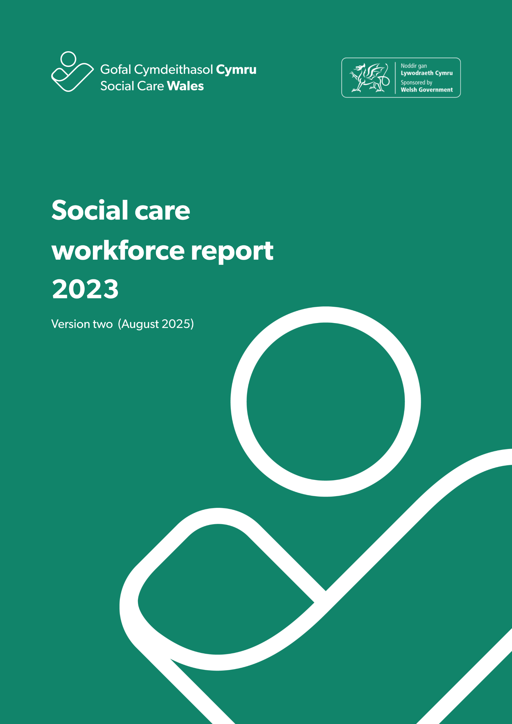

**Index**

1. Introduction 5

1.1 Background 5

1.2 Requirements and changes from 2022 6

1.3 Challenges, issues and data quality 7

1.4 Triangulation of this data with other sources 10

1.5 Lessons learned and next steps 11

2. Our findings 12

Summary of the social care workforce in Wales 12

2.1 Overall social care workforce 13

2.3 Domiciliary care 29

2.4 Day services 33

2.5 Supported living services 37

2.6 Social work teams 41

2.7 Children’s residential care 46

2.8 Mental health residential care 50

2.9 Central staff 53

2.10 Other services 57

Appendix A - Data categories 59

Appendix B – How we dealt with missing data and estimating the total size of the social care workforce in Wales 61

**Notice of revision to Social Care Workforce Report (2023)**

As part of the 2024 annual workforce data collection process, we’ve completed a full review of our previous estimates.

We were able to carry out this review because we had access to improved data, more accurate provider information, and enhanced detail from the Care Inspectorate Wales (CIW) Annual Returns process.

When processing the data for the 2024 collection, we found a possible discrepancy in the 2023 estimates for the number of individuals working in the sector.

This difference was caused by difficulties in matching our dataset with CIW's, which happened because:

* some providers of supported living services were incorrectly classed as domiciliary care. This led to their data being included twice - once in each service category
* some residential care services with multiple settings submitted incorrect information to CIW.

We’ve strengthened and improved our methodology in 2024. This has allowed us to apply the improvements retrospectively to the 2023 data and produce revised estimates that more accurately reflect the workforce at that time. 

**Revised workforce estimates for 2023**

|  |  |  |  |  |  |
| --- | --- | --- | --- | --- | --- |
|  | Domiciliary care | Supported living | Adult residential care | Children’s residential care | Mental health residential care |
| **Original estimate** | 22,064 | 7,303 | 36,794 | 4,394 | 1,179 |
| **Revised estimate** | 20,040 | 7,342 | 34,075 | 3,638 | 683 |

These revisions mean there’s now a more stable and consistent trend in the report.

|  |  |
| --- | --- |
| **Year** | **Total workforce (excluding personal assistants)** |
| 2022 | 80,961 |
| 2023 | 82,265 (revised) |
| 2024 | 82,875 |

All sections relating to the characteristics and contractual nature of the workforce remain unchanged by these revisions, as they’re taken solely from returned data and don’t involve estimation.

We acknowledge that working with incomplete or evolving data presents challenges. Our estimates are based on the best available information at the time of publication.

As new data sources become available or methodologies improve, we’re committed to revisiting and refining our figures to make sure they remain as accurate as possible. We apologise for any inconvenience these revisions may cause and reaffirm our commitment to transparency, accountability, and the continuous improvement of our data reporting processes.

1. In**tro**duction

This report sets out the key findings of our third annual workforce data collection, which we carried out in 2023.

The collection of data for this report followed the same format as our 2022 collection. We collected data directly from commissioned service providers and local authorities in a census-style approach. Data was collected from June to October 2023.

1. Background

The introduction of the Performance and Improvement Framework in April 2020 established a single integrated data collection process of the social care workforce. Since then, we’ve worked closely with people who work in social care in Wales to improve the method and quality in the annual workforce data collection.

This is the third time we’ve collected data under this framework. While there are still areas that need improvement, we‘re seeing some themes and trends emerging in the data we’ve received.

For the purposes of this collection, commercial businesses, not-for-profit and third-sector organisations who provide care and support in Wales are classed as commissioned service providers.

Local authorities[1] are required as part of the Performance and Improvement Framework to provide this data every year. It’s not currently mandatory for commissioned service providers.

We **do not** include organisations who only provide NHS-funded care, care provision paid for privately without local-authority funding, or government agencies responsible for social care regulation and inspection.

We asked for data from providers of:

* adult residential care
* children’s residential care
* domiciliary care
* social work teams
* day services
* adult placement schemes
* central or support staff
* other social care services which don’t fall into any of the above.

We’ve provided a full list of the data categories included in appendix A.

We thank data providers for their continued efforts with this data collection. The data makes a major contribution to how well we understand the social care workforce.

* 1. Requirements and changes from 2022

We try to make as few changes as possible to what we ask for from local authorities and independent providers each year. This makes it easier for data collectors to capture the information and makes sure we can compare with previous years.

The information we asked for in 2023 stayed largely the same as 2022 with some exceptions.

First, we removed the requirement to provide information about foster carers in 2023. We set out to minimise duplication as part of the process of developing a single integrated approach to workforce data in social care. Foster Wales[2] collects and reports on comprehensive data about foster carers in Wales, so we decided not to include them in this collection.

The second change in 2023 was the introduction of a new tier of reporting, allowing data providers to assign data collectors for each work setting. This made it easier for organisations who had more than one location or provided more than one setting type.

We also split agency and casual contract types into separate categories. These are very different contracts that we needed to understand better.

The final change was a minor addition that saw the introduction of a marker to show whether nurses are newly qualified.

* 1. Challenges, issues and data quality

With each collection we continue to learn more about the information collected and

some of the variations in what we receive. This leads to improvements in our

understanding of the data and differences, and how we present changes and trends from year to year. We’ll address some of these findings below.

* + 1. Personal assistants

Only four local authorities submitted data on personal assistants in 2023. This is a significant drop on the 17 who provided some data in 2022. As a result, we don’t have enough data to confidently report on or provide estimates for people who are working as personal assistants. Because of this, we haven’t included them in this report, nor the overall number of people working in social care in Wales in 2023. Exploring why collecting data on personal assistants is an issue and what changes have impacted this is something we’ll continue to work on with authorities for future data collections.

* + 1. Estimating missing data

Creating accurate estimates of the true size of the workforce is difficult with a low response rate. Our methodology for dealing with missing data has been strengthened this year due to two factors:

* the availability of data from last year, so we can more accurately estimate the number of people who might not have provided data this year but did last year
* the availability of the first CIW Annual Return since 2020. This provided us with additional data points to compare to, as well as the challenges we outline below.
  + 1. Comparing data from this report with CIW Annual Returns data

When comparing CIW and Social Care Wales datasets, we identified several areas where data didn’t match. Releasing two datasets that didn’t agree with one another would obviously cause problems. We needed to understand why these differences existed and, if possible, reconcile the two datasets. The issues that were highlighted by comparing CIW data and the data collected by our annual collection process are outlined below.

**Differences in how we categorise job roles**

The most obvious of these differences between CIW’s collection and ours was how we used different definitions for specific care roles and settings. For example, if we look at how we describe residential care settings, we can compare each organisation’s description of each setting as below:

|  |  |
| --- | --- |
| **Care Inspectorate Wales** | **Social Care Wales** |
| Adults without nursing Adults with nursing | Adults |
| Children | Children |
| Adults and children without nursing | Mental health |

We also identified some differences with our domiciliary care data. CIW doesn’t differentiate between domiciliary care and supported living and reports this information at health board level. We collect data on domiciliary care and supported living as separate types of care provision and report on it at a local authority level.

**Missing data**

We identify organisations that should be included (and contacted) through our in-house customer relationship management (CRM) system. We keep this database up to date with regular information from CIW about changes to registered services.

Our analysis showed there were differences in organisations who submitted data to us and to CIW. Some of the organisations that had submitted to CIW were unknown to us, and therefore we hadn’t asked them to submit data. We’ve now implemented monthly updates of our CRM database to ensure we always have a full list of providers and settings.

**Inconsistent service self-descriptions**

In our annual data collection, providers and local authorities self-describe their services, the settings they have and where this provision is based (or delivered). Comparison of the data provided to us with the annual return data from CIW showed a mismatch between our two datasets. We found that some organisations were larger and/or had more settings than in our data and estimates. Our investigations found that this was often due to a lack of clarity with providers about the data collection. For example, on whether collections were done centrally or by individual setting, and who held responsibility for making sure data for all settings had been submitted.

To remedy this for future collections, we’ve now mapped all settings registered with CIW to the parent organisation in our CRM system to make sure that we’re aware of *all* services provided by the organisations we ask to submit data.

Following these findings, our initial estimates of the size of the workforce have now been revised up based on all the provision in Wales. Going forward, we’ll be able to identify any missing settings far more accurately and work with organisations to identify where additional data collectors might be needed to provide a complete picture.

* + 1. Conclusions of our data comparison exercise

This was the first year of CIW collecting annual data since the start of the Covid-19 pandemic. We’re aware that service providers must provide similar data to our organisations and they give us feedback that this is time-consuming, frustrating and confusing.

This has resulted in a drop in response rates and caused additional work for both organisations to understand the reasons for receiving ‘different’data. When we started to understand the differences in how we categorise and collect data, the errors and the missing data, the closer the match between the two organisations became.

But there’s broad agreement that having two separate processes for collecting workforce data is unsustainable. It goes against the principle of single data collections and reusable data. We’re now working with CIW to develop a single process that meets the collective needs of social care in Wales and works better for the organisations submitting the data.

* + 1. Agency workers

We’re aware of some significant differences in data provided on agency workers to data available elsewhere. We know that the number of staff registered with an agency as their primary employer is much higher than has been reported in this data collection. We suspect that these staff aren’t being properly reported in this collection.

* + 1. Return rates

We calculated return rates in the same way as in 2022, by counting the number of organisations that returned at least a partial return (the minimum being the number in post for at least one of their settings) and dividing that number by the total number of organisations.

All 22 local authorities returned data to us, but this is the first year we’ve seen such a distinct variance between authorities in the completeness of the data. Some authorities reported issues with availability of data or their ability to accurately report on areas including qualifications, language skills and ethnicity.

The number of providers we expected returns from was calculated using the lists provided by the local authorities, the information from the Register of Social Care Workers in Wales, and the registered services provided by CIW.

While it’s disappointing that this figure has decreased from the previous year, the completion of all sections by those who did submit is greatly improved.

We’ve prioritised building relationships with providers and connecting with the correct individuals to try and assist them in completing a submission and increasing the return rate. We really value the input of those who have engaged with us through this collection.

* 1. Triangulation of this data with other sources

Wherever possible, we triangulate the data we receive during this process with other similar sources of data. Triangulation means we compare our data with information from other sources to sense check and validate it and to understand why there might be differences. The data for the 2023 report has been compared to:

* the Register of social care workers in Wales
* data from our 2022 workforce data collection
* our understanding of the size of services from data held by CIW
* data from the 2023 Annual Returns process run by CIW.

We provide more detail about each of these below.

* + 1. The Register of Social Care Workers in Wales

Registration is a mandatory requirement for many social care roles in Wales. We manage this process at Social Care Wales, and the Register can tell us the number of people in each role along with their details. But accuracy of this data relies on the individual to keep it up to date, especially if they’re not currently working in the role they’re registered for. This isn’t always the case, and changes are often only recorded when a person renews (every three years) or changes employer. This is why we use the Register as a guide to the overall size of the

workforce, but remain aware of potential delays in individual updates.

* + 1. Data from the workforce data collection 2022

Some organisations who submitted data in 2022 didn’t submit data in 2023 and vice versa. For those who submitted previously and were still in operation in 2023, we used the data submitted in 2022 as a base for estimating their missing data for 2023. This means we based our prediction of change on the number we knew from the previous collection, rather than in comparison to organisations of a similar size (as we did in 2022, where we didn’t have access to similar data).

* + 1. Service level data from CIW

While individual social care professionals register with us, social care organisations register with CIW. We use the registered provider list maintained by CIW to monitor completion rates, including establishing if an organisation is still trading and to estimate the size of a specific setting in residential care.

* + 1. Data from the 2023 Annual Returns process run by CIW

In 2023, CIW carried out its Annual Returns process for the first time since 2020. While the collection is focused on the settings, it also gathers information about the number of staff who work in them. Even though the categories used to define the settings and staff that work in them are different in our data collections, it’s still possible to draw basic comparisons.

* 1. Lessons learned and next steps

We want to learn from the feedback we receive each year so that we can improve our insight into the social care workforce in Wales.

Based on previous feedback, some positive developments from the third year of our data collection include:

* we received higher quality returns from commissioned providers than in previous years, which enabled us to analyse each question with greater confidence. Some of this is due to changes to enable commissioned providers to allocate permissions to staff completing the returns. For example, to allow people to see data by setting or by organisation
* we’ve gained confidence in our estimation methods and the trends we’ve identified, thanks to organisations returning data for consecutive periods
* we’ve also identified some new areas for improvement from this data collection, including ideas for improving the survey design.

We’ll continue to work with local authorities and providers to identify the issues they’re facing in successfully completing the collection, as well as to make sure the data collected is useful to everyone involved in the process.   
  
We rely on the quality of data we collect to produce high-quality outputs, so we’re committed to making the data collection process as streamlined and easy to complete as possible.

1. Our findings

Summary of the social care workforce in Wales

* **82,265** people are estimated to be employed in the social care workforce in Wales.
* This is a 1.6 percentage point increase on the equivalent figure in 2022*.
* The gender split of the workforce remains unchanged, with 81.6 per cent of the workforce recorded as female and 18.4 per cent male.
* Children’s residential care remains the setting where we see the highest number of men (34 per cent)
* 54.3 per cent are now aged 45 or under – an increase of two percentage points since 2022.
* 92.4 per cent are recorded as white. This is a slight increase in diversity over the previous year’s figures (94.5 per cent white in 2022).
* All ethnic minority groups have increased this year and are in line with or above the levels seen in the Welsh population. The biggest change is a 1.4 percentage point increase in the number of people identifying as black (2.3 per cent in 2022 and 3.7 per cent in 2023).
* 79.4 per cent are on permanent contracts, in line with 2022.
* 1.8 per cent are agency workers. This varies from the increased figure seen in commissioned providers (3.2 per cent in 2023, up from 1.7 per cent in 2022) and the stable 0.4 per cent reported by local authorities (0.5 per cent in 2022 and 0.4 per cent in 2021).
* Vacancy rates remain stable, with an estimated 5,299 vacancies open or being held in the sector (5,323 in 2022).

*\* this figure doesn’t include foster carers as in previous years but does include additional data on settings.*

Due to return rates that were lower than needed, missing data has presented a challenge to calculating the size of the social care workforce in 2023. To account for missing data, we’ve used machine-learning methods to make predictions about the size and shape of the overall workforce. We’ve provided a more detailed explanation of these methods in appendix B.

As with the previous two years, all 22 local authorities submitted data. However, only 47.9 per cent of commissioned providers did so. This is a reduction of 10.7 per cent on the number of providers who gave us data in 2022. On the plus side, the returns we did receive from commissioned providers were of significantly higher quality than in previous returns.

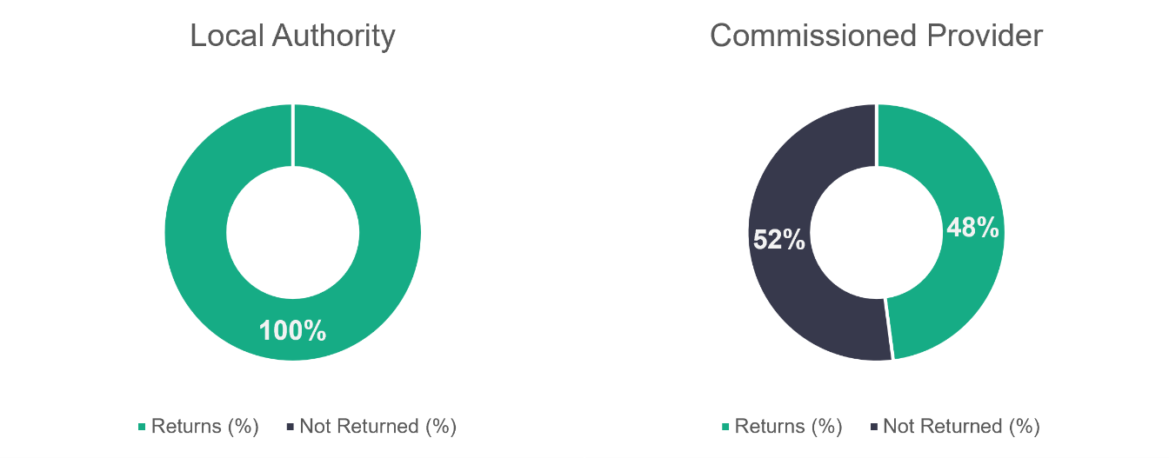

n = 22

n = 673

* 1. Overall social care workforce

Providers who submitted data told us about 52,690 social care workers who worked in their organisations. Using our process for dealing with missing data, we estimate an overall total of 82,265 people were working in social care in Wales in 2023.

The following chart provides a breakdown for the returned and estimated social care workforce in Wales, broken down by the service areas we discuss in the sections that follow.

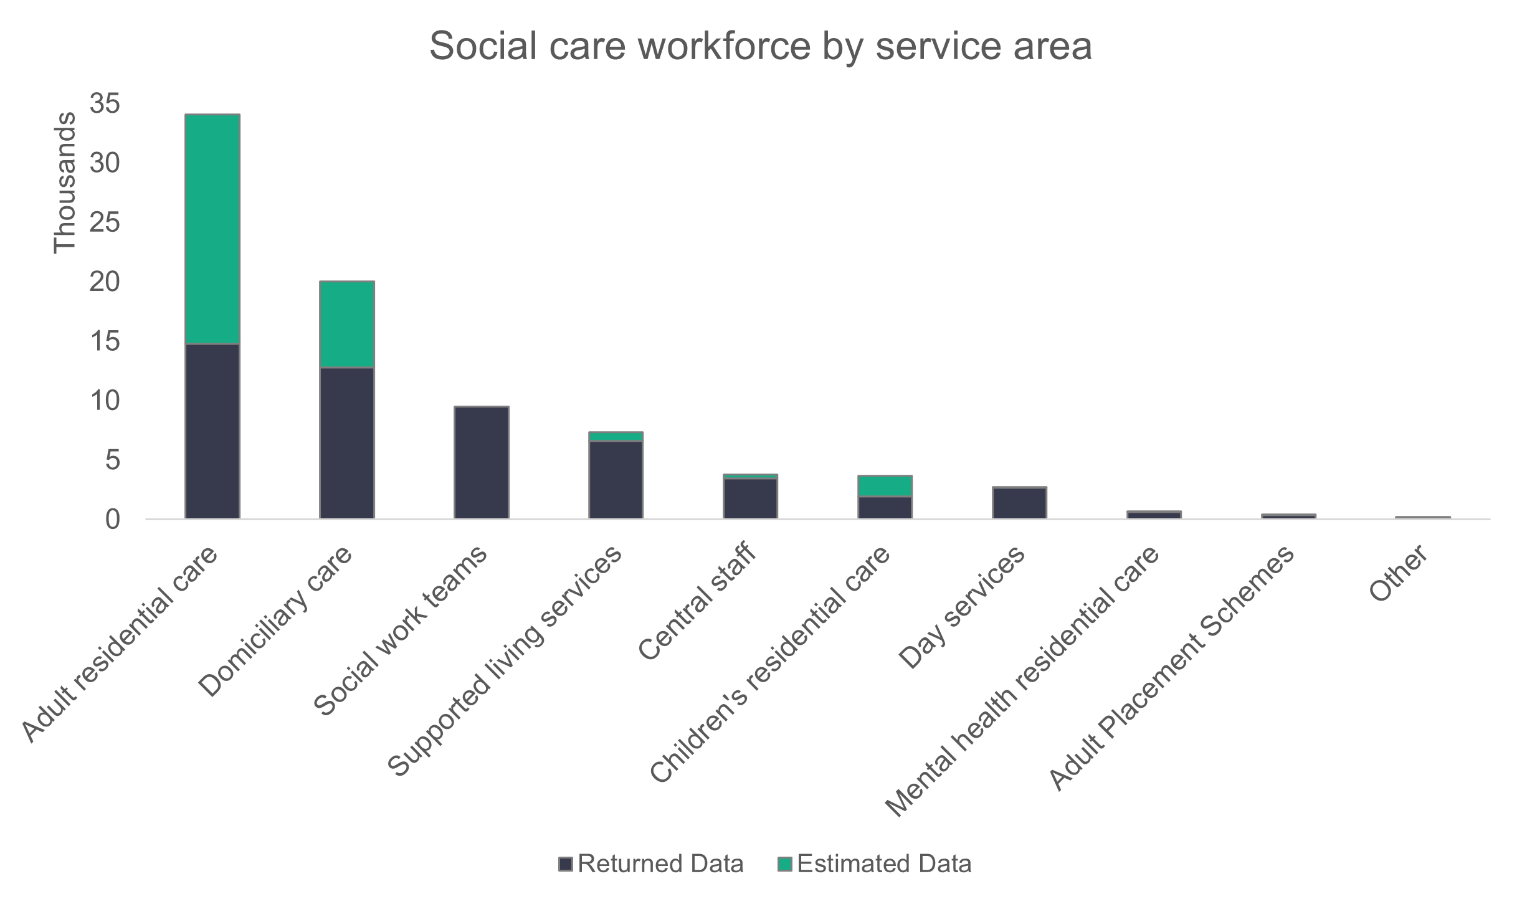

n = 82,265,

Adult placement schemes are included in the chart above and in the overall figure of the social care workforce, but we haven’t broken them down further given the small numbers we see in the returns.

The biggest change in numbers is in adult residential care, where the workforce has increased by 4,974 individuals. The Register also indicates the number of registered individuals working as adult residential managers or workers has increased this year. But we believe at least some of the increase is likely to be due to the improved knowledge on the number of active services, as well as the improved estimation techniques which have given us a better understanding of the size of different types of establishments in residential care.

Our method for calculating missing data has improved this year thanks to the additional data sources available to us and the continued refinement of our processes. This has resulted in a higher figure for estimated data for most settings as displayed in the table below.

|  |  |  |  |  |
| --- | --- | --- | --- | --- |
|  | Number in post |  |  |  |
|  | 2022 |  | 2023 |  |
|  | Returned | Estimated | Returned | Estimated |
| Adult residential  care | 18,158 | 29,101 | 14,785 | 34,075 |
| Domiciliary care | 10,657 | 19,571 | 12,763 | 20,040 |
| Social work  teams | 8,566 | 8,566 | 9,456 | 9,456 |
| Supported living  services | 6,565 | 6,893 | 6,601 | 7,342 |
| Central staff | 3,561 | 3,766 | 3,457 | 3,722 |
| Children's  residential care | 2,171 | 4,411 | 1,926 | 3,638 |
| Day services | 2,812 | 2,831 | 2,644 | 2,684 |
| Mental health  residential care | 539 | 822 | 604 | 683 |
| Adult placement  schemes | 147 | 338 | 343 | 434 |
| Other | 147 | 147 | 111 | 191 |

* + 1. Roles

The social care workforce in Wales covers a wide and diverse range of roles with a varying number of workers. The chart below shows the roles with the highest proportion of social care workers. We haven’t included roles which represent less than one per cent in the chart.

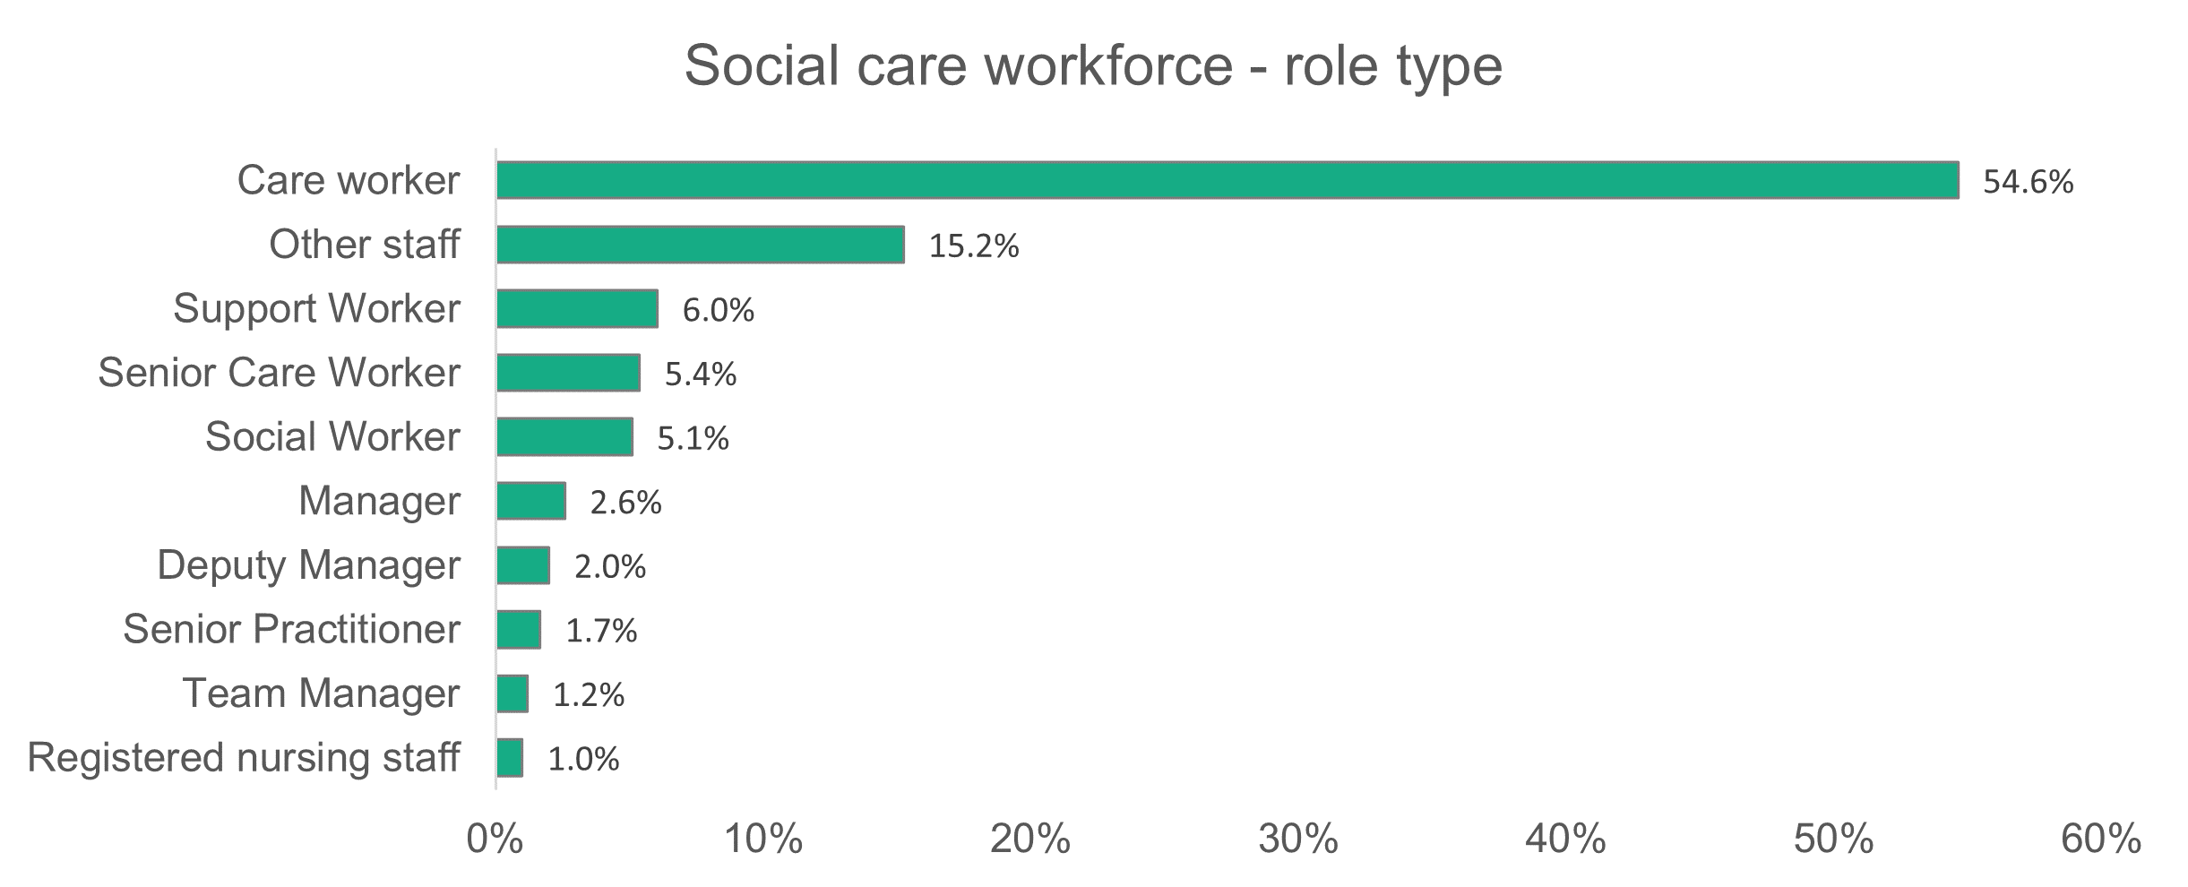

n = 52,690

Care workers make up the majority of roles, representing 54.6 per cent of the workforce. ‘Other staff’ will include ancillary and support staff such as cooks, cleaners and business support. More information about these types of roles can be seen in our section about central staff later in this document. The chart below shows the service areas where the proportion of care worker roles is more than 50 per cent.

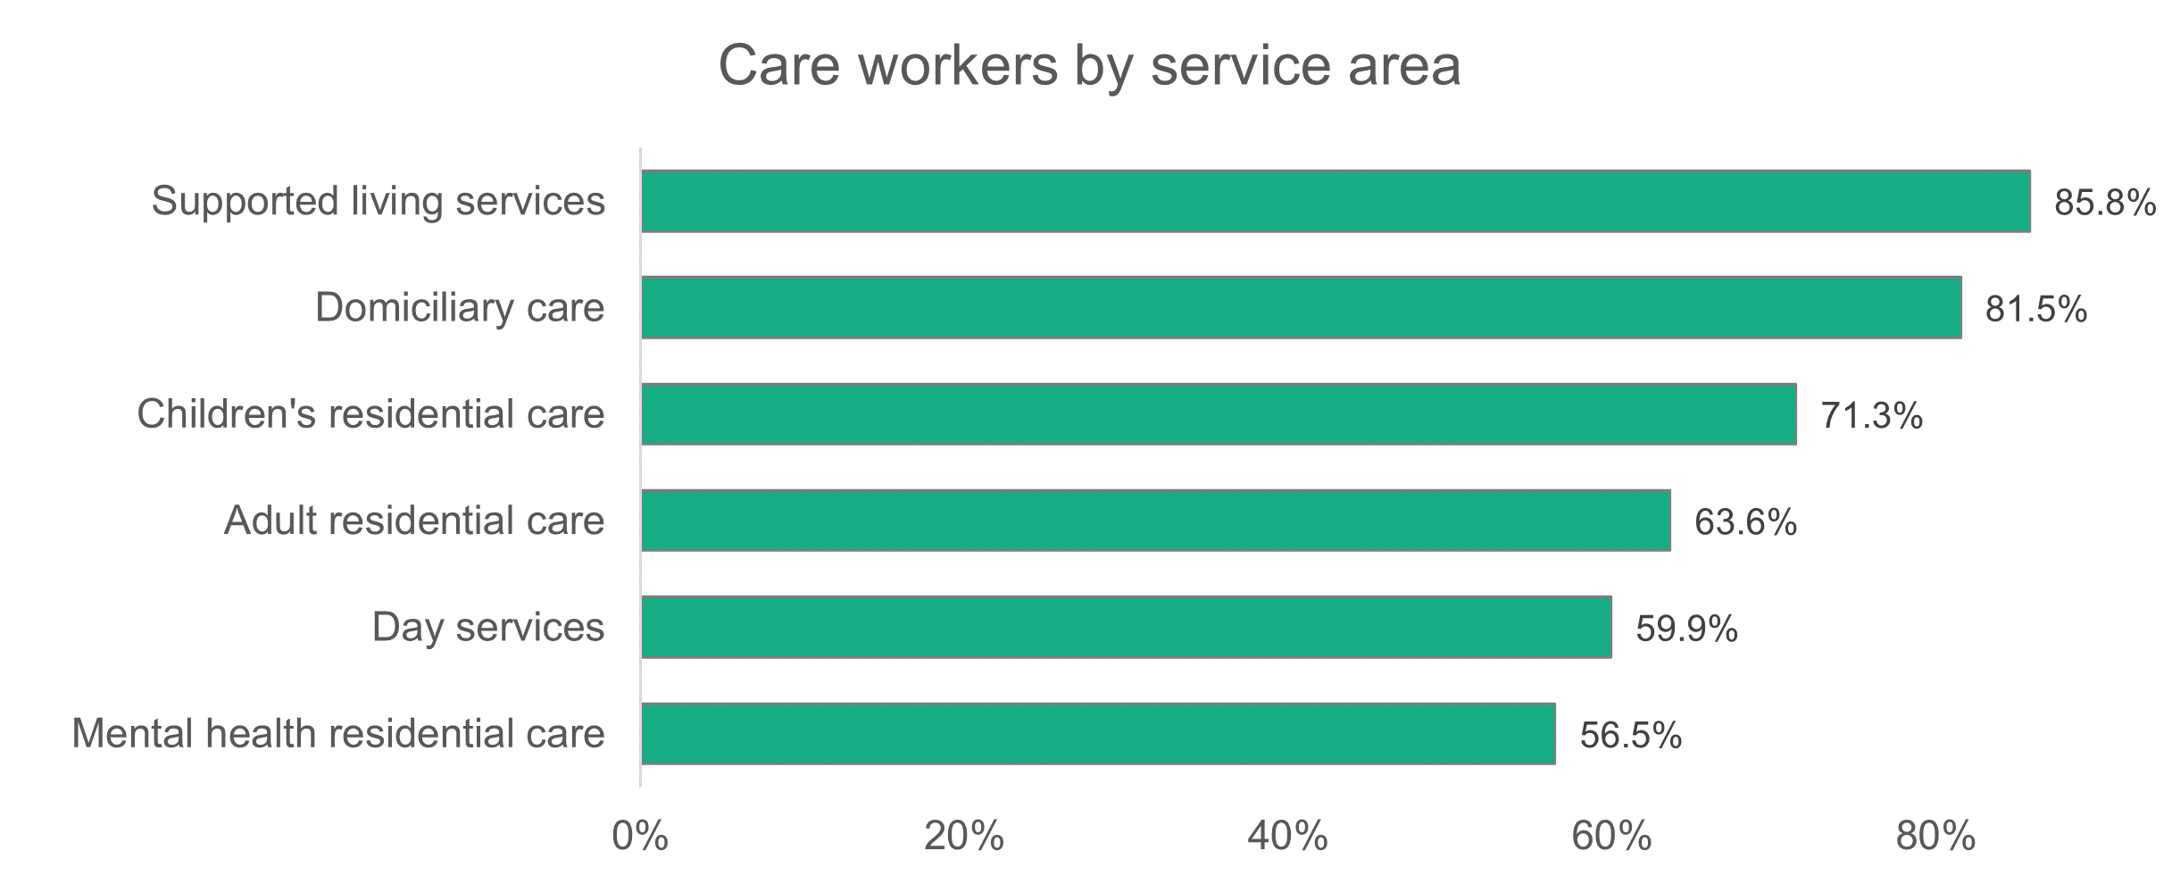

n = 52,690

* + 1. Gender

The overall proportion of men and women remains the same as in the 2022 report, with men making up fewer than one in five of the workforce. For most role types, the proportion of women is 69 per cent or above. The only exception is the director role, where 51.4 per cent are women, 47.2 per cent are men, and 1.4 per cent are gender fluid.

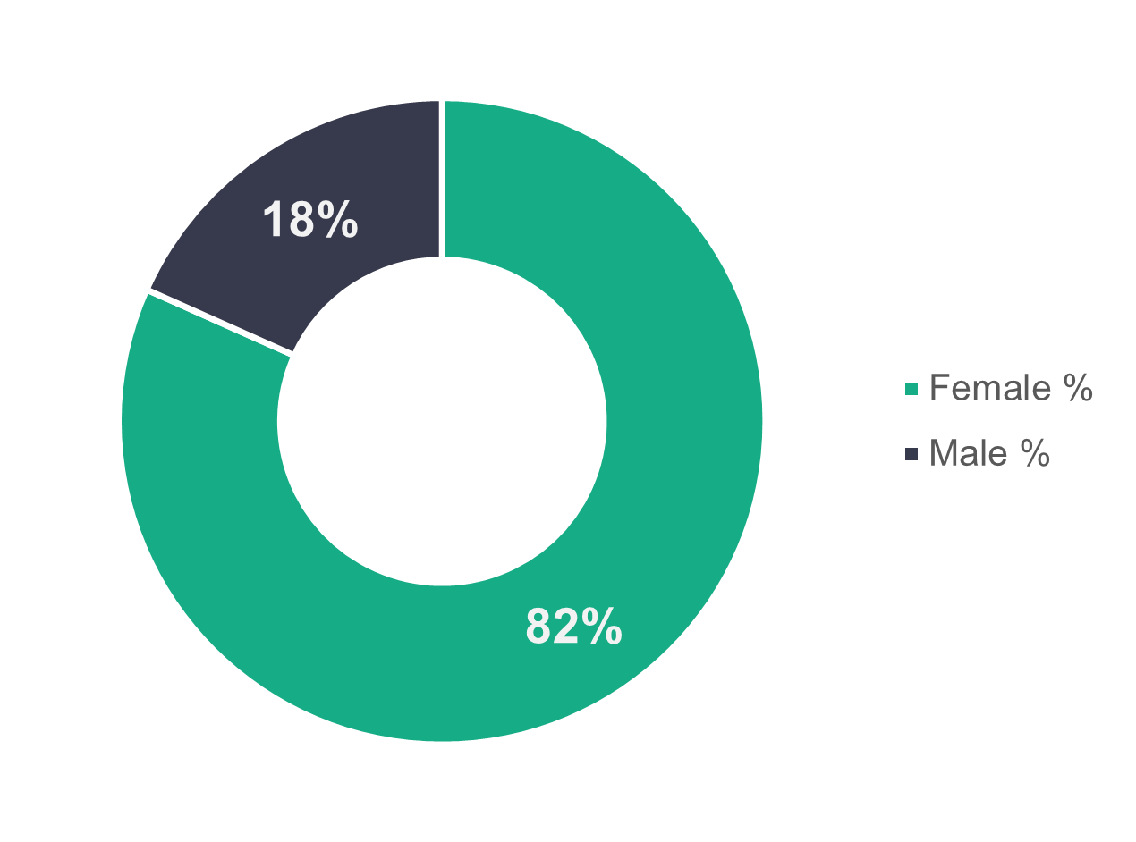

n = 50,589

* + 1. Age profile

Social care workers across both local authorities and commissioned providers span a broad age range, with commissioned services leaning towards a slightly younger workforce than local authorities. For commissioned services, the dominant age group is 26 to 35, which makes up 25.8 per cent of their workforce (61.7 per cent are aged 45 or under). The dominant age group for workers employed by local authorities is 46 to 55, making up 26.1 per cent of their workforce (52.5 per cent are over 45).

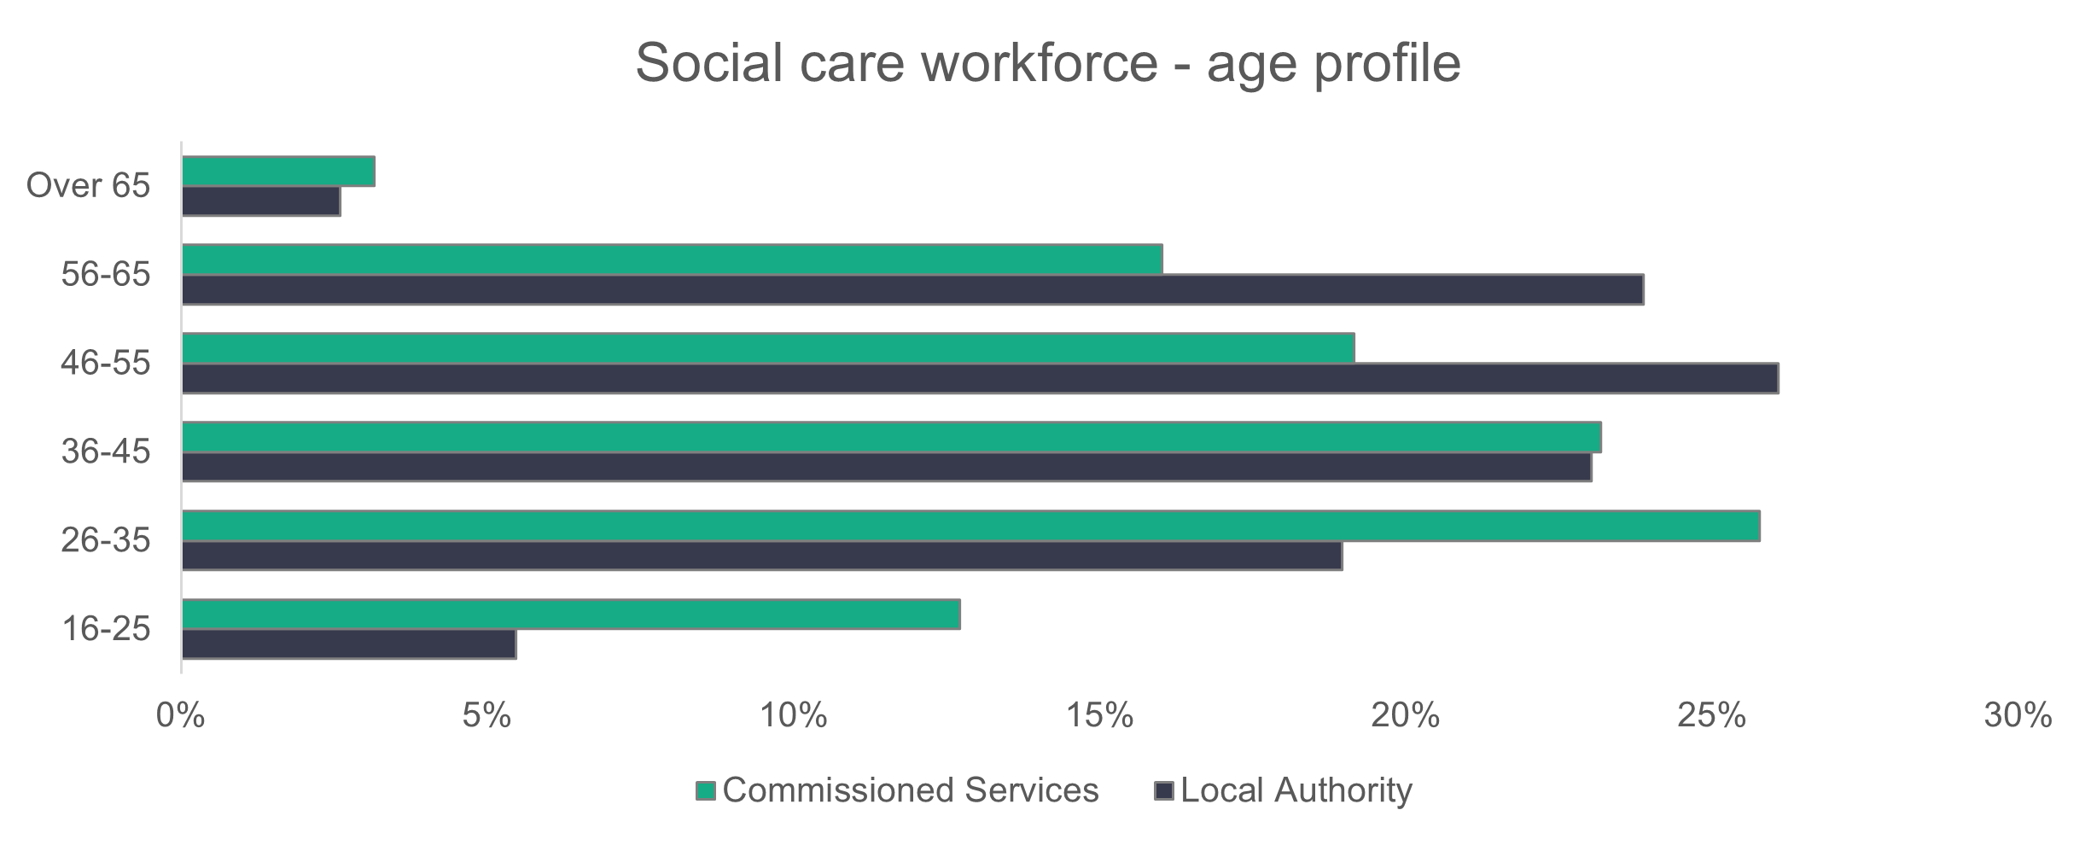

n = 49,186

The age profile for 2023 is very similar to that for 2022. The main differences are for the 26 to 35 and 46 to 55 age groups. A slightly higher proportion of the workforce falls into the 26 to 35 age group for both local authorities (19 per cent) and commissioned services (25.8 per cent) in 2023. The corresponding proportions in 2022 were 18.2 per cent for local authorities and 23.5 per cent for commissioned services. A smaller proportion of the workforce falls into the 46 to 55 age group in 2023 (26.1 per cent for local authorities and 19.2 per cent for commissioned services). The corresponding proportions in 2022 were 27.7 per cent for local authorities and 21.7 per cent for commissioned services.

* + 1. Ethnicity

The social care workforce of 2023 is slightly more diverse than in 2022 according to the data provided. The proportion of the workforce reported as white is down from 94.5 per cent in 2022 to 92.4 per cent in 2023 (but up from 89.1 per cent in 2021). The most striking observation in the chart below is that the proportion of black workers in social care is more than four times higher than in the general population of Wales.

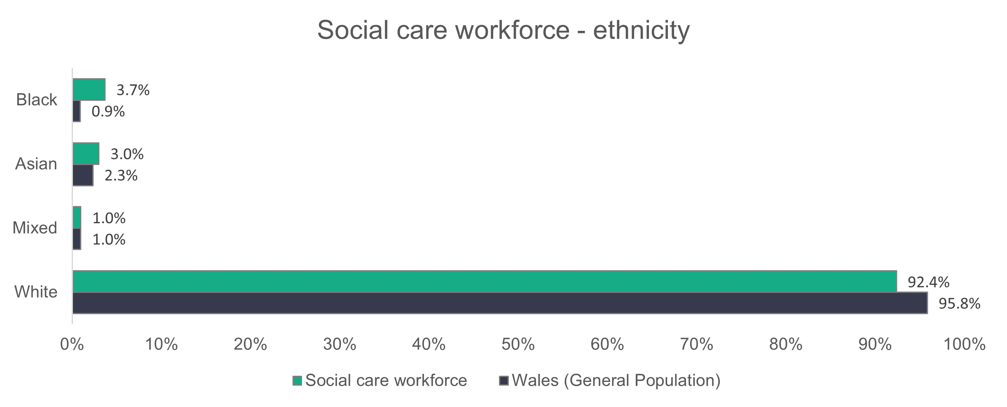

n = 36,738

The ethnic diversity of the workforce varies between roles. We’ve taken a sample of roles to illustrate this point in the example below.

The chart shows the ethnic diversity of:

* registered nursing staff – the most ethnically diverse role type
* care workers – because they make up most of the workforce
* senior roles – which are made up of all defined manager or director roles in the data (including assistant or deputy roles).

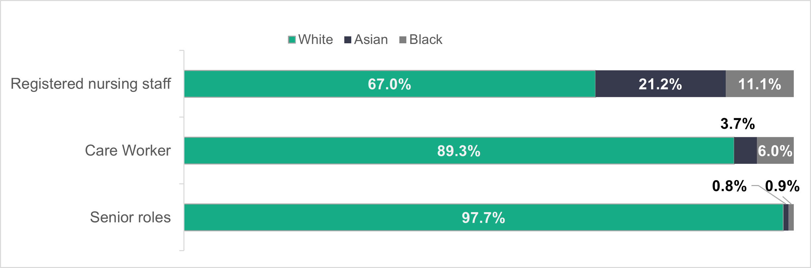

When we look at the ethnicity of the social care workforce by local authorities, Cardiff has the most diverse, with 75.8 per cent recorded as white. Meanwhile, almost 100 per cent (99.8 per cent) of the social care workforce of Merthyr Tydfil is recorded as white, but the local authority population there is 99.7 per cent white. Interestingly, the social care workforce of Denbighshire is considerably more diverse than its population. The Denbighshire workforce is recorded as 86 per cent white, compared to 97.3 per cent of the population.

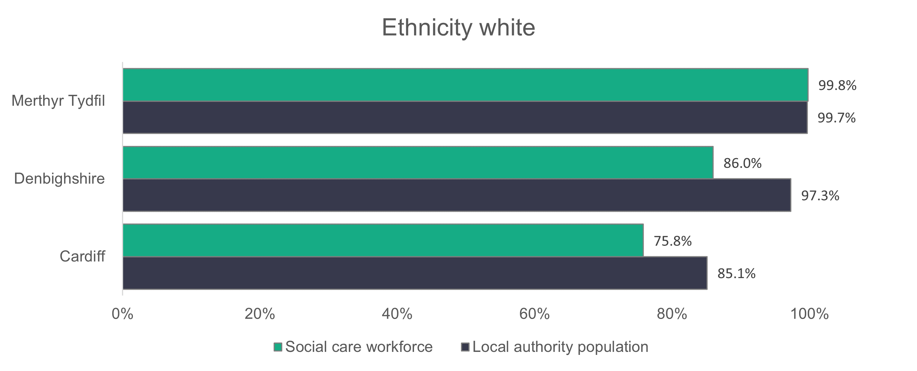

* + 1. Welsh language skills

Welsh language skill levels in the social care workforce haven’t changed significantly from last year according to our data, with 30.5 per cent understanding Welsh to various degrees (the corresponding proportion last year was 29.2 per cent). A breakdown of their Welsh language proficiency is shown below.

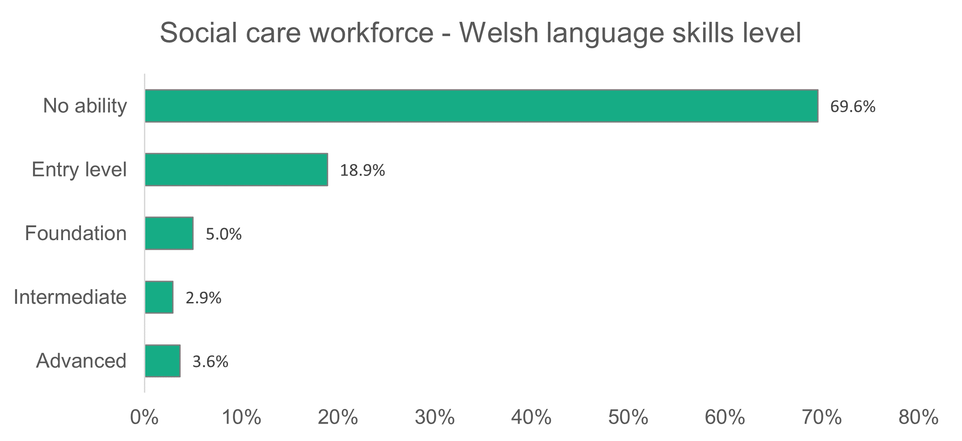

.

n = 35,847

* + 1. Contract type

**Summary:**

* Most workers in the social care sector in Wales are employed on permanent contracts (79.4 per cent).
* The setting type with the highest proportion of its workers on zero-hours contracts is domiciliary care from commissioned services (31.4 per cent).
* Care workers make up the highest proportion on zero-hours contracts (37.5 per cent) in domiciliary care.
* Senior practitioners(4.9 per cent), followed by care workers(4.8 per cent), have the highest proportion of people on casual contracts. Care workers also make up 72.2 per centof all the casual contracts in the social care workforce.
* The residential care mental health sector in local authorities is the setting with the highest proportion of its workforce on agency contracts (15.5 per cent). Registered nursing staff is the role with the highest proportion of people on agency contracts (8.5 per cent).

Commissioned services have 6.3 per cent more of their workers on permanent contracts than local authorities. The chart below shows the contract types for the social care workforce and is quite similar to the 2022 data. The proportion of people employed by commissioned services on temporary contracts is down from 6.2 to 0.8 per cent. We’ve separated ‘casual’ and ‘zero hours’ into distinct categories, having combined them in previous collections.

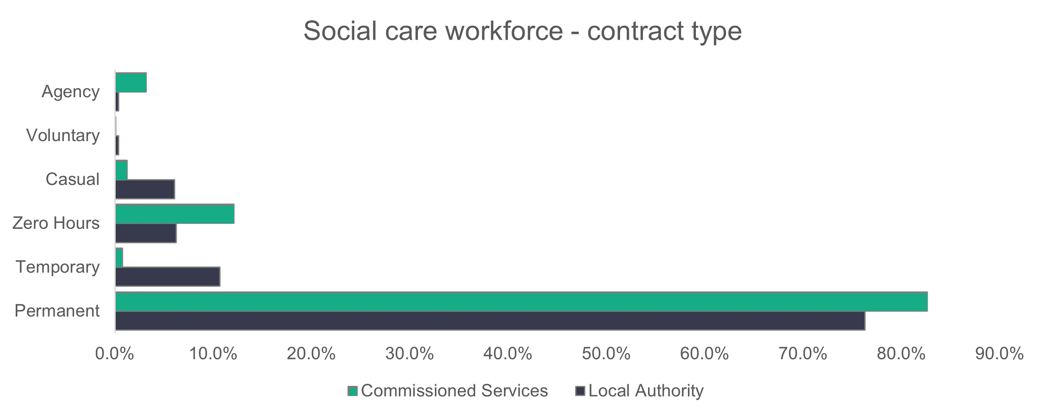

n = 51,217

A total of 9.2 per cent of the social care workforce are on zero-hours contracts, which compares to 3.4 per cent of the most current data available on the general workforce of Wales (TUC data for 2019[3]).

The care worker role has the most social care workers on zero-hours contracts, with 4,147 (14.9 per cent) of the workers on zero-hours contracts. Domiciliary care from commissioned services has the highest proportion of its workers on zero-hours contracts (31.4 per cent) and the care workers within this service make up the highest proportion of 37.5 per cent on zero-hours contracts.

Casual and zero-hours contracts are similar in that they’re irregular and there are no fixed hours to the work. There’s no defined minimum number of hours in a zero-hours contract. In a casual contract, the employee doesn’t have to accept any work offered (similarly, there’s no requirement for the employer to provide work). From our data, we see a distinct difference between casual worker numbers and proportions for local authorities and commissioned services. Commissioned services have 315 casual workers, which is almost a tenth of their number (3,096) of zero-hours contracted workers. Local authorities have a similar number of workers on casual (1,554) and zero-hour (1,600) contracts.

Proportionally, casual contracts make up 1.2 per cent of the commissioned service workforce and 6.1 per cent of the local authorities workforce. Most of the casually contracted local authority workers are in the adult residential care service, with 526 workers. This makes up 11.4 per cent of local authority adult residential care contracts, or 33.8 per cent of all local authority casual contracts.

* + 1. Agency workers

The percentage of the workforce employed by an agency is 1.8 per cent in the data provided for this report. This is much lower than the 6.3 per cent we see who have their primary employer as an agency in the registered workforce.

The workforce data collection includes roles which aren’t included in the role types registered by us, including nurses, occupational therapists, catering and domestic staff. This will account for some (but not all) of the differences we see in the two datasets.

One area where we can directly compare data is social workers. According to the Register, 11.5 per cent of qualified social workers had given their primary employer as an agency in 2023. This differs significantly to the figure returned in the data collection (approximately one per cent). While differences in dates and return rates may account for subtle variations, we’re keen to discuss this further with data collectors as part of our improvement work.

* + 1. Working patterns

The proportion of people working full-time hours (36 or more per week) is broadly similar across local authorities (47.4 per cent) and commissioned services (48.8 per cent). The biggest difference is in the proportion of people who work up to 16 hours a week, with 17.7 per cent doing so for local authorities and 12.1 per cent for commissioned services.

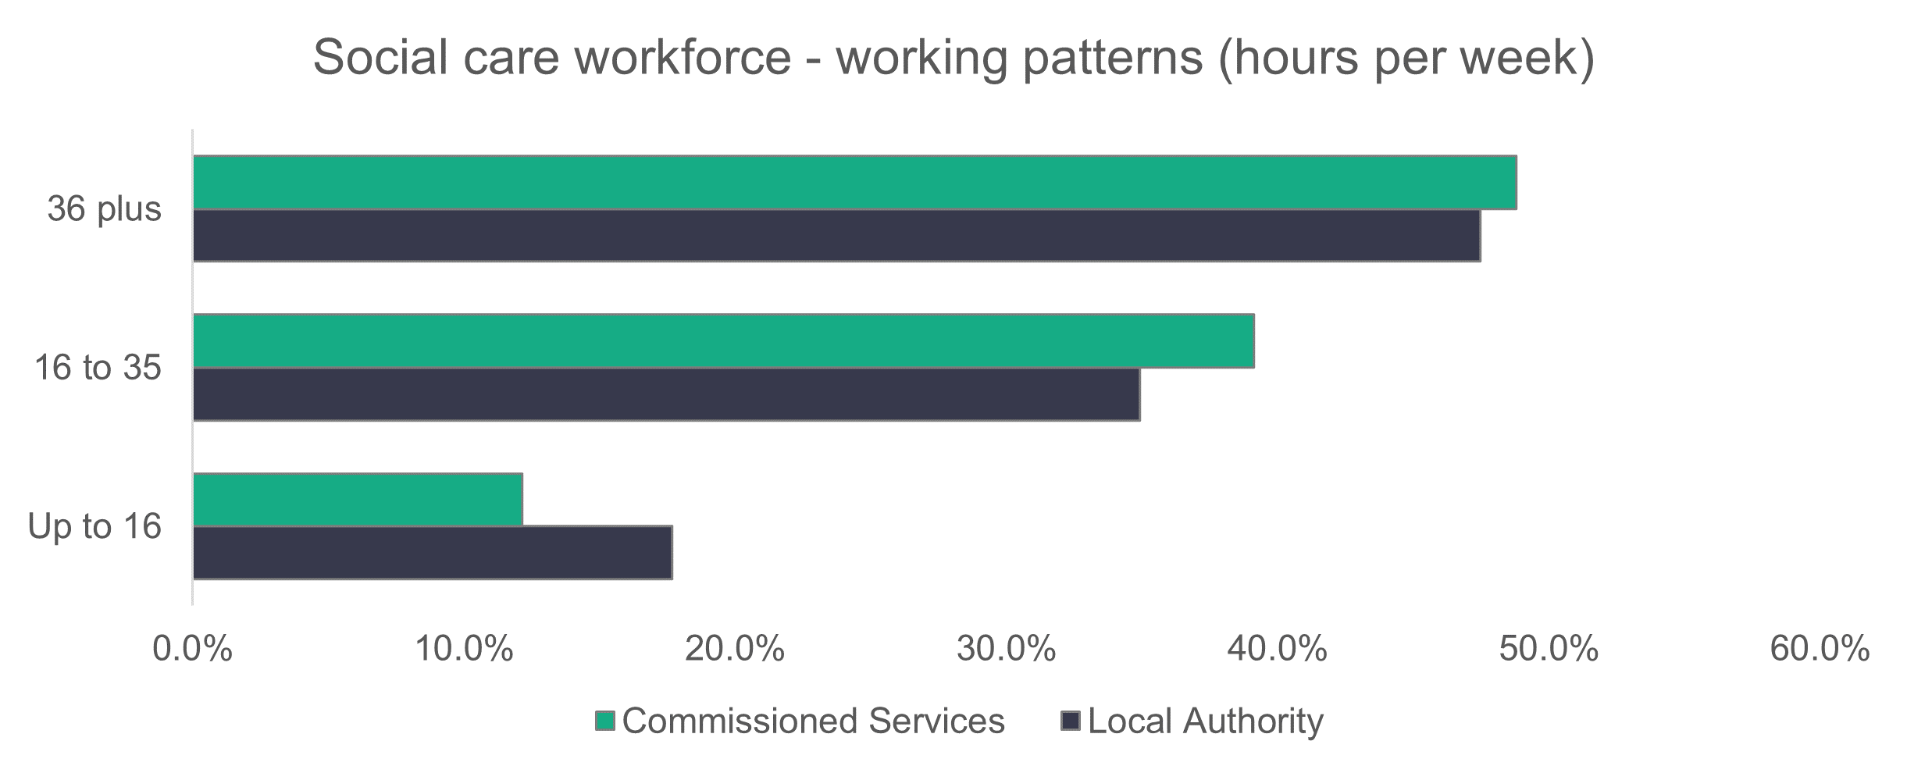

n = 49,906

* + 1. Vacancies

We were told of 3,477 open vacancies in the social care workforce, and a further 847 held vacant. We estimate that there are a further 975 posts that are vacant or held vacant, using the methods described in appendix B. This gives us a total of 5,299 vacancies and represents six per cent of this year’s estimated workforce.

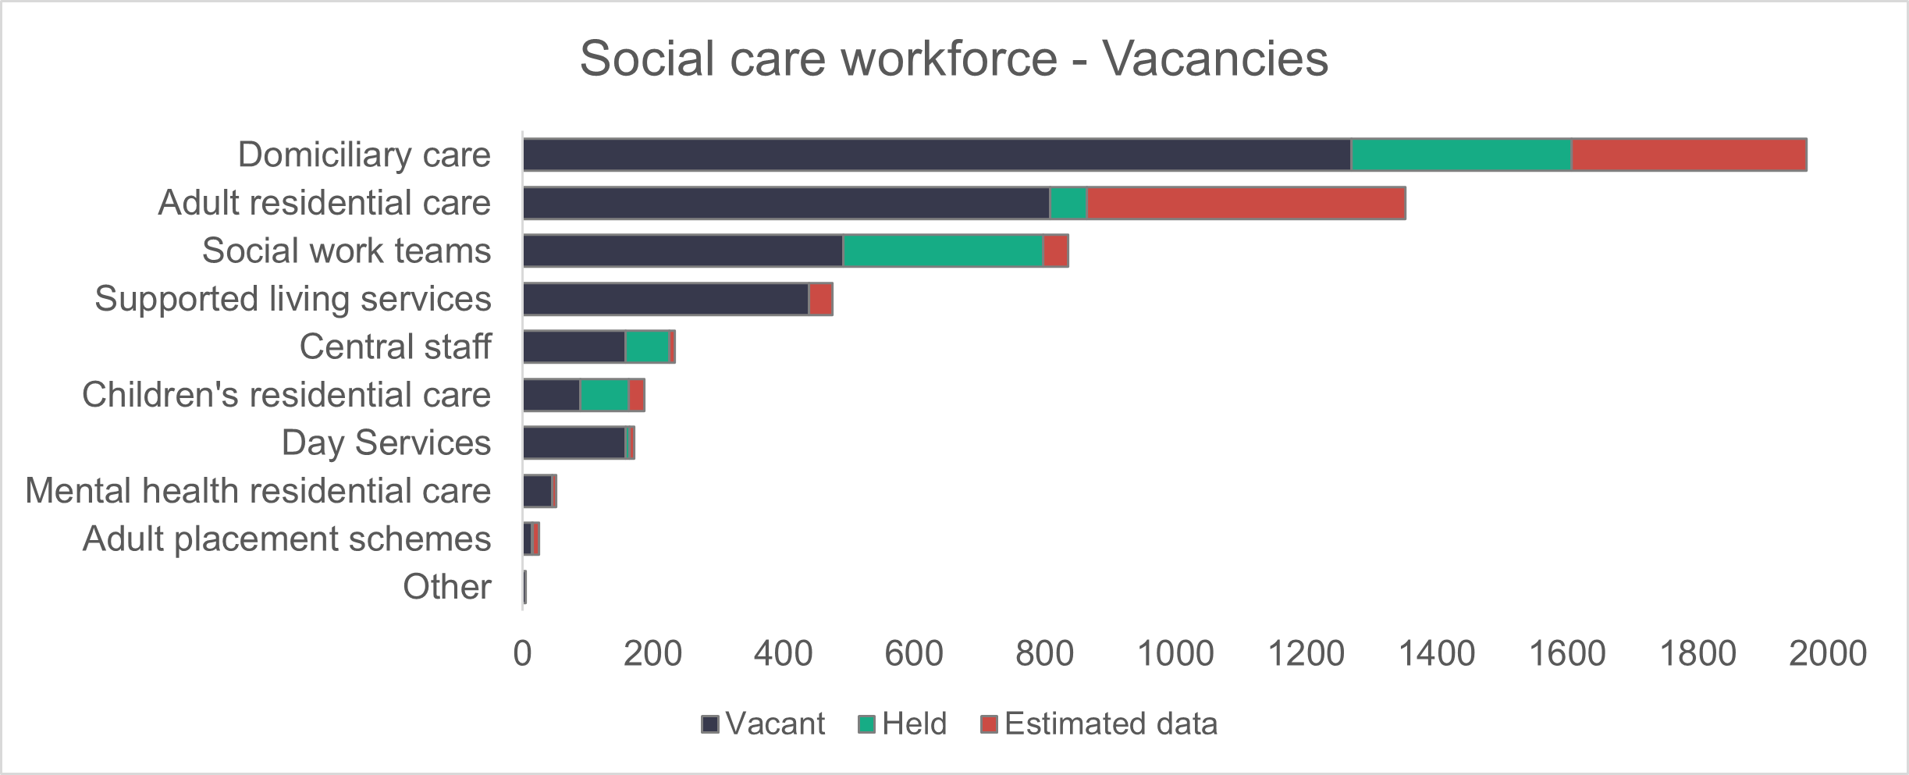Last year we reported an estimated 5,323 posts vacant or held – 24 more than this year.

* + 1. Staff turnover

We asked for information about joiners and leavers. It was reported that 9,499 people started a new role in social care in Wales and 9,503 left the sector during the year. From this data, we can calculate an overall net decrease of four staff in the social care sector in Wales in 2022 to 2023.

A number of settings have permanently closed this year (particularly in adult residential care). These settings wouldn’t have submitted data, so the loss of staff in these settings isn’t reported. We hope to be able to consider methods for calculating the impact of settings closures in future collections. CIW data also indicates a decrease in the number of adult residential care settings this year. This could explain the increased recruitment into remaining establishments, while an increase in domiciliary care settings with an issue of recruitment noted could equally account for the move between settings of staff. Because of this, these numbers should only be seen as indicative.

Table showing the the number of people who've joined and left the social care workforce, as well as the net change. In total, 9,499 people joined and 9.503 left, meaning a net change of minus four.

* + 1. Sickness

A total of 301,023 days were lost to sickness according to the returned data.

The number of days lost to sickness has increased by 28.6 per cent on last year’s reported data.

The biggest change compared to last year’s data came in ‘other illness’, which increased from 66,598 days in 2022 to 102,558 days in 2023.

A breakdown of the reasons for sickness, or absence from work, is shown in the following chart. Proportionally, ‘other illness’ accounts for 34.1 per cent (31 per cent in 2022) of all absences. Stress (work and non-work related) accounts for 22.8 per cent (23 per cent in 2022).

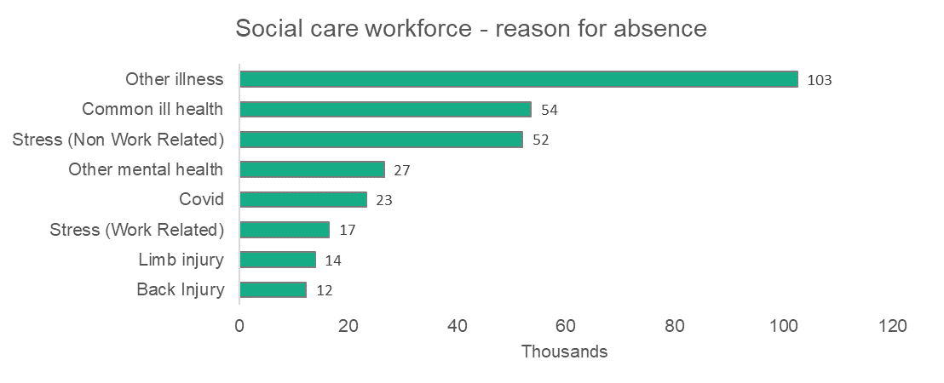

‘Other illness’ remains the highest reason for lost days. All other categories also increased, but far less significantly.

Common ill health has now taken second place above non-work-related stress. In 2022, stress (work-related, non-work-related and other mental health) accounted for nearly 80,000 days lost. In 2023, this rose to 95,184 lost. But this remains lower than ‘other illness' at over 102,000 days lost.

**2.2 Adult residential care**

Summary:

* There’s an increase of 17.1 percentage points in the number of people working in adult residential care.
* Care workers continue to make up the majority (63.6 per cent) of the adult residential care workforce.
* Local authorities have an older workforce than commissioned services.
* Black, Asian or mixed race workers make up 12.3 per cent of the workforce, compared to 4.2 per cent in the population.
* Zero-hour contracts make up 20.4 per cent of local authority contracts.

We estimate that 34,075 people work in the adult residential care sector. This is an increase of 4,974 (17.1 percentage points) on the number estimated in 2022. It should be noted that the return rate from commissioned services has dropped from 54.1 per cent in 2022 to 41.4 per cent in 2023, so estimated data makes up the majority of this figure.

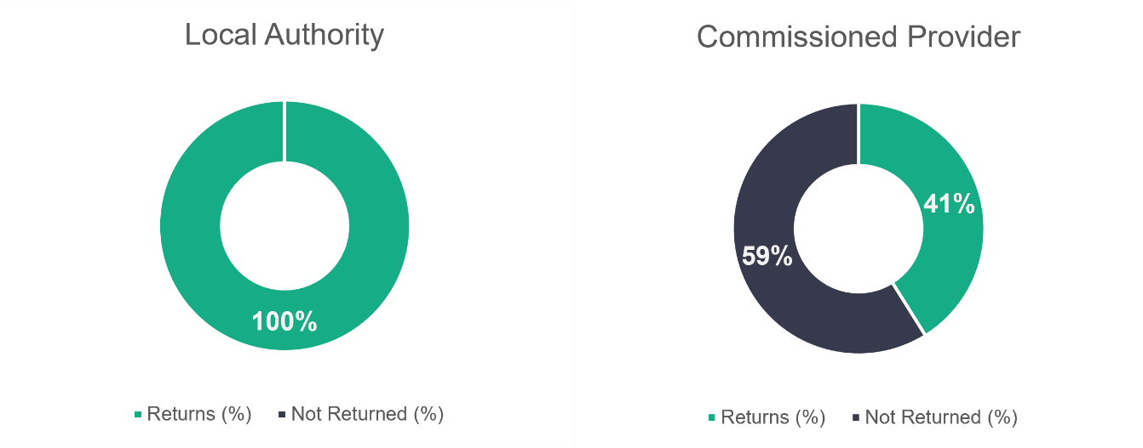

n = 17

n = 374

* + 1. Adult residential care – role type

There hasn’t been much change in the types of roles people are carrying out in the adult residential care workforce from 2022. Care workers make up most of the roles (63.6 per cent, compared to 60.3 per cent in 2022). See the chart below for a breakdown of the role profile of the adult residential care workforce.

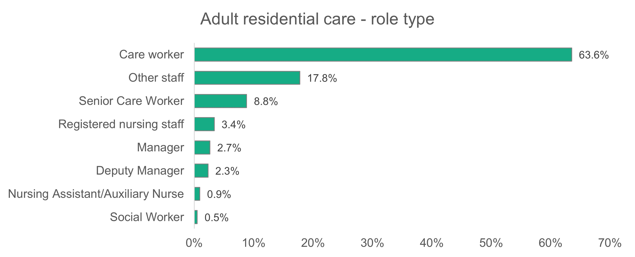

n = 14,785

* + 1. Adult residential care – gender

There are a slightly higher proportion of women working in adult residential care (83.7 per cent) compared to the general social care workforce (81.6 per cent).

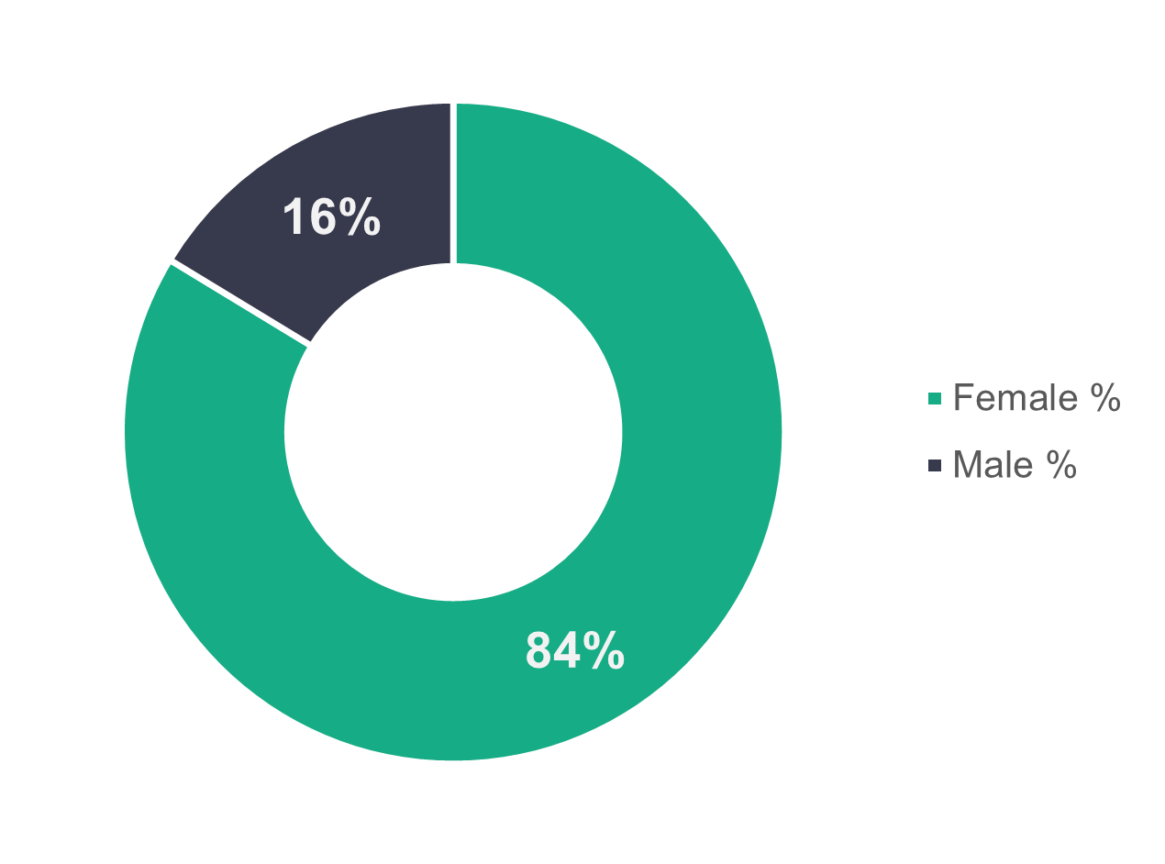

n = 14,384

* + 1. Adult residential care – age profile

Both the local authority and commissioned service workforce span the working age groups, as seen in the chart below. A higher proportion of local authority workers are over 45 years old (60.6 per cent), but we find the opposite trend for commissioned services, with a higher proportion of workers aged 45 years or under (61.4 per cent).

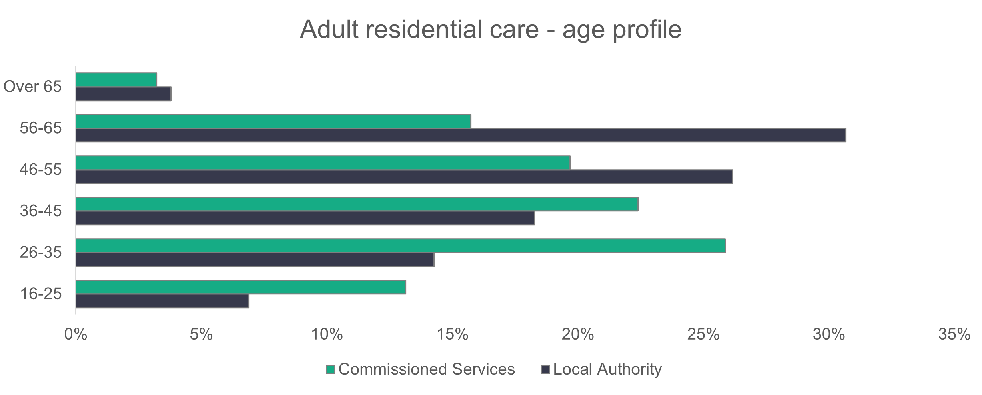

n = 13,824

* + 1. Adult residential care – ethnicity

The adult residential care workforce is ethnically more diverse than the general population of Wales. Black workers make up 5.3 per cent of the workforce, which is almost six times more than the general population of Wales. Asian workers also make up a high proportion (6.3 per cent) of the workforce. Again, this is higher than we‘d expect to see in the general population.

The adult residential care workforce is more ethnically diverse than last year, when 2.4 per cent of workers were black, 5.9 per cent Asian and 0.5 per cent mixed.

Registered nursing staff have the highest proportion of both black (11.5 per cent) and Asian (21.6 per cent) workers in adult residential care, followed by care workers (7.2 per cent black and 6.4 per cent Asian).

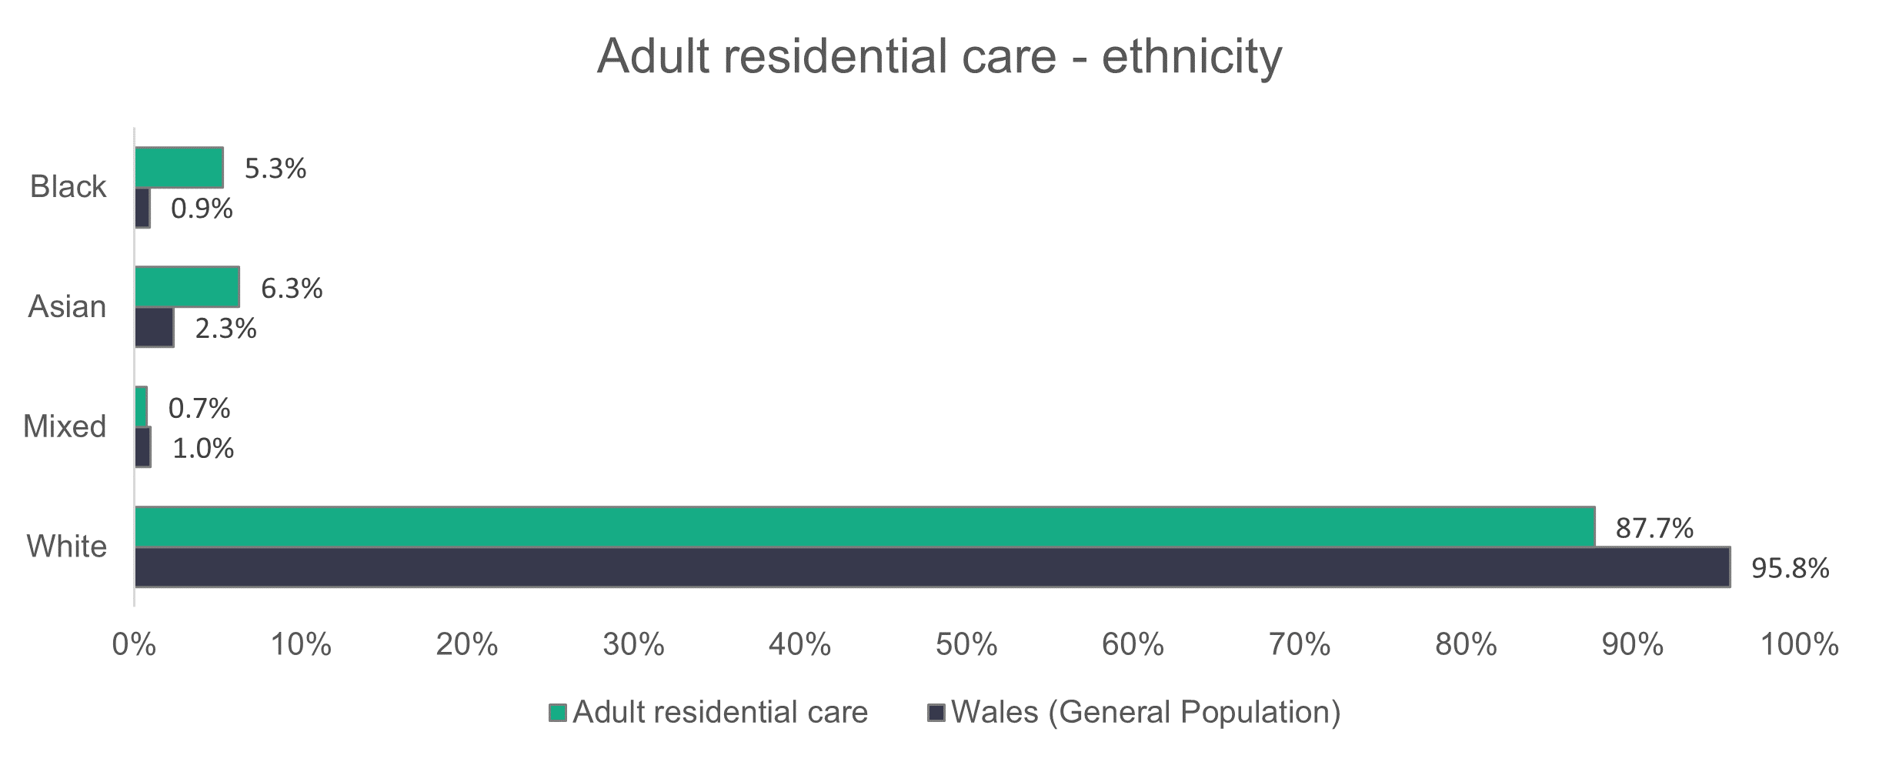

n = 9,387

* + 1. Adult residential care – contract type

Local authorities have far fewer of their workforce on permanent contracts when compared to commissioned services. Permanent contracts make up 90.8 per cent of the commissioned services workforce, while the corresponding figure for local authorities is 63.6 per cent.

A high proportion (20.4 per cent) of local authority workers are on zero-hours contracts. A higher proportion of care workers are on zero-hours contracts than any other role (24.2 per cent).

Casual contracts make up 11.4 per cent of the local authority workforce, and care workers again show the highest proportion of people on this contract type in the local authority adult residential care sector (12.4 per cent). The combined proportion of casual and zero-hours contracted adult residential care workers this year is 31.8 per cent for local authorities and five per cent for commissioned services. This is quite similar to last year (31.5 per cent and 2.4 per cent respectively).

The most noticeable difference from last year’s data is the drop in temporary contracts among people working for commissioned service providers (from 12.4 per cent in 2022 to 0.2 per cent in 2023). This is partly balanced by an increase in permanent contracts (from 82.6 per cent in 2022 to 90.8 per cent in 2023).

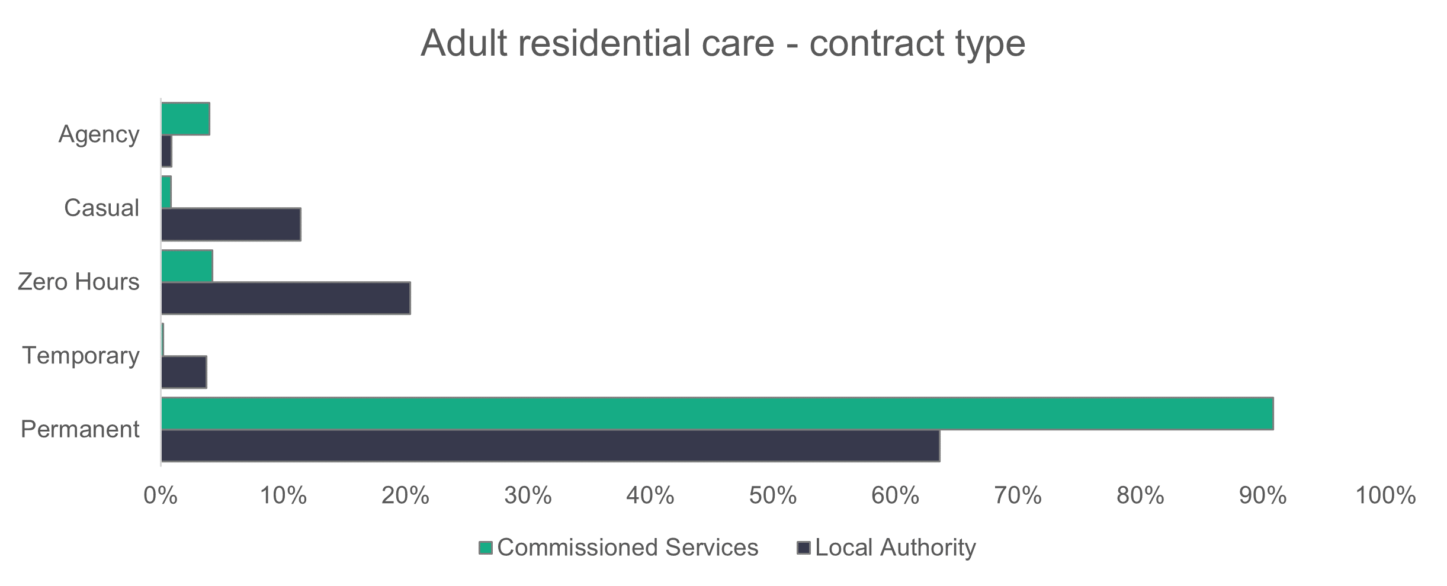

n = 14,614

* + 1. Adult residential care – working patterns

Most people working in adult residential care work part-time hours (fewer than 36 hours per week). Part-time workers account for 52.5 per cent of the commissioned service workforce and a considerably higher proportion (89.3 per cent) for local authority services.

The corresponding proportions last year showed that part-time contracts accounted for 48.6 per cent of the commissioned services workforce and 89 per cent of the local authority workforce.

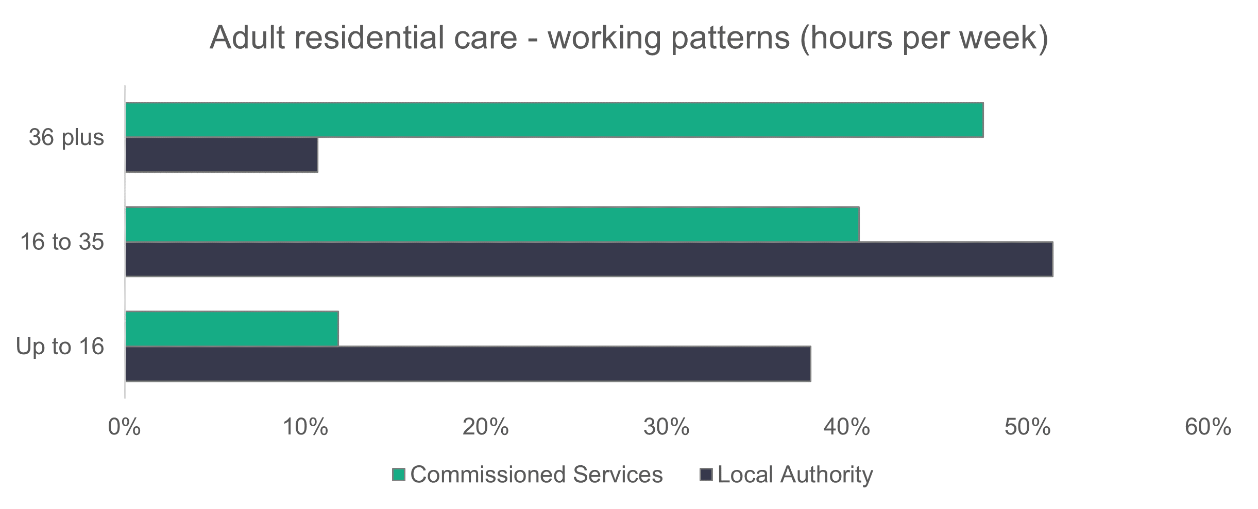

n = 14,336

* + 1. Adult residential care – vacancies

Adult residential care accounted for the second highest number of vacancies in the survey, with an estimated 1,352 vacancies. This accounts for 25.5 per cent of all vacancies across social care and means that 3.6 per cent of jobs in adult residential care were unfilled.

* 1. Domiciliary care

**Summary**:

* Care workers make up the majority (81.5 per cent) of the domiciliary care workforce.
* Women make up a higher percentage of the domiciliary care workforce (85.8 per cent) compared to the general population, although there’s been a decrease in the proportion of women compared to last year.
* Local authorities have an older workforce than commissioned services.
* The domiciliary care workforce is more ethnically diverse than the overall social care workforce. There’s been a 4.2 per cent decrease in the number of white staff compared to last year.
* A significant proportion of domiciliary care workers in commissioned services are on zero-hour contracts (31.4 per cent).
* More staff working for commissioned services work full-time hours compared to those working for local authorities.

We estimate that there are 20,040 people working in domiciliary care, which is a 2.4 per cent increase on last year’s figure of 19,571.

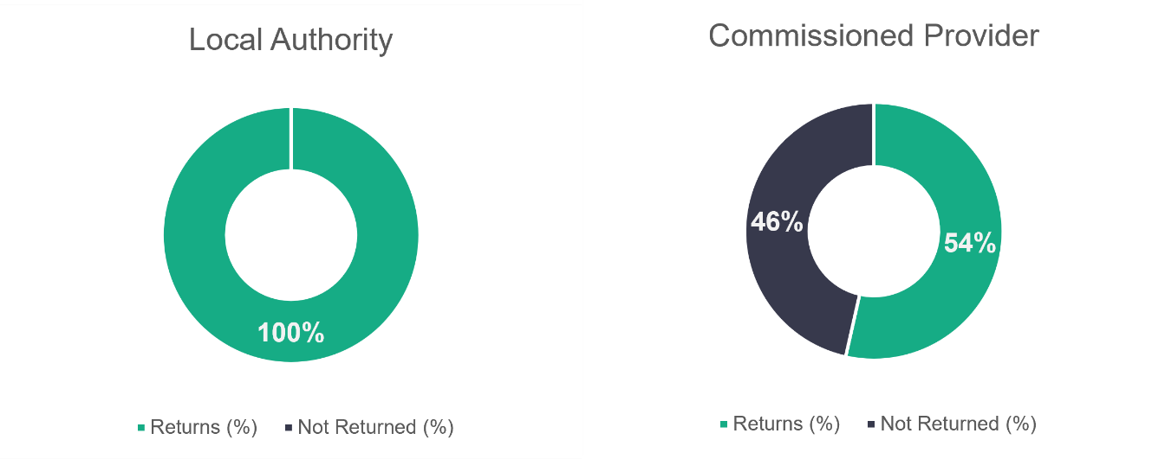

n = 22

n = 255

The return rate of 53.7 per cent among commissioned providers is lower than the 62.5 per cent returned last year (and 2021, when the return rate was 66.8 per cent).

* + 1. Domiciliary care – role type

As expected, care workers make up most of the staff in this service area, accounting for 81.5 per cent of the workforce. This is a slight increase from the 80.8 per cent we saw last year.

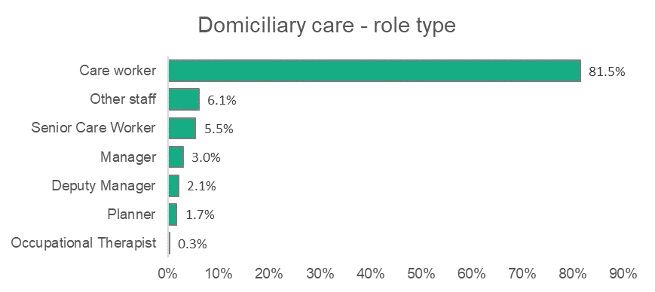

n = 12,763

* + 1. Domiciliary care – gender

The proportion of female domiciliary care workers is higher than that reported for the social care sector as a whole. We found that 85.8 per cent of the roles were occupied by women, compared to 81.6 per cent of women in the overall workforce. This is lower than the proportion (88.1 per cent) of women recorded working in domiciliary care in 2022. Eleven domiciliary care workers were reported as non-binary and a total of 473 preferred not to state their gender.

.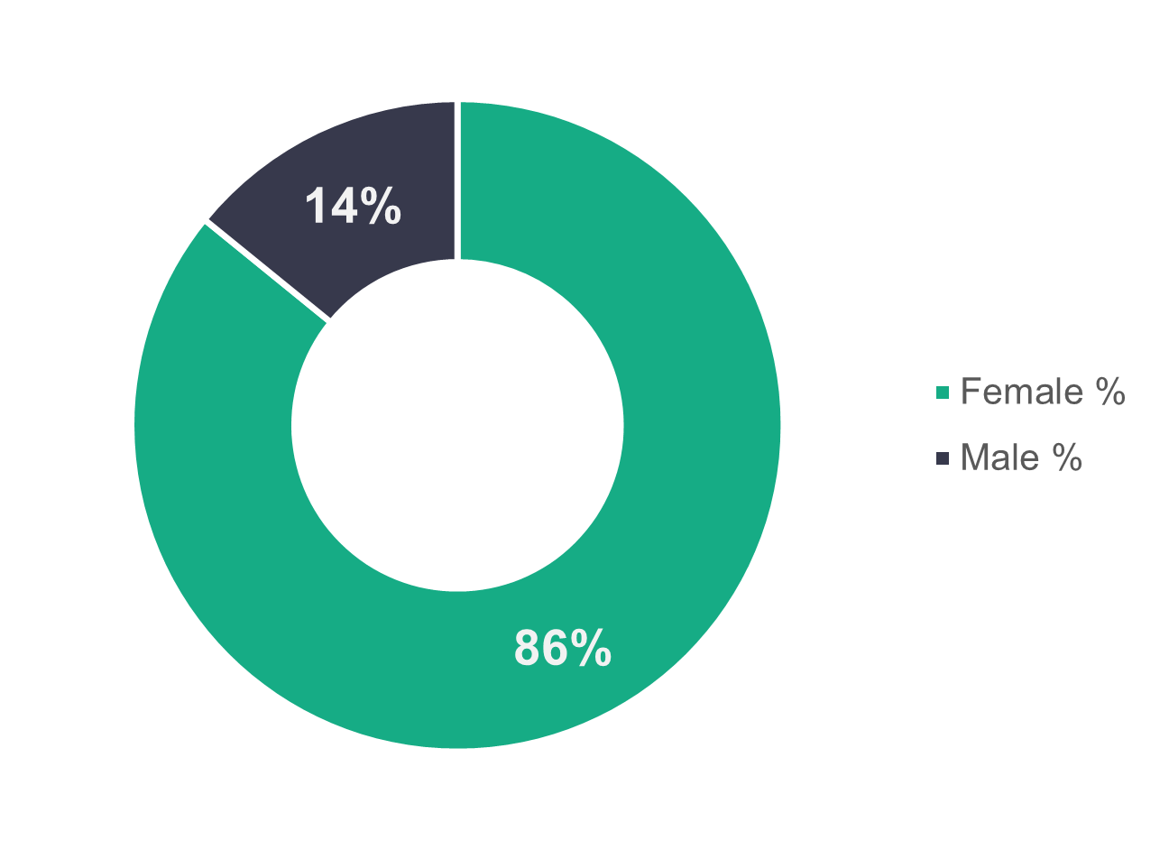

n = 11,725

* + 1. Domiciliary care – age profile

As we saw in the 2022 data, there’s a marked difference between the age profile of those working in local authority and commissioned services. As shown in the chart below, local authority workers tend to be older (46 and over) and commissioned services workers tend to be younger (45 and under).   
  
There could be several reasons for this, including differences in terms and conditions, remuneration and turnover rates.

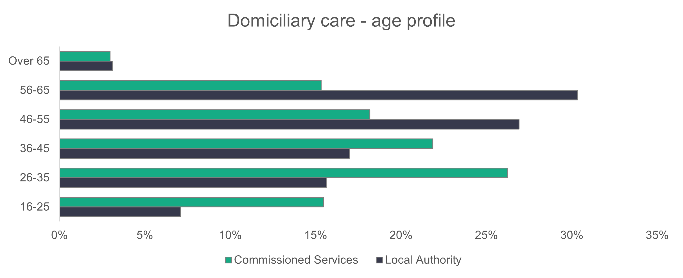

n = 11,349

* + 1. Domiciliary care – ethnicity

The domiciliary care workforce is more ethnically diverse than the general Welsh population, as well as the social care workforce as a whole. The chart below shows that 91.9 per cent of domiciliary care workers are white. The corresponding proportion in 2022 was 96.1 per cent white – a drop of 4.2 percentage points.

Due to the overwhelming proportion of staff in domiciliary care being care workers, the percentages in the chart below are dominated by this role. Removing care workers from the data shows a less diverse workforce, with 97.4 per cent of all other staff being white.

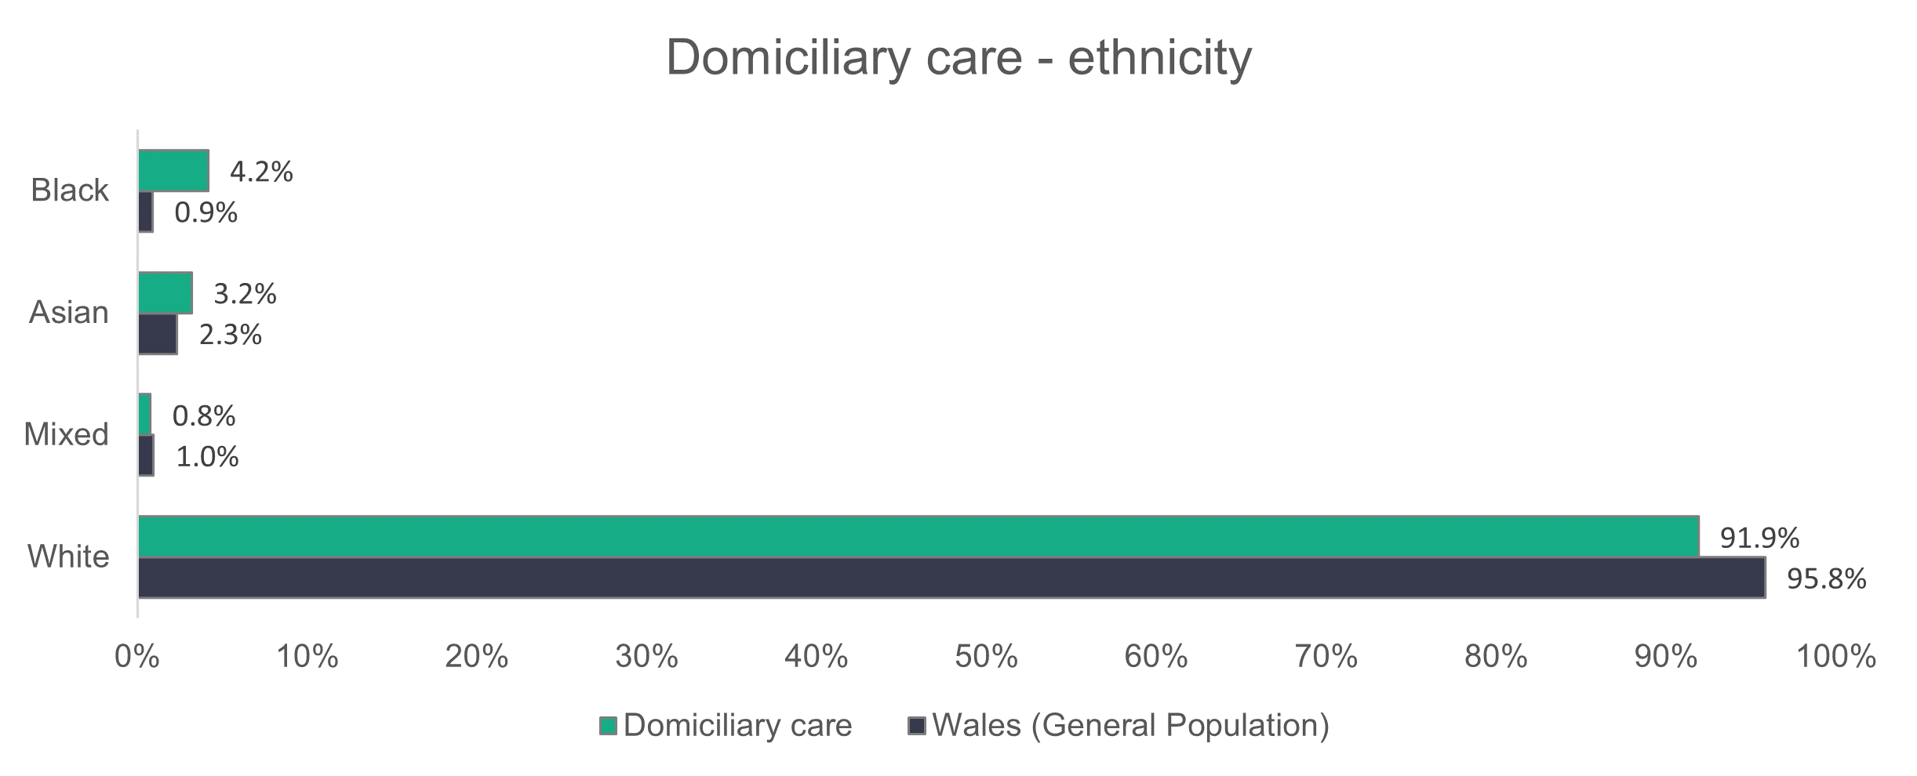

n = 8,612

* + 1. Domiciliary care – contract type

The standout feature of the chart below is the proportion of people who work for commissioned service providers who are on zero-hour contracts (31.4 per cent). This is due to the high number of care workers in this sector, with 37.5 per cent of people in that role on zero-hour contracts.

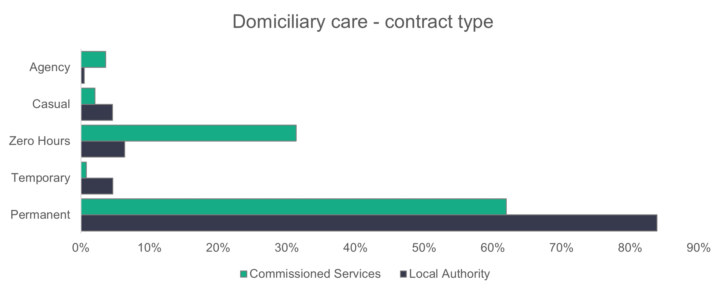

n = 11,964

* + 1. **Domiciliary care – working patterns**

The proportion of full-time workers in commissioned services (44 per cent) is over twice that seen in local authorities (20.3 per cent).

Most domiciliary care workers working for a local authority work between 16 and 35 hours per week (59.6 per cent). The corresponding proportion for commissioned care providers is 41.7 per cent.

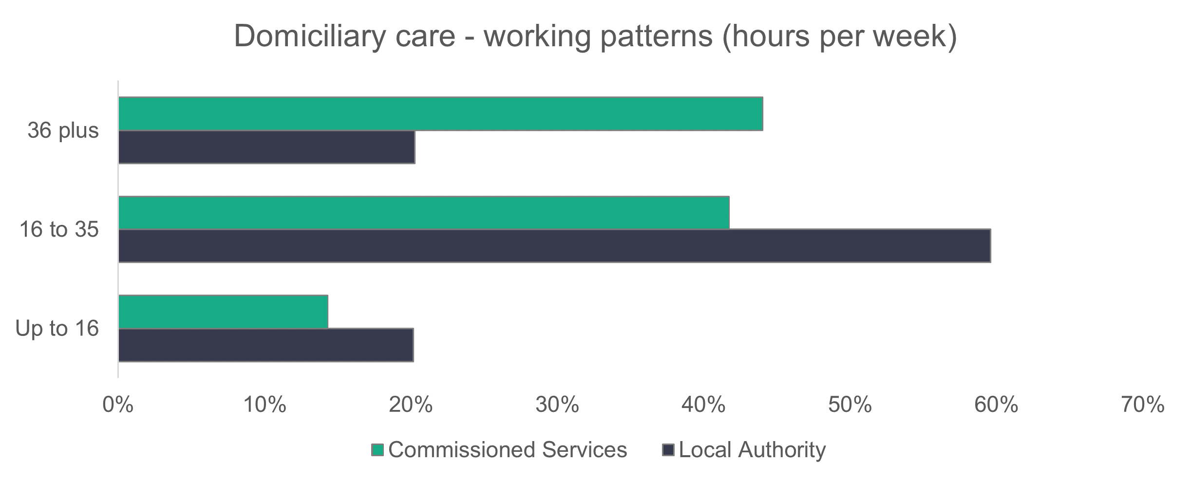

n = 11,769

* + 1. Domiciliary care – vacancies

Domiciliary care vacancies make up more than 37.1 per cent of the total vacancies in social care in Wales, representing an estimated 1,966 vacancies. This is the highest number of vacancies in any service in social care in Wales, despite it being the second largest service. About 8.9 per cent of roles are unfilled.

* 1. Day services

**Summary:**

* There’s been a 4.9 percentage point increase from last year in the proportion of senior care workers in day services.
* There’s a significantly higher proportion (26.3 per cent) of men who work in day services when compared to the overall social care workforce.
* The day services workforce is less ethnically diverse than the general population of Wales. Diversity has also decreased since last year in day services.
* Most employees, in both local authorities and commissioned services, work part-time hours.

We estimate that there are 2,687 workers in day services, which is a drop of nine per cent on last year’s estimation of 2,954 workers.

This year’s commissioned services return rates (94.7 per cent) are similar to last year (94.1 per cent), with a high number of commissioned services providing us with data. 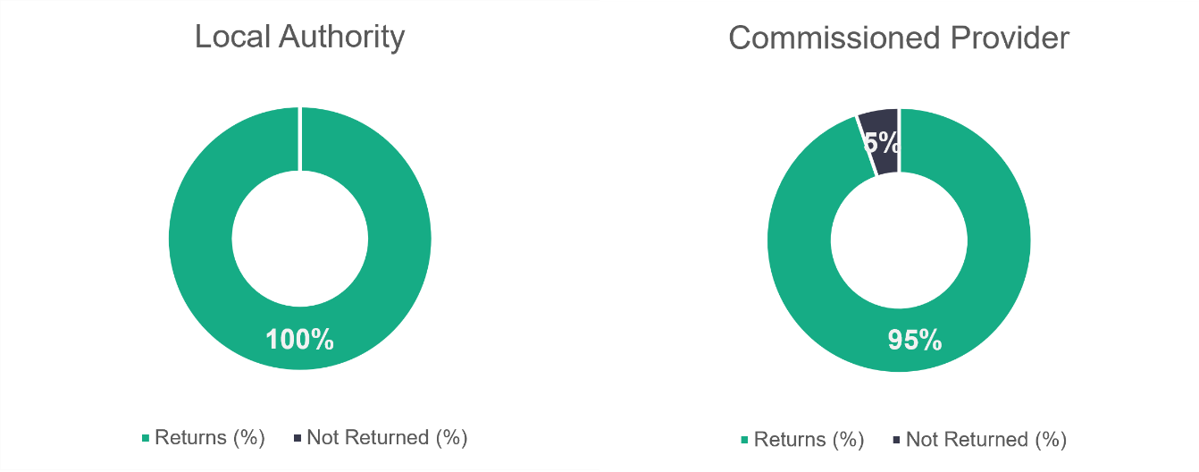

n = 21

n = 19

* + 1. Day services – role type

The distribution of day services roles is quite similar to last year’s data. Last year, care workers made up 60.5 per cent of the roles, compared to 59.9 per cent this year. The biggest difference is in the senior care worker role, which has seen a proportional increase from 8.8 per cent of the day services workforce last year to 13.7 per cent this year.

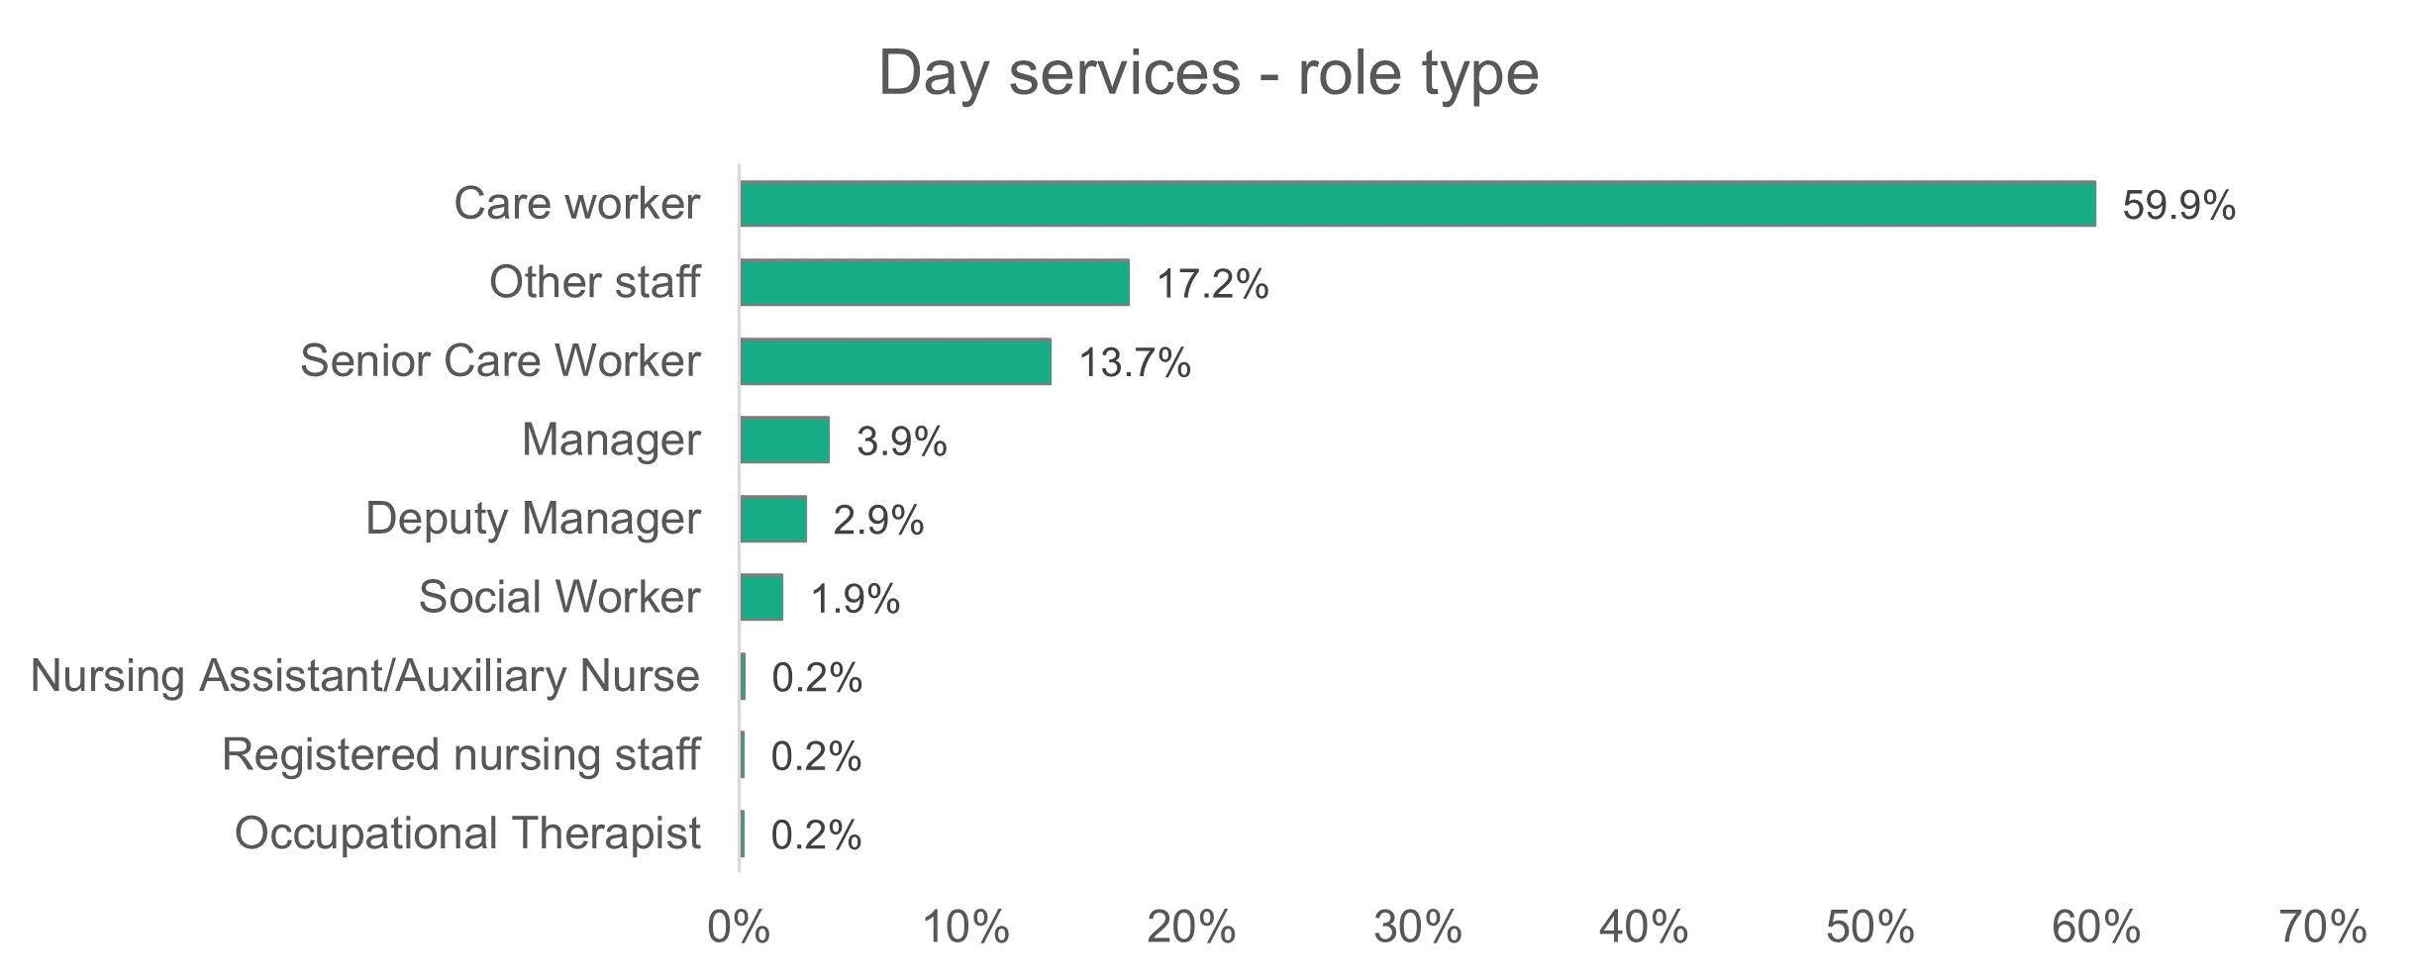

n = 2,644

* + 1. Day services – gender

In comparison to the overall social care workforce of Wales, men make up a significantly higher proportion (26.3 per cent) of the day services’ workforce – the overall social care workforce is only 18.4 per cent male.

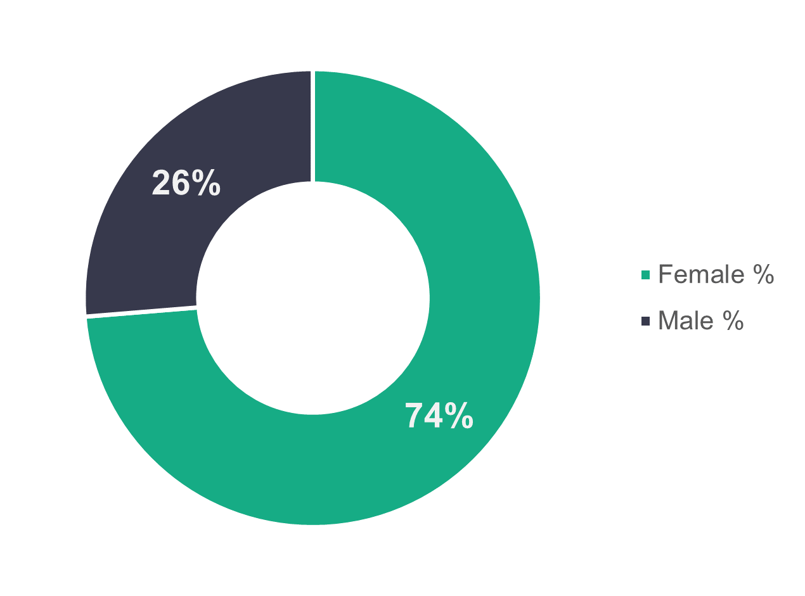

n = 2,643

* + 1. Day services – age profile

There’s a clear separation of age groups between commissioned services and local authorities. Commissioned services are dominated by a younger 26 to 45 age group, which makes up 63.2 per cent of the workforce. Local authorities, meanwhile, are dominated by an older 46 to 65 age group, at 60.1 per cent. This is in line with our 2022 report, but the proportion of older workers in comparison to younger workers is more marked this year.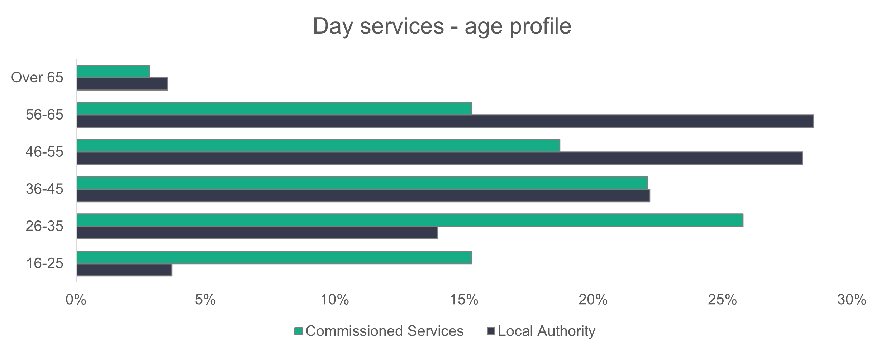

n = 2,643

* + 1. Day services – ethnicity

The day services workforce is less ethnically diverse than the general population of Wales, with 98.4 per cent of workers recorded as white. Last year, our data showed that the ethnicity of the day services workforce was quite similar (96.2 per cent recorded as white) to the Welsh population.

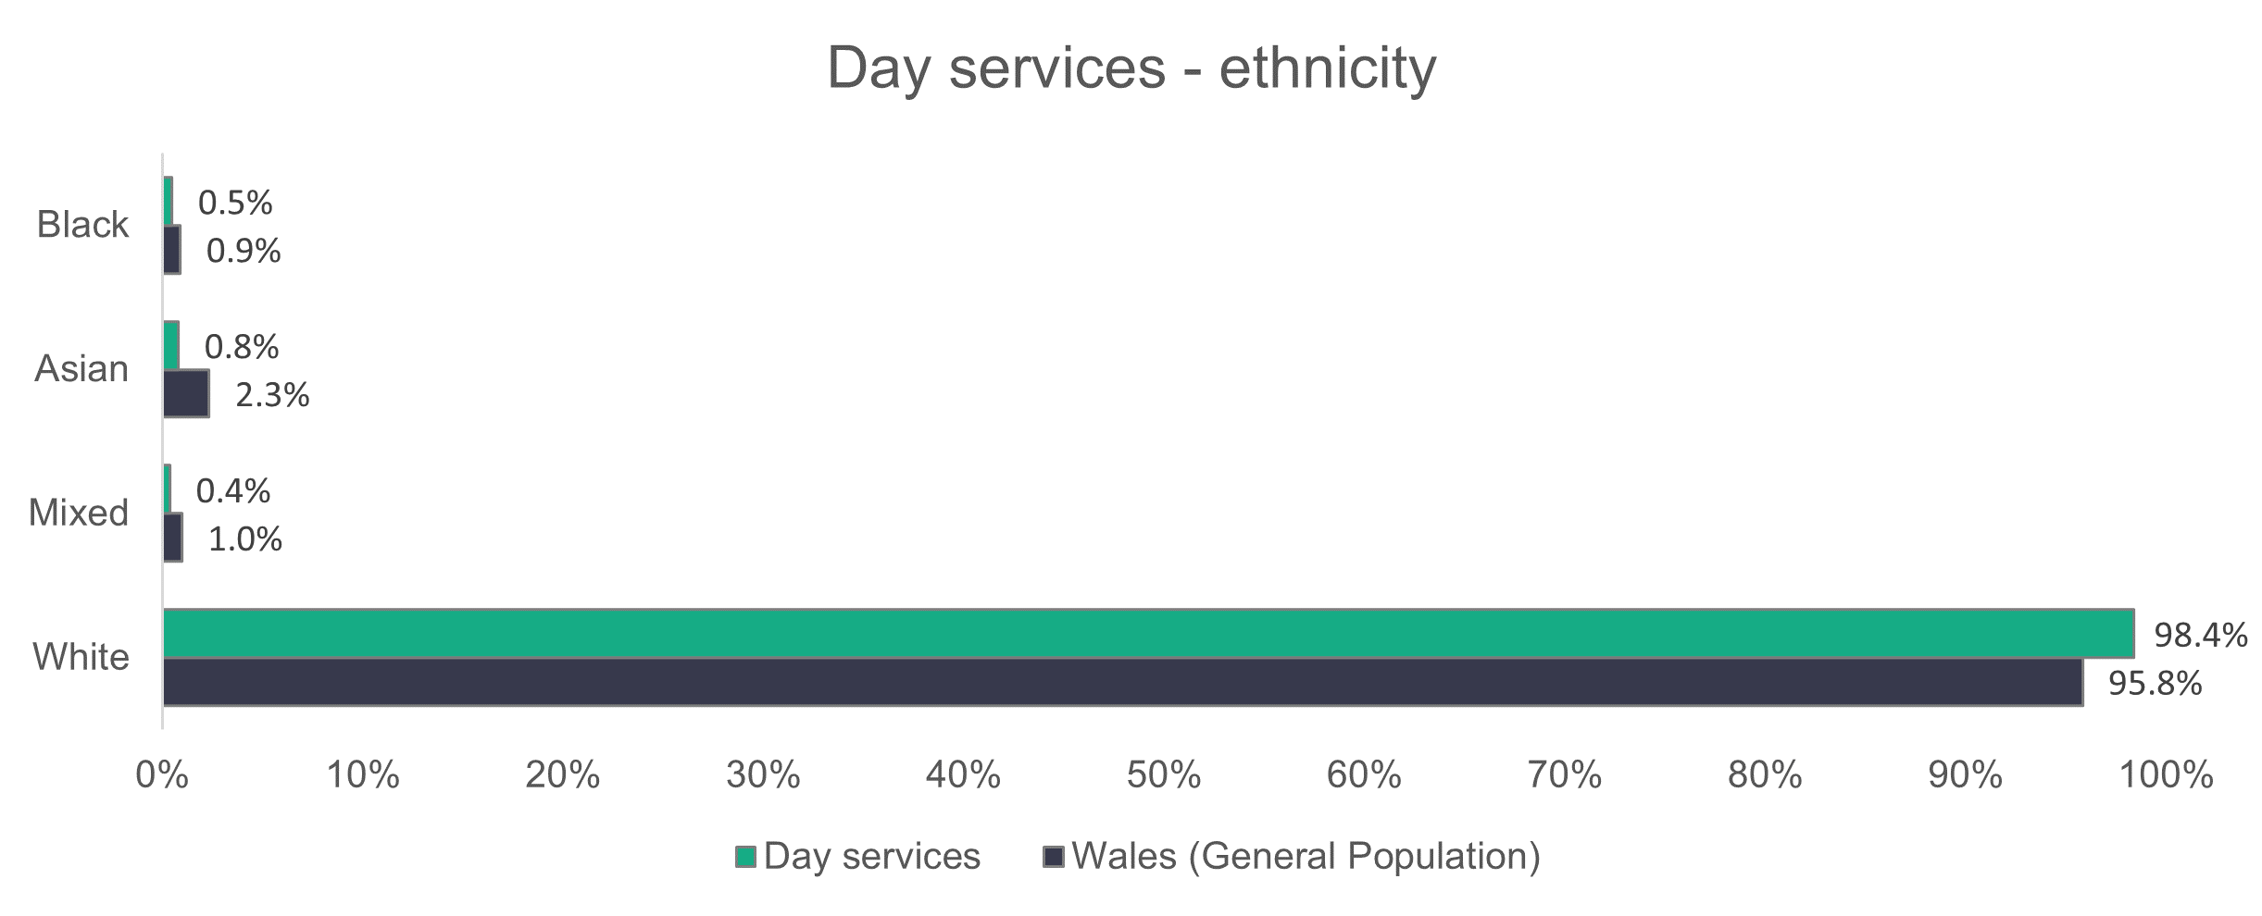

n = 1,901

* + 1. Day services – contract type

Proportionally, more staff are employed on permanent contracts in both commissioned services (84.2 per cent) and local authorities (74.7 per cent) in comparison to the sector as a whole.

Temporary contracts make up a significant 13.8 per cent of local authorities’ contracts.

In commissioned service providers, 7.2 per cent of day service workers are employed on a zero-hours or casual contract, compared to 10.3 per cent of day service workers in local authorities.

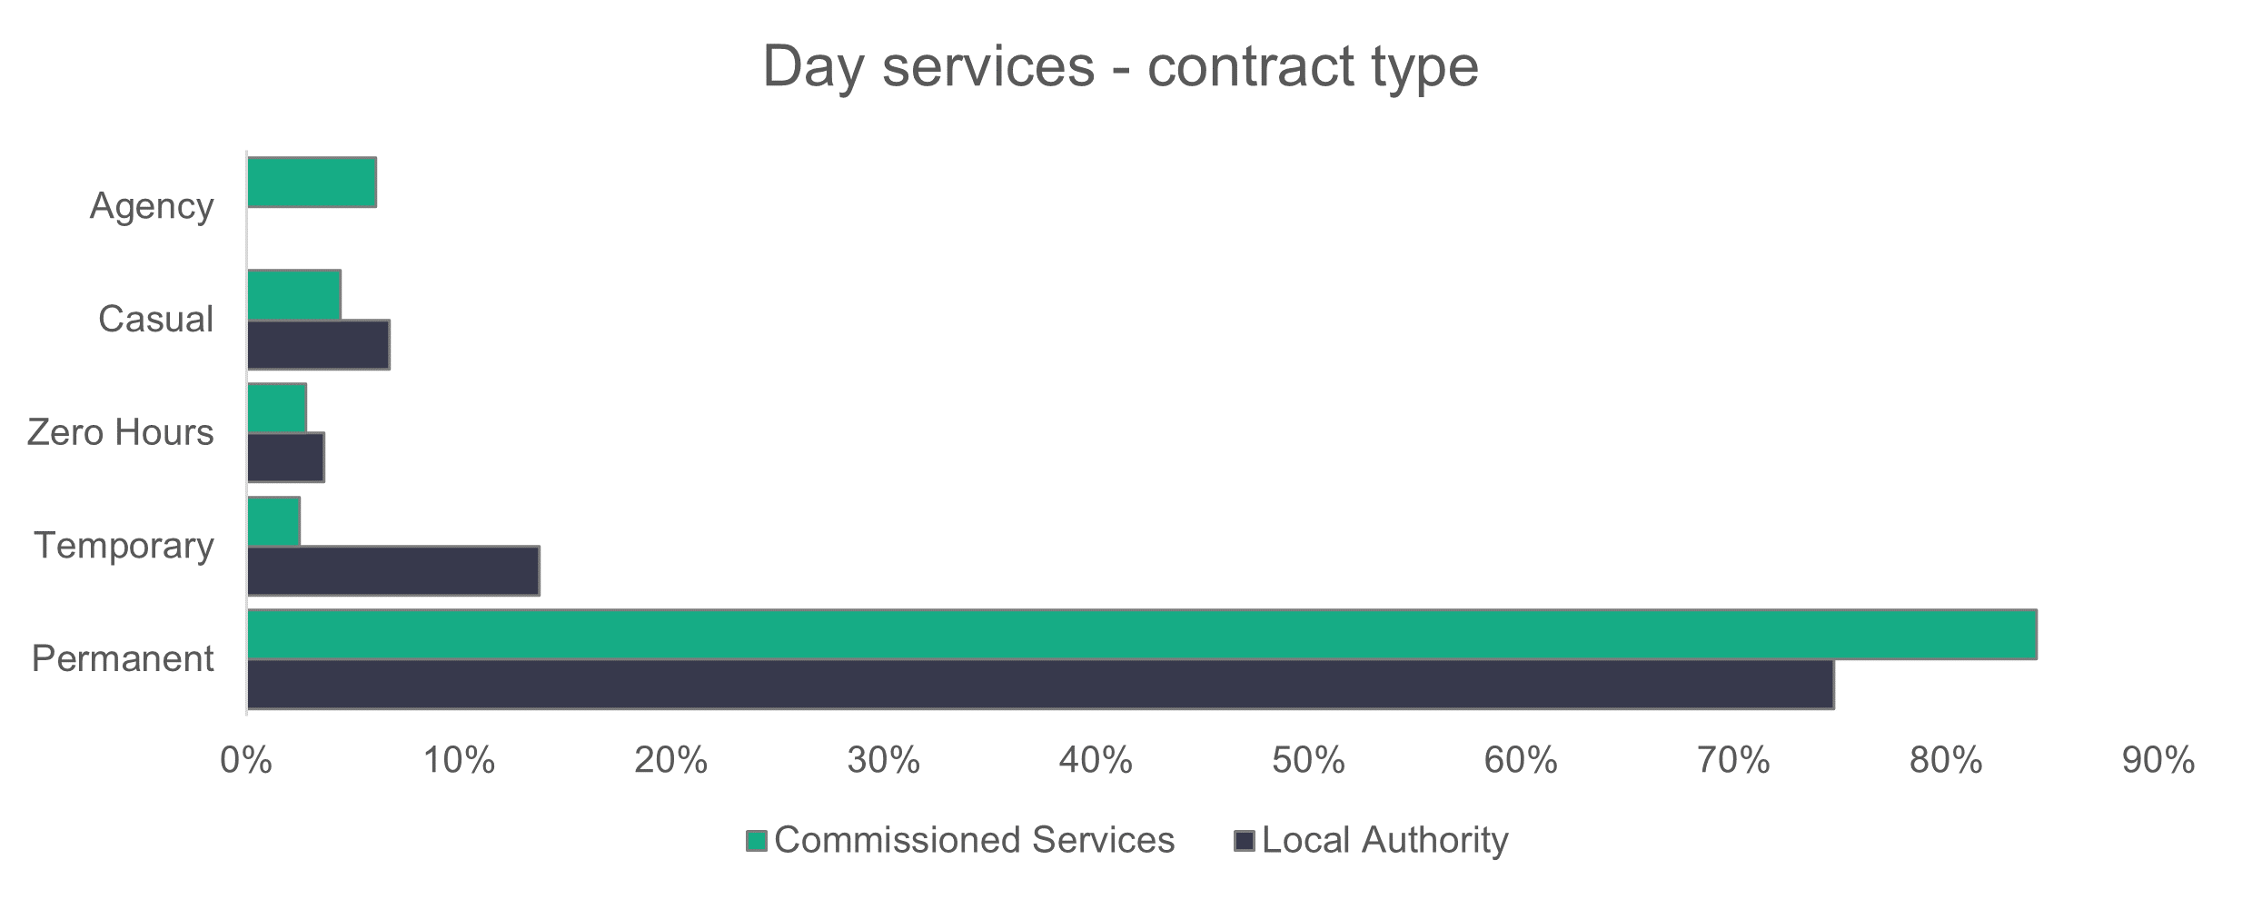

n = 2,666

* + 1. Day services – working patterns

Overall, most employees in both local authority (53.3 per cent) and commissioned services (55.3 per cent) work part-time hours (35 or fewer per week).

Compared to last year, more people who work for commissioned service providers are working up to 16 hours per week (13.2 per cent, compared to 6.9 per cent in 2022). The opposite is found for local authorities, with 17.9 per cent working up to 16 hours a week, compared to 20.7 per cent in 2022.

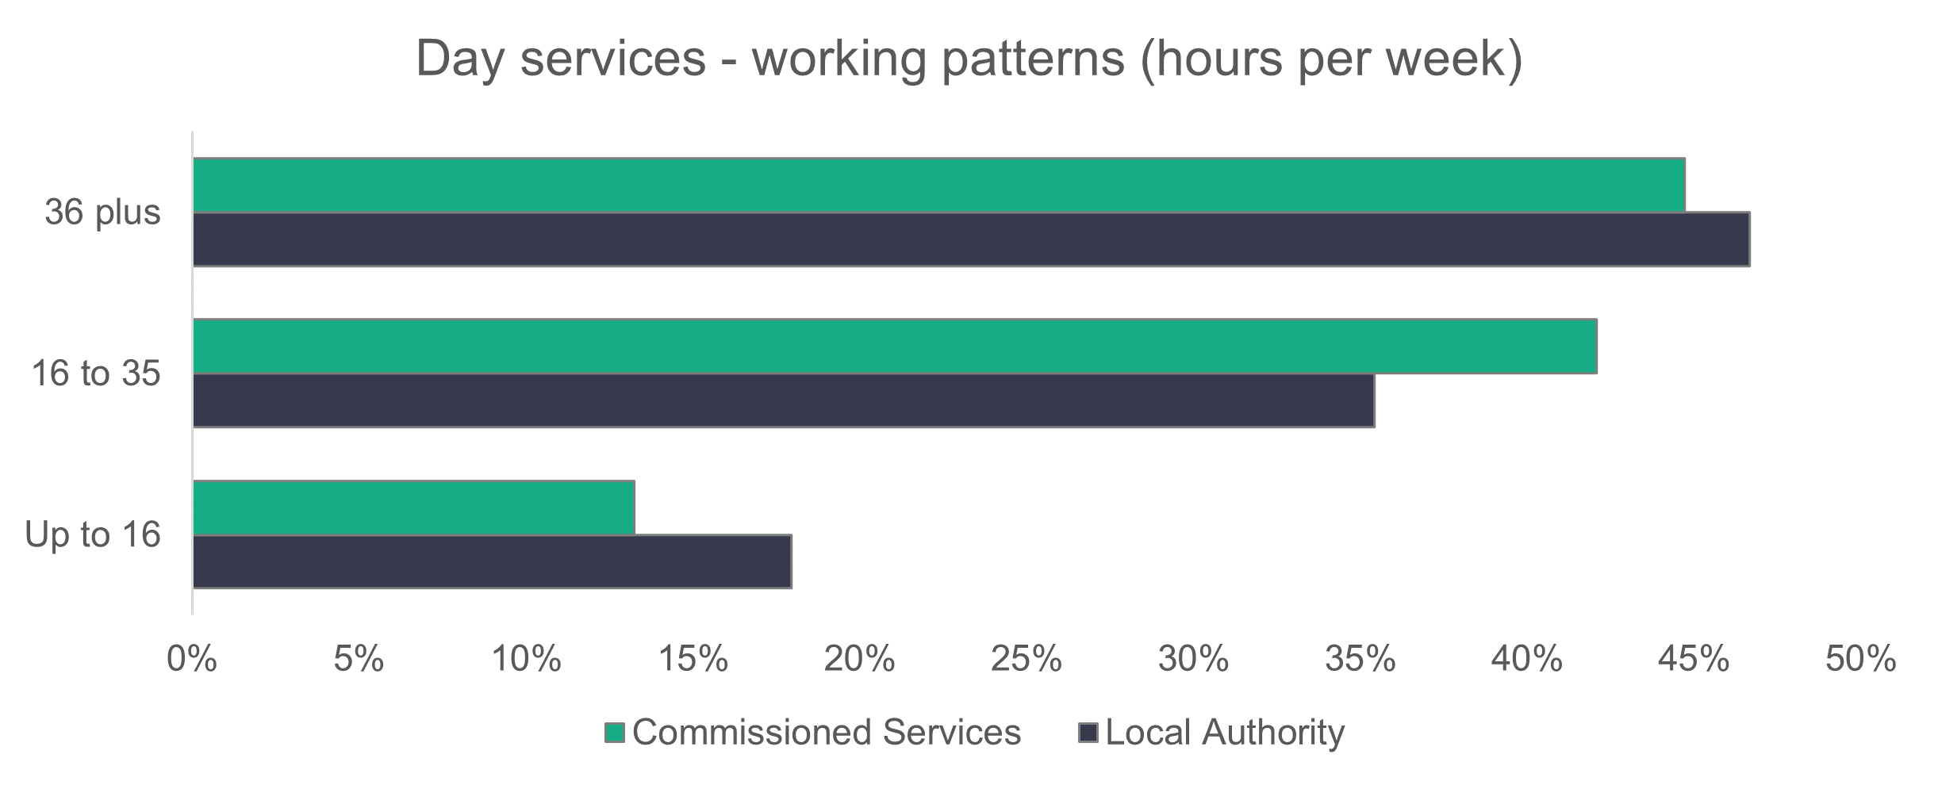

n = 2,597

* + 1. Day services – vacancies

There are 171 vacancies in day services, which means that 6.4 per cent of jobs in day services were unfilled.

* 1. Supported living services

**Summary:**

* A higher proportion of the staff are care workers compared to last year – a 6.4 per cent increase from 79.4 per cent in 2022 to 85.8 per cent in 2023.
* As was recorded last year, a majority of 65.1 per cent of local authority-employed supported living staff are over 46 years old.
* A higher proportion of supported living staff are black (eight per cent) compared to the social care workforce as a whole.
* Casual contracts make up 17.1 per cent of the local authority supported living workforce.

We estimate that there are 7,314 people working in supported living services, with 1,067 employed in local authorities and 6,247 in commissioned service providers. Last year’s estimation was a workforce of 6,893 (970 in local authorities and 5,923 in commissioned services).

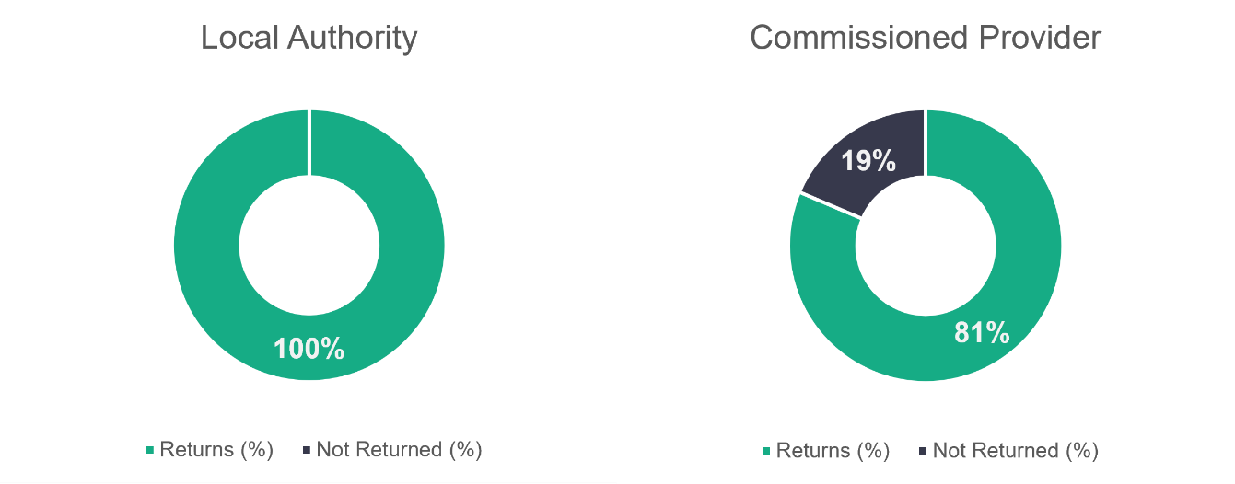

n = 14

n = 43

The return rate of 81 per cent for commissioned services is down from last year’s 90 per cent return rate.

* + 1. Supported living services – role type

Care workers make up 85.8 per cent of the supported living services workforce, as shown in the following chart. This is an increase of 6.4 per cent compared to last year, when 79.4 per cent of the supported living workforce were care workers.

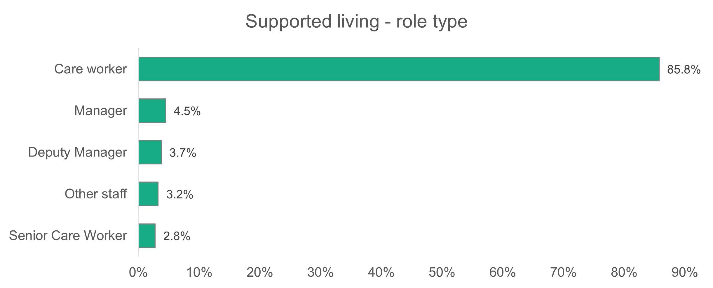

n = 6,601

* + 1. Supported living services – gender

Women make up 76 per cent of the supported living services workforce. This is lower than we’d see generally in social care in Wales, but it’s very similar to the 75.3 per cent recorded last year.

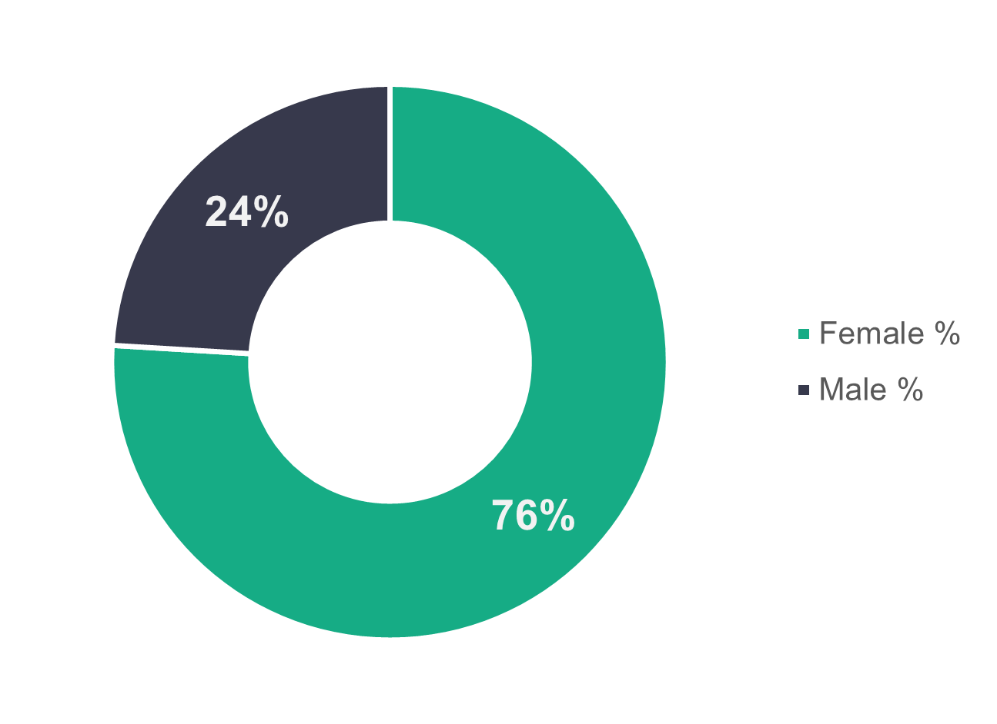

n = 6,317

* + 1. Supported living services – age profile

Similar to last year, local authorities have an older supported living workforce, with 65.1 per cent aged 46 or older. Those aged 25 or under were more than twice as likely to work in commissioned services than in a local authority supported living scheme.

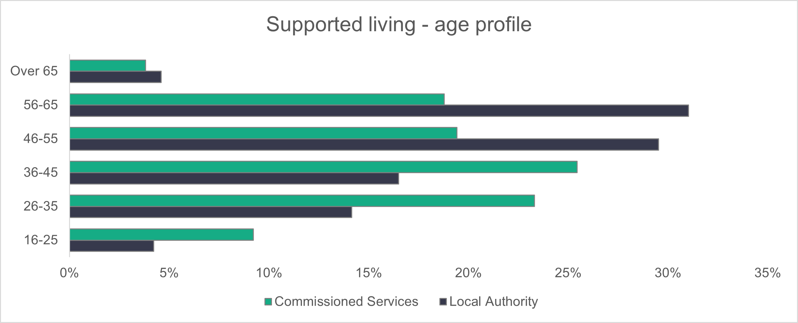

n = 5,974

* + 1. Supported living services – ethnicity

Supported living services are considerably more ethnically diverse than the general Welsh population, with almost nine times the proportion of black people.  
  
Care workers make up almost nine in 10 of the supported living workforce. Among those care workers, 9.3 per cent are black and 87.7 per cent are white.

For all other roles combined, with care workers removed, we find that 98.2 per cent of the workforce is white and 0.7 per cent black.

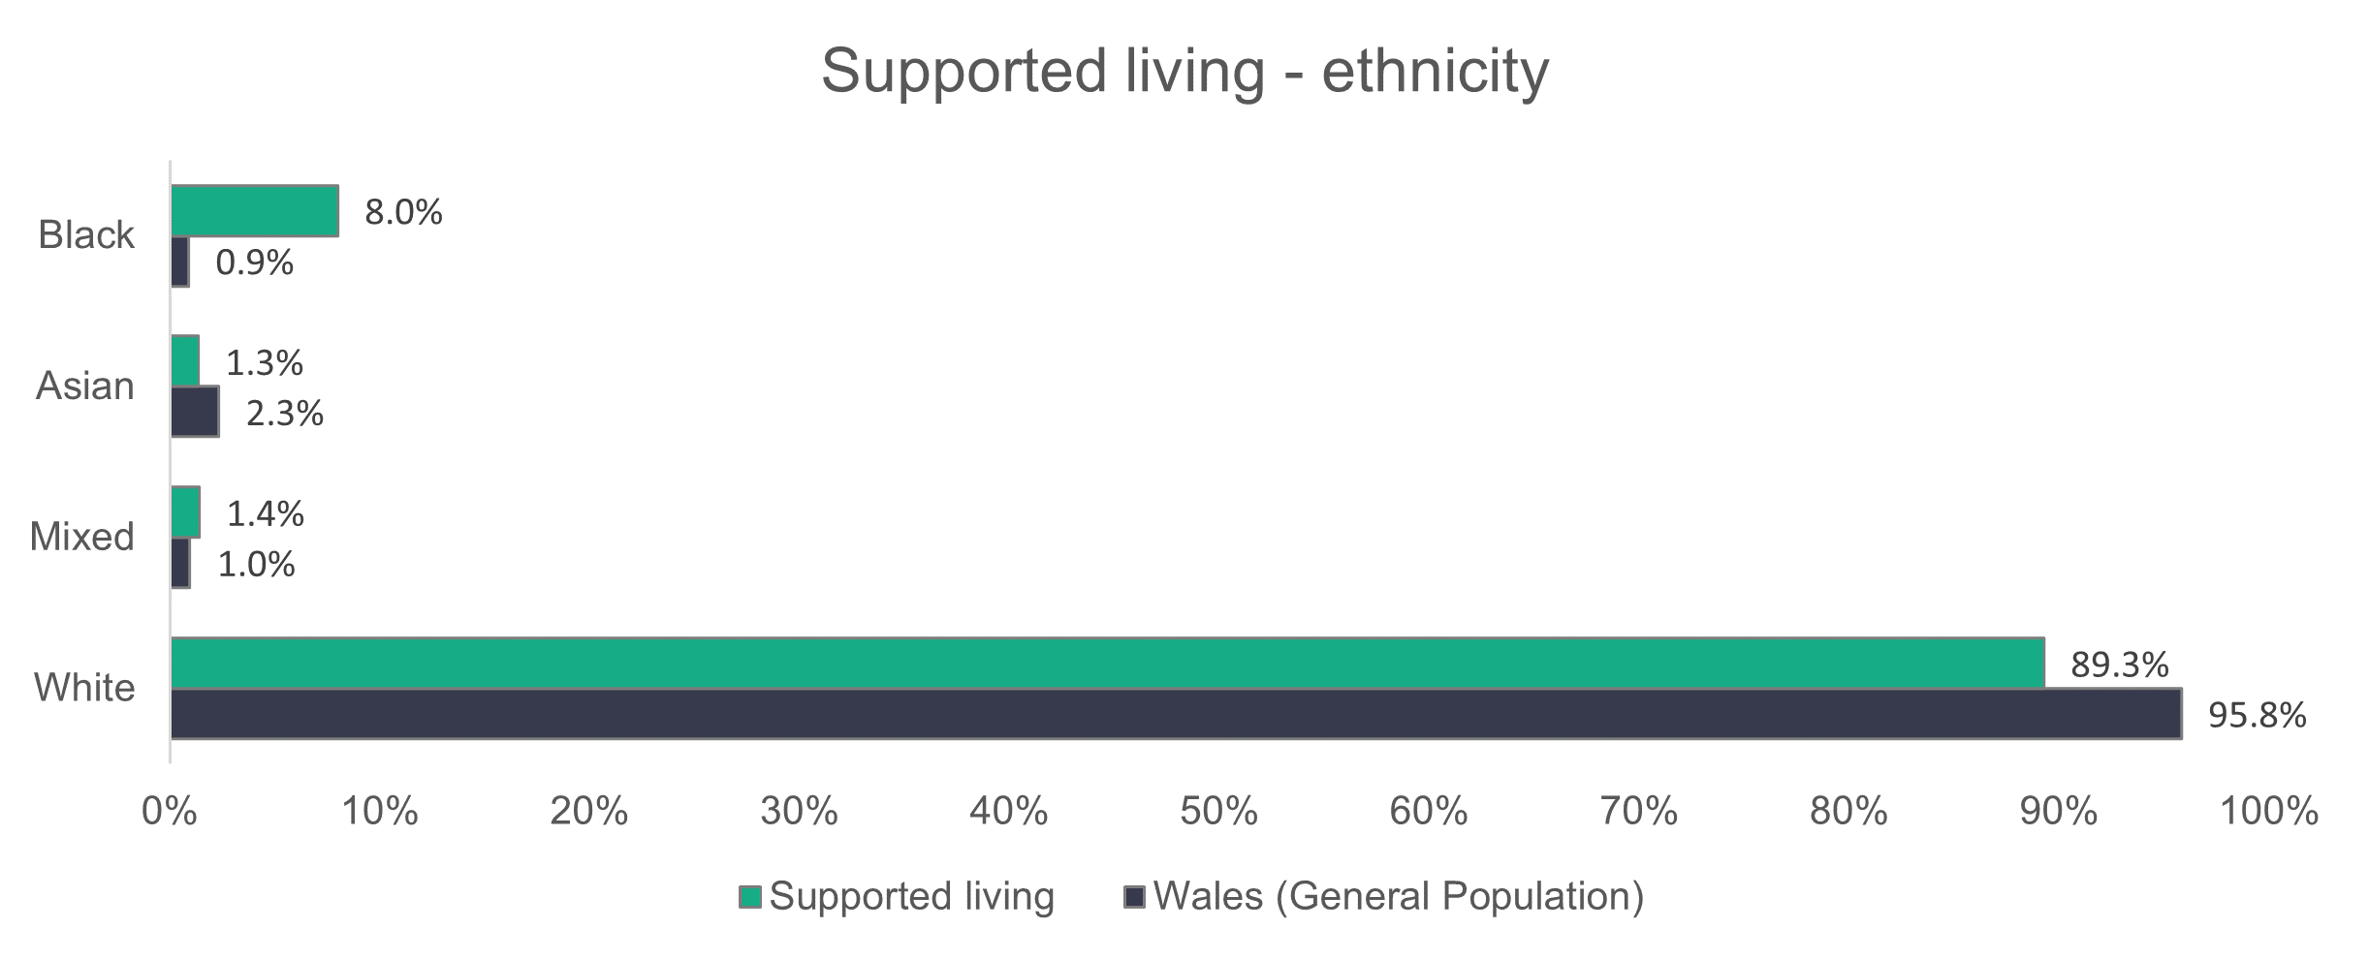

n = 4,458

* + 1. Supported living services – contract type

The standout feature of the chart below is that casual staff make up 17.1 per cent of supported living contracts in local authorities.

In 2022 casual staff and zero hours were a combined category. So that we can compare to last year's data, we‘ve combined the two fields here and can see a drop in the proportion of workers on casual or zero-hours contracts. The figure falls from 24.3 per cent in 2022 to 19.7 per cent in 2023 for local authorities, and from 4.4 per cent to 3.8 per cent for commissioned service providers.

Most supported living service workers are employed on permanent contracts. This is the case for 93.4 per cent of people employed in commissioned services and 74.9 per cent of those employed directly by local authorities. There’s been a 4.7 per cent increase in the number of people working for a local authority on a permanent contract compared to 2022.

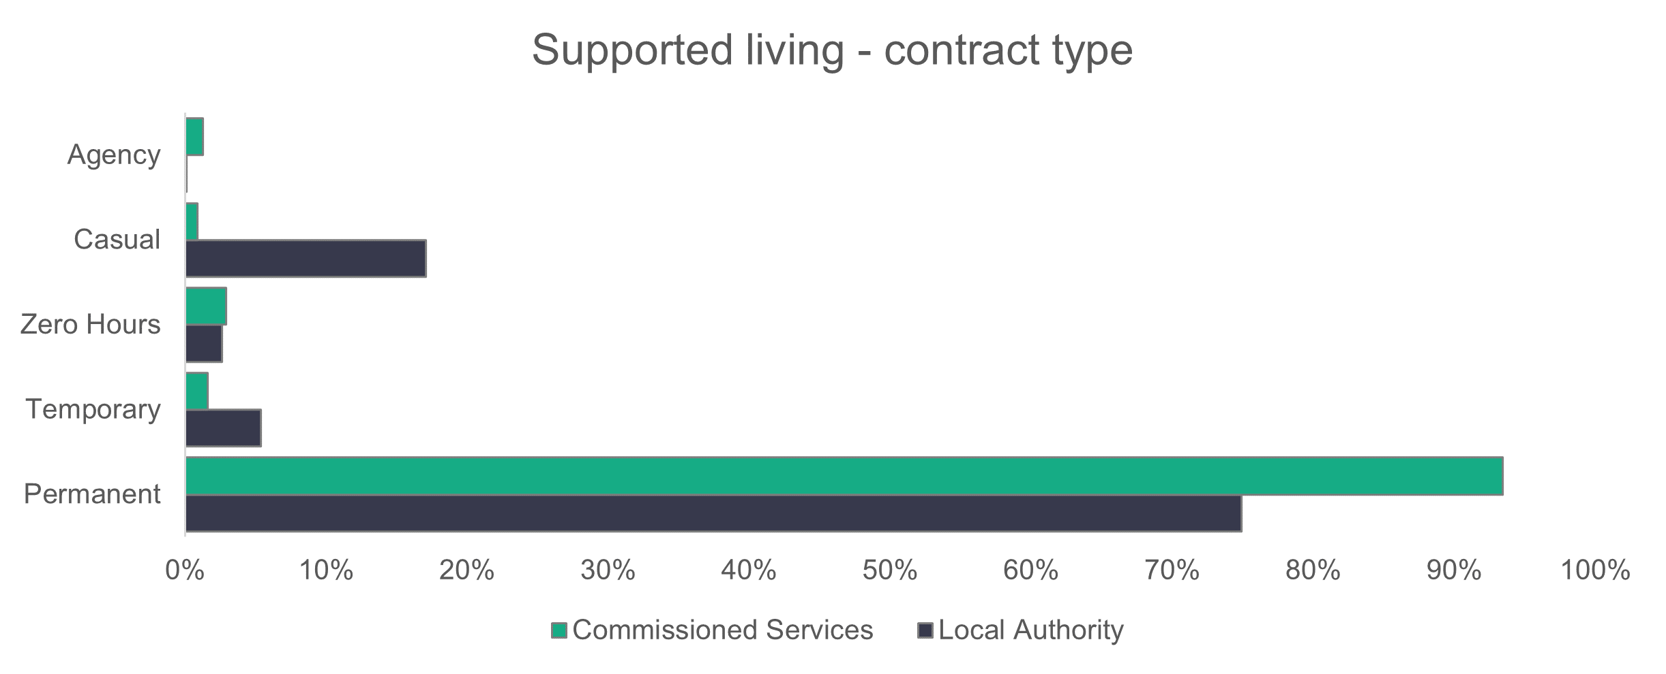

n = 6,628

* + 1. Supported living services – working patterns

Over half (50.2 per cent) of the workers in the commissioned services sector work full-time hours. The corresponding figure for local authorities is 30.6 per cent. This is a slight increase for both commissioned services and local authorities compared to last year. A much bigger proportion of people work fewer than 16 hours in local authorities compared to commissioned services.

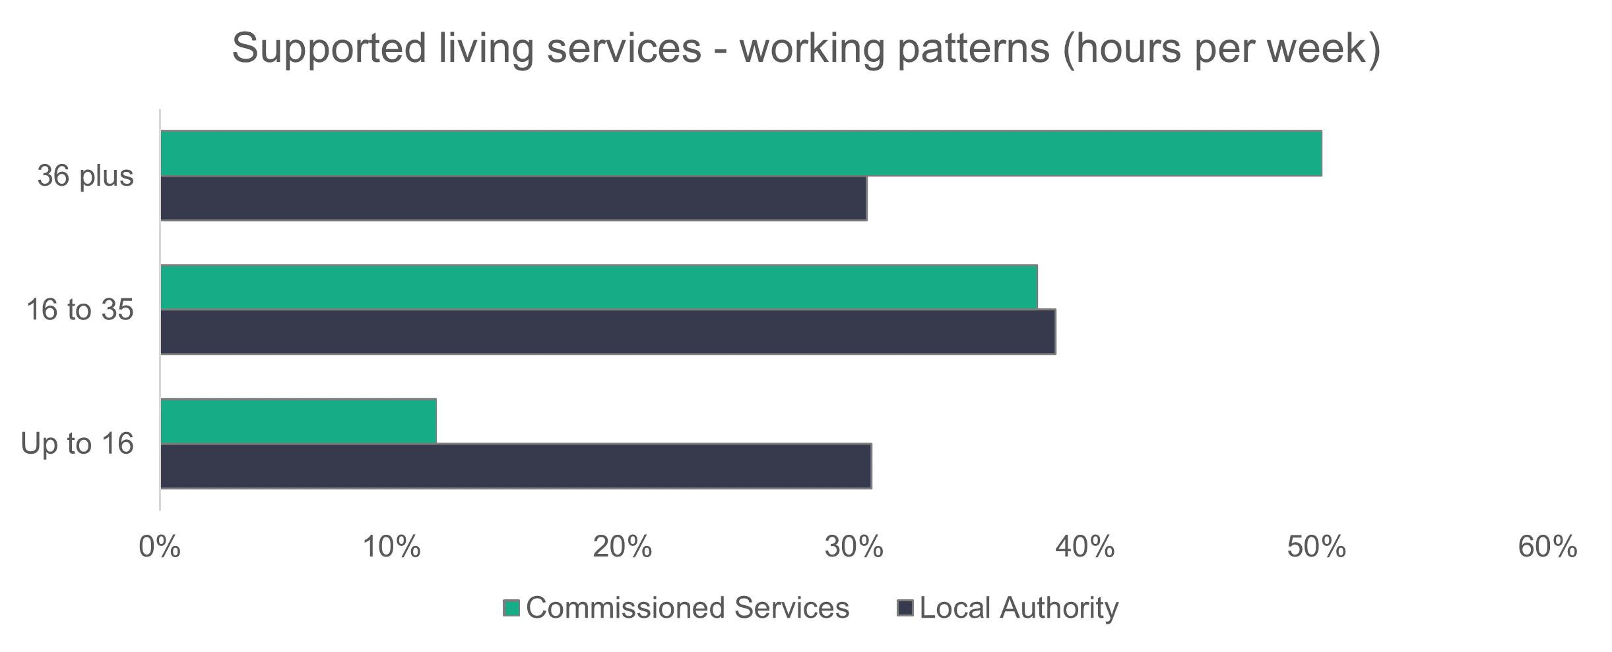

n = 6,283

* + 1. Supported living - vacancies

There are 474 vacancies in supported living services. This means that 6.5 per cent of jobs in adult supported living services were unfilled. There are 240 fewer vacancies this year compared to last year.

* 1. Social work teams

**Summary:**

* There are 4,391 registered social workers in frontline social work teams, which is an increase of 210 compared to last year.
* Almost half of social workers (46.7 per cent) have been qualified for three years or longer.
* The proportion of white workers is one per cent higher than the Welsh population.
* A high proportion of 72.6 per cent of frontline workers work full-time.

There are 9,456 workers in social work teams (28 in commissioned services), and we received data from all local authorities and commissioned services.

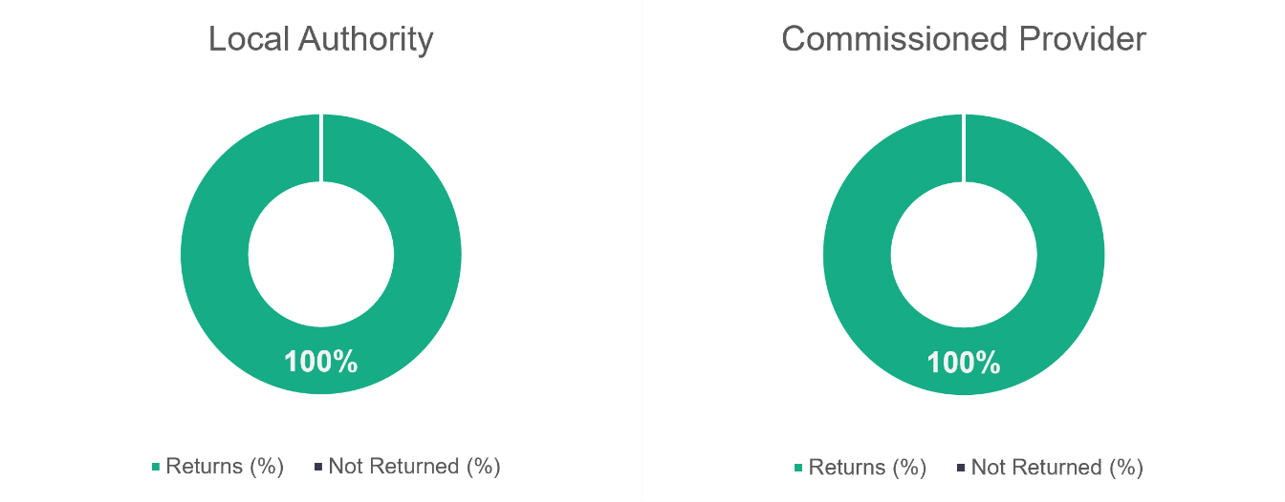

n = 4

n = 22

* + 1. Social work teams – role type

There are 4,391 registered social workers, accounting for 46.4 per cent of the social work teams workforce. There are 210 more social workers in frontline social work teams compared to last year, but the proportion of social workers in the social work teams workforce has decreased slightly.

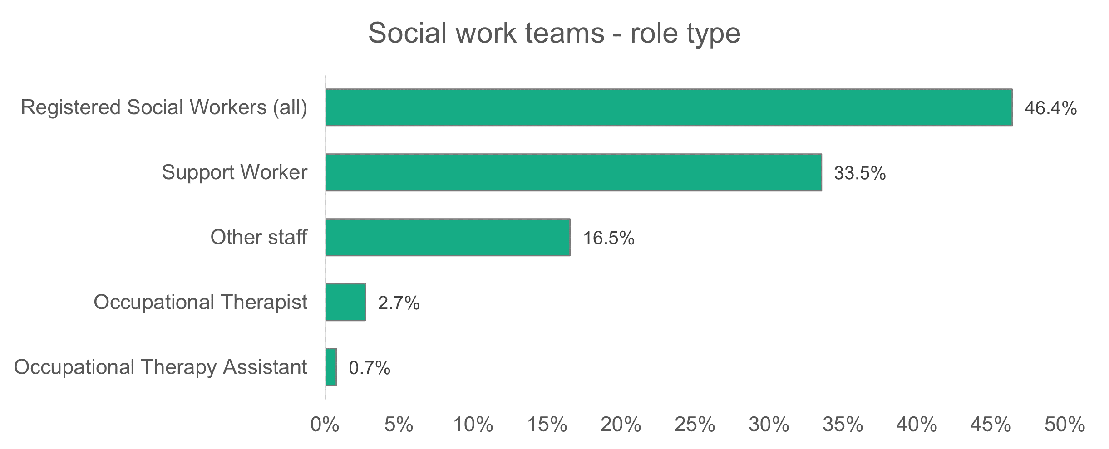

n = 9,456

The experience level of the social work teams is shown on the graph below.

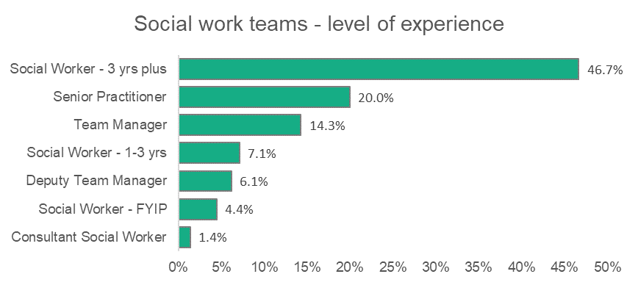

n = 4,391

Nearly half of all social workers (46.7 per cent) reported have been qualified for three years or longer, with a further 20 per cent working in senior practitioner roles and 20.4 per cent in managerial roles. Newly qualified social workers (first year in practice) make up 4.4 per cent of the total number of registered social workers employed in frontline services.  

* + 1. Social work teams – gender

The proportion of male and female workers has not changed from last year, with women occupying most posts at 85 per cent.

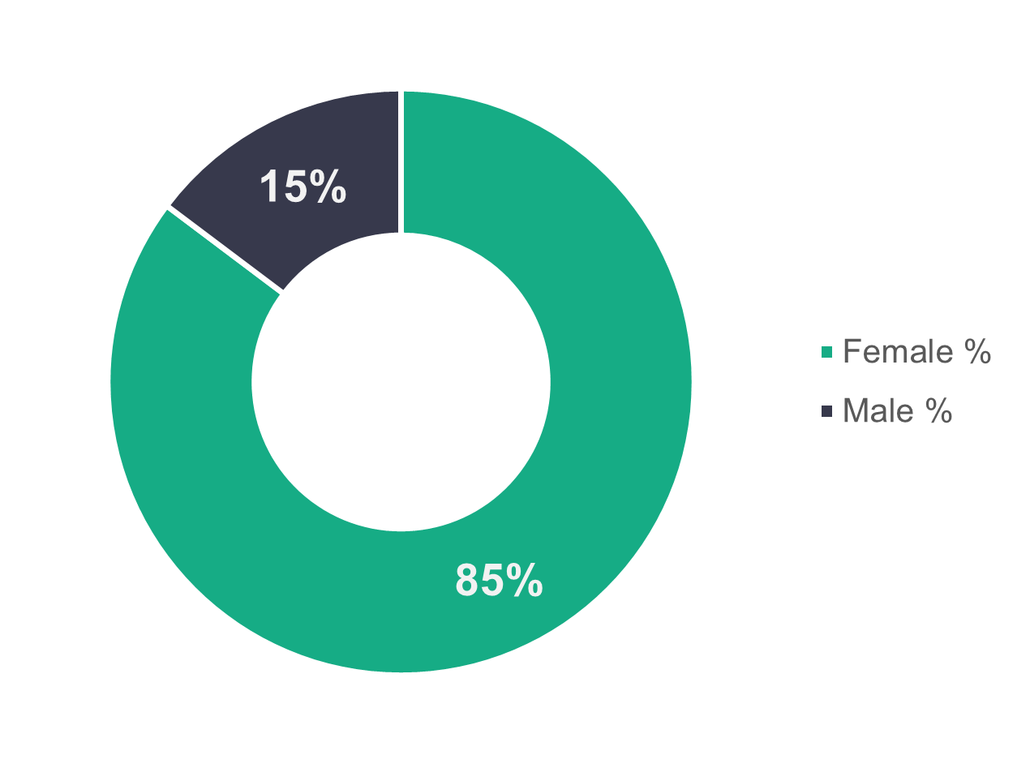

n = 9,445

* + 1. Social work teams – age profile

For the chart below and in the other social work teams subsections, we haven’t separated the data into ‘commissioned services’ and ‘local authorities’ because there are only 28 staff in commissioned services in this category.

The 36 to 45 age group has most workers, with 28.3 per cent in this age range. Indeed, 56.8 per cent of the workforce is aged 45 or under (54.3 per cent of the general social care workforce is aged 45 or under).

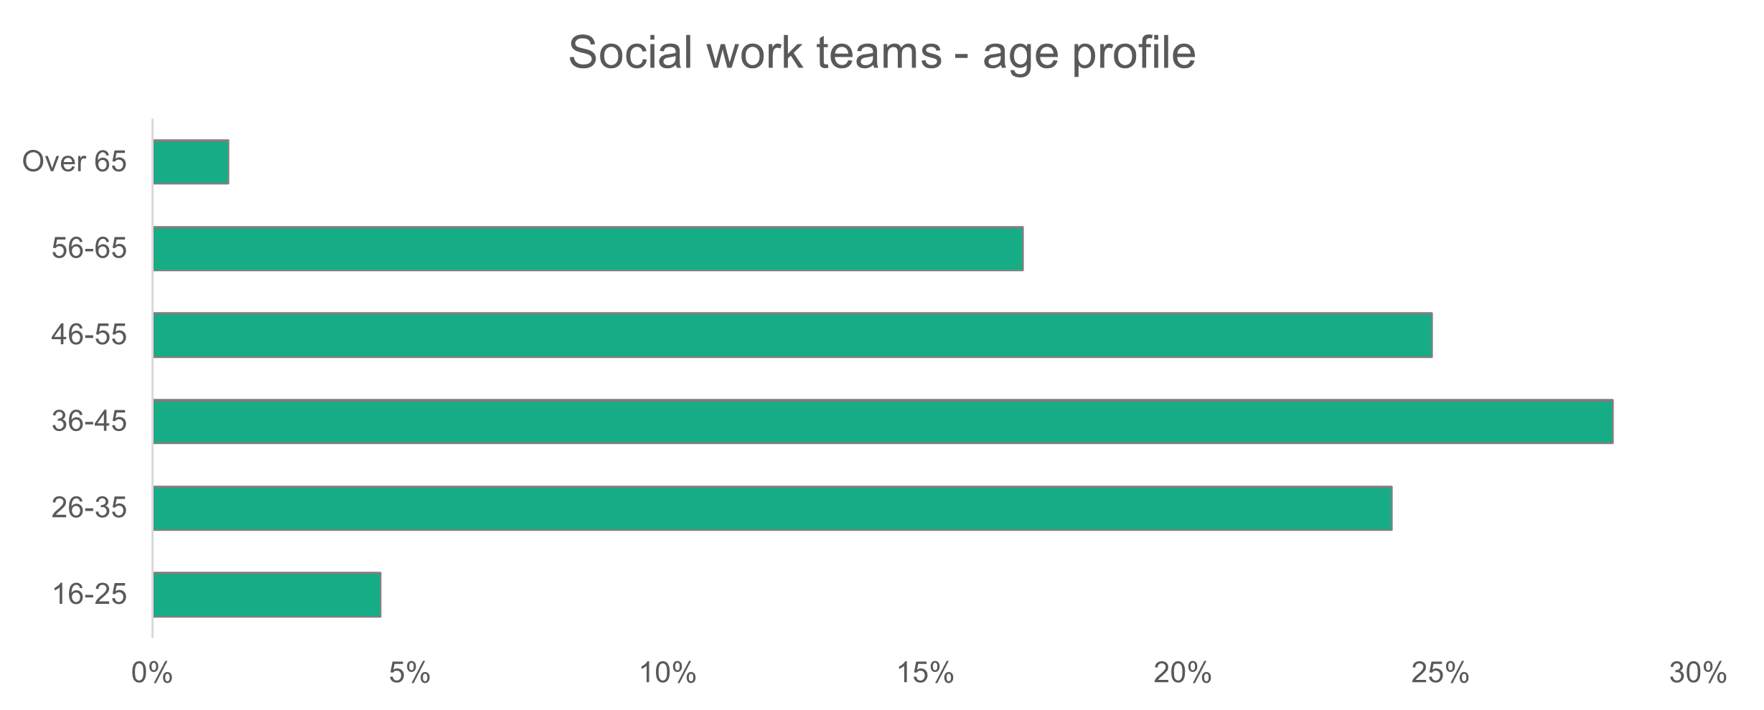

n = 9,444

* + 1. Social work teams – ethnicity

The frontline social work population is less diverse than the general Welsh population.

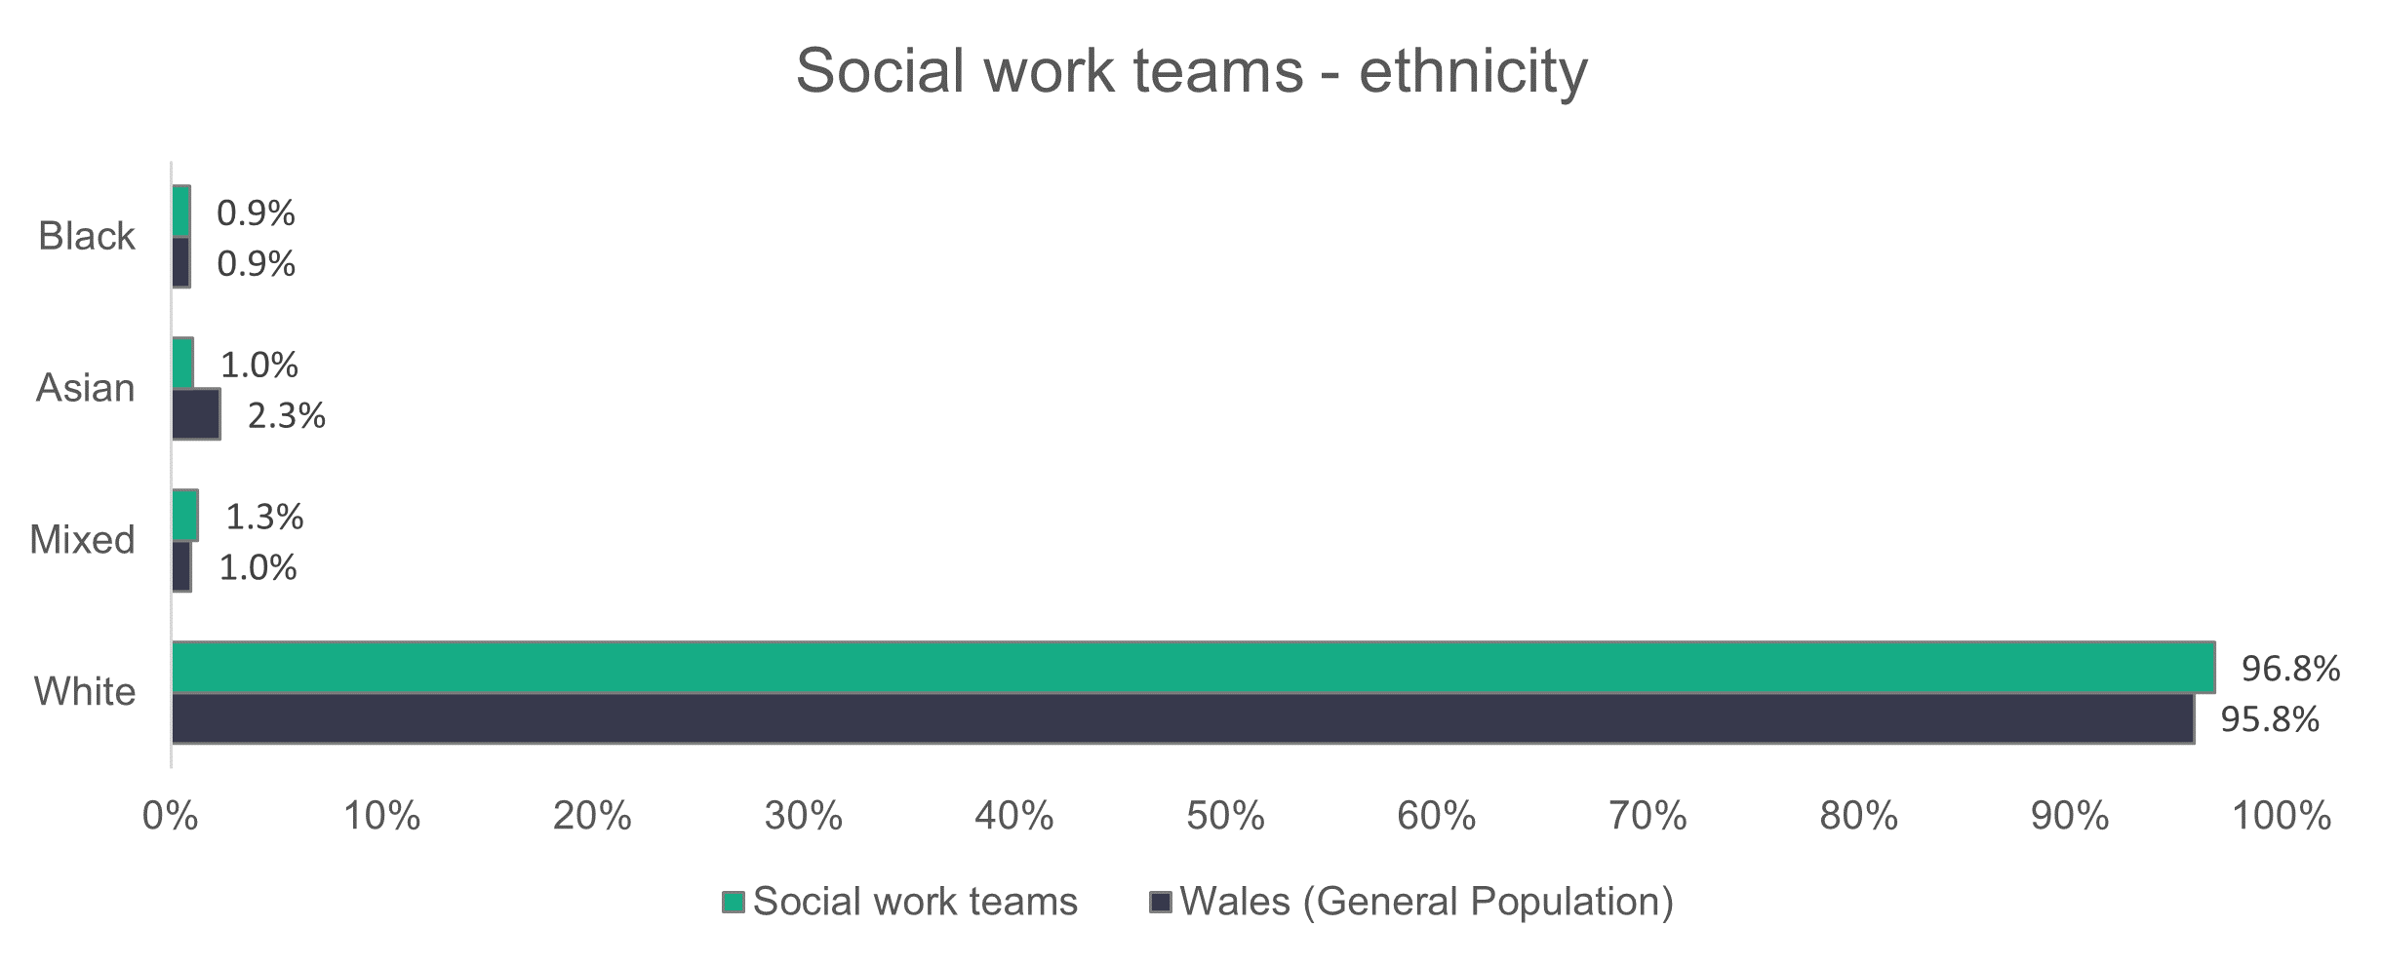

n = 7,438

* + 1. Social work teams – contract type

Most workers (79.4 per cent) are employed on permanent contracts, but a significant 15.6 per cent are employed on temporary contracts.

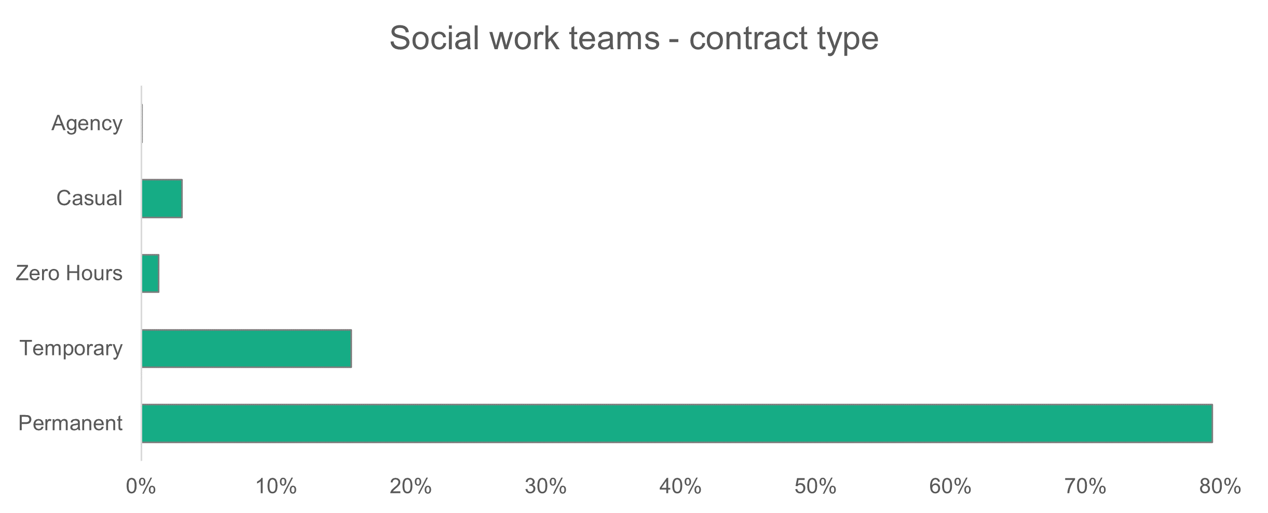

n = 9,478

* + 1. Social work teams – working patterns

Most frontline workers (72.6 per cent) are contracted as full-time. This proportion has barely changed from 2022 (72.5 per cent).

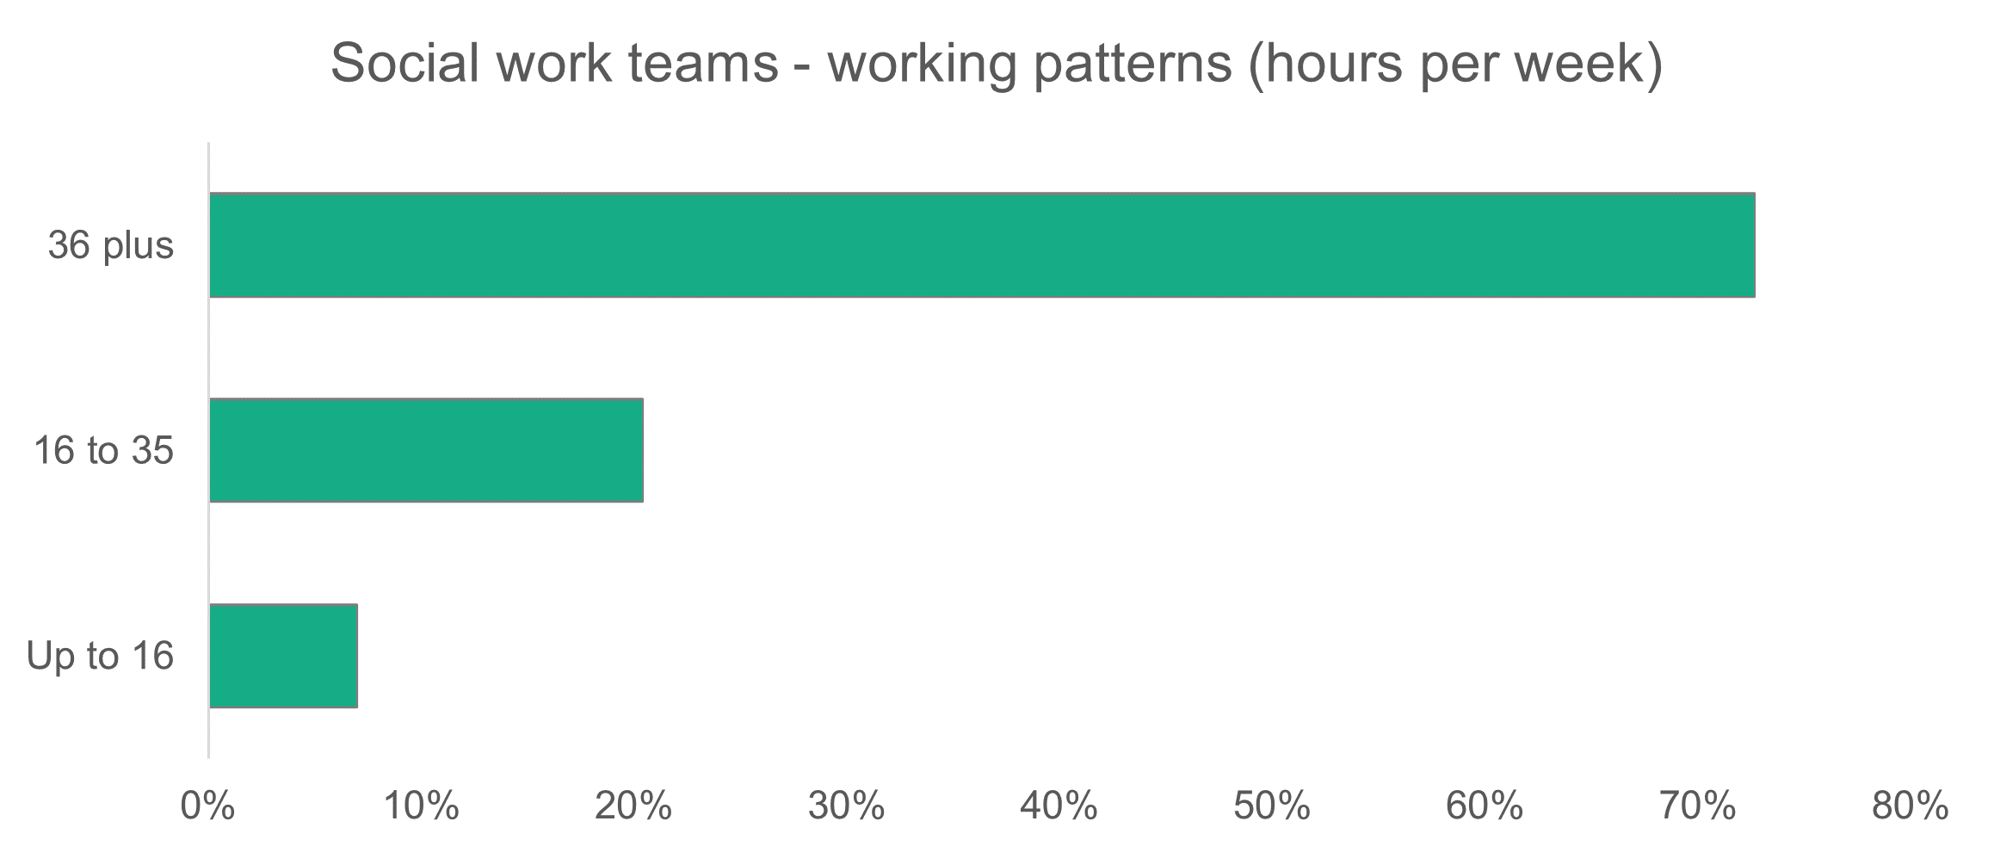

n = 9,167

* + 1. Social work teams – vacancies and turnover

Social work teams accounted for 15.8 per cent of all vacancies, with 836. This means that 8.8 per cent of jobs in frontline social work teams were unfilled*. There are 133 more vacancies in total this year compared to last year.

*\*Not all of these vacant positions will be for qualified social workers.*

**2.7 Children’s residential care**

**Summary:**

* More than one in three (34 per cent) people who work in children’s residential care are men.
* The age profile for children's residential care indicates a younger workforce in both local authorities and commissioned services, when compared to the general social care workforce.
* Almost all staff who work in children’s residential care for commissioned services are on permanent contracts (96.9 per cent)
* A high proportion of commissioned services staff who work in children’s residential care work full-time hours (85.3 per cent).

We estimate that there are 3,638 people working in children’s residential care in Wales. This is a decrease from last year’s number of 4,411 ( 17.5 per cent).

We received a higher return rate this year for commissioned services – 57.1 per cent compared to 37 per cent last year.

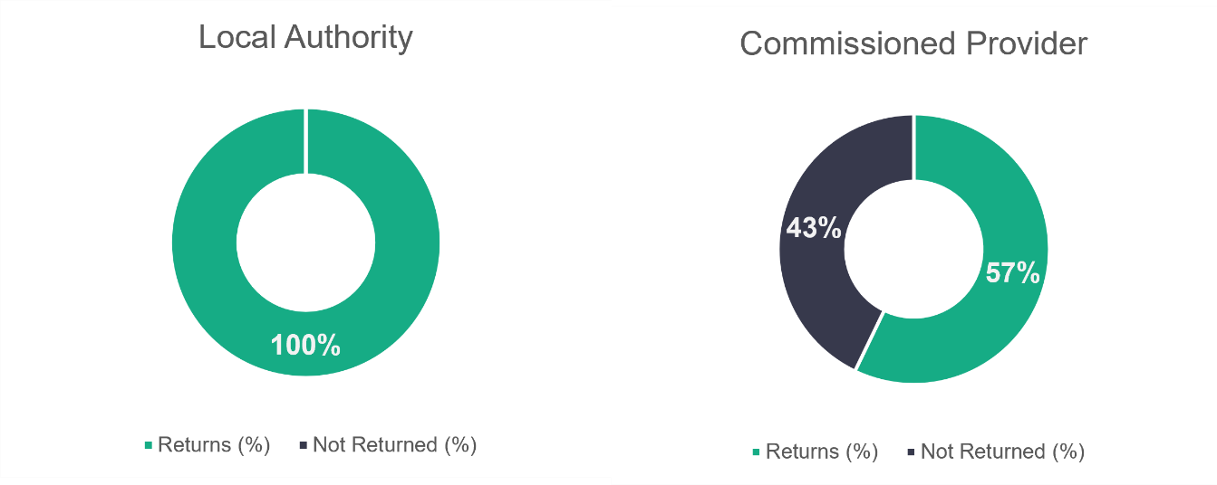

n = 15

n = 42

* + 1. Children’s residential care – role type

Care workers (including senior) make up 83.2 per cent of the children’s residential care workforce, as shown below. Managers (including deputy) make up 11.7 per cent of the workforce.

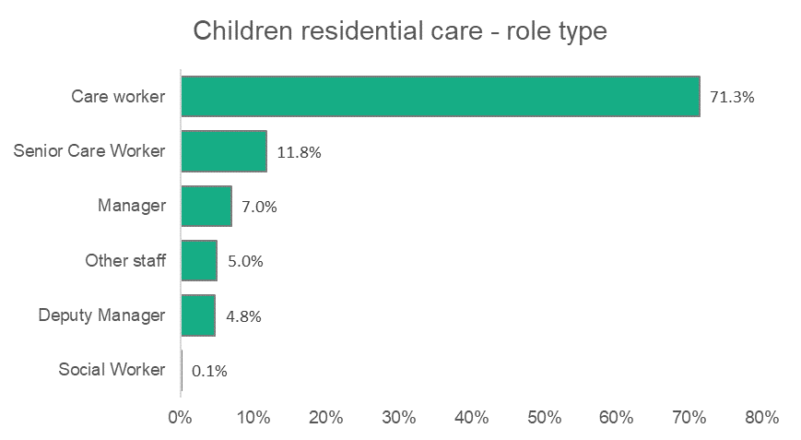

n = 1,926

* + 1. Children’s residential care – gender

More than one in three people who work in children’s residential care are men.

Although more women work in children's residential care, the proportion of men in the sector is higher than that for the whole social care workforce in Wales.   
  
There’s a four percentage point drop in the proportion of men working in the children's residential care workforce in 2022.

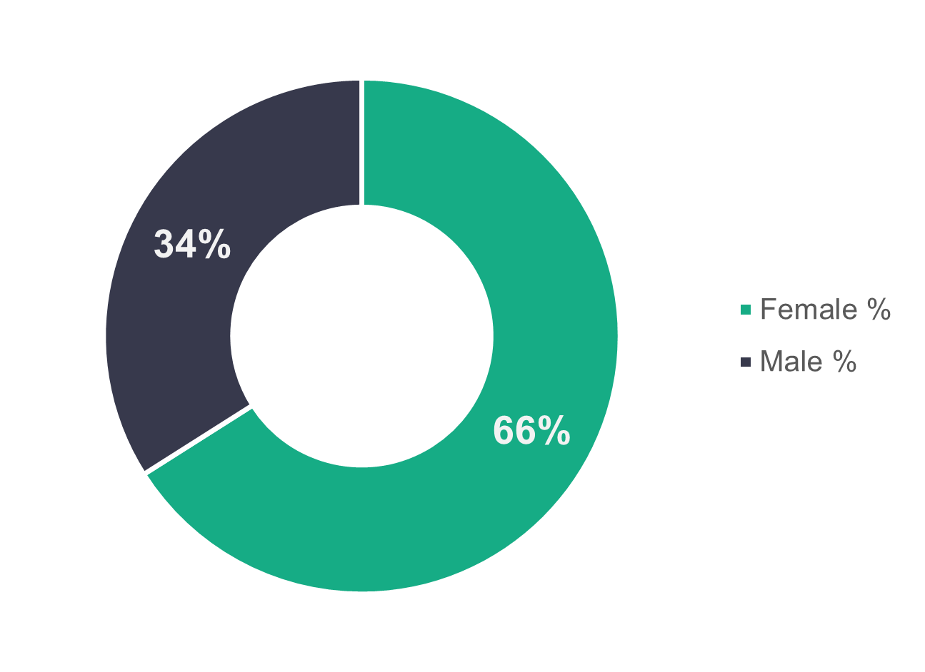

n = 1,742

* + 1. Children’s residential care – age profile

The chart below indicates a young workforce in children's residential care services in Wales. In commissioned services, 49.5 per cent of the workers are aged 35 or under, while in local authorities the proportion is 37.4 per cent.

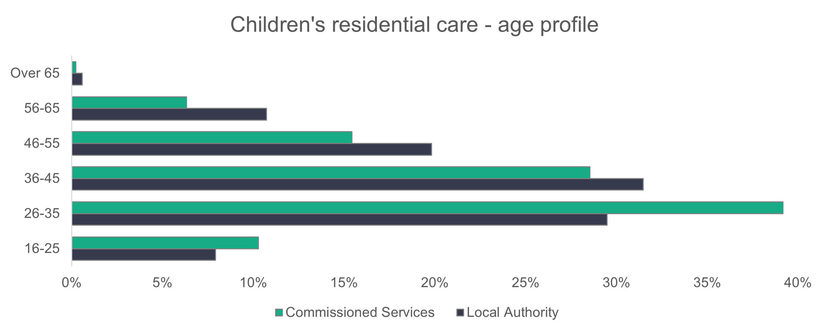

n = 1,713

* + 1. Children’s residential care – ethnicity

The children’s residential care sector in Wales is slightly less diverse than the general population of Wales, with the most noticeable difference found for Asian people.

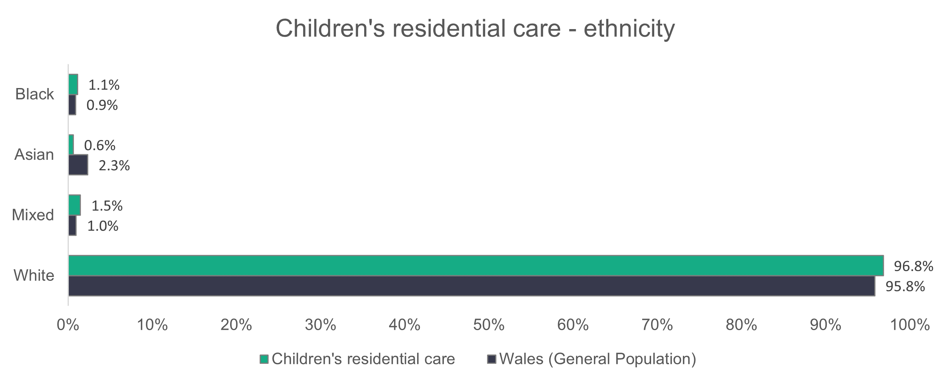

n = 1,639

* + 1. Children’s residential care – contract type

Almost all (96.9 per cent) commissioned service provider workers in children's residential care are on permanent contracts. This is a slight increase of 1.3 per cent compared to 2022. The corresponding proportion of workers employed by local authorities is 67.3 per cent. A significant proportion of local authority workers are on zero-hours (9.3 per cent) and casual (20.4 per cent) contracts, making a combined total of 29.7 per cent – compared to 26.3 per cent last year.

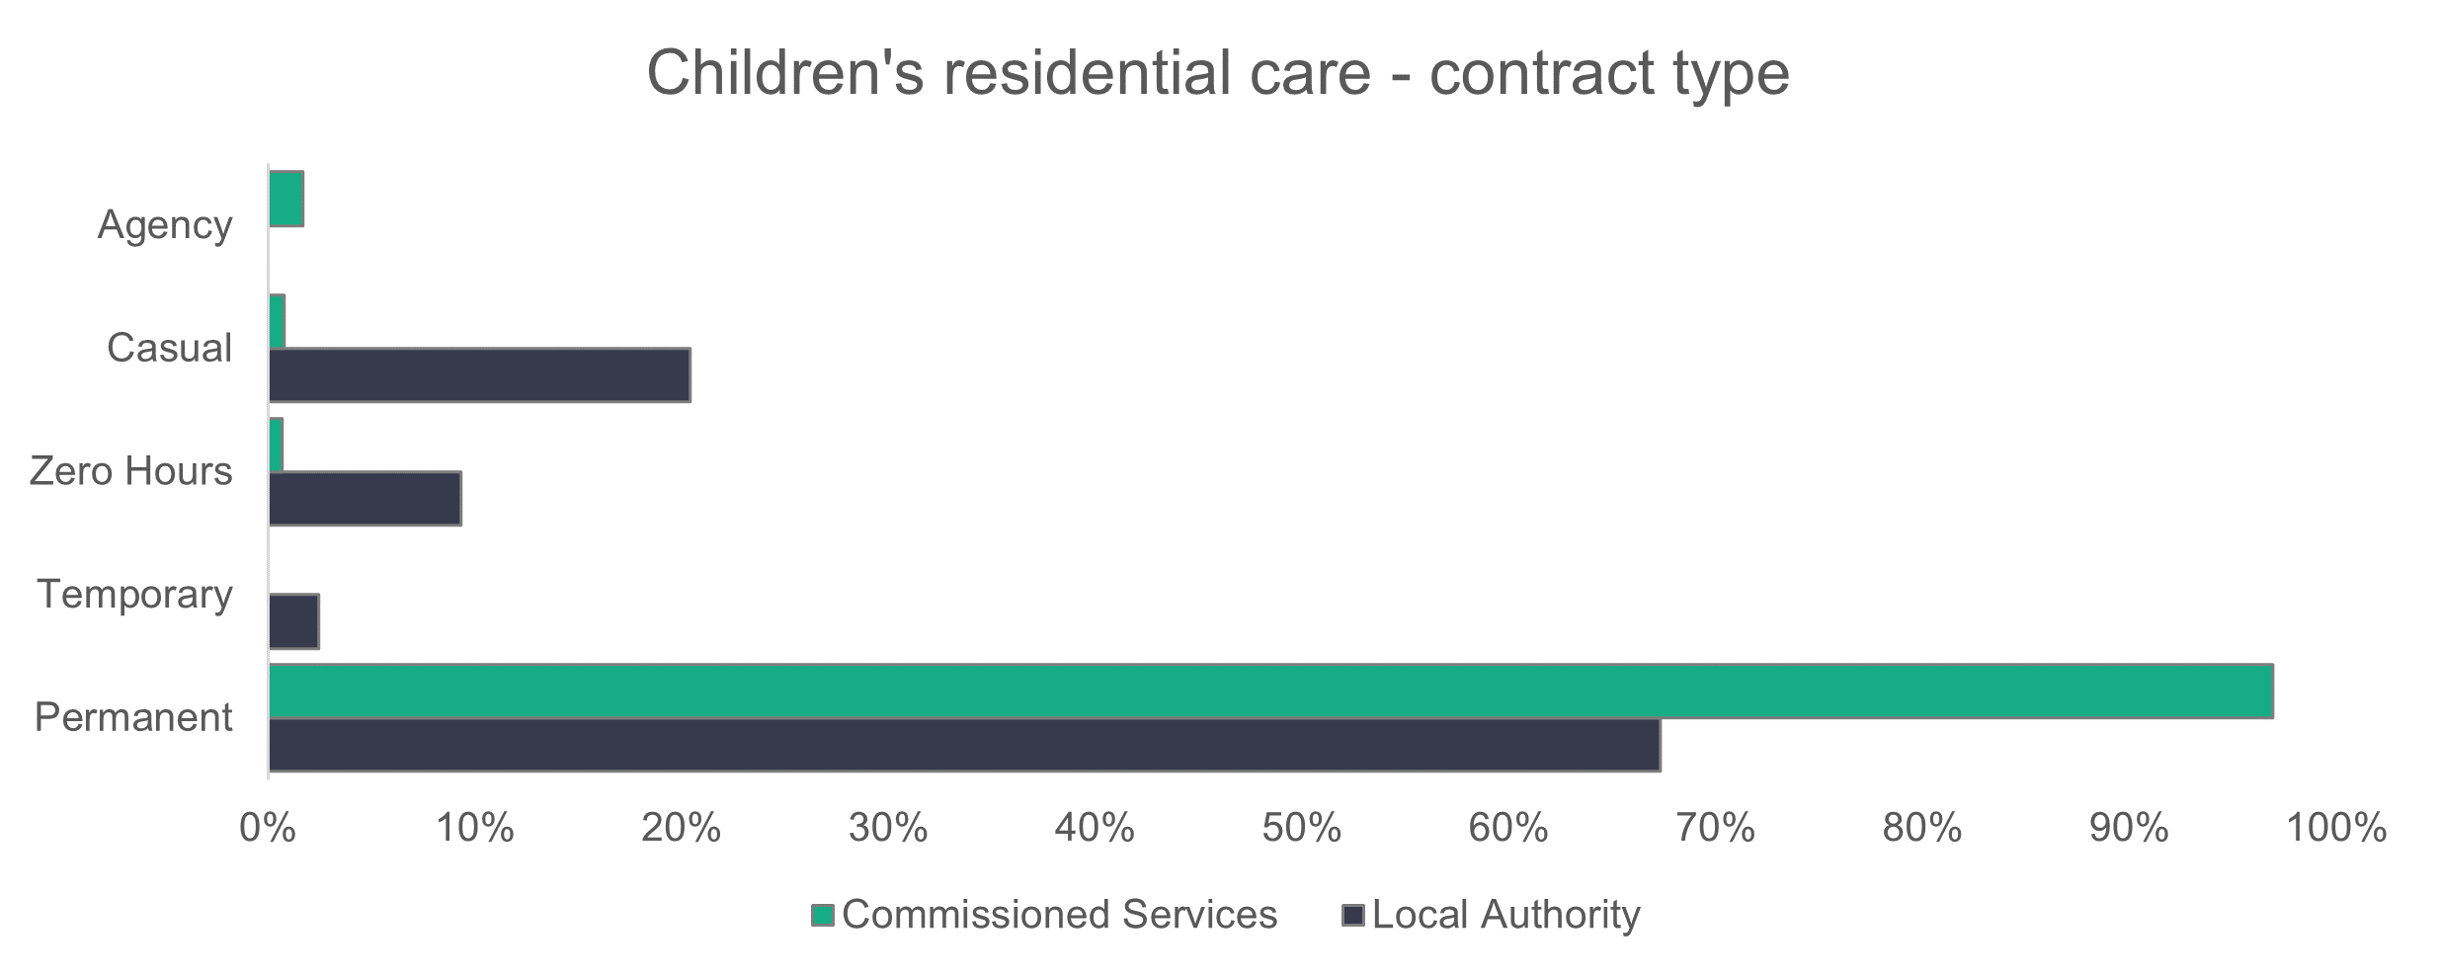

n = 1,759

* + 1. Children’s residential care – working patterns

The majority (85.3 per cent) of commissioned services workers in children’s residential care work full-time hours. Fewer than half of those employed by local authorities work full-time hours, but they make up the largest group of local authority staff in the chart below, with 41.6 per cent working 36 hours or more per week.

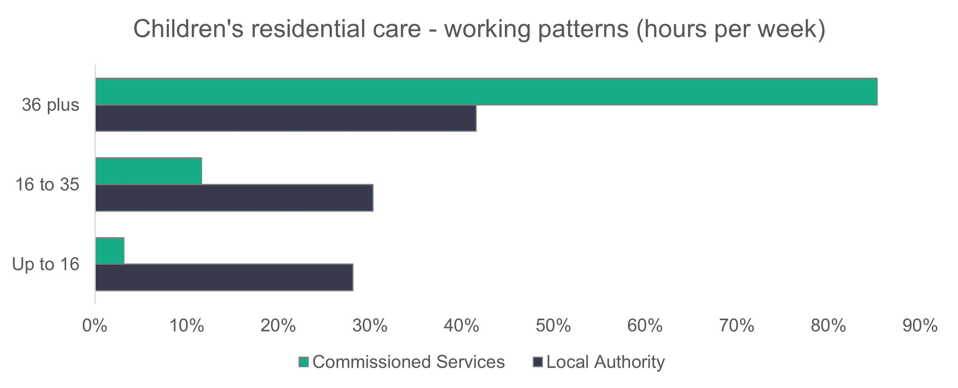

n = 1,715

* + 1. Children’s residential care – vacancies

There are 186 vacancies in children’s residential care. This means that 4.3 per cent of jobs in children’s residential care were unfilled. There are 15 fewer job vacancies in children’s residential care compared to last year.

**2.8 Mental health residential care**

**Summary:**

* The proportion of people in older age groups (46 and over) is higher in local authority-run services than in commissioned services.
* The proportion of black people working in mental health residential care is more than four times higher than the figure for the general Welsh population.
* Agency workers make up 15.5 per cent of local authority contracts.

We estimate that there are 683 people working in mental health residential care.

Return rates for commissioned services (88 per cent) are higher than in 2022 (81 per cent).

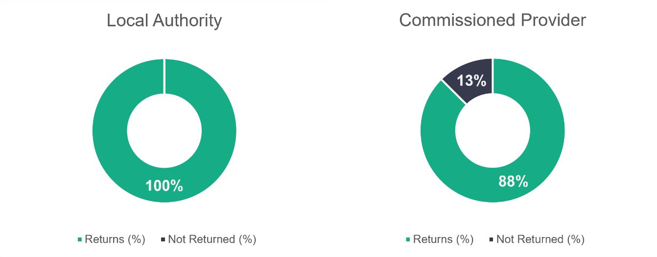

n = 4

n = 24

* + 1. Mental health residential care – role type

Care workers make up 56.5 per cent of the mental health residential care workforce, as shown below. This is a 6.6 per cent decrease compared to 2022.

The next biggest category is ‘other staff’ (17.2 per cent), which is made up of both admin and auxiliary staff.

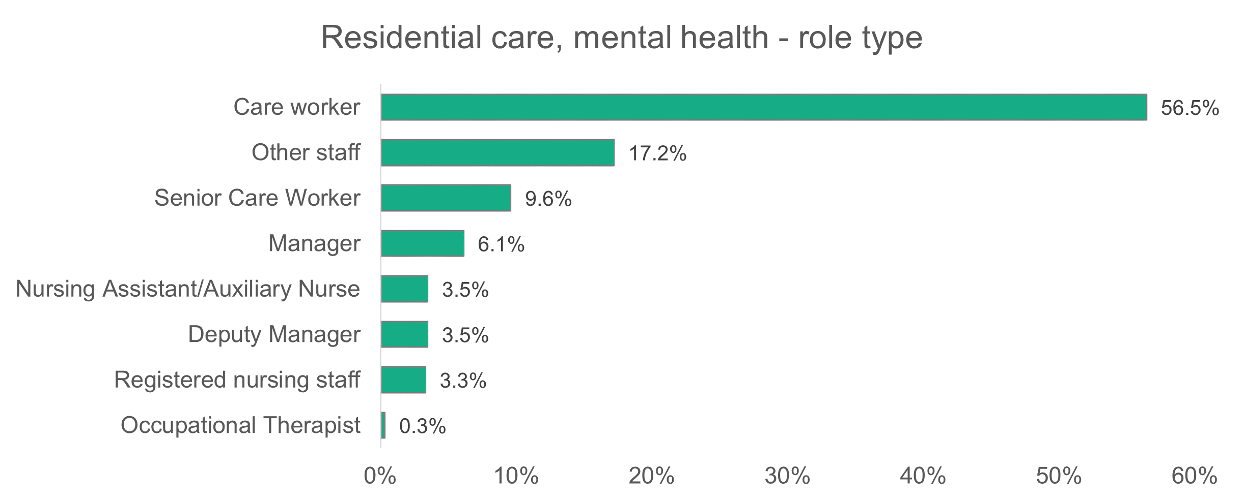

n = 604

* + 1. Mental health residential care – gender

Women occupy most roles in mental health residential care, making up 72.2 per cent of the workforce. This proportion is higher than recorded in 2022 (75 per cent), but lower than the social care workforce as a whole in 2023.

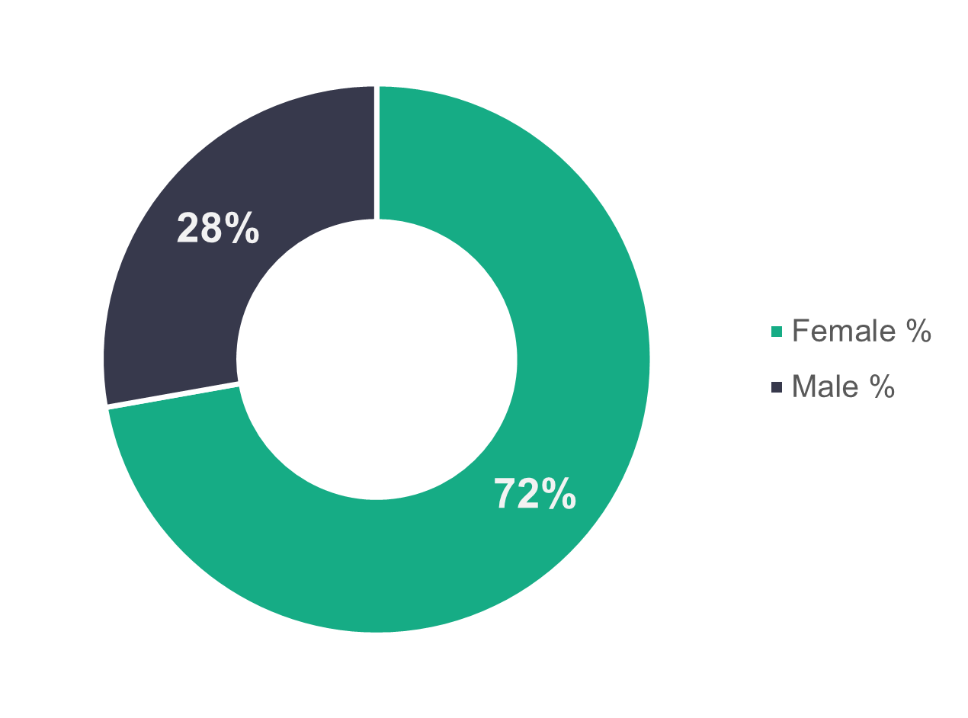

n = 457

* + 1. Mental health residential care – age profile

In local authority-run services, the older age groups (46 and over) make up almost two thirds (62.5 per cent) of the workforce. The opposite is true for commissioned services, where the younger age groups (45 or under) make up 59.6 per cent of the workforce.

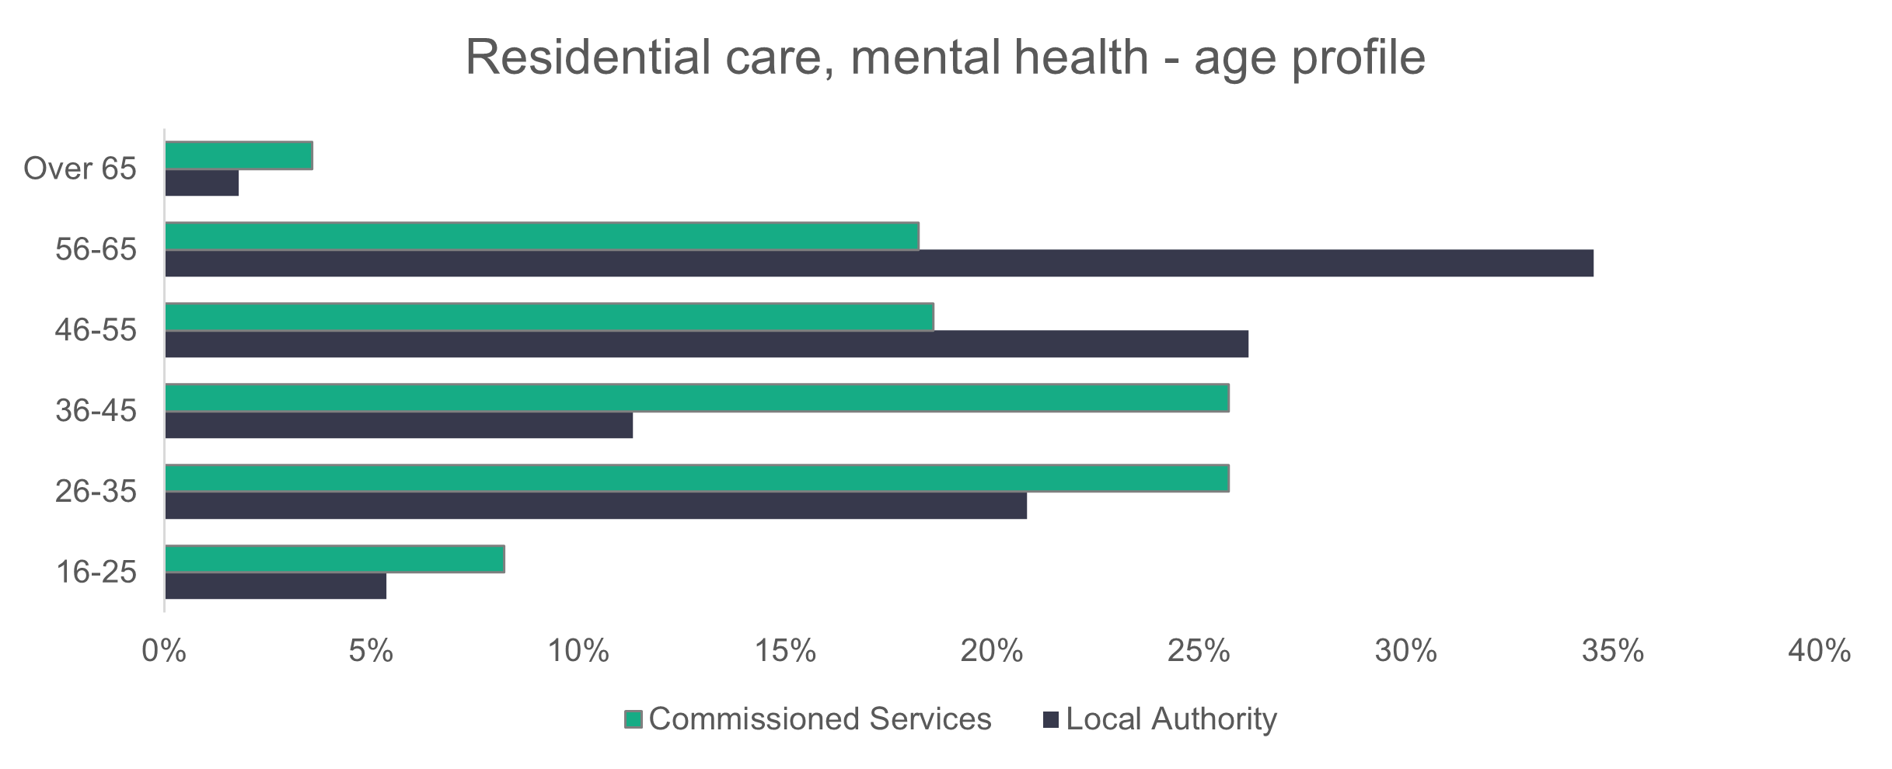

n = 448

* + 1. Mental health residential care – ethnicity

The mental health residential care workforce is more ethnically diverse than the general Welsh population (see chart below). One of the main reasons for this is the high proportion of care workers in this sector, with 11.3 per cent of those workers being from diverse ethnic backgrounds.

Interestingly, 66.7 per cent of nursing assistants and auxiliary nurses working in this area are reported as Asian, but there are only 21 workers in these roles.

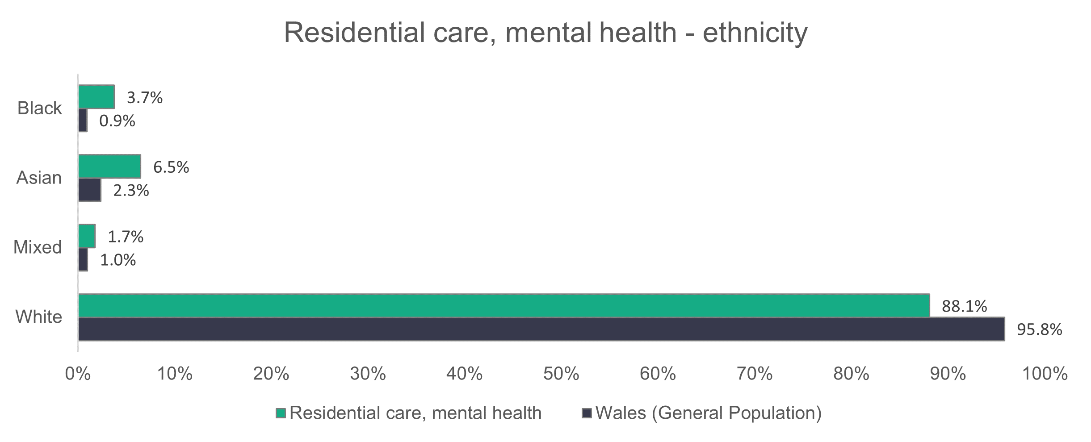

n = 402

* + 1. Mental health residential care – contract type

Fewer workers from local authority-run services (76.8 per cent of staff) are on permanent contracts, compared to 89.9 per cent of those in commissioned services.

The proportion of agency workers in mental health residential care is significantly bigger than we find in any other social care sector. Agency staff account for 15.5 per cent of local authority and 7.3 per cent of commissioned service contracts.

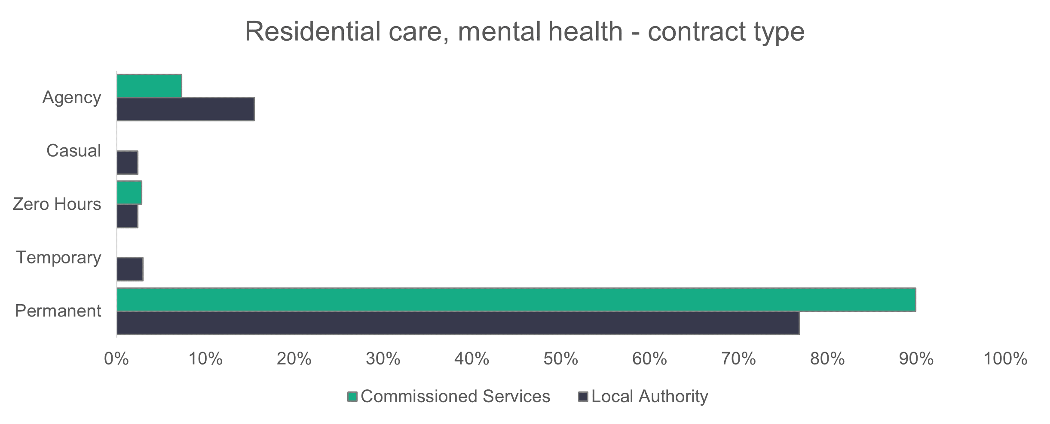

n = 455

* + 1. Mental health residential care – working patterns

Most workers in commissioned services (64.4 per cent) are employed full-time. This compares to 25.6 per cent in local authorities, which is still significantly higher than the 9.2 per cent recorded in 2022.

In local authority-run services, 29.8 per cent of people are contracted to work up to 16 hours per week, compared to 8.5 per cent in commissioned services.

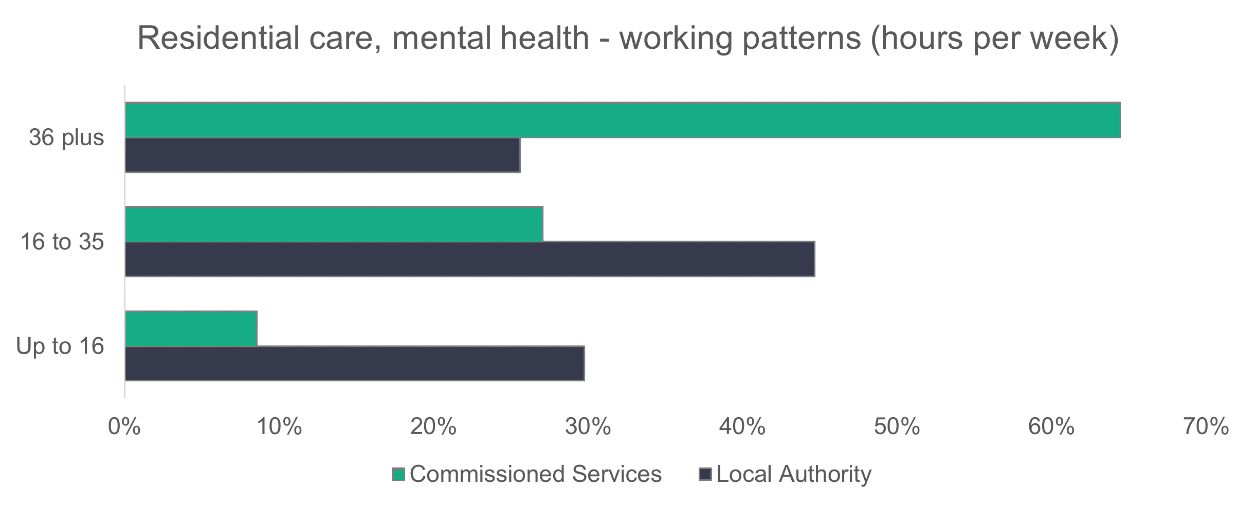

n = 449

* + 1. Mental health residential care – vacancies

There are 51 vacancies in mental health residential care. This means that 7.3 per cent of jobs in mental health residential care were unfilled. There were 13 fewer vacancies in 2023 compared to 2022.

* 1. Central staff

**Summary:**

* One in four workers are men.
* The ethnic diversity of central staff is broadly similar to the population.

Central services are made up of back office, business support, domestic, catering and other ancillary posts needed by organisations as part of their day-to-day operations.

There are an estimated 3,722 people working in central services.

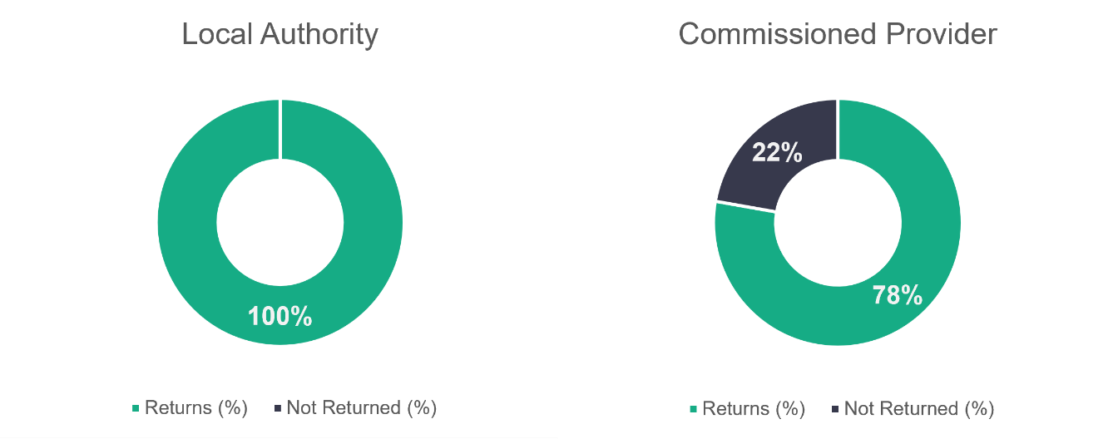

n = 22

n = 36

* + 1. Central staff – role type

‘Other staff’ includes business support and auxiliary workers and makes up 62.1 per cent of the central staff workforce, a 4.8 per cent increase on last year’s data.

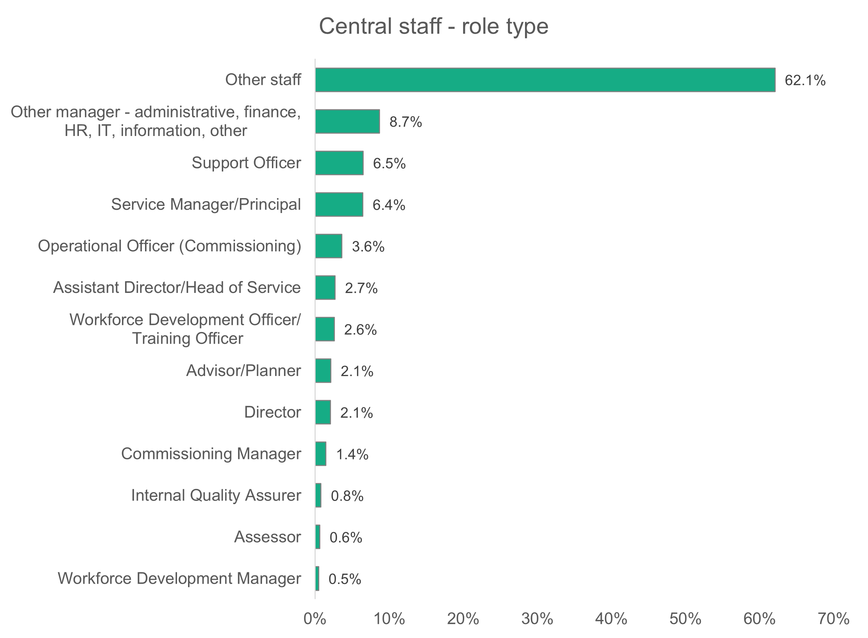

n = 3,457

* + 1. Central staff – gender

A higher proportion of men (25 per cent) work in central services when compared to the 18.4 per cent of men in the social care workforce of Wales as a whole.

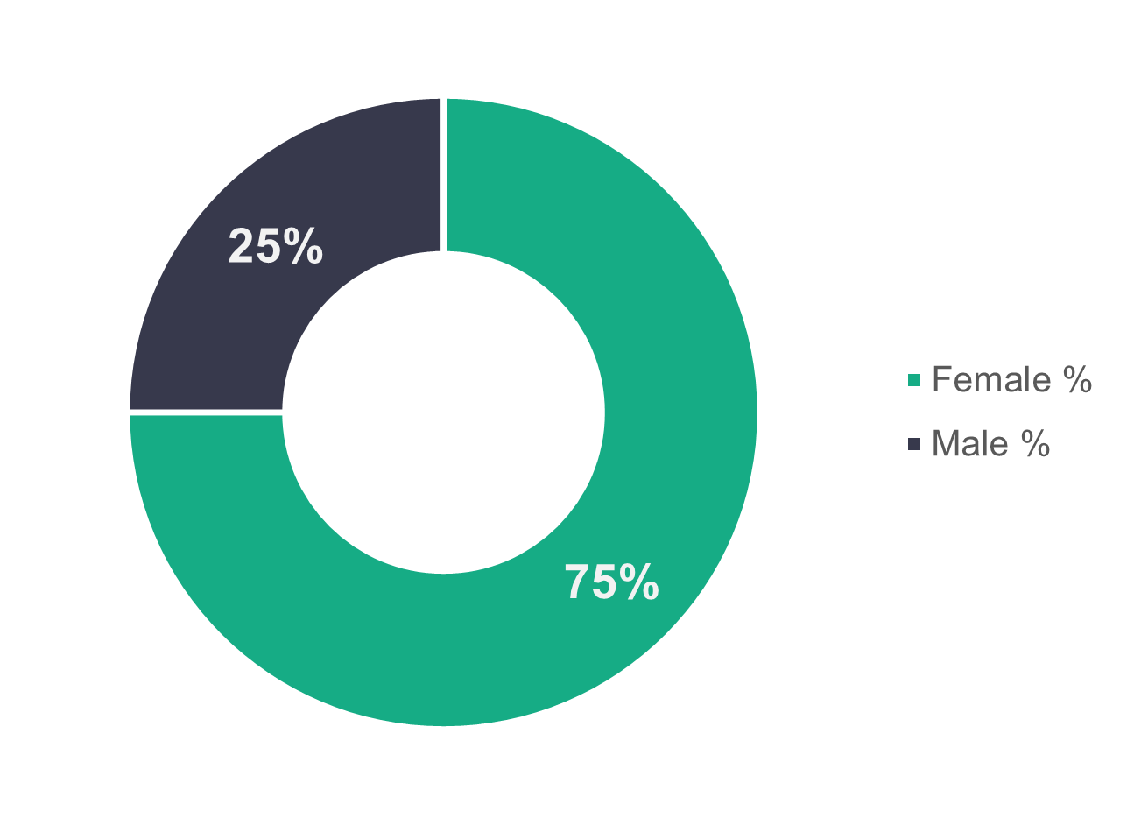

n = 3,450

* + 1. Central staff – age profile

The age of workers is broadly similar for local authorities and commissioned services. More workers fall into the 46 to 55 age group than any other for both local authorities (28.1 per cent) and commissioned service providers (28.8 per cent).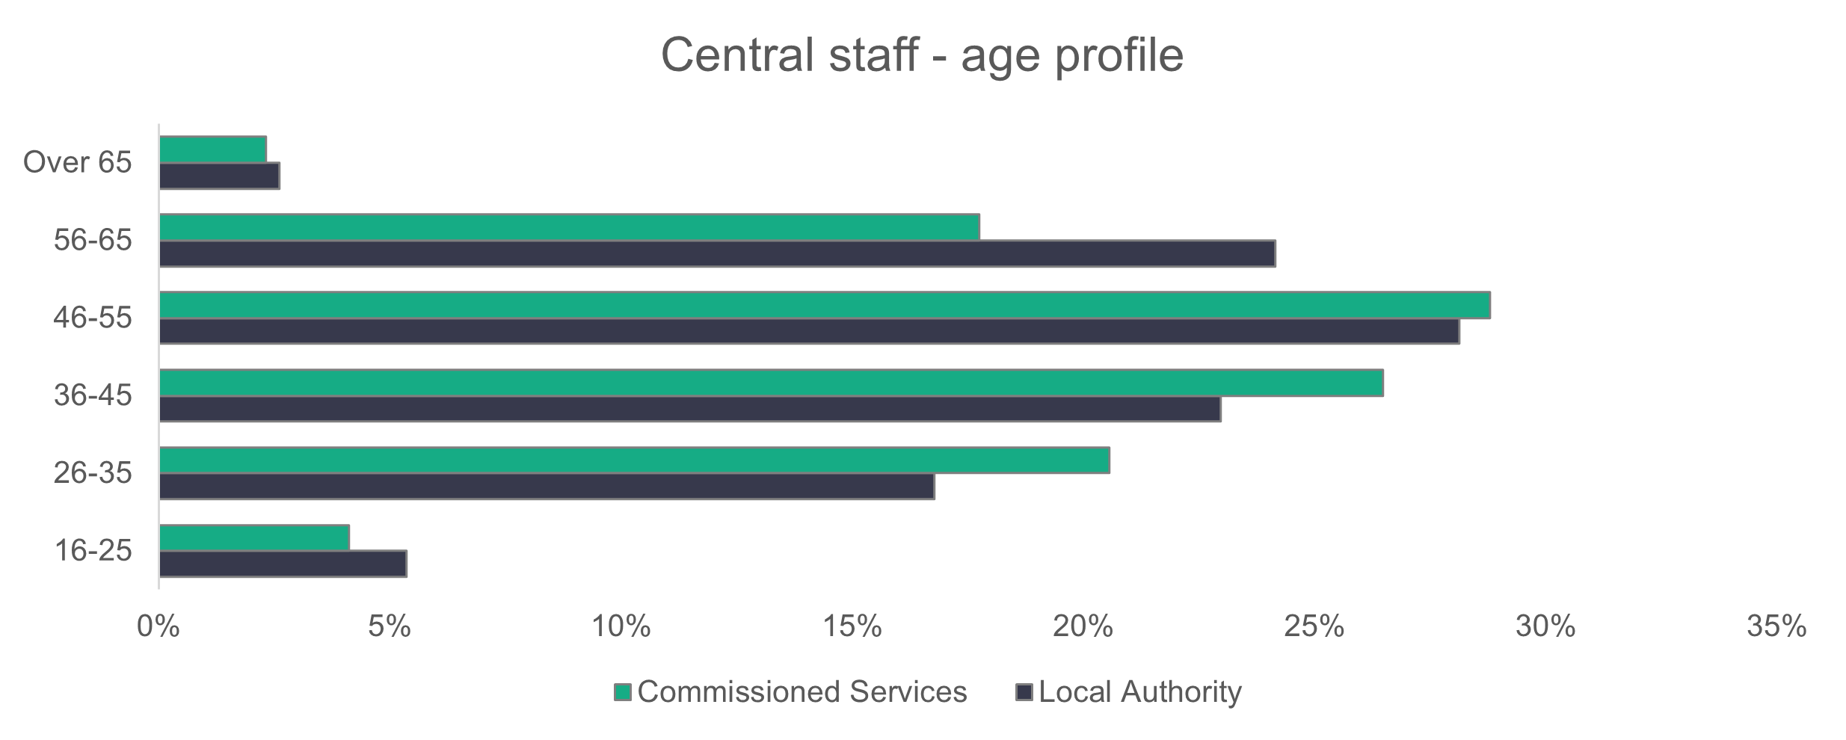

n = 3,375

* + 1. **Central staff – ethnicity**

The ethnicity of the central staff workforce almost mirrors that of the general population of Wales.

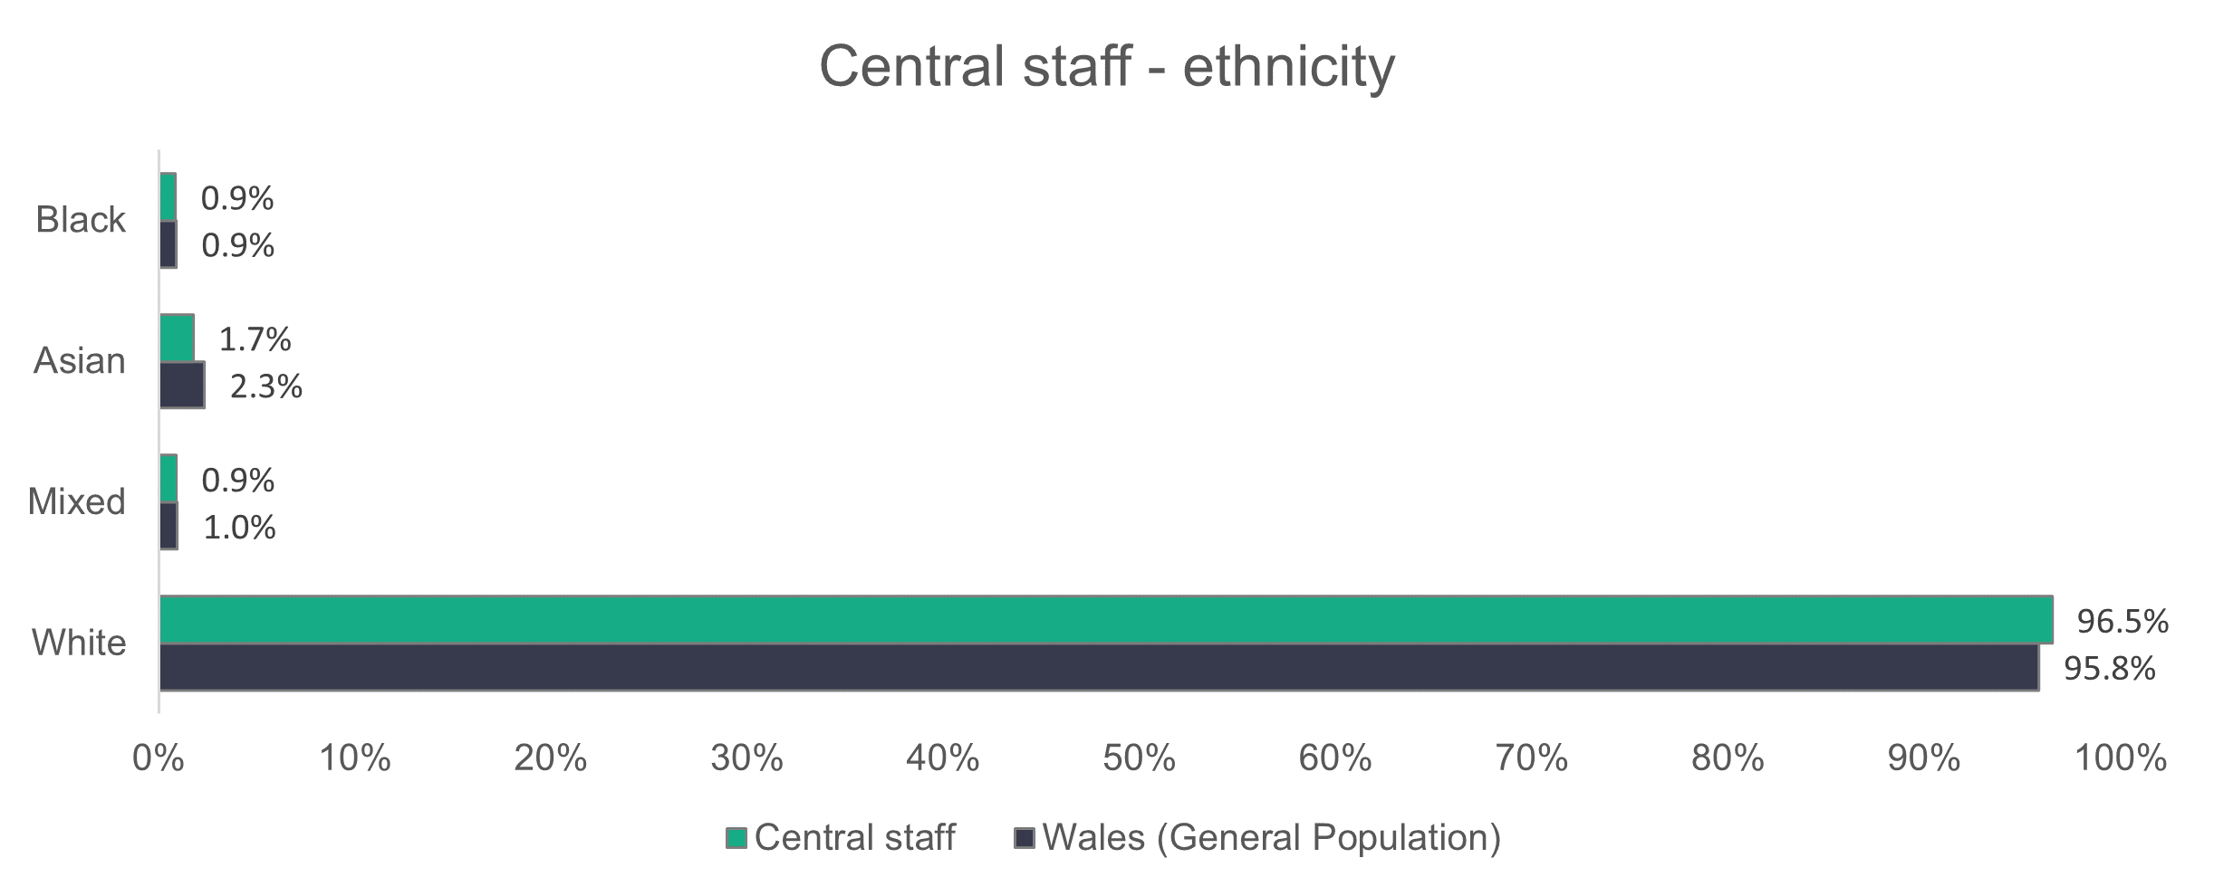

n = 2,690

* + 1. **Central staff – contract type**

Permanent contracts make up 99 per cent of commissioned service contracts. The remainder are made up of 0.2 per cent zero-hours and 0.8 per cent agency contracts. Local authorities have 79.6 per cent of their workers on permanent contracts.

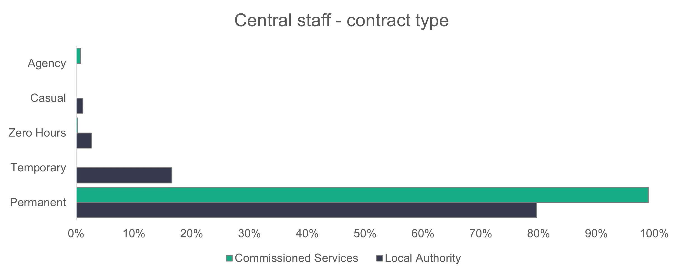

n = 3,403

* + 1. Central staff – working patterns

Most central services staff work full-time hours – 74.7 per cent in local authorities and 65.9 per cent in commissioned service providers.

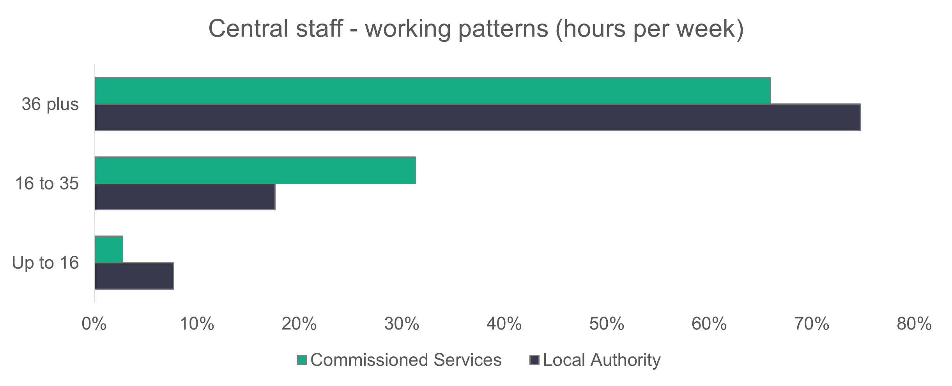

n = 3,348

* + 1. Central staff – vacancies

There are 233 vacancies in central services. This means that 6.3 per cent of central services roles were unfilled. There are about 92 more vacancies in 2023 compared to 2022.

2.10 Other services

For services that don’t naturally fall into the listed setting types, we created an ‘other’ category to make sure we’re able to collect the details of everyone who works in social care in Wales.

We received information from 13 social care service organisations (12 commissioned services and one local authority), who reported a total of 111 workers, whose roles are shown below.

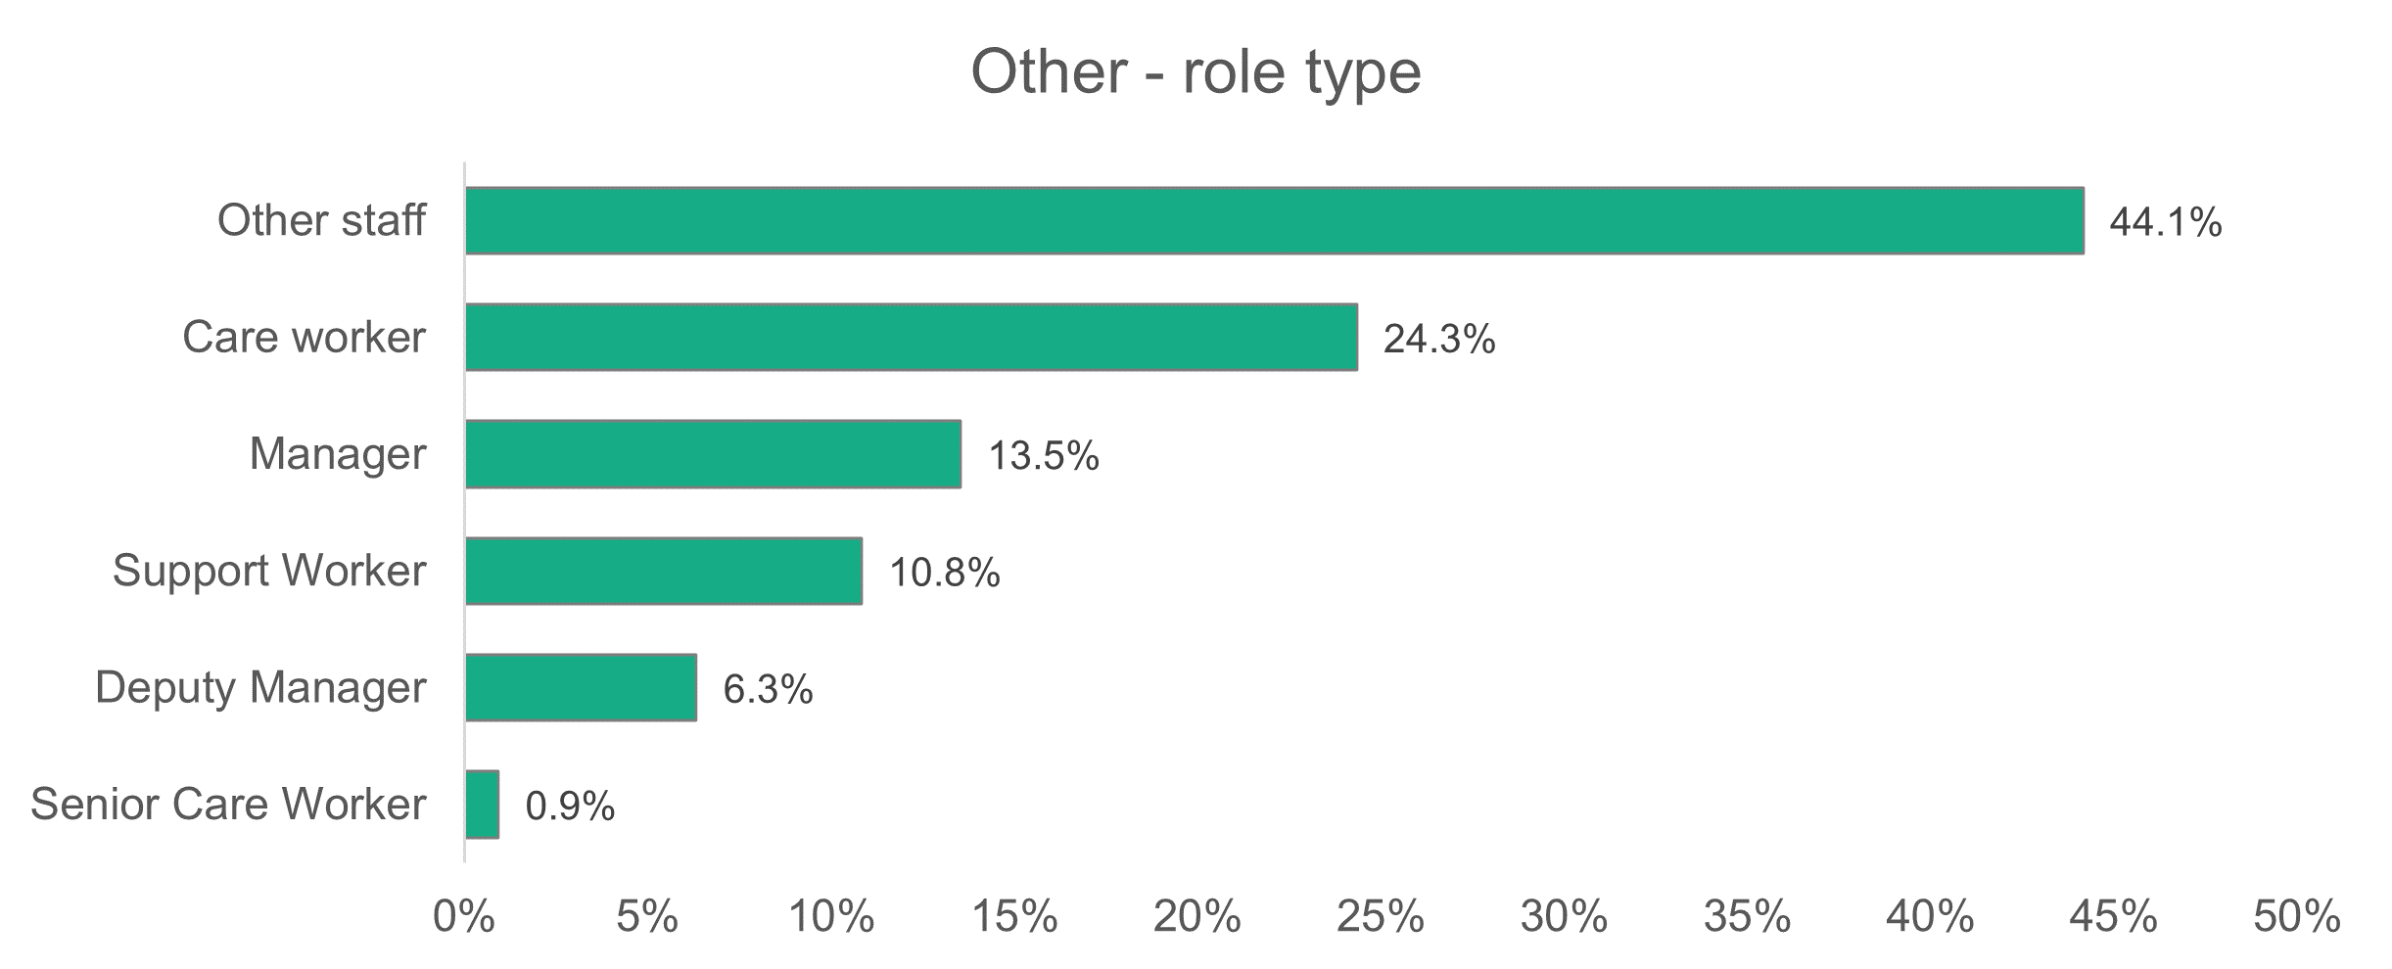

n = 111

Although these services are included in our overall estimates of the workforce, we didn’t receive enough data to calculate reliable estimates for other attributes of these services.

# **Appendix A - Data categories**

Setting type:

|  |  |
| --- | --- |
| * Adult placement schemes | * Residential care – adult |
| * Residential care – mental health services | * Residential care – children |
| * Domiciliary care | * Supported living services |
| * Day services | * Social work teams – adults |
| * Social work teams – children | * Social work teams – all |
| * Personal assistants |  |
| * Central (support) staff Role definition   Role type: |  |

|  |  |  |  |  |
| --- | --- | --- | --- | --- |
| * Adult placement manager | | | * Adult placement worker | |
| * Adviser/planner | | | * Assessor | |
| * Care worker | | | * Consultant social worker | |
| * Deputy manager | | | * Deputy team manager (social work) | |
| * Director | | | * Internal quality assurer (IQA) | |
| * Head of service (assistant director) | | | * Nursing assistant/Auxiliary nurse | |
| * Manager | | | * Occupational therapy assistant | |
| * Occupational therapist | | | * Other manager | |
| * Other staff | | | * Physiotherapist | |
| * Personal assistant | | | * Registered nurse first year in practice | |
| * Planner | | | * Registered nurse 1+ years | |
| * Senior practitioner | | | * Senior care worker | |
| * Social care planning and commissioning manager | | | * Service manager/Principal officer | |
| * Social care planning and commissioning support officer | | | * Social care planning and commissioning operational officer | |
| * Social worker (three years or more) | | | * Social worker (two to three years) | |
| * Speech and language therapist | | | * Social worker (first year in practice) | |
| * Team manager (social work) | | | * Support worker | |
| * Workforce development officer/Training officer | | | Workforce development manager | |
|  | |
|  | |
|  | |
| Age:   * 16 to 24 | Gender: | | | Disability: |
| * 25 to 34 | * Male | | | * Yes |
| * 35 to 44 | * Female | | | * No |
| * 45 to 54 | * Gender fluid | | |  |
| * 55 to 64 * 65 and over | * Non-binary | | |  |

|  |  |  |  |  |  |  |  |
| --- | --- | --- | --- | --- | --- | --- | --- |
| Working hours per week | Contract status | | | Vacancies | | | |
| * Up to 16 hours | * Permanent | | | * To be filled | | | |
| * 16 to 36 hours | * Zero hours | | | * Held vacant | | | |
| * 36 hours or more | * Casual * Voluntary | | | |  | | | |
|  | * Bank/Agency | | | |  | | | |
| Welsh-language proficiency level | | | First language | | | |
| * No ability | | | * Welsh first language | | | |
| * Welsh entry | | | * English first language | | | |
| * Welsh foundation | | | * Other first language | | | |
| * Welsh intermediate | | |  | | | |
| * Fluent | | |  | | | |
| Ethnicity | |  | | | |
| * White Welsh | | * Asian Welsh | | | |
| * White British | | * Asian British | | | |
| * White Irish | | * Asian Pakistani | | | |
| * White European | | * Asian Indian | | | |
| * White and Asian | | * Asian Chinese | | | |
| * White / Black African | | * Asian Bangladeshi | | | |
| * White / Black Caribbean | | * Asian (other) | | | |
| * White (other) | | * Arabic | | | |
| * Black Welsh | | * Mixed ethnicity | | | |
| * Black British | | * Mixed (other) | | | |
| * Black Caribbean | | * Gypsy / Traveller | | | |
| * Black African | | * Other ethnicity | | | |
| * Black (other) | | * Prefer not to say | | | |
|  | |  | | | |
|  | |  | | | |

Appendix B – How we dealt with missing data and estimating the total size of the social care workforce in Wales

A main aim of this report is to accurately determine the size of the social care workforce in Wales. However, the dataset created from the workforce data collection contained both fully and partially completed sections. Notably, crucial fields such as the number of people in post and the number of vacancies to be filled were among the fields with missing values. We developed a way of estimating missing values for these fields so that we could estimate the size of the social care workforce in Wales more accurately.

Unlike last year, the missing data estimation for this year was divided into two parts: estimating data for organisations that provided data last year but not this year, and organisations that have never returned data before.

Machine learning can help to predict missing inputs in the dataset, which helps address the issue around missing data on the total number of people in post by setting. This type of machine learning problem is classed as supervised learning, where a collection of known values (number of roles), known as labelled values, is given. The goal is to use the labelled data to train a machine-learning model to make accurate predictions for unlabelled data[4] .

For the number of vacancies to be filled, we chose median imputation to handle missing data because it’s a simple and robust method. It’s suitable for this case because the ‘vacancies to be filled’ dataset is relatively small. It yielded similar results when compared to the performance of some of the machine-learning models we tested.

We employed two machine learning algorithms: linear regression for organisations that returned data last year and not this year, and eXtreme Gradient Boosting (XGBoost) for estimating the total number of people in post for organisations that have never returned data.

Linear regression is a foundational algorithm that tries to find the best-fitting linear relationship between input features and the target variable. Ordinary Least Square (OLS) is one of the most widely used methods to achieve this objective by minimising the sum of the squared differences between the observed and predicted values. In other words, OLS helps find the line that best fits the data points by minimising the overall difference between where the points are and where the line predicts them to be. Linear regression is commonly utilised due to how simple it is to use and understand, and how efficiently it can be processed by a computer.

There are several key assumptions that should be met before using a linear regression model:

* the relationship between the independent variables and the dependent variables should be linear, which means changes in the dependent variable are proportional to changes in the independent variables
* the value of one observation shouldn’t influence another observation
* the variance of errors should stay constant across all levels of the independent variables, which is referred to as homoscedasticity
* the residuals should follow the normal distribution
* there shouldn’t be a perfect multicollinearity between the independent variables. In other words, it shouldn’t be possible to perfectly predict an independent variable from the others.

As for XGBoost, it’s a supervised learning algorithm that can be used for both regression and classification problems and is an implementation of the gradient boosted decision tree algorithm. Boosting is when many weaker learners (decision trees in this case) are combined to create a strong learning model[5]. The term “gradient” in XGBoost refers to the algorithm’s use of a parameter optimisation method called gradient descent that aims to minimise errors by adjusting the settings’ values, improving the model’s performance.

The metrics we chose to assess the model’s performance on are the Root Mean Squared Error (RMSE) and Mean Absolute Error (MAE). RMSE and MAE are both used to measure the distance between the predicted and actual values of the target variable. RMSE emphasises the larger errors and is defined as the square root of the square of the average distance between the predicted and observed values. This means it’s higher when the difference between the predicted and observed values is big. MAE only measures the average distance between the predicted and observed values. Even though it doesn’t emphasise large errors, it still gives an indication of how different the predictions are on average.

**Number-in-post predictions**

**Estimating values for 2023 using 2022 data**

For this section of the estimations, we projected data for 152 organisations that only provided data in the previous year, using their previous returns. Before proceeding with linear regression, we first needed to create a training dataset using data from organisations that submitted their forms in both 2022 and 2023, and a dataset of the organisations to predict data for.

We started by excluding personal assistants from both the 2022 and 2023 datasets because of the poor quality of the data. We then calculated the total number of people in post for each organisation per authority and setting in both 2022 and 2023 datasets. We then removed outliers as they could affect the accuracy of the estimations. After this, we merged the two to create our training dataset. We also created the dataset of the organisations to estimate values for by merging the 2022 dataset and the organisation names dataset and obtaining the columns that we need.

We then calculated Pearson’s correlation between our target variable (total number of people in post in 2023), and our continuous variables (total number of settings in 2022, and total number of people in post in 2022). We noticed a strong positive correlation of approximately 0.96 between our target variable and the total number in post in 2022. The correlation between the total number of settings in 2022 and our target variable is only 0.22. The correlation coefficient ranges between minus one and one. The closer it is to 0, the weaker the correlation, while the closer it is to each end point, the stronger. For that reason, we decided that the main predictor to be used as a starting point was the total number of people in post in 2022.

Next, we made sure there was a linear relationship between the target variable and the input variable, and that the rest of the linear regression assumptions were met. We then set aside 20 per cent of the training data for testing purposes and used cross-validation on the rest to evaluate and validate our model. Cross-validation is a technique to evaluate the performance of a machine learning model by splitting the dataset into multiple subsets. The model is trained on some of the subsets and evaluated on the remaining data, repeating the process multiple times.

The model yielded a mean MAE of 13.58 in cross-validation, while it yielded an MAE of 7.98 and an RMSE of 13.76 on the test data. This means that on unseen data, the model’s predictions deviate from the actual values by approximately 7.98 on average and have an average magnitude of errors of around 13.76. This indicates that the model performs reasonably well.

We attempted to enhance the model’s performance by including the total number of settings in 2022 as an additional input feature. However, this adjustment did not result in any improvement in the model’s performance.

**Estimating values for non-reporting organisations**

This part of the estimations is different to the previous one. Because these organisations have never returned their data, it was more challenging to estimate their total number of people in post. With only the organisation name variable in our dataset, we had to find more information about them before we could generate estimates.

To gather more data about these organisations, we turned to the Care Inspectorate Wales (CIW) dataset. We started by directly merging our organisation name data and the CIW data to get the setting types, authority and number of settings for

organisations that have the same name on both datasets. However, some organisations weren’t captured because they have a different name in CIW data. For that reason, we used fuzzy matching to get their other names from the other dataset and then reapplied the merge. Fuzzy matching is a method used to find approximate matches between strings that aren’t identical but share similarities. After dropping duplicated rows, we replaced the setting type we extracted from the CIW dataset to match our data.

After this, we calculated the total number of people in post for each organisation per authority and setting so it could be used in training our XGBoost model. We then removed outliers using the interquartile range (IQR) method. It’s a method that involves dividing the dataset into quartiles, which are values that divide the data into four equal parts. The IQR, which describes the spread of the middle 50 per cent of our data, is then calculated by taking the difference between the third quartile (Q3) and the first quartile (Q1). Q1 is the value below which 25 per cent of the data points fall, and Q3 represents the value below which 75 per cent of the data points fall. Any values that fall above Q3 plus 1.5 times the IQR or below Q1 minus 1.5 times IQR are then excluded from the dataset.

The next step was to determine the relationship between our target variable (total number of people in post) and the potential input variables (total number of settings, authority and setting type). For assessing our target variable’s relationship with the continuous variable (total number of settings), we calculated Pearson’s correlation, while we used boxplots for its relationship with the categorical variables.

We started by calculating the correlation between total number in post and the total number of settings. We found a coefficient of approximately 0.51, indicating a moderate positive correlation. This suggests a tendency for the two variables to move together in a positive direction.

We then created a boxplot to visualise the relationship between each local authority and our target variable. The boxplot below shows that the median (the horizontal line inside the boxes) of the total role number in post is somewhat variable in some authorities, which suggests that there might be a relationship between the two variables. The relationship is further suggested when we look at the differences in the boxes’ height and whiskers (the lines extending from the top and bottom of the box to the highest and lowest values). Both the lengths of the whiskers and the sizes of the boxes vary significantly between the different authorities, which indicates that there is a difference in the spread of the total role number in post across the authorities.

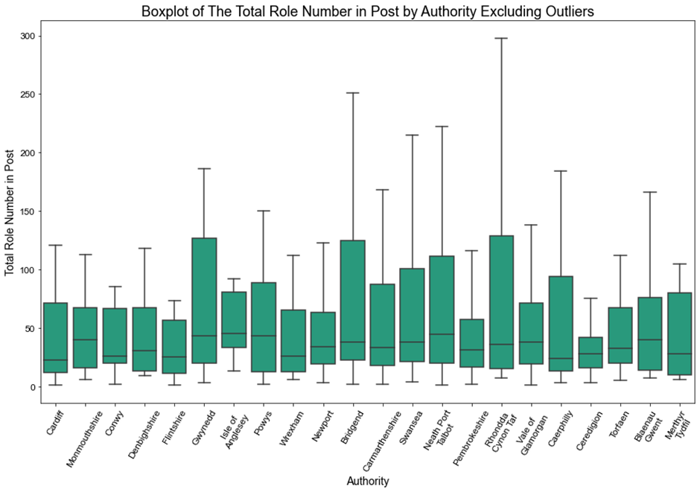

After this, we created another boxplot to investigate the relationship between the total role number in post and the setting type. It’s clear from the boxplot below that the median of the total number in post is significantly different for each setting, which suggests there’s a relationship between the two variables. The lengths of the whiskers and the heights of the boxes are also different across settings, which further suggests the presence of a relationship.

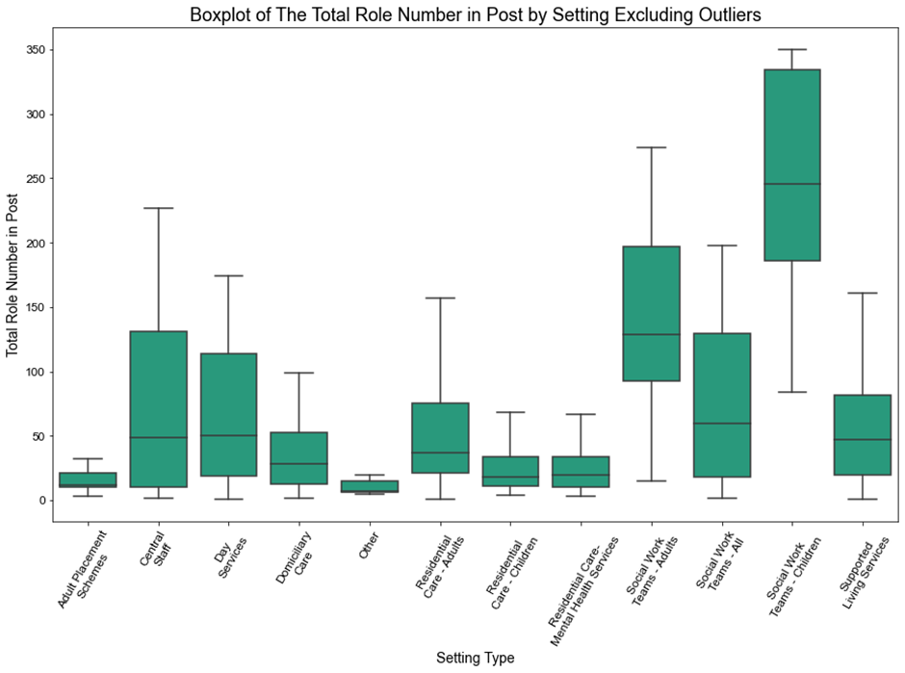

After deciding to use the total number of settings, authority and setting type as input variables, we split our dataset into 80 per cent for training the XGBoost model and 20 per cent for testing. We also used one-hot encoding to convert the nominal categorical variables into a numeric form that can be used in the machine learning procedure. One-hot encoding is a method to represent categorical variables by assigning a unique binary value to each category to indicate its presence or absence.

When training the model, we used grid search[6] to find the best combination of parameters and cross validation to evaluate its performance. The model resulted in an MAE of 26.86 in cross validation, compared to an MAE of 22.24 and an RMSE of 31.01 on the test set. These results suggest low to moderate prediction errors, with RMSE indicating slightly larger variability and sensitivity to outliers compared to MAE. It should be noted that, unlike last year, standardisation, which is the transformation of numerical data so it has a mean of 0 and a standard deviation of one, didn’t improve our model’s performance. For that reason, our metric values are, in turn, not standardised.

**Predicted estimates for vacancies to be filled**

Similar to the role number in post estimation, we aggregated the number of vacancies to be filled for each organisation based on the authority and setting. However, due to the small size of the dataset and its poor quality, we decided against using machine learning.

We chose median imputation to tackle this problem because of its simplicity and robustness. It involves replacing missing values with the median of the observed data. It was selected over the mean imputation as it’s less sensitive to outliers, which makes it more robust in the presence of skewed or extreme data.

We started by allocating 10 per cent of the dataset to test the deviation between our median estimations and the actual values. After this, we calculated the median for each setting per authority, leveraging the central tendency of the data specific to each authority and setting. We then used these computed medians to impute missing values with the corresponding appropriate median value.

The median imputation yielded an MAE of 2.83 and an RMSE of 4.75, which are moderate relative to the variability of the target variable, and indicate that the estimations have a moderate average error magnitude.

**Conclusion**

This year’s report reaffirms our confidence in using machine learning to forecast missing data. As we refine our methods and enhance data quality, we’re aiming for more precise predictions in the future.

1. https://www.gov.wales/performance-and-improvement-framework-social-services-additional-guidance-2023-2024 
2. https://fosterwales.gov.wales/
3. (<https://www.tuc.org.uk/blogs/use-zero-hours-contracts-wales-out-control-its-time-ban-them>).
4. The other types of machine learning are unsupervised learning, semi-supervised learning and reinforcement learning and they are explained here: ﷟HYPERLINK "https://link.springer.com/article/10.1007/s42979-021-00592-x"https://link.springer.com/article/10.1007/s42979-021-00592-x.
5. For more information about XGBoost and decision trees, visit https://www.nvidia.com/en-us/glossary/datascience/xgboost/.
6. For more information about grid search please visit https://scikitlearn.org/stable/modules/grid_search.html.