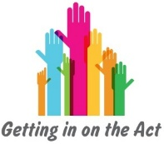
Resource 2c

Formal advocacy

Some broader professional roles have an element of advocacy within them. The professional can support the individual to express their views and wishes while separately expressing their own professional views or judgements.

Resource 2c

Professional/
Independent advocacy

An individual may be able to access an advocate whose job is to provide them with independent support to get their voice heard regardless of their own views or opinions of the situation.

Resource 2c

Informal advocacy

An individual may seek advocacy support from someone they know on an informal basis. This type of advocacy forms part of a broader emotional relationship where the advocate may have their own strong feelings about what’s best for the individual.

Resource 2c

Peer advocacy

An individual might look for advocacy support from someone who understands their situation because they’ve been there or are in similar circumstances
to themselves.

