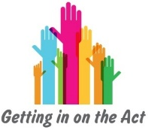
You’ve just been stopped by a police officer for exceeding the speed limit.

“Why are you driving at five miles per hour over the speed limit sir/madam?”

You come across a lost child in a shopping centre.

“I need to find my mummy can you help me?”

Telling your partner you’ve won a large amount of money.

“Slow down, I can’t understand what you’re saying...”

As an advocate, you’re meeting with
a young person of 13 years old for the first time.

“What can you do to help me?”

You’re celebrating your birthday in the pub with a gang of close friends.

“What do you want to do next shall we go to a club?”

