[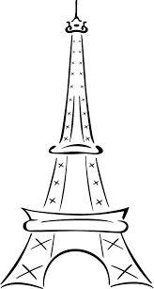](http://www.google.co.uk/url?sa=i&rct=j&q=&esrc=s&source=images&cd=&cad=rja&uact=8&ved=0ahUKEwiyzuW3mMDMAhVJLsAKHcKMC2MQjRwIBw&url=http://www.datemplate.com/post_simple-eiffel-tower-drawing_174032/&bvm=bv.121099550,d.ZGg&psig=AFQjCNFie8EmtpodrP_y--OTBWb4YKrpMQ&ust=1462443371510402)



[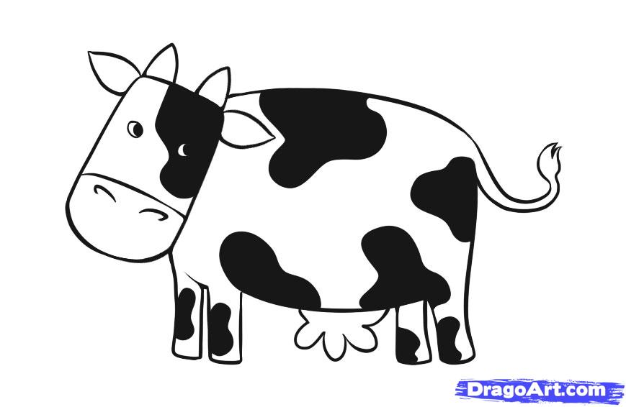](http://www.google.co.uk/url?sa=i&rct=j&q=&esrc=s&source=images&cd=&cad=rja&uact=8&ved=0ahUKEwiH7MrRmMDMAhWlJMAKHWR4ATkQjRwIBw&url=http://www.dragoart.com/tuts/4883/1/1/how-to-draw-a-simple-cow.htm&bvm=bv.121099550,d.ZGg&psig=AFQjCNFie8EmtpodrP_y--OTBWb4YKrpMQ&ust=1462443371510402)



[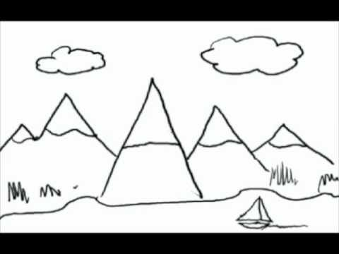](https://www.google.co.uk/url?sa=i&rct=j&q=&esrc=s&source=images&cd=&cad=rja&uact=8&ved=0ahUKEwjuuNnMmcDMAhVBK8AKHU0KAVUQjRwIBw&url=https://www.youtube.com/watch?v=sVzsNEY5Jew&bvm=bv.121099550,d.ZGg&psig=AFQjCNG_9WLtp0NjpEvb7PAJuxrPv4vtwQ&ust=1462443723939092)



[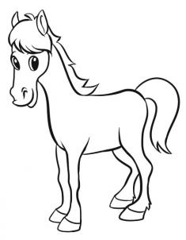](http://www.google.co.uk/url?sa=i&rct=j&q=&esrc=s&source=images&cd=&cad=rja&uact=8&ved=0ahUKEwiS8KGRmcDMAhVCD8AKHbcuAbMQjRwIBw&url=http://www.dragoart.com/tuts/4915/1/1/how-to-draw-a-simple-horse.htm&bvm=bv.121099550,d.ZGg&psig=AFQjCNFie8EmtpodrP_y--OTBWb4YKrpMQ&ust=1462443371510402)



[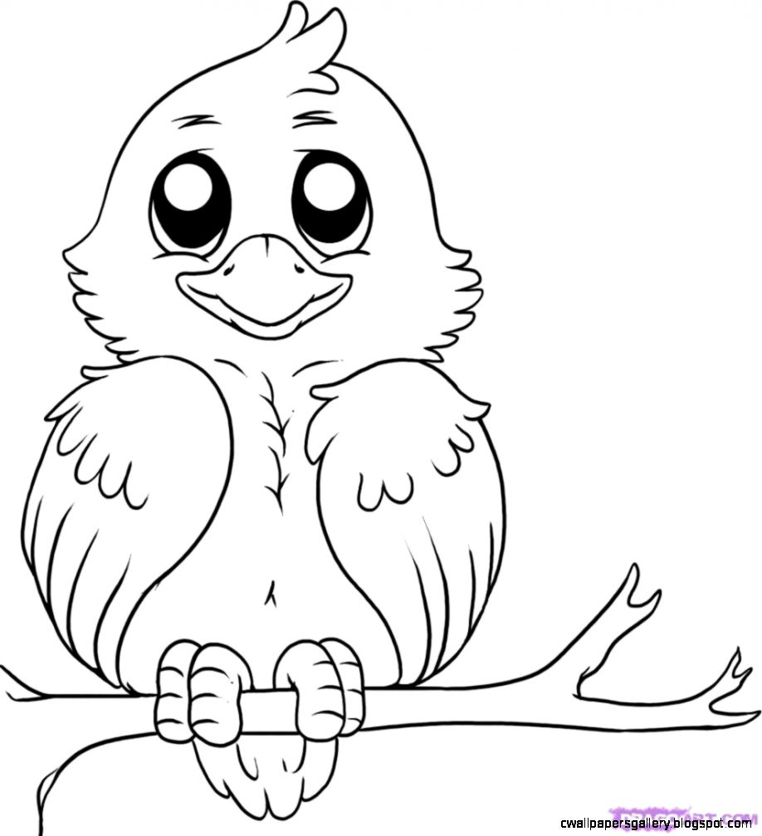](http://www.google.co.uk/url?sa=i&rct=j&q=&esrc=s&source=images&cd=&cad=rja&uact=8&ved=0ahUKEwjxi8elmcDMAhUnDMAKHZ1RC5IQjRwIBw&url=http://cwallpapersgallery.blogspot.com/2015/09/simple-bird-drawing-for-kids.html&bvm=bv.121099550,d.ZGg&psig=AFQjCNFie8EmtpodrP_y--OTBWb4YKrpMQ&ust=1462443371510402)



[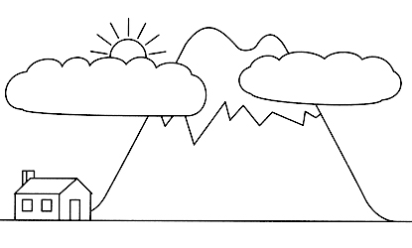](https://www.google.co.uk/url?sa=i&rct=j&q=&esrc=s&source=images&cd=&cad=rja&uact=8&ved=0ahUKEwjuuNnMmcDMAhVBK8AKHU0KAVUQjRwIBw&url=https://www.lds.org/manual/primary-6-old-testament/lesson-42-daniel-in-the-lions-den?lang=eng&bvm=bv.121099550,d.ZGg&psig=AFQjCNG_9WLtp0NjpEvb7PAJuxrPv4vtwQ&ust=1462443723939092)

[](https://www.google.co.uk/url?sa=i&rct=j&q=&esrc=s&source=images&cd=&cad=rja&uact=8&ved=0ahUKEwiZuajbmsDMAhWoL8AKHXfJAXsQjRwIBw&url=https://www.pinterest.com/pin/249035054367634129/&bvm=bv.121099550,d.ZGg&psig=AFQjCNG_9WLtp0NjpEvb7PAJuxrPv4vtwQ&ust=1462443723939092)