Regulation and Inspection of Social Care (Wales) Act 2016
Implications for local authorities

What’s it all about?
The Regulation and Inspection of Social Care (Wales) Act 2016 provides a revised, streamlined framework for the regulation and inspection of social care services in Wales. It embeds the aims of the Social Services and Well-being (Wales) Act 2014 and the Well-being of Future Generations (Wales) Act 2015.

The Act is being introduced to improve the quality of care and support in Wales. It will do this by strengthening protection, increasing accountability and giving a stronger voice to people who use care and support services.

Who will it affect?
Local authorities, care providers, managers, staff and people who use the following regulated services: care homes, secure accommodation, residential family centres, adoption and fostering, adult placements, advocacy, and domiciliary support.

What’s going to be different?
The Act marks a shift away from a system of regulation focused on compliance with minimum standards towards a system and culture which takes greater account of the impact that care and support services have on people’s lives and well-being.
- Local and national market stability reports introduced
- Better market oversight of important providers by the regulator
- Standardised reporting across local authorities
- Local authority inspections focus on impact and well-being

- The Care Council and SSIA will become Social Care Wales: an agent for change in the sector
- Duty to co-operate with CSSIW

- Better accountability through ‘responsible individuals’
- New annual provider returns
- Changes to CSSIW service registration
- Provider inspections focus on impact and well-being
- Mandatory registration of care workers, as well
as social workers and managers
- Workforce registration with Social Care Wales
- Regulation of care worker training

What will this mean for local authorities?
The Act will affect the whole sector. There will be changes for providers of regulated services. If local authorities provide regulated services there will be changes in the way those services are registered and inspected. More information about how the Act affects providers, including local authorities, can be downloaded from the Information and Learning Hub.

There are other changes which will affect local authorities regardless of whether they provide services. For instance, the inspection regime for local authority social services functions is changing to give more of a focus on impact and well-being.
Workforce
- Care and support staff, as well
as managers and social workers must be on the Social Care Wales register
- They must be ‘fit to practise’
Directors’ annual reports
- Standardised reporting template across local authorities
- Makes it easier for citizens to make comparisons
Inspecting for outcomes
- Local authority social services inspections to include assessment of how well services are meeting the well-being outcomes of the people who
use them
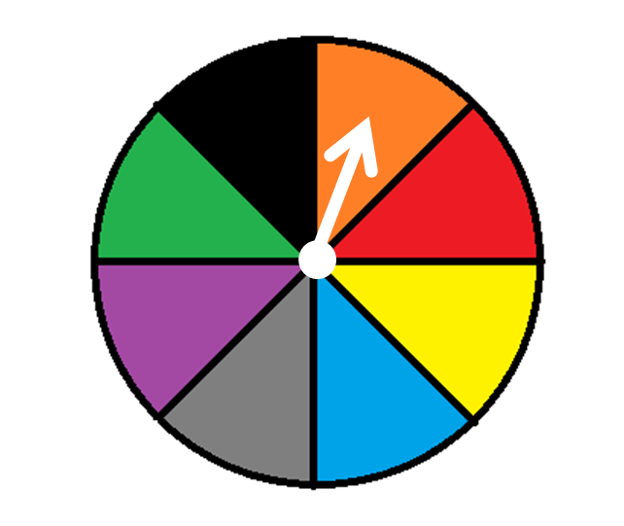
Market stability
- Local authorities to publish market stability reports reviewing the sufficiency of care and support in their area
- These must take account of the population assessment and feed into a national stability report
- Better market oversight of important providers by CSSIW
to spot problems earlier
Good to know
CSSIW has been working with stakeholders to develop a revised framework for inspection, engagement and performance review of local authorities. The proposed framework includes the introduction of a core inspection programme that is supported by improved arrangements for engagement and performance review. The inspection framework will ensure that local authorities are inspected to a common methodology aligned to the well-being outcomes of the Social Services and Well-being (Wales) Act 2014 and include the views and voices of people needing care and support.

The inspection framework will be tested during 2016-17. Lessons learned from
this testing will inform the development of the new requirements of local authority inspection that come into force in April 2018. These detailed requirements will be set out in regulations, which will be consulted upon during late spring to summer 2017.

