Briefing pack to support the implementation of the all Wales induction framework for health and social care, the development of the new health and social care qualifications and the routes to registration

Summer 2019

Content
Introduction  - All Wales induction framework for health and social care  - Qualifications  - Registration | 3
Who is the briefing for?  Aim of the briefing  Language and definitions | 3
Presentation and facilitator notes  Slide 1 – The all Wales induction framework for health and social care | 5  5
Slide 2 – What does the induction framework look like - Demonstration | 7
Slide 3 – Formats of the induction framework | 10
Slide 4 – Sample workbook answers to identify what a good answer looks like – Group exercise  - Section 1 Principles and Values of health and social care (adults)  - Section 2 Principles and Values of health and social care (children and young people) | 12  13  44
Slide 5 – The new qualifications | 87
Slide 6 – The new framework of qualifications | 89
Slide 7 – Journey of a new worker | 91
Slide 8 – Role of the manager | 92
Slide 9 – Assessment of the core qualification | 93
Slide 10 – Level 2 / 3 health and social care practice qualifications | 95
Slide 11 – Assessment of practice qualifications | 96
Slide 12 – Registration of domiciliary care workers | 97
Slide 13 – Domiciliary care workers – potential routes to register until April 2020 – Flow diagram | 98
Slide 14 – Registration of residential child care workers | 101
Slide 15 – Review routes for registration | 102
Slide 16 – Qualification framework | 103
Slide 17 – Qualification framework (continued) | 106
Slide 18 – Discussing the routes to registration – Group exercise | 107

Introduction

All Wales induction framework for health and social care (AWIF)
The All Wales induction framework for health and social care (AWIF) was implemented in Social Care in April 2018. Since then the sector has been getting used to the new framework and has started to fully implement the AWIF.
However, feedback received indicated that there were still some misconceptions and myths around the AWIF. Feedback also received, indicated that some managers and employers were struggling or finding it difficult to judge whether workers answers to workbook materials were sufficient / good enough. Some managers were expecting fully formed, in depth answers from workers who were new to social care rather than answers that reflected their stage of development during induction.

Qualifications
The new suite of level 2 and 3 qualifications for health and social care and children’s care, play, learning and development will be available for 1st teaching from September 2019.
Registration
Mandatory registration for domiciliary care workers is from April 2020. Until then, domiciliary care workers can register with Social Care Wales on a voluntary basis

Who is this briefing for?
This briefing pack has been developed for those who want to develop the sessions on a local or a regional basis. It includes managers and employers, including HR employers and Responsible Individuals, local authority training departments and those responsible for implementing the AWIF and supporting completion of qualifications and registration.

Aim of the briefing
The aim of the briefing pack is to
- explain what the AWIF is and what it includes
- demonstrate the types of AWIF workbook answers that can be expected from workers
- explain the changes to qualifications
- explain the requirements for registration
- systematically shows how induction, the core qualification, the practice qualification and registration all fits together
Language and definitions
Facilitator – The person delivering the training / briefing
Participants – The person receiving the training / briefing

Presentation slides and facilitator notes pages
These slides can be used to deliver the information about the AWIF, qualifications and registration. There are notes pages can be used by the facilitator to explain to participants in detail the background, history and context to the AWIF and how these link to the completion of the new suite of qualifications in health and social care, available in September 2019. The notes then go on to explain the requirements and the different routes available for the registration of domiciliary care workers.
These slides can be used and adapted to suite participants needs, however, we do suggest that they are completed in order to systematically explain the journey from induction through to registration. It is important to confirm participants’ understanding through out the presentation before moving on. To deliver the briefing session in its entirety a full day session should be allowed.

Resources
To deliver the presentation to a group of people a laptop/PC, projector and screen and the PowerPoint presentation itself. This can be found here (Link).
Working through the group work activity on the sample workbooks referred to on slide 4 of the presentation, hard copies of these may be useful.

Presentation and facilitator notes

Slide 1 – the all Wales induction framework for health and social care
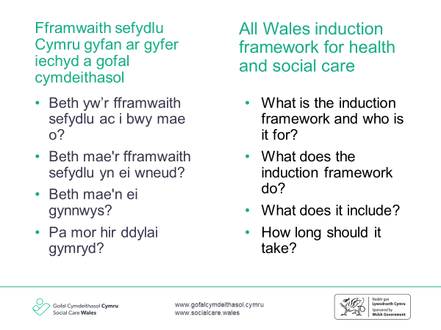
Facilitator notes
- This slide gives the background and the context for the all Wales induction framework for health and social care (AWIF). It explains who the AWIF is for and what it does. The content of the AWIF is outlined as well as how long it should take to complete is.

What is the induction framework and who is it for?
- The All Wales induction framework for health and social care (AWIF) is for new health and social care workers into the sector, new organisation or job role and covers the principles and values, knowledge and skills workers need to carry out their role competently at this stage of development.
- Workers moving from one role to another are not expected to undertake the whole framework again, they may however, need to demonstrate to their new employer how they apply their previous learning in practice. The practice learning outcomes in the framework will help with this.
- The Regulation and Inspection of Social Care (Wales) Act 2016 set a regulatory requirement for use of the framework. The Regulated Services (Service Providers and Responsible Individuals) (Wales) Regulations 2017 state, in section 36. – (2) (a) that a service provider must ensure than any person working at the service “receives an induction appropriate to their role” and the associated statutory guidance states that ‘Social care workers complete the relevant induction programme required by Social Care Wales within the defined timescale alongside any service-specific areas’.

What does the induction framework do?
An induction will help workers to:
- understand their role – what is required of them and what support they can expect
- get to know their working environment and the important information they need to do the job well
- get to know their colleagues and develop good working relationships
- understand how they can best support those they will be working with.

What does the induction framework include?
There are seven sections in the induction framework:
- Sections 1 and 2: Principles and values of health and social care (adults or children and young people)
- Sections 3 and 4: Health and well-being (adults or children and young people)
- Section 5: Professional practice as a health and social care worker (adults and children and young people)
- Section 6: Safeguarding individuals (adults and children and young people)
- Section 7: Health and safety in health and social care (adults and children and young people)

How long should it take to complete the induction framework?
- Most workers should be able to complete the framework within their first 6 months in post but it is recognised that some may take longer depending on the hours they work or their role. Many employers are linking completion of the induction framework to their probationary period.

Slide 2 – What does the induction framework look like - Demonstration
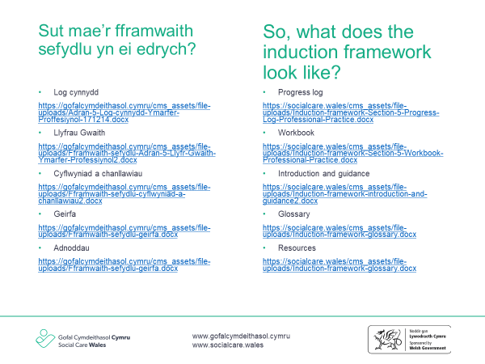
Facilitator notes
- This slide aims to demonstrate what the AWIF documents look like and where they can be found on Social Care Wales’ website.
- The links on the slide link directly to the documents on Social Care Wales’ website. You will need wifi access to open these. Where there is no wifi access, the document can be saved on your desktop, memory stick, or hard copies can be used.
- This part is important as it shows how the progress logs should be used to record when a worker has completed the learning outcomes within the AWIF. It also shows clearly the links between completing the workbooks as the evidence that can be used to complete the learning outcomes within the framework.
- It may also be useful to demonstrate how to find the AWIF on our website by using this link https://socialcare.wales/

Progress logs
These are used to record a worker’s progress through the framework.
Each of the seven progress logs are broken down into:
- headings – for example, 5.5. Personal conduct of health and social care workers
- objectives – for example, the importance of upholding the profession of health and social care workers
- core knowledge learning outcomes – identifies the knowledge and understanding new workers need to gain in their induction period. This includes the core knowledge that applies across all health and social care settings, as well as those that are specific to their role and workplace. These mirror the content of the new health and social care Core qualification. This will be further explained further in the presentation.
- additional practice learning outcomes – confirms application of the core knowledge in practice in the workplace. These mirror the mandatory content of the new health and social care practice qualifications. This will be further explained further in the presentation.
- Evidence used – a space to note down what evidence was used to meet the objective e.g. workbook, observation, supervision etc. In this part, there is no need to include all the evidence that was used to meet the outcomes, rather a ‘signpost’ to where the evidence can be found. E.g referring to a completed workbook.
- Assessed by who and when – who assessed or made a judgement that the worker was able to meet the objective. A range of people can assess the induction framework learning outcomes, including, but not exclusive, to the worker’s:
  - direct line manager
  - team leader
  - mentor
  - supervising social worker
  - qualification assessor.
- Signatures – to be completed by the person who carried out that assessment/judgement and the worker.
- In regulated services, it is the registered manager’s responsibility to sign off the whole induction framework once it’s completed, others can however complete the progress logs.
- Workers don’t have to complete some elements of the additional AWIF if they’re not part of their role, e.g. moving and positioning.

Workbooks
- These have been developed to help put the induction framework into practice and to help new workers generate the evidence they need to complete the progress logs and prepare to undertake the ‘core’ and practice qualifications needed for their roles.
- The workbooks are made up of a number of learning activities using case studies, films and written questions to support learning. You may wish to change, use experiential learning or add to the case studies to reflect the part of the sector you are working in but remember, if you do this, you need to ensure that they continue to support workers to be formally assessed on the content when they complete their qualifications. The case studies available and the learning from these is transferrable across different roles and settings.
- The workbooks are not a mandatory requirement but we hope they will be a helpful tool and would strongly recommend that you use these. Completing the workbooks will provide evidence to the regulators of service that you are carrying out robust induction processes. They will prepare workers for undertaking the assessment of the Core qualification if they need to do this and evidence can be used by the workers towards their practice qualification. If the workbooks are being used for supporting evidence towards a practice qualification, the evidence will need to be judged by a qualified assessor.
- If learner isn’t yet in employment, they can complete the knowledge learning outcomes and then can come back to practice-based activities later when in a role.
- There is a column down the right-hand side of each workbook that is to be used by qualification assessors to record notes if they are using this as evidence for the practice qualifications.
- Workbook reflection heading – this heading gives an opportunity for the learner to reflect on what they have learned during this workbook.
- Practice placement reflection – this heading gives an opportunity for those who are completing the workbook through placement to complete a short reflective account of what that have learned.
- There is a section at the end of each workbook for qualification assessor/learner discussion. These are to be used when the workbooks are put forward as evidence towards the completion of further qualifications.

The workbooks are explored in more detail later in this presentation.

Introduction and guidance
- An introduction and guidance document has been developed that can be used as a guide for managers and for workers. Much of the information found in this document can be used to support workers and learners through their induction as well as providing information to managers.

Glossary
- There is a glossary that covers all the workbooks and progress logs, and provides some definitions of the terms used. Anything marked in bold will be included here. Its aim is to ensure consistency in the meaning of some of the terms used. There may be terminology that is new to the sector, such as from the Social Services and Well-Being (Wales) Act 2014.

Resources
- There’s also a section that includes links and references that the new worker may find helpful, this includes the Information and Learning Hub, The CPD toolkit and publications such as ‘positive approaches: reducing restrictive practices in social care’. The information provided in these resources will support workers and learners to be able to provide evidence to complete the induction framework.
- We have developed personal outcomes resources for domiciliary care managers and workers that may be useful in supporting the completion of the induction framework https://socialcare.wales/service-improvement/personal-outcomes#section-32607-anchor

Slide 3 – Formats of the induction framework
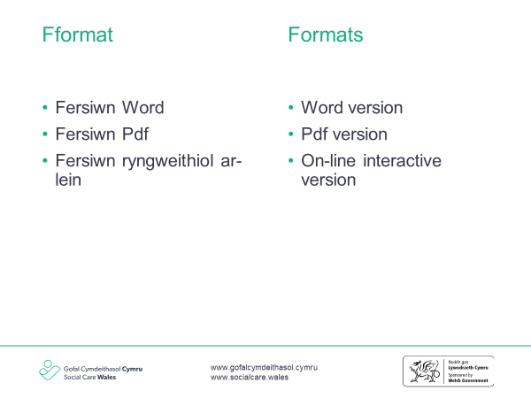
Facilitator notes
- This slide explains the different formats that the AWIF documents are available in, the purpose and the benefits of each.

Word version
- These were available from December 2017. This is a plain portrait version of the induction framework that can be completed by the worker and then printed.
- It is a plain version that can be printed in black and white.
- This version can also be downloaded and used offline without access to the internet.
Pdf version
- These were available from the beginning of February 2018. This is a full colour, interactive version that can be completed by the worker. It includes editable and expandable boxes.
- This is a more colourful, attractive version.
- This can be downloaded and used offline without access to the internet.

Online version
- The first version of this was available in Spring 2018. Following feedback, it has been redeveloped to make easier to use. The new version is available to support registration route 3 for domiciliary care workers, which is the Social Care Wales Principles and Values Course. Further information on this can be found on slide 13 of this qualification.
- It allows workers and learners to create their own account and have a personal log in. They can complete the workbooks in this format and invite their manager to review. Managers will then be able to review the completed sections and provide comment. You will need to make sure your learners have access to a computer and the internet to use the web-based version of the induction framework.

Slide 4 – Sample workbook answers to identify what a good answer looks like
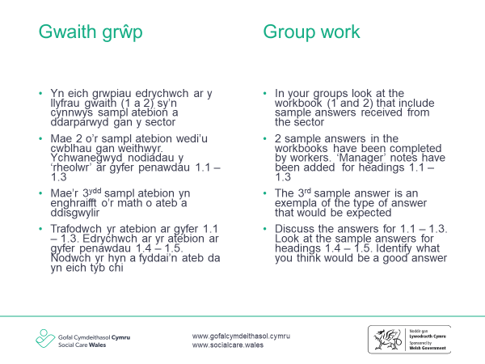
Group work exercise
- This slide explains the group work exercise in looking closer as the AWIF workbooks.

The aim of this exercise is to
- understand the types of answers that could be expected from new workers within the first few months of their employment
- get a feel of the depth and the level of detail that should be included
- think about the responses that can be provided by managers to help support and encourage workers to develop the knowledge for answers if needed
- support managers to share good practice and explore solutions to challenges
- explore the standardisation of answers and responses from workers and learners to the induction framework workbooks
- support managers to share good practice and explore solutions to challenges.

Section 1 Principles and Values of health and social care (adults)
Group exercise explanation Part 1
- An exert from the first workbook for the All Wales Induction Framework for Health and Social Care has been included as part of the activity Appendix 1 (Link).
- Sample materials from 3 completed workbooks completed by workers have been included for headings 1.1, 1.2 and 1.3. These include a range of poor answers, average answers and good or ‘model’ answers. Comments have been provided by a ‘manager’ alongside each answer.
- Look at these in your groups and consider the following.
- What do you think of the answers provided? Do you agree with the ‘manager’ feedback or would you be saying something else in your role?
- The ‘workers’ answers and responses are in italic font and the manager’s notes are included in the boxes next to the responses.

Group exercise explanation Part 2
- Using the same sample materials for headings 1.4 and 1.5, only answers from sample 1 and 2 have been included. The good or ‘model’ answer has been left out.
- Look at these in your group and consider the following.
- Look at the sample answers make some judgement as to whether these are sufficient in their evidence.
- Think about feedback you may give the worker if you were their manager.
- Think about what a ‘good model answer may be’ to each of the questions.
- The ‘workers’ answers and responses are in italic font and the manager’s notes are included in the boxes next to the responses.
- It is expected that this activity takes 45mins to 1 hour.
All Wales Induction Framework for Health and Social Care workbook 1: Principles and values of health and social care (adults)
This workbook will help you explore the principles and values that underpin the practice of health and social care workers. You can use the completed workbook activities as evidence towards achieving the All Wales Induction Framework for Health and Social Care (Induction Framework). It can also be counted towards the qualification that you will need to complete later for your practice.
Contents:
  - Legislation, national policies and codes of conduct and practice
  - How rights-based approaches relate to health and social care
  - How to use person-centred approaches
  - Equality, diversity and inclusion
  - Positive risk taking
  - Positive relationships and professionals boundaries
  - Communication
  - Welsh language and culture
  - Positive approaches to reduce restrictive practices in health and social care
  - Change and transitions in health and social care
  - Reflection
  - Workbook reflection

1.1 Legislation, national policies and Codes of Conduct and Practice
This section will help you develop an awareness of the principles and values of health and social care that have been built into legislation, national policies and codes of conduct and professional practice. It will also help you think about how you can apply these in your day-to-day work.
Learning activity
The Social Services and Well-Being (Wales) Act 2014 is an important piece of legislation about how we should be providing care and support to those who need it throughout Wales. Look at the Social Services and Well-Being (Wales) Act workbook ‘What the Act means for me’ for health and social care workers as this will help you understand the principles and values of health and social care. It provides practical examples of how the principles and values can be carried out when working with individuals.
The Act workbook is split into five sections, one for each principle. You should complete at least two learning activities for each principle – these are varied and range from case studies, to listening to sound bites, or watching short film clips.
The evidence you record in the Act workbook can then be used as evidence towards the learning outcomes in this section. Make sure you also complete the personal development action plan at the end as this will help you think about what you have learnt and how you can put this into practice.
Use the space below to make notes about any other important learning from the Act workbook.
Sample 1 - Workbook notes
Sample 1: comments
Important that the Act workbook is used to develop an understanding of principles and values. This covers a huge chunk of the induction framework and the worker will need to demonstrate the knowledge for the ‘core’ qualification.
This activity was left blank by the worker

Sample 1 - Manager feedback
This activity was left blank by the manager

Sample 2: comments
Important that the Act workbook is used to develop an understanding of principles and values. This covers a huge chunk of the induction framework and the worker will need to demonstrate the knowledge for the ‘core’ qualification.
Sample 2 - Workbook notes
This activity was left blank by the worker

Sample 2 - Manager feedback

This activity was left blank by the manager

Sample 3 - Workbook notes
Sample 3: comments
This type of recording from the manager is sufficient, the ‘Act Workbook’ can be referenced as evidence on the progress log
Act workbook completed

Sample 3 - Manager feedback

Sian has completed all of the activities within the Act workbook and demonstrated a good understanding of the principles of the SSWB Act along with the code of professional practice and how this promotes the principles and values of social care.

  - How rights-based approaches relate to health and social care
In your role as a health and social care worker, you will be supporting individuals who come from different backgrounds, religions and cultures. This work is underpinned by the principles and values you learnt about in the last section, along with the rights:
- to be treated as an individual
- to be treated equally and not discriminated against
- to be respected
- to have privacy
- to be treated in a dignified way
- to be protected from danger and harm
- to be supported and cared for in a way that meets their needs, takes account of their choices and protects them
- to communicate using their preferred methods of communication and language
- to access information about themselves.
These rights will be explored throughout this workbook. This section will help you learn about how rights-based approaches relate to health and social care.
Learning activity
Legislation and national policies have developed over time to support the rights of all citizens. Look up the easy read versions of these to help you understand the main points and then,
- select two of the pieces of legislation in the table below
- identify the rights they support and promote
- write a short summary of how they do this.
Workbook Sample 1
Legislation / national policy | Rights | How does the legislation or national policy support and promote these rights?
Social Services and Well-Being (Wales) Act 2014 | Voice and control  Prevention and early intervention  Well-being  Co-production  Multi-agency  This applies to adults/children and carers | Working together in partnership working between all parties involved. It is the law and must be abided by and Care Inspectorate Wales to regulate by.
Equality Act 2010 | Protects against discrimination and personal characteristics such as age, disability, gender reassignment, marriage, civil partnership, pregnancy, and maternity, race, religion, sexual orientation | The law states no negativity towards these characteristics and must be challenged
Human Rights Act 1998 and associated conventions and protocols such as the UN Convention on the Rights of Persons with Disabilities; the UN Principles for Older Persons 1991; and the Declaration of the Rights of Older People in Wales (2014) | Allows you to defend your rights in a court of law | Compels public organisation, police and law councils to treat everyone equally with fairness, dignity and respect
Mental Health Act (1989), Code of Practice for Wales (2008) and the Mental Health (Wales) Measure (2010) | Places legal duties on local health board and local authority about assessment and treatment of Mental Health problems | It ensures that mental health services are available within primary care
Mental Capacity Act 2005 and associated Code of Practice | Designed to help people over 16 who are unable to make all or some decisions themselves | Each person is deemed to have capacity unless proved otherwise
Deprivation of Liberty Safeguards | It is the legal framework to protect vulnerable adults | It protects vulnerable adults who may become deprived of their liberty in a care home or hospital setting
Welsh Language Act 1993; Welsh language measure (2011) and Mwy na Geiriau, Welsh Government Strategic Framework for the Welsh Language in Health and Social Care (2103 | The use of Welsh language delivery of public services | Language should be treated equally in the conduct of the public
Sample 1: comments
The worker has completed all of these instead of 2 pieces of legislation. Some answers exceed what you would expect from someone at this stage. The manager could provide some positive feedback to the worker on the work that they have put in to complete these answers and explain that their application to practice will be looked at throughout the remainder of their induction.

Workbook Sample 2
Legislation / national policy | Rights | How does the legislation or national policy support and promote these rights?
Social Services and Well-Being (Wales) Act 2014
Equality Act 2010 | All people treated fairly and equally
Human Rights Act 1998 and associated conventions and protocols such as the UN Convention on the Rights of Persons with Disabilities; the UN Principles for Older Persons 1991; and the Declaration of the Rights of Older People in Wales (2014) | The right to life  The right to liberty and security  The right to a fair trial  The right to freedom of expression  The right to marry  Not to be discriminated against…….
Mental Health Act (1989), Code of Practice for Wales (2008) and the Mental Health (Wales) Measure (2010)
Mental Capacity Act 2005 and associated Code of Practice
Deprivation of Liberty Safeguards
Welsh Language Act 1993; Welsh language measure (2011) and Mwy na Geriau, Welsh Government Strategic Framework for the Welsh Language in Health and Social Care (2013)
Sample 2: comments
The worker has missed the column on ‘how does the legislation or national policy support and promote these rights?’ Would be good to see a little more. The description of the Equality Act is also a little thin. The manager could have a conversation with the worker to test out their knowledge a little more e.g. what is their understanding of people being ‘treated equally and fairly’?

Workbook Sample 3
Legislation / national policy | Rights | How does the legislation or national policy support and promote these rights?
Social Services and Well-Being (Wales) Act 2014 | Voice and control – having a say about what matters to the person and control over their lives  Right level of support when the person needs it  Right to well-being | The principles of this Act support the rights of individuals who need care and support and carers. It is a legislative framework that social care services and health must meet.
Equality Act 2010
Human Rights Act 1998 and associated conventions and protocols such as the UN Convention on the Rights of Persons with Disabilities; the UN Principles for Older Persons 1991; and the Declaration of the Rights of Older People in Wales (2014)
Mental Health Act (1989), Code of Practice for Wales (2008) and the Mental Health (Wales) Measure (2010)
Mental Capacity Act 2005 and associated Code of Practice
Deprivation of Liberty Safeguards
Welsh Language Act 1993; Welsh language measure (2011) and Mwy na Geriau, Welsh Government Strategic Framework for the Welsh Language in Health and Social Care (2103 | The right to access services through the medium of Welsh and the need for this to be offered rather than asked for | These place a requirement on services to actively offer services through the medium of Welsh

Sample 3: comments
At this stage of the new worker’s learning, these answers are sufficient. They will develop their understanding as they progress through the workbooks and their induction.

Learning activity
Advocacy underpins all the principles of the Social Services and Well-Being (Wales) Act and is an important tool to support the voice and control, and well-being of individuals. Advocacy can help individuals access information about services, be involved in decisions about their lives, explore choices and options, and make their needs and wishes known.
In the space below, outline what you think is meant by the term ‘advocacy’ and describe how this can support a rights-based approach.
Sample 1 Workbook notes
Sample 1: comments
This is a good answer, but it feels although it has been copied and pasted from somewhere rather than from the workers own words. The manager could ask the worker how they think this would apply to the individuals that they were working with – this would help to check out their understanding

Advocacy is a process of supporting and enabling people to express their views and concerns, to access information and services. Defend and promote their rights and responsibilities and to explore choices and options. An advocate would support a person to have voice and control over their lives. This could be family member, friend or independent person.

Sample 2: comments
The first part of this answer is not really correct. The aim of an advocate is to enable someone to have a voice, rather than ‘act’ as their voice. The second part shows insight. A discussion with the worker would help to clarify their understanding
Sample 2 Workbook notes

To be able to act as someone’s voice. To enable the individual to access information relevant to how they want to live.

Sample 3 Workbook notes
Sample 3: comments
This is a good answer that links learning from the sections on principles and values and legislation and demonstrates an understanding

Advocacy can help individuals / carers to be involved in decisions about their lives. This supports their right to have voice and control. Advocacy is described as the ‘golden thread’ of the SSWB Act.

Learning activity
Talk to your manager about how you can apply rights based approaches in your daily work and record the main points in the space below. If you are not yet employed, leave this space blank and return to it later.
Sample 1 Workbook notes
Sample 1: comments
This should have been completed, it would help to check out that the worker really understands the answers that were given throughout section 1.1 and that they had not been copied from elsewhere. It would also provide evidence for the practice learning outcomes of the induction framework and at a later date, for the practice qualifications

This activity was left blank by the worker

Sample 2 Workbook notes
Sample 2: comments
This feels a bit thin. Some more concrete answers would have been better, perhaps directly related to the individuals that the worker is supporting.

To always treat the individual with respect and dignity. To treat them as an individual, not discriminate against them.

Sample 3 workbook notes
Sample 3: comments
Getting to know an individual, listening to them and taking account of what matters to them is central to the role of workers. This answer shows a good understanding of this

Make sure that the individuals I am supporting can express what is important to them and I listen to and take account of that in the way that I work. Taking the time to get to know someone is really important.

  - How to use person-centred approaches
Person-centred approaches are at the heart of care and support for individuals. This section will build on what you have learnt so far and help you think about how these can be applied in your practice.
Learning activity
In the space below, describe what is meant by the term ‘person-centred approaches’ and why these are important.
Sample 1 Workbook notes
Sample 1: comments
A good answer, but it still feels a bit ‘text book’ but helpful to see that the language of the Act is being used here. Discussions with the manager could draw out the worker’s understanding.

Person centred approaches are treating people as individuals, supporting people to access their rights, supporting people to exercise choice, ensuring privacy, dignity, respect and independence is maintained and recognised that working with people is a partnership rather than a relationship controlled by professionals. This is important as it supports rights, choice, voice and control and well-being.

Sample 2: comments
The first part of this has been copied word for word from the code of professional practice, on the one hand, that is good as it shows that the worker has read it, on the other, it would have been helpful to have an example of what this means for the individuals the worker is supporting.
Sample 2 Workbook notes

Approaches and ways of working that recognise the individual and use their uniqueness as the basis of the planning and the delivery of care. The individual needs to know that they are treated as individuals. They know that they are being listened to.

Sample 3 Workbook notes
Sample 3: comments
This shows a good understanding, and the worker has provided an example of what this means in their practice.

Person centred approaches means that I put the individuals that I am supporting at the heart of everything I do. It’s about their life and what matters to them, rather than what I think. An example of this is supporting xxxxx to go to the allotment every weekend, I have never been very interested in gardening but it is important to him and so important that I learn about it and do the best that I can.

Learning activity
In the first section of this workbook, you learnt about the principles and values of the Social Services and Well-being (Wales) Act. In the space below, record what you think is meant by ‘co-production’ and ‘voice, choice and control’ and explain why these are important for person-centred approaches. You may want to watch the film produced by SCIE ‘Co-production in social care: What it is and how to do it’ to help you think about this.
Sample 1 Workbook notes

Co-production is about developing a more equal partnership between people who use care services, carers and professionals. There are key principles for co-production around equality, diversity, access and reciprocity. People are equal partners and are able to share power to plan and deliver and share services. Co-production should be inclusive and as diverse as possible. Particular effort may be needed to ensure seldom heard groups are included to ensure their voices are heard and services meet their needs.
Sample 1: comments
Another good but ‘text book’ answer

Sample 2 Workbook notes
Sample 2: comments
This doesn’t really answer the question and explain what co production means. The rest of the answer is good though, it just needs teasing out a little through discussion with the manager.

Working with colleagues and other agencies to promote the well-being, voice and control of individuals and carers.
Working with individuals in ways that maximises their well-being and balances their rights and responsibilities.
Make sure that people’s choices are met. That they live the way that they want to live.

Sample 3 Workbook notes
Sample 3: comments
At this stage of the worker’s employment, this shows that they understand what is meant by co-production and why it is important for individuals accessing care and support
Co-production is about deciding on the best way to deliver services with someone rather than for someone.
Voice, choice and control is about having choice and control over the way that you want to live your life – big decisions and the day to day little things.
Both of these help the individual to live the life that they want to live.

Learning activity
Read the case study below and think about why it is important to know about an individual’s preferences and background, and how you would find out about the preferences and backgrounds of individuals and what matters to them.
Case study – Mrs Desai
Towards the end of her life my mum was more or less bed-bound and unable to walk. She had carers who came three times a day (morning, lunchtime and evening). The biggest problem was language, as none of her carers spoke Gujarati, which is the only language my mum spoke. So there was total lack of communication and she felt completely isolated and started feeling more and more depressed. Luckily, they sent female carers so at least she was spared the humiliation of being tended to by a man. Hindu women (particularly the elderly) are very shy - I had never seen my mum's legs as she always wore a sari and no part of her was ever exposed, even to us as children.
One day I visited her in hospital and the nurse (female) was giving her a bed bath so I waited outside her room. Then for some reason the nurse was called away and she left the room, leaving the door open and my mum half dressed and exposed to anyone walking into ward to see. I quickly went in and closed the door. Mum was very, very upset and kept saying to me - she was crying and saying please take me home. She found the whole hospital experience very disturbing - she was - the only word I have is traumatised - not only the bathing incident but being unable to understand a word the nurses and doctors said to her. She couldn't understand what they are saying, unable to ask for help or request for a bed pan or anything.
Modesty is such a big part of Hindu culture. The home carers had no idea about dignity and modesty. When I visited mum at home I often found them giving mum a bed bath and leaving her exposed and talking to someone on their mobile phones. They had no idea how to put a sari on mum - in the end we had to buy kaftans as mum would not wear short nighties. Also, mum always wore sacred tulsi beads around her neck since my father died. The carers did not understand the significance of this and removed it without her permission.
Mum had a small shrine in her bedroom where for years she lit a candle and incense each day and prayed. None of us ever wore our shoes in mum's bedroom because though it was her bedroom it was also her prayer room. The carers had no understanding of this and because the carers changed so often you would inform one of them and the following week there would another carer.
Mum was a pure vegetarian so she would not even eat eggs. Some carers/nurses had very poor knowledge of what Hindu vegetarians can eat or not eat. Mum would not even eat something which was cooked in utensils used to cook meat therefore she never ate hospital food and the family would take her food from home.
Therefore, the key thing is high quality cultural awareness training is most essential for anyone who works with older Hindu patients. I felt really sorry for my mum because this dignified, proud lady who bore eight children and worked really hard to help my dad in his business and made many sacrifices to educate her children really well and had led an exemplary life, found her end of life so hard and undignified.
Learning activity
Sample 1 Workbook notes
What would have helped in this situation?
Sample 1: Comments
Some good examples here, maintaining dignity and respect and some practical changes are included in the answer to the next question
Training in cultural awareness and end of life care, picture cards for communication, facial expressions, objects of reference, body language, interpreter, family member.

How could the health and social care workers have acted differently?
Closing doors to maintain privacy, covering parts of the lady to maintain dignity and avoid embarrassment for her and not using a mobile phone whilst carrying out duties.
Sample 1: Comments
Good practical answers that show that this worker can recognise changes to practice that are needed. The manager could pick up on these through discussion and help the worker make the links to the Codes of conduct and professional practice

Sample 2 Workbook notes
Sample 2: Comments
Good answers at this stage of the worker’s learning.
What would have helped in this situation?
Talking to family members to gain awareness of the individual, cultural and religious beliefs
How could the health and social care workers have acted differently?
They should have treated Mrs Desai with dignity and respect, regardless of the lack of common language.
Sample 2: Comments
Good answers at this stage of the worker’s learning. The manager could pick up on this and the previous answer and help the worker make the links to the Codes of conduct and professional practice

Sample 3 Workbook notes
Sample 3: Comments
Getting to know the individuals that are being supported and what is important to them is a vital aspect of the job. It is good to see references to personal plans here, and also recognition of the role of families and when things need to be checked out with the manager
What would have helped in this situation?
To have found out what was important to Mrs Desai and how she wanted to be cared for and supported. They could have read the personal plan and asked Mrs Desai’s daughter / their manager how they could best communicate with her.

How could the health and social care workers have acted differently?
They could have asked Mrs Desai’s daughter to help them understand. They should also have reported communication difficulties to their manager. Regardless of communication or culture, they did not treat Mrs Desai with respect when supporting her with personal care – you should always make sure that the privacy and dignity of people is in place when helping them with their personal care and help them feel as comfortable as possible
Sample 3: Comments
This shows an understanding of why it is important that the dignity of individuals and ensuring privacy are upheld, particularly when supporting them with their personal care.

Learning activity
The principle of dignity is at the centre of supporting and working with any individuals. It is important that health and social care workers understand what dignity means and how this can be built into practice.
Answer some questions on dignity and respect in the space below.
Workbook notes

Sample 1 Workbook notes:

- What is meant by the term ‘treating people with dignity and respect’?
Always speak politely, include individuals in their care decisions and life. Protect their modesty during procedures with personal care. Ensure they are included in all conversations and finding out how they like to be addressed

- Why is this central to the role of the health and social care sector?
Some procedures that take place are sometimes invasive and personal. It is important to treat individuals with respect and dignity.

- Give a minimum of three examples of how you can treat people with dignity and respect in your day-to-day work.
By speaking politely and respectfully, treating the person as an individual, provide privacy and maintain their dignity

- Thinking about the case study for Mrs Desai, how could she have been treated with dignity and respect?
By respecting her culture and finding out about it, providing privacy for her and maintaining her dignity

- What is meant by establishing consent with individuals when providing care and support, and why is this important?
No procedure should be carried out without consent. You must inform the individual about what is going to take place and they must give consent otherwise you must not do anything

- How could Mrs Desai have been helped to give her consent for the way her care and support was being provided?
By showing pictures / flash cards, interpreter, daughter could have explained first and Mrs Desai could nod her head yes or no

- Give a minimum of three examples of how you would establish consent from individuals for their care and support.
By asking the person / By care plan / By finding out their needs and preferences
Sample 1: Comments
There are some good ideas and answers here, it may be helpful for the manager to gently pick up on the use of the term ‘procedures’ when describing supporting an individual with their personal care
Sample 2 Workbook notes

- What is meant by the term ‘treating people with dignity and respect’?
Understanding how people would like to be treated

- Why is this central to the role of the health and social care sector?
People need to feel valued, especially as they come into the health and social care sector when feeling at their most vulnerable

- Give a minimum of three examples of how you can treat people with dignity and respect in your day-to-day work.
Always ask how they would like things done. Talk in a respectful manner – never swear etc. protect their modesty

- Thinking about the case study for Mrs Desai, how could she have been treated with dignity and respect?
Her carers should have picked up on certain things that made Mrs. Desai uncomfortable. They could have asked her daughter to leave written notes on what is acceptable within the Hindu culture

- What is meant by establishing consent with individuals when providing care and support, and why is this important?
Ask if what you are about to do is ok. You must have the individual’s consent before doing anything

- How could Mrs Desai have been helped to give her consent for the way her care and support was being provided?
Her daughter could have translated and asked her mother if she was happy with the care

- Give a minimum of three examples of how you would establish consent from individuals for their care and support.
Ask the individual
If the individual is unable to communicate check care plan
Use facial expressions/body language/written
Sample 2 comments
There are some good ideas and answers here that build on work completed thus far

Sample 3 Workbook notes

- What is meant by the term ‘treating people with dignity and respect’?
Understanding what is important to people and making sure that you take account of this. Always being aware of the environment and what is happening / how they may be feeling

- Why is this central to the role of the health and social care sector?
When people are accessing health and social care, they are vulnerable, it is important that they feel in control of what is happening to them and feel valued

- Give a minimum of three examples of how you can treat people with dignity and respect in your day-to-day work.
Make sure that people are happy with the way that you are supporting them, get to know them and what is important, speak to them respectfully

- Thinking about the case study for Mrs Desai, how could she have been treated with dignity and respect?
Protecting her privacy, finding out about what was important to her, focusing on her and recognising when she is distressed

- What is meant by establishing consent with individuals when providing care and support, and why is this important?
Individuals agreeing to the task or activity and how you will help them. This is important for their voice and control and it shows that you respect them

- How could Mrs Desai have been helped to give her consent for the way her care and support was being provided?
Her daughter could have helped to interpret and draw up a plan of how she should be supported. Workers should also have observed for signs of distress

- Give a minimum of three examples of how you would establish consent from individuals for their care and support.
Read their personal plan then ask them. If they are unable to understand, you could check with family members
Sample 3 comments
These are really good answers that build on the work completed so far and demonstrate a clear understanding of the values and principles of health and social care and the role of the worker

Learning activity
In the space below, outline what you think is meant by the term ‘active participation’ and why it is important for individuals to be supported to engage in activities and experiences that are important to them.
Workbook notes

Sample 1 Workbook notes
Sample 1: Comments
This is a good answer, it feels more as though this is in the worker’s own words than some of the earlier answers
Active participation is actively involving the individual with all that is taking place, promoting their independence and not taking
over and doing it all for them

Sample 2 Workbook notes
Sample 2: Comments
Good but it is about more than ‘activities’; it is about being active partners in all aspects of their lives. It would be good to have a discussion with the worker about this and how it links to the definition of ‘co-production’ that they described earlier in the workbook

Making sure that the individual is included in activities
It’s important for their physical and mental health, it helps links with their community, friends and family

Sample 3 Workbook notes
Sample 3: Comments
This is a good clear answer that makes links to health and well-being
Active participation is about being an active partner in all aspects of your life and not having things done to you. Being involved in activities and experiences that are important to a person supports their health and well-being and relationships with other people

Learning activity
In this section, you have learnt about the importance of using person centred approaches. Ask an individual that you are working with, another worker or your manager, to give you some feedback on how you are meeting needs and preferences in the way that you are working. Either ask them to write down the key points or record them yourself in the space below.
Workbook notes
Sample 1: Comments
It would have been helpful to have this completed as a means of the manager checking understanding. It would have provided evidence to wards achievement of the practice learning outcomes in the induction framework and then later, towards achievement of the practice qualifications
Sample 1 Workbook notes

This activity was left blank by the worker

Sample 2 Workbook notes
Sample 2: Comments
It would have been helpful to have this completed as a means of the manager checking understanding. It would have provided evidence to wards achievement of the practice learning outcomes in the induction framework and then later, towards achievement of the practice qualifications

This activity was left blank by the worker

Sample 3 Workbook notes
Sample 3: Comments
These are helpful comments from the manager that reinforce Sian’s learning and how she is applying this in practice, they will help build her confidence and encourage her continued development

Sian has demonstrated that she understands and uses person centred approaches with the individuals that she supports. She takes the time to find out what is important to them by reading their personal plans, asking them questions and also asking other members of staff
1.4 Equality, diversity and inclusion
You have thought about a rights based approach and some aspects of equality, diversity and inclusion in sections 1 – 3, this section will help you explore how to promote equality, diversity and inclusion in your day to day work.
Learning activity
In the space below answer the questions to show your understanding of equality, diversity and inclusion and discrimination.
Workbook notes

Sample 1 Workbook notes

- What is meant by the following terms:

- Equality:
ensuring individuals are treated fairly and no less favourable than others

- Diversity:
is about difference, when it comes to people everyone is different by their colour, race, gender, talent, ability and skills, beliefs, religion

- Inclusion:
ensuring specific needs are identified and met so every individual can take part in everyday life

- Discrimination:
being treated unfairly because of differences ie race, colour, religion, beliefs, skills, abilities

- Give an example of how working in a person-centred way promotes:

- Equality:
by finding out specific needs and treating the person as an individual so they can take part in everyday life

- Diversity:
everyone should be treated with equal respect

- Inclusion;
inclusive practice is about attitudes, approaches and strategies taken to ensure that people are not excluded or isolated. It means supporting diversity by accepting and welcoming people’s differences and promoting equality by ensuring equal opportunities for all

- Thinking about the case study on Mrs Desai, consider how her cultural, religious and linguistic background should have been valued.
Cultural values – modesty, privacy, dignity protected

- How can you learn from this for your own practice?
This question was left blank by the worker

- Look at the easy read version of the Equality Act (2010) and outline what is meant by the term ‘protected characteristics’
Protected characteristics include age, disability, gender re-assignment, marriage/civil partnership, pregnancy, maternity, race, religious beliefs, sexual orientation

- When you work in health and social care, there may be times when discrimination happens and you have to challenge it. Give an example of how an individual may be discriminated against and how you could challenge this.
Discrimination could occur by treating everyone the same as not all people are the same, needs may not be met this could be seen as discrimination. Individuality means finding out about each individual and their needs and support so all are met. If a person is being discriminated against because of their colour, race, gender etc the discriminator should be told the behaviour is unacceptable and it should be reported to the Line Manager and recorded

Sample 2 Workbook notes

- What is meant by the following terms:

- Equality:
giving the individual the opportunity to be treated equally having the same rights as others

- Diversity:
understanding that everyone is different. Including race, gender, sexual orientation, social status…….

- Inclusion:
include all individuals, giving equal access and opportunities

- Discrimination:
treating someone unfairly or differently because of their age, sexuality, gender, colour, religion

- Give an example of how working in a person-centred way promotes:

- Equality:
discussed wheelchair use and access (completed by manager)

- Diversity:
discussed promotion of decision making with people and experience of people with learning difficulties (completed by manager)

- Inclusion:
This question was left blank by the worker

- Thinking about the case study on Mrs Desai, consider how her cultural, religious and linguistic background should have been valued.
They should have been the most important elements of how she was cared for. They are all parts of who she is as a person

- How can you learn from this for your own practice?
Always talk to the individual and find out what is important to them

- Look at the easy read version of the Equality Act (2010) and outline what is meant by the term ‘protected characteristics’
Protected characteristics are: age, disability, gender re-assignment, race, religion, sex, sexual orientation, marriage/civil partnership, pregnancy/maternity. You cannot discriminate against any of these characteristics

- When you work in health and social care, there may be times when discrimination happens and you have to challenge it. Give an example of how an individual may be discriminated against and how you could challenge this.
Elderly patients with poor mobility may miss GP/hospital appointments because they cannot get to them. Make sure GP/hospital is aware and make alternative arrangements or organise transport

Learning activity
Read the following case study and think about actions that Sharon should take
Case study
George is a 73-year-old gay man. He recently moved into a care home. George didn’t ‘come out’ until he was 40 years old. He was scared of anybody knowing he was gay, especially his mother for fear of upsetting her and being rejected. He eventually found the courage to tell his family and friends that he was gay and that he had a long-term partner called Jonathon.
George has had a series of strokes and needs support with eating and his personal care. He doesn’t want to be a burden on Jonathon and has decided to pay to live in a care home.
Jonathon is worried about how George will be treated in the care home by the staff and other people living there, but agrees they cannot manage with George living at home any longer. They are both worried about the views of the care home’s staff and residents when Jonathon visits and how they will be treated.
After living in the care home for a few weeks, George confides in one of the care workers Sharon. He tells Sharon that he is gay and that Jonathon is his long-term partner but they had not told anybody in the care home as they were afraid of how people would react.
Recently, Sharon has noticed some of the other people living in the care home commenting about Jonathon’s visits, saying they are more than just friends. Some residents have become less friendly towards George, leaving him out of conversations and activities. Sharon has noticed George seems to becoming withdrawn and isolated and asks him what he would like them to do. George doesn’t want anything to be said as he feels it would make the situation worse.
Workbook notes

Sample 1 Workbook notes

What actions should Sharon take?
Respect George’s wishes but inform the residents their comments are unacceptable and record and report to Manager

Sample 2 Workbook notes

What actions should Sharon take?
Sharon needs to support George and let her manager know what is happening. The other residents need to know what they are doing is wrong and that it won’t be tolerated

Learning activity
Talk to your manager about what equality and diversity means to you and ways that your practice respects and promotes this. Record the important points in the space below. If you are not yet employed, leave this blank and come back to it later.
Workbook notes

Sample 1 Workbook notes

This section was left blank by the worker

Sample 2 Workbook notes

Discussed equality and diversity and inclusion and how in everyday practice they are ensured
1.5 Positive risk taking
This section will focus on how positive risk taking can support well-being, voice, choice and control. However, while it is important to support people to make their own choices, there are times when this may place them at risk. It is therefore essential you know how to work with people to balance their rights, risks and responsibilities.
Learning activity
Read the case study below about Stephen and answer the questions:
Stephen lives with two other people in a supported living setting, he likes to go to the local café every day. Stephen would usually sit there for at least two hours but would never buy any food or drink. He would often hassle other customers to buy him a cup of tea. Whenever the café owner asked him to leave he would become aggressive. As a result he has been banned from the café. Stephen keeps trying to go there and each time the café owner calls the police as his behaviour is getting more aggressive and he is upsetting the other customers.
The staff have been trying to prevent Stephen from going out. This has led to Stephen becoming physically violent with them and discussions are taking place about Stephen being sectioned.
The workers know that it is really important for Stephen to be able to go and sit in the café. They understand that his aggressive behaviour is a result of him being prevented from doing this. They suggest that they talk to the café owner to see if he would be prepared to let Stephen sit in the café with a flask of tea and his own sandwiches. With some persuasion, the café owner agrees to try this. Stephen now goes to the café every day with his flask and sandwiches. He no longer hassles customers and he does not get aggressive towards either the café owner or the café workers.
Workbook notes

Sample 1 Workbook notes

- What were the risks that workers were trying to manage in preventing Stephen from going to the café?
Aggressive behaviour, police activity, getting sectioned

- What was the impact upon him and others of preventing him from going out?
Aggressive behaviour, physically violent

- What were Stephen’s rights here?
Freedom of choice

- Which of the pieces of legislation that you looked at in section 1.2 would be relevant here?
Social Services Well Being Act, Equality Act, Human Rights Act

- Who might have been involved in making the decision to support Stephen to carry on going to the café in a way that minimised the risks?
Social worker, social support workers, Stephen, Family members

- Explain the importance of being able to take risks on people’s well-being
Everyone takes risks it is part of everyday life, risk can be minimised by the support of others enabling a person to do what they wish promotes well being

- Give three other examples of positive risk taking
Person wanting to be left alone in the bathroom and history of falling. With support of risk assessment and equipment this could be possible.
Person wanting to go out and no road safety with risk assessment and support from others this could be possible for them
Person wanting to carry out tasks in a kitchen with direction of others could be possible. Once all risks have been identified in a risk assessment

Sample 2 Workbook notes

- What were the risks that workers were trying to manage in preventing Stephen from going to the café?
They were trying to avoid harm being inflicted on others and Stephen

- What was the impact upon him and others of preventing him from going out?
He was becoming more violent towards staff. He was frustrated at not being allowed out to the cafe

- What were Stephen’s rights here?
Stephen should have been able to go out and treated as an individual, being supported to make his own decisions

- Which of the pieces of legislation that you looked at in section 1.2 would be relevant here?
Human Rights Act – Article 8, Article 5, MCA

- Who might have been involved in making the decision to support Stephen to carry on going to the café in a way that minimised the risks?
Stephen, his support workers and the café owner and staff

- Explain the importance of being able to take risks on people’s well-being
It allows people to live the way that they want whilst having the risks managed

- Give three other examples of positive risk taking
Finding ways of people with physical disabilities to carry on or take up new activities – cycling, sailing, absailing etc. allowing dementia patients to travel independently. Making sure that the risks are looked at and managed so that the individual can do what they want to do

Learning activity
Have a discussion with your manager about positive risk taking and then ask your manager to record how they have witnessed you using risk assessments to help people take positive risks in the space below. If you are not yet employed, leave this blank and come back to it later.
Workbook notes
Sample 1 Workbook notes
This part was left blank by the worker

Sample 2 Workbook notes
Discussed
End
Section 2 Principles and values of health and social care (children and young people)

Group exercise explanation Part 1
- An exert from the first workbook for the All Wales Induction Framework for Health and Social Care has been included as part of the activity (Link).
- Sample materials from 3 workbooks completed by workers have been included for headings 2.1, 2.2 and 2.3. These include a range of poor answers, average answers and good or ‘model’ answers. Comments have been provided by a ‘manager’ alongside each answer.
- Look at these in your groups and consider the following.
- What do you think of the answers provided? Do you agree with the ‘manager’ feedback or would you be saying something else in your role?
- The ‘workers’ answers and responses are in italic font and the manager’s notes are included in the boxes next to the responses.

Group exercise explanation Part 2
- Using the same sample materials for headings 2.4 and 2.5, only answers from sample 1 and 2 have been included. The good or ‘model’ answer has been left out.
- Look at these in your group and consider the following.
- Look at the sample answers make some judgement as to whether these are sufficient in their evidence.
- Think about feedback you may give the worker if you were their manager.
- Think about what a ‘good model answer may be’ to each of the questions.
- The ‘workers’ answers and responses are in italic font and the manager’s notes are included in the boxes next to the responses.
- It is expected that this activity takes 45mins to 1 hours
This workbook will help you explore the principles and values that underpin the practice of health and social care workers. You can use the completed workbook activities evidence towards achievement of the All Wales Induction Framework for Health and Social Care (Induction Framework). It can also be counted towards the qualification that you will need to complete later for your practice.
Contents:
  - Legislation, national policies and codes of conduct and professional practice
  - How rights-based approaches relate to health and social care
  - How to use child centred approaches
  - Equality, diversity and inclusion
  - Positive risk taking
  - Positive relationships and professional boundaries
  - Communication
  - Welsh language and culture
  - Positive approaches to reduce restrictive practices in health and social care
  - Change and transitions in health and social care
  - Reflection
  - Workbook reflection
  - Policies and procedures

2.1 Legislation, national policies and codes of conduct and professional practice
This section will help you develop an awareness of the principles and values of health and social care that have been built into legislation, national policies and codes of conduct and professional practice. It will also help you think about how you can apply these in your day-to-day work. We will look at different aspects of legislation and national policy throughout the workbooks as they underpin and guide the way we should work to support children, young people and adults in a safe and respectful manner.

Learning activity
The Social Services and Well-Being (Wales) Act 2014 is an important piece of legislation about how we should be providing care and support to those who need it throughout Wales. Look at the Social Services and Well-Being (Wales) Act workbook ‘What the Act means to me’ for health and social care workers. This will help you understand the principles and values of health and social care. It provides practical examples of how the principles and values can be put into practice when working with children and young people.
The Act workbook is split into five sections, one for each principle. You should complete at least two learning activities for each principle- these are varied and range from case studies to listening to sound bites or watching short film clips.
The evidence you record in the Act workbook can then be used as evidence towards the learning outcomes in this section. Make sure that you also complete the personal development action plan at the end as this will help you think about what you have learnt and how you can put this into practice.
Use the space below to make notes about of any other important learning from the Act workbook.
Sample 1 Workbook notes
The Social Services and Well-being (Wales) Act 2014 forms the basis for a new statutory framework for social care in Wales.
Ministers have made it clear that they wish the core elements of this framework to be in place for April 2016, when the Act will be put into place with in this the framework will consist of three main elements which are the Act itself, regulations made under the Act and any codes of practice/statutory guidance. These 3 elements will work together to form the framework within which social services will operate from April 2016.

The main aim is to simplify the assessment process so that it is appropriate to the needs of the individual (which is all parties who need a services adults, children and disabilities) and considers the person’s circumstances in the round. The assessment will explore solutions that best meet the needs of the individual within the following services: the information, advice and assistance service; the preventative and community services; and or managed care and support through a care and support plan.

The framework for all assessment, simple and complex, sets a national minimum core data set followed by an analysis of 5 inter-related factors to ensure that local authorities consider the person’s circumstances in the round. These factors are: Personal outcomes Barriers to achieving personal outcomes A person’s circumstances A person’s strengths and capabilities Risks
The principles and values are, voice and control. prevention and early intervention. well-being. co-production.

The SSWB Act (14) set out a requirement for Local Authorities and partners to promote and establish a collaborative/partnership approach to their working. There is an emphasis and requirement to establish a Regional Partnership Board in each of the Seven regions.

Each board is required to respond to the principles of the Act including; managing funding and resources, implement plans for each Local Authority covered by the board, respond to the Population Assessment carried out in accordance with Section 14 of the Act, ensure resources are being used effectively to improve outcomes, prepare an annual report for WAG and ensuring that information is being shared appropriately across the regions.

The following priorities are required to be implemented:
•Holistic and proportionate assessments and record keeping
•Greater regional safeguarding for children and adults and reporting suspicions
•Improved advice and assistance to help members of the public make good health decisions
•Increased numbers of community, well-being and preventative services
•Better relationships with the independent sector
•Shared budgets and integrated services with regards to the health and social care
•Clearer advocacy requirements

Each of the boards are expected to co-operate and work together. They then must share information between themselves, clearly stating what they wanted to change and how. When new priority areas are agreed, the plan can be formulated and then implemented. The new plan will then be reviewed when it has been used.

There is also an emphasis on ensuring the prioritisation of the integration of services in relation to; older people with complex needs, people with learning disabilities, carers (including young carers), Integrated family support services, children with complex needs (relating to disability/illness) and delivering a pooled budget for care homes (by April 2018).

Chelsey Davies, Emma Jones, Bethan Davies Welsh assembly Hub

Section 6 of the well-being act 2014 for residential child care states that there are 8 main parts, which are

Well-being
Being physically, mentally and emotionally happy
Making sure you have your rights
Having education, training, sports and play
You are protected from abuse, harm and neglect
Positive relationships with family and friends
Having a social life and enough money to live a healthy life
Having a good

working along side the well being act 2016 is the Children' act 1989 updated in
2004 which was designed with guiding principles in mind for the care and support of children.
These are:To allow children to be healthy
Allowing children to remain safe in their environments
Helping children to enjoy life
Assist children in their quest to succeed
Help make a contribution – a positive contribution – to the lives of children
Help achieve economic stability for our children’s futures

This act was brought into being in order for the government in conjunction with social and health service bodies to help work towards these common goals.

The Children Act 2004 provides the legal underpinning to 'Every Child Matters: Change for Children' (2004). In response to the Children Act 2004 there have been some structural changes. From April 2006, education and social care services for children in each local authority have been brought together under a director of children's services

This will give a safe and permanent home to ensure that they can plan and cooks meals. Be part of a home and family environment. with these principles i have set up young people to cook food and clean up after them selfs on a daily basics age related. child A has been coached by myself with these skills due to be moved on the independent living. child B is young and need encouraging with personal care due to not washing on a weekly bases, have set in place for him to bath regualur. I read and agree the risk assessments and placement plans for all the young people in our care which are child lead and based on individual needs of young people this relates to the time of night i have to report an individual missing from our care, what main risks are associated with each one of them such as sexual exploration, drug miss use, criminal activities etc which all have different level of risks along with their age and vulnerability.

i have activity monitored the landing area to help manage behaviour's and ensure that all young people are safe and well with in the home. On nights i work mainly with the police when reporting a young person missing from our care, i ensure that i follow the the code of practice and only sharing the relevent information, being factual and accurtate about what im am saying and by being professional. i record then in and out of the Visitors book and use their individual collar numbers. i check that the house is secure by checking the windows and doors, i check that the fire system is working which i am trained for and that all young people are had food and drinks before they settle for the night as the age group i work with is vast 11 to 18 years.

when i pick up overtime on afternoon shifts i shift plan to spend time individually with each young person Child A enjoys Golfing and playing on the xbox so i plan with my colleagues that i can take A out in the afternoon then another member of staff can spend time with him on the Xbox which allows him to build relationships with the staff and on occasions other young people.

The Children and Young Person Act 2008
In addition to the Children Act 2004 the government has also introduced The Children and Young Person Act 2008. The main purpose of The Children and Young Person Act 2008 is to extend the existing framework of children in care in England and Wales and to make sure the care they receive is well supported, of high quality and tailored to their needs.

The act also aims to improve the stability of placements for children and young people in care whilst also improving their educational experience and achievements'.

If you would like more information on the Children Act 2004 and its subsequent reforms your local Social Services department and/or Local Education Authority (LEA) will be only too happy to help.
http://www.workingwithkids.co.uk/childrens-act.html

i work with other agencies such as the Pathway team who look at young people who work towards the "When im ready"

The legal term for a ‘When I am Ready’ arrangement. Found in the Social Services and Well-being (Wales) Act.
‘When I am Ready’
A scheme set up by the Welsh Government in 2015 to prepare local authorities for their new duties in respect of post-18 living arrangements under the Social Services and Well-being (Wales) Act. Local authorities are required to operate their own local ‘When I am Ready’ schemes in line with national guidelines in Wales which is Similar to, but distinct from, ‘Staying Put’ in England.

‘When I am Ready’ arrangement
The term used in Wales for an arrangement whereby a young person in foster care remains with their former foster carer beyond the age of 18.

Pathway Assessment
Shortly before the young person’s 16th birthday, the local authority must carry out an assessment of the young person’s needs. This is to help shape and record what advice, assistance and support would be appropriate for them to provide the young person, as they prepare for, and once they have left, care. This information will be used to help create the Pathway Plan.

When a looked after child is about to turn 16, the local authority must prepare a pathway plan. This plan will capture the actions required from the local authority, the young person’s carer, the young person, birth family and other identified parties to assist the young person to make a successful transition from care into adulthood. The pathway plan will build upon the child’s existing Part 6 Care and Support Plan, which will be subsumed within the pathway plan. It will also contain the results of the Pathway Assessment. In a ‘When I am Ready’ arrangement, the Pathway Plan will mainly be subsumed into the Living Together Agreement when the young person turns 18. However, the pathway plan contains information additional to what is contained in the Living Together Agreement. The pathway plan will be reviewed and updated every 6 months until the young person is 21. This could extend until 25 if in an agreed programme of education or training.

Living Together Agreement
An agreement between the young person and a carer in a ‘When I am Ready’ arrangement. It will generally build on the young person’s Pathway Plan when the young person turns 18.

The Living Together Agreement sets out the outcomes the young person wishes to achieve and the support available from the carer and others, as well as the practical details of the arrangement. It is monitored, evaluated and revised as necessary during the six monthly pathway planning reviews, and may also be used as a supervision tool by the supervising social worker when supporting the carer.

There is currently no provision for young people in residential accommodation (children’s homes) to stay within that setting beyond their 18th birthday. Young people in residential accommodation must also be informed about the ‘When I am Ready’ scheme as part of the pathway assessment and planning process. If the young person wishes to move into a ‘When I am Ready’ arrangement, and the local authority considers this to be in their best interests, then the local authority should consider moving the young person into a foster placement which could become sufficiently stable before their 18th birthday,

Manager feedback
I have met with Gavin and discussed how best to move on. He has shown a basic understanding of what we do, well done! Now you can research the well-being act 2014 and state what it is, who it is there for, how it underpins your practice etc. also look at other legislation, guidance, law to back up what and why we do what we do.
Link to your practice, think about your practice and how it is led by the legislation you discussed in your answer. Any problem just ask. U cant put to much in but please link to your practice and skills.
Sample 1 comments
It is a real shame that the manager did not take this opportunity to talk to Gavin about the amount of information he was recording in his answer to this question. He had obviously spent a lot of time researching the relevant legislation on the internet and copied and paste this into the workbook with limited evidence that he understood how this linked to practice. To say that Gavin ‘can’t put too much in’ is creating additional work for him that is not needed.
It would have been more helpful to have fed back that Gavin had obviously spent a lot of time researching the different pieces of legislation then going through each one asking him to describe in his own words what he thought it meant and why it was important to the children and young people he worked with. The manager could then have helped him to form this into a short paragraph and explained that this is all that is needed and that it is more important for him to show that he understands how the legislation relates to his work and how he needs to practice.
To have had an early conversation with Gavin about this would have saved a lot of unnecessary work as he progresses through the workbook.

Sample 2 Workbook notes
Sample 2 comments
Insufficient answer. Need exploring by the manager.

The act means that I have to work with children earlier, so they get what they want and are well and that their needs are met.

Manager feedback
The manager didn’t complete this section
Sample 3 comments
It is important that the Act workbook is used to understand of the principles and values. This covers a huge chunk of the induction framework and the worker will need to demonstrate knowledge and understanding for the assessment of the Core qualification at a later date.
Sample 3 workbook notes

This worker left this section blank

2.2 How rights-based approaches relate to health and social care
In your role as a health and social care worker, you will be supporting children and young people who come from different backgrounds, religions and cultures. This work is underpinned by the principles and values you learnt about in the last section along with the rights:
- to be treated as an individual
- to be treated equally and not discriminated against
- to be respected
- to have privacy
- to be treated in a dignified way
- to be protected from danger and harm
- to be supported and cared for in a way that meets their needs, takes account of their choices and protects them
- to communicate using their preferred methods of communication and language
- to access information about themselves
These rights will be explored throughout this workbook and this section will help you learn about how rights-based approaches relate to health and social care.

Learning activity
The United Nations Convention on the Rights of the Child (UNCRC) 1989 underpins legislation and national policy in relation to children and young people. These include making sure that children and young people are safe, have what they need to develop and have a say in decisions that affect their lives. Useful information can be found on the Children’s Commissioner for Wales’ website
Answer the questions about rights based approaches in the space below.
Workbook notes

- List five rights from the UNCRC.

Sample 1 workbook notes
Sample 1 comments
The worker has shown an understanding of rights here and it is good to see that he has tried to express this in his own words rather than copying it directly from a website page
Children’s rights are human rights. They protect the child as a human being. As human rights, children’s rights are constituted by fundamental guarantees and essential human rights:

all children under 18 have the Rights too;-

•Children’s rights recognize fundamental guarantees to all human beings: the right to life, the non-discrimination principle, the right to dignity through the protection of physical and mental integrity (protection against slavery, torture and bad treatments, etc.)

•Children’s rights are civil and political rights, such as the right to identity, the right to a nationality, etc.

•Children’s rights are economic, social and cultural rights, such as the right to education, the right to a decent standard of living, the right to health, etc.

•Children’s rights include individual rights: the right to live with his parents, the right to education, the right to benefit from a protection, etc.

•Children’s rights include collective rights: rights of refugee and disabled children, of minority children or from autochtonous groups

Sample 2 workbook notes
Sample 2 comments
The answer is incorrect, the manager needs to pick this up and ask the worker to look at the UNCRC on either the Children’s Commissioner’s website or Children in Wales and then recomplete this answer thinking about how they would apply to the young people they support.

- To learn
- To play
- Not to be abused
- Follow a religion
- Keep well at all times

Sample 3 workbook notes
Sample 3 comments
This is a succinct list, it would be helpful for the manager to pick up with the worker what they mean by ‘the right to childhood’.

- The right to a childhood
- The right to be educated
- The right to be healthy
- The right to be treated fairly
- The right to be heard

- Select one of the rights identified above and give an example of how this would look as a ‘rights-based approach’ when working with children and young people.

Sample 1 Workbook notes
Sample 1 comments
The worker has tried to apply the rights to the young people he supports.
Children’s rights are economic, social and cultural rights have access to the wifi and are allowed free time and can choose to spend it as they please, such as the right to education, which we set in place for the YP's to get transported back and fore, desks are supplied in each room. the right to health care as we enroll them into local dentist, doctors and chase and appointments to be made on behave of the YP's.

Sample 2 Workbook notes
Sample 2 comments
There is some effort her to apply one of the rights to practice.

It would be a right to make sure that all children go to Drs to be treated e.g. they should all have immunisations to keep children well

Sample 3 Workbook notes
Sample 3 comments
This is a good answer that shows a clear understanding of what the right to education means and how it relates to practice.
The right to be educated- If the child/YP is having difficulties in attending a mainstream school (special needs, disruptive behavior) they have the right to be educated in a more suitable setting e.g. a school for their specific needs e.g. autism, hearing or sight difficulties. Or have one-to- one support.

- Identify three other pieces of legislation or national policy that would support a rights based approach.

Sample 1 Workbook notes
Sample 1 comments
If the manager had discussed with the worker earlier about the need to be more succinct in his answers and ensure that he understands what he is writing, it is likely that he would have been able to record a more appropriate answer here.
The Care Act 2015 and the Children and Social Work Act are English legislation and not applicable in Wales. It would have been helpful if the manager had supported the worker to relate this question back to the earlier exercise on the principles of the Social Services and Well-Being Wales Act (2014).
Safeguarding is a term which is broader than ‘child protection’ and relates to the action taken to promote the welfare of children and protect them from harm. Safeguarding is everyone’s responsibility. Safeguarding is defined in Working together to safeguard children 2013 as:
•protecting children from maltreatment
•preventing impairment of children’s health and development
•ensuring that children grow up in circumstances consistent with the provision of safe and effective care and
•taking action to enable all children to have the best outcomes
Safeguarding children: Working together under the Children Act 2004

care standards came in April 2015 which is revision of doing well, doing better. this allows to be looked at across the service to ensure that all that they do is of the highest quality and that they are doing the right thing, in the right way, in the right place at the right time and with the right staff.

Children and Social Work Act 2017. is intended to improve support for looked after children and care leavers, promote the welfare and safeguarding of children, and make provisions about the regulation of social workers.
Sample 2 comments
Safeguarding Act incorrect and would expect at least the full title of the other pieces of legislation listed with the dates. It would have been helpful if the manager had supported the worker to relate this question back to the earlier exercise on the principles of the Social Services and Well-Being Wales Act (2014)
Sample 2 Workbook notes

Equality
Human rights
Safeguarding Act

Sample 3 workbook notes
Sample 3 comments
Good concise answers but the Equality Act date incorrect. DDA was replaced by the Equality Act. It would have been helpful if the manager had supported the worker to relate this question back to the earlier exercise on the principles of the Social Services and Well-Being Wales Act (2014)

Children’s Act 1989 & 2004
Equality Act 2006
Disability Discrimination Acts 1985 & 2005

Learning activity
Advocacy underpins all of the principles of the Social Services and Well-Being (Wales) Act and is an important tool to support the voice and control and well-being of children and young people. Advocacy can help children and young people access information about services, be involved in decisions about their lives, explore choices and options and make their needs and wishes known.
In the space below, briefly describe how you would support children, young people, their families or carers to make a complaint or express concerns about a service and how contribution advocacy may be able to help.

Workbook notes
Sample 1 comments
This needs drawing out with some discussion about what the worker means by defending people.
The list of types of advocacy is just copied from the glossary.
Re example: it would be helpful to have a discussion with the worker about what type of advocacy they think this is and the role that they played and when they think children and young people may need more formal advocacy support
Sample 1 Workbook notes
advocacy means to speak up or defend people and it supports as the person may know more about human rights than the person they are defending under the social services and well being (wales)act 2014. they will assist the person for purposes relating to their care and support. advocacy supports interests, express their views, explore and make informal choices which could include:

self advocacy
informal advocacy
collective advocacy
peer advocacy
citizen advocacy
independent volunteer advocacy
formal advocacy
independent professional advocacy
additional support needs could be physical, emotional, psychological, social learning.

i have done this when child C was being bullied by other young people from the home. child C needed support with how to make a complaint and assist with police due to things went to far. i showed and guided him with he way to go around it.
this was done by the guidance and knowledge from The Children Act 1989

Sample 2 Workbook notes
Sample 2 comments
This answer does not provide a great deal of information nor any confidence that the worker really understands this

Make sure that you ask questions to find out what happened to see if there was anything to complain about and pass it on to the relevant person to deal with.
The advocate would be able to speak for the child or young person.

Sample 3 Workbook notes
Sample 3 comments
A good answer that demonstrates understanding
Firstly stay calm, listen to the complaint and write down what the complaint is. Do not take it personally.
Inform Manager/Link Worker/Social Worker.
Follow establishments/services complaints procedure.

Advocacy can help if the child does not feel able to speak up and make the complaint themselves. Also if the child/YP has no one to speak up on their behalf (no family member). A child/YP person may feel more comfortable speaking to someone who is not a member of staff/ FC/SW. Advocates are important for children /YP who are in local authority care or for children/YP people with communication difficulties.

Learning activity
Talk to your line manager or mentor about how you can apply rights based approaches in your daily work and record the important points in the space below. If you are not yet employed, leave this space blank and return to it later.
Workbook notes
Sample 1 comments
You can understand what the worker is trying to do here in linking up the right to education and the right to be safe that he talked about earlier. It would be good to draw this out through discussion, especially the relation to encouraging personal care
Sample Workbook 1 notes

the right based approaches are used in my daily work as we have to duty to of care and support the child towards an education. i have helped many of YP's but given them a wake up call so the get ready on time for education and not late. made sure the uniforms are washed and ironed ready for the day. transported YP's to school of bus stations to ensure they on time and safe when travelling.

made sure that personal care is encouraged, this is helped by given rewards or incentive plans in place. also teaches the YP's independent living.

to keep all YP's safe, actions are taken around the house by checking doors/ window are locked. if someone does return by curfew time i report them missing with all the infromation is given to the police which may help find the YP's

Sample 2 comments
This should have been completed. It would help to check understanding.
Sample Workbook 2 notes

This section was not completed by the worker

Sample 3 comments
This should have been completed. It would help to check understanding.
Sample Workbook 3 notes

This section was not completed by the worker

2.3 How to use child-centred approaches
Child-centred approaches are at the heart of care and support for children and young people. This section will build on what you have learnt so far and help you think about how these can be applied in your practice.
Learning activity
In the space below, describe what is meant by the term ‘child-centred approaches’, why these are important and ways of working that support them.
Workbook notes

Sample 1 Workbook notes
Sample 1 comments
This answer is not really correct and a discussion is needed with the manager to establish if the worker understands what child-centred approaches means.

This child centred approach is to safeguarding and promoting the welfare of every child. this means keeping the child in focus when making decisions about their lives and working in partnership with them and their families.

the Children Acts 1989 and 2004 - that state that the welfare of children and that they are best looked after within their families, with their parents playing a full part in their lives,

Children may be vulnerable to neglect and abuse or exploitation from within their family and from individuals they come across in their day-to-day lives. These threats can take a variety of different forms, including: sexual, physical and emotional abuse; neglect; exploitation by criminal gangs and organised crime groups; trafficking; online abuse; sexual exploitation and the influence Whatever the form of abuse or neglect, practitioners should put the needs of children first when determining what action to take.

Sample 2 Workbook notes
Sample 2 comments
Inappropriate/incorrect answer and would cause some concern. This definitely needs discussion with the manager!!

Listen to the young person so that they have service delivered in a way that’s important to them. At the same time, may need to explain that they may not get everything that they wanted. E.g. too costly or doesn’t meet the service needs.

Sample 3 Workbook notes
Sample 3 comments
Good comprehensive answer
Child- centred is a way of working that focuses on the needs and interests of the child. Child-centred approaches means that we see the child as a whole person not just a child with problems. That professionals work together with the child to provide services designed to their needs, strengths and interests rather than to organisational needs.
Ways of working include asking the child, finding out their needs likes/dislikes/wants/needs. this could be the food they like, activities they want to do. Actively listening to the child, spending time with them so they feel you are interested in them, builds up trust. Including the child in decisions affecting them, encouraging them to speak up for what they want e.g. encouraging them to attend their LAC reviews. Treating a child as an individual.

Learning activity
Read the case study below and think about why it is important to know about a child’s preferences and background and how you would find out about the preferences and backgrounds of children and young people and what matters to them.
Case study - Daniel
Daniel, aged 12, has a visual impairment and was placed in a children’s home following a violent attack on his mother by her partner. The family have been known to health and social services in the past when his mum Donna, suffered with clinical depression and struggled to care for Daniel and his younger sisters. At the time she had received support from the local family centre and health visitor. Following the violent attack, Daniel’s mother was admitted to hospital with serious head injuries. She has said that she cannot cope with looking after the children anymore and is refusing to leave her partner. His grandmother is caring for his younger sisters. Her home is very small and she has several health issues and did not feel able to care for the all three children. She lives 20 miles away from the children’s home and does not drive.
Daniel comes from a Welsh speaking home and attends a Welsh school; none of the other children living in the home speak Welsh. He is very reserved, and the staff team are concerned about his well-being. Daniel’s key worker has tried to engage him by playing board games and going for walks, but he has become more withdrawn. Contact was made with Daniel’s father to find out whether he has parental responsibility. Daniel was upset when he heard they had been in touch with his father, whom has not been a part of his life since he was 3 years old. Daniel is afraid that he will be made to live with his father.
Eleri works at the children’s home on weekends, although not confident in her language skills, she speaks Welsh with Daniel and he responds positively and slowly starts talking to her. He tells her that he misses his mother and sisters as well as his friends as he now only sees them in school. He has not made friends with the other children in the home. He finds it difficult to understand them sometimes and they keep calling him stupid four eyes because he wears thick glasses. He is also worried about his mother and what will happen to her. He says that he does not trust his social worker because she contacted his father behind his back.

Learning activity
Workbook notes
1. What are Daniel’s rights here?
Sample 1 comments
Answer missing, if the worker had completed the last answer correctly, they would have been more likely to have been able to answer this.
Sample 1 Workbook notes
This section was not completed by the worker

Sample 2 comments
Not sufficient – Would expect specific examples that illustrate that the worker is able to apply the rights of the UNCRC to practice.
Sample 2 Workbook notes
These can be found in UNCRC (see previous answer) He may want to live at home with his family and may need an advocacy to say this.
Sample 3 Workbook notes
Active Offer- to have a service that is provided in Welsh- so to have welsh speaking staff member.
Sample 3 comments
Good answer, especially reference to the Active Offer and Daniel’s right to express what is important to him.
To be kept informed i.e. that his father was going to be contacted.
Not to see his father if he doesn't want to.
To be able to visit his sisters and his mother /grandmother if he wants to.
To be able to meet up with his friends outside of school.

2. How might Daniel be feeling?
Sample 1 Workbook notes
Sample 1 comments
Answer missing.
The worker left this section blank

Sample 2 Workbook notes
Sample 2 comments
This a sketchy answer at best with little substance to it, the manager needs to be drawing more out of this worker.
Daniel would be worried and upset and I think he wants to be back at home with his mum

Sample 3 Workbook notes
Sample 3 comments
Good answer that identifies a range of potential feelings
Angry, frightened, frustrated, isolated, lonely, abandoned, worried

3. What would have helped the situation?
Sample 1 Workbook notes
Sample 1 comments
Answer missing.
This section was not completed by the worker

Sample 2 Workbook notes
Sample 2 comments
Missing – Find out how he is feeling, what is important to him, finding way to communicate via Welsh, helping him settle in, finding out what is important to him.
Keep talking to him about what’s going on. Also would have been better if his mother hadn’t been attacked. Letting him see his family

Sample 3 Workbook notes
Sample 3 comments
It is good to see that the worker has picked up on what is important to Daniel here
The Social Worker keeping Daniel informed- that she was contacting his father.
Being placed with his siblings. Being placed where there are welsh speaking staff/foster carer. Being placed nearer grandmother and sisters.

4. What would co-production and voice and control mean in this situation?
Sample 1 Workbook notes
Sample 1 comments
Not sure how the first part of this answer really relates to the question but it does show an element of sensitivity and understanding of Daniel’s situation and how he may be feeling as a result of his experiences.
The second part shows an understanding of the meaning of co-production – good to see that this is in the worker’s own words.
As a worker you would be self aware when engaging with Daniel therefore keeping a lower tone when communicating, to prevent him becoming distressed. Due to his mother being attacked in the past, this would give him control of situations so he feels like no on is controlling him, or feels threatened in any way. Supporting Daniel in a Co-production manner would be as followed:
1. sharing information and enabling him to be consulted and have an input in decision making.
2. facilitating his capabilities such as providing him with an advocate or external support based on his welsh speaking and interactions if this best suits him.
3. finding out what he would like to happen in regards to his relationships and setting realistic goals and opportunities to set them.
Sample 2 Workbook notes
Sample 2 comments
The workers seems to be putting little or no effort into answering these questions, they are certainly not demonstrating the level of understanding expected and would not pass the Core qualification assessment with answers such as these.
He is listened to and gets what he wants.

Sample 3 Workbook notes
Sample 3 comments
This is a really good answer that demonstrates an understanding of co-production and how this applies in practice.
Co-production would mean that services would be working with Daniel, listening to him, ensuring his 'voice' can be heard so that the services are designed to his needs. So that Daniel has 'control' over what was happening to him.
'Things are not being done to him but with him'
5. How could the workers have found out what was important to Daniel and what matters to him?
Sample 1 Workbook notes
Sample 1 comments
Some ideas here, it would be good to see this expanded to include developing a relationship, building trust, getting to know him, acting quickly to help ensure that his needs are met e.g. making contact with his family.
By talking to him when he came in to care, the social worker passing on his personal plan, asking the school for information,

Sample 2 Workbook notes
Sample 2 comments
Some ideas, but much more needed, see comments for sample 1.
Talking to him, which is difficult as not everyone speaks Welsh, but the weekend worker could work more days so they could find out what he wants. He could teach other children some Welsh so he feels valued and included.

Sample 3 Workbook notes
Sample 3 comments
Some good ideas here but more needed, see comments sample 1.
By asking Daniel what was important to him using a translator. They could involve the school who can converse with him in welsh as no fluent welsh speaking staff.

6. How could a personal plan help both Daniel and the workers make sure that his needs are being met and that he is being supported to achieve what matters to him?
Sample 1 Workbook notes
Sample 1 comments
The essence of this is fine, it would have been good to have had some reference to how it informs the workers about how they need to be supporting Daniel.
is will help so he feels comfortable with staff and other young people, will show what his goals are, to see what he wants to achieve in life, show him the right guidance, to learn independent living, get education,

Sample 2 Workbook notes
Sample 2 comments
Incorrect answer – ‘task based approach’ rather than focused on positive outcomes for Daniel and what is really important to him.
Making sure that the routine etc. is written down about Daniel means that everyone will follow it properly.

Sample 3 Workbook notes
Sample 3 comments
This is a really good answer that shows an understanding of the importance of personal plans for helping Daniel achieve what is important to him as well as informing workers what they need to be doing to support him.
A personal plan is based on the individuals needs. Daniel's plan should be written up with Daniel's involvement. It should contain plans Daniel has agreed to so that he is likely to engage and achieve which is positive for his well-being.
Staff having a plan to follow enables them to know what Daniel wants/needs are and this is especially important as Daniel is not engaging with them at the moment due to the language barrier.

7. What is meant by the term ‘active participation’?
Sample 1 comments
This needs to be explored with the worker, it seems to have been copied from a website again so his understanding needs to be established.
Sample 1 Workbook notes
is an approach that allows individuals to be included in their care and have a greater say in how they live their life in ways that matter to them. The benefits of active participation can be divided into two parts, primary benefits and secondary benefits.
Sample 2 Workbook notes
Sample 2 comments
Incorrect answer that is completely off the point. The manager should be getting concerned about this worker at this point
It means that Daniel gets in all activities and able to say what he wants.

Sample 3 Workbook notes
Sample 3 comments
Good answer that demonstrates an understanding of Active Participation
Active participation is when an individual is actively involved in their care/support. It is an approach that enables individuals to be include in their care and have a greater say in ow they live their life in ways that matter to them.
8. How could Daniel be helped to actively participate and be included in life in the home and activities that are important to him?
Sample 1 Workbook notes
Sample 1 comments
The suggestion of changing glasses may not be possible due to sensory impairment. The other suggestions are good.
to make Daniel feel to have a good self appearance due to being picked on about his glasses. this could be done by changing his glasses if he wants this to happen. build relationship with staff or having group activities so other YP's are involved which will build a positive relationship and break down negative behaviours. provide Daniel with opportunities for him to undertake activities that are also important to him.
Sample 2 comments
Insufficient answer that shows no effort on the workers part
Sample 2 Workbook notes
Talk to him

Sample 3 Workbook notes
Sample 3 comments
Good answer with some good ideas of how to support communication in the short term and also address the bullying behaviour of the other young people
Finding out what Daniel's needs/wants are using a welsh speaker, translator app on mobile phone, using picture cards/photos anything so he can communicate with staff and other YP.
Asking him to join in/involving him in everyday tasks. Speaking to the other YP so they didn't make fun of him.

9. Why would this be important?
Sample 1 Workbook notes
Sample 1 comments
Missing – Self of esteem, well-being, a sense of belonging, etc.
it is important to safeguard the young person and therefore to maintain his safety and well-being within the home. also building trust and dignity within the home for example staff other YP's as well as his social worker.

Sample 2 Workbook notes
Sample 2 comments
Missing – Self of esteem, well-being, a sense of belonging, etc.
Daniel should be included as he is part of the home.

Sample 3 Workbook notes
Sample 3 comments
Good answer that builds well on the last one
This would help Daniel settle in. To make him feel that he is being listened to. That staff are interested, care about him. Build relationships with staff and other YP.
10. What is meant by the term ‘parental responsibility’ and why is it important to find out whether Daniel’s father has this?
Sample 1 Workbook notes
Sample 1 comments
This feels a bit muddled and needs discussion to ensure clarity of understanding
this is when the parent has he legal right, duties and responsibility in the saying of his/her childs care and up bringing. and in this case he hasn't seen his father and is not happy with contact with him so it needs to found out to keep Daniel well being
Sample 2 Workbook notes
Sample 2 comments
Incorrect answer.
This means who should legally look after the child

Sample 3 Workbook notes
Sample 3 comments
Good comprehensive answer that applies the legislation to Daniel’s situation.
Parental responsibility is the legal rights, duties, powers, responsibility a parent has for a child and child's property. A person who has the right to make a decision for a child. A mother has parental responsibilty. The father has parental responsibility if married to the mother when child born and named on birth certificate. Or if the father is not married to the child's mother but is named on the child's birth certificate.
It is important to find out so if Daniel wanted to live with his father in the future he could as long he is named on the birth certificate. Also his father has the legal right to make decisions for Daniel.
11. What is meant by ‘establishing consent with a child or young person when providing care or support’?
Sample 1 Workbook notes
Sample 1 comments
This needs discussion with the worker to draw out the worker’s understanding.
when providing care or support you as a worker will need consent from the young person to act on their behalf. this can be verbal or written consent. But at times this can be overlooked for example if the child is unable to provide consent due to being under the influence or impaired you as a worker can act on their behalf in regards to their best interest.
Sample 2 Workbook notes
Sample 2 comments
incorrect answer.
Making sure that Daniel knows what’s going on by asking and involving him.

Sample 3 Workbook notes
Sample 3 comments
Good concise answer.
Establishing consent is gaining the child/YP persons agreement to carry a task out. So they know what is going to happen and why.

12. Why would it be important for Daniel to be involved in any decisions about contact with his father?
Sample 1 Workbook notes
Sample 1 comments
This answer is fine, it would have been good to relate this answer back to the earlier exercise on rights
as he is worried about going to live with him and hasn't heard off him since he was 3 years old. this is Daniel's right to be involved he needs to know as it safeguarding him from any harm
Sample 2 Workbook notes
Sample 2 comments
Insufficient answer.
Daniel has right to and it will help him trust staff.

Sample 3 Workbook notes
Sample 3 comments
Good answer. It would have been good to relate this answer back to the earlier exercise on rights

So that Daniel feels he is included, that he is being listened to and that things are not happening behind his back. It is Daniel's decision if he wants to meet his father or not. Not to break any trust built up with Daniel (staff).

Learning activity
The principle of dignity is at the heart of supporting and working with any child or young person. It is important that health and social care workers understand what dignity means and how this can be built into practice.
Answer some questions on dignity and respect in the space below.
Workbook notes
- What is meant by ‘behaving towards children and young people with dignity and respect’?

Sample 1 Workbook notes
Sample 1 comments
Some good examples here, helpful if they could be linked back to rights and child-based approaches.

behaving with dignity and respect towards young people will show that you care was will encourage them to enjoy and live their lives comfortably when in care. methods are usually small to uphold this. some factors include communication, choice and control, personal hygiene, privacy,
Sample 2 comments
Insufficient answer.
Sample 2 Workbook notes

Making sure that people are valued and included.

Sample 3 Workbook notes
Sample 3 comments
Good concise answer.

Building relationship of trust with them.
Asking them, giving choices, treating them as individuals.
Treating them with dignity.
Keeping confidentiality.

- Why is this central to the role of the health and social care worker?

Sample 1 Workbook notes
Sample 1 comments
The essence is here but needs some refining.
as the young person most dangerous feeling is to lose theie dignity and self- respect when in care. this will give the young people choices. so staff will respect their life style choices and support them through this. communication with the young person will be the same thought out the care time, this will make them encourage them to talk about how they feel and if and concerns. also will will show if the young person needs are meet and if anything needs to change.

Sample 2 Workbook notes
Sample 2 comments
Insufficient answer.

To make sure that services are provided to make sure that people are happy and safe

Sample 3 Workbook notes
Sample 3 comments
‘How you would like to be treated’ needs some exploration.
Treating a child or young person how you would like to be treated enables you to build a relationship with them. It builds trust and mutual respect.
The child/YP know that you will do you best to provide a service that is individual to their needs.

Learning activity
In this section, you have learnt about the importance of using child-centred approaches. Ask someone that you are working with, another worker or your manager, to give you some feedback on:
- how you embed child-centred approaches in your practice
- how you support children and young people to engage in activities and experiences that reflect their preferences and are meaningful and enjoyable
- how you ensure the best interest of children and young people are paramount.
If you are not yet employed, leave this space blank and come back to it later.
Workbook notes

Sample 1 Workbook notes

i ensure that the best interest of the young people i work with is paramount but ensuring i listen to then and by always being open and honest with the. when they ask to talk with me in private as they want to tell me something. i ensure that i inform them that i will have a duty of care to report accuratly and factually what they have told me, i also ensure that i tell them who i will report and how i record what they have said. i listen and would never be judgmental about what they are telling.
Sample 1 comments
Some good examples of application to practice here.

i have worked with young people on afternoon shifts and i have asked them if they would like to go out for an activity with me, i ask them what there interest and hobbies are so that i can plan to take then. this helps form positive working relationships between myself and individual young people in my care. it promotes physical exercise, positive memories of live experiences, help with build self esteem and identity putting together a memory box etc. A at ………was in a foster placement in …….. his educational placement is there, school friends are there therefore we make every effort to maintain this buy transporting him to meet his friends and then collecting him at an agreed time. If he request to go to the skate park in ……..l we take him as this is where his identity is.

Before a young person is addmitted to ……. their relationships with adults can often negative, chaotic and resentful, frightening, violent and abusive However building on a child centered approach and being moved from the placement into care provision such as a Residential placement can give the individual the opportunities to experience loving, secure, stable and safe relationships even helping to give time to rebuild their relationships with parents etc it also enables a child centered plan taking into account their wishes and feelings of what they see their future as.

by working together with other agencies and services such as

Missing person protacol
sexual exploitation -Barbados
Youth Offending team
advocates
drug and alcohol services

it enables the individual young person to look at there behaviors, risk management can put in place, safe plans, Risk Assessments can identify risk and method/strategies identified to reduce the risks.

Sample 2 Workbook notes
Sample 2 comments
It would have been helpful to have this completed to check understanding. It could have been used as evidence towards the practice qualification.

This section was left blank by the worker.

Sample 3 comments
It would have been helpful to have this completed to check understanding. It could have been used as evidence towards the practice qualification.
Sample 3 Workbook notes

This section was left blank by the worker.

2.4 Equality, diversity and inclusion
You have thought about a rights based approach and some aspects of equality, diversity and inclusion in sections 1 – 3, this section will help you explore how to promote equality, diversity and inclusion in your day to day work.

Learning activity
In the space below answer the questions to show your understanding of equality, diversity, inclusion and discrimination.
Workbook notes

- What is meant by the following terms:

Sample 1 Workbook notes

- equality
means ensuring everyone in your setting has equal opportunities, regardless of their abilities, their background or their lifestyle.

- diversity
means appreciating the differences between people and treating people's values, beliefs, cultures and lifestyles with respect.

- inclusion
to be a part of something not being left out, regardless of the race, gender, disability, medical or other needs.

- discrimination
not to be treated different in categories ie sex, race, age

Sample 2 Workbook notes

- equality
Treating everyone the same

- diversity
Knowing that not everyone will be the same

- inclusion
letting everyone join in and be involved, talk to the children

- discrimination
Not treating everyone the same e.g. because they have a disability

Sample 3 Workbook notes

- equality
Ensuring children/YP are not treated differently or less favourably based on their gender, race, religion, disability, sexual orientation or age.

- diversity
Is valuing the individuality of each child .That everyone has different values, background, culture, religion, personalities, sexual orientation and beliefs.
- inclusion
Including individuals in decisions affecting their everyday life and future needs/wishes/goals. Listening to individuals.

- discrimination
Treating an individual differently because of their appearance, race, relgion, sexual orientation, age, disability. Stereotyping people.

- Give an example of how working in a child-centred way promotes:

Sample 1 Workbook notes

- equality
that each young person is given equal opportunities with education, activities or even their choices in life. nothing is judged on the young person as this will give them low value of them selfs

- diversity
this could be done by a care plan that reflects the likes and dislikes, personal history and beliefs for each young person

- inclusion
When we include all young people in our programs, they learn acceptance of other people, and that each person has unique abilities. young people learn from each other. Working together and creating a partnership with families is an important part of inclusion, and can help children reach their developmental potential.

Sample 2 Workbook notes

- equality
Making sure that any activities include everyone

- diversity
Individuals needs met e.g. religion

- inclusion
Having weekly meeting with young people to make sure that everyone is involved e.g. planning the menu.

Sample 3 Workbook notes

- equality
Giving children/YP opportunities to do activities they enjoy regardless if they have a disability e.g. finding a swimming pool with a hoist for a wheelchair user, cinema screenings especially for individuals who have autism.

- diversity
Following care plans as these will state the indivual child/YP's needs/likes/dislikes/wants.

- inclusion
Including children/YP in their care/support. Listening to them, giving them time to voice their needs/aspirations. Being involved in LAC review meetings/keyworker sessions so they can agree to plans.

- Thinking about the case study on Daniel or a child that you support, consider how their cultural and/or language preference should be valued.

Sample 1 Workbook notes

his cultural and language preference should be valued as the same as the other young people in the care home. as he is in a welsh school and should be no different to how he should be treated. the home should try and meet his needs with language or even food if any is need. this will show that care has been taken of Daniel and are trying to meet his needs.

Sample 2 Workbook notes

Making sure that someone speaks to him in Welsh.

Sample 3 Workbook notes

Daniel's first language is welsh so he should have the right to communicate in his first language. This should be respected, it his identity and he should not have to change to 'fit' in to the services provided to him.

- How can you learn from this for your own practice?

Sample 1 Workbook notes

to listen to what the needs are. make a care plan so every body knows what to give in the home. if any suggestion are given to listen and put in place regarding foods, language or other cultures values. to have a weekly work session/ catch up on how things are going.

Sample 2 Workbook notes

Learn some words in Welsh, perhaps arrange for books / TV programmes that would help. Although all staff would need to do this.

Sample 3 Workbook notes

How by learning a few words in another language can help a child/YP whose first language is not English.
Makes me think about how lonely, isolated, frustrated Daniel may be feeling.

- When you work in health and social care, there may be times when discrimination happens and you have to challenge this. Give an example of how a child may be discriminated against and how you could challenge this.

Sample 1 Workbook notes

a child may be discriminated against his race, this would be challenged by educating the individual, observe the situation and report back to the child on how he/she should approach next time. explain what may happen if things went to far ie police can get involved. try to understand why this is happening, what has caused this.

Sample 2 Workbook notes

In the example of the case study you could tell the other children not to make fun of Daniel because of his disability.

Sample 3 Workbook notes

A person can be talking to you not including the child especially if the child has a learning disability e.g. G.P. appointment. Bring the child in to the conversation so the person redirects questions to child.

Learning activity
Talk to your line manager about what equality and diversity means to you and ways that your practice respects and promotes this. Record important points in the space below. If you are not yet employed, leave this blank and come back to it later.
Workbook notes

Sample 1 Workbook notes

equality and diversity in my work place is that no one is treated different to any other one if this is the yp's or staff and welcomes all backgrounds. this is done with respecting everyone needs and listening to the yp's if they need anything that will help them to settle in. this could be something they do or even something they need on a day to day. education is offered to everyone, with desks and learning books available in the home or bedrooms, and transporting them their is also available via home car or bus passes. activities could be put in place to help the yp's settle and learn to have a set goal. the home will also offer different types of food that the individual that is needed. this could be done by shopping or going to a place of their choice. this will also give the change to achieve their potential and free from prejudice or discrimination.

Sample 2 Workbook notes

This section was not completed

Sample 3 Workbook notes

This section was not completed

End
Slide 5 – The new qualifications
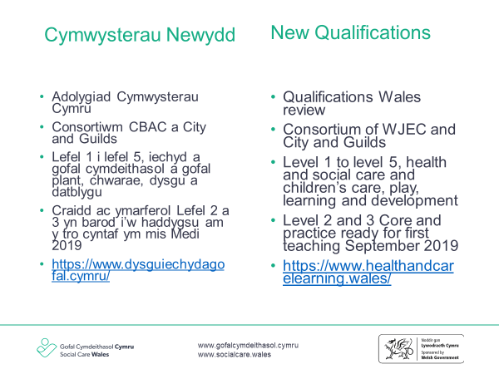
Facilitator notes
- This slide gives the background and the context to the development of the new suite of qualifications. It gives information on what the new qualifications will be and when they will be available.

New qualifications
- Qualifications Wales is the regulator of non-degree qualifications and the qualifications system in Wales.
- Between September 2015 and March 2016, they conducted a review on the effectiveness of the present qualifications and the qualification system in Wales for health and social care (including play and childcare).
- The review identified a number of strengths in the current system, along with issues that need to be addressed.

Key issues included amongst others:
- Inconsistency and ineffectiveness of both assessment and quality assurance processes
- Insufficient learning opportunities through the medium of Welsh and preparing learners to work in a bilingual nation
- Currency of qualifications for 14 – 16 year olds
- Insufficient preparation for the workplace
- Progression routes both to employment and into higher education were unclear.
Qualifications Wales have therefore made a commitment to a number of actions including making arrangements for the development of a new suite of qualifications for health and social care (including childcare) with a teaching date of September 2019 to cover:
- Level 1/2 qualifications for 14 – 16 year olds
- Level 2/3 vocational qualifications
- Level 3 academic qualifications
- Level 4 vocational qualifications
- Level 5 management qualifications
- The GCSE, the Core and level 2 and 3 practice qualifications will all be ready for delivery in September 2019, the remainder of the qualifications will follow in 2020.
Sign up to the consortium website to get alerts for more information about these qualifications https://www.healthandcarelearning.wales/

Slide 6 – The new framework of qualifications
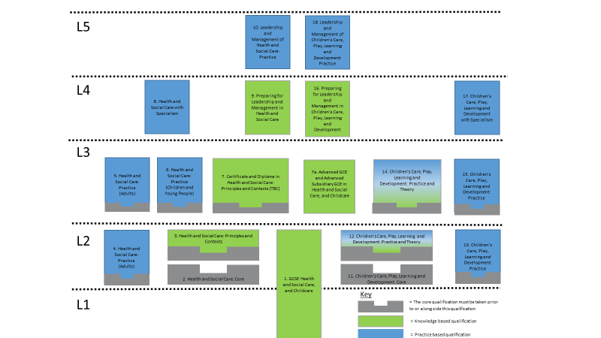
Facilitator notes

- This slide shows the full framework of the new suite of health and social care and children’s care, play, learning and development qualifications that are currently being developed by the consortium.

- There are 19 qualifications being developed in all.

- From September 2019 the following qualifications will be available
- GCSE Health and Social Care and Childcare
- Health and Social Care: Core
- L2 Health and Social Care: Principles and Contexts
- L2 Health and Social Care: Practice (adults)
- L3 Health and Social Care: Practice (adults)
- L3 Health and Social Care: Practice (children and young people)

11. Children’s Care, Play, Learning and Development: Core
12. L2 Children’s Care, Play, Learning and Development: Practice and Theory
13. L2 Children’s Care, Play, Learning and Development: Practice
15. L3 Children’s Care, Play, Learning and Development

- The following qualifications have been deferred and will be available from 2020
- Certificate and diploma in health and social care
7a. Advance GCE and Advance Subsidiary GCE in health and social care
- L4 Health and Social Care with Specialism
- L4 Preparing for Leadership and Management in Health and Social Care
- L5 Leadership and Management of Health and Social Care: Practice
14. L3 Children’s Care, Play, Learning and Development: Practice and Theory
16. L4 Preparing for Leadership and Management in Children’s Care, Play, Learning and Development
17. L4 Children’s Care, Play, Learning and Development with Specialism
18. L5 Leadership and Management Children’s Care, Play, Learning and Development

- The grey boxes are the core qualification
- The green boxes are knowledge-based qualifications
- The blue boxes are practice based qualifications
- The green/blue boxes are a hybrid of knowledge and practice qualifications

Slide 7 – Journey of a new worker
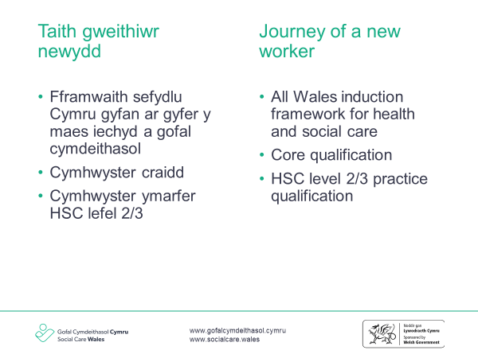
Facilitator notes
- This slide plots the journey of a worker through their new employment, beginning the AWIF and through to their core and practice qualification.

- New workers would be expected to complete the induction framework, usually within their first 6 months. Learning undertaken will prepare them for the formal assessment of the ‘Core’ and practice qualifications.
- When the worker’s manager and assessor agree that they are ready, they will undertake the assessment for the Core qualification and then the practice qualification that is relevant to their role.

Slide 8 – Role of the manager
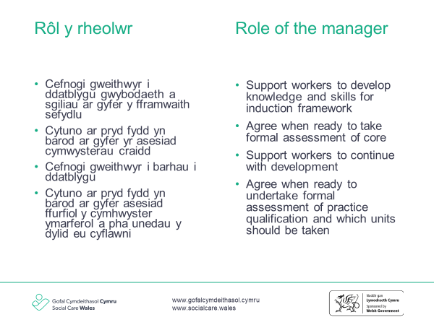
Facilitator notes
- This slide outlines the role of the manager in supporting the completion of the AWIF, developing the knowledge and the skills of the worker, agreeing with the assessor when they are ready to undertake the formal assessment of both the core and practice qualifications.

Role of the manager
- The worker’s manager will play a crucial role in supporting them to complete both the induction framework and the required Core and practice qualifications. This would include activities such as:
- Formal training
- Coaching and mentoring
- Feedback on practice
- Supervision
- Supporting reflective practice
- Agreeing appropriate qualification units for their role
- Ensuring appropriate consent of individuals for observation of practice to take place
- Agreeing with the assessor when they are ready to undertake the formal assessment of the qualifications

Slide 9 – Assessment of the core qualification
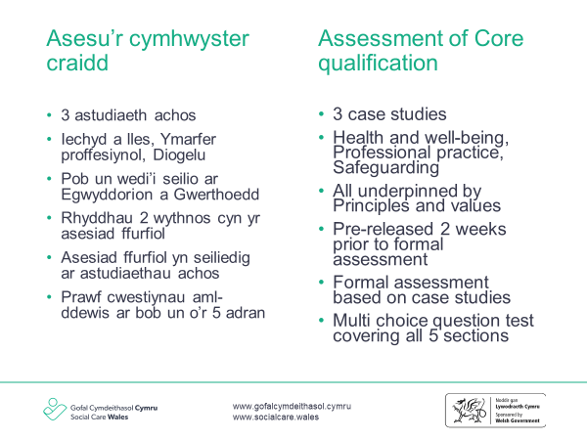
Facilitator notes
- This slide goes into detail and explains how the core qualification will be formally assessed and the role of the worker, manager and assessor to ensure that the worker is prepared.

Assessment of core qualification
- The new core qualification will be formally assessed using 2 methods:
- Case studies
- Multi-choice question test
- When the manager and assessor agree that the worker is ready to undertake formal assessment for this qualification, the assessor will support them to access one of the 3 case studies they will need to use. The case studies are available 2 weeks prior to their assessment – this will give the worker time to think about the topic and the type of questions that they may be asked.
- There will be 3 case studies in total:
- Health and well-being
- Professional practice
- Safeguarding
- All 3 case studies will be underpinned by the principles and values of health and social care.
- Once assessment on the case studies has been successfully completed, the worker will undertake a multi-choice question test that covers all 5 sections of the Core qualification. The multi-choice question test can be taken on-line or by using a paper version.
- Learning completed by the worker for the induction framework will help to prepare them for each of these assessments as the content of the induction framework and the Core qualification is the same.
- The credit value for this qualification is 30.
- More information about the way that learners will be assessed will be made available on ‘health and care learning Wales’ website https://www.healthandcarelearning.wales as soon as the qualifications have received final approval from Qualifications Wales.

Slide 10 – Level 2 / 3 health and social care practice qualifications
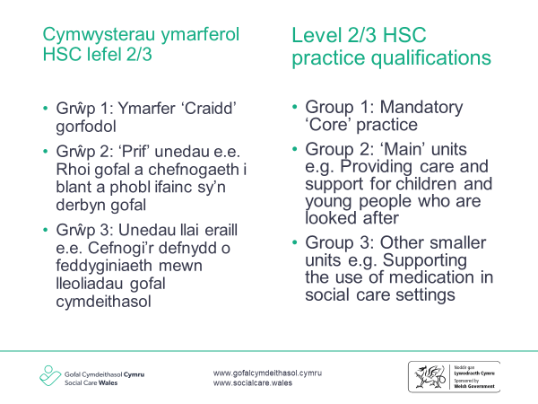
Facilitator notes
- This slide continues with information on the structures of the presentation. It provides information on the groups of qualification units.

L2/3 practice qualifications
- The structure of the new practice qualifications will be familiar to the current and predecessor qualifications.
- The mandatory content mirrors the practice elements of the induction framework, it is therefore really important that managers record any discussions / observations about the worker’s practice during this period against the induction framework as this can be used as evidence towards the achievement of the practice qualification.
- There are a range of main units in group 2 that reflect a wide array of roles in the health and social care sector. A full qualification specification will be available on the consortium website from the beginning of March, but topics such as dementia, learning disability, children who are looked after are all covered.
- The units in group 3 are smaller and may have specific assessment requirements e.g. moving and positioning.
- The total credit value of the level 2 qualification is 35 and the level 3 is 50.

Slide 11 – Assessment of practice qualifications

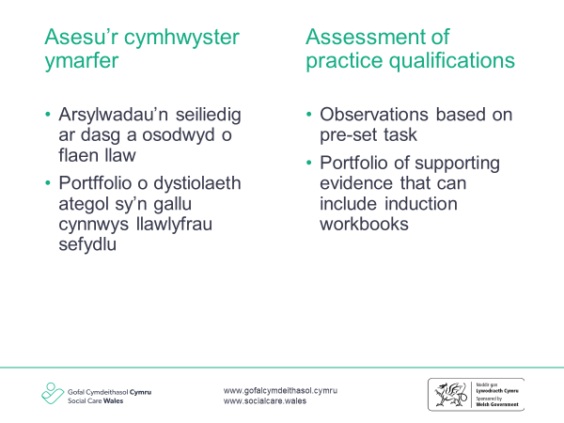
Facilitator notes
- This slide provides information on the assessment of the practice qualification.

Assessment of practice qualifications
- The practice qualifications will be assessed using a mixture of familiar and less familiar methods. Observations will be based on a task that is pre-set by the awarding body, these will be supplemented by a portfolio of evidence that could include:
- Completed workbooks
- Expert witness testimonies
- Product evidence
- There will also be a requirement for learners to complete a reflective log throughout completion of the qualification and their assessor will hold a structured discussion with them to clarify any areas of understanding needed
- Information and updates will be available on the health and care learning Wales website www.healthandcarelearning.wales

Slide 12 – Registration of domiciliary care workers
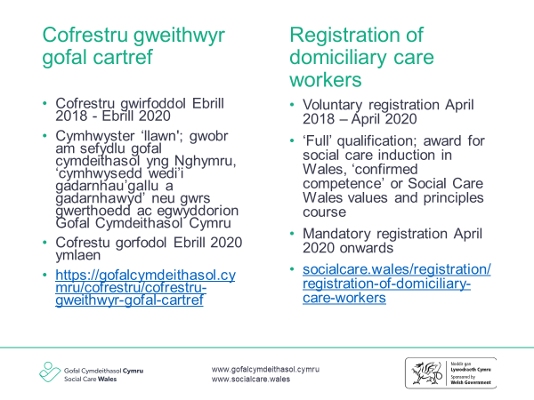
Facilitator notes
- This slide gives information on the registration of domiciliary care workers, the timescales and the different routes to use.

Registration of domiciliary care workers
- The register opened for domiciliary care workers on a voluntary basis in April 2018.
- Registration will be mandatory for these workers from April 2020.
- Welsh Government intend extending the register to adult care home workers from 2020– they will consult on this beforehand.
- During the voluntary period of registration of April 2018 – April 2020, there are a umber of routes that workers can use to register:
- Route 1: if they hold one of the qualifications listed on the ‘Qualification Framework’ or the L2 award for social care induction in Wales
- Route 2: if they have been employed in a domiciliary care role for 3 of the past 5 years they can use ‘confirmed competence’
- Route 3: if they are not able to use either of these routes, they can apply for registration following completion of the Social Care Wales course ‘Principles and Values’
- The diagram on the next slide illustrates these routes

Slide 13 – Domiciliary care workers – potential routes to register until April 2020 – Flow diagram
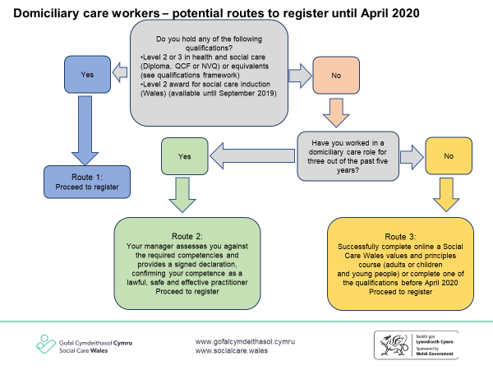
Facilitator notes
- This slide is a flow diagram of the routes available to domiciliary care workers to register in the voluntary period. It goes into detail about the requirements and the criteria for each of the routes.

- Route 1: Listed Qualification or L2 Award in Social Care Induction in Wales. If a worker holds the award for social care induction in Wales or one of the listed qualifications on the Qualification Framework, they can apply for registration. If they do not hold one of these qualifications and are not likely to complete one before registration becomes mandatory, there are other routes that can be used.
- If a worker is successful in registering by using this route, they will have to complete their mandatory 15 days/ 90 hours Post Registration Training and Learning (PRTL) every 3 years in order to renew their registration.

- Route 2: Confirmed competence. This can be used if the worker has been employed in a domiciliary care role for 3 out of the past 5 years.
- The competencies are based on the practice outcomes set out in the all-Wales induction framework for health and social care. There are seven sections in total. Those working with adults need to complete sections 1, 3, 5, 6 and 7, and those working with children and young people need to complete sections 2, 4, 5, 6 and 7.
- Each section lists ways in which the worker should be practising. There is a column next to each outcome where any evidence used should be recorded. It is likely that some pieces of evidence may cover more than one learning outcome across more than one section.
- Some of the elements are specific to a worker’s role. For example, those who do not support people with foot care will not be expected to show their practice in this area.
- A suggested starting point for evidence mapping would be the worker’s job description and probationary review. Once a worker has completed and passed their probation review, this could be used as evidence of competence.
- Social Care Wales may sample the evidence used to support the decision, so the manager should be able to make this available should it be requested.
- Examples of evidence for these competencies could include (but is not limited to):
- probationary review and job description
- induction workbook activities
- training records
- certificates gained through assessed training e.g. moving and handling, first aid, food hygiene, etc
- supervision and/ or appraisal notes
- team meetings
- observation
- discussions
- feedback from colleagues and people who use the service.

- Please note that workers who use the confirmed competency route route do not need to complete one of the qualifications listed on the Qualification Framework. They will however, have to complete their mandatory 15 days/ 90 hours Post Registration Training and Learning (PRTL) every 3 years in order to renew their registration.

- Route 3: Social Care Wales Principles and Values Course. This is a new route that has been added in response to feedback from the sector. If workers are not able to use either route 1 or 2, they can complete a Social Care Wales Principles and Values course which is available on-line only. This entails on-line completion of either workbook 1 or 2 of the all Wales induction framework (principles and values). https://inductionframework.wales/
- Once the manager has signed this off as being satisfactorily completed, the worker will complete an on-line multi-choice question test based on these sections. Successful achievement of this can be used to apply for registration.
- Workers who use this route must complete both the Core and relevant level 2 or 3 HSC practice qualification within 3 years of the date of their registration.
- If a worker is successful in registering by using this route, they will have to complete their mandatory 15 days/ 90 hours Post Registration Training and Learning (PRTL) every 3 years in order to renew their registration.

- Further information on the registration of domiciliary care workers, as well as information on the process, the length of time the registration process takes and the requirements can be found here https://socialcare.wales/registration/domiciliary-care-workers-registration

Slide 14 – Registration of residential child care workers
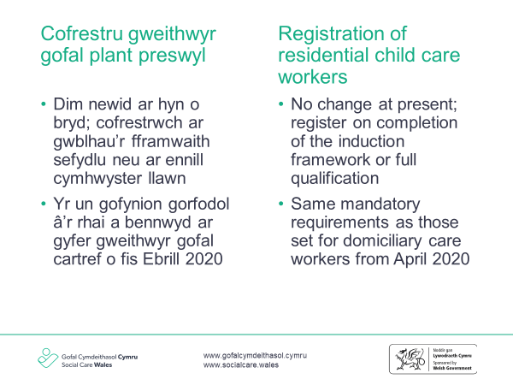
Facilitator notes
- This slide notes that there are not changes at present to the registration of residential child care workers as well as outlining the mandatory requirements for this group of workers from April 2020.

Registration of residential child care workers
- There is currently no intention to change the registration requirements for residential child care workers.
- It is intended, that the same mandatory requirements will apply to residential child care workers as those for domiciliary care workers from April 2020.
- They will need to complete the Core qualification and the all Wales induction framework for health and social care in order to apply for registration. They will then need to complete the relevant L2 or L3 practice qualification by in time for their renewal of registration after 3 years.

Slide 15 – Review routes for registration
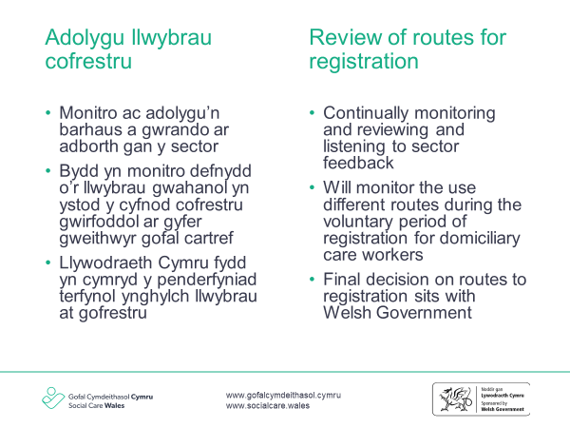
Facilitator notes
- This slide explains that the routes of registration for domiciliary care workers will be monitored continually and recommendations made to Welsh Government on these.

Review of routes to registration
- It is important to note that the final decision about groups that must register with Social Care Wales and the routes used, sits with Welsh Government. Social Care Wales will however, continually monitor the routes used, including sector feedback, managers, employers and workers are therefore encouraged to tell us what they think.

Slide 16 – Qualification framework
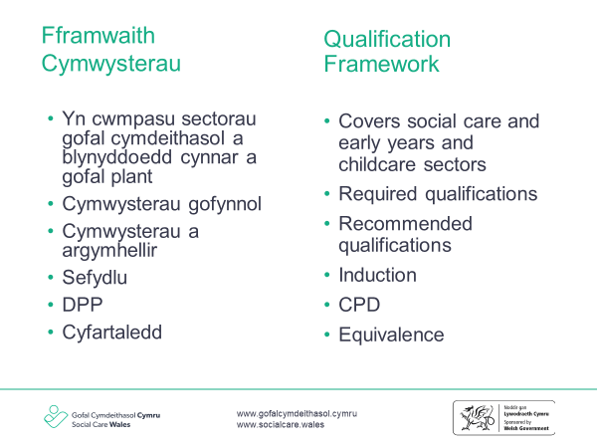
Facilitator notes
- This slide explains what the Qualification Framework for Social Care and Regulated Childcare is and how it can be used to identify the required or recommended qualifications for different roles, as well as other requirements or recommendations around induction and continuing professional development.

Qualification Framework
- Social Care Wales has produced this qualification framework as guidance for social care, early years and childcare employers, practitioners, learning providers, other regulators and the public. It aims to give clear information about what qualifications are required or recommended for different job roles and what will assist in continued learning and development.
- The online interactive version of the qualification framework can be found by following this link https://socialcare.wales/qualification-framework
- This is the fifth version of the framework and replaces the previous Qualification Framework for the Care Sector in Wales and the List of Required Qualifications to Work within Early Years and Childcare in Wales (April 2017).
- This new framework also includes information from the Guide to Qualifications in Health and Social Care, Early Years and Childcare and Qualifications across Boundaries comparison of competence qualifications across the UK.
- The framework reflects recent legislation and policy changes including:
- Social Services and Well-being (Wales) Act 2014
- Principles of Prudent Healthcare
- Regulation and Inspection of Social Care (Wales) Act 2016
- Well-being of Future Generations (Wales) Act 2015
- The Welsh Government’s Childcare, Play and Early Years Workforce Plan.
- There are significant changes to the framework because of the new legislation, especially the Regulation and Inspection of Social Care (Wales) Act (2016), including:
- the requirement for domiciliary support services to register all workers and managers with Social Care Wales from 2020
- the replacement of the National Minimum Standards for social care with new service regulations and statutory guidance
- early years childcare workers are now included in the definition of “social care worker” under the Social Services and Well-being (Wales) Act 2014 and Regulation and Inspection of Social Care (Wales) Act 2016.
- new roles and areas of service, such as information, advice and assistance workers.
- The qualification framework can be used to help find:
- the required or recommended qualifications in a service area
- the required or recommended qualifications for a job role
- what induction is required
- what will be useful or required for updating, maintaining and progressing skills and knowledge.

The all Wales induction framework for health and social care
- The induction framework has been designed and developed so it can be used by all care and support workers. However, there are additional regulatory requirements for some groups of workers. These include:
- Residential child care workers – workers employed in Wales must register with Social Care Wales. Workers who do not have one of the required qualifications in this framework can apply to register so long as they complete the induction framework within six months. They will need to complete the level 3 Diploma in Health and Social Care (Children and Young People) Wales and Northern Ireland within three years.
- From April 2020, residential child care workers who do not hold one of the required qualifications will need to complete both the core health and social care qualification, along with the all Wales induction framework to register.
- Domiciliary care workers – all domiciliary care workers must register with Social Care Wales by April 2020. At this point, if they do not hold one of the qualifications listed in this framework, they will only be able to apply to register if they have completed the induction framework, along with the induction qualification (the Award for Social Care Induction in Wales until August 2019, and from September 2019, the core health and social care qualification).
- Between April 2018 and April 2020, domiciliary care workers can register on a voluntary basis. To do this, workers must hold one of the qualifications listed in this framework, or if they do not hold one of these, they can apply to register until April 2020 by either:
a) holding the Level 2 Award for Social Care Induction (Wales) and a statement of competence signed by the registered manager
or
b) for workers with three or more years’ continuous experience of working in the sector, a statement of competence that has been signed by the registered manager and is supported by evidence of relevant knowledge and skills.
or
c) Completion of the Social Care Wales course ‘Principles and values’
- These routes are only currently available for voluntary registration until April 2020.

Equivalence
- Where a worker wants to gain employment in Wales and there is a required qualification for registration but their qualification is not listed in this framework they can apply to Social Care Wales for an assessment of equivalence if they meet the following criteria:
  - the qualification is based on competence, such as the National Occupational Standards relevant to the role
  - the person has been assessed in the workplace
  - the person must have been in a relevant role while the qualification was undertaken
  - the person must have been in a relevant setting while the qualification was undertaken.

Slide 17 – Qualification framework (continued)
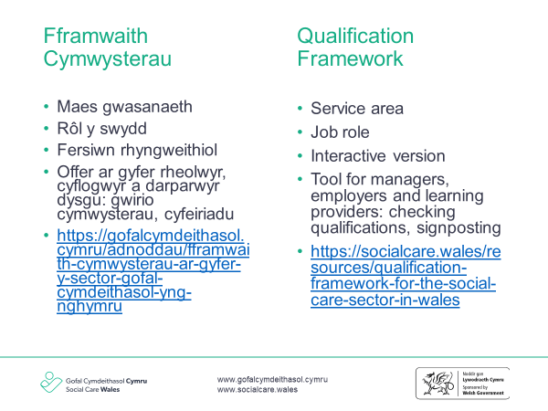
Facilitator notes
- This slide is a continuation of the previous slide. It also explains that an interactive, online version of the qualifications framework is being developed.

- The qualification framework is organised into service areas and job roles and include:
- Qualifications required for registration with Social Care Wales
- Qualifications required by Welsh Government policy / other regulations
- Qualifications recommended for practice
- An interactive version of the Qualification Framework has recently been developed which will make it easier for the user to navigate and find the information required. This version can be found by following the link https://socialcare.wales/qualification-framework

Slide 18 – Discussing the routes to registration
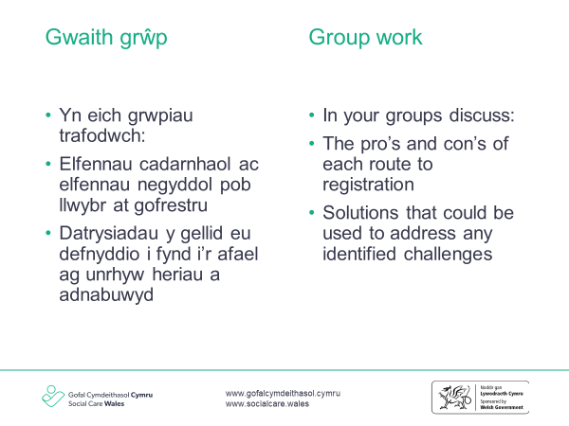
Facilitator notes
- This slide explains the group work activity to look closer at the routes to registration, the pro’s and con’s of each one and if there are any possible solution to challenges that may arise.

The aim of this activity to
- Understand what the routes to registration for domiciliary care workers during the voluntary period until April 2020
- Explore the pros and cons for each of these routes to registration for domiciliary care workers during the voluntary period until April 2020.
- Explore if these routes could be an option for registration for other groups of workers (residential child care workers and for adult care home workers when the register opens on a voluntary basis from April 2020)
- Find and discuss possible solutions to any challenges that may arise

https://www.scie.org.uk/publications/guides/guide51/resources.asp
https://socialcare.wales/cms_assets/hub-downloads/Workbook-What-does-the-Act-mean-for-me.pdf
https://www.childcomwales.org.uk/uncrc-childrens-rights/uncrc/

