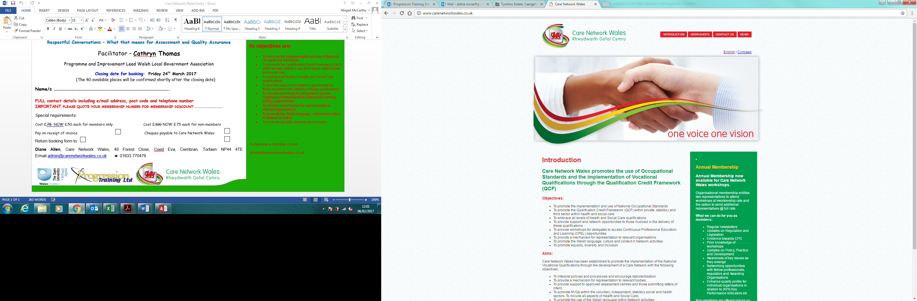

Care Network Wales Autumn Workshops
“Improving for today; Planning for tomorrow”
November 7th 2017 (1.30pm – 4.30pm) – Brynglas House, Newport
November 15th 2017 (9.30am – 12.30pm) – Mochdre, Colwyn Bay
December 12th 2017 (10.30am – 2.30pm) - Media Resource Centre, Llandrindod Wells

The above workshops are targeted for Assessors of Health & Social Care, Children’s Care Learning Development and some aspects of Play Qualifications
THIS EVENT IS IMPORTANT FOR WORK-BASED ASSESSORS AND PERIPATETIC ASSESSORS

Session One: Standardisation on current QCF Qualifications
- Practice Exchange: Sharing of tools used for standardisation in your Centre
- It is intended that the tools shared will be uploaded onto the Care Network website for reference by members
- Please take tools used in your Centres to the workshop. Please ask for permission to share tools at the workshop and via the Care Network website

Session Two: Future Assessment Expectations (new qualifications – 2019)
- Future development outlined
- Introduction to external assessment – What does it mean?
- Assessor skills and knowledge needed to conduct external assessment
- Implications and impact of external assessment for Assessors, IQAs and Centres

CSSIW Facilitators – Anne Rowling and Margaret Rooney

Closing date for booking: Friday 5th May 2017

IMPORTANT
PLEASE QUOTE YOUR MEMBERSHIP NUMBER FOR MEMBERSHIP DISCOUNT ……………………………………
Special requirements:

£20 each for members £25 each for non-members
Pay on receipt of invoice Cheques payable to Care Network Wales

Please complete the booking form on the next page.
Places will be given on a first come first served basis, so It is important that you book as early as possible to avoid disappointment. (Members will be given priority)

BOOKING FORM

Care Network Wales Autumn Workshops
“Improving for today; Planning for tomorrow”

Please tick the box indicating which workshop you wish to attend

November 7th 2017 (1.30pm – 4.30pm) – Brynglas House, Newport
(Facilitated by Jacky Drysdale, Suzi Gray, Lynne Pratten, Kath McMullen)

November 15th 2017 (9.30am – 12.30pm) – Mochdre, Colwyn Bay
(Facilitated by Jacky Drysdale, Suzi Gray, Anne-Marie Furse, Anita Curley, Jan Wood)

December 12th 2017 (10.30am – 2.30pm) – Media Resource Centre,
Llandrindod Wells
(Facilitated by Jacky Drysdale, Suzi Gray, Cheryl Stephens, Adrian Hemmens)

Name/s ……………………………………………………………………………………………………………………..

FULL contact details including e/mail address, post code and telephone number

IMPORTANT
PLEASE QUOTE YOUR MEMBERSHIP NUMBER FOR MEMBERSHIP DISCOUNT ……………………………………
Special requirements:

£20 each for members £25 each for non-members
Pay on receipt of invoice Cheques payable to Care Network Wales

