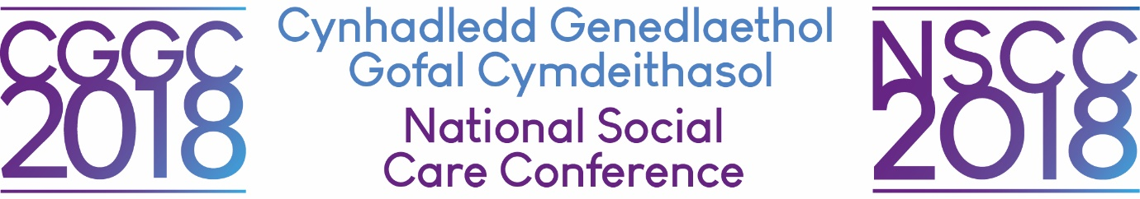

The Royal College of Music and Drama
Cardiff
12-13 September 2018

Call for Workshop Presentations and Learning Zone Events
This year we are delivering a National Social Care Conference and to celebrate this change, we are planning to operate a different format for the Conference. The conference will be addressing the big issues facing social care in Wales and will be aimed at frontline staff, as well as senior managers, leaders and decision makers in social care.
To give different groups of delegates access to a range of events, we will be offering a dual-focused conference programme. There will be a “traditional” style of conference with international keynote speakers, plenary sessions and workshops that will be accessed by delegates who have paid the full price for their “access all areas” ticket. But there will also be a “value for money” ticket that will give access to the exhibition areas, well-being festival and the learning zone events that will be happening throughout the conference.
The conference has three “themes” or “presentation streams”:
- dementia / older people / adult services
- children who are looked after / children’s services
- workforce issues / strategic developments

The NSCC18 Planning Group is seeking bids to run workshops sessions and learning zone events at our 2018 conference.

Aims of the sessions:

The workshop and the learning zone events are about discovering, sharing and comparing other people’s experiences and solutions regarding the issues and challenges raised for discussion.

All sessions need to be of high quality and relevant to the world of social care. These events are an opportunity for delegates to learn and participate and therefore need to include debate and discussion.

LEARNING ZONE:
These will be 30 minute sessions running throughout the conference, which can be doubled up to create sessions of up to one hour.
The learning zone sessions will give practioners/delegates an opportunity to:
- explore current social care policy and practice
- learn about new and future developments
- share examples of innovation and good practice.
The short informative, engaging and innovative sessions will contribute to continuing professional development.

WORKSHOPS:
These will be 45 minute sessions within the main conference programme.

The Conference Planning Group aims to bring together a strong programme, which reflects the wide agenda facing social care in Wales. We are looking for contributions from across all sectors of the social care world, including:
- innovation and good practice
- current or proposed research
- new and future developments
- current priorities and policies.

How to apply for a workshop or learning zone session
You can download the bid form to run a workshop session or a learning zone event from Social Care Wales or ADSS Cymru’s website.
Please return to:
carla.green@adsscymru.org.uk or phil.tyrrell@adsscymru.org.uk
Applications must be made using the session bid form by Wednesday, 18 April 2018. Forms submitted after this date will not be considered.

