CYFARFOD BWRDD / BOARD MEETING: 22.03.18

EITEM/ITEM: | 6
TEITL/TITLE:  SCW/18/08 | Project Proposal – Attraction and Recruitment Campaign Programme: an update
AWDURON/AUTHORS: | Jon Day  Kate Salter
ATODIADAU/APPENDICIES: | None
TRAFODWYD YN FLAENOROL YN/ITEM PREVIOUSLY DISCUSSED AT:

The Improvement Committee discussed in their January meeting the proposed approach for progressing the workforce strategy and approach to raising the profile of the sector.

Raising the Profile: Attractions, recruitment and retention proposals developed from regional workshops over the summer and discussed with Welsh Government officials on 15 November, and a wider group of stakeholders on 21 December.

Executive Management Team discussed the paper on 12 March 2018

PENDERFYNIAD / DECISION:

Members are invited to receive this report as information on the approach for the attraction and recruitment campaign

Project Proposal – Attraction and Recruitment Campaign Programme: an update

- Purpose of report and recommendation

1.1 The purpose of the report is to provide Members with an overview and update on the approach to a four-year attraction and recruitment campaign programme.

1.2 Members are invited to receive this report as information on the approach for the attraction and recruitment campaign.

1.3 An overview of the resource considerations, communication and engagement plan and the equalities assessment will be provided verbally to Members at the Board meeting.

2. Context

2.1 As the national organisation responsible for leading on the improvement of care and support in Wales, one of our strategic aims for the next five years is to develop the workforce. To meet current and future demands, we are committed to making sure there is high-quality training to equip and support the social care and early years and childcare workforce so they have the right knowledge, skills, understanding and approach to provide good-quality care and support. We will also provide clear career pathways and promote working in social care and childcare as professions of choice to support the sustainability and viability of the workforce.

2.2 In January 2018 the Improvement Committee considered our approach to the development of a Workforce Strategy (paper is on Member’s portal). Two of the six areas of focus for the workforce strategy is attracting and recruiting people into the social care and early years sector.

2.3 It was agreed through discussions with Welsh Government and wider stakeholders that we would, over the next three – four years, work with the social care and early years sector, partners and stakeholders at local, national and UK level to co-ordinate an attraction and recruitment campaign to achieve the following:

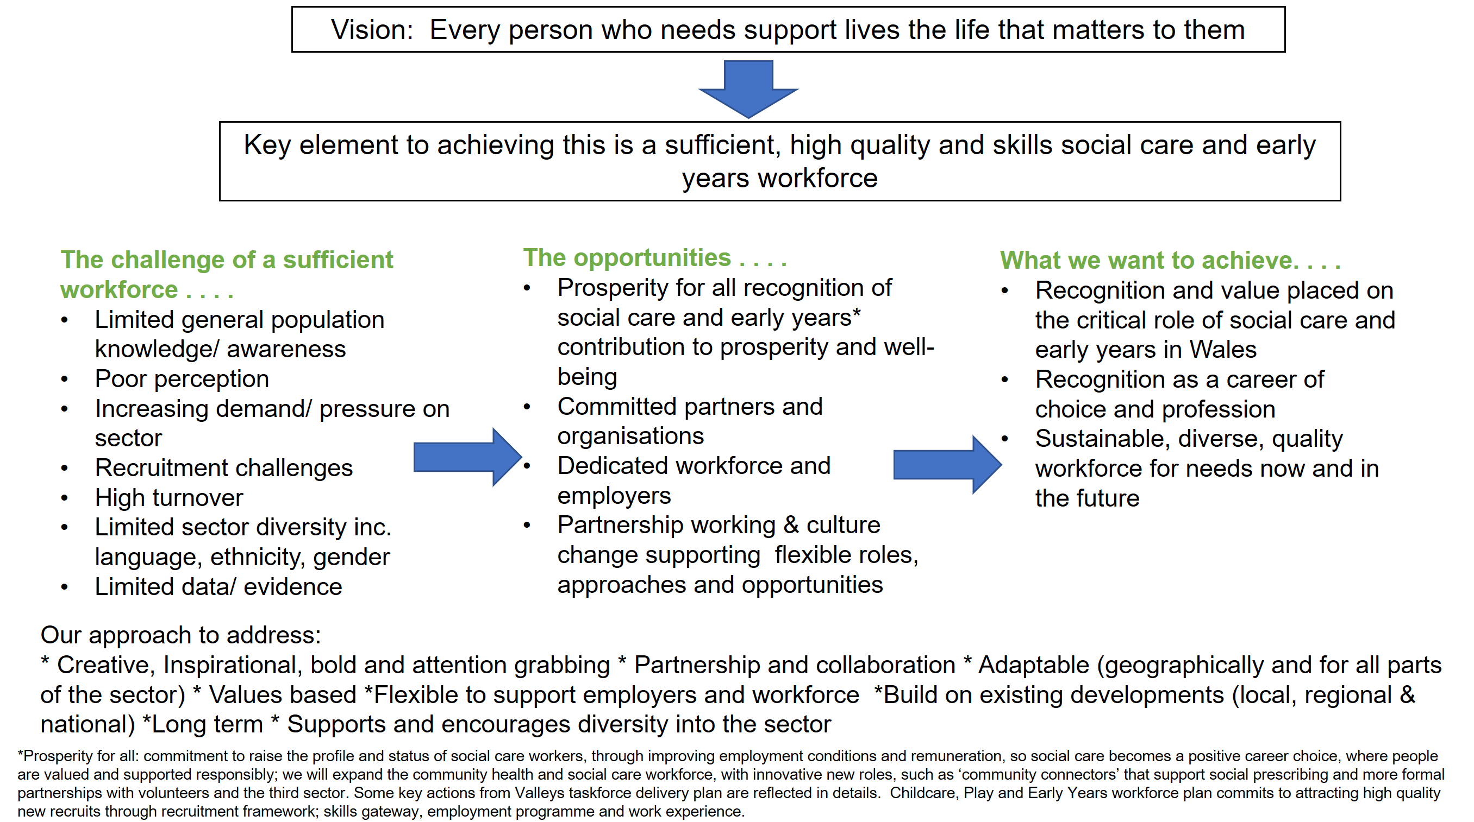

3. Elements of the programme

3.1 In order to support and co-ordinate the delivery of the attraction and recruitment campaign we identified the following additional resource requirements:

- Procurement of a creative supplier to support the campaign
- Recruitment of a programme manager to co-ordinate the programme’s requirement
- Governance arrangements of a stakeholder reference group

3.2 To support this initiative a research project has been commissioned to identify the perceptions of the social care and early years sectors which will hopefully inform the ongoing campaign and present an opportunity to dispel some of those perceptions.

Procurement of a creative supplier to support the campaign

3.3 We identified the need to procure an agency to develop an effective bilingual multi-media campaign which will help employers in Wales recruit more of the right people to work in social care and early years and childcare in Wales and as part of the short to medium term planning, £250,000 has been allocated over the next 3 – 4 years to support this multi media campaign. The aim is to successfully appoint the supplier by mid-April 2018.

Recruitment of a programme manager to co-ordinate the programme’s requirement

3.4 Additional resource is required to support the co-ordination of the attraction and recruitment campaign in order to:

- work across the organisation linking the programme requirements into existing and future streams of work
- work with the Communications Manager and a third party supplier on the delivery of an appropriately branded national campaign
- link with existing and future regional recruitment campaigns for the sector to make sure consistency of message, add value to existing work streams at national, regional and local level and reduce likelihood of duplication
- work with relevant UK organisations on linking the national recruitment campaign in Wales to those taking place across the UK for the social care and early years sector

3.5 Therefore, we advertised a programme manager role on 14 February. The aim is to complete the recruitment to this post by the end of April 2018.

Governance arrangements of a stakeholder reference group

3.6 We will be working with the sector, stakeholders and key partners in the delivery of this programme of work. We will be using existing stakeholder networks to inform the programme’s work areas. We are currently mapping and updating our networks map so that we make best use of resources to feed into and from the work of the programme.

3.7 We have recognised that there will be a need to establish a stakeholder reference group who will be responsible for:

- Taking responsibility for providing a sounding board on the campaign’s development, delivery, review and evaluation of impact
- Taking forward actions identified as and when required
- Providing the perspectives and expertise from their specialist areas
- Undertaking and making sure effective links and relationships with other existing relevant regional and national groups and networks
- Establishing and ensuring the effective governance of sub groups set-up to progress the work areas included within the remit of the group.

3.8 The Chair of the stakeholder reference group will be Sue Evans and will meet on a quarterly basis.

