

**Candidate Information Pack**

Social Care Wales

Closing Date: 10 June 2018

**Content:**

* Who we are and what we do
* How we work
* Key information about the role
* Key dates
* Employee benefits
* Contact us
* How to apply
* Job description and person specification

**Who we are and what we do**

Our aim is to make sure people in Wales can rely on a high-quality social care workforce that provides services to fully meet their needs.

We work with people who use care and support services, and organisations to lead improvement in social care.

We:

* set standards for the care and support workforce, making them accountable for their work
* develop the workforce so they have the knowledge and skills to provide the best care and support
* work with others to improve services for areas seen as a priority, such as care and support in people’s homes
* set priorities for research to collect evidence of what works well
* share good practice with the workforce so they can provide the best care
* provide information on care and support for the public, the workforce and other organisations.

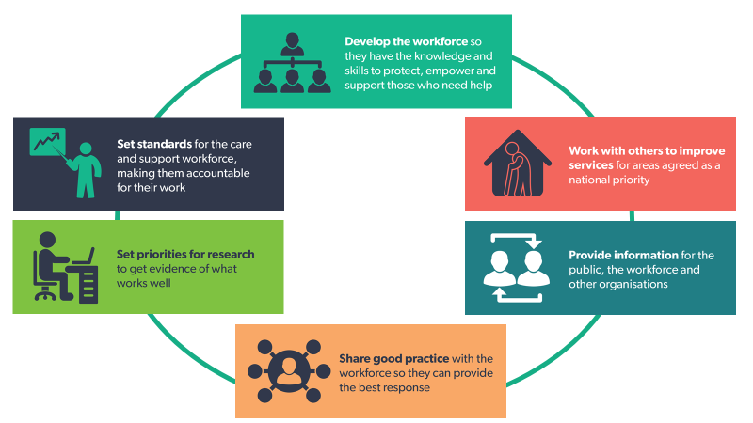

**How we work**

We expect our staff, board members, and anyone who works on our behalf, to behave in a way that demonstrates our values.

**Our values mean we:**

* **respect everyone -** we see people as individuals and treat everyone with dignity and respect.
* **take a professional approach** - we act responsibly and in the right way, holding each other to account.
* **are always learning** – we believe in improving ourselves and supporting others to be the best we can be.
* **involve people** – we encourage and enable everyone to work together.

**We're committed to:**

* being a truly bilingual organisation
* valuing diversity and improving opportunity for all
* involving the people of Wales in how we work
* listening to feedback
* setting high standards of customer service
* publishing and accessing information
* improving our own performance

**Key information about Fitness to Practise**

Fitness to Practise ensures that people on the Social Care Register have the skills, knowledge and character to work safely and effectively. Outcomes from our work are used to support improvement in the sector. This enables the workforce to practice to the highest standards, which helps to provide public assurance around the quality of the social care workforce.

Social Care Wales has a register of 12,000 workers. This includes managers working with adults, children and in domiciliary care services. We also register social workers, social work students and have recently opened our Register to Domiciliary care workers. We expect the Register to increase to over 50,000 individuals by 2022 when registration of adult care workers becomes mandatory.

We are looking for individuals from a wide range of backgrounds including individuals working in human resources, nursing, legal, social work or as managers in an adult or children’s home setting. We will provide full training, carried out by Bond Solon, who are a leading training organisation for employers working within a legal framework.

The Fitness to Practise team is currently based in Cardiff. We are advertising posts on an all Wales basis and are looking to establish a permanent team at our office in North Wales. This is an exciting opportunity for individuals wanting to be part of a new set-up in North Wales and being part of an experienced established team.

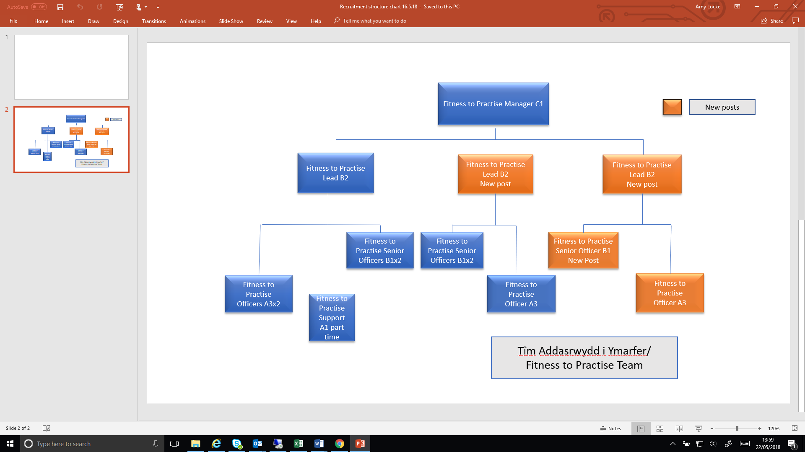

**Role Title and Description**

**Fitness to Practise Lead B2 (Cardiff and St Asaph/ 1 permanent, 1 fixed term for 2 years, with the potential for extension to a permanent post subject to the agreement of both parties.)**

The post holder will:

* manage the Fitness to Practise Senior Officer and Fitness to Practise Officer posts, as well as any Support staff recruited to the team
* be able to communicate with equivalent level staff in Cardiff/ St Asaph to ensure a single and consistent approach to work in the wider team
* manage and allocate fitness to practise cases to the team while carrying a caseload; this will include considering member of public complaints, which may involve Local Authority Stage 2 reports, court reports and Safeguarding information
* actively engage with employers across Wales to promote the work of Social Care Wales and specifically employers’ responsibilities for making referrals to Social Care Wales under the Code of Practice for Social Care Employers.

The post based in St Asaph requires Welsh language skills

The Fitness to Practise Lead post reports to the Fitness to Practise Manager.

**Fitness to Practise Senior Officer B1 based in St Asaph**

The post holder will:

* need to be highly organised to manage a complex caseload
* be confident to liaise with employers, registered persons and members of the public and solicitors
* have experience of writing formal reports
* be able to present case information to peers in order to make decisions
* have experience of interviewing witnesses
* have an enquiring mind and pragmatic approach to work

The Fitness to Practise Senior Officer post reports to the Fitness to Practise Lead

**Fitness to Practise Officer A3 based in St Asaph**

The post holder will:

* need to work seamlessly with other Fitness to Practise Officers across both sites to ensure daily management of unallocated cases
* have experience of writing formal reports
* be confident to make decisions on declarations made on applications to the Social Care Register.
* be confident to liaise with employers, registered persons and members of the public and solicitors

The Fitness to Practise Officer post reports to the Fitness to Practise Lead

**Where are we recruiting**

These are national posts and we have two office locations:

Unit 19 St Asaph Business Park, Glascoed Rd, St Asaph LL17 0LJ. A smaller office than in Cardiff but benefits greatly from being an open plan, close-nit environment, with the added advantage of on-site parking.

Southgate House, Wood St, Cardiff CF10 1EW, we are part of a multi occupancy building less than 5 minutes’ walk from Cardiff Central train station.

**Key timelines**

**Closing date**: 10 June 2018

**Interview**: w/c 2 July 2018 (St Asaph); w/c 16 July 2018 (Cardiff)

**Employee Benefits**

We believe that a happy and healthy workforce is a productive workforce, and are always looking for new ways to motivate and engage our workforce.

We believe that we offer excellent terms and conditions including:

* + Generous annual leave entitlement of 28 days + 3 privilege days + 8 public holidays (This rises to 29 days after 3 years’ service and 30 days after 5 years’ service).
  + Our standard contractual hours are 9am-5pm Monday to Friday, however we do operate in a flexible environment.
  + Membership of a local government pension scheme
  + A comprehensive induction and learning and development framework
  + Family-friendly policies
  + Salary sacrifice scheme for childcare vouchers
  + Cycle to work scheme
  + Travel to work loans

We have been recognised as an Investor in People at Silver Level, and also hold the silver Corporate Health Award.

Completed application documentation should be sent to:

[Amy.Locke@socialcare.wales](mailto:Amy.Locke@socialcare.wales)

**Get in touch**

If we haven’t answered all your questions, or if you would just like to talk to someone to find out a bit more about the role, please contact Louise Williams, Fitness to Practise Manager.

Tel: 02920 780648

Email: [Louise.Williams@socialcare.wales](mailto:Louise.Williams@socialcare.wales)