

**Registration Support – Information for Candidates**

Closing Date: Sunday 26 August 2018 at 17:00

**Content:**

* Who we are and what we do
* Our Registration team
* Information about the role
* Key dates
* Why work for us?
* Get in touch

**Social Care Wales - Who we are and what we do**

Our aim is to make sure people in Wales can rely on a high-quality social care workforce that provides support and services to meet their needs.

We work with people who use care and support services as well as with the organisations who deliver support and care across the sector.

See more detail in the diagram below:

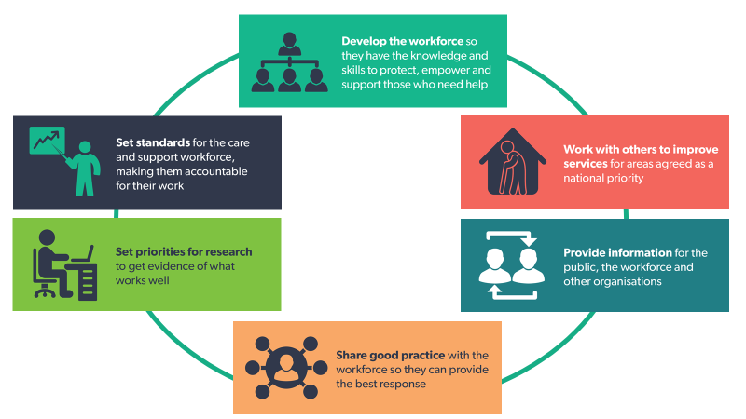

**Our Registration Team**

We are a busy team that deals with the day to day maintenance of the Register such as processing applications and renewals. We are made up of three smaller teams, Applicants, Registered Persons and Enquiries.

We have a strong reputation for delivering good customer service, and work together to ensure that the Register is managed efficiently. We support all our team members with their professional development.

Our work varies and there will be opportunities to develop and work with colleagues across the organisation.

We have recently opened the Register to the 23,000+ domiciliary care workers in Wales. This means that the registration team is getting bigger as we support them to register, both face-to-face through events and by email/telephone.

**Information about the role**

**Registration Support**

The post holder will be working in any of our sub-teams to:

Assist with maintaining the Register by providing telephone, email and face to face support to external and internal customers, stakeholders and staff.

The support will include advice for:

* Registration
* Qualifications
* Our online system
* Employers

**Where are we recruiting**

Southgate House, Wood St, Cardiff CF10 1EW, we are less than 5 minutes’ walk from Cardiff Central train station.

**Key dates**

**Closing date**: Sunday 26 August 2018 at 17:00

**Interview**: Week commencing 3 September 2018

**Why work for us?**

We believe that a happy and healthy workforce is a productive workforce, and are always looking for new ways to motivate and engage our workforce.

We believe that we offer excellent terms and conditions including:

* + Generous annual leave entitlement of 28 days + 3 privilege days + 8 public holidays
  + Our standard contractual hours are 9am-5pm Monday to Friday however we do operate in a flexible environment.
  + Family-friendly policies
  + Salary sacrifice scheme for childcare vouchers
  + Cycle to work scheme
  + Travel to work loans
  + A comprehensive learning and development framework
  + Membership of a local government pension scheme

We have been recognised as an Investor in People at Silver Level, and hold the silver Corporate Health Award.

Download the full application from our [website](https://socialcare.wales/about/work-for-us)

**Send your completed application to:** [Amy.Locke@socialcare.wales](mailto:Amy.Locke@socialcare.wales)

**Get in touch**

If we haven’t answered all your questions, or if you would just like to talk to someone to find out a bit more about the role, please contact the registration manager, Dean John.

Email: [dean.john@socialcare.wales](mailto:dean.john@socialcare.wales)