Social Care Wales logo

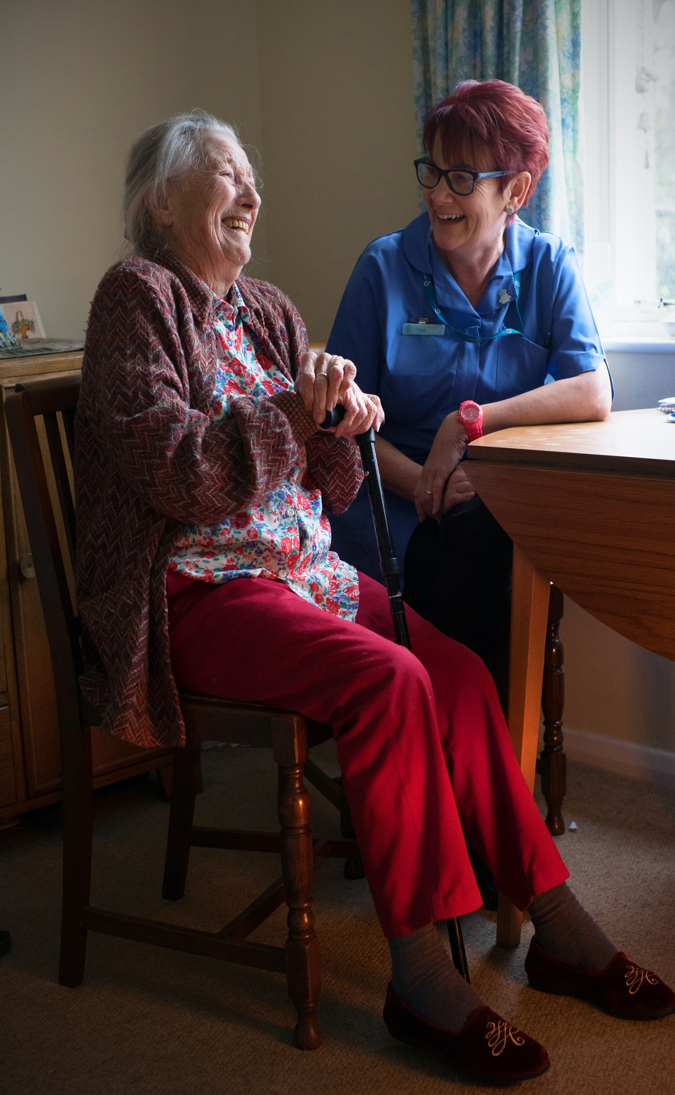

Welsh Language Standards Annual Report for 2019-20

# Social Care Wales

# September 2020

Welsh Government logo

**Foreword by the Chief Executive**

“The Welsh Language (Wales) Measure 2011 sets out a legal framework which imposes a duty on Social Care Wales, among other public institutions, to comply with the Standards relating to the Welsh language.

We are a truly bilingual organisation providing an environment which nurtures and develops staff to learn and improve their bilingual skills. We welcome contact from our customers in Welsh and English, and we aim to provide a completely bilingual service across all our work areas.

Through our work, we also promote and influence the importance of language choice for people who use care and support. We know how important it is for children, adults, their families and carers to receive care and support in their language of choice.

During 2019-20, we continued to implement the requirements of the Welsh Language Standards, working closely with teams to ensure they all conform.

This report sets out our compliance with the Standards and submits the necessary data for the 2019-20 financial year.”

Sue Evans

Chief Executive, Social Care Wales

**Background and the current situation**

In accordance with section 44 of the Welsh Language (Wales) Measure 2011, we received our organisation’s compliance notice in November 2018. The compliance notice notes which standards within the Welsh Language Standards (No. 4) 2016 Regulations states which standards we need to comply with, and this is available on our website. Our Welsh Language Standards came into effect on the 30 May 2018.

**Accountability**

The Welsh language Standards belongs to Social Care Wales corporately, and responsibility for its successful compliance lies with everyone who contributes to the organisation’s work – the Board, the Chief Executive, and all members of staff. The Director of Improvement and Development currently has strategic responsibility for ensuring this happens.

All Directors and managers, however, are responsible for implementing those aspects of the Standards which are relevant to their work. They are responsible for making sure that their teams deliver services in both Welsh and English, develop and adopt policies and practices in line with the Standards.

We have established a Welsh language framework group with members from all parts of the organisation which the Assistant Director of Corporate Services chairs. The group assists in monitoring our compliance with the Welsh Language Standards and developing resources to support the sector in delivering bilingual services.

**Monitoring**

Monitoring of compliance is integrated within the planning cycle and reported on a quarterly basis. Our Leadership Team and the Audit and Risk Committee have responsibility for scrutinising our compliance with the Welsh Language Standards on a quarterly basis.

The linguistic consequences of all new organisational policies and procedures affecting our service delivery are assessed, when they are being formulated, which will then be considered by the executive management team for approval.

**Reporting**

We will publish our annual report within 6 months of the end of each financial year on our website. Every financial year we analyse the Welsh Language skills of our workforce. Every member of staff is required to complete a self-assessment of their reading, writing, listening and understanding skills.

**Engagement**

We expect our staff, Board members and anyone who works on our behalf to behave in a way that shows our values <https://socialcare.wales/about/what-we-do>

Training and awareness for staff takes place on a quarterly basis and is incorporated into the annual corporate training plan. As Members and staff join Social Care Wales, their induction programme includes language awareness training which includes cultural, linguistic and public policy matters in Wales. An awareness session on the Welsh Language Standards delivered by the Corporate Governance team is also provided which outlines the requirements set out and how all staff are responsible for the delivery of a bilingual service.

Instructions and guidance on compliance with the Standards are available on our internal intranet. This is as a reference point and compliance check for staff. Prior to the Standards coming into effect, the Strategy and Performance Senior Officer met with teams across the organisation to provide a step by step outline of the commitments and actions which were required in order to ensure compliance.

**How we complied with the standards**

**Service delivery standards (Standards 1-82)**

This set of standards states how we are required to use Welsh in different situations so that Welsh speakers can have unhindered access to Welsh-language services. For example, when sending correspondence, calling over the phone, using online or face-to-face services.

We are a bilingual organisation and the services we provide to our customers are available in both English and Welsh - Welsh language provision is not treated less favourably than English language provision.

We have taken several proactive steps to promote and facilitate the Welsh Language Standards and to ensure that staff members comply with the requirements. Below are some examples:

* Corporate guidelines: Guidance on providing bilingual services, answering the telephone, correspondence, bilingual meetings etc
* Welsh language training is available to all members of staff whether as a learner or improving on existing Welsh language skills
* Staff wear *Iaith Gwaith* logos for Welsh speakers and learners on security tag lanyards. The logos are also added to email footers where appropriate.
* Iaith Gwaith logos visible at the reception desk
* Welsh Language Interface Packs (LIPs) for Windows XP, Vista and Office are available to all staff enabling a bi-lingual computing experience. Our staff intranet is bilingual and there are bilingual guidance notes available to all staff on how bilingual service support should be provided.
* There is Welsh language software available such as Cysill/Cysgair to assist staff in using the Welsh language.
* Our documents and records management system (SharePoint) has been integrated within our bilingual intranet and can be used in either Welsh or English. Staff can post messages and responses in both languages.
* Our staff conferences are conducted bilingually, and staff are encouraged to participate in working groups, make presentations and provide feedback in the language of their choice.
* Our internal HR system Ciphr is available bilingually for staff and internal correspondence about terms and conditions is sent bilingually by the HR team.
* Using national days to raise awareness and to share information with staff on the language resources that are available such as Diwrnod Shw Mae? Sut, mae?, Welsh Language Rights Day etc.

**Providing a bilingual service**

Initial telephone contact is bilingual, as are all standard letters and forms. The automatic telephone system allows the caller the opportunity to specify their preferred language. All staff provide a bilingual greeting when answering the telephone. If they are unable to provide a service through the medium of Welsh, they will transfer the call to a colleague in their team who can answer queries in Welsh.

We offer a bilingual reception service when customers contact us or visit the office. Reception staff wear badges to show visitors that they speak Welsh. Staff can also choose to include a Welsh symbol in their email signature to indicate that they can offer a bilingual service. All letters and emails will be acknowledged within 5 working days of receipt. The timetable for replying to correspondence in Welsh and English is the same. This ensures that there will be no delay in replying to Welsh correspondence

All our external communications, such as our website, publications, apps and social media activities are published in Welsh and English. We ensure that bilingual staff are available at external events at all times.

Social Care Wales' IT registration system (https://socialcare.wales/registration/beth-yw-gccarlein) allows registrars to view their information online in the language of their choice. Individuals are welcome to apply to register through the medium of Welsh or English. They can also maintain their registration in the language of their choice. Once logged in their information will appear in their preferred language. They can switch between the English and Welsh screens at any time. All our registration services are available in English and Welsh.

Information about Welsh language ability is held on the Register by collecting information on equality monitoring and it is entirely voluntary for the individual to decide whether to provide this information. The information is published within the statistical profile of the registration functions (https://socialcare.wales/registration/why-we-register#section-34681-anchor).

**Welsh Language Rights Day**

We also took part in the Welsh Language Commissioner’s Welsh Language Rights Day on the 9th of December 2019, organising a campaign around residents’ rights.

Posters on rights were produced and displayed around the office. In addition, we shared the Welsh Language Commissioner’s message widely on social media and internally among members of staff. We also promoted our Welsh Language services on social media.

**Caring in Welsh award**

The Caring in Welsh award was a new initiative for 2019 to help raise awareness of the importance and value of using the Welsh language when providing care and support. The award recognised and celebrated paid care workers in social care, early years and childcare who provide excellent care through the medium of Welsh. The workers could be a fluent Welsh speaker, know a little Welsh or be a learner, and needed to use the language when providing care and support.

Twenty-two care workers were nominated for the award. These were whittled down to six finalists from across Wales by our panel of three judges and more than 850 people took part in a public vote to decide the winner. The winner was announced at a ceremony at the National Eisteddfod in Llanrwst on 6 August 2019, attended by the First Minister, the Welsh Language Commissioner and the Strategic Director of Social Care and Education at Conwy County Borough Council.

**Working from home**

During the Covid-19 pandemic all our staff have been working from home. During this period, we have been able to continue to provide a bilingual service to all our customers. We have revised our guidelines for digital meetings to include information on conducting ‘virtual meetings’ bilingually and have used the translation tool in zoom for internal meetings. Our public Board meetings have also continued bilingually through using zoom.

**Policy making standards (Standards 82-91)**

In order to comply with the class of Standards regarding policy making, we have undertaken the following actions:

* **Developing or Renewing Policies:** Officers are required to assess the impact that any policy decision may have on people’s ability to use Welsh. This is an area that we identified as needing improvement and further development. Therefore, in March 2020 we introduced and implemented an impact assessment questionnaire which reflects requirements of Data Protection Act, Equalities Act and Welsh Language requirements.
* **Conducting public consultations:** Officers are required to consider the potential impact of a consultation decision on the use of Welsh and must seek the public’s opinion on this impact. A set of questions have been developed that officials may use when undertaking a consultation.
* **Awarding Grants:** All tender documents and quotations refer to our Welsh Language Standards and ask the contractor to state how they will take this into account when working with us. The evaluation matrix provides an opportunity to score against this particular requirement. Specifications specifically mention that contractors may submit their response to a tender or quotation in the Welsh language.

All contracts entered into refer to our Standards and all contractors engaging with the sector are expected to provide bilingual services. It is then the responsibility of the project manager to evaluate whether the supplier has met the requirements of the work specified in the original specification (which would include language requirements). All partners and / or contractors are expected to provide bilingual options when engaging with the sector, and all contracts state this.

* **Conducting research exercises:** Officers have been made aware of the standards in relation on seeking opinion on the use of Welsh in any research work.

**Operational standards (standards 92-139)**

These Standards relate to the use of the Welsh language in the internal administration of Social Care Wales.

* **Human Resources service available in Welsh:** All staff may receive their Human Resources service in their chosen language, whether that be a service that is face-to-face, via correspondence, over the phone or online. Our internal HR system Ciphr is available bilingually for staff and internal correspondence about terms and conditions is sent bilingually by the HR team.
* **Internet and Policies available in Welsh**: Our documents and records management system (SharePoint) has been integrated within our bilingual intranet and can be used in either Welsh or English. Staff are able to post messages and responses in both languages. All HR policies are published in English and Welsh.
* **Language Awareness Sessions and Implementing the Standards:** Corporate Inductions sessions are provided to all new staff. The sessions provide an overview of the requirements of the Welsh Language Standards and working in a bilingual organisation.
* **Opportunities to learn Welsh-language skills:** Social Care Wales encourages staff to learn or improve their Welsh. We will provide opportunities for employees during working hours to receive basic Welsh lessons and provide opportunities for employees at all levels to improve their language skills.

**Compliance with Record Keeping Standards (140-148)**

This set of Standards requires us to keep data about the language skills of the workforce, recruitment and the Welsh language, training and complaints.

**What needs to be reported on?**

* **Staff Language Skills:** Number of staff with Welsh Language Skills,
* **Recruiting to vacant posts:** Number of posts advertised during the year which asked for Welsh language skills
* **Training - Learning or Improving Welsh language skills:** Number of staff who attended training courses either to learn or to improve their Welsh language skills
* **Welsh-medium Training Provision:** Number of staff who attended training courses through the medium of Welsh during the year
* **Complaints by members of the public:** Number of complaints received relating to the Welsh language

**Staff Language Skills**

Staff were asked to self-assess their Welsh Language skills in relation to reading, speaking, understanding and writing. 104 staff members completed the questionnaire; we currently have 125 staff members.

Reading

|  |  |
| --- | --- |
| No skills | 6 |
| Can read basic words and phrases with understanding | 27 |
| Can read simple materials on everyday topics with understanding | 9 |
| Can read some routine work-related material with support e.g. dictionary | 7 |
| Can read most work-related material | 11 |
| Full understanding of all work-related material | 44 |

Speaking

|  |  |
| --- | --- |
| No skills | 5 |
| Can hold basic conversations in Welsh | 33 |
| Can hold simple work-related conversations | 8 |
| Can hold some work-related conversations | 6 |
| Can hold most work-related conversations | 8 |
| Fluent | 45 |

Understanding

|  |  |
| --- | --- |
| No skills | 8 |
| Can understand part of a basic conversation | 25 |
| Can understand basic conversations about everyday topics | 7 |
| Can understand routine work-related conversations | 8 |
| Can understand most work-related conversations | 13 |
| Can understand all work-related conversations | 44 |

Writing

|  |  |
| --- | --- |
| No skills | 22 |
| Can write basic messages on everyday topics | 22 |
| Can write simple work-related correspondence | 6 |
| Can prepare routine work-related material with checking | 9 |
| Can prepare most written work in Welsh | 16 |
| Can prepare written materials for all work-related matters | 30 |

**Recruiting to vacant posts**

|  |  |  |
| --- | --- | --- |
| Number of posts advertised | Advertised as:  Welsh Essential | Advertised as:  Welsh desirable |
| 27 | 13 | 14 |

**Training - Learning or Improving Welsh language skills**

* 1 member of staff has attended a residential course at Nant Gwrtheyrn
* 4 members of staff have been attending Welsh Language lessons
* We have been encouraging staff to complete the Cymraeg Gwaith 10-hour course
* All new staff attend a Corporate Induction training which includes a session on Welsh Language requirements and working in a bilingual organisation

**Welsh-medium Training Provision**

Most training sessions undertaken internally are held bilingually with documentation provided in both languages and Welsh Language groups for discussion or role play.

All health and safety training are conducted via computer modules and are available in Welsh and English.

**Complaints procedure**

The provision of services in Welsh is integrated in our service standards and complaints procedures, with the aim of ensuring that the quality and standard of service through the medium of Welsh is equal to that provided in English.

<https://socialcare.wales/about/what-we-do>

We are committed to monitoring these standards, and their implementation. When we respond to a complaint relating to our service delivery through Welsh, we will inform the complainant that they may refer the matter to the Welsh Language Commissioner if not satisfied. We will record:

• the number of complaints we receive and what area of our work they relate to

• how quickly they were resolved

• what we learned from each one.

We will regularly give this information to our Chief Executive, directors and Board members so they can scrutinise us.

**During the 2019-20 financial year we did not receive any complaints in relation to our Welsh Language services.**

**Conclusions and recommendations**

Although we endeavour to provide a bilingual service at all times and comply with the Standards there are always areas in which we can improve. Below are recommendations that we hope to take forward during the current year:

1. We have introduced an Impact Assessment Questionnaire for all new projects. This will ensure that any impact on the Welsh Language are considered at the outset of any new work. We will monitor and revise these questionnaires as appropriate.
2. We will continue to improve our record keeping in relation to Welsh Language considerations. Work will be done to ensure that any assessments when amending policies, undertaking research and consultations are collated centrally as to ensure consistency and easy access to data.
3. We will undertake a bilingual skills audit to ensure that our welsh language skills are distributed across the organisation at different levels. This will also help managers when completing the Welsh Language skills section of their business cases when recruiting to new posts.
4. We will work to ensure that as an organisation we keep our bilingual ethos during the “working from home period”. While working in the office the Welsh Language is often seen and heard by all members of staff around the offices, however this is not the case while staff are working from their homes. The Welsh Language Framework group will take a lead in ensuring that our bilingual way of working is encouraged and continues even in our new ‘virtual office’.
5. During November 2020 our internal auditors will be undertaking an audit on how we are complying with the Welsh Language Standards. We will take forward any recommendations from this audit.