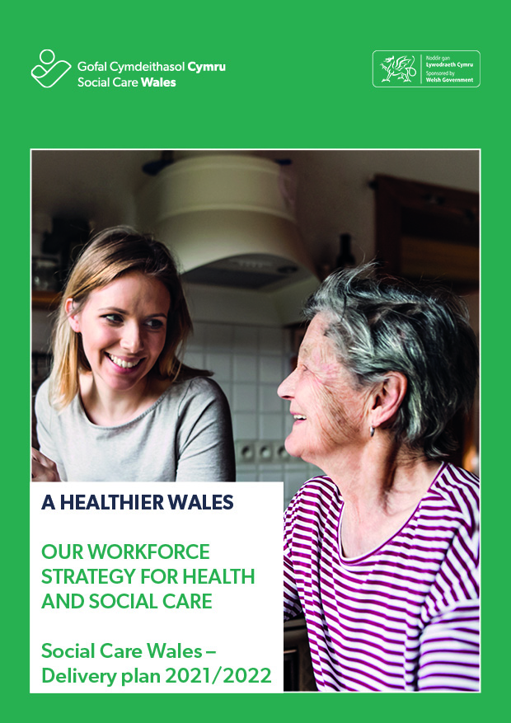

A HEALTHIER WALES – A WORKFORCE STRATEGY FOR HEALTH AND SOCIAL CARE
SOCIAL CARE WALES – DELIVERY PLAN 2021 - 2022
2021-2022 is the first full operating year since the launch of Our Workforce Strategy for Health and Social Care by Health Education and Improvement Wales (HEIW) and Social Care Wales (SCW), in October 2020 to support implementation of A Healthier Wales. The Minister for Health and Social Services welcomed the strategy, which was launched mid-way through one of the most challenging periods of a generation and tested and stretched the resources and systems of both health and social care.
This is coupled with key legislative and political changes with the introduction of the Clinical Framework, the new Liberty Protection Safeguards, the consultation on the White Paper “Rebalancing Care and Support”, Senedd elections in early May 2021 and the subsequent programme for government and the recently published Social Care Recovery Framework.
COVID-19 has seen a huge change in many areas of the health and social care sector including the way we deliver our services accelerated the use of digital and virtual technology to support new ways of working and supporting citizens. We have seen such bravery, courage, compassion and professionalism from our people over the last year, with absolute dedication to the individuals and families they have supported for. The Covid-19 pandemic is undoubtedly having and will continue to have a lasting impact on both sectors for years to come. In response we need to put in place the support workforce and employers need, by implementing the commitments set out in the strategy with pace and energy.
The pandemic is reinforcing the case for change that underpins the strategy. The golden threads of wellbeing, Welsh language and inclusion will run throughout each of the themes and actions strengthened and underpinning all that we do.
COVID-19 is bringing into sharp focus the issues of parity of esteem between health and social care workforce and the need to protect the safety and wellbeing of our people particularly those at the front line of service provision. It highlights the need for increased focus on the diversity of our workforce, and the additional vulnerability some people particularly our BAME colleagues have faced. It reinforces the benefit of building on and developing further a compassionate leadership approach at all levels, developing an inclusive and diverse culture, reflective of our local communities, where staff well-being is paramount and each individual feels valued and supported as part of a health and social care professional fraternity.
In order to ensure that the implementation of the workforce strategy was focused on supporting the pandemic in the short term we developed our “Supporting the Winter Protection Plan” in September which built on our experience of the first peak which we reported on in May 2021

Our focus has been to seize opportunities to work together across health and social care systems, in such areas as compassionate leadership and the wellbeing of the workforce. We will continue to progress the ambition of the workforce strategy, in the context of responding and recovery from Covid-19 during 2021-22 and also look to our longer term plans, continuing to work closely with HEIW, sharing learning and looking to progress joint activity where this can add value. The full list of social care actions and those we are progressing jointly with health against the ambition of the workforce strategy is as follows

 | ACTION | How we will progress these actions during 2021-22
Gweithlu Cysylltiedig, Cymhellus a Iachus  An Engaged, Motivated & Healthy Workforce  By 2030, the health and social care workforce will feel valued, fairly rewarded and supported wherever they work. | ACTION 1  Introduce a Health and Wellbeing Framework across the health and social care workforce setting clear and measurable standards to help drive improvement.  ACTION 2  Introduce a ‘Staff Governance’ Framework setting out expectations for both employers and employees to drive positive employee experience and improved quality.  ACTION 3  Work towards fair reward and recognition across the health and social care  ACTION 4  Implement a consistent approach to monitoring and measuring employee experience through health and social care staff surveys.  ACTION 5  Incorporate a set of workforce wellbeing and engagement measures in the performance framework for organisations, and the broader health and social care system. | Together with HEIW we will  - Share good practice and resources between health and social care to drive improvement with places on health and wellbeing networks reciprocated between HEIW and Social Care Wales  - Deliver a health and wellbeing conference  SCW will  - Continue to add to, evaluate and refine the range of wellbeing resources available via our websites, occupational health services and externally procured resources  - Continue to offer employee assistance programmes  - Publish and monitor achievement against our strategic equality plans  - Contribute to the development and delivery of the Welsh Government Race Equality Action Plan  - Continue to increase staff voice through the streamlining and delivery of regular staff experience feedback opportunities to drive positive experience and improved quality  - Develop and launch our Social Care staff governance framework confirming the expectations of both employers and our people to drive positive employee experience and improved quality.  - Continue to facilitate a social wellbeing network for partners and stakeholders  - Launch our health and wellbeing framework  - Continue to facilitate peer support groups for domiciliary care managers and care home managers to support resilience and wellbeing for managers in the workforce.  - Continue to collate wellbeing resources specific to supporting the wellbeing and resilience of social care leaders  - Creating a standard welcome pack for all new registered people  - Continue to support the Resourceful Communities Partnership to establish itself as a national, multi-sector forum for organisations that help develop and promote local activities/action that enable improvement of wellbeing in communities throughout Wales  - Continue to support the sector to work bi-lingually through targeted resources to support the current and future workforce  - Launch a new care worker card, moving to single digital solution and partnering with two major discount providers to increase the retail benefits available bringing it in line with the offer available in the NHS  - Continue to contribute to the Welsh Government led Social Care Fair Work Forum whose work centres around improving working conditions in social care and whose full remit can be found at https://gov.wales/social-care-fair-work-forum  - Undertake the first all sector engagement survey
Atyniad a Recriwtio  Attraction & Recruitment  By 2030, health and social care will be well established as a strong and recognisable brand and the sector of choice for our future workforce. | ACTION 6  Establish a National Careers Service for health and social care which promotes all roles and reaches out to all parts of the community and workforce.  ACTION 7  Review and develop targeted schemes for  a) significant shortages in professional and occupational groups and hard to recruit areas including medicine, domiciliary care, social work and nursing (linked to action 31)  b) under-represented groups  ACTION 8  Implement a modern values based bi-lingual recruitment approach for all health and social care staff. | Together with HEIW we will  - Further develop the Careers Network links and connections between careers approaches in health and social care to maximise our reach  - Deliver a joint network to share good practice and resources to drive improvement in recruitment and retention across the sectors  SCW will  - Develop targeted schemes for shortage professions and hard to recruit areas.  - Continue to promote apprenticeships as a viable career choice for entering and remaining in the sector  - Work with key stakeholders such as Department of Work and Pensions and Careers Wales, awarding organisations (City and Guilds and WJEC) to strengthen links between job seekers and careers in social care  - Develop and deliver training programmes promoting values-based resources and approaches to recruitment and retention.  - Launch schools based resources to promote careers in social care  - Continue to financially support the care career connector posts in the 7 regions  - Evaluate the introduction to social care programme pilot and make decisions on how to scale up and provide wider access  - Partner with City and Guilds to support their skills bridge programme and signposting the WeCare Wales website as part of their approach  - Continue to develop the WeCare Wales website including specific resources and support to employers including focusing on those hard to recruit to posts such as social workers and nurses in social care.  - Further support the development of the jobs portal enhancing the user experience for both employers and job seekers  - Continue a social media and TV based campaign approach  - Develop a specific campaign, in partnership with employers, promoting the Social Work Degree as a career choice.
Modelau gwaith  di-dor  Seamless Working Models  By 2030, multi-professional and multi-agency workforce models will be the norm. | ACTION 9  Develop a multi-professional workforce plan to support implementation of the new primary and community care workforce model (Strategic Programme for Primary Care).  ACTION 10  Develop a multi-professional workforce plan to support implementation of Together for Mental Health.  ACTION 11  Translate the workforce models being developed through Regional Partnership Boards into a good practice guide for integrated working.  ACTION 12  Develop a clear competence and capabilities framework for extended skills and advanced practice across professional groups.  ACTION 13  Implement a values based, common induction programme for all of our workforce who deliver health and social care in primary and community settings.  ACTION 14  Work with partners to harmonise governance, regulation and registration arrangements to facilitate multi-professional working. | Together with HEIW we will  - Work with partners to expand training on offer to health workers in care homes through care home education facilitator roles  - Develop a workforce plan to support together for mental health, focusing on some early priorities around CAMHS, Clinical psychology and perinatal services  - Progress work on liberty protection safeguards  - Publish the evaluation of the Hywel Dda joint health and social care induction pilot and share lessons learnt  SCW will  - Support the development and implementation of multi-professional workforce models for primary and community care, in line with the Strategic Programme for Primary Care and Regional Partnership Board plans  - Publish a workforce plan for direct care workforce  - Contribute to the development of an induction standards for volunteers  - Publish a workforce plan for the social work profession including a new post qualification framework
Adeiladu Gweithlu  sy’n barod  yn ddigidol  Building a Digitally Ready Workforce  By 2030, the digital and technological capabilities of the workforce will be well developed and in widespread use to optimise the way we work, to help us deliver the best possible care for people.  . | ACTION 15  Implement a “Building a Digitally Ready Workforce Programme” focused on enhancing the digital literacy and confidence of the wider health and social care workforce in Wales.  ACTION 16  Commission consistent digital aspects as part of all under graduate curricula for health and social care professionals.  ACTION 17  Implement a requirement for all digital transformation projects and programmes to include a clear organisational development plan. | Together with HEIW we will  - Launch revised digitally enabled Infection Prevention and Control (IPC) training  SCW will  - Support the development of increased digital capability throughout our workforce  - Continue to develop digitally enabled learning resources  - Launch a digital learning platform and test out opportunities for once for Wales training including safeguarding, infection, prevention and control and principles and values  - Increase in the social care workforce confidence in using digital technology to provide support (along with joint work with Digital Communities Wales)  - Monitor the delivery of a national priority for digital approaches in the Social Care Wales Workforce Development Programme grant for 21/22  - Develop the skills, capabilities and connections of those using, delivering and researching care and support in Wales
Addysgu a Dysgu  Excellent Education & Learning  By 2030, the investment in education and learning for health and social care professionals will deliver the skills and capabilities needed to meet the future needs of people in Wales. | ACTION 18  Work with education providers to ensure education meets the needs of the health and social care system, and includes programmes delivered through the medium of Welsh.  ACTION 19  Work with education providers to support the workforce to develop and/or improve Welsh language skills.  ACTION 20  In partnership with Higher Education Institutions, implement changes to the content of curricula and flexibility of provision for undergraduate programmes to meet future needs and delivery modes, stipulating inter professional education, placement requirements for common competences, and language requirements.  ACTION 21  Continue to invest in increasing the numbers of health and social care professionals who are trained in Wales, with a focus on value.  ACTION 22  Widen access into health and social care careers by developing the work-based learning model.  ACTION 23  Develop a clear and equitable funding and commissioning model for health and social care education including undergraduate education, apprenticeships and vocational education.  ACTION 24  Develop a clear strategy for Continuing Professional Development (CPD) across professional and occupational groups. | Together with HEIW we will  - Work with City and Guilds, to share intelligence and data on the impact of Covid-19 on the delivery and achievement of vocational qualifications  SCW will  - Improve opportunities for learners to undertake education and training through the medium of Welsh.  - Maximise opportunities for work-based learning (WBL) and apprenticeships as viable career choices to enter and remain in the sector  - Widen access to, and promote a reduction in differential attainment across health and care education programmes  - Lead on the development and implementation of a programme of learning to support the implementation of the Liberty Protection Safeguards  - Monitor the take up and delivery of the new Level 2 & 3 qualifications and support the implementation of new Levels 4 and 5 qualifications.  - Support the implementation and take up of the revised Level 4 and 5 apprenticeship frameworks  - Maintain and develop All Wales Network of Mentors for outcomes focussed practice  - Analyse, report and act on the impact of Covid-19 on learners who have not been able to complete assessments/ placements  - Bring national consistency to Safeguarding training and learning  - Upon sign off of the restrictive practice guidance, the Social Care Wales resource will be revised and the website updated  - Work with City and Guilds to share intelligence of the impact of Covid-19 on the delivery and achievement of vocational qualifications  - Complete a review of funding streams that support workforce development including the SCWWDP grant  - Provide ongoing support to student social workers through qualifying training into employment including reviewing the funding arrangements that support qualifying and post qualifying training  - Support the delivery of a social care managers induction framework  - Support the development of resources for the Social Services Practitioner award  - Develop a competency framework for Information, Advice and Assistance workers  - Support the development of an advocacy workers competency framework  - Support the development of a revised principles and values award to support registration of care workers
Arweinyddiaeth a Dilyniant  Leadership and Succession  By 2030, leaders in the health and social care system will display collective and compassionate leadership. | ACTION 25  Develop a strategy to frame a consistent approach to compassionate leadership in health and social care in Wales.  ACTION 26  Establish an accessible range of leadership development resources and programmes for individuals and organisations.  ACTION 27  Develop a talent management pipeline for leadership roles | Together with HEIW we will  - Launch the Principles for compassionate leadership for health and social care in Wales to enable a shared definition, understanding and language relating to what compassionate leadership looks like across both sectors in Wales and develop compassionate leadership online engagement content to ‘spotlight’ individual principles and themes  SCW will  - Continue to invest in developing compassionate leaders across health and social care  - Design webpage content for a ‘compassionate leadership’ page on Social Care Wales website  - Continue to invest in specific leadership programmes for social care professional heads of service and statutory directors including TMDP and MMDP qualifications, with bespoke development programmes in place for Directors and Assistant Directors of Services and Workforce.  - Support peer networks across registered managers in social care in private, voluntary and public services to enhance wellbeing and help protect resilience  - Continue to support the promotion and implementation of the new Level 4 and Level 5 qualifications including the related apprenticeship pathways  - Continue to provide a leadership role in the promotion of bi-lingual working  - Contribute to and respond to the review of Welsh Governments mwy na geiriau action plan with the development of a revised action plan for Social Care Wales
Siâp a Chyflenwad y Gweithlu  Workforce Supply & Shape  By 2030, we will have a sustainable workforce in sufficient numbers to meet the health and social care needs of our population. | ACTION 28  Create a centre of excellence for workforce intelligence for health and social care in Wales.  ACTION 29  Build capacity and capability in workforce planning and development across health and social care, underpinned by a standardised, methodology.  ACTION 30  Develop workforce planning guidance for Welsh language skills identification and development in the health and social care workforce.  ACTION 31  Develop workforce plans for key professional and occupational groups, in the first instance; Nursing, Domiciliary care, Social Work, Medicine.  ACTION 32  Commission a programme of work to understand the contribution of volunteers and carers to inform future workforce plans. | Together with HEIW we will  - Publish the workforce plan for the mental health workforce  SCW will  - Develop digital resources and online training to support workforce planning for health and care providers.  - Contribute to the development of an induction standard for volunteers  - Launch the revised model of workforce data collection using the newly created employer dashboard  - Continue to modify data collection approaches to ensure robust data is available including improving reporting on data around language and ethnicity  - Continue to enable the care home workforce to register on a voluntary basis  - Publish the workforce plans for the direct care workforce and the social work profession  - Drill down into areas of concern to better understand the profile of the workforce in order to provide intelligence to support effective decision making e.g. profiling of nurses in social care, turnover rates for key areas such as social work and domiciliary care.  - Undertake a scoping review of the approaches to workforce planning across the sector and provide recommendations for developing this function  - Undertake a full review of the Social Care Wales Workforce Development Programme grant

IN CONCLUSION

As we look towards 2021 – 2022, it will inevitably present further change and challenge as we see the ongoing recovery from the pandemic including the continuation of the vaccination programme, the removal of restrictions of movement and the return to more normal operating systems for both health and social care.

Achieving the ambition of the 10 year strategy, will continue to require excellent and committed collaborative working across health and social care, between local organisations and national bodies working in social partnership. The work undertaken since the launch of the strategy, clearly linking the work to the seven key themes and underpinning golden threads of the strategy, has allowed a momentum to be gained that could be built on in subsequent years in line with our longer term aspirations and goals which puts us in good stead to meet the challenges and opportunities that 2021-2022 will present.

We have reviewed the strategy in light of Covid-19 and believe the ambitions and actions remain relevant, this plan represents those areas we need to expediate to meet very pressing challenges for the sectors. During 2021-22 we will endeavour to develop the longer-term implementation plans and governance required to realise the 10 year ambition.

Social Care Wales July 2021

