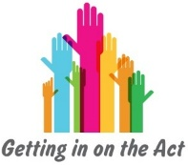  Not being listened to | Don’t feel as important as everyone else
Unable to speak up | Not given the opportunity to speak
Unsure of options  for change | Don’t understand language being used
Not asked opinions | Difficult situation which raises emotions

