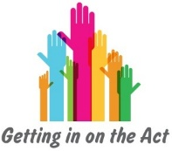
You are advocating that red is the best colour.

Because:
- It is warm
- It is fun
- It catches your attention

Resource 3h

You are advocating that blue is the best colour.

Because:
- It is natural i.e. the colour of the sea and the sky
- It can be either bright or pale
- It is calming

You are advocating that an apple is the best fruit.

Because:
- It is crunchy
- You get different varieties
- It is easy to eat out and about

Resource 3h

You are advocating that an orange is the best fruit.

Because:
- It is juicy
- It is sweet
- You can make juice with it

You are advocating that a car is the best form of transport.

Because:
- You can do things on your own time
- You can pack as much as you want
- You can detour

Resource 3h

You are advocating that a bus is the best form of transport.

Because:
- It’s environmentally friendly
- You can read on your journey
- You don’t have to worry about parking

You are advocating that showers are best.

Because:
- They are quick
- They don’t use much water
- They are refreshing

Resource 3h

You are advocating that baths are best.

Because:
- They are relaxing
- They sooth your muscles
- They are indulgent

