SOCIAL SERVICES AND WELL-BEING (WALES)
ACT 2014
ADULT PROTECTION AND SUPPORT ORDERS

APSO training guide

November 2016

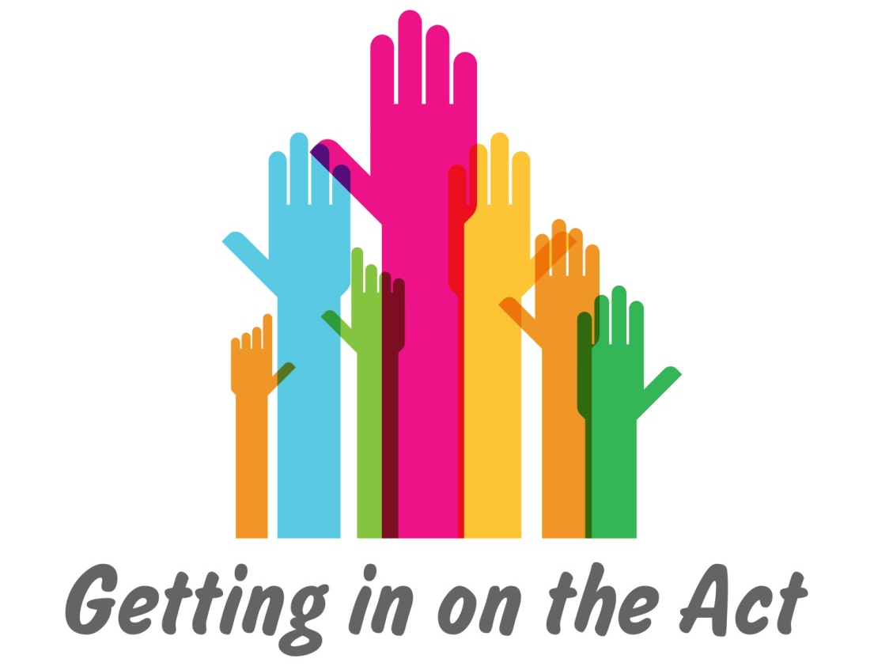

Contents
1 Contents 2
2 Introduction 3
3 Who is It for? 4
4 What does It include? 5
5 How to use the Materials 6
5.1 Training transfer 6
5.2 How to use the Training materials 6
5.3 Facilitator person specification 8

Introduction
The Social Services and Well-being (Wales) Act 2014 (the Act) introduced wide-ranging reforms that have major implications for practice. This module looks at one element of the Act: the use of adult protection and support orders (APSOs).

APSOs are introduced in Part 7 of the Act, which is concerned with safeguarding. They are part of a wide change in safeguarding practice brought about by the Act. This in turn reflects a cultural change in social care across Wales.

When working with any element of the Act, it is essential to bear in mind the Act’s guiding principles:

- The Act aims to change the way people’s care and support needs are met – putting an individual at the centre of their care and support and giving them a voice in, and choice and control over, reaching the personal outcome goals that matter to them. This includes a duty on local authorities to ensure people are able to work in partnership with professionals and to have access to an advocate or other person to support them if they wish.
- Central to the Act is the concept of well-being – helping people to maximise their own well-being.
- The Act attempts to rebalance the focus of care and support to prevention and earlier intervention – increasing preventative services within the community to minimise the escalation of needs to a critical level.
- Strong partnership working between organisations and co-production with people needing care and support is a key focus of the Act. The Act requires a culture change from the way in which services have often been provided, to an approach based on collaboration, and an equal relationship between practitioners and people who need care and support.
- The Act specifically refers to the European Convention on Human Rights and the requirement on professionals to consider the United Nations Principles for Older People, the UN Convention on the Rights of Disabled People and the Convention on the Rights of the Child.

These principles will enable people to be at the centre of their care and support and ensure their well-being will be central to any decisions made about their lives.

The APSO training materials, and this guide, form part of the suite of learning materials that has been developed by Research in Practice for Adults and the Institute of Public Care at Oxford Brookes University. They link to other information that supports the implementation of the Act. This includes:

- Working Together to Safeguard People statutory guidance, especially Volume 4 on Adult Protection and Support Orders
- Other codes of practice and statutory guidance related to the Act
- The Information and Learning Hub‘s learning resources on the Act, in particular on Safeguarding and Advocacy
- Code of Professional Practice for Social Care Professionals (Care Council for Wales, 2015) – this includes: Promote the well-being, voice and control of individuals and carers while supporting them to stay safe.
- National Occupational Standards for Social Work (Care Council for Wales, revised 2011) – this includes standard 13, Investigate harm or abuse: This standard is for social workers working with individuals, families, carers, groups and communities. Investigating harm or abuse is a complex and demanding activity which has at its heart the safe-guarding of a vulnerable adult, young person or child. It involves working closely with other disciplines and agencies; exercising professional assertiveness in situations where there may be overt or covert hostility; making difficult judgements; and developing options for action which may have far-reaching consequences. All this must be done in the context of legal, organisational and other binding requirements. The standard covers these aspects and highlights the need to maintain a focus on the person who is at risk, whatever others needs or issues may come to light during the investigation process.

Authorised officers, and others using these training materials, will need to be very familiar with the Act and with the resources listed above.

Who is it for?
The training material supports the implementation of APSOs. Its use is likely to involve:

- Authorised officers and legal officers – existing and new
- Others who support the implementation of APSOs in practice
- Learning and development managers who ensure appropriate learning
- Learning facilitators who deliver training based on these materials.

The materials can be used for the following main purposes:

- Delivering training to new authorised officers and legal officers or other key roles
- Refreshing the learning of existing authorised officers and legal officers or other key roles, as part of their Continuing Professional Development.

The overarching learning outcome for this training is to enable authorised officers and legal officers, or other key roles, to act lawfully and in the spirit of the Act to use APSOs for the benefit of adults at risk in Wales.

The specific learning outcomes are to:

- Ground the use of APSOs in the aims and principles of the Act
- Develop an ethical, expert practice culture to support the use of APSOs
- Ensure robust understanding of law and guidance
- Ensure individual responsibility for decision making in the context of appropriate support
- Build a consistent approach to implementing APSOs across Wales
- Identify confidence and competence in this area of practice, and additional support needs so that people can continue to develop their practice.

What does it include?
Materials are available to download from the Information and Learning Hub in Welsh and English. The following materials, as well as this guide, are as available:

- Authorised officer process – this sets out how appropriate people can become authorised officers
- Activity: preparation and learning needs analysis – this sets out the background knowledge that authorised officers need to have and the Learning Needs Analysis that they need to do before undertaking the module
- Training module PowerPoint – this is a series of slides taking you through the training module
- Training module Word document – this provides facilitator notes and additional information for all the slides. It also includes:
  - Facilitators hints and tips that provide ideas for how to deliver the module
  - Key learning points that highlight important messages from the module
  - Suggestions for when handouts and activities should be used
  - Links to regulations and codes of practice or statutory guidance
  - References
- Activity: follow up and learning needs analysis and action plan – this sets out what authorised officers need to do at the end of the module, including repeating the learning needs analysis and creating an action plan; this should be redone at least annually and reviewed at appraisal
- Activities – other activities that support learning and development
- Handouts – other handouts which provide information to support learning and development.

How to use the materials

Training transfer
Training is only successful when it is transferred into practice and has an impact on people’s experience and outcomes.

There are four main factors involved in changing practice through training (Research in Practice, 2012, Training transfer: getting learning into practice):
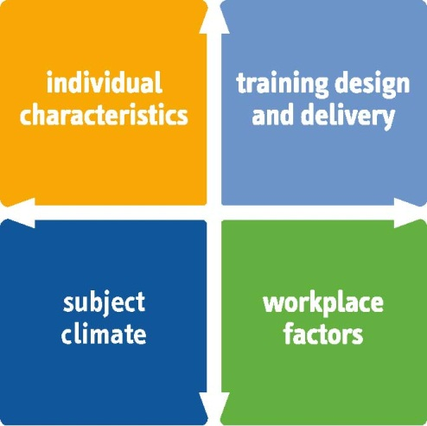
- The design and delivery of the programme – how well learning is delivered and how this addresses the need to transfer this learning into practice.
- Individual characteristics – how relevant learning is for people and their motivation to transfer this learning into practice.
- Workplace factors – how managers and peers support transfer of learning into practice, and what opportunities there are to use this.
- Subject climate – how far the organisational culture, structures and attitudes encourage transfer of learning into practice
These factors are enabled in this module in the following ways:
- Design and delivery – the materials include preparation and follow-up; there are a range of activities to support practice.
- Individual characteristics – participants complete a learning needs analysis to identify their individual needs before and after the module, and they complete an action plan to enable use of learning.
- Workplace factors – the authorised officers process includes the local authority nominating and following up with authorised officers; action plans identify support to carry out actions.
- Subject climate – this module forms part of wider work by the Care Council for Wales to implement the Social Services and Well-being (Wales) Act 2014; this is referenced throughout the training module.

How to use the training materials
Not all the training materials will be equally applicable to every organisation or practitioner. Outlined below are suggestions for how to use the materials for different groups of learners, including a session plan for a one-day workshop.

The training materials can be adapted, altered and amended. They are designed to be flexible and user friendly. However, they are also intended to promote consistency in learning, particularly with regard to knowledge about the Act and the related codes of practice. The materials have also been quality assured and tested.
We suggest the following ways of using the materials:

For complete training of new authorised officers, along with legal officers or other key people that support them:

- Provide the authorised officer process information and the activity: preparation and learning needs analysis to people undertaking the training.
- Deliver a one-day workshop using the PowerPoint and training module, including the activities and handouts referenced in the training module notes. See the session plan in Appendix 1 for a suggested one-day workshop.
- Conclude the one-day workshop with the activity: follow up and learning needs analysis and action plan.

For training of a few new authorised officers by existing authorised officers:

- Provide the authorised officer process information and the activity: preparation and learning needs analysis to people undertaking the training.
- Meet with the people undertaking the training to go through the learning needs analysis and to identify the important learning areas.
- Participants use half a day to work through the ‘Purpose of APSOs’ and ‘Use of APSOs’ sections in the training module.
- Meet for two hours to undertake activities: purpose; promoting well-being; case study alternatives.
- Participants use half a day to work through the ‘Role of authorised officers’ and ‘Process’ sections in the training module.
- Meet for two hours to undertake activities: acting independently and case study making an application/ assessment/ next steps.
- Conclude with the activity: follow up and learning needs analysis and action plan.

For refresher training of authorised officers:

- For preparation, ask participants to revisit the ‘Role of authorised officers’ section in the training module and redo the learning needs analysis and identify learning needs.
- Review the learning needs analyses and identify the areas for a half-day session.
- Pick the appropriate PowerPoint slides, handouts and activities.
- Include a discussion about authorised officers’ experiences of the role.
- Conclude with the activity: follow up and learning needs analysis and action plan.

If you are arranging short sessions with other key individuals, you can use the same approach in terms of asking people to do the learning needs analysis and then structuring the session around this, and concluding with the learning needs analysis and action plan. The case study activity offers a structured way through the key points of the training module.

For annual appraisal discussion with authorised officers:

- For preparation, ask the authorised officer to revisit the ‘Role of authorised officers’ section in the training module and redo the learning needs analysis and action plan.
- Review the learning needs analysis and action plan.
- Have a discussion about: strengths; weaknesses; barriers and enablers to the role for the authorised officer.
- Have a discussion about: learning needs; actions to meet these; support required.
- Finalise the action plan and confirm ongoing suitability for the role to the local authority, if this is agreed.

Facilitator person specification
If you are delivering training to authorised officers then you will need a high level of knowledge about the following areas:

- Working Together to Safeguard People statutory guidance, especially Volume 4 on Adult Protection and Support Orders
- Other codes of practice and statutory guidance related to the Act
- The Information and Learning Hub’s learning resources on the Act, in particular on Safeguarding and Advocacy
- Human Rights
- Code of Professional Practice for Social Care Professionals (Care Council for Wales, 2015)
- National Occupational Standards for Social Work (Care Council for Wales, revised 2011)
- The policies and procedures of the organisation(s) you are delivering in.

You will need a high level of skills in:

- Delivering adult learning programmes
- Facilitating learning for experienced professionals
- Supporting continuing, self-directed learning
- Delivering complex information
- Facilitation of group work.

You will need strong values in:

- Promoting well-being
- Promoting human rights
- Partnership working.

You may find it helpful to complete the learning needs analysis to identify your own strengths and areas of development.

Contact details

Care Council for Wales
South Gate House
Wood Street
Cardiff
CF10 1EW

Tel: 0300 3033 444
Fax: 029 2038 4764
Minicom: 029 2078 0680

E-mail: hub@ccwales.org.uk http://www.ccwales.org.uk/getting-in-on-the-act-hub

© 2016 Care Council for Wales

It is expressly prohibited to use any, or all, of this training resource for commercial gain.

Further copies and other formats:
This publication is also available in other versions, including as a pdf. Further copies of this document and other Care Council resources about the Social Services and Well-being (Wales) Act 2014 are available to download from the Information and Learning Hub.

Appendix 1
Session plan for one-day workshop

Time | Session | Training module slides | Handouts/ Activities
Preparation |  |  | Activity – Preparation and learning needs analysis
09.30 – 10.00 | Introduction | 1 | Handout: Introduction to the module
10.00 – 11.00 | The purpose of APSOs | 2-7 | Activity – Exercise: Purpose  Activity – Discussion: Promoting well-being
11.00 – 11.15 | Break
11.15 – 12.00 | The use of APSOs | 8-12 | Handout: Coercive control  Activity – Case study: Alternatives  Handout: Legal alternatives
12.00 – 12.40 | The role of the authorised officer | 13-17 | Activity – Discussion: Acting independently
12.40 – 13.15 | Lunch
13.15 – 14.15 | Process: Collecting evidence; planning | 18-27 | Handout: Process  Handout: Advocacy  Activity – Case study: Making an application
14.15 – 15.00 | Process: Court; using an APSO | 28-33 | Activity – Case study: Assessment
15.00 – 15.15 | Break
15.15 – 16.00 | Process: Next steps | 34-35 | Activity – Case study: Next steps
16.00 – 16.30 | Ongoing learning | 36-39 | Activity – Follow-up learning needs analysis and action plan

