**SOCIAL SERVICES AND WELL-BEING (WALES) ACT**

**FACILITATORS’ GUIDE**

Facilitators’ Guide

**June 2016**

# Contents

2 Introduction 3

3 Who is this Guide for? 4

3.1 How to use these Materials 4

3.2 Accessibility 6

3.3 Next Steps 8

3.3.1 Personal Action Plan 9

3.3.2 Evaluation Form 10

4 Summaries and Overviews 12

4.1 Summaries 12

4.2 Overview PowerPoint Slides 12

4.2.1 Overview PowerPoint Slides with Audio 13

5 Training Modules and PowerPoint Slides 14

5.1 Full PowerPoint Slides 14

5.2 Training Modules 15

5.2.1 Introduction 15

5.2.2 Module Training Resources 16

5.2.3 Links to Key Resources 17

5.3 Finding Your Way Round the Materials 17

6 Other Materials 19

6.1 Session Plan 19

7 List of Materials in the Suite 20

# Introduction

The Social Services and Well-being (Wales) Act 2014 introduces wide-ranging reforms that have major implications for the learning and development needs of the sector workforce. In advance of the Act coming into effect on 6 April 2016, the Care Council for Wales has developed an evolving national learning and development plan to support its implementation. A key strand is the development of learning materials for those whose roles are most affected by the changes and require training.

This facilitators’ guide forms part of the suite of learning materials that has been developed by the Institute of Public Care at Oxford Brookes University. The suite of materials summarises and explains the regulations and codes of practice or statutory guidance that underpin the Act. The suite is designed to help those whose roles are most affected to understand and implement it.

As well as this guide, the suite of materials contains learning material for each of the following topic areas:

1. Introduction and General Functions – Parts 1 and 2 of the Act
2. Assessing and Meeting the Needs of Individuals - Parts 3, 4 and 11 of the Act
3. Looked After and Accommodated Children – Parts 6 and 11 of the Act
4. Safeguarding – Part 7 of the Act

Each of these four topic areas contains a range of learning materials relating to it as shown in the diagram below:

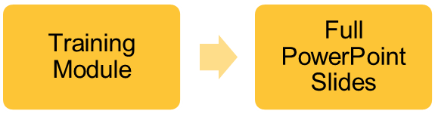

Each topic area has a short summary and brief overview PowerPoint slides. Each topic area also has more detailed learning material in the form of a training module and a set of linked PowerPoint slides that match the training module. The learning materials for each topic area are colour coded to help identify which materials are intended to be used together. There are other materials available that are not necessarily linked to a particular topic area, such as self-assessment exercises and a glossary.

# Who is this Guide for?

This facilitators’ guide is for anyone who needs to navigate around these learning materials, for example learning and development managers, and in particular for learning facilitators who need to deliver training based on these materials.

The learning materials have been written for learning facilitators and include PowerPoint-based input, handouts, exercises, suggested group discussions, points of reflection and case studies that facilitators can use either in their entirety or to pick and choose from as they see fit when designing a learning programme.

Sucessful implementation of the Act requires whole systems change and underpinning this is a need for cultural change. While training materials alone will not affect such change, they are one tool that can be used to support people along the journey. In many instances, implementing the Act successfully will require those involved in the care and support system to change the way they work i.e. behaviour change. Research suggests that the way people behave is influenced by their knowledge, skills and attitudes:

Behaviour

The PowerPoint presentations and handouts are designed to increase knowledge about the Act or codes of practice. The questions and exercises are designed to spark conversations that encourage people to reflect on their own attitudes and the attitudes of others. They aim to give learners the opportunity to discuss the complexities of implementing the changes in practice, and / or provide a safe way of challenging attitudes that go against good practice. The case studies are designed to provide an opportunity for people to analyse and practice their skills.

## How to use these Materials

The materials are designed to provide a range of tools for use by those responsible for introducing practitioners and others to the changes brought about by the Act and the impact it will have on their roles and services. To be most effective, use of these materials needs to follow on from systematic workforce planning. Because individual organisations’ policy, procedures and workforce differ, these materials will need to be used in conjunction with that local knowledge.

These are resources rather than an off-the-peg training pack; they can be adapted, altered and amended. They can be customised for use by a range of organisations across the care and support workforce in Wales. Not all material will be equally applicable to every organisation or practitioner.

The training materials are designed to be flexible and user friendly. However, they are also intended to promote consistency in learning, particularly with regard to knowledge about the Act and the related codes of practice. The materials have also been quality assured and tested. With this in mind, it is recommended that the Getting in on the Act branding is retained for all training specifically on the Act. It is appropriate to also add local branding as necessary e.g. local authority or health board logo, etc. The Getting in on the Act resources are available to all free of charge and are not to be copied, re-sold or used for commercial gain.

Materials are available to download from the [Information and Learning Hub](http://www.ccwales.org.uk/getting-in-on-the-act-hub/). A list of all the materials available in the suite, and links to them, are included in section 7.

To successfully facilitate training based on these materials we suggest that you:

* have read the relevant sections of the Act, regulations and codes of practice or statutory guidance;
* have a good understanding of best practice in the relevant topic area;
* be familiar with the organisation’s policies and procedures relevant to the session content;
* choose the most suitable materials for your learners and learning programme, noting that there is a range available;
* remember that you can pick and mix questions, exercises and case studies from a training module or from other topic areas; and
* design your training session in a way that provides a range of training methods and takes account of the learning pyramid below so as to maximise the experience and learning outcomes for your learners.

Facilitators’ hints and tips

During the training session it is likely that participants will ask questions about the details of implementation in their local area. There may be many occasions when you as a facilitator are unable to answer these questions or address some of the tricky issues that arise. One way of managing this is to have a flip chart for ‘tricky issues and unanswered questions’. The issues and questions can be written on the flip chart and then used to provide feedback to the people who have commissioned the training. As the training develops over a number of sessions it might be useful to develop a handout of Frequently Asked Questions with the official responses.

**Average retention rates of learners**

Participatory training methods

Passive training methods

Source: Adapted from National Training Laboratories, Bethel, Maine

## Accessibility

We suggest that these materials follow on from systematic workforce planning and are used by facilitators with local knowledge. It is important that this knowledge extends to information about your learners’ language and communication needs. This must include learners’ preference for materials and delivery in the medium of Welsh or English.

Good practice requires you to ask learners in advance whether they have any specific access, communication or learning needs. We suggest that you include such questions on your booking form (or similar) and give learners the opportunity to write their answers and / or discuss their specific learning needs with you in advance.

We have designed the materials to be as generically accessible as possible, including:

* An accessible font of minimum 12 point in Word documents
* Considering legibility on the page in the design i.e. colour contrast, boxes, borders and white space around text
* Online graphics are accessible to screen reading software or have voice overs for the visually impaired (in English and Welsh)
* Online audio materials have subtitles (in English and Welsh)

However, this alone is not enough. You will need to consider your learners’ needs in the preparation for your training programme. Generalisations about what learners want or don't want, or can or can't do, are unwise and generally unhelpful. Learners are a very diverse group, and even the same or similar impairment may have very different effects on individuals. The following may be helpful to you as a starting point:

* Most of the needs of learners will be the same: they will need you to be clear about the arrangements, what the learning outcomes are, and what they are expected to do.
* Over and above this, some learners will have a specific need for additional support perhaps arising from an impairment or barrier to their learning. The best way to find out what these are is to ask the individual.
* Many of these suggestions will probably be easy to act on. But be aware of the huge impact on an individual of quite small changes you might make to how you train, such as always facing the audience when speaking. Similarly for the physical or organisational aspects of the learning environment, such as room layout.
* You will need to be aware of accessibility considerations of any training venue such as good physical access to all rooms, including toilets, good quality acoustics, and clear signposting to training rooms at the venue.

In our experience the most common specific need is dyslexia. Advice from the British Dyslexia Association is to avoid white backgrounds for printed materials as white can appear too dazzling. Instead use cream or a soft pastel colour. However, some people with dyslexia will have their own colour preference or may require a larger font. What can also have a big influence on the accessibility of a document is the quality of photocopied resources. The paper type, too, can have an influence as glossy or thin paper that allows type from the reverse side of following pages to show can impact on the readability of the text.

Many people with dyslexia are slower to process lengthy written texts, which may hinder learners when undertaking exercises and group work. It may be helpful, therefore, for learners with dyslexia to have access to any lengthy exercises and / or case studies in advance.

[AbilityNet](http://www.abilitynet.org.uk/) is a useful source of information and advice about accessibility issues as is the British Dyslexia Association’s [Training Tips](http://www.bdadyslexia.org.uk/employer/training-tips) for employers, and Disability Wales’s [Good Practice Guidance Toolkit](http://www.disabilitywales.org/toolkit/wp-content/uploads/sites/3/Good-Practice-Guidance-Toolkit-E.pdf).

## Next Steps

We suggest that, at the end of a training session or learning programme, you take time to reflect on the learning experience with participants and to help them identify their next steps and key actions. This should include asking learners, either individually or in pairs, to complete the action plan below.

Facilitators’ hints and tips

At the end of the training session you could lead a group discussion to explore with participants their key learning from the programme and how they might take this forward. This could include asking the group the following questions:

* What has struck you most about this session?
* You will need to think about what should change in your practice and in the way your organisation works. Reflecting on what you have learnt about [this topic area]:
* how might the key changes brought about by the Act impact on your current arrangements?
* what might be the biggest challenges for you?
* what actions will you need to take?
* what further support do you need?

### Personal Action Plan

What are your top three priorities that you need to change?

|  |
| --- |
|  |

What are your next steps for each priority?

|  |
| --- |
|  |

How will you review your progress?

|  |
| --- |
|  |

What further support will you need?

|  |
| --- |
|  |

### Evaluation Form

At the end of the training session you may want to evaluate the training using the evaluation form below.

|  |  |  |  |  |  |  |  |  |  |  |  |  |  |  |  |  |  |  |  |  |  |  |  |  |  |  |  |  |  |  |  |  |  |  |  |  |  |  |  |  |  |  |  |  |  |  |  |  |  |  |  |  |  |  |  |  |  |  |  |  |
| --- | --- | --- | --- | --- | --- | --- | --- | --- | --- | --- | --- | --- | --- | --- | --- | --- | --- | --- | --- | --- | --- | --- | --- | --- | --- | --- | --- | --- | --- | --- | --- | --- | --- | --- | --- | --- | --- | --- | --- | --- | --- | --- | --- | --- | --- | --- | --- | --- | --- | --- | --- | --- | --- | --- | --- | --- | --- | --- | --- | --- |
| Evaluation Form  We value your feedback; please take a few minutes to complete this form.  Name (optional): _________________ Organisation (optional): _______________________  1. Please tell us how well you think the training session:   |  |  |  |  |  |  | | --- | --- | --- | --- | --- | --- | | Please ✓ appropriate box | Very well | Quite well | Partly | Not well | Not at all | | Met your needs? |  |  |  |  |  | | Was relevant to your organisation? |  |  |  |  |  |   2. Which were the most beneficial parts and why?  3. If there was one thing you could change, what would it be?  4. Please rate your facilitator’s:   |  |  |  |  |  |  | | --- | --- | --- | --- | --- | --- | | Please ✓ appropriate box | Very well | Quite well | Partly | Not well | Not at all | | Knowledge of the subject |  |  |  |  |  | | Ability to respond to questions |  |  |  |  |  | | Enthusiasm for the subject |  |  |  |  |  |   Additional comments:  5. How well do you rate:   |  |  |  |  |  |  | | --- | --- | --- | --- | --- | --- | | Please ✓ appropriate box | Very well | Quite well | Partly | Not well | Not at all | | The venue and facilities? |  |  |  |  |  | | Quality of materials and content? |  |  |  |  |  |   6. Any other comments? |

### Training participants’ survey

As part of an independent evaluation into the national training programme for the implementation of the Social Services and Well-being (Wales) Act, ICF Consulting is looking to survey individuals who have completed training on the core modules.

The survey will collect information on the early impact of the training, including how the training has affected respondents’ skills and their level of knowledge, and if it has contributed to changing the way they work.

The respondents need to have returned to work and had time to reflect on the training to be able to provide information on these early impacts. Therefore the survey should be sent to training participants no sooner than four weeks after they have completed their training. Below you will find an email you can send to training participants inviting them to complete the survey.

### Training participants’ survey – introductory email

This is an invitation to complete an e-survey. It is for individuals who have completed training modules for the Social Services and Well-Being Act (Wales) 2014. We would ask you to complete this survey no sooner than four weeks after completing the training.

This is a survey to collect your views on the training you have received and the impact it has had. We will also be collecting your views on whether the training could be improved in the future. We therefore strongly encourage you to complete the survey, which should take around 10 minutes to complete.

Please click the link below to access the survey:

English: <https://www.snapsurveys.com/wh/s.asp?k=145555568854>

Welsh: <https://www.snapsurveys.com/wh/s.asp?k=145570698855>

The survey is being administered by the independent research company ICF Consulting Ltd. Your responses will be treated in the strictest of confidence and in line with the Data Protection Act. All responses to the survey will be anonymised in reporting. If you have any questions or any problems accessing the survey, please contact the project manager of the research at ICF at [james.kearney@icfi.com](mailto:james.kearney@icfi.com)

# Summaries and Overviews

Each topic area has a short summary and brief overview PowerPoint slides. These summaries and overviews are for all roles across the sector so that they can be informed of the key changes brought about by the Act.

They provide a high level summary of the legislative regulations and relevant codes of practice of the Act, which highlights the change to current practice. Their aim is to provide a foundation for learning more about the Act. They do not focus on specific job roles.

## Summaries



Each topic area has an engaging summary document, no more than four pages long, that gives a brief and generic overview of the key messages and changes relating to the relevant parts of the Act.

You could use summaries, for instance, to:

* Set as pre-reading for participants before delivering a workshop based on the full training module
* Compile a briefing pack for learners to take away
* Suggest as reading for a self-directed learner

## Overview PowerPoint Slides

Each topic area has overview PowerPoint slides, no more than ten slides in length, which cover the same content as the summary.

Overviews are designed for facilitators to deliver in a short training session. They are suitable for a wide ranging audience and have been developed so that if you need people to have a grasp of the key changes you can do so quickly for any topic area.

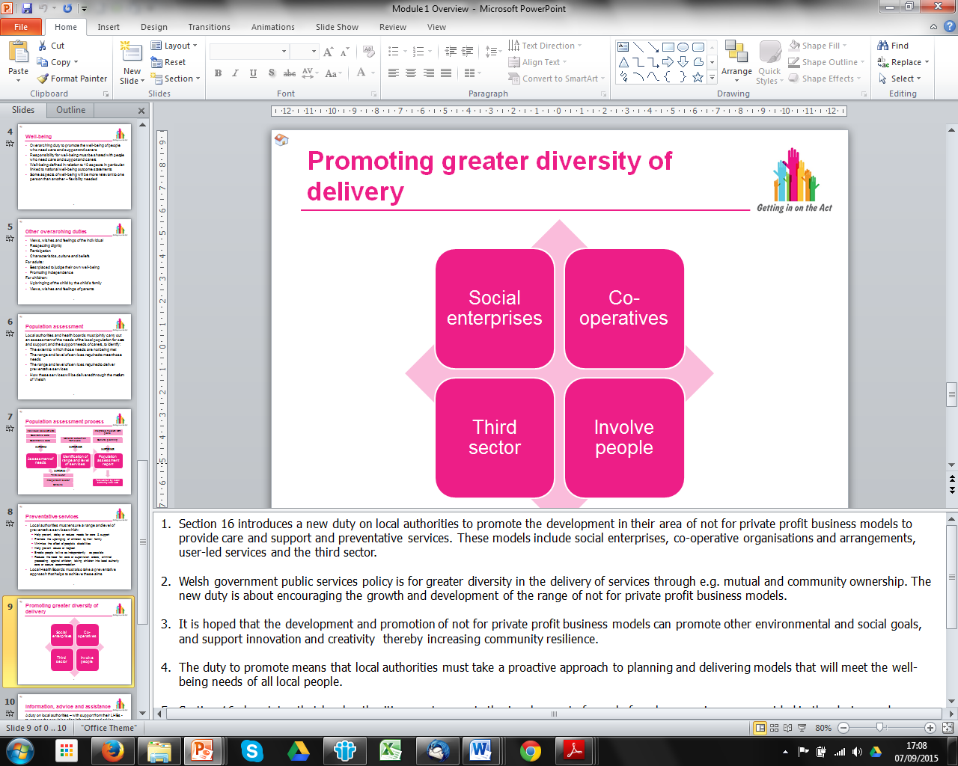

Overview slides have facilitators’ notes in the Notes Pages of the PowerPoints, which will help you to deliver them.

If any of the slides have animation it will highlight this in the facilitators’ notes.

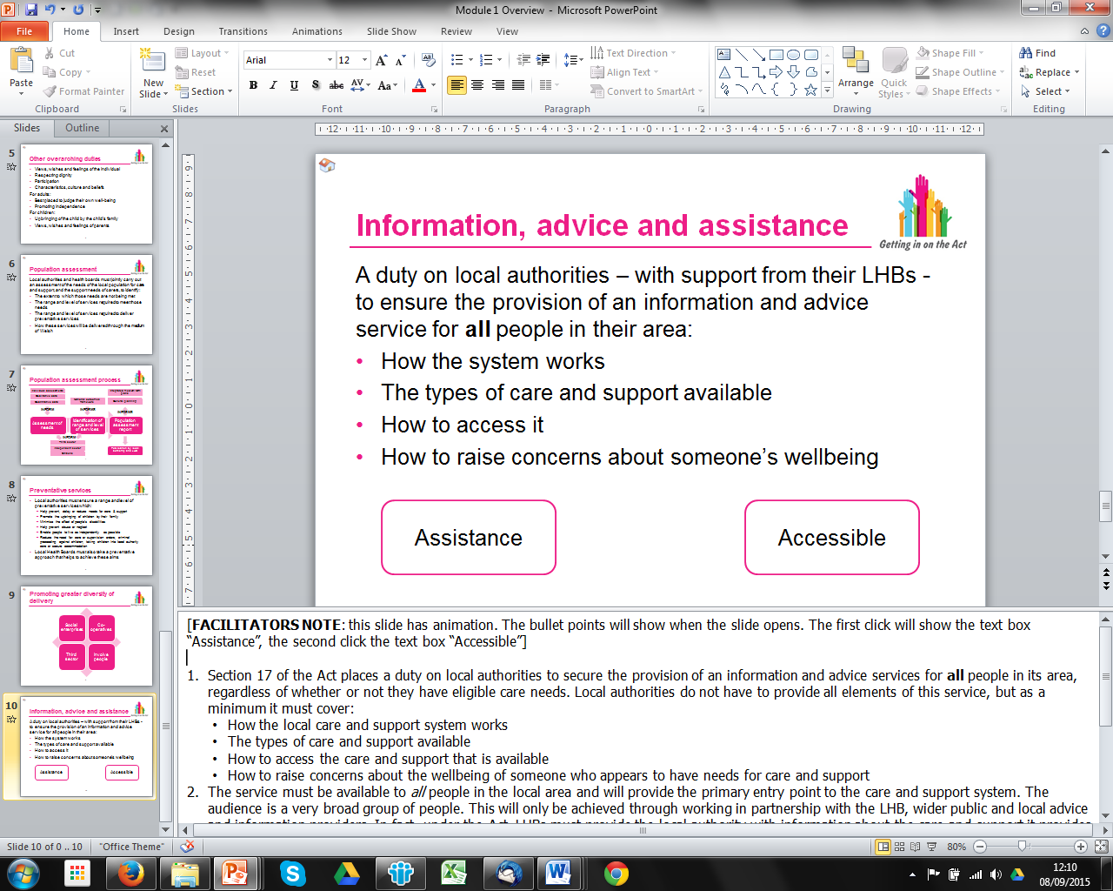

### Overview PowerPoint Slides with Audio

The overviews are also available as a slide show with audio i.e. the facilitators’ notes have been made into a script. These narrated slide shows have been developed so that self-directed learners can watch and listen to the slide show to gain an understanding of the key messages and changes.

However, they could be used in other ways such as part of an introduction in a longer face-to-face training session on that topic area.

# Training Modules and PowerPoint Slides

Each topic area has a training module and linked set of PowerPoint slides. These detailed learning materials are for those whose roles are most affected by the Act and consequently need training to help them understand and implement the changes.

They provide input, exercises, suggested group discussions, points of reflection and case studies that facilitators can use either in their entirety or to pick and choose from as they see fit when designing a learning programme. They can also be used to assemble a pack of relevant materials for each participant to take away. They focus on specific job roles as identified in each training module.

## Full PowerPoint Slides



Each topic area has a full PowerPoint slide pack, which you can use to deliver a training session relevant to that module. They are designed to upskill those whose roles are most affected. Who each module is for, as well as the aims and learning outcomes of the presentation, is outlined in the training module for each topic area.

Facilitators can print the slides as a handout with space for participants to make notes. They can also change the order of the slides, miss some out or mix them with ones from different modules if they wish. Note that slides do not have facilitators’ notes as these are in the relevant training module.

Some of the PowerPoints may have animation, e.g. one line appears at a time when you click the slide, or other effects embedded in the slide. If so that will be highlighted in the notes page of the PowerPoint slide.

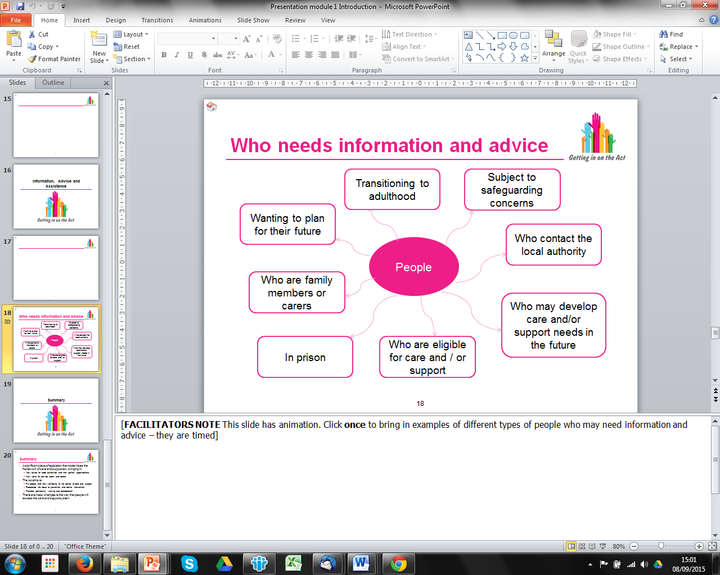

## Training Modules

Each topic area has a training module, which is a key document in the suite of learning materials and refers to any other materials relevant to that topic area. They offer a detailed discussion and analysis of the codes of practice or statutory guidance and include exercises, suggested group discussions, points of reflection and scenarios that facilitators can use when designing a learning programme.

There are hyperlinks throughout the electronic version of the training module to help you get to either different sections within the module, or a separate document, easily and quickly.

We suggest that you read the summary and look at the PowerPoint slides first before reading the training module.

All the training modules have three main sections: an introduction; the detailed training module resources; and links to other key resources.

### Introduction

The training modules start with a common introduction and give an indication of who the module will be most useful for i.e. target job roles that will need in depth learning on this topic area.

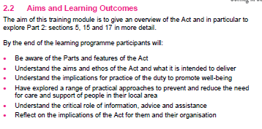

The introduction section will give the **aims and learning outcomes** for the module.

Highlighted in the introduction section are **key words** that are relevant to that topic area. Definitions of these key words are in the glossary, which can be accessed by a hyperlink.

### Module Training Resources

The training module matches the PowerPoint presentation for that topic area. This means that each slide in the presentation is reproduced in section 3 of the training module i.e. slide 5 will be section 3.5 as shown left. The slides in the training module are only representations of the content, and they are small and may be difficult to read. Look at the PowerPoint slides to be sure of the content of each slide.

Below each slide there are detailed **facilitators’ notes** that learning facilitators can use to help them plan what they will say in training sessions.

For some slides, below the facilitators’ notes, there are **key learning points** that we recommend you stress when facilitating a learning programme, as illustrated below:

|  |
| --- |
| **Key learning point**  These are used as a way of highlighting changes that are likely to have a significant impact on practice i.e. the major changes that the Act brings in. |

The training modules contain a number of **activities**. Shown here is an example discussion.

Activities are a mixture of suggested discussion points, questions and exercises. Some activities are short whilst others are longer. For longer activities and / or exercises with more detailed ‘instructions’ there is a separate handout that can be printed and given to learners.



The training modules also have case studies to help people to apply the learning. Each case study scenario and question(s) for the learner is shown in the training module (as illustrated here) and is available as a separate handout that can be printed and given to learners. However, our suggested answer(s) to the question(s) is only shown in the training module.

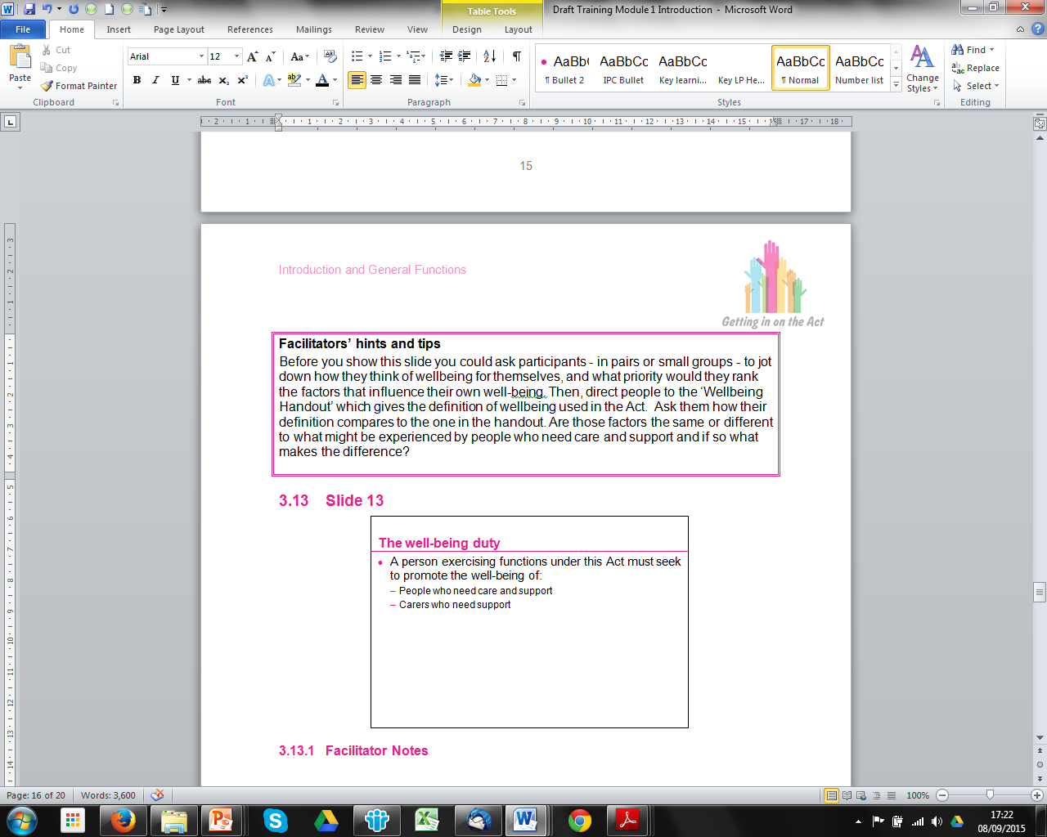Throughout the training module there are **facilitators’ hints and tips**, which signpost you to existing good practice resources on the topic area and / or suggest ways in which you could deliver the materials. Their aim is to help you to design interactive learning programmes that are the most appropriate for your audience.

### Links to Key Resources

The training modules end with links to key resources. This includes hyperlinks to relevant Welsh Government regulations and codes of practice or statutory guidance, as well as links to other useful materials from, for instance, the Social Services Improvement Agency or Social Care Institute for Excellence.

The electronic version of the training module has hyperlinks to click on that take you to the other useful resources and there is a brief explanation of them for you to read to help you decide whether that resource is relevant to you.

## Finding Your Way Round the Materials

There is a lot in the materials. To help you find your way round the full slide sets and training modules, and to help you to plan learning sessions, each topic area is split into several sub-sections. Slide number 2 in each PowerPoint presentation is a contents page and shows the subsections of that training module as illustrated below for module 1.

There is a ‘home’ button in the top left hand corner of each PowerPoint slide. Clicking on the ‘home’ button when in Slide Show mode will take you to the contents page (slide 2) from wherever you are in the presentation.

The contents page (slide 2) has hyperlinks to the sub-sections. Clicking on a hyperlink when in Slide Show mode will take you to the first slide of that sub-section.

The training module matches the PowerPoint presentation for that topic area. This means that the training module is also split into the same sub-sections as the PowerPoint presentation.



As illustrated here for module 1, the contents page of the training module shows the same sub-sections as the PowerPoint presentation and their slide number and page number.

For example, the “well-being and other overarching duties” sub-section starts at slide 9 and page 16 of the training module.

# Other Materials

There are other materials available in the learning suite that are not necessarily linked to a particular topic area, such as online self-assessment exercises and a glossary.

There is a glossary that is relevant to all topic areas. Highlighted in the introduction section of each training module are key words that are relevant to that topic area. Definitions of these key words are in the glossary. Definitions are mostly taken from the codes of practice or statutory guidance.

There is a series of online self-assessments that self-directed learners could view independently or facilitators could use them as part of training sessions.

## Session Plan

There is a session planning template below that can support facilitators to plan a training session.

|  |  |  |  |
| --- | --- | --- | --- |
| Slides | Activity / Exercise | Materials | Time |
|  |  |  |  |
|  |  |  |  |
|  |  |  |  |
|  |  |  |  |

# List of Materials in the Suite

|  |  |  |  |
| --- | --- | --- | --- |
| Summaries | PowerPoint slides | Training Modules | Related handouts, exercises etc. |
| Introduction and General Functions summary | Overview slides  Overview slides with audio  Full slide pack | Introduction and General Functions training module | National well-being statement handout  Well-being handout  Well-being exercise  Active offer handout  Mental Capacity Act 2005 handout  Service focused or person focused handout  Preventative services exercise  Prevention partners exercise  Advocacy handout  Margaret case study  Huw case study  Paul case study  Luc case study  Dylan case study |
| Assessing and Meeting the Needs of Individuals summary | Overview slides  Overview slides with audio  Full slide pack | Assessing and Meeting the Needs of Individuals training module | Well-being of children exercise  Analysing risk for children handout  Eligibility case study handout  Eligibility criteria for adults handout  Eligibility criteria for children handout  Eligibility criteria for carers handout  Geraint case study  Mrs D case study  Deryn case study  Aled case study  Simon case study  Deana case study  Nathan case study  Nathan, Jessie and Anna case study |
| Looked After and Accommodated Children summary | Overview slides  Overview slides with audio  Full slide pack | Looked After and Accommodated Children training module | Content of a Part 6 care and support plan handout  Categories of young people leaving care handout  Owen, Megan and Kylie scenarios  Charlie case study  Matthew case study  Rhys case study |
| Safeguarding summary | Overview slides  Overview slides with audio  Full slide pack | Safeguarding training module | Well-being and welfare handout  Safeguarding self-assessment exercise  Adults' views and wishes in safeguarding handout  Important to or for exercise  Making enquiries handout  Adult P case study  Stewart family case study |
| Other materials | | | |
| Glossary of key words used in the codes of practice or statutory guidance | | | |

**Contact Details**

Care Council for Wales

South Gate House

Wood Street

Cardiff

CF10 1EW

Tel: 0300 3033 444

Fax: 029 2038 4764

Minicom: 029 2078 0680

[E-mail: hub@ccwales.org.uk](mailto:E-mail:%20hub@ccwales.org.uk) [www.ccwales.org.uk](http://www.ccwales.org.uk/)

© 2015 Care Council for Wales

It is expressly prohibited to use any, or all, of this training resource for commercial gain.

Further copies and other formats:

This publication is also available in other versions, including as a pdf. Further copies of this document and other Care Council resources about the Social Services and Well-being (Wales) Act are available to download from the [Information and Learning Hub](http://www.ccwales.org.uk/getting-in-on-the-act-hub/)