SOCIAL SERVICES AND WELL-BEING (WALES) ACT
TRAINING

Independent Professional Advocacy
March 2016

1 Contents
1 Contents 2
2 Introduction 4
Who is this Module for? 4
Language and terminology 5
Aims and learning outcomes 5
Aims of the modules 5

3 Training – Module 1 7
Module 1 – About Advocacy 7
Contents 8
Introduction 9
History of advocacy 11
Advocacy definitions 13
Principles of advocacy 15
Purpose of advocacy 18
What is advocacy? 20
Myth busting quiz 23
Advocacy relationship 24
Types of advocacy 25
Independent Professional Advocacy 27
Tools of advocacy – Do they need independence? 29
Rights – UN and European Conventions 32
Potential barriers to rights 35
Why is the role of an Independent Professional Advocate 36
important in ensuring rights are upheld?
Reflective learning 37
Conclusion to Module 1 38

Module 2 – Well-being 39
Well-being principles and duties 40
Contents 41
Reflection of Module 1 42
Introduction 43
Choice and control 45
Advocacy and consent 47
Confidentiality in an advocacy partnership 49
Risk and the principles of advocacy 50
A person centred approach 51
Citizen Directed Support 53
Empowerment 55
Mental Capacity Act – Five statutory principles 56
Best interests and the Mental Capacity Act 56
Best interests and non-instructed advocacy 59
Watching Brief – Eight domains to ordinary living 62
Challenges to achieving personal well-being outcomes 65
Benefits of advocacy 66
Well-being and advocacy 67
Other related overarching duties 68
Reflective learning 69

Module 3 – Golden Thread 71
Content 73
Reflection of Module 2 74
Introduction 74
The Golden Thread 76
Functions relevant to advocacy 78
Barriers to participation 79
When to engage an Independent Professional Advocate 81
Circumstances requiring an advocate 82
Early referral and early intervention 83
Independent Professional Advocacy versus ‘I am their advocate’ 83
Advocacy and safeguarding 86
Professional focus and practice of: social care, 90
education and health professionals
Working with an advocate 92
Referring to an Independent Professional Advocacy Service 95
Reflective learning 97
Conclusion 97

4 Links to key resources 99

Links to regulations and codes of practice or statutory guidance 99 Useful links to other materials 99 Contact details 101

2 Introduction
The Care Council for Wales has been asked by Welsh Government to work with partners to develop the national learning and development plan to support the implementation of the Social Services and Well-being (Wales) Act 2014 (the Act) and to develop a 'one stop shop' where all resources on the Act can be available and accessed by all organisations from one central information hub http://www.ccwales.org.uk/getting-in-on-the-act-hub/

The aim of this Welsh Government-funded initiative is to ensure the workforce is supported and informed to deliver social services in accordance with Welsh law, and its interface with other relevant statutes, and to practice in line with the principles of the Act.

Age Cymru in partnership with Disability Wales, Swansea University and Martin Coyle (former Chief Executive of Action for Advocacy) have developed learning materials which support the development of knowledge, understanding and skills in relation to advocacy support and services in light of the Act and Code of Practice for Part 10 for those working with (or potentially working with) advocates in the wider workforce.

Who is this Module for?
This training module is about advocacy and specifically Independent Professional Advocacy. It explores Part 10 of the Act and how advocacy fits with other parts of the Act.

Specifically, we have developed materials to build awareness and understanding with those who would have the potential to work with or make referrals to advocacy services.

We have developed learning materials that raise awareness of the role of advocates, identify when it is appropriate to make referrals, when practitioners have a duty to make referrals and to help the wider workforce understand what advocacy is and how it can help.

The learning explores the relationships of advocates with individuals and services and clarifies the role of the learner in those scenarios. The learning will seek to increase the confidence of learners in understanding when and why they might make a referral, their duty of care and their understanding of confidentiality.

Recognising the scale of learning and development that will need to take place to support the implementation of the Act, the materials can be delivered as full day sessions or in shorter blocks to meet the needs of a range of organisations.

The materials will also be designed to act as ongoing reference materials for learners. Each learning block will provide for an interactive exercise to enable facilitators and learners to check progress and understanding.

Language and terminology

Throughout the manual there are certain key terms that need to be handled with caution to present a citizen-directed, Social Model of Disability approach, such as: ‘care’, ‘needs’, ‘vulnerable’.

- A carer is defined in the Act itself as someone providing social support without payment

- Use of the term ‘needs’ without context could be interpreted as ‘special needs’, which refers to the Medical Model of Disability rather than the Social Model

- Vulnerability, like disability, is imposed upon people rather than being innate in the person

Aims and learning outcomes
The aim of this training module is to explore Advocacy in Part 10 of the Act in more detail. The intention is to strengthen and build on professionals' existing knowledge and understanding of advocacy in Wales.

By the end of the training participants will have completed the following three modules:

Slide 1

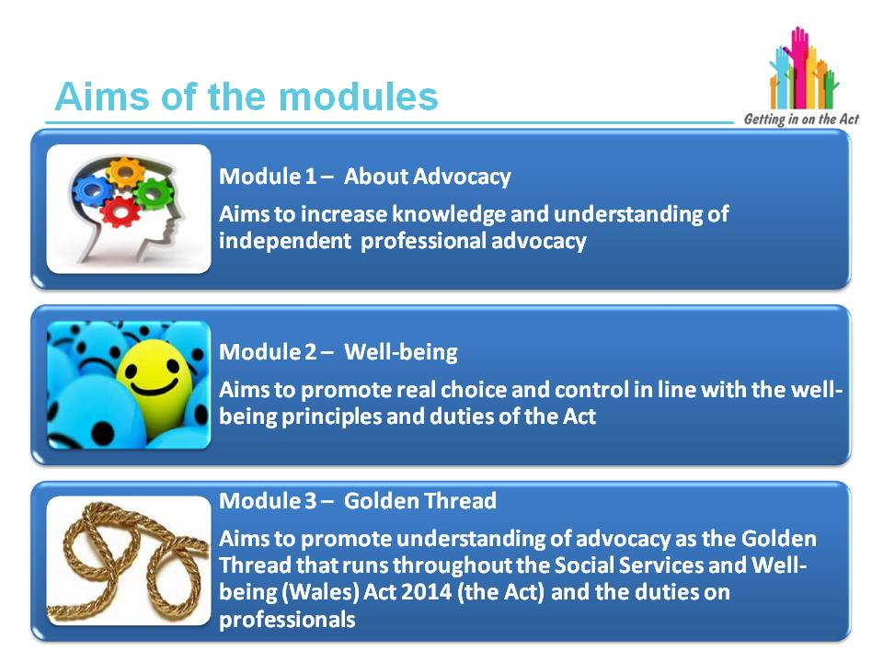

- This training has been split into three modules. The learner can either complete the whole training or they can split it down and complete one module at a time

- The materials are also designed to act as ongoing reference materials for learners

- Each module has interactive exercises to enable facilitators and learners to check progress and understanding

- Each module of the training has a clear identified aim and learning outcomes

3 Training – Module 1
This handbook provides the facilitator with a range of learning materials and information. It is all linked to a separate PowerPoint presentation that can be used as an additional handout for the learners. All the slides from the PowerPoint are in this resource and have a range of additional information for facilitators including:

- Exercises and activities, and suggestions as to how these should be delivered
- Some possible answers to the exercises, although this may not always be possible due to the range of discussion that will take place
- Information relevant to each slide which could be used as handouts if required
- Links to where the information has come from
- Key learning points

This training has been developed to include information relevant to the advocacy learning experience. It is recognised that, depending on the audience, not all of it will be required and some can be provided as additional information.

Slide 3
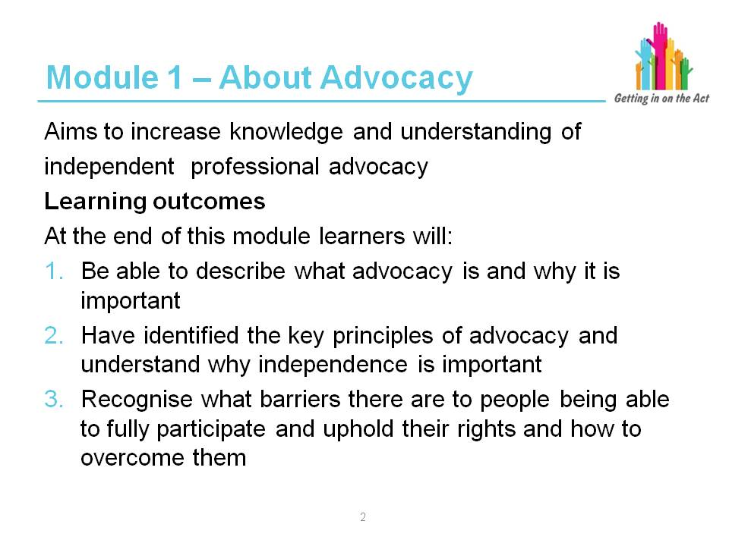

Exercise

This activity is to act as an icebreaker to introduce all the participants to each other and to the facilitator, and to establish the different levels of knowledge people already have of this topic. It will also help the facilitator to focus on the needs of the group and what they are expecting to get from it.

- Why is this training important to you in your role?
- What experience do you have of advocacy?
- What do you hope to learn from the session?

This training is designed to adapt to a range of learning styles and there are a range of activities to do this.
It is important that the learners are able to discuss issues through the activities and come up with their own ideas of how any barriers can be overcome and look at how they can then improve their own practice.
Many learners will have their own ideas about advocacy when they come to the training. Some may be correct and some may not.
At the end of this module, learners will be able to describe, identify and recognise the barriers that prevent people from exercising their rights and exploring ways to overcome them.
This training module will also enable learners to go away with a greater understanding of what advocacy is, what the principles are and how it can be beneficial to their clients.

Slide 4
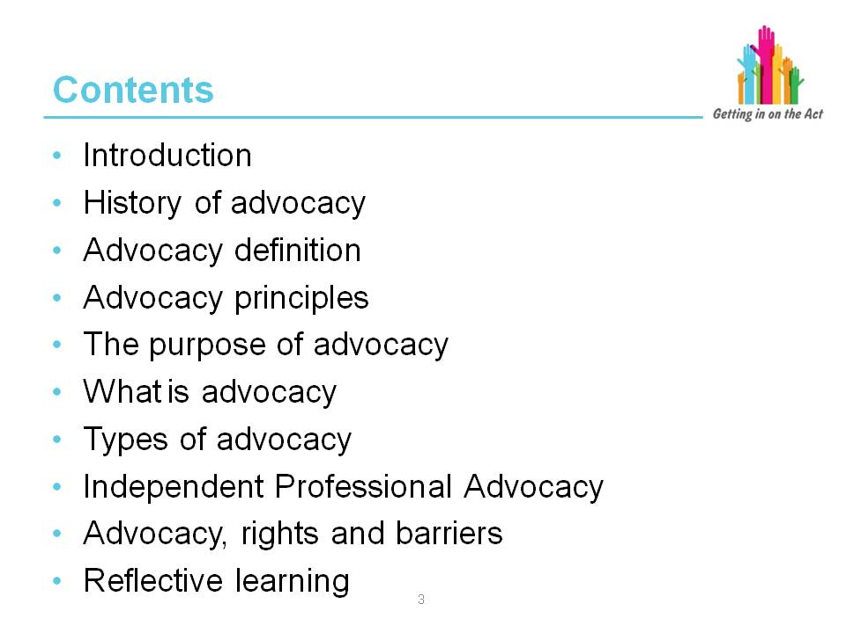

Facilitator notes

- This slide is an overview of what the learners can expect from this module.
This can be checked with the learners' expectations from the first exercise and adapted as required.
- It is designed to be a general introduction to advocacy in all its forms in the first instance and then it will go into more detail about Independent Professional Advocacy.
- Part 10 of the Act includes advocacy. Understanding the basics of advocacy is important prior to learning about how it relates to well-being and what professionals' duties and requirements might be. These are discussed in modules 2 and 3.
- The training module ends with a summary and reflective learning for both the facilitator and the learners to check progress and understanding.

At this point the facilitator can outline:
- Timings
- Housekeeping
- Ground rules and group contract e.g. confidentiality and timekeeping (a group contract will engage participants and ensure the rules are owned by the group)
- Key activities

Slide 5
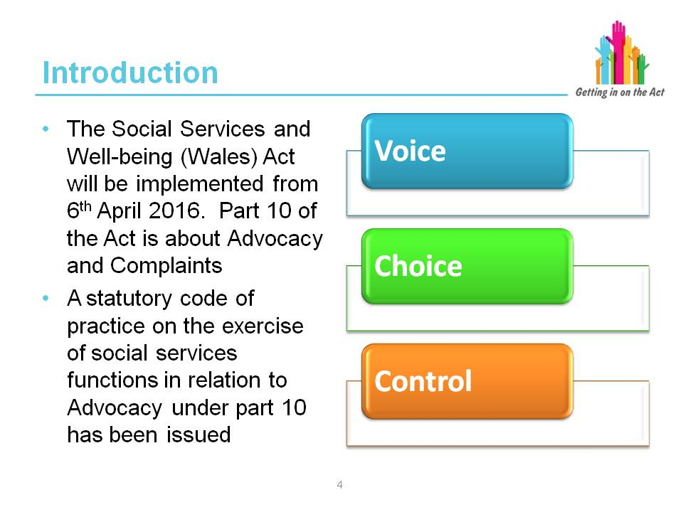

Facilitator notes

The Code of Practice on Advocacy (code) is issued under Section 145 of the Social Services and Well-being (Wales) Act 2014 (the Act).

The Social Services and Well-being (Wales) Act 2014 is available at: http://www.legislation.gov.uk/anaw/2014/4/enacted

“Local authorities, when exercising their social services functions, must act in accordance with the requirements contained in the code. Section 147 (departure from requirements in codes) does not apply to any requirements contained in the code. In addition, local authorities must have regard to any guidelines set out here.

“In this code, a requirement is expressed as “must” or “must not”. Guidelines are expressed as “may” or “should / should not”.

“The code should be read in conjunction with all relevant codes of practice issued under the Act to require local authorities to consider people’s needs for advocacy where a local authority exercises a specific function in relation to that person.

“Specific regard should be given to Part 2 (General Functions), Part 3 (Assessing the Needs of Individuals), Part 4 (Meeting Needs), Part 5 (Charging and Financial Assessment), as well as statutory guidance issued under Part 7 (Safeguarding) and Part 9 (Co-operation and Partnership) of the Act.

“The Welsh Government has sought to support implementation through a process that engages our stakeholders. Central to this approach has been the establishment of technical groups made up of representatives with the relevant expertise, technical knowledge and practical experience to work with officials on the detailed policy necessary to develop the codes of practice which in turn will deliver the policy aspirations underpinning the Act. The code is one of the outcomes of that exercise of co-production."

Part 10 Code of Practice (Advocacy)

The Care Council for Wales has developed an Information and Learning Hub where all the training materials, codes of practice and other resources that support the implementation of the Act can be found. This website will continue to evolve and be updated, and will be an important resource for anyone who needs to develop their skills and knowledge about the Act.

http://www.ccwales.org.uk/getting-in-on-the-act-hub/

Key learning point
One of the key aims of the Act is for individuals to be at the centre of decisions about them and to be supported to have choice and control over their lives.

Slide 6
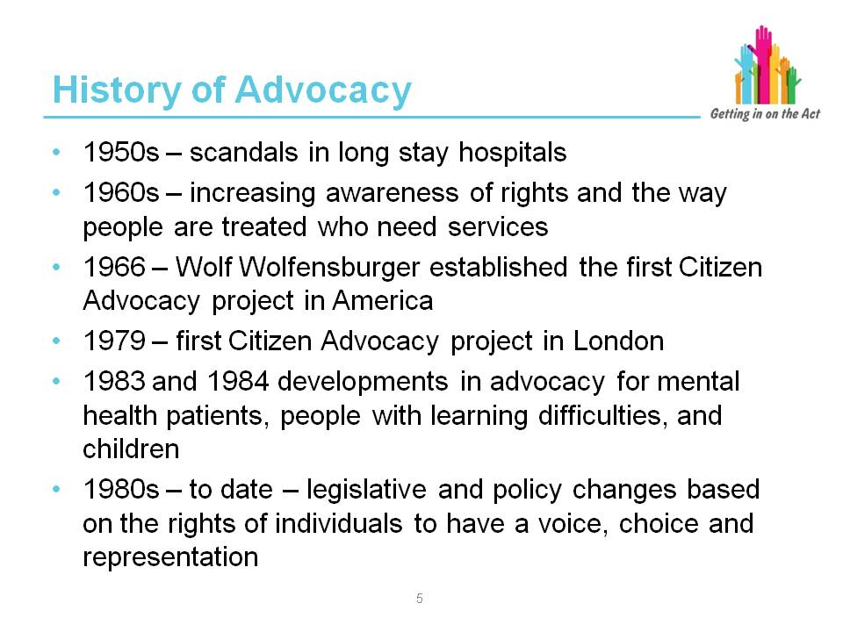

Facilitator notes

It may be difficult to accurately identify the starting point of the advocacy movement as advocacy has arguably been around in one form or another since humankind started to organise itself into societies or communities. People have always fought
to be heard, fought against injustice, persecution and forms of discrimination.
In modern day however, organised forms of advocacy began to take shape in the latter half of the 20th century.

Following the Second World War many people started to question different aspects of Western culture, including psychiatry and how services were provided to vulnerable people. This led to a number of patients, relatives, friends and service providers questioning whether it was right to lock people with mental health needs or learning difficulties away in large asylums for long periods of time.

From the 1950s onwards, numerous scandals concerning long stay hospitals placed pressure on the government who considered their closure. At this point a number of charities lobbied for change, including more legal protection for patients.

In the late 1950s and 1960s an increasing awareness of rights and the way society treated people who needed services, led to the development of citizen advocacy. In 1966 Wolfensberger introduced the first citizen advocacy scheme in America. The first citizen advocacy organisation in the UK was established in 1979 in London. At around the same time in America, a number of parents of children with learning difficulties got together to discuss the idea of having somebody specific who could look after the rights of their children, as if they were their own.

More information about the history of advocacy can be found at:

http://www.peoplefirstltd.com

http://www.sandwelladvocacy.org/home/history.htm

http://borgenproject.org/history-advocacy/

Exercise

Complete in pairs, then feed back to the group.

- Discuss what key words you might use to describe advocacy
- In one minute, explain to your partner what you understand by the term advocacy as though you were explaining it to a client
- How easy was this exercise? What, if any, difficulties did you have?
- Feed back to the group some of the key words you used to describe advocacy

The purpose of this exercise is to get people thinking immediately about what advocacy is, and if they have to explain to a client, then it is important that they can do this in a concise and clear way. This exercise will be repeated towards the end
of this module when they will have acquired more understanding of the role of an advocate, and what they do and why.

Slide 7
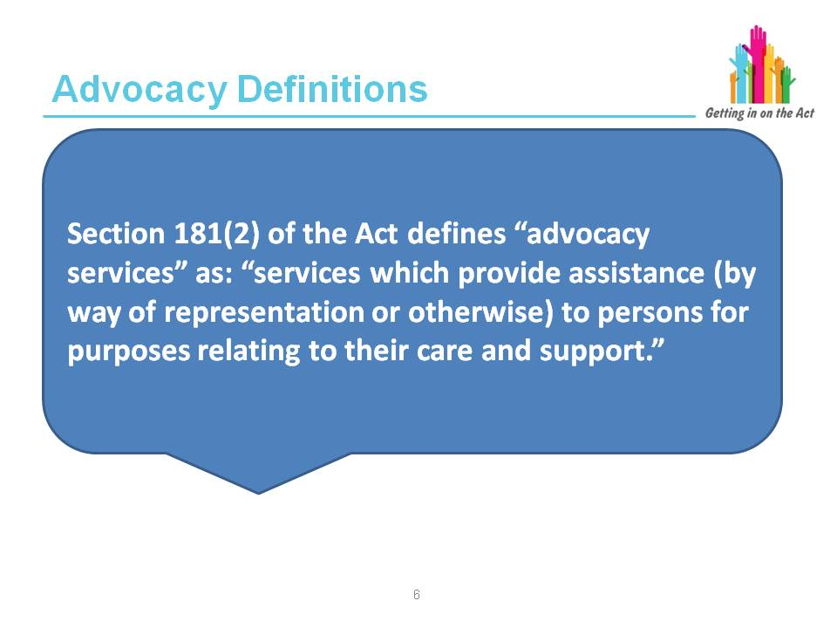

Facilitator notes

“Section 181(2) of the Act defines ‘advocacy services’ as: services which provide assistance (by way of representation or otherwise) to persons for purposes relating
to their care and support. Similarly, advocacy is one of the examples specified in Section 34(2)(e) of what may be provided or arranged to meet individuals’ care and support needs under Sections 35 to 45 of the Act.”

Part 10 Code of Practice (Advocacy)

Following on from the previous slide, this slide and the next one give the formally recognised definitions of advocacy.

Slide 8

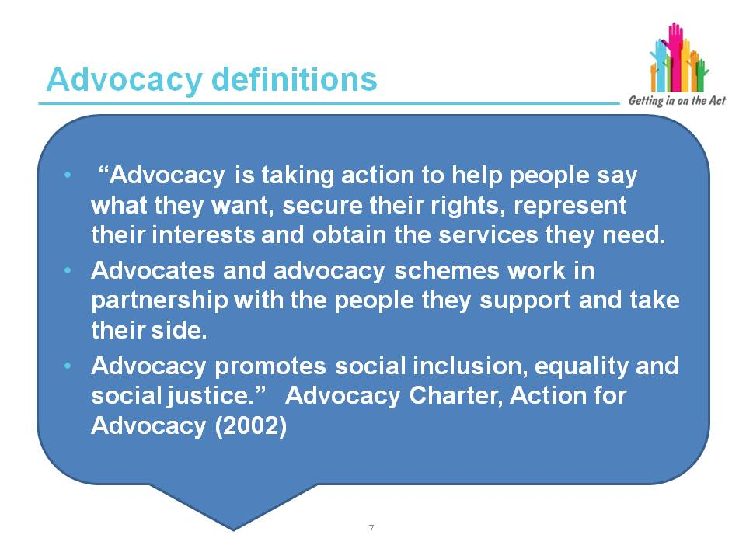
Facilitator notes

This definition is the one that is widely used by advocacy services. It is linked to the advocacy Charter, Code of Practice for Advocates and the Quality Performance Mark for advocacy.

Another definition is:

“Advocacy supports and enables people who have difficulty representing their interests, to exercise their rights, express their views, explore and make informed choices.

“Independent Advocacy supports the person regardless of the demands and concerns of others. It challenges the causes and effects of injustice, oppression and abuse and upholds human rights."
(OPAAL National Forum, 2008)

The Advocacy Charter and Code of Practice

The Advocacy Charter was published in July 2002 by Action for Advocacy and set out to define and promote key advocacy principles. The Charter provides advocacy schemes and others with a vehicle for both explaining what advocacy is and outlining a common vision of what constitutes effective advocacy. The Advocacy Charter principles and the Code of Practice have been revised in 2014, by Empowerment Matters CIC and the National Development Team for Inclusion (NDTi), to reflect changes in legislation as well as developments in advocacy practice.

The Code of Practice is a set of guidelines for advocates and their managers, aimed at providing clarity, support and boundaries for their practice. It is also a guide for commissioners of advocacy services that outlines the expectations and purpose of the role and what clients, as well as commissioners should expect from the delivery of the service. The Code provides a clear description of what is and is not expected of an advocate in their day-to-day work with clients.

An effective Code of Practice can:

- Offer guidance to advocates in their role
- Inform clients of what they can realistically expect from their advocate/ advocacy service
- Educate health, social care, third and private sector services, commissioners and others about the scope and limitations of the advocate’s role
- Help to develop a better understanding of the training, supervision and support needs of advocates
- Raise awareness of the need for and benefits of independent advocacy for vulnerable people

Slide 9
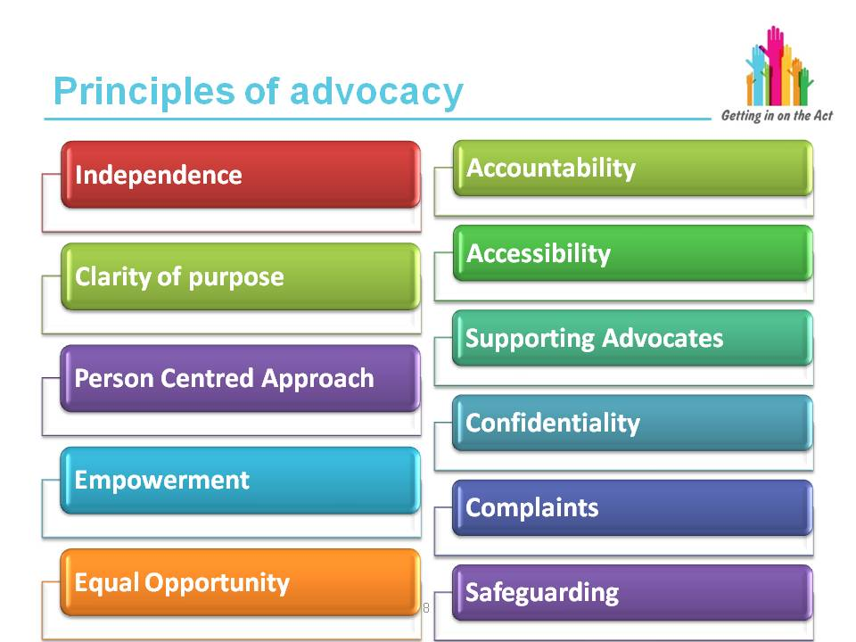

Facilitator notes

Defining and promoting key advocacy principles

Clarity of purpose
The advocacy provider’s aims, objectives and planned activities are within the objects set out in its governing document and providers should be able to demonstrate how these meet the principles contained in this Charter. Advocacy providers should ensure that the people they advocate on behalf of, health and
social care services and funding agencies have information on the scope and limitations of the advocacy provider’s role.

Independence
The advocacy provider will be structurally independent from statutory organisations. The advocacy provider will be as free from conflict of interest as possible, both in design and operation of advocacy services, and seek actively to reduce conflicting interests, in particular where the organisation provides additional services such as housing provision.

Person-centred approach
The advocacy provider will ensure that the wishes and interests of the people it advocates on behalf of direct its work. Advocates should be non-judgmental and respectful of people’s needs, views, culture and experiences.

Empowerment
The advocacy provider will support self-advocacy and empowerment through its work. People who access the service should have a say in the level of involvement and style of advocacy support they want where they are able and wish to. Where clients lack the ability or capacity to influence the service, the advocacy provider should have a process in place to enable those with an interest in the welfare of the person to influence this. Providers will ensure that people who want to, can influence and be involved in the wider activities of the organisation up to and including at board level.

Equal opportunity
The organisation will have a written equal opportunities policy that recognises the need to be pro-active in tackling all forms of inequality, discrimination and social exclusion. The advocacy provider will have systems in place for the fair and equitable allocation of advocates’ time.

Accessibility
Advocacy will be provided free of charge to eligible people. Where clients need or want to purchase advocacy or where someone has an appointed deputy/attorney in place who wishes to instruct an advocate on the person’s behalf, suitable processes should be in place to safeguard the person and ensure they are not open to financial abuse. The advocacy provider will aim to ensure that its premises (where appropriate), policies, procedures and publicity materials promote access for the population it serves.

Supporting advocates
The advocacy provider will ensure advocates are suitably prepared, trained and supported in their role and provided with opportunities to develop their knowledge, skills and experience.

Accountability
The advocacy provider will have systems in place for the effective monitoring and evaluation of its work, including identification of outcomes for people supported. All those who access the service will have a named advocate and a means of contacting them.

Confidentiality
The advocacy provider will have a written policy on confidentiality that is in line with the Data Protection Act 1998 and the Mental Capacity Act 2005. It should outline how information about a person accessing the service may be shared, as well as the circumstances under which confidentiality might be breached. Advocates must also be aware of situations that would require making a child or adult safeguarding alert.

Complaints
The advocacy provider will have a written policy describing how individuals, including relevant stakeholders, can make complaints or give feedback about the service or about individual advocates. Where necessary, the organisation will enable people who use its services to access external independent support to make or pursue a complaint.

Safeguarding
Clear policies and procedures will be in place to ensure safeguarding issues are identified and acted upon. Advocates will be supported to understand the different forms of abuse and neglect, issues relating to confidentiality and what to do if they suspect a client is at risk.

Key learning point
Advocacy schemes and advocates work to a charter, a set of standards and a quality performance mark.

The Quality Performance Mark, Code of Practice, 2014. NDTI

Slide 10
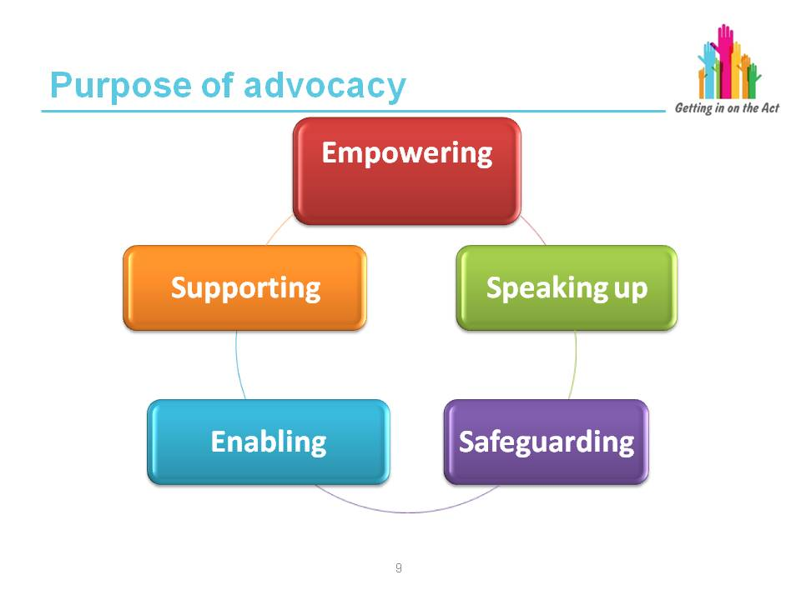

Exercise

Complete this exercise in small groups.
In each of the categories on the slide, consider under what circumstances a client may need an advocate.
Feedback examples to the full group

Explore the circumstances the group has identified and compare them with the notes below from the Advocacy Code of Practice.

Ensure the group of learners understands the purpose of advocacy and how their clients' needs may fall into each of the different categories.

Facilitator notes

Purpose of advocacy, Part 10 Code of Practice (Advocacy):

- Safeguards individuals who are vulnerable and discriminated against or who services find difficult to serve
- Speaks up on behalf of individuals who are unable to do so for themselves
- Empowers individuals who need a stronger voice by enabling them to express their own needs and make their own informed decisions
- Enables individuals to gain access to information, explore and understand their options, and to make their views, wishes and feelings known
- Actively supports people to make informed choices

Chapter 10 (of the Code of Practice) sets out the full range of local authority functions where local authorities in partnership with an individual must consider the role of advocacy. There are particular circumstances and periods of change or transition which will be significant to the individual and when their needs for advocacy may be heightened. These include but not exclusively:

- When making decisions that will have a significant impact on their day-to-day life including:
- Assessment, care and support planning, reviews
- Safeguarding
- Accessing information, advice and assistance
- Where they are going to live
- The assessment of, or changes to, informal care and support arrangements
- Moving from receiving care and support via a care and support plan, or support plan if they are a carer, to receiving care and support from preventative well-being support in the community

- When external factors impact on their care and support arrangements, for example, provider failure; care home closure; changes of management or ownership arrangements in care homes.

- When suspected of being at risk of harm or neglect, subject of safeguarding concerns, including when the subject of any inquiry under Section 126 of the Act (adults at risk) or Section 47 of the Children Act 1989 (local authority’s duty to investigate), action under Section 127 of the Act (adult protection and support orders), under Section 128 of the Act (duty to report adults at risk) or Section 130 of the Act (duty to report children at risk).

- When preparing to leave hospital and return to the community.

Key learning point
There may be a range of different circumstances where an individual may need an advocate. There is no prescriptive list of circumstances but the Code of Practice gives guidance on when this may be.

It is important to ensure that consideration is given to the need for an Independent Professional Advocate at the earliest opportunity.

Slide 11
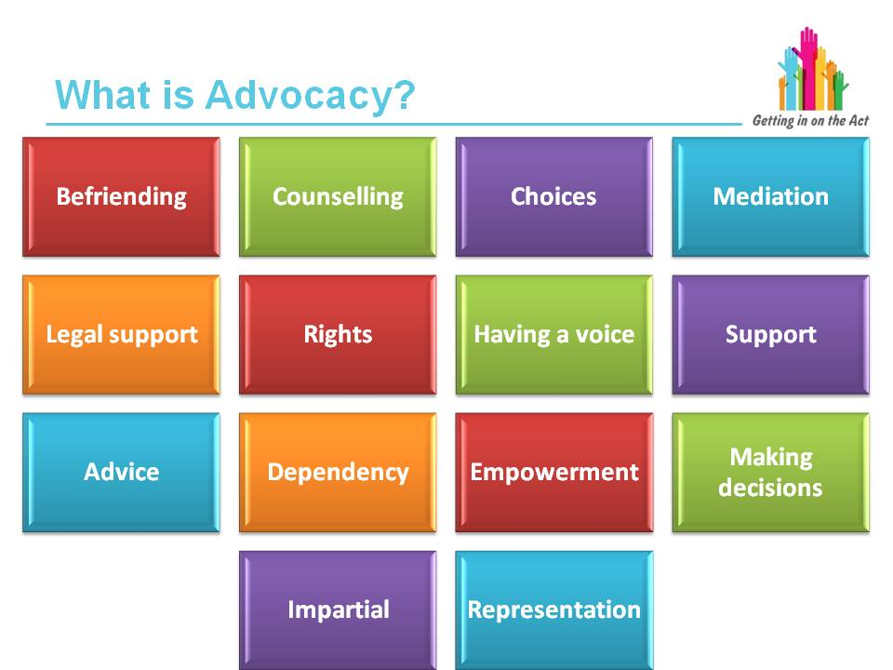

Exercise

(You will need to have Post-it notes and two pieces of flip chart paper. One piece with the title ‘Advocacy is about’ and the other with ‘Advocacy is not about’.)

Ask the group to decide which of these words are about advocacy and which are not.

Also ask them to add their own words based on their existing knowledge. You could give the learners the opportunity to swap from one side to the other if they think a word is in the wrong place and ask them to explain why.

Answers on the next slide and then go back to the flip chart paper to see how well they have done.

This is an opportunity for the learners to explore what they think they know about an advocate. There are many misunderstandings about the role and this exercise will start to look at this in more detail.

Slide 12
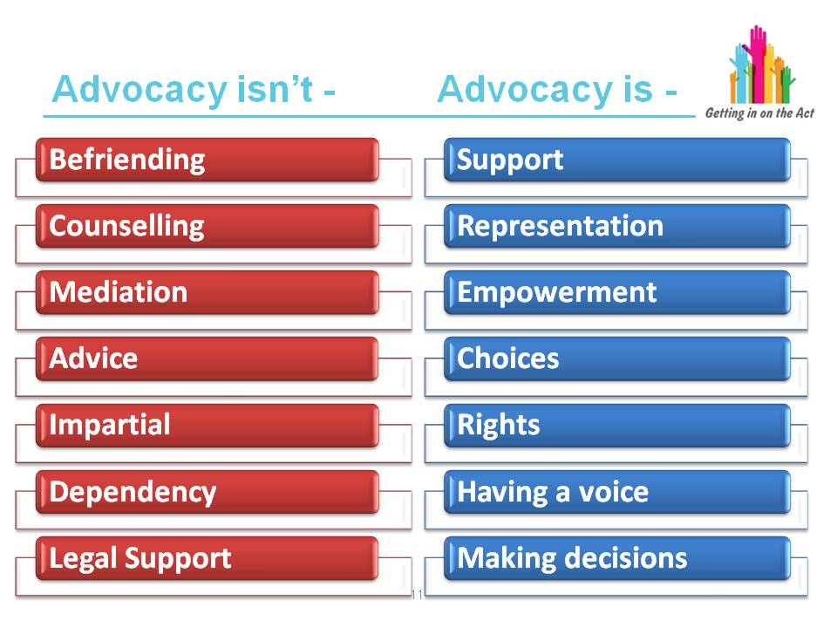

Facilitator notes

Befriending
This involves sharing friendship and social activities – the focus of advocacy is to develop a relationship with regards to a specific issue or rights and representation.

Advice work
Is usually undertaken by someone who has specific expertise and can give information and make recommendations. Advocacy is a wider role in which knowledge is sought and shared with the client and where the advocate acts
as an aide rather than an advisor.

Mediation
Mediation services arbitrate or help two parties resolve disputes between themselves; advocates act on behalf of the partner alone.

Counselling
Counselling is a type of therapy and needs a specially trained person to do this as it seeks to help people deal with difficult thoughts and feelings over a period of time. Advocates aim to develop an equality of relationship to support the individual in representing themselves and obtaining their rights.

Impartial
If you are impartial you are not on anyone’s side or indifferent to each side. To be impartial is to be unbiased and to treat all equally. An advocate is always on the side of the person they are supporting and only them.

Dependency
A central theme for advocacy is about maximising the empowerment of an individual so that they are better able to stand up for themselves, speak up for themselves, make decisions, uphold their rights through information and improved confidence. If someone becomes dependent on their advocate in such a way that is detrimental to their well-being, this is not a good advocacy relationship and must not continue on the same path. An advocate must always be looking to empower the person no matter how small a way that may be.

Key learning point
It is very important to distinguish between what is and isn't the role of an advocate both for the client and the professional who may refer an individual to an advocacy service. This will prevent misunderstandings about how an advocate works and help professionals to explain the role appropriately to their clients.

Slide 13

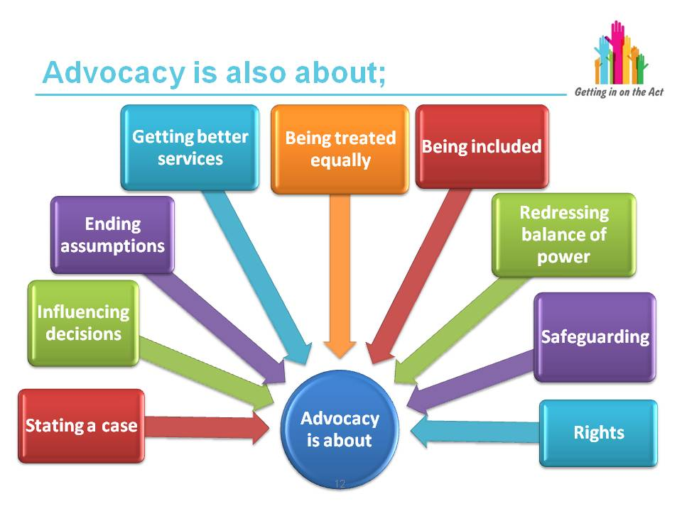

Facilitator notes

An advocate can also help with:

- Talking to professionals
- Making sure that someone is fairly treated
- Raising concerns or complaints
- Speaking up in a residential setting
- Finding out an individual's rights and options
- Keeping someone at the centre of decisions about their life
- Adult and child safeguarding

Key learning points
Advocacy is not just about making a complaint or challenging. An advocate works to uphold the rights and wishes of an individual, to empower them and if necessary to speak up for them. When an advocate speaks on behalf of someone it is not the advocate’s views that are represented, it is those of the client. An advocate will spend time with the individual to establish their wishes and represent as such.

Slide 14
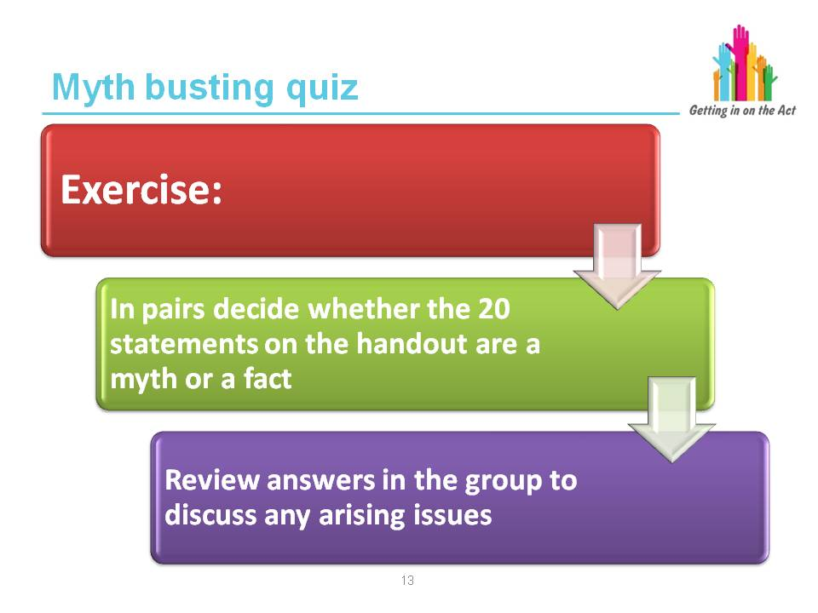

Exercise

The facilitator will provide the learners with an exercise sheet featuring
20 statements.

In pairs, the learners are to decide whether each of the 20 statements is a myth or a fact.

The facilitator will have a separate sheet with notes explaining why each is a myth or a fact.

The group will be encouraged to explore any issues that may arise during this exercise.

Slide 15
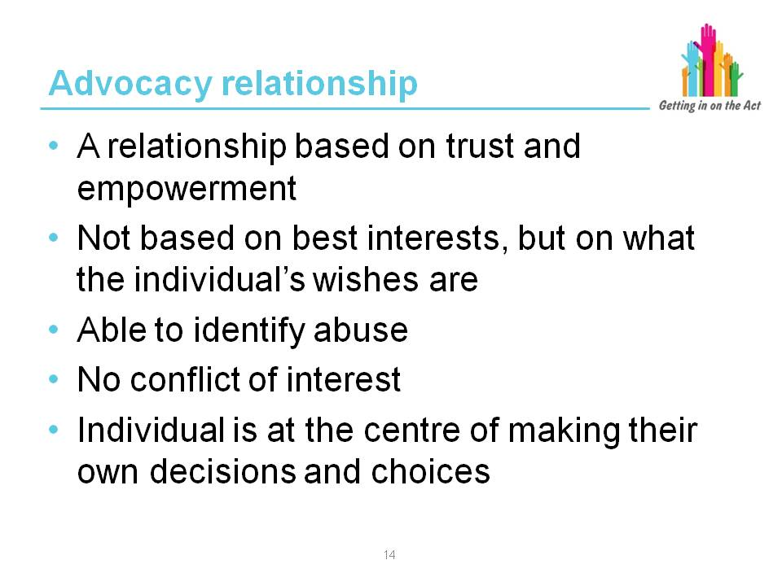

Facilitator notes

It is recognised that not all individuals need advocacy all the time. However, there are times when they may feel socially isolated, frail and vulnerable, dependent on others for services and support, and lonely even when not alone. This is when independent advocacy can empower someone. Over time, trust and confidence can be regained and a relationship can be developed where the power and control is put back into the hands of the individual.

Because of this one-to-one relationship, many older people have eventually felt strong enough to say no to abuse or to challenge injustice or discrimination.

There are times when we all need someone to talk to and to listen to us who is on our side.

There are times when we have all felt vulnerable and alone and needed someone to talk to and help us make sense of our lives.

There are times when we need to talk through our choices and options with someone who has no reason to influence our decisions or our future.

There are times when we need someone to help us understand what our rights are and how to make sure people respect them and act on them.

And there are times when even people's most basic human rights of fairness, respect, equality and dignity are not being upheld and they need someone who can support them in challenging this and improving their quality of life.

Exercise
In pairs, ask the group to consider someone they know who is vulnerable and disempowered and share this with the other person.

Ask them to think about why that is and why they may not be in a position to participate fully in making choices, speaking up for themselves, etc.

Feed back the key points from the discussions to the whole group.

Slide 16
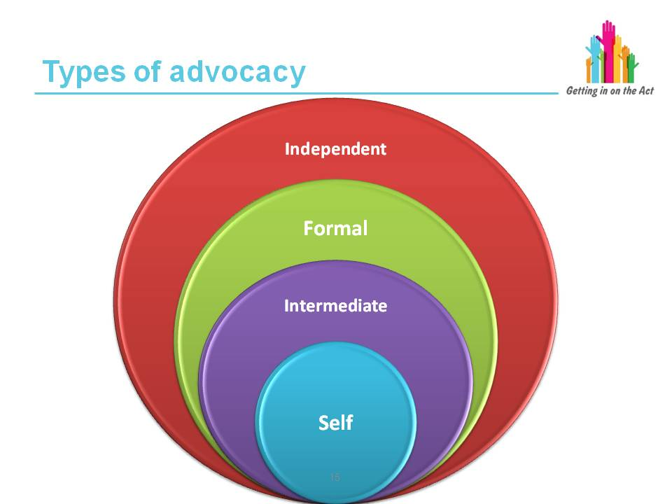

Facilitator notes

Self

Self-advocacy – when individuals represent and speak up for themselves.

Intermediate

Informal advocacy – when family, friends or neighbours support an individual in having their wishes and feelings heard, which may include speaking on their behalf.

Collective advocacy – involves groups of individuals with common experiences being empowered to have a voice and influence change and promote social justice.

Peer advocacy – one individual acting as an advocate for another who shares a common experience or background.

Citizen advocacy – involves a one-to-one long-term partnership between a trained or supported volunteer citizen advocate and an individual.

Formal

May refer to the advocacy role of staff in health, social care and other settings where professionals are required as part of their role to consider the wishes and feelings of the individual and to help ensure they are addressed properly.

Independent

Independent professional advocacy – involves a one-to-one partnership between an independent professional advocate who is trained and paid to undertake their professional role as an advocate. This might be for a single issue or multiple issues. Independent professional advocates must ensure individuals’ views are accurately conveyed irrespective of the view of the advocate or others as to what is in the best interests of the individuals.

Independent volunteer advocacy – involves an independent and unpaid advocate who works on a short term, or issue-led basis, with one or more individuals.

Slide 17
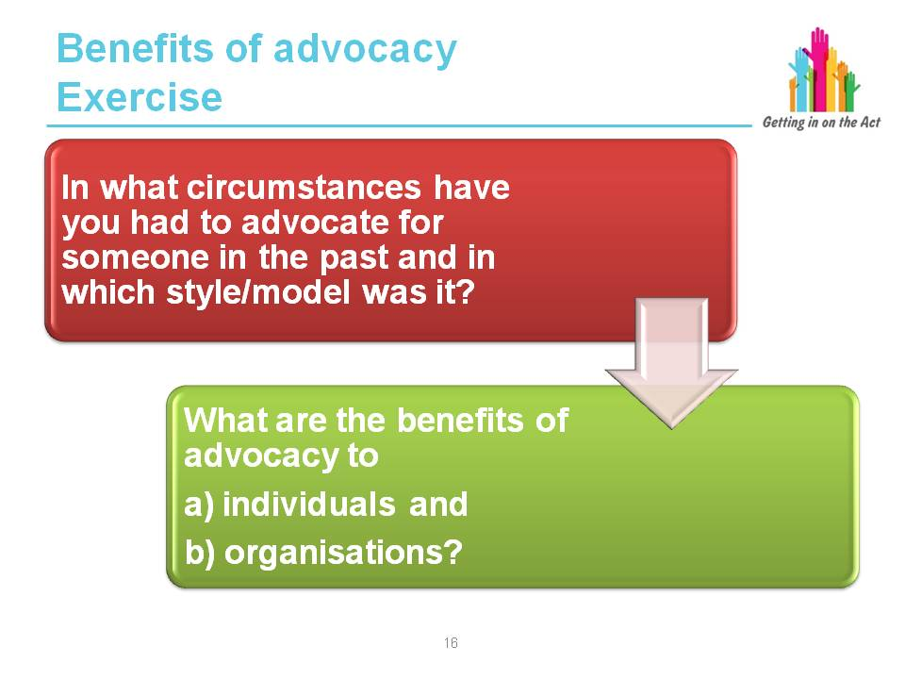

Exercise

In pairs, discuss and feedback:

- In what circumstances have you had to advocate for someone in the past and in which style/model was it?
- Or have you ever needed someone on your side as an advocate?
- What are the benefits of advocacy to a) individuals and b) organisations?

The aim of this is to get the group to think about how it feels to be an advocate and the difficulties people find themselves in where they need someone on their side.

Key learning points
Advocacy can take many forms, each with the common aim of supporting individuals to have their voices heard, clarifying options and express their views, wishes and feelings.

Slide 18
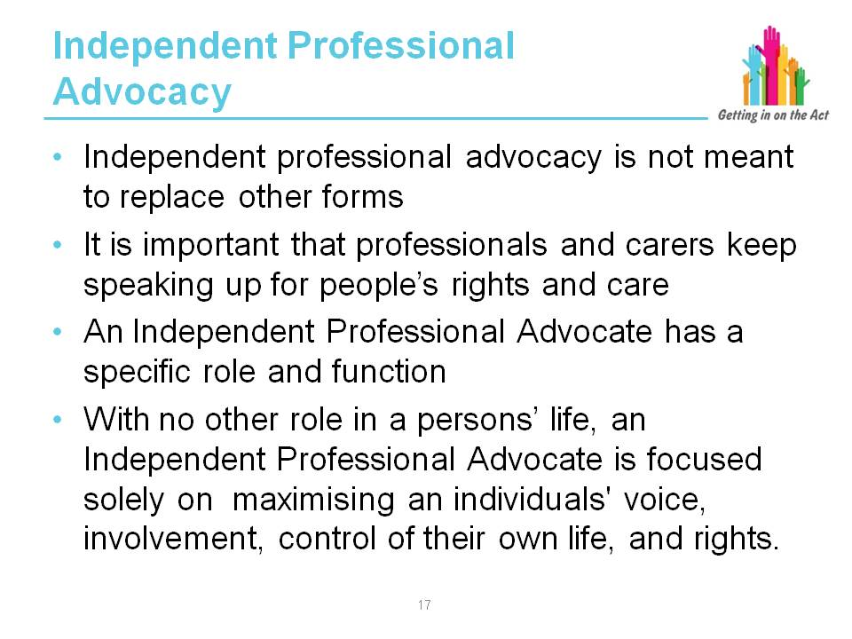

Facilitator notes

"Advocacy can take many forms, each with the common aim of supporting individuals to have their voices heard, clarifying options and express their views, wishes and feelings. Each form of advocacy has its own benefits and local authorities should recognise and value all these forms. Advocacy can be instructed or non-instructed.

Instructed and non-instructed advocacy

“An important distinction needs to be made between instructed and non-instructed approaches to advocacy. Usually, advocates are instructed by the individual, even if the latter has not referred themselves to the advocacy scheme. Together, they are able to establish a relationship and identify the advocacy issues, goals and intended outcomes in accordance with the wishes and preferences and consent of the user.

“Non-instructed advocacy may be needed when matters of communication and capacity mean that instruction and the expression of choices and concerns are not forthcoming directly from the individual. It is:

“’...taking affirmative action with or on behalf of a person who is unable to give a clear indication of their views or wishes in a specific situation. The non-instructed advocate seeks to uphold the person’s rights; ensure fair and equal treatment and access to services; and make certain that decisions are taken with due consideration for their unique preferences and perspectives.’
(Henderson, 2006)

“Non-instructed advocates may adopt different approaches to representing the person based upon human rights, being person-centred, maintaining oversight or acting as a witness and observer.

“Social care and other professionals play a key role in acting as an advocate on behalf of individuals as part of the exercise of their daily professional roles. However, there will be occasions where a conflict of interest may arise in relation to the decision being made.

“Professionals will need to be alert to situations where they believe that the objectivity or independence of the decision-making process is, or could be seen to be undermined. In such circumstances, the roles of other forms of advocacy must be considered."

Part 10 Code of Practice (Advocacy)

Key learning point
Be clear when there may be a requirement for an advocate and what type of advocate that might be while recognising any conflicts of interest and the wishes of the individual.

Slide 19
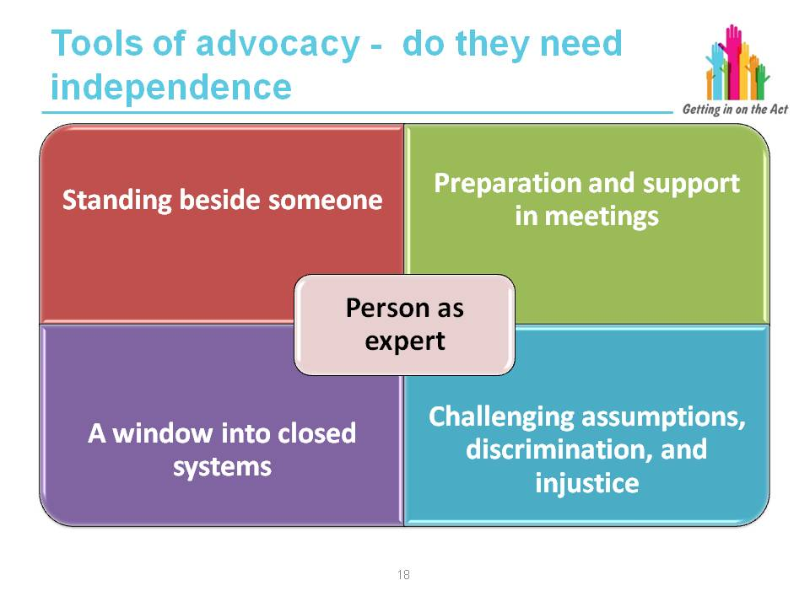

Facilitator notes

Standing beside someone:

By standing/sitting alongside someone in a meeting or consultation, the advocate is implicitly stating that they believe the person. In a number of meetings there are multiple health/social services staff while the person is on their own. Having someone alongside you can make the meeting feel more balanced and fair, and reduce the person’s anxiety.

Preparation and support in meetings:

Advocates help people have their voice heard in meetings by helping them to prepare; identifying what they want, what the options are and the constraints there might be on these. This leads to more productive meetings. By providing support in meetings, making notes, etc., they help the person stay calm and focused. With a focus on making sure that the person’s voice is heard, the advocate will try to ensure that the meeting does not accidentally neglect this aspect. They also ensure that action points and next steps are clearly understood.

Challenging assumptions:

It is possible for assumptions about ability, expectations, outcomes or what constitutes success to lead to plans that have little to do with the person’s wishes, abilities or aspirations. Advocacy provides a constructive challenge to such assumptions.

A window into closed systems:

It has been established that the risk of abuse rises where people are in “closed” social support or health systems. Research by Inclusion North, NHS North East and True Voice showed the risk of abuse decreases in relation to the number of people from outside the system that individuals have regular contact with.

As an outside presence, independent advocates can provide a safe route for raising issues of concern, ensure there is a link between health or social support settings and the wider public, and can identify and challenge established practices that do not support the control, rights and dignity of people using the service.

Key learning point
The ability to use these tools is inherently underpinned by the independence of advocates.

Slide 20
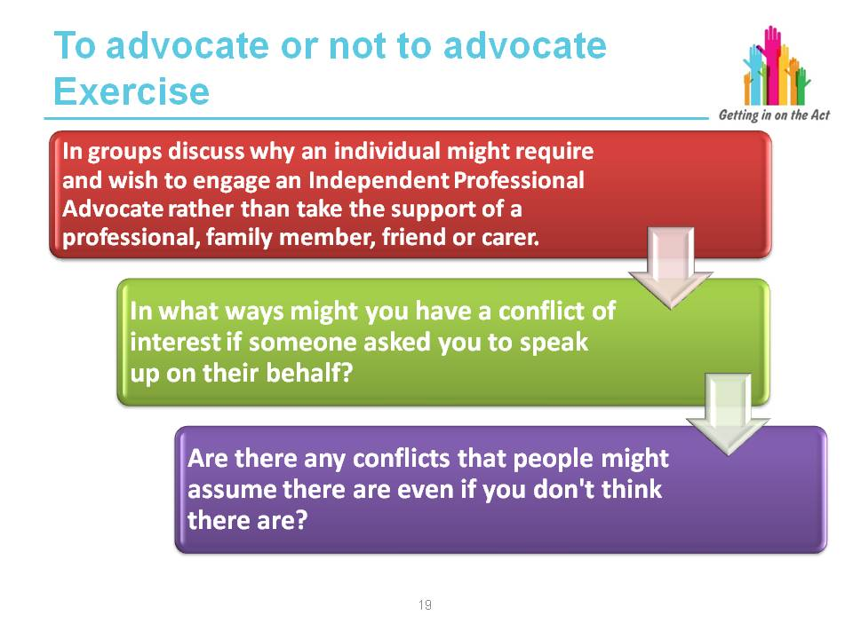

Exercise – small group discussion

Why choose an Independent Professional Advocate instead of a professional, family member, friend or carer?

After the discussion, groups are to feed back to the main group.

The aim of this discussion is to identify why people might want an independent advocate. The reasons for this are not all negative. Facilitate the discussion and try to ensure that the listed reasons include:

- Not wanting the whole team to know their view
- Fear they will have services reduced or removed
- Worry they might offend you by asking for something different
- Seeing you as the colleague of the person they are having problems with
- Valuing your support so much they don’t want to jeopardise it
- Risk of being perceived as higher risk
- Fear of increased coercion

Potential conflicts could include: professional responsibilities, alliances with the rest of the staff, who you are paid by, line management structures, responsibilities relating to resource management, ability to exercise statutory powers, etc. It is important to note that a perceived conflict of interest is still a significant barrier, even if you do not believe this would apply in your case.

Facilitator notes

When is an individual inappropriate to act as an advocate?

“61. Local authorities in partnership with the individual must consider whether there is an appropriate individual who can facilitate that individual’s involvement in the assessment, care and support planning, review or safeguarding process (see paragraph 49 above), and this includes three specific considerations. The appropriate individual cannot be:

- Someone the individual does not want to support them
- Someone who is unlikely to be able to, or available to, adequately support the individual’s involvement, and
- Someone implicated in an enquiry into abuse or neglect or whose actions have influenced a local authority’s decisions to consider adult protection and support order actions or protection activity in respect of a child

“62. Social care and other professionals play a key role in acting as an advocate on behalf of individuals as part of the exercise of their daily professional roles. However, there will be occasions where a conflict of interest may arise in relation to the decision being made. Professionals will need to be alert to situations where they believe that the objectivity or independence of the decision making process is, or could seen to be undermined. In such circumstances, the roles of other forms of advocacy outlined in Chapter 8 to secure individuals’ views, wishes and feelings and well-being outcomes must be considered.

“63. Appropriate individuals are expected to support, represent and to facilitate the individual’s involvement in securing their well-being outcomes. Whilst often this will be a family member, friend or someone in the wider support network it is likely that some people may not find it that easy to fulfil this role. For instance, a family member who lives at a distance and who only has occasional contact with the person; a spouse who also finds it difficult to understand the local authority processes; a friend who expresses strong opinions of their own prior to finding out those of the individual concerned. It is not sufficient to know the person well. The role of the appropriate individual is to support the individual’s full engagement and participation in determining their well-being outcomes.

“64. An individual’s wishes not to be supported by friends or family should be respected and if the individual has capacity, or is competent to consent, the individual’s wishes must be followed. An individual may not wish to be supported by a relative, for example, because there is a conflict of interest in moving forward.”

Part 10 Code of Practice (Advocacy) (2015)

Key learning point
It is not always appropriate for a professional, friend, relative or carer to advocate for someone.
Being alert to when there may be a conflict of interest or other reason which will impede someone's ability to advocate for an individual will ensure that they receive appropriate independent advocacy support at the earliest possible opportunity.

Slide 21

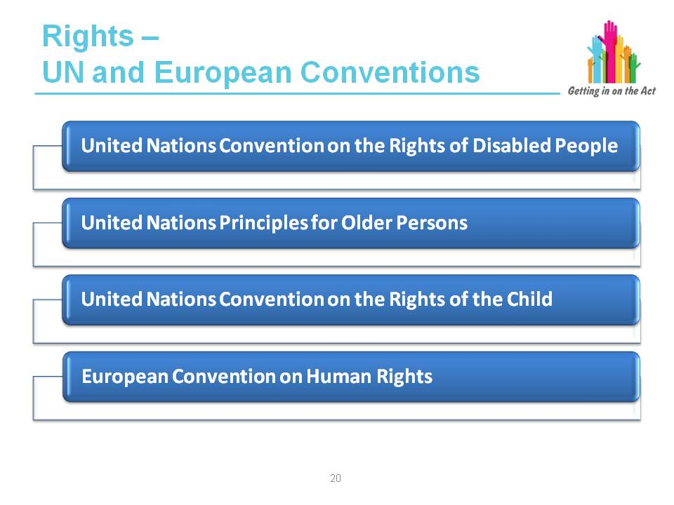

Facilitator notes

From April 2016, a person exercising functions under the Act will be required to demonstrate ‘due regard’ to the United Nations Conventions.

1. A person exercising functions under this Act in relation to an adult must have due regard to the United Nations Principles for Older Persons. These state that:

- Older persons should be able to enjoy human rights and fundamental freedoms when residing in any shelter, care or treatment facility, including
full respect for their dignity, beliefs, needs and privacy, and for the right to make decisions about their care and the quality of their lives
- Older persons should be able to live in dignity and security and be free of exploitation and physical or mental abuse

2. A person exercising functions under this Act in relation to a child must have due regard to the United Nations Convention on the Rights of the Child (UNCRC). This includes four articles that are general principles:
- Non-discrimination (article 2)
- Best interest of the child (article 3)
- Right to life, survival and development (article 6)
- Right to be heard (article 12)
- Right to be protected (article 19)

3. A person exercising functions under this Act in relation to disabled adults or children must have due regard to the United Nations Convention on the Rights of Disabled People (UNCRDP). This includes:

Local authorities need to understand and support the well-being outcomes that people wish to achieve. The outcome statements set out in the Code of Practice on General Functions specify the key areas where care and support can make a difference to improve well-being outcomes for people, these include:

- Disabled children to have all human rights and fundamental freedoms on an equal basis with other children, including the right to express their views freely, and the best interests of the child shall be a primary consideration (article 7)
- Equal access to the built environment, transport, information and communication, and for all the barriers to the above to be identified and removed (article 9)
- Living independently and being included in the community (article 19)
- Freedom of expression and opinion, and access to information (article 21)
- Respect for home and the family (article 23)
- Education (article 24)
- Habilitation and rehabilitation (article 26)
- Work and employment (article 27)

5. The Code of Practice for Part 2 of the Act also points out that public authorities must not act in a way that is incompatible with rights under the European Convention on Human Rights, included at Schedule 1 of the UK Human Rights Act. This includes:

- Article 2 – right to have life protected
- Article 3 – right not to be subjected to inhuman or degrading treatment
- Article 5 – right to liberty and security
- Article 6 – right to a fair hearing
- Article 8 – right to respect for private and family life, home, and correspondence

Human rights can be absolute rights, limited rights or qualified rights. Absolute rights mean rights that the state can never infringe, and include the right to protection from torture and inhuman and degrading treatment. Limited rights are rights that may be limited under explicit and finite circumstances, such as the right to liberty. Qualified rights are rights which require a balance between the rights of the individual and the rights of the broader community or the state. They include the right to respect for private and family life; the right to manifest one’s religion or belief; freedom of expression; freedom of assembly and association and the right to peaceful enjoyment of property. More information on the Human Rights Act can be found in the Ministry of Justice’s publication Making sense of human rights: a short introduction.

From the Care Council for Wales's safeguarding training module

Key learning point
Professionals and advocates need to be aware of people's rights and uphold them.

Slide 22
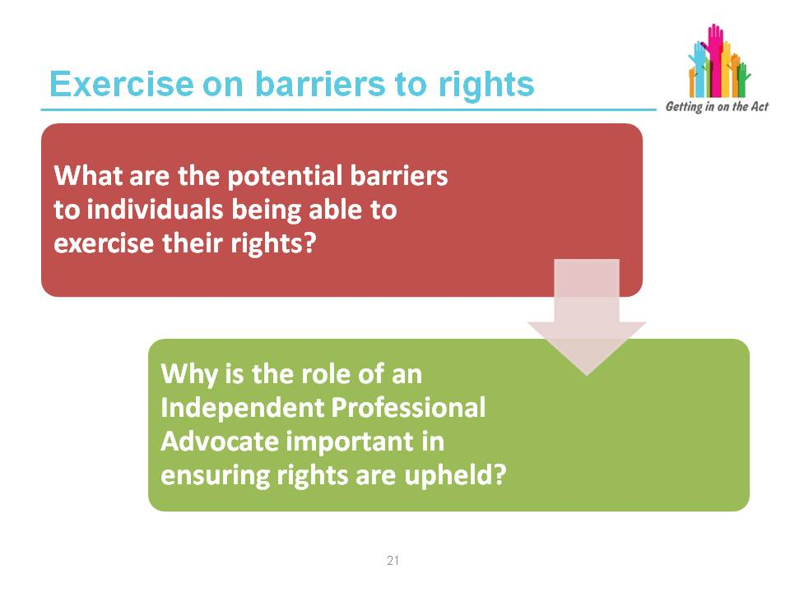

Exercise

In pairs, ask the group to spend some time discussing barriers to individual’s exercising their rights as outlined by the United Nations and European Conventions. Provide a handout of the relevant conventions.

Depending on their client groups, the responses may be different and specific but there will generally be similarities in the responses.

Ask the group to feed back their thoughts on barriers and the importance of an advocate.

Some possible responses are on the next slide but are not a prescriptive list.

Slide 23
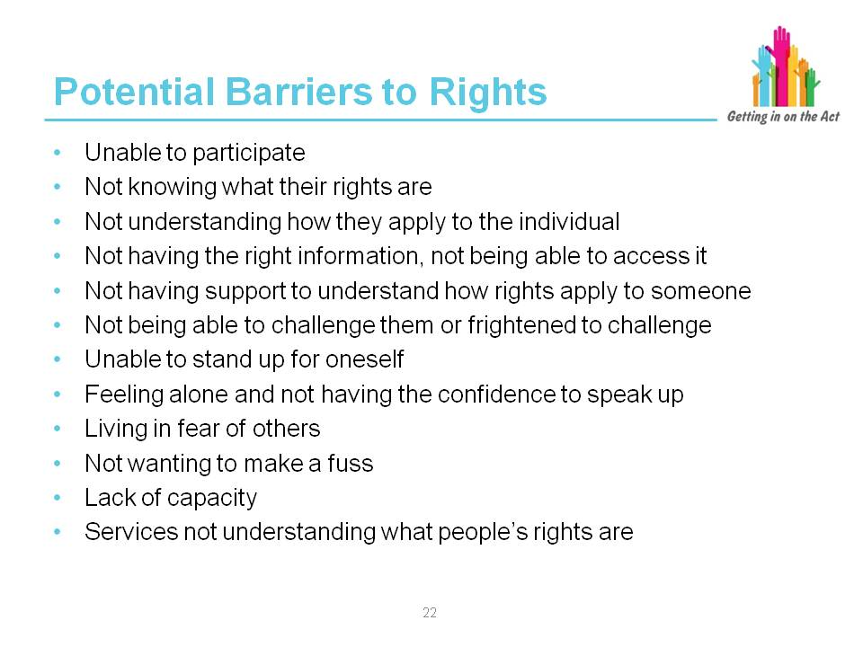

Facilitator notes

Some additional information on rights can be found at:

Know Your Rights, Use Your Rights, Live Your Rights
http://www.disabilitywales.org/know-your-rights/

http://www.traffordcil.co.uk/#!the-pillars-of-independent-living/c22uk

http://www.un.org/esa/socdev/enable/dispaperdes0.htm

https://www.gov.uk/government/collections/life-opportunities-survey

Key learning point
Barriers can be wide ranging and to be able to identify them is a step closer to overcoming them.

Slide 24

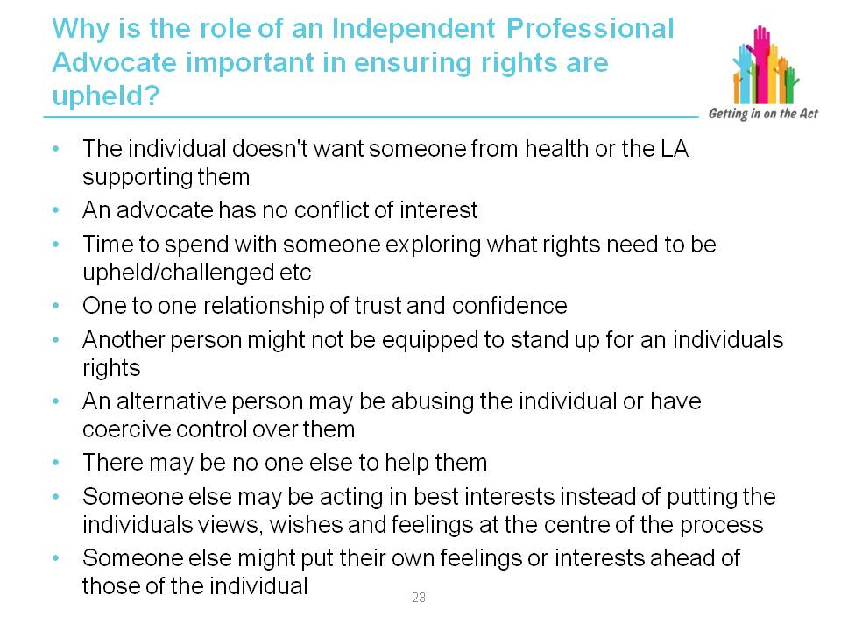

Facilitator notes

People are entitled to be in control of their own lives but sometimes, whether through impairment, financial circumstances or social attitudes, they may find themselves in
a position where their ability to exercise choice or represent their own interests is limited. In these circumstances, independent advocates can help ensure that an individual’s rights are upheld and that views, wishes and needs are heard, respected and acted upon.

Advocates promote the person’s rights within decision-making meetings and highlighting relevant guidance and legislation that underpin this.

Advocates should be able to explain to all clients what their rights and options are with respect to the specific decision at hand. Where the advocate is unable to do this, either due to a lack of knowledge, skills or specific expertise, they should support clients to access the most appropriate representation, advice or information e.g. via
a solicitor, advice organisation or alternative specialist service.

Advocacy providers should be aware of their duties and responsibilities under relevant human rights and equality legislation including the Equality Act 2010, Human Rights Act 1998 and other relevant wider policies that promote personalisation and person-centred care and support.

From the Advocacy QPM, Code of Practice, 2014

Key learning point
An Independent Professional Advocate is trained and paid to undertake their professional role as an advocate. The IPA must ensure individuals' views are accurately conveyed irrespective of the views of the advocate.

The IPA ensures that the person’s fundamental human rights are respected and upheld at all times.

Slide 25
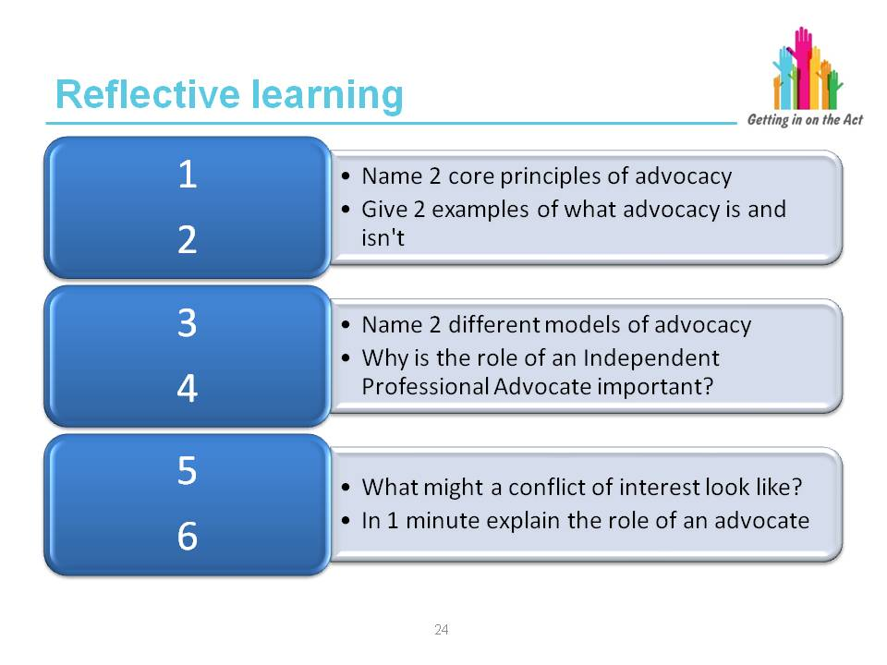

Facilitator notes

This reflective learning slide is for both the facilitator and the learner to check the learner's progress and understanding of the module.

Slide 26
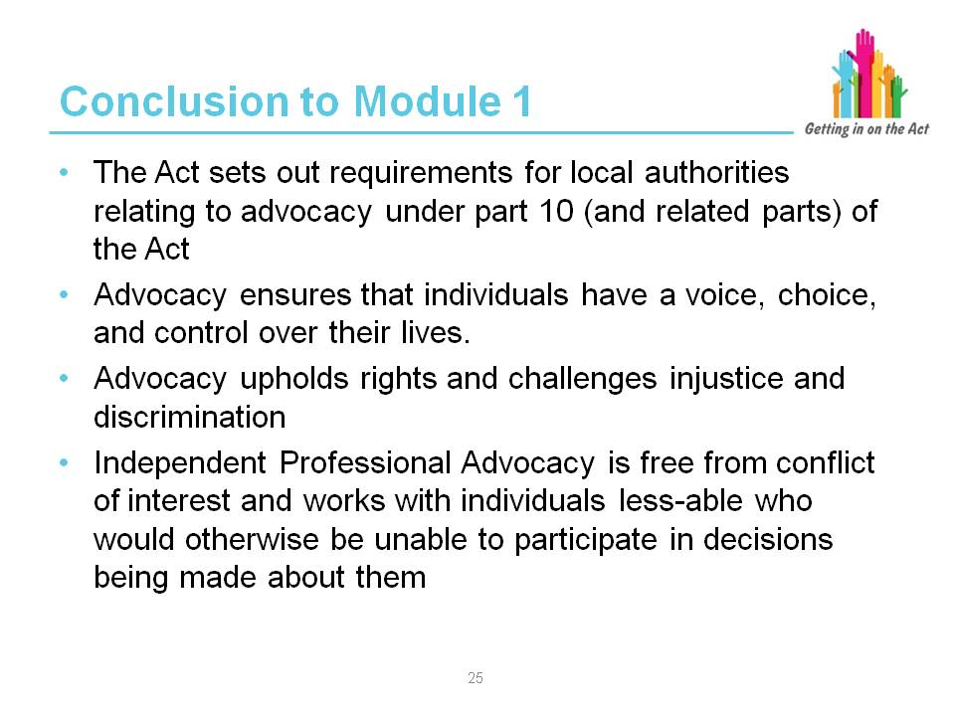

Facilitator notes

This slide brings Module 1 to an end.

Ask the participants for any feedback on what they have learnt and review what they had expected from the session to ensure all elements have been covered.

Establish if any other training needs have been identified.

Ask them to fill in a feedback form about the module

Module 2 – Well-being

Slide 27
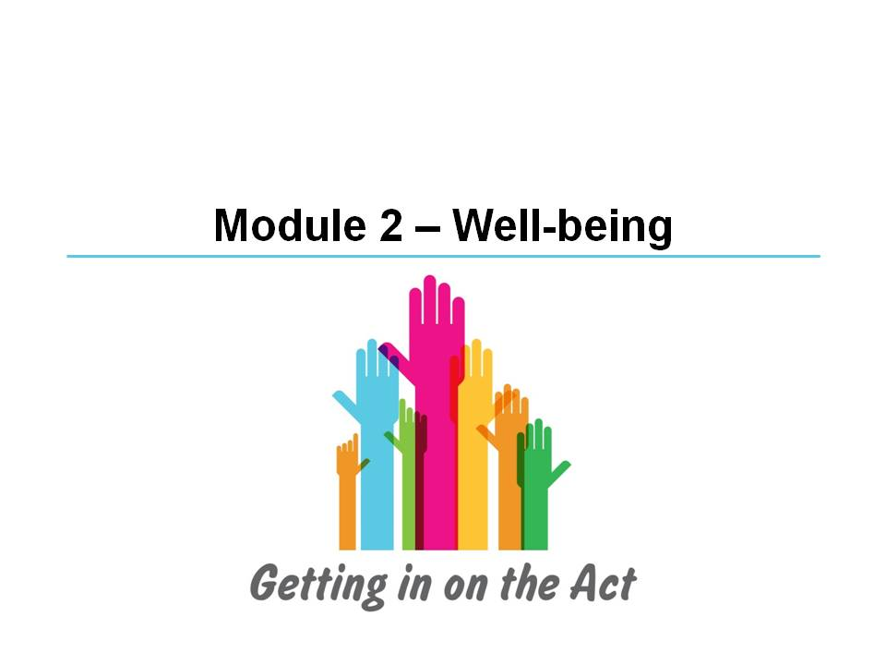

Slide 28

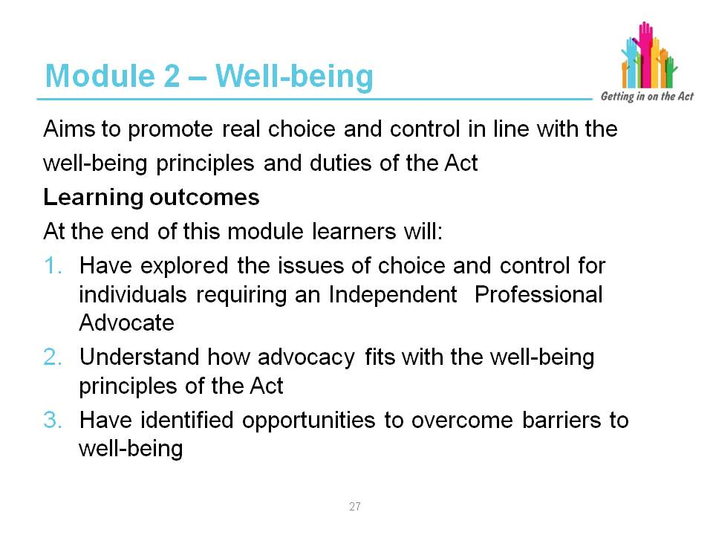

Facilitator notes

Include an icebreaker exercise here.

Ask what levels of understanding there is in the group about the well-being principles in the General Functions part of the Act.

Ask what individuals consider is important to their own well-being and how that is achieved.

Slide 29
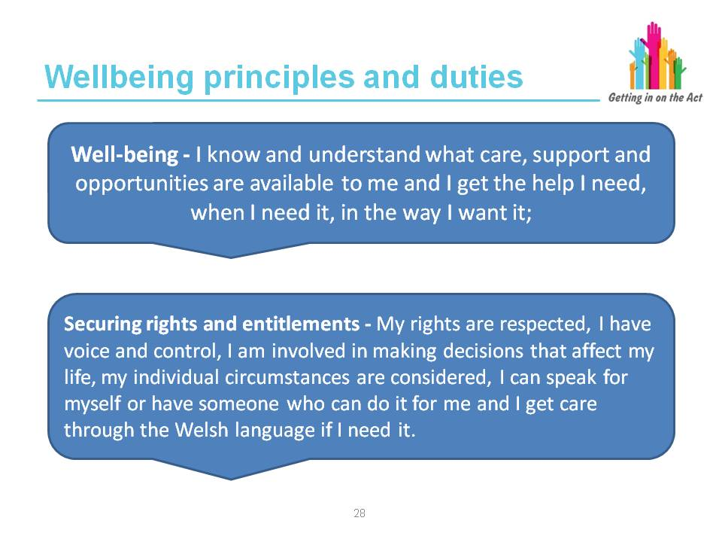

Facilitator notes

Central to the Act is the well-being duty. People have a responsibility for their own well-being, supported by their families, friends and communities. However, people may also need support to ensure that they achieve well-being. Professionals and agencies are there to provide some of this support.

Part 2 of the Act requires “any persons exercising functions under the Act to seek to promote the well-being of people who need care and support, and carers who need support.” This overarching duty applies to local authorities (and organisations they have delegated functions to) and their practitioners when, for instance, carrying out an assessment or providing information and advice. This is an overarching duty that has to be met by everyone exercising functions under the Act (this includes Welsh Ministers, local authorities, local health boards and other statutory bodies).

Practitioners must look at what people can contribute in achieving their well-being and empower them to contribute to achieving their own well-being, with the appropriate level of support. This will involve building on people’s resources, including people’s strengths, abilities, and families and communities. However:

“The eligibility criteria must not be used as a tool to require individuals to demonstrate they have exhausted every other possible avenue of support before becoming eligible for local authority assistance.”
Part 4 Code of Practice (Meeting Needs)

In the Act, well-being is defined with eight aspects:
- Physical and mental health, and emotional well-being
- Protection from abuse and neglect
- Education, training and recreation
- Domestic, family and personal relationships
- Contribution made to society
- Securing rights and entitlements
- Social and economic well-being
- Suitability of living accommodation

In relation to an adult, well-being also includes:
- Control over day-to-day life
- Participation in work

In relation to a child, well-being also includes:
- Physical, intellectual, emotional, social and behavioural development
- “Welfare” as that word is interpreted for the purposes of the Children
Act 1989

Slide 30
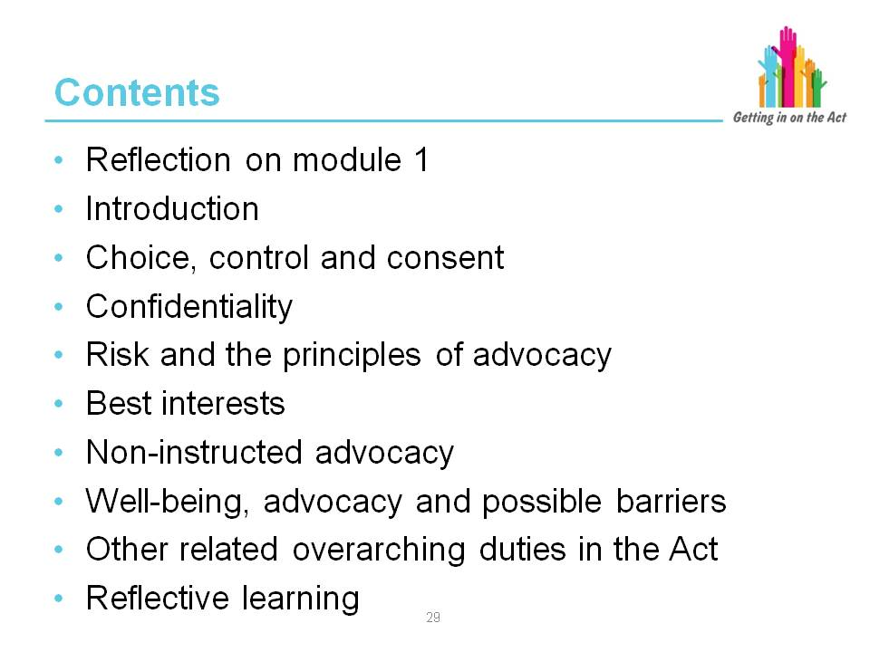

Facilitator notes

The Act:

- Places the person and their well-being outcomes at the centre of this new framework
- Gives them a voice in, and control over, achieving those outcomes
- Supports people to achieve their own well-being
- Measures the success of this care and support based upon all contributions to well-being; including people, families, supporters, formal and informal services

Despite the barriers individuals may be experiencing, local authorities must involve people to help them express their views, wishes and feelings, to support them to weigh up options and to make decisions about their well-being outcomes. These requirements apply irrespective of where an individual is living, including the secure estate.

This slide looks at principles that are fundamental to establishing well-being outcomes and what barriers there may be to choice and control.

Slide 31
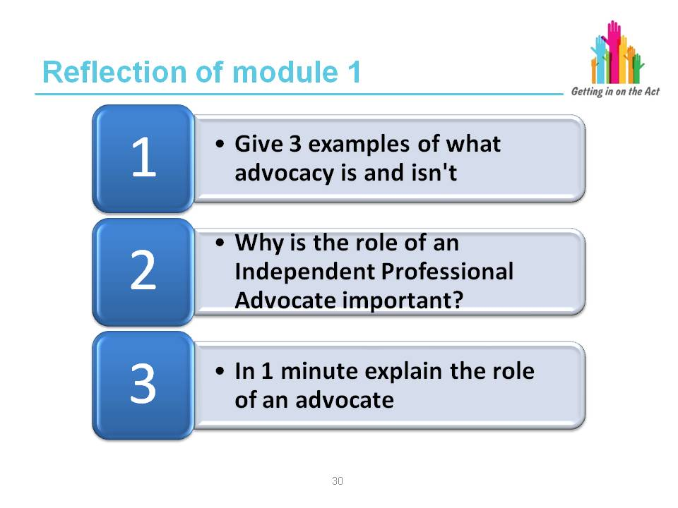

Suggested answers

1. It is not about…
- Befriending
- Counselling
- Mediation
- Advice
- Impartiality
- Dependency
- Legal advice (need legal support)

It is about…
- Support
- Representation
- Empowerment
- Choices
- Rights
- Having a voice
- Making decisions

- Independent Advocates are free from conflicts of interest, able to promote the wishes and feelings of the client without being restricted. Choices and decisions are made by the person, about the person, and not about what is in their best interest (where they have capacity). When representing an individual, an advocate will only present the views and wishes of the individual and not their own or anyone else’s. They will uphold rights and support and empower the individual to challenge abuse, injustice or discrimination.

Slide 32
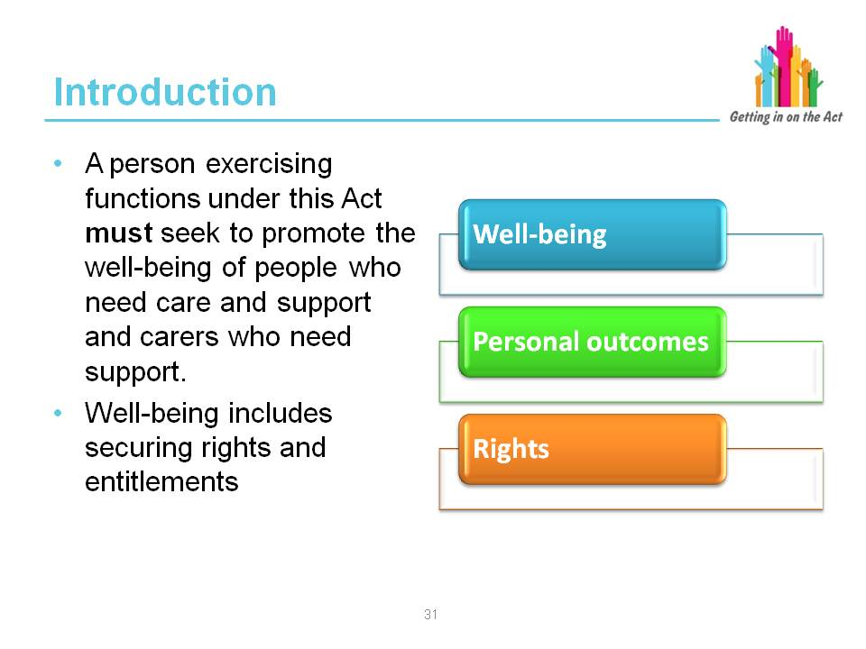

Facilitator notes

The Part 10 Code of Practice says that:

“Advocacy should be considered as an inherent element of the Act to focus social care around people and their well-being. Advocacy helps people to understand how they can be involved, how they can contribute and take part and whenever possible, to lead or direct the process.

“Through advocacy, people are active partners in the key care and support processes that identify and secure solutions through preventative services; information, advice and assistance; assessment; care and support, and support planning; review and safeguarding.

“The Act:
- Places the person and their well-being outcomes at the centre of this new framework
- Gives them a voice in, and control over, achieving those outcomes
- Supports people to achieve their own well-being, and
- Measures the success of this care and support based upon all contributions to well-being; including people, families, supporters, formal and informal services

“Despite the barriers individuals may be experiencing, local authorities must involve people to help them express their views, wishes and feelings, to support them to weigh up options and to make decisions about their well-being outcomes. These requirements apply irrespective of where an individual is living, including the secure estate.

“Local authorities need to understand and support the well-being outcomes that people wish to achieve. The outcome statements set out in the Code of Practice on General Functions specify the key areas where care and support can make a difference to improve well-being outcomes for people, these include:

- Well-being – I know and understand what care, support and opportunities are available to me and I get the help I need, when I need it, in the way I want it

- Securing rights and entitlements – my rights are respected, I have voice and control, I am involved in making decisions that affect my life, my individual circumstances are considered, I can speak for myself or have someone who can do it for me and I get care through the Welsh language if I need it

“Advocacy services are fundamental to supporting people to engage actively and participate in the development of their own well-being outcomes."

Part 10 Code of Practice (Advocacy)

Slide 33
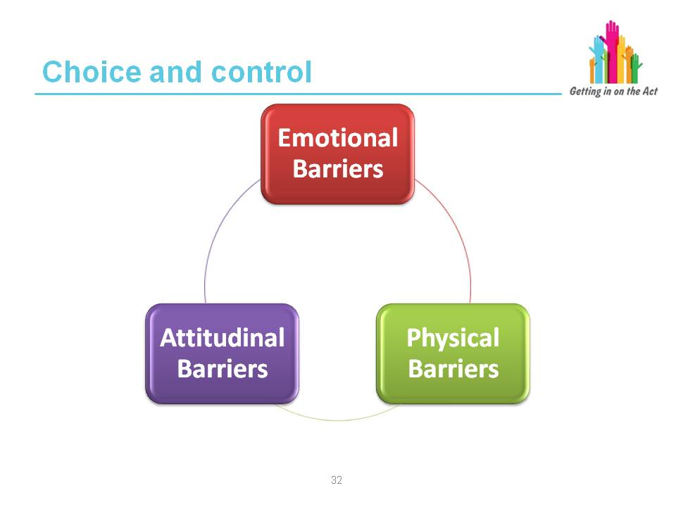

Facilitator notes
Making decisions is something that happens daily for most people. From the small decisions perhaps about what we eat, what we wear, what we do during the day up to the big decisions perhaps about where we live, who we live with, where we go on holiday, who our friends are or what profession to pursue.

All the choices we make help to identify who we are and are important personal freedoms.

Making choices is not so easy for all individuals and they may find barriers to making day-to-day choices and having control over our own decision making. These barriers can fall into three categories: emotional barriers, physical barriers and attitudinal barriers.

Emotional barriers (affecting the way we feel about something):
- Fear about the consequences of making a choice
- Anxiety that someone else will think it stupid
- Lacking the confidence to speak up and take control
- Feeling powerless because someone else makes all your decisions
- Frightened of change or the unknown
- Scared of being thought a troublemaker
- Scared of losing someone's friendship if you don't do what they think is best for you
- Emotional because of the uncertainty of having to move home
- Upset and not thinking straight because you are vulnerable
- Too emotional to make clear decisions
- Unsure what to do because you don't know what all your options are
- Feeling alone and isolated with no one to talk to
- Uncertain because of a language barrier
- Feeling lost because you can't remember things that should help you make a decision

Physical barriers (tangible obstacles that inhibit someone from having a voice, choice and control):
- Losing cognitive ability
- Coercive control by another individual
- Unable to access up-to-date information
- Unable to find out what rights a person has
- Information about services or procedures are complex and inaccessible
- Communication problems (language, sensory impairment, unable to read or write, physical difficulties)
- Lack of independent support (or perceived lack)
- Unable to make sense of information you are provided
- Health problems
- Abuse, harm or mistreatment

Attitudinal barriers (how people think about others). Attitudes can be a real barrier to making choices and taking control:
- Other people thinking they know what’s best (controlling behaviour)
- Actual or perceived discrimination
- Not believing someone can make a decision because their memory is failing or they have a diagnosis of dementia
- Professionals using language that is full of jargon and is very technical
- Considering someone is incapable of forming a view, making a decision, taking control over their own decision making
- Overlooking someone who uses non-verbal communication
- Specialists not considering someone can understand if they are told in plain language
- Not making eye contact

Exercise

Exercise in pairs.

Use the case study about Mrs A. Ask the learners to discuss the case, reflect on what they know should happen and answer the questions.

Feed back to main group and use the facilitator's sheet to add background to the case and what the advocate did with Mrs A.

Slide 34
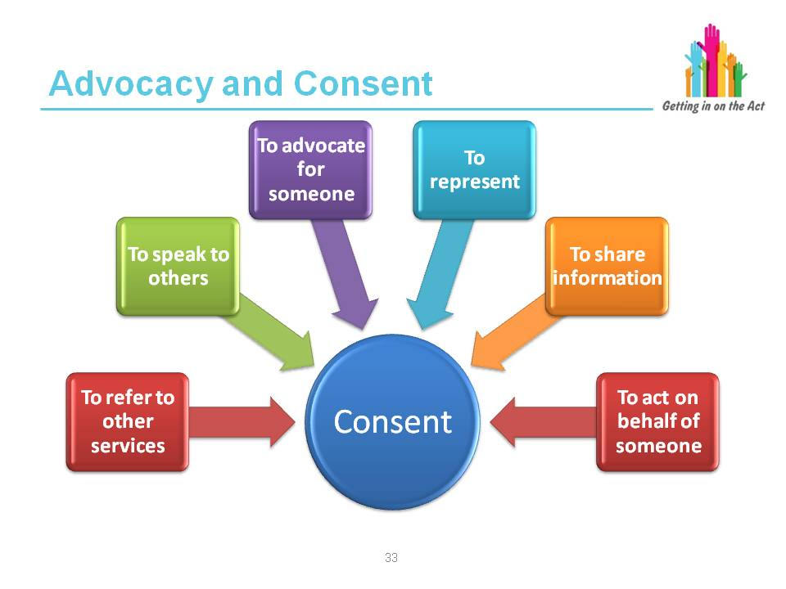

Exercise

Ask the group the following questions:

- What is consent needed for?
- How should it be obtained?
- How can you be sure you’ve got it right?
- How do you prove it?
- What if the individual can’t consent?
- Can consent be overruled? If so, when?

Facilitator notes

What about permission for non-instructed advocates to work with clients?

It is recognised that various groups of people, including some who cannot instruct
an advocate, should be entitled to independent advocacy; either as a legal right (for example, under the Mental Capacity Act), or as part of 'best practice'. Other clients who cannot access advocacy for themselves may also benefit from independent input which is entirely focused around understanding and advocating from their perspective.

Non-instructed advocates will be aware they do not have direct permission for their work from clients, and will often have taken a referral from a third party. They will always try to ensure, as a minimum, that the client is content with their presence when they visit. By building up a picture of communication possibilities and following leads from clients where possible, they will often be able to take informal direction from clients who cannot formally instruct. Because they do not have direct consent from their clients, non-instructed advocates are supervised and supported by a line manager to ensure they have considered all options for their clients and continue working from an independent perspective.

Advocates' notes will show they have kept the issue of consent under review.

The issue of consent is discussed in some detail in Hear what I say: Developing Dementia Advocacy. A list of suggestions is made for dealing with consent and other ethical issues, which arise in non-instructed advocacy:

- Treating consent as an ongoing process not a one-off decision
- Recording how consent is obtained at the beginning and throughout the advocacy process
- Recording the basis on which views are formed about what the person wants
- Explaining to the person what is being recorded and how this information will be used
- Establishing the issue(s) that are important to the person and agreeing which to prioritise
- Continually reflecting on what is being done, why, and in whose interests
- Ensuring that confidentiality is maintained and that consent is gained to share information with others in the family or the service system
- Ensuring that advocates receive regular supervision in which potential and actual ethical issues are identified and discussed with clear recording of agreed action and the reasoning underpinning those actions
- Ensuring advocates have received appropriate training and education on issues of capacity, consent, human rights and other ethical issues

Key learning point
Consent is important in an advocacy relationship. Apart from specific circumstances where confidentiality can be breached, advocates should not share information about a client with others without that individual’s permission where they have the capacity to consent.

Reference:

Hear what I say: Developing Dementia Advocacy by Caroline Cantley, Kay Steven and Monica Smith

https://www.bjf.org.uk/web/documents/resources/HearWhatISay.pdf

Slide 35
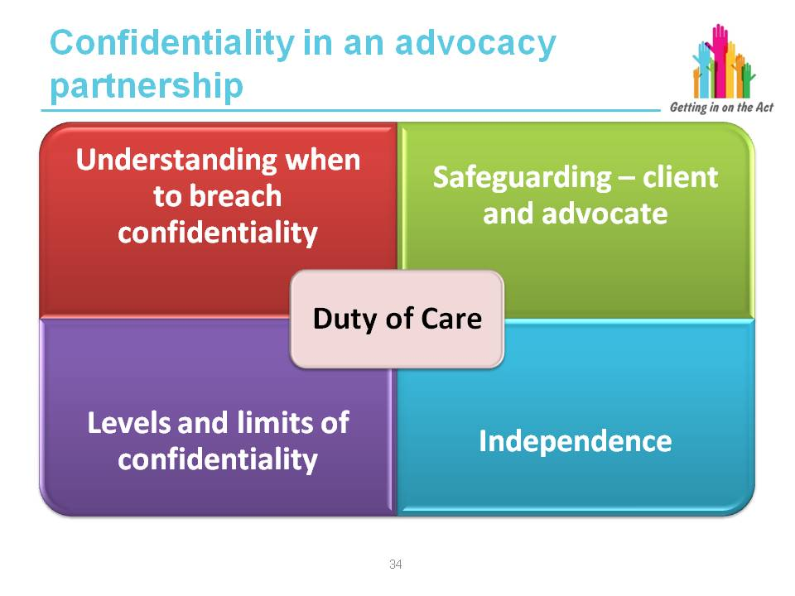

Facilitator notes

Confidentiality

The advocacy provider will have a written policy on confidentiality that is in line with the Data Protection Act 1998 and the Mental Capacity Act 2005. It should outline
how information about a person accessing the service may be shared, as well as the circumstances under which confidentiality might be breached. Advocates must also be aware of situations that would require making a child or adult safeguarding alert.

Advocacy QPM, Recognising Quality in Independent Advocacy, Code of Practice, Revised 2014

1. Advocacy providers should ensure their confidentiality policy is in line with the Data Protection Act 1998 and Mental Capacity Act 2005.

2. Advocates should be fully conversant with their organisation’s confidentiality policy and be able to explain it in straightforward language including where information will be shared in a person’s best interests (in line with the Mental Capacity Act 2005).

3. Advocates should at all times observe and respect the rights and remits of confidentiality for clients within the policy of the organisation which should include:
- Breaching confidentiality where there are concerns for the health and/or safety of the person or others
- Sharing information in line with the Data Protection Act 1998 and Mental Capacity Act 2005
- Awareness of the responsibilities of being a ‘record holder’ under the Data Protection Act 1998 and the holding of data about clients
- In line with best practice, this will generally mean that:
  - Advocates should be honest with the client about the level of confidentiality they can realistically guarantee. This means explaining any conditions under which confidentiality may be breached (e.g. harm to self or others and abuse) and the means by which this may occur
  - Advocates should receive appropriate casework supervision and will be expected to discuss their work with their line manager on a regular basis

Notwithstanding the above exceptions, advocates should not share information about a client with others without that individual’s permission where they have the capacity to consent. Where permission cannot be obtained due to reasons of incapacity, information should be shared in accordance with the Mental Capacity Act 2005 e.g. to ensure the client’s wishes and views are heard and their rights are upheld / taken into account within decision making.

- Advocates should inform the client about all actions taken on their behalf
- Advocates should avoid colluding with hearsay and speculation about a client
- Advocates should ensure that all data kept on a client is securely stored in line with the Data Protection Act 1998 and routinely updated and checked for accuracy. Clients should have access to this information as requested

Advocacy Quality Performance Mark, Recognising Quality in Independent Advocacy, Code of Practice, Revised 2014

http://www.qualityadvocacy.org.uk/wp-content/uploads/2014/03/Code-of-Practice.pdf

Please note the following document for children:
'Safeguarding Children: Working Together under the Children Act 2004', which is statutory guidance and deals with information sharing and confidentiality.

Slide 36
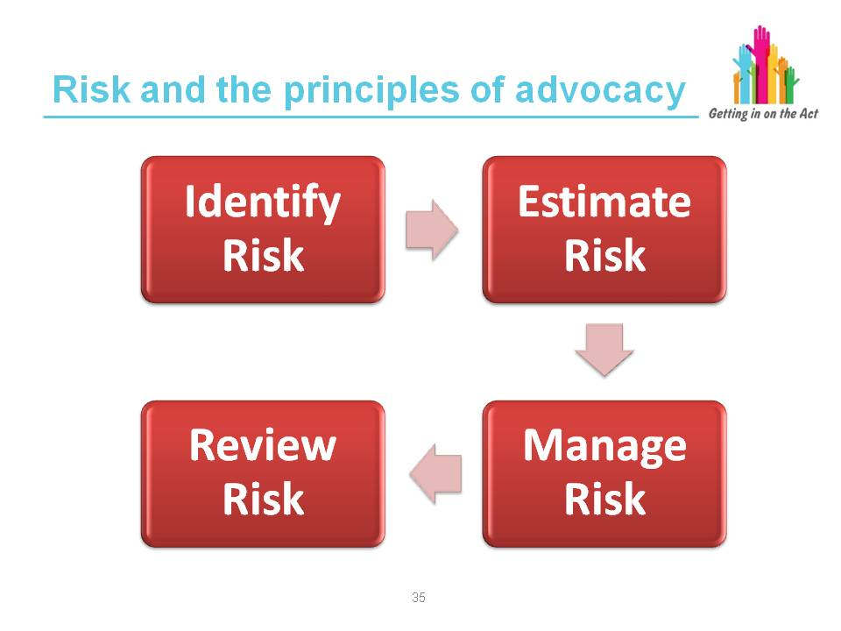

Facilitator notes

Risk is associated particularly with two of the principles from the Advocacy Charter discussed in Module 1.

In this case we are discussing risk-taking by the individual rather than organisational risks.

Through the advocacy relationship and working to the principles of ‘a person-centred approach’ and ‘empowerment’ the advocate can work with the individual to identify risks, estimate the level of the risk, understand if the risk can be managed and finally to review the risk.

Exercise

Individuals are entitled to make decisions that others may deem risky.

Discuss how to manage this.

Key learning point
If the individual has capacity and understands all the issues around their decision-making then the advocate would (as much as possible) support the individual with that decision.

Slide 37
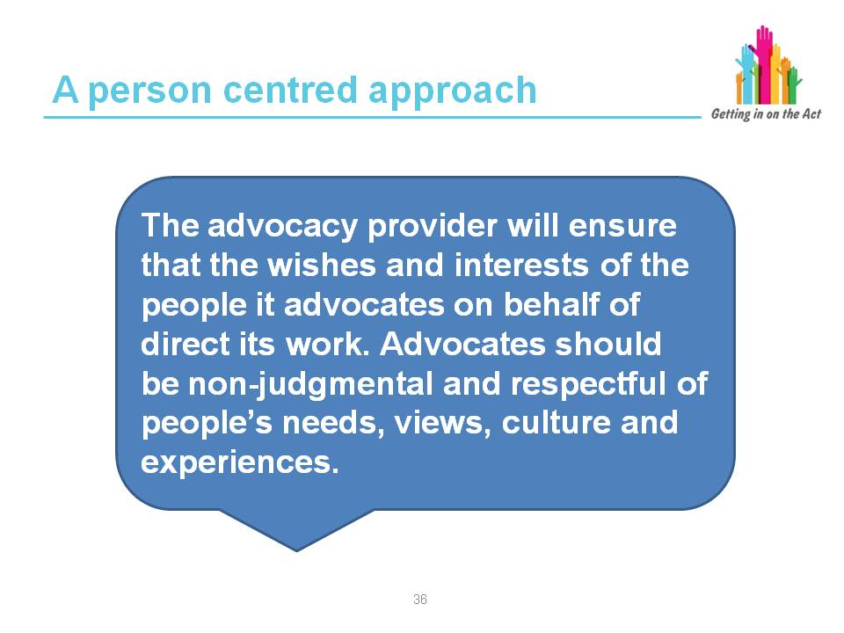

Facilitator notes

Person-centred approach (from the Advocacy Quality Performance Mark)

The advocacy provider will ensure that the wishes and interests of the people it advocates on behalf of direct its work. Advocates should be non-judgmental and respectful of people’s requirements, views, culture and experiences.

1. Advocates should ensure advocacy support is appropriate to the client’s needs and/or expressed wishes.

2. Advocates should take instruction from clients where they have the capacity to instruct, or take instruction from a third party where the client lacks capacity to instruct.

3. Advocates should base their actions on mutually agreed plans and preferred outcomes, and work in partnership with clients to achieve this.

4. Where advocates are acting in a non-instructed role their actions should be guided by the framework of the Mental Capacity Act 2005, the Mental Health Act 1983 (where applicable) and the recognised approaches to non-instructed advocacy.

The advocacy role may include:

As part of Instructed Advocacy:

- Gathering and presenting up-to-date and accurate information to help clients make informed choices but NOT giving advice
- Listening to clients and discussing options but NOT imposing views or opinions
- Channelling clients wishes, views and requested instruction, NOT filtering them e.g. due to personal views that the client will not achieve what they wish
- Talking to and corresponding with family members or other professionals with the client’s permission but NOT making decisions or choices on behalf of clients
- Representing the client’s expressed views and wishes but NOT taking action independently of the client unless they have clearly instructed this
- Agreeing a plan of action and identifying initial outcomes and timescales with clients but NOT being prescriptive or inflexible
- Ensuring the person’s fundamental human rights are respected and upheld at all times
- Challenging health, social care or third sector service providers and decision makers in order to promote a person-centred approach

Key learning point
Working with the individual and being client-led while exploring options is the advocate's role. It is up to the individual if they wish to take risks, however unwise they may seem to others. The advocate cannot advise a client not to take a particular course of action. The advocate will work within the guidelines of the advocacy QPM Code of Practice.

Slide 38
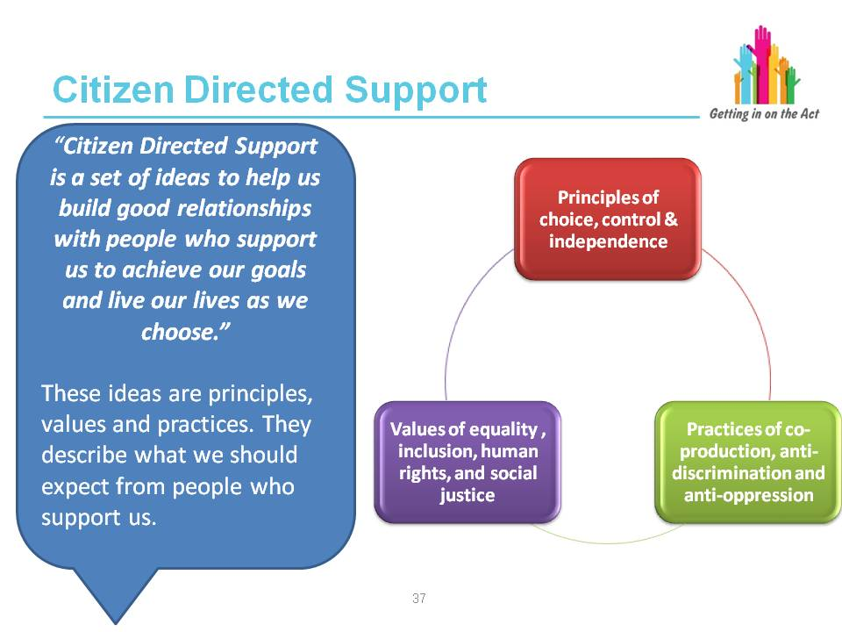

Facilitator notes

This slide has been included to recognise the different terminology that is used and this is based on the Social Model of Disability. The previous slide is the language currently used and recognised in relation to advocacy.

About Wales Alliance for Citizen Directed Support

WACDS is an alliance of citizens and representatives of service providers, local authorities and the third sector which has worked for more than eight years to develop a “made in Wales” approach to provision of personalised support for people who are eligible for social services. The WACDS Citizens and Providers Network forms part of the Alliance, together with the Citizen Directed Support Learning and Improvement Network. The WACDS Council was formed in 2011 to oversee and direct the Alliance’s work. WACDS continues to engage proactively with Welsh Government and partners in shaping the Social Services and Well-being (Wales)
Act 2014.

About Citizen Directed Support

Citizen Directed Support (CDS) is a set of values and principles that Alliance members wish to see at the heart of a transformed and sustainable social service.
In contrast to the model of Self-Directed Support which has been implemented in England, CDS is values-based rather than process driven. While recognising that case management methods and processes must change in order to facilitate a genuinely citizen-directed model of support, WACDS is primarily concerned with ensuring that the core values and principles it has identified are embedded into working practices and relationships.

We know when these ideas are working because we feel that…

- We get on well with people who support us
- We are involved when decisions are made that affect our lives
- We are listened to when we speak up about our wishes and feelings
- We are able to take responsibility for our lives
- What matters to us also matters to others
- We are in control of all aspects of our support, as much as we wish to be
- We have the resources we need to achieve our goals
- We are part of a network of supportive people
- There are no barriers to us participating in and contributing to our communities
- Our strengths, knowledge, skills, experience, creativity and expertise are recognised
- We are valued and respected for who we are
- We can take considered risks when we wish to
- Our lives are interesting, creative and full of potential
- Our health and well-being matters to other people
- We are empowered and enabled, not powerless and disabled
- We are living the life that we choose for ourselves

The above builds upon the “Transforming Social Services: Towards an Enabling Wales” toolkit (1) which was co-produced by WACDS and representatives of Welsh Government and other organisations in February 2014. This was developed for the purpose of introducing the concept of CDS to members of the Act's technical groups. It has been included on pages 12-15 of the Social Services Improvement Agency’s publication Creating Change: An E-Resource Guide to the changes required by the Act (2).

Slide 39
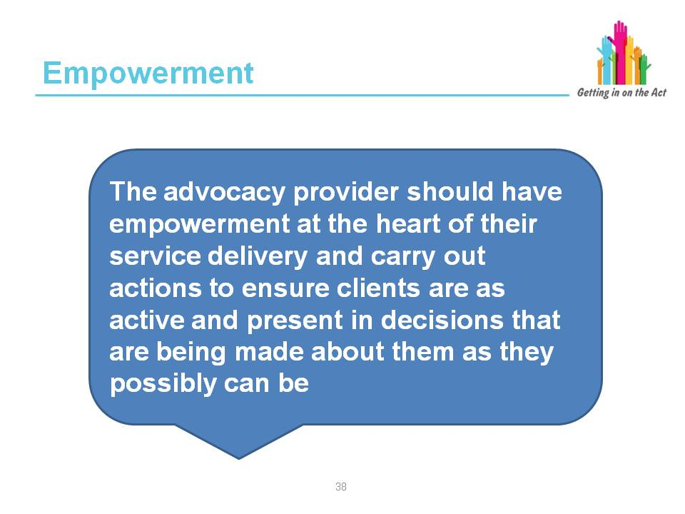

Facilitator notes

Empowerment (from the Advocacy Quality Performance Mark)

1. The advocacy provider should have empowerment at the heart of their service delivery and carry out the following actions to ensure clients are as active and present in decisions that are being made about them as they possibly can be:
- Promoting supportive decision-making to ensure the client is at the heart of decisions about their own care and support
- Recording the outcomes achieved by an advocacy client
- Promoting the person’s rights within decision-making meetings and highlighting relevant guidance and legislation that underpins this
- Agreeing on methods of advocacy representation where the client is able to instruct the advocate to ensure they have a say in their own lives and become enabled to access relevant services
- Use the framework of the Mental Capacity Act 2005 and recognised models of non-instructed advocacy where the person lacks capacity to make particular decisions to ensure the person has a say in their own lives and decisions that are being made about them

2. Advocates should be able to explain to all clients what their rights and options are with respect to the specific decision at hand. Where the advocate is unable to do this either due to a lack of knowledge, skills or specific expertise they should support clients to access the most appropriate representation, advice or information e.g. via
a solicitor, advice organisation or alternative specialist service.

Slide 40
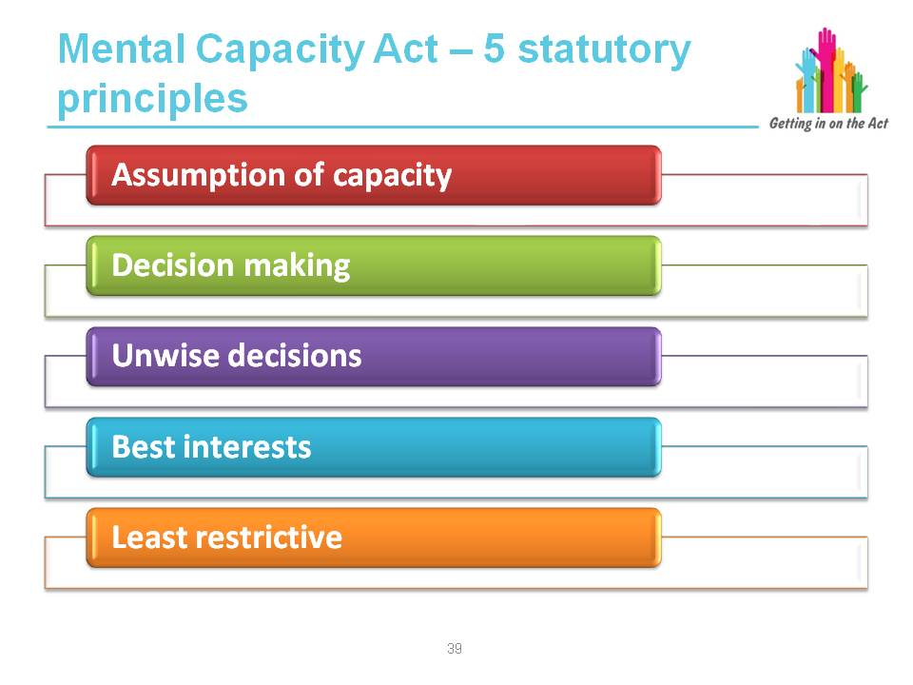

Facilitator notes

The Mental Capacity Act 2005 sets out five statutory principles. These are:
- A person must be assumed to have capacity unless it is established that they lack capacity.
- A person is not to be treated as unable to make a decision unless all practicable steps to help him to do so have been taken without success.
- A person is not to be treated as unable to make a decision merely because he makes an unwise decision.
- An act done, or decision made, under this Act for, or on behalf of, a person who lacks capacity must be done, or made, in his best interests.
- Before the act is done, or the decision is made, regard must be had to whether the purpose for which it is needed can be as effectively achieved in a way that is less restrictive of the person’s rights and freedom of action.

Slide 41
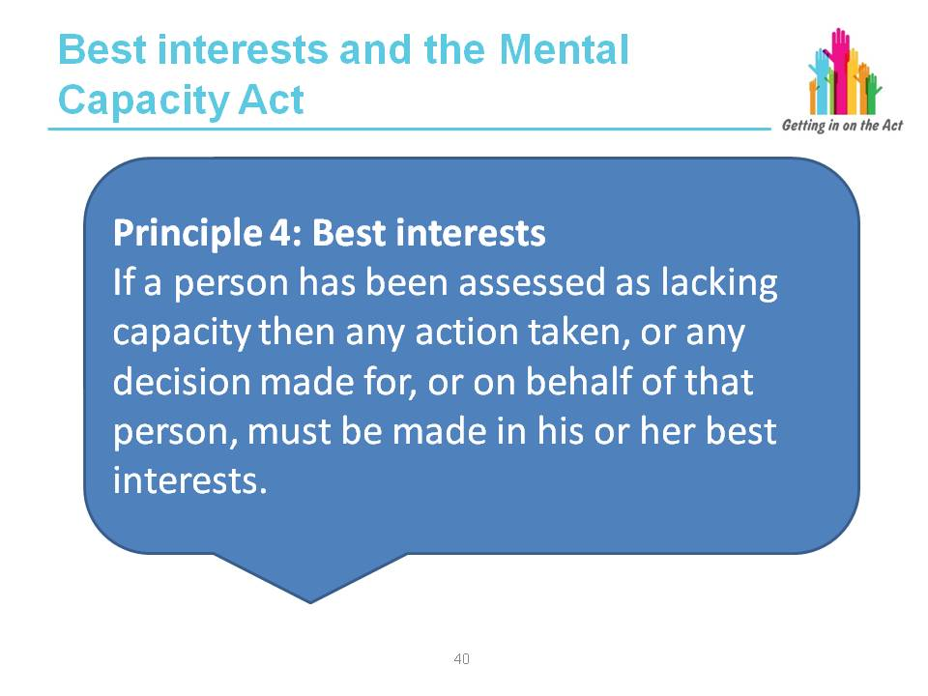

Facilitator notes

In instructed advocacy, an advocate agrees an agenda with the advocacy partner and represents the partner’s views and wishes or supports the partner to do so.

In general, an advocate would expect to represent the partner’s views to decision makers or to support the partner to express these views. Non-instructed advocacy considers the following question:

‘How can we (advocates) best advocate for people who cannot tell us clearly what they want or need?’

To help provide an answer to this, there are a number of questions that a
non-instructed advocate should consider:

- What is life like for this person?
- What is important to them?
- What might their wishes, feelings and desires be?
- What are their rights?
- What do other people who know this person well think?
- What responsibilities do other people or organisations have towards this person?
- Is this person being treated fairly?
- How can we increase this person’s involvement in decisions made about them and their life?

This is by no means an exhaustive list but by considering all these questions, by observing the advocacy partner and by trying to find the partner’s preferred means
of communication, an advocate will be prepared to speak up for the partner.

The Scottish Independent Advocacy Alliance Non-Instructed Advocacy Guidelines:
A Companion to the Code of Practice for Independent Advocacy

http://www.siaa.org.uk/wp-content/uploads/2014/02/SIAA_Non_Instructed_Advocacy.pdf

Best interests principle

It is important for the application of the Mental Capacity Act 2005 to have a fundamental understanding of the best interests principle.

If a person has been assessed as lacking capacity then any action taken, or any decision made for, or on behalf of, that person, must be made in his or her best interests (principle 4). The person who has to make the decision is known as the ‘decision-maker’ and normally will be the carer responsible for the day-to-day care,
or a professional such as a doctor, nurse or social worker where decisions about treatment, care arrangements or accommodation need to be made.

What is ‘best interests’?

The MCA provides a non-exhaustive checklist of factors that decision-makers must work through in deciding what is in a person’s best interests.

Some of the factors to take into consideration are:

- Do not discriminate. Do not make assumptions about someone’s best interests merely on the basis of the person’s age or appearance, condition or any aspect of their behaviour
- Take into account all relevant circumstances
- If faced with a particularly difficult or contentious decision, it is recommended that practitioners adopt a ‘balance sheet’ approach
- Will the person regain capacity? If so, can the decision wait?
- Involve the individual as fully as possible
- Take into account the individual’s past and present wishes and feelings, and any beliefs and values likely to have a bearing on the decision
- Consult as far and as widely as possible

Again, it is vital that you record your best interests decision. Not only does this concur with good professional practice, but given the evidence-based approach required by the MCA, you will have an objective record should your decision or decision-making processes later be challenged.

http://www.scie.org.uk/publications/mca/bestinterests.asp
Exercise
Use the best interests versus wishes and feelings case study.
Facilitator notes
Use this case study with the learners and give it to them in sections. After section 1 ask them to consider the issues relevant to advocacy and what they might do next in this circumstance.
After section 2, discuss the importance of having an advocate and what the benefits might be.
After section 3, discuss concerns that might be raised and how her wishes and feelings were being affected. Consider if a best interest decision is required or if her wishes and feelings can be established. If not, what are the barriers and how can they be overcome.

Slide 42

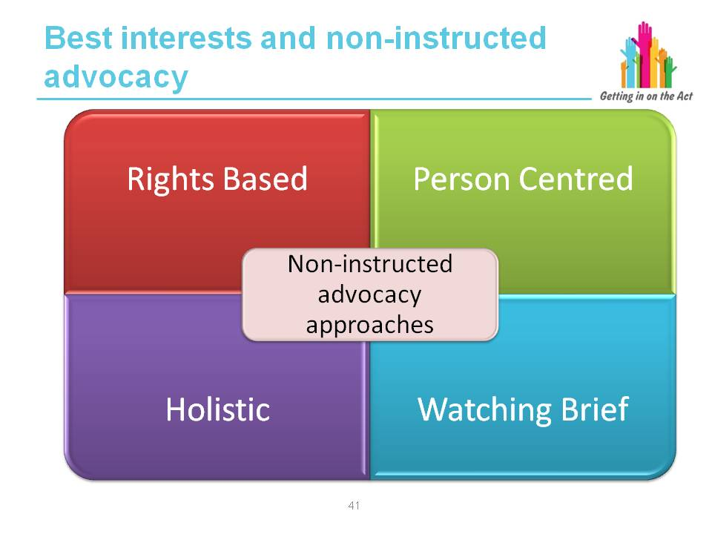

Facilitator notes

When non-instructed advocacy was first talked about it was argued by some people that it was not really advocacy. Even without the capacity to give instruction it is possible to provide non-instructed advocacy that meets the well-recognised standards and principles that apply to all advocacy support.

There are some advocates who have a statutory role, that is, advocates whose role is written into law. These include Independent Mental Capacity Advocates (IMCA) whose role is written into the Mental Capacity Act 2005; and Independent Mental Health Advocates (IMHA) whose role is written into the Wales Mental Health.
There are four main elements to the IMCA work, the last of which relates specifically to best interests decisions, including auditing the decision-making process and checking that the decision maker is acting in accordance with the Act, and that the decision is in the person's best interests.

Best interests advocacy is not something that would be used by independent
non-instructed advocates. Indeed, IMCAs are not best interest advocates, they are appointed to ensure the best interest process as laid out in law is adhered to. However, it is important to remember that 'best interests' meetings often take place among health and social services workers, when trying to decide the best course of action for an individual. An independent non-instructed advocate may find themselves involved in 'best interests' meetings.

In these situations, the advocate's role, as in all other situations, will be to reflect the wishes and preferences of the individual they are advocating for. This will happen through finding out about the individual and the kinds of decisions they made in the past, their preferences and their dislikes. It is always good practice to consider whether the individual an advocate is working with is entitled to an IMCA, and to refer to this service as appropriate.

From "An Advocates Guide to Non Instructed Advocacy 2013" (Age Concern and Age Cymru Gwent)

Rights based

As with being person-centred, the 'rights-based' approach to non-instructed advocacy is not standalone. All advocacy provision, whether instructed or otherwise, will involve a person's rights in some ways. 'Rights' can help the non-instructed advocate to make decisions, identify poor or unequal treatment, and understand and fight for fair and legal treatment. Independent non-instructed advocacy makes sure that universal rights are upheld for us all. Rights-based non-instructed advocacy makes use of things, such as the Mental Capacity Act 2005 and the Deprivation of Liberty Safeguards. These are used to ensure that people are receiving the support and treatment they are legally entitled to in ways that promote their dignity and respect. Rights-based advocacy can also draw upon written standards and procedures regarding quality of support and support provision.

As well as the Mental Capacity Act 2005 and the Deprivation of Liberty Safeguards, the other two main pieces of law used in rights-based advocacy are the Equality Act and the Human Rights Act.

Person-centered

While a ‘person-centred’ approach has been recognised as a non-instructed advocacy approach for a long time, it is in fact not a standalone approach but is rather the basic standard of good practice in providing all types of services, including independent advocacy. Being person-centred recognises a person's individuality, their personal history and personality. It seeks to understand the world from the individual's perspective. Being person-centred is something that should happen regardless of the type of service being provided, and regardless of capacity.

“Person-centred support can only exist in a sustained and effective manner when it is underpinned by certain core values such as inclusion, respect, independence and personal choice.”

This quote is taken from a guide written for health and social care practitioners. The guide contains some useful information and ideas for independent advocates to consider.

Holistic

A holistic approach to advocacy offers a structure for decision making. It provides a way of not just depending on what an individual is expressing, but also thinking inclusively about what really matters for the person.

Some key questions for a holistic approach would include:

- What is the person communicating about their views?
- How can we help them understand and communicate more?
- If we wait, will they be more able to decide?
- How can we increase involvement in the decision?
- What are their wishes and feelings?
- What do they believe in?
- If they understood, what factors would they weigh up?
- What do other people think?
- Acting as witness or observer to the way that services interact with the client. The advocate may hear or see things that are unacceptable or which pose a threat to the person’s well-being
- The advocate may also pick up on the client's body language and behaviour which may help to determine preferences and pleasures that can be used to enhance positive relationships
- The advocate reports on their observations without making judgements or assumptions

From the perspective of the person being advocated for:

“You could just watch me in my world and see what you can find out about my life, the way I am treated, the environments I spend my time in.

“You can see how people relate to me. You won’t make judgments on what you see. What you see and report to people in my life could make them think differently about me and my life – it could lead to things getting better in my life. You could come back after a while to see if things have got better.”

Watching Brief:

- Centres around eight quality of life domains that are used as a basis for
a series of questions that an advocate can put to the decision maker on behalf of the client (see next slide)

This provides a framework for challenging the decision maker in a
non-confrontational way and puts the client at the centre of the decision-making process.

Exercise

Split the learners into four groups.

Give each group one of the four non-instructed advocacy approaches to discuss. Draw out key elements in each then feedback to the entire group for comparison.

Key learning point
Best interests – this is often a decision made by somebody who is not 'independent', perhaps a health or social care worker.

Slides 43 and 44
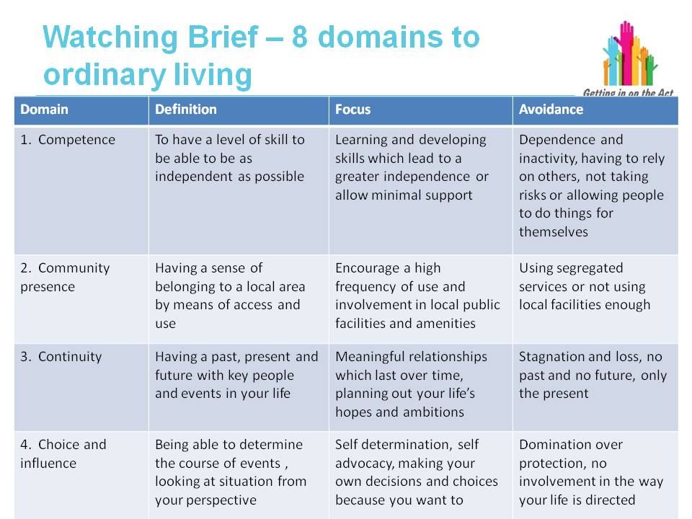

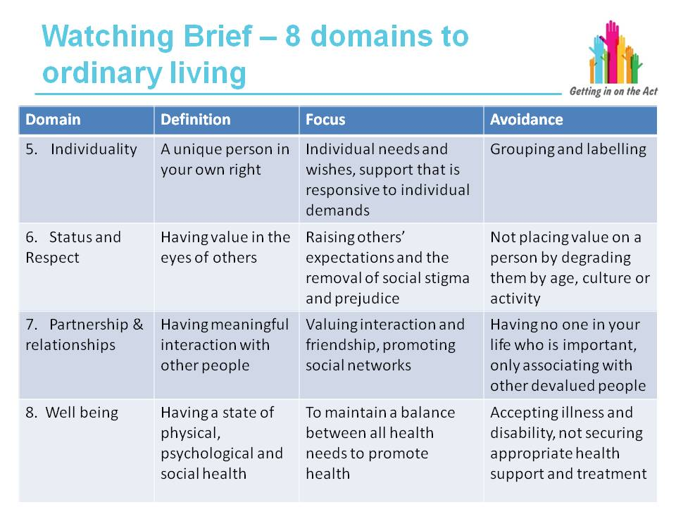

Facilitator notes

Watching Brief

From the perspective of the person being advocated for:

“You could think about the quality of my life and think about how changes or decisions about my life will affect me. You can ask questions of powerful people who are making decisions about me to make them really think about the decision from my point of view – this keeps me at the centre of the decision so any decisions that are made will really be in my ‘best interest’.”

The Watching Brief strongly promotes the second view that observation is something that happens as part of a holistic approach to independent non-instructed advocacy which uses a number of different techniques together.

The Watching Brief is a practice guide for advocates using non-instructed advocacy and was developed by Advocacy Services in Staffordshire (ASIST). ASIST describes the Watching Brief as 'a policy for offering advocacy to people who do not have a system of communication that is recognised by the advocate'.

The Watching Brief was developed in part to address the concerns around
non-instructed advocacy regarding instruction, which were examined earlier. In relation to this the introduction to the Watching Brief states:

“[The Watching Brief] sets out a viable and principled approach to Non-Instructed
Advocacy which retains the fundamental practices of advocacy whilst avoiding the necessity to revert to best interest approaches or a temptation to walk away.”

The Watching Brief (ASIST)

The Watching Brief should be used as a tool only when all attempts to develop a system of communication and gain an 'instruction' have been made without success. The Watching Brief should also be used only in addition to and not instead of other non-instructed advocacy techniques. Before using the Watching Brief therefore, the following steps must have been taken:

1. Being person-centred: focusing on the individual and trying to find out what they want to happen.
2. Considering the rights of the individual: raising issues where rights or standards are being ignored or infringed.
3. Understanding the individual's life: finding out as much as possible about their likes, dislikes and preferences; seeing them as a unique individual.

From Age Connects’ document An Advocate’s Guide to Independent Non-Independent Non-Instructed Advocacy 2013

Slide 45

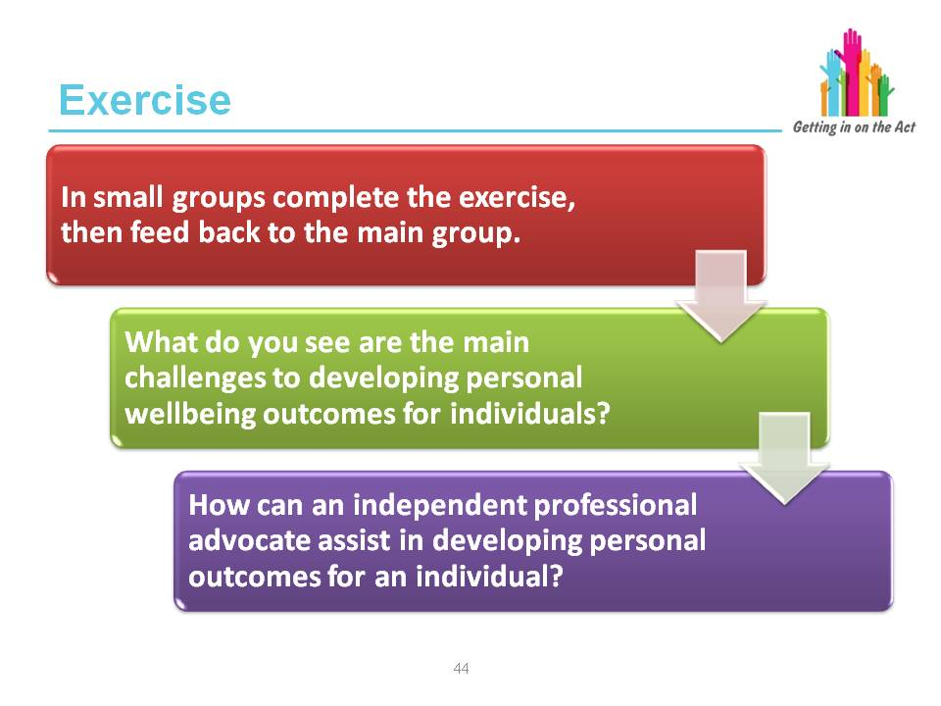

Exercise
In small groups complete the exercise, then feed back to the main group.
- What do you see are the main challenges to developing personal well-being outcomes for individuals?
- How can an independent professional advocate assist in developing personal outcomes for an individual?
Suggested answers on the next two slides.

Slide 46
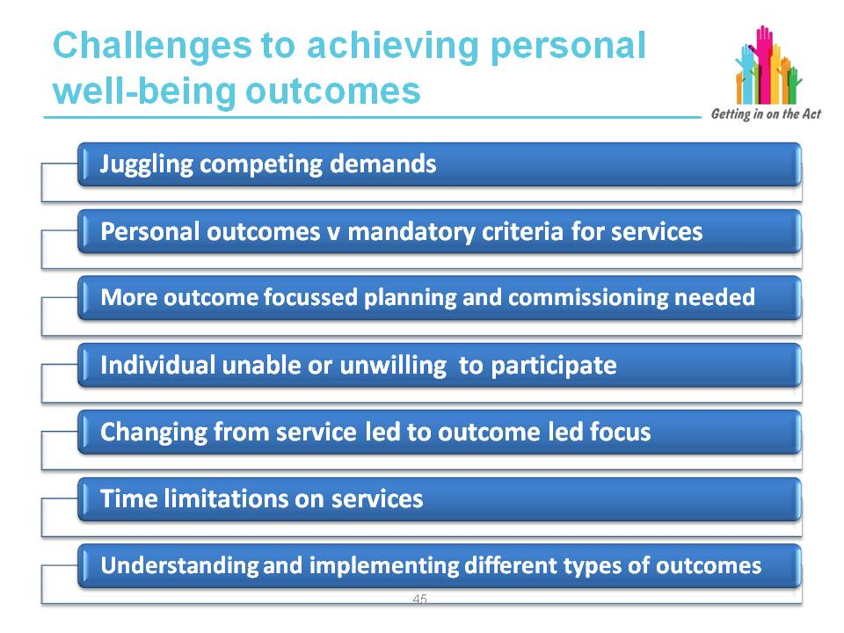

Facilitator notes

Responses could include:

- Juggling competing demands
- Balancing personal outcomes with mandatory eligibility criteria
- The need for more outcomes-focused planning and commissioning to develop a wider service landscape that is outcomes-focused, enabling and holistic
- The need to develop outcomes-focused and integrated commissioning strategies alongside a requirement to increase personalisation and citizen-directed support
- An individual is perceived to be unable to participate due to not being able to: understand information; retain information; use or weigh the information; or communicate their views, wishes, choices and feelings
- Changing the way services think about working with individuals from a
service-led focus to an outcomes-led focus
- Changing the way services have conversations about outcomes with individuals
- Time restrictions
- Understanding different types of outcomes, including: quality of life outcomes (being as well as you can); change outcomes (focus on short-term removal of barriers to quality of life or improving well-being); process outcomes (focus on how services are delivered, or how people feel they have been treated, but retaining the knowledge that the most important outcomes are those identified by individuals, with whatever level of support required, and these may be unique to that individual
- Individuals don't want to engage with services (for whatever reason) and can't fully engage in the decision-making process
- Barriers to enabling an individual to obtain a direct payment e.g. individual is lacking either capacity to manage or capacity to choose that cannot and must not be a barrier to them receiving a DP package with whatever support is required to make it function

Slide 47
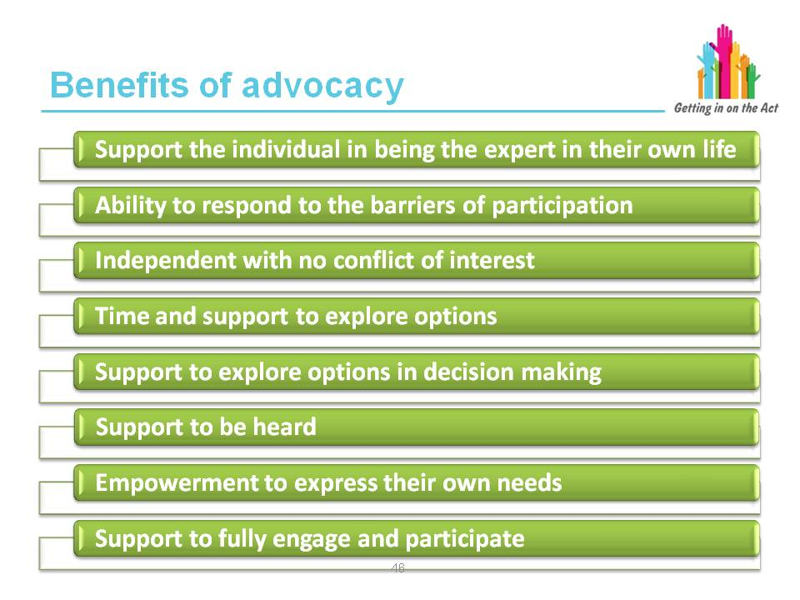

Facilitator notes

Possible responses:

How can an independent professional advocate assist in developing personal outcomes for an individual?

- They are able to respond to the barriers of participation
- They have no conflict of interest
- They are able to take the time to provide information, help someone to understand it and then support them to make decisions
- They can support people to fully engage and participate in the development of their own well-being outcomes
- Advocates can speak up for and with individuals who are not being heard
- Empower individuals who need a stronger voice by enabling them to express their own needs
- Actively support people to make informed choices

Slide 48
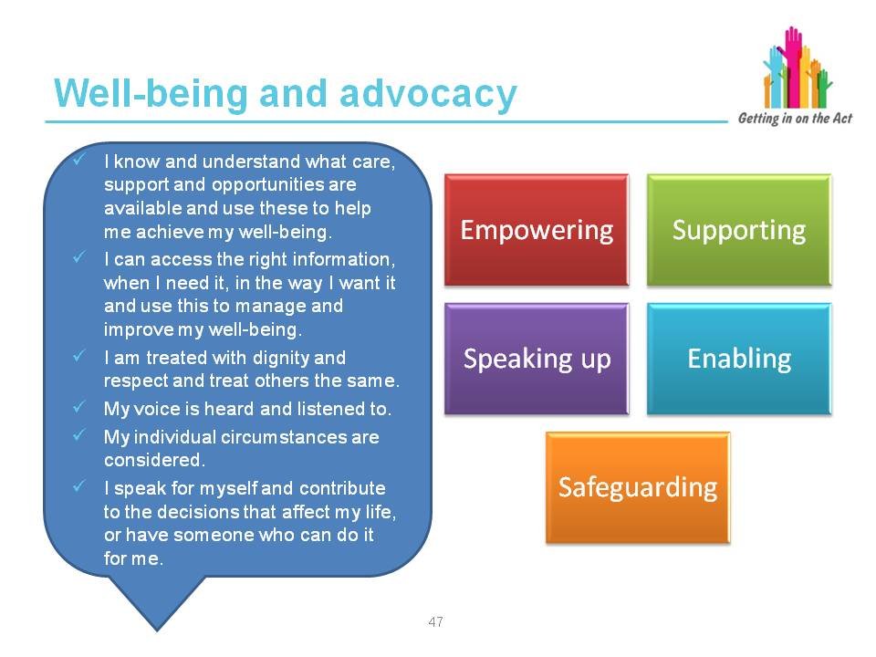
Facilitator notes
Well-being statement regarding securing rights and entitlements from ‘The National Outcomes Framework for People Who Need Care and Support and Carers Who Need Support’.
In 2011, the Welsh Government published its ambitions for the future of social care in Sustainable Social Services for Wales: A Framework for Action. This paper puts in place a framework for meeting the challenges facing social services in the next decade and beyond, and sets out the priorities for action.
Sustainable Social Services for Wales is supported in legislation by the Social Services and Well-Being (Wales) Act and will provide for a system that will be centred on the well-being of people who need care and support and carers who need support.
Care and support will be based on the well-being outcomes that people want to achieve, and on their rights and their responsibilities. All people, children, adults and carers have a right to be involved in decisions made about their care and support. Working in partnership with people will be key to securing well-being and preventing the development of people’s needs for care and support.
Objectives of the National Outcomes Framework
The National Outcomes Framework is made up of the well-being statement that contains outcomes to be achieved for people who need care and support and carers who need support, and the national outcome indicators that evidence well-being (as defined in the well-being statement).
Slide 49
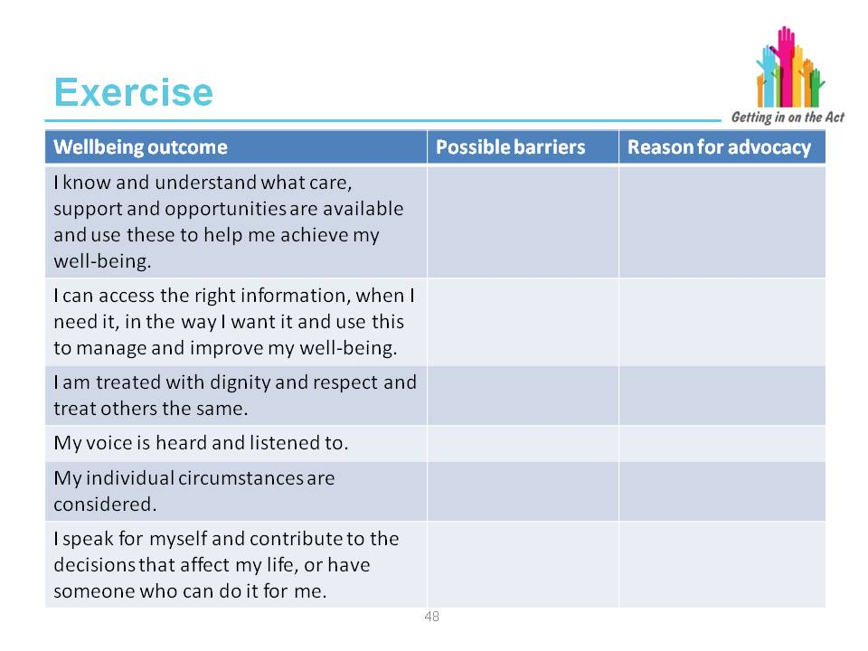
Exercise
Complete the table and outline barriers to the statements above and decide which of the five reasons for advocacy could enable the well-being statement to be achieved and how.
Slide 50
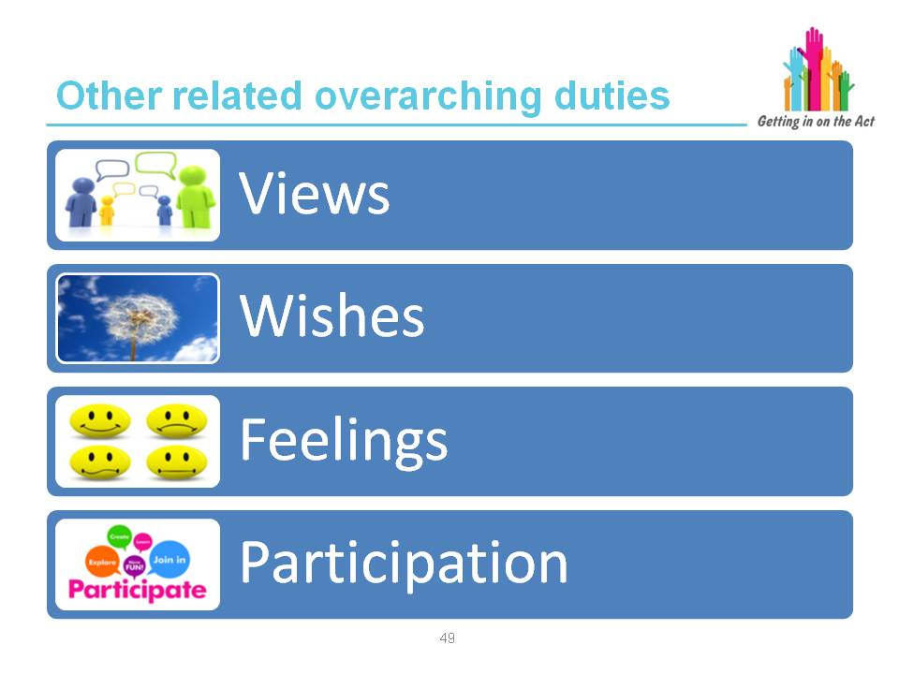

Facilitator notes
Part 10 Code of Practice (Advocacy)

“The overarching duties under Section 6 of the Act require that any person exercising functions under the Act must:
- in so far as reasonably practicable, ascertain and have regard to people’s views, wishes and feelings.
“In addition, any person exercising functions under the Act must:
- have regard to the importance of providing support to enable the individual to participate in decisions that affect him or her, to the extent that it is appropriate in the circumstances, particularly where the individual’s ability to communicate is limited for any reason.
“These overarching duties, together with the United Nation Principles and Convention under Section 7 of the Act are integral in understanding and assessing people’s well-being outcomes; what matters to people; and people’s needs for care and support to enable them to achieve their personal well-being outcomes.”
Slide 51
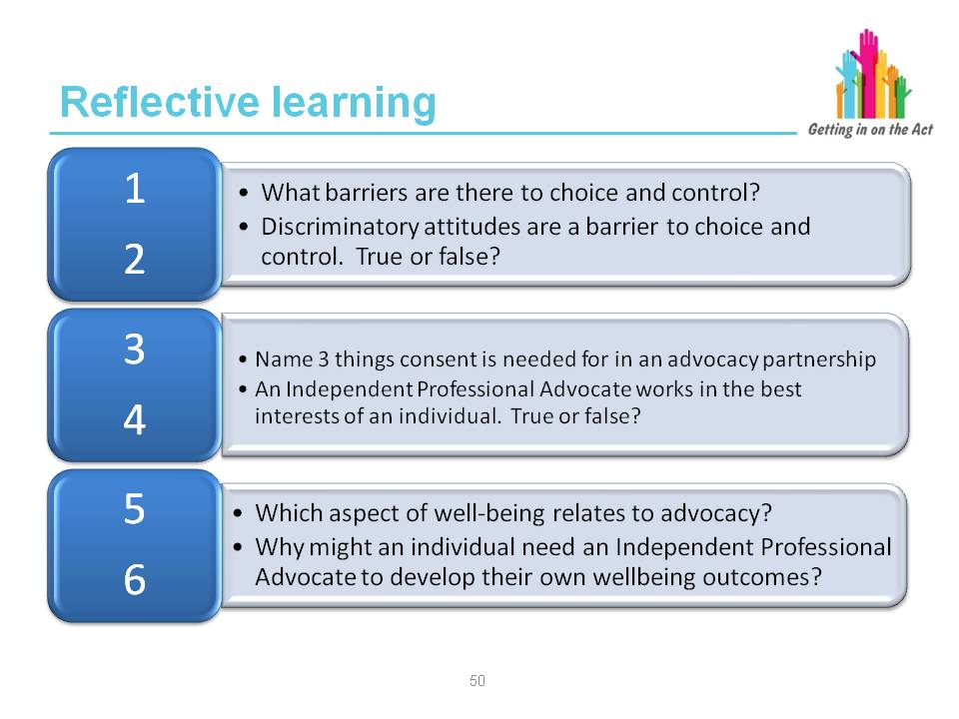
Facilitator notes
All the responses to these questions have been discussed in Modules 1 and 2.

Slide 52
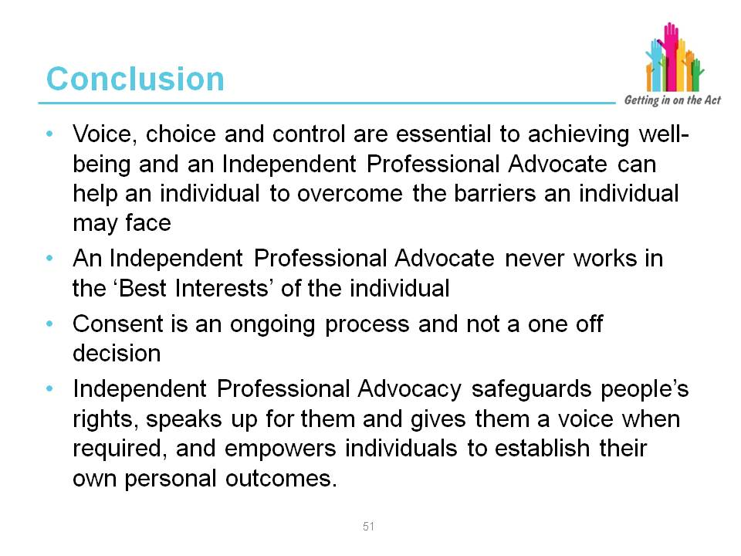
This concludes Module 2.
Ask the participants for any feedback on what they have learned and review what they had expected from the session to ensure all elements have been covered.

Establish if any other training needs have been identified.
Ask participants to fill in a feedback form about the module

Module 3 – Golden Thread

Slides 53
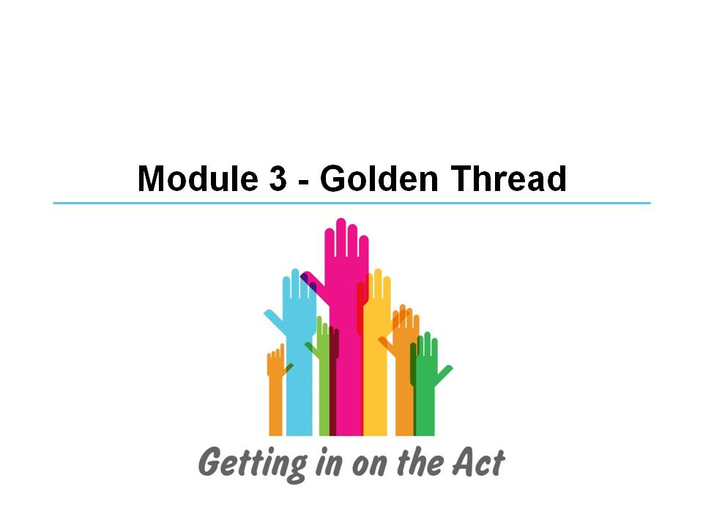
Slide 54
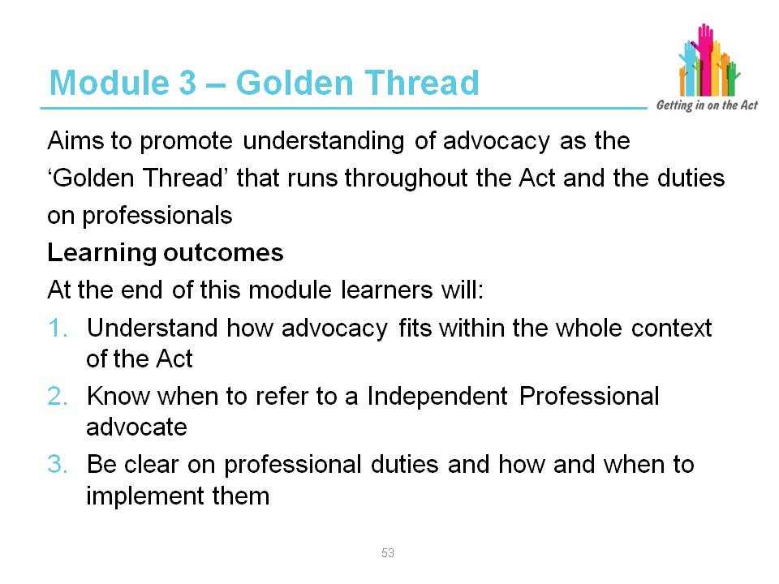
Facilitator notes
Advocacy is the ‘golden thread’ running through the Social Services and Well-being (Wales) Act 2014. This module will underpin the ‘golden thread’ principle by cross-referencing the use of advocacy principles with professional code of conduct / practice and the themes of autonomy and listening, ensuring that the learning reflects the policy intent and spirit of the Act.

Research has shown (Dunning 2005) there was generally very low understanding of the role, importance and impact of advocacy among professionals and those who might use it, and consequently very variable provision, access to and take up of advocacy services. This has been reinforced by a number of reports published by the Older People’s Commissioner for Wales, including the 2010 Scoping Study and 2014 business case for advocacy.
The Older People’s Commissioner for Wales has described the common misunderstandings that exist about advocacy, and while work has taken place to increase awareness and understanding, the need for such work remains. She reports that:

"The term advocacy is not consistently understood by residents, relatives, care
home managers and care home staff. A narrow view has emerged which sees it as synonymous with safeguarding, dispute resolution and complaints. There is a notable lack of awareness amongst residents in relation to the availability of advocacy and, in particular, how and in what circumstances they might access it. There also appears to be a lack of training about advocacy services available for care home managers and staff."

This lack of awareness is reinforced by a body of evidence that has been developed in England. In an advocacy survey carried out by Martin Coyle in January 2015 in respect of the Care Act, 68 per cent of respondents (from advocacy services covering 60 local authority areas in England) did not believe that local social services and health services would be able to identify and refer people who have a right to advocacy through the Care Act.

https://truevoiceblog.wordpress.com/2015/02/09/right-or-might/

The CQC in their report “Monitoring the Mental Health Act 2010 / 11 (p28) state that (our emphasis):

"The most common concern raised on MHA Commissioners’ visits in relation to IMHA was whether patients and their Nearest Relatives are aware of the nature of the service and how to get in contact with it. In a number of cases we found that staff who should be fulfilling the detaining authority’s legal duty to explain the IMHA service to patients did not understand it, or know of the existence of that service."

http://www.cqc.org.uk/sites/default/files/documents/cqc_mha_report_2011_main_final.pdf

Moreover, in the following year they report;

"The poorest performance was in providing patients with specific information of their right to request help from an Independent Mental Health Advocate (IMHA).There was no evidence that patients had been informed of their legal right to an IMHA in 21% of records reviewed in 2011/12.”

Monitoring the Mental Health Act 2011/12 (p24)

http://www.cqc.org.uk/sites/default/files/documents/monitoring-the-mental-health-act-in-2011-12-full-report.pdf
In developing their Framework for Action on Independent Living, Welsh Government acknowledged that an independent advocate would make a significant contribution to assist an individual with complex requirements in making decisions about their social support.

Both the Flynn Report and Ockenden Report highlighted the impact of neglect on individuals and provide clear examples of where with a clearer understanding of advocacy and access to advocacy services professionals must be able to better facilitate the voices of service recipients to be heard in expressing their views and feelings, and securing their human rights and interests through independent advocacy.
Slide 55
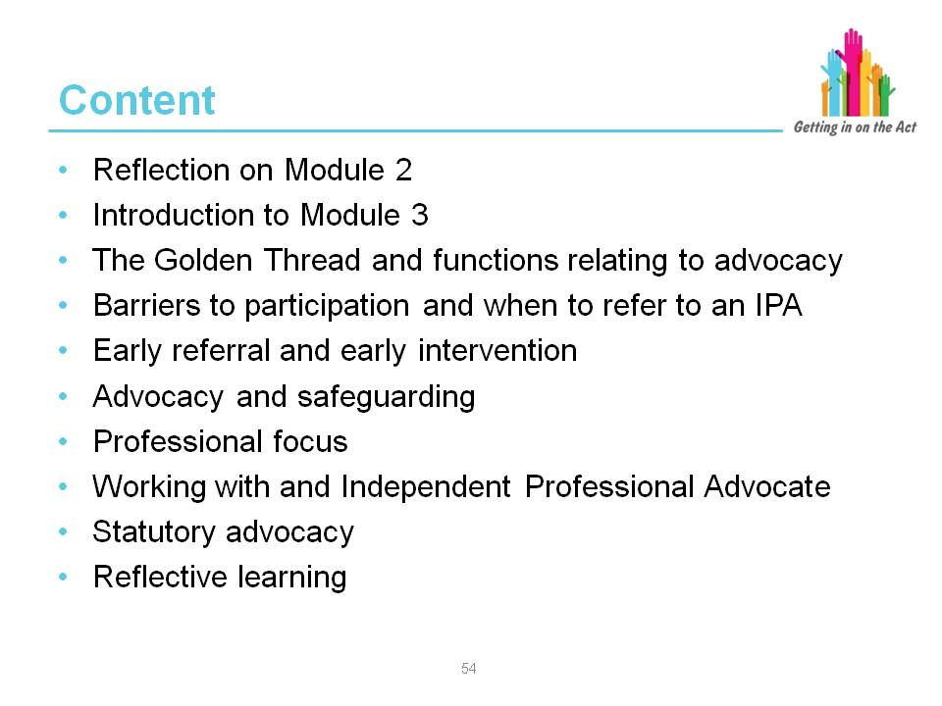
Facilitator notes
Complete a short icebreaker exercise here.
Ask the group how confident they feel about when they should be referring to an Independent Professional Advocate. Do they have any concerns and if so, what
are they?
Ask what the participants want to get out of this module.

Slide 56
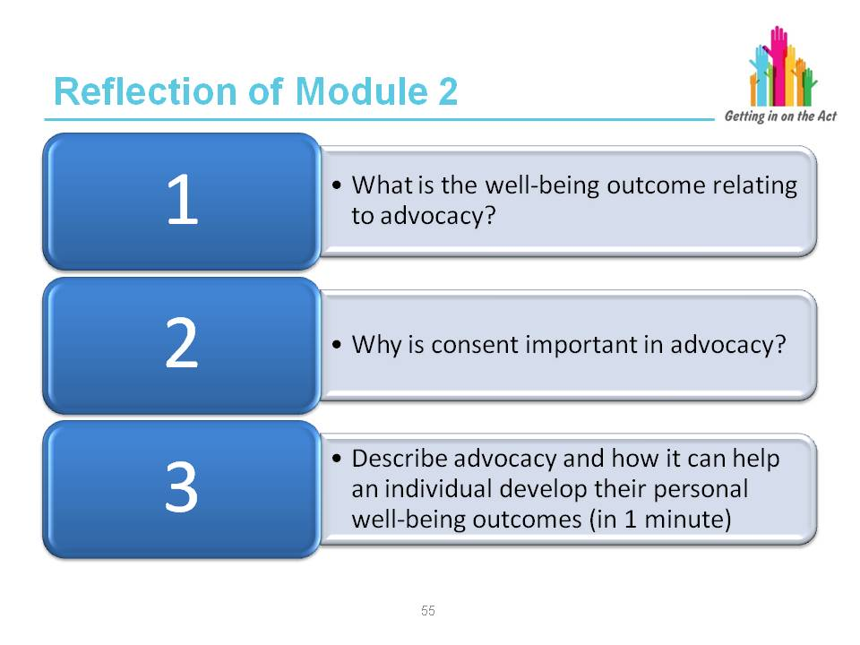
Facilitator notes
The learning required to answer these three questions can be found in Module 2.
Gather feedback from the group on any additional learning still outstanding and clarify where possible.

Slide 57
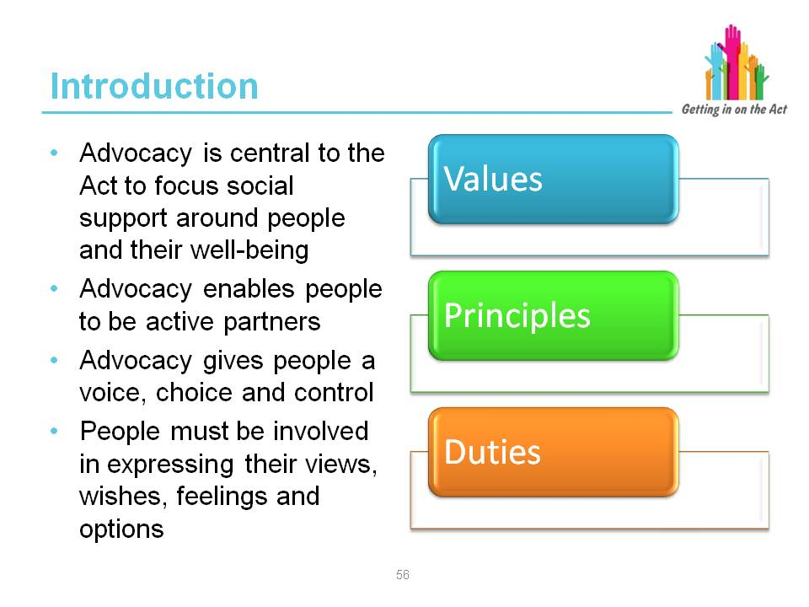

Facilitator notes
The benefits of advocacy
The Part 10 Code of Practice (Advocacy) says:
“Advocacy should be considered as an inherent element of the Act to focus social care around people and their well-being. Advocacy helps people to understand how they can be involved, how they can contribute and take part and whenever possible, to lead or direct the process.
“Through advocacy, people are active partners in the key care and support processes that identify and secure solutions through preventative services; information, advice and assistance; assessment; care and support and support planning; review and safeguarding.
“The Act:
- Places the person and their well-being outcomes at the centre of this new framework
- Gives them a voice in, and control over, achieving those outcomes
- Supports people to achieve their own well-being, and
- Measures the success of this care and support based upon all contributions to well-being; including people, families, supporters, formal and informal services

“Despite the barriers individuals may be experiencing, local authorities must involve people to help them express their views, wishes and feelings, to support them to weigh up options and to make decisions about their well-being outcomes. These requirements apply irrespective of where an individual is living, including the secure estate.”
Part 10 Code of Practice (Advocacy)

Slide 58
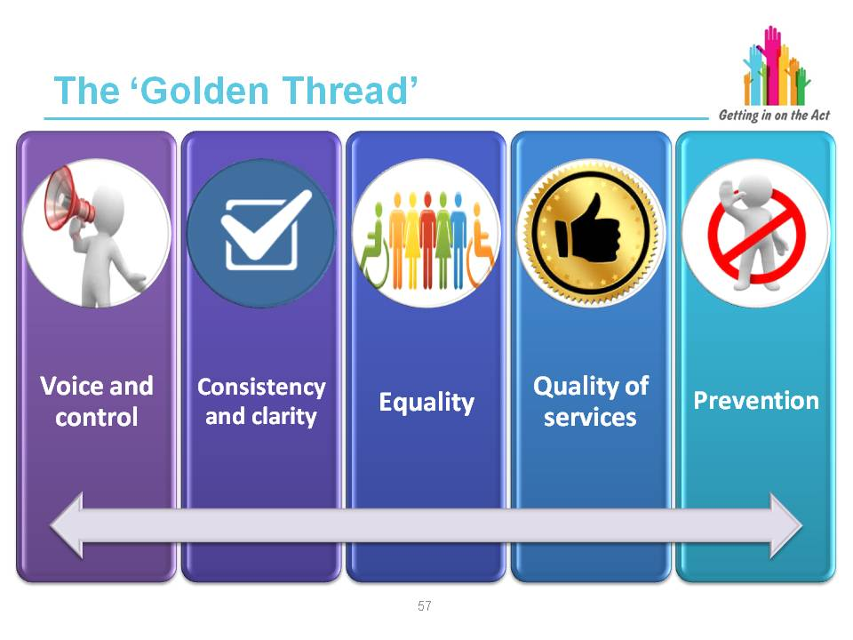
Facilitator notes
Welsh Government published its Framework for Action on Independent Living in September 2013 [1]. Its vision is of an inclusive and enabling society that recognises the rights of disabled people to self-determine their lives. As an outcome it aims to achieve an enabling society in which disabled children and adults enjoy the right to independent living and social inclusion.
The Framework for Action gives practical effect to the Social Model of Disability, which the National Assembly for Wales adopted in 2002 [2]. This recognises that people with impairments and chronic health conditions are disabled by the barriers created by society, and that the guiding principles of policy should be:
- To remove these barriers and create an enabling society
- To promote the rights and full inclusion of disabled people
Independent Living expresses the right of disabled people to participate fully in
all aspects of life. The Welsh Government supports the following definition of independent living:
“Independent living enables us as disabled people to achieve our own goals and live our own lives in the way that we choose for ourselves.”
The Framework also sets out how the Welsh Government is taking forward implementation of the UN Convention on the Rights of Disabled People [3].
This includes Article 19: the right to independent living, which states that:
- Disabled people have an equal right to live in and take part in the community
- Disabled people have the right to the same voice, choice and control as non-disabled people
The Framework’s key actions include:
Improved access to independent advocacy services.
Paragraphs 65-67 of the Code of Practice on Part 2 of the Act, and paragraph 46 of the Code of Practice on Part 3, state that any persons exercising functions under the Act in relation to adults who need care and support, and adult carers who need support, must have due regard to the United Nations Principles for Older Persons, the United Nations Convention on the Rights of the Child and the UN Convention on the Rights of Disabled People. In Part 2, paragraph 56 highlights in particular Article 19 of the UNCRDP, the right to Independent Living:
[1] Welsh Government’s Framework for Action on Independent Living http://gov.wales/topics/people-and-communities/equality-diversity/rightsequality/disability/framework-for-action/?lang=en
[2] Social Model of Disability
http://www.disabilitywales.org/social-model/
[3] UN Convention on the Rights of Disabled People
http://www.un.org/disabilities/convention/conventionfull.shtml
The Act provides the statutory framework to deliver the Welsh Government’s commitment to integrate social services to support people of all ages, and support people as part of families and communities.
It will transform the way social services are delivered, primarily through promoting people’s independence to give them stronger voice, choice and control. Integration and simplification of the law will also provide greater consistency and clarity to
people who use social services, their carers, local authority staff and their partner organisations, the courts and the judiciary.
The Act promotes equality, improvements in the quality of services and the provision of information people receive, and a shared focus on prevention and early intervention.
Chapter 2 sets out the distinct duties under the Act to ascertain people’s views wishes and feelings and provide support to enable people’s participation in decisions that affect them. To have voice, choice and control, an individual must be able to feel they are a genuinely equal partner in their interactions with professionals. It is, therefore open to any individual to exercise choice and to invite any advocate to support them in expressing their views, wishes and feelings.
It is a principle of the Act that a local authority responds in a person-centred,
co-productive way to each individual’s particular circumstances. Individuals and their families must be able to participate fully in the process of determining and meeting their well-being outcomes through a process that is accessible to them.
The process must ensure that people are empowered to express their needs and are able to participate fully as equal partners. This must include enabling an individual to indicate that they want to have someone sitting alongside them when weighing up options and making decisions about their well-being outcomes.
The importance of family and friends in assisting the person to engage and participate fully is fundamental. Participating fully enables the individual to clarify, express and have their views, wishes and feelings heard, acknowledged and acted upon; and feel empowered and in control of the process. Family and friends are only one element of an effective advocacy framework. Chapter 8 sets out the different forms of advocacy.
A key role of the information advice and assistance service which must be secured by a local authority under Part 2 of the Act, will be to provide individuals with information about the range of advocacy services in their area and to assist them to access it where required as part of achieving their well-being outcomes. This will include advocacy support to access the service itself.

Slide 59
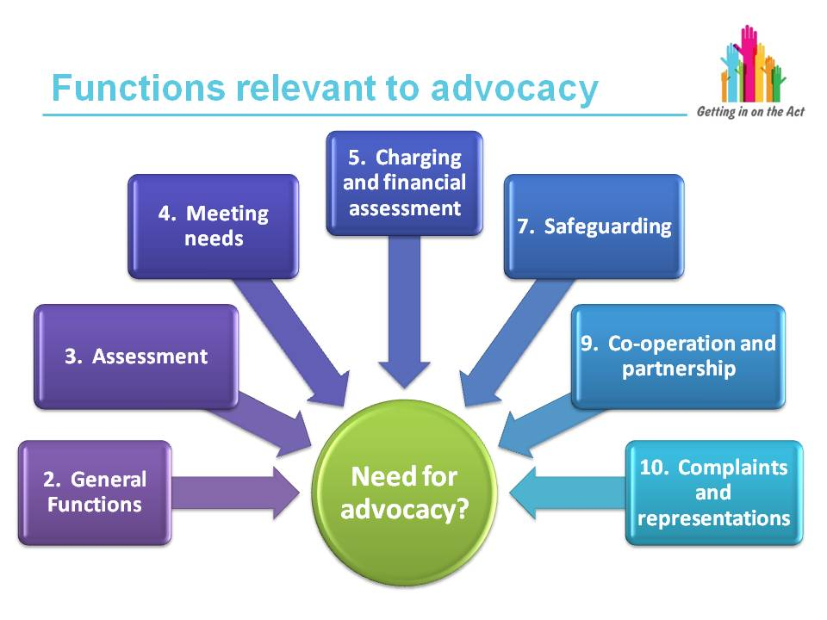
Facilitator notes
Consistent with the commitments to secure strong voice, choice and control, the specific code on advocacy, supplemented by all relevant codes of practice issued under the Act, enable local authorities and individuals, in genuine partnership,
to consider the range of advocacy support available and put the necessary arrangements in place. This will include the specific requirements on the local authority to arrange an independent professional advocate to support the individual wherever a local authority exercises a relevant function under the Act in relation to that person.
Additional information on the functions relevant to advocacy can be found in Part 10 Code of Practice (Advocacy)

http://gov.wales/docs/dhss/publications/151218part10en.pdf
Slide 60
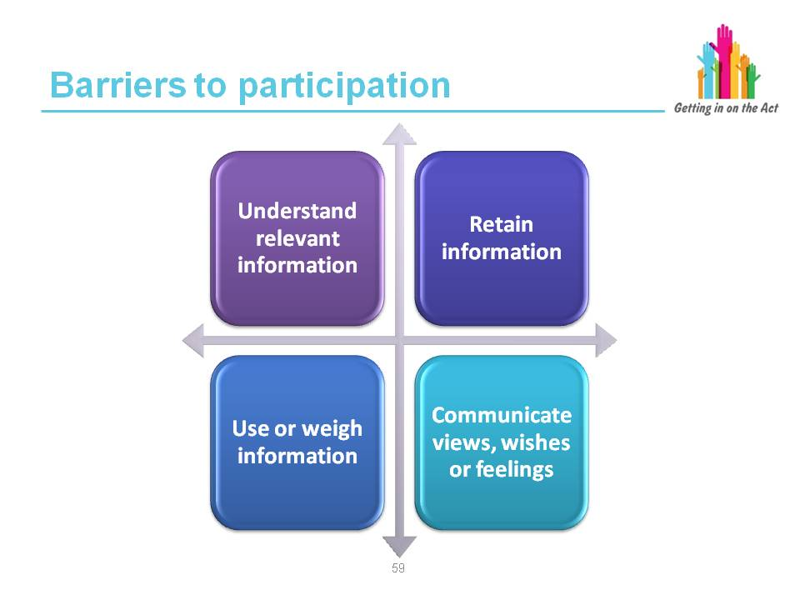
Facilitator notes
The Code says that local authorities must, in partnership with each individual, consider whether that individual is likely to experience barriers to participating fully in determining their well-being outcomes and reaching a conclusion on their needs for advocacy support. Key barriers will include issues and situations that will impair individuals’ ability to:
- Understand relevant information
- Retain information
- Use or weigh information
- Communicate their views, wishes and feelings.
Understanding relevant information
Many individuals can be supported to understand relevant information, if it is presented appropriately and if time is taken to explain it. Some individuals, however, will not be able to understand relevant information.
Retaining information
If an individual is unable to retain information long enough to be able to weigh up options and make decisions, then they are likely to be experiencing barriers in engaging and participating in determining their well-being outcomes.
Using or weighing the information as part of the process of being involved
An individual must be able to weigh up information to participate fully and express preferences for or choose between options. For example, they need to be able
to weigh up the advantages and disadvantages of moving into a care home or terminating an undermining relationship. If they are unable to do this, they are likely to be experiencing barriers in participating fully in determining their well-being outcomes.
Communicating their views, wishes and feelings
An individual must be able to communicate their views, wishes and feelings whether by talking, writing, signing or any other means, to aid the decision process and to make priorities clear. If they are unable to do this they are likely to be experiencing barriers in participating fully in determining their well-being outcomes.
If a person is experiencing one or more of these barriers and this is because of an impairment of, or disturbance in, the functioning of the mind or brain, the person may lack capacity to make a decision and an assessment of their capacity under the Mental Capacity Act 2005 should be made. This may affect the type of advocacy which is appropriate to be provided for the person.
Part 10 Code of Practice (Advocacy)

Some people with mid-stage or advanced dementia, significant learning difficulties, a brain injury or mental ill health may experience barriers to their full participation in decisions. But equally, a person diagnosed with Asperger’s may do too, as may a frail older person who does not have a diagnosis but is confused as a result of an infection, or a person who is near the end of their life and appears disengaged from involvement and decision-making. Within this context, it is the person’s ability to communicate their views, wishes and feelings that is fundamental to their participation rather than any medical diagnosis or specific condition.

Exercise
In small groups discuss what intellectual, physical, emotional, psychological or sensory issues there may be to each of the 4 barriers.
Remember that this is not necessarily about lacking capacity and that other barriers to participation may exist for individuals.
Consider what questions you might want to ask your client to establish what barriers they may be experiencing.
Key learning point
Local authorities must in partnership with each individual, consider whether that individual is likely to experience barriers to participating fully in determining their
well-being outcomes and reaching a conclusion on their needs for advocacy support.

Slide 61
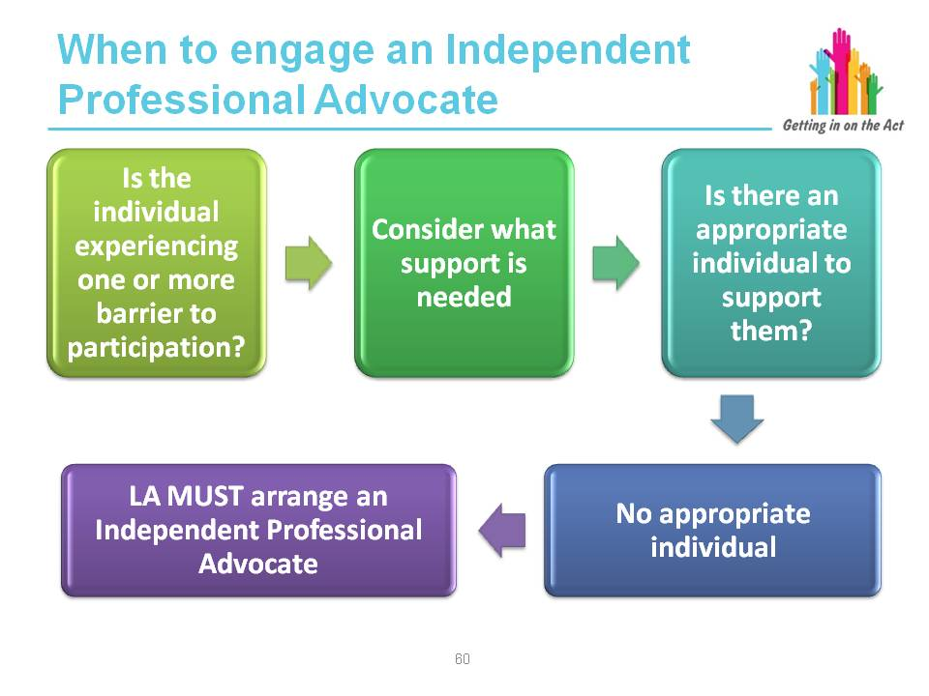
Facilitator notes
Local authorities have significant experience of recognising the factors that impact on individuals’ ability to engage and participate in shaping the services and support necessary to enable them to lead fulfilled lives.
Each of the codes of practice specifically recognises and requires professionals and individuals to reach a judgement about the role advocacy can contribute.
Local authorities must arrange for the provision of an independent professional advocate when a person can only overcome the barrier(s) to participate fully in the assessment, care and support planning, review and safeguarding processes with assistance from an appropriate individual, but there is no appropriate individual available.
Participating fully enables the individual to express or have represented and taken into account their views, wishes and feelings; that they understand their rights and entitlements; the decision making process; what matters to them; the personal well-being outcomes that they wish to achieve; the barriers to achieving those outcomes, and the options and choices available to them.
Please note: Chapters 20 and 21 of the Part 10 Code of Practice give clear guidance on advocacy for looked after and other specified children. If there are learners in your group who work with children then it will be important for you to be familiar with these chapters. Of particular note is:
99. When a child or young person believes that a concern or problem is not being resolved and they intend to, or are considering, making a representation, local authorities must ensure that entitled children are advised of the availability of independent advocacy services and support specified children to access those services. Rights to advocacy do not extend to a parent or another person making a complaint on behalf of an entitled child but these individuals or other person may be invited by the child to advocate on their behalf.

Part 10 Code of Practice (Advocacy)

Slide 62
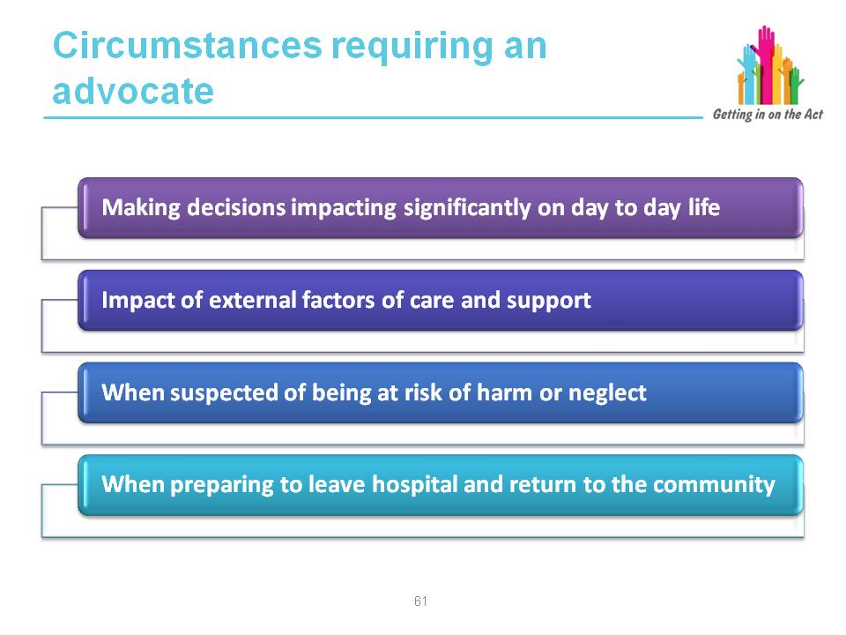

Facilitator notes
“Chapter 8 (of the Part 10 Code of Practice on advocacy) sets out the full range of local authority functions when local authorities in partnership with an individual must consider the role of advocacy. There are particular circumstances and periods of change or transition which will be significant to the individual and when their needs for advocacy may be heightened. These include, but not exclusively:
“When making decisions that will have a significant impact on their day-to-day life including:
- Assessment, care and support planning, reviews
- Safeguarding
- Accessing information, advice and assistance
- Where they are going to live
- The assessment of, or changes to, informal care and support arrangements
- Moving from receiving care and support via a care and support plan, or support plan if they are a carer, to receiving care and support from preventative well-being support in the community

“When external factors impact on their care and support arrangements, for example: provider failure; care home closure; changes of management or ownership arrangements in care homes
“When suspected of being at risk of harm or neglect, subject of safeguarding concerns, including when subject of any enquiry under Section 126 of the Act (adults at risk) or Section 47 of the Children Act 1989 (local authority’s duty to investigate), action under Section 127 of the Act (adult protection and support orders), under Section 128 of the Act (duty to report adults at risk) or Section 130f the Act (duty to report children at risk), and
“When preparing to leave hospital and return to the community.”
Part 10 Code of Practice (Advocacy)

Key learning point
Ensuring individuals and those that support them have the information they need to understand and fully contribute to the decision-making process is a fundamental component to securing well-being. Decisions should be taken in full consultation with those concerned.

Slide 63
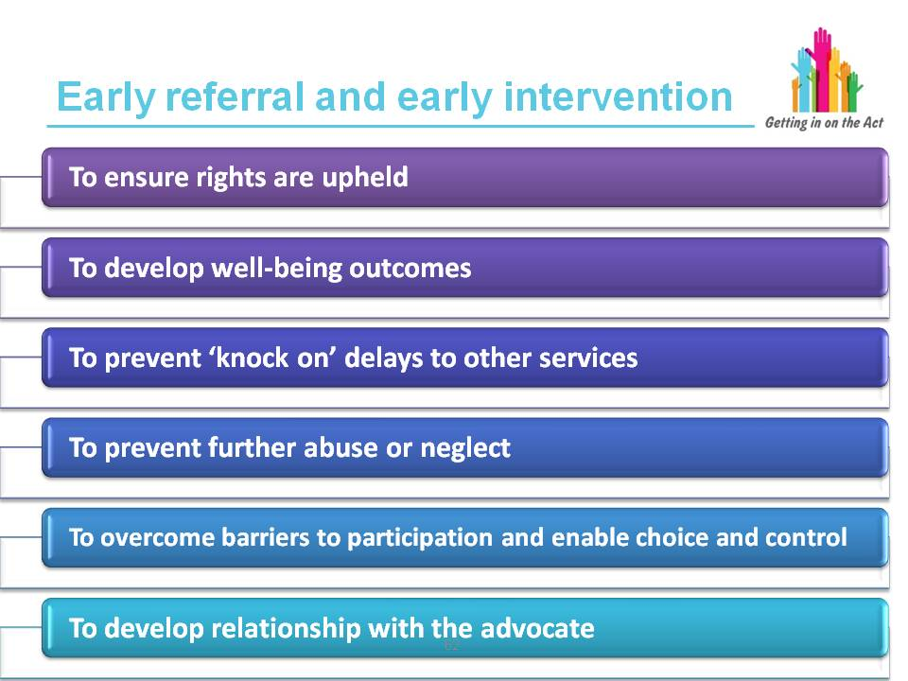
Exercise
In pairs, consider the process you have currently for referring to an advocate. What is working well and what can be improved to ensure there is no delay in getting an IPA?
What other reasons might there be that contributes to a delay in getting an IPA? Can these be overcome? If so, how? Share comments and ideas with the whole group.
Slide 64
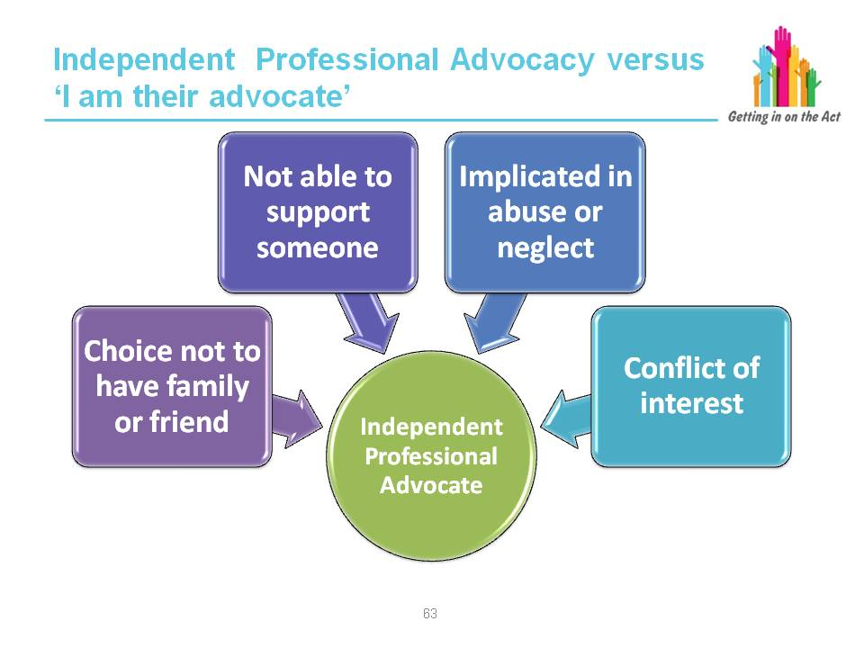

Facilitator notes
“When is an individual inappropriate to act as an advocate? Local authorities in partnership with the individual must consider whether there is an appropriate individual who can facilitate that individual’s involvement in the assessment, care and support planning, review or safeguarding process (see paragraph 49 above), and this includes three specific considerations. The appropriate individual cannot be:
- Someone the individual does not want to support them
- Someone who is unlikely to be able to, or available to, adequately support the individual’s involvement, and
- Someone implicated in an enquiry into abuse or neglect or whose actions have influenced a local authority decisions to consider adult protection and support order actions or protection activity in respect of a child
“Social care and other professionals play a key role in acting as an advocate on behalf of individuals as part of the exercise of their daily professional roles. However, there will be occasions where a conflict of interest may arise in relation to the decision being made. Professionals will need to be alert to situations where they believe that the objectivity or independence of the decision making process is, or could seen to be undermined. In such circumstances, the roles of other forms of advocacy outlined in Chapter 8 to secure individuals’ views, wishes and feelings and well-being outcomes must be considered.
“Appropriate individuals are expected to support, represent and facilitate the individual’s involvement in securing their well-being outcomes. While often this will be a family member, friend or someone in the wider support network it is likely that some people may not find it that easy to fulfil this role. For instance, a family member who lives at a distance and who only has occasional contact with the person; a spouse who also finds it difficult to understand the local authority processes; a friend who expresses strong opinions of their own prior to finding out those of the individual concerned. It is not sufficient to know the person well. The role of the appropriate individual is to support the individual’s full engagement and participation in determining their well-being outcomes.
“An individual’s wishes not to be supported by friends or family should be respected and if the individual has capacity, or is competent to consent, the individual’s wishes must be followed. An individual may not wish to be supported by a relative, for example, because there is a conflict of interest in moving forward.
“If an individual has been judged to lack the capacity to make a decision, then the local authority must be satisfied that it is in an individual’s best interests to be supported and represented by that family member or friend.
“It will clearly not be suitable for a person to be regarded as an appropriate individual where they are implicated in any enquiry of abuse or neglect against an adult or a child or whose actions have influenced a local authority’s decision to consider exercising their safeguarding responsibilities.”
Part 10 Code of Practice (Advocacy)

Exercise
Consider in small groups what issues could arise with the four areas above for professionals and family/friends, and why they might not be suitable to advocate for an individual.
When would it be appropriate for others to advocate?
Share examples back to the main group.
Slide 65
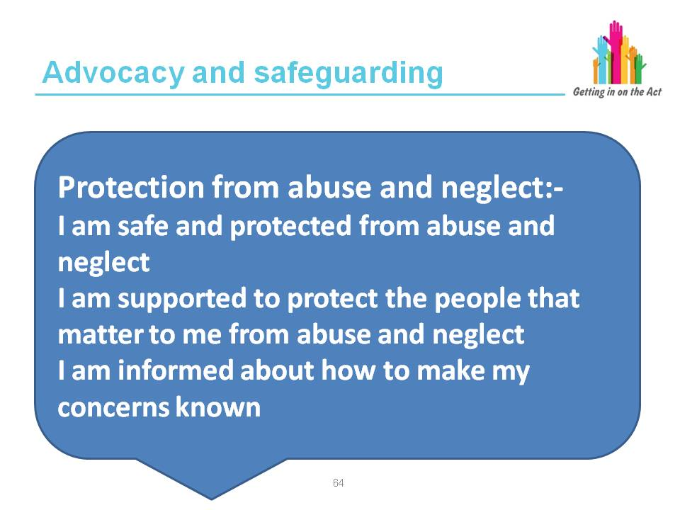
Facilitator notes
The quote on the slide is from the National Outcomes Framework.
Local authorities must have regard to the need to help protect adults and children from abuse and neglect. Local authorities are experienced in supporting adults in deciding how much risk they are able to manage. Chapter 11 (of the Part 10 Code of Practice on advocacy) identifies circumstances where it is inappropriate for someone to act as an advocate.
A human rights based approach includes participation. The participation of individuals, including children, in decision making is a component of human rights
as it reduces discrimination and helps to prevent abuse of power. Participation must be active, free and meaningful and give due attention to issues of accessibility, including access to information in a form and a language which can be understood.
The review of In Safe Hands (Welsh Institute for Health and Social Care, 2010) found that adults want safeguarding to be based on the following principles:
- People are not intrinsically vulnerable – this is contextual
- People’s views and wishes should guide how they are supported
- The starting point must be to believe people who raise concerns about abuse
- Safeguarding should be based on consent
- Adults with capacity should have the right to refuse intervention even if this leaves them at risk of harm
- The priority should be to stop abuse
- There is a crucial balance to be struck between autonomy and protection
- People at risk from abuse should be involved in decision-making processes
- People should be supported with strategies to keep themselves safe
- Safeguarding should be in the context of fully engaged citizenship
The All Wales Child Protection Procedures set out the principles for safeguarding children. Work with children and families should be:
Child-centred:
- Rooted in child development
- Supporting the achievement of the best possible outcomes for children and improving their well-being
- Holistic in approach
- Ensuring equality of opportunity
- Involving children and families
- Building on strengths, as well as identifying and addressing difficulties
- Multi- / inter-agency in its approach
- A continuing process
- Designed to identify the services required and monitor the impact their provision has on a child's developmental progress
- Evidence-based, derived from theory, research, policy and practice
Notes are from the safeguarding training module developed for the implementation
of the Social Services and Well-being Wales Act which can be found at:

http://www.ccwales.org.uk/learning-resources-1/safeguarding/
Slide 66
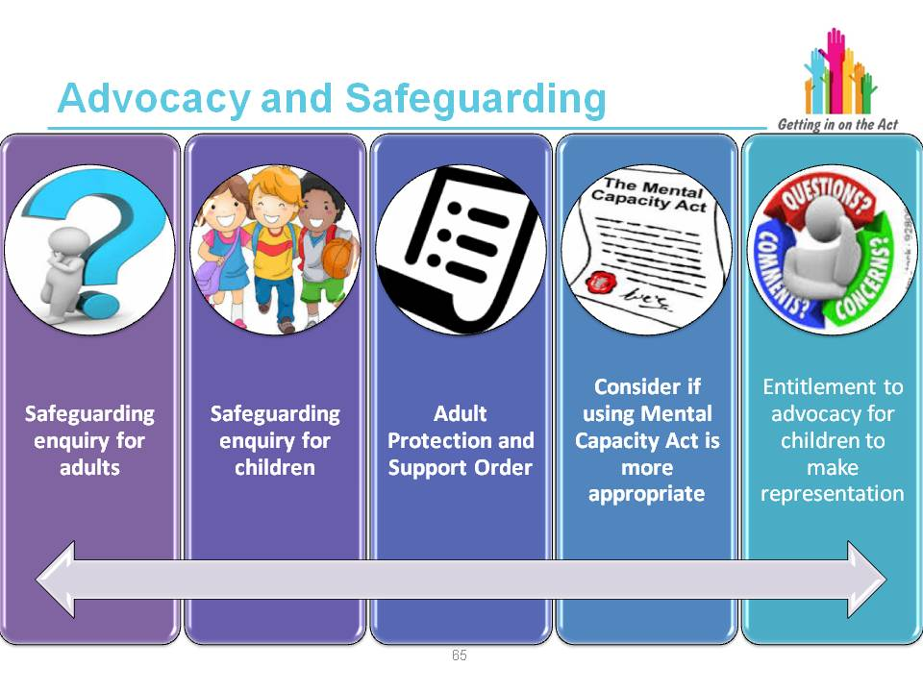
Facilitator notes
“The local authority in partnership with the individual, must consider and reach a conclusion on arrangements to appoint an Independent Professional Advocate to support and represent an individual who is the subject of a safeguarding enquiry under Section 126 of the Act or Section 47 of the Children Act 1989 or who is subject to arrangements for an adult protection and support order under Section 127 of the Act. Where an independent professional advocate has already been arranged under this Act or under the Mental Capacity Act 2005 then, unless inappropriate, the same advocate may be used.
“If a safeguarding enquiry needs to start urgently, it can begin before an advocate is appointed but one must be appointed as soon as possible. All safeguarding agencies need to know how advocacy services can be accessed and what their role is.
“It is critical in this particularly sensitive area that the individual is supported in what may feel a daunting process, which may lead to some very difficult decisions. An individual who is thought to have been abused or neglected may be so demoralised, frightened, embarrassed or upset that independent advocacy provided under the Act to enable them to express their views, wishes and feelings and participate fully will be crucial.”
Part 10 Code of Practice (Advocacy)

Research has shown that people who have used social care state that decisions are dominated by practitioners’ views of risk. People are more fearful of losing their independence. People in mental health services and residential care feel they have limited rights. People who are seen as at risk have fewer rights. Participation is essential to promoting rights in social care
The Right to Take Risks: Service Users’ Views of Risk in Adult Social Care, Joseph Rowntree Foundation, 2012
Slide 67
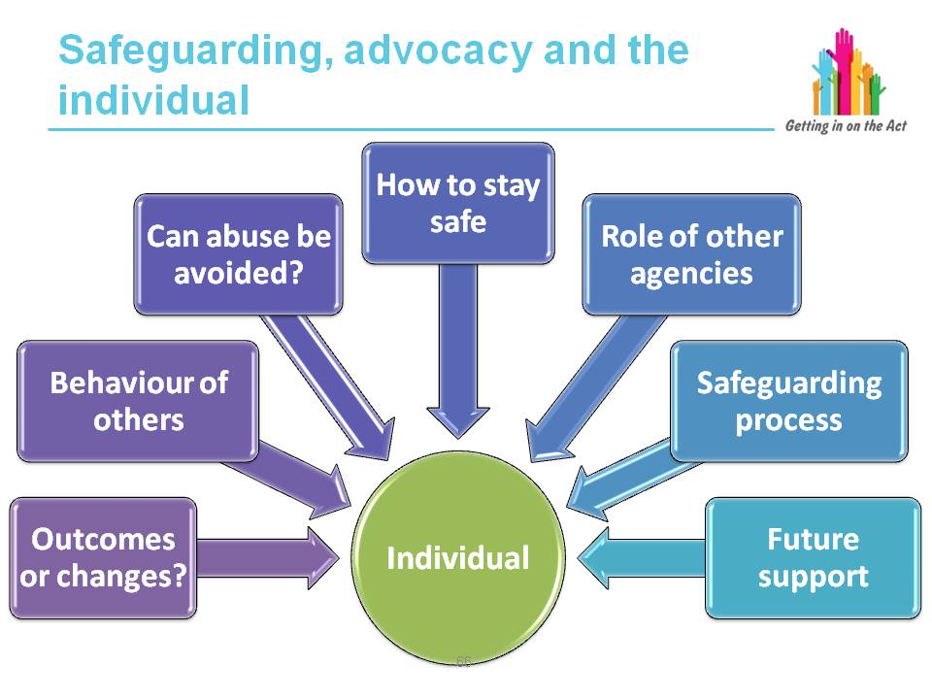
Facilitator notes
There are particular important safeguarding issues for independent professional advocates to address. These include assisting a person to:
- Decide what outcomes/changes they want
- Understand the behaviour of others that are abusive/neglectful
- Understand which actions of their own may expose them to avoidable abuse or neglect
- Understand what actions that they can take to safeguard themselves
- Understand what advice and help they can expect from others, including the criminal justice system
- Understand what parts of the process are completely or partially within their control
- Explain what help they want to avoid reoccurrence and also recover from the experience
Part 10 Code of Practice (Advocacy)

Key learning point
People need to be helped to understand what actions they can take to safeguard themselves without being made to feel at fault or in any way responsible for their
own abuse.

Slide 68
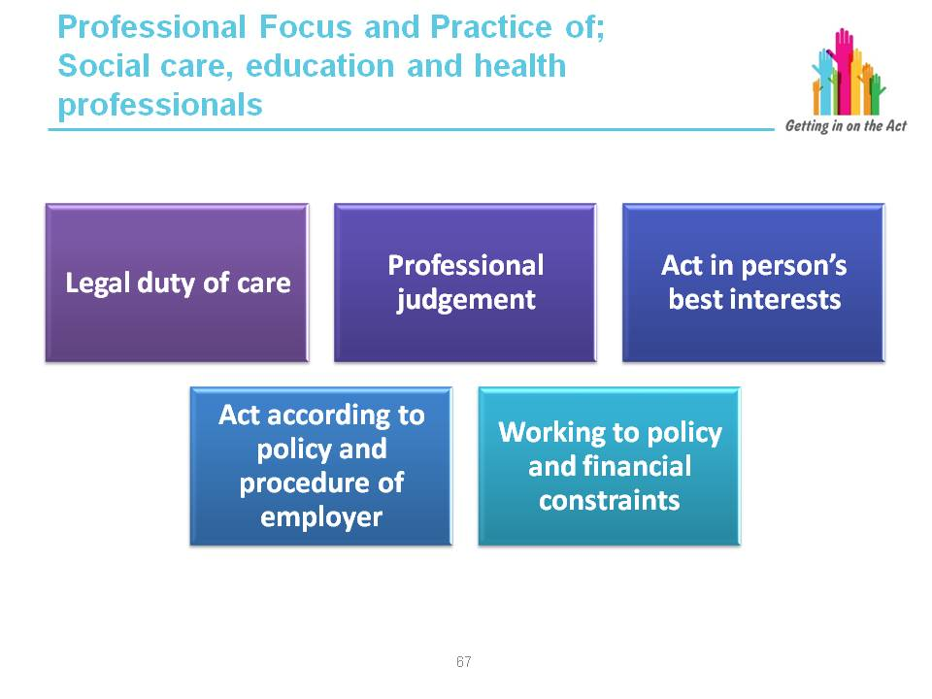

Facilitator notes
This slide is to note the differences in the roles of the professionals and the IPA. It is to emphasise the importance of independence and why the professional has a conflict of interest.

Independent Professional Advocacy
At the heart of advocacy is the concept of independence.

An independent advocacy service is designed to provide safeguards for people and it is imperative that the advocates providing the service should be free to support them, without any conflicts of interest, and to appropriately challenge service providers on people’s behalf. The subject of such challenge may be very broad and can include:

- Decisions made about a person’s care
- The upholding of a person’s legal rights
- The quality of care being provided

The role of the advocate is to support a person to make an informed decision with the person’s views and wishes being their sole focus. An advocate will help a person to understand his or her rights and the choices of action that are available, but ultimately, any decisions taken will be the person’s own.

Other professionals – formal advocacy

Social care, education and health professionals all have a role in supporting people to have a voice, to speak up for people and make sure their rights are respected and their views, wishes and feelings respected and taken into consideration. Often the support provided by independent advocates will be similar to that provided by these professionals in the course of their work, but there are some important differences of approach.

These professionals owe a person a legal duty of care and will use their professional judgement to assess how a person is and how that might be impacting on their actions. Using this judgement, they are required to act in a person’s best interests. The role of the advocate however, is to support the person’s own views or wishes, even where these may be different to, or conflict with, the best interests of the person as perceived by those professionals.

Those professionals are also required to act according to the policy and procedures of their employers. Hence they have to work within policy and financial constraints and may not be able to promote or offer what is being requested by the person. For advocates to be effective they need to be able to work outside these constraints and within the framework of their own professional practice.

Managing/supporting independence

It is very important, therefore that the principle of independent advocacy is clearly acknowledged and supported by those procuring services and social care providers and practitioners and other professionals with whom the advocates will be working.

Exercise (referral quiz)
Tell participants they will be discussing whether a group of scenarios should lead to a referral to advocacy or not. Make sure they have a copy of the Referral Quiz Sheet and read through the scenarios.

Give people 10 minutes to go through the quiz on their own, then ask them to get into small groups for five minutes and ask them to talk through the scenarios they found trickiest.

Read through all the scenarios with the whole group using information from the answer sheet, which provides information on specific referral scenarios.

What an advocate can do:

- Assist a person to understand the relevant processes
- Assist a person to communicate their views, wishes and feelings
- Assist a person to understand how their needs can be met
- Assist the person to make decisions about their care and support arrangements
- Assist the person to understand their rights under the Act
- Assist a person to challenge a decision or process made by the local authority; and where a person cannot challenge the decision even with assistance, then to challenge it on their behalf

Key learning point
The correct response to some of the scenarios is debatable, however the default position should be “when in doubt refer/ask the advocacy provider”.

Slide 69
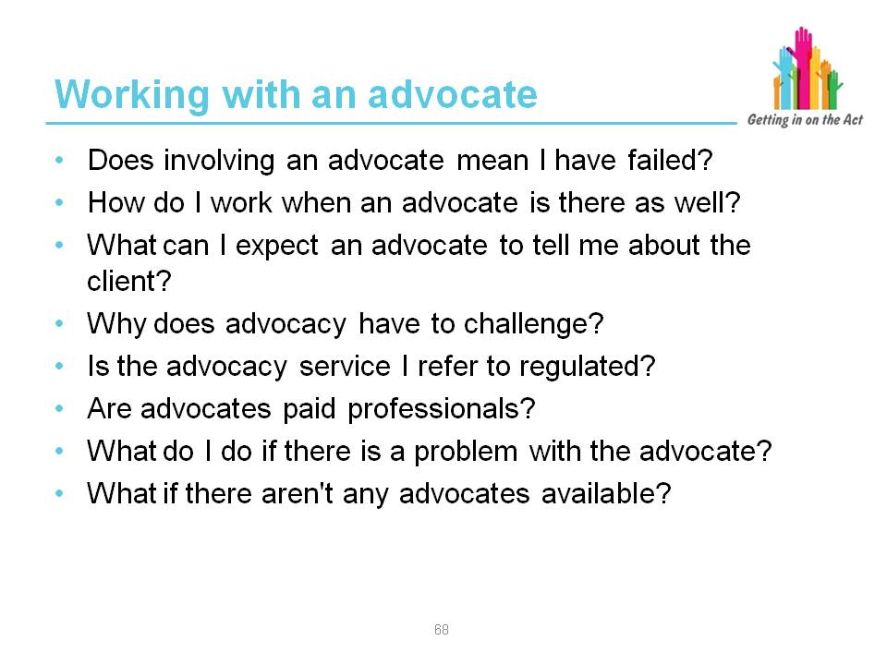
Exercise
Ask the group to discuss the questions on the slide and establish any concerns that may arise, as well as the ones above.
Facilitate a more organic group discussion with views gathered and learning shared.
Facilitator notes
Most of the questions have already been discussed in some way during the modules. This will be a good opportunity to check learning again and to draw out any other issues.
For the questions that are more technical in nature, more information has been provided below:
Q) Is the advocacy service I refer to regulated?
A) The Regulation and Inspection of Social Care (Wales) Act 2016 will require advocacy services to be regulated when the Act is implemented from 2017.
The Regulation and Inspection of Social Care (Wales) Act received Royal Assent on 18 January 2016.

Why we need the Act
The Social Services and Well-being (Wales) Act 2014 changed the foundation of the social care sector. The Regulation and Inspection of Social Care (Wales) Act 2016 is the next step in making social services in Wales sustainable.

What is the purpose of the Act?
The Act builds on the success of regulation in Wales and reflects the changing world of social care. It places service quality and improvement at the heart of the regulatory regime and strengthens protection for those who need it. Regulation will move beyond compliance with minimum standards, and focus more on the quality of services and the impact they have on people receiving them.

What the Act provides
- Establishes a regulatory regime that is consistent with the changes that are being delivered by the Social Services and Well-being (Wales) Act 2014
- Contributes to more effective public services by creating a regulatory regime that enables and empowers both citizens and service professionals
- Provides a robust and meaningful response to the clear lessons that have been learned from the exposure of failures in the system – most recently the Flynn Review
- The Care Council for Wales will become Social Care Wales, with a broadened remit, in April 2017
For more information and to view the Act, please visit the National Assembly for Wales website.
Q) What do I do if there is a problem with the advocate?
A) Complaints

The advocacy provider will have a written policy describing how individuals, including relevant stakeholders, can make complaints or give feedback about the service or about individual advocates. Where necessary, the organisation will enable people who use its services to access external independent support to make or pursue a complaint.
1. Advocacy providers should ensure that complaints are dealt with in a timely manner and in accordance with the organisation’s policies and procedures.
2. Advocates should be fully conversant with their organisation’s complaints procedure and be able to explain it in straightforward language to both clients and other relevant stakeholders.
3. Advocates should ensure that clients are made aware of their right to make a complaint about the advocate or advocacy service. This may involve giving clients a copy of the organisation’s complaints leaflet; explaining the various stages of the complaints process to them at the start and during the course of the relationship; and being open to criticism and suggestions without becoming defensive.
4. Where the complaint is from another professional e.g. social worker, care home manager or a relative of the client, the same high standards of professional conduct should apply.
5. All complaints received by the advocate in the course of their work, whether verbal or written, should be passed on to their line manager at the earliest opportunity.

From the Quality Performance Mark, Advocacy Code of Practice 2014
Slide 70
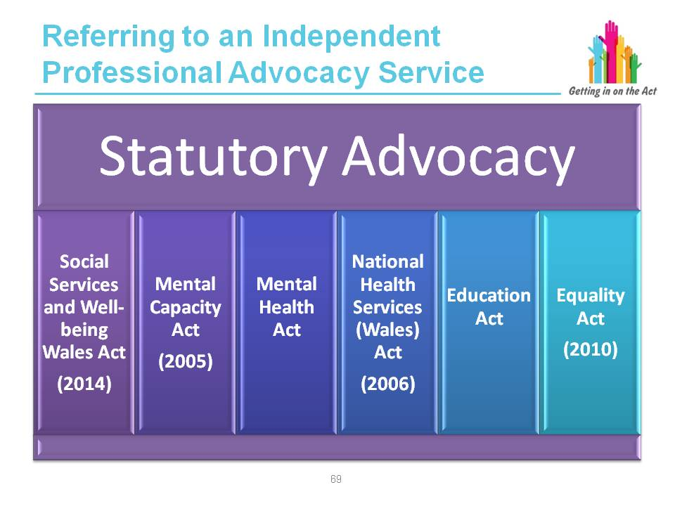
Facilitator notes
Publicising advocacy services
“Local authorities must ensure that individuals who may require or benefit from advocacy services are aware of and able to access it. This will require information to be available in accessible and appropriate formats and be able to reach out to the hardest to reach groups. The table at paragraph 50 identifies the key areas where local authorities must consider individuals’ needs for advocacy.
“Local authorities and local health boards must assess as part of their population needs assessment, the range of advocacy services in their area and secure and promote their availability as part of their portfolio of preventative services.
“Local authorities must as part of their general duties to provide information, advice and assistance ensure arrangements are in place to support people to prevent, delay or reduce their needs for care and support. This must include signposting individuals to advocacy services.
“Certain individuals may require advocacy services to enable them to access the information, advice and assistance service. Similarly individuals’ needs for advocacy services will be heightened because of where they are accommodated. For example, care homes and other forms of residential accommodation, sheltered housing schemes and shared lives schemes.
“Where local authorities commission services as part of their duties under the Act, they should consider including requirements on service providers to make information available about advocacy services in their area and how to access advocacy services.”
Deprivation of liberty consideration
“If following assessment the care and support a person requires in order to meet their well-being outcomes may amount to a deprivation of liberty the appropriate assessments and referrals must be made and completed. The local authority must also have regard to ensuring that any restriction on the person’s rights or freedom is kept to the minimum necessary. Restrictions should be carefully considered and reviewed. Any potential deprivation of liberty must be authorised, either by a Deprivation of Liberty Safeguards Authorisation under the Mental Capacity Act 2005 or by the Court of Protection as appropriate.
“Local authorities should consider how advocacy services can be utilised from the earliest possible opportunity where it is apparent that individuals may after a period of time fall within the Deprivation of Liberty safeguards because of their increasing needs for care and support.”
Existing advocacy services
“Similarly, there will be occasions when the different entitlements to statutory advocacy may overlap, for example:
- Section 130E of the Mental Health Act
- Section 332BB of the Education Act or paragraph 6D of Schedule 17 to the Equality Act 2010
- Section 35 of the Mental Capacity Act 2005
- Section 187 of the National Health Services (Wales) Act 2006

“In these circumstances, consideration should be given to maximise the opportunities to secure continuity in individuals’ advocacy needs, minimising duplication including the need for the individual to have to repeat their experiences and desired outcomes to different advocates. Wherever possible, the parties should seek to agree a single advocate to support the person.
“Similarly, during the discussions about individuals’ well-being outcomes, local authorities may identify a duty to provide an Independent Mental Capacity Advocate (IMCA) under the Mental Capacity Act 2005, for example when a decision needs to be taken about the person’s long-term accommodation.”
Part 10 Code of Practice (Advocacy)
Slide 71
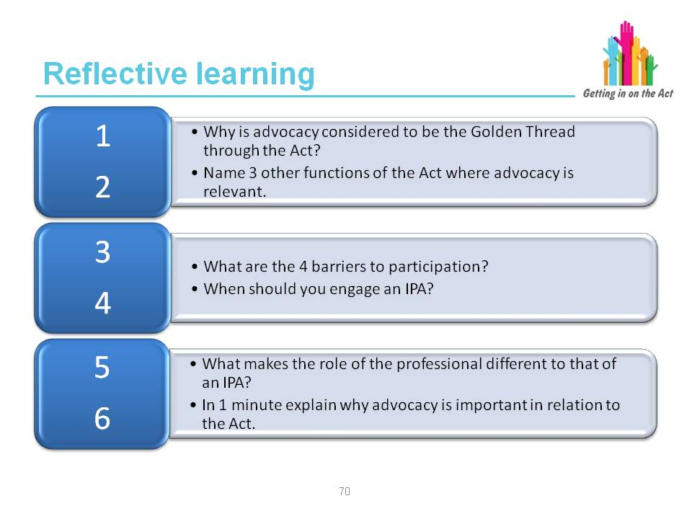
Slide 72
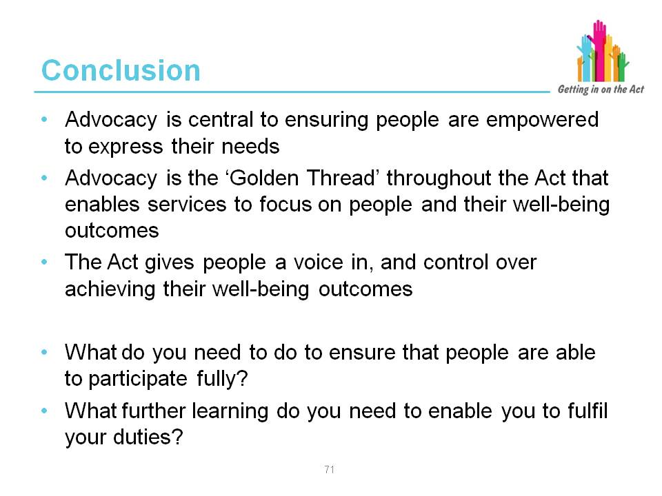
Facilitator notes
- The Act sets out what must and should be done to ensure that people are empowered to express their needs and are able to participate as equal partners.
- Advocacy should be considered as an inherent element of the Act to focus social care around people and their well-being. Advocacy helps people to understand how they can be involved, how they can contribute and take part, and whenever possible, to lead or direct the process.
- You will need to start thinking about what should change in your practice and in the way your organisation works.
- You should identify any further learning you need and the actions you will take to change the way you work.

4 Links to key resources

Links to regulations and codes of practice or statutory guidance
Social Services and Well-being (Wales) Act 2014. This is an Act of the National Assembly for Wales which reforms social services law in Wales. It was enacted in May 2014 and comes into force in April 2016. Its overall aim is to make provision to improve well-being outcomes for people who need social support, whether adults, children or carers.

Social Services and Well-being (Wales) Act 2014 Part 10 Code of Practice (Advocacy) http://bit.ly/ccwadvocacy1

Useful links to other materials

Advocacy Quality Performance Mark, Recognising Quality in Independent Advocacy, Code of Practice, Revised 2014
http://bit.ly/ccwadvocacy5

An Advocate’s Guide to Independent Non-Instructed Advocacy – Age Cymru Gwent, Age Concern Cardiff and the Vale, Age Concern Torfaen, Age Concern Morgannwg
http://bit.ly/ccwadvocacy6

Human Rights Explained – The British Institute of Human Rights
http://bit.ly/ccwadvocacy7

Mental Health Advocacy and Human Rights: Your Guide – The British Institute of Human Rights
http://bit.ly/ccwadvocacy8

Social Care Institute for Excellence (SCIE) Mental Capacity Act (MCA) resource
http://bit.ly/ccwadvocacy9

The Social Model of Disability
http://bit.ly/ccwadvocacy3

Talking Points: Personal Outcomes Approach (2012) – Joint Improvement Team
http://bit.ly/ccwadvocacy10

The Credibility Gap (explaining how and why people are disbelieved) – Martin Coyle
http://bit.ly/ccwadvocacy11

The National Outcomes Framework for People Who Need Care and Support and Carers Who Need Support
http://gov.wales/docs/dhss/publications/160331ss-outcomesen.pdf

The Right to be Heard: Review of IMHA services in England (summary) – Karen Newbiggin
http://bit.ly/ccwadvocacy13

The Scottish Independent Advocacy Alliance Non-Instructed Advocacy Guidelines:
A companion to the Code of Practice for Independent Advocacy
http://bit.ly/ccwadvocacy14

Transforming Social Services: Towards an Enabling Wales Toolkit
http://bit.ly/ccwadvocacy16

UN Convention on the Rights of Disabled People
http://bit.ly/ccwadvocacy4

Voice, Choice and Control – Older People’s Commissioner Wales http://bit.ly/ccwadvocacy17

Welsh Government’s Framework for Action on Independent Living http://bit.ly/ccwadvocacy2

Contact Details

Care Council for Wales
South Gate House
Wood Street
Cardiff CF10 1EW

Tel: 0300 3033 444
Fax: 029 2038 4764
Minicom: 029 2078 0680

Email: hub@ccwales.org.uk www.ccwales.org.uk

© 2016 Care Council for Wales

It is expressly prohibited to use any, or all, of this training resource for commercial gain.

Further copies and other formats:
This publication is also available in other versions, including as a pdf. Further copies of this document and other Care Council resources about the Social Services and Well-being (Wales) Act are available to download from the Information and Learning Hub

