**Learner’s workbook**

Session date:

Learner’s name:

Tutor’s name:

**Module 3 – Enhancing Advocacy Skills**

This handbook is designed to complement the session and support you to record your learning to provide a point of reference for future use. You are encouraged to complete the handbook as fully as possible and use it in a way that you feel is most appropriate to your needs.

As module 3 is practice-based, you are provided with notes pages to record your observations and learning from each workshop activity.

The handbook is for you to take away and will not be assessed or marked in any way.

**Learning outcomes for this module**

By the end of the session learners will be able to:

* Identify the key skills to be an effective advocate
* Recognise their own advocacy skills and relate them to their own experiences
* Demonstrate new and/or enhanced skills to complement their role as an advocate

**Exercise 1 – What makes a good advocate?**

**Overview:** In this exercise, learners are asked to note what they think makes a good advocate under the three headings ‘skills’, ‘personal qualities’ and ‘knowledge’.

Note some of the group’s responses here.

**Skills**

|  |
| --- |
|  |

**Personal qualities**

|  |
| --- |
|  |

**Knowledge**

|  |
| --- |
|  |

**How would you describe the difference between skills, personal qualities and knowledge?**

|  |
| --- |
|  |

From slides 5 and 7

**What makes a good advocate?**

|  |  |  |
| --- | --- | --- |
| **Skills** | **Personal qualities** | **Knowledge** |
| Active listening | Being organised | Understanding jargon |
| Being non-judgemental | Caring | Qualifications |
| Appropriate  non-verbal communication | Liking people | Knowing your way around the system |
| Good use of language | Wanting to help | Professional experience |
| Effective questioning | Kind | Contacts |
| Ability to build rapport | Good time-keeping | Legal knowledge |
| Assertiveness | Good researcher | Personal experience |

**Skills for advocacy**

Good communication skills are the building blocks of being an effective advocate.

Expressing our wants, feelings, thoughts and opinions clearly and effectively is only half the communication process…

…the other half is listening and understanding what others communicate to us.

From slides 9 and 10

**Listening effectively**

* Active listening
* Reflecting/clarifying
* Reading non-verbal cues
* Demonstrating a non-judgemental response and showing empathy

**Expressing yourself effectively**

* Appropriate use of language
* Effective questioning
* Awareness of non-verbal communication
* Rapport building
* Assertiveness

**Skills practice workshops**

A – Active listening

B – Demonstrating a non-judgemental response

C – Non-verbal communication (body language)

D – Appropriate use of language

E – Effective questioning

F – Rapport building

G – Assertiveness

**Workshop A – Active listening**



**Skills practice – My dream holiday**

Record your observations and learning from this exercise here.

|  |
| --- |
|  |

**Workshop B – Demonstrating a non-judgemental response**



**Skills practice – Split second judgements**

Record your observations and learning from this exercise here.

|  |
| --- |
|  |

**Workshop C – Non-verbal communication (body language)**

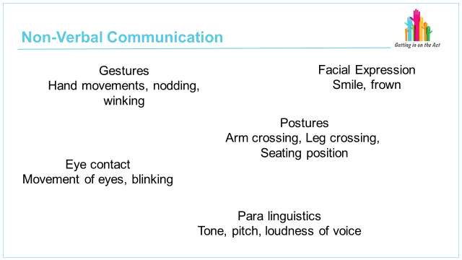

**Skills practice – Using non-verbal communication to express yourself**

Record your observations and learning from this exercise here.

|  |
| --- |
|  |

**Workshop D – Appropriate use of language**

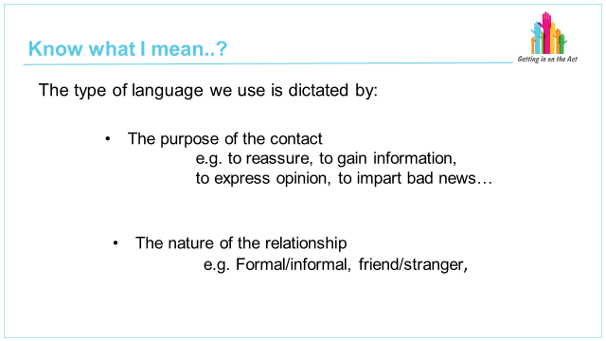

**Skills practice – Appropriate language and tone**

Record your observations and learning from this exercise here.

|  |
| --- |
|  |

**Workshop E – Effective questioning**

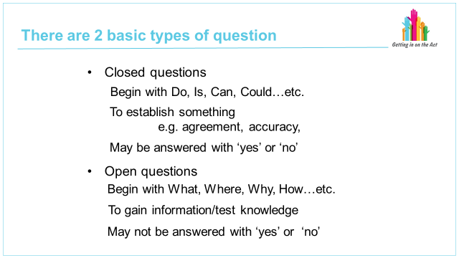

**Skills practice – What did you do last night?**

Record your observations and learning from this exercise here.

|  |
| --- |
|  |

**Workshop F – Rapport building**

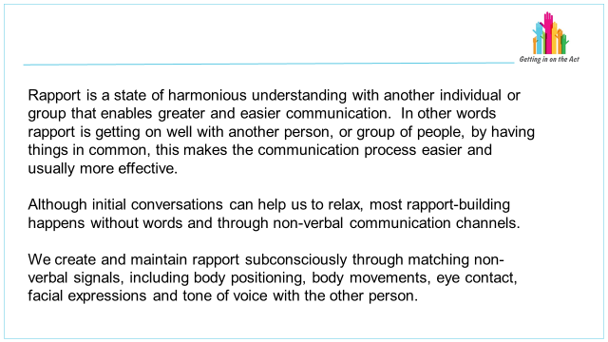

**Skills practice – Who makes the meals?**

Record your observations and learning from this exercise here.

|  |
| --- |
|  |

**Workshop G – Assertiveness**

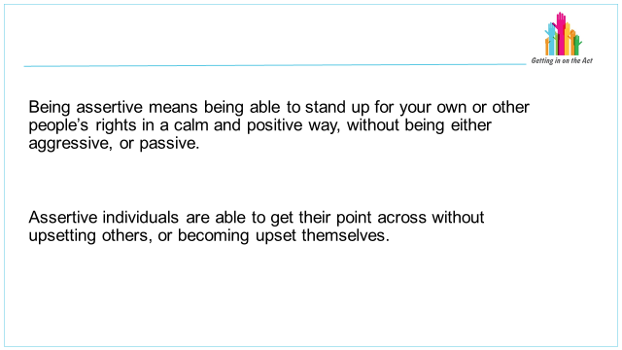

**Skills practice – A matter of opinion**

Record your observations and learning from this exercise here.

|  |
| --- |
|  |