SOCIAL SERVICES AND WELL-BEING (WALES) ACT
TRAINING MODULE AND GUIDE

Organisation Development Workshops for Managers

June 2016

Contents
2 Introduction 3
2.1 organisation Development Workshops for managers 3
2.2 Aims and learning outcomes 3
2.3 Expectations of participants 4
2.4 Materials 5
3 Workshop 1: Changing cultures 6
4 Workshop 2: Measuring progress 26
5 Illustrative documents 43
5.1 Illustrative session plans 43
5.2 Evaluation form 47
5.3 Workshop 1: Pre-workshop information sheet 48
5.4 Workshop 2: Pre-workshop information sheet 50

Introduction

Organisation Development Workshops for Managers
The Social Services and Well-being (Wales) Act 2014 introduces wide-ranging reforms that have major implications for the learning and development needs of the sector workforce. The Care Council for Wales has developed an evolving national learning and development plan to support its implementation. A key strand is the development of learning and development materials for those whose roles are most affected by the changes and consequently require training.

This training module complements the core learning materials that have been developed by the Institute of Public Care at Oxford Brookes University. The materials explore two key aspects of the implementation of the Act.

Workshop 1: The identification of the need for, and successful implementation of culture change to enable the implementation of the Act locally.

Workshop 2: The development of local performance measurement approaches that inform strategic planning and drive local improvement in the context of the National Well-being Outcomes and Performance Frameworks.

The workshops are designed to help managers with responsibilities for the strategic planning of future service delivery that meets the requirements of the Act, and in particular contributes to the National Well-being Outcomes.

This training module and guide has been written for workshop facilitators and includes exercises, suggested group discussions, and points of reflection that facilitators can use either in their entirety or to pick and choose from as they see
fit when tailoring the workshops to suit specific participants. Each workshop is designed as a half-day developmental activity and it is recommended that they are held not more than four weeks apart. Illustrative session plans, evaluation form and
pre-workshop information sheets are also provided.

Aims and learning outcomes

Workshop 1: Changing cultures
The first workshop will focus on the cultural changes needed to enable the implementation of the Act, and how participants articulate and plan for the changes relevant to their area of work.

By the end of the workshop, participants will:

- Have a clearer understanding of the implications of implementing the Act locally
- Be able to describe what this will look like locally
- Be able to articulate what changes and actions will be needed to deliver this effectively
- Be clear about what they need to do next in taking this change forward

Workshop 2: Measuring progress
The second workshop will focus on the measurement of performance needed to enable the implementation of the Act.

By the end of the workshop participants will:
- Have a better understanding of the importance of performance measurement in relation to the Act, particularly the Performance Measurement Framework
- Understand the main characteristics of effective performance measurement
- Be able to explain the rationale for the approaches needed locally for a range of different stakeholders
- Be clear about what needs to happen as next steps for them in taking this forward

Expectations of participants
The workshops are designed for managers who have a responsibility for the
strategic planning of services and the implementation of aspects of the Act locally.
It is a mandatory requirement that participants will have attended core learning modules and will be familiar with the Act at least at a theoretical level. The purpose of the workshops is to provide an opportunity to work through the implications of the Act in terms of culture change and performance management, and to plan for what needs to happen locally; they will not revisit the detail of the Act.

Participants will be required to carry out a pre-workshop exercise for each of the workshops, and these will form the basis of workshop activities.

The workshops are designed to be highly interactive with participants working through a series of exercises, and being provided with the opportunity to plan
next steps they need to take locally. Some theoretical material is offered but
the expectation is that managers will be familiar with change management and performance management theories; the focus is on the implications of the Act in these key areas.

Expectation of Workshop Facilitators
The two workshops offer an opportunity for developmental work rather than providing training, and require active and skilled facilitation.

It is suggested that potential facilitators should be:

- Experienced and skilful at facilitating group discussions, engaging a mix of people, and maximising the learning opportunity for all participants to ensure delivery of the learning outcomes
- Able to respond to the needs of individuals while maintaining a balanced approach for the whole group
- Knowledgeable about the implications of the Act for managers, including their responsibilities for delivering change

Materials
The materials required for each workshop are as follows:

- Pre-workshop information sheet, including the exercise
- For workshop 2, it is suggested participants are given a copy of the Social Services and Well-being (Wales) Act 2014 Code of Practice in relation to Measuring Social Services Performance
- Slides
- Evaluation sheet

In addition, the facilitator and participants will need access to flipcharts and pens.

Workshop 1: Changing Cultures

Pre-workshop information and exercise
A pre-workshop information sheet should be circulated beforehand to all participants; this should provide details of both workshops, as well as the pre-workshop exercise. It should be emphasised that the exercise will form the basis of the workshop activities and so must be completed beforehand. An example of a completed template is also provided, and facilitators may wish to use this one or create one relevant to specific groups of participants.

Pre-workshop exercise:
As a manager you will be responsible for leading and supporting the implementation of the Act within your particular area. You will need to plan for and deliver on the National Well-being Outcomes and Quality Standards. This may involve changes
for a number of different stakeholder groups depending on your area of work: for example, the teams you manage, the citizens you support, the communities you work within, the providers you work with, other agencies within your partnership arrangements, other local authority services.
To prepare for the first exercise, please spend some time thinking about what success will look like in terms of the culture that will be developed in one particular area in which you work. Please use the template overleaf to set out the service
area and/or group of people you are focusing on, the aspects of the Act that mean cultures will need to change for this group/service, what the culture will look like and where you are now.
Please bring this with you to the workshop.

PLEASE COMPLETE BEFORE ATTENDING WORKSHOP 1 AND
BRING WITH YOU TO THE WORKSHOP
What area and what group of people are you focusing on for this exercise?
(E.g. a specific team,
or group of teams; a provider type; a local community; parts of the local authority)
What aspects of
the Act require the culture change in this particular area? Why do cultures need to change? Is there a particular National Outcome driving the change?
What does the new culture need to look like?

Where are you now?

EXAMPLE OF A COMPLETED TEMPLATE
What area and what group of people are you focusing on for this exercise?  (E.g. a specific team,  or group of teams; a provider type; a local community; parts of the local authority) | Focus on the commissioning team for adult services.
What aspects of  the Act require the culture change in this particular area? Why do cultures need to change? Is there a particular National Outcome driving the change? | Requirement to work co-productively/collaboratively  with providers to deliver outcomes for individuals and develop/deliver the range of services needed in local communities; to help with population needs assessment.
What does the new culture need to look like? | Need to develop a culture of partnership working consistently across all provider groups, and have confidence to work collaboratively.
Where are you now? | One or two commissioning officers have developed good relationships with providers, but majority have more traditional procurement-led approach. Tend to be quite defensive about changing their way of working, and are mistrustful of providers.

Slide 1
An opportunity for managers…
- Two linked workshops exploring what it means to implement the Act locally
- Each workshop has a particular focus:
- Workshop 1: Changing cultures
- Workshop 2: Measuring performance
- Expectation that participants will do some preparatory thinking and a short exercise as the basis for activities during the workshop
- Expectation that participants will develop their own action plans at the end of each workshop.

Facilitator Notes
This workshop is the first of two which provide the opportunity to explore what it means to implement the Act locally looking at two specific areas:

- Changing culture: in particular the culture changes that are needed to enable the implementation of the Act, including how individual managers articulate and plan for the changes relevant to their areas of work
- Measuring performance: in particular the implications of the National Well-being Outcomes Framework and the National Performance Framework for local performance management practice, which informs strategic planning and drives improvement

Both workshops are designed to build on pre-workshop exercises and will provide the opportunity to explore practice more generally, and plan for actions to be taken locally.

Slide 2
Aims and learning outcomes
- This first workshop will focus on the cultural changes needed to enable the implementation of the Act, and how you articulate and plan for the changes relevant to your area of work
- By the end of the workshop you will:
- Have a clearer understanding of the implications of implementing the Act locally
- Be able to describe what this will look like locally
- Be able to articulate what changes and actions will be needed to deliver this effectively
- Be clear about what you need to do next in taking this change forward

Facilitator Notes
- This slide has animation.
- By the end of the workshop you will:
- Have a clearer understanding of the implications of implementing the Act locally
- Be able to describe what this will look like locally
- Be able to articulate what changes and actions will be needed to deliver this effectively
- Be clear about what you need to do next in taking this change forward

Slide 3
Our approach
- Assumes you bring an awareness of the contents of the Act, and its implications for you locally
- Provides an opportunity for you to reflect on what this means for you in your role as a manager
- Gives you space to discuss the opportunities and challenges for cultural change locally
- Enables you to plan next steps and for the longer term

Facilitator Notes
- It is important to emphasise the expectation that participants will need to engage in the activities to get the most out of this – it is not a chalk and talk exercise!
- It may be appropriate at this stage to discuss confidentiality within the group if it is a mixed group and there is any sensitivity in discussing local challenges.
- It is important that participants take this opportunity to plan next steps for themselves in taking forward local culture change.
- Ask the group: are they happy with this approach, and do they have any comments or questions?

Slide 4
Agenda
- Introduction
- What needs to be different and how do we
describe it?
- Who do we need to work with?
- What do we need to do to deliver the change?
- Planning next steps

Facilitator Notes
- You may wish to add timings to this slide, including showing a break (see the illustrative session plan).

Slide 5

What makes up our organisational culture?

Facilitator Notes
- The culture of an organisation (or team) is informed and created by a number
of factors. For example, the practices, principles, policies and values of an organisation will form its culture. The culture of an organisation decides the way employees behave among themselves, as well as with the people outside the organisation, for example:
A team may be used to behaving in a paternalistic way with service users and will need to make a shift to working co-productively, taking a user-led approach
An organisation may have previously been driven by written guidelines and procedures, and need to shift to empowering staff to being creative in their problem solving
A department may have a protective attitude to its own work and resources, and resist working collaboratively with other departments or other organisations; it will need to change to enable partnership working
- Ask the group what else contributes or embodies the culture of their organisations? What else would they expect to see on this diagram?

Slide 6
What needs to be different?

Facilitator Notes
- There’s animation on this slide with “People” appearing first as it’s central to the implementation of the Act.
- This is a brief reminder that the Act aims to:
Put people and their well-being at the centre of care and support
Rebalance the focus to prevention and earlier intervention
Promote partnership working, collaboration and co-production
- Ask the group whether they think there are any key words missing from the diagram.

Slide 7
Example of changes to culture and practice

Facilitator Notes
- These two slides are a reminder of what was suggested in the core learning materials as the key changes to culture and practice in two specific areas –
firstly in adult services, then children’s services.
- Talk through one of these briefly (eg how attitudes to risk might need to change for practitioners) as an example of how culture change will be needed.

Slide 8
Example of changes to culture and practice

Facilitator Notes
- This slide looks at children’s services. Again talk briefly through one example (for example, the shift from being service-led to being person-centred) to illustrate the type of culture change needed.
- Ask the group for other examples – particularly look for partnerships with other agencies, with providers and with communities.

Slide 9
What does change look like for you locally?
- In pairs:
- Describe to your partner the culture change you identified in your pre-workshop exercise.
- Discuss:
What do you notice about the type of changes needed?
What do you notice about who needs to change?

Facilitator Notes
- Facilitator to set up a brief discussion about culture change locally.
- In pairs, talk through your pre-workshop exercise and briefly describe what culture change will be needed.
- Ask the pairs to consider: what do you notice about the type of changes needed? What do you notice about who needs to change?
- Facilitator to seek brief feedback on what they notice from their discussion and then draw out any themes.
- Facilitator to then move participants into four or five small groups where there’s a similar interest in terms of where the culture change is required locally, e.g. adults’ or children’s services, working with providers, or with local communities. These groups will then be working together on subsequent activities.

Slide 10
Articulating our vision: what are we aiming for?

Facilitator Notes
- Set up the task for each of the small groups (as at the end of the previous slide). The group has been tasked with producing a description of your local vision of what the culture will/should look like in your particular themed area. This is to be developed in stages with the facilitator moving the group onto the next stage at the appropriate time.
- Individually jot down four or five bullet points describing what you think is needed in your particular change area (5 mins).
- Then share with neighbour and agree between you shared key four or five bullet points (10 mins).
- Then within whole themed group, negotiate the key/best descriptors of what you are aiming for and record on flipchart paper (15 mins).
- Note: the groups will need flipchart paper and pens to record their thinking.

Slide 11
Who do we need to work with?

Facilitator Notes
- Start as a whole group discussion and ask participants to call out/suggest who are likely to be the main people we will need to work with to implement the appropriate culture change – record on the flipchart. Answers could include individual citizens (both existing and potential service users), carers, front line staff, senior managers/directors, statutory and non-statutory organisations, voluntary and private sector providers, social care/health and other public sectors (eg housing), board members, local and national politicians. The purpose of this initial activity is to illustrate the range of people who may need to be involved in any culture change activity.
- Back in the original groups agree the top four groups of stakeholders who they should prioritise for working with to deliver their identified culture change.
- Then each group is to spend a few minutes revisiting their group’s agreed vision, and taking into account who needs to hear the messages, consider whether they still seem to be the right ones and make any changes necessary.

Slide 12
So what is the task?
- How will you deliver the vision you have described?
- What approaches can you take?

Facilitator Notes
- Explain that the next task will be to work within their themed groups to plan what they will do to deliver the culture change they have described.
- Depending on the experience of the group, you could offer some theory about building commitment from others, on leadership styles, and on the potential impact of a manager’s own behaviour. Alternatively, you could provide these for reference and not talk through them, and move straight on to slide 18.

Slide 13
Understanding the issues
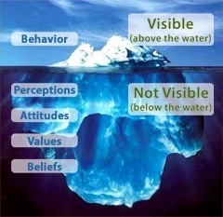

Facilitator Notes
- It is assumed that participants will be aware of change management theories, so these next slides are offered as a reminder and to provide ideas for how to frame the task. They focus on understanding how to support people to change behaviours and their role as managers.
- It is useful to remember that the way people behave is influenced by a number of ‘unseen’ factors. A common metaphor is that of the ‘cultural iceberg’ where some aspects and behaviours within an organisation are clearly visible and not that difficult to change. The more difficult part is that of the ‘unseen’ elements which – continuing the metaphor – sit beneath the water line and form the bulk of the organisational culture. These are the most potent and harder to shift, and include the perceptions, attitudes, values and beliefs that underpin how organisations behave.

Slide 14
Building professional commitment
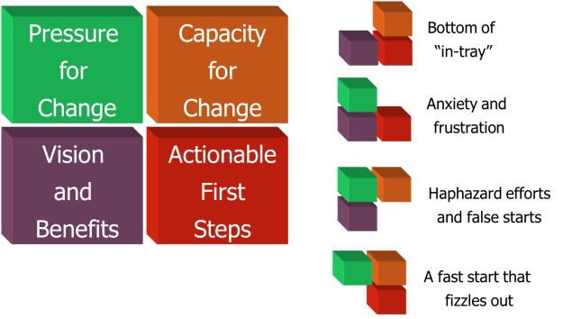

Facilitator Notes
- Slide shows the pre-requisites for successful PROFESSIONAL motivation. And builds to show the effect when a component is missing – if any of the four boxes is missing then it will be difficult to get professional commitment to change.
- Influencing and building commitment to support changes requires rational arguments covering the following key areas:
- Pressure for change – What is the compelling reason to change (the burning platform)? How can this proposal compete against others for attention? Is the rationale clearly laid out?
- Capacity for change – Without capacity or capability to implement recommendations, then there will be little change. Is this proposal competing against others that also require staff capacity/capability? Is there enough resource available?
- Actionable first steps – Any change needs a clear, systematic and logical route – will need to understand the early actions and gain confidence that the benefits are being (or will be) delivered. How are you building confidence?
- Vision and benefits – A vision is essential to show where the project/organisation/etc is heading, and what the value of achieving the vision is. What vision is the organisation already signed up to, and how does the proposal align to that?

Slide 15
Building personal commitment
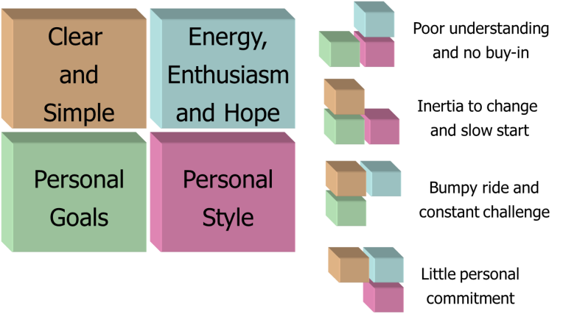

Facilitator Notes
- Slide shows the pre-requisites for successful PERSONAL motivation. And builds to show the effect when a component is missing – if any of the four boxes is missing then it will be difficult to get personal commitment to change.
- Professional motivations are rational and often task driven, personal motivations tend to be more hidden and difficult to address in a systematic way. In building commitment, you may wish to consider the following personal factors:
- Clear and simple – People are often swamped with difficult to navigate information, which can adversely affect decisions. What level of information
do you need to provide? How can you ensure that proposals are simple and understood? Does everyone understand your approach and how decisions
are evidenced and made? What training are you providing?
- Energy, enthusiasm and hope – Support can be slow to galvanise if stakeholders are not engaged with enthusiasm and energy. How are you selling the benefits of change? How are you enthusing and leading people
to the right conclusions? How are you building expectations and hope that objectives can be met? Can you make use of other stakeholders to bring enthusiasm and galvanise support – e.g. community leaders?
- Personal style – What leadership style or culture is dominant? E.g. participative management or authoritarian management.
  - Participative: Seek wider support and sell the benefits of working differently. Use emotional arguments as well as evidence
  - Authoritarian: Generally results driven, so orientate discussion around achieving results using facts and figures to back up the argument and cutting out incidental information. Be realistic and always deliver promises. Be constructive and avoid direct confrontation.
- Personal goals – What does the individual want? What personal pressures are they under? What is their career path and how will this change help them achieve that goal?

Slide 16
Styles of leadership
- 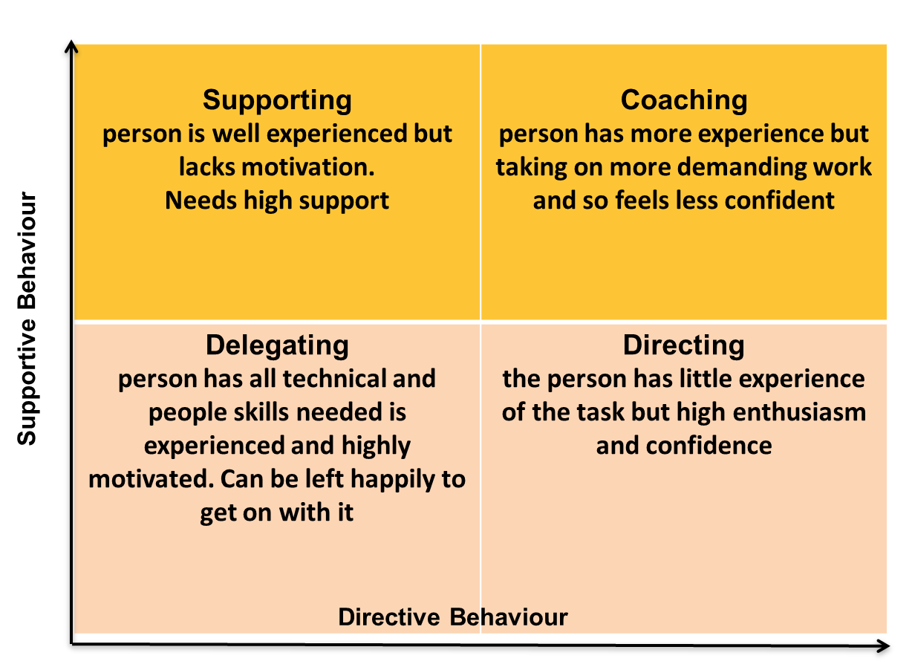

Facilitator Notes
- Hersey and Blanchard’s theory of situational leadership (1993) is a practical way to implement the ideas of the role of the line manager on a day-to-day basis (NB this is an appealing model but there’s little evidence to support it!). It is ‘situational’ in that the manager’s behaviour needs to vary from situation to situation, according to the characteristics of the individual staff member. Need to match the leadership behaviour to the development level of the staff member in whatever task they are undertaking.
- Directing – The subordinate has little experience of the task but high enthusiasm and confidence. She needs telling what to do, but little support in carrying it out
- Coaching – The person has more experience, but is taking on more demanding work and so feels less confident. He needs showing what to do, but little support in carrying it out
- Supporting – The person is well experienced but lacks motivation. Needs high support
- Delegating – The person has all the technical and people skills needed is experienced and highly motivated. Can be left happily to get on with it.
- People’s situation and roles can fluctuate so the leader has to respond dynamically. Each subordinate can be in a different place in different situations.

Slide 16
Is it all about “them” or me…?
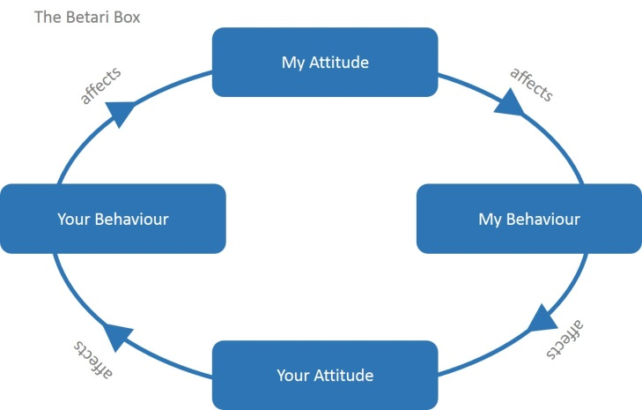

Facilitator Notes
- It is important to remember that your own behaviour will have a big impact on that of those you work with. Offer these examples to illustrate this.
- Example 1:
Imagine your drive to work is very stressful. The longer you sit in traffic, the more frustrated you become – and by the time you get to the office, you're in a negative mood.
Your attitude causes you to use inappropriate negative behaviours. Your temper is short, so you yell at your assistant and then shout at a colleague when you discover a mistake in the report she just gave you.
Your negative behaviour, in turn, affects your assistant and colleague. They are upset by your attitude and behaviour, and they then repeat them in other negative ways. Your assistant is sulky and unhelpful for the next few hours, and your colleague is sarcastic and resentful towards you as well. No real communication takes place.
- Example 2:
Imagine it's just after lunch. You've had your negative drive into work, and you've already yelled at your assistant and your colleague.
As you sit at your desk angry, you realise this all started with something incredibly silly: your drive into work. After thinking about this, you decide to exit the cycle. You begin by offering your assistant a genuine apology, which he accepts with a smile. You also apologise to your colleague and offer to work with her on the report to improve it. She also accepts your apology and thanks you for being willing to help fix her mistake.
The end result: productive, meaningful communication can now take place, simply because you were willing to stop your negative thinking and step out of the cycle.
- Example 3:
The next day, your commute is just as bad, but you use relaxation techniques in your car and make a real effort to be positive as you go into the office. You greet your assistant and your colleague warmly. Soon they're pleasant back to you, and you all have a positive, enjoyable, productive day.

Key learning point
The Betari Box illustrates how our own attitudes and behaviours directly affect the attitudes and behaviours of people around us. When we're stuck in a negative cycle, then it's up to us to stop that cycle by changing our attitude. This will positively impact those around us – and therefore break the cycle.

Slide 18
Consider:
- Direct actions, such as: changing supervision approaches with staff, arranging different activities with providers, providing information and training
- Indirect actions, such as: modelling required behaviours, influencing leaders, rewarding success, providing space to learn from mistakes
- For example:
- Are there people who would be natural champions of the change?
- Are there events taking place at which your message can be heard and supported?
- Will you need to change your own approaches and behaviours?
- How will you tackle resistance?

Facilitator Notes
When planning to implement culture change it is important to consider both direct and indirect actions, and to think through potential opportunities that could enable change, as well as barriers to change.

Slide 19
Planning for change
- How will you deliver the vision you have described?
- What approaches can you take?

Facilitator Notes
- Within their themed groups, ask the participants to plan what they will do to deliver the culture change they have described (headlines only). Encourage the group to challenge each other to think outside the box and focus on solutions.

Slide 20
Planning ahead
- Each group to present headlines of action plans with a brief rationale for taking the approach they have agreed
- Feedback from the whole group:
- What ideas did they find most useful for them locally?
- What approaches have they tried themselves and what learning could they offer others to make sure they work?

Facilitator Notes
- Ask for a brief presentation (three or four minutes) from each group setting out the headlines of the actions they have discussed.
- At end of presentations, ask each person in the room (or volunteers) to comment on either one idea they liked or would find useful, or one approach they have tried themselves and a learning point to offer the group. The intention is to identify positives and/or opportunities for the group to take into their own planning.

Slide 21
Planning next steps
Revisiting the original pre-workshop exercise:
- What do you need to do as a priority action to take the cultural change forward?
- What do you see as the main opportunity locally for moving on with the implementation of the Act?

Facilitator Notes
- Ask everyone to spend five minutes individually thinking about what they will take away to do, and identify the main opportunity for moving on locally. Then ask them to share these with their neighbour.
- If there is time, ask for feedback on the opportunities identified.

Slide 22
Moving on
- Evaluation sheet
- Plans for second workshop “Measuring Progress”
- Date and other arrangements
- Reminder about pre-workshop exercise

Facilitator Notes
- Add relevant details about the next workshop including the date, venue, and the requirement for the pre-workshop exercise which will be used during the workshop.
- Remind each participant to fill in an evaluation sheet.

Workshop 2: Measuring Progress

Pre-workshop information and exercise
A pre-workshop information sheet should be circulated beforehand to all participants. This should provide details of both workshops, as well as the pre-workshop exercise. It should be emphasised that the exercise will form the basis of the workshop activities and so must be completed beforehand.

In addition, participants should bring (or should be provided with a copy with the information sheet of) the Social Services and Well-Being (Wales) Act 2014 Code of Practice in relation to Measuring Social Services Performance.

Pre-workshop exercise:
As a manager you will be responsible for leading and supporting the implementation of the Act within your particular service area including planning for future service delivery. This will include considering how your service or team contributes to the local delivery of the national outcomes set out in the National Outcomes Framework, and how performance will be measured and monitored.
To prepare for the first exercise in this workshop, please spend some time thinking about the implications of one of the national outcomes for your service area: choose one national outcome, and one related qualitative and one quantitative performance measure from the National Performance Framework and think through how it relates to current performance measurement activity in your area? How would you use it to drive improvement in performance? Please use the template overleaf to set out the service area and/or group of people you are focusing on, the national outcome you have chosen, and how it relates to your particular area and responsibilities.
Please bring this with you to the workshop.

PLEASE COMPLETE BEFORE ATTENDING WORKSHOP 2 AND
BRING WITH YOU TO THE WORKSHOP

What area and what group of people are you focusing on for this exercise?
Which national outcome have you chosen to focus on?

Which of its qualitative measures have you chosen?

Which of its quantitative measures have you chosen?

How does this relate
to your area of responsibility? Why
is it relevant?
Comment on how
you would measure performance in this area?
Comment on how this national measurement will enable you to plan for and drive the local improvement of services?

Slide 1
An opportunity for managers…
- Two linked workshops exploring what it means to implement the Act locally
- Each workshop has a particular focus:
- Workshop 1: Changing cultures
- Workshop 2: Measuring performance
- Expectation that participants will do some preparatory thinking and a short exercise as the basis for activities during the workshop
- Expectation that participants will develop their own action plans at the end of each workshop

Facilitator Notes
This workshop is the second of two that provide the opportunity to explore what it means to implement the Act locally looking at two specific areas:

- Changing culture: in particular the culture changes that are needed to enable the implementation of the Act, including how individual managers articulate and plan for the changes relevant to their areas of work
- Measuring performance: in particular the implications of the National Well-being Outcomes Framework and the National Performance Framework for local performance management practice that informs strategic planning and drives improvement

Both workshops are designed to build on pre-workshop exercises and will provide
the opportunity to explore practice more generally, and plan for actions to be taken locally.

Slide 2
Aims and learning outcomes
- This second workshop will focus on the measurement of performance needed to enable the implementation of the Act
- By the end of the workshop you will:
- Have a better understanding of the importance of performance measurement in relation to the Act, particularly the Performance Measurement Framework
- Understand the main characteristics of effective performance measurement
- Be able to explain the rationale for the approaches needed locally for a range of different stakeholders
- Be clear about what needs to happen as next steps for you in taking this forward

Facilitator Notes
- This slide has animation
- By the end of the workshop you will:
  - Have a better understanding of the importance of performance measurement in relation to the Act, particularly the Performance Measurement Framework
  - Understand the main characteristics of effective performance measurement
  - Be able to explain the rationale for the approaches needed locally for
a range of different stakeholders
  - Be clear about what needs to happen as next steps for you in taking this forward

Slide 3
Our approach
- Assumes you bring an awareness of the contents of the Act, and its implications for you locally
- Provides an opportunity for you to reflect on what this means for you in your role as a manager
- Gives you space to discuss the opportunities and challenges of performance measurement locally
- Enables you to plan next steps and for the longer term

Facilitator Notes
- It is important to emphasise the expectation that participants will need to engage in the activities to get the most out of this – it is not a chalk and talk exercise!
- It may be appropriate at this stage to discuss confidentiality within the group if it is a mixed group and there is any sensitivity in discussing local challenges.
- It is important that participants take this opportunity to plan the next steps for themselves in taking forward local performance management approaches.
- Ask the group: are they happy with this approach, and do they have any comments or questions?

Slide 4
Agenda
- Introduction
- Performance measurement – the bigger picture
- What do we need to measure?
- What does effective performance measurement
look like?
- Making use of performance information
- Planning next steps

Facilitator Notes
- You may wish to add timings to this slide, including showing breaks (see the illustrative session plan).

Slide 5
The bigger picture

Facilitator Notes
- There are five main principles within the Act:
  - Voice and control
  - Prevention and early intervention
  - Well-being
  - Co-production
  - Multi agency
- These apply to approaches to working with children, adults and carers.
- Most importantly these seek to deliver a range of defined outcomes as set out in the National Outcomes Framework.

Slide 6
Social Services National Outcomes Framework
- To describe the important well-being outcomes that people should expect in order to lead fulfilled lives…
- To set national direction for all services working in partnership with people…
- To provide greater transparency… and to shine
a spotlight on what needs to be done to improve
well-being

Facilitator Notes
- A reminder that the Social Services and Well-being (Wales) Act requires Welsh Ministers to specify outcomes to be achieved in terms of the well-being of people who need care and support and carers who need support. Welsh Ministers must report on the progress made towards the achievement of
well-being.

Slide 7
Performance Measurement Framework
- Enable people to understand the quality of social services and to make informed decisions about their care and support
- Reinforce local authorities’ strategic planning to enable targeted resources and improvement activity
- Support local authorities to compare and benchmark, learn and improve
- Evidence responsibility and accountability for local delivery and inform national policy development
- Support and inform regulation, inspection, scrutiny

Facilitator Notes
- There are a number of the reasons for the Performance Measurement Framework and it is seen to benefit individuals, local authorities and national government.
- The framework provides performance information that will enable individuals to make informed decisions about different forms of care and support; it will enable local authorities to plan and improve services; it will enable local and national government to be accountable and responsible for performance; and it will support regulatory and scrutiny activities.
- Ask the group how this relates to the current use of performance measurement as they experience it locally. Is it used in this way?

Slide 8

Quality standards for local authorities
- Describe the activities of social services that contribute to the achievement of well-being
- Must be undertaken to discharge duties under the Act and secure well-being for people who need care and support, and carers who need support
- Local authorities must achieve the quality standards

Facilitator Notes
- Local authorities undertake actions to help people to achieve well-being. The quality standards describe the activities of social services that contribute to the achievement of well-being. These activities must be undertaken to discharge duties under the Act and secure well-being for people who need care and support, and carers who need support.
- Note that the Code of Practice Annex A maps the links between the well-being outcomes and quality standards.

Slide 9
Developing a national picture
- Range of quantitative measures, for example:
- Percentage of adults who have received support from the IAA service and have not contacted the service again during the year
- Percentage of care leavers who have experienced homelessness during the year
- The average length of time older people are supported in residential care homes
- The percentage of children supported to remain living within
their family

Facilitator Notes
- In measuring whether the quality standards are achieved, each local authority must have arrangements in place to collect and return data on a series of statutory performance measures. These measures are both quantitative and qualitative.
- The Code of Practice Annex A also maps outcomes and quality standards
against quantitative and qualitative measures – here are some examples of the quantitative measures and the next slide gives examples of qualitative measures.

Slide 10
Developing a national picture
- Range of qualitative measures, including:
- People reporting they have received the right information or advice when they needed it
- People reporting they were treated with dignity and respect
- People reporting that they feel safe
- People reporting they feel satisfied with their social networks
- Carers reporting they feel supported to continue in their
caring role
- People reporting that they live in the right home for them
- Young adults reporting they received advice, help and support to prepare them for adulthood

Facilitator Notes
- There are national approaches to obtaining this information, so comparison can be made across areas – self-completion paper questionnaire, online survey, telephone interviews, face-to-face interviews. These can be seen in draft form on the Welsh Government website.
- Authorities will need to collect this information between 1 September and 30 November of the financial year in which it is reporting, with the first year of data being 2016/2017 and so being collected between September and November 2016 for submission by March 2017.

Slide 11
Implementing locally
- In pairs, discuss the outcome and the quantitative and qualitative measures you had each chosen from the pre-workshop exercise:
- How does it reflect how you currently measure performance in your area?
- How would you use it to drive improvement?
- What does it mean for you in terms of planning future service delivery?

Facilitator Notes
- Refer to the pre-workshop exercise completed by participants and ask them to discuss these in pairs:
How does it reflect how you currently measure performance in your area?
How would you use it to drive improvement?
What does it mean for you in terms of planning future service delivery?
- Ask for feedback on what they notice about these outcome measures and their local implementation.

Slide 12
Linking national to local/individual outcomes

Facilitator Notes
- The implementation of the Act requires them in their role as managers to think about how the performance of their team/service contributes to the achievement of individual outcomes and national outcomes, and how they can measure and demonstrate this. The pre-workshop exercise provided an example of the thinking they will need to go through to make the necessary links and plan strategically for future service delivery.
- Ask the group to suggest other examples of service objectives.

Slide 13
Where do these measures sit?
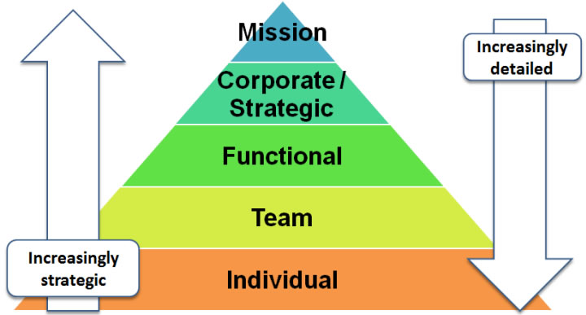

Facilitator Notes
- The types of measures will typically reflect how strategic the objective being measured is. As measures are aggregated they will become less detailed.
- The focus for the rest of the workshop will be on performance measurement as it relates to the group as managers, so for themselves and their teams or functions. Ask the group to form four or five small groups, if they are not already in these on tables. Each group will then work through the process of linking national outcomes to local performance management.

Slide 14
Designing a local response
- In your group choose one of these outcomes from the national framework
- “I speak for myself and contribute to the decisions that affect my life, or who have someone who can do it for me” OR
- “I get the help that I need to grow up and be independent” OR
- “I engage and make a contribution to my community”
- As a manager you are tasked with describing what this outcome means to your staff/service group – how does it relate to their work and why is it important?
- Working in pairs, discuss what you would say and share with others in your group

Facilitator Notes
- The first stage is about developing a broad statement describing what this particular outcome means for your team/service, and why it is important. What
is the rationale for developing performance measures around it?
- Either allocate one of the outcomes to each group or allow them to choose one for themselves. It will be helpful in terms of variety to make sure each outcome is considered, but it not essential to the exercise.
- Start by working in pairs for about five minutes and then share with the others in the group and develop a shared view.

Slide 15
Effective goal setting
Objective | SMART objective that addresses an important priority for the service or team
Rationale | An explanation or rationale which explains why it is so important to the service or team
Measures | Identify what will be counted to measure progress against each objective
Monitoring | Specify the arrangements necessary to collect the measures
Action plan | 3-4 specific planned actions to help achieve the objective, who is responsible and timescales
Support implications | Support activities required to ensure the objective is achieved

Facilitator Notes
- Having developed a rationale we must make sure we develop SMART objectives. This table sets out the elements of performance measurement we will now work through as an exercise.
- Work through this to suit experience of the group; it may be sufficient to show the slide as a reminder and to set the framework for the following activities.
- Two key elements to consider when setting goals: Are they clear and measurable, etc? Do they contribute to the achievement of the business strategy?
- Objectives set a target that can then be measured. SMART objectives = specific, measurable, achievable/attributable, realistic, time-bound
- Rationale helps to gain clarity over what is wanted and why
- Measures identify out what will be counted to tell you whether you have achieved your OBJECTIVE – performance indicators. They are not the targets in themselves. For each objective identify a few (three to four) key measures, or PIs, which will be used to measure progress against it. Measures are not targets, they are simply what you will count. Measures usually start with `Number of…’ or `Percentage of…’ or `Proportion of…’
- Monitoring arrangements spell out how, when and who will collect and report back on the measures, which ensures compliance against objectives
- Action plans are what will be done to achieve the objective. What actions will be taken by who and when?

Slide 16
Setting local objectives
- Develop SMART objectives that as the manager of the service/team you would use to demonstrate performance towards this outcome
Remember:
- SMART objectives = specific, measurable, achievable/attributable, realistic, time-bound.

Facilitator Notes
- In your group, discuss and agree SMART objectives for the area you are working on and that will contribute to the national outcome you have chosen.

Slide 17
Measuring performance
Questions we might ask:
- How much are we doing?
- e.g. How many family visits have taken place in the last month?
- How well are we doing?
- e.g. How satisfied are families with the service they receive?
- Is anyone better off?
- e.g. Parental self-reports of confidence in parenting after attending parenting sessions (self-reported impact)

Facilitator Notes
- Having developed objectives we now need to think about how we measure performance against them. These questions are based on Mark Friedman’s Results Based Accountability, which participants may be familiar with. It is typically the last question that is difficult to measure – the outcomes delivered
– although it may well be that systems do not enable the easy collection of outputs as well.

Slide 18
Measuring outcomes

Facilitator Notes
- Where outcomes need to be measured there are different approaches that can be taken to measuring them, both qualitatively and quantitatively. It is worth noting that the National Performance Framework includes standard surveys and questionnaires to be used to ensure national collection is standardised.

Slide 19
Measuring performance
In your groups discuss and agree:
- What are the top three performance measures you will need to use to demonstrate performance against your objectives?
- In outline how would you collect evidence against these measures?

Facilitator Notes
- So having developed objectives you now need to agree what performance measures you will need to use to demonstrate performance against them.
- As a group discuss and agree the top three, and then think through how you would collect evidence against these measures.

Slide 20
Designing a local response
Each group to present:
- National outcome
- Objectives for specific service/group
- Measures and outline methodology
Check:
- Will the proposed service/team objectives contribute to the national outcome?
- Are the measures right?
- Any comments or further ideas?

Facilitator Notes
- Ask each group to give a short presentation giving headlines only on the approach they have designed.
- Ask the whole group for comments on their appropriateness as objectives and as measures.

Slide 21
Implementing a local approach
- You are tasked with establishing a practicable and sustainable approach to performance measurement which enables your service/team to demonstrate its delivery of your chosen outcome
- This approach will need to contribute to or complement the annual collection of data for
the national performance framework report

Facilitator Notes
- Staying in the same groups and continuing to work on chosen service/team outcomes. This task is about designing an approach to the measuring and monitoring of performance against these outcomes. The next slide sets out some suggested areas to consider.

Slide 22
Your local plan
- Your plan will need to consider the following:
- Who would need to be involved in its development (for example service users, front line staff, providers, senior managers, others)
- How the performance indicators would be collected, by whom, and how often
- What will be the best way to engage with stakeholders to learn from good/poor performance, and take remedial action where necessary?
- What could this mean for the way you currently discuss performance?

Facilitator Notes
- Ask for feedback from the groups on what they found challenging in the exercise, and what they learnt in terms of their own role as manager.

Slide 23
Planning next steps
- What do you need to do yourself as a priority action to take forward the culture of performance management and measurement in your area?
- What needs to happen to link with the national frameworks?
- What strengths can you build on?

Facilitator Notes
- Everyone individually spend five minutes thinking about what they will take away to do, and the main opportunity for moving on. Then share with their neighbour.
- Ask for feedback on opportunities identified by the group and the strengths they can build on.
- Remind the participants at the end to complete the evaluation sheets

Illustrative documents

Illustrative session plans
The following session plans are provided as illustrations of how the workshops could be timed to take place. Facilitators will need to tailor these to suit their own workshops as appropriate.

Workshop 1: Changing Cultures
Example timing | Activity | Resources
9.30- 9.45am | Introduction to workshop including any housekeeping information.  Emphasis on interactive approach rather than “chalk and talk”, and opportunity to reflect and plan individually as managers. | Slides 1-4 PowerPoint presentation
9.45- 10.15am | What needs to be different?  Brief discussion about what makes up a culture in an organisation, then reminder about key principles within the Act, including two slides which refer back to core learning materials.  Short discussion in pairs to reflect on the changes each identified in pre-workshop exercise – seek to identify what cultural change needed and for whom. Brief feedback on what needed from small number of pairs.  Organise group into themed small groups of about four or five people to work on exercises for remainder of the workshop. Ideally based on the area they work in and specific area of culture change, but this will depend on who attends the workshop. | Slides 5-9 PowerPoint presentation
10.15- 10.50am | Articulating our vision  In themed groups (as at the end of the previous slide).  You have been tasked with producing a draft description of your local vision of what the culture will/should look like in your particular themed area:  - Individually jot down four or five bullet points describing what you think the culture should be  in your particular change area (5 mins)  - Share with your neighbour and agree between you shared key four or five bullet points (10 mins)  - As a whole group, negotiate the key/best descriptors of what you are aiming for and record on flipchart paper (15 mins) | Slide 10  Flipchart paper and pens for each small group
10.50- 11.15am | Who do we need to work with?  1. Whole group discussion – everyone call out/suggest who are likely to be the main people we will need to  work with across all areas to implement the appropriate culture change – facilitator to record on flipchart.  Answers could include individual citizens (both existing and potential service users), carers, front line staff, senior managers/directors, statutory and non-statutory organisations, voluntary and private sector providers, social care/health and other public sectors (eg housing), board members, local and national politicians.  2. Back in the original groups – agree the top four groups of stakeholders who should be prioritised for working with to deliver your culture change, and revisit your agreed vision – given who needs to hear the messages do they still seem to be the right ones? | Slide 11  Flipchart and pens
11.15- 11.30am | Break
11.30- 12.15pm | Planning for change  Having agreed a vision of what the culture should be in the chosen area, the next task is to plan how to make  the changes necessary working with your stakeholders. Depending on the experience of the group either go straight to slide 18, skip through these quickly, or  spend more time on them: some ideas about building commitment from others, on leadership styles, and on manager’s own behaviours.  In small groups, plan what they will do to deliver the culture change they have described. Headlines only. Encourage the group to challenge each other to think outside the box and focus on solutions. | Slide 12-19
12.15- 12.40pm | Planning ahead  Suggest brief presentation from each group with headlines of activities needed (assume 5 groups x 4 minutes = 20 mins).  Then ask each person in the room to comment on either one idea they liked/would find useful, or one approach they have tried themselves and a learning point to offer the group. | Slide 20
12.40- 12.55pm | Next steps  Individually revisit the original pre-workshop exercise:  - What do you need to do as a priority action to take the cultural change forward?  - Reflect on your own approach to leadership and change – are there areas you will need to develop/strengthen?  - What do you see as the main opportunity locally for moving on with the implementation of the Act?  If time, suggest they share with their neighbour and/or ask people to comment on the opportunities going forward to develop the culture needed. | Slide 21
12.55- 13.00pm | Reminder about the evaluation sheet and next workshop, including the pre-workshop exercise | Evaluation sheet

Workshop 2: Measuring Performance
Example timing | Activity | Resources
9.30- 9.45am | Introduction to the workshop, including any housekeeping information.  Emphasis on an interactive approach rather than  “chalk and talk”, and an opportunity to reflect and plan individually as managers. | Slides 1-4 PowerPoint presentation
9.45- 10.15am | The bigger picture  A brief reminder of the National Outcomes Framework and National Performance Framework, and the purpose they both play.  Short discussion in pairs looking at pre-workshop exercise to consider a national outcome and measures, and how they relate to manager’s areas of responsibility. | Slides 5-11  Handout
10.15- 10.35am | Moving from national to local  A reminder about the relationship between individual and national outcomes, and local service or team objectives. Also a reminder that measures will look different depending on whether they relate to the individual or the more strategic.  Exercise to develop a performance measurement approach starting from a national outcome. In small groups choose one of the three suggested outcomes and describe what it means in relation to your chosen service/team – how does it relate to their work and why is it important? Start in pairs (5 mins) and then share with others in the group (15 mins). | Slide 12-14  Flipchart and pens
10.35- 10.55am | Effective goal setting  Remind the group about SMART objectives and then get each group to develop them for their national outcome. | Slide 15-16
10.55- 11.15am | Measuring performance  Briefly talk through the ideas about measuring performance, and then get the groups to consider performance measures for their objectives. | Slide 17-19
11.15- 11.30am | BREAK
11.30- 12.10pm | Designing a local response  Each group to briefly present to the whole group, with the whole group encouraged to comment and offer ideas or solutions (10 mins per group x 4). | Slide 20
12.10- 12.40pm | Implementing a local approach  Either in pairs or small groups (depending on people attending).  Develop a headline plan for developing performance measurement, which enables your service/team to demonstrate its delivery of the chosen outcome.  Feedback from the groups on what they found challenging in the exercise, and what they learnt in terms of their own role as a manager. | Slides 21-22
12.40- 12.55pm | Next steps  Individually revisit original pre-workshop exercise:  - What do you need to do as a priority action to take forward a culture of performance management in your area? What needs to happen to link it with the national frameworks?  - What do you see as the main opportunity locally for moving on with the implementation of the Act?  Ask for comments on what positives they felt they could build on locally – what did they see as the opportunities? | Slide 23
12.55- 13.00pm | Reminder about the evaluation sheet . | Evaluation sheet

Evaluation form
At the end of the training session, you may want to evaluate the training using the evaluation form below.

Evaluation Form

We value your feedback. Please take a few minutes to complete this form.

Name (optional): _________________ Organisation (optional): _______________________

1. Please tell us how well you think the training session:
Please appropriate box | Very well | Quite well | Partly | Not well | Not at all
Met your needs?
Was relevant to your organisation?

2. What were the most beneficial parts and why?

3. If there was one thing you could change, what would it be?

4. Please rate your facilitator’s:
Please appropriate box | Very well | Quite well | Partly | Not well | Not at all
Knowledge of the subject
Ability to respond to questions
Enthusiasm for the subject

Additional comments:

5. How well do you rate:
Please appropriate box | Very well | Quite well | Partly | Not well | Not at all
The venue and facilities?
Quality of materials and content?

6. Any other comments?

Workshop 1: Pre-workshop information sheet

Introduction
This is the first of two workshops designed to help managers think through two key ingredients in the effective implementation of the Social Services and Well-being (Wales) Act and develop their own individual plans to take this work forward:

Workshop 1: Changing Cultures
This first workshop will provide the opportunity to reflect on the culture you are seeking to develop in your area of work as part of the implementation of the Act, consider approaches to enabling and supporting the changes needed, and plan the next steps.
Workshop 2: Measuring Progress
The second workshop will focus on how you will develop performance measurement approaches that enable you to plan, monitor and report on progress locally towards the delivery of the National Outcomes Framework.

Both workshops will be highly interactive and will include opportunities to develop your thinking with colleagues, as well as individual reflection and action planning.

It is a mandatory requirement that participants have attended the Getting in on the Act core modules training. If necessary, it may be helpful to refer to the materials on the Information and Learning Hub as a refresher before attending the workshop. In addition, participants will need to have completed the pre-workshop exercise as described below as this will form the basis for the workshop activities.

Pre-workshop Exercise
As a manager you will be responsible for leading and supporting the implementation of the Act within your particular area. You will need to plan for and deliver on the National Well-being Outcomes and Quality Standards. This may involve changes
for a number of different stakeholder groups depending on your area of work: for example, the teams you manage, the citizens you support, the communities you
work within, the providers you work with, other agencies within your partnership arrangements, other local authority services.

To prepare for the first exercise, please spend some time thinking about what success will look like in terms of the culture that will be developed in one particular area in which you work. Please use the template overleaf to set out the service area and/or group of people you are focusing on, the aspects of the Act that mean cultures will need to change for this group/service, what the culture will look like and where you are now.

Please bring this with you to the workshop.

PLEASE COMPLETE BEFORE ATTENDING WORKSHOP 1 AND
BRING WITH YOU TO THE WORKSHOP
What area and what group of people are you focusing on for this exercise?
(Eg a specific team,
or group of teams, a provider type, a local community, parts of
the local authority.)
What aspects of
the Act require the culture change in this particular area? Why do cultures need to change? Is there a particular National Outcome driving the change?

What does the new culture need to look like?

Where are you now?

Workshop 2: Pre-workshop information sheet

Introduction
This is the second of two workshops designed to help managers think through two key ingredients in the effective implementation of the Social Services and Well-being (Wales) Act and develop their own individual plans to take this work forward:

Workshop 1: Changing Cultures
This first workshop will provide the opportunity to reflect on the culture you are seeking to develop in your area of work as part of the implementation of the Act, consider approaches to enabling and supporting the changes needed, and plan the next steps.
Workshop 2: Measuring Progress
The second workshop will focus on how you will develop performance measurement approaches that enable you to plan, monitor and report on progress locally towards delivery of the National Outcomes Framework.

Both workshops will be highly interactive and will include opportunities to develop your thinking with colleagues, as well as individual reflection and action planning.

It is a mandatory requirement that participants have attended the Getting in on the Act core module training. If necessary, it may be helpful to refer to the materials on the Information and Learning Hub as a refresher before attending the workshop. In addition, participants will need to have completed the pre-workshop exercise as described below as this will form the basis for the workshop activities.

Pre-workshop Exercise
As a manager you will be responsible for leading and supporting the implementation of the Act within your particular service area, including planning for future service delivery. This will include considering how your service or team contributes to the local delivery of the national outcomes set out in the National Outcomes Framework, and how performance will be measured and monitored.

To prepare for the first exercise in this workshop please spend some time thinking about the implications of one of the national outcomes for your service area: choose one national outcome, and one related qualitative and one quantitative performance measure from the National Performance Framework and think through how it relates to current performance measurement activity in your area? How would you use it to drive improvement in performance? Please use the template overleaf to set out the service area and/or group of people you are focusing on, the national outcome you have chosen, and how it relates to your particular area and responsibilities.

Please bring this with you to the workshop.

PLEASE COMPLETE BEFORE ATTENDING WORKSHOP 2 AND
BRING WITH YOU TO THE WORKSHOP
What area and what group of people are you focusing on for this exercise?
Which national outcome have you chosen to focus on?

Which of its qualitative measures have you chosen?

Which of its quantitative measures have you chosen?

How does this relate
to your area of responsibility? Why
is it relevant?
Comment on how
you would measure performance in this area?
Comment on how this national measurement will enable you to plan for and drive the local improvement of services?

Contact Details

Care Council for Wales
South Gate House
Wood Street
Cardiff CF10 1EW

Tel: 0300 3033 444
Fax: 029 2038 4764
Minicom: 029 2078 0680

Email: hub@ccwales.org.uk www.ccwales.org.uk

© 2016 Care Council for Wales

It is expressly prohibited to use any, or all, of this training resource for commercial gain.

Further copies of this document and other Care Council resources about the Social Services and Well-being (Wales) Act are available to download from the Information and Learning Hub.

