Trainer notes – Module: 5 – Safeguarding allegations/concerns about practitioners and those in positions of trust
- PowerPoint for module
- Everyone should have the Wales Safeguarding Procedures App on their phone or tablet to refer to throughout the module
- Note: Some of the slides feature internal links, which take you to optional slides (positioned at the end of the PowerPoint) that explain the meaning of the linked word/phrase
Slides | Notes
Introduction
https://safeguarding.wales/adu/a5/a5.p1.html
These procedures set out arrangements for responding to safeguarding concerns about those whose work, either in a paid or voluntary capacity, which brings them into contact with children or adults at risk. It also includes individuals who have caring responsibilities for children or adults in need of care and support and their employment or voluntary work brings them into contact with children or adults at risk.
It is intended that these procedures support internal disciplinary procedures and provide guidance to deal appropriately with any concerns or allegations of professional abuse, neglect or harm and to ensure that all allegations of abuse made against staff or volunteers working with children, young people and adults at risk are dealt with in a fair, consistent and timely manner.
The main factor to consider when applying these procedures is whether the individual subject to the allegation or concern, occupies a position of trust. This is where a member of staff / volunteer is in a position of power or influence over a child or adult at risk, by virtue of the work or nature of activity being undertaken.

 | These procedures are underpinned by legislation and guidance, and should be read in conjunction with them.
Section 5 is identical in both
- Children and Young People at Risk of Harm
https://safeguarding.wales/chi/index.c5.html
- Adults at Risk
https://safeguarding.wales/adu/index.a5.html

Section 2
The duty to report an adult at risk of abuse and/or neglect > Duty to report concerns (including abuse and neglect) about a practitioner
https://safeguarding.wales/adu/a2/a2.p4.html
https://safeguarding.wales/chi/c2/c2.p5.html
It is important that practitioners do not ignore or dismiss suspicions about another practitioner or colleague who may be abusing, neglecting or causing harm to a child or adult at risk.
Every practitioner has a responsibility to safeguard children and adults at risk and that includes protection from abuse by a professional, paid carer or volunteer. Therefore, the duty to report any concerns about suspected abuse and neglect applies in these situations. This duty also covers situations when abuse is only suspected.

Pointers for Practice: Identifying Professional Concerns
https://safeguarding.wales/chi/cp/c2p.p3.html
Introduction
https://safeguarding.wales/adu/a5/a5.p1.html

Trainer to stress:
Failure to report such concerns may be a breach of duty of care and may result in disciplinary sanctions.

Overarching principles
https://safeguarding.wales/adu/a5/a5.p3.html

Additional information for trainer:
These procedures are for dealing appropriately with a practitioner who is the subject of concerns or allegations of professional abuse.
- Ensure that allegations and safeguarding concerns are dealt with in a fair, consistent and timely manner, and in accordance with statutory guidance
- Ensure that there is appropriate support, information and advice for all those affected during this process
- Ensure that individuals who are not suitable to work with children and adults at risk are prevented from doing so by notification to the Disclosure and Barring Service and other relevant and professional bodies
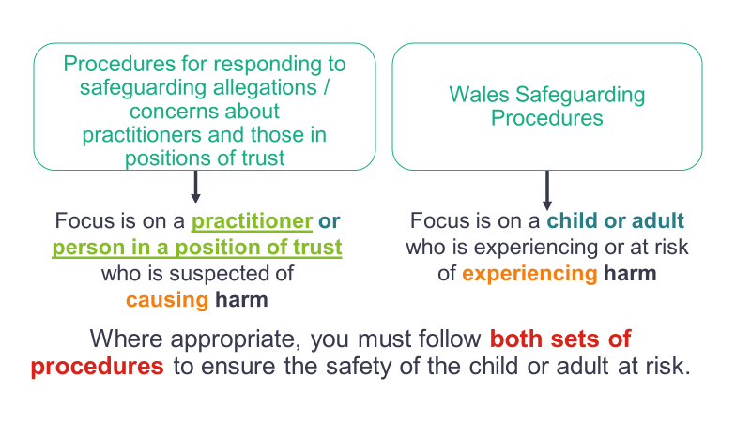  Note: This slide contains internal hyperlinks (in bold) to slides that provide definitions and/or more detail on the linked term/phrase. | Additional information for trainer:  These procedures are for dealing appropriately with a practitioner who is the subject of concerns or allegations of professional abuse.  Overarching principles  https://safeguarding.wales/adu/a5/a5.p3.html  In cases where there is an identifiable child or adult at risk who has been subject to abuse or neglect, the Wales Safeguarding Procedures will be implemented and followed alongside the process outlined in these procedures.  If there is no identifiable child or adult at risk and the professional meets the criteria identified above, these procedures will still be invoked.  In cases where there is an identifiable child, young person or adult at risk who may be raising the concern or has been subjected to possible abuse then a proportionate assessment will be carried out by social services in accordance with the Social Services and Well-being (Wales) Act 2014. The outcome of this assessment must be fed back to the designated officer for safeguarding.  If the allegation has not come from within the employee’s organisation and referred accordingly, then the police and/or social services should inform the designated officer for safeguarding within the employing agency that an allegation against a member of staff has been made and formal investigations are required.
Example
Any staff or volunteers working on behalf of social care, health services, police and criminal justice, housing, education, and so on.
https://safeguarding.wales/adu/a5/a5.p1.html
The main factor to consider when applying these procedures is whether the individual subject to the allegation or concern, occupies a position of trust. This is where a member of staff / volunteer is in a position of power or influence over a child or adult at risk, by virtue of the work or nature of activity being undertaken.

The definition of “work" includes the following:
https://safeguarding.wales/adu/a5/a5.p3.html
- those in paid employment, including temporary, students/trainees, casual, agency staff and those who are employed as personal assistants under the direct payment scheme
- individuals undertaking unpaid voluntary work
- individuals who are self-employed and work directly, or are contracted to work, in the provision of services to children and adults at risk.
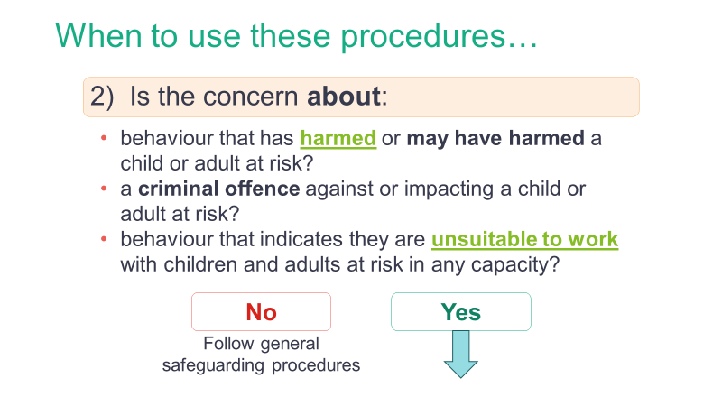  Note: This slide contains internal hyperlinks (in bold) to slides that provide definitions and/or more detail on the linked term/phrase. | Note:  https://safeguarding.wales/adu/a5/a5.p2.html  Managing cases under these procedures applies to a wider range of allegations than those in which there is reasonable cause to believe a child or adult at risk is suffering, or is likely to suffer harm.  It also applies to concerns that might indicate that a person is unsuitable to continue to work with children or adults at risk in their present position or in any capacity.
Overarching principles
https://safeguarding.wales/chi/c5/c5.p3.html

Trainer to expand:
The person to whom an allegation or concern is first reported should treat the matter seriously and keep an open mind.

They should not:
- investigate or ask leading questions
- make assumptions or offer alternative explanations
- promise confidentiality – the person/persons should be advised that the concern will be shared on a 'need to know' basis.
They should:
- make a written record of the information (using where possible, the child’s/adult’s own words), including the time, date and place where the alleged incident took place, what was said and anyone else present
- sign and date the written record
- immediately report the matter to the designated officer for safeguarding (within their agency), or deputy in their absence
- where the designated officer for safeguarding is the subject of the allegation, the information should be reported to a more senior manager.

Trainer to explain:
It is important to minimise inappropriate referrals.
The employer/voluntary organisation should first consider the allegation/s and consider four possible courses of action.

The professional strategy discussion
https://safeguarding.wales/adu/a5/a5.p4.html
Professional strategy meeting
https://safeguarding.wales/adu/a5/a5.p5.html
- Who to invite to the professional strategy meeting
- Informing the individual
- Informing parents/ carers, children, adults at risk or their representatives
https://safeguarding.wales/adu/a5/a5.p6.html
Concluding the process
https://safeguarding.wales/adu/a5/a5.p7.html

Cross boundary issues
https://safeguarding.wales/adu/a5/a5.p8.html
This is an area of work that is best supported by sound inter-authority working. Where child or adult protection enquiries have been made in one area, but the alleged perpetrator lives or works within other areas, there will be need for information to be shared between the two areas. The designated officer for safeguarding must ensure that they share all information with their counterpart in the other local authority.
Confidentiality and record of the professional strategy meeting
https://safeguarding.wales/adu/a5/a5.p9.html

Flowchart:
Referrals about people whose work brings them into contact with children or adults at risk
https://safeguarding.wales/downloads/referrals_flowchart.pdf
 | The following is an optional activity.
Pointers for Practice: Professional concerns
https://safeguarding.wales/adu/ap/a2p.p3.html?highlight=barriers
When to use these procedures
https://safeguarding.wales/adu/a5/a5.p2.html?highlight=LADO
Overarching principles
https://safeguarding.wales/adu/a5/a5.p3.html
It must be noted that some allegations are so serious as to require immediate referral to the police and social services. These procedures are not in any way intended to impede the requirement for urgent or immediate responses to circumstances that are clearly serious, although it is expected that the designated officer for safeguarding is informed of such events at the very earliest opportunity and in all circumstances within no more than 24 hours after the concern has arisen (next working day – if out of office hours).
Overarching principles
https://safeguarding.wales/adu/a5/a5.p3.html

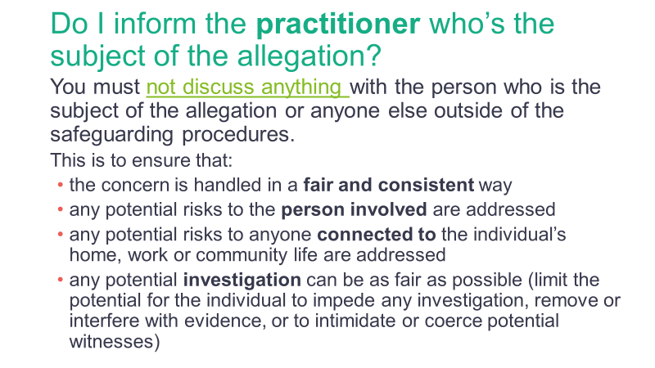  Note: This slide contains internal hyperlinks (in bold) to slides that provide definitions and/or more detail on the linked term/phrase. | Who to invite to the professional strategy meeting / Informing the individual  https://safeguarding.wales/adu/a5/a5.p6.html
Who to invite to the professional strategy meeting / Informing parents/carers, children, adults at risk or their representatives
https://safeguarding.wales/adu/a5/a5.p6.html
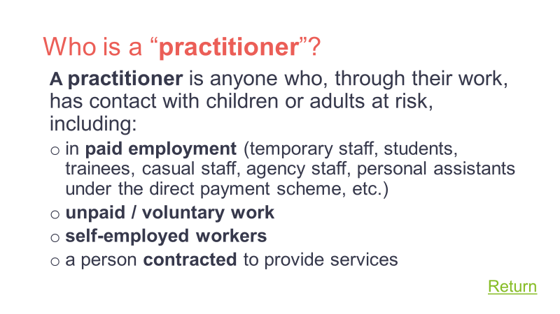  Note: This slide contains an internal hyperlink (Return) to the initial slide that linked to it. Simply click on this to resume your presentation. | Glossary  https://safeguarding.wales/glossary.html  The term practitioner has been used as a blanket term to describe anyone who is in paid employment as well as unpaid volunteers.
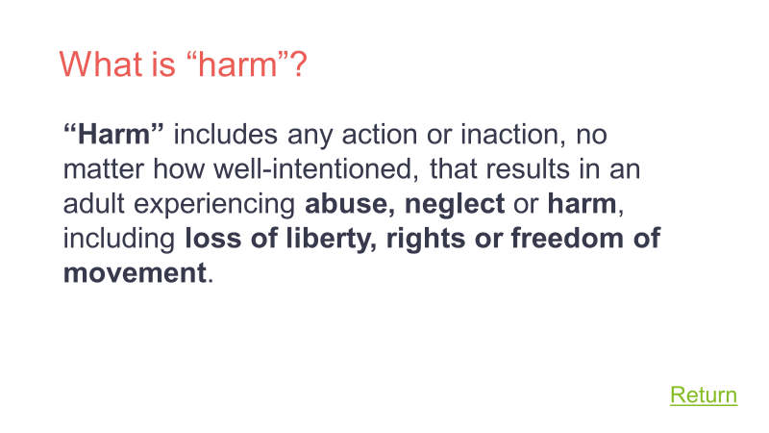  Note: This slide contains an internal hyperlink (Return) to the initial slide that linked to it. Simply click on this to resume your presentation. | Glossary  https://safeguarding.wales/glossary.html  Harm means abuse or the impairment of (a) physical or mental health, or (b) physical, intellectual, emotional, social or behavioural development. The references to ‘harm’, in relation to Section 47 enquiries, referred to in handling individual cases volume 5, means significant harm. Therefore, practitioners must where the question of whether harm is significant turns on the child’s health or development, the child’s health or development is to be compared with that which could reasonably be expected of a similar child.
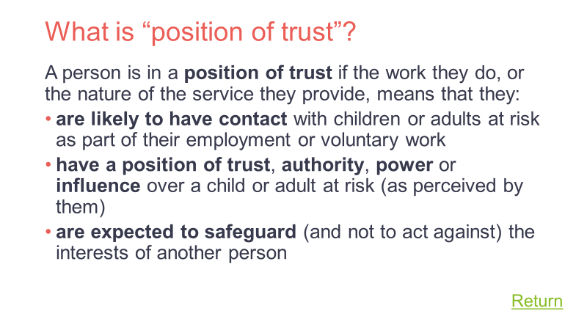  Note: This slide contains an internal hyperlink (Return) to the initial slide that linked to it. Simply click on this to resume your presentation. | https://safeguarding.wales/adu/a5/a5.p1.html  The main factor to consider when applying these procedures is whether the individual subject to the allegation or concern, occupies a position of trust. This is where a member of staff/volunteer is in a position of power or influence over a child or adult at risk, by virtue of the work or nature of activity being undertaken.  The definition of ‘work’ includes the following:  https://safeguarding.wales/adu/a5/a5.p3.html  - those in paid employment, including temporary, students/trainees, casual, agency staff and those who are employed as personal assistants under the direct payment scheme  - individuals undertaking unpaid voluntary work  - individuals who are self-employed and work directly, or are contracted to work, in the provision of services to children and adults at risk.
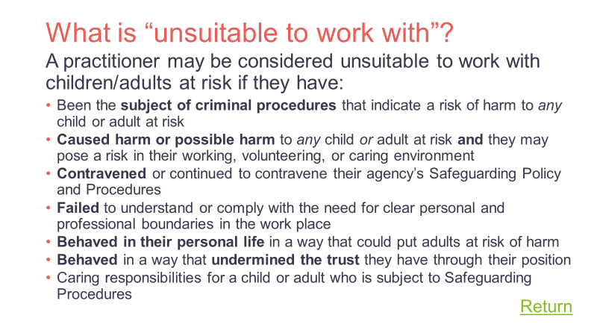  Note: This slide contains an internal hyperlink (Return) to the initial slide that linked to it. Simply click on this to resume your presentation. | When to use these procedures  https://safeguarding.wales/adu/a5/a5.p2.html  Contravene:  - to do something that a law or rule does not allow, or to break a law or rule  - failing/refusing to follow agency’s safeguarding policy.
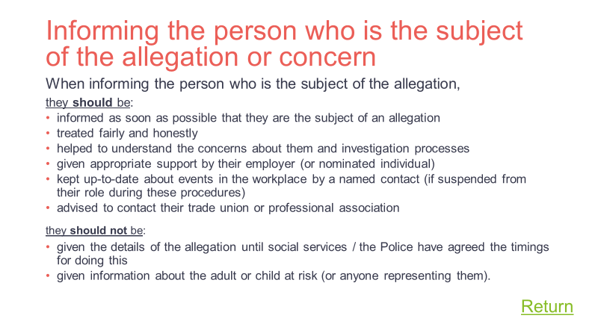  Note: This slide contains an internal hyperlink (Return) to the initial slide that linked to it. Simply click on this to resume your presentation. | Who to invite to the professional strategy meeting / Informing the individual  https://safeguarding.wales/adu/a5/a5.p6.html

