The Social Services

and Well-being (Wales) Act 2014

The Social Services and Well-being (Wales) Act 2014 is an important piece of legislation about how we should be providing care and support to those who need it in Wales.

The Act has:

- regulations, which give more detail about what must be done to put the Act into practice
- codes of practice, which give guidance to help put the Act into practice.

The Act covers:

- adults (people aged 18 or over)
- children (people under the age of 18)
- carers (adults or children who provide or intend to provide care and support).

The Act is built on five important principles, you don’t need to know details about the Act and the regulations, but you do need to understand about the principles as these will inform the way you work:

- voice and control
- prevention and early intervention
- well-being
- co-production
- multi-agency.

To help you get started, watch this film that introduces the Act and its principles.

We are now going to explore these principles one at a time.

Principle 1: Voice and control

The person is at the centre of decision-making

“A strong voice and greater control over support I receive... what matters to me.”
This could be:
- having a safe and permanent home
- taking part in activities
- being able to plan and cook a meal
- remain or become part of their communities

The Act gives people a stronger voice and greater control over the support and services they receive to help them achieve well-being and the things that matter most to them.

Principle 2: Prevention and early intervention

Timely advice and support
Help
Support
The Act is designed to make sure that:
- people ask for the help
they need when they need it to prevent their situation from getting worse
- carers can access support to assist them in their caring roles and maintain their own well-being

It is important that people get timely advice and assistance to prevent things reaching a crisis point for them. Stepping in early to help people can reduce or delay the need for longer term care and support.

Learning activity – prevention and early intervention

June is 52 years old and has multiple sclerosis. Llinos, her 15-year-old daughter, is her carer. When June’s symptoms are very bad, Llinos can’t go to school as she has to stay home to look after her mother.

After struggling for some months, June and Llinos decide they need help, so they contact their local authority’s information, advice and assistance (IAA) service. The service carries out an early assessment over the phone. This is followed up with visits from an information, advice and assistance worker who completes a full assessment with June and Llinos. The assessment helps June and Llinos talk about their situation, what they want to achieve, and how they may do this. As Llinos is under 18, the assessment must take into account her welfare and development needs.

Both are clear about what would make their lives better. June would like to not have to rely on Llinos so much. She would also like to be able to get out of the house more and feel she’s doing something worthwhile with her time. Most of all, June is worried about Llinos missing school.

Llinos would like to be able to go to school without having to worry about how her mother is coping and have time to do her homework. She also wants to see more of her friends.

- What do you think might be important to June and Llinos?

- What do you think might be important for June and Llinos?

c. How could advice and assistance support positive outcomes for June and Llinos?
d. What could happen to June and Llinos if they don’t receive any advice or assistance?

Principle 3: Well-being

The Act will change the way social services, health and other care and support services work together to help and support people
People have a responsibility for their own well- being, but some people will need help to achieve this
Supporting the well-being of individuals and helping people achieve what matters to them

Well-being

People’s right to well-being is at the heart of the Act. While people have a responsibility for their own well-being, some will need help to achieve this.

There are many interpretations of well-being. The Oxford English Dictionary defines well-being as “the state of being comfortable, healthy or happy”. It is important to understand what this means to the people you support.

Well-being is about more than just being healthy. It can also include:

- being safe
- having somewhere suitable to live
- being involved in decisions about your life
- having friends
- being part of good, strong communities
- having every chance to do well in education
- feeling good about your life
- for adults – being able to work
- for children – being able to grow up happily and successfully, and being well-looked after.

A helpful starting point is to think about well-being in your own life and what this means to you. Think about this and write a few sentences about what is important to you and what helps you achieve a good life.

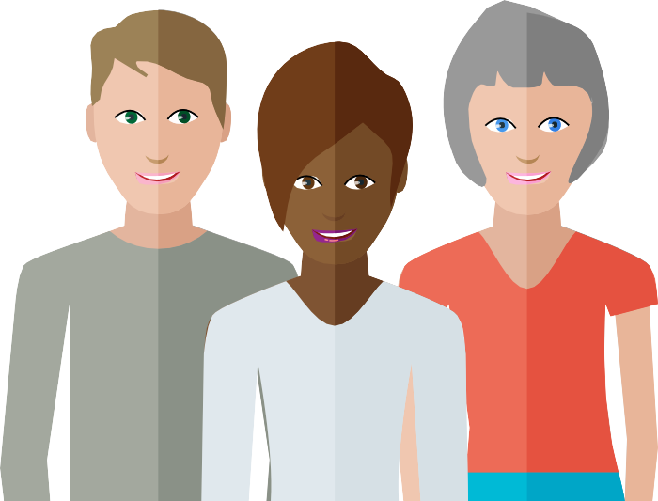Well-being

For children – being able to grow up happily and successfully, and being looked after

For adults – being able to work

Feeling good about your life

Having every chance to do well in education
Being safe

Having somewhere suitable to live

Being involved in making decisions
that impact your life

Having friends and being part of good, strong communities

Well-being – it’s essential to understand what this means to them

The arts and well-being

The arts bring colour, comfort, imagination and meaning to life, and can be important for our sense of well-being. They can be especially helpful in health and social care settings.

Engaging with the arts can:

- improve emotional health by helping relaxation and emotional release
- provide an important way of self-expression
- provide enjoyable social contact
- increase self-esteem, confidence, and personal growth
- develop our self-awareness.

Learning activity – the arts and well-being

Idris lives in a care home in Mountain Ash. He has no family or visitors. Idris is living with dementia and is often depressed and withdrawn. The staff notice him singing along to Calon Lan when a male voice choir is singing in a concert on the television.

The staff download some choir concerts for Idris to listen to in his room on his tablet. He does this most evenings and it lifts his mood. The staff have now arranged for some members of a local choir to come and perform a small concert and are planning to set up a home choir for staff and residents to sing together.

Think about how the arts could be used with the people you work with to support their well-being.

Principle 4: Co-production

People will be more involved in the design and delivery of their support,
working with them and their family, friends and carers

Recognising strengths and expertise

Co-producing their

Working with people in a more equal way

Under the Act, people are to be more involved in the design and provision of their care and support. It means working with them and their family, friends and carers so their care and support is the best it can be. It recognises people’s strengths and the expertise they can bring. This will make sure our care and support services are designed around what matters most to people.

Learning activity – the importance of working with individuals to achieve positive outcomes
John is 21 years old and lives at home with his parents.

He has a happy family life. He enjoys cooking and helping his mother prepare the evening meal. He also helps his mother with the weekly shopping and likes to choose some of the ingredients for cooking.

John has a learning disability and has support from day services two days a week. His brother lives close by but works away in the week. He usually goes out with him on a Saturday. He is close to all his family. John’s parents are getting older, and they are struggling to look after him on their own. John’s dad has had a stroke and his mum is losing her sight. They don’t want to think about the future and what might happen to John when they can no longer support him.

When John’s mum has a fall that results in hospital admission, his dad cannot look after himself and John. John has to move into emergency supported living accommodation.

The move makes John unhappy. It isn’t close to his home, he doesn’t get on with the people he lives with, and he doesn’t do any cooking as the staff prepare all the meals. As a result, John has become withdrawn and has stopped talking to people.
- What do you think is important to John?

b. What do you think is important for John?

c. What could change to help John achieve the outcomes that are important to him?

d. What may have helped earlier?

e. How could you work with John and his family to make sure they are equal partners and have real voice and control over his care and support?

Principle 5: Multi-agency

Health organisations Education

Voluntary
sector

Housing

Multi-agency and strong partnership working

Probation services

Community services

Emergency services

The Act strengthens joint working between local authorities and other partners, such as health, housing and the voluntary sector, to improve people’s well-being and the quality of services. This is sometimes called ‘integration’.

Learning activity – working in partnership

Think about how you work in partnership with other agencies and local communities in your role:

- who do you work with and what are you aiming to achieve?
- are there others in your local community you could work with?
- what are the benefits of agencies working together for people?
- what difference would this make to the lives of the people you support?

Summary
The Social Services and Well-being (Wales) Act 2014 sets out how we should provide care and support. It has five important principles:

- Voice and control – putting an individual and their needs at the centre of their care and support, with voice and control over the outcomes that will help them achieve well-being
- Prevention and early intervention – being able to access advice and support at an early stage to maintain a good quality of life, and reduce or delay the need for longer term care and support
- Well-being – supporting people to achieve well-being in every part of their lives
- Co-production – involving people in the design and provision of their support and services, and recognising the knowledge and expertise they can bring
- Multi agency – strong partnership working between all agencies and organisations to improve the well-being of people in need of care and support, and carers in need of support.

