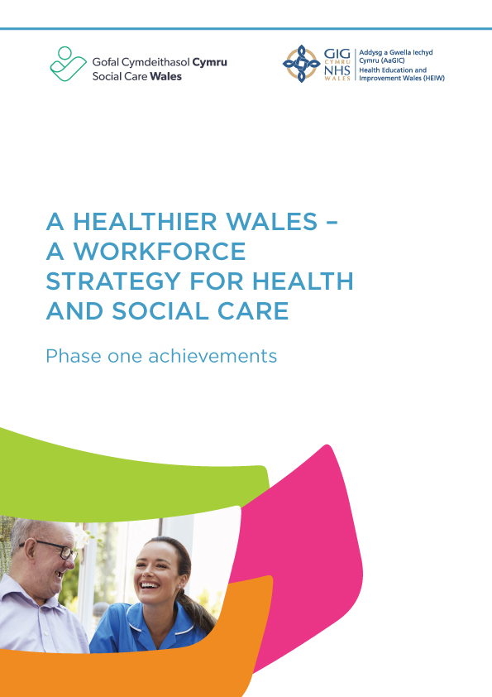

# Introduction

In October 2020, Social Care Wales and Health Education and Improvement Wales (HEIW) launched [Our Workforce Strategy for Health and Social Care](https://heiw.nhs.wales/files/a-healthier-wales-our-workforce-strategy-for-health-and-social-care/), to support the implementation of [A Healthier Wales](https://www.gov.wales/healthier-wales-long-term-plan-health-and-social-care). We developed the strategy, which provided a framework of direction for the next 10 years, after carrying out significant engagement work and hearing the views of staff, partners and stakeholders.

Since we published the strategy, the health and social care sector continues to face challenges which are set within the context of significant financial difficulties. The Covid-19 pandemic will have a lasting impact for years to come and the cost-of-living crisis is having a negative effect on communities.

There are still major workforce challenges within both sectors. It’s difficulty to attract people into the sector, recruit enough staff and retain the existing workforce. This is at a time when there’s continually growing demand for services.

Despite the ongoing challenges faced by the health and social care sector we’ve made progress, and these achievements and improvements should be celebrated. The progress wouldn’t have been possible without the collaboration of key partners including employers, unions, the workforce, and stakeholder and national bodies. So, when we say “we” or “us”, we mean a collective of everyone in the health and social care sector, at local, regional and national level. This shows our collective responsibility to deliver on the ambition of the strategy and support the workforce.

When we launched the workforce strategy, we highlighted that some work would be taken forward at the national level, while some would be delivered at the regional or even local level. The progress has been made through a complex landscape and much work is delivered and reported through a range of different mechanisms at the national, regional and local level. This report summarises the key achievements at the national level.

The workforce strategy is crucial in keeping us focussed on achieving our ambition “*to have a motivated, engaged and valued health and social care workforce with the capacity, competence and confidence to meet the needs of the people of Wales*.”

This report summarises the progress we’ve made at the national level since we launched the strategy four years ago, in both our individual and joint programmes of work.

Well-being, the Welsh language and inclusion are the golden threads of the workforce strategy, which run through all our themes and actions. They continue to play an essential part in the culture change needed to provide vital modern services for the people of Wales.

We’ve made this progress at the same time as carrying out significant engagement work. We consulted on the actions and content of the next stage of implementation, which led to the publication of the [Social Care Workforce Delivery Plan 2024 to 2027](https://socialcare.wales/about-us/workforce-strategy/social-care-delivery-plan-2024-to-2027) and [[National Workforce Implementation Plan: Addressing NHS Wales Workforce Challenges.](https://www.gov.wales/sites/default/files/publications/2023-01/national-workforce-implementation-plan.pdf) Together we’ve also identified joint areas of work that we’ll continue to progress together to support the workforce](https://www.gov.wales/sites/default/files/publications/2023-01/national-workforce-implementation-plan.pdf). This is in line with our first formal review period, as promised in the original strategy. These plans will help you understand future priority actions areas.

We’ve structured our achievements under each of the seven themes of the workforce strategy.

1. An engaged, motivated and healthy workforce
2. Attraction and recruitment
3. Seamless workforce models
4. Building a digitally ready workforce
5. Excellent education and learning
6. Leadership and succession
7. Workforce supply and shape

For each theme we’ve summarised:

* the ambition by 2030
* the main achievements so far.

### 1. An engaged, motivated and healthy workforce

On the theme of an engaged, motivated and healthy workforce, our ambition by 2030 is that the health and social care workforce will feel valued and supported wherever they work.

Since we published the workforce strategy, these are the main achievements of phase one:

* developed health and well-being frameworks so employers and employees can measure their organisation against an agreed set of standards and areas of development
* sharing good practice and resources between health and social care to drive improvement
* given access for the first time to a new universal [mental health support service](https://canopi.nhs.wales/) that’s free at the point of access for the whole workforce across health and social care
* carried out the first workforce surveys of both sectors that gave us a baseline about workforce well-being and engagement in the sector
* delivered health and well-being conferences, set up peer networks, and provided resources and initiatives to highlight the importance of workforce well-being and the contribution it makes to people’s outcomes
* continued to work towards fair reward and recognition across the health and social care workforce.
* contributed to the development of Welsh Government’s [Anti-racist Wales Action Plan](https://www.gov.wales/anti-racist-wales-action-plan) and [LGBTQ+ Action Plan for Wales](https://www.gov.wales/lgbtq-action-plan-wales) and we’re contributing to their implementation and delivery.

### 2. Attraction and recruitment

On the theme of attraction and recruitment, our ambition by 2030 is that health and social care will be well established as a strong and recognisable brand and the sector of choice for our future workforce.

Since we published the workforce strategy, these are the main achievements of phase one:

* worked together to build our existing brands of [WeCare Wales](https://wecare.wales/) and [TrainWorkLive](https://trainworklive.wales/) to attract and recruit staff to our sectors. This included targeted campaigns for professions experiencing staff shortages and those finding it hard to recruit
* launched a digital approach to promoting health and social care careers through the [Careersville](https://heiw.nhs.wales/careers/nhs-wales-careers/careersville/) platform
* strengthened careers network links and connections between careers approaches in health and social care
* established a joint careers network to share good practice and resources to drive improvement across health and care
* worked with stakeholders to strengthen links and understanding of career opportunities in health and social care
* carried out research to understand recruitment and job seeker behaviour.

### 3. Seamless working models

On the theme of seamless working models, our ambition by 2030 is that multi-professional and multi-agency workforce models will be the norm.

Since we published the workforce strategy, these are the main achievements of phase one:

* scoped, engaged and developed the primary care workforce plan
* established and began carrying out actions in the joint [Strategic Mental Health Workforce Plan](https://heiw.nhs.wales/files/strategic-mental-health-workforce-plan/)
* carried out activities to increase the professional pathway into nursing and reablement roles in social care
* acted on the evaluation of the Hywel Dda joint health and social care induction pilot and shared lessons learnt
* worked with partners to develop a [framework for volunteering](https://wcva.cymru/wp-content/uploads/2021/09/Framework-for-Volunteering-in-Health-and-Social-Care-August-2021.pdf) in health and social care
* worked with partners to develop a Trusted assessor online toolkit, including a competency matrix, as part of [Goal 6 of the Six Goals for Urgent and Emergency Care Programme](https://executive.nhs.wales/functions/six-goals-uec/).

### 4. Building a digitally ready workforce

On the theme of building a digitally ready workforce, our ambition by 2030 is that the digital and technological capabilities of the workforce will be well developed and widely used, to optimise the way we work and help us deliver the best possible care for people.

Since we published the workforce strategy, these are the main achievements of phase one:

* designed a digital capability assessment framework for health and commissioned work to develop an approach to understand the digital maturity and literacy of the social care sector in Wales
* worked to increase digital capability in the workforce, allowing them to work and learn using the right technology and digitally enabled ways of delivering health and care services
* launched the revised digitally enabled Infection Prevention and Control (IPC) training
* worked with partners to increase the availability and range of virtual learning, including e-learning, virtual classroom and simulation
* commissioned research to understand the shift to digital learning in social care. We also supported the sector’s shift to digital through targeted increases in funding and by developing national learning modules, including digital learning assets
* carrying out work to understand the best way of supporting digital innovation
* built relationships with important partners including The Centre for Digital Public Services and Digital Communities Wales.

### 5. Excellent education and training

On the theme excellent education and training, our ambition by 2030 is that the investment in education and learning for health and social care professionals will deliver the skills and capabilities needed to meet the needs of people in Wales.

Since we published the workforce strategy, these are the main achievements of phase one:

* supported the sector to implement new health and social care vocational qualifications that were introduced in 2019 and 2020. Following sector feedback, in 2023 to 2024 we worked with partners to support changes to how Level 2 and Level 3 qualifications are assessed. There’s more improvement work to come on Level 4 and 5 qualifications
* worked with partners to try to reduce differences in attainment across health and care education programmes
* created better opportunities to learn through the medium of Welsh by providing resources, webinars and exploring targeted e-learning for the workforce with the [National Centre for learning Welsh](https://learnwelsh.cymru/work-welsh/social-care-camau-scheme/)
* supported the development of a new [Welsh language checker](https://learnwelsh.cymru/work-welsh/social-care-wales-language-levels/) to collect information about workers’ Welsh language skills in speaking, reading, listening and writing. The checker helps workers to take the next step to develop their language skills
* improved opportunities for work-based learning and apprenticeships
* funding and developing “grow your own” models for qualifying as a social worker, delivered by local authorities. These give the workforce the chance to learn while they earn.

### 6. Leadership and succession

On the leadership and succession theme, our ambition by 2030 is that leaders in the health and social care system will show collective and compassionate leadership.

Since we published the workforce strategy, these are the main achievements of phase one:

* developing agreed [compassionate leadership principles](https://nhswalesleadershipportal.heiw.wales/principles-spotlight) and a ‘[compassionate leadership behaviour compass’](https://nhswalesleadershipportal.heiw.wales/what-are-compassionate-behaviours), which explains how to create compassionate leaders and cultures in health and care
* maintaining and developing leadership programmes to embed compassionate leadership principles
* developed the [Gwella](https://nhswalesleadershipportal.heiw.wales/social-care-wales) site, a leadership portal that provides access to and promotes a range of compassionate leadership resources to everyone within health and social care in Wales
* raised awareness of other leadership programme opportunities across health and social care, like [Climb](https://dragonsheart.org/learn/climb/), [Intensive learning academies](https://lshubwales.com/ILA-Wales) and [Academi Wales](https://academiwales.gov.wales/).

### 7. Workforce supply and shape

On the theme of workforce supply and shape, our ambition by 2030 is that we’ll have a sustainable workforce in sufficient numbers to meet the health and social care needs of our population.

Since we published the workforce strategy, these are the main achievements of phase one:

* developed plans for a centre of excellence for workforce intelligence to improve consistency and data access to support long term workforce planning in the health sector
* completed work with local authorities to [better understand their approach to workforce planning](https://socialcare.wales/workforce-planning-executive-summary) in the social care sector
* shared approaches to workforce data collection and planning across sectors to make sure we learn from each other and increase opportunities
* built capacity and capability in workforce planning and development across health and social care
* developed digital resources and online training to support workforce planning for health and care providers
* carried out specific areas of investigation, such as our work to better understand the significant increase of agency workers.
* started a [pilot programme](https://socialcare.wales/news-stories/welsh-language-employer-scheme) to support employers with workforce planning, to meet the Welsh language needs of people receiving care and support
* carried out a [data maturity assessment](https://socialcare.wales/research-and-data/data-maturity-assessment-2023) with all local authorities. The national findings will be published in 2024
* developed workforce plans for key professional groups, such as nursing, the mental health workforce, direct care and social work.

# 

# Conclusion

As a sector, we still aim to achieve the ambition of the 10-year strategy and we’ll carry on supporting collaborative working across health and social care, between local organisations and national bodies working in social partnership.

The work we’ve achieved since the strategy’s launch has allowed us to gain a momentum we can build on in future years, in-line with our longer-term goals.

The Social Care Workforce Delivery Plan 2024 to 2027 and the National Workforce Implementation Plan outline the clear set of actions for phase two of the strategy’s delivery so we can continue to support and develop the workforce.

**Social Care Wales and HEIW** **May 2024**