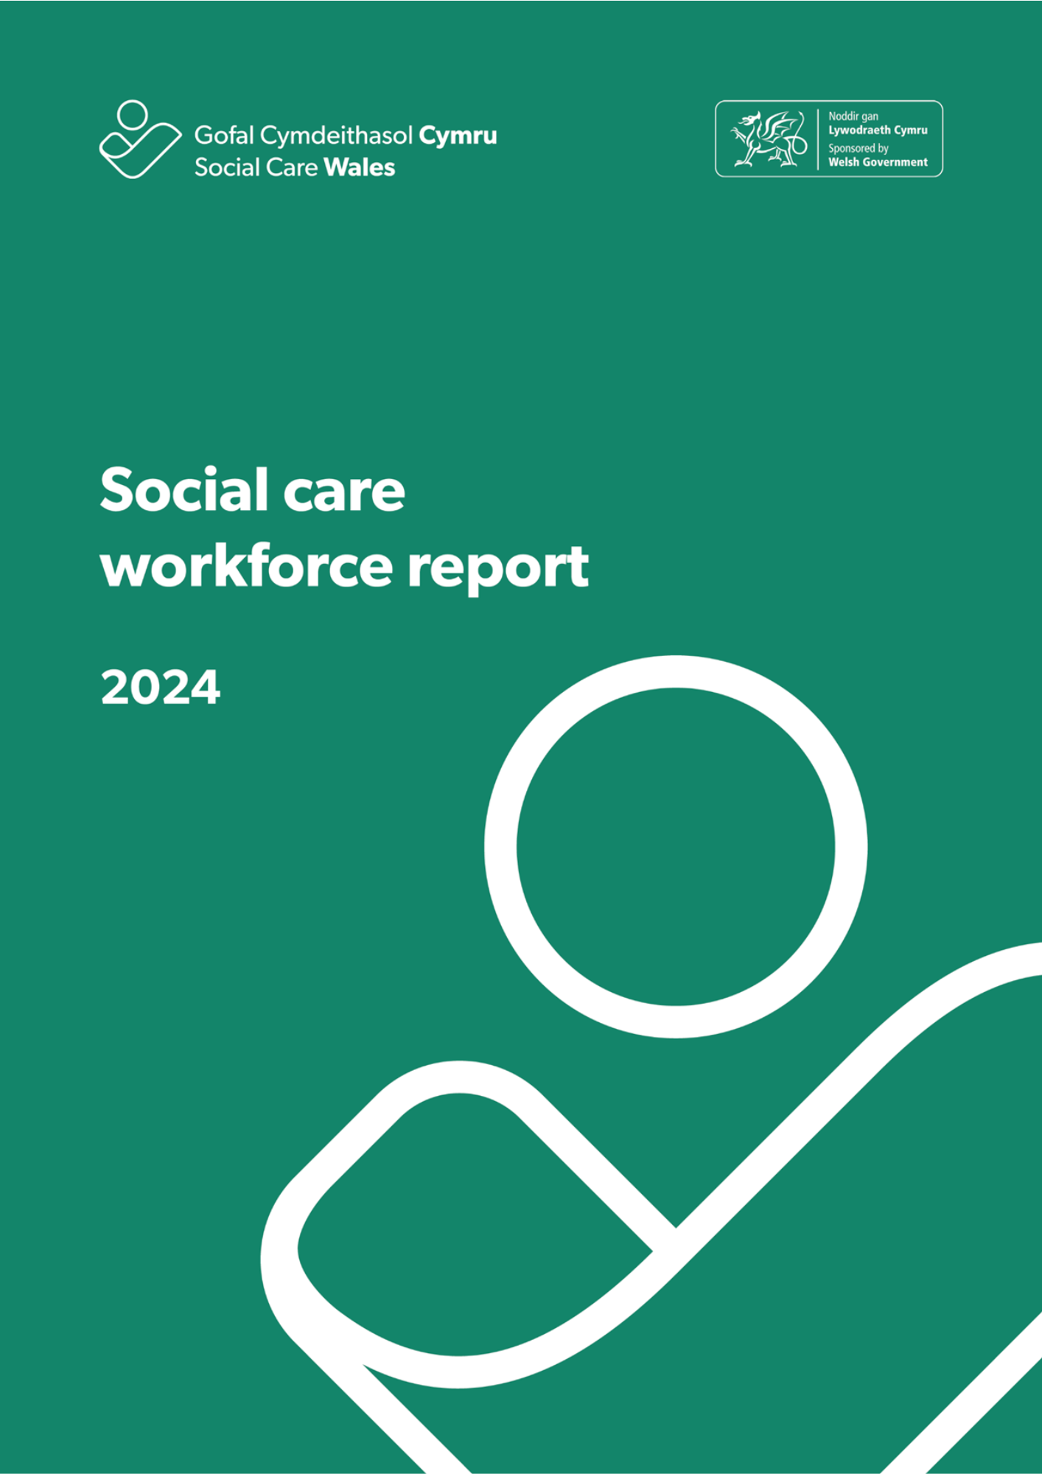
Contents
1. Introduction 3
1.1 Background 3
Summary 4
1.2 Who uses this report and why is this work important? 5
1.3 Changes from 2023 5
1.4 Challenges, issues and data quality 6
1.5 Triangulation of this data with other sources 9
2. Our Findings 11
2.1 Overall social care workforce 11
2.2 Adult residential care 21
2.3 Domiciliary care 25
2.4 Day services 30
2.5 Supported living services 34
2.6 Social work teams 38
2.7 Children’s residential care 42
2.8 Mental health residential care 46
2.9 Central staff 51
2.10 Other services 55
Appendix A - Data categories 56
Appendix B – How we dealt with missing data and estimating the total size of the social care workforce in Wales 59

- Introduction
This report sets out the key findings of our fourth annual workforce data collection, which we carried out in 2024.

We collected the data from September to November 2024. One difference this year is that we asked for data as at 31 March, rather than a date during the collection window. This is part of our work to align this collection with Care Inspectorate Wales’s (CIW) Annual Returns.

  - Background
The introduction of the Performance and Improvement Framework in April 2020 established an integrated data collection process of the social care workforce. Since then, we’ve worked closely with people who work in social care in Wales to improve the method and quality in the annual workforce data collection.

This is the fourth time we’ve collected data under this framework. While there are still areas that need improvement, we’re seeing some themes and trends emerging in the data we’ve received.

For the purposes of this collection, commercial businesses, not-for-profit and third-sector organisations who provide care and support in Wales are classed as commissioned service providers.

Local authorities are required as part of the Performance and Improvement Framework to send us this data every year.

We do not include organisations who only provide NHS-funded care, care provision paid for privately without local-authority funding, or government agencies responsible for social care regulation and inspection.

We asked for data from providers of:
- adult residential care
- children’s residential care
- domiciliary care
- social work teams
- day services
- adult placement schemes
- central or support staff
- other social care services which don’t fall into any of the above.
A full list of the data categories is included in appendix A.

We'd like to thank providers for their continued efforts with this data collection. The data makes a major contribution to how well we understand the social care workforce.

Summary

- 82,875 people were estimated to be employed in the social care workforce in Wales in 2024.

- This is a 0.7 percentage point increase on the equivalent figure in 2023.

- The gender of people working in social care in 2024 remains largely unchanged, with women occupying 81.1 per cent of roles and men 18.9 per cent. Male workers have seen a minor proportional increase (0.5 per cent) in 2024.

- Children’s residential care remains the setting with the highest number of men (30.5 per cent), although this has fallen slightly from last year (34 per cent)

- Care worker roles make up more than half the social care workforce (50.8 per cent).

- There’s a difference in the age of people who work in local authority social services compared to those in commissioned services. In local authorities, just over half (51.2 per cent) of workers are aged 46 or over. Among commissioned services, 60.5 per cent of workers are younger than 46.

- The social care workforce is becoming more diverse, with 8.9 per cent of the workforce now reported as being from a black, Asian or minority ethnic group.

- 5.3 per cent of all social care workers require a working visa to do their jobs.

- 87.2 per cent of the workforce are on permanent contracts. This is a moderate increase from 2023 (79.4 per cent).

- Vacancies have remained stable. We estimate there were 5,346 open or held vacancies in social care in Wales at 31 March 2024.
  - Who uses this report and why is this work important?
The data we collect for this report is the only data collected on the entire social care workforce in Wales. Because of this, the report has a variety of different users. These include:

- Welsh and UK governments
- the Association of Directors of Social Services (ADSS) Cymru and local authorities
- regulators such as Care Inspectorate Wales and Social Care Wales
- care providers
- researchers
- the media
- members of the public.

Examples of where the data has been used in reports and policy created by these organisations can be found in the documents linked in the footnote below. Making sure we have the highest quality data to understand the social care workforce in Wales is incredibly important. Without good quality data, we can’t truly understand the shape and size of social care in Wales.
It also helps us get a better idea of where the demand for care is, in which types of provision, and to plan effectively for the future.
Good quality data enables us to make better decisions, based on evidence. This means we can help to deliver better care and support for people in Wales and provide better support for the hardworking staff who deliver it.

  - Changes from 2023
We try to make as few changes as possible to what we ask for from local authorities and commissioned providers each year. This makes it easier for data collectors to capture the information and makes sure we can compare it with previous years.

With that in mind, we only made two changes for the 2024 collection.
The first was adding a question about the need for a visa to work in the UK. There’s a high level of interest in this area, but no national data is currently available. All commissioned providers who completed their submission answered this question and we received no queries from them about the addition of the question. But many local authorities told us they didn’t hold or couldn’t report on this information. Because of this, there are gaps in this data.

As previously mentioned, the second change was the date on which the data was to be reported on. We changed from the previous approach of asking for data at a date during the collection window, to asking for data as at 31 March.

  - Challenges, issues and data quality
With each collection we continue to learn more about the information collected, recognise the challenges that some organisations have in providing data, and begin to understand the variations in the data we receive. We’ll address some of these findings below.

In 2024 we’ve seen a slight decrease in the number of organisations that have submitted data to us, but an increase in the number of returns by the individual settings provided by those organisations. Getting more detail by setting rather than at an organisational level is positive, but it does mean that comparisons to last year’s data are more difficult.
We now cross-reference our data with data on regulated providers held by Care Inspectorate Wales. This has allowed us to confidently make sure that we’ve contacted all of the settings run by an organisation, rather than relying on a main address or head office. This year, we’ve seen organisations continue to create data collectors at setting level and assign the responsibility to managers to complete their own return. We believe this has improved the quality of some returns.
There are gaps in the data, particularly in certain local authority data, such as data on personal assistants and visa requirements, and we’ll aim to address these in future collections.
In our annual data collection, providers and local authorities self-describe their services, the settings they have and where this provision is based or delivered. In 2023, there was a significant mismatch between Social Care Wales and CIW data sets. In 2024, the work we’ve done to cross-reference our data on organisational settings with CIW’s data means there are now areas that clearly match more closely across both data sets. The low response rate in the 2023 collections led to an over-estimation in the size of the workforce for the period.
We’ve refined our processes and methodology and adjusted the figures in this report.
But providers have told us that submitting data about the workforce to both Social Care Wales and CIW is time-consuming and potentially confusing.
For this reason we’re working closely with our colleagues in CIW to create a single unified collection in the future. In the meantime, we’ll continue working to make it easier to use the same data across both collections.
- Personal assistants
We saw no improvement in the number of authorities who provided data on personal assistants this year. Because of this, we remain unable to report on their numbers in this report.

- Estimating missing data
Creating accurate estimates of the true size of the workforce is difficult with a low response rate. In 2024, we haven’t been able to estimate the total number of people working in domiciliary care with the accuracy and confidence we need.
We’ve continued to use all available reference sources, including submissions from previous years, CIW Annual Returns and capacity data and our Register to refine and improve the accuracy of the data. We’ve used these as a proxy to an estimate of the total number of people working in domiciliary care. A proxy is a stand-in figure used when the actual data is either unavailable or not reliable enough. This also has an impact on our ability to estimate the total number of people working in social care in Wales. For 2024, we've used proxy data within the estimate to account for the number of people working in domiciliary care.

- Comparing data from this report with CIW Annual Returns data
We know that completing two different collections for Social Care Wales and CIW is problematic and inefficient. We’re working to understand what we can do to improve things for the people who we ask for data.

- Differences in how we categorise job roles
The most obvious difference between CIW’s Annual Returns collection and this collection is how we describe care roles and settings. CIW collects data on residential care and domiciliary care in the Annual Returns process. How we describe these settings is slightly different, as shown in the tables below. It’s also important to note that domiciliary care is reported by CIW at health board level, not by local authority as in our collection.
Residential care
Care Inspectorate Wales | Social Care Wales
Adults without nursing  Adults with nursing | Adults
Children | Children
Adults and children without nursing | Mental health

Domiciliary care
Care Inspectorate Wales | Social Care Wales
Domiciliary care | Domiciliary care  Supported living

Building on what we learned in 2023, we now have a more robust approach in distinguishing those who describe themselves as supported living settings in our collection. This has allowed us to consider what it means in relation to the estimates on the number working in this type of service and domiciliary care. Data from CIW and Social Care Wales is now much more likely to be comparable when the differences shown in the above table are taken into account.

- Return rates
This year, we’ve been able to calculate the return rates by taking the number of settings that returned data and dividing that by the total number of settings we expect to see (based on our comparison with CIW data). This is in addition to how we’ve calculated rates in the past, where we calculated return rates by the number of organisations that submitted data, regardless of how many settings they submitted.

Both calculation methods can be seen in section two. The original method of calculating by organisation has been used in individual sections so that comparisons can be made to previous years if needed.

This addition was made due to having more confidence in the number of settings known, but also due to having a lot more data submissions at setting level. Our work to compare our data on the number of settings to CIW’s has highlighted lower return rates in 2024.

All 22 local authorities returned data to us, but we continue to be concerned about the availability of data for some key areas. These include data on qualifications, work visas, and joiners and leavers. This year we included data from last year in the submission tool. This meant organisations could compare this year’s data with what they provided last year before they sent us their data.

We calculated the number of commissioned providers we expected returns from by using the information from the Register of Social Care Workers in Wales, and a list of the services that are registered with CIW.

For commissioned providers, the National Framework for the Commissioning of Care and Support in Wales: Code of practice says:

Commissioners must proactively encourage their providers to complete and return the annual Social Care Wales workforce data collection undertaken by Social Care Wales. Having an accurate and up to date national dataset relating to the social care workforce supports robust workforce planning at national, regional and local levels.

While it’s disappointing that this figure has decreased from the previous year, there’s been an increase in the completeness of the data provided.

We’ve prioritised building relationships with providers and connecting with the correct individuals to try and help them complete a submission and increase the return rate. While we don’t see the benefit of this work in this year’s collection, we’re confident it will have a positive impact in future years. We really value the input of those who’ve engaged with us through this collection.

  - Triangulation of this data with other sources
Wherever possible, we triangulate the data we receive during this process with other similar sources of data. Triangulation means we compare our data with information from other sources to sense check and validate it and to understand why there might be differences. The data for the 2024 report has been compared to:
- the Register of Social Care Workers in Wales
- data from our 2022 and 2023 workforce data collection
- our understanding of the size of services from data held by CIW
- data from the 2024 Annual Returns process run by CIW.

We provide more detail about each of these below:

The Register of Social Care Workers in Wales
Registration is a mandatory requirement for many social care roles in Wales. The Register is managed by Social Care Wales and can tell us the number of people in each role, along with their details. The accuracy of this data relies on the individual to keep it up to date, especially if they’re not currently working in the role they’re registered for. This isn’t always the case, and changes are often only recorded when a person renews (every three years) or changes employer. This is why we use the Register as a guide to the overall size of the workforce, but remain aware of potential delays in individual updates.

Not all of the people who we collect data on for the annual workforce collection will need to register. Many administrative, back-office and support staff work in social care in Wales. We estimate that registered staff make up somewhere between two-thirds and three-quarters of the overall workforce.

Data from the workforce data collection 2022 and 2023
Some organisations who submitted data in 2022 or 2023 didn’t submit data in 2024 and vice versa. For those who submitted previously and were still in operation in 2024, we used the data submitted in previous collections as a base for estimating their missing data for 2024. This means we based our prediction of change on the number we knew from the previous collection, rather than in comparison to organisations of a similar size (as we did in 2022, where we didn’t have access to similar data).

Comparisons with CIW data
For 2023 and 2024, we’ve been able to make much better use of CIW data in the collection. This is described in more detail in Section 1.4.3 and 1.4.4.

- Our findings
- Overall social care workforce
Providers who submitted data told us about 47,915 social care workers who worked in their organisations. But using our process for dealing with missing data described in appendix B, we estimate a total of 82,875 people working in social care in Wales in 2024.

The chart below gives a breakdown of the returned and estimated numbers for each service area. Adult placement schemes are included in the chart below and in the overall numbers, but we haven’t broken them down further given the small numbers we see in the returns. This is in line with what we’ve done in previous years.
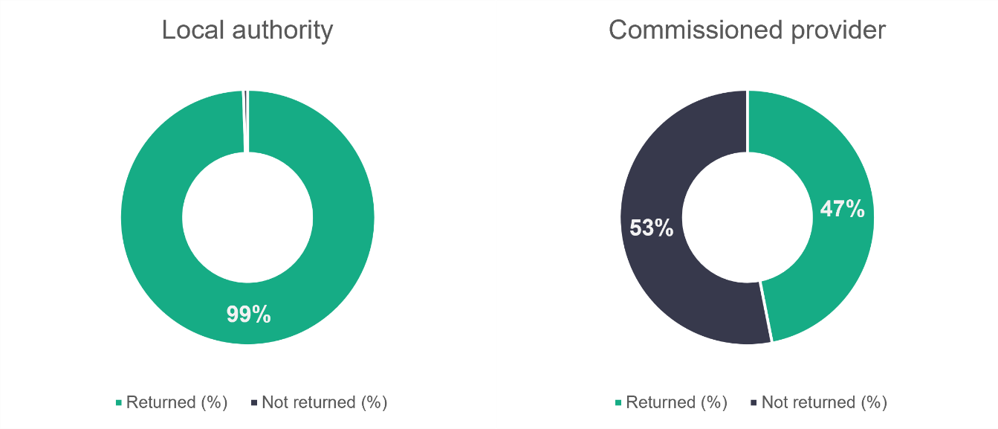
n = 22
n = 746
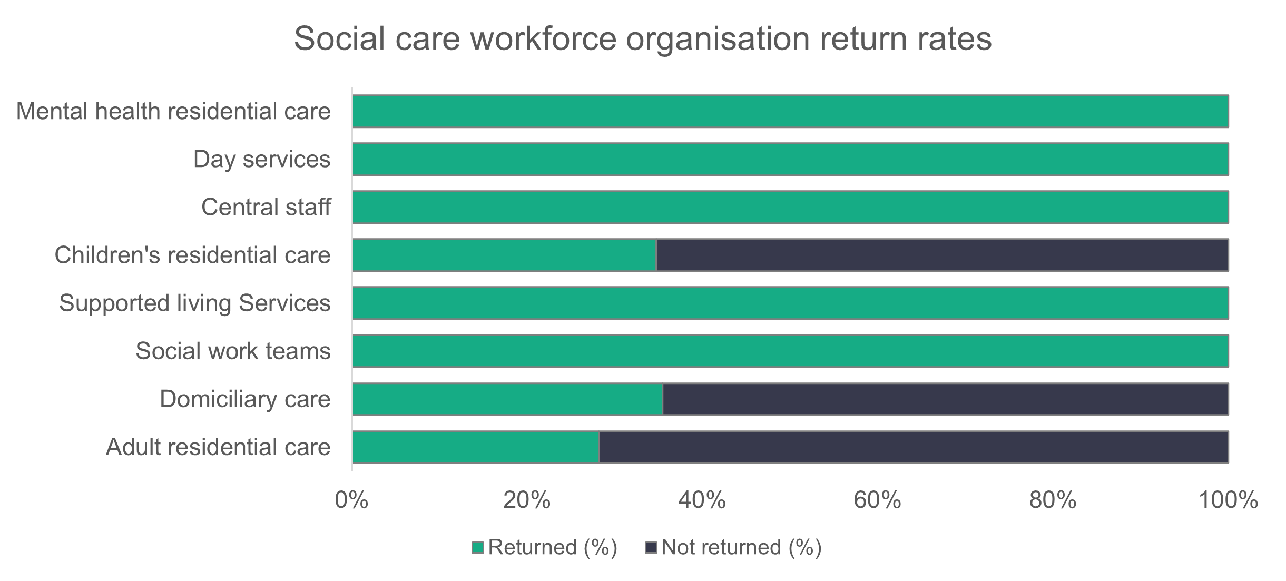
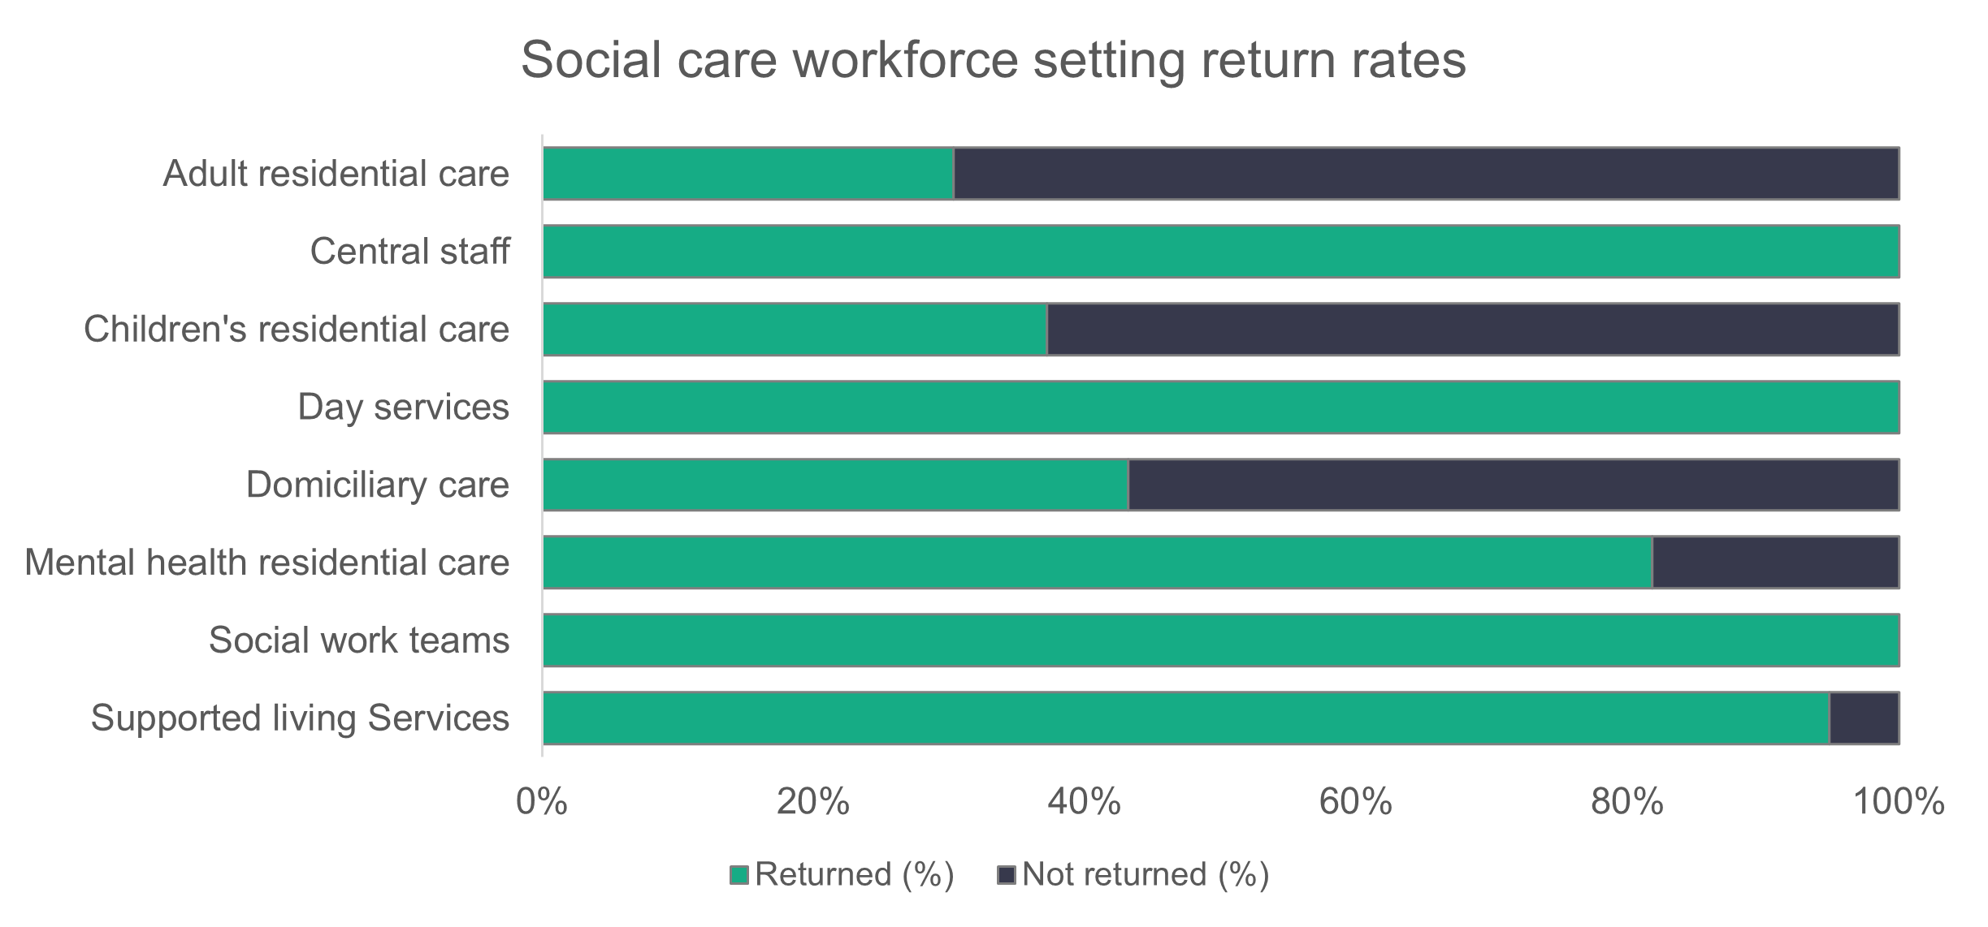
The difference between setting and organisational return rates is that an organisation may have more than one setting. Organisational return rates show as returned if any of an organisation’s settings provides us with data. Setting level return rates count each individual setting, regardless of organisation. It’s important to see both, but setting is the most accurate. For example, all mental health residential care provider organisations gave us some data. But we can see from setting-level data that some organisations only gave us partial data and that nearly 20 per cent of settings hadn’t provided their data.

This is the first time we’ve been able to achieve this level of detail in the returns data. We’ve kept individual role type return rates at organisational level to allow for comparison with previous years.
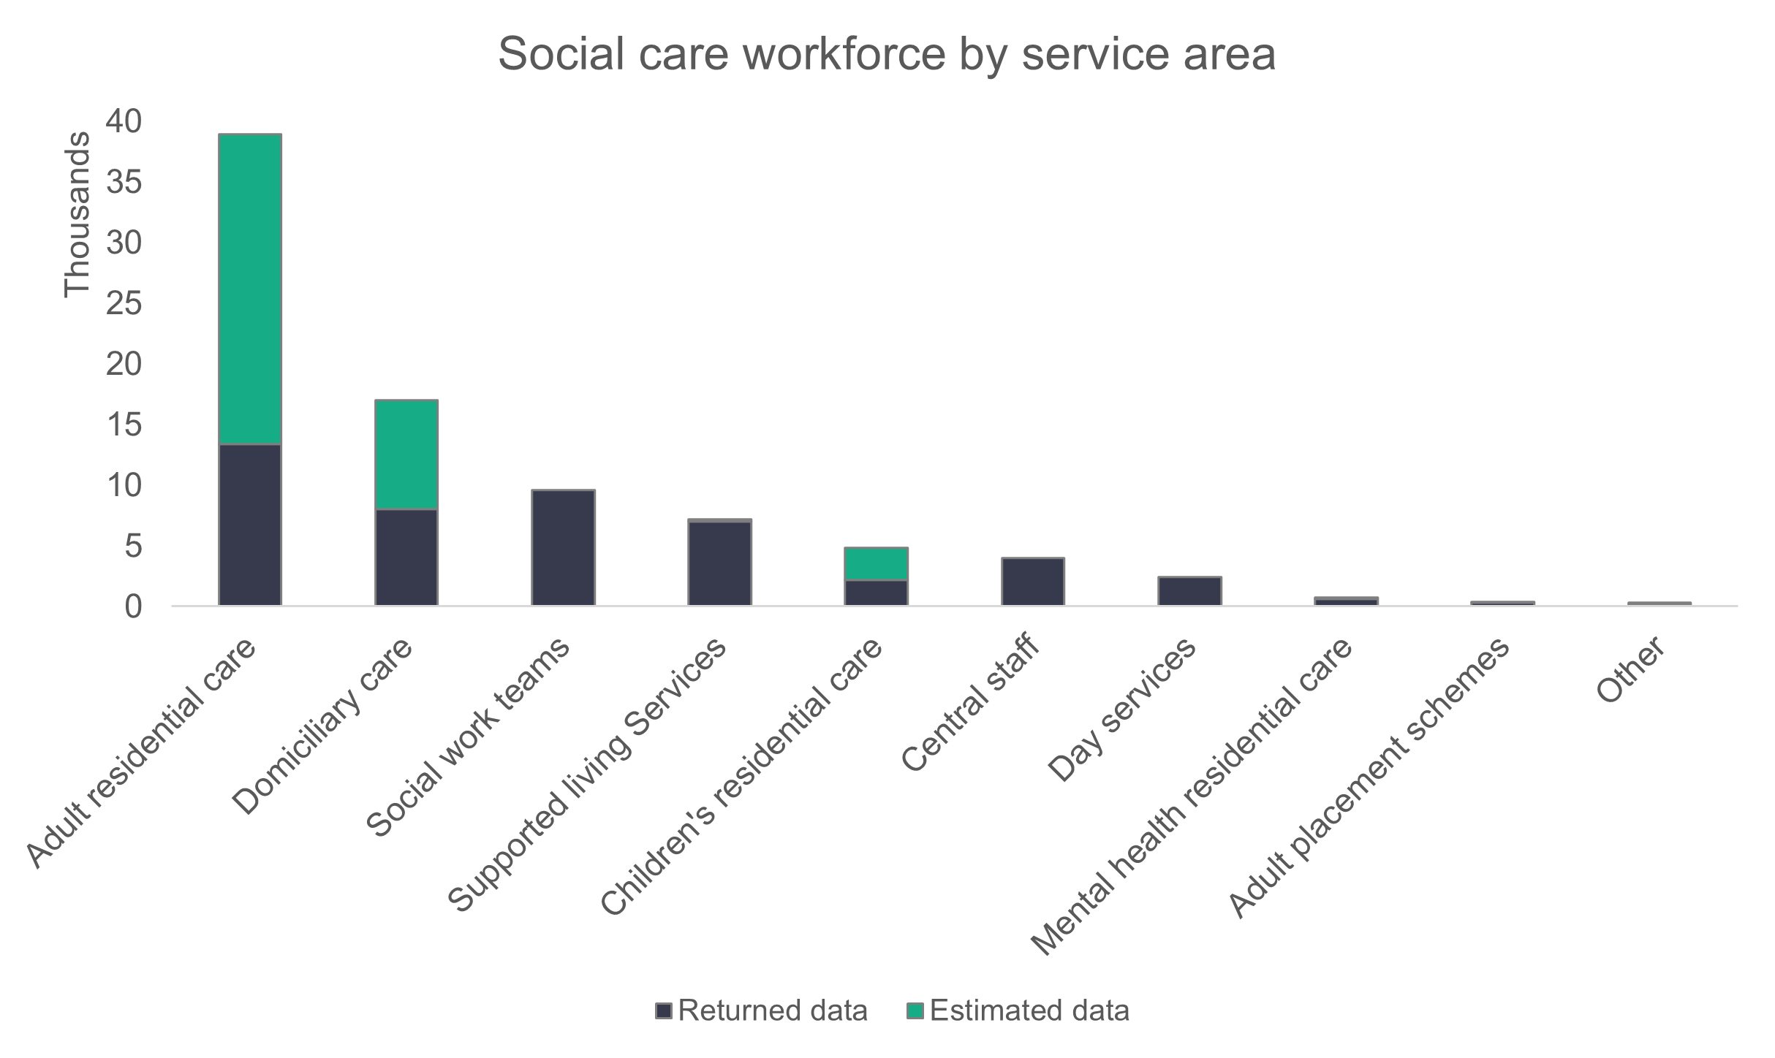
n = 85,442
The change in the numbers in each setting is relatively stable this year, with adult residential care seeing the biggest change in numbers, where the estimated workforce has decreased by 791. This is closely followed by children’s residential care, which has seen an increase of 590 in its workforce based on the revised 2023 figures.
Number in post

 | 2022 |  |  | 2023 |  |  | 2024
 | Returned |  | Estimated | Returned |  | Estimated | Returned | Estimated
Adult residential care | 18,158 |  | 29,101 | 14,785 |  | 34,075 | 13,394 | 33,284
Domiciliary care | 10,657 |  | 19,571 | 12,763 |  | 20,040 | 8,058 | 20,682
Social work teams | 8,566 |  | 8,566 | 9,456 |  | 9,456 | 9,601 | 9,601
Supported living services | 6,565 |  | 6,893 | 6,601 |  | 7,342 | 6,982 | 7,165
Central staff | 3,561 |  | 3,766 | 3,457 |  | 3,722 | 4,014 | 4,014
Children's residential care | 2,171 |  | 4,411 | 1,926 |  | 3,638 | 2,216 | 4,340
Day services | 2,812 |  | 2,831 | 2,644 |  | 2,684 | 2,444 | 2,444
Mental health residential care services | 539 |  | 822 | 604 |  | 683 | 630 | 630
Adult placement schemes | 147 |  | 338 | 343 |  | 434 | 347 | 379
Other | 147 |  | 147 | 111 |  | 191 | 229 | 336

- Roles
The chart below shows the proportion of roles filled by the social care workforce. We haven’t included roles that represent less than one per cent of the workforce in the chart. Care workers make up the majority of roles, representing slightly more than half the workforce (50.8 per cent). This proportion has dropped from 54.6 per cent last year.
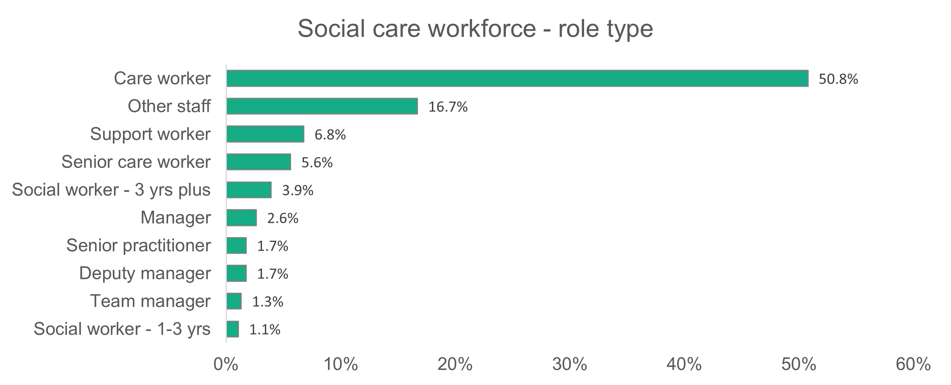
n = 47,766
- Gender
Women make up 81.1 per cent of the social care workforce. This is only slightly lower than last year’s figure of 81.6 per cent. The proportion of female care workers in the workforce is 81 per cent. The director role has the lowest proportion of women at 55.6 per cent.
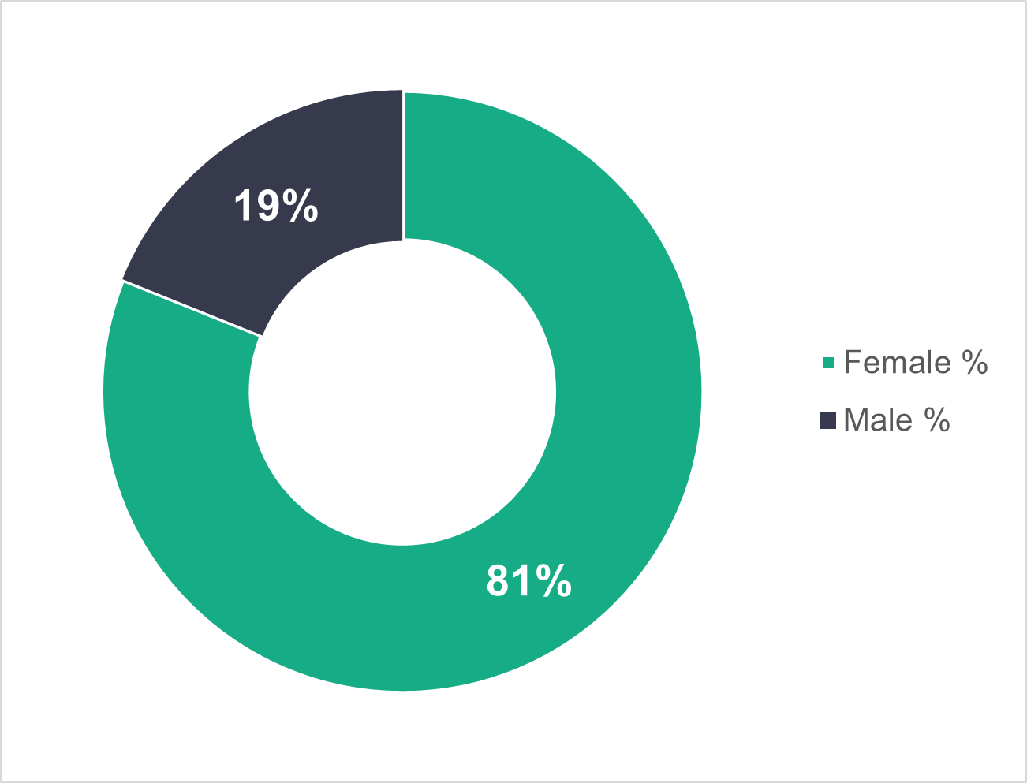
n = 46,791

- Age profile
In local authorities, 46 to 55 is the largest age group, making up 25.5 per cent of their workforce. Just over half (51.2 per cent) of their workers are aged 46 or over.
For commissioned services, we see that the 26 to 35 age group is the biggest, making up 24.6 per cent of their workforce. Among commissioned services, 60.5 per cent of workers are younger than 46.
We also see a significant difference in the youngest age group, with commissioned services having more than double the proportion of workers in the 16 to 25 bracket.

These differences suggest that local authorities are much more likely to retain staff than commissioned services. It might also mean that workers are moving from commissioned services to local authority services later in their careers.
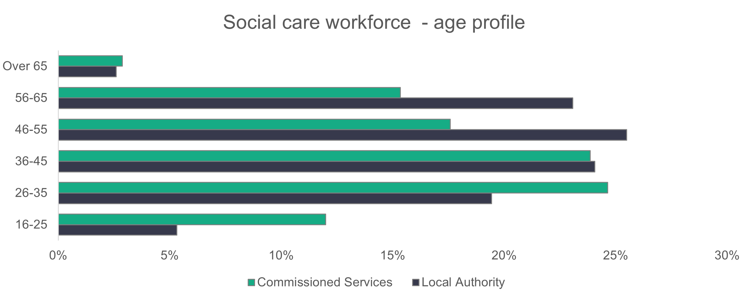
n = 46,027

- Ethnicity
The ethnicity of the social care workforce has become more diverse over the past three years, with 8.9 per cent of the workforce now reported as being from a black, Asian or minority ethnic group. The corresponding value in 2023 was 7.6 per cent, and 5.5 per cent in 2022. The proportion of black workers, has risen from 2.3 per cent in 2022, to 3.7 per cent in 2023 and 5.2 per cent in 2024. This proportion is almost six times more than we’d see in the general Welsh population.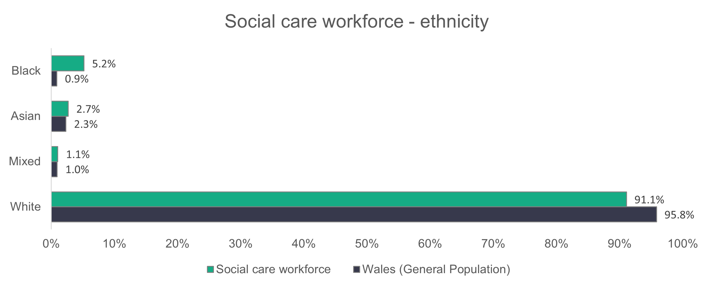
n = 34,254
The ethnic diversity of the workforce can vary quite drastically between roles. As we did in 2023, we’ve taken a sample of roles to show this variation.
The chart below shows the ethnic diversity of:

- registered nursing staff – the most ethnically diverse role type
- care workers – because they make up most of the workforce
- senior roles – which are made up of all defined manager or senior manager roles in the data (including director level, assistant manager or deputy manager roles).
The general trend is similar to last year, but the proportion of white registered nursing staff has increased from 67 per cent to 71 per cent this year, and the proportion of white care workers has decreased from 89.3 per cent to 87.5 per cent. The proportion of black care workers has increased from six per cent to 8.5 per cent.

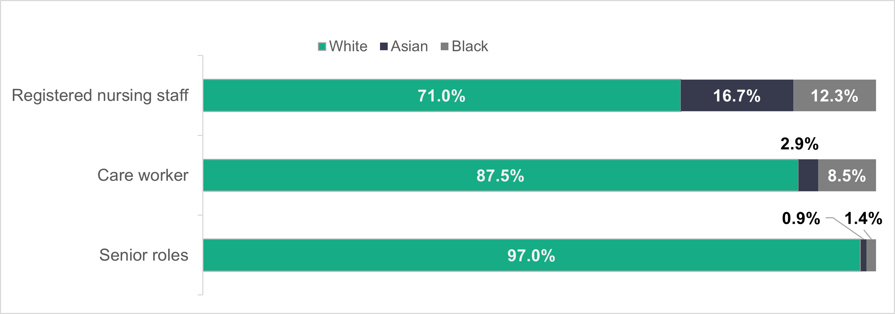

- Welsh language skills
The proportion of the workforce with no Welsh language ability has dropped quite drastically from 69.6 per cent in 2023 to 49.5 per cent in 2024. But it’s worth noting that we only received data on this topic for 23,344 people this year, compared to 35,847 in 2023.
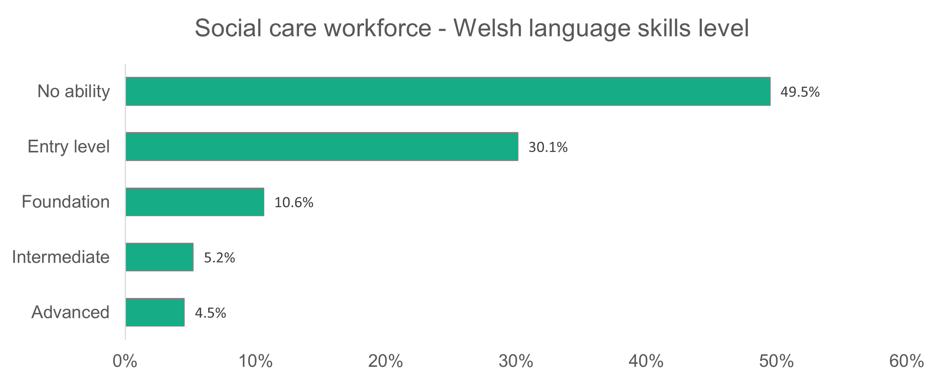
n = 23,344

- Contract type
Commissioned services have 87.2 per cent of their workforce on permanent contracts. The proportion for local authorities is 76.6 per cent. In 2023, 82.6 per cent of the commissioned services workforce and 76.3 per cent of the local authority workforce were on permanent contracts.

Local authorities have 11.2 per cent of their workforce on casual contracts. This is up from 6.1 per cent last year, but the combined proportion of casual and zero-hours contracts has only changed slightly (up from 12.3 per cent to 12.4 per cent). The proportion of commissioned service workers on zero-hours contracts has almost halved, from 12.1 per cent last year to 6.6 per cent this year. But this year’s value is still almost twice the proportion for the general workforce of Wales, which stands at 3.7 per cent.
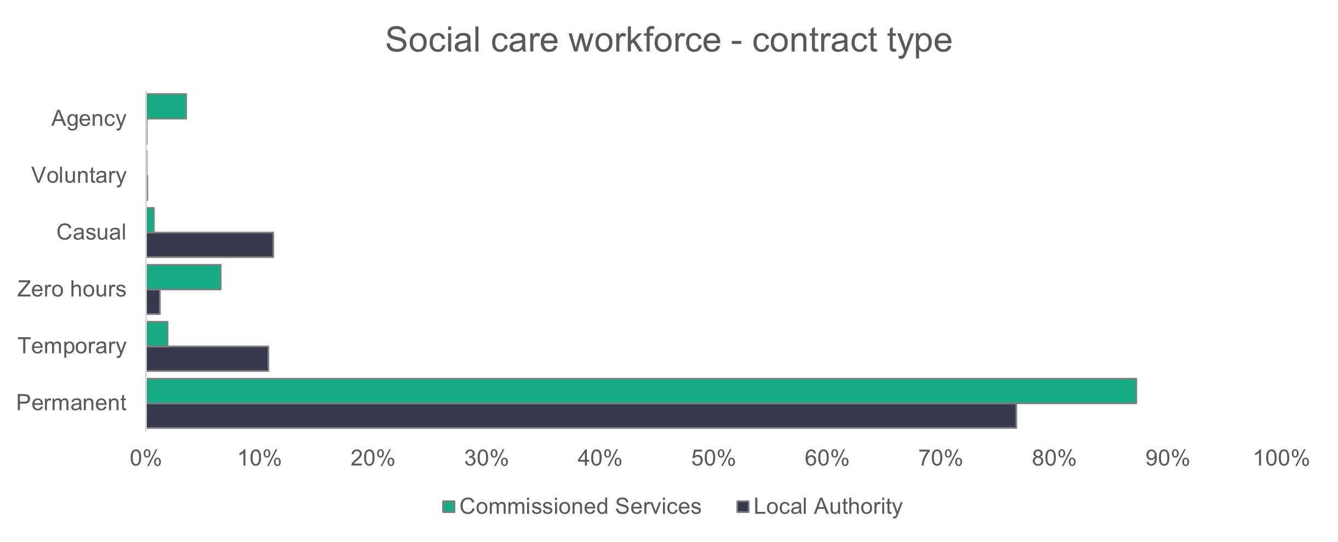
n = 47,020

Care workers are most likely to be employed on casual contracts, with 2,313 (9.7 per cent) workers on such a contract. When combined, 15.6 per cent of care workers are on casual or zero-hours contracts. Residential care services provided by local authorities have the highest proportion of staff on casual contracts – 30.9 per cent for adult, 19.8 per cent for mental health, and 24.4 per cent for children’s residential care.

For commissioned services, the domiciliary care sector has the highest proportion of staff on zero-hours contracts (25.9 per cent).

- Work visa
This is the first year we’ve collected this data, with this also being the first time this question has been asked of the workforce. The key thing we’ve noted in this first look at the data is that 5.3 per cent of the social care workforce need a visa to work in the UK. This varies a lot by setting and role, but overall there’s a larger proportion of workers who need a visa in the commissioned provider workforce (10.7 per cent) in comparison to the local authority workforce (one per cent). The proportion of workers who need a work visa is shown in the chart below for each setting type. Almost one in 10 (9.7 per cent) of the workers in adult residential care need a work visa.
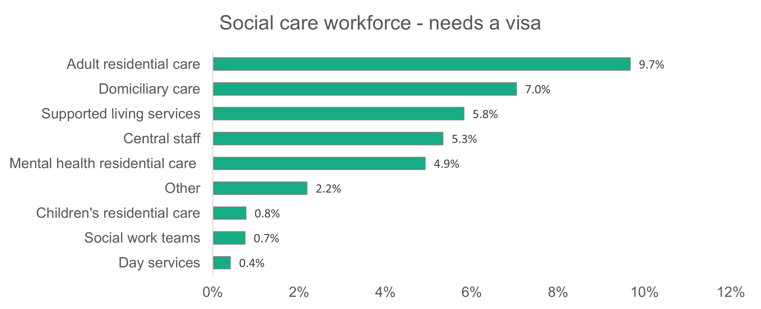
n = 2,586
As seen in the chart above, adult residential care and domiciliary care have the largest proportion of workers who need a visa. This is because these settings are where the most registered nurse and care workers are employed. These role types are where we see the highest percentage of workers who need a visa (19.2 per cent and eight per cent respectively).

- Agency workers
Our data on agency workers underestimates the number of agency staff used as it can only give a point-in-time estimate, rather than the total number of staff used over the course of a year. We also know that HR departments may not always know immediately about the use of agency staff. This can be a particular problem in local authorities. What we can say is that we haven’t seen any significant rise in the data presented to us on the use of agency staff since 2022.

The Association of Directors of Social Services (ADSS) Cymru has been monitoring the use of agency workers in children’s services with the aim of reducing the use of these staff.

- Working patterns
The proportion of people working full-time hours (36 or more per week) is broadly similar across local authorities (50.1 per cent) and commissioned services (48.3 per cent). Compared to last year, a slightly higher proportion of the local authority
workforce work full-time (47.4 per cent last year).
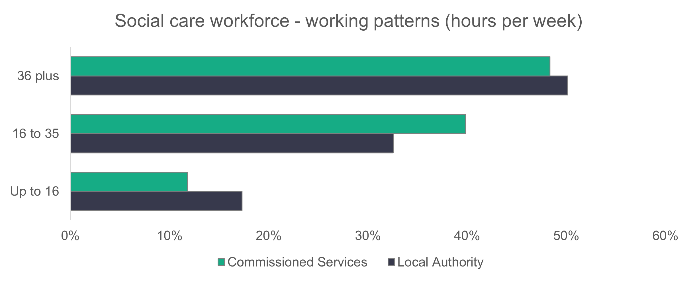
n = 45,984
- Vacancies
Throughout the social care workforce, there are 2,419 open vacancies and 846 held vacant. We estimate that there are a further 2,081 posts that are vacant or held vacant. This gives us a total of 5,346 vacancies and represents 6.3 per cent of the workforce. Last year, there were an estimated 5,299 posts vacant or held vacant – 47 fewer than this year.
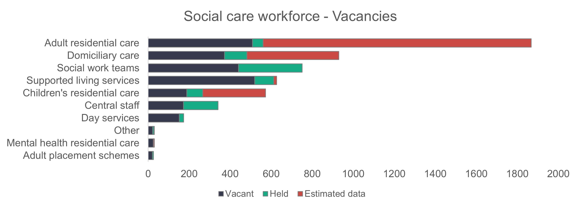

- Staff turnover
We asked for information about joiners and leavers. It was reported that 8,187 people started a new role in social care in Wales and 8,709 left the sector during the year. From this data, we can calculate an overall net decrease of 522 staff in the social care sector in Wales in 2023 to 2024.

The data for staff turnover gives us a figure that shows the change in the size of the workforce over the course of the year. Not all providers have provided data, so we can only present the data that has been submitted. For that reason, this data about joiners, leavers and net change should be read with caution.

Setting | Joiners | Leavers | Net change
Adult placement schemes | 107 | 74 | +33
Central staff | 495 | 520 | -25
Day services | 160 | 275 | -115
Domiciliary care | 1,738 | 1,873 | -135
Other | 36 | 27 | +9
Residential care – adults | 2,484 | 2,541 | -57
Residential care – children | 630 | 492 | +138
Residential care – mental health | 122 | 115 | +7
Social work teams – adults | 269 | 437 | -168
Social work teams – all | 134 | 102 | +32
Social work teams – children | 723 | 865 | -142
Supported living services | 1,289 | 1,388 | -99
Total | 8,187 | 8,709 | -522

- Sickness
A total of 302,673 days were lost to sickness according to the returned data – an increase of 0.5 per cent on last year.

The biggest change compared to last year’s data came in ‘common ill health’, which increased from 53,668 days in 2023 to 67,145 days in 2024. Absence due to Covid dropped significantly from 23,333 to 10,022 days.

A breakdown of the reasons for sickness, or absence from work, is shown in the following chart. Proportionally, ‘other illness’ accounts for 33.9 per cent (34.1 per cent in 2023) of all absences. Stress (work and non-work related) accounts for 22.4 per cent (22.8 per cent in 2023).

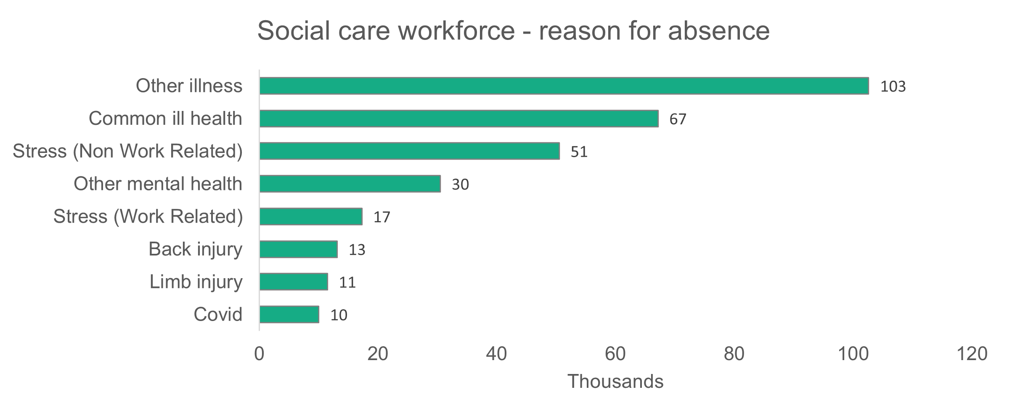

Workforce information by type of setting
- Adult residential care

Summary:
- Care workers continue to make up the majority (65.2 per cent) of the adult residential care workforce.
- Local authorities have an older workforce than commissioned services.
- Black, Asian or mixed-race workers make up 13.2 per cent of the workforce, compared to 4.2 per cent in the population.
- Casual contracts make up 30.9 per cent of local authority contracts.

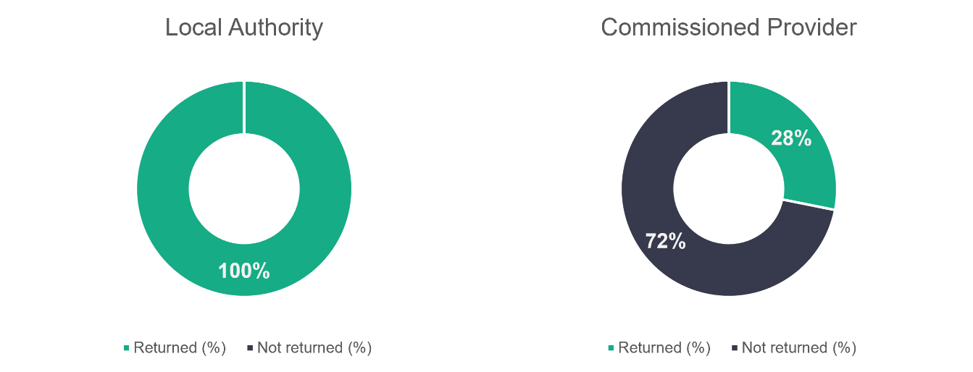
n = 17
n = 444
- Adult residential care – role type
There are no major changes in the proportion of workers in the types of roles highlighted in the chart below since 2022. But the number of roles we’ve been told about this year is down from 14,785 in 2023 to 13,394.

Care workers make up most (65.2 per cent) of the roles, compared to 63.6 per cent in 2023 and 60.3 per cent in 2022 – an increase of almost five per cent from two years ago. See the chart below for a breakdown of the role profile of the adult residential care workforce.
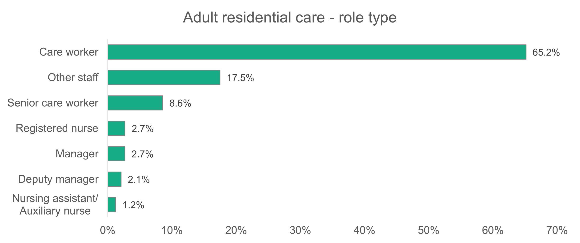
n = 13,394

- Adult residential care – gender
The proportion of women working in adult residential care (81.8 per cent) is very close to the proportion in the general social care workforce (81.1 per cent). Last year, 83.7 per cent of the adult residential care sector was female. The proportion in 2022 was 85 per cent.
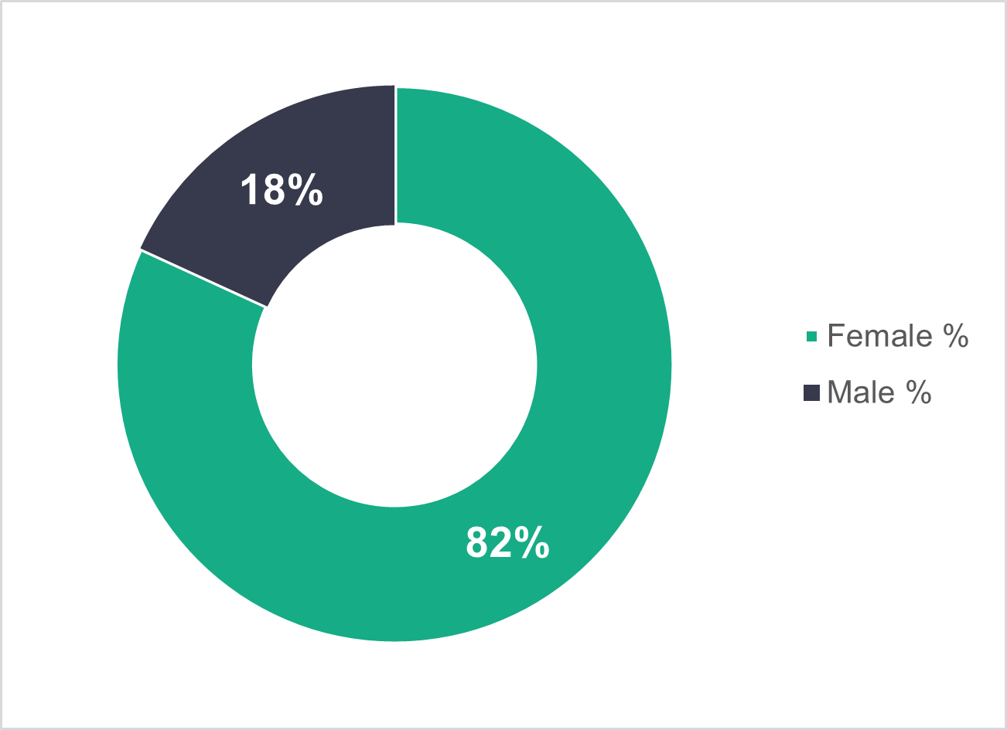
n = 12,936

- Adult residential care – age profile
The age profile of the adult residential care workforce has hardly changed from 2023. A higher proportion of local authority workers are over 45 (58 per cent), but we find the opposite trend for commissioned services, with a higher proportion of workers aged 45 or under (63.1 per cent).
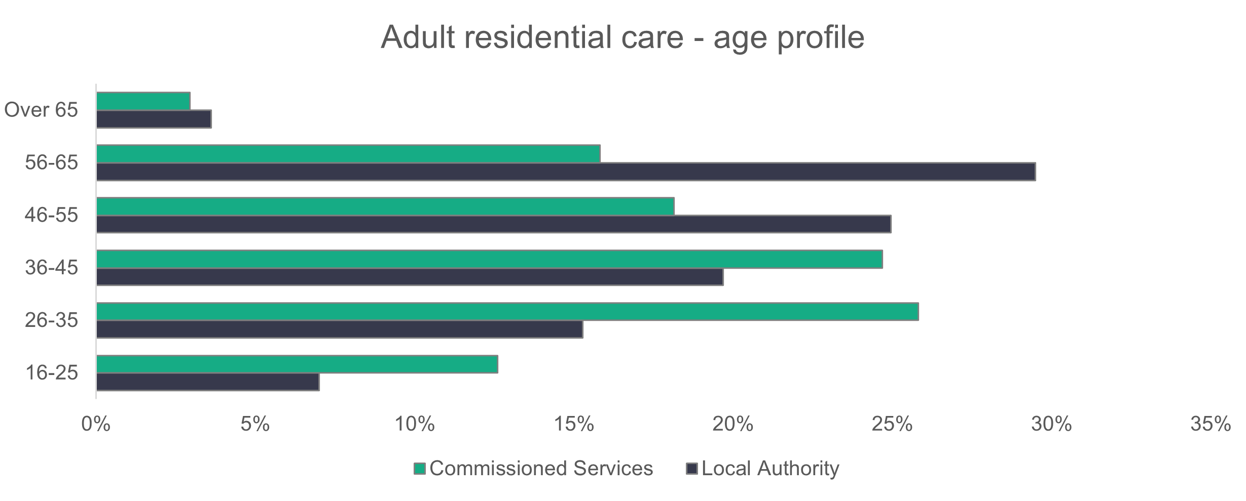
n = 12,543
- Adult residential care – ethnicity
Similar to 2023, the adult residential care workforce is ethnically more diverse than the general population of Wales. The proportion of black workers has increased this year from 5.3 per cent to 7.2 per cent of the workforce, which is eight times more than the general population of Wales. The proportion of Asian workers has dropped from 6.3 per cent to 5.1 per cent of the workforce. Again, this is higher than we‘d expect to see in the general population.
The proportion of black workers has risen steadily since 2022, when the adult residential care workforce was 2.4 per cent black. The proportion of Asian workers has increased and decreased over the years, as it was 5.9 per cent in 2022.

Registered nursing staff have the highest proportion of both black (13.2 per cent) and Asian (18.2 per cent) workers in adult residential care.
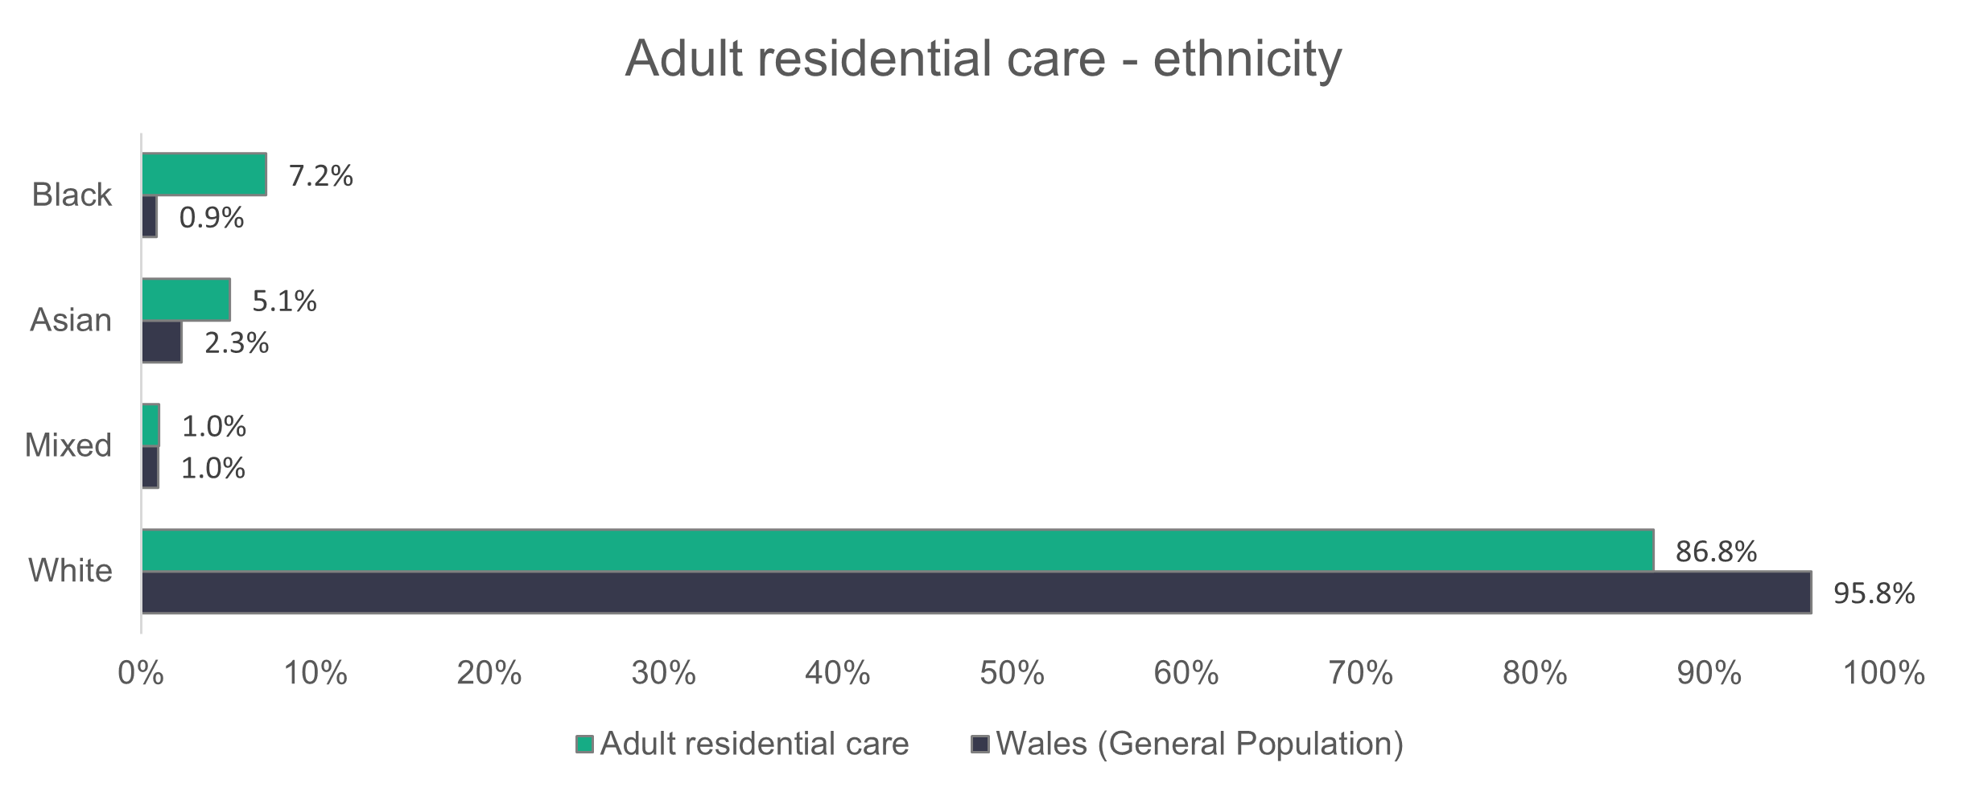
n = 8,668

- Adult residential care – contract type
Local authorities have far fewer of their workforce on permanent contracts when compared to commissioned services. Permanent contracts make up 89.4 per cent of the commissioned services workforce, while the corresponding figure for local authorities is 64.2 per cent.

A high proportion (30.9 per cent) of local authority workers are on casual contracts. We also see that a higher proportion of local authority care workers are on casual contracts than any other role (37.3 per cent).

Zero-hours contracts make up 2.6 per cent of the local authority workforce. Last year, zero-hours contracts made up 20.4 per cent of the local authority workforce. But the combined proportion of casual and zero-hours is quite similar this year (33.4 per cent) to last year (31.8 per cent) and 2022 (31.5 per cent) for local authorities.
Commissioned service providers have seen an increase in agency workers in their adult residential care workforce, from 3.9 per cent in 2023 to 4.7 per cent this year.

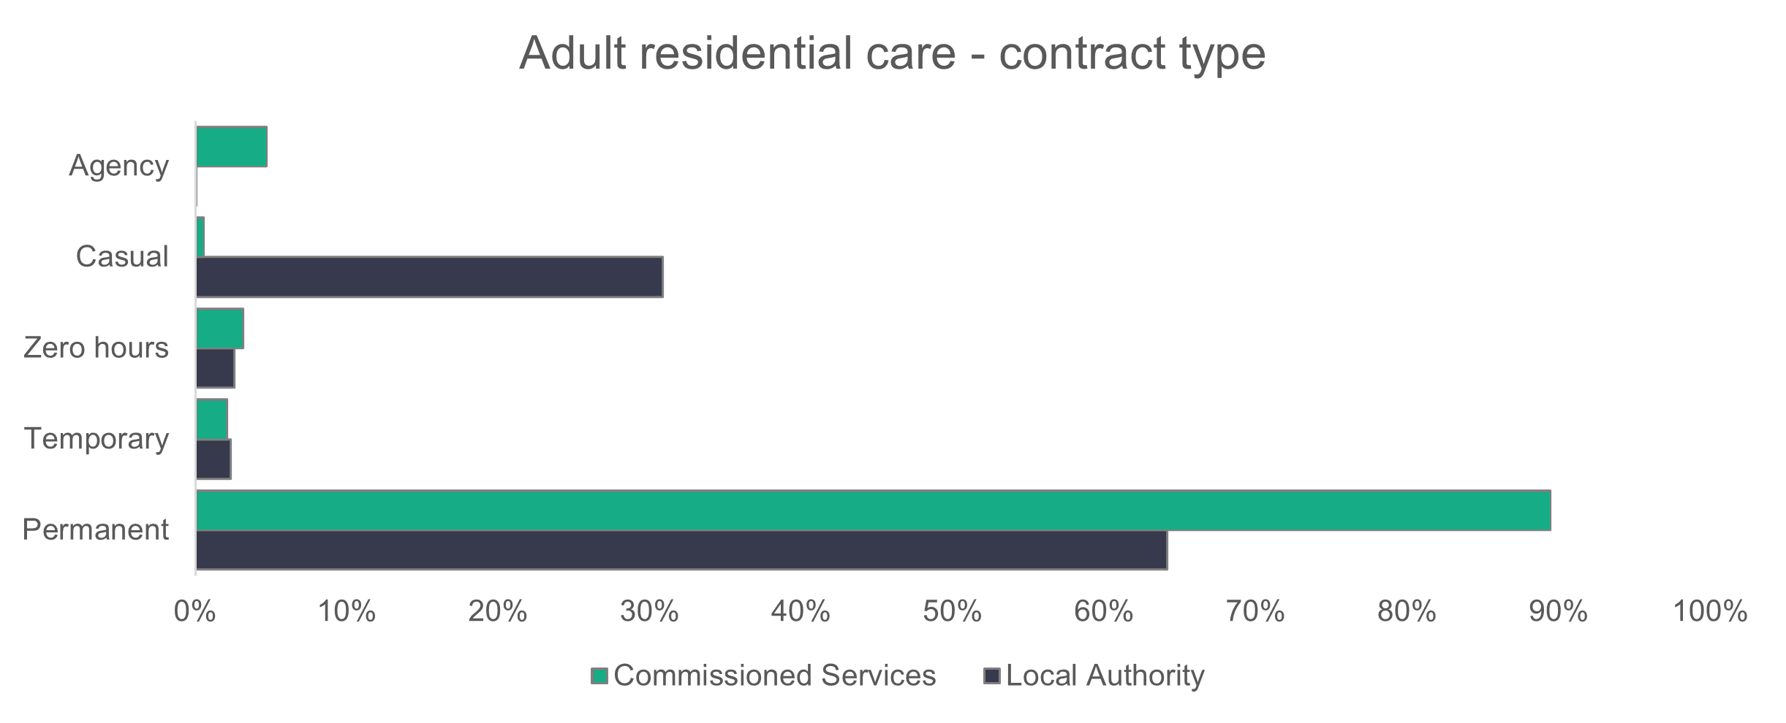
n = 12,931
- Adult residential care – working patterns
The working patterns of the adult residential care workforce haven’t changed much from 2023. Most people working in adult residential care work part-time hours (fewer than 36 hours per week). Part-time workers account for 54.7 per cent of the commissioned service workforce and a considerably higher 87.7 per cent for local authority services.
The corresponding proportions last year showed that part-time contracts accounted for 52.5 per cent of the commissioned services workforce and 89.3 per cent of the local authority workforce.

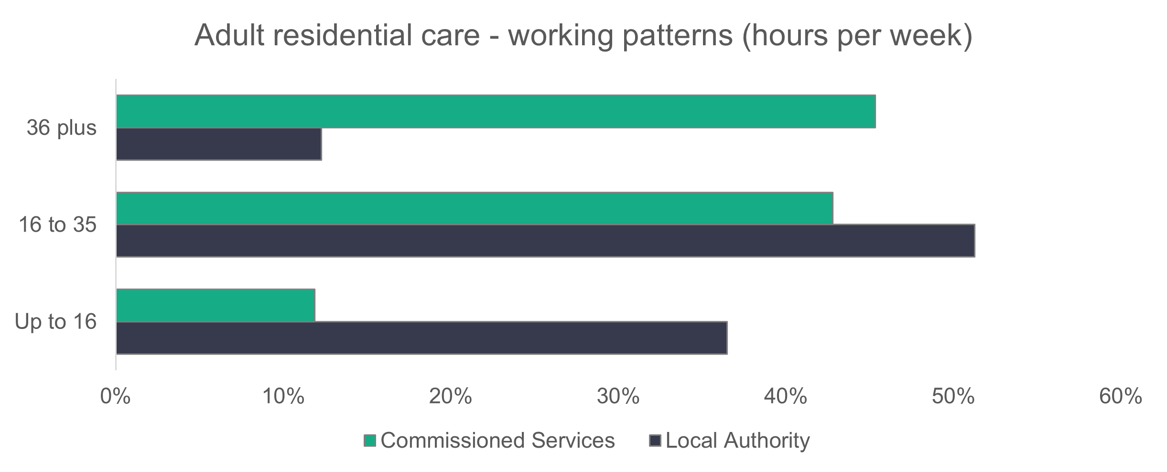
n = 12,640
- Adult residential care – vacancies
There are 1,867 vacancies in adult residential care. This makes up the highest proportion (34.9 per cent) of all the vacancies in social care. It also means that 4.8 per cent of roles in this sector are unfilled. Last year the proportion was 3.6 per cent.

- Domiciliary care

Summary:
- Care workers make up the majority (78.6 per cent) of the domiciliary care workforce.
- Women make up a higher percentage of the domiciliary care workforce (87.5 per cent) compared to the general population. This year’s proportion is up from 85.8 per cent last year.
- Local authorities have an older workforce than commissioned services.
- The domiciliary care workforce is more ethnically diverse than the overall social care workforce.
- A significant proportion of domiciliary care workers in commissioned services are on zero-hours contracts (25.9 per cent).
- More staff working for commissioned services work full-time hours compared to those working for local authorities.

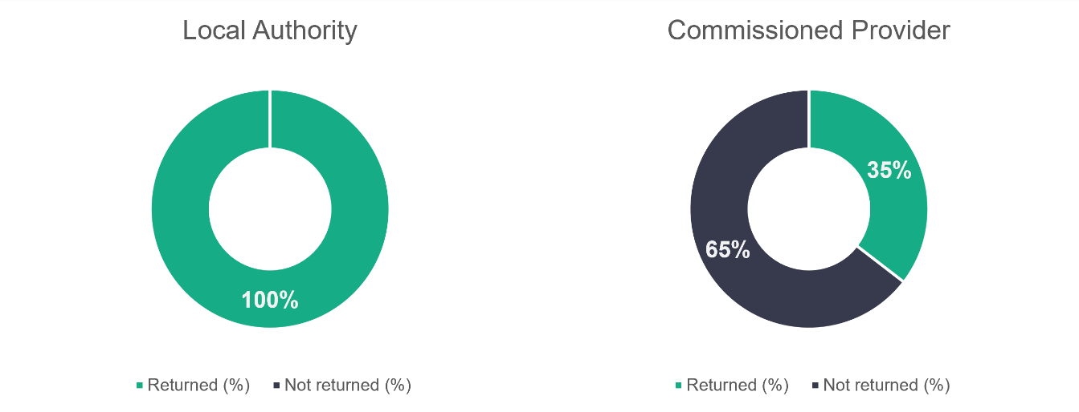

n = 22
n = 254

- Domiciliary care – role type
The proportion of care workers in the domiciliary care workforce has dropped slightly to 78.6 per cent (81.5 per cent in 2023, 80.8 per cent in 2022). But the proportion of senior care workers has increased from 5.5 per cent in 2023 to 6.1 per cent in 2024. The proportion of workers classed as ‘other staff’ has increased from 6.1 per cent in 2023 to 8.2 per cent this year.
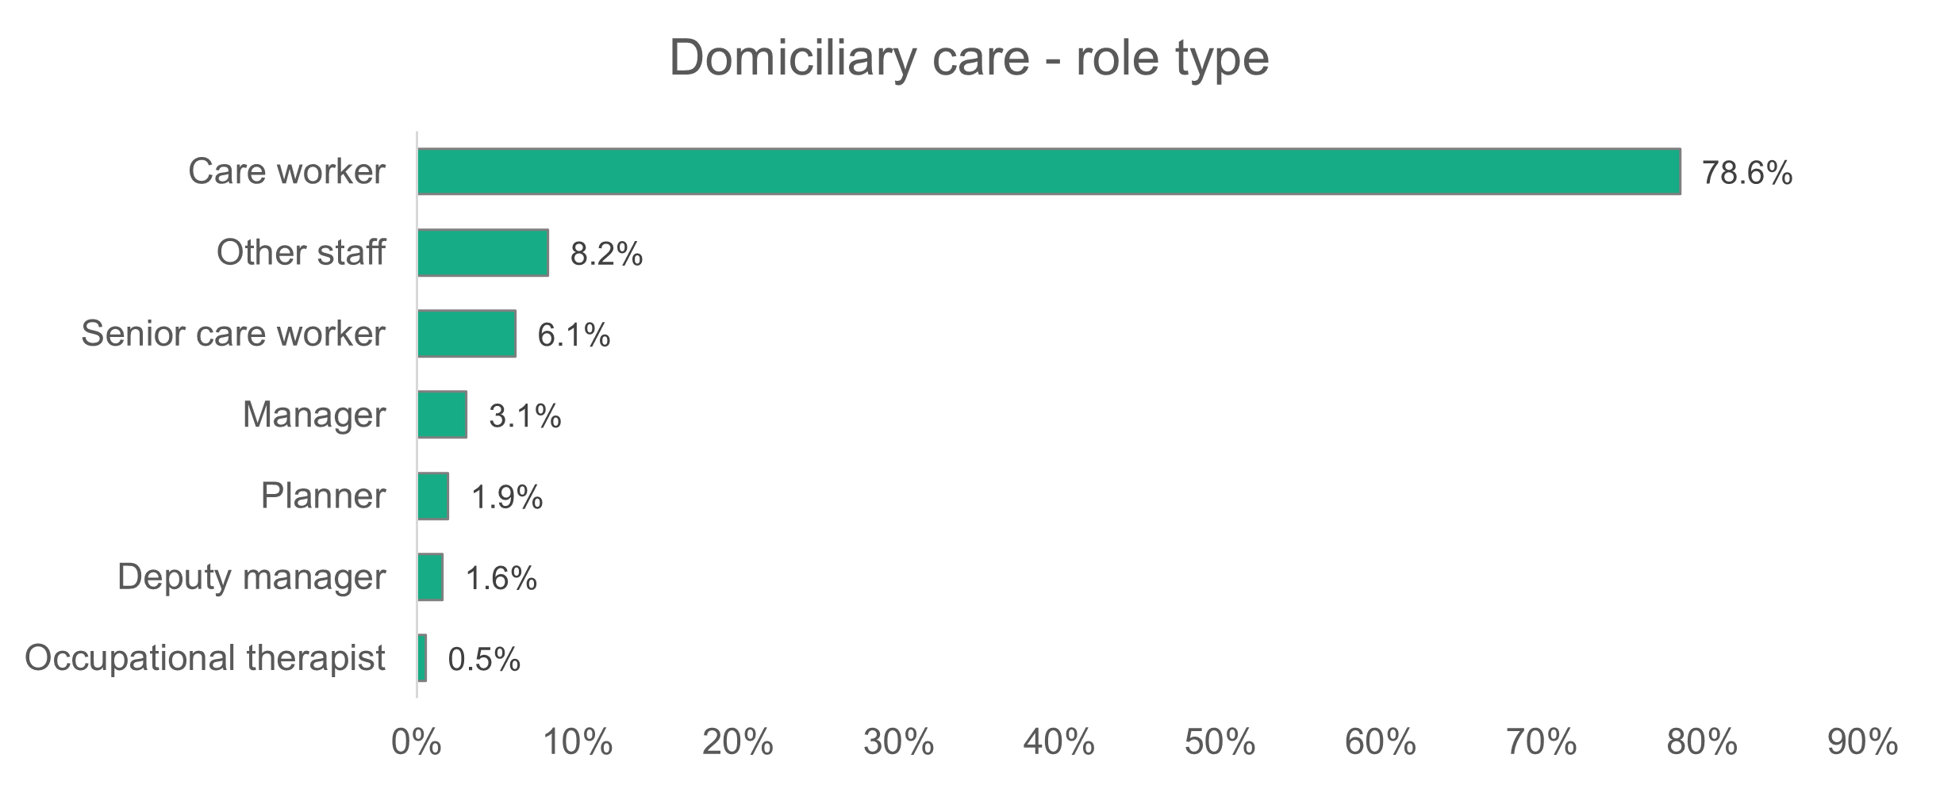
n = 8,023

- Domiciliary care – gender
The proportion of women working in domiciliary care is higher than that reported for social care as a whole. We found that 87.5 per cent of the roles were occupied by women, compared to 81.6 per cent of women in the overall workforce. This is higher than the proportion of women recorded working in domiciliary care in 2023 (85.8 per cent).

.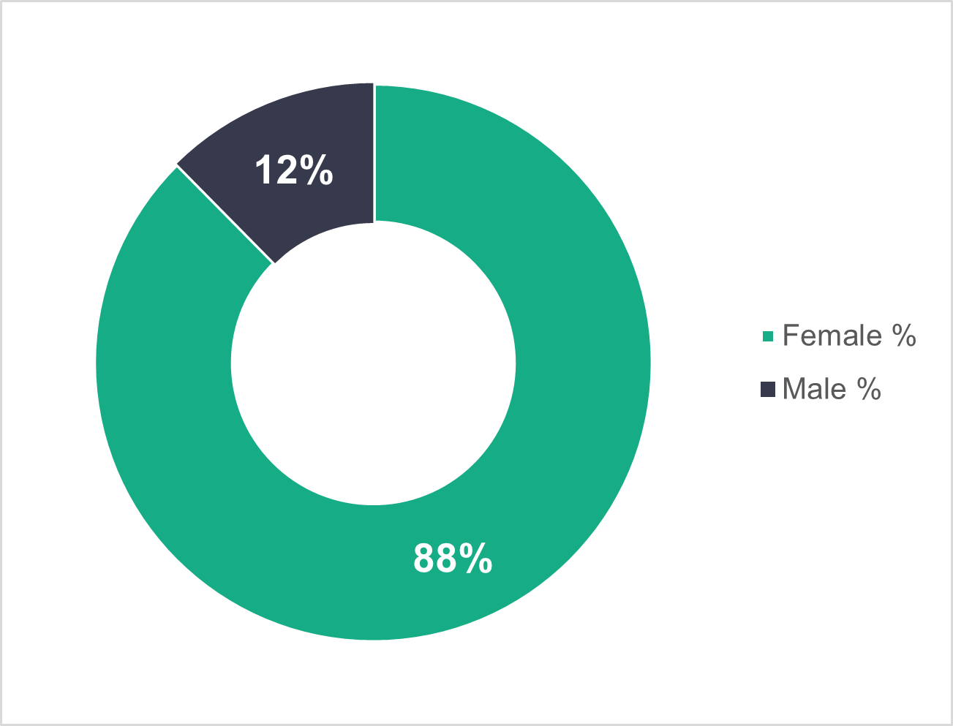

n = 7,878

- Domiciliary care – age profile
The age profile of the domiciliary care workforce is almost identical to 2023. As we saw in both the 2022 and 2023 data, there’s a marked difference between the age profile of those working in local authority and commissioned services. Local authority workers tend to be older (60.6 per cent of the workers are 46 and over) and commissioned services workers tend to be younger (62.9 per cent of the workers are 45 and under).
There could be several reasons for this, including differences in terms and conditions, remuneration and turnover rates.

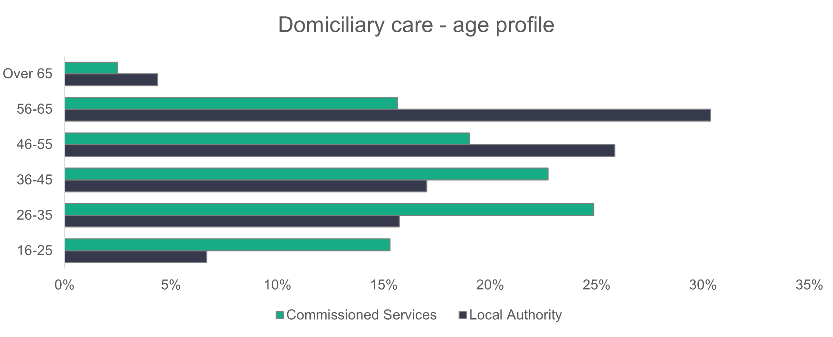
n = 7,857

- Domiciliary care – ethnicity
The chart below shows that 91.7 per cent of domiciliary care workers are white. This proportion has hardly changed from 2023, when 91.9 per cent were white. The noticeable differences from 2023 are the increase in the proportion of black workers from 4.2 per cent to 4.8 per cent, and the decrease in Asian workers from 3.2 per cent to 2.7 per cent. 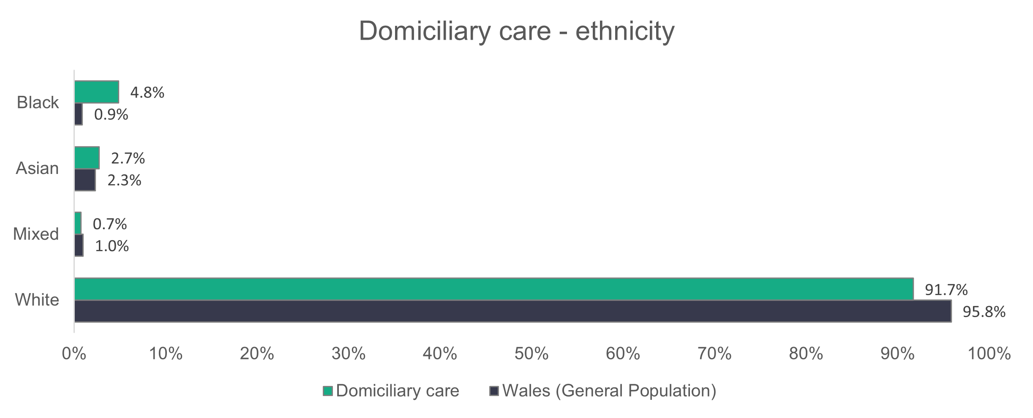
n = 5,930

- Domiciliary care – contract type
Most of the domiciliary care workforce are on permanent contracts in both commissioned service providers and local authorities. But the proportion is significantly higher for local authorities (83.7 per cent) than commissioned service providers (67 per cent).

There’s been a decrease in the proportion of commissioned service provider workers on zero-hours contracts, from 31.4 per cent last year to 25.9 per cent this year. Similar to last year, the zero-hours contracts are mostly made up of care workers (30.3 per cent). In local authorities, we see that 12.4 per cent of the workforce is on casual contracts and none have zero-hours contracts. This is a significant increase on last year’s proportion of 4.6 per cent, but the combined proportion of local authority workers on zero-hours or casual contracts was 11 per cent last year.

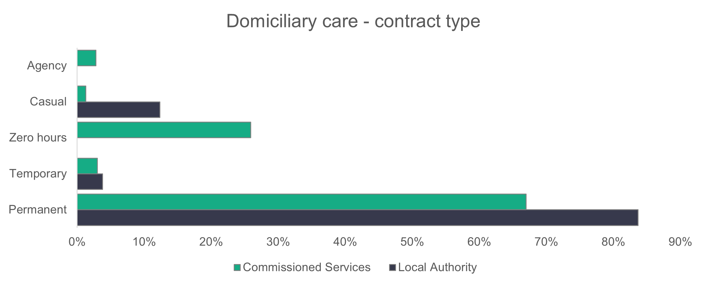
n = 7,983

- Domiciliary care – working patterns
Staff who work between 16 and 35 hours per week are the largest group for both commissioned service providers (42.9 per cent) and local authorities (56.6 per cent). Analysis of the working hours of the different roles in domiciliary care shows that 66.4 per cent of local authority care workers work between 16 and 35 hours per week. The biggest category for all other roles in local authorities is full-time (36 hours or more per week), at 71.2 per cent. For commissioned service providers, 45.8 per cent of care workers work between 16 and 35 hours per week.The proportion of full-time workers in commissioned services (39.5 per cent) is almost twice that seen in local authorities (21.5 per cent). Overall, the working patterns are similar to what we’ve seen over the past two years for the domiciliary care workforce. 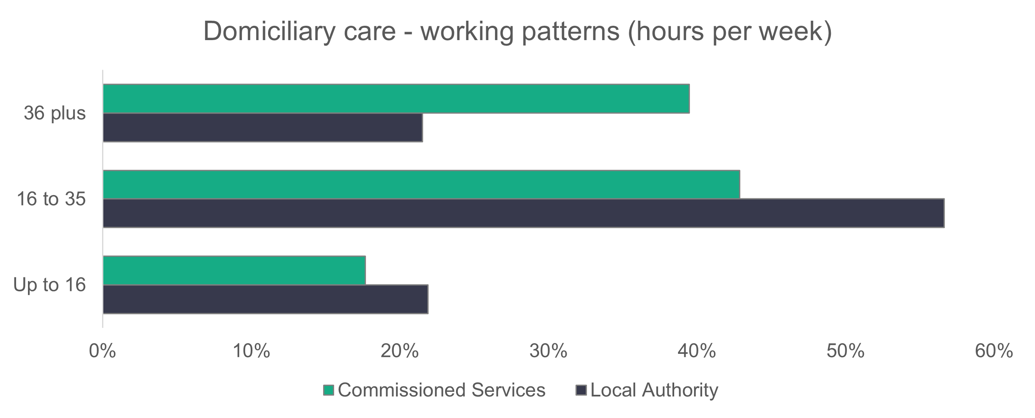
n = 7,602

- Domiciliary care – vacancies
There are 929 vacancies in domiciliary care, which means that 5.5 per cent of the jobs are unfilled. Last year, 8.9 per cent of the jobs were unfilled.
- Day services
Summary:
- A higher proportion of men work in day services (22.9 per cent, compared to 18.9 per cent in the overall social care workforce).
- The day services workforce is less ethnically diverse than the general population of Wales.
- The proportion of commissioned services workers on permanent contracts has dropped from 84.2 per cent in 2023 to 75.2 per cent in 2024.
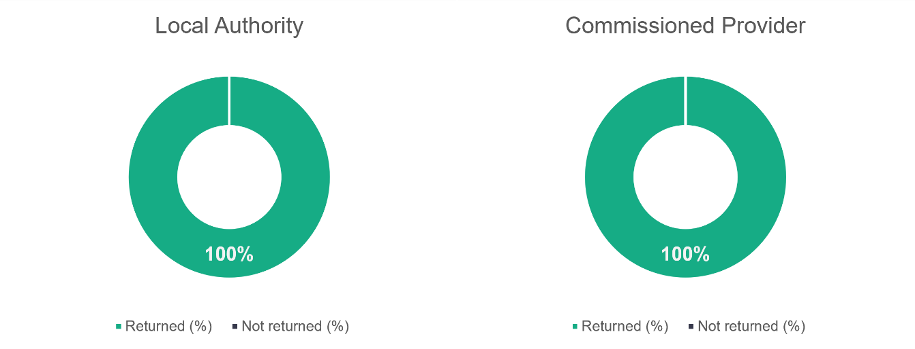
n = 21
n = 18
- Day services – role type
We see a slight drop in the proportion of care workers this year, down from 59.9 per cent last year to 55.6 per cent this year. The proportion of senior care workers has also dropped (from 13.7 per cent to 10.6 per cent), but there’s a noticeable increase for ‘other staff’ (up from 17.2 per cent to 22.9 per cent).
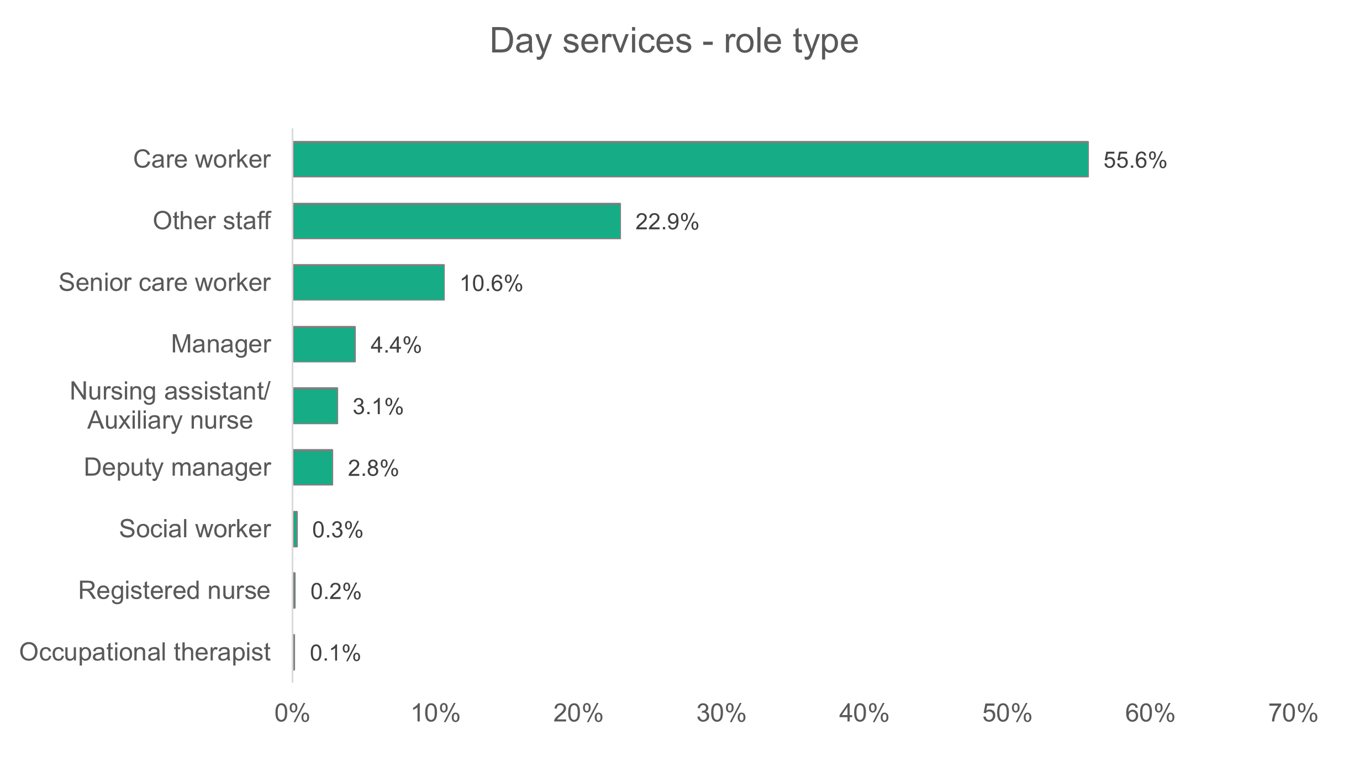
n = 2,444

- Day services – gender
The proportion of women working in day services (77.1 per cent) is lower than the 81.1 per cent of women in the overall workforce. Last year, 73.7 per cent of day services workers were women.
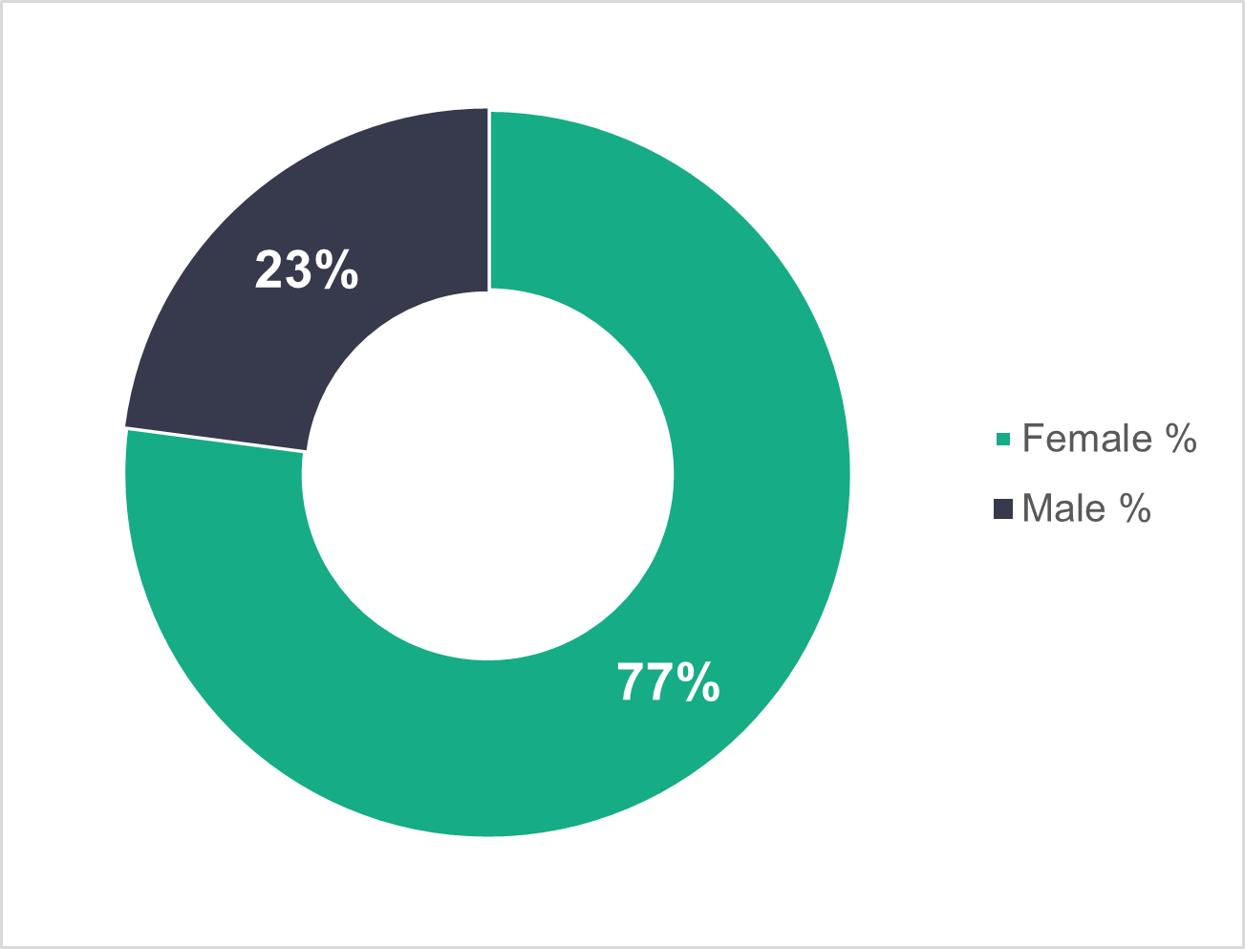
n = 2,444
- Day services – age profile
Similar to last year, commissioned service providers have a younger age profile, with 67 per cent of their workforce younger than 46, and 34.4 per cent in the 36 to 45 age range. Local authorities have an older workforce, with 59.1 per cent of their workforce aged 46 or over. Again, this is a similar trend to 2023.

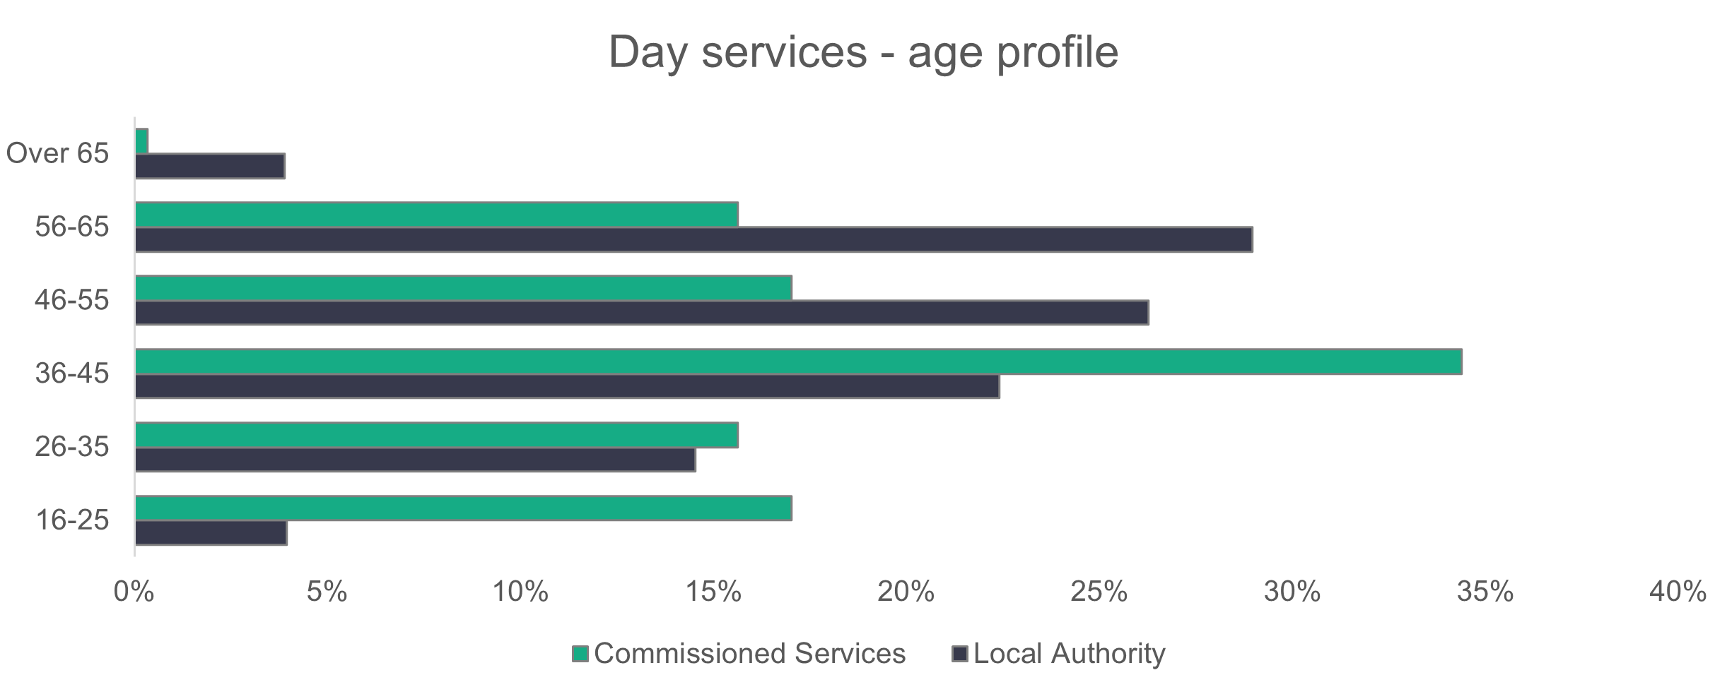
n = 2,443
- Day services – ethnicity
The day services workforce is less ethnically diverse than the general population of Wales, with 98 per cent of workers recorded as white. This proportion has hardly changed from last year’s value of 98.4 per cent.
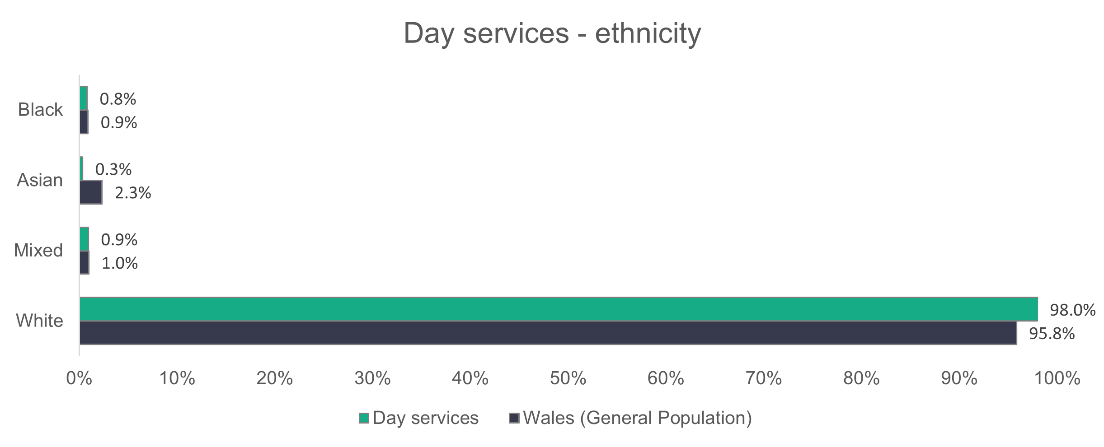
n = 1,526
- Day services – contract type
The proportion of day services workers on permanent contracts is almost the same for both commissioned services (75.2 per cent) and local authorities (75.4 per cent). The proportion of local authority staff on permanent contracts has hardly changed from last year (74.7 per cent in 2023), but the proportion for commissioned services has dropped from 84.2 per cent last year to 75.2 per cent this year. Another noticeable change from last year is the increase in commissioned services temporary contracts, from 2.5 per cent in 2023 to 15.2 per cent in 2024.

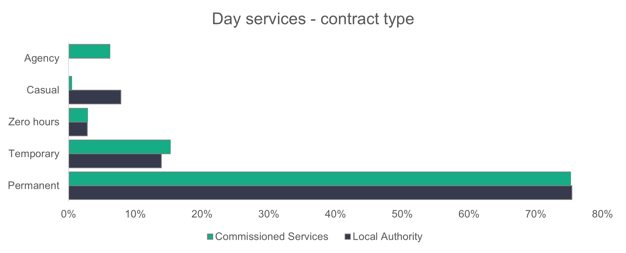
fffff
n = 2,365
- Day services – working patterns
Slightly fewer than half (49.2 per cent) of local authority day service employees work part-time hours (35 or fewer per week). The corresponding value for commissioned services is 72.1 per cent. Last year, most employees in both local authority (53.3 per cent) and commissioned services (55.3 per cent) worked part-time hours.
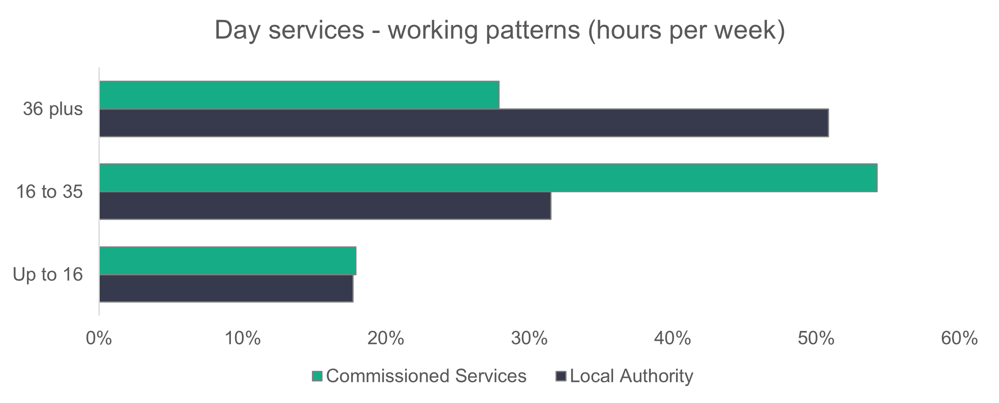
n = 2,355
- Day services – vacancies
There are 173 vacancies in day services, which represents 3.2 per cent of the total number of estimated social care vacancies. It also means that three per cent of day services roles are unfilled.

- Supported living services
Summary:
- The proportion of senior care workers that make up the workforce has more than doubled from last year.
- The proportion of black workers in supported living services is more than 13 times higher than the corresponding proportion in the general population of Wales.
- A relatively large proportion of the local authority workforce are on casual contracts (18.2 per cent).
n = 14
n = 33
- Supported living services – role type
Care workers make up 83.8 per cent (89.5 per cent if we include senior carers) of the supported living services workforce, as shown in the following chart. Last year, care workers made up 85.8 per cent (88.5 per cent including senior carers). The proportion of senior care workers (5.7 per cent) is more than double the proportion reported last year (2.8 per cent)
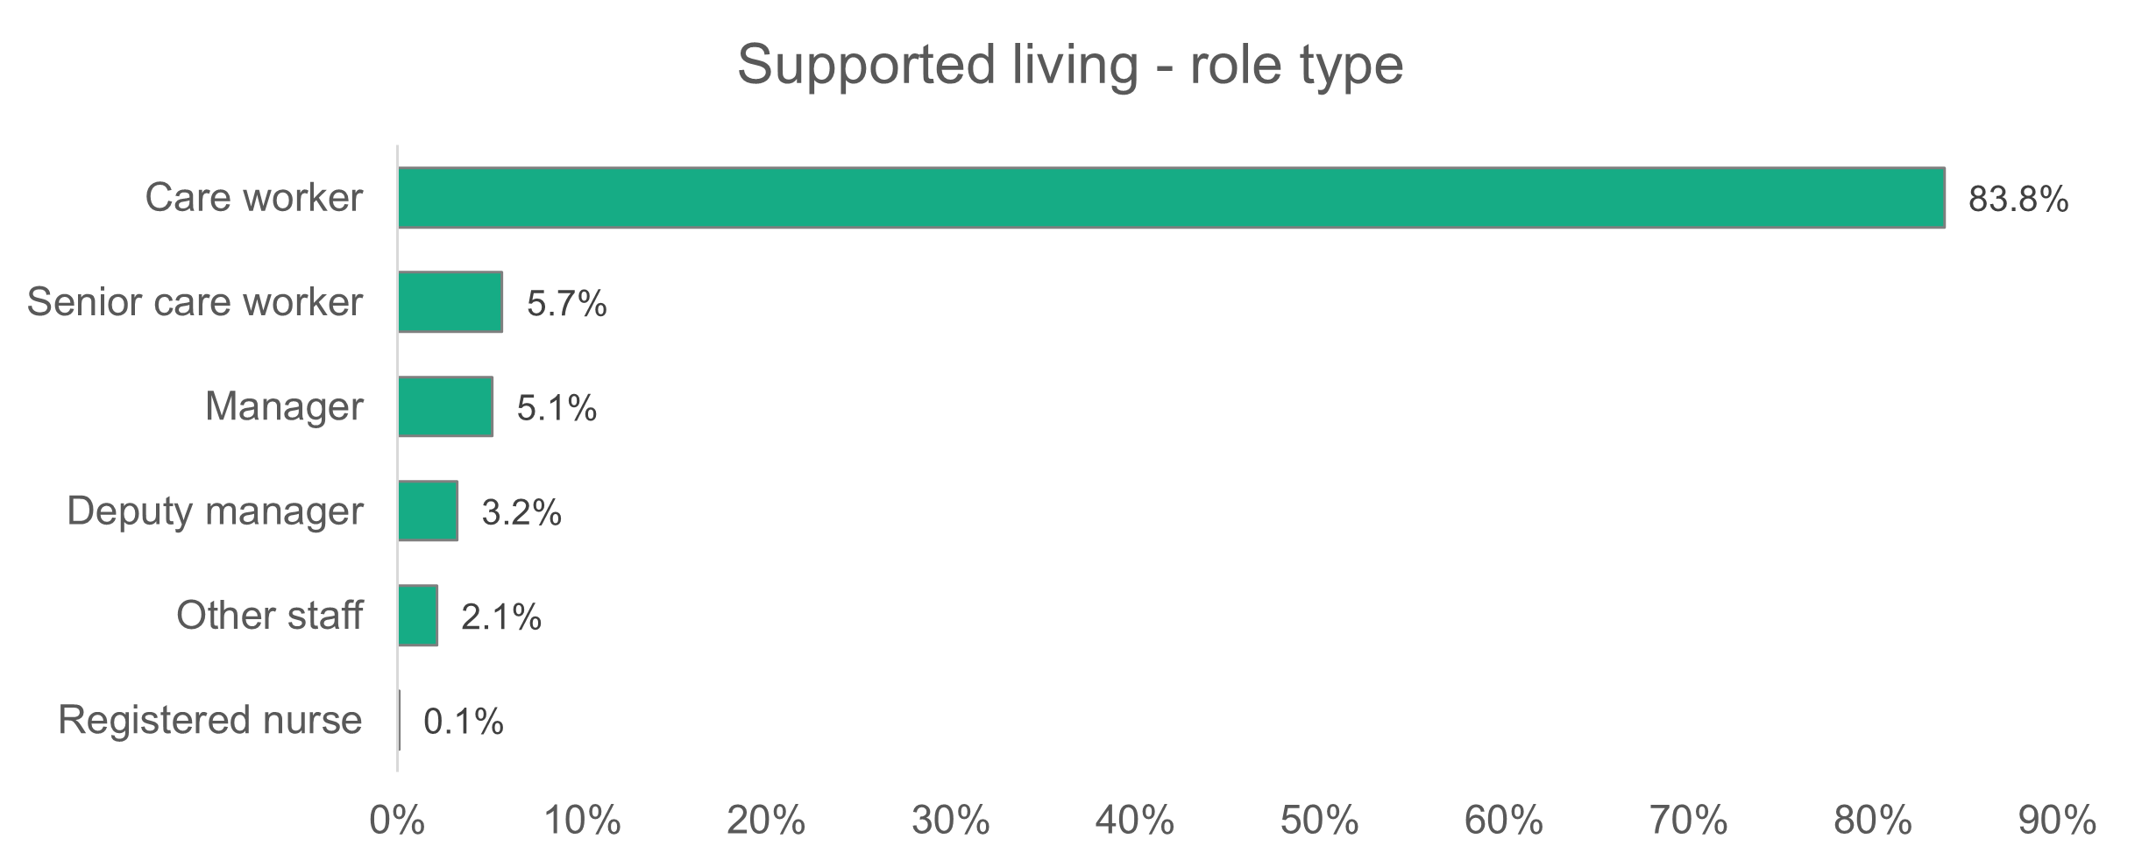
n = 6,963

- Supported living services – gender
The gender profile in supported living services has hardly changed over the past three years. Women make up 75 per cent, compared to 75.3 per cent in 2022, and 76 per cent in 2023.
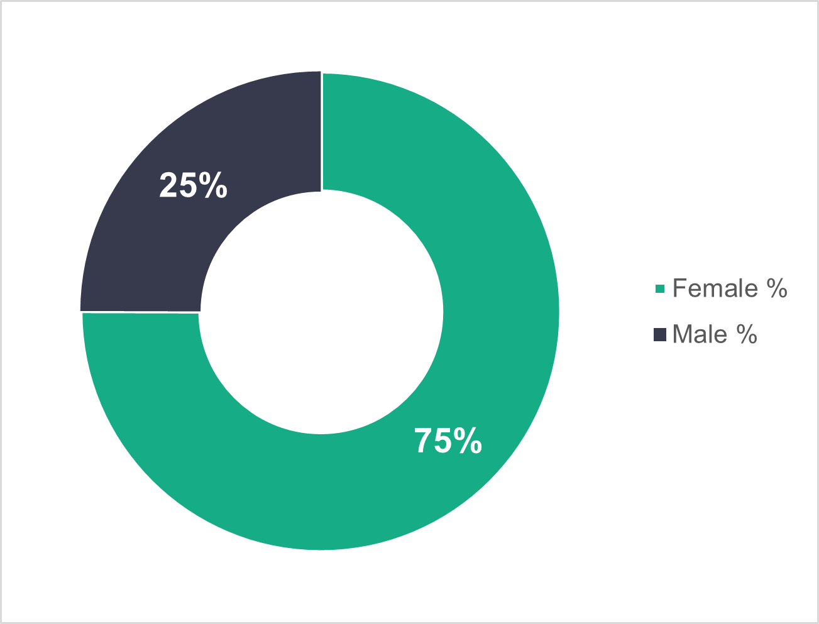

n = 6,739
- Supported living services – age profile
Local authorities have an older supported living workforce, with 62.7 per cent of workers aged 46 or over. In commissioned services, we see that 58.6 per cent of workers are younger than 46. We’ve seen similar trends in the previous two years.
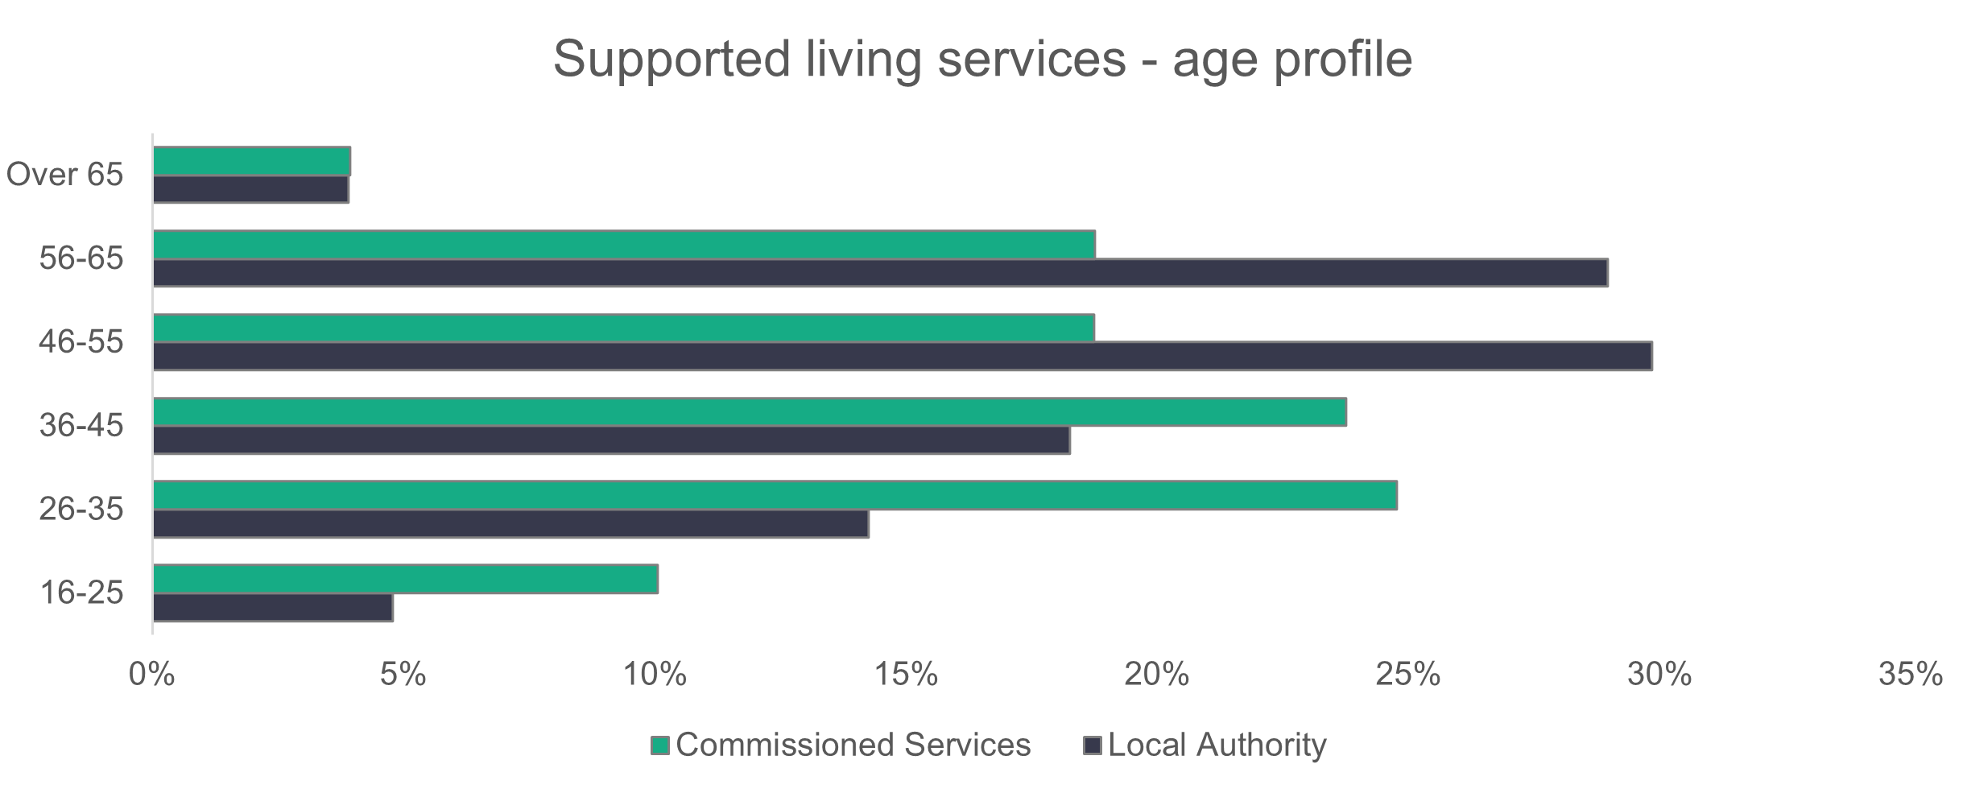
n = 6,420
- Supported living services – ethnicity
The supported living workforce is more ethnically diverse than last year (85.8 per cent white this year, compared to 89.3 per cent in 2023). It’s also considerably more ethnically diverse than the general Welsh population, with more than 13 times the proportion of black people.
Care workers make up almost nine in 10 of the supported living workforce. Among those care workers, 13.5 per cent are black and 84 per cent are white.
For all other roles combined, with care workers removed, we find that 94 per cent of the workforce is white and 5.2 per cent black. Last year, 0.7 per cent of all other roles were black and 98.2 per cent white.
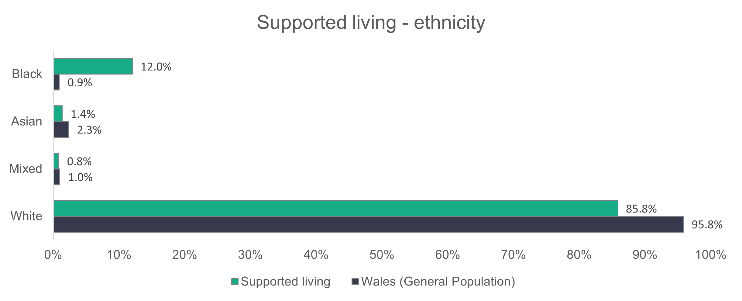
n = 5,035
- Supported living services – contract type
Local authority employees on casual contracts make up18.2 per cent of the supported living workforce. Care workers make up all the casual and zero-hours contracts in both local authority and commissioned service providers.

Only commissioned services have agency staff, made up of 69.4 per cent care workers and 30.6 per cent ‘other staff’.

The chart below shows the proportion of workers by contract type, and the trend is similar to last year’s data.
n = 6,958
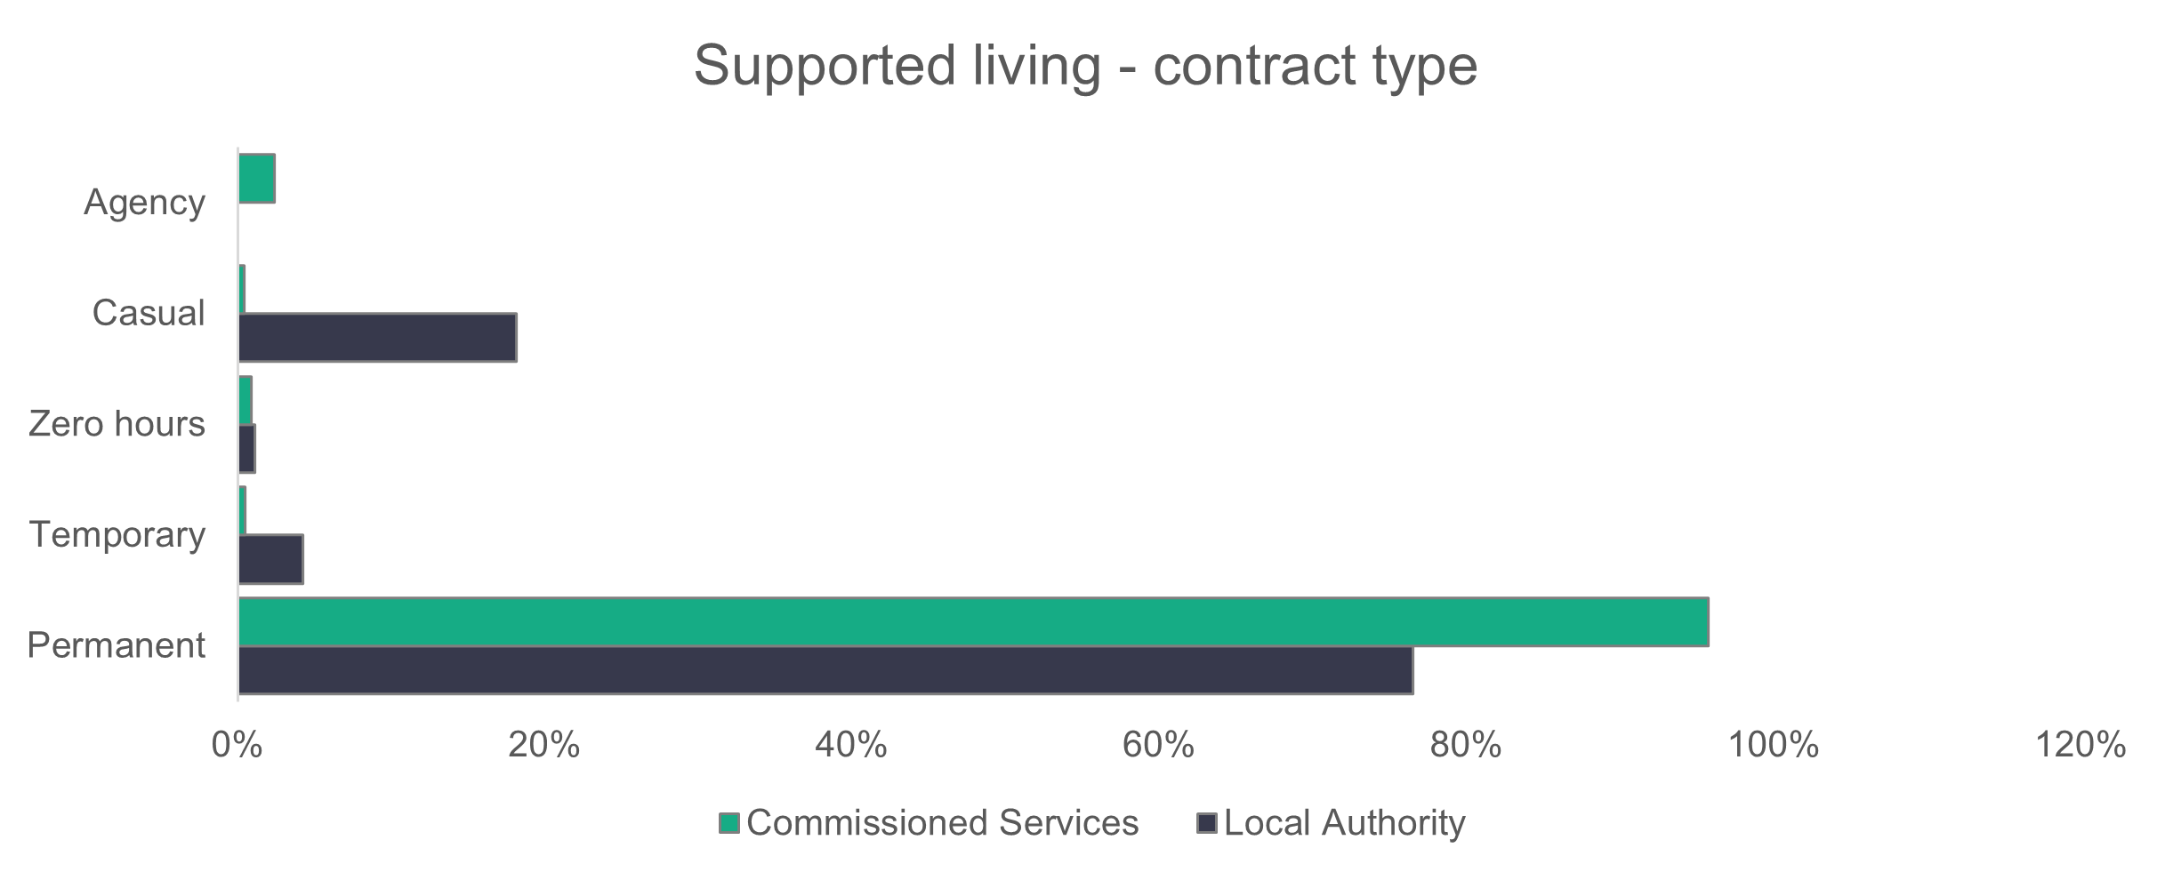

- Supported living services – working patterns
More commissioned services employees (48.4 per cent) work full-time hours than in local authorities (37.2 per cent). Local authorities have seen an increase from last year, when 30.6 per cent of the workforce were working full-time hours. Commissioned services have seen a slight drop from 50.2 per cent last year.

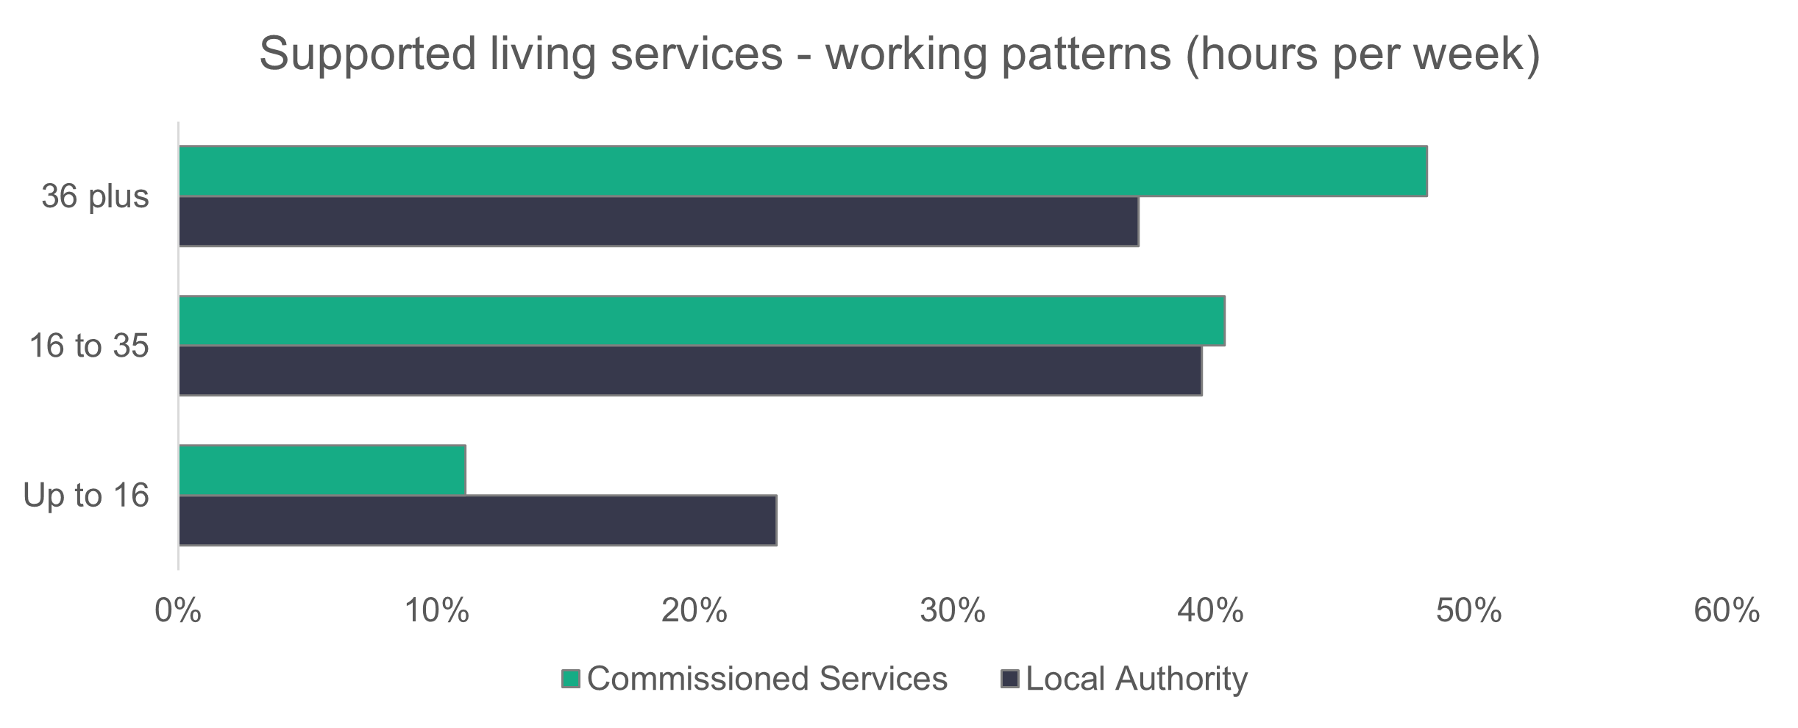
n = 6,612
- Supported living – vacancies
Supported living services have 627 vacancies in an estimated workforce of 7,165, which means that 8.8 per cent of roles are unfilled. There are 242 more vacancies this year compared to last year.

- Social work teams
Summary:

- The number of registered social workers in frontline social work teams has hardly changed from last year, with a decrease of two people.
- Most workers in social work teams are on permanent contracts (79.6 per cent).
- Most workers in social work teams work full-time (72.9 per cent).

n = 22
n = 6
- Social work teams – role type
The number (4,389) and proportion (46 per cent) of registered social workers has hardly changed from last year, when there were 4,391 registered social workers, accounting for 46.4 per cent of the social work teams workforce. 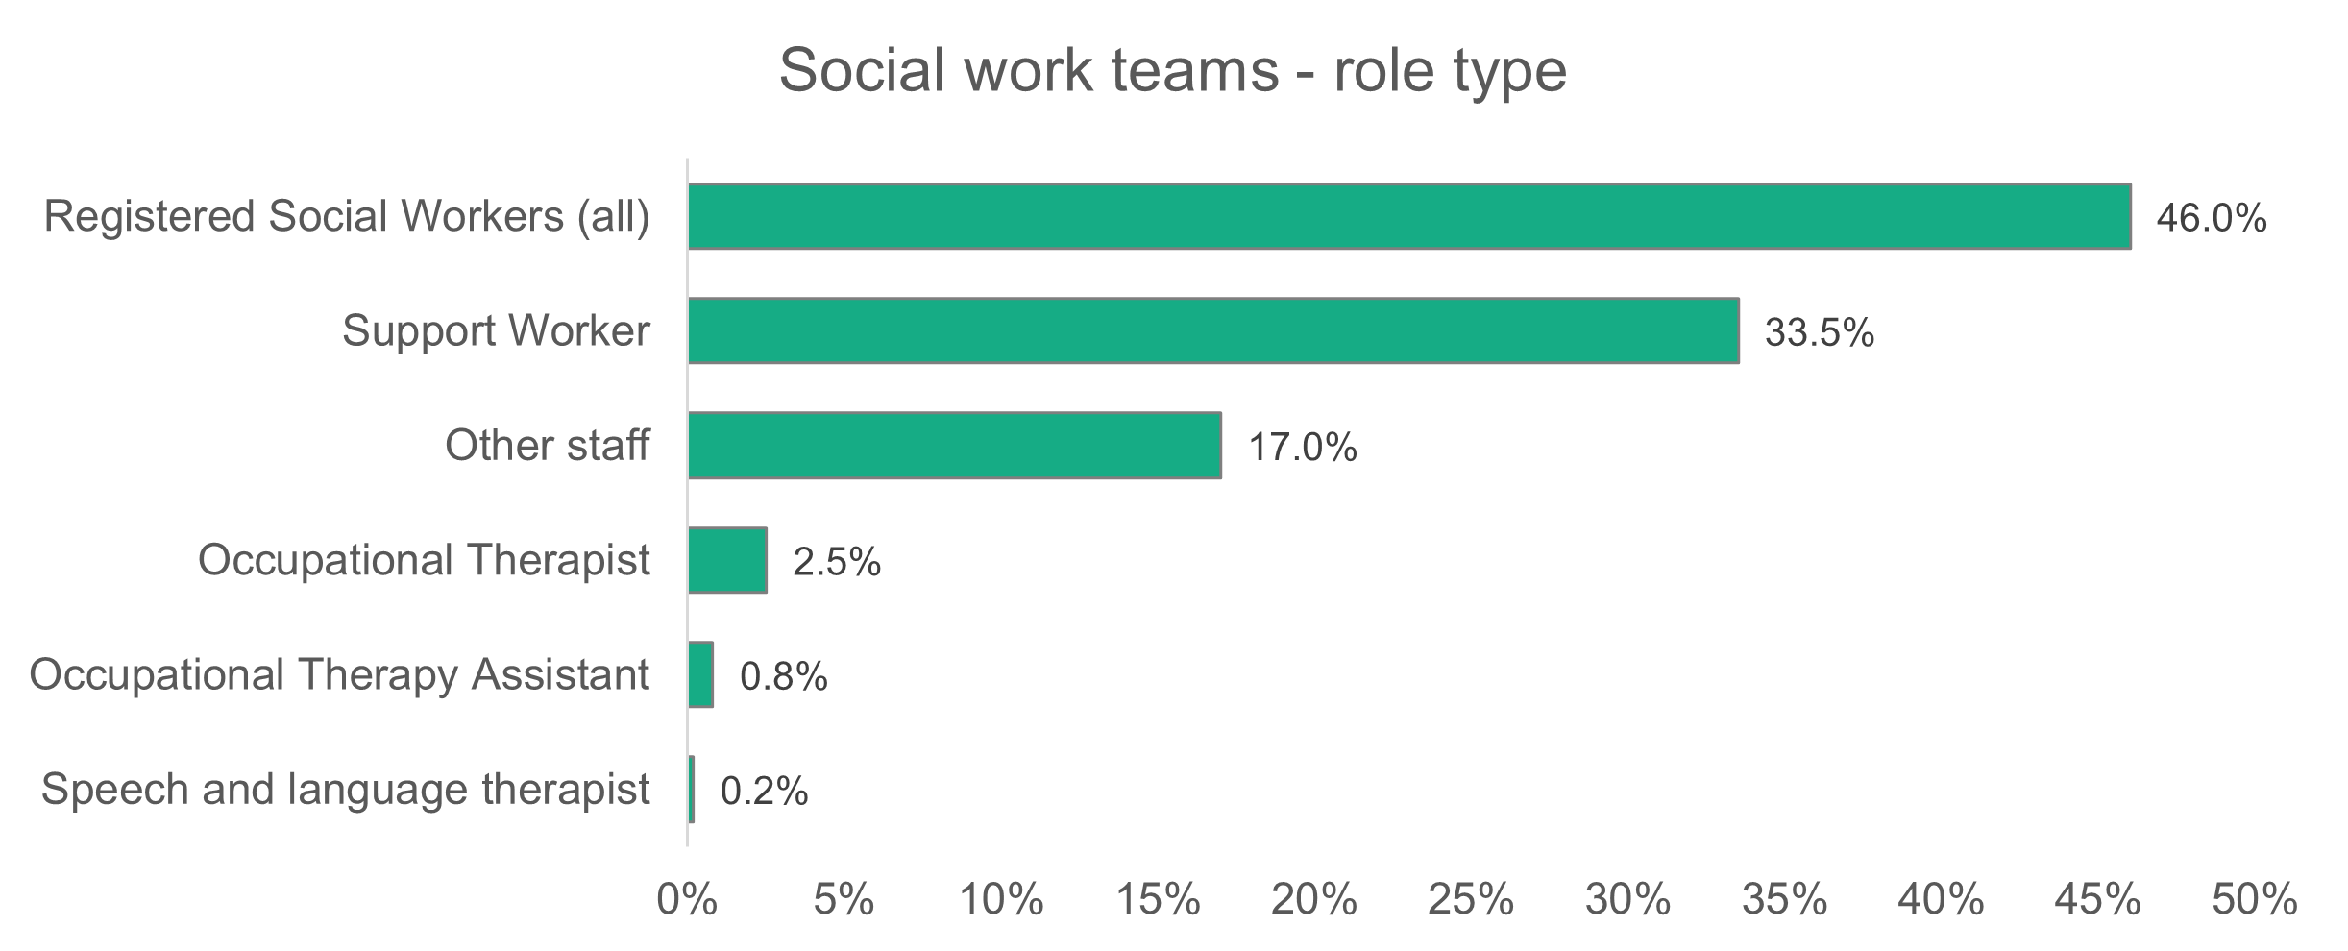
n = 9,537

The experience level of the social work teams is shown on the chart below. We see a drop in the proportion of senior staff, with social workers with three years or more experience making up 42.8 per cent and senior practitioners making up 18.9 per cent. Last year’s values were 46.7 per cent and 20 per cent respectively. The proportion of social workers with one to three years of experience in post has increased, from 7.1 per cent last year to 11.5 per cent.

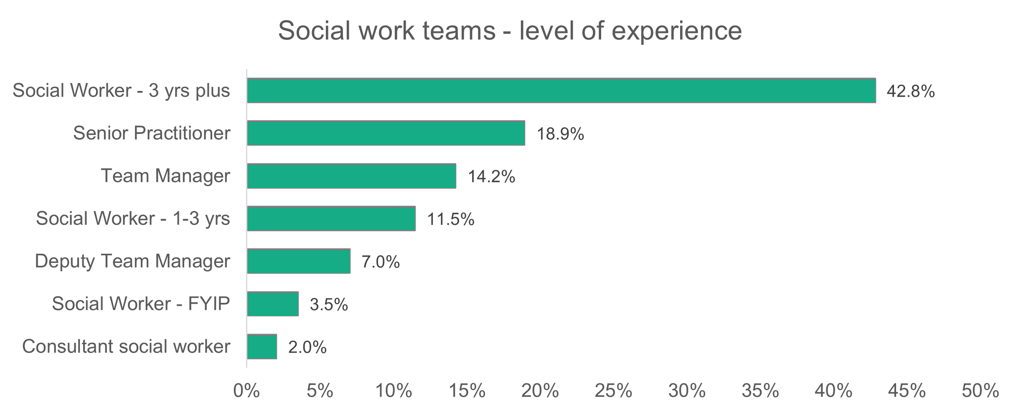
n = 4,389
- Social work teams – gender
There’s only a slight change in the proportion of men and women from the last two years, with women having occupied 85 per cent of the posts in 2022 and 2023.
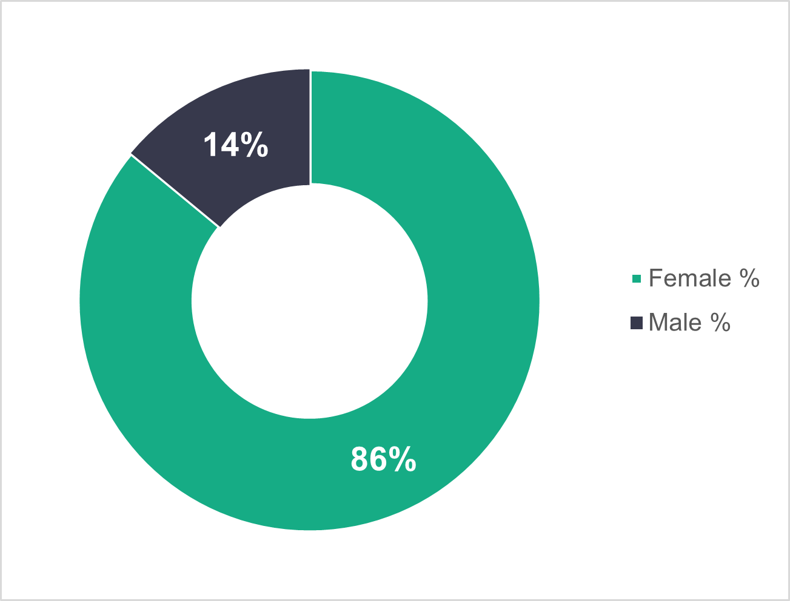
n = 9,480
- Social work teams – age profile
For the chart below and in the other social work teams subsections, we haven’t separated the data into ‘commissioned services’ and ‘local authorities’. This is because there are only 28 staff in commissioned services in this category.
In social work teams, 57.4 per cent of the workforce is under 46. This has hardly changed from last year’s value of 56.8 per cent.
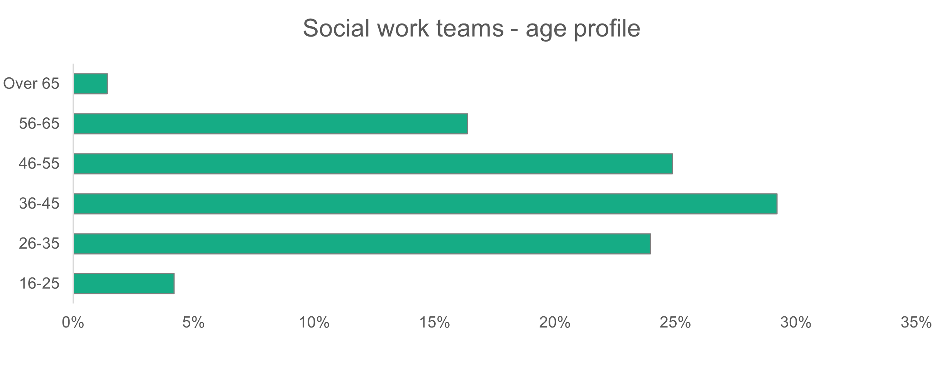
n = 9,475
- Social work teams – ethnicity
Social work teams in 2024 show that 3.6 per cent of the workforce are black, Asian or mixed ethnicity, which hasn’t changed much from last year (3.2 per cent). The sector is less diverse than the general population of Wales, which is 95.8 per cent white.
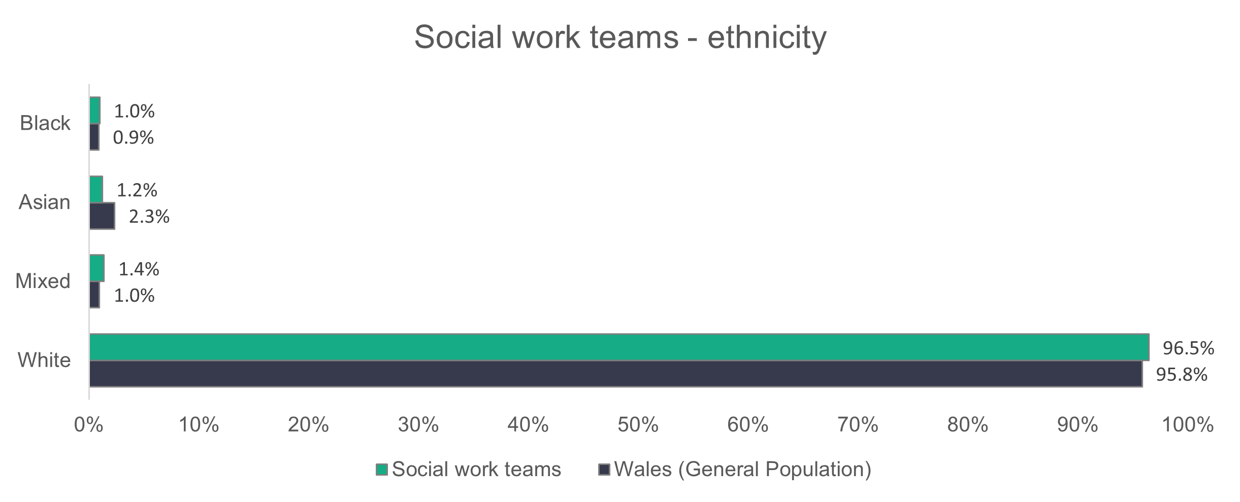
n = 7,473
- Social work teams – contract type
Permanent contracts account for 79.6 per cent of the social work teams workforce – close to last year’s value of 79.4 per cent. There’s an increase in the proportion of workers on temporary contracts, from 15.6 per cent last year to 16.3 per cent this year.
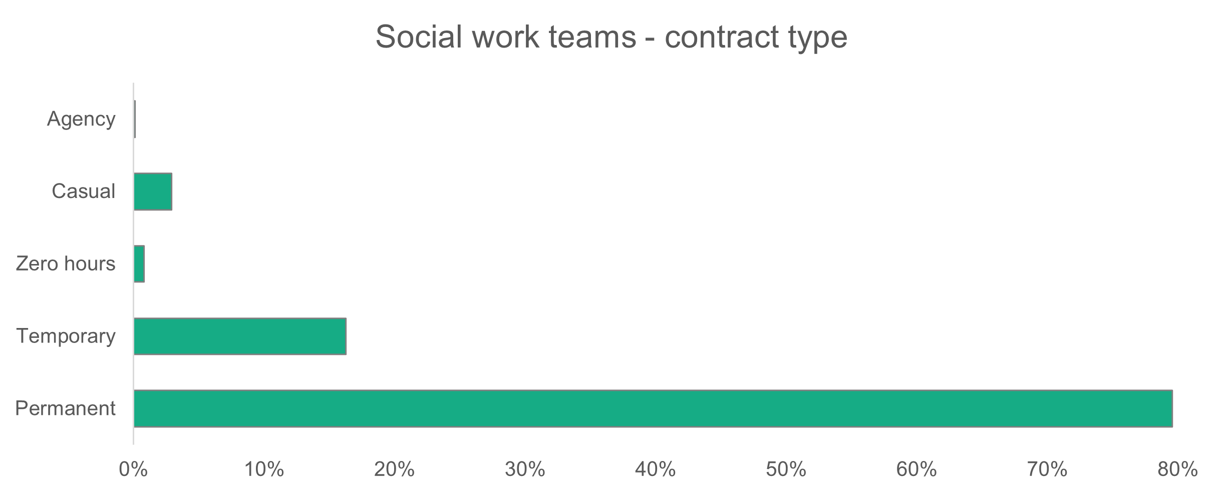
n = 9,485
- Social work teams – working patterns
Most workers (72.9 per cent) are contracted as full-time. This proportion has barely changed from 2023 (72.6 per cent) and 2022 (72.5 per cent).

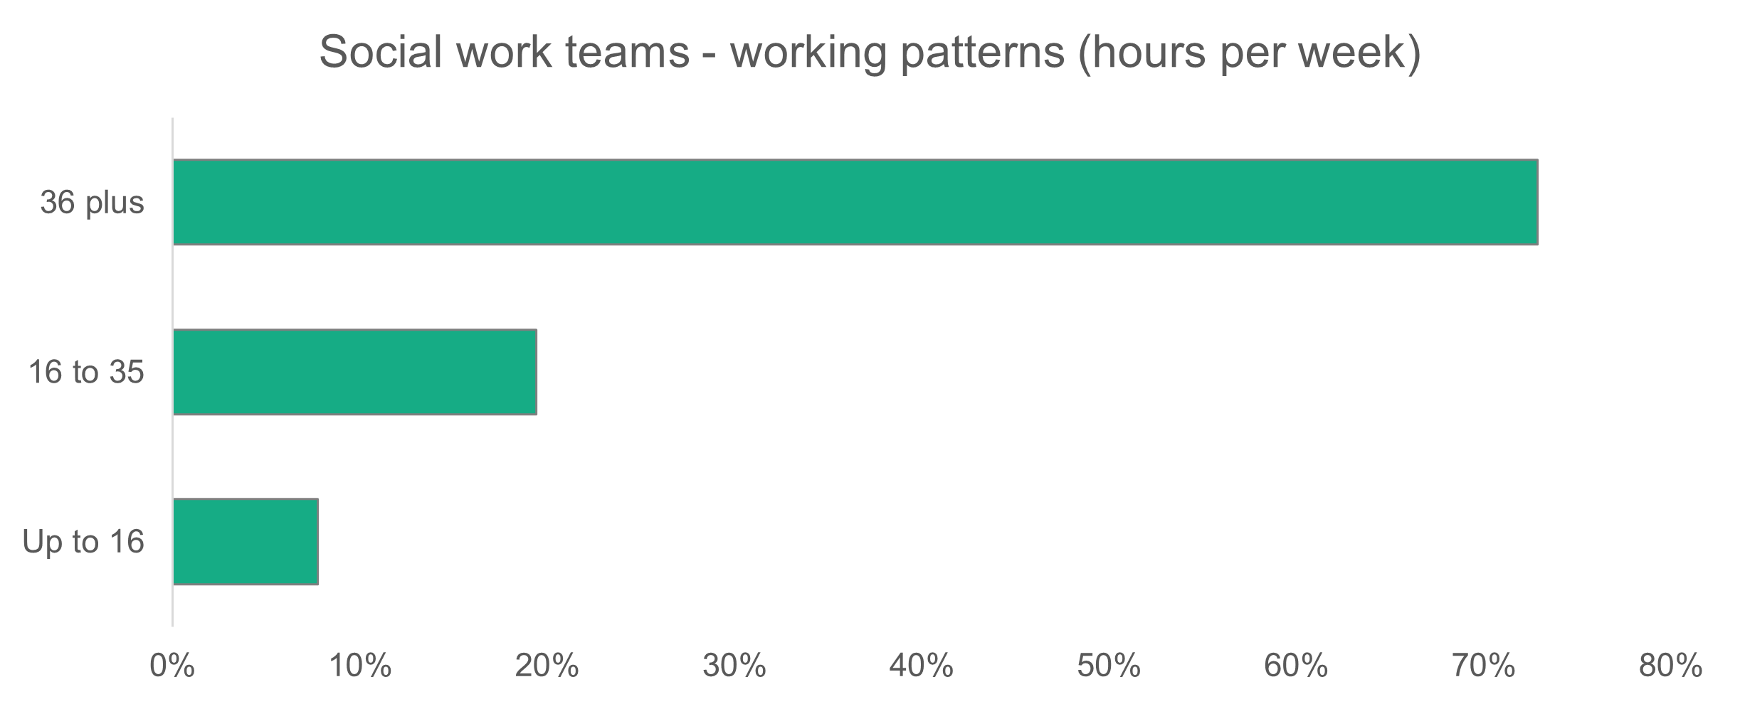
n = 9,459
- Social work teams – vacancies and turnover
There are 751 vacancies in social work teams, which means 7.8 per cent of roles are unfilled. Compared to last year, there are 85 fewer vacancies. Social work teams make up 13 per cent of all vacancies in the social care workforce.
For social workers there’s been a slight decrease in the number of vacancies to be filled from 266 in 2023 to 263 in 2024.

Social worker role | 2023 | 2024
First year in practice | 19 | 16
1-3 years | 3 | 29
3 years+ | 160 | 131
Senior practitioner | 48 | 55
Consultant social worker | 0 | 0
Team manager | 36 | 32
Total | 266 | 263

- Children’s residential care
Summary:
- Care workers (including senior carers) make up 82.5 per cent of the children’s residential care workforce.
- Men make up 30.5 per cent of the workforce.
- Children’s residential care has a relatively young workforce, with 70.9 per cent aged 45 or under.
- Casual and zero-hours contracts make up 28.5 per cent of the workforce.

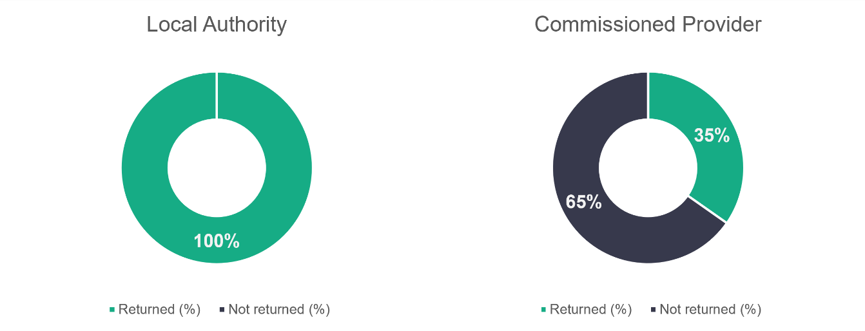
n = 19
n = 72
- Children’s residential care – role type
The proportion of workers in the types of roles highlighted in the chart below has hardly changed since 2022. Care workers make up most of the roles (68.1 per cent, compared to 71.3 per cent in 2023 and 69.5 per cent in 2022). See the chart below for a breakdown of the role profile of the children’s residential care workforce.

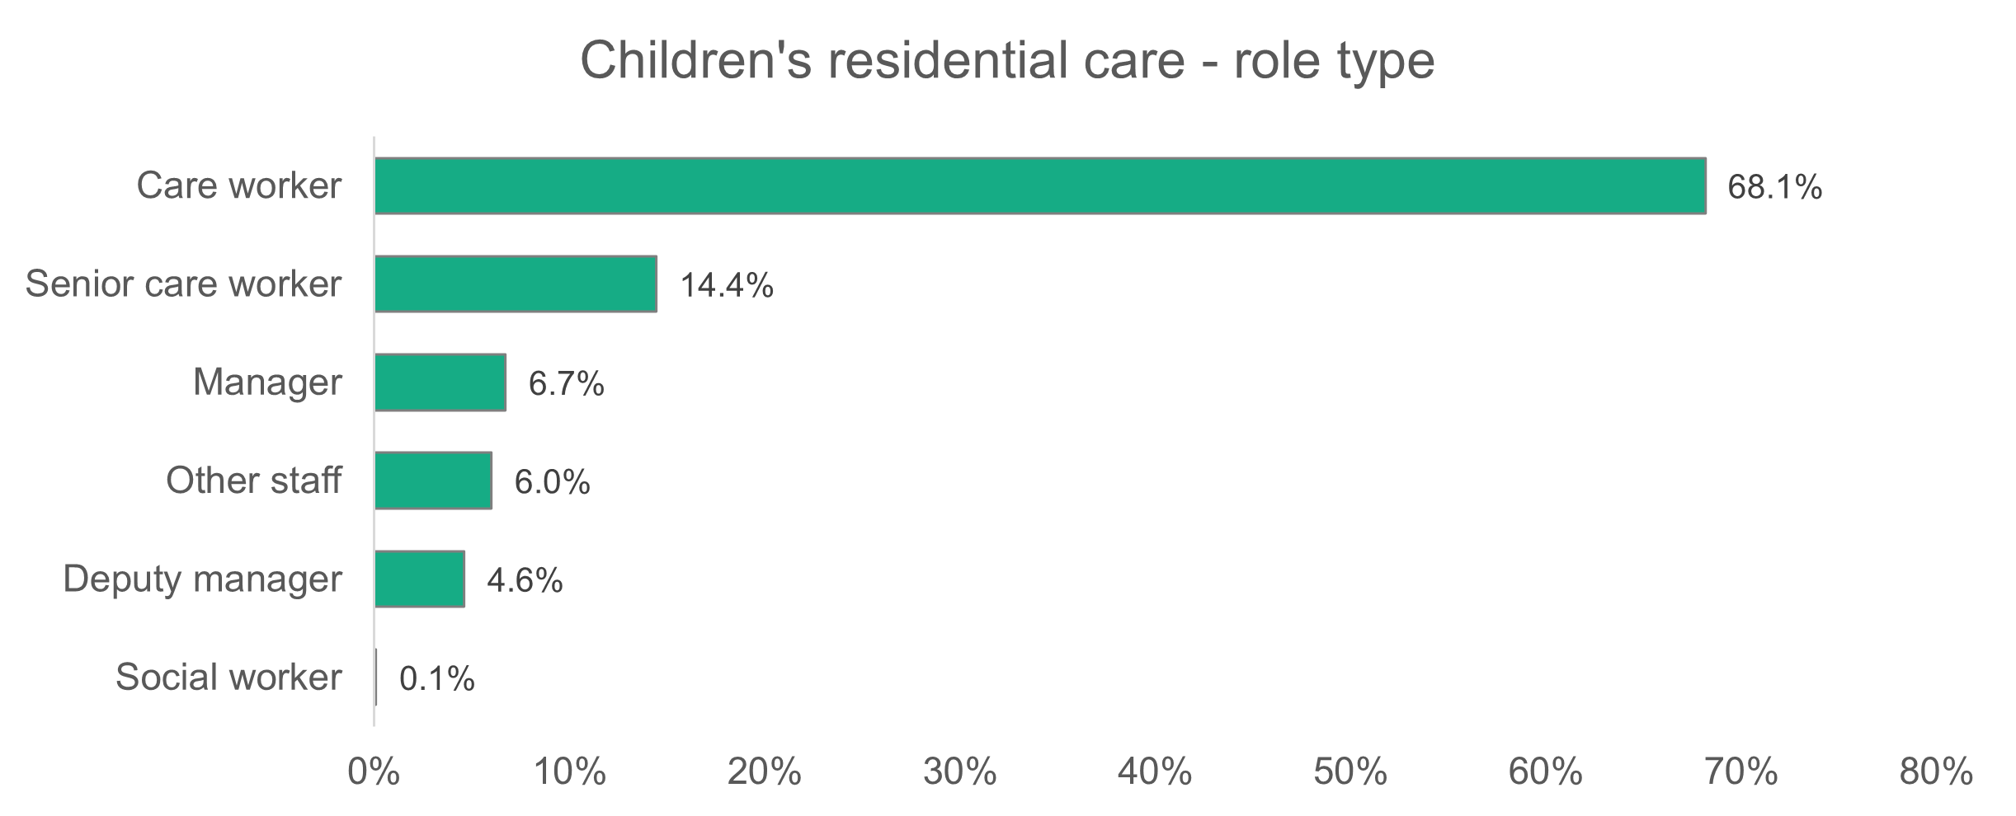
n = 2,216
- Children’s residential care – gender
The proportion of women working in children’s residential care has increased to 69.5 per cent. Last year, 66 per cent of the children’s residential care workforce were women. The proportion in 2022 was 62 per cent. Children’s residential care is the sector that has the highest proportion of men in the social care workforce of Wales (30.5 per cent).
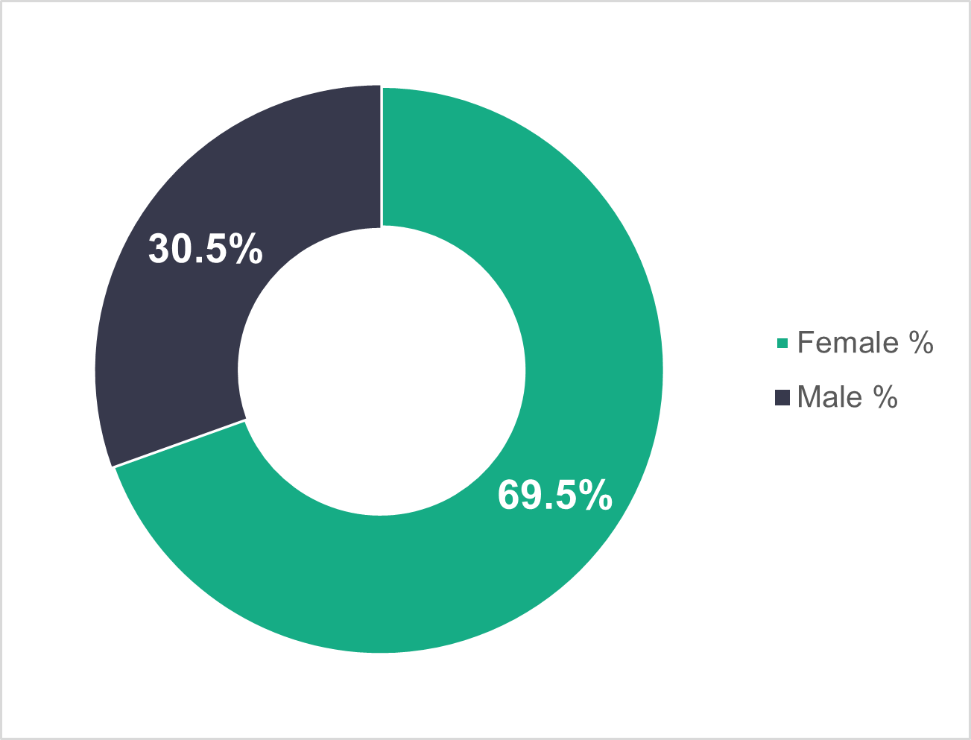
n = 2,179
- Children’s residential care – age profile
The age profile of the children’s residential care workforce has changed very little from 2023. This year, 70.9 per cent of the children’s residential care workforce are under 46 (this was 73.4 per cent in 2023).
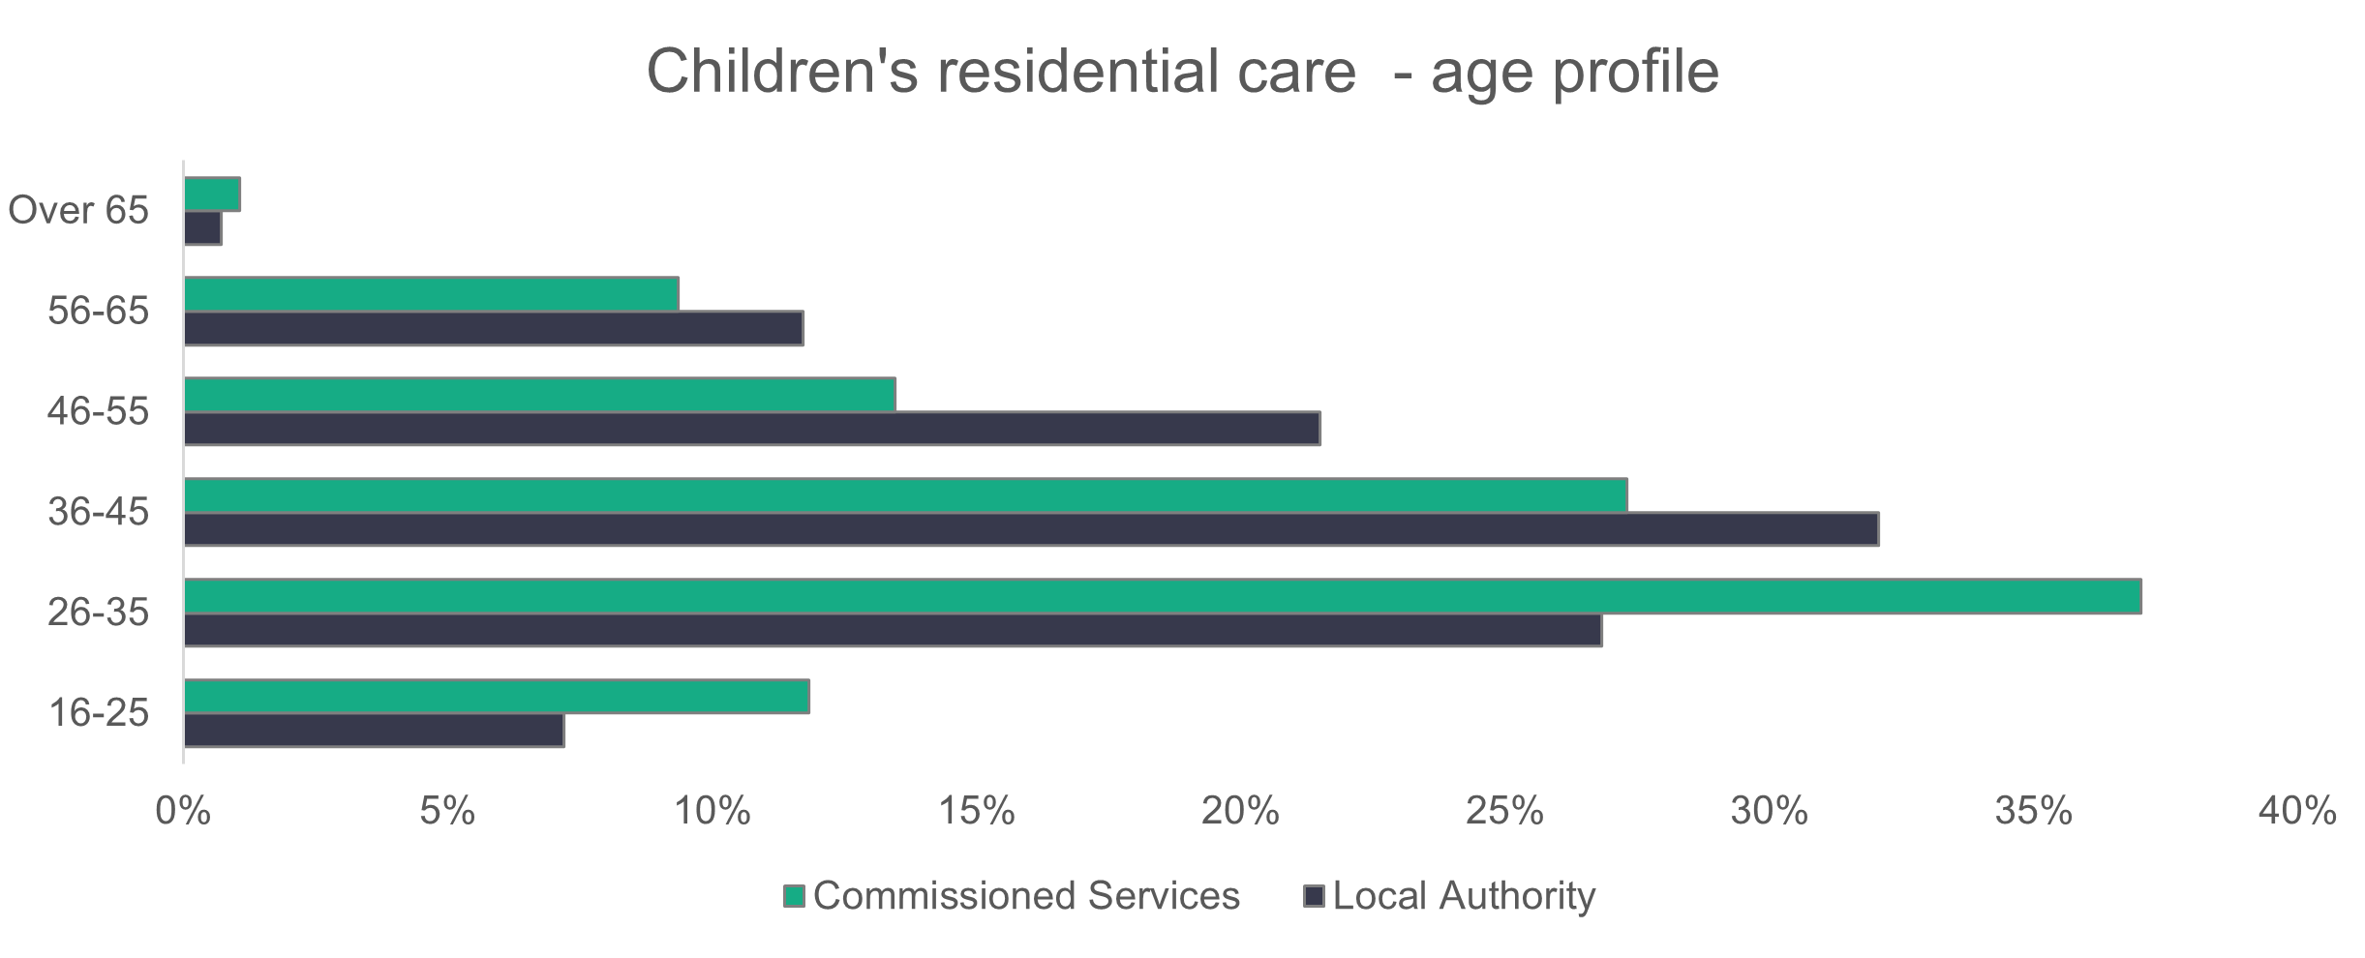
n = 2,174
- Children’s residential care – ethnicity
The ethnicity of the children’s residential care workforce has become more diverse since last year. The percentage of non-white workers has increased from 3.2 per cent to 3.9 per cent, while the number of black workers has increased from 1.1 per cent to 1.6 per cent. The children’s residential care workforce is less ethnically diverse than the social care workforce as a whole.
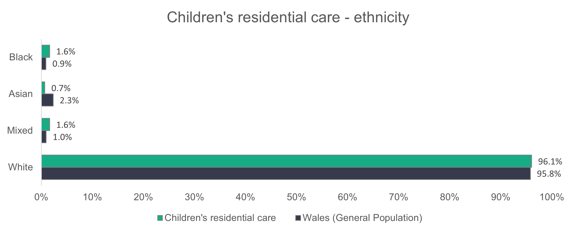
n = 1,907
- Children’s residential care – contract type
Local authorities have far fewer of their workforce on permanent contracts when compared to commissioned services. Permanent contracts make up 89.4 per cent of the commissioned services workforce, while the corresponding figure for local authorities is 68.4 per cent. A high proportion of local authority workers are on casual contracts (24.4 per cent).

Zero-hours contracts in local authority services have decreased from 9.3 per cent to 4.1 per cent since last year. But zero-hours contracts have increased in commissioned services from 0.7 per cent to 3.1 per cent over the same period.
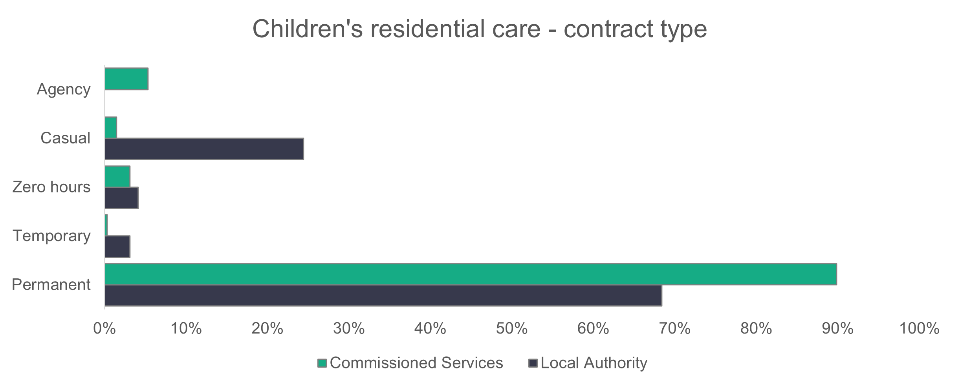
n = 2,218
- Children’s residential care – working patterns
The working patterns of the children’s residential care workforce haven’t changed much from 2023. Most people working in children’s residential care work full-time hours (36 hours or more per week). Full-time workers account for 83.4 per cent of the commissioned services workforce and 44.3 per cent of the local authority workforce.
The corresponding proportions last year showed that full-time contracts accounted for 85.3 per cent of the commissioned services workforce and 41.6 per cent of the local authority workforce.
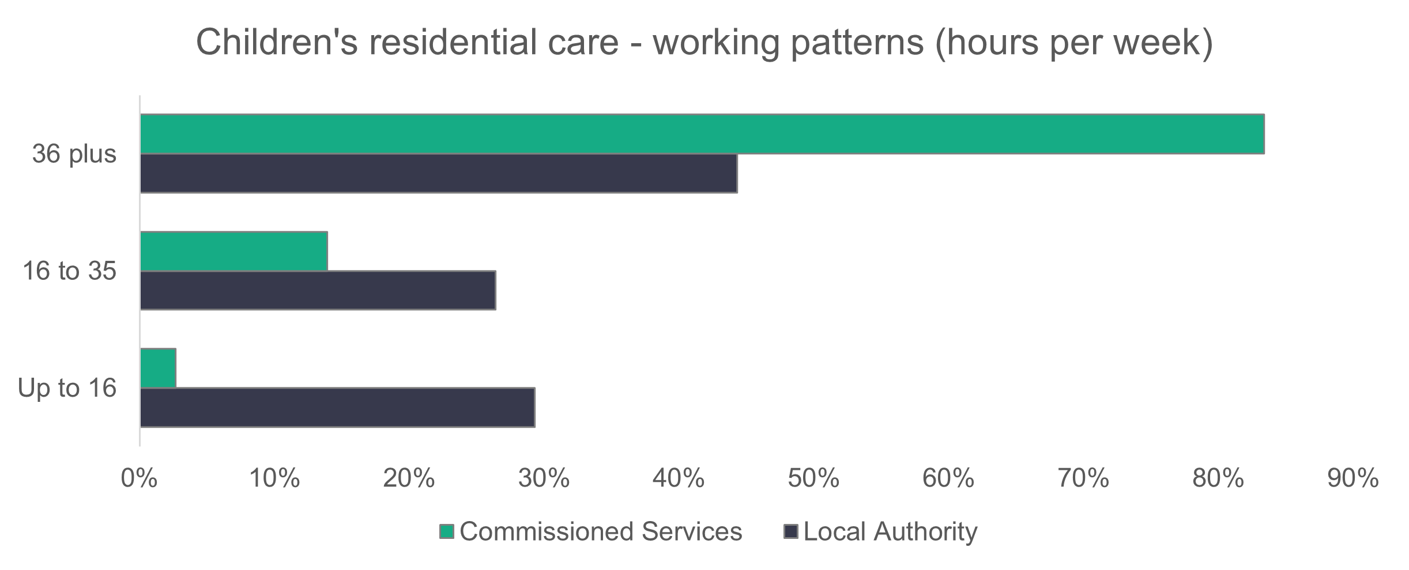
n = 2,168
- Children’s residential care – vacancies
There are 572 estimated vacancies in children’s residential care. This means that 11.9 per cent of jobs in children’s residential care are unfilled. There are 80 more reported job vacancies in children’s residential care compared to last year.

- Mental health residential care
Summary:

- Care workers (including senior carers) make up 73.2 per cent of the mental health residential care workforce.
- Men make up 19.1 per cent of the workforce.
- 61.5 per cent of the mental health residential care workforce in local authority-led services are aged 46 or over.
- Permanent contracts make up 84.3 per cent of the workforce.
n = 4
n = 12

- Mental health residential care – role type
Since 2023, the proportion of care workers in mental health residential care has increased from 56.5 to 63.7 per cent. The proportion of care workers is now closer to that in 2022, when it was 63.1 per cent. Since 2023, the proportion of workers in a manager role has decreased from 6.1 to 3.8 per cent. In 2022, 5.3 per cent were managers.
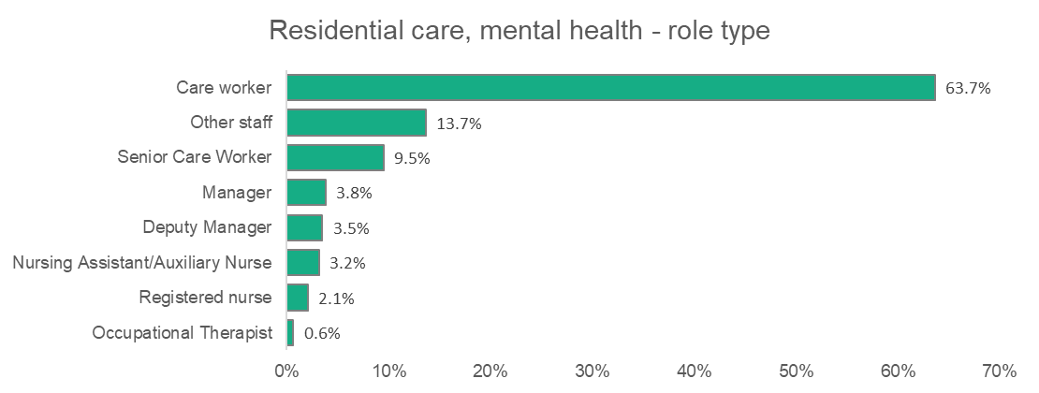
n = 630

- Mental health residential care – gender
The proportion of women working in mental health residential care has increased to 80.9 per cent. Last year, 72.2 per cent of the mental health residential care sector was female. The proportion in 2022 was 75 per cent.
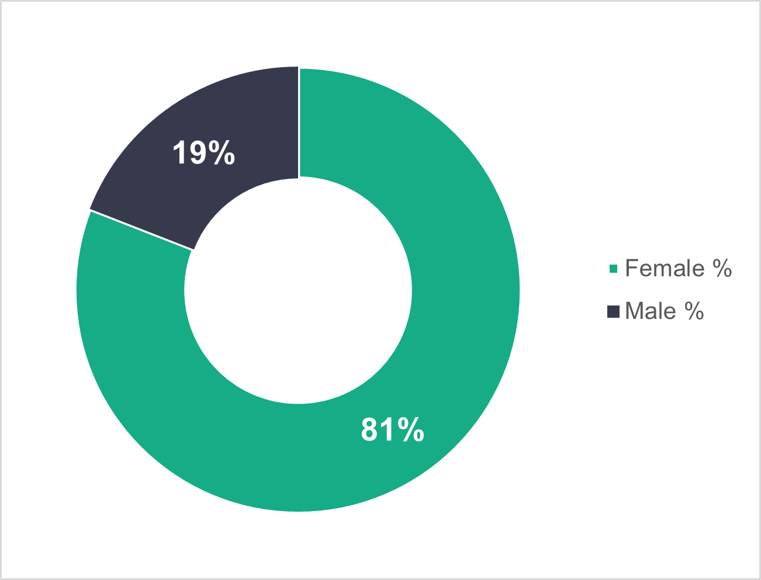
n = 624

- Mental health residential care – age profile
The age profile of the mental health residential care workforce is similar to 2023. We found that 61.5 per cent of workers in local authority-led services are 46 or over, compared to 62.5 per cent in 2023. There’s been a decrease in the proportion of workers in commissioned services who are 46 or over – down from 40.4 per cent in 2023 to 35.3 per cent.
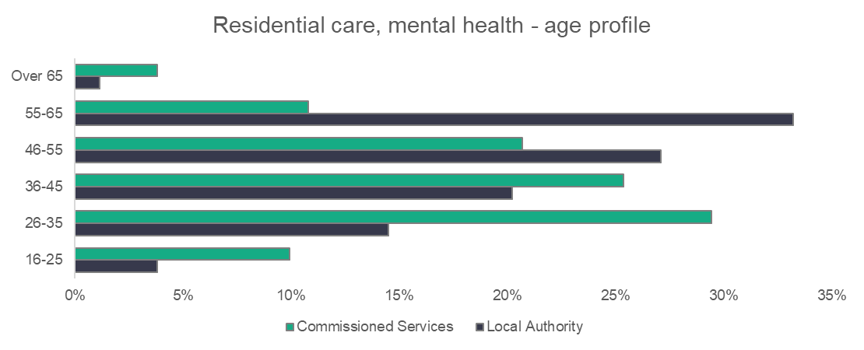
n = 605

- Mental health residential care – ethnicity
The proportion of white workers in mental health residential care compared to last year has barely changed (88.7 per cent this year, 88.1 per cent in 2023). We do see an increase in the proportion of Asian workers, from 6.5 per cent last year to 7.8 per cent this year. The mental health residential care workforce is more ethnically diverse than the social care workforce as a whole.
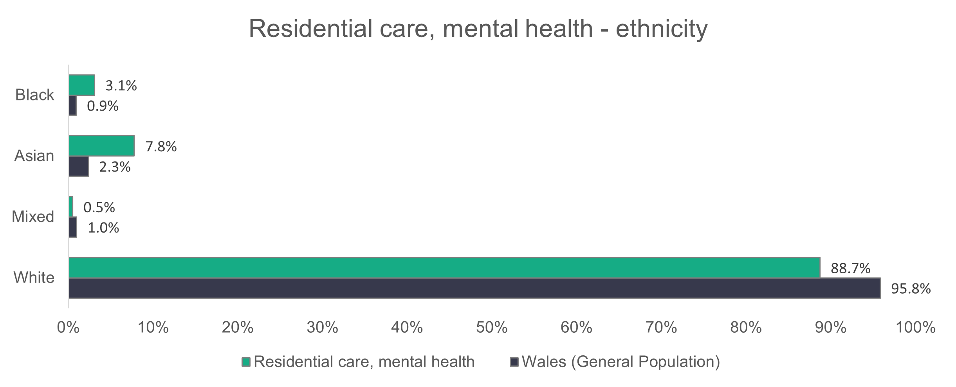
n = 425
- Mental health residential care – contract type
Local authorities have less of their workforce on permanent contracts when compared to commissioned services. Permanent contracts make up 89 per cent of the commissioned services workforce, while the corresponding figure for local authorities is 79 per cent. A high proportion of local authority workers are on casual contracts (19.8 per cent), compared to 0.3 per cent in commissioned services. This is a relatively large increase from 2023, when only 2.4 per cent of local authority workers were on casual contracts. Last year, 15.5 per cent of local authority workers were on agency contracts, but this year there are none.
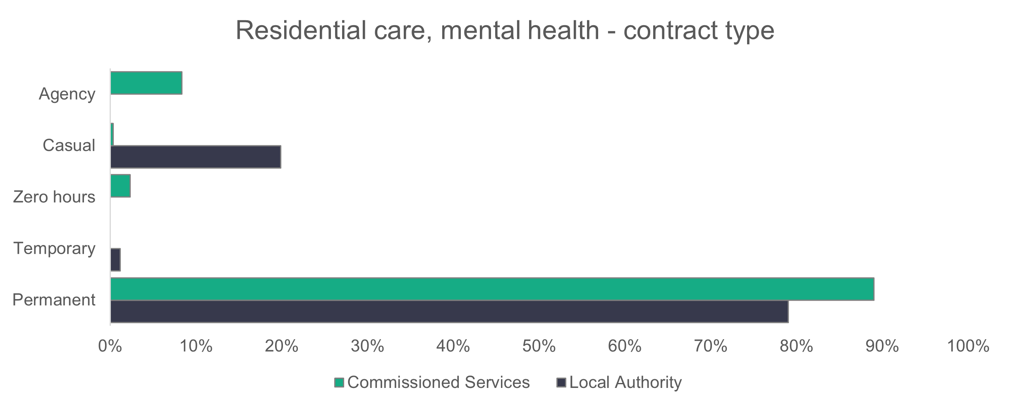
n = 562

- Mental health residential care – working patterns
We found that 53.6 per cent of the commissioned services workforce work full-time, compared to 17.6 per cent in the local authority workforce. This is a decrease in the number of full-time workers compared to last year. In 2023, 64.4 per cent of the commissioned services workforce and 25.6 per cent of the local authority workforce worked full-time hours.
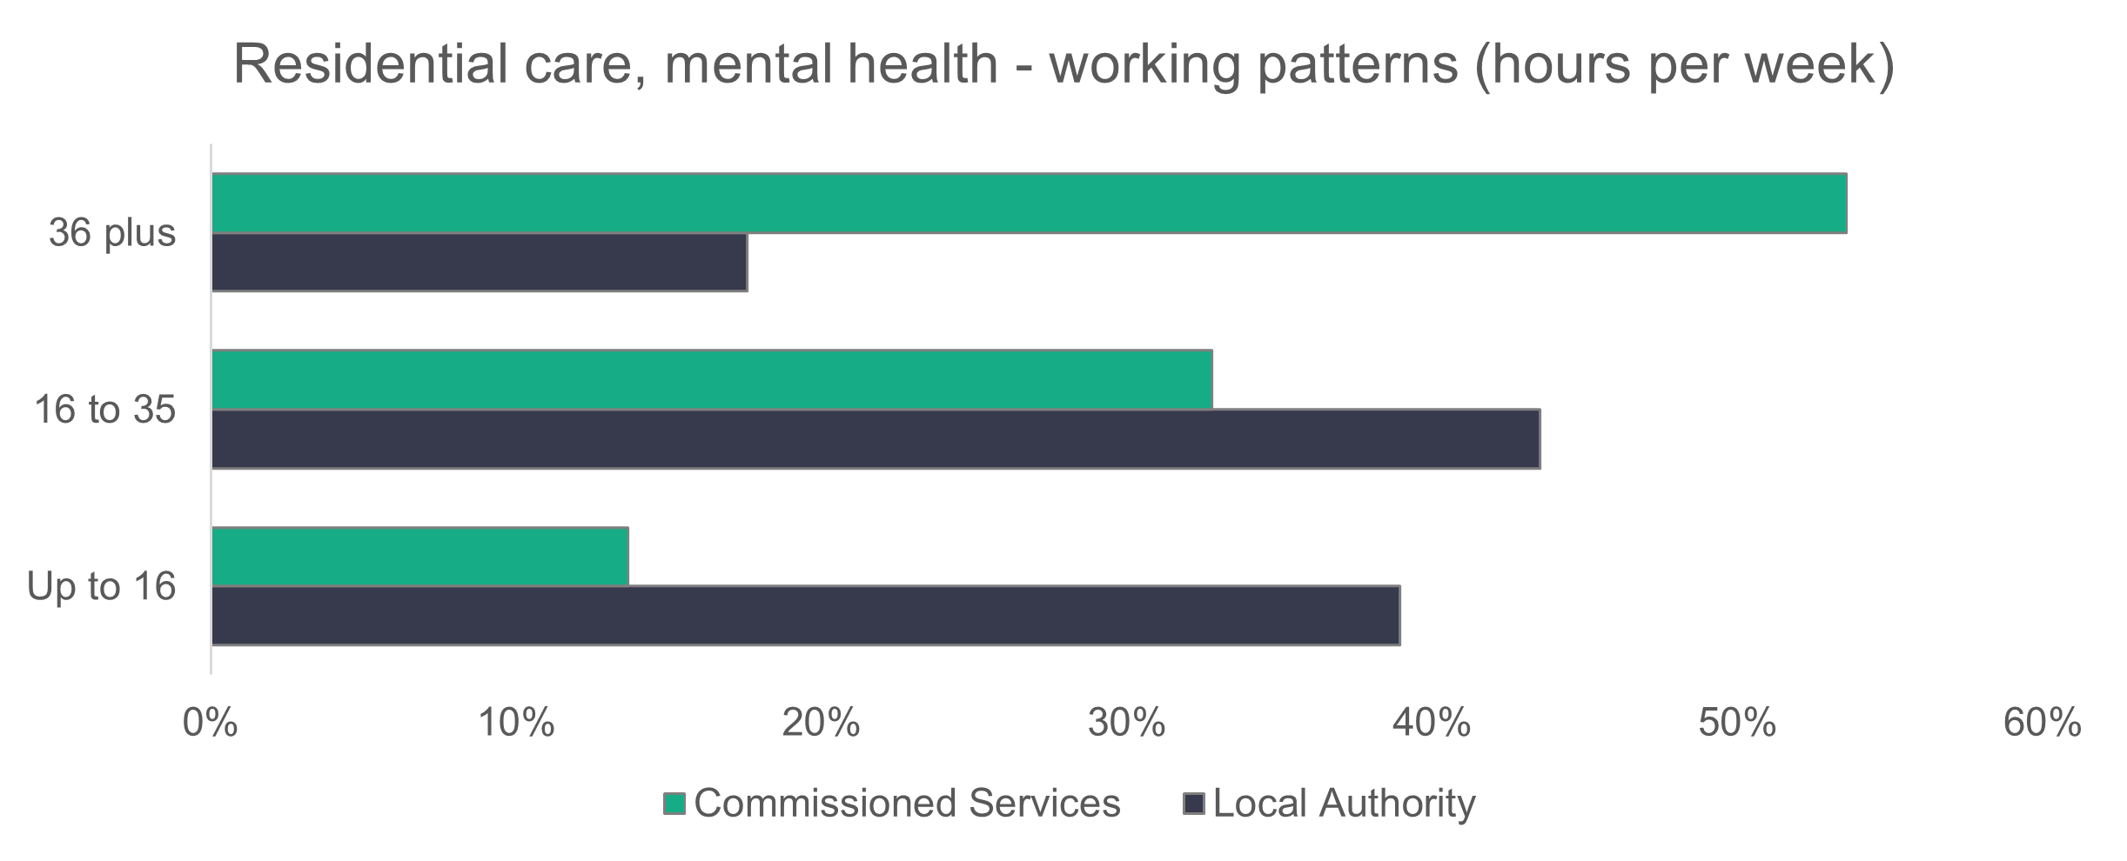
n = 628

- Mental health residential care – vacancies
With 30 vacancies, 3.9 per cent of roles in mental health residential care are unfilled. Last year, there were 51 vacancies (7.3 per cent unfilled).

- Central staff
Summary:
- ‘Other staff’ make up 59.8 per cent of the central staff workforce.
- Men make up 26.2 per cent of the central staff workforce.
- 51.3 per cent of the central staff workforce are aged between 36 and 55.
- Permanent contracts make up 83.2 per cent of the workforce.
- 75.8 per cent of the central staff workforce work full-time hours.
n = 22
n = 35

- Central staff – role type
‘Other staff’ includes business support and auxiliary workers and makes up 59.8 per cent of the central staff workforce – a 2.3 per cent decrease on last year’s data.
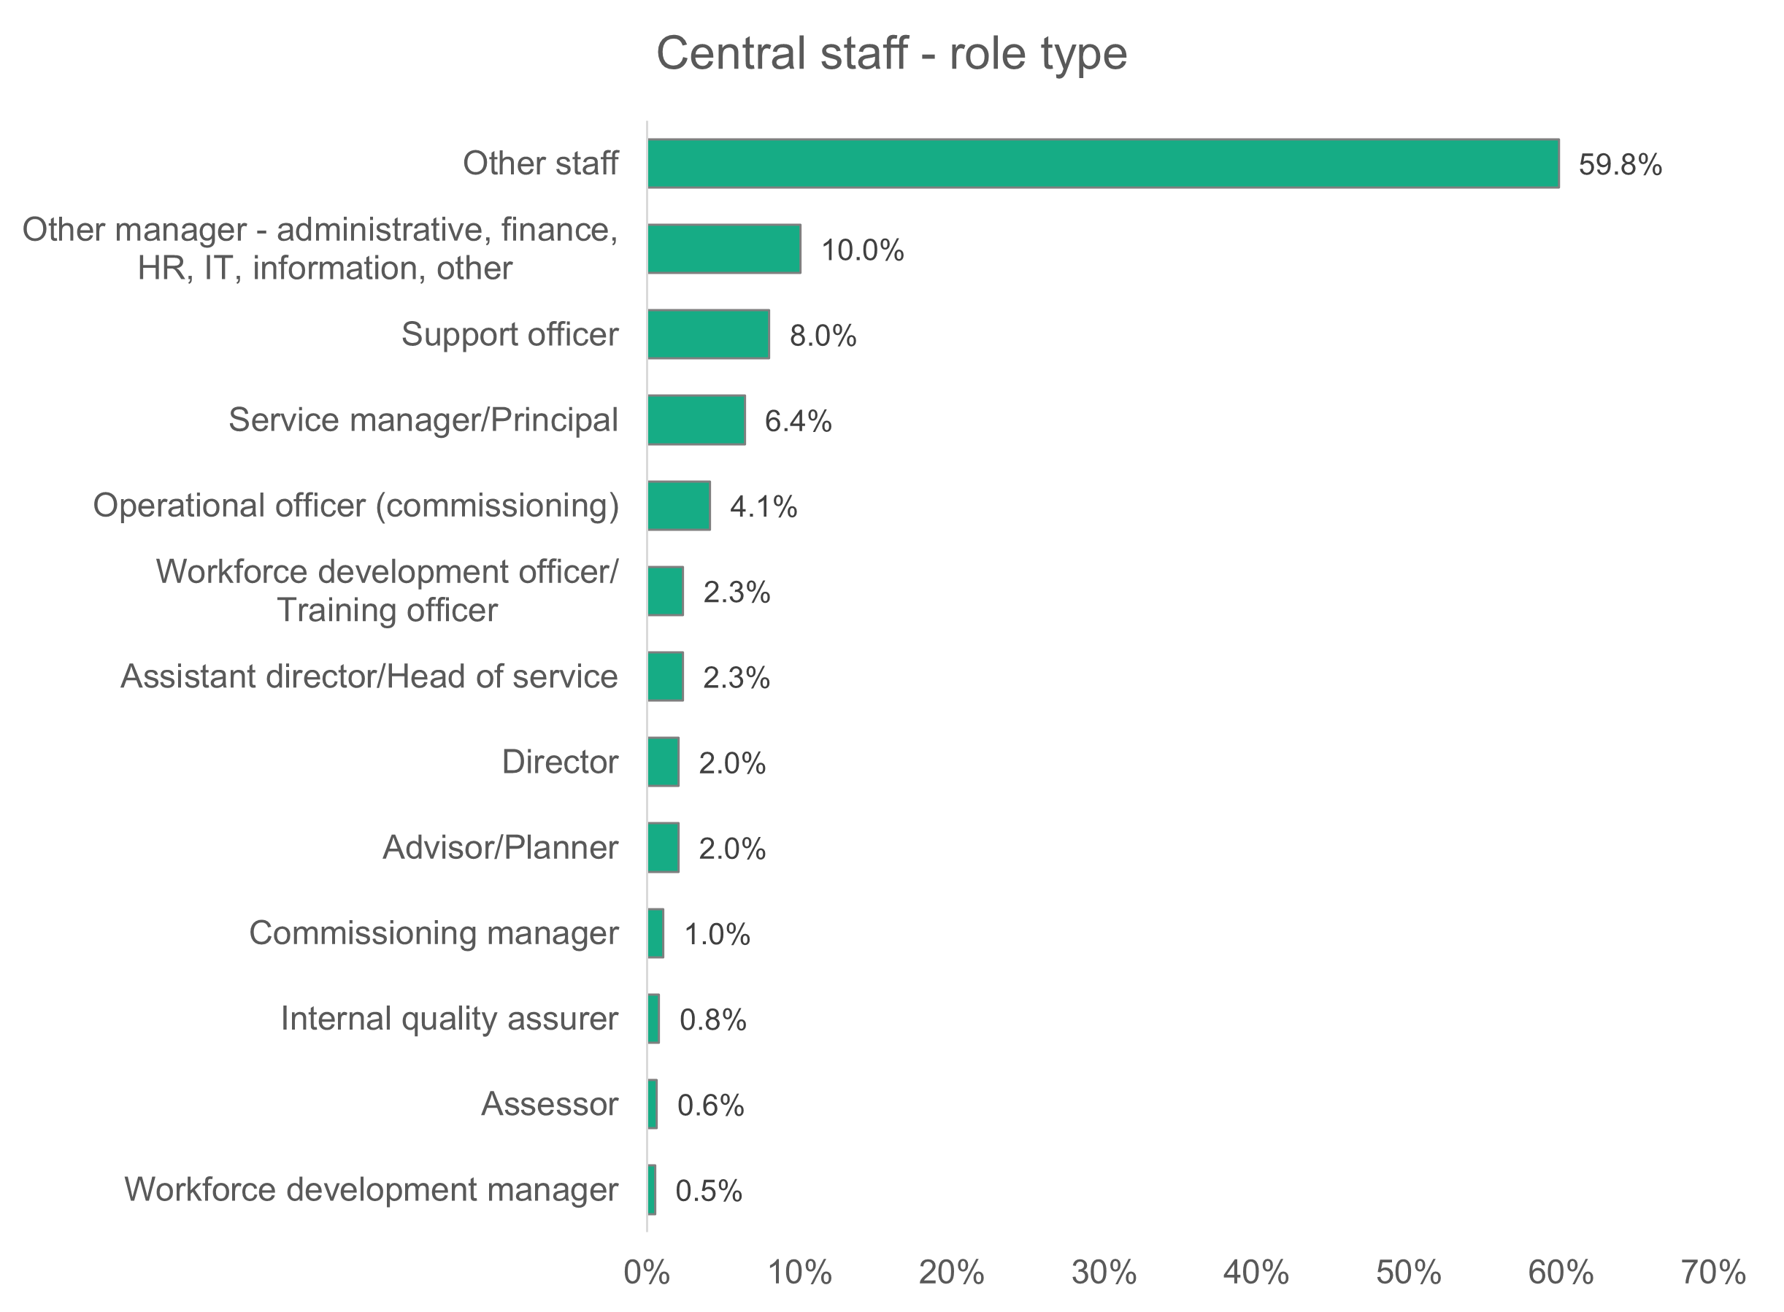
n = 4,013
- Central staff – gender
A higher proportion of men (26.2 per cent) work in central services compared to the 19.1 per cent who work in the social care workforce of Wales as a whole.
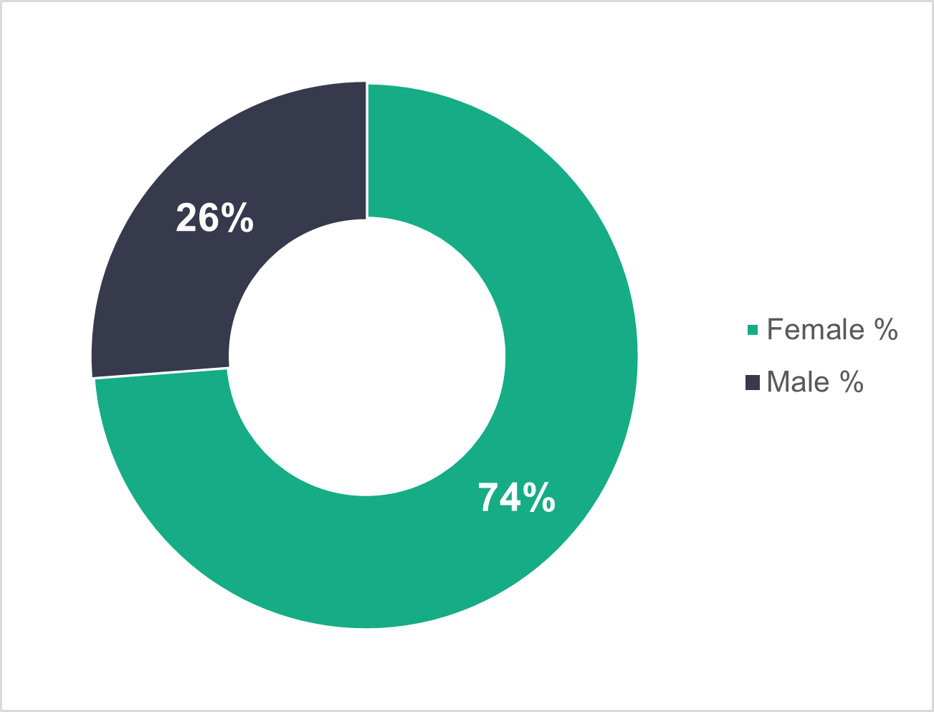
n = 3,987

- Central staff – age profile
In local authority central staff teams, 46 to 55 is the biggest age group (27.1 per cent). For commissioned services, the biggest age group is 36 to 45 (32 per cent).
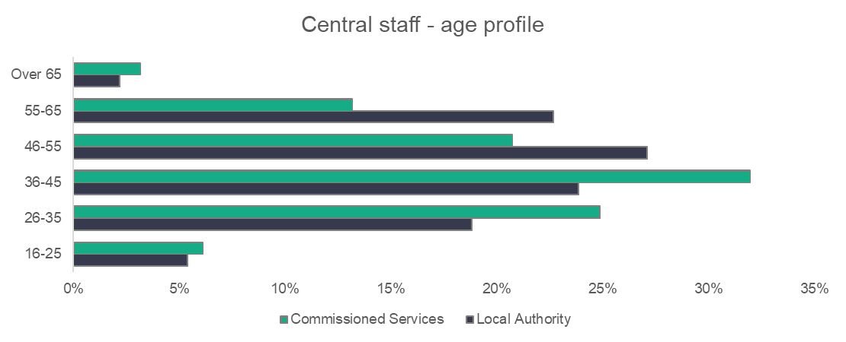
n = 4,004
- Central staff – ethnicity
The ethnicity of the central staff workforce almost mirrors that of the general population of Wales, with 95.7 per cent being white.
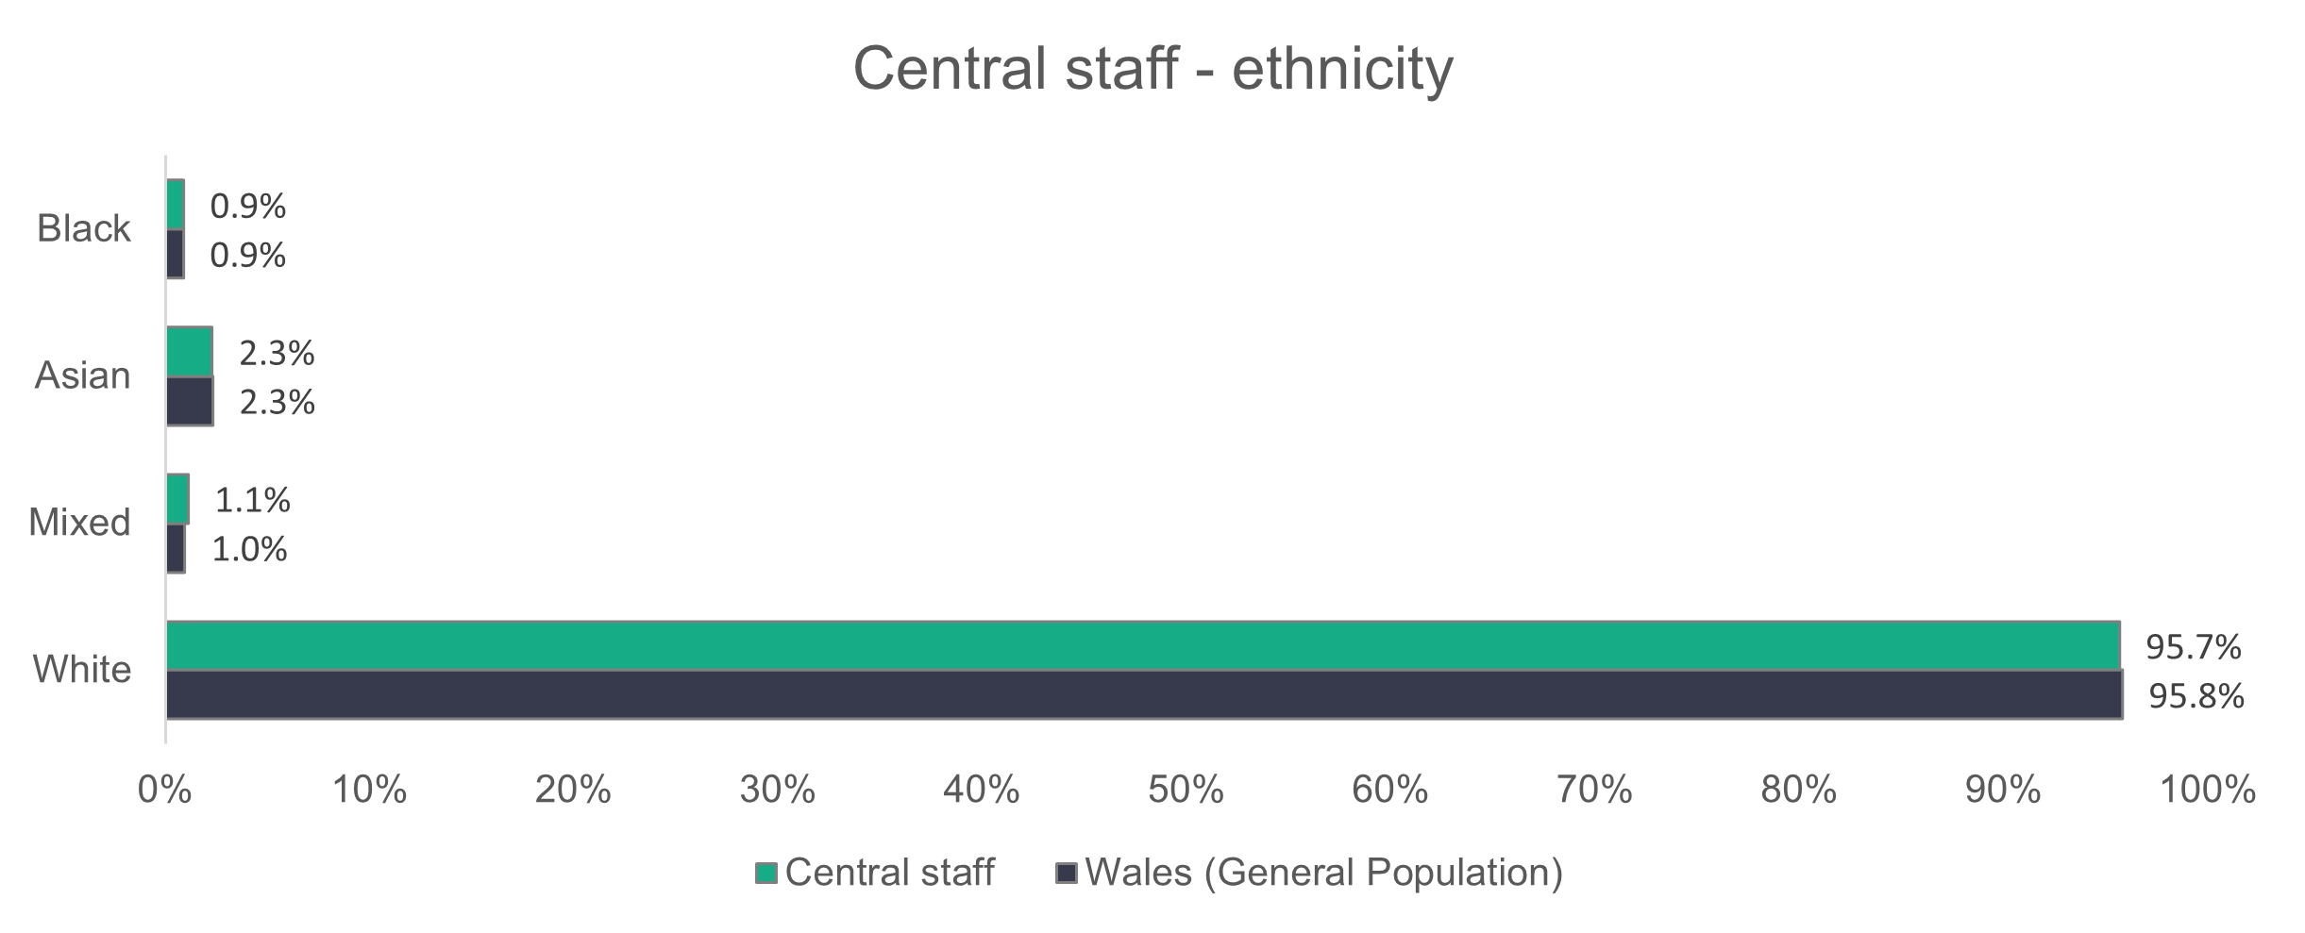
n = 2,782
- Central staff – contract type
Permanent contracts make up 99.5 per cent of commissioned service contracts. The remainder are made up of temporary contracts. Local authorities have 79.1 per cent of their workers on permanent contracts.

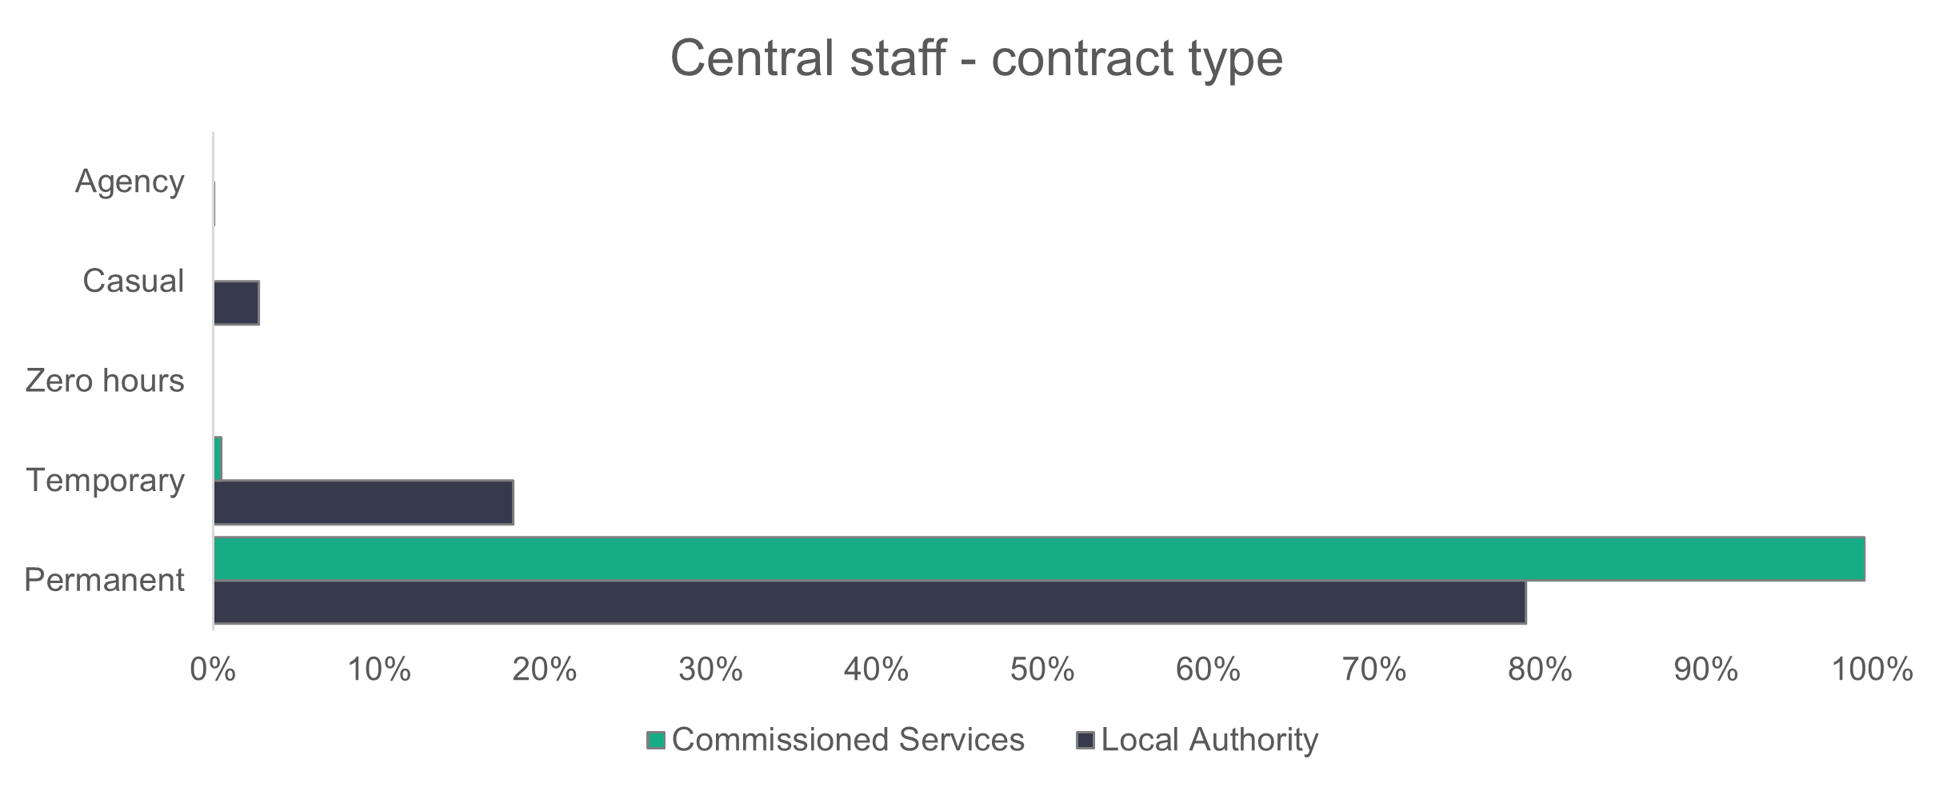
n = 4,004
- Central staff – working patterns
Most central services staff work full-time hours – 76 per cent in local authorities and 75.2 per cent in commissioned service providers. The proportion of commissioned service staff working full-time hours has increased by 9.3 per cent from 65.9 per cent last year.
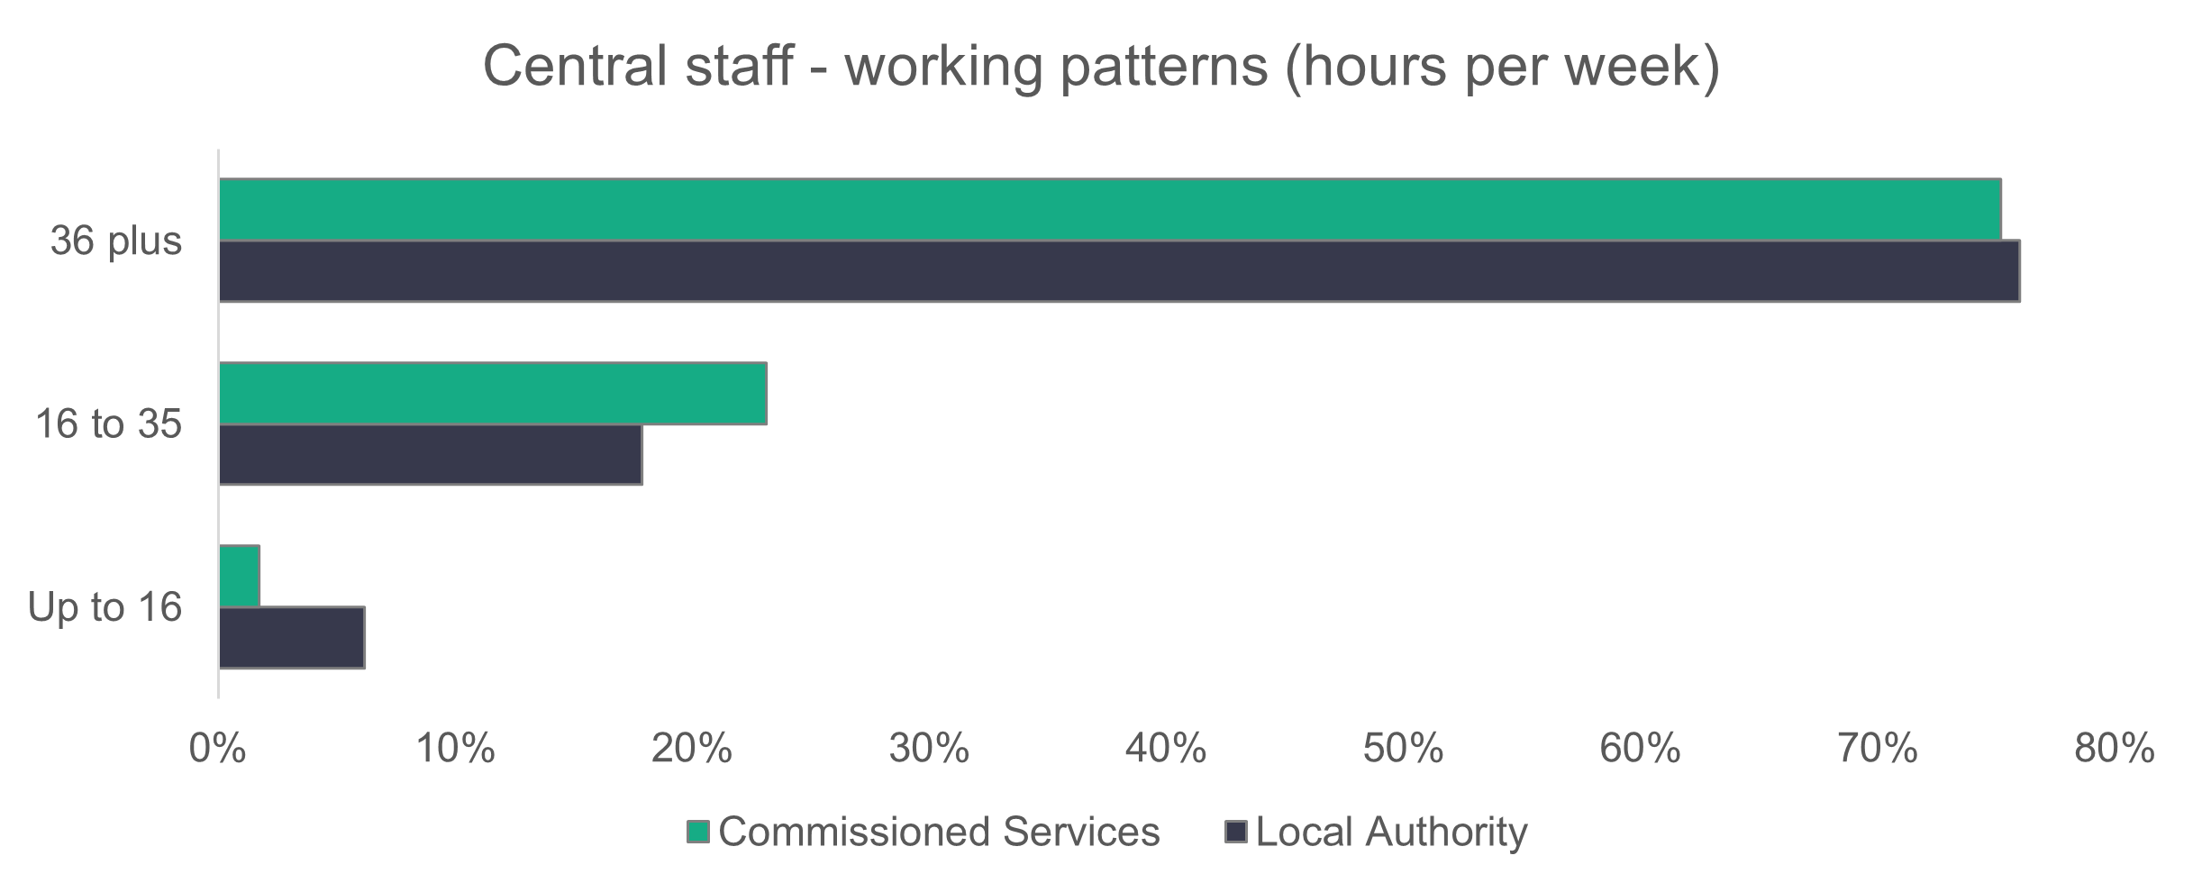
n = 4,002
- Central staff – vacancies
Central staff have 341 vacancies, meaning that 8.5 per cent of roles are unfilled. There are 108 more vacancies this year compared to last year.

- Other services

Organisations are able to self-describe the type of setting they feel most reflects their service. Sometimes providers feel their service has not been included in the list of standard setting types. This year we received information from 11 organisations who described themselves as other (10 commissioned services and one local authority), a slight reduction on the 13 settings received last year. However the number in post for these settings has increased to 229, in comparison to the 111 of 2023. Organisations who have identified as other will be contacted to discuss their settings.

The breakdown of roles returned is shown below.

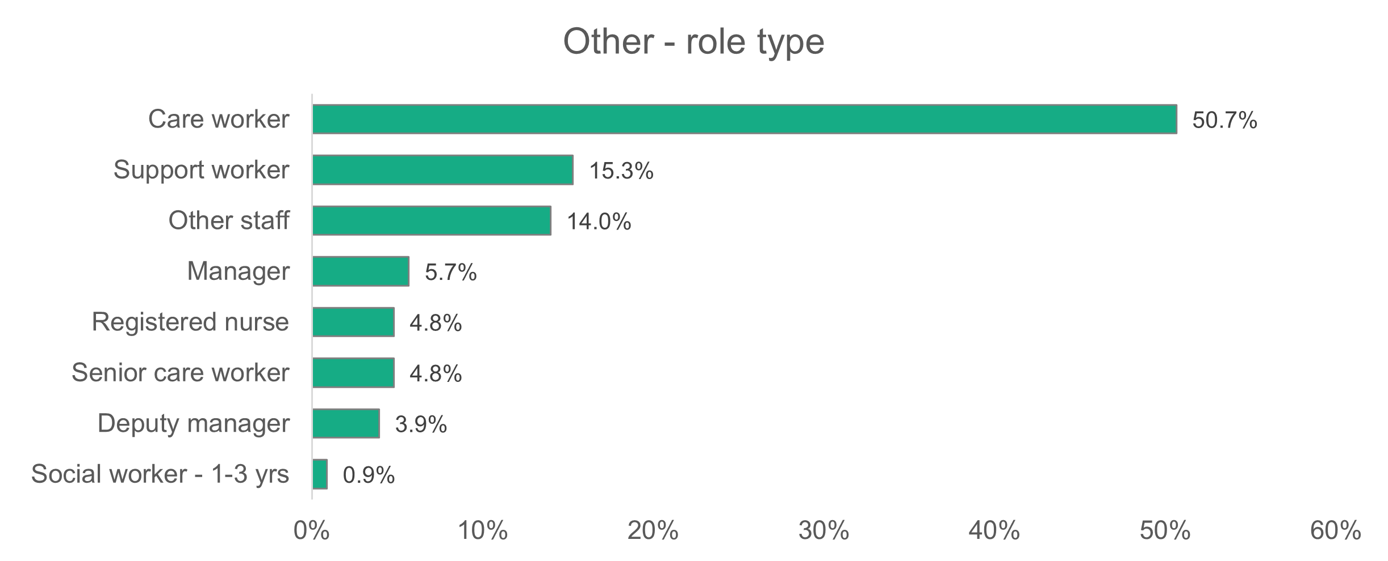
n = 229

Appendix A - Data categories

Setting type:
- Adult placement schemes | - Residential care – adult
- Residential care – mental health services | - Residential care – children
- Domiciliary care | - Supported living services
- Day services | - Social work teams – adults
- Social work teams – children | - Social work teams – all
- Personal assistants
- Central (support) staff Role definition

Role types:
- Adult placement manager | - Adult placement worker
- Adviser/planner | - Assessor
- Care worker | - Consultant social worker
- Deputy manager | - Deputy team manager (social work)
- Director | - Internal quality assurer (IQA)
- Head of service (assistant director) | - Nursing assistant/Auxiliary nurse
- Manager | - Occupational therapy assistant
- Occupational therapist | - Other manager
- Other staff | - Physiotherapist
- Personal assistant | - Registered nurse
- Planner | - Senior care worker
- Registered nursing staff | - Service manager/Principal officer
- Senior practitioner | - Social care planning and commissioning operational officer
- Social care planning and commissioning manager | - Social worker (two to three years)
- Social care planning and commissioning support officer | - Social worker (first year in practice)
- Social worker (three years or more) | - Support worker
- Speech and language therapist | - Workforce development manager
- Team manager (social work) | - Workforce development officer/Training officer

Age | Gender |  |  | Disability
- 16 to 24 | - Male |  |  | - Yes
- 25 to 34 | - Female |  |  | - No
- 35 to 44 | - Gender fluid
- 45 to 54 | - Non-binary
- 55 to 64
- 65 and over

Working hours per week |  | Contract status |  | Vacancies
- Up to 16 hours |  | - Permanent |  | - To be filled
- 16 to 36 hours |  | - Zero hours |  | - Held vacant
- 36 hours or more |  | - Casual  - Voluntary
 |  | - Bank/Agency
Requires a work visa |  | Welsh-language proficiency |  | First language
- Yes |  | - No ability |  | - Welsh first language
- No |  | - Welsh entry |  | - English first language
 |  | - Welsh foundation |  | - Other first language
 |  | - Welsh intermediate
 |  | - Fluent
Joiners |  | Leavers |  | Sickness
- Internal transfer/ promotion |  | - Internal transfer/ promotion |  | - No of days short term
- Welsh Local Authority |  | - Welsh Local Authority |  | - No of days long term
- Outside Wales |  | - Outside Wales |  | - Stress (work related)
- A private care organisation |  | - A private care organisation |  | - Stress (non-work related)
- Outside social care |  | - Outside social care |  | - Other mental health
- Voluntary/3rd sector care organisation |  | - Voluntary/3rd sector care organisation |  | - Back injury
- From education |  | - To education |  | - Limb injury
- Were not working |  | - Left the sector |  | - Common ill health
- Destination unknown |  | - Retirement |  | - Covid
 |  | - Redundancy |  | - Other illness
 |  | - Were dismissed
 |  | - Left temporarily
 |  | - Destination unknown

Ethnicity
- White Welsh | - Asian Welsh
- White British | - Asian British
- White Irish | - Asian Pakistani
- White European | - Asian Indian
- White and Asian | - Asian Chinese
- White / Black African | - Asian Bangladeshi
- White / Black Caribbean | - Asian (other)
- White (other) | - Arabic
- Black Welsh | - Mixed ethnicity
- Black British | - Mixed (other)
- Black Caribbean | - Gypsy / Traveller
- Black African | - Other ethnicity
- Black (other) | - Prefer not to say

Appendix B – How we dealt with missing data and estimating the total size of the social care workforce in Wales

A primary objective of this project is to estimate the size of the social care workforce in Wales. However, the data set compiled for this study contained incomplete information. Significantly, essential data such as the number of people in post and the number of vacancies were among the fields with missing values. We implemented a methodology for approximating these missing values, enabling us to produce a more comprehensive assessment of the social care workforce size across Wales.
The approach to missing data estimation was done in two parts, focusing on calculating figures for organisations that submitted data in the previous years but failed to do so this year, then estimating data for organisations without a history of data submission.
We chose machine learning to predict the missing values for the number of people in post, specifically using a supervised learning approach, where known (labelled) values are used to train a model to accurately predict values for unseen data.
As for the number of vacancies to be filled, we selected mean imputation to address data gaps due to its simplicity and reliability. This technique was particularly appropriate given the limited size of the vacancy data set. When evaluated against various machine learning models, the mean imputation method produced comparable results.
The algorithm we utilised is XGBoost, a supervised learning method applicable to both regression and classification tasks. It is an implementation of the gradient-boosted decision tree algorithm, which enhances predictive performance by combining multiple weaker learners into a single robust model. The “gradient” in XGBoost refers to its use of gradient descent, an optimisation technique that adjusts model parameters to minimise errors and improve performance.
We selected Mean Absolute Error (MAE) and Root Mean Squared Error (RMSE) as our metrics to assess the model’s performance. Both measure the difference between predicted and actual values of the target variable. RMSE, calculated as the square root of the mean squared differences, gives greater weight to larger errors, making it particularly sensitive to significant deviations. MAE on the other hand represents the average absolute difference between predicted and actual values, providing a general measure of prediction accuracy without emphasising extreme errors.

Number-in-post predictions
Estimating values for 2024 using 2022 and 2023 data
For this part of the estimations, we forecasted data for organisations that submitted data in both 2022 and 2023 using their prior returns. Before applying XGBoost, we first needed to create a training data set containing 2022, 2023 and 2024 data, as well as a data set for the organisations we aimed to predict data for. We began by calculating the total number of people in post for each organisation by county and setting type for each year. Outliers were then removed using the interquartile range (IQR) method, to avoid impacting the accuracy of the estimates. This method involves dividing the data set into quartiles, which are values that split the data into four equal parts. IQR, which represents the spread of the middle 50 per cent of the data, is calculated by subtracting the first quartile (Q1) from the third quartile (Q3). Q1 is the value below which 25 per cent of the data points fall, while Q3 is the value below which 75 per cent of the data points fall. Any data points above Q3 plus 1.5 times the IQR or below Q1 minus 1.5 times the IQR are considered outliers and are removed from the data set.
Following this, we calculated Pearson’s correlation between total number of people in 2024 and our continuous variables: number of settings, total number of people in 2022 and total number of people in 2023. As expected, the total number of people in post in 2024 is highly correlated with the total number in post in 2022 and 2023, with correlation coefficients of 0.92 and 0.95 respectively. The correlation between the number of settings and the target variable (total number of people in 2024) is moderate, with a coefficient of 0.62. It is important to note that the correlation coefficient ranges from -1 to 1, with values close to 0 indicating a weak correlation, and values closer to either endpoint indicating a stronger correlation. We created a ‘growth rate in 2023’ variable to assess whether it correlates with the target variable but found a weak correlation. Therefore, we selected ‘number of settings’ as well as ‘total number of people in post’ in both 2022 and 2023 as predictors.
Next, we assessed the relationship between the target variable and the categorical variables ‘county’ and ‘setting type’ to determine whether we should include them in the data fed into the model.
We started by creating a boxplot to explore the distribution of the total number in post across different authorities. The boxplot below illustrates that the median differs across some authorities, suggesting variation in the total number in post. Further evidence of this variation is seen in the differences in the height of the boxes and the length of the whiskers. The significant variation in whisker lengths and box sizes across authorities suggests differences in the spread of the total number in post.

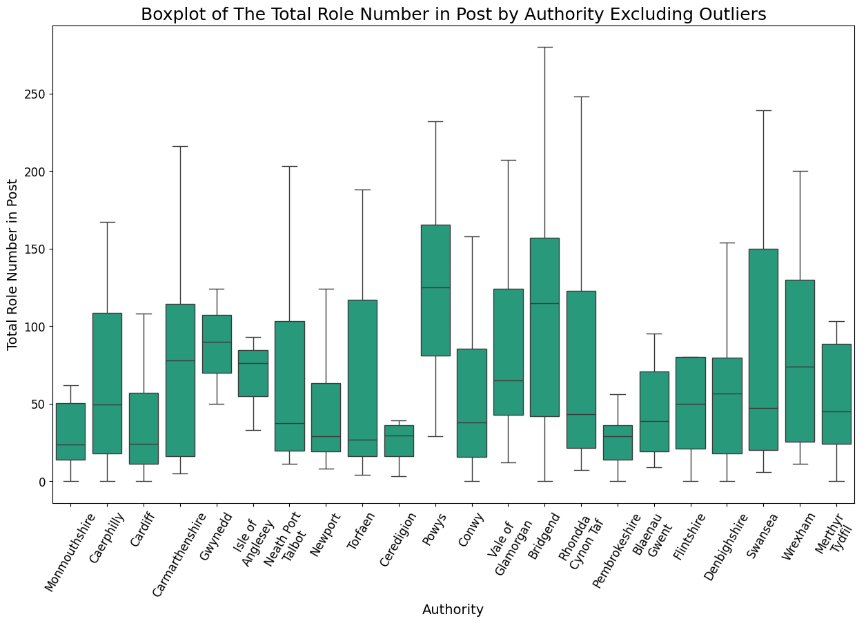

After this, we generated another boxplot to examine the distribution of the total number in post across different setting types. The boxplot below shows that the median total number in post varies significantly between some of the settings, indicating differences in workforce size across them. Additionally, the variation in whisker lengths and box heights across settings suggests differences in the spread of the total number in post, further highlighting variability between setting types.

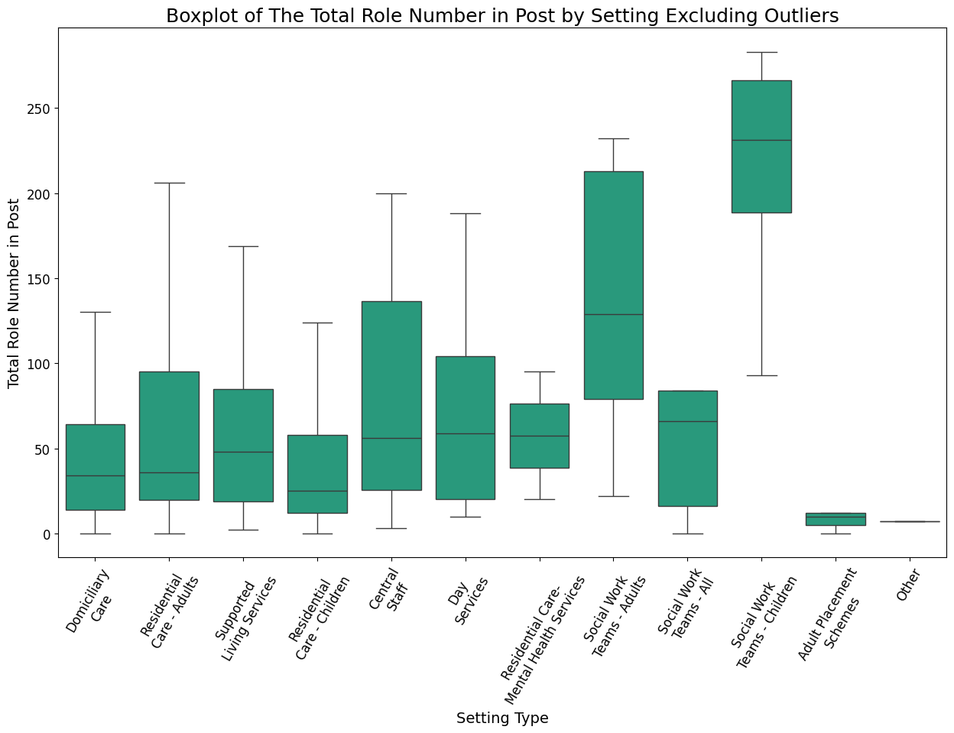

After selecting the authority and setting type as input variables, along with the previously examined continuous variables, we split the data set into 80 per cent for training the XGBoost model and 20 per cent for testing. Additionally, we applied one-hot encoding to transform the nominal categorical variables into a numerical format suitable for the machine-learning process. One-hot encoding represents categorical variables by assigning a unique binary indicator to each category, specifying its presence or absence.
When training the model, we evaluated its performance on the test set, which resulted in an MAE of 11.9 and an RMSE of 19.03. Initially, setting type was included as a predictor, but it did not improve the results, so it was excluded from the final model. The metrics suggest that the model performs reasonably well, with the RMSE indicating slightly greater variability and sensitivity to outliers compared to MAE.

Estimating values for non-reporting organisations
This part of the estimations differed from the previous one. Since these organisations had never submitted data before, estimating their total number of people in post was more challenging. To generate reliable estimates, we first needed to gather additional information about them. Specifically, we obtained details on authority, setting type and the number of settings.
The next steps followed a similar approach to the previous section. We began by calculating the total number of people in post per authority and setting for each organisation to use as input for training the XGBoost model. Next, we assessed the relationship between the number of settings and the total number in post, finding a weak to moderate correlation of 0.32.
To further explore the distribution of the target variable, we generated boxplots of the total number in post per authority and per setting. As shown in the boxplots below, the median, whisker lengths, and box sizes vary across categories, indicating differences in distribution. While the boxplots below exclude outliers for better visualisation, it is important to note that the final model was trained with outliers included, as this approach resulted in better predictions.

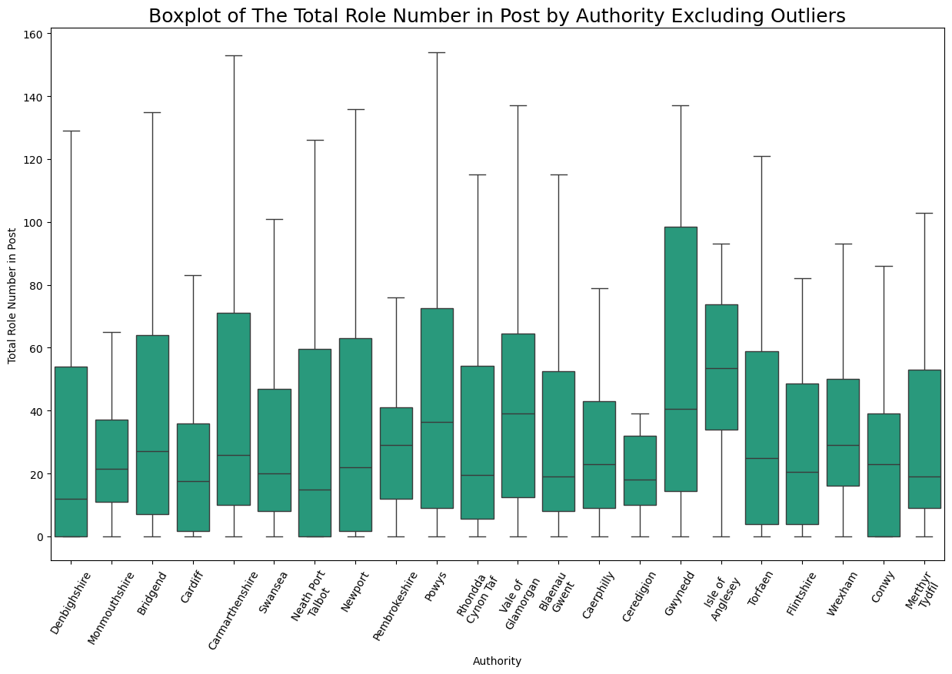

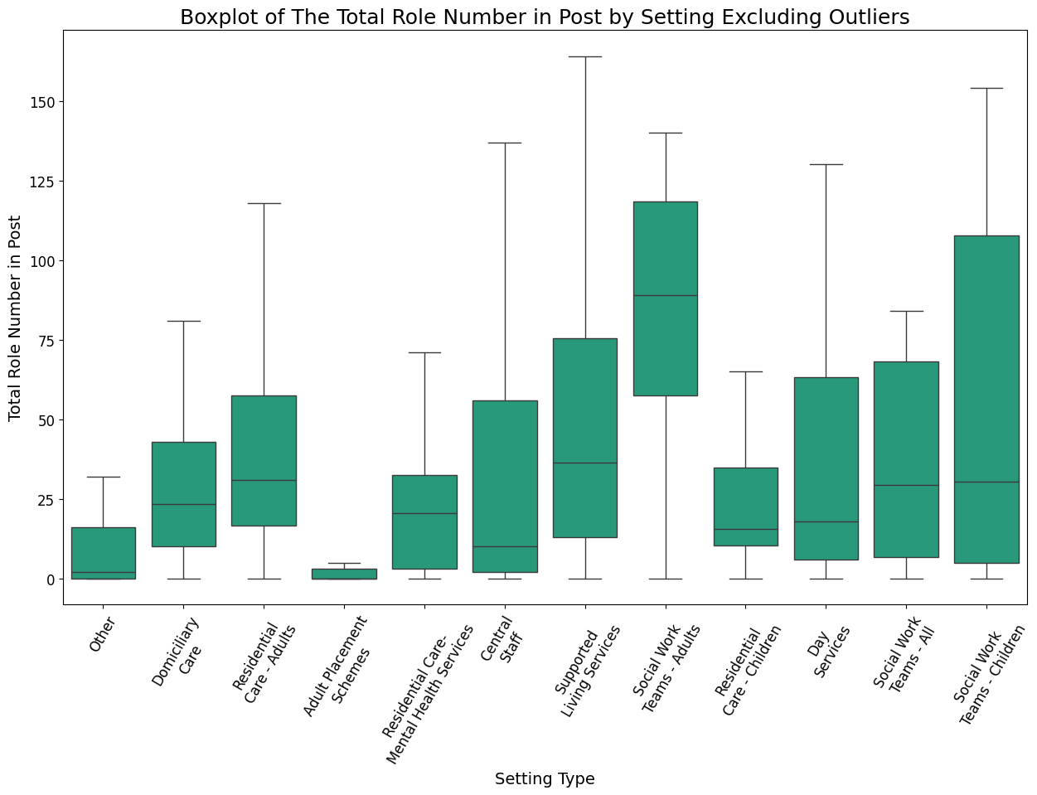

Following this, we decided to include all three variables as input features for the model, as the weak to moderate correlation and the differences observed in the boxplots suggest they may contribute to the predictions.
Our final model resulted in an MAE of 37.9 and an RMSE of 72.2, which are reasonable given the high variability of the test set. The MAE indicates an average prediction error of 43, which is acceptable considering the spread of the data. The RMSE, which is influenced by outliers and larger values, aligns with the characteristics of the data set.

Predicted estimates for vacancies to be filled
Similar to our approach for estimating number of people in post, we consolidated vacancy figures for each organisation per authority and setting type. However, the limited data set size and quality concerns led us to avoid machine-learning techniques for this particular task.
We implemented mean imputation to address this problem due to its simplicity and straightforward application. This method replaces missing values with the arithmetic average of available observations. We reserved 10 per cent of our data set to evaluate the accuracy of our mean-based estimates against actual reported values. Next, we calculated separate means for each setting type within each authority, capturing average patterns specific to these combinations. These calculated means were then applied to fill in the corresponding missing values.
Our mean imputation approach achieved an MAE of 1.8 and an RMSE of 3.6, indicating moderate estimation errors relative to the overall variability in the target variable.

Conclusion
Building on our previous work, our confidence in our statistical techniques for handling missing data continues to grow. Looking ahead, we anticipate that ongoing refinements to our methodology, coupled with improvements in data quality, will yield even more accurate estimations in future reports.

https://www.gov.wales/sites/default/files/publications/2024-06/performance-and-improvement-framework-additional-guidance-2024-to-2025.pdf
https://research.senedd.wales/research-articles/a-spotlight-on-social-care-workers-the-latest-challenges-facing-the-sector-part-2/ https://www.gov.uk/government/publications/adult-social-care-asc-workforce-and-work-related-quality-of-life/executive-summary-adult-social-care-workforce-and-work-related-quality-of-life https://researchbriefings.files.parliament.uk/documents/CBP-9615/CBP-9615.pdf https://www.adss.cymru/en/blog/view/delivering-social-care-in-an-anti-racist-wales-report/fileAttachment
https://www.careinspectorate.wales/submitting-annual-returns
https://www.gov.wales/sites/default/files/publications/2024-07/national-framework-for-commissioning-care-and-support-code-of-practice.pdf
See Appendix B for estimation methodology.

