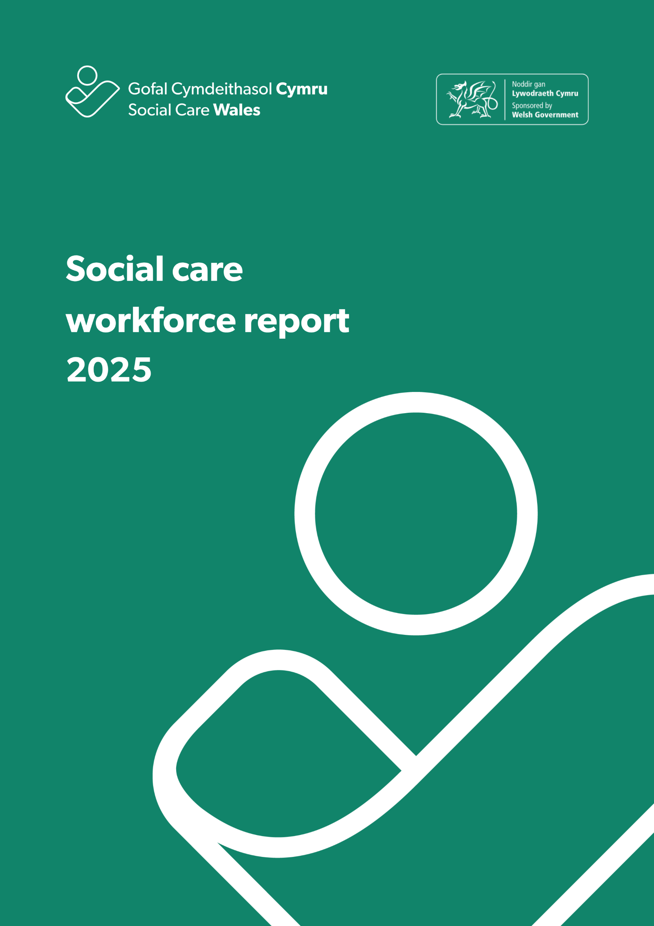
Contents
Executive summary 4
1. Introduction 6
1.1 Background 6
1.2 Changes from 2024 7
1.3 Challenges, issues and data quality 8
2. Our findings 12
Summary: 12
2.1 Overall social care workforce 12
2.2 Adult residential care 22
2.3 Domiciliary care 26
2.4 Day services 30
2.5 Supported living services 34
2.6 Social work teams 38
2.7 Children’s residential care 42
2.8 Mental health residential care 46
2.9 Central staff 50
2.10 Other services 54
Appendix A - Data categories 55
Appendix B – How we dealt with missing data and estimating the total size of the social care workforce in Wales 57

Mae’r adroddiad hwn hefyd ar gael yn Gymraeg ar ein gwefan.
This report is also available in Welsh on our website.

Executive summary

This report presents the findings from the 2025 Social Care Workforce Data Collection, providing a national picture of the size, composition and characteristics of the social care workforce in Wales. The data is collected annually and plays a critical role in informing workforce planning, policy development and service improvement at national, regional and local levels.
Using the methods described in Appendix B, we estimate that 84,908 people were employed in the social care workforce in Wales in 2025. While there are noticeable year-on-year changes in some setting types, the overall size of the workforce remains broadly stable when improvements in data quality, service classification and estimation methods are taken into account.
The gender profile of the workforce remains largely unchanged, with women continuing to make up around 80 per cent of the workforce. Care workers remain the largest occupational group, accounting for over half of all roles, although their proportion has continued a gradual decline over recent years – from 54.6 per cent in 2023, to 50.8 per cent in 2024 and down to 48.5 per cent in 2025
The age profile of the workforce continues to differ markedly between local authorities and commissioned services. Local authority services tend to retain an older workforce, with just over half of workers aged 46 or over, while commissioned services employ a younger workforce, with around 60 per cent of staff under the age of 46. This pattern has remained consistent across successive collections and has implications for recruitment, retention and succession planning.
The social care workforce continues to become more ethnically diverse. The proportion of workers identifying as black, Asian or mixed ethnicity has increased steadily since 2022, with particularly notable growth among care workers and registered nursing staff. Despite this increase, diversity remains uneven across settings and roles.
Data collected on work visas indicates that 6.7 per cent of the workforce require a visa to work in the UK, with significantly higher concentrations in commissioned services (commissioned services 13.6 per cent compared to local authorities 0.7 per cent). Over half of all those recorded as requiring a visa work within residential care (adults, children and mental health) - 56.2 per cent in 2025, which is a rise from 50.1 in 2024.
Permanent contracts continue to dominate across the workforce, especially in services commissioned by local authorities. However, reliance on casual and temporary contracts remains significant in some local authority-run residential settings. Vacancies have increased overall, with an estimated 6,103 vacancies (5,346 vacancies in 2024), representing 6.7 per cent of roles Domiciliary care accounts for around half of all vacancies.
Reported sickness absence fell substantially in 2025, reversing the increase seen in 2024. While this represents a positive change, interpretation should be cautious due to variation in data completeness across providers and settings.

- Introduction

This report presents the key findings from the 2025 social care workforce data collection, the fifth annual collection we’ve carried out.
The collection was launched at the beginning of October 2025 and closed at the beginning of December, requesting information on the workforce as at 31 March 2025.

  - Background
The introduction of the Performance and Improvement Framework in April 2020 established an integrated data collection process of the social care workforce. Since then, we’ve worked closely with people who work in social care in Wales to improve the method and quality of the annual workforce data collection.
This is the fifth and final time data will be collected in this way under this framework. In 2026 the data will be collected only once, via the Care Inspectorate Wales Annual Return, which has been adapted to incorporate the requirements of the workforce data collection. This unified collection is now possible due to further alignment of how the two organisations record roles and service types. We’re confident this will ensure both organisations can continue to report on what the data is telling us, without losing the ability to compare to what we’ve previously seen..
While there are still areas that need improvement, we’re seeing solid themes and trends emerging in the data we’ve received and are carrying this learning into the development and implementation of the unified data collection work with Care Inspectorate Wales.
For the purposes of this collection, commercial businesses, not-for-profit and third-sector organisations who provide care and support in Wales are classed as commissioned service providers.
Local authorities are required as part of the Performance and Improvement Framework to send us this data every year. Commissioned providers are strongly encouraged to submit data in both the Performance and Improvement Framework and the newly released National Framework for the Commissioning of Care and Support in Wales.
We don’t include organisations who solely provide NHS-funded or privately paid for (without local-authority funding) care, or government agencies responsible for social care regulation and inspection.
We asked for data from providers of:
- adult residential care
- children’s residential care
- mental health residential care
- domiciliary care
- supported living
- social work teams
- day services
- adult placement schemes
- personal assistants
- central or support staff
- other social care services which don’t fall into any of the above.
A full list of the data categories included in this collection is provided in Appendix A.
As in previous years, this collection plays a critical role in informing workforce planning, policy development and service improvement at local, regional and national levels. The data is used by Welsh Government, local authorities, regulators, care providers, researchers and policy organisations, and has informed evidence submitted to the Senedd, UK Parliament and other national bodies.
This year’s report builds on the methodological refinements introduced in 2024, with further improvements to data validation and triangulation with CIW data. While challenges remain in some areas of data completeness, particularly for personal assistants and some protected characteristics, the overall quality and consistency of returns continues to improve.
Changes in how providers classify services, differences between organisations responding to different collections, and improved alignment with CIW data can all affect the workforce sample. As a result, short-term fluctuations should be considered alongside longer-term trends. Where possible, we’ve provided data from different collection periods to support comparison.

  - Changes from 2024
As 2025 is the final year in which this workforce data collection will be undertaken in its current form, ahead of unification with CIW, we considered it important to increase transparency around the figures submitted through both collections. For this reason, we reflected the number of staff in post that had been reported through the CIW Annual Return, and the number reported through this workforce data collection side by side.
We did this to support understanding of the differences among data collectors and to inform discussion about why they might occur.

As in previous years, we’ve tried to keep changes to the data we request from local authorities and commissioned providers to a minimum. Maintaining a consistent data request reduces the burden for those completing returns and supports meaningful comparison with previous collections, allowing trends to be interpreted with greater confidence over time.

  - Challenges, issues and data quality
With each workforce data collection, we continue to gain new insight, both from the data itself and from our engagement with those who submit it. While overall return rates have remained stable this year, we’ve seen a continued improvement among commissioned providers in the level of detail provided across the question sets. This reflects the time, effort and commitment invested by those providers who submit data, and we’re grateful for the work they put into gathering and returning this information.

In contrast, we’ve seen no improvement, and in some cases a decline, in the completeness of local authority data relating to qualifications and ethnicity. There has, however, been some improvement in the number of local authorities reporting data on staff requiring a work visa, although five authorities didn’t submit any data for this field in 2025.

Looking ahead to the move to a unified collection with Care Inspectorate Wales in 2026, we’ve worked to streamline and align the metrics used in the Annual Return and the workforce data collection. We’ve done this carefully to make sure that no additional reporting requirements are introduced, while still allowing meaningful comparison with historic data. Our intention is to support continued improvements in the quality and completeness of returns over time, while also reducing the reporting burden on providers as far as possible.

As with previous years, data submitted through this collection is based on self-descriptions provided by local authorities and providers, including how services, settings and delivery models are classified. We’ve continued to build on the alignment work undertaken in 2024 to ensure consistency across datasets. Some differences remain, particularly in how residential care is categorised by providers, and in the further breakdown of domiciliary care used in this collection compared with CIW returns, as outlined below.

    - Personal assistants
We saw no improvement in the number of authorities who provided data on personal assistants this year. Because of this, we haven’t been able to report on their numbers in this report.

    - Comparing data from this report with CIW Annual Returns data
We continue to recognise that completing two separate data collections for Social Care Wales and CIW creates additional burden for providers and is an inefficient use of resources. The first unified collection was launched successfully in April 2026 the outcome of this collection will inform our learning of any future developments and iterations going forward,

    - Differences in how we categorise job roles
One of the key differences between CIW’s Annual Returns and this collection remains how we categorise care roles and settings. CIW collects data on residential care and domiciliary care through the Annual Returns process. While these broadly align with our collections, the way settings are defined and grouped is slightly different, as shown in the tables below.
Residential care
Care Inspectorate Wales | Social Care Wales
Adults without nursing  Adults with nursing | Adults
Children | Children
Adults and children without nursing | Mental health

Domiciliary care
Care Inspectorate Wales | Social Care Wales
Domiciliary care | Domiciliary care  Supported living

It’s also important to note that CIW collects domiciliary care data at health board level, whereas this report provides information at local authority level.
Building on the approach refined during the 2023 and 2024 collections, we now have more confidence in how settings identifying as supported living are captured in our data. This has further improved our ability to distinguish between supported living and domiciliary care services when producing workforce estimates.
Taking account of the categorisation differences outlined above, data from CIW and Social Care Wales is increasingly comparable. The increase in the number of registered residential children’s and domiciliary care settings in Wales reported by CIW aligns with the increase of staff in the corresponding settings reported in this collection.
    - Return rates
For the 2025 report, return rates have been calculated for the number of settings that submitted data as a percentage of the total number of settings we expect to see, based on comparisons with CIW data. This builds on the approach introduced in the previous reporting year.
The inclusion of setting-level return rates reflects continued improvements in the availability of setting-level submissions and enhanced matching of our data with CIW records. This comparison has again highlighted areas where return rates remain lower than expected in 2025.
All 22 local authorities submitted data for the 2025 collection, but we continue to be concerned about the completeness of data in some key areas. These include qualifications, work visas, and joiners and leavers.
Expected returns from commissioned providers were estimated using data from the Register of Social Care Workers in Wales and information on services registered with CIW.
The National Framework for the Commissioning of Care and Support in Wales: Code of Practice states that:
“Commissioners must proactively encourage their providers to complete and return the annual Social Care Wales workforce data collection undertaken by Social Care Wales. Having an accurate and up-to-date national dataset relating to the social care workforce supports robust workforce planning at national, regional and local levels.”
While overall return rates haven’t recovered to earlier levels, there’s been a continued improvement in the completeness of the data we receive from those who do submit. We’ve prioritised building relationships with providers and making sure we engage with the most appropriate contacts in organisations to support data submission. Although we don’t see the full impact of this work in the 2025 collection, we expect it to contribute to improved return rates and data quality in future years. We remain grateful to all organisations that engaged with us during the 2025collection.
    - Triangulation of this data with other sources
Wherever possible, we triangulate the data collected through the workforce data collection with other relevant data sources. Triangulation means we compare our data with information from other sources to sense-check findings, validate estimates and better understand any differences.
For the 2025 report, we compared the data with:
- the Register of Social Care Workers in Wales
- data from the 2022, 2023 and 2024 workforce data collections
- Social Care Wales’s understanding of the size of services based on CIW information
- data from the 2025 CIW Annual Returns process.
Further details on each of these sources are set out below.
The Register of Social Care Workers in Wales
Registration is mandatory for many social care roles in Wales. The Register, managed by Social Care Wales, provides information on the number of registered workers and their roles. The accuracy of this data relies on individuals keeping their records up to date. In practice, changes are often only recorded at renewal (every three years) or when an individual changes employer. As a result, the Register is used as an indicator of overall workforce size rather than a real-time measure.
Not all individuals included in the workforce data collection are required to register. A significant proportion of the workforce includes administrative, back-office and support staff. We continue to estimate that registered workers account for approximately two-thirds to three-quarters of the overall social care workforce.
Data from previous workforce data collections (2022 to 2024)
As in previous years, organisations’ participation varies between collections. Where organisations that submitted data in earlier years didn’t submit in 2025 but were still known to be operating, we used data from earlier collections to inform estimates of missing data. This means we based our prediction of change on the numbers we knew from previous collections, rather than in comparison to organisations of a similar size. This approach reflects our increased confidence due to the availability of multiple years of historical data.
Comparisons with CIW data
For the 2025 report, CIW data has again been used extensively to support validation and estimation. The improvements made to categorisation and mapping of settings, as described in Sections 1.3.3 and 1.3.4, mean that CIW data can now be incorporated more effectively than in earlier collections.

- Our findings

Summary:

- 84,908 people were estimated to be employed in the social care workforce in Wales in 2025.
- This is a 2.2 percentage point increase on the equivalent figure in 2024.
- Women continue to make up the majority of the workforce (80.8 per cent), a pattern that has remained consistent since the workforce data collection began.
- Care workers remain the largest occupational group, although their share of the workforce (at 50.7 per cent) has continued a gradual decline.
- The age profile of the workforce continues to differ between local authority and commissioned services. Over half of the local authority workforce are 46 or older, while commissioned services employ proportionally younger workers, with over 60 per cent of their workforce being 45 or under. This pattern has remained stable over multiple years.
- The ethnic diversity of the social care workforce continues to increase. The proportion of workers identifying as black, Asian or mixed ethnicity has risen steadily since 2022 and stands at 11.9 per cent of the workforce, with particularly notable increases among care workers and registered nursing staff. Despite this progress, diversity remains uneven across settings and roles.
- Permanent contracts continue to dominate, particularly in commissioned services, although some settings—most notably local authority residential care—rely on casual and temporary contracts (32.6 per cent of all residential care workers in local authorities are on a temporary or casual contract).
- There are 6,103 vacancies across the sector in 2025, an increase of 757 compared to 2024, while the number of vacancies being held (vacancies that appear in the structure but aren’t actively being recruited for) has almost tripled.
- Domiciliary care accounts for around half of all vacancies in the sector.
- 6.7 per cent of the workforce require a visa to work in the UK, an increase from 5.3 per cent in 2024.
- Reported sickness absence fell substantially, from 302,673 days in 2024 to 249,070 days in 2025, and reversed the increase seen in 2024.

2.1 Overall social care workforce

The diagram below shows the return rate for both local authority and commissioned providers, and shows the proportion of settings that returned some data to us. All local authorities returned data, and 47 per cent of commissioned providers did so. Last year the return rate was also 47 per cent for commissioned providers.
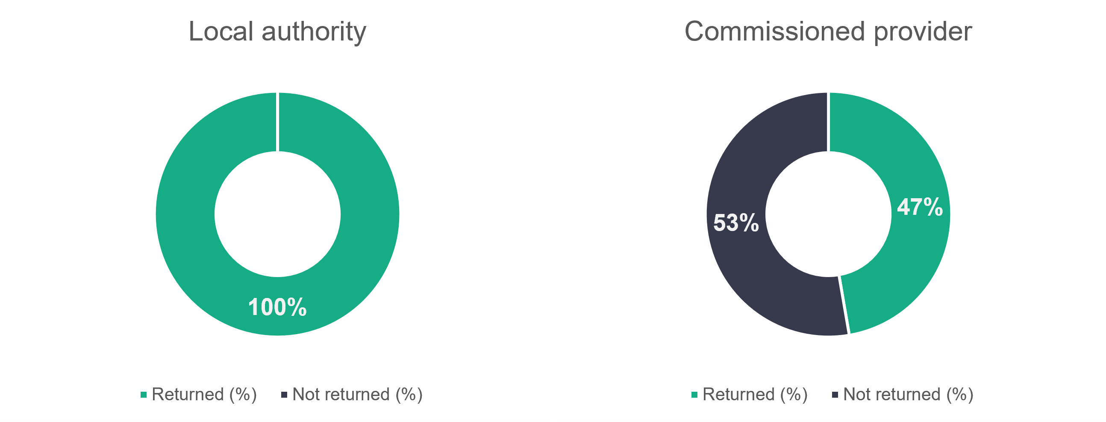
Number of settings = 1645
Number of settings = 180

The providers who returned data told us about 51,945 social care workers. This climbs to an estimated 84,908 across the workforce when using the data prediction methods described in Appendix B. As with previous years, adult placement schemes are included in the chart below and in the overall numbers, but we haven’t broken them down further given the small numbers we see in the returns.
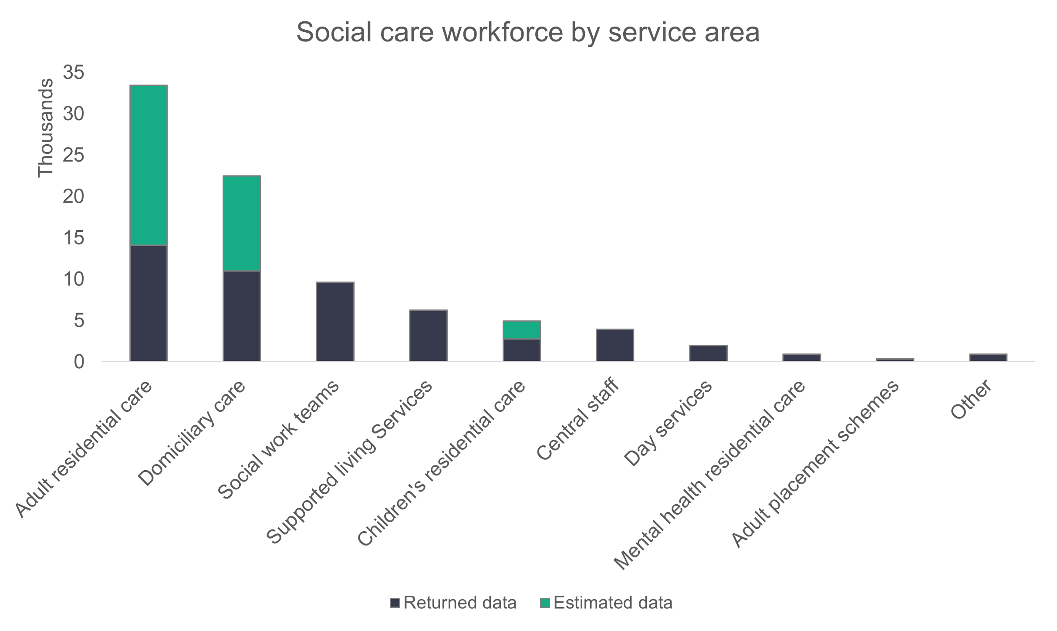
n = 84,908

The table below shows both returned and estimated numbers for each setting over the last four years. Domiciliary care has seen the biggest change in numbers and, compared to 2024, the workforce has increased by 1,780 individuals. Proportionately, however, we see the largest changes (when comparing 2025 to 2024) for the ‘Other’ setting, with an increase of 168 per cent, followed by mental health residential care, which shows a 46 per cent increase in the workforce.

 | 2022 |  | 2023 |  | 2024 |  | 2025
 | Returned | Estimated | Returned | Estimated | Returned | Estimated | Returned | Estimated
Adult residential care | 18,158 | 29,101 | 14,785 | 34,075 | 13,394 | 33,284 | 14,302 | 33,638
Domiciliary care | 10,657 | 19,571 | 12,763 | 20,040 | 8,058 | 20,682 | 10,981 | 22,462
Social work teams | 8,566 | 8,566 | 9,456 | 9,456 | 9,601 | 9,601 | 9,605 | 9,605
Supported living services | 6,565 | 6,893 | 6,601 | 7,342 | 6,982 | 7,165 | 6,254 | 6,254
Central staff | 3,561 | 3,766 | 3,457 | 3,722 | 4,014 | 4,014 | 3,918 | 3,918
Children's residential care | 2,171 | 4,411 | 1,926 | 3,638 | 2,216 | 4,340 | 2,761 | 4,896
Day services | 2,812 | 2,831 | 2,644 | 2,684 | 2,444 | 2,444 | 1,969 | 1,969
Mental health residential care services | 539 | 822 | 604 | 683 | 630 | 630 | 919 | 919
Adult placement schemes | 147 | 338 | 343 | 434 | 347 | 379 | 336 | 347
Other | 147 | 147 | 111 | 191 | 229 | 336 | 900 | 900

    - Roles
The chart below shows a breakdown of the roles filled in the social care workforce. Roles that represent less than one per cent of the workforce haven’t been included in the chart. Care workers (including senior care workers) make up most roles, representing 55.7 per cent of the workforce. This proportion has dropped from 56.4 per cent in 2024.
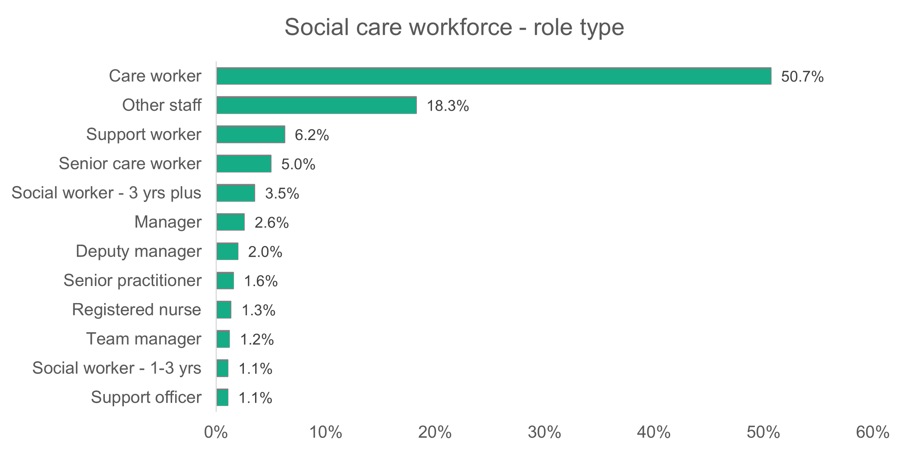
n = 51,945
    - Gender
Women make up 80.8 per cent of the social care workforce, and this proportion has hardly changed since the workforce data collection started in 2021. For almost all role types, the proportion of women is 69 per cent or above. The exception is the director role, where 53.3 per cent are women.
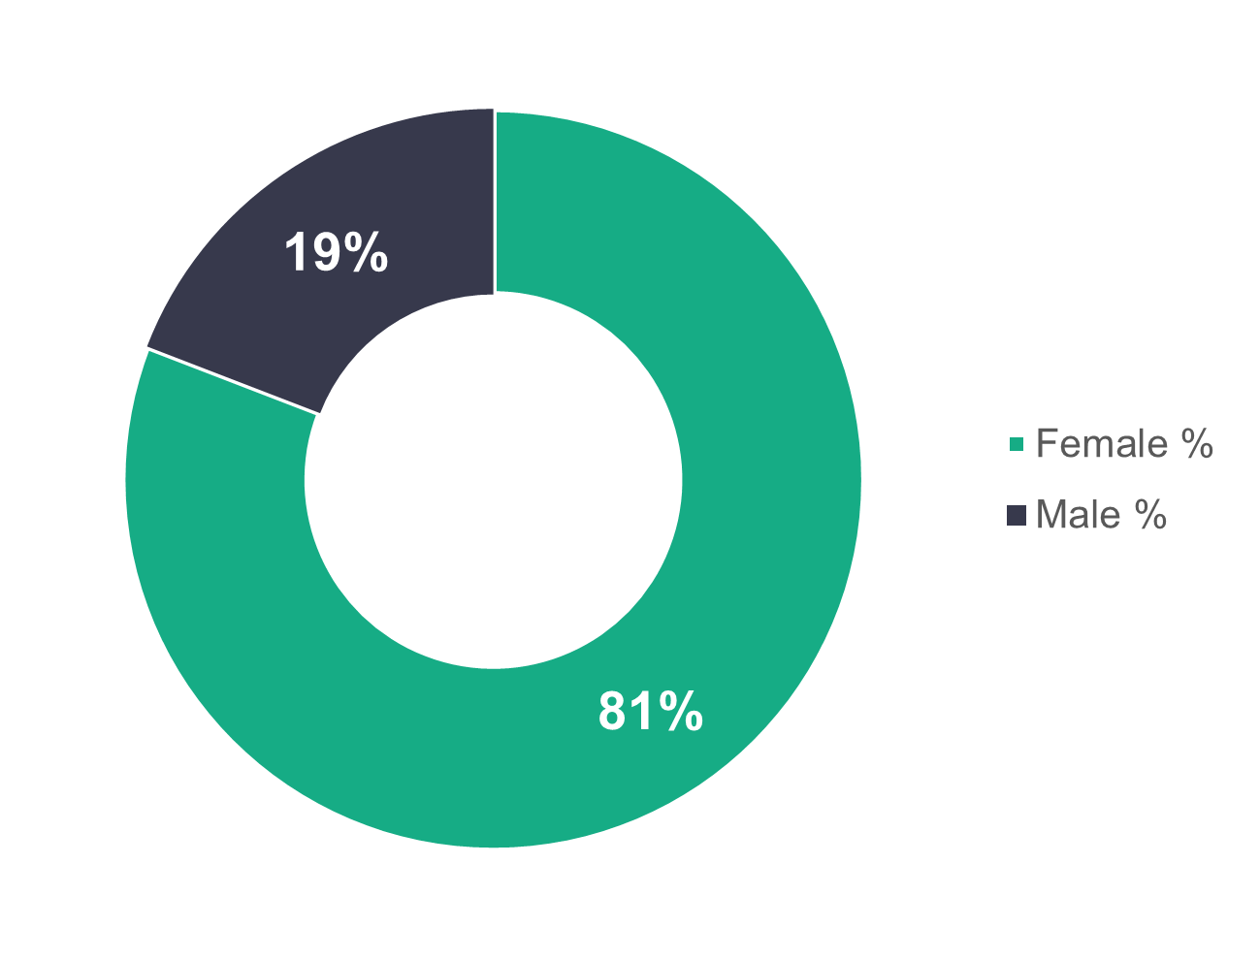
n = 50,434

    - Age profile
The age profile distribution for the social care workforce is almost identical to the 2024 workforce, with none of the categories shown in the charts below differing by more than one per cent from the 2024 data. We see a clear separation of younger versus older age profile between commissioned services and local authorities. For commissioned services, 61.3 per cent of workers are younger than 46, while in local authorities 51 per cent of workers are aged 46 or over.
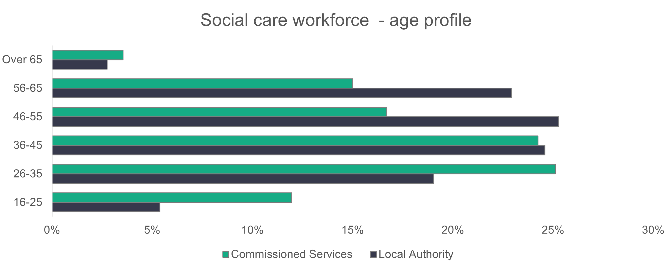
n = 49,571
    - Ethnicity
The ethnicity of the social care workforce has become more diverse over the four years since the workforce data collection started. The proportion of the workforce who reported their ethnicity as black, Asian or mixed is now 11.9 per cent. This is a progressive increase from 5.5 per cent in 2022, 7.6 per cent in 2023 and 8.9 per cent in 2024. Black workers make up six per cent of the social care workforce, which is over six times more then we'd see in the general Welsh population.
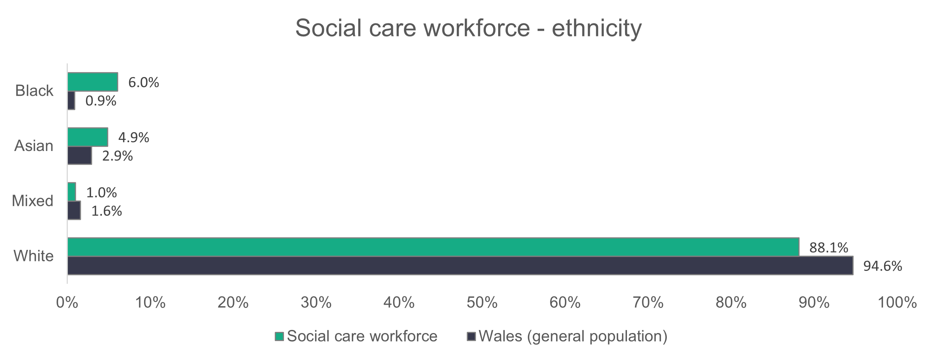
n = 38,269
Different social care roles show different levels of ethnic diversity.

The chart below shows the ethnic diversity of:

- registered nursing staff – the most ethnically diverse role type
- care workers – because they make up most of the workforce
- senior roles – which are made up of all defined manager or director roles in the data (including assistant or deputy roles).
Compared to 2024, the ethnicity profile of senior roles has hardly changed. However, the proportion of white care workers has dropped from 87.5 per cent in 2024 to 82.8 per cent in 2025, and the proportion of white registered nursing staff has dropped from 71 per cent to 55.4 per cent (and we see a significant increase in Asian registered nurses from 16.7 per cent to 29.1 per cent).
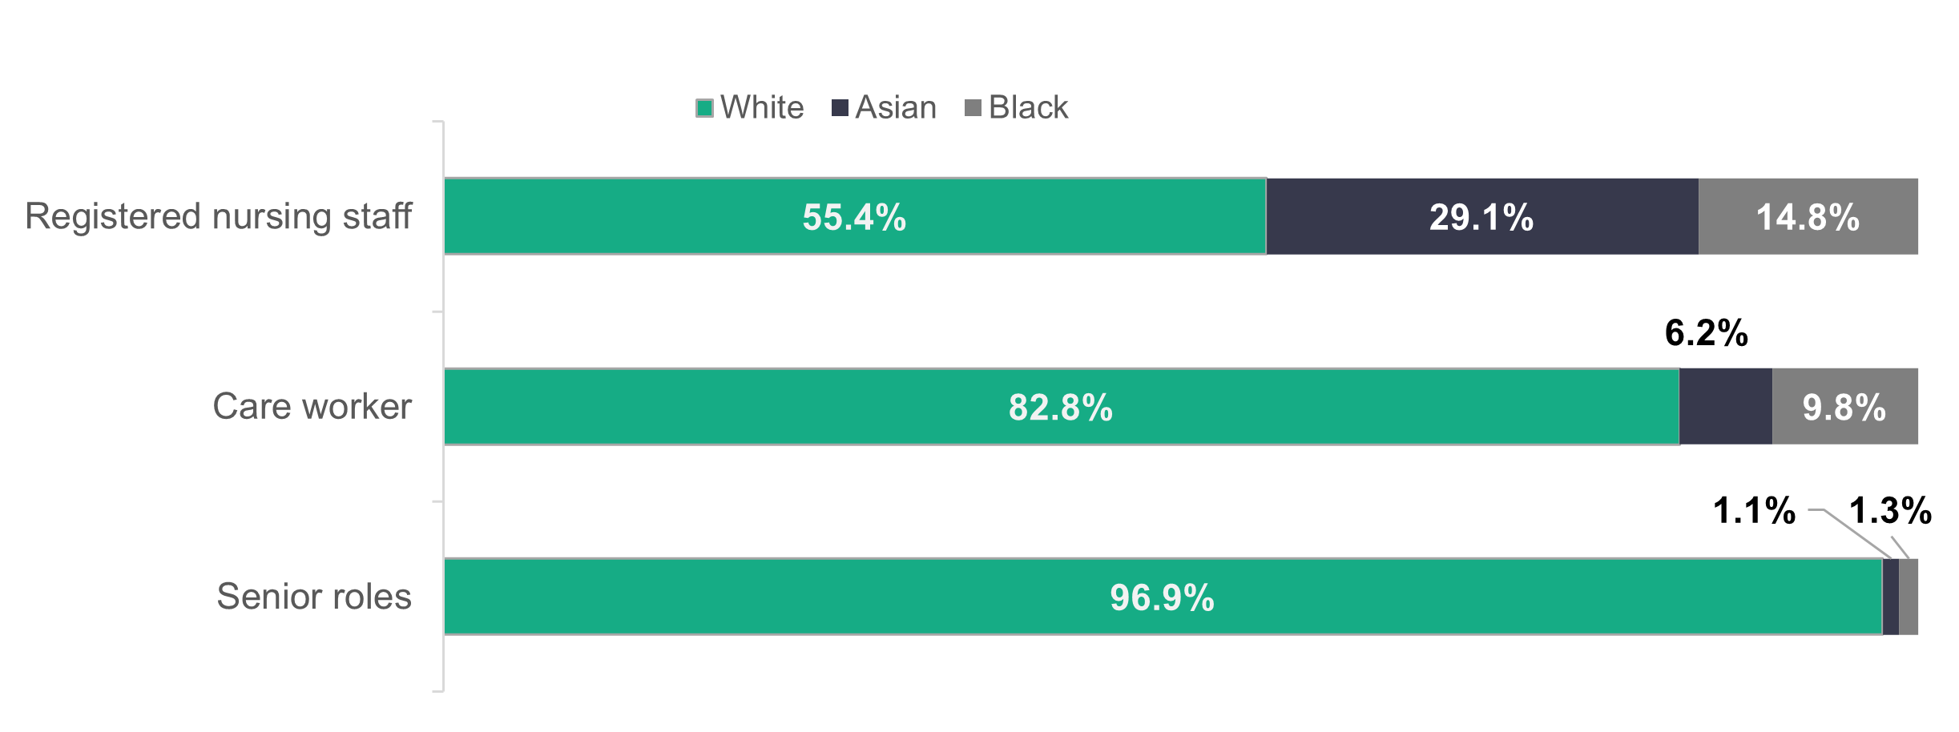

    - Welsh-language skills
The proportion of the workforce with no Welsh-language ability has increased from 49.5 per cent in 2024 to 59.8 per cent in 2025. In 2024 the number of people who provided data on their Welsh language skills was lower than previously seen (35,847 in 2023 to 23,344 in 2024) resulting in a drop in the number with no ability (69.6 per cent in 2023 to 49.5 per cent in 2024). The number of people who provided data increased to 29,484 this year. The changes in the volume of information provided does skew the percentages, as the number of individuals who identify with any level of Welsh ability has increased steadily in the last three years (10,897, 11,788 and 11,845 respectively).
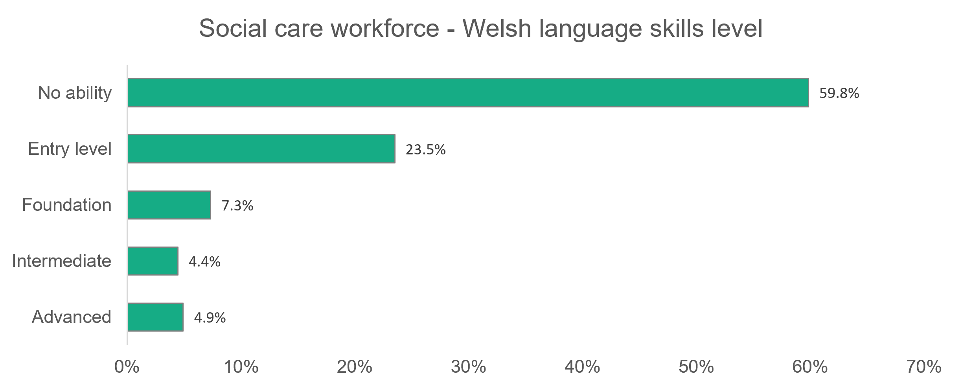
n = 29,484
    - Contract type
Permanent contracts make up 82.7 per cent of the social care workforce. Commissioned services have a higher proportion (88 per cent) of their workforce on permanent contracts compared to local authorities (77.6 per cent). The proportions of the workforce on different contract types has not changed much from 2024 - except for agency workers in commissioned services, which has seen a drop from 3.6 per cent in 2024 to 2.5 per cent in 2025.

In the charts below, we see for local authorities that 8.9 per cent of their workforce are on temporary contracts and 11.9 per cent are on casual contracts. For commissioned services, we see 7.9 per cent of the workforce on zero hours contracts.

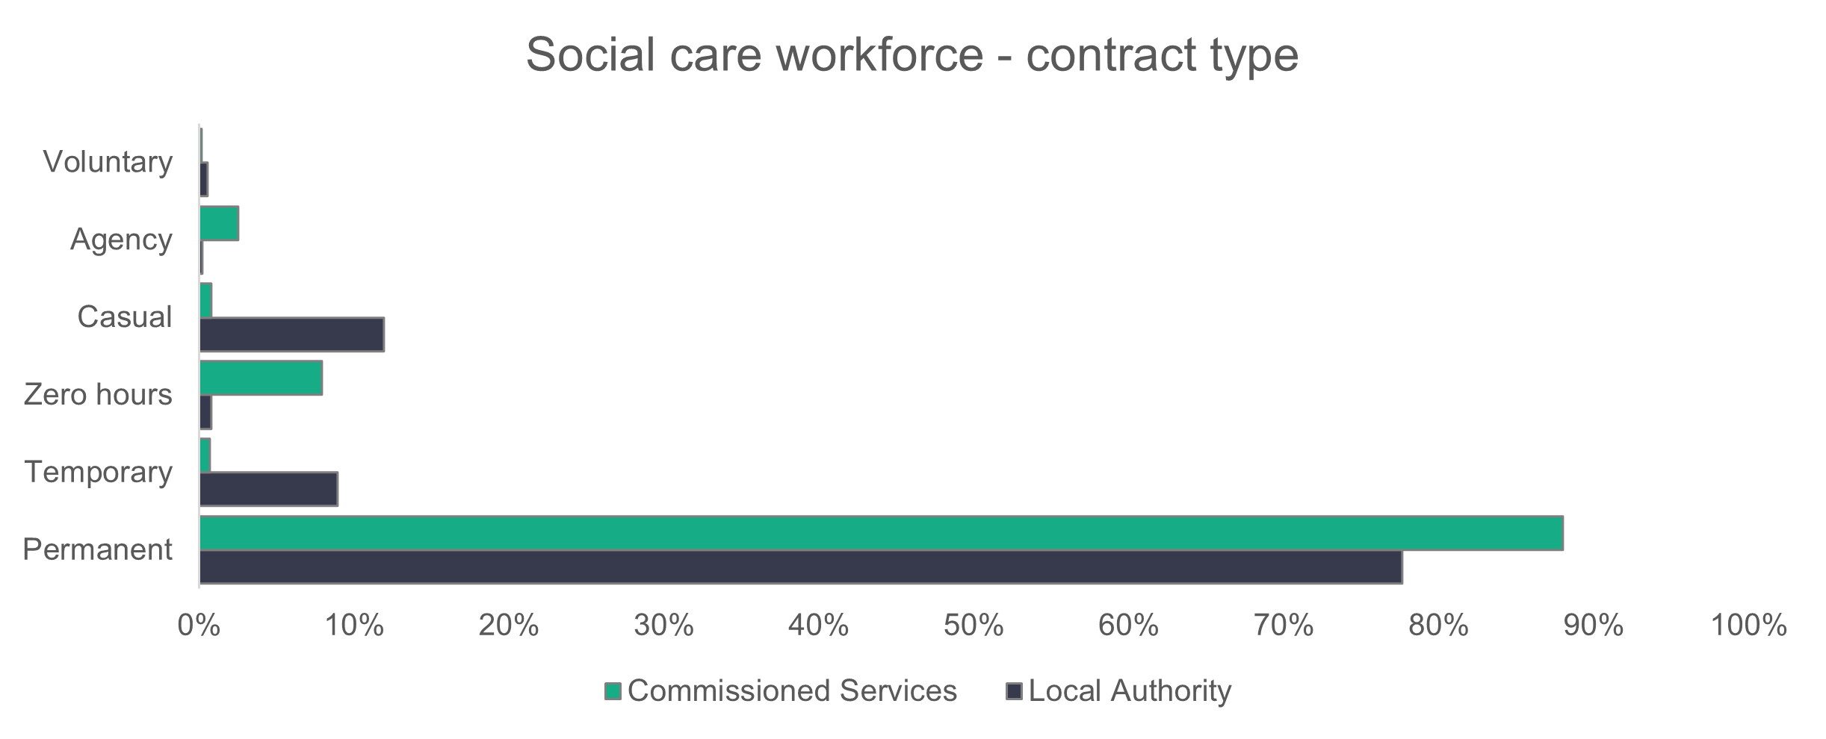

n = 50,760
In terms of the role breakdown, care workers are the most likely of all the roles to be employed on zero-hour contracts (7.1 per cent). For casual contracts, the corresponding role is ‘Other staff’ (at 8.7 per cent). Similar to 2024, residential care services provided by local authorities have the highest proportion of staff on casual contracts (32.3 per cent for adult, 36.4 per cent for mental health and 25.9 per cent for children’s). For commissioned services, the domiciliary care sector has the highest proportion of staff on zero-hour contracts (23.5 per cent).

    - Work visa
The proportion of the social care workforce that need a visa to work in the UK is just below seven per cent. The majority of the workforce requiring a visa are in commissioned services (13.3 per cent), compared to only 0.6 per cent of the local authorities’ workforce. This is only the second year we’ve collected data on visas and the increased number of returns in this area reflects the positive efforts of collectors to gather and report on this area. As we continue to gather this data, it’ll be vital to consider the emerging themes against the known changes to social work visas and the effect that has on the workforce.

The chart below shows the proportion of the number of workers in post for each setting type who need a visa. Residential care continues to be the service type with the highest proportion of workers requiring a visa.
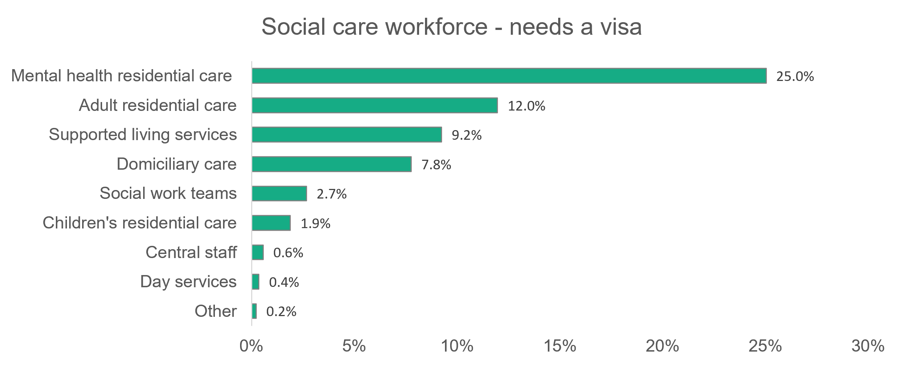
n = 3,619
    - Working patterns
Full-time hours are classed as 36 hours or more per week. Around half (50.1 per cent) of all local authority employees work full-time hours, and the proportion is slightly less than half (47.5 per cent) for commissioned services. The working patterns of the social care workforce have not changed significantly in the last three years.
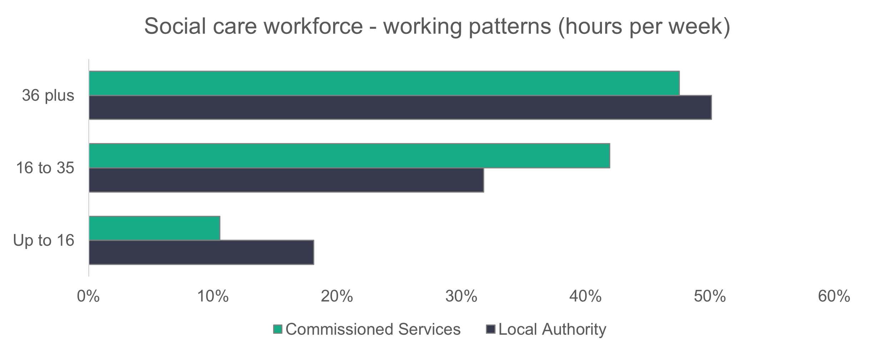
n = 49,842
    - Vacancies
With an estimated total of 6,103 vacancies, we predict that 6.7 per cent of roles are unfilled in the social care workforce. This number is broken down to the 1,807 open vacancies and 2,401 held posts that were submitted to us, and a further 1,895 posts estimated using the methods described in Appendix B. In 2024 there were an estimated 5,346 vacancies in the social care workforce.
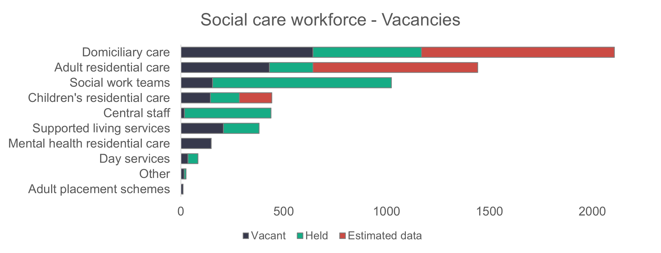

    - Staff turnover
The table below gives a breakdown of the number of both joiners and leavers for each setting, and the net change. During 2025 there was a net increase of 219 staff in the social care sector in Wales. It should be noted that not all providers have provided data about joiners and leavers, and so the net change should be read with caution.

Setting | Joiners | Leavers | Net change
Adult placement schemes | 88 | 68 | +20
Central staff | 290 | 331 | -41
Day Services | 153 | 173 | -20
Domiciliary care | 2,435 | 2,242 | +193
Other | 61 | 61 | +0
Residential care - adults | 2,176 | 2,364 | -188
Residential care - children | 582 | 412 | +170
Residential care – mental health | 219 | 257 | -38
Social work teams - adults | 328 | 318 | +10
Social work teams - all | 128 | 111 | +17
Social work teams - children | 591 | 596 | -5
Supported living | 1,168 | 1,067 | +101
Total | 8,219 | 8,000 | +219

    - Sickness
A total 249070 days were lost to sickness. While this is a decrease of 21.5 per cent on 2024, it’s important to note that two local authorities didn’t provide this mandatory data this year. In 2024, the two non-returning local authorities accounted for 20.8 per cent of all sickness days lost.

A breakdown of the reasons for sickness, or absence from work, is shown in the following chart. Proportionally, ‘Other illness’ accounts for 31.3 per cent of all absences.

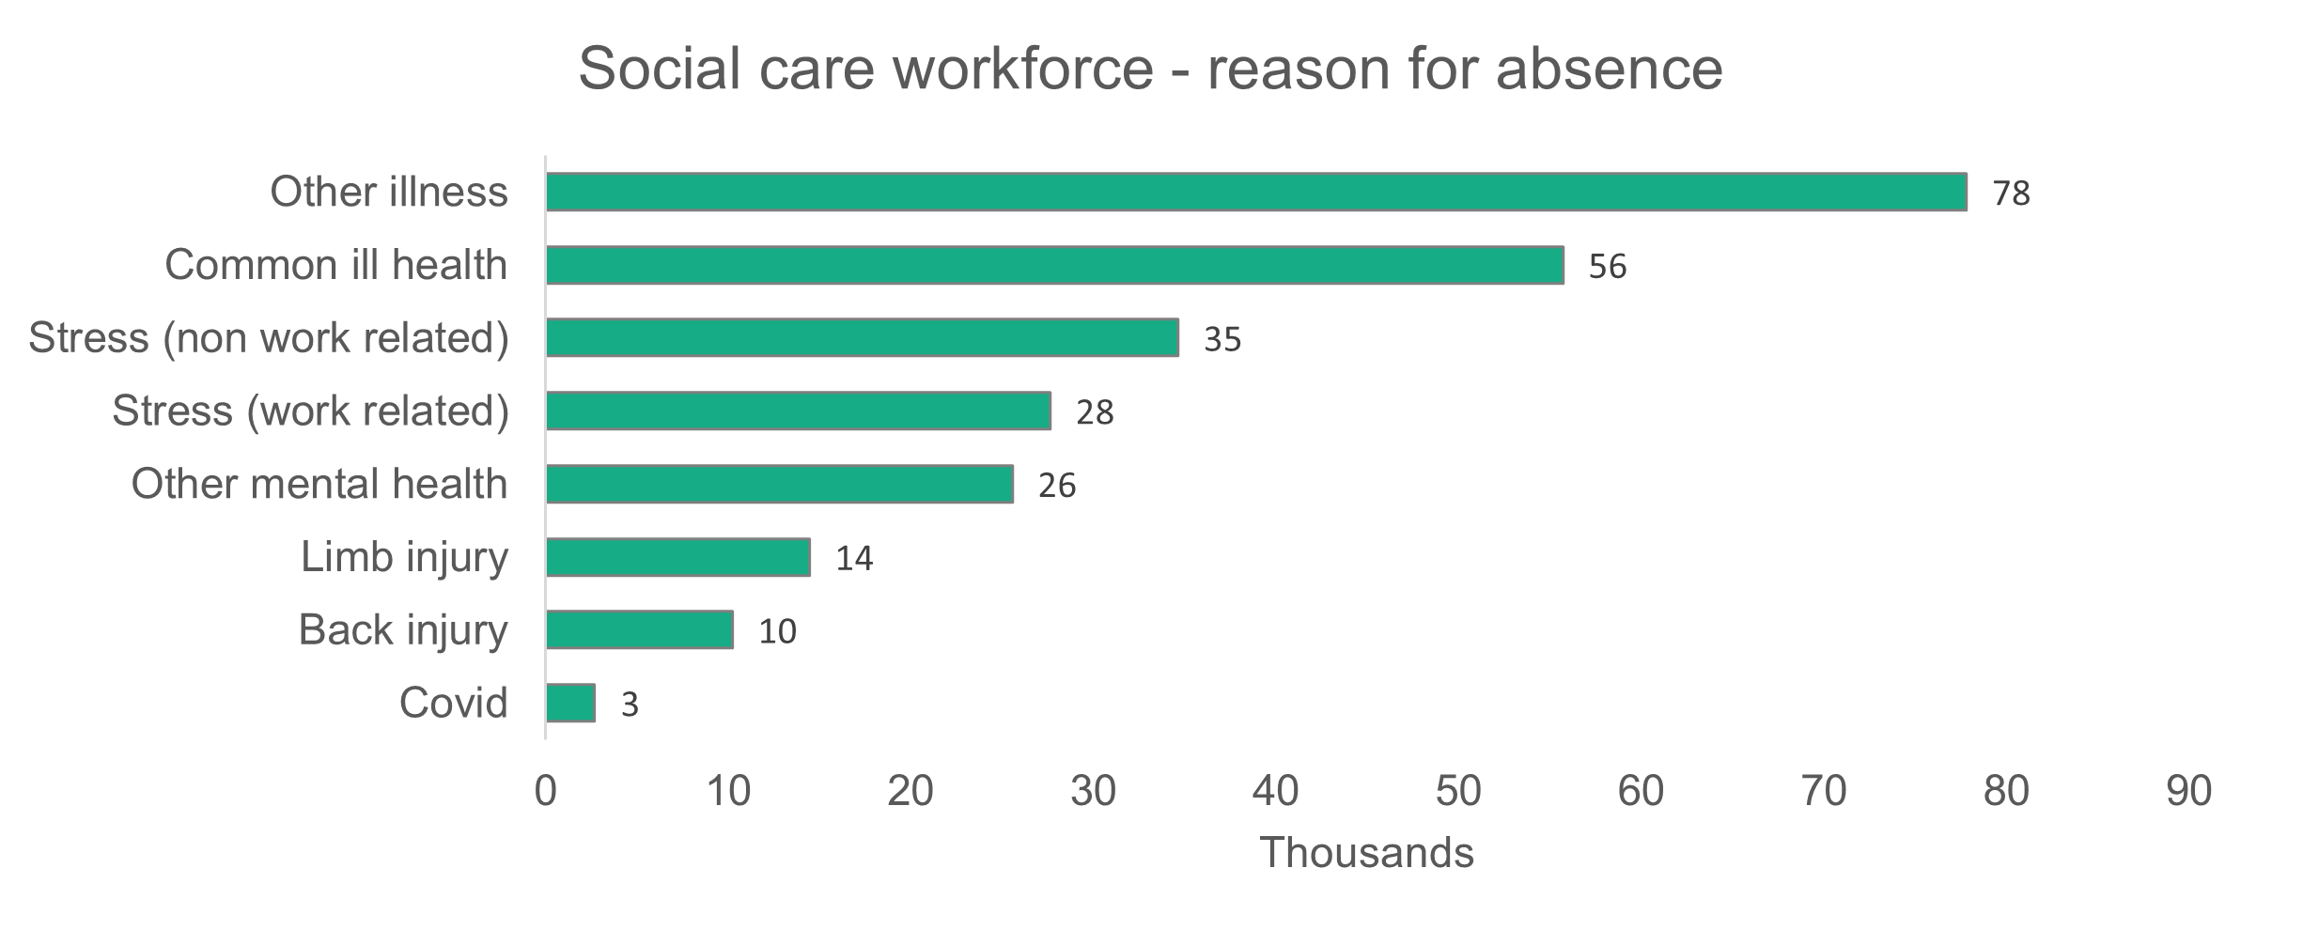

2.2 Adult residential care

Summary:
- Care workers make up the majority (60.4 per cent) of the adult residential care workforce.
- Four out of every five of the workforce are women.
- Casual contracts make up 32.3 per cent of the local authority workforce.

The return rate for commissioned services has increased slightly from 30.3 per cent in 2024 to 33.8 per cent in 2025.
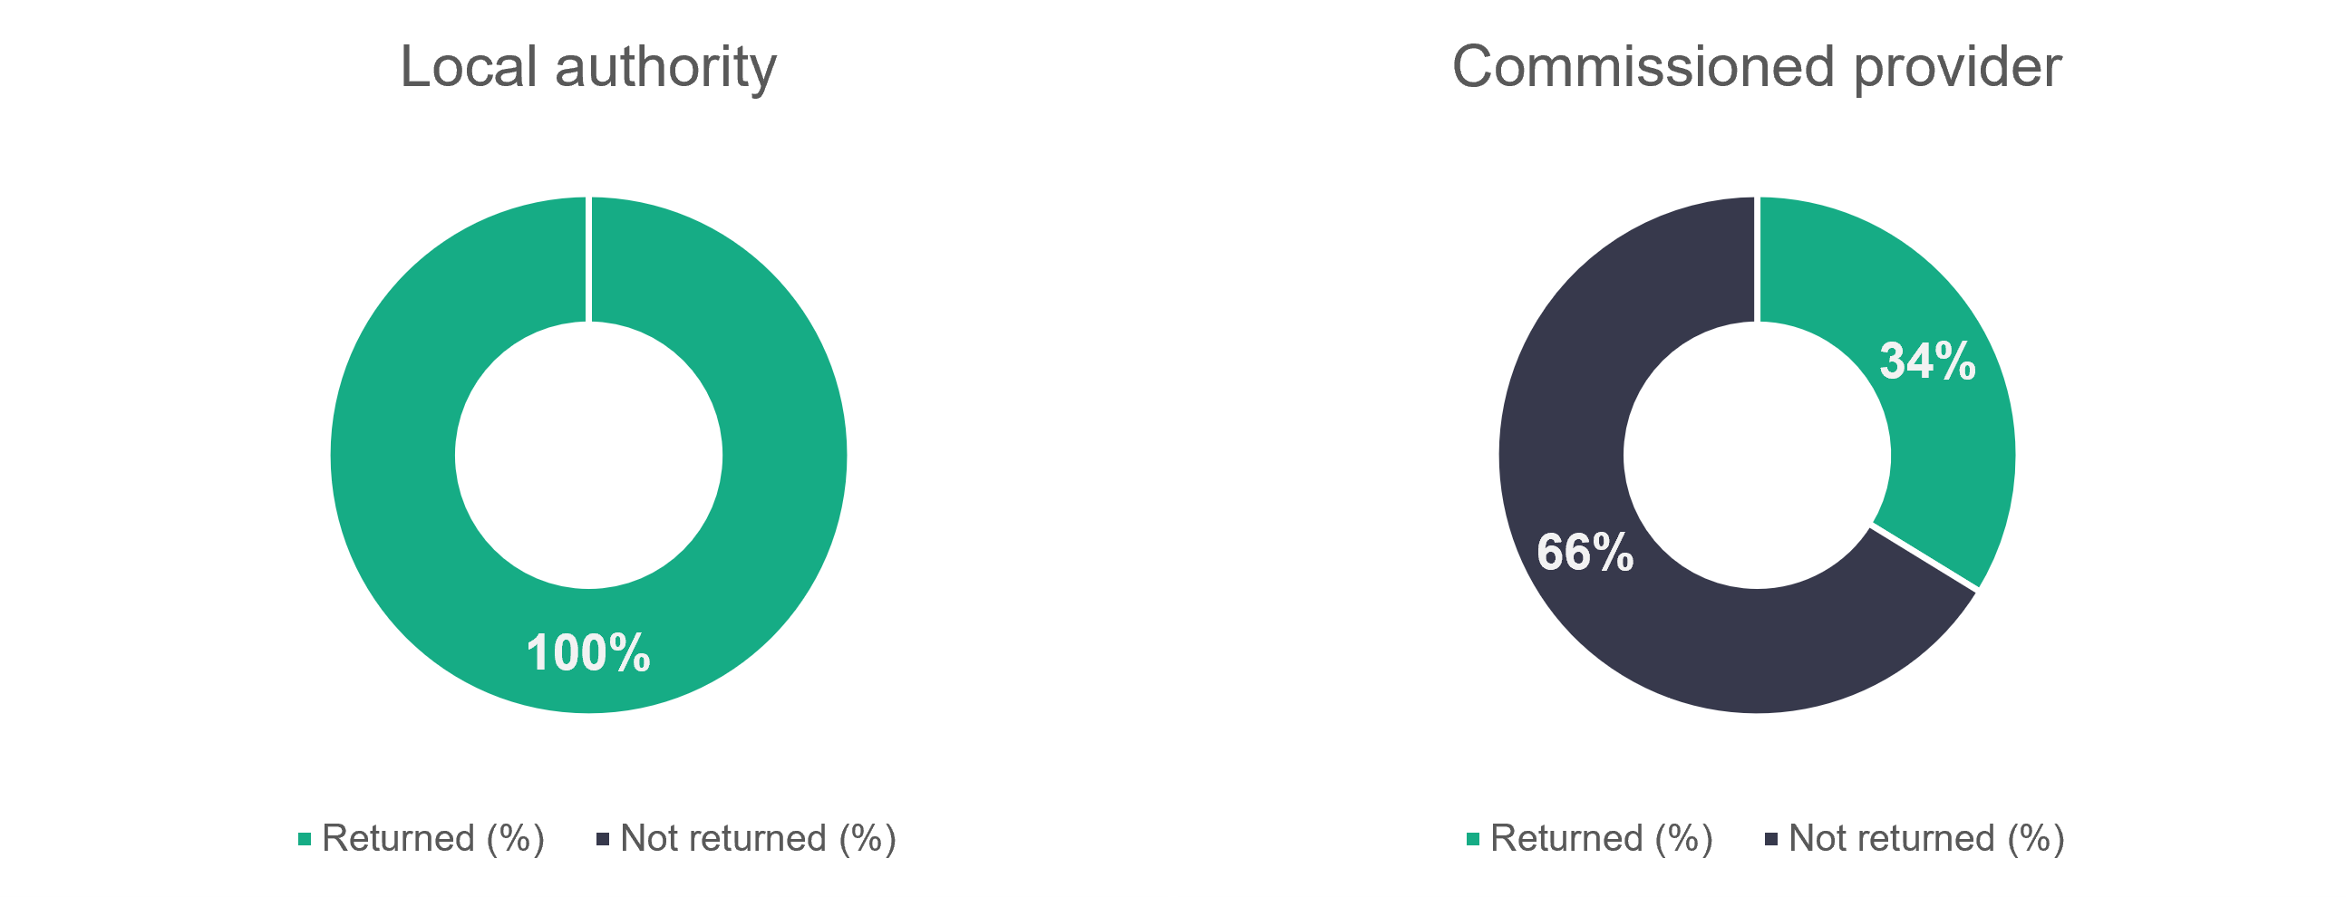
n = 18
n = 625
    - Adult residential care – role type
The proportion of care workers has dropped from 65.2 per cent in 2024 down to 60.4 per cent in 2025. There’s also a slight drop in senior care workers, from 8.6 per cent to 7.6 per cent this year. Roles collated into ‘Other staff’ make up 22.6 per cent of the workforce, and this is an increase of 5.1 per cent on last year.

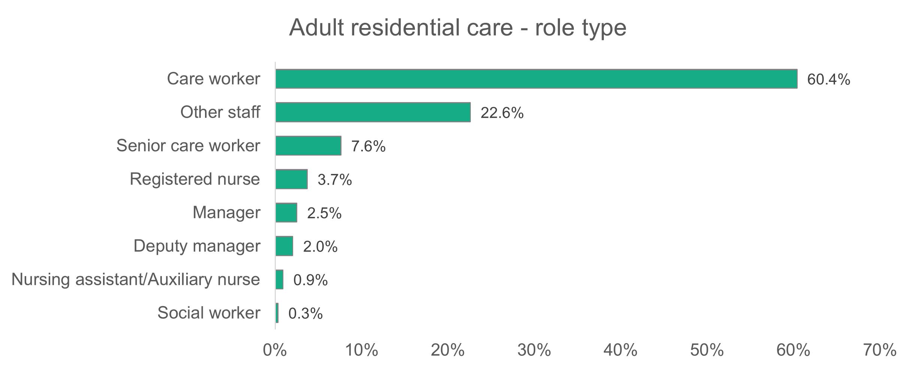
n = 14,302

    - Adult residential care – gender
There’s little change from last year in the gender split. This year 81.2 per cent of adult residential care workers are women, while last year the proportion was 81.8 per cent. There’s no change from last year in the number of non-binary workers.
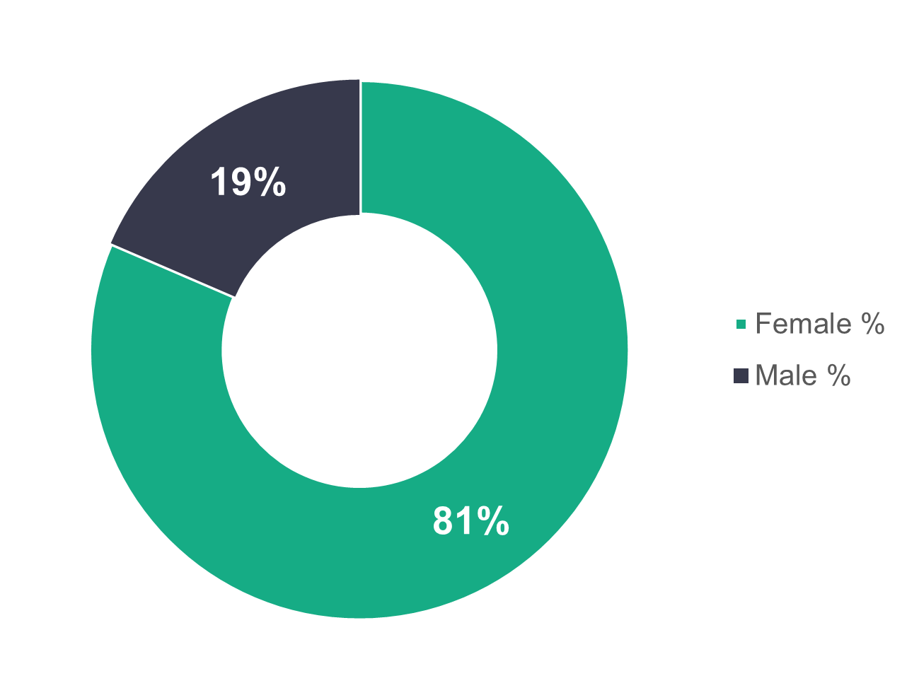
n = 13,865

    - Adult residential care – age profile
The age distribution shown in the chart below is almost identical to the 2024 data, with no single age category differing from the 2024 data by more than one percentage point. The noticeable trend that we see in the chart below is that the dominant age group for local authorities is the 56 to 65 age group. More workers in commissioned services are 45 years old or younger, while the opposite is true for local authority workers.
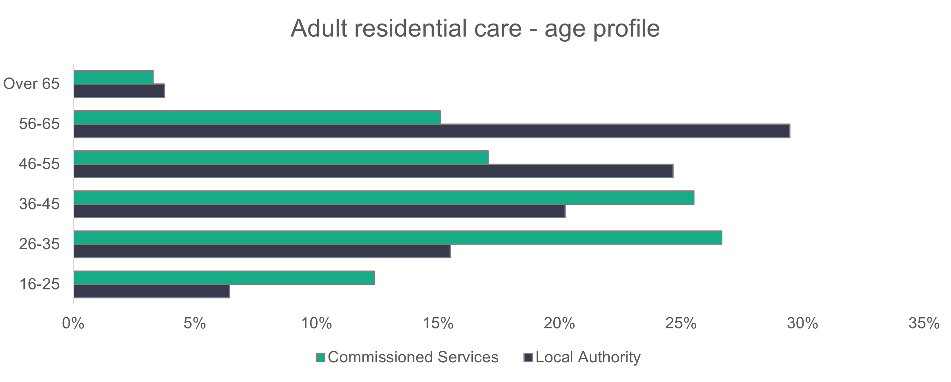
n = 13,449

    - Adult residential care – ethnicity
The adult residential care workforce is ethnically more diverse than the general population of Wales. The proportion of white workers has dropped from 86.8 per cent in 2024 to 78.2 per cent in 2025. The proportion of black workers has risen steadily since 2022, when the residential care workforce was 2.4 per cent black. It was 5.3 per cent in 2023, 7.2 per cent in 2024 and 8.4 per cent in 2025. There’s been a big increase in Asian workers, from 5.1 per cent in 2024 to 12.3 per cent in 2025.
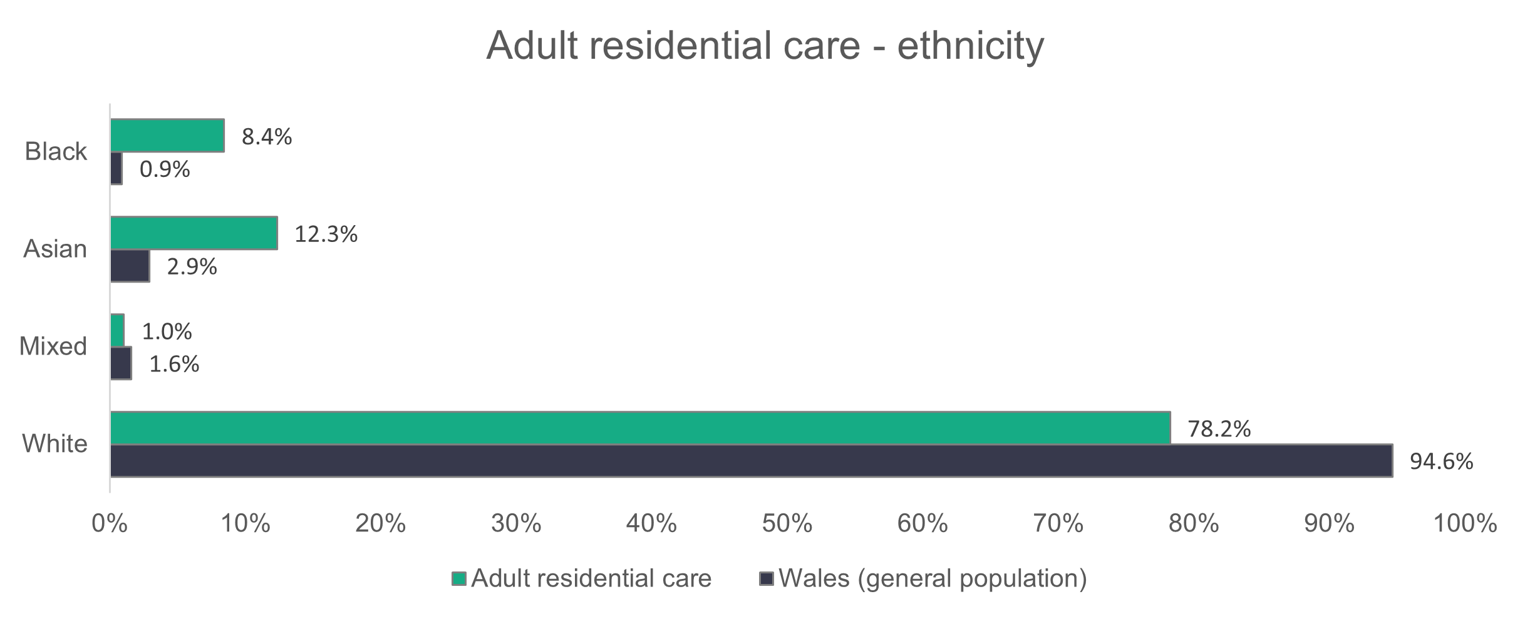
n = 10,522
Registered nursing staff have the highest proportion of both black (13.8 per cent) and Asian (30.1 per cent) workers in adult residential care.

    - Adult residential care – contract type
The types of contract among the adult residential care workforce are very similar to 2024. The standout feature is the relatively high number of local authority workers on casual contracts, which stands at 32.3 per cent of their workforce. Permanent workers make up 64.6 per cent of the local authority workforce, and 92.1 per cent for commissioned services. Agency workers make up 3.8 per cent of the commissioned services workforce, which is much higher than the 0.7 per cent of agency workers in the local authority workforce.
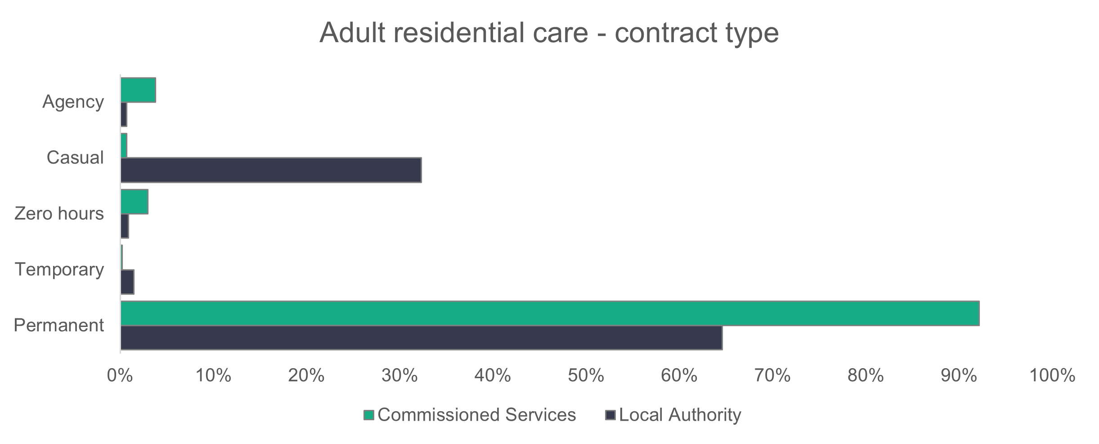
n = 14,080
    - Adult residential care – working patterns
There’s little change in adult residential care working patterns from 2023 and 2024. Part-time hours (fewer than 36 hours per week) account for the working patterns of 89.2 per cent of local authority workers (87.7 per cent in 2024 and 89.3 per cent in 2023) and 57.5 per cent of commissioned services staff (54.7 per cent in 2024 and 52.5 per cent in 2023).

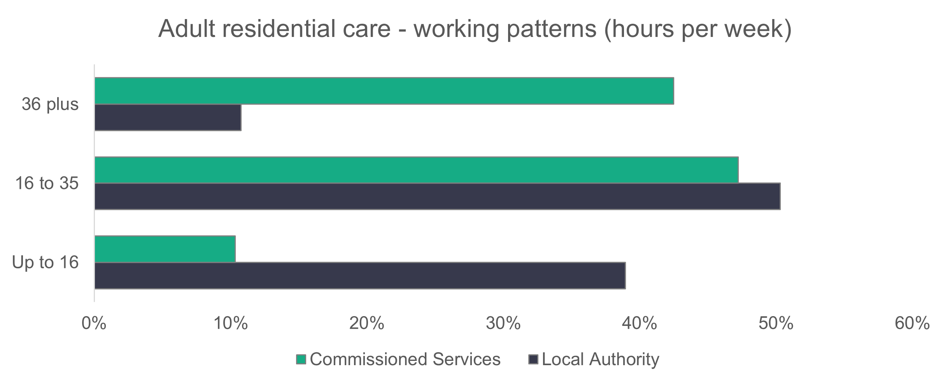
n = 13,767

    - Adult residential care – vacancies
There are 1,443 vacancies in adult residential care, which means that 4.1 per cent of roles are unfilled. Last year the vacancy number was 1,867.

2.3 Domiciliary care

Summary:

- Care workers make up the majority (79.8 per cent) of the domiciliary care workforce.
- Women make up 86.2 per cent of the domiciliary care workforce, down from last year’s figure of 87.5 per cent.
- Local authority workers in this sector tend to be older, with 58.2 per cent aged 46 and over.
- White workers make up 89.2 per cent of the domiciliary care workforce, down from 91.7 per cent in 2024.
- Zero-hours contracts make up a significant 23.5 per cent of contracts in commissioned services.
- Similarly to 2024, more commissioned services staff work full-time hours compared to local authority workers.

The return rate of 40.5 per cent for commissioned services is lower than the 43.2 per cent returned in 2024. 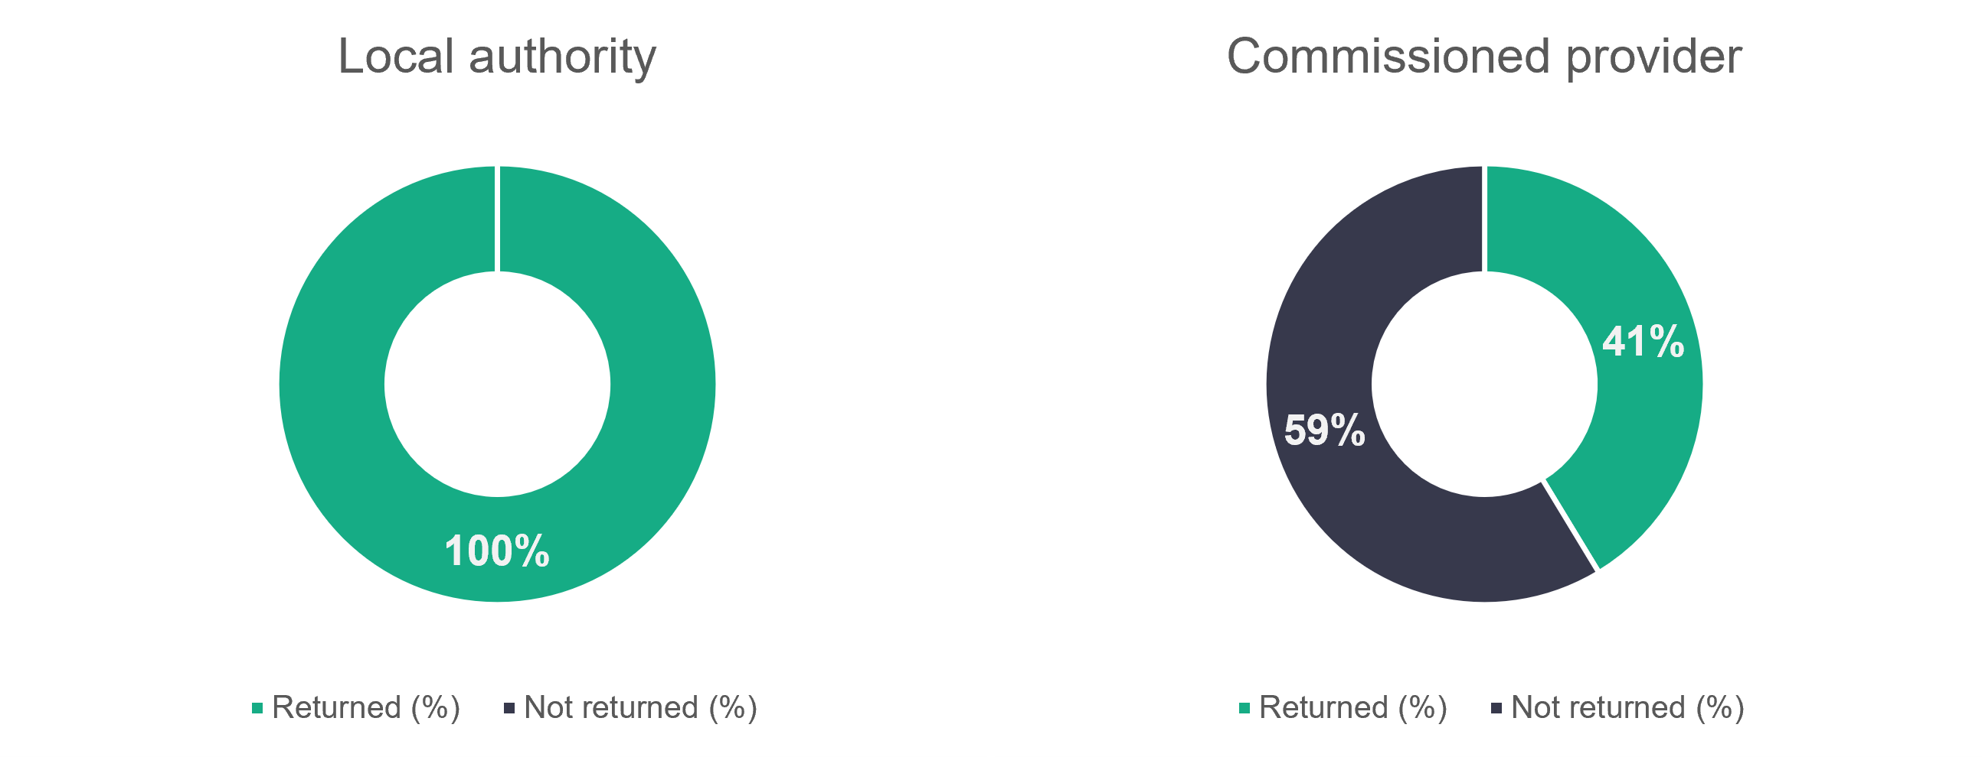
n = 612
n = 22

We estimate that there are 22,462 people working in domiciliary care in 2025, which is an 8.6 per cent increase on the 20,682 estimated in 2024.

    - Domiciliary care – role type
There’s little change in the proportion of roles that make up the domiciliary care workforce. The proportion of care workers has increased slightly from 78.6 per cent in 2024 to 79.8 per cent in 2025, while the percentage of workers classed as ‘Other staff’ has decreased from 8.2 to 6.6. None of the proportions for any of the other roles in the chart have changed by more than one percentage point.

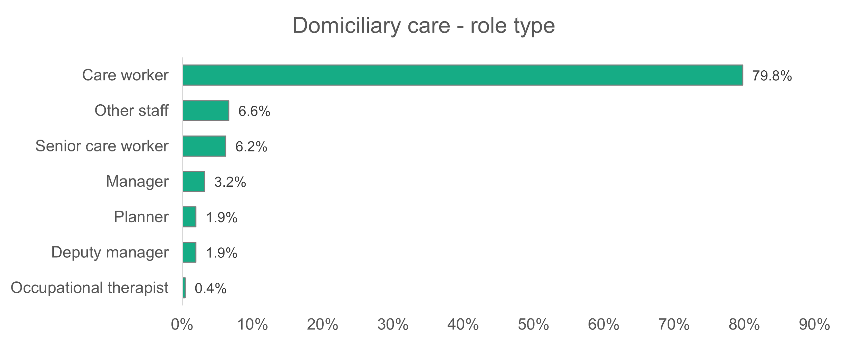
n = 10,981

    - Domiciliary care – gender
The proportion of women working in domiciliary care has dropped from 87.5 per cent in 2024 to 86.2 per cent in 2025. That proportion is still higher than the 80.8 per cent reported for the social care sector as a whole.
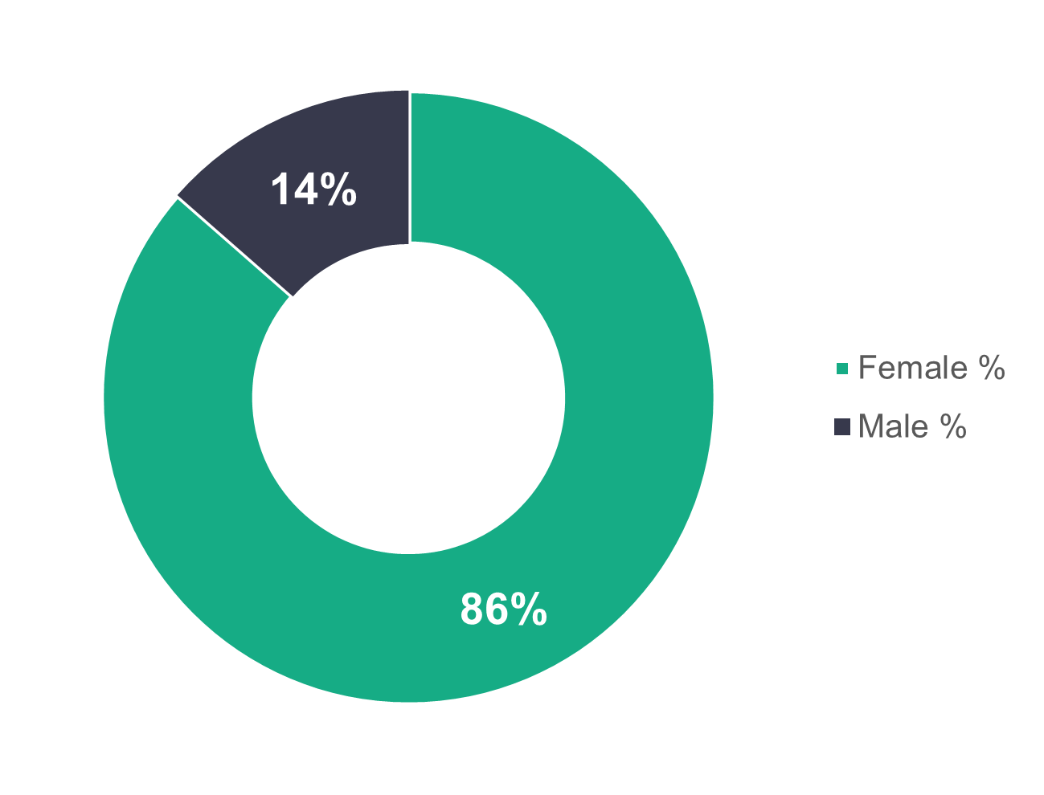
    - Domiciliary care – age profile
n = 10,790
The age profile of the domiciliary care workforce is very similar to 2024. As in the adult residential care sector, local authority workers tend to be older (58.2 per cent of the workers are 46 and over) and commissioned services workers tend to be younger (65.1 per cent of the workers are 45 and under).

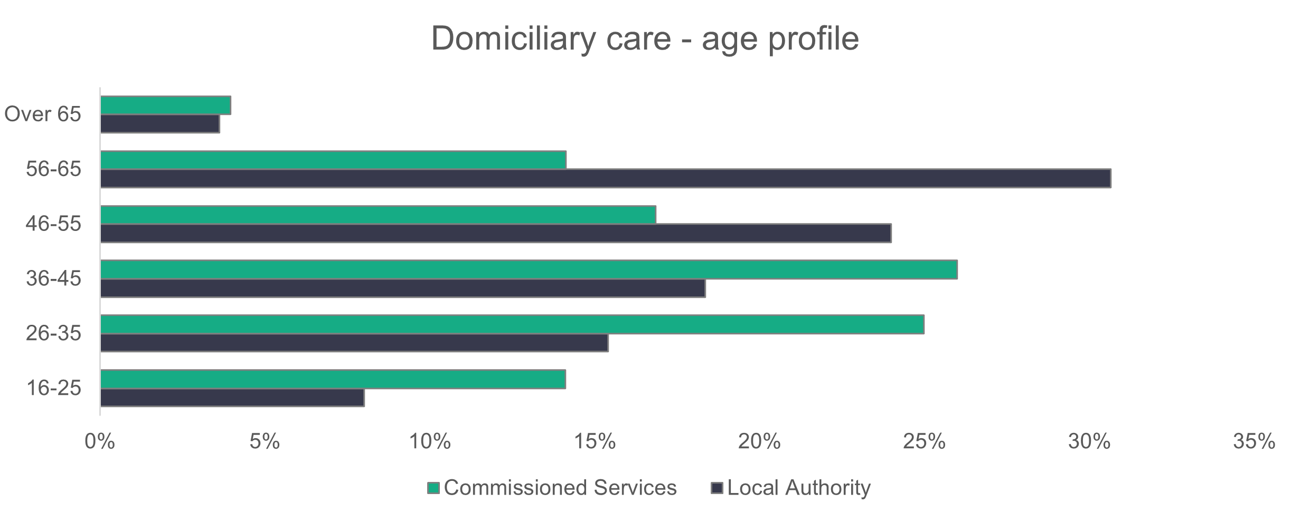
n = 10,588

    - Domiciliary care – ethnicity
The chart below shows a domiciliary care workforce that has a slightly higher proportion of white workers when compared to the overall social care workforce (89.2 per cent), but lower than the general population of Wales. In comparison to 2024, the proportion of black workers has increased from 4.8 per cent to 7.5 per cent.
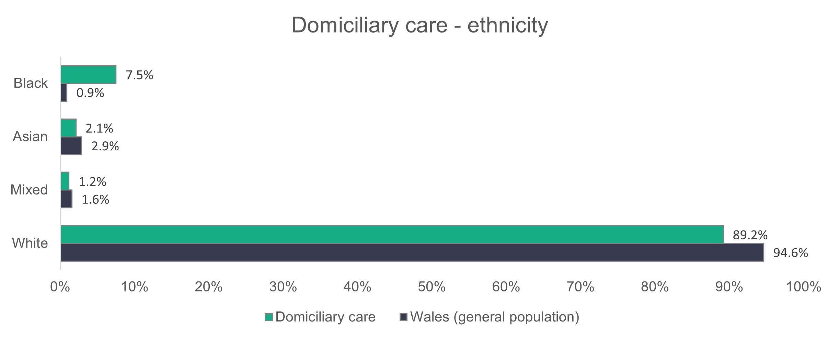
n = 8,007

    - Domiciliary care – contract type
The proportion of domiciliary care workers on permanent contracts has increased in 2025. This increase is small for local authorities (from 83.7 per cent in 2024 to 85.3 per cent in 2025), and for commissioned services the increase is a more significant five per cent, from 67 per cent in 2024 to 72 per cent in 2025. Similar to the previous two years, commissioned services have a large proportion of their workers on zero-hours contracts. However, this proportion has been dropping over
the last two years, from 30.3 per cent in 2023 to 25.9 per cent in 2024 and 23.5 per cent in 2025. Local authorities have 11.4 per cent of their workers on casual contracts.
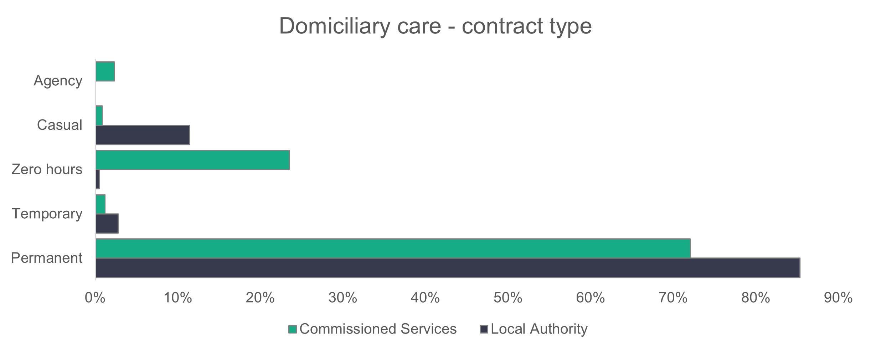
n = 10,469

    - Domiciliary care – working patterns
A higher proportion of commissioned services workers (41.6 per cent) work full-time hours (36 or more) compared to local authority workers (24.9 per cent). The 16 to 35 working hours category has the highest proportion of domiciliary care workers. Overall, the working patterns are similar to what we've seen over the past three years for the domiciliary care workforce.
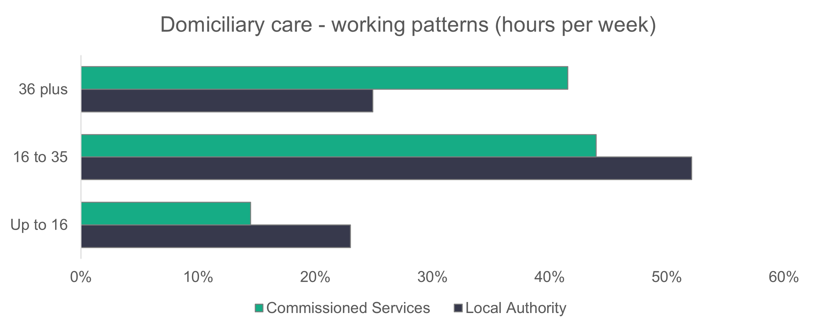
n = 10,350

    - Domiciliary care – vacancies
The number of vacancies in domiciliary care has more than doubled from 929 in 2024 to 2,107 in 2025. A contributing factor affecting this rise is the increased number of organisations (both returned and estimated) included in the data collection in 2025 compared to 2024. The proportion of unfilled roles stands at 8.6 per cent. Domiciliary care vacancies make up 34.5 per cent of all social care workforce vacancies.

2.4 Day services

Summary:

- Commissioned service providers have a relatively high proportion of workers (28.3 per cent) in the 16 to 25 age category.
- The day services workforce is less ethnically diverse than the general population of Wales.
- The proportion of commissioned services employees working full-time hours has dropped from 27.9 per cent in 2024 to 9.1 per cent in 2025.

All settings in day services returned some data.
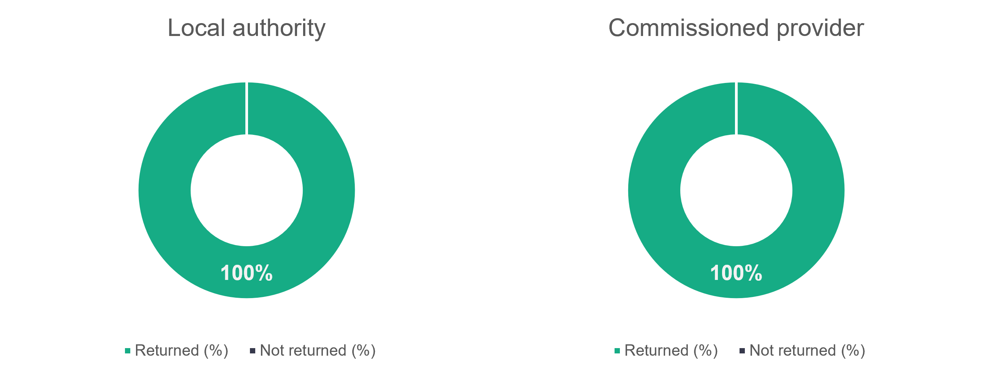
n = 21
n = 18

    - Day services – role type
The distribution of roles in day services has changed from 2024, but the overall trend remains similar. The proportion of care workers has increased from 55.6 per cent in 2024 to 59.9 per cent in 2025. There’s also a drop in the proportion of senior care workers from 10.6 per cent in 2024 to nine percent in 2025.

Those classed as ‘Other staff’ have increased proportionately from 22.9 per cent in 2024 to 25.1 per cent in 2025. No social workers, registered nurses or occupational therapists were returned for the day services sector in 2025.

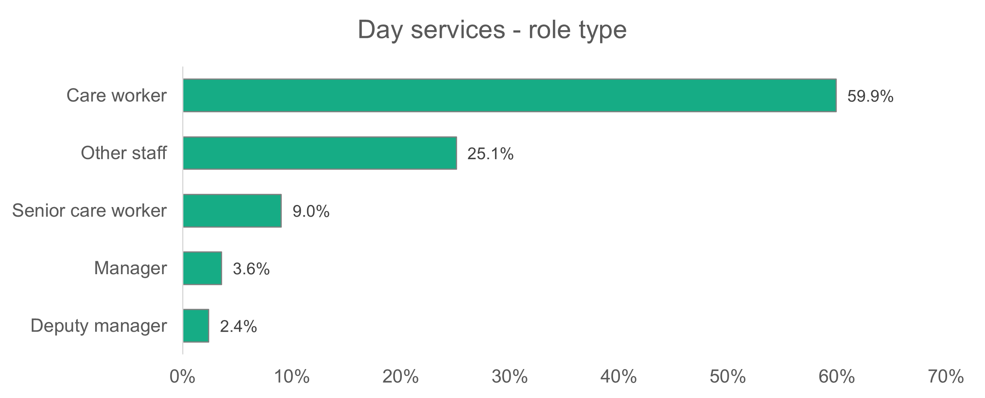
n = 1,969
    - Day services – gender
The proportion of women working in day services is 73.8 per cent – lower than both the 80.8 per cent of women in the overall workforce and the 77.1 per cent in day services reported in 2024.
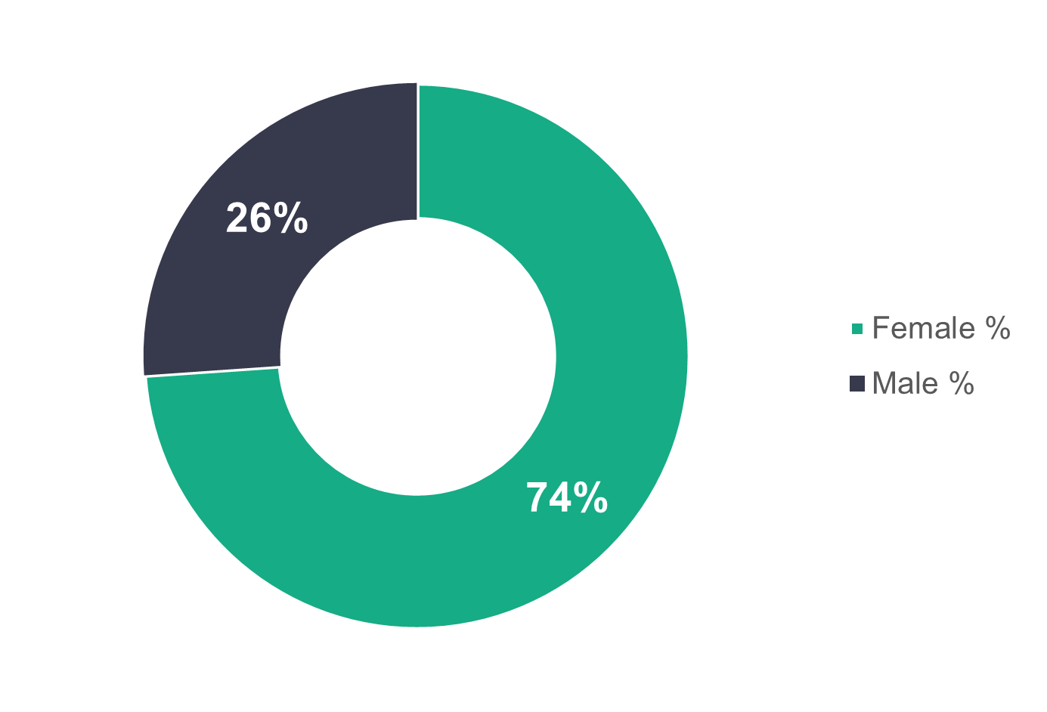
n = 1,850
    - Day services – age profile
There are some noticeable differences for the commissioned services workforce when comparing this year's age profile with that of the 2024 data. Specifically, the proportion of 16 to 25 year olds has increased from 17 per cent in 2024 to 28.3 per cent in 2025. Also, the proportion of 36 to 45 year olds has decreased from 34.4 per cent in 2024 to 18.4 per cent in 2025.

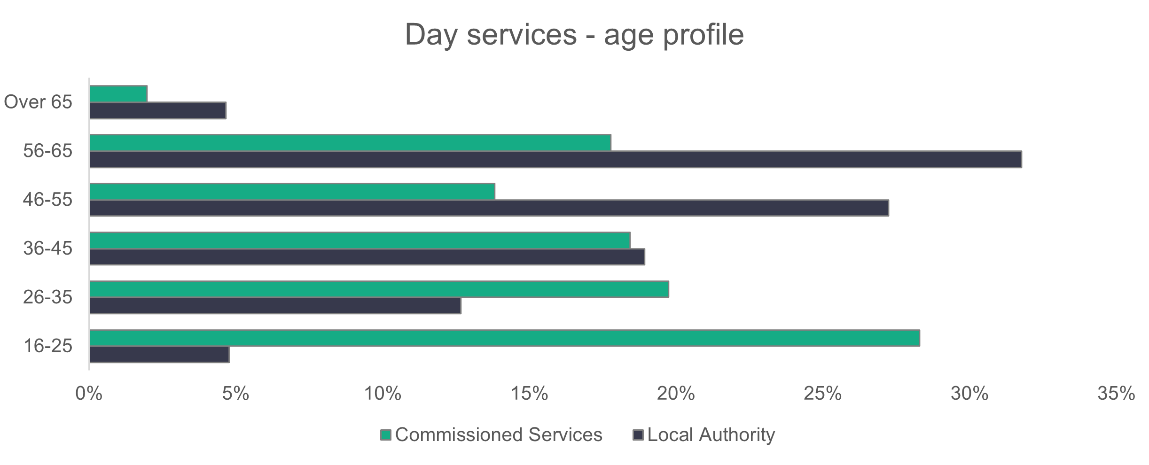
n = 1,849
    - Day services – ethnicity
The day services workforce is less ethnically diverse than the general population of Wales, with 97.8 per cent of workers recorded as white. This proportion has hardly changed over the last two years.
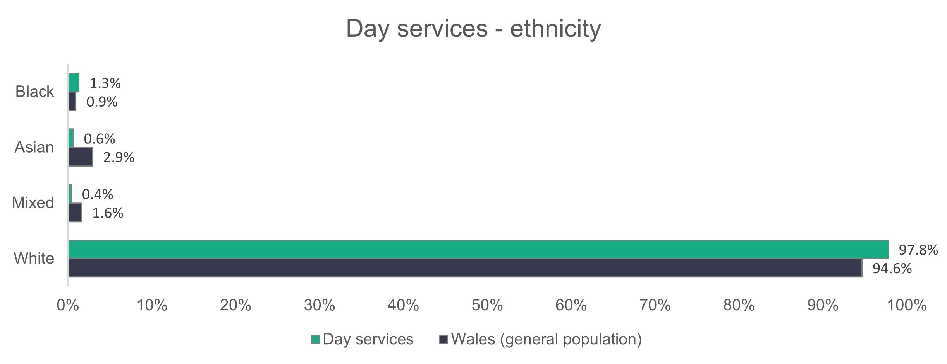

n = 1,344
    - Day services – contract type
The proportion of day services workers on permanent contracts is similar for both commissioned services (84.1 per cent) and local authorities (86.2 per cent). This is an increase of around 10 per cent for both local authorities (75.4 per cent in 2024) and commissioned services (75.2 per cent in 2024). Compared to 2024, the proportion of workers on temporary contracts has dropped significantly from 13.8 to 2.5 per cent for local authorities and 15.2 to 9.6 per cent for commissioned services. However, this drop in the proportion of temporary contracts is in line with the 2023 data.

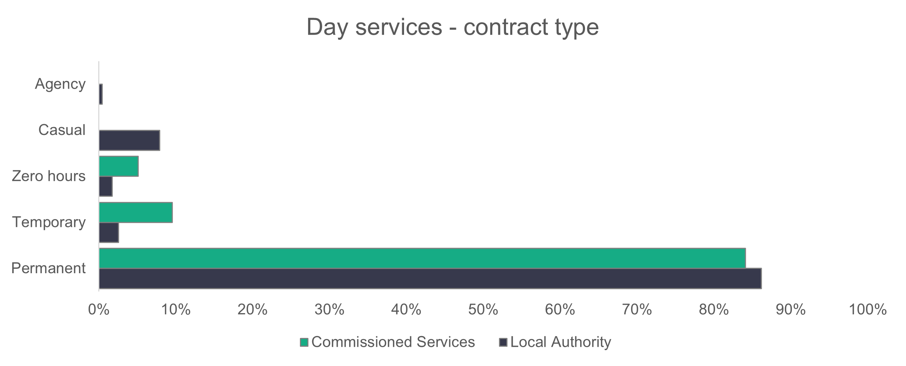
n = 1,854
ffff
    - Day services – working patterns
Most employees in both local authorities (54.6 per cent) and commissioned services (90.9 per cent) work part-time hours (less than 36 hours per week). Working patterns in local authorities have not changed significantly from 2024. However, we see changes for commissioned services, where the proportion of workers working up to 16 hours has increased from 17.9 per cent in 2024 to 29.9 per cent in 2025, and the proportion of workers working 36 hours or more per week has fallen from 27.9 per cent to 9.1 per cent. The number of day service settings is relatively small and the addition or deduction of organisations can have more of an effect on percentages. 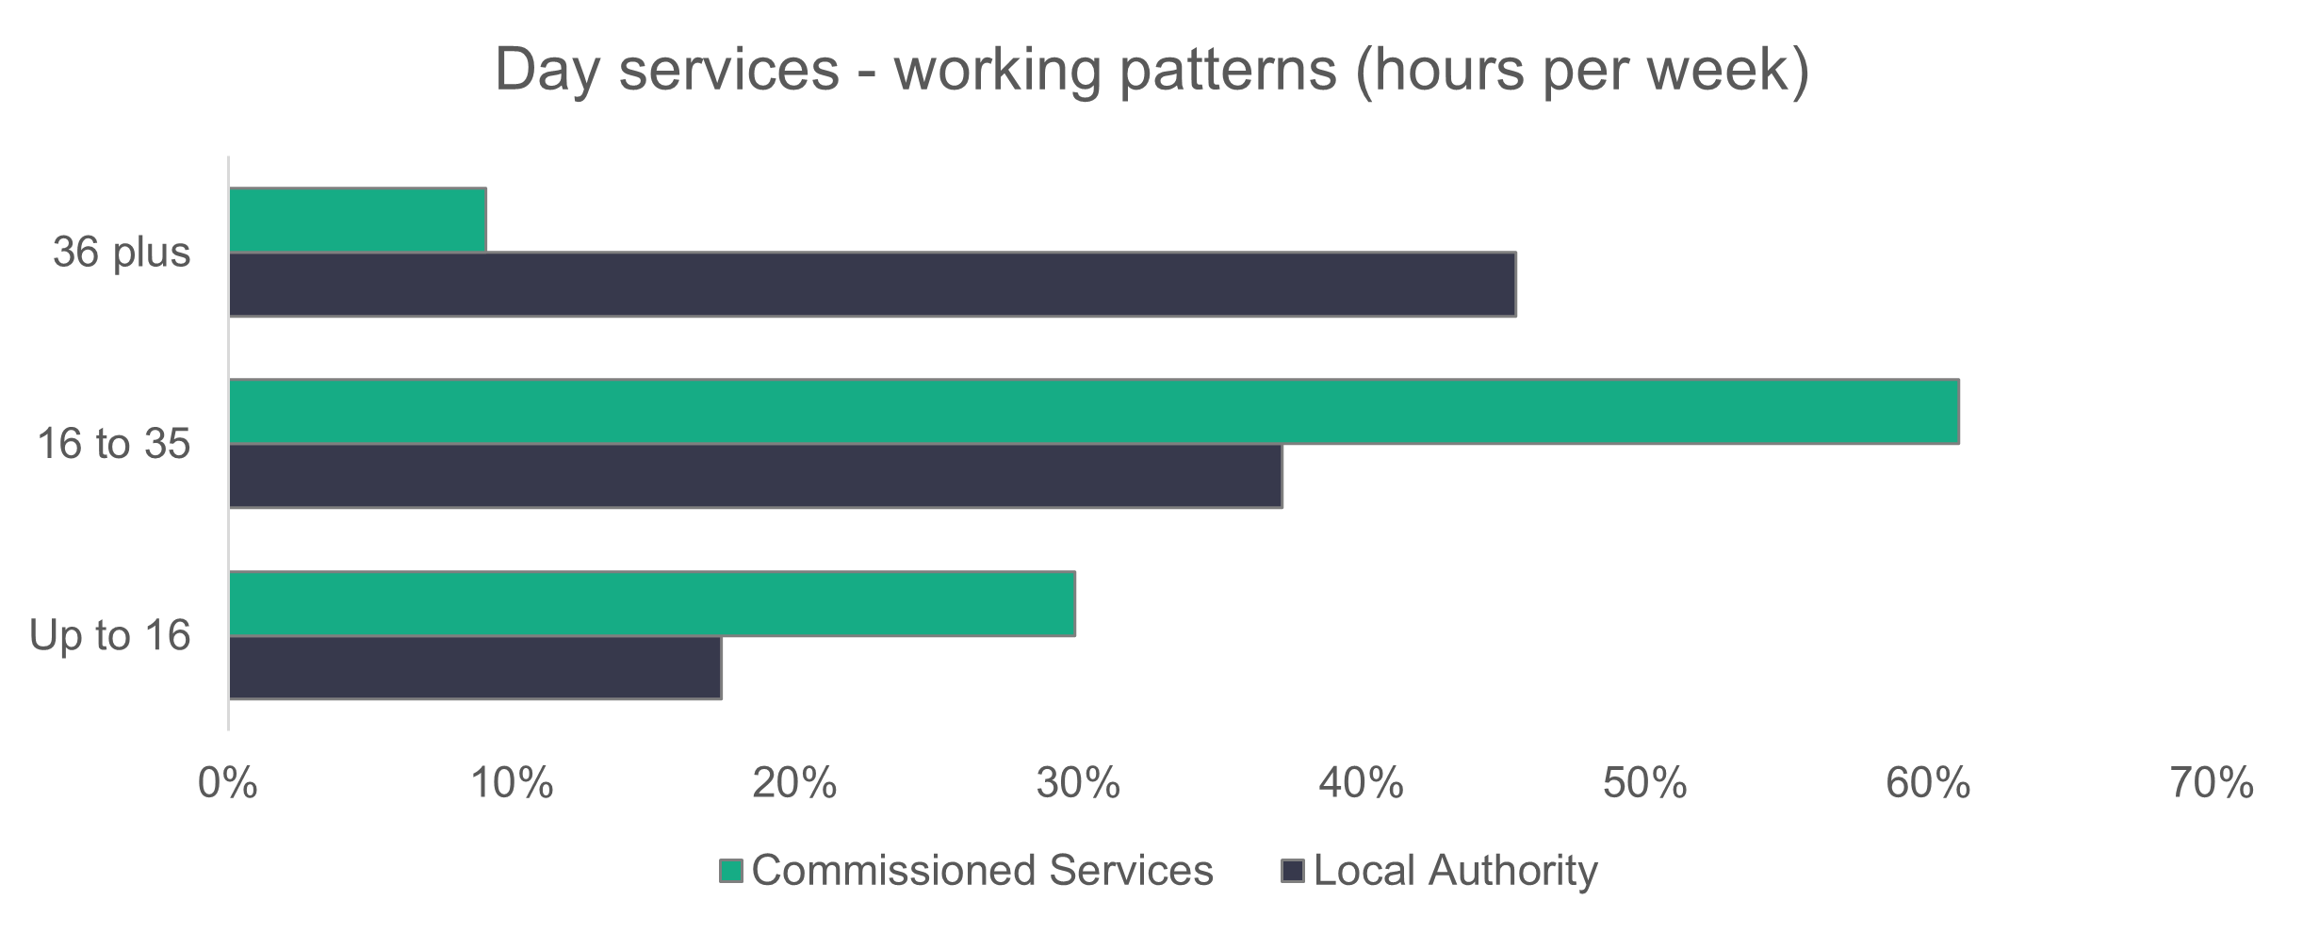
n = 1,849
    - Day services – vacancies
There are 83 vacancies in day services, meaning that four per cent of roles are unfilled. The number of vacancies has more than halved from last year's value of 173.

2.5 Supported living services

Summary:

- Care workers (including senior care workers) make up 85.9 per cent of the supported living workforce.
- The supported living workforce is more ethnically diverse than the general population of Wales.
- Casual contracts make up 23.3 per cent of the local authority workforce.

All settings in supported living services submitted some data.
n = 13
n = 98
    - Supported living services – role type
Care workers make up 82.6 per cent of the supported living services workforce. This is only a slight drop from last year's proportion of 83.8 per cent. The proportion of senior care workers, however, has dropped from 5.7 per cent in 2024 to 3.3 percent in 2025.

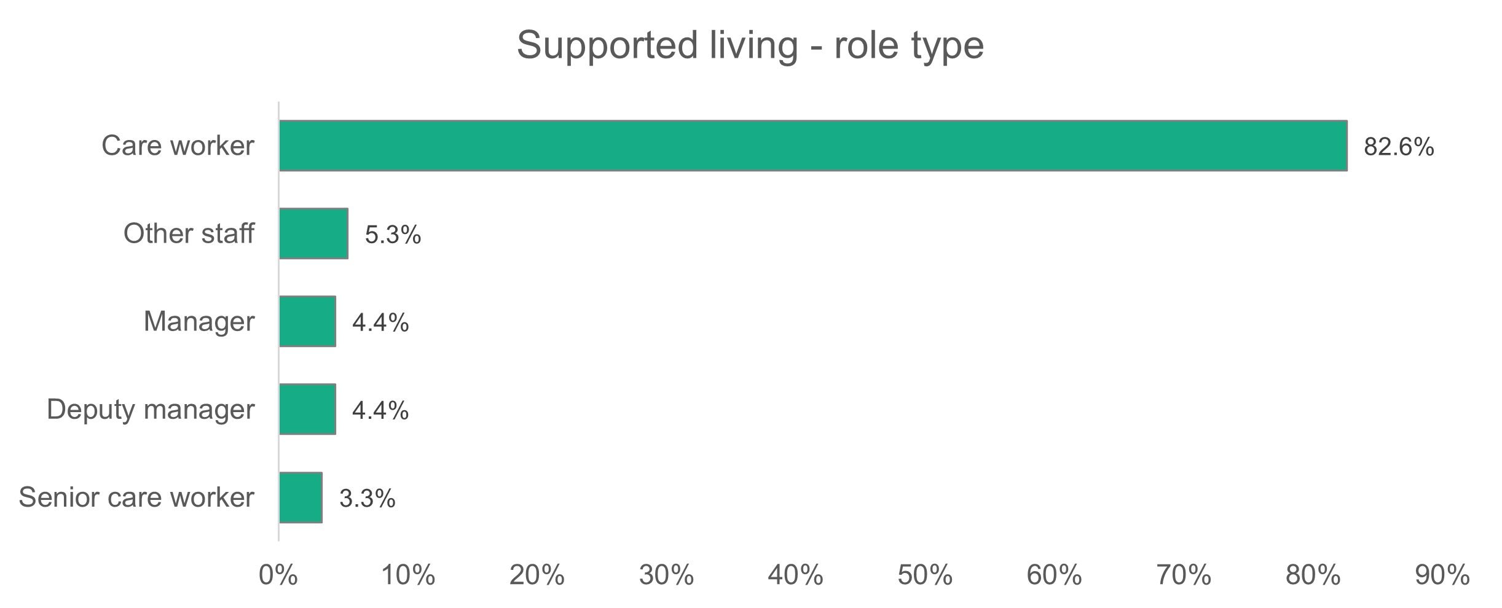
n = 6,254
    - Supported living services – gender
The gender profile in supported living services has hardly changed over the last four years. Women make up 74.3 per cent of the workforce.
n = 5,881
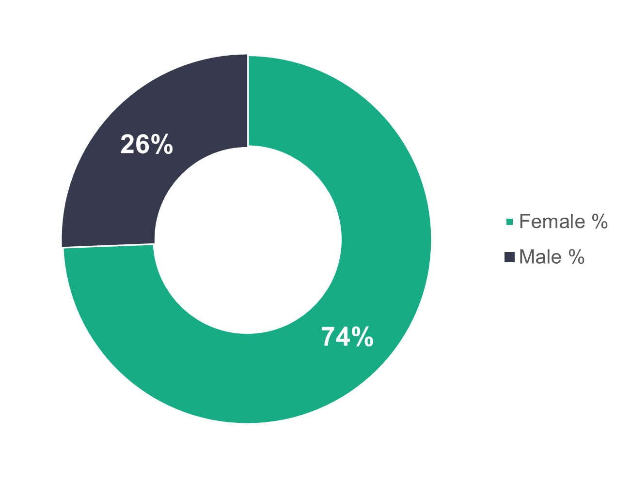
    - Supported living services – age profile
Local authorities have an older supported living workforce, with 63.8 per cent of workers aged 46 or over. In commissioned services, we see that 55.2 per cent of workers are younger than 46. These trends are similar to the previous three years.
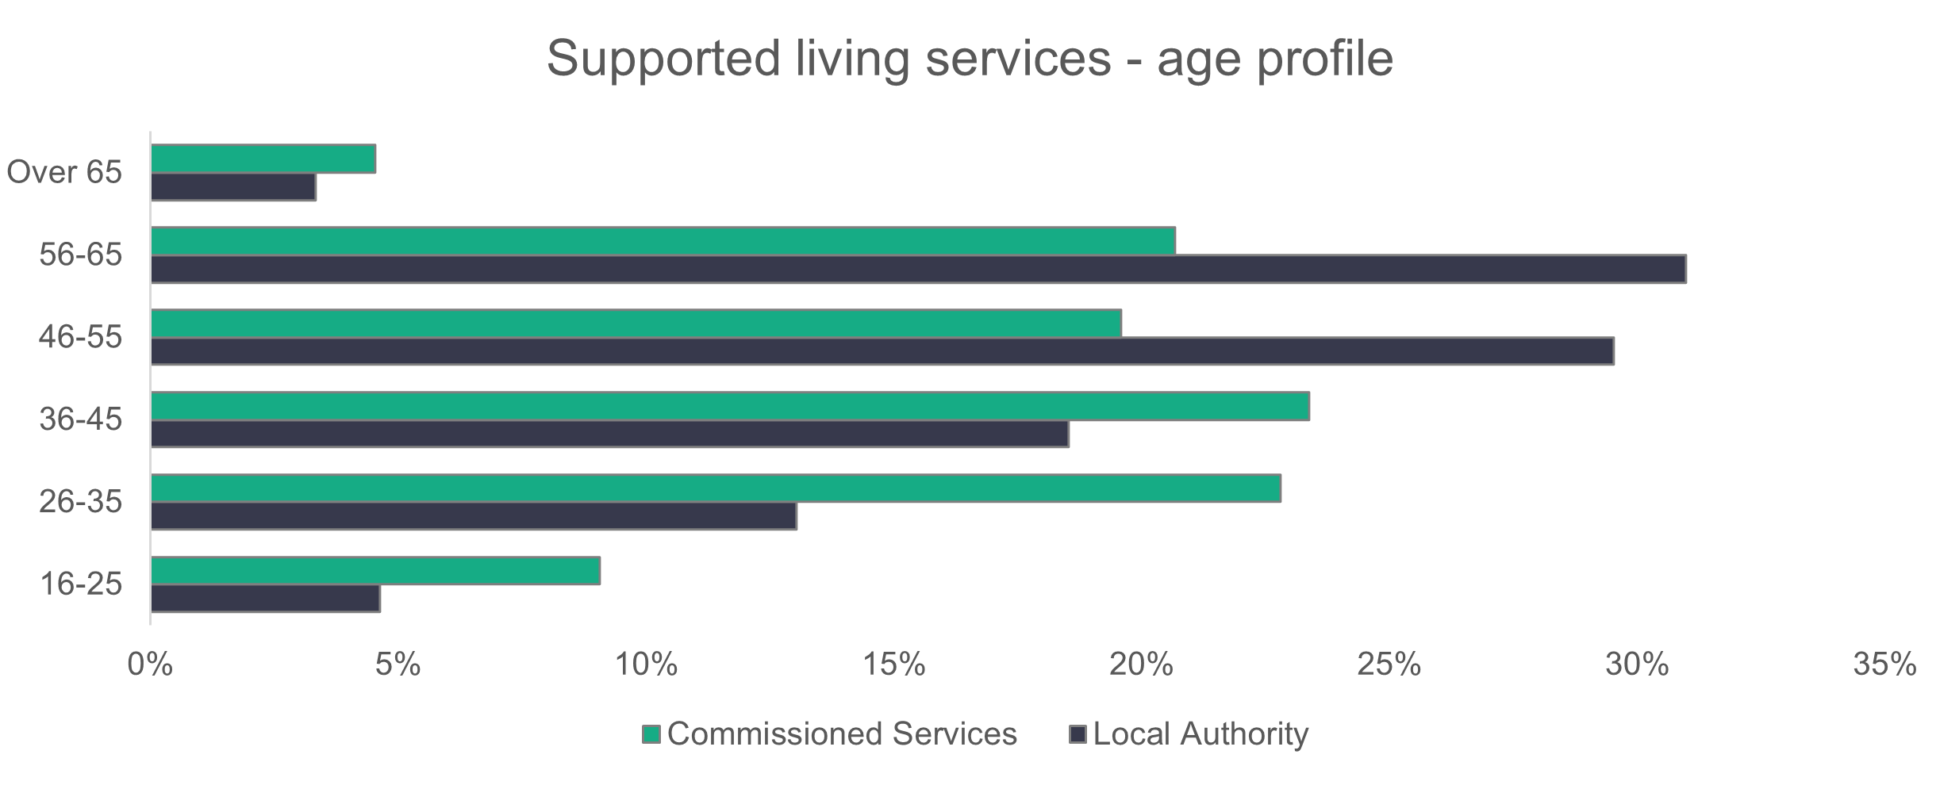
n = 5,710
    - Supported living services – ethnicity
The supported living workforce is less ethnically diverse than in 2024 (89 per cent white in 2025, compared to 85.8 per cent white in 2024) but more in line with the 2023 data (89.3 per cent white). However, the workforce is more ethnically diverse than the general population of Wales, with more than 10 times the proportion of black workers.
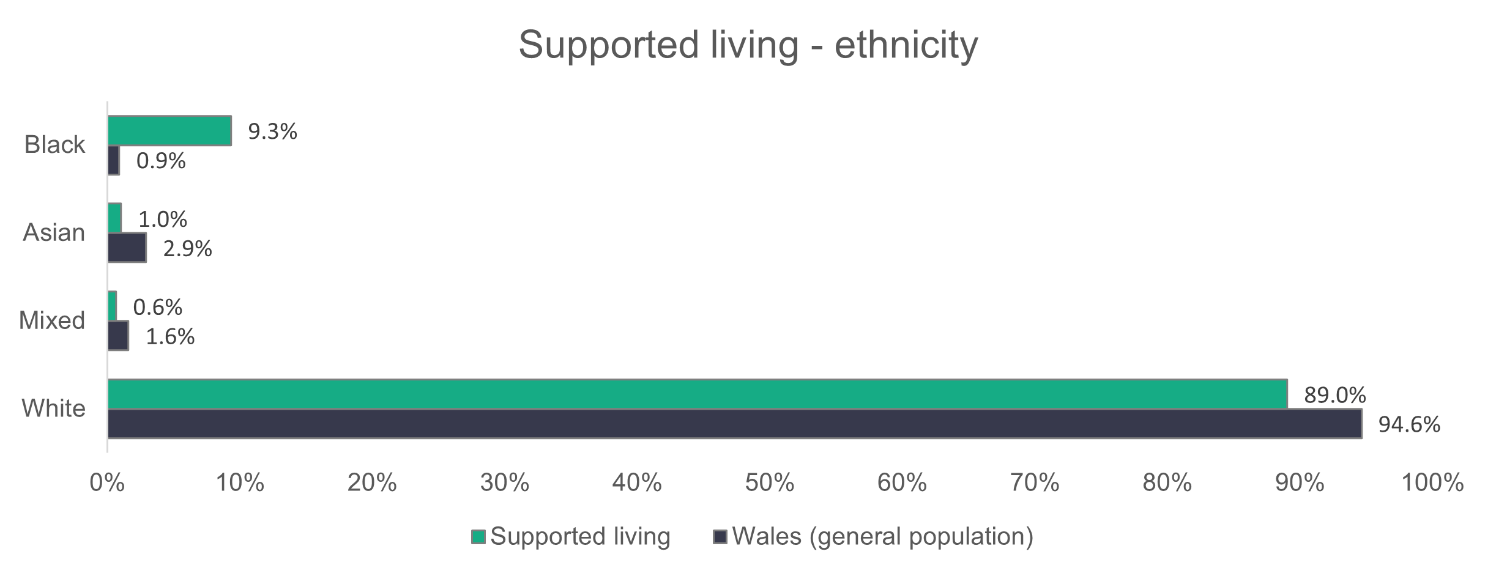
n = 4,659
    - Supported living services – contract type
Almost all (95.8 per cent) commissioned services employees are on permanent contracts. The proportion of commissioned services employees on zero-hours contracts has increased from 0.9 per cent in 2024 to 1.9 per cent in 2025, but those on agency-type contracts have dropped from 2.4 per cent in 2024 to one per cent in 2025. Local authorities have a relatively big proportion of their employees
on casual contracts. In 2025, casual contracts make up 23.3 per cent of the local
authority workforce, compared to 18.2 per cent in 2024.
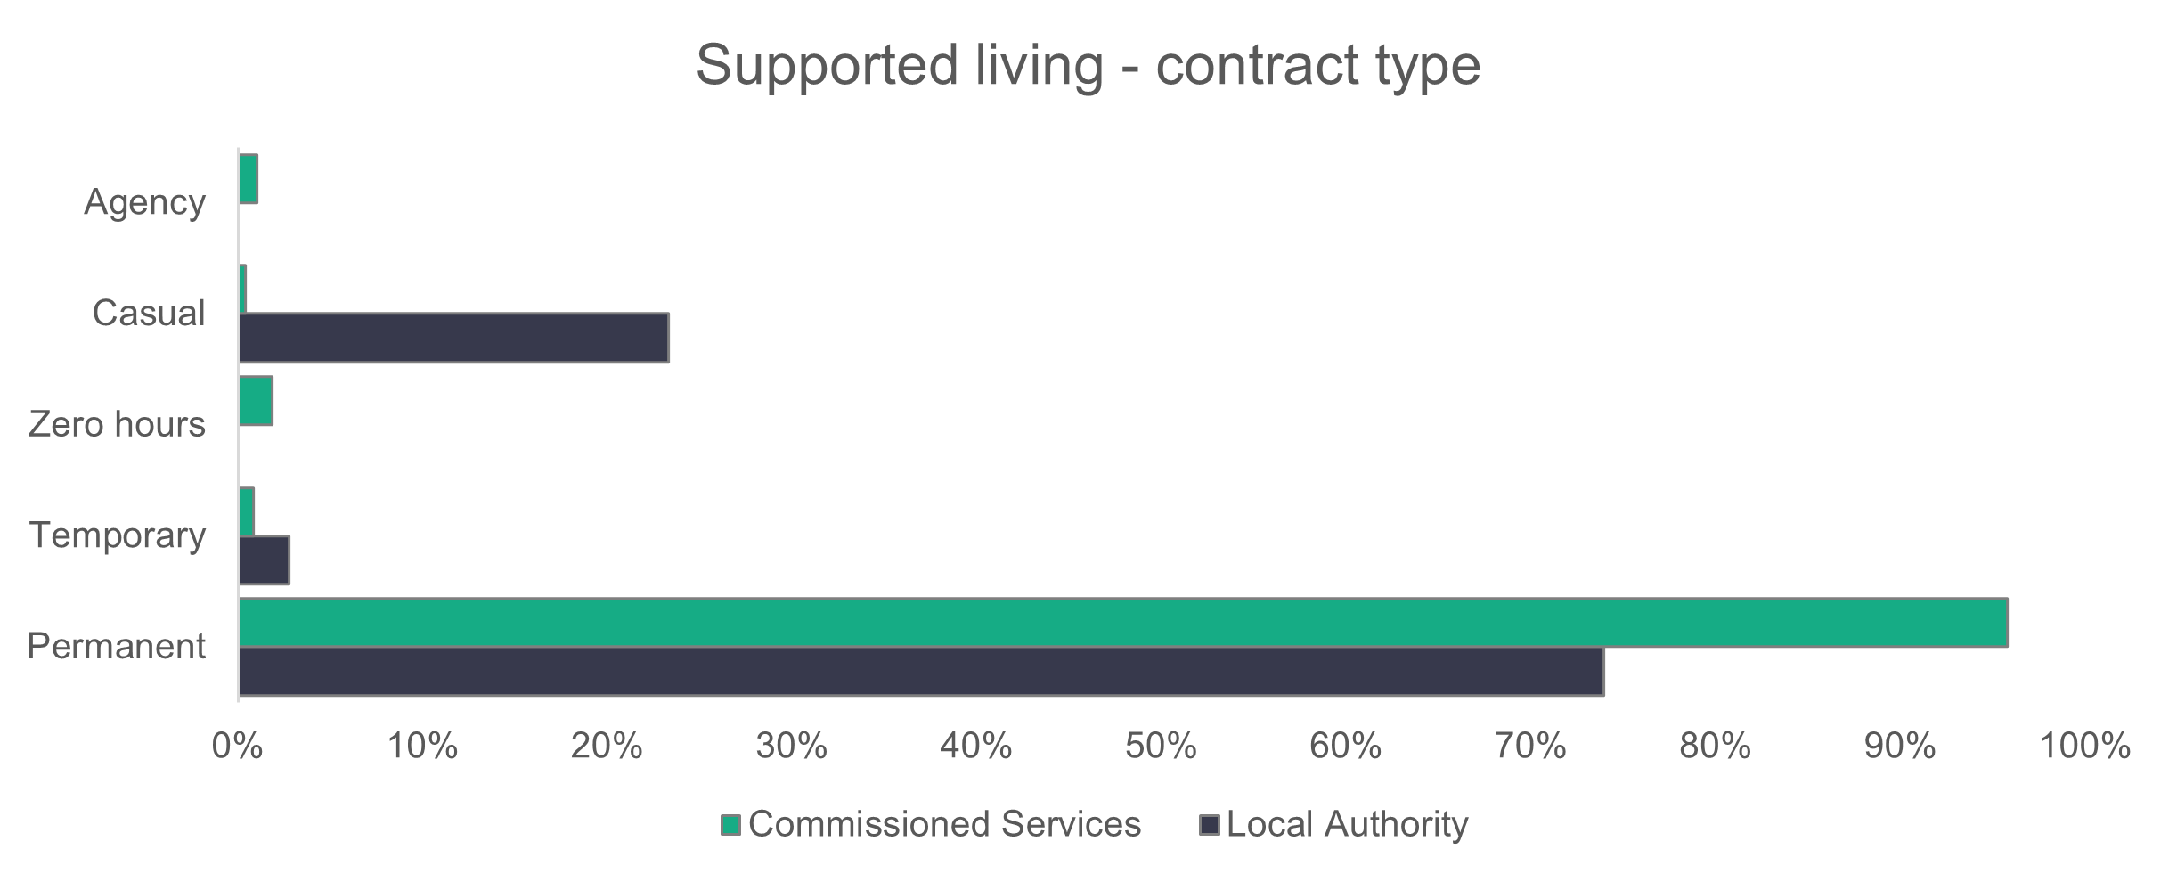
n = 6,241
    - Supported living services – working patterns
More commissioned services employees (50 per cent) work full-time hours than in local authorities (30.8 per cent). Local authorities have seen a fall in the proportion of full-time workers, from 37.2 per cent in 2024 down to 30.8 per cent in 2025.

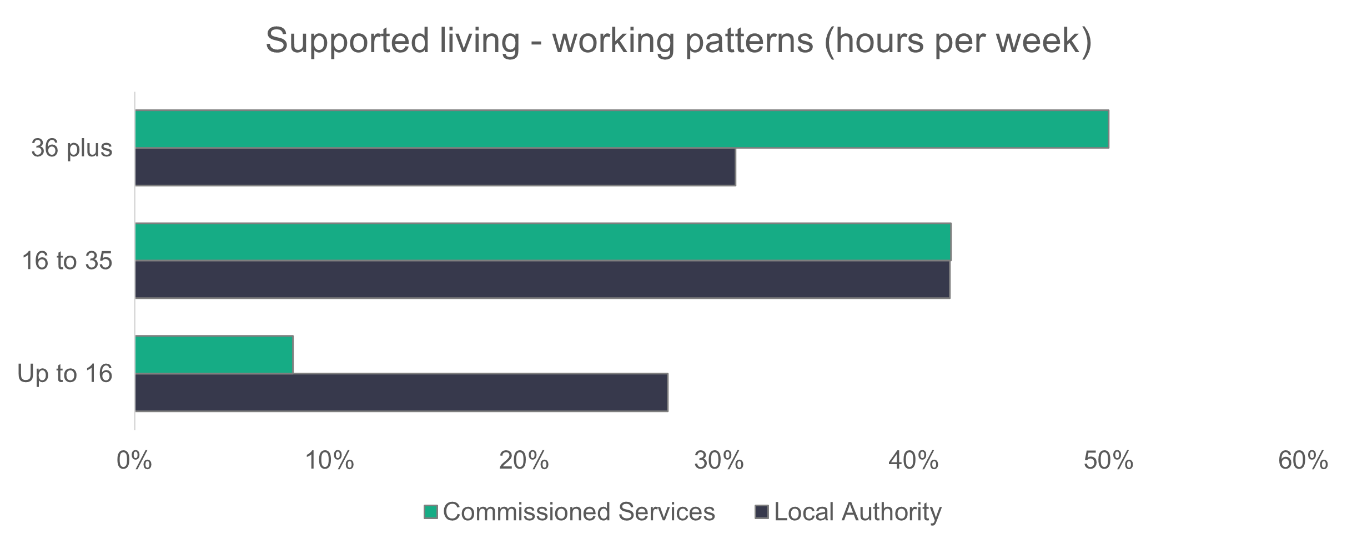
n = 5,937
    - Supported living – vacancies
With 381 vacancies, supported living services have 5.7 per cent of their roles unfilled. Last year there were 627 vacancies.

2.6 Social work teams
Only one return was received from a commissioned service. As this makes the risk of identifiability greater, we haven’t distinguished between commissioned services and local authorities for the social work teams subsections

Summary:

- Women make up 86 per cent of the social work teams workforce.
- The workforce is less ethnically diverse than the general population of Wales.
- Most workers are on permanent contracts (79 per cent) and work full-time hours (73.7 per cent).
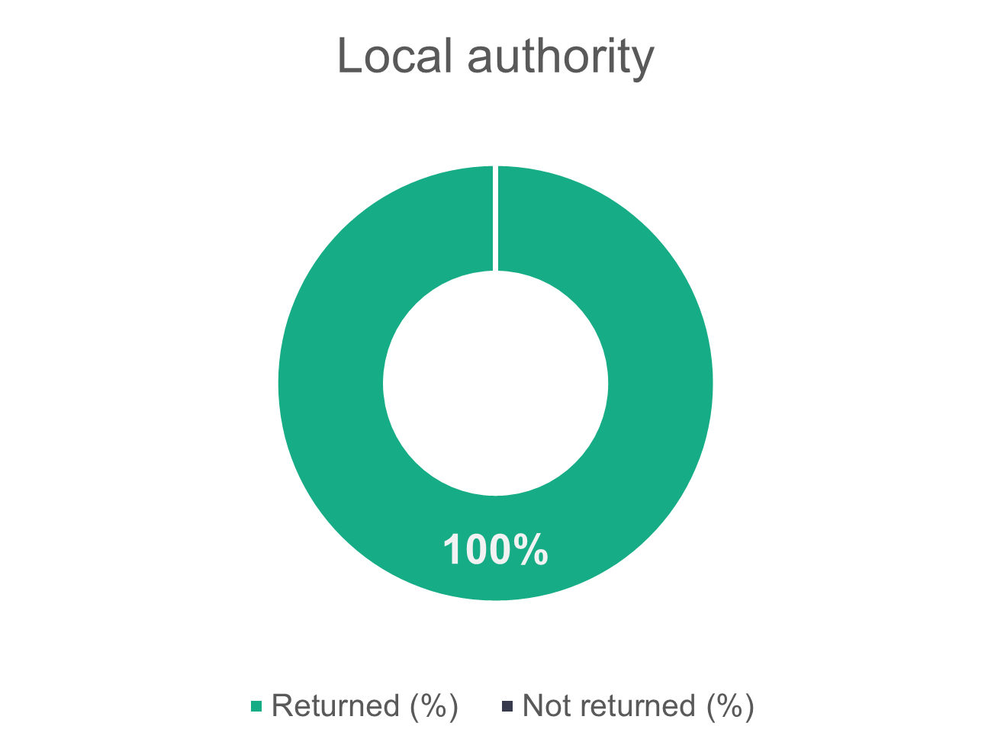
    - Social work teams – role type
The proportion of registered social workers has hardly changed from 2024, but there’s a slight increase in the number of registered social workers, from 4,391 in 2024 to 4,411 in 2025.
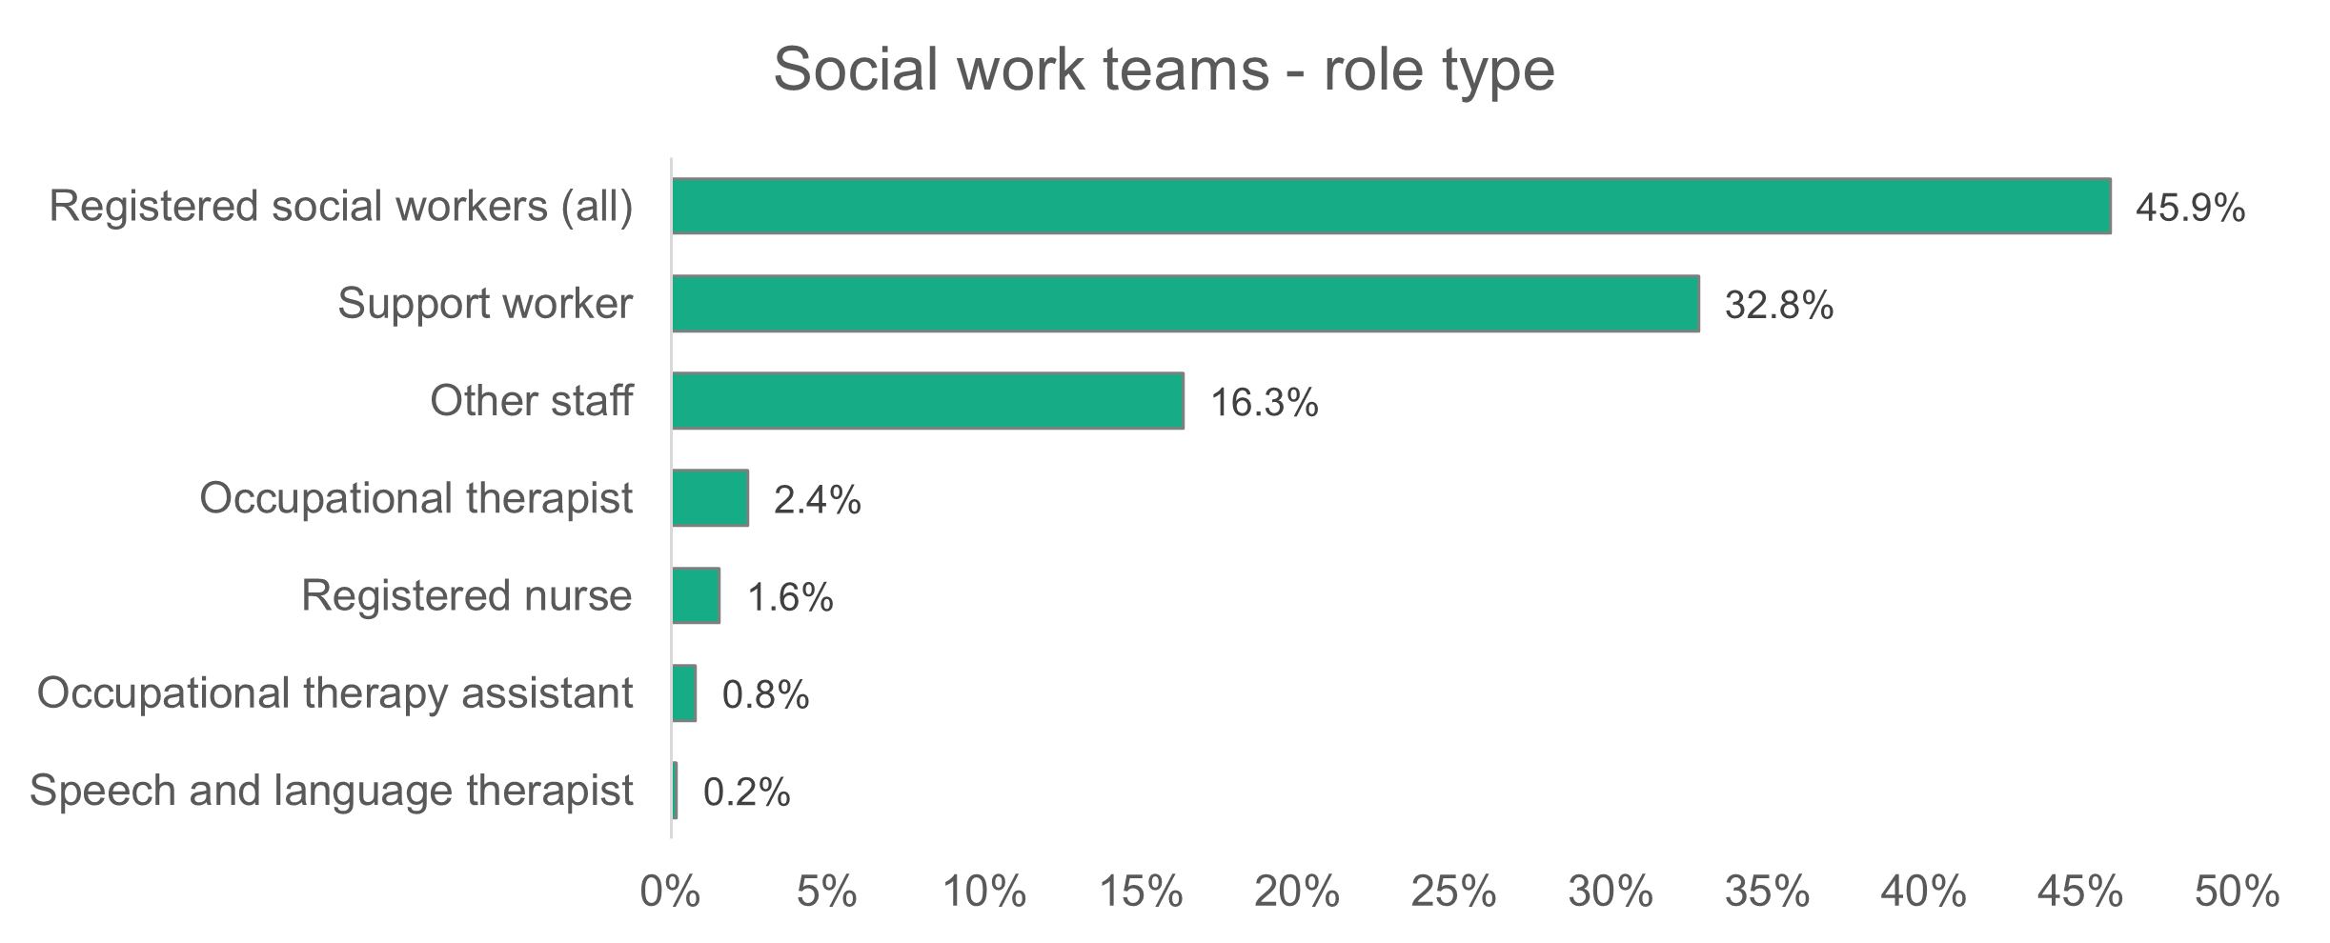
n = 9,605
The breakdown of the experience level of registered social workers is shown in the charts below. Compared to 2024, there’s a slight drop in the proportion of social workers with three or more years’ experience (down from 42.8 per cent to 41.2 per cent) and senior practitioners (from 18.9 per cent to 18.3 per cent). There’s a slight increase in the proportion of social workers with one to three years’ experience, from 11.5 per cent in 2024 to 12.5 per cent in 2025. The proportion of social workers in their first year in post has almost doubled from 3.5 per cent in 2024 to 6.3 per cent in 2025. This correlates with an increase in the number of people taking up funding opportunities to train as social workers via bursaries and ‘grow your own’ opportunities within local authorities in the past five years. We see a drop in consultant social workers from two per cent in 2024 to 1.4 per cent in 2025.
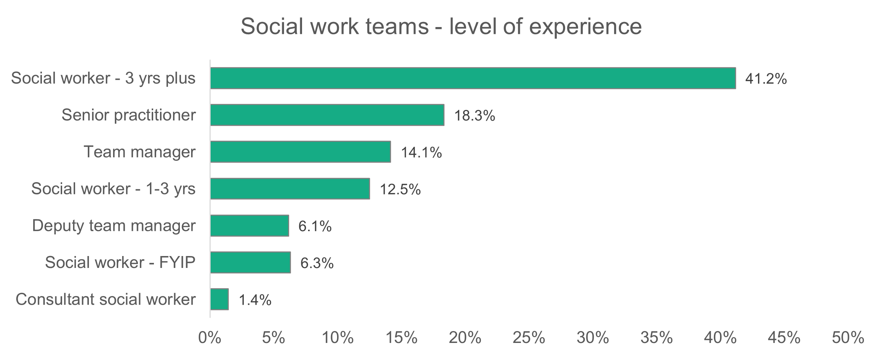
n = 4,411
    - Social work teams – gender
The gender profile of social work teams remained unchanged from 2024, with women making up 86.2 per cent of the workforce.
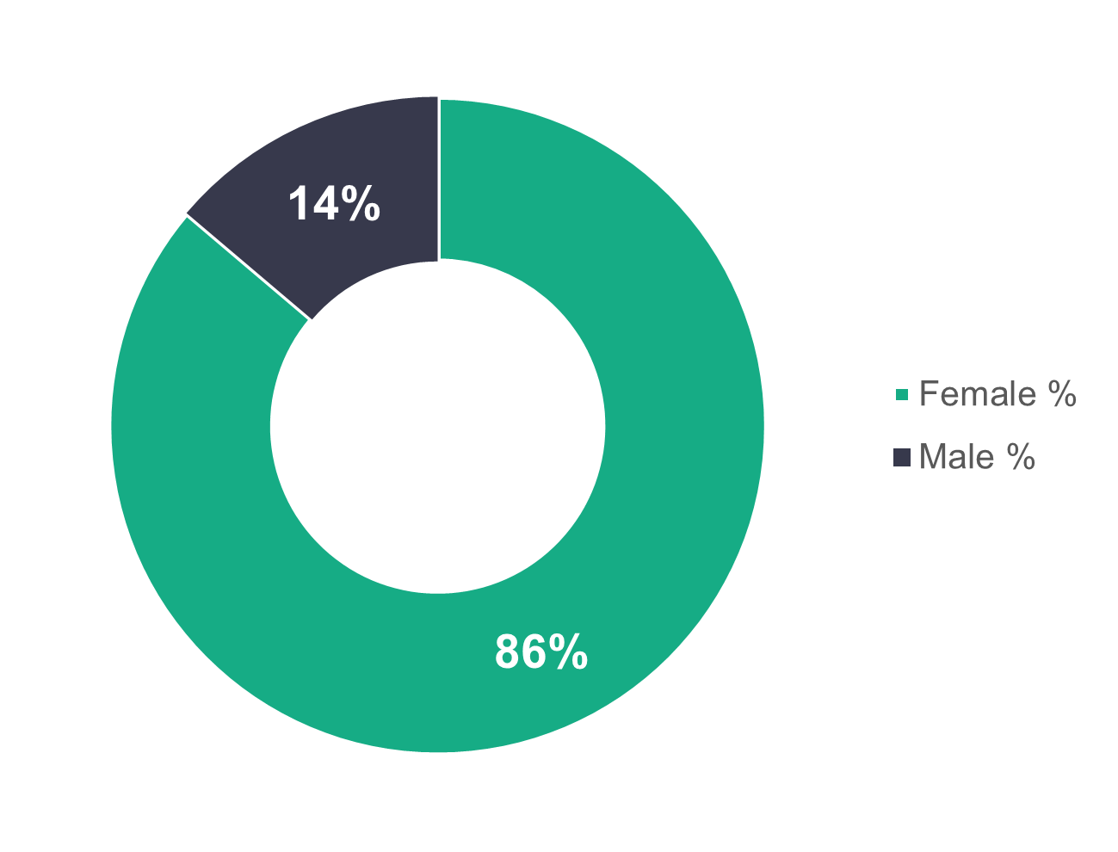
n = 9,424

    - Social work teams – age profile
The age profile of social work teams is very similar to that of 2024, with none of the age category proportions changing by more than one per cent. We see that 56 per cent of the workforce is under the age of 46.
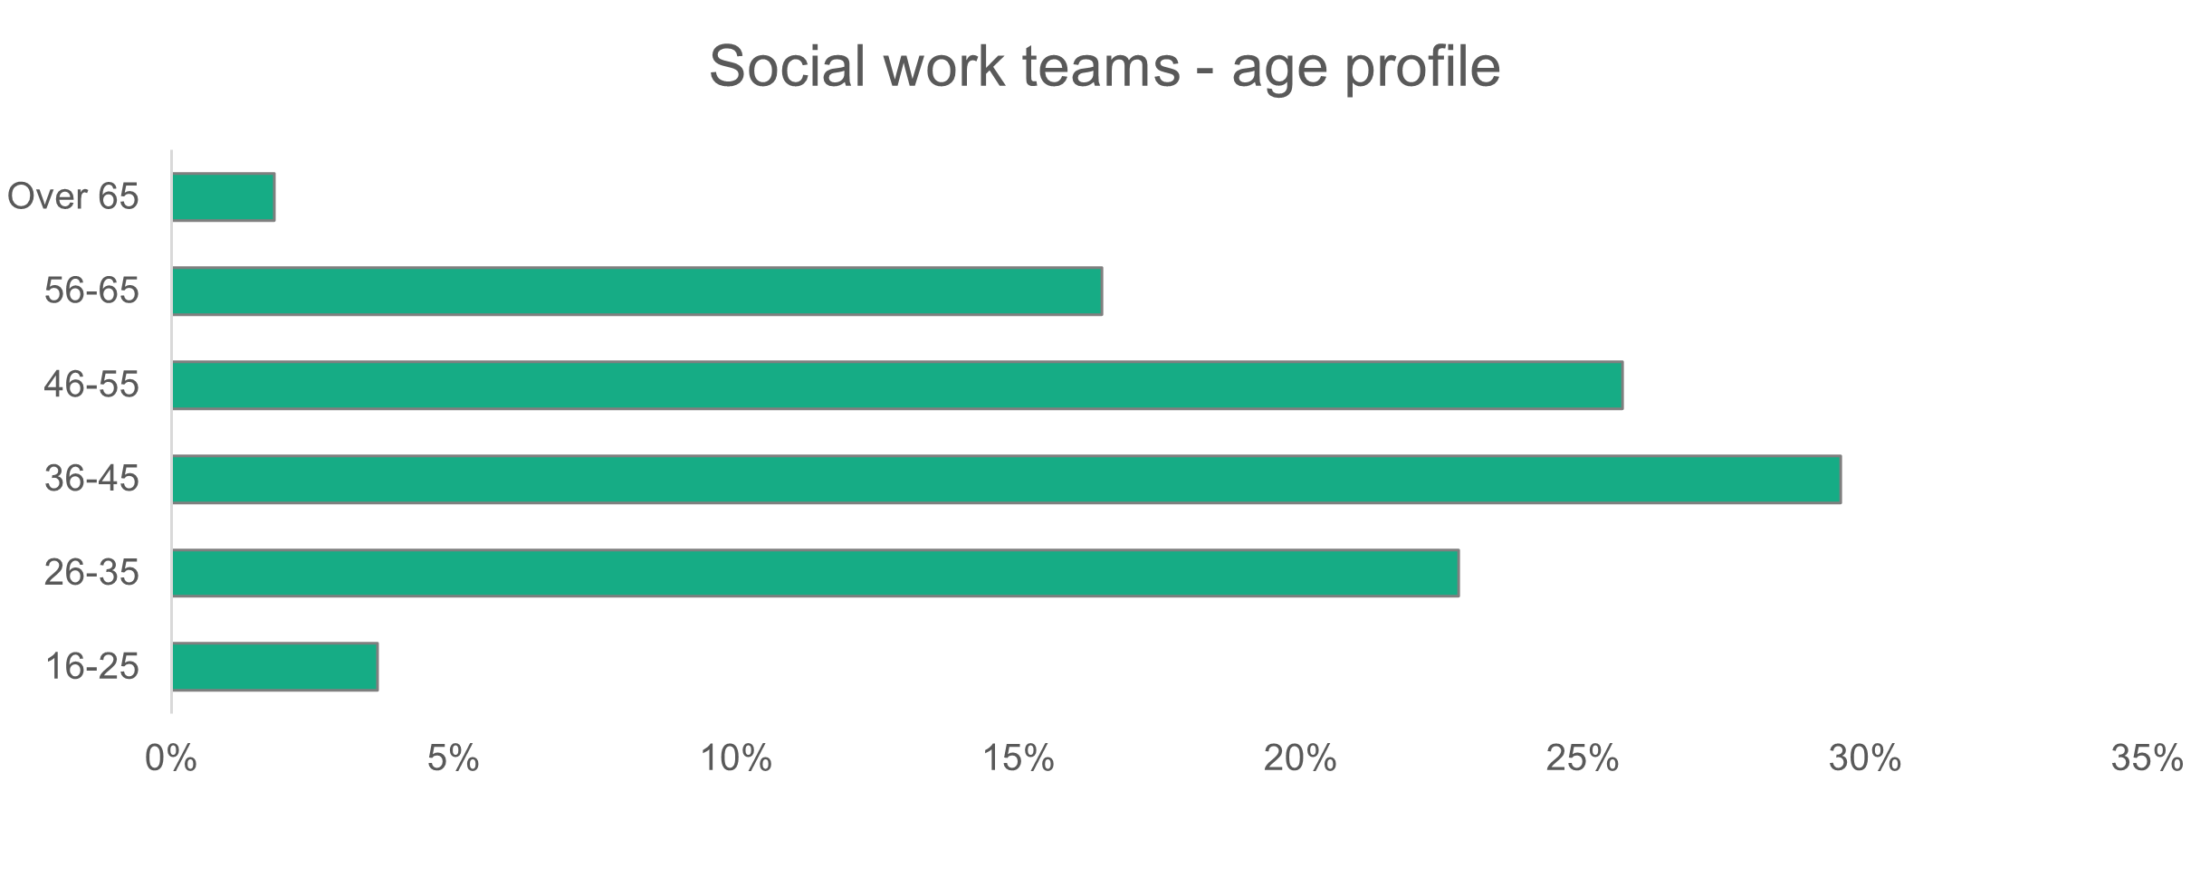
n = 9,425
    - Social work teams – ethnicity
The ethnic profile of social work teams (96.6 per cent white) has hardly changed from 2024 and is less diverse than the general population of Wales (94.6 per cent white).
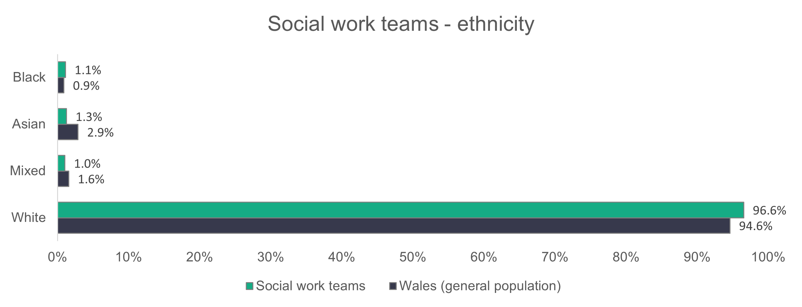
n = 7,364
    - Social work teams – contract type
Permanent contracts make up 79 per cent of the social work teams workforce. Temporary contracts account for 15.4 per cent of the workforce, and casual or zero-hours contracts make up 4.5 per cent. This data is very similar to what we saw in 2024.

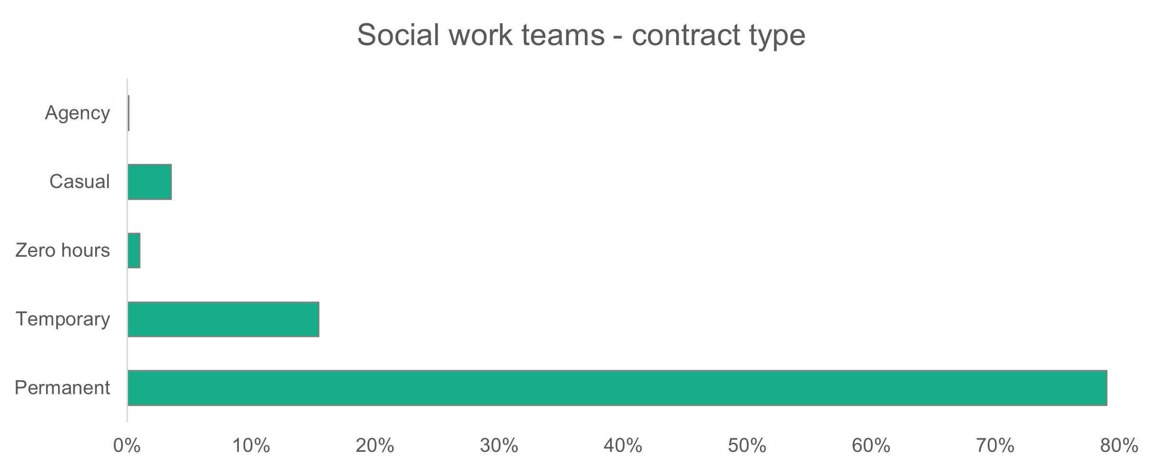
n = 9,345
    - Social work teams – working patterns
As in previous years, most workers are on full-time contracts. In 2025, 73.7 per cent of workers work full-time hours, an increase from 72.9 per cent in 2024.
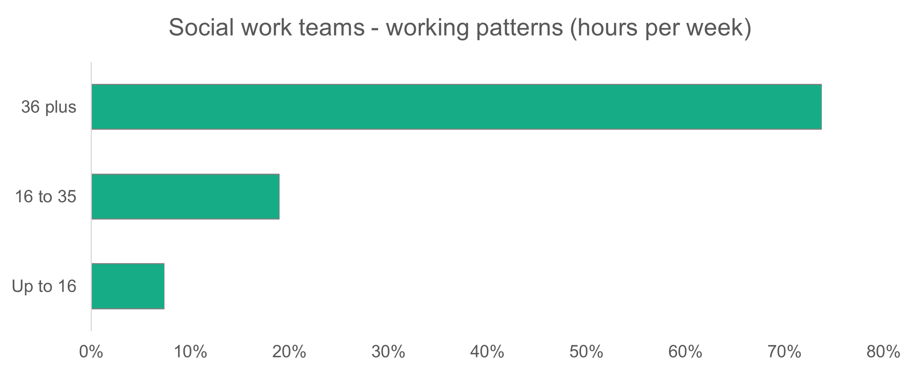
n = 9,411
    - Social work teams – vacancies
There are 1,023 vacancies in social work teams, which means that 9.6 per cent of roles are unfilled. Last year, there were 751 vacancies in social work teams.
Not all of these vacant positions will be for qualified social workers.

2.7 Children’s residential care

Summary:
- Care workers, including senior carers make up the majority of workers in the children’s residential care workforce (80.2 per cent).
- Women make 70.6 per cent of the workforce.
- 73.1 per cent of children’s residential care workers are under the age of 46, slightly higher than the 2024 figure of 70.9 per cent.
- Most workers in children’s residential care are on permanent contracts, with 93.8 per cent of the commissioned services workforce on this type of contract.

The return rate for children's residential care has increased from 37.2 per cent in 2024 to 41.3 per cent in 2025.
n = 150
n = 19
    - Children’s residential care – role type
There have been very small changes to the proportion of the workforce who occupy the different roles in children’s residential care from 2024, as shown in the chart below. Care workers make up the biggest proportion at 68.4 per cent, an increase of 0.3 per cent from 2024.

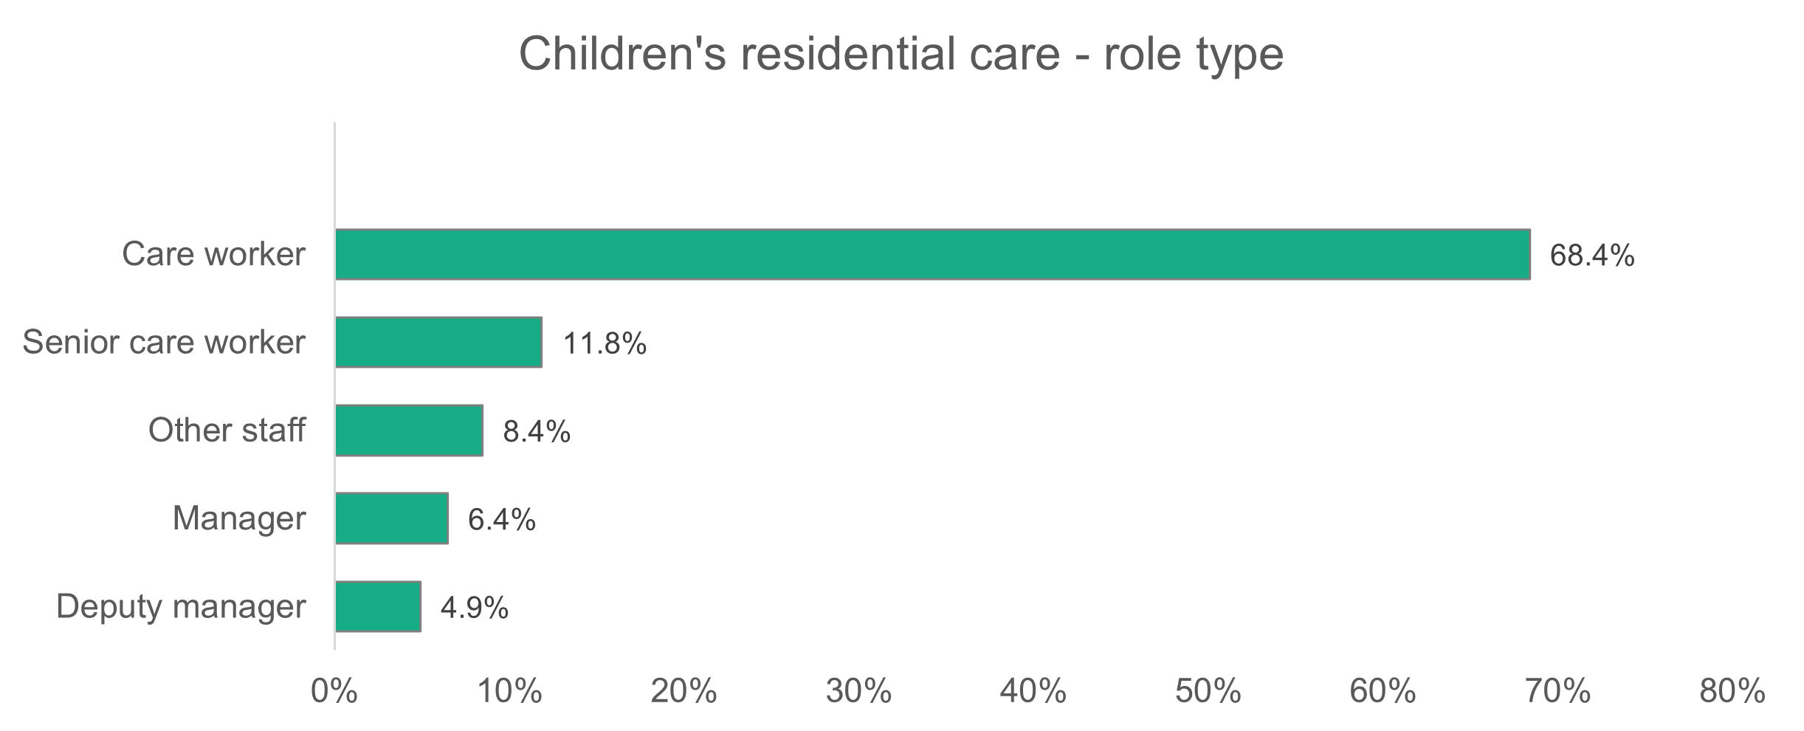
n = 2,761
    - Children’s residential care – gender
The proportion of women working in children’s residential care has increased again to 70.6 per cent. This figure has risen steadily over recent years, from 62 per cent in 2022, to 66 per cent in 2023 and 69.5 per cent in 2024.
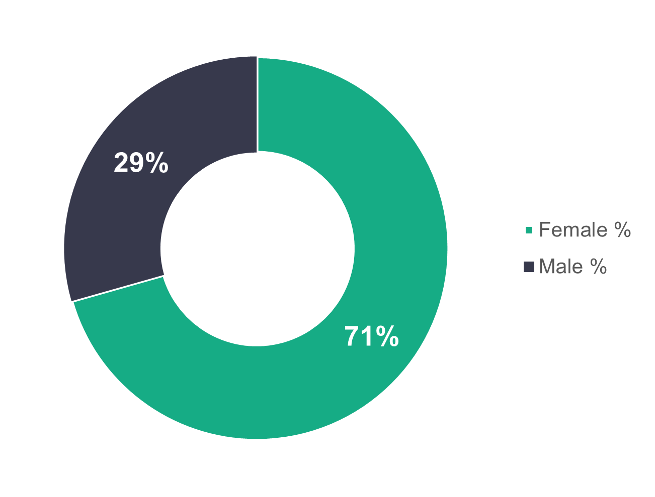
n = 2,730
    - Children’s residential care – age profile
There’s been little change to the age profile of the children’s residential care workforce. In 2025, 71.3 per cent of children’s residential care workers are under the age of 46, slightly higher than the 2024 figure of 70.9 per cent.

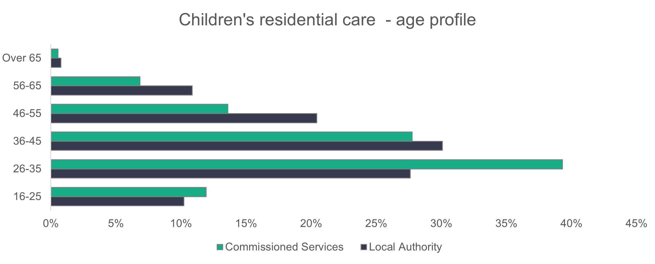
n = 2,676
    - Children’s residential care – ethnicity
The ethnicity of the children’s residential care workforce has seen only small changes from the 2024 data, with the percentage of non-white workers increasing from 3.9 per cent to 5.6 per cent. The proportion of black workers has climbed from 1.6 per cent to 2.9 per cent, while Asian workers now make up one per cent (up from 0.7 per cent). The proportion of workers of mixed ethnicity has remained the same at 1.6 per cent.
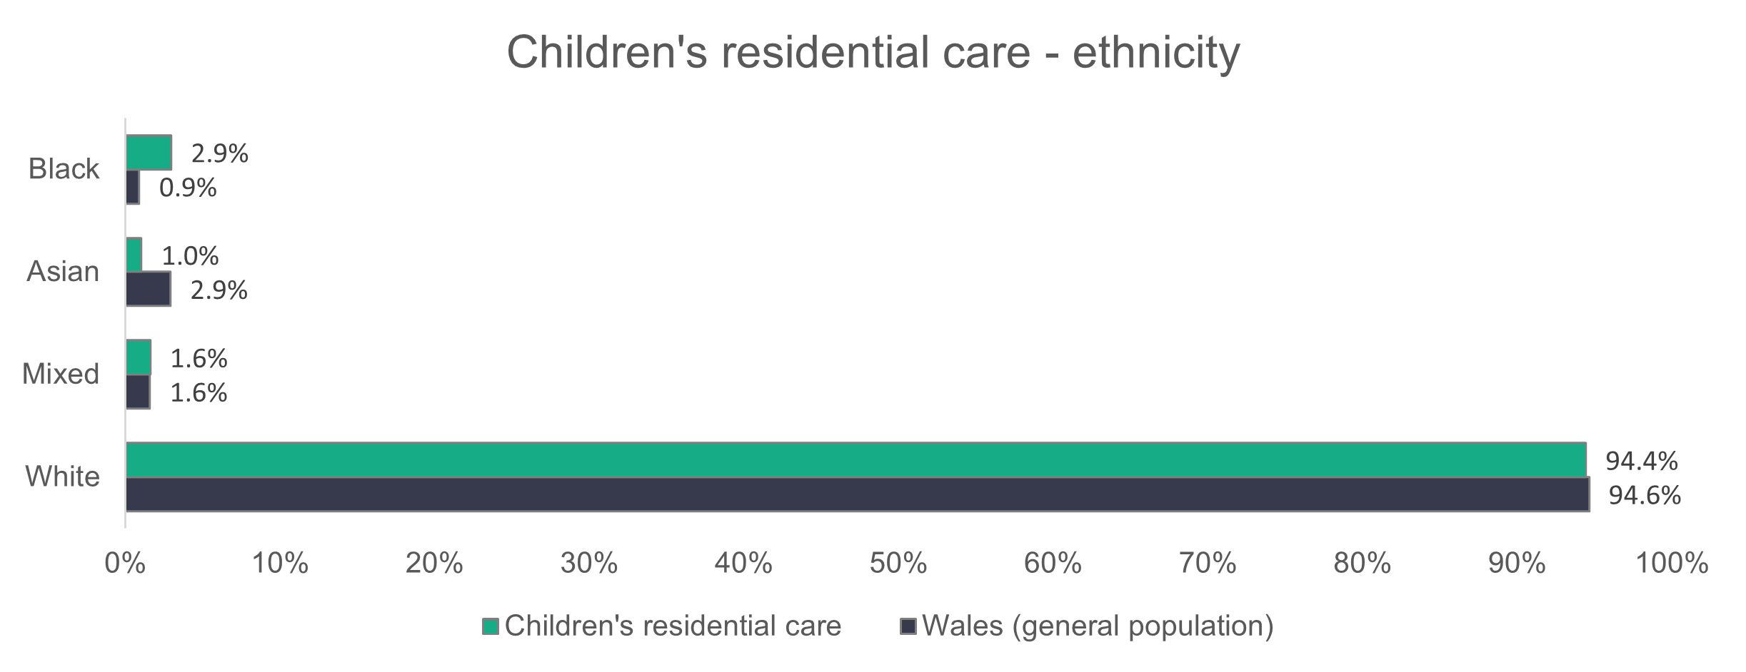
n = 2,139
    - Children’s residential care – contract type
Permanent contracts make up 93.8 per cent of contract types in commissioned services, an increase of 4.4 per cent from 2024.
Zero-hours contracts in local authority services have dropped slightly from 4.1 per cent to 0.9 per cent. Commissioned services have also seen a decrease in the use of zero-hours contracts – from 3.1 per cent to 2.9 per cent.
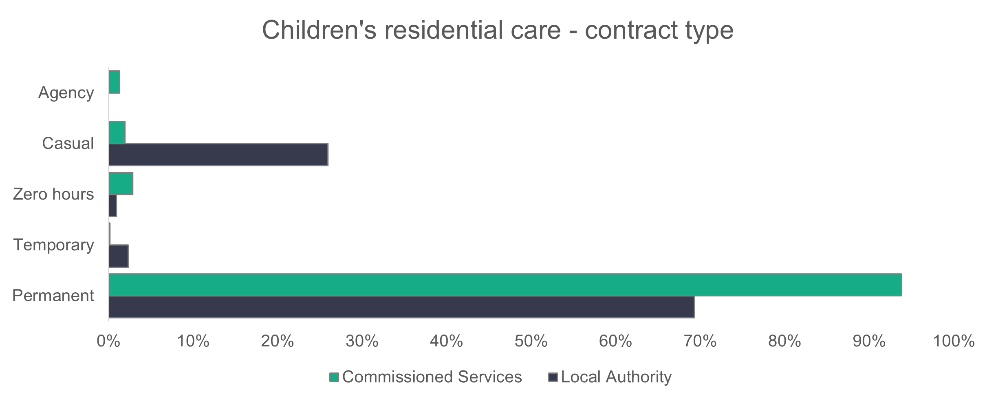
n = 2,686
    - Children’s residential care – working patterns
There has been little change to the working patterns of children’s residential care workers from 2024, with most working full-time hours (36 or more per week). Full-time workers account for 83.9 per cent of the commissioned service workforce and 46.4 per cent of the local authority workforce.
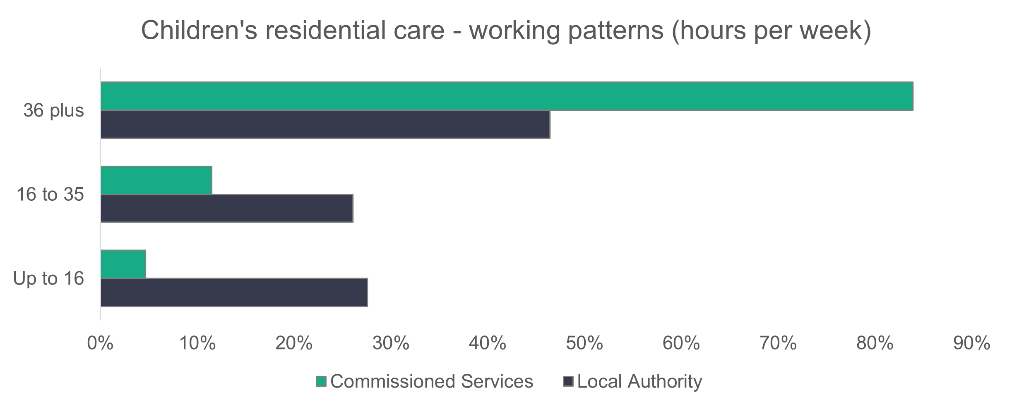
n = 2,644
    - Children’s residential care – vacancies
There are 442 vacancies in children’s residential care, meaning that 8.3 per cent of roles are unfilled. Last year there were 572 vacancies in this sector.

2.8 Mental health residential care

Summary:

- Women make up 61.8 per cent of the mental health residential care workforce, compared to 80.9 per cent in 2024.
- Black workers make up 27.2 per cent of the mental health residential care workforce.
- Casual contracts make up 36.4 per cent of the mental health residential care workforce.
All organisations in the mental health residential care sector returned some data.
The data returned for this setting type is significantly different from the data in 2024. This is due to data from a large national organisation whose workforce appears to be considerably more diverse in its gender and ethnicity than similar organisations in this field.
n = 3
n = 24
    - Mental health residential care – role type
In 2025, we see the highest proportion of care workers in this sector (69.6 per cent) since the workforce data collection started in 2021. Compared to 2024, we also see a slight increase in the proportion of senior care workers, from 9.5 per cent to 9.9 per cent, while ‘Other staff’ has decreased from 13.7 per cent to 10.1 per cent.
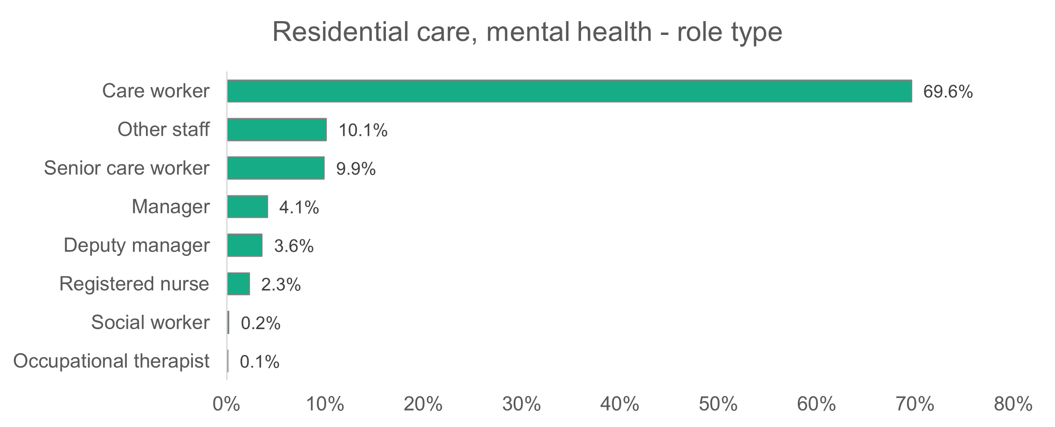
n = 919
    - Mental health residential care – gender
The proportion of women working in mental health residential care has decreased significantly from 80.9 per cent in 2024 to 61.8 per cent in 2025. This proportion of 61.8 per cent is also significantly lower than the proportion of women in the social care sector as a whole (80.8 per cent).
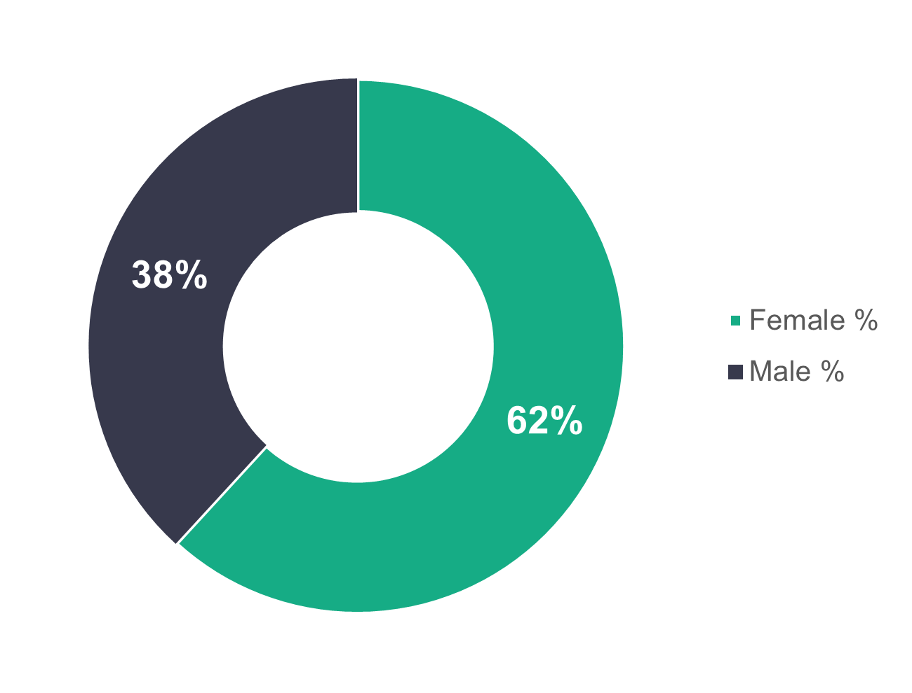
n = 919

    - Mental health residential care – age profile
Commissioned services have a younger workforce, with 74 per cent of employees aged 45 or under. For local authorities, 46.4 per cent of the workforce is aged 45 or under. In 2024, 64.7 per cent of commissioned services staff were aged 45 or under and the proportion for local authorities was 38.5 per cent.

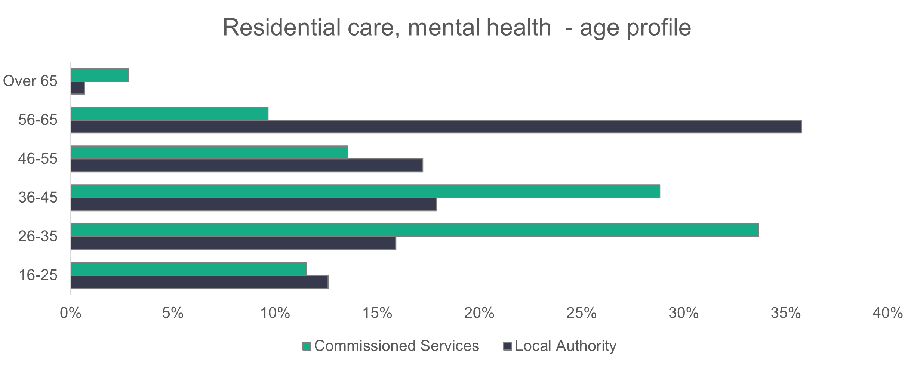
n = 897
    - Mental health residential care – ethnicity
Over one in four (27.2 per cent) of the mental health residential care workforce is black. Last year the proportion of black workers was 3.1 per cent.
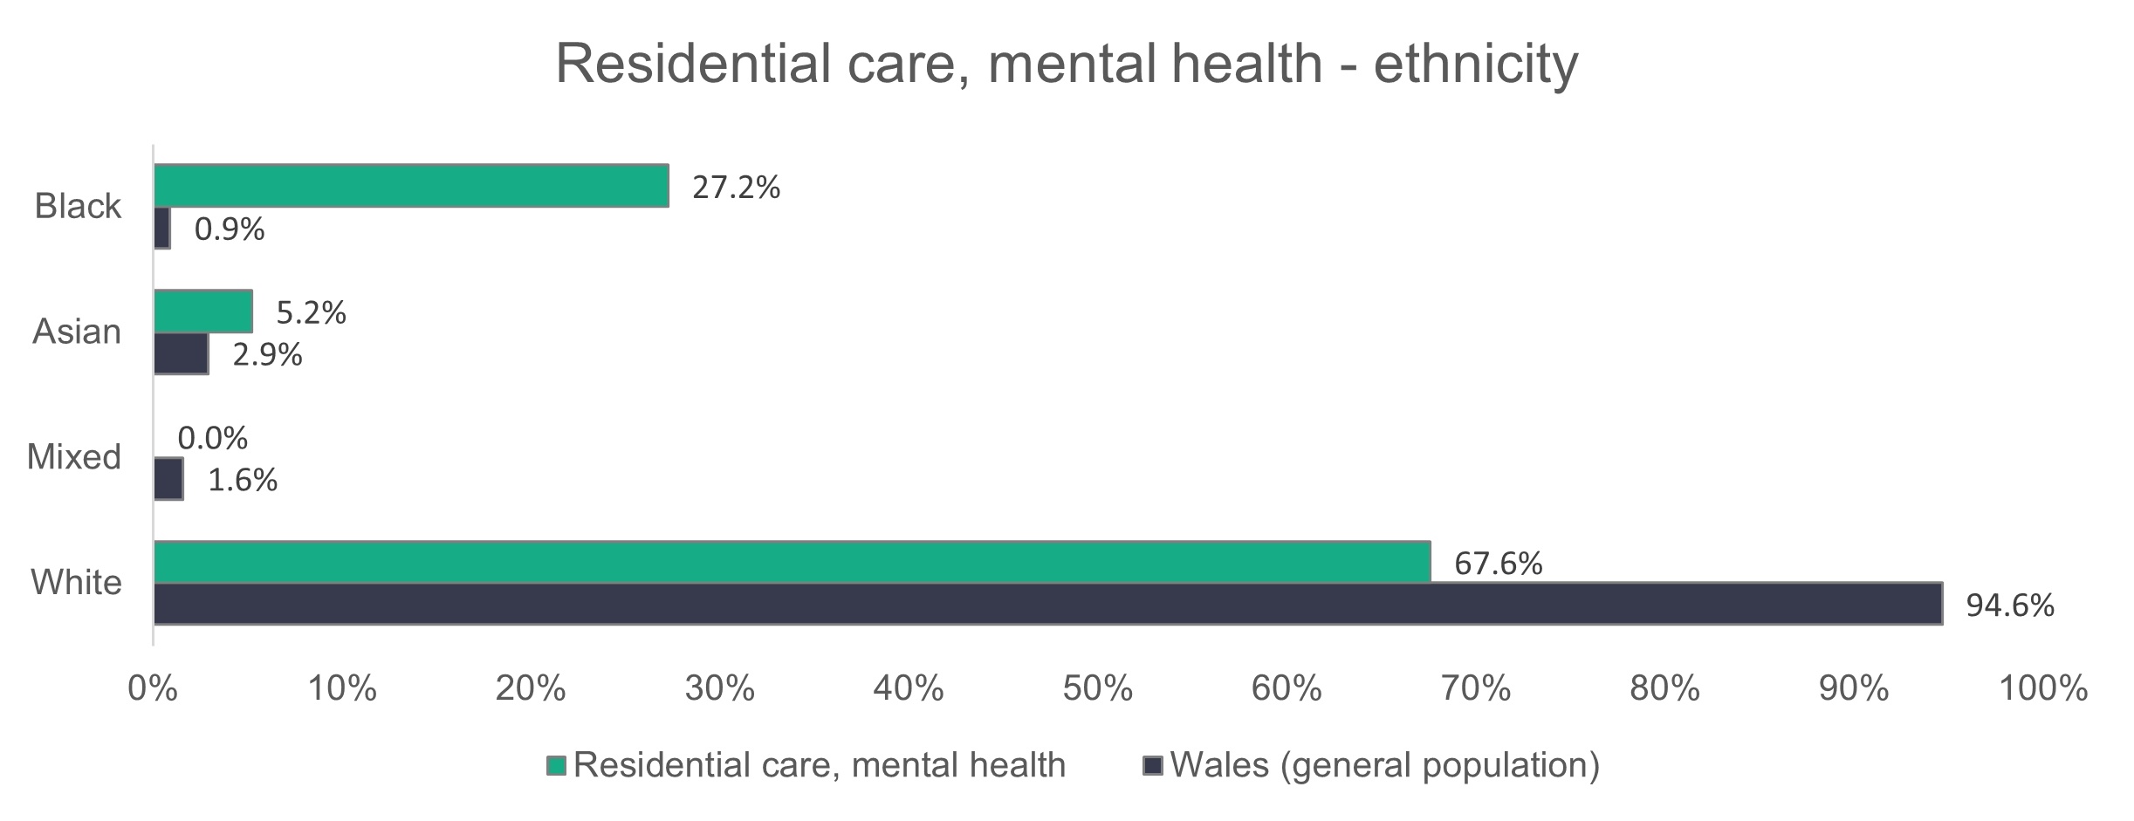
n = 672
    - Mental health residential care – contract type
The biggest changes we see in the contract types for mental health residential care are among local authorities, where 63.6 per cent are on permanent contracts and 36.4 per cent are on casual-type contracts. In 2024, 79 per cent of local authority employees were on permanent contracts and 19.8 per cent were on casual-type contracts.

For commissioned service providers, changes in comparison to 2024 aren’t as significant. We see an increase in the proportion of permanent contracts from 89 per cent to 93.8 per cent, while the proportion of agency workers has dropped from 8.3 per cent to five per cent.
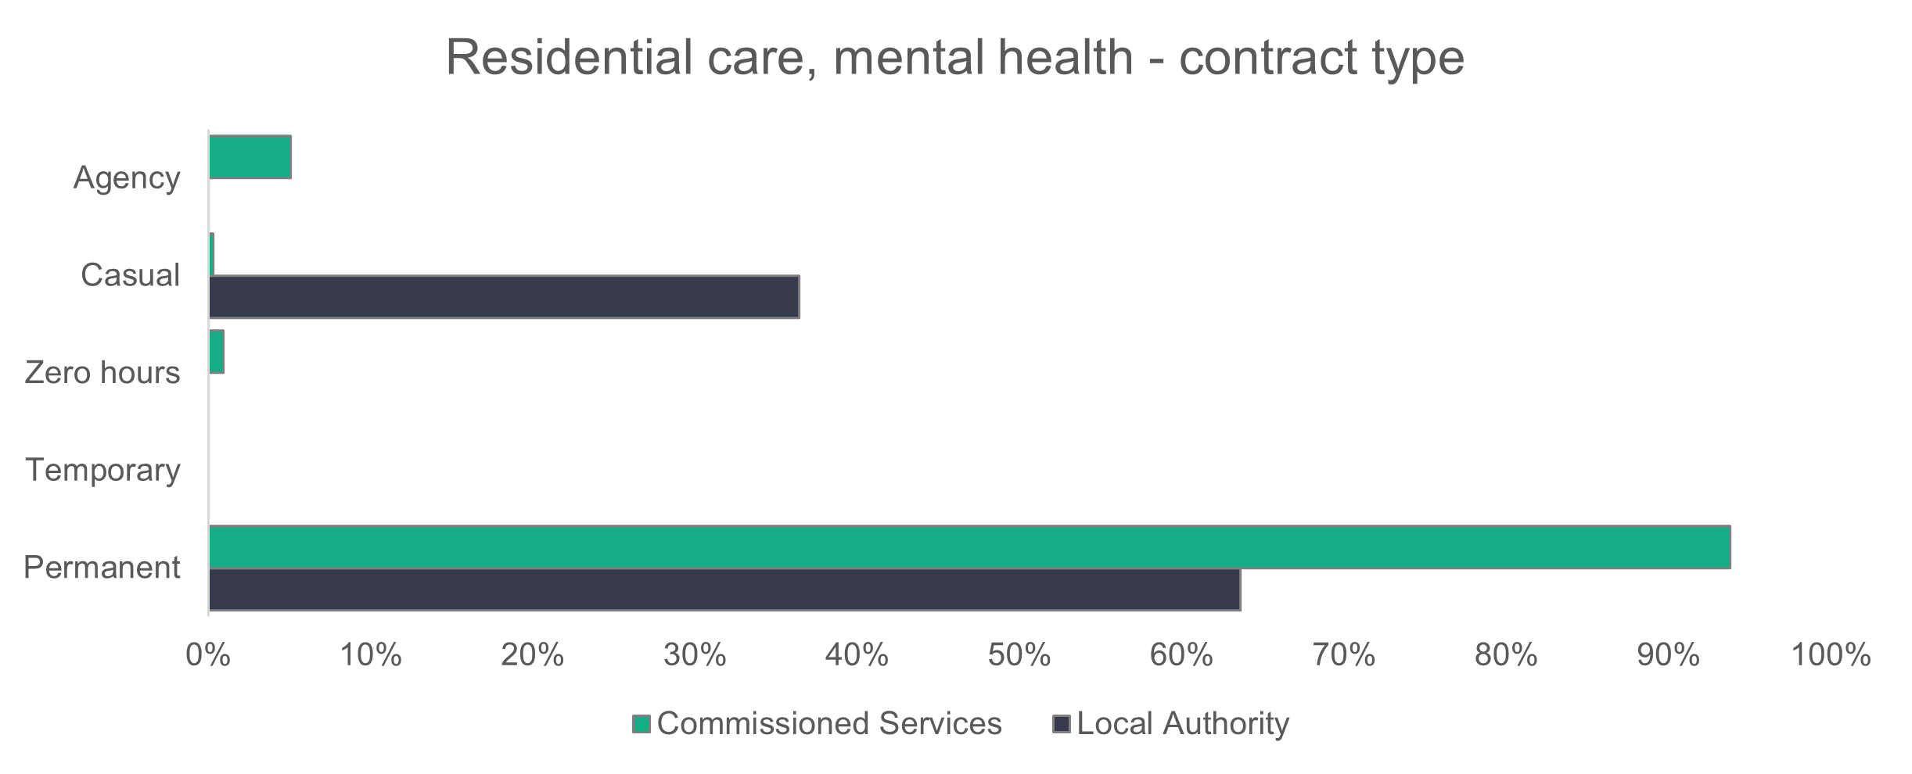
n = 904
    - Mental health residential care – working patterns
Most workers in commissioned services (72 per cent) work full-time hours, which is an increase on the 53.6 per cent reported in 2024. For local authorities, only 8.6 per cent work full-time hours. In 2024, 17.6 per cent worked full-time hours in local authorities, while it was 25.6 per cent in 2023.
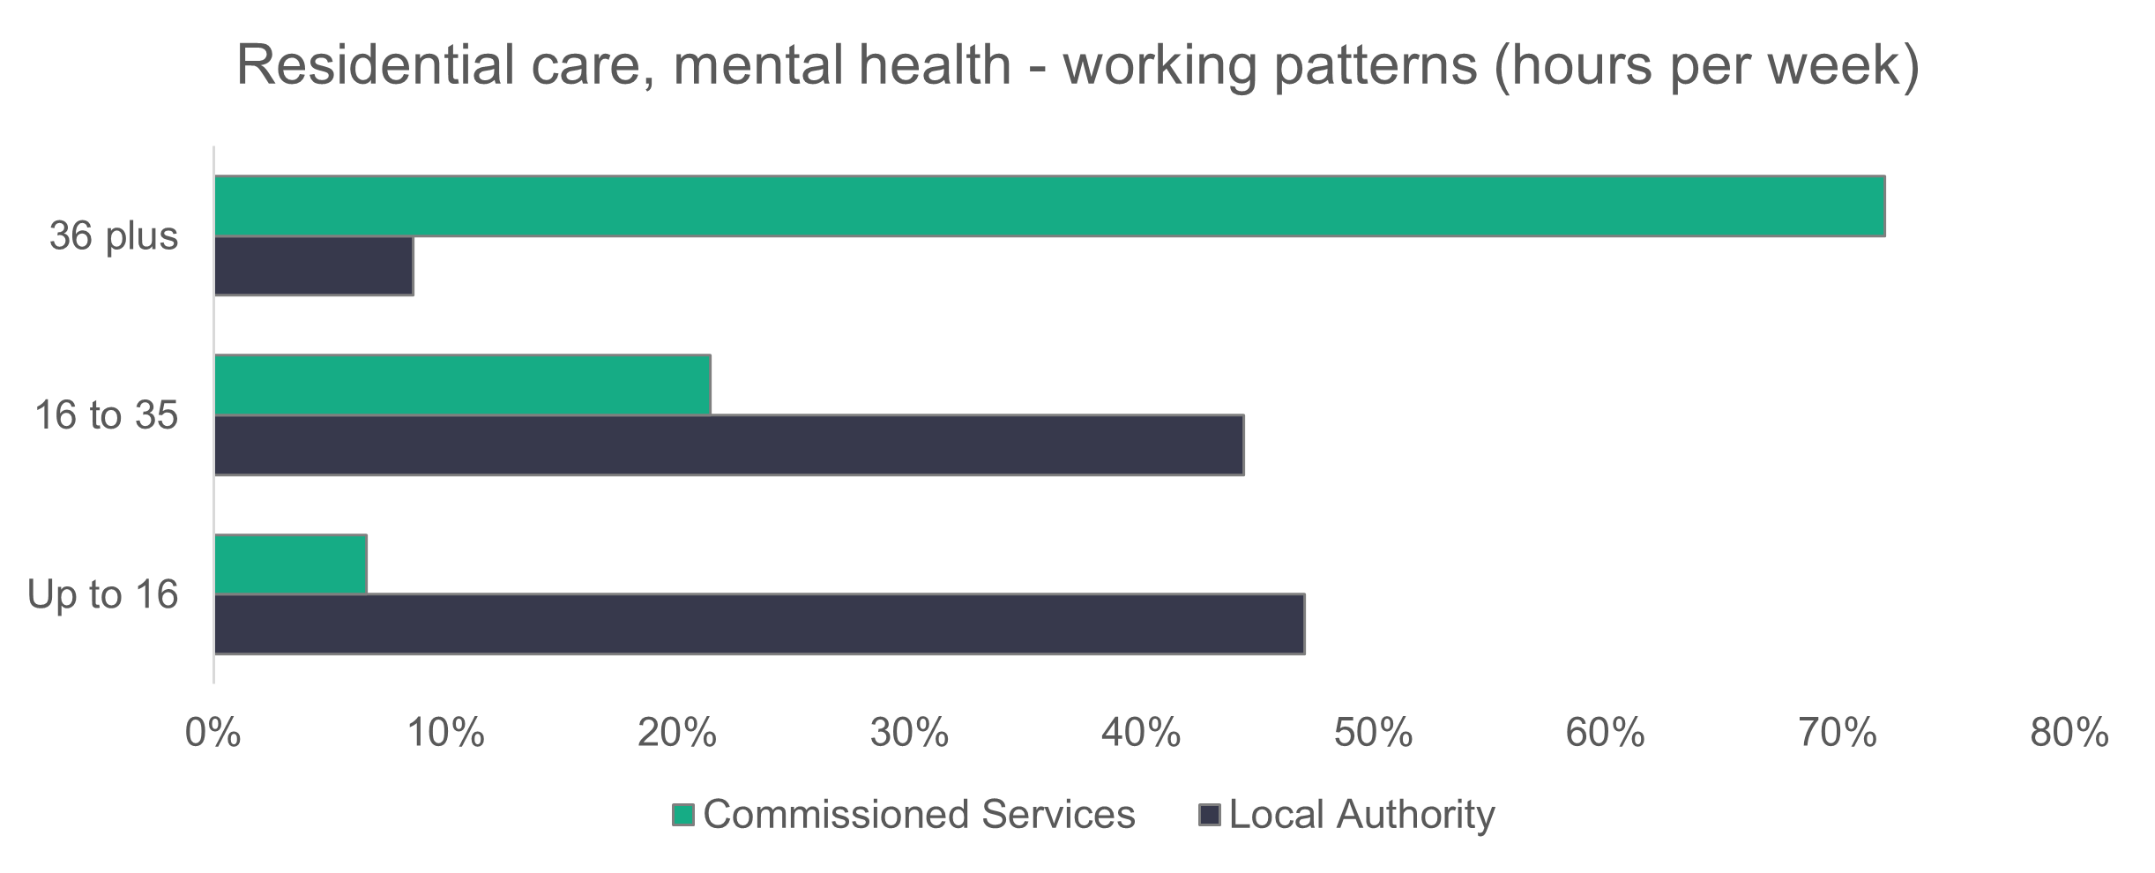
n = 894
    - Mental health residential care – vacancies
There are 148 vacancies in mental health residential care, which gives a vacancy rate of 14.1 per cent. This is almost five times more than the 30 vacancies reported in 2024.

2.9 Central staff

Summary:

- Three out of every four central staff workers are women.
- The central staff workforce is slightly less ethnically diverse than the general population of Wales.
- Most central staff work full-time hours.

We received complete return rates for central staff.
n = 58
n = 22
    - Central staff – role type
‘Other staff’ includes business support and auxiliary workers and makes up 56.3 per cent of the central staff workforce – a 3.5 per cent decrease on last year’s data. The proportion of support officers has increased from 10 per cent in 2024 to 13.9 per cent in 2025.

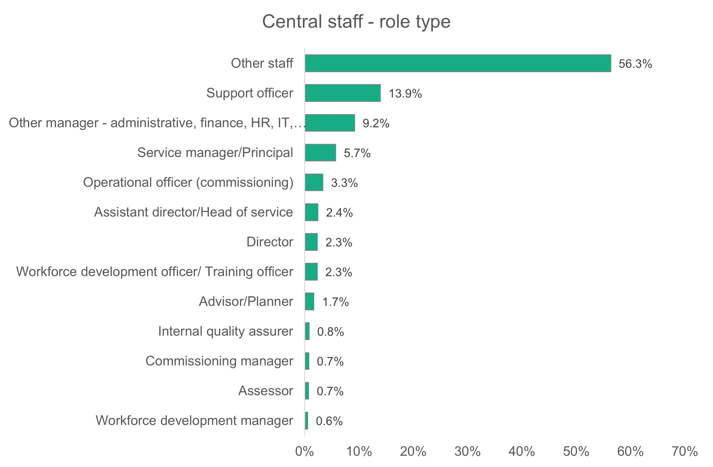
n = 3,918
    - Central staff – gender
The proportion of men working in central services has dropped from 26.2 per cent in 2024 to 24.7 per cent in 2025. However, this proportion is higher than the 19.1 per cent who work in the social care workforce of Wales as a whole.
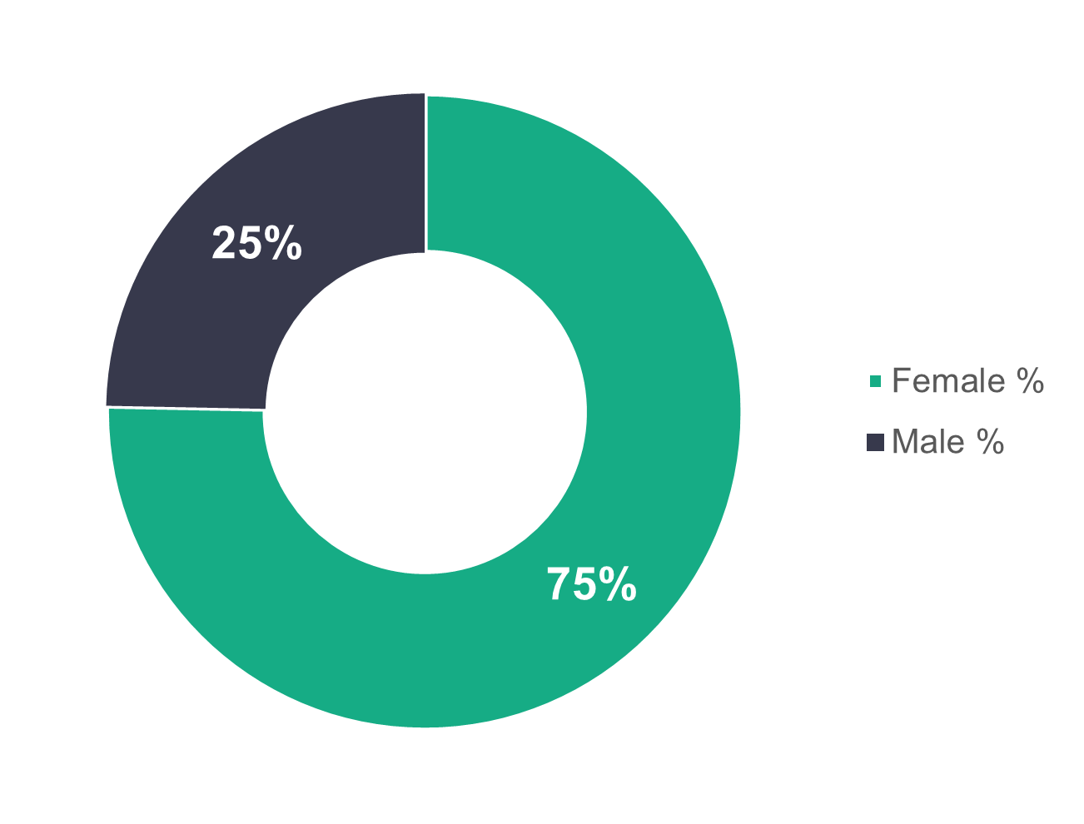
n = 3,771
    - Central staff – age profile
The proportion of workers in each age category shown below doesn’t differ significantly between commissioned services and local authorities. However, at 50.8 per cent of the workforce, we do see slightly higher proportions overall in
commissioned services for the younger age groups (45 or under). Local authorities, meanwhile, have higher proportions (53.3 per cent) in the older age groups (46 and over).
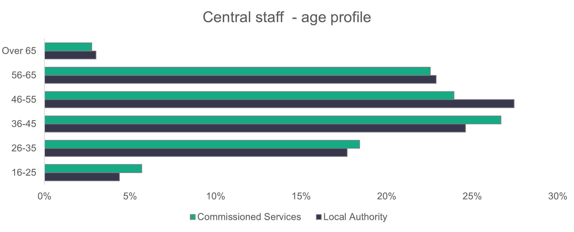
n = 3,780
    - Central staff – ethnicity
The ethnicity of the central staff workforce almost mirrors that of the general population of Wales, and this is a trend we've seen since starting the workforce data collection in 2021.
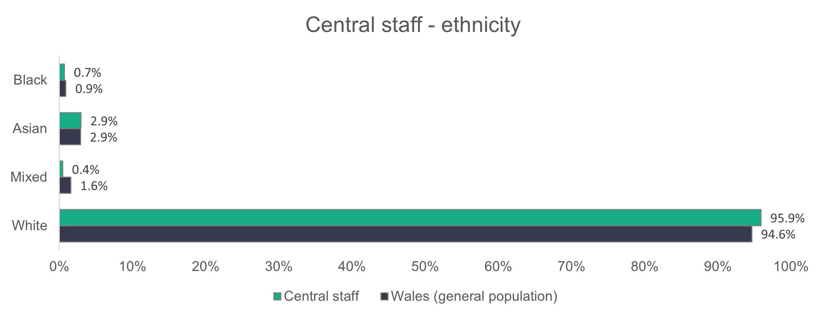
n = 2,717

    - Central staff – contract type
Almost all commissioned services workers (99.2 per cent) are on permanent contracts, and temporary contracts make up the remainder. Local authorities have 84.2 per cent of their workers on permanent contracts, 13 per cent on temporary
contracts and 2.8 per cent on casual contracts. These proportions are similar to what we've seen in previous years.
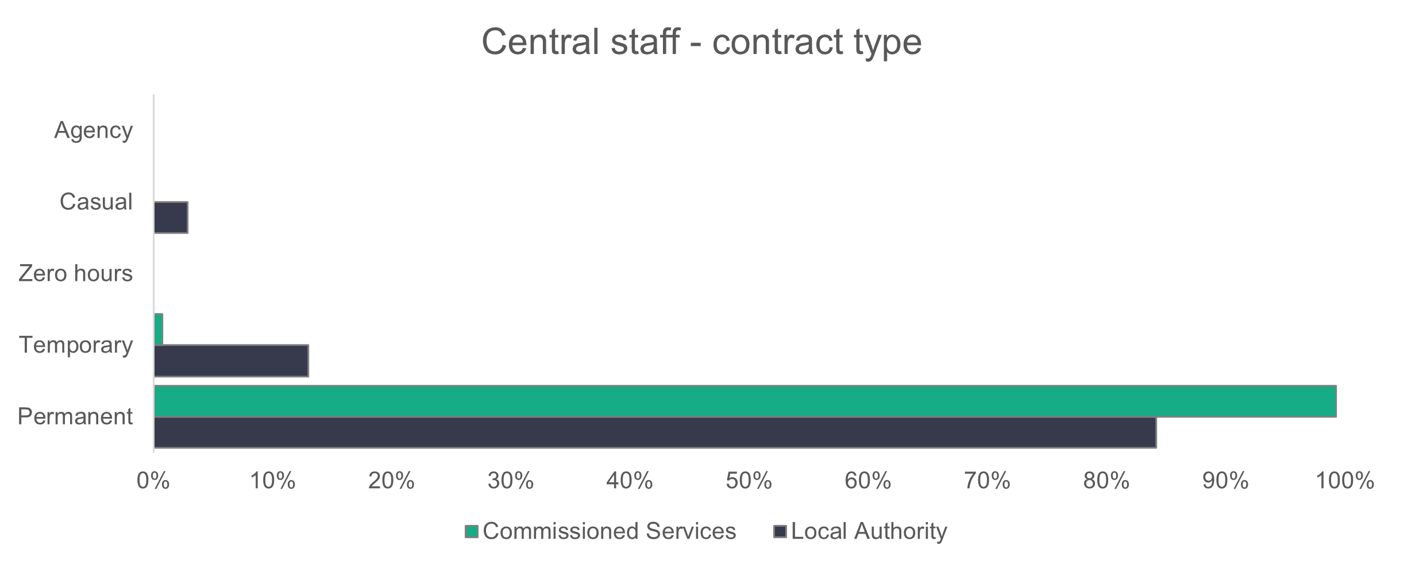
n = 3,863
    - Central staff – working patterns
Most central services staff work full-time hours - 73.7 per cent in local authorities and 66.1 per cent in commissioned services. In 2024, 76 per cent of staff worked full-time hours in local authorities, and 75.2 per cent in commissioned services.
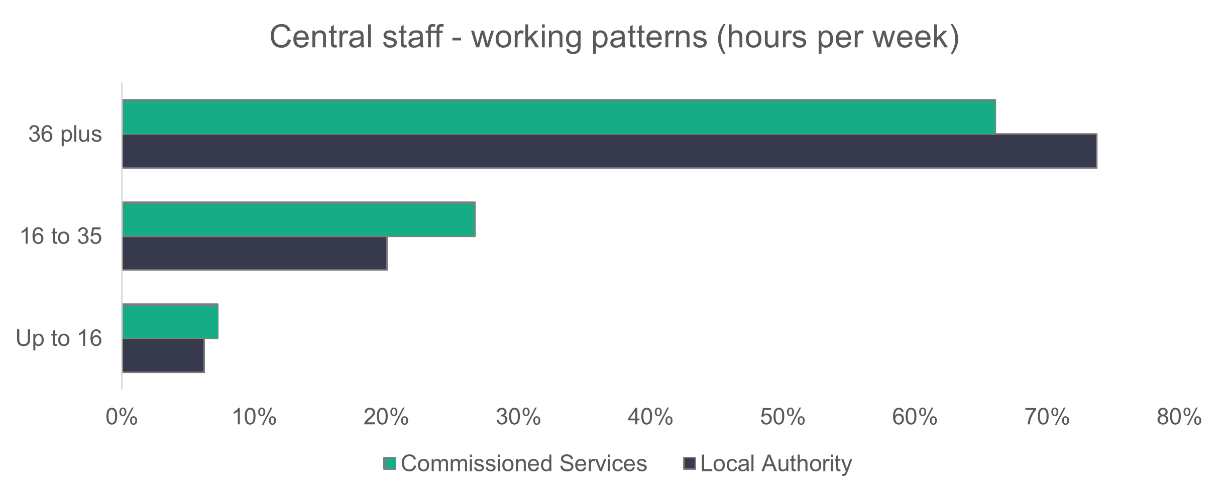
n = 3,860
    - Central staff – vacancies

Central staff have 439 vacancies, meaning that 10.1 per cent of roles are unfilled. There are 108 more vacancies in 2025 compared to 2024.

2.10 Other services
Some services can’t clearly be allocated into the listed setting types and have been placed in an ‘Other’ category. This year we received information from 15 organisations who described themselves as ‘Other’ (11 commissioned services and four local authority). This is an increase on the 11 organisations received last year, and the number in post for these organisations has increased significantly from 229 to 900 in 2025.
The breakdown of roles returned is shown in the chart below, with ‘Other staff’ making up the biggest proportion (66.9 per cent).
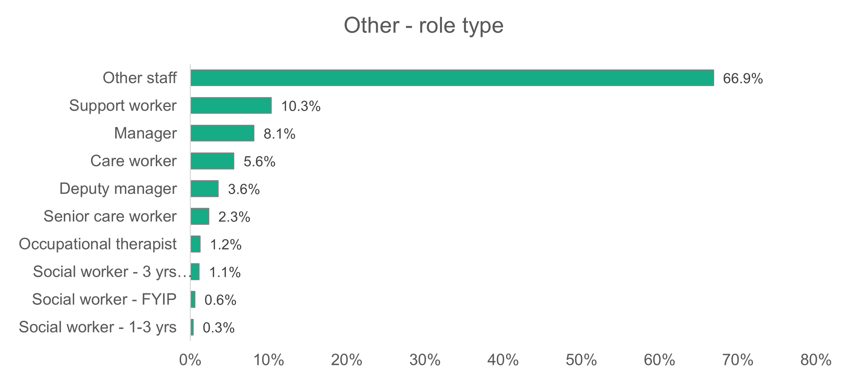
n = 900

Appendix A - Data categories

Setting type:

- Adult placement schemes | - Residential care – adult
- Residential care – mental health services | - Residential care – children
- Domiciliary care | - Supported living services
- Day services | - Social work teams – adults
- Social work teams – children | - Social work teams – all
- Personal assistants
- Central (support) staff Role definition

Role types:

- Adult placement manager | - Adult placement worker
- Adviser/planner | - Assessor
- Care worker | - Consultant social worker
- Deputy manager | - Deputy team manager (social work)
- Director | - Internal quality assurer (IQA)
- Head of service (assistant director) | - Nursing assistant/Auxiliary nurse
- Manager | - Occupational therapy assistant
- Occupational therapist | - Other manager
- Other staff | - Physiotherapist
- Personal assistant | - Registered nurse
- Planner | - Senior care worker
- Registered nursing staff | - Service manager/Principal officer
- Senior practitioner | - Social care planning and commissioning operational officer
- Social care planning and commissioning manager | - Social worker (two to three years)
- Social care planning and commissioning support officer | - Social worker (first year in practice)
- Social worker (three years or more) | - Support worker
- Speech and language therapist | - Workforce development manager
- Team manager (social work) | - Workforce development officer/Training officer

Age |  | Gender |  |  | Disability
- 16 to 24 |  | - Male |  |  | - Yes
- 25 to 34 |  | - Female |  |  | - No
- 35 to 44 |  | - Gender fluid
- 45 to 54 |  | - Non-binary
- 55 to 64
- 65 and over

Working hours per week |  | Contract status |  |  | Vacancies
- Up to 16 hours |  | - Permanent |  |  | - To be filled
- 16 to 36 hours |  | - Zero hours |  |  | - Held vacant
- 36 hours or more |  | - Casual  - Voluntary
 |  | - Bank/Agency
Requires a work visa |  | Welsh-language proficiency |  |  | First language
- Yes |  | - No ability |  |  | - Welsh first language
- No |  | - Welsh entry |  |  | - English first language
 |  | - Welsh foundation |  |  | - Other first language
 |  | - Welsh intermediate
 |  | - Fluent
Joiners |  | Leavers |  |  | Sickness
- Internal transfer/ promotion |  | - Internal transfer/ promotion |  |  | - No of days short term
- Welsh Local Authority |  | - Welsh Local Authority |  |  | - No of days long term
- Outside Wales |  | - Outside Wales |  |  | - Stress (work related)
- A private care organisation |  | - A private care organisation |  |  | - Stress (non-work related)
- Outside social care |  | - Outside social care |  |  | - Other mental health
- Voluntary/3rd sector care organisation |  | - Voluntary/3rd sector care organisation |  |  | - Back injury
- From education |  | - To education |  |  | - Limb injury
- Were not working |  | - Left the sector |  |  | - Common ill health
- Destination unknown |  | - Retirement |  |  | - Covid
 |  | - Redundancy |  |  | - Other illness
 |  | - Were dismissed
 |  | - Left temporarily
 |  | - Destination unknown
 | Ethnicity
 | - White Welsh |  | - Asian Welsh
 | - White British |  | - Asian British
 | - White Irish |  | - Asian Pakistani
 | - White European |  | - Asian Indian
 | - White and Asian |  | - Asian Chinese
 | - White / Black African |  | - Asian Bangladeshi
 | - White / Black Caribbean |  | - Asian (other)
 | - White (other) |  | - Arabic
 | - Black Welsh |  | - Mixed ethnicity
 | - Black British |  | - Mixed (other)
 | - Black Caribbean |  | - Gypsy / Traveller
 | - Black African |  | - Other ethnicity
 | - Black (other) |  | - Prefer not to say

Appendix B – How we dealt with missing data and estimating the total size of the social care workforce in Wales

A primary objective of this project is to estimate the size of the social care workforce in Wales. However, the data set compiled for this study contained incomplete information. Significantly, essential data such as the number of people in post and the number of vacancies were among the fields with missing values. We implemented a methodology for approximating these missing values, enabling us to produce a more comprehensive assessment of the social care workforce size across Wales.
Our approach to estimating missing data was made up of two parts. First, we focused on calculating figures for organisations that submitted data in previous years but failed to do so this year. We then estimated data for organisations without a history of submitting data.
We chose machine learning to predict the missing values for the number of people in post, specifically using a supervised learning approach, where known (labelled) values are used to train a model to accurately predict values for the data we haven’t received.
As for the number of vacancies to be filled, we selected mean imputation to address data gaps due to its simplicity and reliability. This technique was particularly appropriate given the limited size of the vacancy data set. When evaluated against various machine learning models, the mean imputation method produced comparable results.
We used two supervised learning methods: Linear Regression and XGBoost. Linear Regression models the relationship between a dependent variable and one or more independent variables by fitting a straight line that minimises the difference between predicted and actual values. XGBoost is applicable to both regression and classification tasks. It’s an implementation of the gradient-boosted decision tree algorithm, which enhances predictive performance by combining multiple weaker learners into a single robust model. The “gradient” in XGBoost refers to its use of gradient descent, an optimisation technique that adjusts model parameters to minimise errors and improve performance.
We selected Mean Absolute Error (MAE), R squared, Root Mean Squared Error (RMSE) and Median Absolute Error (MdAE) as our metrics to assess the models’ performance. RMSE, calculated as the square root of the mean squared differences, gives greater weight to larger errors, making it particularly sensitive to significant deviations. MAE represents the average absolute difference between predicted and actual values, providing a general measure of prediction accuracy without emphasising extreme errors. MdAE represents the median of absolute differences between predicted and actual values, making it more robust to outliers than MAE as it isn’t influenced by extreme errors. R-squared, also known as the coefficient of determination, measures the proportion of variance in the target variable that’s explained by the model, with values closer to one indicating a stronger fit.

Predicting number in post using previous years’ data
For this part of the estimations, we forecasted data for organisations that submitted data in previous years using their prior returns.
Prior to model development, we calculated Pearson’s correlation between total number of people in 2025 and our continuous variables: number of settings and total number in post in 2024. As expected, the total number of people in post in 2025 is highly correlated with the total number in post in 2024, with a correlation coefficient of 0.95. The correlation between the number of settings and the target variable (total number of people in 2025) is weak, with a coefficient of 0.24. It’s important to note that the correlation coefficient ranges from minus one to one, with values close to zero indicating a weak correlation, and values closer to either endpoint indicating a stronger correlation. We created ‘year-on-year change in 2024’ and ‘year-on-year change in 2023’ variables to assess whether they correlate with the target variable but found a weak correlation and we therefore excluded them. We evaluated number of settings, along with additional features, including county and setting type, but found that they didn’t meaningfully improve model performance, so we excluded them as well. We selected ‘total number of people in post’ in 2024 as our sole predictor.
Given the strong linear relationship between number in post in 2024 and number in post in 2025, we identified linear regression as the most appropriate modelling approach. When training the model, we evaluated its performance on the test set, which resulted in an R-squared value of 0.92. This indicates that 92 per cent of the variance in number in post in 2025 is explained by the model, confirming the strong predictive relationship between 2024 and 2025 workforce numbers. We also found an MAE of 17.7, a median absolute error of 6.6 and an RMSE of 31.9. This indicates that for the typical organisation, the predicted number in post values deviate from actual values by approximately seven people. These results reflect the influence of a small number of large organisations where absolute errors were greater, which is expected given the skewed distribution of the number in post values. The RMSE, which gives greater weight to larger errors, is consistent with this pattern.

Estimating values for non-reporting organisations
This part of the estimations differed from the previous one. Since these organisations had never submitted data before, estimating their total number of people in post was more challenging. To generate reliable estimates, we first needed to gather additional information about them. Specifically, we obtained details on authority, setting type and the number of settings.
To further explore the distribution of the target variable, we generated boxplots of the total number in post per authority and per setting. As shown in the boxplots below, the median, whisker lengths and box sizes vary across categories, indicating differences in distribution. While the boxplots below exclude outliers for better visualisation, it’s important to note that the final model was trained with outliers included, as this approach resulted in better predictions.
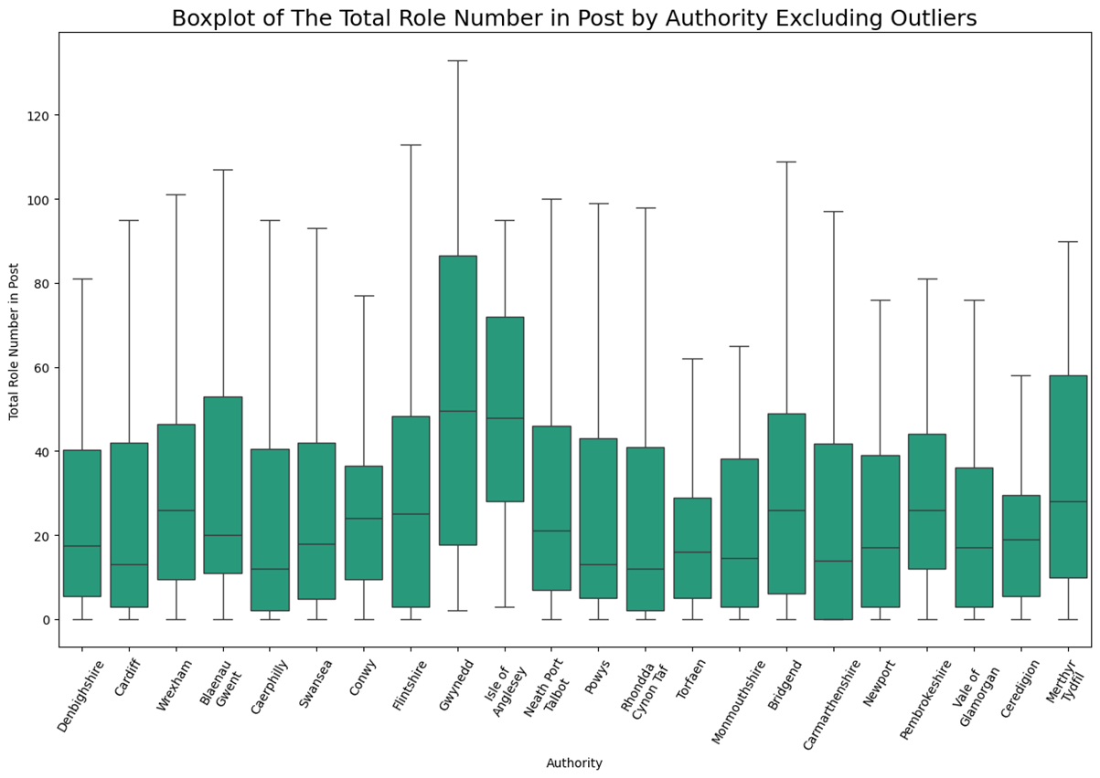

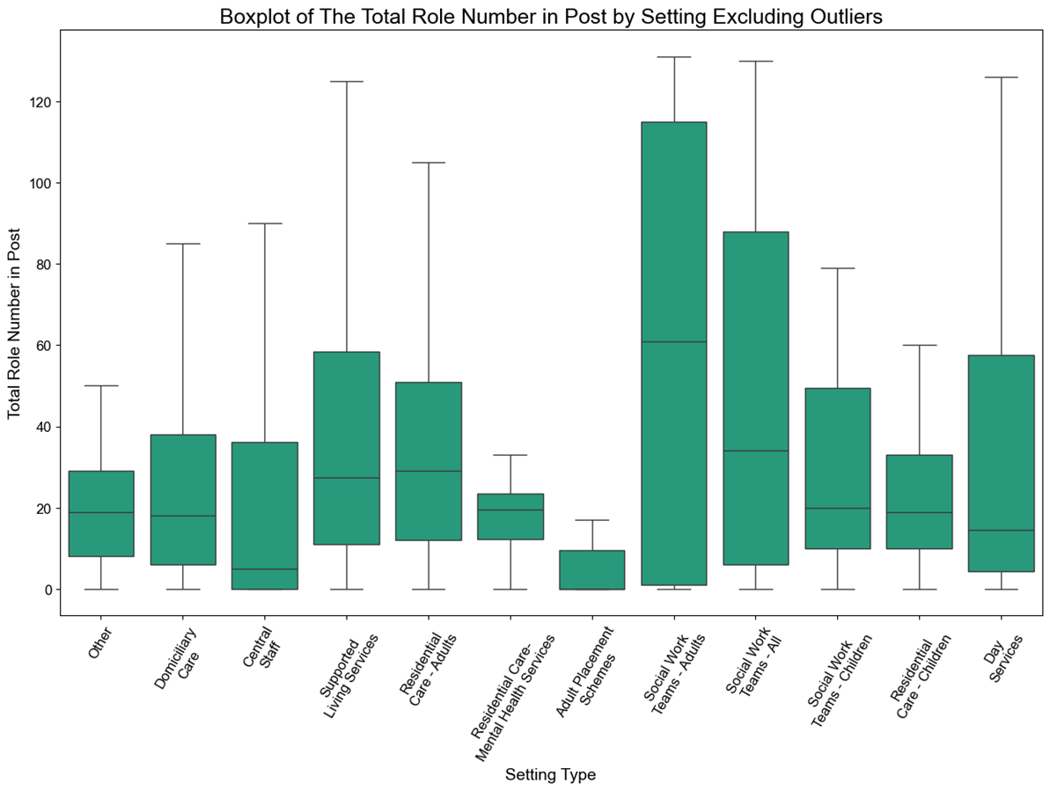
Following this, we decided to include both variables as input features for the model, alongside number of settings, as the differences observed in the boxplots suggest they may contribute to the predictions. XGBoost was selected as the modelling approach due to its ability to handle non-linear relationships and categorical features, and because it’s consistent with the approach used in previous years.
The test set used for evaluation had a highly skewed distribution, reflecting the presence of very large organisations alongside many smaller ones. Our final model resulted in an MAE of 47.3, a median absolute error of 21.1 and an RMSE of 100.7, which are reasonable given the high variability of the test set. The average prediction error and the median error are acceptable considering the spread of the data. Additionally, the RMSE, which is influenced by outliers and larger values, aligns with the presence of large organisations in the test set.
Predicted estimates for vacancies to be filled
Similar to our approach for estimating number of people in post, we consolidated vacancy figures for each organisation per authority and setting type. However, the limited data set size and quality concerns led us to avoid machine-learning techniques for this particular task.
We implemented mean imputation to address this problem due to its simplicity and straightforward application. This method replaces missing values with the arithmetic average of available observations. We reserved 10 per cent of our data set to evaluate the accuracy of our mean-based estimates against actual reported values. Next, we calculated separate means for each setting type within each authority, capturing average patterns specific to these combinations. These calculated means were then applied to fill in the corresponding missing values.
Our mean imputation approach achieved an MAE of 1.8 and an RMSE of 2.6, indicating moderate estimation errors relative to the overall variability in the target variable.
Conclusion
Building on our previous work, our confidence in our statistical techniques for handling missing data continues to develop. Looking ahead, we anticipate that ongoing refinements to our methodology, coupled with improvements in data quality, will yield even more accurate estimations in future reports.

https://www.gov.wales/sites/default/files/publications/2024-06/performance-and-improvement-framework-additional-guidance-2024-to-2025.pdf
https://statswales.gov.wales/Catalogue/Equality-and-Diversity/Ethnicity/census-2021

