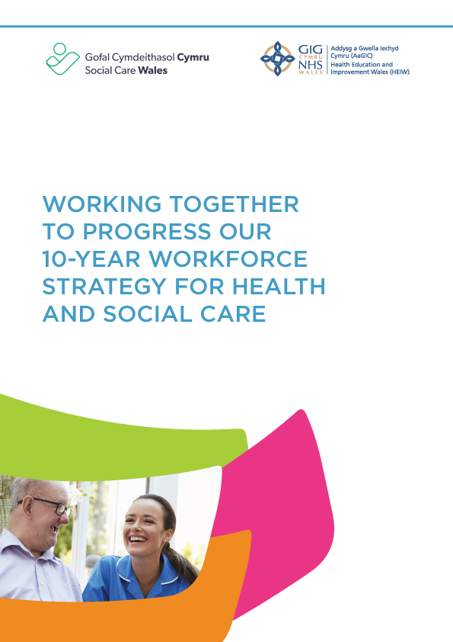

## Why we’re working together

This page explains why and how Health Education and Improvement Wales (HEIW) and Social Care Wales’ will **jointly** take forward specific areas of work to continue delivery of the 10-year joint workforce strategy for health and social care.

Since we published the [Workforce Strategy for Health and Social Care](https://socialcare.wales/cms-assets/documents/Workforce-strategy-ENG-March-2021.pdf) on 22 October 2020, several plans and strategies have been developed and have been, or are currently being progressed to contribute to the overall ambition of the workforce strategy. There has been much progress to date. These plans include our individual Integrated medium term plans and delivery plans, as well as Health Board and local authority plans, the Minister’s national workforce implementation plan and several organisational plans, which carry their own governance oversight arrangements, including performance reporting through appropriate mechanisms.

## Context

The 10-year joint workforce strategy for health and social care was launched during the Covid-19 pandemic. Health and social care are still feeling the effects of the pandemic, which will have a lasting impact for years to come. Since then, we have experienced cost of living crisis, war in Ukraine, conflict in the middle east as well as the impact of Brexit on staff recruitment in some areas. We have also seen significant industrial unrest across our health services, and severe financial challenges in delivering our health and social care services.

The workforce strategy had 32 actions across seven themes identified through substantial research and engagement. Three fundamental principles of well-being, inclusion and Welsh language and culture, are woven throughout the strategy and the implementation plans. While many of these actions have been completed, some will take the lifetime of the strategy to be delivered in full, and our work to date has laid strong foundations on which we continue to build.

In 2022, we carried out engagement, evidence collection and consultation across Wales to consider the priority actions for progressing the workforce strategy. This work supported the Minister for the Health and Social Services to publish the [National Workforce Implementation Plan: Addressing NHS Wales Workforce Challenges](https://www.gov.wales/sites/default/files/publications/2023-01/national-workforce-implementation-plan.pdf)and Social Care Wales were to develop the [Social care workforce delivery plan 2024 to 2027](https://socialcare.wales/about-us/workforce-strategy/social-care-delivery-plan-2024-to-2027).

These plans outline a series of practical actions to act as enablers to accelerate the 10-year vision of the workforce strategy and accelerate the commitment made by Welsh Government in [A Healthier Wales](https://www.gov.wales/sites/default/files/publications/2021-09/a-healthier-wales-our-plan-for-health-and-social-care.pdf) of ‘A motivated and sustainable health and social care workforce’. We also developed a number of workforce specific plans for prioritised occupations.

## Why we’re taking this approach

When we launched the strategy, we highlighted that some work would be taken forward at national level, while some would be delivered at regional or even local level. We’re pleased to see that this is the case, but it also means that the workforce strategy is being progressed through a complex landscape, and much work is delivered and reported through a vast range of mechanisms.

We have reflected on this and have concluded that all these plans are contributing to our overall 10-year ambition ‘*to have a motivated, engaged and valued health and social care workforce with the capacity, competence and confidence to meet the needs of the people of Wales*.’

While we continue to progress significant areas of work through the various plans and ways we’ve described, we’ve taken this opportunity to identify where we’re able to make a unique contribution across the system. We have set out our commitment to do so, through jointly progressing specific strategic areas of work. This will result in maximising opportunities and adding specific and concentrated value to the overall delivery across the system.

## What we’ll do

The workforce strategy aims to increase opportunities for joint working and integration across the health and social care workforce.

We recognise that to achieve the vision and ambition of this strategy, we all need to work together, but we’re mindful that in the current context, there’s a risk of duplication in many areas. To mitigate against this, individually HEIW and Social Care Wales will continue to plan, deliver and monitor work outside of what we’ve highlighted in this report.

This approach has enabled us to set out our commitment to how we in Social Care Wales and HEIW will jointly take forward a specific programme of work to compliment this, and take us closer to the 2030 ambition.

We have identified seven strategic areas where we will focus our efforts. We’ll progress these together so that we add value in our joint working, avoid duplication across the system, and ultimately provide excellent care and support to the people of Wales through our valued workforce.

The actions we’ll take forward to deliver against the seven strategic areas will be iterative. Every year, we’ll define our plans for these areas, which will allow us to take a flexible approach and enable us to respond to strategic challenges and take full advantage of further opportunities as and when they arise.

## Our joint strategic focus

**Area 1:**

**Create opportunities to share and spread workforce best practice across health and social care services.**

*This will include, but isn’t limited to: areas relating to integrated working, placed based care, integrated quality statement for people living with frailty, workforce engagement and well-being, quality improvement, culture, organisational development, workforce planning, multi-agency and multi-disciplinary team working, areas that promote staff retention.*

**Area 2:**

**Embed** [**compassionate leadership**](https://nhswalesleadershipportal.heiw.wales/pledge#:~:text=What%20is%20the%20Compassionate%20Leadership,of%20the%20Compassionate%20Leadership%20Principles.)  **in both sectors**

*Evidence shows that a compassionate and collective culture results in improved care and better outcomes for individuals. Creating compassionate cultures helps us attract and retain our valued workforce. Alongside this we’ll accelerate our work in relation to anti-discriminatory practice and inclusion. Achieving this culture is everyone’s business and responsibility.*

**Area 3:**

**Use the joint health and social care careers network to align and progress strategic careers campaigns and information.**

*This bilingual approach will build on current approaches including widening access to careers, health and social care work experience and career pathways. It will be supported by comprehensive marketing campaigns and identifiable branding for the full range of occupations, professions and roles across health and social care.*

**Area 4:**

**Continue to drive improvements in workforce data and analytics.**

*This action builds on our initial work to increase capacity and capability in workforce planning. Our workforce planning approaches will be strengthened by our work to create high quality standardised data sets, analytical methods and sophisticated modelling techniques to support workforce planning, development and productivity.*

**Area 5:**

**Support employers to embed workforce well-being in their organisations by refreshing and implementing the** [**social care**](https://socialcare.wales/resources-guidance/health-and-well-being-resources) **and** [**NHS**](https://nhswalesleadershipportal.heiw.wales/health-and-wellbeing) **health and well-being frameworks.**

*Our respective frameworks have been developed using each other’s input and knowledge. To support employers, our work will include a reliable and evidence-based guide to good practice, reliable and high-quality measures of staff well-being and curation of high-quality resources and case studies. There will also be ongoing promotion of and development of further well-being resources and services, including* [*Canopi*](https://canopi.nhs.wales/)*, the* [*care worker*](https://www.scwonline.wales/en/care-worker-card/) *card,* [*blue light*](https://www.bluelightcard.co.uk/newaccount.php) *card and links to other incentive schemes.*

**Area 6:**

**Deliver the jointly assigned actions within the Mwy na geriau action plan.**

*Embedding the Welsh language into all our work is a fundamental principle of the workforce strategy. This action will focus specifically on the areas identified for Social Care Wales and HEIW to take forward jointly.*

**Area 7:**

**Support professional development and progression of the workforce**

*This will include but isn’t limited to, maintaining joint vocational qualifications in health and social care at Level 2 to 5, our joint apprenticeship framework and supporting professional qualifying and learning pathways in both sectors.*

## The ambition

Our ambition is to have **a motivated, engaged and valued, health and social care workforce, with the capacity, competence and confidence to meet the needs of the people of Wales.** Specifically, this means that we’ll have a workforce:

* with the right values, behaviours, knowledge, skills and confidence to deliver evidence-based care, and support people’s well-being as close to home as possible
* in sufficient numbers to be able to deliver responsive health and social care that meets the needs of the people of Wales
* that is reflective of the population’s diversity, Welsh language and cultural identity
* that feels valued and is valued.

## Fundamental principles

When we launched the strategy, we set out three fundamental principles of well-being, inclusion and Welsh language and culture which, rather than being separated into themes, were woven throughout the implementation of each action. We will continue to do this in progressing this work.

**Well-being**

When we published the workforce strategy, we demonstrated that there is an increasing and compelling body of evidence linking well-being, capability and engagement of the health and social care workforce to improved outcomes for the people to whom we provide health, care and support. We’ll make sure our workforce is treated fairly and recognised for the contribution they make. We want our workforce to be happy, healthy and supported, so that they in turn support the well-being of the people in their care and will be more likely to stay with us.

Delivery of the actions in this strategy supports the development of a culture of well-being, mutual respect and improvement. It’s essential that this is reflected in strategic and consistent arrangements across Wales for commissioning the private and voluntary provider services.

**Welsh language**

The strategy has built on the foundations of the [Well-being of Future Generations Act (2015)](https://www.gov.wales/sites/default/files/publications/2024-07/well-being-future-generations-wales-act-2015-the-essentials-2024.pdf), and [Cymraeg 2050: A million Welsh speakers](https://www.gov.wales/sites/default/files/publications/2018-12/cymraeg-2050-welsh-language-strategy.pdf) to create an engaged, healthy, flexible, responsive and sustainable workforce for the future that reflects Wales’ diverse population, the Welsh language and cultural identity. The legislative framework we’re working within relating to the use and delivery of services in the Welsh language, will drive the embedding of the Welsh language into the care and support we provide.

Evidence of better clinical outcomes, and outcomes for people accessing care and support, highlights the vital importance we place on the delivery of health and social care in Welsh.

We’ll aim to improve on the work we have progressed to date, to more fully understand, anticipate and plan to meet the Welsh language needs of health and social care students, our workforce and ultimately the people we serve.

Supporting our workforce to deliver care using the Welsh language where needed, is a fundamental principle which must underpin every area of this workforce strategy.

**Inclusion**

Creating a culture of true inclusion, fairness and equity across our workforce remains at the heart of this strategy. There’s ongoing and clear evidence of deepening poverty and growing gaps in experience and opportunities for people born into different socio-economic backgrounds and those with protected characteristics. To make sure there’s equity and fairness, co-production with those most affected is key to the implementation, and will be taken forward through all the actions we progress.

Strong [compassionate and inclusive leadership](https://nhswalesleadershipportal.heiw.wales/compassionate-leadership-hub) ensures a clear focus on engaging and addressing inequalities for people from differing socio-economic circumstances, including those who share the same protected characteristics and those who don’t.

## Retaining our workforce

Retaining our staff is critical to our future workforce sustainability. We have often used the phrase ‘80 per cent of today’s workforce will be with us tomorrow’, but this is now outdated, and we can no longer rely on it.

We’re seeing rapidly changing expectations of work, and we need to continually and actively take steps to provide exemplar working experiences, in supportive environments. This will require us to think differently in our offer of working practices, development and career opportunities and flexibility, in both training and working.

In recognition of this, we have identified staff retention as a fundamental and critical element of the strategy. We believe that the actions within each of the seven themes will come together to deliver an engaged, motivated and healthy workforce who are more likely to remain with us. But, we must not rely on this alone, and we have launched a high-quality retention programme which will have a significant focus throughout the delivery of these actions.

Our goal is to have a workforce that’s led by excellent leaders who create compassionate cultures that enable staff to thrive, innovation to flourish and improve outcomes for the people we serve.

## Governance arrangements

HEIW and Social Care Wales will be accountable for delivery to their respective boards, through an operational group which reports to an oversight board on a regular basis. A joint board meeting will also be held twice a year.

## Communication

Our [HEIW](https://heiw.nhs.wales/workforce/10-year-workforce-strategy-for-health-and-social-care/) and [Social Care Wales](https://socialcare.wales/about-us/workforce-strategy) websites hold information, resources and progress updates so that our work is transparent and widely shared.

## Looking forward to 2023 and beyond

We believe the [NHS England long-term workforce plan,](https://www.england.nhs.uk/wp-content/uploads/2023/06/nhs-long-term-workforce-plan-v1.2.pdf) published in June 2023, stimulates a critical discussion about the future shape of care, work and education – and how to achieve the right balance between them, to deliver the best possible care for the changing needs of our population. The financial pressures are driven by significant workforce shortages – we won’t break this cycle without long term workforce planning. This is essential to ensure the best use of resources in line with the Well-being of Future Generations

Changes to education and training take time to implement safely, and we’ll need change if we’re serious about embracing a prevention agenda. We recognise that there are going to be fewer younger people available to care for the older population, and so our opportunities for workforce supply will also change. The continued heavy reliance on international colleagues to support our services is also a risk, particularly in the context of a global health workforce shortage.

The workforce plans we’re currently developing can only realistically look two to three years ahead. While they’re focused on improvement and innovation, they can’t be truly transformative unless we look further into the future.

We believe that it’s essential to develop a long-term workforce plan for Wales to determine the actions we need to take today to create a more sustainable workforce. This would set out the steps we need to take to:

* deliver a future of stability and consistent supply of workforce to better meet demand – reducing gaps and deficits
* prompt critical discussions about the future shape of care, work and education – fuelling the case for transformation
* build in agility and flexibility to our short term actions because the future starts now
* effectively plan a workforce that can support the shift to prevention agenda as well as respond to rapid advances in treatment and technology – a “more and different” approach
* prepare for the predicted reduction in working age population and the rapid change in the ways people wish to work
* promote the value and importance of the workforce across political cycles, enhancing attraction, recruitment and retention.

In the strategy, we acknowledged that what we spend on our workforce is not a cost, but an investment. Continuing to deliver this strategy will ensure that we get maximum value from this investment for our workforce, for the people we serve and for the health and social care system in Wales.